Individualisation: Medico, Social, & Psychological Approach

Dr. Sinchan Das
Author1
Director
Humanity, Institute for Advanced Medical & Cultural research
J-40, Banerjee Para, Kamdahari, Garia, Kolkata-84
Kolkata, India
drsinchanas@gmail.com

Swastika Subba
Author 2
Research Scholar
Humanity, Institute for Advanced Medical & Cultural Research, India
J-40 Banerjee Para, Kamdahari, Garia, Kolkata-84
Kolkata, India
7novsandypota@gmail.com

Abstract
We live in a system of varying diversity where we share different interests, thoughts, perspectives, wants & dislikes. On the other hand, everything in this system shares a symbiotic relationship with one another where a small disruptions or breakage leads to major impact on the entire diversity. However, as humans are progressing, this symbiotic relationship is slowly losing its grips while making a major disruption in the ecological balance. This disruption in our symbiotic relationship has been fading our ability to think, questions, & perceive differently. In addition, the hyper-consciousness of human has been majorly distancing them from nature & more towards destruction. For instance, the individualised traditional approach carried forwards throughout the course of history like in case of Ayurveda have now accounted to alternative approach. Currently, the society is instead more depended on approaches that are more generalised, faster & so call laboratory proved. The ignorant & hyper-individualistic mentality of people in the current scenario has eradicated out capacity to think rationally, logically & seek beyond truth. We may feel that our action is negligible but we forget or say we have lost that ability to sense the fact it is enough to cause a mass eradication. The major crisis of Covid-19 for instance is just the small outcome of our ignorant & hyper-individualistic mentality while accelerating towards extinction.

Keywords
Individualisation; Generalisation; Health; Disease; Society; Homoeopathy; Psychology; Medico-social; Genetics; Individual; ID; Superego; Ego; Consciousness

Introduction
One of the unique features that serve us being a part of Homo sapiens is our diversity not just in terms of ethnicity, beliefs, religion, caste, creed or colour but also in terms of thoughts, perceptions, thinking, emotions & the diseases or disorders one suffers. We all may belong to the same species greatly with our mental & physical development. The concept of individualisation holds a deep meaning throughout our history of evolutions as well as through the course of traditional & ancient medical beliefs. For instance, the age-old Ayurveda text outlines a unique concept of “Prakriti” which is genetically determined while categorising populations based on several subgroups in terms of their phenotypic characteristics such as appearance, temperament & habits. The following concept is thought to be an effective way that plays a major role in predicting the susceptibility of an individual towards a specific disease, & the prognosis of their illnesses while being able to make the most suitable therapy. However, in the current scenario, all of these have faded away under the dumps of consistent human ignorance, manipulations, resistance, denial, displacement, projection & regression. On the other h&, the very concept of reality or actuality has just got confined within the boundaries of human vision, touch & feel where other things beyond their boundaries are either non-reachable or vague mythological concepts. This has been more significant lately among humans due to their super-sensual complex while making them fully disconnected from nature. The detachment from nature has made humans more reluctant while transforming them into complex hyper-individualistic individuals. In addition, this hyper-individualistic complex of humans has been compelling humans to be the ultimate supreme as well as super-conscious. Because of this, the humans are becoming more & more ignorant as well as resistant to the things that threaten their concept of reality.
Individualisation
Individualisation has been a circumstance in a society considering it as whole in order to increase for adapting conditions, predilections, as well as need for individuals at the same time as acknowledging the individuals right to this & encourage individuals in using them. This finding aims has been neither to disrespect any profession nor to hurt believe as well as question on anyone life saving works for healthcare practitioner. Rather, we strongly desire to convey the need for changes within treatment approaches since it could be able to reach each person with the necessitate for individual health care, where treatments could be accessible to every group & class of people as well as more importantly it could focus on the generation of a disease free environment. Neither within the field of healthcare but even a change in the society is required that will aid in breaking many long-standing stereotypes.

Individualisation in Medicine-Genetic approach:-
A. Personalized medicine,
This is even referred as individualised medicine, where the medical procedures separate patient into different groups based on the aspects of medical decisions, practices, interventions or products being tailored to each individual patient on the basis of predicted response or disease risks. The process may take longer time & even take several hours or even days, & in that period a practitioner may be able to examine around 9-10 patient; however, the question arises here; that what healthcare facility are we providing to person that completely as well as blindly needs cure and has been relying for that purpose, quantitative or qualitative? Even though, most of the variation occurs between individuals do no impact on the health, an individual's health stems are based on genetic variation including behaviours & influences from the environment. Modern advances in personalised medicine rely on technology by confirming a patient's fundamental biology, Deoxyribonucleic acid, Ribonucleic Acid, and protein, which ultimately leads to confirming disease. For example, personalised techniques for instance genome sequencing could reveal mutations within DNA that could even influence diseases ranging from cystic fibrosis to cancer. Another aspect, referred as RNA sequencing, could show which RNA molecules that are involved in specific diseases. Other than DNA, RNA levels could change in response to the environment. Hence, sequencing RNA could provide a broader analysis and understanding about a person health state. Recently, studies have linked genetic differences between individuals in order to RNA expression, translation, & protein levels.
Physicians majorly perform different studies referred as “genome-wide association study” (GWAS) in order to study the genetic variation, genetic changes, and mutation in the human individual. GWAS study majorly focuses on looking at specific disease, and then sequence the genome of many patients with that particular disease to look for shared mutations in the genome. Mutations determine to relate a disease through GWAS study then used to diagnose the disease in future patients by looking at their genome sequence to find that same mutation.
The genetic content of an individual will allow guided decisions in determining the source of the disease & thus treating it or preventing its progression. This will be extremely useful for diseases like Alzheimer’s or cancers that are to be linked to certain mutations in our DNA.
Individualisation within medical Approach (Homoeopathy):-
The concept of disease in homeopathy could be visualised as these (diseases) occurs due to total affection of mind & body. Mind and body are the dynamic as well as complexly interlinked where each one of them influences the other and even they have been acting together. Neither mind nor the body shows the symptological changes of any disease individually. Hence, when we need to start learn about prolong emotional stress that could be defined as too much desire, anger, greed, pride, jealousy, suspicion, and many more. It could be found that its leads to upset stomach, difficulty digesting food, poor nutrient absorption, sleeplessness, weaken immune system, etc.
The emotional state closely relates to endocrine glands & nerves, which influence over the working of the physical body.
Thus, homeopathy medicine is as psychosomatic medicine & is excellent for psychosomatic diseases such as Migraine, Asthma, Peptic ulcer, Allergy, Ulcerative colitis, etc.
Individualisation: Medicinal Structure (Indian Medicine):-
Indian Medicine system such as the Ayurveda has been the traditional medicinal system practiced within the Indian Subcontinent and has remained as the most ancient and even one of the living traditions with appropriate philosophical as well as experimental basis. It has been a science of life with the crucial holistic approach to health considering all the dimensions of an individualisation as well as personalized medicine. It has been hence known to be a complete medical system that focuses on every aspects of human life such as physical, psychological, philosophical, ethical, spiritual, and other dimension. In Ayurveda, each cell is considered to be inherently an essential expression of pure intelligence hence called self-healing science.
In addition, to the self-healing concept, the use of herbal treatment is equally important in this Indian traditional system of medicine.
Individualisation in the Social structure
Although physicians have been just beginning to see promise of genetic medicine coming to realization & cannot hide excitement relative to the advancement in technology, the patients have been asking for personalized care; wholistic approach considering an individual overall health well being such as physical, mental, as well as spiritual dimension. In addition, these points of view consider psychological, religious, & ethical challenges that may arise as the precision of preventive medicine improves.
Acknowledging current vicinity for the potential conflict between religion & medicines could be informative where anticipating public concerns regarding personalized medicine has been crucial. The extreme conflict presently has been found within the virtue of the medical society & churches that rejects modern medicine, such as the Indiana-based Faith Assembly as well as the Christian Science Church. Apart from this, personalised medicine will not focus on those individuals since they have been rejecting most medical assistance. Even, majority of them even estimated that around 172 children died between 1975 & 1995 because prayer was used instead of applying effective medical care were from such churches. Another group of people who may challenge personalized medicine are individuals questioning evolution and by association, genetics.
In a June 2008, Pew Forum polled that around 45% of Americans have rejected evolution being the best explanation for the human life origin. Population genetics will form the basis for various scientific advances within the personalized medicine and even relying on some of the heredity tenets that took roots from evolutionary biology. For instance, certain religious groups have been rejecting these personalised medicines, while majority of the patients as well as physicians have been likely to continue in accepting technologies while that have been distant from the theoretical foundations. Atheists may view illness as a statistically based combination of genetic & environmental factors, while believers of certain religions may view illness as punishment or a test of faith by a higher power, as illustrated in the story of Job. Many Pentecostal & Charismatic Christians envision Satan as the author of sickness & Christ as their healer; in this framework, they view spiritual & physical healing as complementary rather than conflicting. Although the majority of religious institutions, including Roman Catholic & conservative Protestant churches, have been supportive of DNA-based research & diagnostics, this view could change if personalized medicine appears to conflict with the sanctity of human life.
Individualisation in the Medico-Social Consideration:
Indians have been keeping follow of their nucleic protein such as the development of DNA line with the application of the GOTRA tracking system with the consideration of the four father sages that existed for long period. In most of tribes & religion marriage and future planning has been done on this system where two people in the same kula or gotra have been not allowed to marry considering that they share similar ancestral origin & some similarities within their genetic sequences. It could be justified with the scientific as according to genetic science the parents who are close relatives & siblings are like to be give birth to a child who are mentally retarded, suffer from various genetic conditions, & like to show grater mutation in the genetic makeup which leads to various deformities. Hence, in order to avoid all this; from very ancient time during the -gurus have kept the track of gotra.
This DNA tracking line can significantly help in individualising medicines based on the GOTRA of an individual.
Individualisation approach in Psychological consideration:-
The biggest challenges in order to implement these concepts have been the most difficult task since many ruler areas consider the basic accesses to healthcare facility have been still believed to be a taboo within the society. In addition, people still consider tantaras, black magic, and shamans for their cure believing it to be true from million years. These are due to the lack of awareness and the mentality of people under their elder pressure or within the namesake for age-old practices.
Implementation of personalized medicine would require attention to psychological issues that could be already encountered with the genetic counsellors & aid of physicians. Prior to the genetic testing was found to be functionally possible, 60%–75% of the individuals were risked for Huntington disease indicated that they need to undergo testing; however, when various medical advancement became possible in life, only 3%–21% of the individuals opted to be tested. Even for the management of cancer, positive genetic testing could be applied in order to encourage women or even their daughters in order to participate in vigorous screening or pre-emptive surgery (such as mastectomy), testing is not universally accepted. In addition, among insured women that have recently diagnosed breast cancer there has been a significant amount comparing approximately 20%–30% have refused the genetic testing with proper psychological counselling has been highly crucial for the process of individualisation. Hence, the physician needs to focus on understanding and evaluating their patients in order to make the medicines holistic, personalised & effective. In addition, making patients connected with them will make the medicine even more effective as a person in peace produces minimal level of stress hormone & make the medicine work with least hindrance.
Individualisation v/s Generalisation
Every human is made up of 206 bones, over 640 muscles, 34 main veins & other similar structures that categorise the human species in a general class. However, considering the overall structure, it would be valid to focus on the actual scenario of an individual rather is it not essential to focus on other aspects of the overall human society. For instance, if we consider the multi-factorial approach of health, it could be found that an individual health is dependent on 12 determinants that not only vary from region to region rather vary from person to person making a clear differentiation with the concept of generalisation.
In contrast to the above fact, one must even underst& that generalisation is the form of abstraction where common properties of specific instances have been formulated for the general population excluding other individual factors. For example, the normal range for the blood pressure measurement have been considered between 100-130/70-90mm of Hg for each & every individual; however, the impact of weather, food habit, circadian rhythm, region of birth, developmental stage, age, sex, occupation, & many more factors have been totally excluded for the people creating a chaos on the general people.

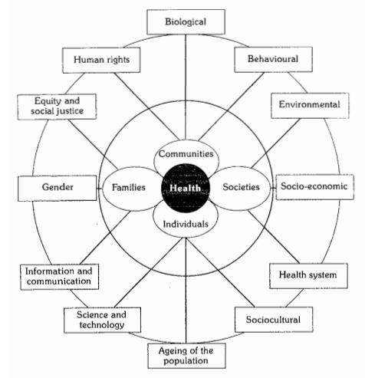
Figure 1: Determinants of Health
The textbook of Park’s Preventive & Social medicine highlighted that “factors which influence health both within the individual & externally in the society in which he or she lives.” Hence, the findings from this section & the above image clarifies that an individual health or any other factor could not be considered as a generalised possession as the totality of the individual.
In order to clarify the difference between the individualisation & generalisation, a simple study was conducted on the people from different regions of India considering their common diseases, issues, weather condition, soil condition, & many more. Hence, following report was found valid within them:
Table 1: Study conducted on people from different regions of India
Region | Weather condition | Desires of individual | Soil condition | Common diseases found
Gangtok & Namchi, Sikkim, India | Sub-tropical climatic scenario with altitudinal variation  It faces the temperate weather condition in southern lower parts to cold deserts & snowy northern Sikkim | Sour & pungent | Summit & ridge (<30%)  Side Slope of Hills  Very steeply sloping (>50%)  Escarpments (>50%)  Steeply Sloping (30-50%) | DCM  Dermal issues  DM2  Hepatobiliary complication
Darjeeling, West Bengal | Sub-tropical hilly regions with several fertile l&s & arid places  It has a temperate to snowy weather condition with heavy rainfall throughout the year | Sweet, Sour & Pungent | Mixed sandy loam & loamy at the regions of Pokhrebong, Bijanbari  Clayey loam & reddish soil in Mirik & Kurseong  S&y soils near the slopes of Tista, Naxalbari | UTI  Cholethiasis  Nephrolithiasis  Hepato-billiary complication  DCM  Varicose veins
Hasnabad, Sundarban | Swampy, loamy weather with huge rainfall during the mid annual monsoon season | Salty to pungent | Dry, fertile lands  Salty soil condition due to correlated bay of Bengal | DCM  HTN  DM2  Insomnia  Loss of appetite
South Bihar | Fertile l& with Ganges & Koshi on each side of 8 districts of Bhagalpur, Purnea, Katihar, & Banka | Sweet, sour, pungent | Gangetic Alluvium soil in the Ganges region  Terai Soil have been found across the border of Nepal such as Purnea & Katihar | Dermal issues  Hernia  Orchitis  Cancer  Leukoplakia  Leucoderma  Uternine Fibroid  Eczema
Kolkata & urban regions of South 24 Paraganas | It has a tropical wet & dry climate with an annual mean temperature of 26.8 degree Celsius & connective rainy season between the months of June to August | Mixed & diverse living & taste preferences  Predominately, sweet, sour & pungent | Alluvial soil around the regions of Indo-Gangetic Plane making it the fertile region for agriculture in the Bengal Basin | Lifestyle-based diseases turning to genetic disposition  Psychosomatic origin of issues majorly found with sleeplessness, deranged circadian system
The above study of several regions that lies within distant places provides critical evidences that the determination of a generalised system excludes the above stated points clearly causing issues in underst&ing their visionary approach. On the other h&, one could even identify that the weather condition even changes with the change in district, soil infrastructure & hence a change in the occupational st&ard has been even administered. Thus, one could easily justify that considering a generalised approach for any health or other parameters could affect the health of an individual rather it could create a barrier in the social infrastructure.
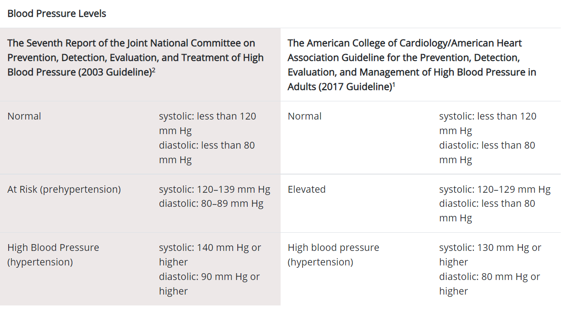
Figure 2: Blood pressure diagnosed by CDC
For instance, the above report provided by the Centre for Disease Control & Prevention clearly outlines the term adult without specifying the range of adulthood in their guidelines for the high blood pressure. Moreover, a common anatomical differentiation occurs between man & women that even differentiates its physiology that is even not considered during this generalised approach. In order to focus on this case, it is important to underst& a study that was conducted by Chatterjee & Raymahasaya in 1956 that pointed out the differentiation in the average blood pressure within an apparently healthy person considering their age gap as well as sex.
Table 2: Differentiation in the average blood pressure
Age Group | Males |  | Females
 | Systolic | Diastolic | Systolic | Diastolic
20-29 | 124.0±13.2 | 77.0±9.5 | 116.5±11.6 | 73.0±9.4
30-39 | 126.5±13.9 | 79.5±10.0 | 122.0±14.0 | 76.5±10.4
40-49 | 129.5±16.0 | 81.5±10.2 | 129.0±18.3 | 81.0±11.1
50-59 | 136.5±19.0 | 83.5±11.4 | 138.0±21.4 | 84.0±12.0
60-69 | 142.5±23.5 | 84.0±11.2 | 149.0±25.7 | 85.0±13.4
70-79 | 145.5±24.0 | 81.5±14.1 | 158.5±26.0 | 84.5±14.2
80-89 | 145.0±25.0 | 80.5±12.4 | 155.5±28.0 | 82.5±15.2
From the above table, it could be understood that the differentiation in generalisation is highly prevalent where the ratio of false & fallacies have been strongly affecting the health of an individual. So, it could be said that if we consider the definition of health as the balance between physical, social, & mental determinants; then, every individual posses different physique with various BMI/BMR, weight, height, sex; mental state; & social parameter on which their life exists.
The individualisation approach witnessed in psychoanalysis
Psychoanalysis can be accounted as a generic term that can be outlined as the set of both psychological theories & a group of techniques where each of it gives its major emphasis on unconsciousness as one of the crucial factors for adaptation & behaviour in humans. The following therapeutic approach was brought to light by the Austrian neurologist & psychiatrist Sigmund Freud (1856-1939), which is currently known as “Talk” Psychotherapy. Freud further outlines that “The unconscious mind is the primary source of human behaviour like an Iceberg; the most important part of the mind is the part you cannot see. Our feelings, motives & decisions are actually powerfully influenced by our past experiences & stored in the unconscious.”
Unlike other therapies in psychology, Psychoanalysis psychology can be accounted as one of the most holistic approaches that are administrated by clinicians on a particular individual. The major success of psychotherapy depends on the individual’s conduct, understanding, adaptability & perseverance. Further, Freud & Breuer outlines that the improvement of a patient through an intervention depends on two major factors, which are as follows:
Abreaction, a cathartic process where repressed emotions are released
Insight, a process whereby the unconscious conflicts in a patient is brought into consciousness
The intervention of psychoanalysis is outlined to be individualistic as well as holistic approach to help people with neurotic condition. The major part of the therapy relies on the Freud’s concepts of Mind. Freud divides mind into three major parts, commonly to known as the Iceberg model.
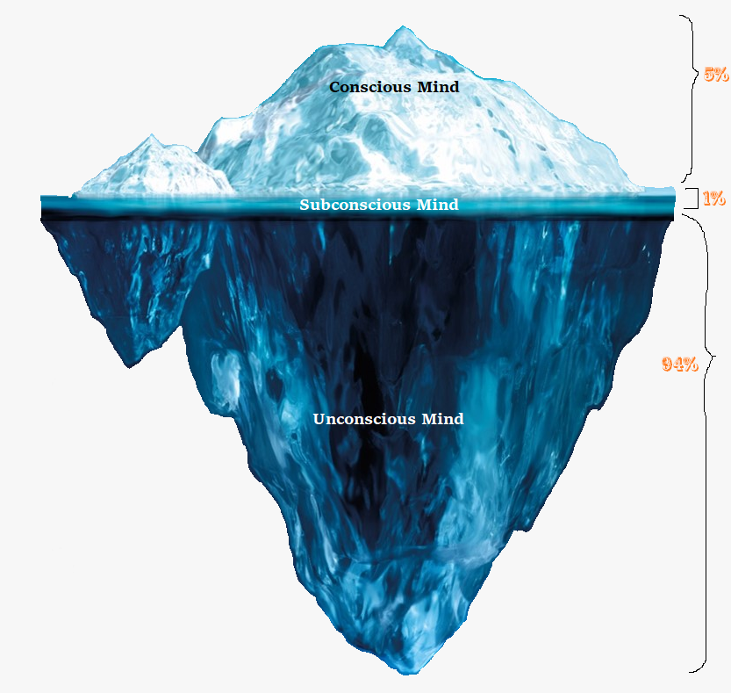
Figure 3: Iceberg phenomenon of mind by Sigmund Freud
The major parts of mind are as follows:
Conscious: Part of mind that is aware of their environment, thoughts, feelings or sensations helps an individual to be both aware & awake for being able to experience. It is also the place ego resides within small portion of mental life
Subconscious: This accounted to be an associations & impulses that are not accessible to consciousness. In other words, it can also be described as a bridge between the conscious & unconscious.
Unconscious: In context to the figure below, it can be noted that this is the part comprising of largest portion. Further, this is also the place where ID resides & its not easily reachable. However, it makes a huge contribution in giving rise to importance needs & influences of human behaviour.
*Superego resides in all the three level of consciousness
In context to the aforementioned discussion, it can be outlined that psychoanalysis is a kind of psychotherapy that seeks to facilitate eventually ensure to work though & resolve a neurotic transferase through interpretation. Considering, an interpretation can be accounted as an intervention designed by the psychoanalyst that links together both conscious (manifest) & the unconscious (latent) aspects of the communication made by the patients. Further, Freud considered dream as a major source of insight to unconscious. Freud further outlines that dream analysis, free association & the childhood interpretation conflict makes a major contibution to the patient’s neurotic symptoms.
Practice of Individualisation within the regions of Homoeopathy
CFS Hahnemann in the 17th century came up with the discovery of Homoeopathy & even coined the aspects for individualisation in health practices. In his words from Organon of Medicine 6th Edition, one could easily find the approach of individualisation that Hahnemann wanted to be practised from Aphorism 82-104.
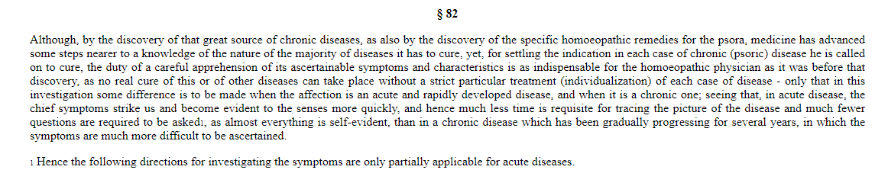
Figure 4: concept of individualisation introduced by Hahnemann in Homoeopathy
The above aphorism relates with the fundamental approach that is, it should be a duty of a practitioner to focus on careful apprehension of its ascertainable symptoms & characteristics as the indispensable factor for an individual only. He even quotes that for any individual person or a patient there is no real cure of the disease without considering its own particular treatment for each case of disease. Hence, for the investigation of any disease for any individual of any origin should be analysed by tracing the picture of disease, picture of the patient comprising all through the ends across the mind to toe.
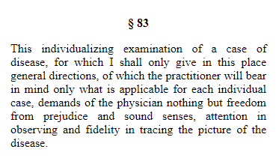
Figure 5: Aphorism 83 providing direction for individualisation to practitioner
In the above image, the quotation for the examination of mind to toe concept for each individual is specified where Hahnemann provides specific guidelines to the practitioner so that they could concentrate on individual case rather than being affected from any sort of prejudice & sound senses. Hence, the guidelines from the Aphorism 82-104 could be justified by understanding the following approach used by the homoeopathic practitioner excluding the generalised structure.
Similarly, the other visionary statement from the Organon of medicine directs to manage the issues that correlated with an individual by considering the patient. In § 3, Hahnemann clearly states about the what is to be cured in diseases that is in every individual case of disease, a physician should have knowledge of disease with its clear indication. Additionally, the physician should even perceives that what each individual curative medicine could be applied on that specific individual case & how it could adapt the disease of an individual case in order to ensure suitability & appropriate recovery. Thus, he even needs to understand the doses, way of drug administration, & the pathways based on which the medicine could work on restoring the health of each individual.
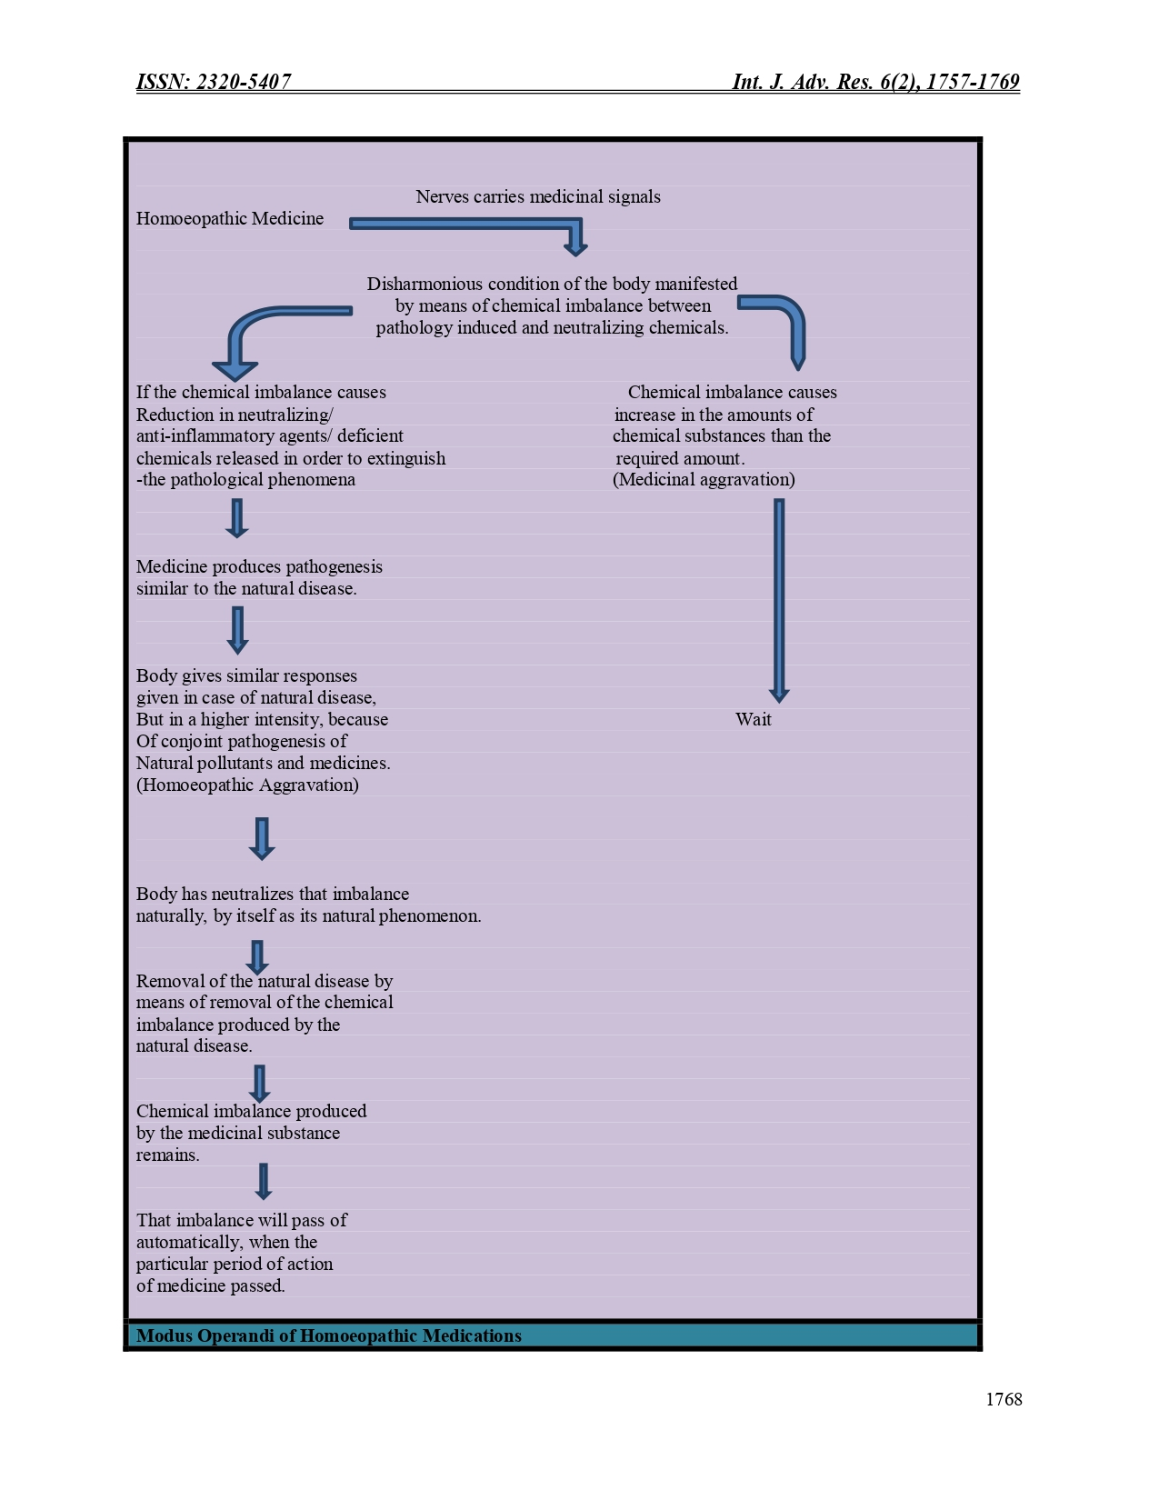
Figure 6: Modus operandi of Homoeopathic Medicine
Acknowledgment: We acknowledge Priyankesh Mishra for his support during the research work.

References
https://www.researchgate.net/publication/316011507_Psychoanalysis
https://en.wikipedia.org/wiki/Psychoanalysis
https://eduardolbm.files.wordpress.com/2014/10/a-general-introduction-to-psychoanalysis-sigmund-freud.pdf
Chatterjee, C.C. & Raymahasaya, D., 1956. Human physiology. Book Concern.
https://www.ijtsrd.com/humanities-&-the-arts/sociology/26359/individualisation-a-medico-social-&-psychological-approach/swastika-subba
https://www.academia.edu/39735749/DIAGNOSIS_OF_LIFE_STYLE_DISEASES_Manuscript_info
https://en.wikipedia.org/wiki/Climate_of_Kolkata#:~:text=Kolkata%20has%20a%20Tropical%20wet,F%20to%2086%20%C2%B0F).
https://www.cdc.gov/bloodpressure/about.htm
https://www.journalijar.com/article/19999/role-of-colours-on-human-life/
https://www.journalijar.com/article/22375/mechanism-of-action-of-homoeopathic-medicines/

