‘WORK FROM HOME’ TO ‘WORK FROM ANYWHERE’: A STRATEGIC HRM JOURNEY COMFORTING FROM COVID ABERRATIONS
(With special reference to the specific scenario in Hyderabad, India)
Prof. Dr. Pranab Kumar Bhattacharya
Former Professor of Business Studies with Wollega Central University, Govt. of Ethiopia, and Presently, CEO and Chief Consultant, Ushanilson Management Solutions,
Hyderabad, Telangana State, India.
Email: drpranabkumarbhattacharya09@gmail.com
Abstract:
Work from home (WFH), rechristened in its latest journey as work from anywhere (WFA), a new normal in the existing circumstances, has become the most sought-after strategic HRM prospect being favored during those agonizing years of the Covid-19 pandemic. In effect, this facility has resulted in survival options for a large chunk of vulnerable working milieu who were denied access to their regular workstations in curbing any possible spread of the dreaded virus. Today, this arrangement has brought succor to employers and employees seeking alternative work in the fast-paced industrial hubs in India and elsewhere in the world. The practice of WFH/WFA, of late, has become a policy priority for governments and private sectors across the globe. The study here provides a unique insight as to how well WFH/WFA works and plays an important role in urgent policy formulations that would help reconstruct the ongoing structure of working hours that allows flexibility in the working sphere with a human face. An exploratory research framework was introduced followed by a SWOT analysis. The study investigates the continuing exploits faced by its stakeholders. It also highlights other impacting factors on the workers’ physical and mental health while pursuing WFH and further provides a foundation for considering how to best support a positive WFH experience along all verticals. In-depth discussions based on critical reviews and recommendations have been developed for the future. Usual pros and cons notwithstanding, this study will caramelize if this working mode will continue as a time-bound transitory phase in responding to the special circumstantial situation or whether it could beneficially trigger a long-lasting working solution in the years ahead.
Keywords: Commute, Caramelize, Mitigating, Strategic, SWOT, WFA
I. Introduction
The coronavirus pandemic mercilessly engulfing almost every nook and corner of the world, has unimaginably challenged society, literally putting the people to look for alternative practices, from work to entertainment, to travel and also a range of daily life chores. The virus has impacted economically and transformed an array of businesses to a complete standstill. Despite timely warnings served from public health departments, substantial challenges remained that required vigorous follow-up.
The pandemic, believed to have first surfaced in Wuhan, China, has begun attacking the local hapless people from early December 2019 onwards. Covid-19 was a member of the same virus family that caused the Severe Acute Respiratory Syndrome (SARS) outbreak in South East Asia in 2002 and the Middle East Respiratory Syndrome (MERS) outbreak in 2012. The exclusive mode of virus transmission was through respiratory droplets passing from people to people contact. Extensive use of face masks, norms of social distancing, and practicing hand sanitization was advised as the best protective weapon to combat the viral spread. Prime world health monitoring authority, WHO, declared the outbreak of the pandemic as a global health disorder in January 2020 while the first confirmed case in India was, however, noticed on March 24, 2020 [].
Before the pandemic, the idea of WFH around the business world was merely a casual thought, used sparingly, and never considered an alternative. Tons of doubts among industry captains were aroused over its efficiency in modern times. Could WFH be a solution for working without any distraction and also be able to manage a work-life balance (WLB) without compromising productivity? These are important questions that this paper aims to tackle through its subsequent deliberations. Though the pandemic was unwelcome, it provided us with a rare scope to analyze the implications of WFH in greater detail.
This highly infectious virus spread worldwide with alarming agility, officially confirmed cases crossed over a billion and deaths over 1.8 million as of 31 March 2022. The number has been swelling uninterruptedly, though at a lesser pace, as per WHO 2021 report. As the virus spreads its killer wings across the globe albeit, in different avatars, a wide majority of governments, worldwide, have imposed lockdowns, and closed off a host of several businesses while banning people from gathering to keep hospitals from the threats of overcrowding patients.
Before the pandemic, the discussions on WFH were never serious, but for the very cause of business survival amidst the pandemic, a decision favoring the WFH option was ultimately considered by those grasping HR professionals around the world. The WFH has widely been practiced in the U.S., Europe, and many other developing countries.. Updated WFH guidelines were notified by incumbent governments for their employees, while advisories were sent to employers of private organizations, as a precautionary measure to prevent further spread.
Demography of the pandemic has appeared with many variants starting with alpha, beta, gamma, delta, and omicron and the latest is the onset of Omicron XE. It is now understood with certainty that the effects of this disease are here to stay. Companies around the world did adapt to this new way of working by introducing new policies and learning along the way forward. While social media institutions like Twitter asked their employees to WFH since the start of the coronavirus pandemic as early as January 2020, other social media like Facebook, WhatsApp, Instagram, alongside Google have decided further to extend their WFH until December 2022, as of now.
There have also been discussions about adopting WFH as a permanent aspect for some profiles and we are looking into remote working ecosystems in the time to come. More than half of Facebook’s employees are expected to be working remotely till 2030. Such policies have come to light keeping in view the safety and comfort of the employees.
This paper, in the course of its further deliberations, also introduces ‘WFA’, a term that typically refers to working from anywhere, extending further comforts of operation. Increasingly, working away from traditional offices is finding a strategic opportunity across today’s world.
II. Literature survey
Extensive literature surveys in the context suggest that people with WFH need flexibility for different reasons. Initially, taking safeguards against the virus spread, besides home-working is a typical solution for those who need to care for their dependents, children, and elderly people alike at home, while seeking a better WLB and nurturing the comfort of an alternative work environment.
Conceptually, WFH was first coined by Nilles in 1988, then known as “telecommuting” which Messenger and Gschwind also referred to in 2016. WFH, in its earlier avatars with several names i.e., remote work, telework, telecommuting, flexible workplace, e-working, etc. The term of reference used to be the ability of employees to work in flexible workplaces, especially at home, by using technology to execute work duties as per Gajendran and Harrison 2007; Grant 2019.
Some studies by researchers, Collins and Moschler 2009; Delanoeije and Verbruggen 2020; point out that telework can reduce turnover rates and increase employees’ productivity, job engagement, and job performance. Similarly, e-working can increase productivity, flexibility, job satisfaction, and WLB, including reducing work-life conflict and commuting as per Grant 2019. Additionally, Purwanto 2020 argued that WFH could support employees in terms of flexible time to complete the work and save money on commuting.
Among certain drawbacks of WFH, employees working at home have to pay for electricity and internet costs by themselves. It was observed by Collins and Moschler in 2009 that workers were isolated from their coworkers, and managers were concerned about productivity status while working from home. Moreover, the relationship between coworkers could also be harmed as per Gajendran and Harrison, as evidenced by their exclusive research done in 2007. In a similar vein, the management of boundaries between work and family of remote workers as Eddleston and Mulki 2017 revealed that WFH relates to the inability of remote workers to disengage from work, more often than not.
III. Routing for the investigation
Extending the researcher’s connection to the topic combined with his professional exposure to WFH, which has referenced Hyderabad, a city credited as one of the industrial powerhouses in the country, and also to examine whether WFH would remain temporary during this critical phase, or could it continue in the coming days too? Herein, two major exploratory factors i.e., organizational and individual-family were taken into consideration. The researcher aimed to scrutinize how best these factors influence WFH.
Studies have found that organizational factors are very crucial in the work of employees. It would include employers extending support to WFH employees' operational needs like providing cost of training, technology back-up, and also upgraded infrastructural facilities. Other factors include employees’ well-being, trust extended by colleagues, managers, and IT support from the organization.
Individual factors include possessing qualities like discipline, motivation, organizing skills, level of confidence, the ability for independent work-handling, time management, computer savvy, etc. Based on a recent study it was found that the time and number of working days spent in WFH, also have an impact on individuals []. To consider family factors, the size of one’s living area, the number of family members within the accommodation, the number, and age of rearing children, and elderly dependents available when working at home are of high significance.
Alongside the exploratory investigations, the researcher has also combined situational SWOT analysis that may help to carry out further investigations covering the ongoing experience of employers and employees in the city.
III A. Learning objectives
The study aims to deal with the following [] ;
- To discuss the darker sides of full-time WFH noticed during the pandemic and measure the potential impacts on both employers and employees.
- To summarize the sample characteristics and variables assessed during the survey on workers who embraced WFH, and;
- To discuss the various effects of WFH on physical and mental health.
IV. Testing methods
Online questionnaires, from September to December 23, 2021, were randomly sent to eligible participants, who once worked exclusively within office four walls but were forced to switch to WFH during the pandemic, through social media and using personal contacts. After thorough scrutinizing 1123 responses were found to be suitable. Multiple regression techniques were judiciously used in deliberating on various physical and mental health issues. The questionnaire included a total of 28 Likert-type and open-end questions. Questions featuring different factors of demographics, home, and occupational environment, and other information related to primary dependent variables on work performance, physical and mental health, etc. were included in the overall testing scheme. Additional data gathered from open-ended questions were analyzed separately.
V. WFH: Outcome of the study
To limit the print size of this study, the researcher apologizes for genuinely avoiding the cumbersome mathematical calculations brought into the script and instead preferred to give more time to useful deliberations on the issue. The study highlighted factors that impacted workers’ physical and mental health while performing WFH and provided a solid foundation for advising support for a positive WFH experience[]. The pandemic has drastically altered people's work and life. Honoring the countries' containment policies in vogue, organizations encouraged their employees to work remotely from home to stay safe. The WFH concept emerged in India in the early 2000s when remote technologies just started taking their wings and pursued workers to use WFH to avoid traveling, access flexibility in their work schedules, and enjoy WLB. Owing to the unwelcome advent of the pandemic, workers were advised to perform WFH full-time. A large spectrum of companies is now assessing if operational costs have substantially decreased because of a reduction in the use of office space[].
Companies counting gains from WFH noted many benefits to their workers. WFH zeros daily transportation costs and time besides offering them the choice to care for their families. Employees here decide the best productive time to work, devoid of distractions from coworkers. An array of options are available to WFH workers in need of an assured healthy lifestyle WLB program. When pursuing WFH, workers can facilitate sufficient individual control of environmental factors including indoor environmental quality (IEQ) e.g., air, light, temperature, humidity, noise, ergonomics, etc.[].
However, every comfort comes with a rider. Benefits aside, full-time WFH has also noticed some accompanying negative aspects. WFH employees have to forgo socializing with colleagues, decreased physical movements, and long hours of screen exposure leading to fatigue, tiredness, hypertension, headaches, and eye-related symptoms [].
In a nutshell, this study would help the readers in (1) understanding the imminent changes occurring in physical and mental health being perceived of WFH; (2) identifying how the changes in lifestyle and home environment would influence physical and mental well-being after WFH, and (3) investigating how the IEQ affect physical and mental well-being during full-time WFH []
While measuring different impacts, the researcher at its first instant, took to the lifestyle and home environment factors that gave them access to overall physical activities pursued through standing, step counting, physical exercises like walking, running, biking and on intake of foods, healthy or junk. The next priority followed the occupational environment with the varying number of working hours, workload expectations, and distractions.
V.A Data analysis
For all those lifestyles and home environments, including occupational, home office, physical as well as mental health variables, descriptive statistics have been calculated. Pearson correlations were pushed to find that among all continuous variables is the extent of individual associations, including physical and mental health. Correlations were rated as weak when it is within 0.30 to 0.50, moderate from 0.50 to 0.70, and strong when above 0.70. t-tests were used to know the significance of the difference in physical and mental status across groups. Linear regressions were pressed into to understand how workers’ demographics, lifestyle, home, and occupational factors affected physical and mental health. After examining all the aforementioned vital factors, the researcher explored some potential associations with the number of negative health issues too. Multinomial logistic regression and chi-square tests were also conducted to assess the relationships between continuous and categorical variables. Tests used SPSS v. 26 (IBM) at .05 significance.

V.B SWOT analysis w.r.t. Hyderabad
India’s 5th largest city, Hyderabad, has been chosen for the analysis. as the city possesses the requisite potential for the purpose. As per the World Bank Group Report 2021, 82% of Hyderabad’s working population have access to a reliable internet connection, for WFH. However, a majority of them lack dedicated workspaces in their multi-generational congested homes. Since the practice of mass-scale adoption of WFH is relatively new and to do justice to the research, it is essential to identify the potential and pitfalls by using a brief SWOT analysis with a particular focus on the Hi-Tech City, Hyderabad, was carried out and presented in Table 1 below, which is self-explanatory[].
Table 1
SWOT Analysis on Hyderabad, India

Analysis | Work from office | Work from home
Strength | Facilities for networking/face-to-face interactions;  Avenues for collaborations; Avoids misconceptions/ease of supervision; a greater sense of belongingness; Separation: work and family life; Better inductions for new entrants; Greater access to technology; Fewer chances of information pilferages. | Flexibility; No office distractions; Freedom and autonomy; No commuting, saves time; Familiar environment; Less stress; Money saving on office rent; Work-life balance.
Weakness | Lacks flexibility; Sedentary lifestyle; Office politics; Noisy surroundings; Wasting time in unnecessary meetings; Higher operational expenses; Commuting costs. | Evidenced distractions through the household, and family pressures; Communication barriers; Lack of supervision; Insufficient hardware  supports; Blurred work and personal life leading to unhealthy lifestyles.
Opportunity | Maintains professional appearance resulting in long-lasting relationships with valued clients. | No mental tension. Appreciable WLB. Support to family members.
Threat | Higher cost of operations; Traffic-related air pollution and likely exposure to dangerous road accidents. | Compromised cybersecurity; Lack of privacy to safeguard corporate/ employee/ customer data; High competition….employees may surrender to dual loyalty.
Source: NBER Working Paper [No w27612] 2021.

VI. Discussions
It is now amply clear that a few glaring issues are being overlooked so far which need to be addressed on priority. This study highlights strong unhappiness because of the non-availability of supporting office documents[]. The reason could be attributed to ill-preparedness in assessing the situation well in advance which has resulted in inconsistency for the delayed output delivery, lack of flexibility, and tolerance by employers. The study also suggests that the prevailing Hyderabad work culture does not make WFH favorable for workers, who often get confused between personal and professional spaces. The researcher’s survey additionally features that married employees above 30 years or older who live in multi-generational households with in-laws, parents, and children have to undergo distractions and imbalances between work and home life.
In a survey by the Mental Health Association of India, conducted during the country's second COVID-19, over 70% of the respondents were observed to have severe stress syndromes [] . During the pandemic, despite many pursuing WFH, WLB had to face the most casualties. Nevertheless, amidst many upheavals faced by the world during the time of the pandemic, the introduction of WFH as a succor has reshaped the traditional way of working into a potential future and saved many families from imminent starvation.
VI. A WFH dependency: Industry speaks
When TCS, India's big name infotech and outsourcing conglomerate, with over four lac employees on board, decided to move over 70% of its employees (Anand Shefali, December 26, 2021, ET) to WFH by 2025, most HR experts across the country.
Industry experts believed that WFH, which was once strictly no-no to them, had toed the line once the advent of Covid-19 engulfed the globe with its killer pangs. Employers found an encouraging opportunity to substantially lower operational costs, while employees revealed that they gained productivity at home and saved commuting time []. Yogi Sriram, an advisor at L & T, strongly advocates for hybrid WFH models that give employees a choice of whether they want to work remotely or not.
“Young people surely lose out on the ultimate learning process if they pursue WFH for quite some time. In digital working, one can not get a feel of the emotional pull besides missing the intangible benefits of fun and frolic of being with office colleagues” claims Devatree Srikanth, 29-year-old CHRO of a renowned Wellness MNC. For employees, belonging to underprivileged economic backgrounds, attending office raises social standing in their neighborhood. "Putting on the uniform with the ID badge hanging on the chest, it's a matter of great psychological pride," said Devatree. That is surely robbing away in a whole-time WFH model[] .
VI.B Challenges for Companies
In a situation as different today, though remote work is indeed an ideal pandemic response for individual efforts, it may put an unrepairable dent in collaboration, impromptu meets, and making close connections with colleagues. Information can be channeled via a digital medium, but learning is never a robotic parade. The human face reveals through physical presence which can evaluate the given knowledge and remain creative to a new one.
Camaraderie and the connectedness that employees should have for a healthy organization take a severe beating when permanent WFH becomes the rule. Managers go from desk to desk to say ‘hello’, carry an 'empathy check' on colleagues, and keep chatting on topics other than the job, physical office setting is the only answer to perform these.
VII. WFH: Advantages And Disadvantages
The Internet entered our lives not so long ago. Everything has started changing dramatically very fast since then. Innovations apart, due to the availability of some services which are operated online, today’s lives have become damn easier. Today, it has become pretty common for companies to allow their employees to WFH, depending upon their individual choices. This way of work has its inherent advantages and disadvantages (Table 2) because it may not appeal to be attractive to everyone, every time, and everywhere [] .
Table 2
Advantages and disadvantages of WFH
Srl | Advantages | Disadvantages
1. | Saves money and time for both employees and employers. Commuting expenses, lunch breaks, wasting time in traffic jams, etc. reduce substantially. | The Concentration often shatters because the home office provides absolute liberties to choose from - one can take a short nap, make a coffee break, go for a chat on a social site, or the like to get away from work at will.
2. | Professionals do have computers/laptops or tablets at home with associated infrastructures. | Loneliness feelings might surface while WFH and to compensate, people try to spend time with various time-killing techniques.
3. | As per one's comfort, one can schedule his/her time to work taking care of home needs. This liberty enhances productivity. | Other people at home may not be serious enough to understand the gravity of one’s WFH assignments. So, they do not mind bothering, calling, or visiting at will whenever they want.
4. | When not disturbed by colleagues at home, one can enhance unpredictable efficiency. | If one encounters some work-associated problems, out of anxiety, he/she might feel stressed. Unlike in the office, none would be able to extend any help to solve.
5. | WFH doesn’t mean "home" alone. The workplace may be shifted anywhere as per one’s convenience- a coffee shop, a stadium, a beach, or even a private lounge. | For some people, the liberty of eating at will might provoke improper dietary indiscipline leading to many health complications besides accumulating unburnt fats in the body.
6. | Unwarranted interruptions and not that important meetings can be avoided keeping intact the work seriousness. | Sometimes people might get confused and overlook the clear boundary between work and home and forget that they need to take a break.
Source: Health app CALO Mama 2020
To summarize, it is necessary that everybody should try to find one's way of working, and only then, the work will be performed most productively.
VIII. Stop Press: Offices likely to reopen, but roles of WFH remain top choice
What is it that ensures a place of special treatment to WFH? Is it the commuting relief or the comfort of a home environment or both? Once the second Covid-19 wave subsided to a livable extent, open-door options are at the fore for a likely reset in the way people work — either from the office or in a hybrid way -- but WFH remains a hot favorite among most job aspirants. Organizations worldwide have largely opted for the hybrid work culture, which has emerged championing the future of work. Notwithstanding a few bouts of the intermittent surge of pandemic cases here and there, and considering the decline in the number of affected over the past few weeks, Hindustan Unilever Limited (HUL) has embraced hybrid working with immediate effect.
Siddhartha Gupta, CEO of Assessment technology provider Mercer-Mettl, said the other day, “With inherent pros and cons, while face-to-face interactions are more creative and aim at problem-solving, WFH surely scores over as a time-saver and also scopes for cool thinking which is not possible in a conventional office environment.” Some organizations continue to offer the work-from-anywhere (WFA) option for their employees. Sabre, a Travel tech firm, is one such to introduce a global WFA program providing their employees with a choice of flexible work. As per recent Monster data, 39% (Chart 2) of total WFH jobs were posted for freshers, which accounted for the highest share across functions.

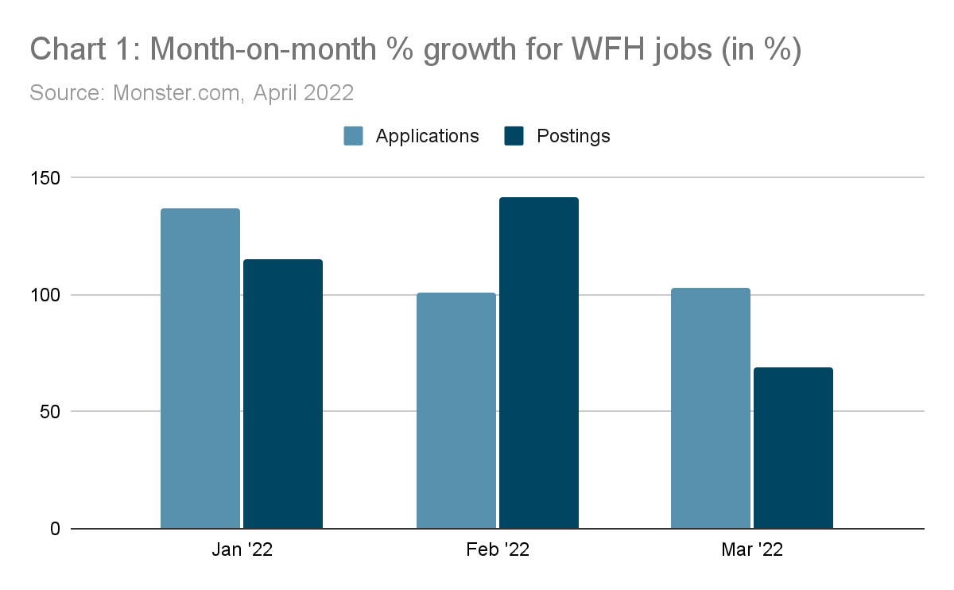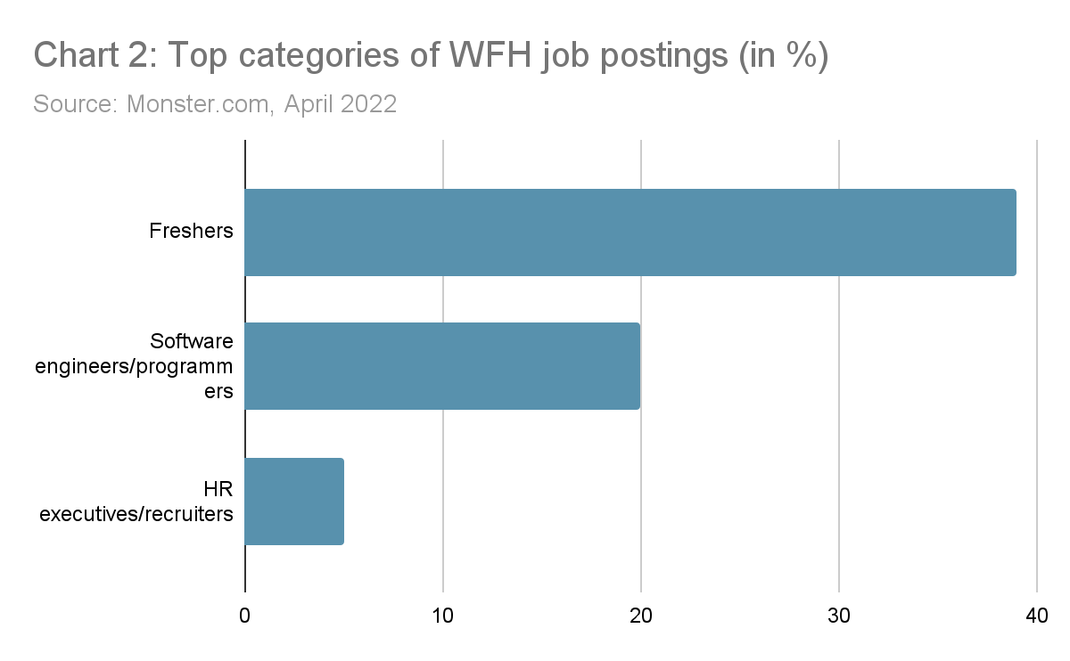

Hyderabad is now getting down to brass tacks, especially for its IT employees. Albeit reluctantly, they are now getting ready to switch back to the work-from-office (WFO) culture. Over 40 percent of the six lakh employees working in over 1,900 IT and ITES companies here, who had earlier moved out to different places in the country, are slowly returning to the Telangana capital as the severity of the pandemic is almost on the wane. Leading IT firms, including HCL Tech, Infosys, Wipro, TCS, and several others have either asked or are getting ready to ask their employees to bid adieu to WFH for now and get back to their office sooner than later.
VIII.A WFH: Important features
It is evidenced from this study that remote working has clear benefits, but no situation is guaranteed to be perfect. Understanding the reasons why WFH may go a long way in learning how to perform WFH successfully. The features are,
i) Flexible working hours: One has the liberty to choose his/her working hours and can speak with the manager to fix a working hour that may suit. Often a person may have chores to finish since s/he is a part of the family and may have certain duties that need to be done. So it’s always better to keep flexible working hours; ii) No physical separation between work and leisure time: When the workplace is one's home; and home is the workplace, then the mental separation between the personal space and the workspace is not there anymore. This could take a toll on one’s mental well-being and the idea of unwinding in familiar spaces which may not be familiar anymore; iii) No commuting: One saves up on fuel or travel because s/he has the comfort of their place to work out from. Working from home does help save money and expenses that aren’t needed anymore; iv) More time with family: Spending time at home means spending even more time with one’s family. Complaints of not spending enough quality time with the family get nullified; v) Less human interaction: A person may have family around him/her, but still, need peers and friends to socialize. For that one needs a separate group of friends to cope with the stress that may be happening at home; vi) Healthier lifestyle: Various studies confirm that remote workers usually eat healthier food when WFH because of having self-access to one’s chosen food selection and the luxury of flexible time. When people have the time and space; giving food preferences a thought is what is next; vii) Hard to switch off: A remote worker sleeps at home, and works there too. Because of this, it becomes hard to separate private life and business life. One’s whole life revolves around work and it becomes a little difficult to turn off and detox which would have been done under normal circumstances.
IX. Discussions
The study entails examining the effects of lifestyles, homes, and other occupational factors on the physical and mental health of individuals who had opted for WFH, either at will or forced, due to the COVID-19 pandemic safety compulsions. The data, collected during the research, indicate minimized physical and mental activities which have correlated effects that directly impact both gender and income level.
Female workers including other workers with an annual income of less than three lac were reportedly found to have more physical and mental issues than the male workers and workers with higher income[] . Further, a recent survey noted that working mothers while pursuing WFH usually carry huge depression at home due to a lack of support with homeschooling and caring for underage children. In the same vein, lower-income group individuals often find a lack of job security that increases tensions manifesting in physical and mental health issues.
In WFH, even though one shies away from physical activities, continuing moderate exercise such as walking, taking intermittent short breaks, playing with children etc., should benefit health. It is reported that decreased physical and mental activities increased food intake manifold, especially junk food, contributing in weight gain, fatigue and digestive malfunctioning[] .
Though this study throws insights into important factors in supporting the physical and mental health of WFH workers, yet multiple limitations need be acknowledged in the interpretation and use of findings. It is important to note that these data were obtained during the days of the heightened COVID-19 pandemic time; therefore, the findings are not meant to represent those of traditional WFH situation and may not replicate the health status or experiences once the restrictions and WFH became increasingly routine[].
X. Recommendations
In the absence of legally binding legislative guidelines in vogue in the country, the recommendations include a series of possible actions that could be initiated by the administrative authority to make WFH more attractive and feasible.
1. For accomplishments in the short run, the Government should initiate: i) Formulating regulations for a robust WFH guideline for both employers and employees; ii) COVID-19 risk assessment results are to considered while developing the guidelines; iii) Providing sector wise adequate measures ; iv) Guidelines must safeguard stakeholders genuine expectations; v) Specifying criterias for technology training and back up for virtual offices.
2. For the long run, the Government should consider: i) Reassessing the possibility of remote working becoming the new normal; ii) To review the current labor legislation status to ensure that the labor insurance policies are extended to WFH; iii) Encouraging MSME sector to also adopt WFH measures by providing subsidy and other incentives; iv) Strengthening the ongoing WFH practices at par to the rest of the world, and; v) Promoting family-friendly employment cultures and practices.
XI. Conclusions

As is revealed by the study through its preceding paragraphs, it makes a pertinent point that the most sought-after ‘distress-time’ rescuing option, WFH, could not stand apart as the panacea for the vulnerable workforce. Appropriate policies and guidelines are needed from the enforcing and maintaining authority to be in place for proper regulations and making WFH really attractive and feasible. Proper policy planning and implementation are of absolute necessity in adapting works remotely. During the COVID19 pandemic scare, the decision to suspend in-person meetings and work was implemented swiftly, but without sufficient guidance to carry on flawlessly. Workers were vastly left unaware of what WFH meant to them and the lack of adequate resources required for enforcing the change, like availability of software, access to official documents and adequate working space, etc. were found wanting. Proper skilling is required if the practice needs to be a feasible option as the new normal.
Pandemic had cast devastating effects on lives, more so on the poorer chunk of the society, and depending upon its severity clamping lockdown was inevitable. Many people were starving and became jobless and in such a situation, WFH/WFA was a good option that brought much-needed relief to those hapless bandwagons. The concept of WFH has evolved before the pandemic though, during the days of turmoil, amidst this critical scenario, people across the nations were more inclined to embrace WFH rather than commuting for a 10-5 job under risk. The credit for success, however, goes to advanced software technologies like Slack, Skype, Google Hangouts, and Zoom- and not to forget email and texting.
Under the safe canopy of WFH, it is not essential these days to regularly visit the office to become an effective workman. Every important work can be performed effectively from one’s home office. It would continue to be a very powerful instrument if employers too did acknowledge the benefits accrued from the arrangement. Companies that push the WFH facility, may enhance employee productivity, lower organizational expenses, and can reduce turnover. As a saving grace, the inevitable experience gained from the COVID-19 disaster that forced a major quantum of a vast global workforce into embracing WFH/WFA, ultimately helped both employers and employees to survive.

Reference
World Health Organisation 2020, “Public Health Emergency of International Concern (PHEIC) Global Research and Innovation Forum.” Accessed 12 Feb 2021.
Cross C, “ Working and learning from home during the COVID-19 outbreak; 2020. Available At: https://www.healthychildren.org/English/health-issues/conditions/COVID-19/Pages/Working-and-Learning-from-Home-COVID-19.aspx. Accessed September 10, 2021.
Collins, J. H., and J. J. Moschler. 2009. “The benefits and limitations of telecommuting.” Defense AR Journal 16 (1): 55–66.
Bartik A, Cullen Z, Glaeser EL, Luca M, Stanton C. “What jobs are being done at home during the COVID-19 crisis? Evidence from firm-level surveys”. NBER Working Paper [No w27422] 2020; Available at SSRN: https://ssrn.com/abstract=3637723. Accessed November 25, 2021.
Evanoff BA, Strickland JR, Dale AM, “Work-related and personal factors associated with mental well-being during COVID-19 response: a survey of healthcare and other workers” (preprint). J Med Internet Res 2021; 22:e21366.
Abdulaali HS, “Impact of poor indoor environmental quality (IEQ) to inhabitants’ health, well-being, and satisfaction”. Int J Adv Sci Technol 2020; 29:1284–1296.
Bouziri H, Smith DRM, Descatha A, Dab W, Jean K. “Working from home in the time of COVID-19: how to best preserve occupational health”? Occup Environ Med 2020; 77:509–510.
Vander Elst T, Verhoogen R, Sercu M, Van den Broeck A, Baillien E, Godderis L. “Not extent of telecommuting, but job characteristics as proximal predictors of work-related well-being”. J Occup Environ Med 2017; 59:e180–e186.
Namrata.Singh @timesgroup.com Times of India, “IT hub Hyderabad’s response to pandemic through WFH”, Times Business, Pune Edition, Page 10, April 18, 2022,
Messenger J, “Working anytime, anywhere: the effects on the world of work”. Eurofound and the International Labour Office (2017). 2017. Available at: http://eurofound.link/ef1658. Accessed November 25, 2021.
Baker, E, G. C. Avery, and J. Crawford. 2007. “Satisfaction and perceived productivity when professionals work from home.” Research & Practice in Human Resource Management 15 (1): 37–62.
Kim J, de Dear R. “Workspace satisfaction: the privacy-communication trade-off in open-plan offices”. J Environ Psychol 2013; 36:18–26.
Moretti A, Menna F, Aulicino M, Paoletta M, Liguori S, Iolascon G. “Characterization of home working population during a covid-19 emergency: a cross-sectional analysis”. Int J Environ Res Public Health 2020; 17:1–13.
Bloom, N., J. Liang, J. Roberts, and Z. J. Ying. 2021. “Does Working from Home Work? Evidence from a Chinese Experiment.” The Quarterly Journal of Economics 130 (1): 165–218. doi:10.1093/are/qju032.
Arntz M, Ben S, Francesco Y. “Working from home and COVID-19: The chances and risks for gender gaps” ZEW expert brief 2020; Available at: https://www.zew.de/PU82032-1. Accessed October 20, 2021.
Kaur T, Sharma P. “A study on working women and work from home amid a coronavirus pandemic”. J Xi’an Univ Archit Technol 2020; XII:1400–1408.
Wilson JM, Lee J, Fitzgerald HN, Oosterhoff B, Sevi B, Shook NJ. “Job insecurity and financial concern during the COVID-19 pandemic is associated with worse mental health”. J Occup Environ Med 2020; 62:686–691.

Kim J, de Dear R. “Workspace satisfaction: the privacy-communication trade-off in open-plan offices”. J Environ Psychol 2013; 36:18–26.
Moretti A, Menna F, Aulicino M, Paoletta M, Liguori S, Iolascon G. “Characterization of home working for the population during covid-19 emergency: a cross-sectional analysis”. Int J Environ Res Public Health 2020; 17:1–13.
Bloom, N., J. Liang, J. Roberts, and Z. J. Ying. 2021. “Does Working from Home Work? Evidence from a Chinese Experiment.” The Quarterly Journal of Economics 130 (1): 165–218. doi:10.1093/qje/qju032.
Bartik A, Cullen Z, Glaeser EL, Luca M, Stanton C. “What jobs are being done at home during the COVID-19 crisis? Evidence from firm-level surveys”. NBER Working Paper [No w27422] 2020; Available at SSRN: https://ssrn.com/abstract=3637723. Accessed November 25, 2021.
Evanoff BA, Strickland JR, Dale AM, et al. “Work-related and personal factors associated with mental well-being during COVID-19 response: a survey of healthcare and other workers” (preprint). J Med Internet Res 2021; 22:e21366.
Vander Elst T, Verhoogen R, Sercu M, Van den Broeck A, Baillien E, Godderis L. “Not extent of telecommuting, but job characteristics as proximal predictors of work-related well-being”. J Occup Environ Med 2017; 59:e180–e186.
Bouziri H, Smith DRM, Descatha A, Dab W, Jean K. “Working from home in the time of COVID-19: how to best preserve occupational health”? Occup Environ Med 2020; 77:509–510.
Namrata.Singh @timesgroup.com Times of India, “IT hub Hyderabad’s response to pandemic through WFH”, Times Business, Pune Edition, Page 10, April 18, 2022,
Messenger J, “Working anytime, anywhere: the effects on the world of work”. Eurofound and the International Labour Office (2017). 2017. Available at: http://eurofound.link/ef1658. Accessed November 25, 2021.
Arntz M, Ben S, Francesco Y. “Working from home and COVID-19: The chances and risks for gender gaps” ZEW expert brief 2020; Available at: https://www.zew.de/PU82032-1. Accessed October 20, 2021.
Cross C. “Working and learning from home during the COVID-19 outbreak”; 2020. Available At: https://www.healthychildren.org/English/health-issues/conditions/COVID-19/Pages/Working-and-Learning-from-Home-COVID-19.aspx. Accessed September 10, 2021.
Collins, J. H., and J. J. Moschler. 2009. “The benefits and limitations of telecommuting.” Defense AR Journal 16 (1): 55–66.
Baker, E., G. C. Avery, and J. Crawford. 2007. “Satisfaction and Perceived Productivity When Professionals Work from Home.” Research & Practice in Human Resource Management 15 (1): 37–62.
Abdulaali HS, “Impact of poor indoor environmental quality (IEQ) to inhabitants’ health, well being and satisfaction”. Int J Adv Sci Technol 2020; 29:1284–1296.
World Health Organisation 2020, “Public Health Emergency of International Concern (PHEIC) Global Research and Innovation Forum.” Accessed 12 Feb 2021.
Wilson JM, Lee J, Fitzgerald HN, Oosterhoff B, Sevi B, Shook NJ. “Job insecurity and financial concern during the COVID-19 pandemic are associated with worse mental health”. J Occup Environ Med 2020; 62:686–691.
Kaur T, Sharma P. “A study on working women and work from home amid a coronavirus pandemic”. J Xi’an Univ Archit Technol 2020; XII:1400–1408.

