A REVOLUTIONARY TECHNOLOGY IN PHARMA PROFESSION: 3D PRINTING

R. PRABHU*, A. ABDUL HASSAN SATHALI, P. ELAKKIYA,
S. GOWSIKKUMAR, S. KARTHIKEYAN

Department Of Pharmaceutics,
College Of Pharmacy,
Madurai Medical College,
Madurai-625020 (TN), India

CORRESPONDING AUTHOR*
R. Prabhu, M.Pharm.,
Assistant Professor,
Department Of Pharmaceutics,
College of Pharmacy, Madurai Medical College,
Madurai-625020 (TN)
Mobile No: 09443314062
Email: prabhurajaram2005@gmail.com

A REVOLUTIONARY TECHNOLOGY IN PHARMA PROFESSION: 3D PRINTING
R. PRABHU*, A. ABDUL HASSAN SATHALI, P. ELAKKIYA, S. GOWSIKKUMAR, S. KARTHIKEYAN
DEPARTMENT OF PHARMACEUTICS, COLLEGE OF PHARMACY, MADURAI MEDICAL COLLEGE, MADURAI-625020 (TN), INDIA
CORRESPONDING AUTHOR* R. Prabhu, M.Pharm., Assistant Professor, Department Of Pharmaceutics, College of Pharmacy, Madurai Medical College, Madurai-625020 (TN)

1. INTRODUCTION
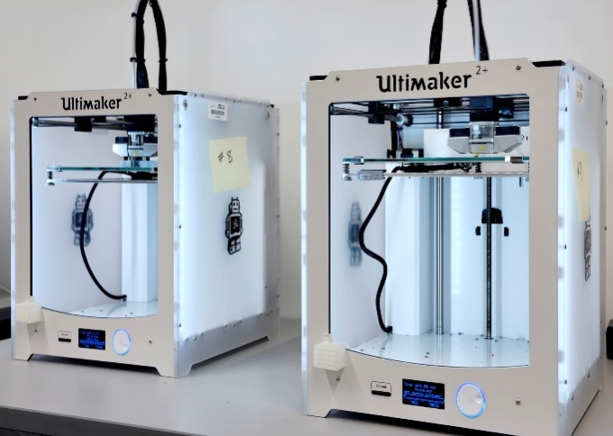
3D printing (3DP) is a versatile process used to fabricate three-dimensional objects by depositing layers of materials successively and thus forming different shapes with varied sizes. 3D printing is also known as additive manufacturing (AM) and solid freeform technology. AM was discovered by Charles Hull in 1984. It can be done efficiently by a computer model using computer-aided design (CAD)¹. The CAD software is used to feed the data and the instructions required for printing to commence. These instructions direct the printer nozzle to stack the ink with the intended materials layer by layer. At present, there are certain technologies used for 3D printing of drugs that include binder jetting, vat polymerization, powder bed fusion, material jetting, and material extrusion. 3DP advances the production of drugs with certain release characteristics and geometrics. 3D printing has been depicted as a game-changing technology, and it is being used in various fields, including the military, aviation, and medicine. In medicine, it is primarily used for the production of the moulds that can produce pills, and with great precision, 3DP is being used to print the actual drugs. 3DP has certain advantages like formulation optimization and production of personalized drugs (chewable tablets with required flavours have been printed for age groups of paediatrics and geriatrics). In the year 2015, the Food and Drug Administration (FDA) approved a drug named Spritam® (levetiracetam), the world’s first 3D printed drug commercially available on the market. It is a prescription medicine taken by mouth that is used to treat partial-onset seizures in people 4 years of age and older². Filament Deposition Modeling (FDM), 3DP technology has been utilized for the fabrication of 10 different printlets (the names for novel 3D printed formulations), stating the fact that researchers can print chewable isoleucine printlets for the treatment of patients with maple syrup urine disease and has been met with competent ability³. Considerable progress has been made in the last decade with translating the theoretical knowledge to actual working applications and aiming to advance 3DP as an authentic pharmaceutical production process. Compared to conventional methods of drug manufacturing, 3D printing has various advantages in the production of accurate micro-controlling of drug doses, fast forming, and also a stable operation with precision. Customary pharmaceutical manufacturing processes are confined to the case of drugs, which encapsulates the size, release type, and other specifications. It is advantageous to the combination of multiple drugs into a single drug (Polypill). With new developments in fields like cell biology, regenerative medicine, and bionic medicine, the 3DP technology will be efficient in these biomedical fields for regenerative therapy⁴, this method is described as 3D Bio-Printing. Bionic bones and cochlear implants have already been printed and are in the market for a while. With more knowledge and technical developments organs can also be printed using the 3DP techniques.

Fig.1: 3D Printer

Timeline of 3d printing
Fig. 8: Material Jetting Apparatus
BIOPRINTING
PHARMACEUTICAL TECHNOLOGY
YEAR 1984
CHARLES HULL CREDITED FOR THE FIRST 3D PRINTER. CHARLES PIONEERED IN SOLID IMAGE PROCESSING KNOWN AS STEREOLITHOGRAPHY (STL)

YEAR 1990
APPLICATION IN CLINICAL LEVEL TISSUE REGENERATION
- SELECTIVE LASER
SINTERING PATENT
- FUSED DEPOSITION MODEL (FDM)

THREE-DIMENSIONAL PRINTING
YEAR 2000
- PERSONALIZED MEDICINE
- LARGE-SCALE MANUFACTURING
- AVAILABILITY OF PRINTABLE APIs AND EXCIPIENTS
- FULLY FUNCTIONING 3D PRINTED ORGANS

YEAR 2012 - 2015
YEAR 2020
- FDM PRINTED TABLETS
- BILAYER TABLETS AND MULTI-DRUG DELIVERY

FUTURE ASPECTS
ExVIVE LIVER COMMERCIALLY AVAILABLE 3D HUMAN LIVER TISSUE
FABRx LAUNCHED M3DIMAKER 3D PRINTER FOR PERSONALISED MEDICINE
IN-SITU BIOPRINTING REALISED ON ANIMALS
FIRST 3D PRINTED BLADDER
ANNOUNCEMENT OF WORK ON A FULLY BIOPRINTED KIDNEY
IMPLANTATION OF 3D-PRINTED JAW
BIOPRINTING ARTIFICIAL LIVER BY EXTRUSION BASED METHOD
SPRITAM® BECOMES THE FIRST FDA-APPROVED 3D PRINTED DRUG TO HIT THE MARKET. MANUFACTURED BY APRECIA PHARMACEUTICALS

FIRST 3D PRINTED MINIATURE FUNCTIONAL KIDNEY
FDA PUBLISHED, “TECHNICAL CONSIDERATIONS FOR ADDITIVE MANUFACTURED MEDICAL DEVICES”, A GUIDANCE FOR INDUSTRY AND FOOD AND DRUG ADMINISTRATION STAFF
YEAR 2016
ALLEVI LAUNCHES THE ALLEVI 2, THE FIRST DESKTOP BIOPRINTER
YEAR 2010

Applications Of 3D Printing in The Pharmaceutical Industry
The major limitation in the conventional methods of drug manufacturing is that the drug product cannot always be dosed, but with the accuracy and flexibility of 3D printing technologies, that limitation is no longer a hindrance. Once there is overall control over the area of accurate dosing and dose flexibility, then it paves the way for the implementation of personalised medicine or personalised therapy. This can also mean that the drug product can be fabricated for a certain age group of patients. Drugs with varied release rates and release mechanisms can also be manufactured through 3DP. Dosage forms such as transdermal patches and microneedle patches have also been developed and are constantly being improved with advancements.

Fig. 2: Representation of The Applications Of 3d Printing in Medical and Pharmaceutical Fields
Apart from dosage forms, the 3DP technology has also been used in the production of medical devices such as leg, arm casts, stents, and models of organs and diseases for academic purposes⁵. The advantageous ability to fabricate a customised implant and a prostheses on demand has solved most persistent problems in many fields, the reason of modifications by the surgeons during the grafting process can be highly reduced when customised models are available. As mentioned previously the 3D printing technology has already been a widely used technique in the manufacturing of 3D printed hearing aids, other models like the Invisalign is also efficiently manufactured using the 3D printing methods. Currently the Oxford Performance Medicals have received the approval from the FDA for a 3D printed Polyetherketoneketone (PEKK) skull implant. A supplementary method of 3D printing, when living cells and tissues are utilised instead of the drug materials is known as 3D Bioprinting. The bioprinted invitro models are made to use in the processes of drug testing and toxicity studies of drugs, irrespective of the above-mentioned applications, the major application of the process of bioprinting is the development of the fully functioning organs. The current treatment for an organ failure is the organ transplant, however the necessary organs are not always readily available, this causes the patients to wait for their turn to receive the organ until a matching donor is assigned, the follow up transplant surgery is also expensive. Considering these limitations, the 3D bioprinting is in development stages. The research and the organs printed so far are the miniature versions have a comparatively simpler working and those working can vary from the actual organ. Various medical devices and materials are built using 3D printing techniques with required porosity and physical characteristics.

2. DIFFERENT 3D PRINTING TECHNOLOGIES USED IN THE PHARMACEUTICAL INDUSTRY:
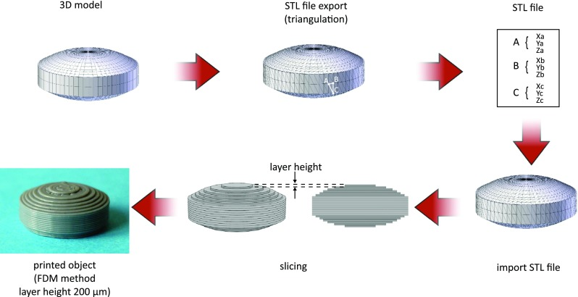
Since the late 1980s, numerous 3D printing technologies have been developed, and highly capable printers have also been invented and incorporated into the development of theoretical knowledge. The American Society of Testing Materials (ASTM) categories the seven major additive manufacturing technologies as binder jetting, directed energy deposition, VAT polymerization, powder bed fusion, material extrusion, directed energy deposition, and sheet lamination⁶, out of which only a handful can be utilised in the field of pharmaceutics for the manufacturing of drugs, which includes Vat Polymerization, Binder Jetting, Material Extrusion, Powder Bed Fusion, and Material Jetting. All the technologies follow the basic principles of modelling, printing, and finishing. Before printing a 3DP model, an STL (Standard Tessellation Language or Standard Triangle Language) file is created for the required product. The file must be processed by software known as a "slicer." The Slicer (or) the slicing software, which is used to convert the 3D -object model to a set of specific instructions for the 3D Printer, translates the 3D model into a file known as the G-Code file format. The G-Code is a widely used computer numerical control (CNC). It is a programming language used in processes following computer-aided manufacturing. The G-Code instructs the printer on how to layer the material according to the original 3DP object model.

Fig.3: Steps followed by a slicer software

ADDITIVE MANUFACTURING TECHNOLOGIES:
- Vat Polymerization
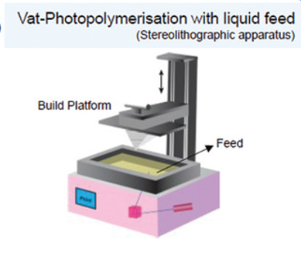
The above-mentioned types of AM technologies vary from each other in the application process or the principles involved in printing. The oldest of them all is the method of VAT polymerization. Photopolymerization is classified with regard to the method of curing, which encompasses lasers (SLA), digital projection (digital light processing (DLP), light-emitting diodes (LEDs), and continuous liquid interface production (CLIP). The photopolymerization process involves a photopolymer that with the use of UV (or) visible illumination can excite a photo-initiator and that indeed can kick start polymerization. VAT polymerization is currently being incorporated into the production of multidrug-containing polypills⁷. VAT polymerization uses a laser for solidification where the light causes chains of the present molecule to link to each other, which indeed solidifies the drug material. This solidification is followed layer by layer until the intended solid structure is formed⁸. The major challenge for VAT polymerization is the selection of resins and the possible toxicity that may increase due to the reactions.

Fig. 4: Vat-Polymerization with liquid feed

B) Binder Jetting
The world’s first FDA-approved 3D printed drug, Spritam®, was fabricated using the method of binder jetting. The method includes a binding solution that is selectively deposited using the printer nozzle over a powder bed. This binder solution further solidifies the powder bed layer. In other words, the solution is deposited to join the particles in the powder bed. The Binder jetting method is intended for the production of drugs with high porosity. The drugs produced can have quick dissolving properties⁸. For instance, Spritam has a dissolving time of 11 seconds in saliva.
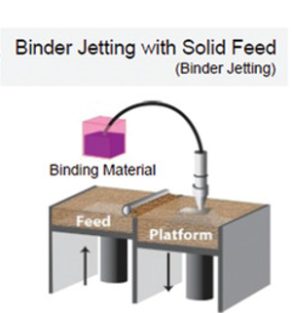

Fig. 5: Binder Jetting

- Material Extrusion
Fused Deposition Modeling (FDM)
FDM is a prime example of material extrusion. This is an AM process including the deposition of successive layers of soft molten materials in a determined pattern to obtain an intended shape8. This method can be used for drugs with geometric specifications that are not possible with conventional powder compaction. FDM can be used to modify the drug release design and can allow one to obtain a controlled release in a drug product. The main limitation of FDM is that the method requires high printing temperatures, and those temperatures can include a change for possible drug degradation.

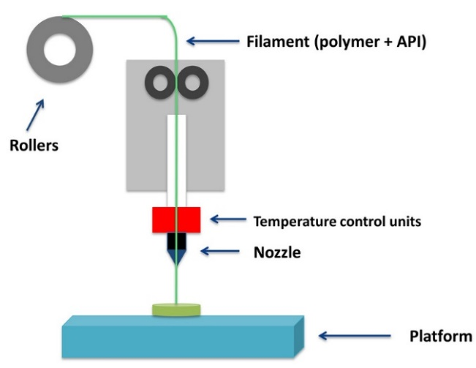

Fig.6: Fused Deposition Modelling

Direct Powder Extrusion (DPE)
This is another type of extrusion method that directly prints using the hot melt extruder inside the nozzle of the printhead. A very crucial advantage of DPE is that the requirement for the excipients and the printing materials is fairly lower than the other methods.

- Power bed fusion
This method utilizes a laser to obtain the required patterns on the powder bed surface. Selective laser sintering (SLS), multi-jet fusion, direct metal laser sintering or selective laser melting, and electron beam melting are all incorporated into the technologies in the powder bed fusion method. SLS is the primary technique employed in the fabrication of medicines and medical devices8. In earlier times, high localized temperatures were required to sinter the powder materials which in need can cause drug degradation, hence this method is only instituted for the production of medical devices. In 2010, it has been reported that the manufacturing of tablets, incorporating SLS, excluded and overcame the degradation by the use of an alternative diode laser⁹.
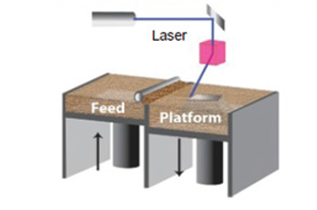

Fig.7: Powder Bed Fusion

- Material Jetting
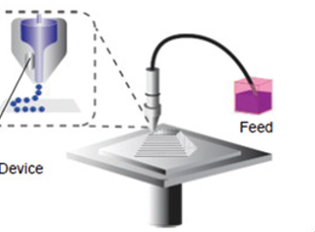
On a whole, this technique involves the process of depositing liquid droplets of materials onto the powder surface. often under UV¹⁰, this technique includes drop-on-demand and nanoparticle jetting, this technology is heavily employed in the production of oral films.

Fig.8: Material jetting

3. MANAGEMENT OF DISEASES USING 3D PRINTED DRUGS:
The treatment of chronic diseases is considered a significant burden since long-term treatment and therapy are required. The treatment regimen can be influenced by both patient compliance and medication adherence. For effective therapeutic effect, any variation in the abovementioned factors should be effectively changed, which includes change in dose or change in drug used. The 3D printed approach for chronic disease treatment has effective advantages, including a reduction in dosing errors and regular treatment monitoring¹¹.The 3D printed approaches include drugs fabricated by additive manufacturing and polypills.
 |  |  | STATISTICS
DISEASE |  | DIAGRAM | PREVALENCE OF THE DISEASE IN THE UNITED STATES | PREVALENCE PERCENTAGE IN THE UNITED STATES | ASSOCIATED COST OF TREATMENT IN THE UNITED STATES
OSTEOARTHRITIS | 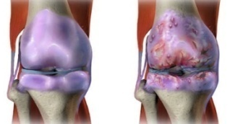 |  | 54.4 MILLION | 16% | 185.5 BILLION USD
DIABETES MELLITUS | 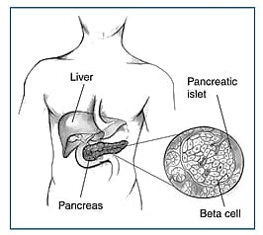 |  | 34.2 MILLION | 10.5% | 49.4 BILLION USD
CHRONIC OBSTRUCTIVE PULMONARY DISEASES (COPD) | 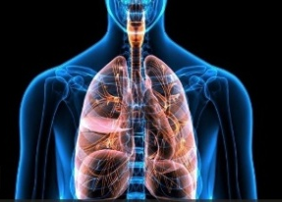 |  | 24 MILLION | 9% | 49 BILLION USD
CARDIO VASCULAR DISEASE (CVD) | 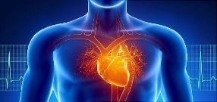 |  | 18.2 MILLION | 9.3% | 219 BILLION USD
CANCER | 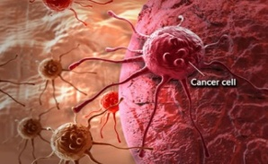 |  | 16.9 MILLION | 5.5 % | 208.9 BILLION USD
EPILEPSY |  |  | 3.4 MILLION | 1.2% | 28 BILLION USD

Table 1: Statistics of Chronic Diseases Prevalent in the USA
3.1 EPILEPSY:
A central nervous system (neurological) disorder in which brain activity becomes abnormal, causing seizures or periods of unusual behaviour, sensations, and sometimes loss of awareness.
Epilepsy is defined as a chronic disease of the brain characterised by a persistent tendency to cause unprovoked seizures. About 50 million individuals are affected worldwide. Irrespective of their age or gender, epilepsy can potentially affect people across the globe. However, nearly 80% of those affected live in low- and middle-income countries (LMIC)¹¹. It is found to be slightly more prevalent in males, having a higher incidence rate in males as compared to females, especially in the elderly.
The pathophysiology of epilepsy:
- A Stroke, Brain tumors, Severe head injury, drug abuse or alcohol misuse, Brain infection,or lack of oxygen during birth.
Types of epilepsy:
- Generalized epilepsy
- Focal epilepsy
- Generalized and focal epilepsy
- Unknown if generalized or focal epilepsy.
The first 3D printed tablet was:
SPRITAM:
Aprecia Pharmaceuticals' Spritam (levetiracetam), an anti-epileptic drug, is the first and only 3D-printed pharmaceutical¹². It received Food and Drug Administration (FDA) approval in 2015 and is made using Aprecia’s proprietary Zip-Dose technology¹³.
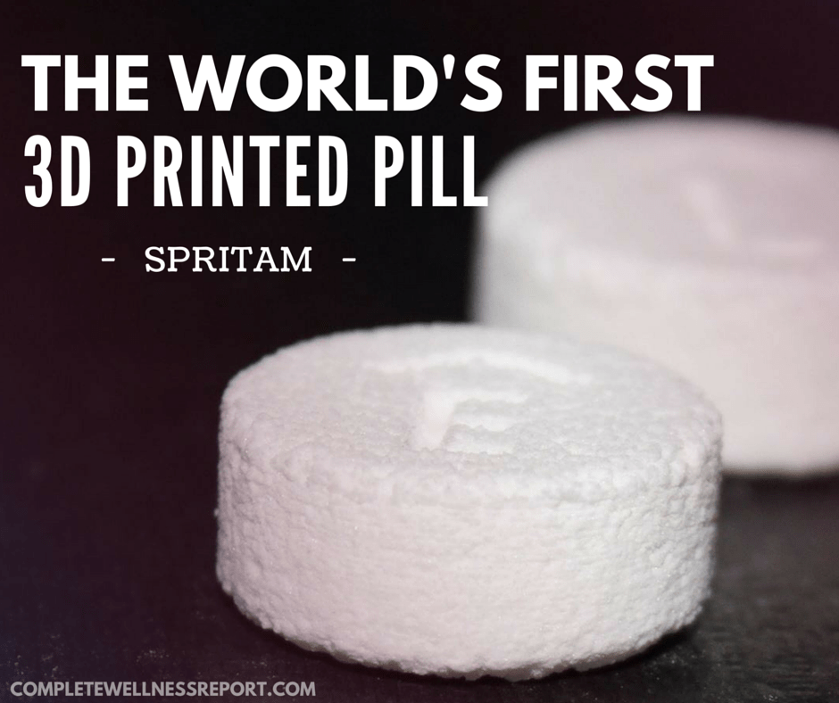
Fig 9: Schematic representation of the first 3D printed pill – SPRITAM
Innovative Colour Jet 3D Printing of Levetiracetam-Paediatric Preparationsfor the Treatment of Epilepsy:
3D printing is a promising technology used in the production of complex oral dosage delivery pharmaceuticals. This study first reports an innovative colour jet 3D printing (CJ-3DP) technology to produce colourfulcartoon levetiracetam paediatric preparations with high accuracy and reproducibility and which proves the potential of personalised administration.
The irregular surface indicated that the CJ-3DP tablets looked significantly better than the first 3D printed drug listed (Spritam®)¹⁴.
3D printing (three-dimensional printing) technology is a promising approach to manufacturing personalised products. 3D printing has other names such as "rapid prototyping", "solid free form fabrication", and "additive manufacturing".
The 3D printing techniques utilised in the pharmaceutical field are:
- Binder Jet 3D printing (BJ-3DP): This technology, also known as Drop-on-Powder (DoP), was applied to develop this formulation.
- Stereolithography (SLA): The process of building the layered 3D structures by solidifying a thin layer of the liquid resin on the movable platform and curing the polymer with an ultraviolet laser beam across the liquid surface at a defined depth is known as the SLA process.
- Fused Deposition Modelling (FDM): In the pharmaceutical field, FDM is the most extensively investigated 3D printing technique.

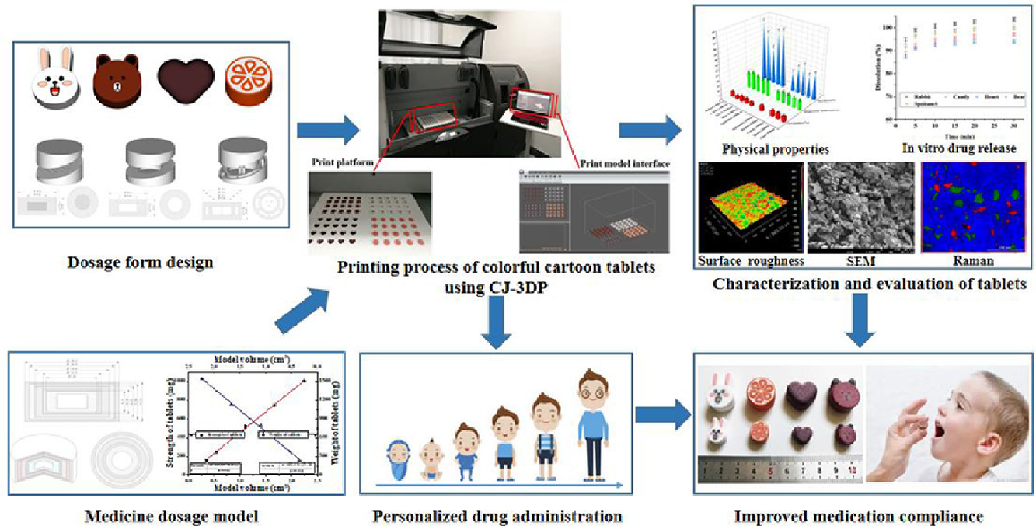

Fig 10: Schematic representation Processof 3D printed tablet

The preparation of colourful cartoon levetiracetam paediatric tablets can be realised by using CJ-3DP. Through the methodology of formulation and tablet structure, the 3D printed tablets had an admirable appearance and a lower surface roughness, all of which were notably improved compared with the properties of Spritam.
3.2 CARDIOVASCULAR DISEASE:
In 2003, Wald and Law presented the idea of a hypothetical polypill intended to reduce the risk of cardiovascular disease (CVD) and stroke by at least 80% while maintaining a relatively safe profile¹⁵. This multi-component combination tablet would be administered to patients older than 55 years regardless of the presence of risk factors for cardiovascular diseases.
Adverse effects:
- Gastric, Cough, Dizziness, Hypotension,Myopathy.
Types of Cardiovascular diseases:
- Coronary artery disease
- Cardiac arrest
- Congestive Heart Failure
- Arrhythmia
- Peripheral artery disease
- Stroke
- Congenital Heart disease
Polypills for Cardiovascular diseases:
Recent Clinical Studies:
In 2009, the first Phase 2 double-blind, randomised trial involving a polypill formulation was published. TIPS are designed to determine the effectiveness, acceptability, and safety of once-daily Polycap (simvastatin 20 mg, aspirin 100 mg, hydrochlorothiazide 12.5 mg, atenolol 50 mg, ramipril 5 mg). A total of 2053 patients from different centres in India were randomly assigned to 1 of 9 treatment groups, which included the Polycap and the individual components in various combinations¹⁵. In this non-inferiority study, the primary outcomes were reductions in LDL-C, blood pressure, heart rate, and urinary 11-dehydrothromboxane B2, as well as discontinuation rates. Patients aged 45–80 years with 1 risk factor for cardiovascular diseases but without cardiovascular diseases were included. The trial was scheduled for 12 weeks.

Influence on Clinical Practice:
Studies of the polypill in low-risk patients have not shown the same benefit as originally predicted by Wald and Law, while studies in higher-risk patients have demonstrated greater benefit in reducing blood pressure and LDL-C¹⁵, risk factors correlated with CVD and stroke. The schematic representation of polypills for cardiovascular disease^{16.}
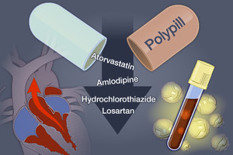

Fig 11: Schematic representation of Polypill
3.3. DIABETES MELLITUS:
Diabetes mellitus is considered one of the most common chronic metabolic disorders characterised by lower blood sugar levels in the body.
- Type 1 Diabetes Mellitus (T1DM) results from the autoimmune destruction of β-cellsof the endocrine pancreas.
- Type 2 Diabetes Mellitus (T2DM) is characterised by peripheral insulin resistance, impaired regulation of hepatic glucose production, and declining β-cell function, eventually leading to β-cell failure.
Causes of Diabetes Mellitus:
- Obesity and Weight gain
- Smoking
- Increase in alcohol intake
- Disorders of nervous and endocrine system
- Increase in cortisol
- Lowered energy consumption due to lack of exercise
- Genetic factors such as ageing can cause diabetes mellitus.
Types of Diabetes Mellitus:
- Type 1 Diabetes
- Type 2 Diabetes
- Gestational Diabetes
- Maturity onset Diabetes of the young (MODY)
- Neonatal Diabetes
- Wolfram Syndrome
- Alstrom Syndrome
- Latent Autoimmune Diabetes in Adults (LADA)
In recent years, 3D printed polypills have been manufactured to encapsulate 2 or 3 pharmaceutical actives in 1 pill, thereby reducing HBA1c levels with a decrease in the dosing frequency. Triple oral therapy is a treatment regimen that recruits a drug that is combined with a combination of two unsuccessful drugs in a polypill that initiates a decrease in the glycemic index and HbA1c%, as reported by the Tried-I study. A combination pill containing glimepiride, metformin, and pioglitazone (GMP) was administered along with a combination of slow-release metformin and 70/30 human insulin both twice daily (BD), which allows for the easy reduction of HBA1c levels in type 2 diabetic patients.
In addition, fused deposition modelling (FDM) with hot-melt extrusion (HME) technology was used to fabricate glipizide-containing 3D printed controlled-release tablets using polyvinyl alcohol (PVA) as an additive.
Furthermore, Fourier-transform infrared spectroscopy (FTIR) of glipizide-loaded polyvinylidene (PVA) showed peaks that indicated an intact molecular structure of glipizide throughout. As well, FDM was also employed for the fabrication of a bilayer dosage form containing metformin and glimepiride,ingrained in the Eudragit RL sustained-release layer and the polyvinyl alcohol (PVA) layer.
Moreover, multi-active tablets containing three different drugs with well-defined and separate controlled release profiles were fabricated by 3D extrusion-based printing techniques. The drugs incorporated into the tablet included captopril, nifedipine, and glipizide, and HPMC was used as an additive. This combination tablet acted as an antidiabetic and an antihypertensive agent.
Polypill for Diabetes mellitus:
The bilayer oral solid dosage form combines metformin for prolonged and glimepiride for immediate drug delivery:
Fused Deposition Modelling (FDM) (3D printing) has been previously employed in the development of personalised medicines with unique properties and release behaviour. In the present work, a bilayer dosage form containing two anti-diabetic drugs with different daily dosage regimens, i.e., metformin and glimepirid, was fabricated via FDM 3D printing, studied using a variety of techniques, and characterised in vitro. Metformin and glimepiride were ingrained in the Eudragit® RL sustained release layer and polyvinyl alcohol (PVA) layer, respectively. Incorporation of more than one active pharmaceutical ingredient into the formulation is desirable, as it increases patient compliance and reduces the cost of treatment, especially when distinct dosages of APIs can be adjusted individually in order to meet each patient's specific needs, a capability provided by 3D printing. Several different preparation methods, which involved different plasticizers and extruders, were tested for manufacturing Eudragit® RL¹⁷ drug-loaded filaments for printing the sustained release layer. The properties of the produced filaments were assessed employing mechanical and physicochemical characterization techniques, and the filaments with the optimum properties were used for printing.
Upper immediate release layer containing glimepiride
Previous research has shown that 3D printing frequently produces structures that are not completely solid but do contain small internal voids and pores. Mass (m) was expressed as a function of only one dimension (height-h) of the 3D printed formulation (keeping other dimensions constant) and a linear equation between these two parameters was established by printing and weighting dosage forms with different heights.
It was based on printing and weighting five single-layer dosage forms with different heights.
Considering that the filament contains 2% w/w glimepiride, the desired filament mass should be adjusted to mg = 100 mg. Glimepiride-loaded PVA filament¹⁷ was found to contain 89.49% of the theoretically incorporated glimepiride. Therefore, the theoretical value of 2 mg of glimepiride could be achieved with an upper PVA layer weighting of 111.74 mg. Eventually, the desired height for the upper glimepiride-loaded PVA layer is hg = 0.552 mm.
The filament used for the preparationglimepirideride – loaded PVA filament: MowiolR 4-88 (PVA) and mannitol are chosen based on their properties.
Lower metformin-loaded sustained release layer.:
In this case, two different filaments were utilized, one derived from the twin screw and the other from the single-screw extruder.Considering that the filament contains 50% w/w metformin, the desired filament mass should be adjusted to mm = 1000 mg. Metformin-loaded filament¹⁷ was found to contain 99.53% of the theoretically incorporated metformin, corresponding to an upper PVA layer of 1004.72 mg. The desired height for the lower metformin-loaded Eudragit® layer is hmT = 5.54 mm and HMS = 5.18 mm.The filament used for the preparation of metformin-loaded Eudragit^{R} filament includes: Metformin, Eudragit^{R}RL PO, PLA (Resomer), PLA filament (granulated), TEC, CA monohydratede, PEG 400.

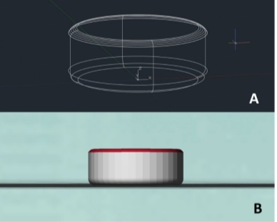
A. AutoCAD draw of 3D printed dosage form,
B. Stereolithography model of 3D printed dosage form

Fig 12: Schematic representation of 3D printed dosage form – Diabetes Mellitus
3.4 TUBERCULOSIS (TB):
Tuberculosis is a bacterial infection which targets and infects the lungs. The pathophysiology of Mycobacterium tuberculosis infections is known as tuberculosis.
The Causes of Tuberculosis:
Poverty, HIV infections, homelessness, substance abuse, and taking medications that weaken the immune system. Diabetes and kidney disease, as well as organ transplants.
Types of Tuberculosis:
Tuberculosis is classified into two types¹⁸.
- Latent Tuberculosis: In this case, you have a TB infection, but the bacteria in your body are inactive and cause no symptoms. It is also called inactive TB or TB infection.
- Active TB: This condition makes you sick and, in most cases, can spread to others. It is also called TB disease.
The design and production of an oral dual-compartmental dosage unit (dcDU) were examined in vitro and in vivo with the purpose of physically isolating and modulating the release profile of an anti-tuberculosis drug combination. Rifampicin (RIF) and isoniazid (ISO) are first-line combination drugs for the treatment of tuberculosis (TB) that negatively interact with each other upon simultaneous release in an acidic environment. The dcDUs were designed in silico by computer-aided design (CAD) and produced in two steps: first three-dimensional (3D) printing of the outer structure, followed by hot-melt extrusion (HME) of the drug-containing filaments. The structure of the manufactured dcDUs was visualised by scanning electron microscopy (SEM). The 3D printed compartmentalised shells were loaded with filaments containing active pharmaceutical ingredients (API) and selectively sealed to modulate drug dissolution. The drug release profile of the dcDUs was characterised by pH-transfer dissolution in vitro and pharmacokinetics studies in rat, and resulted in the modified release of the APIs from the dcDUs as compared to the free filaments. Additionally, the selective physical sealing of the compartments resulted in affective retardation of the in vitro API release. These findings support the development of controllable-by-design dcDU systems for combination therapies to enable efficient therapeutic translation of oral dosage forms. The procedure for fabrication of bi-layer tablets and 3D printed isoniazid caplet^{19.}
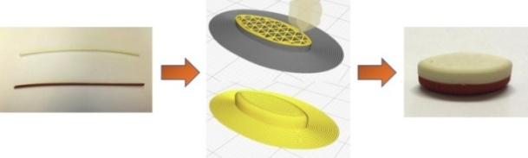
Fig 13: Procedure for fabrication of bi-layer tablet
a. Hot melt extruded isoniazid filament (top) and rifampicin 3Dprinting filaments (bottom)
b. Design and Slicing of the bi-layer tablet
c. 3D printed bi-layer tablet by Fused deposition modelling

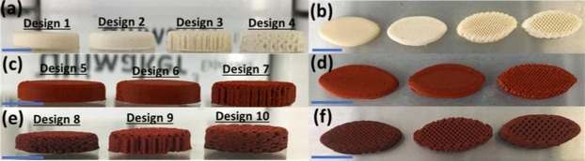
- Side view
- Top view 3D printed 25% rifampicin loaded caplet
- Side view
- Top view 3D printed 35% rifampicin loaded caplet
- Side view
- Top view

Fig 14: 3D printed Isoniazid caplet

Polypill for Tuberculosis diseases:
1. Hot-melt extrusion
The API (either ISO or RIF) was physically mixed with PEO at a 70%:30% (w/w) ratio and a batch size of 4 g. The mixtures were extruded using a lab-scale twin screw compounder (DSM, ®XPLORE, The Netherlands) equipped with two co-rotating screws, consisting of conveying elements, and a heated barrel with a 5 mL volume. The API-PEO mixtures were gradually added to the extruder and extruded at 30 rpm using a 1 mm circular die at 80 oC for all three temperature-adjustable zones of the heated barrel. The extrudates were collected and extruded again using the same extrusion settings, except for ISO-PEO extrudates²⁰, where the extrusion speed was set to 10 rpm. This double extrusion was needed to produce long homogeneous high-dosefilaments of 0.7-0.9 mm in diameter that could fit into the apertures of the designed dosage forms. The required diameter of the filaments was achieved by manually pulling the extrudates at the end of the die filled with the drug filament without a cap.
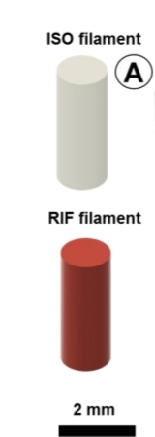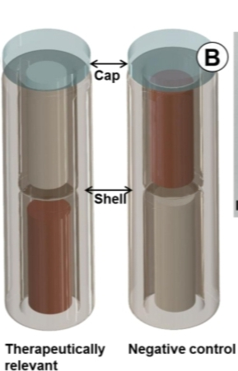
B. The photograph of the final dcDUs
- Final dual compartmental dosage units (dcDUs)
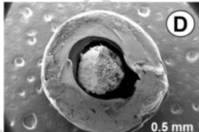
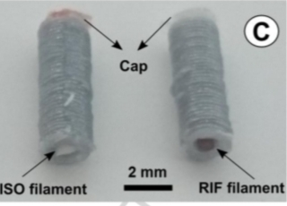
C. The scanning electron micrograph of the compartment D.ISO – Isoniazid, RIF – Rifampicin.

Fig 15: Schematic representation of the Hot-melt extruded drug filaments

2. Dual-compartmental dosage unit (dcDU) design and 3D printing:
The compartmental systems were designed in ComsolMultiphysics, having two water-insoluble compartments (made of PLA) to be filled with either ISO or RIF extrudates during 3D printing. The water-soluble cap (made of PVA) was positioned on the top of the 3D printed API-loaded dcDU to seal the top compartment.
3D printing was conducted using a dual-nozzle Ultimaker 3 Extended printer, which is based on the fused deposition modelling (FDM) technique. The applied process parameters for both polymers, PLA and PVA, were: printing temperature of 210 °C (for PLA) and 225 °C (PVA); layer height of 0.2 mm; built plate temperature of 60 °C; infill parameter of 100%; printing speed of 35 mm/s; and brim as a build plate adhesive type. Total printing time was 4 minutes per geometry.
The shell of the dcDU was 3D printed using PLA filament in the vertical position, from the bottom and up in a circular, layer-by-layer mode (35 layers). The 3D printer was paused prior to the printing of the PVA cap. During this pause, either ISO or RIF extrudate of known weight was manually loaded into the top compartment. The printing was subsequently resumed and the remaining two layers of PLA were printed, followed by the printing of the sealing cap in PVA (2 layers)²⁰. After that, the compartmental systems were detached from the build plate. Either ISO or RIF extrudate of a known weight was manually inserted into the bottom compartment. No cap was applied to the bottom compartment.

Evaluation Of Morphological Texture and Structure by Using Scanning Electron Microscopy (SEM):
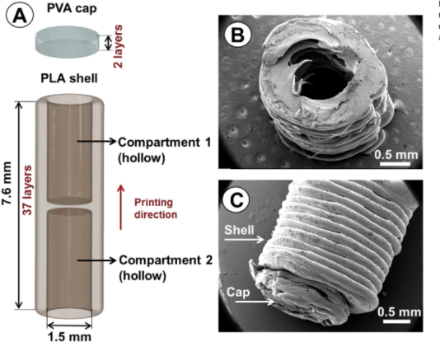
The samples were placed on double-sided carbon tape, fixed on the stainless-steel stubs and sputter coated with a layer of gold (5 nm) using a Leica EM ACE200 (Wetzlar, Germany) coater before sample imaging. The images were acquired using an FEI/Philips XL30 FEG (Hillsboro, OR, USA) scanning electron microscope (SEM) at an acceleration voltage of 2 kV using the secondary electron detector.

Fig 16: Schematic representation of the dual – compartmental unit
A.Scanning electron micrographs of the empty compartment from the top view,
B.Side view
C.PLA – Polylactic acid, PVA – Polyvinyl alcohol.

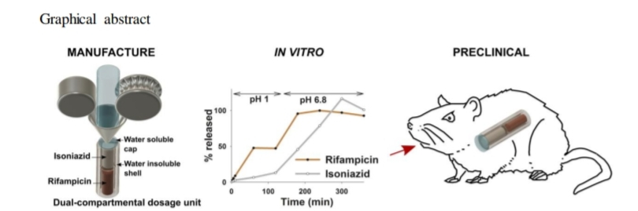

Fig17: Graphical abstract of dual – compartmental dosage unit
REPORT:
Spritam is the only 3D-printed drug currently available on the US market. The 3D printed approaches for the treatment of diseases such as cardiovascular diseases, diabetes mellitus, and tuberculosis are in the development stages and clinical trials.

4. BIOPRINTING IN 3D VIEWS
Based on Stereolithography (SLA), 3D bioprinting technology has emerged. Bioprinting is nothing but the method of printing biomedical structures with the help of living cells, biomaterials, polymers, and biological molecules, which is called Bioink. In other words, 3D bioprinting is the deposition of biological material in a layer-by-layer fashion to create 3D structures like tissues and organs^{21,22,23}. The ultimate aim of 3D bioprinting is to provide a convenient substitute for tissue implants and animal testing procedures during research on diseases like cancer and the development of medicine in the pharma field²⁴.
Cyclic representation of Bio-printing:
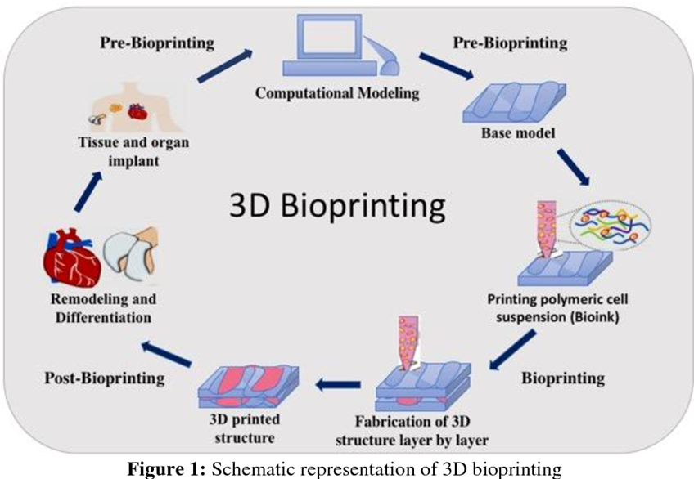

Fig.20: Schematic representation of 3D bioprinting

In pre-bioprinting, data is obtained with the help of computational modelling like computed tomography (CT) or magnetic resonance imaging (MRI). One of the software is CAD (computer-aided design), which is used to make the base model for the targeted organ. Then biomaterials and cells are selected depending on the structure of tissues or organs. The combination of biomaterial and viable cells is commonly known as bioink. Then the bioink is placed in the bioprinter, like the inkjet bioprinter, which was the first bioprinter in 2003. Then, the bioprinter produces the desired organ.
4.1. BIOINK

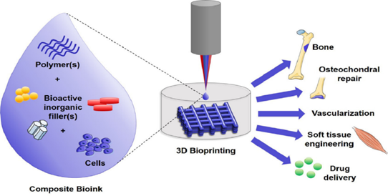
Bioink is biological materials (polymers, bioactive inorganic filters, and living cells) used to recreate live tissue structures with the help of 3D bioprinting. The term "bioink" not only indicates the cells used in the manufacture of tissues but also carrier molecules that provide support to the growing cells. The biopolymers used in bioink are essential to retain water, which provides mechanical stability to the engineered tissues. The polymer gels act as 3D molecular scaffolds so that cells can attach, grow, and increase. The selection of bioink is an important step to get the desired physicochemical properties that include mechanical, chemical, biological, and rheological characteristics²⁵.

Fig.19: composition of bioink-like polymers, bioactive compounds and viable or living cells.
Fig.20: Components in Bioink

4.2. PROPERTIES OF BIOINK
Bioink is used to promote adequate mechanical strength and robustness. The bioink molecules should have adaptable gelation and stabilisation to result in fidelity during bio-printing. The bioink should be biocompatible and biodegradable. The bioink should be suitable for chemical modifications to form specific tissues^{21,25}.

4.3. Principle of 3D Bioprinting
The principle of 3D printing is dependent on the accurate placement of biochemicals, biological components, polymers, and viable cells in layer-by-layer fashion to recreate the fabricated 3D structure. The process of 3D bioprinting is dependent on the three different applications: autonomous self-assembly, biomimetics or biomimicry, and mini-tissue building blocks²⁶.

4.4 Steps involved in 3D Bioprinting
Fig.21: Diagrammatic representation of 3D Bioprinting
The process of 3D bioprinting can be accomplished by three different steps; those are pre-bioprinting, bioprinting, and post-bioprinting²¹
PROCESS/ STEP | PROCEDURE | REPRESENTATION
PRE-BIOPRINTING | The formation of a pre-bioprinting model is the first step, which is used by the printer to pick out the materials. It starts with the extraction of a biopsy of a tissue, which supplies a biological model which is to be recreated by the 3D bioprinting method. Computed tomography (CT) or magnetic resonance imaging (MRI) scans26. These types of technologies are also used in this step. The pictures obtained through these methods are topographically recreated to obtain 2D images. Then the cell is selected, which is necessary for the process and multiplied. The cell mass is mixed with oxygen and other nutrients to keep them viable. | 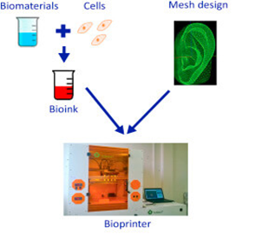
BIOPRINTING | This step is the real printing process, where the bioink is put into the printer to create a 3D structure²¹. The combination of cells, nutrients, polymers, and matrix together to form bioink, which is then placed into a printer cartridge, which deposits the material dependence on the digital model prepared²². After the deposition of bioink on to the scaffold in a layer-by-layer approach to generate a 3D tissue structure, this process needs the creation of distinct cell types depending on the type of tissues and organs to be formed. That’s why this step of the bioprinting process is a complex one^{23,28}. | 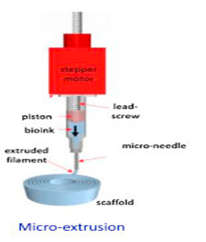
POST-BIOPRINTING | Post-bioprinting is the final step of the bioprinting process, which is essential to promote the stability of the printed structure. Physical and chemical stimulation are required to maintain the structure and function of biological matter. These stimulations provide signals to the cells to reorganise to maintain the growth of tissues28. The mechanical structure of the material might be disrupted in the absence of this step, which will affect the functioning of the material. | 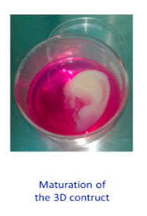
Table :2 Steps involved in 3D Bioprinting

Advantages and disadvantages of bioprinting:
Technique | Advantages | Disadvantages
Stereolithography-Based | High resolution  Easy to remove trapped materials | Expensive equipment  Only photopolymer materials
Extrusion-Based | Wide range of material choices  Low cost  Good mechanical properties | Limited materials to thermoplastics  Filament required  Viscosity and temperature of materials
Laser-Based | Wide range of material choices  High resolution | Expensive equipment  Heat effects
inkjet-Based | Low heat effect  High resolution | Limited choice of materials  Limited height  Difficulties in complex 3D geometries  Poor Mechanical properties
Table: 3 Advantage and Disadvantage of 3D Bioprinting

Organ on chip
Organs-on-chips (OOC) are systems that have engineered or natural miniature tissues grown inside microfluidic chips, which allow the cultivation of cells in vivo-like microenvironment that help the high expression of organotypic properties. OOCs can reduce or be an alternative to animal or pre-clinical experiment. Moreover, OOCs consists of biosensors which allow the online measurements of the functionality of the cells and viability in real time. OOCs containing tissues from distinct origins could be connected by microfluidic techniques to create the multiple OOC. Drug is exposed to tissues which is present in the chip and the response of the tissue is measured dependence on the functionality of the organ, these responses include the toxicity, metabolism of the drug substance, pharmacological effects and drug absorption and transport processes and cell viability²⁹. The term "Chip" refers to a design which is based on microchip technology and then the term "organ" refers to create the microenvironmental which is inspired by the organ-level function. In future, the sacrifice of animals in experimental purposes or in pre-clinical studies will be avoided. It is also used to anticipate drug responses and environmental effects on organs.
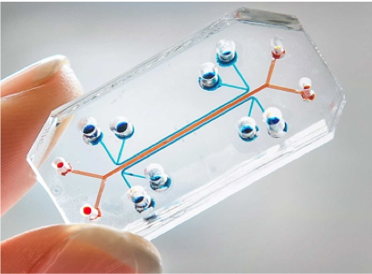
.

Fig.23: Organ on chip

Single-Organ Chips
Scientists started to develop the single-organ chips so they could later be linked with the entire body system on a chip. These single-organ chips were developed with the help of the semiconductor industry and microchip technology. The first lungs on chip were reported in a science magazine, which got the attention of people all over the world²⁹. Then, after other biomimetic organ systems on chip have been developed, for example, a liver on chip, a kidney on chip, a lung on chip, a gut on chip, a heart on chip, a muscle on chip, a blood brain barrier on chip, and a human on chip are all examples of chip-based organs. Only fascinating topics will be explained in more detail. That is a chipped lung and a chipped heart.
Multi Organ Chip
The multi-organ-chip is also referred to as the body-on-chip (BOC)³⁰. This instrument is nothing but a combination of both microscale technology and mathematical PK-PD (pharmacokinetic and pharmacodynamic) modelling, which has distinct chambers joined by microfluidic flow channels precisely emulating blood circulation³¹. Multiple micro-organs are connected on the same plate with the help of the multiple micro-wells and bio-reactor. Each chamber contains distinct cellular types representing different organs. For example, interconnected chambers consist of liver, skin, bone marrow, and tumour³².
Timeline of organ on chip
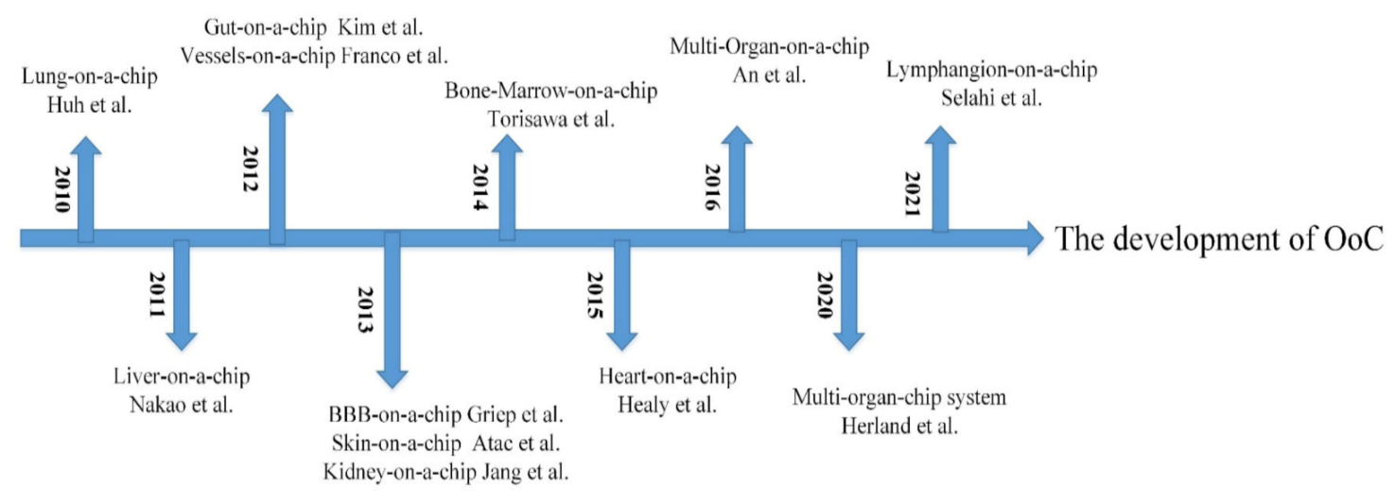
Fig.24: The development of Organ on chips
Lung on chip
The first organ system on a chip was reported as the lung in a science magazine and thus inspired much attention all around the world.
Lungs have two lung lobes which are divided from the trachea and then again divided till the smallest part of the alveoli. The gas exchange between air and the blood occurs on the large surface of the alveoli. Lungs have the alveolar-capillary unit. It contains alveolar epithelial cells and pulmonary microvascular endothelial cells detached by a thin interstitial. Therefore, the alveolar membrane is essential for the investigation of lung toxicity or pulmonary drug application²⁹. That’s why the alveolar membrane is an essential functional unit, which was manufactured in the lung on chip developed by Huh et al. who used PDMS (polydimethylsiloxane) to produce the lung-on-chip model with a multi-layer microfluidic structure.
The instrument was separated by a thin (10 m) porous flexible membrane made of PDMS coated with ECM (fibronectin or collagen). On either side of the membrane, both alveolar epithelial cells and pulmonary microvascular endothelial cells were cultured. The breathing-induced cyclic mechanical should be stimulated by vacuuming and restoring the space on both sides³³.
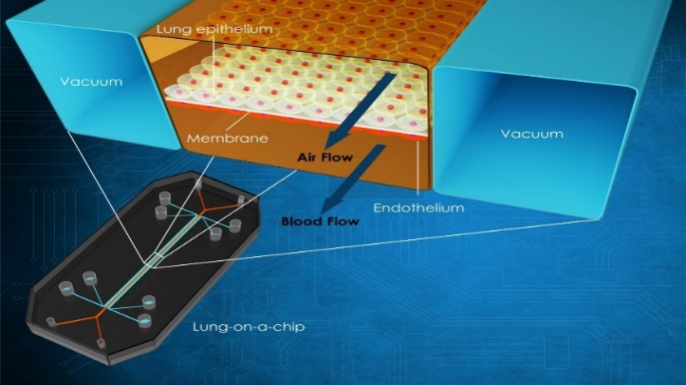
In experiments that provide good knowledge about the toxic effects of silica nanoparticles, they found that silica nanoparticles significantly increased the pro-inflammatory activity of respiratory exercise, which significantly contributed to the development of acute lung inflammation³⁴. The experimental shows the results that, compared with the traditional static culture system, the multi-layer OOC can better mimic the motion state of tiny particles in the human body, which provides the study principle of various diseases and drug toxicity.

Fig.25 Diagrammatic representation of lung on chip

:

Heart on chip
One of the least regenerative organs is heart in our human body nut most essential organ³⁵. Cardiovascular problems have been growing in recent year and gained attention³⁶. So that, it is necessary to known about the pathogenesis of cardia vascular disease and prevent it. Advantage of the microfluidic chips has used to study heart tissues in vitro. The beat of cardiomyocytes is commonly used to identify effect of drug and pumping of heart by muscle membrane MTF technology³⁷, Grosberg et al designed a heart-chip structure in 2011. Neonatal rat cardiomyocytes were implanted on the elastic membrane as the result to get the muscle membrane. The contraction is created on the muscle membrane to form the wrinkle by placing the with electrodes. Analysed the myocardial contractility of myocardial ells by access degree of curl or wrinkle. On the basis, Sub-millimetre MTF was obtained by Agarwal et al by using engraving laser machine to measure the contractility which helps the cardiac test. Marso et al. incorporated physiological environment into the design. By using latest 3D Bioprinting technology (direct laser writing photo lithography)³⁸, Zhang et al fabricated endothelial myocardial tissue³⁹. After the microfiber scaffold is printed, the human umbilical vein endothelial cells are migrated around the fibre to get a vascular bed. Finally, cardiomyocytes were fixed into void of the scaffold which is prepared by 3D Bioprinting technology as the result to get an endothelial zed myocardium. It is cultured in microfluid perfusion bioreactor and then this can be used for drug screening
Applications Of Heart on Chip
Various applications of heart on chip, including disease modeling, drug screening, and physiological study
Physiological study
To enhance our understanding of the physiological behaviour of the heart with the help of the organ-on-chip Yasuda et al. fabricated a heart-on-chip with a microchamber array by using the agarose material⁴¹. Wu et al. designed a heart-on-a-chip to stimulate the circulation system⁴². The chip has four pump units, which are denoted as the four-chamber. Varghese et al. investigated the effect of electrical stimulation on cardiomyocyte contraction in the heart-on-chip prototype⁴³.
Drug screening
One of the most essential applications of the heart-on-chip is drug screening. The adverse effects of some drugs may cause heart damage or even heart failure. So, that’s why it is essential to study the drug's induced cardiotoxicity. Heart-on-chip has a high potential for evaluating cardiotoxicity and is accurate in vitro model. The isopropyl noradrenaline has an influence on the contraction force of CMs using heart-on-a-chip, which was found by Parker et al⁴⁴.
Disease modelling
Another essential step in the analysis of disease mechanisms with the help of disease modelling in the research and development of drugs for the treatment of patients⁴⁵. The heart-on-a-chip can be used to study the pathology of cardiac fibrosis and provide an effective treatment for the patient. With the help of heart-on-a-chip, Healy et al. designed a 3D in vitro arrhythmia model in which ipsc-CMs and filamentous matrix were used to fabricate the 3D microtissues⁴⁶.

CONCLUSION
3D printing is a revolutionary technology which advances the production of drugs with preplanned release characters and geometries. This technology utilizes CAD software (Computer-aided design) to feed data for printing to commence. 3D printing was found to be efficient and accurate technology in bionic and regenerative medicine various methods of capturing prints in this technology includes Vat polymerization Binder jetting, fused deposition modelling Power bed fusion and material jetting. Spritam “levetiracetam” was the first launch of 3Dprint, used for epilepsy. Current and future prospects focus on the coordination of 3D printing for the treatment of various diseases and for placing biochips, and prospective transformation of Organ transplants like kidneys, lungs, heart etc.…
REFERENCES:

- Vinod G Gokhare, Dr.D.N Raut, Dr.D.K Shinde. A review paper on 3D Printing aspects and various processes used in the 3D printing. International Journal of Engineering Research and Technology. Vol-6 Issue 06, June (2017)
- (https://spritam.com/what-is-zipdose-technology/ )
- Xiao Zhu, Hongjian Li, Lianfang Huang, Ming Zhang, Wenguo Fan, Liao Cui. 3D Printing promotes the development of drugs. Biomedicine &Pharmacotheraphy.131(2020) 110644
- Gu Qi,Hao Jie, Lu Yangjie, Wang Liu, Wallace gordon G, Zhou Qi. Three Dimensional bioprinting. Science China, vol-58 (2015) 411-419
- Jamróz W, Szafraniec J, Kurek M, Jachowicz R. 3D Printing in Pharmaceutical and Medical Applications - Recent Achievements and Challenges. Pharm Res. 2018 Jul 11;35(9):176. doi: 10.1007/s11095-018-2454-x. PMID: 29998405; PMCID: PMC6061505
- N.Shahrubdin,T.C.Lee, R.Ramlan. An Overview on 3D Printing technology: Technological materials and applications. Procedia Manufacturing (2019) 35 (1286-1296)
- Pamela Robles-Martinez, Xiaoyan Xu, Sarah J.Trenfield, Atheer Awad, Alvaro Goyanes. 3D Printing of a multi-layer polypill containing six drugs using a novel Stereolithography method. Pharmaceutics (2019),11 (274)
- Iria Seoane Viano, Sarah J. Trenfield, Abdul W. Basit, Alvaro Goyanes. Translating 3D Printing Pharmaceuticals; From Hype to real – world clinical application. Advanced drug delivery and reviews. 174.553-575(2020)
- F.Fina, A.Goyanes, C.M.Madla, A.Awad, S.J.Trenfield, J.M.Kuek,er.al. 3D Printing of drug loaded gyroid-lattices using selective laser sintering. International Journal of Pharmaceutics. 547 (1-2) (2018) 44-52
- C.Silbernagel, “Additive Manufacture: What is Material jetting? Canada Makers, (2018) (online) https://canadamakes.ca/what-is-material-jetting
- Ryan Varghese, Sahil Salvi, Purab Sood, Jainam Karsiya, Dileep Kumar. “3D Printed medicine for the management of chronic disease : The road less travelled”. Annals of 3D printed medicine 5 (2022) 100043.
- https://3dprintingindustry.com/news/triastek-receives-fda-ind-clearance-for-3d-printed-drug-to-treat-rheumatoid-arthritis-184159/.
- https://images.app.goo.gl/zTbA6vpyvJkMiULR7.
- Zengming Wang, Xiaolu Han, Ruxin Chen, Jingru Li, et.al, “Innovative color jet 3D printing of Levetiracetam personalized paediatric preparation”. Asian Journal of Pharmaceutical Sciences (2021).
- Katherina M Carey, Morgan R Comee, Jennifer L Donovan, and Abir O kanaan. “A Pollypill for all? Critical review of the polypill Literature for primary prevention of cardiovascular disease and stroke”. Annals of pharmacotherapy 2021 May, volume 46.
- https://images.app.goo.gl/dVWoyYqVGsRxHosCA.
- Christos I. Gioamouxouzi, Apostolos Baklavaridis,Orastis L,et.al,.“A 3D printed bilayer oral solid dosage form combining Metformin for prolonged and Glimepride for immediate drug delivery”. European Journal of Pharmaceutical sciences 120 (2018) 40- 52.
- https://www.mayoclinic.org/diseases-conditions/tuberculosis/symptoms-causes/syc-20351250.
- Atabak Ghanizadeh Tabirz,, Uttom Nandi, Andrew P.Hurt, Ho-Wah Hui,et.al, “3D Printed bilayer tablet with dual controlled drug release for Tuberculosis treatment”. International Journal of Pharmaceutics volume 593, 25 January 2021, 120147.
- N.Genina, J.P.Boetker, S.Colombo, N.Harmankaya,et.al,. “Anti-tuberculosis drug combination for controlled oral delivery using 3D printed compartmental dosage forms: From drug product design to in- vivo testing”. Journal of controlled release 268 (2017) 40 – 48.
- https://thebiologynotes.com/3d-bioprinting/
- Murphy, S., Atala, A. 3D bioprinting of tissues and organs. Nat Biotechnol 32, 773–785 (2014). https://doi.org/10.1038/nbt.2958
- Dey, Madhuri, and Ibrahim T Ozbolat. “3D bioprinting of cells, tissues and organs.” Scientific reports vol. 10,1 14023. 18 Aug. 2020, doi:10.1038/s41598-020-70086-y
- Peng, Weijie & Datta, Pallab & Ayan, Bugra & Ozbolat, Veli & Sosnoski, Donna & Ozbolat, Ibrahim.3D Bioprinting for Drug Discovery and Development in Pharmaceutics. Acta Biomaterialia.. (2017). 57. 10.1016.
- Susan Heid, Aldo R.Boccaccini. Advancing bioinks for 3D bioprinting using reactive fillers. Acto biomaterials 113(2020) 1-22
- Zhengjie Wu, Xin su, Yuanyuan Xu, Bin kong, Wei’s son & Shenglime. Bioprinting Three-dimensional cell-laden tissue constructs with controllable degradation. Scientific Reports Published;19 April (2016)
- Ecem Saygili, Asli Aybike Dogan-Gurbuz, Ozlem Yesil-Celiktas, Mohamed S. Draz. 3D Bioprinting: A powerful tool to leverage tissue engineering and microbial systems. Bioprinting. Volume 18. (2020).
- Pereira F.D.A.S., Parfenov V., Khesuani Y.D., Ovsianikov A., Mironov V. (2018) Commercial 3D Bioprinters. In: Ovsianikov A., Yoo J., Mironov V. (eds) 3D Printing and Biofabrication. Reference Series in Biomedical Engineering. Springer, Cham.
- N.Beibner, T.Lorenz and S.Reichl. Organ on chip. Springer International Publishing Switzerland (2016).
- Wang Y.I., Oleaga C., Long C.J. Self-contained, low-cost Body-on-a-Chip systems for drug development. Exp. Biol. Med. (2017); 242:1701–1713.
- Yizho, Ranjithkumar kankala Shibinwang, Al-Zhengchen. Multi Organs-on-chip; towards Long-Term Biomedical Investigations. Molecules. V.24(4);2019 Feb
- Wagner, I.; Materne, E.M.; Brincker, S.; Sussbier, U.; Fradrich, C.; Busek, M.; Sonntag, F.; Sakharov, D.A.; Trushkin, E.V.; Tonevitsky, A.G.; et al. A dynamic multi-organ-chip for long-term cultivation and substance testing proven by 3D human liver and skin tissue co-culture. Lab Chip (2013), 13, 3538–3547.
- Zening Li, Jianan Hui, Panhuiyang & Hongju mao. Microfluidic Organ-on-chip system form. Disease modelling and development biosensor. Published: 27 may (2022).
- Huh, D.; Matthews, B.D.; Mammoto, A.; Montoya-Zavala, M.; Hsin, H.Y.; Ingber, D.E. Reconstituting organ-level lung functions on a chip. Science (2010), 328, 1662–1668.
- Hirose, K.; Payumo, A.Y.; Cutie, S.; Hoang, A.; Zhang, H.; Guyot, R.; Lunn, D.; Bigley, R.B.; Yu, H.; Wang, J.; et al. Evidence for hormonal control of heart regenerative capacity during endothermy acquisition. Science (2019), 364, 184–188.
- Benjamin, E.J.; Muntner, P.; Alonso, A.; Bittencourt, M.S.; Callaway, C.W.; Carson, A.P.; Chamberlain, A.M.; Chang, A.R.; Cheng, S.; Das, S.R.; et al. heart disease and Stroke Statistics-2019 Update: A Report from the American Heart Association. Circulation (2019), 139, 56–528.
- Visone, R.; Gilardi, M.; Marsano, A.; Rasponi, M.; Bersini, S.; Moretti, M. Cardiac Meets Skeletal: What’s New in Microfluidic Models for Muscle Tissue Engineering. Molecules (2016), 21, 1128.
- Agarwal, A.; Goss, J.A.; Cho, A.; McCain, M.L.; Parker, K.K. Microfluidic heart on a chip for higher throughput pharmacological studies. Lab Chip (2013), 13, 3599–3608.
- Colosi, C.; Shin, S.R.; Manoharan, V.; Massa, S.; Costantini, M.; Barbetta, A.; Dokmeci, M.R.; Dentini, M.; Khademhosseini, A. Microfluidic Bioprinting of Heterogeneous 3D Tissue Constructs Using Low-Viscosity Bioink. Adv. Mater. (2016), 28, 677–684.
- Zhang, Y.S.; Arneri, A.; Bersini, S.; Shin, S.R.; Zhu, K.; Goli-Malekabadi, Z.; Aleman, J.; Colosi, C.; Busignani, F.; Dell’Erba, V.; et al. Bioprinting 3D microfibrous scaffolds for engineering endothelialized myocardium and heart-on-a-chip. Biomaterials (2016), 110, 45–59.

- Kaneko T, Kojima K, Yasuda K. An On-Chip Cardiomyocyte Cell Network Assay for Stable Drug Screening Regarding Community Effect of Cell Network Size. Analyst. 2007;132:892–8. https://doi.org/10.1039/b704961g. [PubMed] [Google Scholar]

- Chen Y, Chan HN, Michael SA, et al. A Microfluidic Circulatory System Integrated with Capillary-Assisted Pressure Sensors. Lab Chip. 2017;17:653–62. https://doi.org/10.1039/c6lc01427

- Aung A, Bhullar IS, Theprungsirikul J, et al. 3D Cardiac Mu Tissues Within a Microfluidic Device with Real-Time Contractile Stress Readout. Lab Chip. 2016;16:153–62. https://doi.org/10.1039/c5lc00820d.

- Agarwal A, Goss JA, Cho A, et al. Microfluidic Heart on a Chip for Higher Throughput Pharmacological Studies. Lab Chip. 2013;13:3599–608.

- . Savoji H, Mohammadi MH, Rafatian N, et al. Cardiovascular Disease Models:A Game Changing Paradigm in Drug Discovery and Screening. Biomaterials. 2019;198:3–26.

- Ma Z, Koo S, Finnegan MA, et al. Three-Dimensional Filamentous Human Diseased Cardiac Tissue Model. Biomaterials. 2014;35:1367–77. https://doi.org/10.1016/j.biomaterials.2013.10.052

