Antifungal effect of Syzygium aromaticum buds, Prunus dulcis seeds, Caesalpinia bonducella seed, Phyllanthus emblica fruits, Sesbania grandiflora leaves, Solanum trilobatum leaves on mouth ulcer pathogen

(Candida tropicalis)

*KRISHNAVENI.R¹., NARMADHA.K¹,GEETHA.S,¹ SUBALAKSHMI.G,¹ATCHAYA.G¹
*KRISHNAVENI.R¹ Assistant professer and Head , PG and Research Department of Microbiology.
Idhaya college for women Kumbakonam.
NARMADHA.K¹ ,
PG students Department of Microbiology. Idhaya College for women Kumbakonam.
SUBALAKSHMI.G,¹ATCHAYA.G¹
UG students Department of Microbiology .Idhaya College for women Kumbakonam
Corresponding Author :* KRISHNAVENI.R. Email-krishnavenimicro@gmail.com

ABSRACT
Oral Candidiasis is a common opportunitic infection caused by the Yeast candida species , normally lives on skin and inside the body in places such as mouth, throat, gut and vagina. Sometimes it can multiply and cause on infection if its adopts inside the mouth, throat or esophagus several host factors were involved in this type of infection. Especially immunocompromised patients including HIV, old age, radiotherapy, malignant diseases and other several crucial diseases have lead to increase the percentage of oral Candidiasis over the past several years. So necessary to design a new drug against these fungal infection normal.
INTRODUCTION
A mouth ulcer is occurring in the mucous membrane of the oral cavity.It is very common occurring in association with many disease (Filomina. Raffaelea et al., 2007). Cloves are the flower buds of the clove tree, and evergreen called as Syzygium aromaticum native to the Maluku islands. Both lower and buds have the best medicinal properties like antiviral, antifungal, anaesthetic and arminative (Paoli et al., 2007) That oil consist of several terpenes, terpenoid, phenolderived aromatic and Previous study also evaluated the antimicrobial activity against Staphyloccus aureus, E.Coli, Yeast candida etc. Aneja K R et al 2010). Essential oils of M.fragrans seen has been reported as antimicrobial effect gainst Shigella dysen, E.Coli, and Pseudomonas aeruginosa. M.Fragrans leaves, seeds combined with ssential oils of Syzygium aromaticum were used for the preparation of some medicines to treat aginal infections. (Kathasamymuthaliyar 1954).Previous study also evaluated the antimicrobial activity against taphyloccus aureus, E.Coli, Yeast In ancient times, plants were used as medicinal treat so many isorders. Researches also investigated and characterised several herbal plants and their commercial non commercial uses, distribution reproduction and noted that the therapeutic activities.Syzygium romaticum commonly called as clove act as herbal medicinal Dried flower buds also used as spice flavour in food nd dental care edicine in East Asian medicines.Nuts or mace considered to as nutritionally complete food for human health due to the conten Caesalpinia bonducella is one of important ayurvedic herb the seads are grey colour and have shining surface many reports confirmed that it has multiple therapeutic properties such as antipyretic, antidiuretic, antieminitic and antibacterial, anti-anaphylactic, anti diarraheal, antiviral, antiasthmatic, anti amebic and ankestrogenic activities and have some antifungal properties. (Shruthi Shukla et al.,2011)Not only the nature of disease also increase and maintain the proper health condition various traditional system used the herbal plant materials for pharmacological activities in recent years (Asolker et al.,1992)All parts of plant material used for treating various disorders due to the presence of metabolities such as alkaloids, flavenoids, glycoside, saponins, connins, and terpenoids.Caesalpinia bonducella crude extract was studied against Tricophyton longifusus, Cadida albicans, A.flarus, M.canis, F Solani and C. globerata with the positive control of miconozole and amphotericin B. (Antimed). In this evaluation, no effect was reported in F.Solani or M.Canis. The chloroform fraction exhibited effect against A.Flavus (70%), C.albicans (20 %) and candida globerota (60) when testing in isolation rabbit jejunum (Hidayat-Ullah Khan 2017). Solanum trilobatum comes under the herbal plant containing natural steroids called as solasoline occur in leaves fruits, seeds and stem used for steroid drug production (ANM…). In general medicinal plants such as purple fruit egg pea plant containing constituents activate in hepato protective and mitotic properties Solanum trilobatum have the ability to treat lung cancer.Caesalpinia bonducella flower extract (CBFC) was administered orally and tested for analgesic and antipyuretic activities in adult mice and rats. In this analgesic activity proved that capsain induced pain, formalin induced pain, acetic acid – induced test hot plate test and tail flick test. Antipyuretic activity was prooved in Brewer’s yeast induced pyrenia in rate. Prunus dulcis seed extract was omvestigated for its antioxidant activity with different fractions. Six compunds were isolated and evaluated for antiradical, antiproliferative, antibacterial, antioxidant activity. (Singh Rana et al 2011).Antiproliferative terpenoids from almond hulls(prunus dulcius): identification and structure-activity relationships.Journal of agriculture and food chemistry.(Amico,v.,et al 2006).A ntioxidant potential of chestnut ana almond products.(Barreira,Oliveira,Ic.,et al 2010).

MATERIALS AND METHODS

Sample Collection

The lesion sample from mouth was from SWASTI DIAGNOSTICS AND HEALTH CENTER, JOHN SELVARAJ NAGAR, KUMBAKONAM by sterilecotton spatula.Sample was transported and processed in laboratory as soon as earliest.
Plant material
Healthy and matured plant seeds of Caesalpinia bonducella, Prunus ducis, Syzygium aromaticum, Sesbania grandiflora, Phyllanthus emblica, Solanum trilobatum were collected. Seeds were detached from outer layer and washed with steriled distilled water. Then drying was made at room temperature and ground into a fin Isolation of FungiThe collected swab sample was cultured in sabouraud dextrose agar medium, by streak plate method with sterile inoculation loop. After that incubated at 37 degree celcius for 48 hrs.

Identification of fungi

Staining and germ tube test were performed for identification of fungal species

Germ tube test

It is a sreening test used to differentiate Candida albicans.Candida sp grown as a germ tube formation in human and sheep serum at 37 degree celcius for 3 hrs and it can be detected with wet KOH film. This is the positive result in this approach, especially in Candida albicans and Candida other than albicans develope germ tube formation in protein aceaus media at 95-97 Aliquot (0.5 ml) of serum was taken in a test tube.Suspension of swab was inoculated with a sterile wooden stick on serum.Incubation was made for 2-3 hrs in 37 degree celcius.Then drop of suspension was placed on a slide using pipette and cover with coverslip.Finally wet mount miroscopy was accomplished for the prodution of germ tubes

RESULT AND DISCUSION
The antifungal acitivity of the seed and buds extracts of Caesalpinia bonducella (Kalarchikai), Prunus dulcis (Badam), (Syzygium aromaticumClove),(Sesbania grandiflora leave)s, (Phyllanthus emblica fruit)s, (Solanum trilobatum leaves) furnished in table. All the extracts exhibit different degrees of antifungal acitivity.Bioactivities and chemical profilling of sesbania grandiflora,pharmaceutical science.(Farhina,Rahman,et al., 2016).Journal of pharnacognosy and phytochemistry(Nisrat jahan.,2015).
The aqueous extract of Syzygium aromaticum (Clove)buds, Caesalpinia bonducella (Seed), Prunus dulcis (Seed),(Sesbania grandiflora leave)s, (Phyllanthus emblica fruit)s, (Solanum trilobatum leaves) was observed against the organisms of Yeast Candida trophicalisin.

Solanum trilobatum

The antimicrobial activity is highly in the bacteria and fungi by producing important properties of silver. Solanum trilobatum Linn (Solanacea) also known as in Ayurvedha and siddha as ‘Alarka’ and ‘Tuduvelai’ it was thomy shrub.The Solanum trilobatum shows antifungal activity against fungal Candida tropicalis Zone of inhibition in the plate showed that Silver nano particles synthesized using Solanum trilobactum has the antifungal activity against test pathogens namely (Candida albicans. In equal dilution the zone of inhibition was (20 mm), and in ½ dil. the zone of inhibition is 16 mm and ¼ dil the zone of inhibition is 13 mm.In our study the Solanum trilobatum leafs shows maximum antifungal activity on Candida tropicalis (19mm) in equal dilution and ¼ dil (6 mm) the result agreed with the work.

Sesbania grandiflora

Herbalism is traditional curing method to destroy the various diseases by using various valuable plants. The extracts from medicinal plants distributed for Centuries to cures herbal remedies and ashomeopathic medicine (Gowri SS and Vasantha K – 2010). Candida species, which tend to be less suseptible to the commonly used antifungaldrugs, have recently emerged as significant opportunistic pathogens.
Sesbania grandiflora otherwise known as ‘Agathi ‘is a widely available plant. It is belongs to Fabaceae, Open branching tree tall up to 15 m and 39 cm in diameter.
Sesbania grandiflora extracts showed maximum antifungal effect on Candida sp (14 mm) at 75 mill/g concentration. In our findings the sesbania grandiflora leafs shows antifungal acctivity on Candida tropicalis (12 mm) in equal dilution.Pharmacological and phyto pharmaceutics aspects of sesbania grandiflora .(Vijay d,wagh 2009).

Syzygium aromaticum

Inspite of the newly coming of new antifungal drugs they are still limited in number, So that we should introduce new drugs that are more effective and less toxic than those already in use. The essential oil of Syzygium aromaticum shown important antifungal activity against Yeast, which is mainly used in involving mucosae, the skin and the respiratory tract.Syzygium aromaticum produced in Indonasia, Srilanka, Madagaskar, Tansania and Brazil. The Syzygium aromaticum using in antiseptic analgesic and anaesthetic effects.
Phyllanthus emblica

Now a days the rate of infection and resistant of the powerful antibiotic to micro organisms. In this situation we should reduce the problem to continue studies for the development of new drugs, either natural or synthetic to improve the new drugs we should use the proper plants to develop the new remedies. The Candida species causes most of the human skin and oral vascular system infection. As the medicinal plants of fruits of phyllanthus emblica treated against for antifungal activity in our studies. The Phyllanthus emblica shows antifungal activity against Yeast tropicalis. Phyllanthus emblica extracts showed maximum antifungal effects on Aspergillus niger (17 mm). Where as Candida albicans and Penicillium notatum showed minimum zone of inhibition (6 mm) at different concentration.Protection given by the extract of phyllanthus emblica fruit.(Ghosh A,Sharma A,et al 1992).
In our finding the phyllanthus emblica fruits shows antifungal activity on Candida tropicalis 6 mm in equal dilution and ¼ dilution in 3 mm the result agreed with the work of Phyllanthus emblica have the antifungal activity.Antioxidants of phyllanthus emblica L bark.(Renuka chaphalkar 2017).

Caesalpinia bonducella
Fungai destroyed more food stuffs and eliminate nutritive value of the food most of the fungai causing so many diseases to human beings. Candida tropicalis causing mouth ulcer to the human. Instead of using chemical antibiotic we will prefer to use of herbal medicinal plants seed for treating fungal diseases.Review on pharmacological properties of Caesalpinia bonducella,Journal of medical Arom,plants.(Vibha singh et al.,2012).Caesalpinia bonducella known as Nata Karanja, it was a shrub, found dat India, Myanmar and Sri Lanka seed was yellowish in color, Bitter and fatty kernal .Oral antibiotic activities of different exract of caesalpinia bonducella seed karnels(Sudeep parameshwar et al.,2002).

Prunus dulcis

The skin of the Prunus dulcis nut accounts for 4% of the total nut weight and is rich in Polyphenols, including hydroxybenzoic acids and aldehydes, flavonel and flavanone, aglyccones and glycosides. Prunus dulcis included in the family Rosaceae, It is fruit tree is very important in all over the world. The prunus dulcis native was mountain region of central Asia.The prunus dulcis shows anti fungal activity against Yeast tropicalis (16 mm) in 0.5 g/ml and (18 mm) in 1.0 g/ml in dilutions. In our findings the Prunus dulcis seeds shows antifungal activity on Candida tropicalis 2.5 mm in equal dilution and 1 mm in ¼ dilution 0.5 mm the result agreed with the work.

Table 1

Susceptibility pattern of antifungal activity of Herbal plants extracts

Zone of Inhibition

S.No | Herbal Plants | Equal dil. | ½ dil. | ¼ dil.
1. | Solanum trilobatum | 19 mm | 14 mm | 6 mm
2. | Phyllanthus emblica | 17.9 mm | 15 mm | 8 mm
3. | Sesbania grandiflora | 17.5 mm | 2 mm | 1.5 mm
4. | Syzygium aromaticum | 17.3 mm | 5 mm | 2 mm
5. | Prunus dulcis | 2.5 mm | 1.5 mm | 1 mm
6. | Caesalpinia bonducella | 2 mm | 1 mm | 0.5 mm
7. | POSITIVE CONTROL | 20 mm | 20 mm | 20 mm
8 | NEGATIVE CONTROL | 0 mm | 0 mm | 0 mm

Susecptibility pattern of antifungal activity of Herbal plants extracts in Equal Dilution.
Zone Formation

HERBAL PLANTS in Equal Dil.
25

20

15

10

5

0
Extract dilution
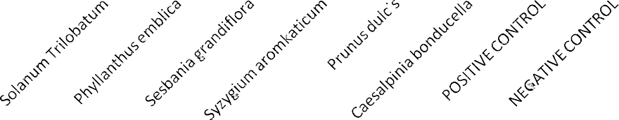
POSITIVE CONTROL : AMPHOTERICIN NEGATIVE CONTROL : PLAIN DISC

Susceptibility pattern antifungal activity of Herbal Plants extract

Aqueous extract of Herbal plants

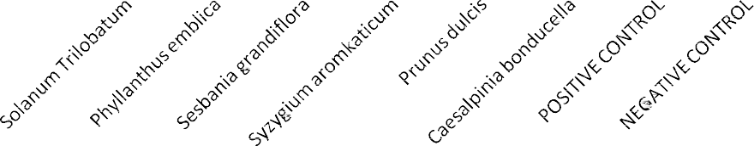
HERBAL PLANTS in 1/4 Dil.
25

20

15

10

5

0
Extract dilution
Zone Formation

POSITIVE CONTROL : AMPHOTERICIN NEGATIVE CONTROL : PLAIN DISC

Antifungal Acitivity done by using Yeast Candida tropicalis in Chemical antibiotic reference

S.No | Chemical Antibiotic | Zone of Inhibition
1. | ITRACONAZOLE | 23 mm
2. | AMPHOTERICIN-B | 18 mm
3. | NYSTATIN | 16 mm
4. | FLUCONAZOLE | RESISTANT
5. | KETACONAZOLE | RESISTANT
6. | CLOTRIMAZOLE | RESISTANT

MEDICINAL PLANT OF SYZYGIUM AROMATICUM BUD
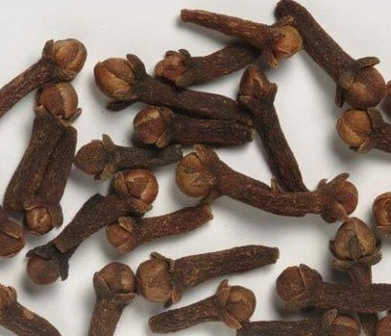

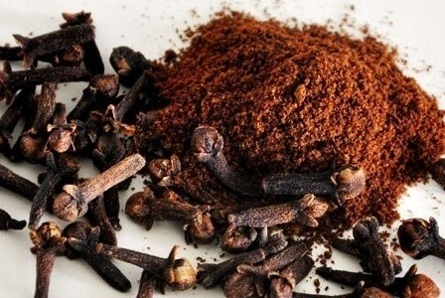
Syzygium aromaticum buds Syzygium aromaticum Powder

MEDICINAL PLANTS OF Caesalpinia bonducella

Caesalpinia bonducella seed caesalpinia bonducella powder
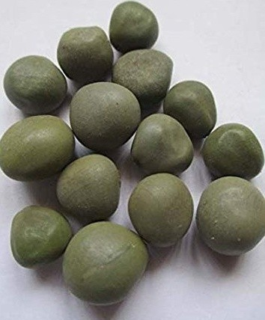
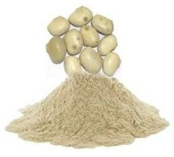

MEDICINAL PLANT OF PRUNUS DULCIS

prunus dulcis seed prunus dulcis seed powder

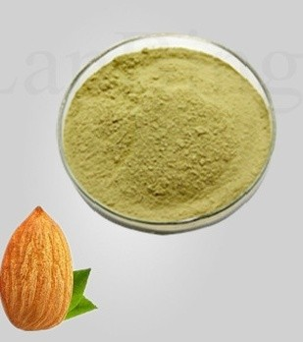
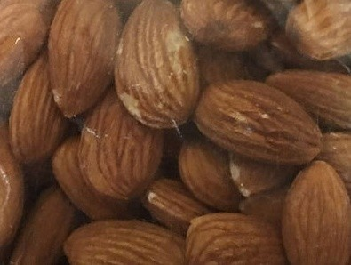
1. MEDICINAL PLANT OF SESBANIA GRANDIFLORA
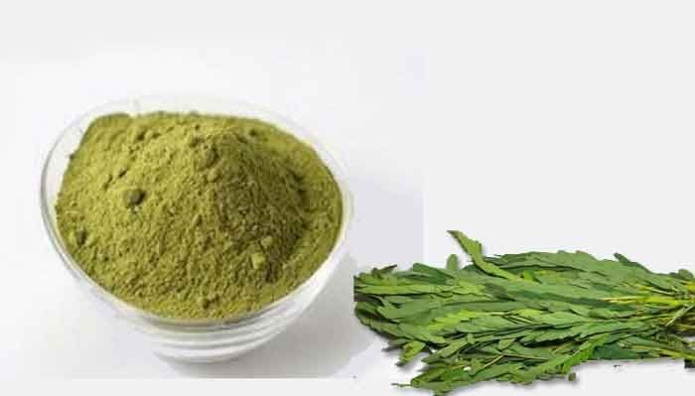
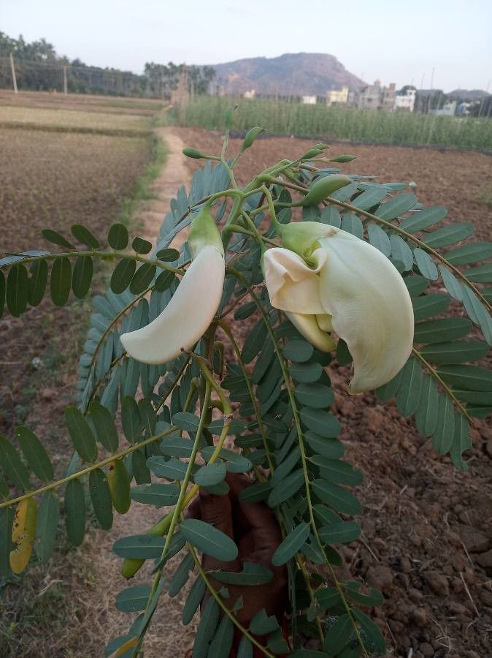
(Agathi) leaf powder

MEDICINAL PLANT OF PHYLLANTHUS EMBLICA
(Nelli) Nelli powder

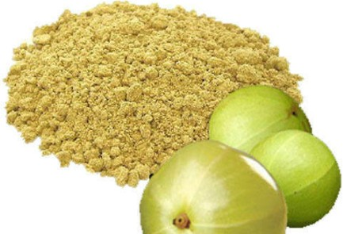
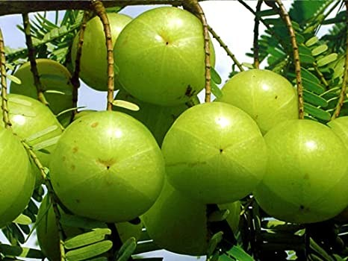

FIGURE 9.1 MEDICINAL PLANT OF SOLANUM TRILOBATUM
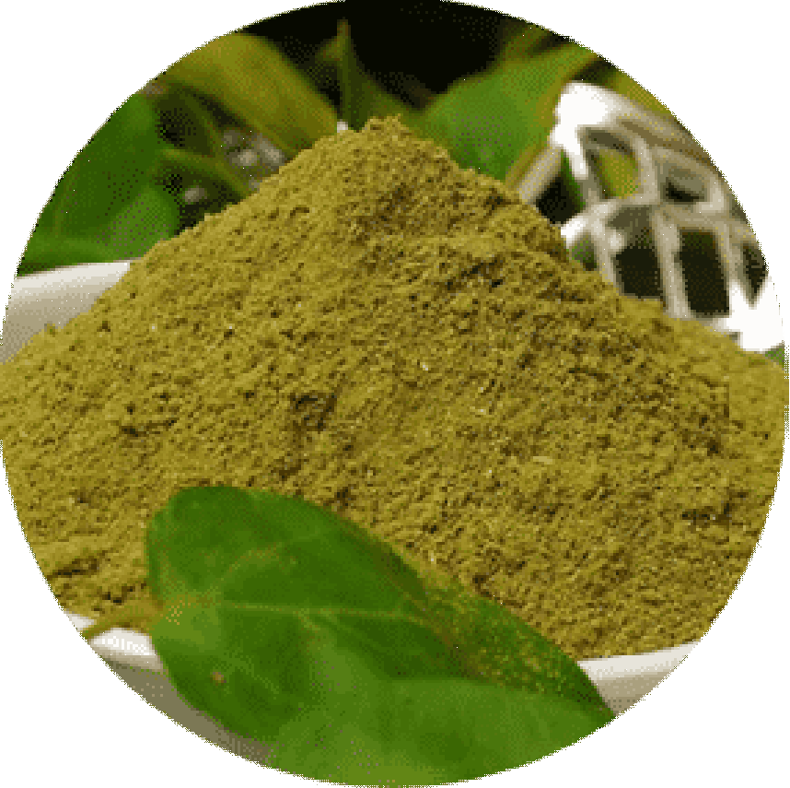
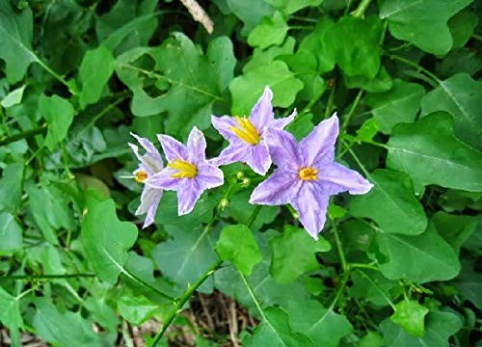
(Thoothuvalai)

FIGURE 10.1 MEDICINAL PLANT EXTRACT PREPARATION
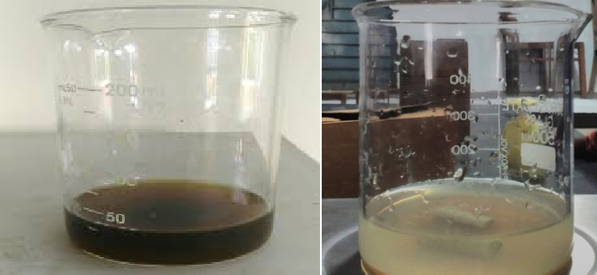
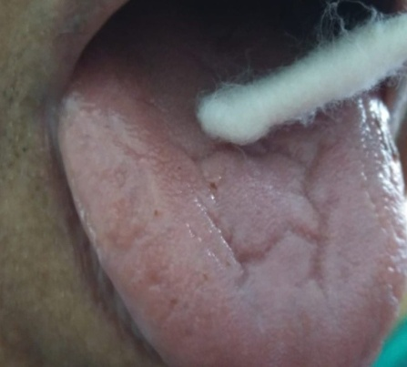
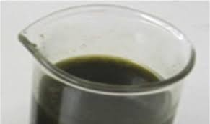
SAMPLE COLLECTION FROM ORAL ULCER
YEAST CANDIDA TROPICALIS ISOLATION
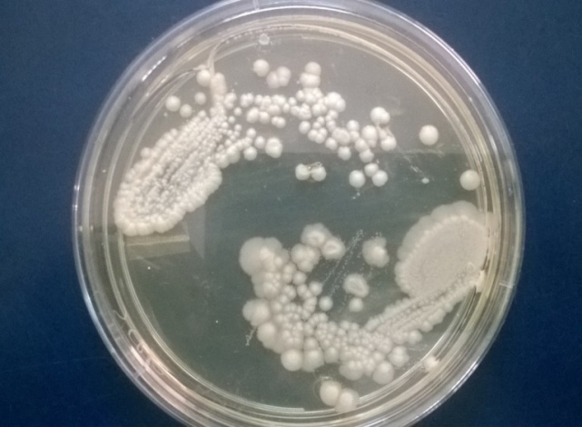

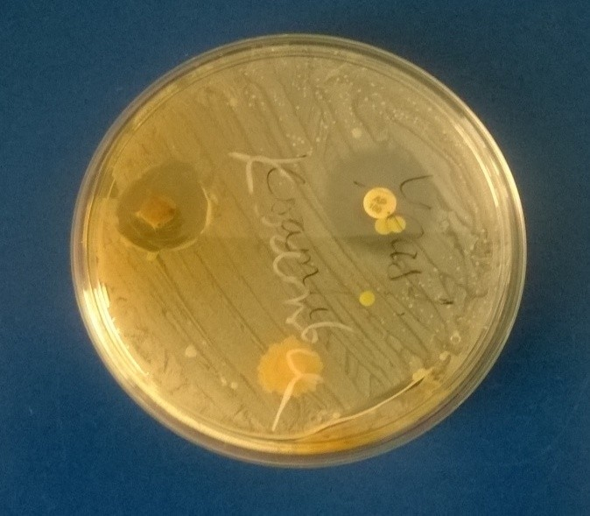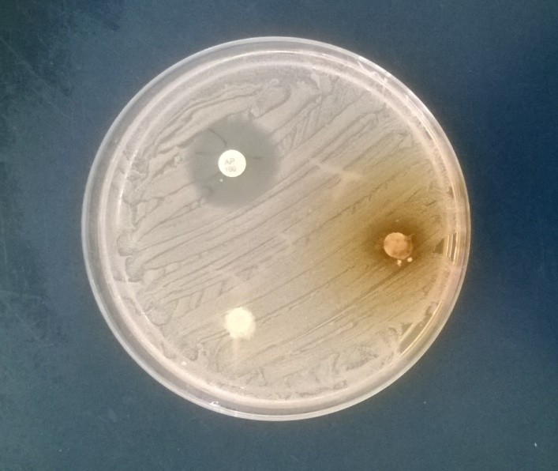 ANTIFUNGAL ACTIVITY OF BUDS
C
B
B
C

SYSYZIUM AROMATICUM

CAESALPINIA BONDUCELLA
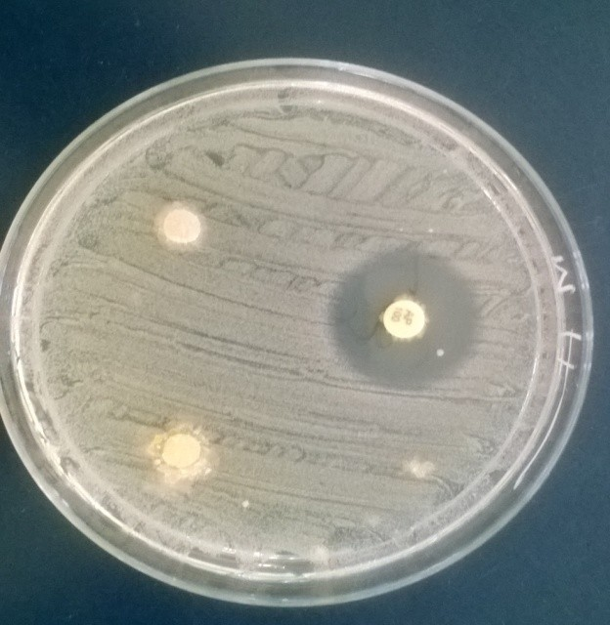
A
B
C
B
C

( Sesbania grandiflora leave)

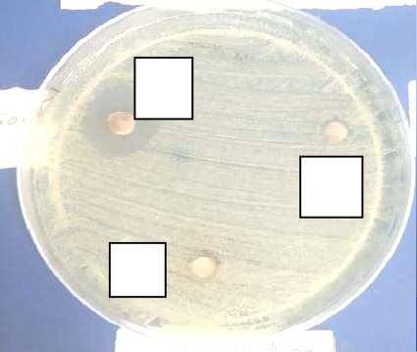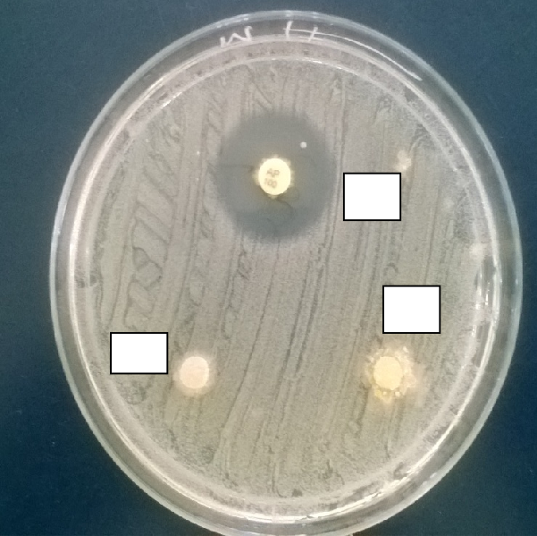
B
C
A
B
C

ANTIFUNGAL ACTIVITY OF FRUITS IN AQUEOUS EXTRACT

(Phyllanthus emblica Fruit)
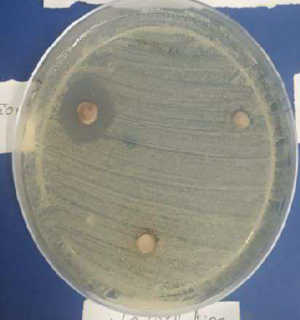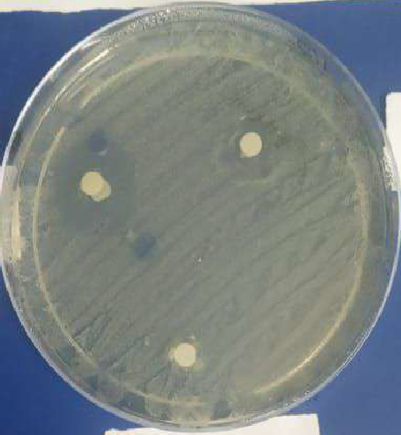
B
B
C
C
A
A
½ dilution Equal dilution

Yeast Candida tropicalis on Sabauraud agar
plate.
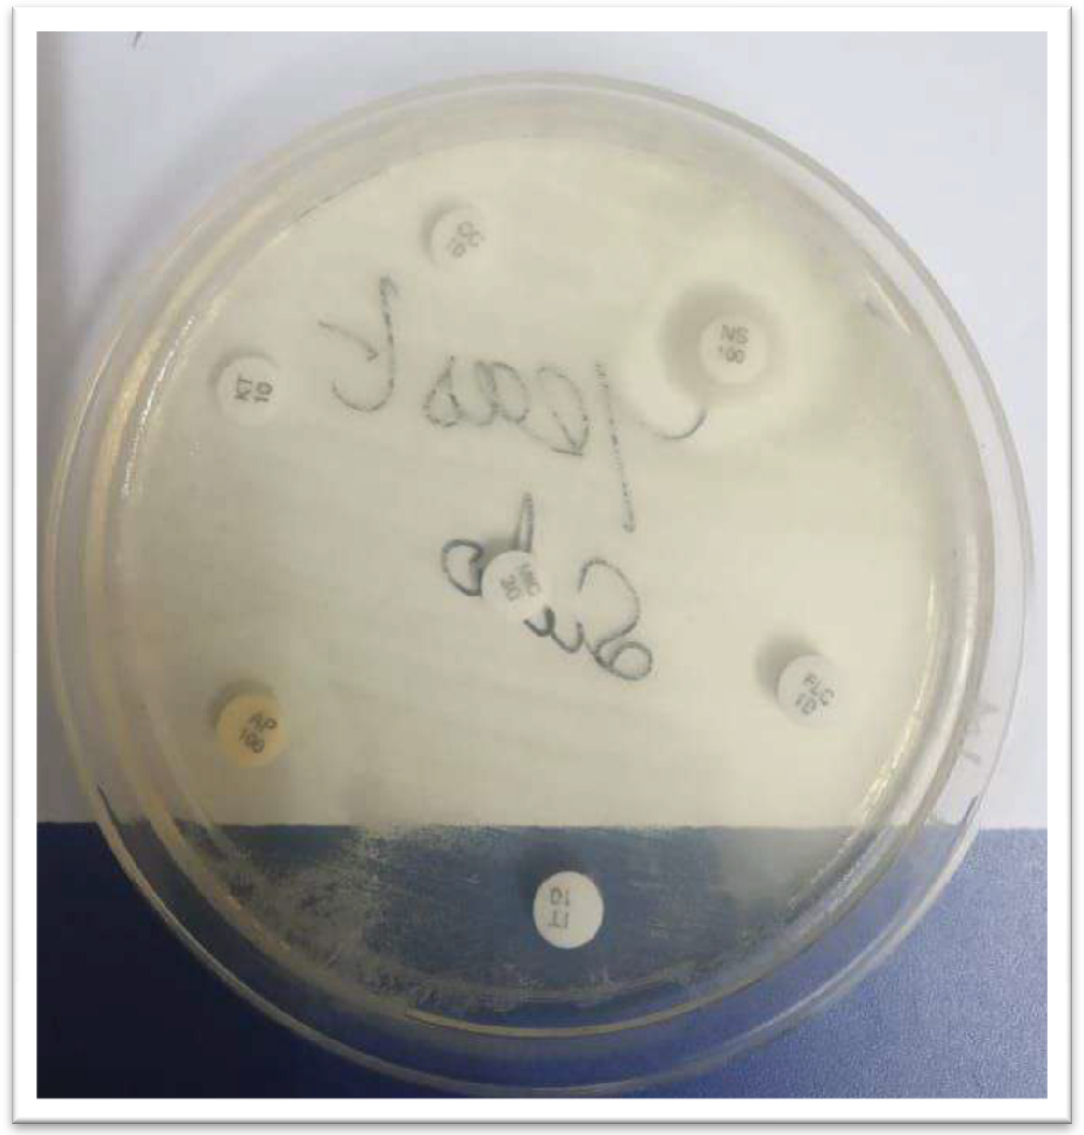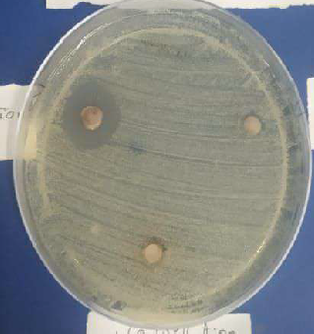
B
C
A

SUMMARY AND CONCLUSION

In the present work carried out on testing antifungal ativity of Candida tropicalis with herbal plants etracts, and chemical antibiotic.In our findings the herbal plants Phyllanthus emblica shows maximum 17.9 mm Zone of inbibtion observed.In our findings the herbal plant Caesalpinia bonducella shows minimum (2 mm) Zone of inhibition observed.In the present study Testing of antifungal activity again Candida tropicalis. The maximum zone of Inhibition 14 mm observed Itraconazole, and minimum 10mm, Nystatin, Fluconazole, Ketaconazole, Clotrimazole, Amphotericini- B Resistant.In the final study we conclude Insstead of using Chemical antibiotics the herbal medicinal plant used to treat fungal diseases caused by Candida tropicalis.

REFERENCE

Aneja, K.R, and Radhika, J, 2010, Antimicrobial Activity of Syzygium aromaticum and Its Bud Oil against Dental Caries Causing Microorganisms, Journal of Ethno botanical Leaflets, Vol 14 :960-75.
Asolkar LV, Kakkar KK, and Chakre OJ,1992, Glossary of Indian Medicinal Plants with Active, Journlal of PID-CSIR, Vol1 : 150.
Abraham Daniel Arulraj, Jeya Prabha, Ramaraj Deepa, Bernard Neppolian and valrathevar Sivasamy, Vasantha (2018), Material Research Express, Vol.6, 215-216.
Amico, V., Barresi, V., Condorelli, D., Spatafora, C., Tringali, C., 2006. Antiproliferative terpenoids from almond hulls (Prunus dulcis): identification and structure–activity relationships. Journal of Agricultural and Food Chemistry 54, 810– 814.
Barreira, J.C., Ferreira, I.C., Oliveira, M.B., Pereira, J.A., 2010. Antioxidant potential of chestnut (Castanea sativa L.) and almond (Prunus dulcis L.) by-products. Food Science and Technology International 16, 209–216.
Cortes-Rojas DF, De Souza CRF, Pereira Oliveira W, 2014, Clove (Syzygium aromaticum): a precious spice, Journal of Tropical BiomedicineVol 4 : 90-96.
Di Paoli S, Giani TS, Presta, GA, Pereira MO, Da Fonseca AD,Brandao-Neto J, Medeiros AD, Santos-Filho SD, Bern ardo, Filho M ,2007, Effects of Clove (Caryophyllus aromaticus L.) Oral of Brazilian Archives of Biology and TechnologyVol 50 : 175-182.
Filomena, N., Florinda, F., Laura De, M., Raffaele, C. and Vincenzo, D.F, 2013, Effect of Essential Oils on Pathogenic Bacteria. Journal of Pharmaceuticals (Basel), 6(12) : 1451-1474.
Farhina, Rahman, Labni, Samira, Karim, Jalal, Uddin and Zubaikhan (2016), Bioactivities and Chemical Profilling of Sebania grandiflora, Journal Phamaceticals Science, Vol.15(2) :173-176.

Gowri SS (2010) : Journal fo American Eurasian Journal of Scientific Research. Vol.5, No.2, PP 114-119 ref.26
Ghosh A, Sharma A, Talukder G, (1992) : Relative protection given by extract of phyllanthus emblica fruit. Vol.10, 1016/0165-1218 (90).
Gowri SS (2010) : Journal fo American Eurasian Journal of Scientific Research. Vol.5, No.2, PP 114-119 ref.26
Ghosh A, Sharma A, Talukder G, (1992) : Relative protection given by extract of phyllanthus emblica fruit. Vol.10, 1016/0165-1218 (90).
Hidayat-Ullah , Ali, Irshad , Khan, Arif-Ullah , Naz, Rubina and Gilani, Anwarul Hassan, (2011), Antibacterial, antifungal, antispasmodic and Ca++ antagonist effects of Caesalpinia bonducella, Natural Product Research, 25 (4), 444 — 449.
Kanthasamymuthaliyar, 1952, Megarogapadalam. Arthmaradcha amirtham ennum vaiththiya sarasankirakam. Journal of Raththina nayakar and sons publications, Vol.1 : 347-367
Nisrat Jahan, Salma Akter (2015), Journal of Pharmacognosy and phytochemistry. Vol 4(4) :142-155.
Shruti shukla, Pradeep mehta, Archana mehta, Suresh prasad VYAS, Vivek K, Bajpai, 2011, Preliminary phytochemical and antifungal screening of various organic extracts of Caesalpinia bonducella seeds, Journal of Romanian Biotechnological. Vol 16, 4- 10.
Sudeep parameshwar, Srinivasan KK and Malikarjuna Rao C, 2002, Oral antidiabetic activities of different extracts of Caesalpinia bonducella seed Karnels. Pharmaceutical Biology, 40 (8) : 590-595.
Sigh Rana, Aarti Singh Rana and Ramcharan, Rajak (2017), Brazil Journal Microbiology. Vol.42(4), pp1269-1277.The Wealth Of India, 1992, Raw material, Ca-Ci, Revised Ed, Publication and Information Directorate, CSIR, Vol 3: 6-8. Gupta, M., Mazumder, U.K., Kumar, R.S.,Sivakumar, T., Gomathi, P., Rajeshwar, Y, 2005, Antioxidant Defense System Inducedby a Methanol Extract of Caesalpiniabonducella. Journal of Pharmacological Sciences, Vol 43(5) : 411- 419.
Vijay D, Wagh (2009) : Jounal of Pharmacy Research phytochemical, Pharmacological and Phytopharmaceutics aspects of Sesbania grandiflora. Vol 2(5), 889-892.

Vibha SINGH, Pramod K, Raghav, 2012, Review on Pharmacological Properties of Caesalpinia bonducella, International Journal of Medical Arom, plants Vol 2 : 514-530

.

Yang J, Liu RH (2009) Induction of phase II enzyme, quinone reductase, in murine hepatoma cells in vitro by grape extracts and selected phytochemicals. Food Chemistry 114: 898–904.

Yang J, Liu RH (2009) Induction of phase II enzyme, quinone reductase, in murine hepatoma cells in vitro by grape extracts and selected phytochemicals. Food Chemistry 114: 898–904.

