Decentralized Cryptocurrency Wallet

Dr. Jyothi A P Dr.Pushphavathi T P
Assistant Professor, Dept. of CSE, Associate professor & HOD, Dept. of CSE,
Faculty of Engineering and Technology, Faculty of Engineering and Technology,
Ramaiah University of Applied Sciences, Ramaiah University of Applied Sciences
Bengaluru, India Bengaluru, India
jyothiarcotprashant@gmail.com pushphavathi.cs.et@msruas.ac.in

ABSTRACT

A cryptocurrency is an encoded information string that indicates a unit of cash. It is observed and coordinated by a distributed organization called a Blockchain, which aids protected record of exchanges, e.g., purchasing, selling etc. The fundamental benefits are that digital forms of money don't have a central allotment, so utilizing a decentralized framework to record exchanges makes it secure. The main motive of this paper is to make a platform where people can send crypto currency, receive cryptocurrency and along with that they can also send Messages and Gif’s along with those transactions. In this paper Decentralized Cryptocurrency Wallet where people can have interactive crypto data and have safe Ethereum transfer is discussed. The application is primarily a decentralized cryptocurrency wallet, which will be able to send and receive transaction between two accounts. The application is also able to send messages and gifs with the transactions as an attachment. The application is also able to display the transaction history.

Keywords— Ethereum, Decentralized Cryptocurrency Wallet, transaction history, Blockchain.

INTRODUCTION

A cryptocurrency wallet is an application that functions as a wallet for your cryptocurrency. It is called a wallet because it is used similarly to a wallet you put cash and cards in. Instead of holding these physical items, it stores the passkeys you use to sign for your cryptocurrency transactions and provides the interface that lets you access your crypto. Modern cryptocurrency wallets make the blockchain accessible to everyone. When cryptocurrency was first introduced, sending cryptocurrency was a manual task that required entering long keys. Today, the software does most of it for you. In this paper discussion on Sending transaction to any account, View the balance in the Ethereum card and Sending messages and Gif’s along with the transaction is done. It is accessible from many browsers as a web application.

LITERATURE SURVEY

Dejan Vujičić, Dijana Jagodić, Siniša Ranđić [1], Blockchain Technology, Bitcoin, and Ethereum: A Brief Overview The target of the task is to give an early turn of events and thoughts on Decentralized Digital Currencies how it develops and develop into such huge scope. In this overview paper 1 Research patterns have been determined as:

(1) Understanding buyer's (non)acceptance of digital forms of money

(2) Ethical perspectives and confidence in digital currencies,

(3) Blockchain innovation as a without trust innovation,

(4) The blockchain/trust economy

(5) Blockchain innovation: testing trust.

Saeed Alzahrani Portland State University Tugrul Daim Portland State University,[3] Analysis of the Cryptocurrency Adoption Decision on year 2019, The objective is to offer a cash that isn't tied, made or upheld by an administration. Cryptographic money utilize the block chain innovation. Digital currency reception level has expanded, and the market has developed decisively. The primary objective is to arrange the current reception level. The blockchain wallet is utilized in this strategy. The objective of this paper is to examine the digital money reception choice. We analyzed the variable impacting the reception choice and gave an inside and out examination of each component.

Shamili Prabakaran and B. Muruganantha m, Enhancing the Decentralized Application (DApp) for E-business by Using the Ethereum Blockchain [4] January 2022, Research basically centers around building the blockchain based decentralized application by utilizing the web3 library alongside the ganche and metamask in the nearby host. To get the internet shopping exchanges upon the client's protection concern.

Sandeep Kumar Panda and Suresh Chandra Satapathy, An Investigation into Smart Contract Deployment on Ethereum Platform Using Web3.js and Solidity Using Blockchain [5] May 2021, Here in this paper, they chiefly center around the agreement calculations that are utilized to oversee and control blocks on the blockchain. Likewise, on the Ethereum which is utilized to execute DApp utilizing Smart Contract. Recently centers around the execution strategy on Ethereum blockchain for making and conveying and furthermore collaboration with the brilliant agreement.

PROPOSED TECHNIQUE

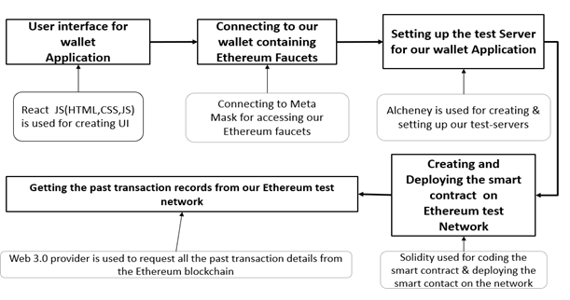
We present a system to implement a decentralized Cryptocurrency wallet application with Web3.0 Technologies and Ethereum blockchain as shown in Figure 1.

Figure 1: Proposed System.

A complete knowledge and understanding of the different technologies and frameworks that were required for implementation of project is discussed below.

React.js:

React.js is the most well-known front-end JavaScript library for building Web applications. React.js or Reactjs or essentially React are various ways of addressing React.js. React.js is an open-source JavaScript library that is utilized for building UIs explicitly for single-page applications. It is utilized for dealing with the view layer for web and portable applications. Respond additionally permits us to make reusable UI parts. Respond was first made by Jordan Walke, a programmer working for Facebook. Respond permits designers to make enormous web applications that can change information, without reloading the page. The primary reason for React is to be quick, versatile, and straightforward. It works just on UIs in the application. This relates to the view in the MVC layout. It very well may be utilized with a blend of other JavaScript libraries or structures, like Angular JS in MVC. A few significant elements of React.
• Respond is revelatory
• Respond is straightforward yet strong
• Respond is part based
• Respond upholds server-side
• Respond upholds portable help
• Respond is extensible

CSS:

Cascading Style Sheets (CSS) is a template language utilized for portraying the introduction of a report written in a markup language like HTML. CSS is a foundation innovation of the World Wide Web, close by HTML and JavaScript. CSS is intended to empower the partition of show and content, including design, varieties, and textual styles. This partition can work on satisfied openness; give greater adaptability and control in the particular of show qualities; empower numerous website pages to share designing by determining the pertinent CSS in a different .css document, which lessens intricacy and redundancy in the primary substance; and empower the .css record to be stored to further develop the page load speed between the pages that share the record and its organizing. Detachment of arranging and content likewise makes it achievable to introduce a similar markup page in various styles for various delivering techniques, like on-screen, on paper, by voice (through discourse based program or screen peruser). The name flowing comes from the predetermined need plan to figure out which style rule applies in the event that more than one rule matches a specific component.

JavaScript:
JavaScript is one of the center innovations of the World Wide Web close by HTML and CSS. All significant internet browsers have a devoted JavaScript motor to execute the code on the client's gadget and sites use it client-side for website page conduct, frequently consolidating outsider libraries. As a multi-worldview language, JavaScript upholds occasion driven, practical, and basic programming styles. It has application programming points of interaction (APIs) for working with text, dates, customary articulations, standard information structures, and the Document Object Model (DOM). JavaScript motors were initially utilized exclusively in internet browsers, however they are currently center parts of certain servers and various applications. The most well known runtime framework for this use is Node.js.

Hardhat:
It is an Ethereum improvement climate for experts. It works with performing successive errands, like running test, consequently looking at code for botches or cooperating with a shrewd agreement. This implies accumulating, running and testing Smart Contract at the very center. Hardhat comes worked in with Hardhat Network, a neighborhood Ethereum network intended for improvement. Its usefulness centers around Solidity investigating, including stack follows, console.log () and unequivocal mistake messages when exchanges fizzle.

Solidity:
It's utilized to make brilliant agreements that execute business rationale and produce a chain of exchange records in the Blockchain framework. It goes about as a device for making machine-level code and incorporating it on the Ethereum Virtual Machine. It has a ton of similitudes with C and C++ and is easy to learn and comprehend. For Like other programming dialects, robustness programming additionally has factors, capabilities, classes, math tasks, string control, and numerous different ideas. It is and object-situated programming language made explicitly by the Ethereum Network group for building and planning Smart Contract on Blockchain stages. Model, a "principal" in C is identical to a "contract" in Solidity.

Alchemy:
It is a blockchain scaling stage that permits engineers to safely make, test, and screen their decentralized applications. This stage gives reliable organization availability and hub the executives endpoints. Speculative chemistry basically decentralized improvement and go past furnishing distant hubs with highlights like Notify, which permits engineers to send constant pop-up messages to clients for basic occasions in view of blockchain exercises and their NFT API that gives a suite to administrations permitting us to immediately find, check and show and NFT across numerous blockchains.

Ethereum:
It is a decentralized blockchain stage that lays out a shared organization that safely executes and confirms application code, called brilliant agreements. Smart Contract permit members to execute with one another without a confided in focal power. Exchange records are permanent, undeniable, and safely conveyed across the organization, giving members full proprietorship and perceivability into exchange information. Exchanges are sent from and gotten by client made Ethereum accounts. A source should sign exchanges and spend Ether, Ethereum's local cryptographic money, as an expense of handling exchanges on the organization.

Smart Contract:
Smart Contracts are PC programs that are facilitated and executed on a blockchain network. Each savvy contract comprises of code indicating foreordained conditions that, when met, trigger results. By running on a decentralized blockchain rather than a concentrated server, shrewd agreements permit various gatherings to come to a common outcome in an exact, opportune, and sealed way. Brilliant agreements are a strong foundation for robotization since they are not constrained by a focal executive and are not defenseless against single marks of assault by pernicious substances. When applied to multi-party advanced arrangements, shrewd agreement applications can lessen counterparty risk, increment productivity, lower costs, and give new degrees of straightforwardness into processes.

METHODOLOGY

Algorithm

- Start.

- Connect to MetaMask:
If account present do: Login
Else do:
write create Account.

- Enter R_Add, Amt, Message, Gif and click send button;

- T_Fee := G_Units + (B_Fee + tip); Final_Amt := Amt + T_Fee;

- Check the wallet balance:
If Wallet Balance < Final_Amt do:
write Error ;
else do: proceed ;

- Authenticate the Transaction in the MetaMask;

- Store the Transaction on the Test-Server Address and on Ethereum Blockchain;

- Show past transactions on the Wallet User Interface := S_Add, R_Add, Message and Gif;

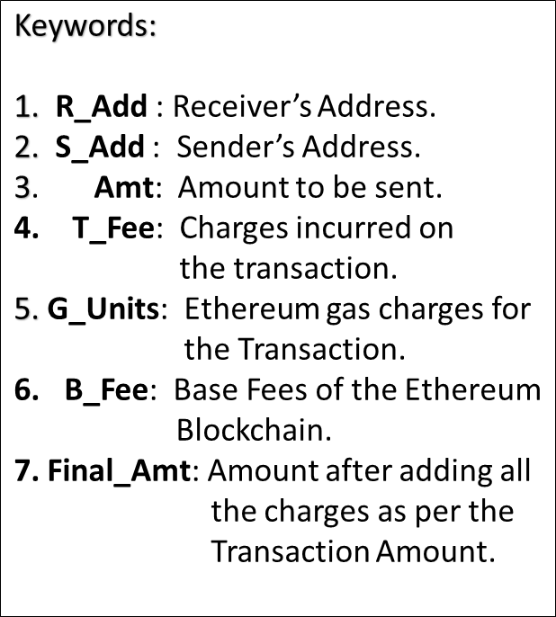
- End.

RESULTS AND DISCUSSION

Functional Requirements No. | Expected | Obtained
FR1 | The application should allow user to connect with their Ethereum blockchain which stores the Ethers. | System successfully allows to connect to the wallet.
FR2 | The application should allow the user to login using credential in the Meta Mask. | The user was successfully able to login in the MetaMask.
FR3 | The application should allow the user to see balance in the Ethereum card | The user was successfully able to view the balance in the Ethereum card.
FR4 | The application should allow to send cryptocurrency to their friend’s wallet address, and receive cryptocurrency on their wallets also. | The user was successfully able to send cryptocurrency to and receive too by wallet address.
FR5 | User should have an option to send a text attached to the transaction so that the receiver may find it easier to recognize from whom he has received the cryptocurrency. | The user was successfully able to send text attachment.
FR6 | User should be able to send Gif attachments along with the transaction message so that the wallet looks attractive. | The user was successfully able to send Gif’s attachments along with the transaction.
FR7 | All the transactions taking place in the user's wallet must be reflected in the Ethereum Blockchain | All the transactions taking place in the users wallet was successfully reflected in the Ethereum Blockchain.

Table 1: Results obtained for Functional requirements
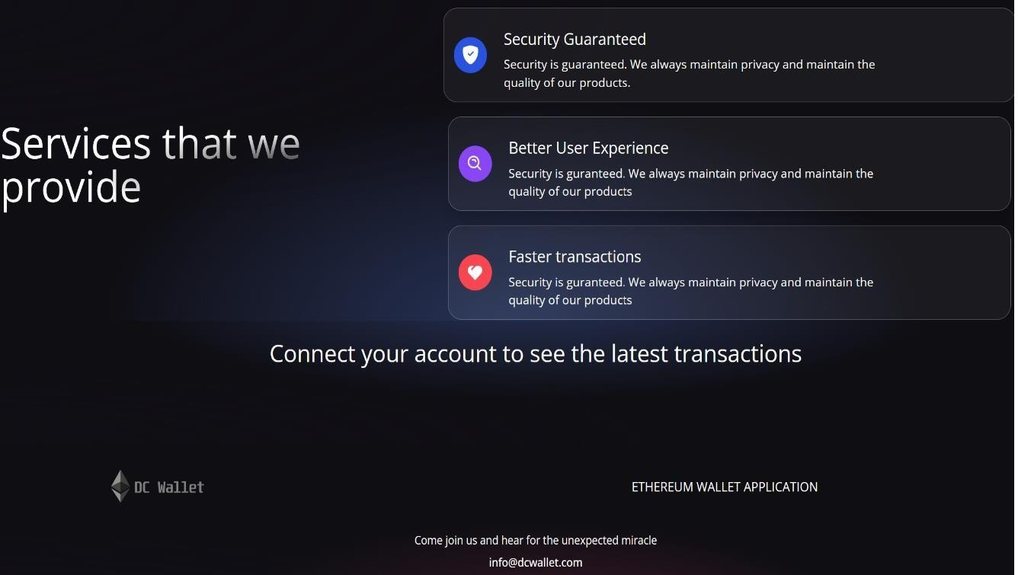
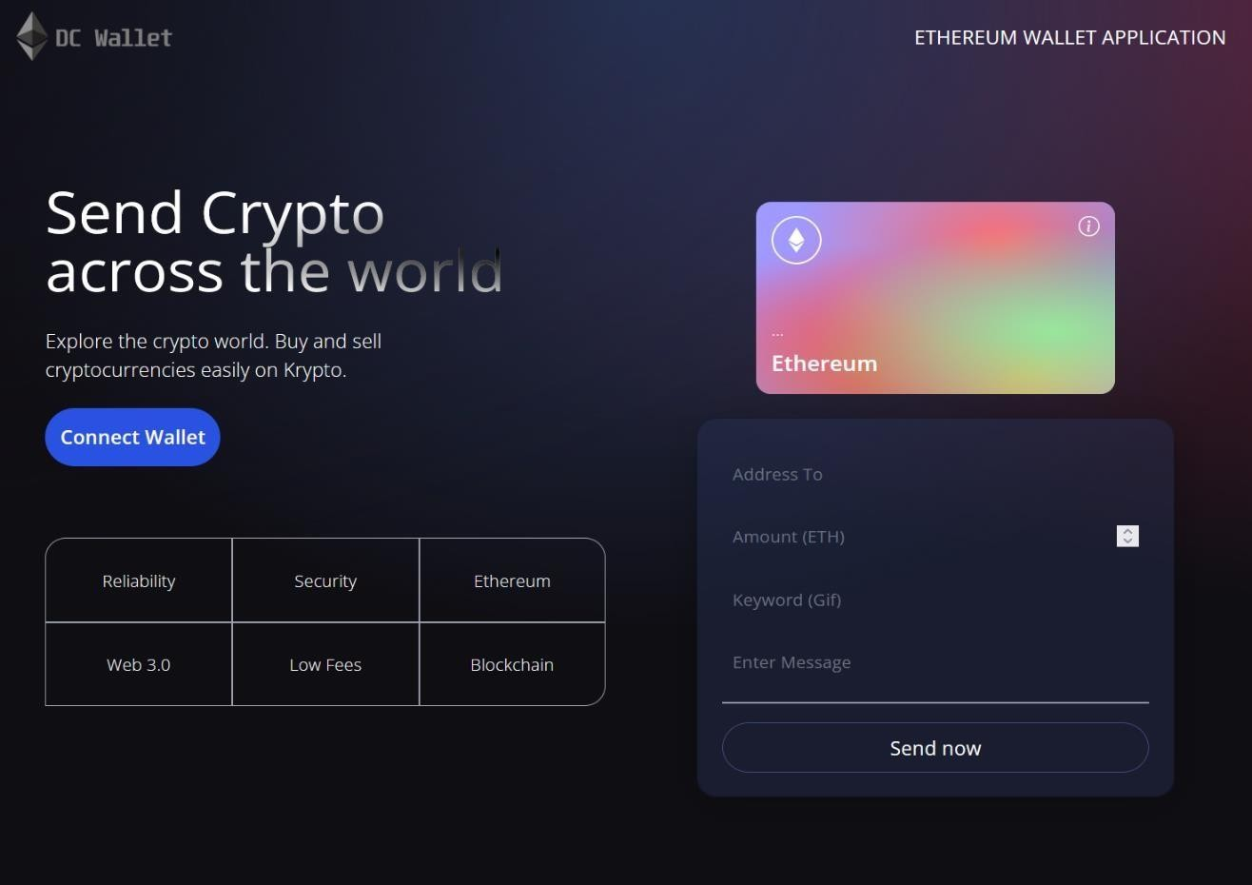

Figure 2: Shows the User Interface for the wallet application

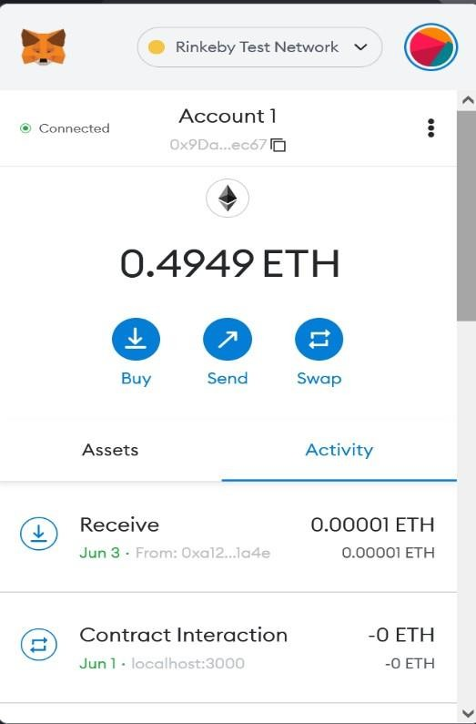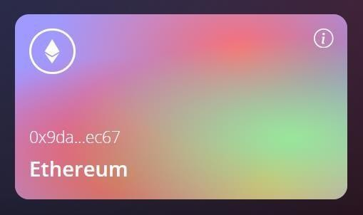
Figure 3: Shows the MetaMask Connected for the wallet application and the Address on the Ethereum Card.

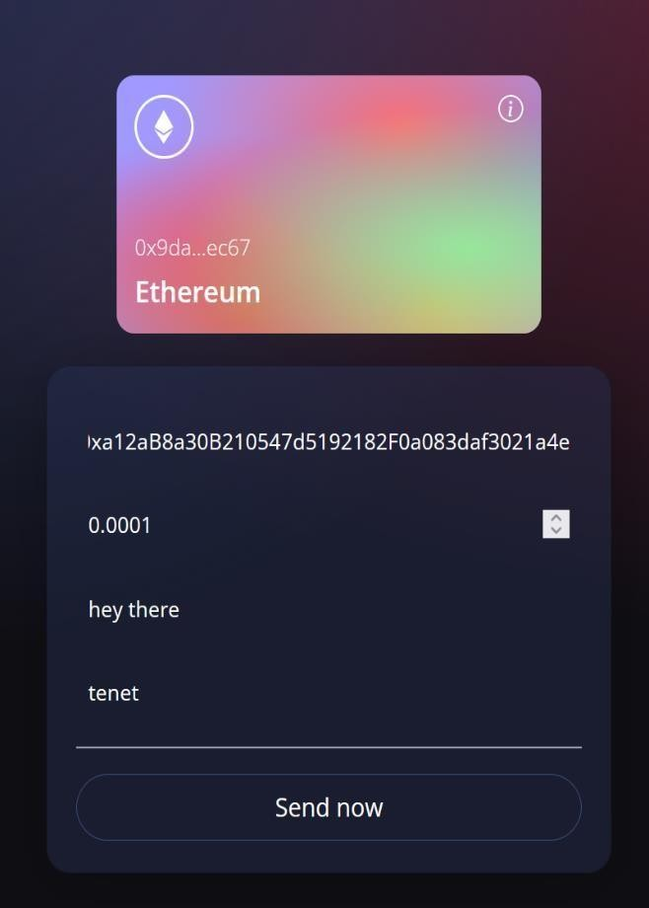

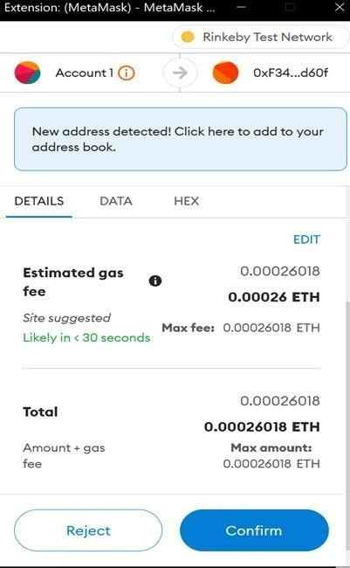
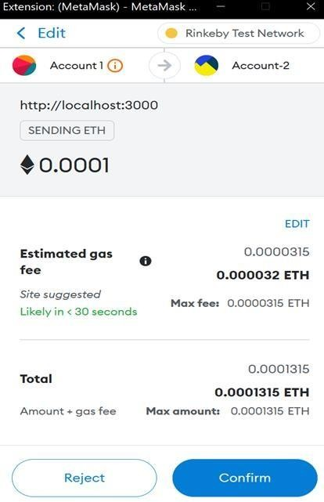

Figure 4: Shows the transactions made through the wallet application on our Test Network on Ehterum Blockchain.

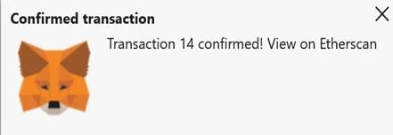
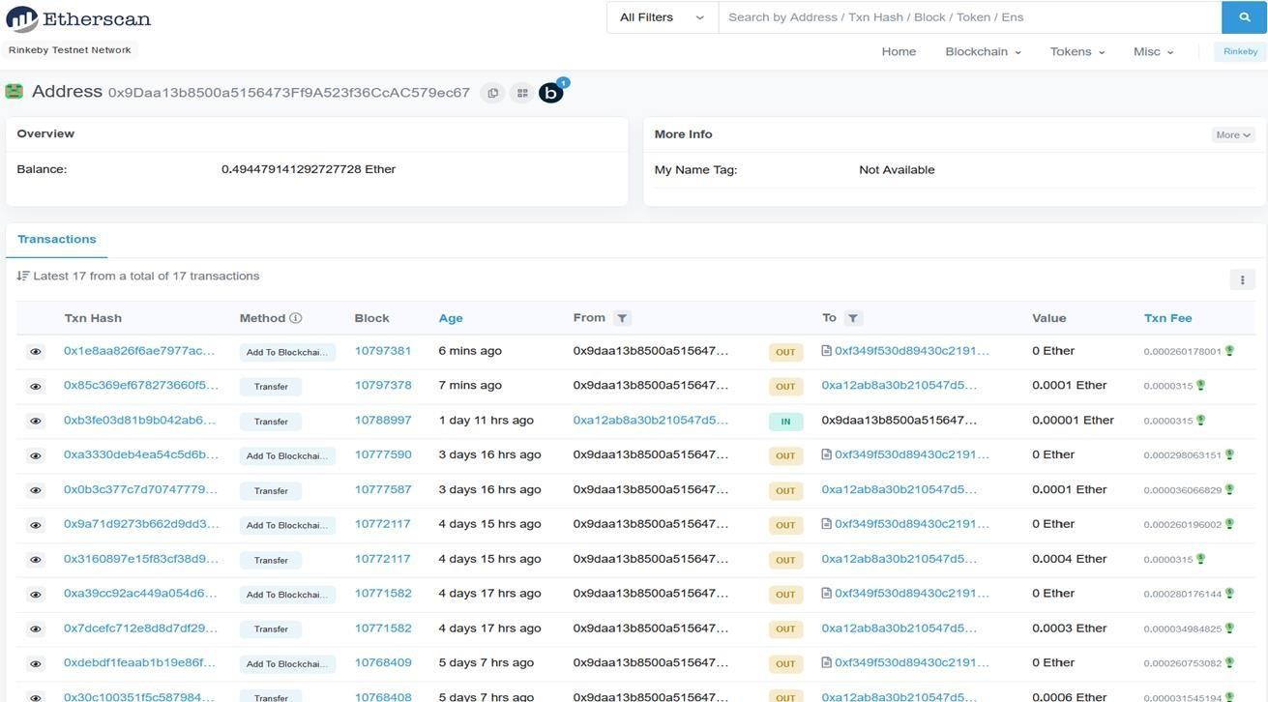

Figure 5: Shows the Transaction confirmation on MetaMask and Storing the Transaction on the Ethereum Blockchain

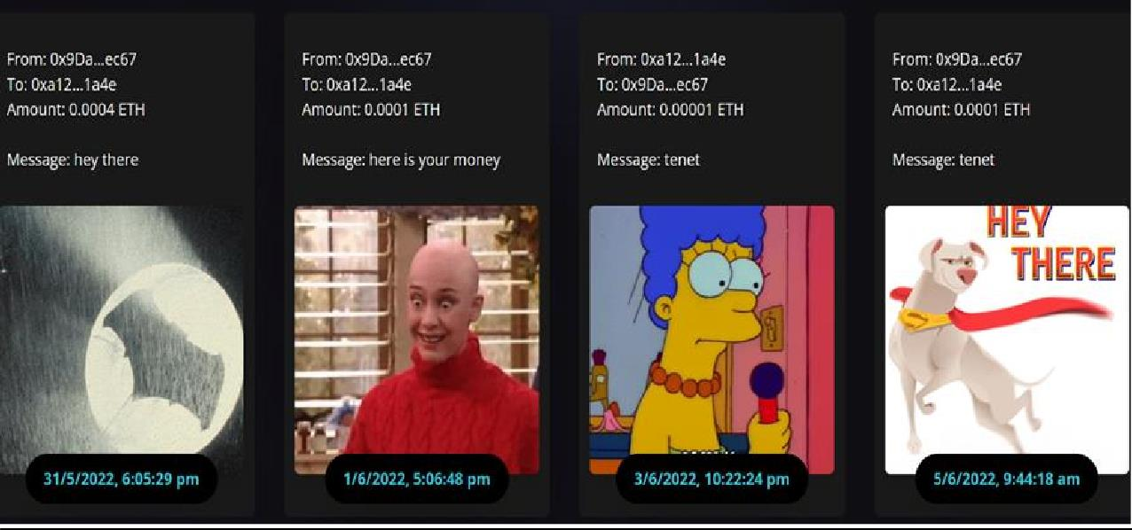
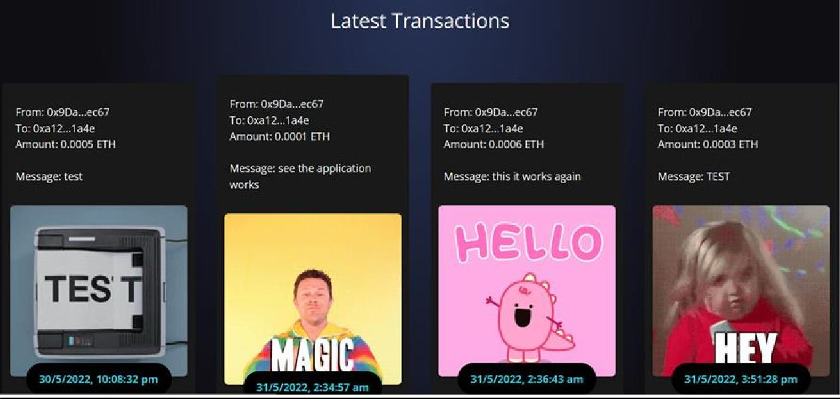

Figure 6: Shows the Transactions made from the wallet application with date, time, Address of both Sender and Receiver and Gif’s/Attached Message in the transactions.

- CONCLUSION AND FUTURE WORK

Conclusion:
Literature survey has been successfully conducted on different papers, journals which were on decentralized cryptocurrency wallets and Ethereum blockchain. The project successfully delivered on all requirement specifications. Care was guaranteed during the plan to ensure information uprightness is kept up with and to keep away from all types of redundancies related with information. The client is guaranteed a well-disposed interface, behind which there are colossal specialized subtleties. This venture has likewise been inherent such a way that future changes or changes that are required can undoubtedly be carried out without influencing the usefulness of the framework. Documentation has been successfully completed in every phase of the project.

Future work:
There is always room for improvement in any solution, however good and efficient it may be done. But most importantly it should be extremely flexible to accept further modification. For now, we are just dealing with ethers transactions and messages and gifs attachment. We can extend further this project by monetizing the platform as it is just a prototype. And we can also include decentralized exchange of different crypto currencies. Also, In the future the application provides many other services such as stock market rates of different cryptocurrencies as well as NFT’s.

REFERENCES

[1]“Enhancing the Decentralized Application (Dapp)for E-commerce by using the Ethereum Blockchain” by: P.Shamili and Dr.B.Muruganantham, SRM Institute of Science and Technology, Department of Engineering and Technology, Kattankulathur, Chennai.

[2] “Blockchain technology, bitcoin, and Ethereum: A brief overview” by: Dejan Vujičić, Dijana Jagodić, Siniša Ranđić, Faculty of Technical Sciences in Čačak University of KragujevacČačak, Serbia.

[3] “An Investigation into Smart Contract Deployment on Ethereum Platform Using Web3.js and Solidity using Blockchain” by: Sandeep Kumar Panda and Suresh Chandra Satapathy.

[4] “Survey on Blockchain-Based Smart Contracts: Technical Aspects and Future Research” by: Tharaka Mawanane Hewa1, (Student Member, IEEE), Yining Hu2, (Student Member IEEE),Madhusanka Liyanage3, (Senior Member, IEEE), Salil Kanhare4, (Senior Member, IEEE) and Mika Ylianttila 5, (Senior Member, IEEE) (PDF) Survey on Blockchain-Based Smart Contracts Technical Aspects and Future Research.

[5] “Decentralized apps of the future implementing Web3.” by: Aditya Patil, Prof. Santosh S (Computer Science and Engineering, Jain (Deemed to be University))

[6] https://imaginovation.net/blog/crypto-wallet-app-development-guide/ "DECENTRALIZED WALLET APPLICATION (Dapp wallet) ".

[7]"Building Blockchain Projects: Building decentralized Blockchain applications with Ethereum and Solidity "by Narayan Prusty (Author).

[8] https://docs.soliditylang.org/en/v0.8.14/ “Solidity Language documentation”.

[9] https://reactjs.org/docs/getting-started.html, “React JS official documentation”,

[10] https://www.dappuniversity.com/articles/how-to-build-a-blockchain-app , “Building a Blockchain application”.

