Machine Learning based Nutrient Optimization for Smart Aquaponics System

Prof. Ragini Sharma
Department of Information Technology,
Saraswati College of Engineering, Kharghar
Navi Mumbai, Maharashtra, India
ragini.sharma@it.sce.edu.in

ABSTRACT

Agriculture is considered as the primary occupation by a vast population of India. Considering the population of India, maximum yield of crops is the major requirement, which in turn requires a vast land with appropriate soil nutrients. The proposed aquaponics system provides a soil less solution of growing crops in less space. The IOT enabled automatic system monitors and maintains the temperature, humidity, pH and NPK nutrients in the tank water. The system automatically controls the operation of lights and fans depending upon the readings of temperature and humidity sensors. The concentration of nutrients in the biofilter are monitored through pH sensors. If concentration is high, then the water is diluted or else nutrients are added in the biofilter. The complete system can be monitored through a mobile app. The readings from various sensors were taken at particular interval of time and considered as a dataset for machine learning model for monitoring the growth of the plant. The amount of ammonium and nitrates were considered to be the prime parameters for predicting the growth of plant through machine learning models. The proposed system can be considered as an automatic soil less, temperature controlled agriculture solution for growing crop in limited area.

Keywords – IOT, fishes, plants, machine-learning, sensor, growth, nutrients

- INTRODUCTION

The growing demand of food supply has raised a concern with the increasing issues of global warming and natural calamities. With the increase in population, most of the land is utilized for residential use, leaving limited land for agriculture. The proposed system tries to provide a solution for all these issues. Aquaponic farming is a way of soil less farming in a limited space. It is a provision of growing plant and fishes together. The plants absorbs nutrients from the excreta of the fishes and thus leaving the pure water for the fishes. The system is automated through IOT. The proposed system has hydroponic tank for water storage, biofilter for constant filtering of water, Raspberry pi with sensors for regulating different parameters along with piping system to transfer water from one section to another. [1] The paper focuses on temperature detection, monitoring and maintaining through cooling fan. It also focus on monitoring the pH value through pH sensor. A siphon is maintained for cleaning and re coursing of water. [2] Due to increasing communities, less of farmlands are available for traditional farming and fishkeeping and thus impacting the availability of food. Also continuously changing climate has made it difficult to grown climate specific crops. This paper solve these issues through Aquaponics system with IOT. [3] The concept of Aquaponics is clearly explained in this. Aquaponics is basically a combination of hydroponics and aquaculture which provides a single system for growing plants and fishes together. The paper proposes an automatic IOT environment that uses sensors for automatic fish feeding and plant water supply system. [4] The tank water and air quality are monitored with the help of sensors actuators and microcontroller. The system also monitors the growth of fishes and plants and also warns the user through phone notification, well before any erratic condition. [5] This paper proposes an Aquaponics sustainable system, which regulates the growth of plant and fishes with minimum human intervention. The paper also proposes a mobile application for easy monitoring of plants and also for notification alerts. [6] Aquaponics system has provided a solution of growing crops in limited space. This system proposes vertical farming instead of horizontal one which requires more space. As the temperature, humidity and moisture can be controlled, this system is eligible to grow any crop irrespective of its restrictions for climatic conditions. [7] The system is an independent autonomous model through wireless sensor network. The system uses WPAN to smooth and systematic communication. [8] The paper proposes a mobile application to control and monitor different sensors through GSM.

- METHODOLOGY
- Details of Hardware

- Raspberry Pi : It is a microcontroller board
- pH sensor: This sensor will measure the acidity or alkalinity of the water in fish tank and nutrients tank. The value of pH sensor is between 0-14
- Water level sensor: This sensor is used to monitor the level of water
- DHT11 sensor for temperature & humidity: The DHT11 sensor is used to calculate environment temperature and humidity.
- Motors: Motors are used to pump water from nutrient tanks to biofilter tank and then to fish tank
- White LED Light: LED lights are very efficient and capable of producing the type of light needed by plants.
- Fan: The fan is used to remove the moisture and hot air from the room.

- Working
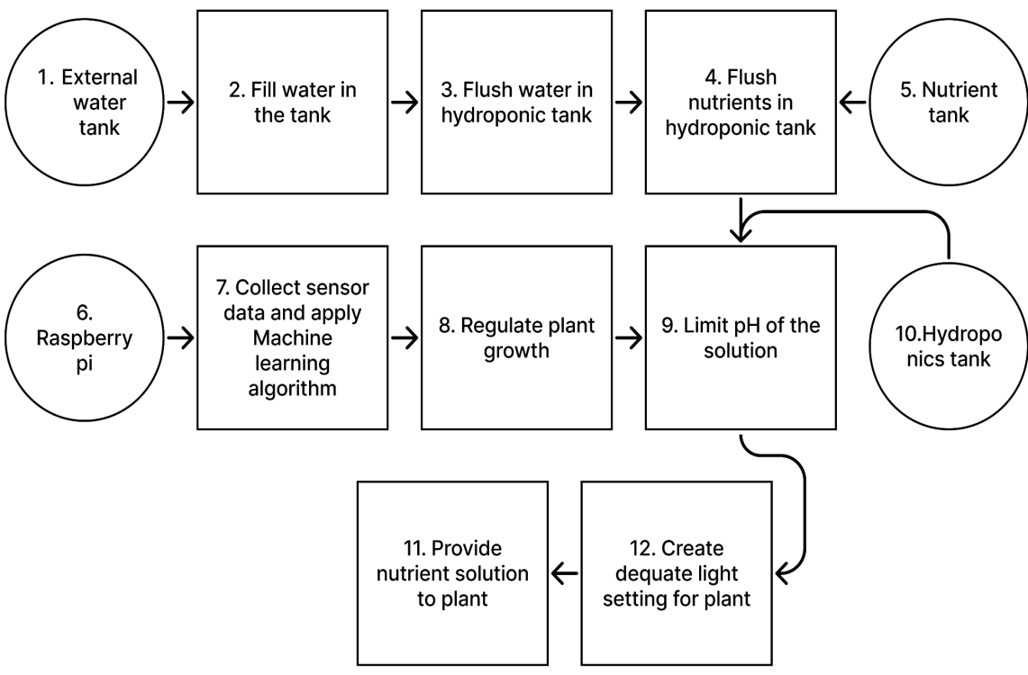
Fig. 1.1 Block Diagram of Aquaponics system

The working of Aquaponics system is explained through block diagram in Fig1.1

      - The core tasks of the system are performed through an external water source
      - This water is stored in a water storage tank which has a series of connections with other storage tanks.
      - The water from the storage tank is transferred to the hydroponic tank.
      - Some essential nutrients NPK, if required are added in the hydroponic tank.
      - The nutrient tank which consists of nutrients required for the plants.
      - A number of sensors are connected to a microcontroller Raspberry Pi.
      - Reading from various sensors are collected and machine learning algorithm is performed on this dataset.
      - The system provides an automatic solution to regulate the growth of plants based on the sensor readings..
      - First of those is pH regulation, since this water will be sent to plants, it has to have ~7 pH value.
      - The pH level of the system is regulated by adding water from hydroponics tank.
      - This nutrient and pH regulated solution is provided to the plant.
      - Depending upon the sensor reading, adequate light is provided to the plants.

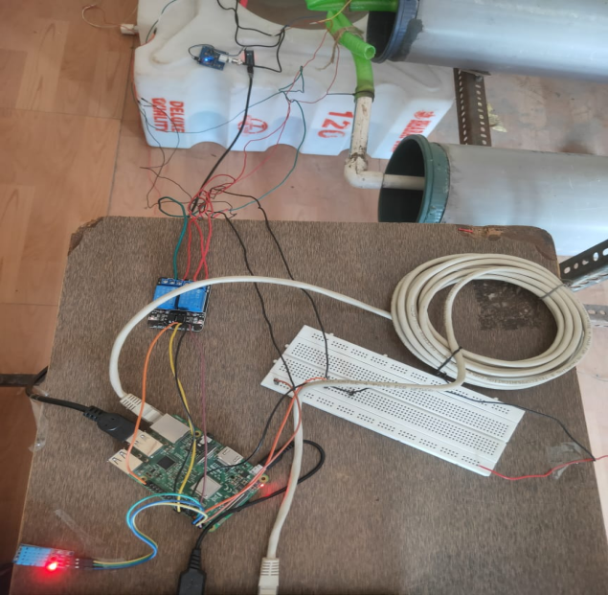
Fig. 1.2 Hardware connections of system
Fig 1.2 represents the hardware connections of Raspberry Pi and different sensors. The temperature and humidity sensors are connected to Raspberry Pi board. These sensors records the environment temperature and humidity. A particular temperature and humidity value is set according to a particular plant. If the temperature and humidity value exceeds the predefined threshold values than the servo motors on the fan, till the time the temperature drops to the required one. On contrast, if the temperature drops as compared to the threshold value then, the LED lights are turned ON, till the temperature returns to the required ones. The water level sensor in the hydroponic tank and the fish tank, monitors the level of water, thus preventing the overflow of waters from tanks.

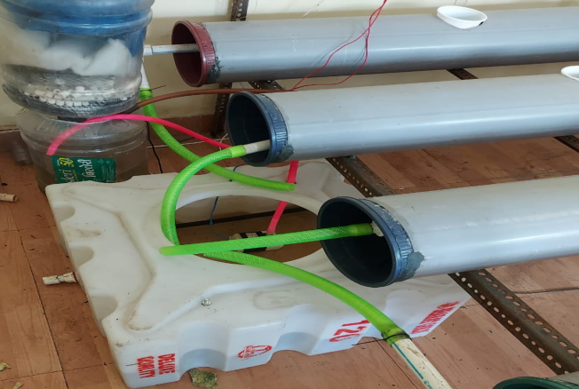
Fig. 1.3 Biofilter & Hydroponic tank
There is a symbiotic relationship between the plant and fish growth. The excreta of fish contains ammonia required for the growth of the plant. The fish tank water containing dissolved nutrients and particles of excreta are send to biofilter tank, as shown in Fig. 1.3. The biofilter tank filters the excreta. As the excreta can change the pH level of the water, it becomes necessary to check the pH value of water before forwarding it to hydroponic tank. The pH sensor checks the value and accordingly maintains the pH value in the range between 5.5 to 7.5. Once the water is in the pH range then it is forwarded to the hydroponic tank which is further supplied to the plants.
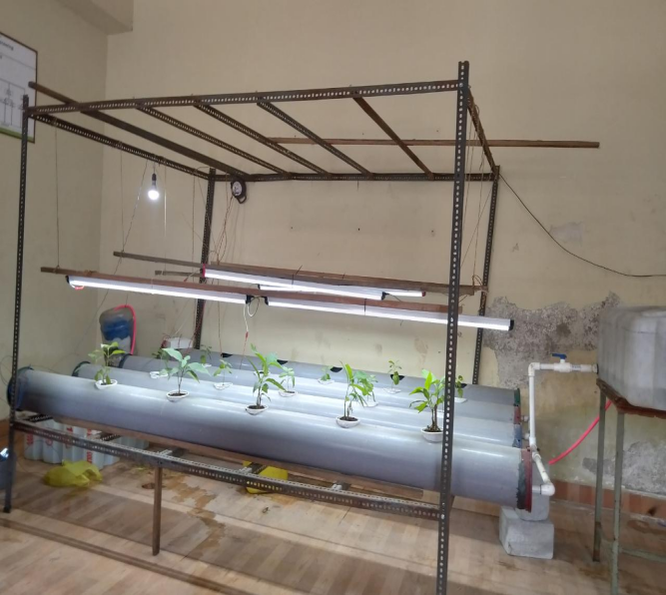.
Fig. 1.4 Structural setup of Aquaponics
Fig 1.4 represents the structural setup of Aquaponics system. The structural design of the aquaponics model is a 7 feet long structure providing a scope for the plants to grow. Various plant beds are place horizontally with each bed having water inlet and outlet. The plant selected for cultivation is Stevia. The seedlings of the plant is planted in the plant beds. The structure also has LED lights for maintaining proper light and temperature of the plant. A fan is provided to maintain the temperature. Both lights and fan is automatically controlled depending upon the readings of sensors attached to Raspberry Pi.
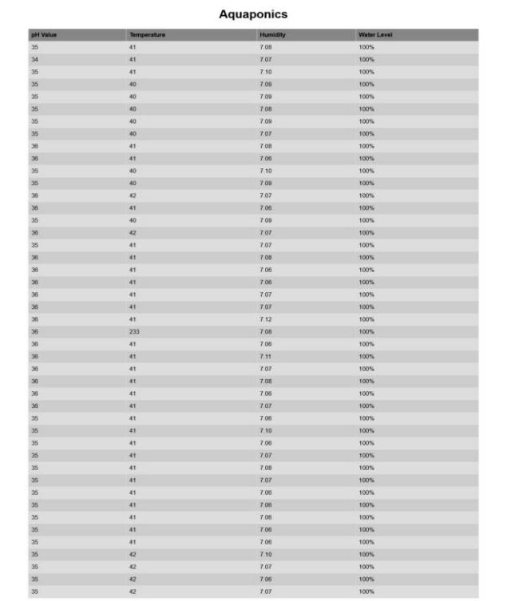
Fig. 1.5 Dataset with sensor readings
The temperature, humidity and pH values from various sensors are taken thrice a day at a particular fixed time for 120 days. These readings are stored and are considered as a dataset for machine learning model to predict the proper growth of the plant. A screenshot of dataset is shown in Fig1.5. The dataset also contains the readings based on the concentration of nutrients. Machine learning algorithm is used to predict the proper amount of nutrients required for the growth of the plants. First of all feature extraction is done through XGBoost classifier. The dataset prepared from the sensor readings is divided into training and testing data. Random forest algorithm is applied to predict the growth of the plant. An accuracy of 82% is achieved.

III. CONCLUSION

Aquaponics is the most efficient way of farming that could easily ensure the needs of all people and suits all climate around the world. This aquaponic model is not only sustainable, but can also be used to perform rain water harvesting on rainy days. This rain water collected can be recycled, purified and used for continuous usage in the whole aquaponic system. The automated model removes the dependency of farmers for continous monitoring of the crop. The crop can be monitored through mobile app. The IOT based system, automatically monitors the temperature and pH value. The machine learning model predicts the requirements of nutrients for proper growth of the plants. The system also ensures the growth of fishes by providing clean water with appropriate pH value

- References
[1] R Mahkeswaran, Andrew Keong NgSmart and Sustainable Home Aquaponics System with Feature-Rich Internet of Things Mobile Application (ICCAR 2020).
[2] Yaoguang Wei, Wenshu Li, Dong An, Daoliang Li, Yisha Jiao, Qiong Wei, Equipment and Intelligent Control System in Aquaponics: A Review (IEEE Access 2019).
[3] Siriporn Sansri, Wu-Yuin Hwang; Theerasak, Srikhumpa, Design and Implementation of Smart Small Aquaponics System(TICUC 2019).
[4] K S Aishwarya; M Harish; S Prathibhashree; K Panimozhi, Survey on IoT Based Automated Aquaponics Gardening Approaches(ICICCT 2018).
[5] N. Hari Kumar; Sandhya Baskaran; Sanjana Hariraj; Vaishali Krishnan, An Autonomous Aquaponics System Using 6LoWPAN Based WSN(IEEE FiCloudW 2016).
[6] M. Manju, V. Karthik, S. Hariharan, B. Sreekar, Real time monitoring of the environmental parameters of an aquaponic system based on the Internet of Things(ICONSTEM 2017).
[7] Akbar Riansyah, Rina Mardiati, Mufid Ridlo Effendi, Nanang Ismail, Fish Feeding Automation and Aquaponics Monitoring System Based on IoT(ICWT 2020).
[8]Adrian K. Pasha; Edi Mulyana; Cecep Hidayat; Muhammad Ali Ramdhani; Opik T. Kurahman; M. Adhipradana, System Design of Controlling and Monitoring on Aquaponic Based on the Internet of Things(ICWT 2018).
[9] Muhamad Asmi Romli, Shuhaizar Daud, Phak Len Eh Kan, Zahari Awang Ahmad, Sazali Mahmud, Aquaponic growbed siphon water flow status acquisition and control using fog server(MICC 2017).
[10] Fachrul Rozie, Iwan Syarif, M. Udin Harun Al Rasyid, Design and implementation of Intelligent Aquaponics Monitoring System based on IoT(IES 2020).

