**PRODUCTION OF BIO-ENZYME BY USING (*Citrus sinensis*) AND TESTING ITS ANTIMICROBIAL ACTIVITY OF MICROBES AGAINST HUMAN (*Homosapiens*) HAND**

**\*KRISHNAVENI.R1., NAJMA BEGAM.N1., ASHEERA ASHRIN.M1., LAVANYA.S1.,**

**ASIYA NACHIYA.H1**

1**.*KRISHNAVENI.R**1 Assistant professer and Head , PG and Research Department of Microbiology. Idhaya college for women Kumbakonam.

1. **NAJMA BEGAM.N1, ASHEERA ASHRIN.M1 ,**

**LAVANYA.S, ASIYA NACHIYA.H1** UG students Department of Microbiology .Idhaya college for women Kumbakonam.

Corresponding Author :* **KRISHNAVENI.R.** Email-krishnavenimicro@gmail.com

**Abstract**:

*Citrus sinensis* known as sweet orange.It has been traditionally used to treat cramps, colic, diarrhea,bronchitis ,cough,cold,obesity,menstrual disorder.The bio-enzyme is a universal natural cleaner produced from vegetables fruit peels.The present work carried out on production of bio-enzyme from *citrus sinensis* and testing its antimicrobial activity of microbes against human homosapiens hand .The present work concluded that the isolated microbes from cow dung *klebsiella sp* (15mm),*proteus* *sp* (14mm),*staphylo coccous sp* (16mm).

**INTRODUCTION:**

Human skin in the first layer of defence against various pathogenic microbes. The skin is infected by intrinsic and extrinsic microbial community on the skin (**P.Zeeumen**,***etal***.,**2013**).The non-pathogenic microbes present everywhere on human hand upto 1 ×107 bacteria per cm2(**D.Fredricks,*et al*.,2001).**The skin microbiology culture dependent studies with most samples from pathologies**.( A.Mathieu,*et al*.,2013).**The prevention of infectious disease has been a important goal for the elucidation of germs.Modern approaches include practising sanitize program and multiple personal hygiene practice(**Dixon RE,1961-2011).**Regular hand washing and practicing use of sanitizer rountine**. (WORLD HEALTH ORGANISATION,2009**) World Health Organisation recommended all people should,wash their hand before and after preparing food and before eating food. Bio-enzyme is a natural organic enzyme made from fermented *Citrus sinensis.*It can be used for floor cleaner,Glass cleaner and Dish washing.It also used in laundary.It also contain good bacteria.It leads to breakdown of strains .The bio-enzyme design to breakdown,certain molecules into smaller pieces.The countries with highest *Citrus sinensis* consumption are Luxembourg(104.76 kg/capita/year). (Food and Agriculture Organization ,Food supply crops 2019)

*Citrus sinensis* , also known as the *Citrus* *aurantium* sweet *Citrus sinensis* group, includes the commonly cultivated sweet *Citrus sinensis* , including blood *Citrus* sinensis and neval

*Citrus* sinensis. The most important commercial fruit crops grow all over the word citrus is a term commonly used for genus of flowering plants in family Rutaceae originating in tropical and sub tropical south-east regions of world. The grow also encompasses others citrus fruits such as *citrus reticulate,citrus vitis, citrus medica and citrus limon*. Citrus fruits are commonly cosumed because they can contain a high amount of vitamins, minerals and antioxident compounds that have many biological properties including Hepotoprotective, Antithrombotic, Antibacterial, Anti viral and Anti cancer activites. It also has a relatively low glycaemicindex which help in maintaining a more stable blood glucose level and generally healthier carbohydrates metabolism.

**Materials and Requirement**

Harmful microorganisms can be transferred from one hand to other hand and can cause transmission diseases of one self as well as to others.Therefore, this study was planned to isolate and identification of bacterial isolates from the hand and thumb of sports students.

**ISOLATION OF PATHOGENIC ORGANISMS FROM THUMB & HAND SAMPLES:**

The collected sample was inoculated on to nutrient agar and incubated at 37℃ for 24 hours to be 48 hours. After the incubation period, selected colonies of samples were transferred from mixed culture of the plate on to Respective agar plates and agar slants, and incubated at 37 ℃ for 48 hours incubation. Slant containing pure culture were stored at 4 ℃ for further re-examination. Cultural characteristic of pure isolated in nutrient agar media were regarded after incubation period at 37 ℃ For 48 hours incubation. Morphological methods consists of macroscopic,by various bio chemical methods. like Indole test, Methyl red test, VP test,Citrate utilization test, TSI agar test , Gelatin hydrolysis, Catalase test , Urease test, Starch hydrolysis.

**PREPARATION OF *Citrus sinensis* BIO-ENZYME PRODUCTION:**

Bio-enzyme products are added of jaggery (Gud) or black strap molasses is 100g and *Citrus sinensis* peels is 300g is added and the distilled water 1000ml is added and also the quarter (1/4)teaspoon dry yeast.The ratio is 1:3:10 ratio of jaggery: *Citrus sinensis*:peel:water

 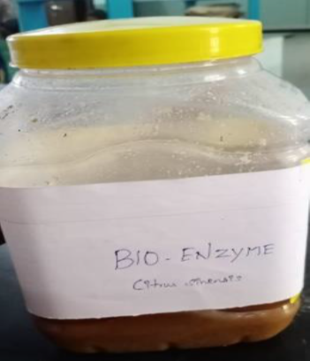

*Citrus sinensis* peels BIO-ENZYME

Citrus sinensis 26

**Result**

**Table-1:Microbial load of hand before and after using sanitizer**

|  |  |  |  |
| --- | --- | --- | --- |
| **S.no** | **Microbes** | **Total Bacterium Load(before)using** | **Total microbial load After** |
| 1 | *Klebsiella sp.,* | 2.4 ×103 | 2.2 ×103 |
| 2 | *Proteus sp.,* | 2.2 ×103 | 2.1 ×103 |
| 3 | *Staphylococcus sp.,* | 2.6 ×103 | 1.2 ×103 |

**Table-2:Biochemical Characteristics of *Staphylo coccus sp.,***

|  |  |  |
| --- | --- | --- |
| **S.No** | **Biochemical Test/Morphology** | **Results** |
| 1 | Gram staining | Coccus Rod |
| 2 | Cultural characteristics on agar slant | Abundant ,opaque |
| 3 | Gelatin liquefication | + ve |
| 4 | Starch hydrolysis | -ve |
| 5 | Lipid hydrolysis | + ve |
| 6 | lactose | Acid production |
| 7 | Dextrose | Acid production |
| 8 | Sucrose | Acid production |
| 9 | H2s production | -ve |
| 10 | No3 reduction | +ve |
| 11 | Indole production | -ve |
| 12 | MR Reaction | +ve |
| 13 | VP reaction | + |
| 14 | Citrate | -ve |
| 15 | Urease activity | -ve |
| 16 | Catalase activity | +ve |
| 17 | Oxidase activity | -ve |

1.(+)-positive 2.(-)-Negative 3.A-Acid

**Fig:1Biochemical characters of *Staphylo coccus sp.,***

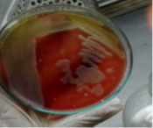

1. *Staphylo coccus sp.,* in **Blood Agar Medium**

**Table -3:Biochemical Characteristics of *Klebsiella sp.,***

|  |  |  |
| --- | --- | --- |
| **S.No** | **Biochemical Test/Morphology** | **Results** |
| 1 | Gram staining | Rod (-) |
| 2 | Cultural characteristics on agar slant | Slimy,white,somewhat,  translucent,raised growth |
| 3 | Gelatin liquefication | -ve |
| 4 | Starch hydrolysis | -ve |
| 5 | Lipid hydrolysis | -ve |
| 6 | lactose | Acid gas |
| 7 | Dextrose | Acid gas |
| 8 | Sucrose | Acid gas |
| 9 | H2s production | -ve |
| 10 | No3 reduction | +ve |
| 11 | Indole production | -ve |
| 12 | MR Reaction | +ve |
| 13 | VP reaction | + |
| 14 | Citrate | -ve |
| 15 | Urease activity | -ve |
| 16 | Catalase activity | +ve |
| 17 | Oxidase activity | -ve |

1.(+)-positive 2.(-)-Negative 3.AG-Acid gas

Fig:2 Biochemical characters of *Klebsiella sp.,*

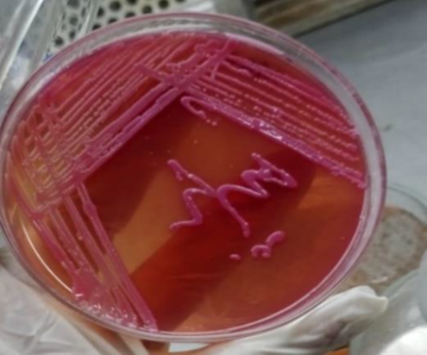 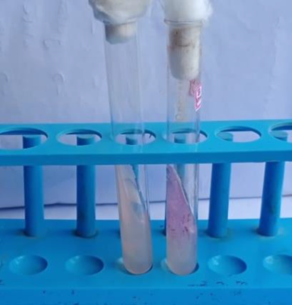

1. Klebsiella sp.,in Mac Conkey,s Agar B)Urease +VE

**Table-4:Biochemical characteristics of *proteus sp****.,*

|  |  |  |
| --- | --- | --- |
| **S.NO** | **Biochemical Test/Morphology** | **Results** |
| 1 | Gram staining | Coccus rod |
| 2 | Cultural characteristics on agar slant | Thin ,blue-grey,spreading growing |
| 3 | Gelatin liquefication | +ve |
| 4 | Starch hydrolysis | -ve |
| 5 | Lipid hydrolysis | -ve |
| 6 | lactose | -ve |
| 7 | Dextrose | Alkaline |
| 8 | Sucrose | Alkaline+_ |
| 9 | H2s production | +ve |
| 10 | No3 reduction | +ve |
| 11 | Indole production | +ve |
| 12 | MR Reaction | +ve |
| 13 | VP reaction | -ve |
| 14 | Citrate | -ve |
| 15 | Urease activity | +ve |
| 16 | Catalase activity | +ve |
| 17 | Oxidase activity | -ve |

1.(+)-positive 2.(-)-Negative 3.(A)-Alkaline

Fig:3 Biochemical characters of *Proteus sp.,*

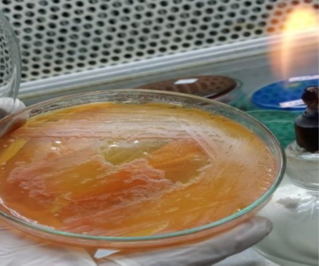 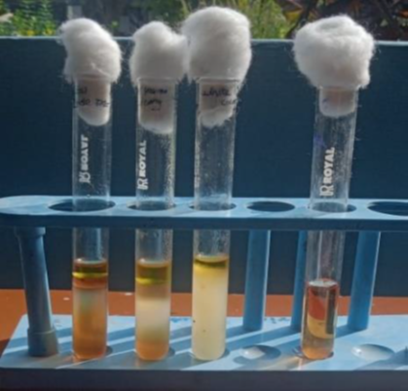

a)Proteus sp., in Macconkey agar b)Indole +VE

**Table-5:Testing Antimicrobial sensitivity of Isolates Against Bio-enzyme (*Citrus sinensis*)**

|  |  |  |
| --- | --- | --- |
| S.NO | Tested oraganism | Zone of inhibition |
| 1 | *Klebsiella sp.,* | 15mm |
| 2 | *Proteus sp.,* | 14mm |
| 3 | *Staphylo coccous sp.,* | 16mm |

**Fig: 4 Antimicrobial Activity of Isolated microbes Against Bio-Enzyme (*Citrus sinensis*)**

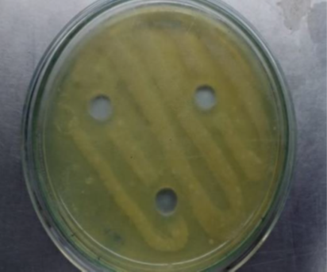

**A)Antibacterial Activity of *Citrus sinensis* Bio-Enzyme Against *Proteus sp.***

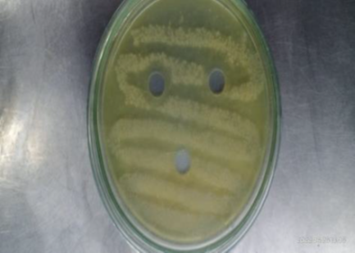

**B)Antibacterial Activity of *Citrus sinensis*Bio-Enzyme Against *Klebsiella sp***

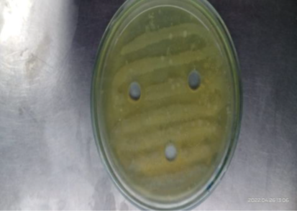

***C)* Antibacterial Activity of *Citrus sinensis* Bio-Enzyme Against *Staphylo coccous sp.,***

Table-1:Shows biochemical characters of *Staphylo coccous sp.,* In *Staphylo coccous sp.*, appears gram positive coccus rods. Cultural characteristics on agar slant it appears thin,even greyish growth.It appears positive on gelatin liquefication ,lipid hydrolysis ,NO3 reduction ,MR reaction,VP reaction Catalase activity.It appears negative on starch hydrolysis ,H2S production,Indole production, VP reaction ,citrate, Urease activity ,Oxidase activity .It appears acid production on Lactose,Dextrose, Sucrose.(Fig:1)

Table-2:Shows biochemical characters of *klebsiella pneumonia sp.* Appears gram negative rods.Cultural characteristics on agar slant it appears Thin,even greyish growth. It appears positive on NO3reduction,VPreaction, Citrate, Urease activity, Catalase activity. It appears negative on gelatin liquefication, Starch hydrolysis, Lipid hydrolysis, H2S production ,Indole production ,MR reaction, VP reaction ,Oxidase activity.It appears acid production on lactose, Dextrose ,Sucrose. (Fig:2)

Table -3:Shows biochemical characters of *proteus sp.,* in *proteus sp.,* appears gram negative rods.Cultural characteristics on agar slant it appears Thin,even greyish growth. It appears positive on gelatineliquefication , H2S production, NO3 reduction, Indole production ,MR reaction ,Urease activity, Catalase activity.It appears negative on starch hydrolysis, lipid hydrolysis ,lactose ,VP reaction ,citrate. It appears acid production on Dextrose , sucrose. (Fig :3)

Table-4:Shows the antimicrobial avtivity isolates against Bio-enzymes (*Citrus sinensis*).The maximum zone of inhibition 16mm in *staphylo coccous sp.*, The maximum zone of inhibition 15mm in *klebsiella pneumonia sp.,* The maximum zone of inhibition 14mm in *proteus sp.,* ( Fig :4)

**SUMMARY AND CONCLUSION**

Bio-enzyme is a universal Natural cleaner produced from vegetable fruit peels ( Usually *Citrus sinensis*) or waste .It is an effective alternative to harsh chemicals such as bleach, phenyl,and other chemical solution use typically to wash our bathrooms, clean toilets, wipe our floors, tiles and other surfaces.

Chemically they are a mixture of complex organic substances such a proteins, salts and other materials that are by-products of the bacteria/yeast that use will to make bio-enzymes.These organic substance are capable of the breaking down of chemical and other organic waste thus helping us in removing stains, odor, getting rid of other harmful microbes, etc. They also greatly neutralize toxins and pollutants. *Citrus sinensis* fruit peels are used sharp flavor, source of vitamin C and also rich in medicinal properties along with high acidity value. The jaggery which is added is utilized by microbes due to there metabolism ozone that is derived may kill the bacteria.

Several kinds of fruits and vegetables wastes can be used to perform enzyme and antimicrobial activities . These produced enzymes from garbage show positive bacterial results in the antimicrobial method. These bio-enzymes are very useful for enhancing the soil properties construction or other works. They are easy to make and provied tremendous effects on all over plant growth. Bioenzyme can convert trash into teasure.

The present work carried out on preparation of Bioenzymes from *citrus sinensis* and testing its antimicrobial activites against *Klebsiella sp*.,*Staphylo coccous sp*., and *proteus sp*., in our finding the maximum zone of inhibition in 18mm in *staphylo coccous sp*., and minimum 14mm in *proteus sp*., 15m.

Vitamin C supplements do not provide as much protective benefits as drinking a glass of *citrus sinensis* juice. *Citrus sinensis*is well known for its medicinal and nutritional properties all over the word. Its plant parts like peel, flower, fruit and juice are used as a traditional medicine. The available literature does not reveal any adverse or side effect. Clinical trials need to be carried out to exploit the therapeutic utility of orange in combating various diseases. No wonder the *Citrus sinensis* in combating various diseases. No wonder that *Citrus sinensis* are one of the most popular fruits in the world.

The present study concluded the *Citrus* sinensis Bio-enzymes shows potential antimicrobial activity, so the present study concluded that *Citrus* sinensis. Bio- enzymes act as a potential hand sanitizer.