Futuristic Trends in Project Management
Dr. Kirti Makwana
Assistant Professor
Indukaka Ipcowala Institute of Management (IIIM)
Faculty of Management Studies (FMS)
Charotar University of Science and Technology (CHARUSAT), India

- Introduction
The Project Management field is constantly progressing and will continue to gain importance as a strategic competency and important organization’s function in all the industry sectors. Businesses are gradually more accepting of a project-based methodology and the same momentum will continue in the coming decades. The pattern of working has transformed in Project Management field too. In this dynamic business world, where significant changes in society, environment, economy and technology are seen, Project Management filed too has to evolve and adjust to the changing conditions. This chapter presents major futuristic trends in the Project Management field.

- Trends in Project Management
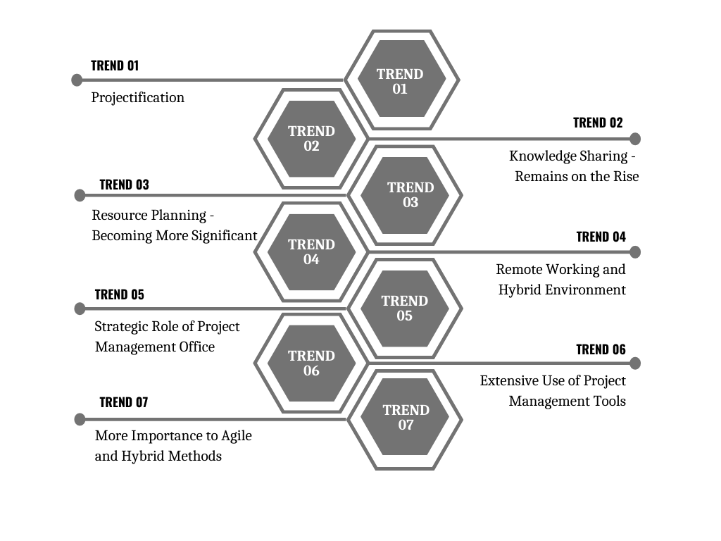
Figure -1 – Future Trends in Project Management

- Trend - 1 Projectification
“Project-based work will turn out to be the standard or business as normal in maximum sectors and most jobs, relatively somewhat distinct from, or entrenched within, monotonous, tedious activities.”
Projectification denotes the grade of dissemination of Project Management in all segments of the society which includes various industries, and private and public initiatives. (Packendorff and Lindgren, 2014; Midler, 1995). Though Project Management in terms of management innovation has at present stretched a great mark of dissemination, it will remain growing. This specifies that in the coming days even more sectors will apply Project Management methodologies to solve their multifaceted exclusive jobs. Further, more functional domains in the business will apply project management to create value and routine operations will be shifted to projects. Conventionally the corporations which are part of the project economy propose their goods as customized multifaceted facilities as in the construction, manufacturing, shipbuilding, or aerospace industries. Further, in the service industry product in terms of process is organized as a project. Today, whole IT and ITES companies deliver their tasks on a project-based. Projectification of societies refers to application of Project Management methods in the other industries not limiting to research and development, sports and culture, educational institutes, public administration etc. The time will come when a project society will be transformed from a project economy.

- Trend - 2 Knowledge Sharing – Remains on the Rise
Project Managers who are new to the profession or the organization can learn from experienced Project Managers who are skillful and knowledgeable. Experienced Project Managers can also sustain and improve their efficacy by continuous learning through knowledge transfer. Organizations which are regularly delivering successful projects have learnings from project experiences as one of the substantial aspects paying to the accomplishment of the projects. In time to come, Project Managers will focus on leading the projects and find ways to transfer knowledge. In the upcoming days, novel knowledge management tools will be developed and used which will help project managers to create and maintain a huge knowledge database. This will confirm that each employee is on the same page and that all guidelines, procedures and codes concerning a process are transparent.

- Trend – 3 Resource Planning – Becoming More Significant
The contemporary research studies and reviews have revealed that in project management resource planning is becoming more significant. In near future, dedicated resource planning tools shall be more in use which can:
- Identify the physical and human resources needed for a project
- Forecast the resources (required per day/week/month)
- Create project timelines and resource scheduling
- Maintain the availability of project team members

- Trend - 4 Remote Working and Hybrid Environment
The latest research in the human resource management area endorses that in the coming years, workplaces will be more diverse. In upcoming days, there will be an increase in diversification in project teams due to changes in the policies, gender representations, globalization etc. In near future, because of wide-ranging categories of employees (comprising of permanent, part-time, tele workers, freelancers etc. there will be complications in administration, communications and team dynamics. Diverse workforce possibly complicating clerical operations, routine communications and team dynamics. Loehken (2016) endorses, the diverse groups are extensively used for workin on events and projects. The team comprises different genders, generations, and members of different nationalities and cultures. Loehken (2016) confirms that diverse teams can bring creative solutions and designs as compared to homogeneous teams.

Because of technological development and various platforms for virtual communication, project teams from various geographic locations can form part of the project. It is expected that there will be an outburst of remote project teams. It will reduce the administrative, travel, and logistics cost. However, it becomes complicated to manage the work as the team members are working remotely, from different geographic locations and different time zones. After the Covid-19 pandemic, there has been an unparalleled shift in the way of managing projects. The primarily young generation is preferring flexible and remote working hours across industries. Project Managers are now required to enhance their knowledge about diversity and take the maximum out of the team’s capabilities. To manage diverse teams successfully, project managers are required to enhance their acquaintance of diversity management in order to make all the members will be involved in the project and can contribute to its implementation with maximum use of their capabilities. (Betchoo 2015; Sayers 2017).

- Trend – 5 Project Management Office’ Strategic Role
The Project Management Office (PMO) is gradually taking on accountability for the execution of strategic goals. Administratively, it is greatest advantageous if the PMO is recognized as a policymaking division by means of direct admittance to the top management. In the same view, effective Strategic Capacity Planning necessitates an organization-wide resource outline and decent expertise. Exploring and preparing appropriate resources is indispensable. As a part of Portfolio Management, the PMO should focus more on aborting the weaker projects in near future.
In the upcoming days, PMOs must support the below-mentioned changes:
- Robust connections with the top management
- Additional harmonization in management of resources
- Contribution to manage portfolio
- Flexible usage of Project Management approaches
- Specific supervision and backing for project managers in customary, agile or hybrid procedures and approaches
- Learnings to be made pragmatic and continuing modifications to the Project Management Guide

- Trend – 6 Extensive Use of Project Management Tools
Teams with specialized skill sets carry out the projects. Now it has become mandatory for an individual to have the know-how of project-based software in order to take the project to the advanced level. Many project management tools will require to undergo changes in order to meet the changing demands of the market. Projects in the future will be paperless and will maximum be using the internet to share the required information.
- Trend – 7 More Importance to Agile and Hybrid Methods
As per the Project Management Institute (PMI)’s research “The Drivers of Agility” brings into being that corporations functioning through a great mark of agility carry considerably additional projects to a positive and effective completion than those that don’t. Out of the organizations which are more agile, 68% use agile methods, 71% are predictive, and 72% use a hybrid methodology. While amongst the organizations which are less/not agile, merely 41% use agile methods, 45% are predictive, and 51% hybrid methods. The Agile community is swiftly growing, with added procedures and methodologies being industrialized every year.

- Conclusion
Project Management developments are determined by corporate trends, on the other hand, the project management can take creative, pioneering and problem-solving approaches to organization’s challenges. Nevertheless, altogether the challenges are exclusive and thus a broad-confrontation resolution will merely not suffice. Attainment of deliverables require a supplementary custom-made project management methodology personalized according to the project type, organization culture and industry. There is an era where all established organizations make out that all strategic revolutions take place over projects and programmes. The subsequent generation of project managers will be required to work on their skill sets to meet their existing as well as forthcoming requirements of the organization. In order to achieve success in this novel time, a project leader with a high-performing team is required. Project leaders must stand in an atmosphere wherein teams can accomplish their complete talent and overcome project challenges which leads to creating prospects for an individual, team and the organization; basically, a win-win for all.

- References
- Cooke-Davies, Terry. (2002), The “real” success factors on projects, International Journal of Project Management, 20. 185-190. 10.1016/S0263-7863(01)00067-9.
- Packendorff, J. & Lindgren, M. (2014), Projectification and its consequences: Narrow and broad conceptualisations, South African Journal of Economic and Management Sciences, Vol 17, No 1: pp. 7-21.
- McGrath, John & Kostalova, Jana. (2020). Project Management Trends and New Challenges 2020+. 534-542. 10.36689/uhk/hed/2020-01-061.
- Brownlee Dana. 2019. 4 Project Management Trends on The Horizon…Are You Ready? Available online: https://www.forbes.com/sites/danabrownlee/2019/07/21/4-project-management-trends-on-the-horizonareyou-ready/#23c3db976769 (accessed on 4 July 2022)
- Loehken Sylvia. 2016, The Power of Personality: How Introverts and Extroverts Can Combine to Amazing Effect, Hamburk: John Murray Learning Publishing.

