NURSING & MIDWIFERY PRACTICE
Mrs.Rajeswari.V, M.Sc( Nursing),Associate Professor, R.V.S College of Nursing, Kannampalayam, Coimbatore-641 402.
REFERRED BY
DR.S.Muthukumar,
Assistant professor,
Pharmaceutics,
KMCH college of Pharmacy,
Coimbatore.
IIP ID: IIPER1655893677
INTRODUCTION:
Nursing is a profession within the health care sector focused on the care of individuals, families, and communities so they may attain, maintain, or recover optimal health and quality of life. They also take on vital roles of education, assessing situations, and support. Nurses may be differentiated from other health care providers by their approach to patient care, training, and scope of practice. Nurses practice in many specialties with differing levels of prescription authority. “To significantly improve health and well-being of populations, to reduce health inequities and to ensure sustainable people-centered health systems”
DEFINITION OF NURSING:
Nursing encompasses autonomous and collaborative care of individuals of all ages, families, groups and communities, sick or well and in all settings.
Nursing includes the promotion of health, prevention of illness, and the care of ill, disabled and dying people. Advocacy, promotion of a safe environment, research, participation in shaping health policy and in patient and health systems management, and education are also key nursing roles. (ICN, 2002)
N= NOBILITY, KNOWLEDGE
U= UNDERSTANDING, USEFULNESS
R= RESPONSIBILITY
S= SIMPLICITY, SYMPATHY
E= EFFICENT
DEFINITON OF MIDWIFERY:
Midwifery is defined as “skilled, knowledgeable and compassionate care for childbearing women, newborn infants and families across the continuum from prepregnancy, pregnancy, birth, postpartum and the early weeks of life”.

Who is a midwife?
A midwife is a person who, having been regularly admitted to a midwifery educational programme, duly recognized in the country in which it is located, has successfully completed the prescribed course of studies in midwifery and has acquired the requisite qualifications to be registered and/or legally licensed to practice midwifery.
NURSING & MIDWIFERY PRACTICE:
Nursing & Midwifery practice as conducted by certified nurse-midwives and certified midwives is the independent management of women's health care, focusing particularly on pregnancy, childbirth, the post-partum period, care of the newborn and the family planning and gynecologic needs of women.
SCOPE OF NURSE-MIDWIFERY PRACTICE:
- Pregnancy-related care including prenatal care, birth, and postpartum
- Women’s primary care , health promotion & Family planning
- Assessment of the newborn and care of the well, term newborn during the first 28 days of life
- Treatment of male partners for sexually transmitted infections
- Health promotion, disease prevention, and individualized wellness education and counseling

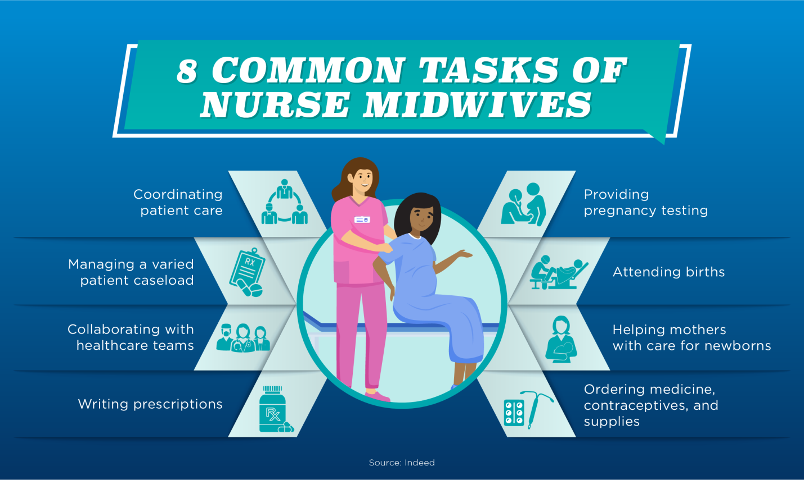

HOW MIDWIFERY HELP TO PREGNANT MOTHERS
- Monitoring pregnancy & baby
- Advising the mother to healthy eating & exercising
- Facilitating to ask questions comfortably
- Caring for women in labour
- Supporting women in 1:1 care in labour
DEVELOPMENT OF NURSE- MIDWIFERY SERVICE
- By the early 1800’s schools of nursing were being established throughout Europe. In 1860, Florence Nightingle founded ST.Thomas School of Nursing In London. She advocated the training of a “better class” of women as Nurses and Midwives to provide services to women.
- In 1872, the obstetrical society of London begin issuing certificates to qualitified midvies, in 1881, Rosalind paget, one of Miss Nigtingale’s Ladies “ Founded the midwives Institute now the Royal College of Midwives to reigister midwives and promoted a bill to ensure proper education and control.
- In 1902, the English midwives Act was passed. The act also brought central Midwives board, a statutory body controlling the training and practice of midwives.
- During the 19th century, obstetrics were greatly influenced by William Dewees. He brought into practice the lithotomy position for delivery, insisted on relieving pain during labour and advocated judicious use of forceps. He is considered as the “Father of American obstetrics”
- The American Medical Association founded in 1847 established a section on obstetrics women’s disease and children in 1873.
- Maternal and Child health services were first organized in India in 1912 by a committee of “the Lady Chelmsford League” which collected funds for child welfare and established demonstration on all India bases.
- In 1931, Indian Red cross Society started maternity centers in different parts of the country through its Maternal and Child welfare Bureau”.
- Internal organization like WHO & UNICEF also began to help the nations in improving Maternal & Child Health services. MCH scheme under family planning has been re-emphasized since 1977 along with the change in the name of the Department from family welfare.
Indian Nursing Council made an important decision in terms of training of nurses and midwives at that time only two courses were recognized:
- General Nursing and Midwifery (GNM) course
- Axillary Nurse Midwifery (ANM) course.
GOALS OF MIDWIFERY NURSING:
- Emphasize the naturalness of pregnancy as a normal part of mature human development.
- Promote the highest welfare for mother & child
- Prepare and educate all expectant mothers’ well-informed participants in care throughout the entire childbearing process from conception to delivery.
- Establish a supportive care environment that makes childbearing a positive experience and encourages the development of wholesome relationship between mother and newborn and within the entire family unit.
TRENDS IN MIDWIFERY NURSING

Economic issues trends:
- The cost of having and raising children continues to increase faster than family income as cost has increased and as more women work outside the home.
- Women of childbearing age are employed outside the home than ever before. Because cost of living is high.
- Poorly educated parents are even more likely to experience difficulty coping with the demands.

Trends related to technology:
- Advanced in technology had led to change in every aspects of our lives.it affects us as individuals, our families, our society or culture and may the approach child bearing.
- Technology allows diagnosing and treating serious deformities and diseases.
- Specific areas where advance in technology affect child bearing family includes:
- Fertility concerns
- Genetic counseling
- Ante partum or intra partum diagnostic testing.
Demographic issues and trends:
- Shift in population distribution large cities provide the greatest number of economic opportunities and convenience.
- Availability of maternity care in cities numbers of hospitals that are staffer and equipped to provide care to high risk maternity clients. Rural areas often lack these facilities.
- Increased cultural diversity, today significant members of people move away from their place of birth either temporary or permanently. This population has increased cultural diversity and presented new challenges to health care providers in all areas.
- Vital statistics include birth rate, maternal mortality & morbidityrates.To effects changes in mortality rated, the focus must shift from high-technology medical interventions to improving access to preventive care.

Trends in health care settings:
- Managed care is system of health care delivery that focuses on reducing the cost of health care through closely monitoring the cost of the health care of personnel.
- Hospitals have responded to consumers demand for a more natural childbirth environment.
- Nursing education curriculums are increasingly community based care.
- Routine hospitalization for mothers and newborn after an uncomplicated delivery is now 2 days or less. They are allowed to return home on medications with continued monitoring.
Trends in patient involvements:
- Maternity patients are usually well and thus their care focuses on enhancing health and wellness.visit to health care providers presents opportunity to address topics such as
- Nutrition education
- Stress management
- Smoking cessation
- Alcohol and
- Drug treatment.
Other trends:
- Increase in high risk pregnancies incidents of prematurity, Low Birth weight, congenital defects, learning disabilities and withdrawal symptoms in infants.
- High cost of health care a shift in demographic and increased emphasis of high cost technology.
- Lack of transportation, lack of insurance and high cost, a lack of providers for low income women.
CURRENT PROBLEMS:
- Decrease length of hospital stay
- Higher patient acuities
- Lack of facilities in rural areas
- Changes in maternal-newborn nursing
- Family centered care
- Labour, delivery, recovery and postpartum care (LDRP)
- Mother- baby couplet care
- Legal issues in delivery of care
- Ethical issues
- Future trends.
CHILD BEARING BELIEF AND PRACTICES:
- Communication
- Personal Space
- Use Of Interpreters
- Time Orientation
- Family Roles.
CULTURAL VARIATION IN MATERNAL CARE
- Emotional responses
- Clothing
- Physical activity and rest
- Sexual activity
- Diet
- Cultural aspects of lactation
- Post-partum care

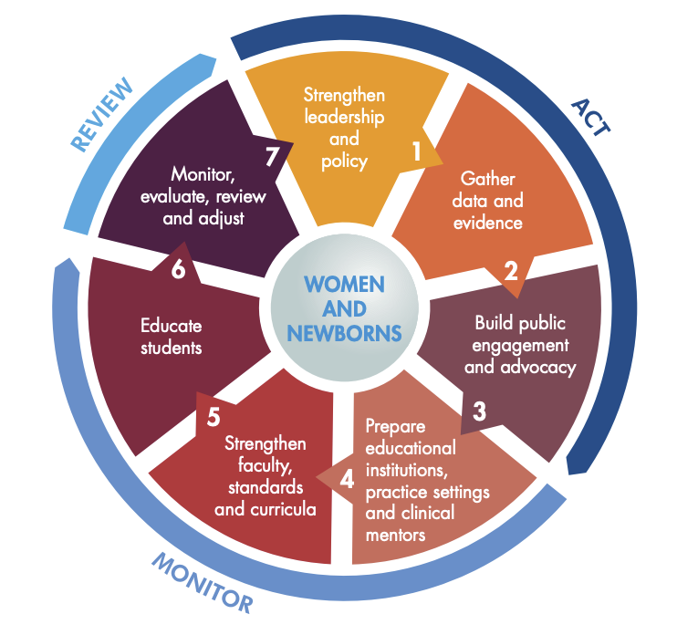

MATERNAL SCHEMES IN INDIA
- Janani-Shishu Suraksha Karyakram.
- Janani Suraksha Yojana.
- DAKSHATA Implementation Package.
- Pradhan Mantri Surakshit Matritva Abhiyan.

Janani-Shishu Suraksha Karyakram
Government of India has launched the Janani Shishu Suraksha Karyakaram (JSSK) on 1st June, 2011. The scheme is to benefit pregnant women who access Government health facilities for their delivery.

- Free and cashless delivery
- Free C-Section
- Free drugs and consumables
- Free diagnostics
- Free diet during stay in the health institutions
- Free provision of blood
- Exemption from user charges
- Free transport from home to health institutions
- Free transport between facilities in case of referral
- Free drop back from Institutions to home after 48hrs stay
- Janani Suraksha Yojana.
JANANI SURAKSHA YOJANA.
Janani Suraksha Yojana (JSY) is a safe motherhood intervention under the National Rural Health Mission (NRHM) being implemented with the objective of reducing maternal and neo-natal mortality by promoting institutional delivery among the poor pregnant women.

Role of ASHA or other link health worker associated with JSY would be to:
* Identify pregnant woman as a beneficiary of the scheme and report or facilitate registration for ANC.
* Assist the pregnant woman to obtain necessary certifications wherever necessary.
* Provide and / or help the women in receiving at least three ANC checkups including TT injections, Iron &Folic Acid tablets.
* Identify a functional Government health center or an accredited private health institution for referral and delivery.
* Counsel for institutional delivery.
* Escort the beneficiary women to the pre-determined health center and stay with her till the woman is discharged.
* Arrange to immunize the newborn till the age of 14 weeks
* Inform about the birth or death of the child or mother to the ANM/MO
* Post natal visit within 7 days of delivery to track mother’s health after delivery and facilitate in obtaining care.
* Counsel for initiation of breastfeeding to the newborn within one-hour of delivery and its continuance till 3-6 months and promote family planning.

DAKSHATA IMPLEMENTATION PACKAGE.
District Administration enabled the Dakshata Initiative to find solutions to this multi-pronged problem.
- The Initiative focuses on capacity building for supply side frontline workers,
- Routine tracking of pregnant women to enable safe deliveries,
- Analytical exercises to examine the causal factors and bottlenecks to efficient health service delivery, and
- Effective decentralization in decision making which allows village level contextual needs to be translated to planning interventions at the Block and District level.
PRADHAN MANTRI SURAKSHIT MATRITVA ABHIYAN
Pradhan Mantri Surakshit Matritva Abhiyan (PMSMA) was launched to provide fixed-day assured, comprehensive and quality antenatal care universally to all pregnant women (in 2nd and 3rd trimester) on the 9th of every month.
Objectives:
- Antenatal care is routinely provided to pregnant women, special ANC services are provided by OBGY specialists/ Radiologist/ Physicians at government health facilities under PMSMA.
- As part of the campaign, a minimum package of antenatal care services are provided to pregnant women in their 2nd/ 3rd trimesters of at Government health facilities (PHCs/ CHCs, DHs/ urban health facilities etc) in both urban and rural areas.
- Using the principles of a single window system, it is envisaged that a minimum package of investigations and medicines such as IFA and calcium supplements would be provided to all pregnant women attending the PMSMA clinics.
- The critical components of the Abhiyan is identification and follow-up of high risk pregnancies and red stickers are added on to the Mother and Child Protection cards of women with high risk pregnancies.
Conclusion:
Ending preventable maternal death must remain at the top of the global agenda. At the same time, simply surviving pregnancy and childbirth can never be the marker of successful maternal health care. It is critical to expand efforts reducing maternal injury and disability to promote health and well-being.
Every pregnancy and birth is unique. Addressing inequalities that affect health outcomes, especially sexual and reproductive health and rights and gender, is fundamental to ensuring all women have access to respectful and high-quality maternity care.

