“Agritourism” – a model for natural resource sustainability and rural development
Sanjeeb Pal (orcid=0000-0003-0567-9086)
Author Affiliations
Professor - Amity School of Hospitality,
Amity University Rajasthan
Kant Kalwar, NH-11C, Jaipur Delhi National Highway
Rajasthan- 303002, India.

Corresponding author: sanjeebpal2002@gmail.com

Abstract:
CONTEXT: India is a country with diverse climatic conditions and a variety of cultural offerings with agriculture as the backbone. It is always observed that Natural calamities resulting from misuse or overuse of land resources cause havoc in terms of culture as well as the economic condition of the host population, especially the farmers. They desperately need guidance on sustainable agriculture and Agritourism practices as a source of alternate income.
OBJECTIVE: The present study covers these aspects and attempts to form a linkage with tourism resulting in both economic progress and resource sustainability.
METHODS: The Researcher follows a combination of Ethnographic Study and Case Study methods, by systematically deriving information from the results of findings that were conducted to address similar types of queries. Personal Interviews were conducted at selected places of Agritourism in the Maharashtra district of India, to compare and form a model for Agritourism development.
RESULTS AND CONCLUSIONS: The result shows that Visitors are willing to travel to these destinations as an attraction, and Agriculture forms a major part of the same. A systematic way of land use can help the farmers to sustain their agricultural produce and linking with tourism can result in an alternative source of income as well as sustainable development of the area.
SIGNIFICANCE: The Review and Analysis can result in further research on the area and could be a source of a Sustainable Model which could be followed throughout since proper use of land and uplifting of the economic conditions along with preservation of heritage is required globally.

Keywords: Agritourism, Sustainability, land use, economic development, Principles of Agritourism, Sustainable Development.

Introduction:
Agriculture has been the pillar of the Indian Economy for decades. It is more of our culture than just a profession. Recent developments in Technology and the way of producing more with less input may have added the necessary input required to excel in this field, but, the 2019-20 report on Economic Survey shows a decline in the impact of agriculture on the economy of the country. The decline may be attributed to the higher growth performance in other non-agricultural sectors. (Table 1).
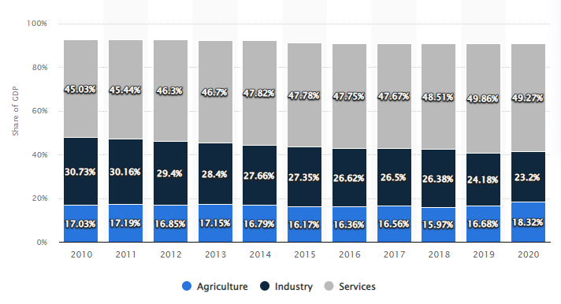
TABLE 1: Source: https://www.statista.com
Due to this reason Development of Rural Areas has become a Top priority for most developing countries (Fariborz Aref 2009)[1]. One major issue the Farmers in the 21st Century are facing is the problem related to Natural Calamity and how to overcome the disasters happening beyond the human call. Since natural calamities have a substantial negative impact on agricultural production at the local level, it is very important to have assistance to affected households in terms of post-disaster employment opportunities ( DC Israel, RM Briones – 2012). This raises a very important question in mind as to- (Q1): “What could be a Sustainable diversification option to enhance the economic condition of the farmers’?
India is a country with a diverse cultural Heritage in place and most of the cultural sites may be located within the periphery of rural India. The locals or the host population are majorly concerned with ensuring the conservation of the cultural heritage, as well as the various rituals and festivals, celebrate locally. Some of the most important components of rural landscape are the important buildings and historic places as well as monuments and other physical resources which may be considered worthy of safeguarding (UNESCO 2013). Several mountainous regions in India are famous for their unique landscape, torrential rainfall, and agricultural richness – an example is the Garo, Khasi, and Jaintia Hills. The area is very rich in its floristic and biodiversity. These three places are further credited with the practice of “Sacred grove” or managing the forest with sustainable biodiversity conservation [17]. Even though agriculture and Tourism research bodies are growing but still proper evidence suggesting the associations between Agriculture and Sustainability of the Tangible Rural Heritage is missing [6]. It is also a common fact that most of the architectural and cultural heritage, along with the Natural resources of a particular place is always exploited in the name of tourism. These resulted in a value degradation of our Cultural, Historic as well as environmental heritage [16]. All these factors raise my second question– (Q2): Can Agritourism in linkage with Rural Tourism become a Model for sustaining the Rural Heritage as well as becoming an alternative means of generating income for the farmers?

Theoretical framework:
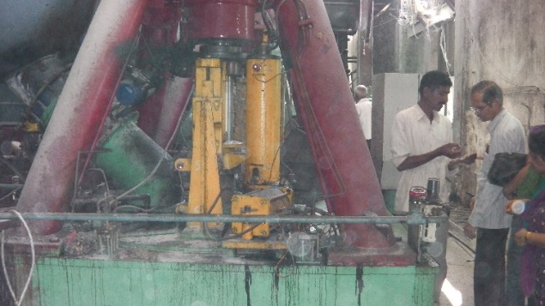
Rural tourism and agritourism are two concepts that are closely related. Rural tourism typically includes activities related to living in the country, its culture, religion, and everything else that is understood through ethnography, in addition to farm production and processing. Agritourism refers to tourist visits to farms and ranches in small towns that are well-prepared with packages that include activities in rural regions and excursions to food processing facilities..
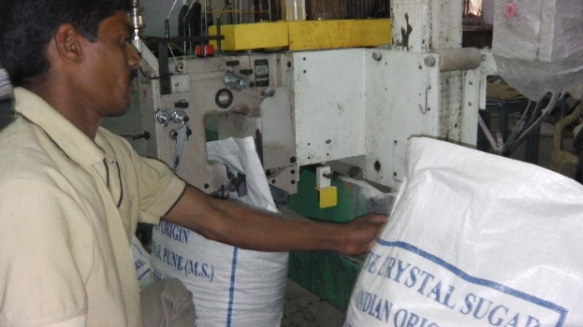
(a) (b)
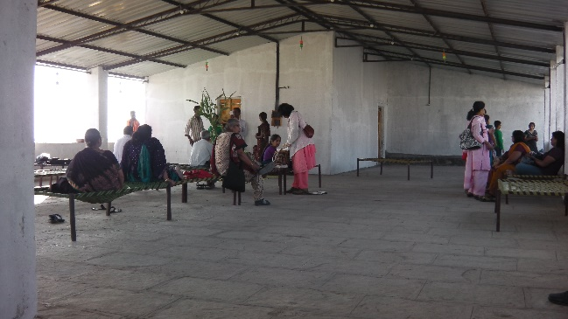
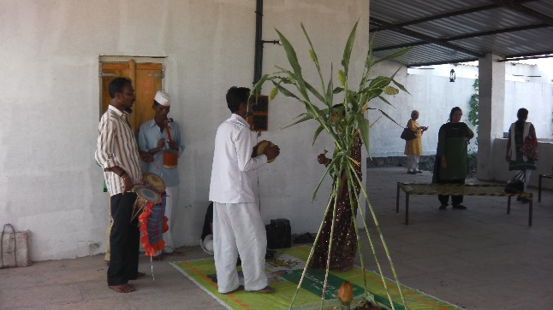
FIGURE 1 – (a) & (b) - Sugar Processing Unit at Baramati Agritourism Farm- Pune, Source: Author
(a) (b)
FIGURE 2- (a) & (b) Local Rituals & Food Service at Govind Bag- Agritourism Farm- Pune, Source: Author
Chantell LaPan & Carla Barbieri (2014),[2] established that Agritourism is a suitable tool to preserve Rural Tangible Heritage since the Cultural and Personal Values belong to the farmers. But to gain economically from the heritage assets, they should make the preservations sustainable through information about the historic buildings and site visits of the tourists. In their study, N. Ray et al. (2012) [13] came to the conclusion that rural tourism is expected to become a crucial component of sustainable human growth, including the reduction of poverty, the creation of jobs, the regeneration of the environment, and the development of remote areas, as well as the empowerment of women. In their article from 2016 [18], Singh, K., Gantait, A., Puri, and Swamy addressed the need, potential, and marketing strategy for rural tourism in India. The focus will be on promoting village tourism as the main type of travel to reap the greatest socioeconomic benefits. According to Sanjeeb Pal and Dr. Madhu Murdia's study from 2018 [14], some of the biggest obstacles to agritourism initiatives are a lack of awareness among farmers, a lack of opportunities for learning about the industry and carrying out projects, and a lack of policies and infrastructural assistance. In his study on the typology of agritourism, Pal, S. (2016) [11] came to the following conclusion: Farming-related activities are conducted for fun or education on a working farm or in another agricultural location. According to Santucci, F. M. (2013) [15], agritourism has been a very good possibility for boosting farm employment and income since the early 1980s. Agritourism has permitted both horizontal and vertical diversification under the new paradigm of multifunctionality.
Another strong aspect was to look into the concept of Agri-Tourism from the point of view of the Tourist or the community. Does the tourist want to embrace community-based tourism without the frills of luxury on their lap? Dalen (1989)[4], in their study, spoke about new tourists who are modern idealists, and seek excitement and entertainment but are also interested in more intellectual and cultural activities. They refuse mass tourism and fixed itineraries. Gray's (1970) [7] wanderlust tourist is another interpretation of the new traveller that chases multi-destination vacations and looks for foreign cultural encounters to sate the thirst for both learning and exoticism. Fiorello, A., & Bo, D. (2012) [5] conducted a study using six case studies, under the stipulations of internal project origin, internal management, and economic, psychological, social, and political empowerment of the public, and concluded that community-based ecotourism projects are designed to be sustainable and to meet new tourists' expectations for immersion in the local life, environmental conservation, and sustained quality of life of the host community.
The Albergo Diffuso is examined by Cucari, Wankowicz, and De Falco (2019)[3] as an illustration of sustainable community-based entrepreneurial land use. It served as a significant example of sustainable tourism and demonstrated how entrepreneurship and the region working together can improve the landscape and build popular tourist sites while generating profit for all parties involved.
Research Methodology:
This paper uses a combination of the Ethnographic Study and Case Study method and pooled information required to systematically search and combine the results of studies that addressed a similar kind of question. Most of the data used in this editorial has been drawn from Secondary sources, ie. Scholarly publications, policy papers, and other relevant public bodies and international agencies. Some primary data were collected from observations and verbal discussions with some Agritourism farms in Maharashtra.
Case study of Lepchajagat: Sunny Rawat (2020)[12]- This study was conducted on a small village in the Darjeeling district of West Bengal called Lepcha Jagat, 19 km away from the town of Darjeeling. Tourists can get hands-on with the process of cultivation and interact with the pet animals and livestock on the farms. From tending chickens with your little one, feeding the pigs to riding a horse – everything can be availed within the farm destination. This kind of Tourism provides an opportunity for the travelers to embark on an agritourism adventure, knowing the nitty-gritty of farming techniques while staying on a local farm and touring the entire facility. The study revealed that this area got developed due to the introduction and combination of Tourism along with Agricultural activities. It enhanced the growth of the service sector and resulted in the conservation of rural ecology sustainably. The pattern has also resulted in environmental conservation through sustainable land use and resource conservation. It has also helped in linking the gap between the urban and rural population thereby creating room for economic parity and development.
A case study from Poncokusumo, Malang, Indonesia: Hakim L, Siswanto D, Rahardi B, Zayadi H (2019)[8]- This village is located on the South border line of Bromo National Park in Indonesia at the western side of Semeru sloping area. It falls around 40kms from eastern Malang with beautiful sightseeing surrounded by green apple plantations. The study focuses on Poncokusumo since ecologically it is a vital buffer zone area for biodiversity conservation in the national park system. Most of the land in the area is dominated by the cultivation of corn, vegetables like cabbage, citrus fruits, and green apples. It was discussed in the study that a lot of unsustainable changes took place due to intensive crop cultivation resulting from the desire for high economic benefit. The tourist location Poncokusumo is situated within a network of tourist attractions and has a fantastic resource for attractions. Consequently, there was a chance to use coffee-based tourism as a method for sustainable development.
Cases of selected micro-entrepreneurs (Cavite, Laguna, and Rizal provinces), in the Philippines, Tugade, L. O. (2020)[20].: This study mainly focused on the motivational aspect of Agritourism and the reasons which lead to the acceptance of this concept. Personal hobbies and a deep urge to share and show the visitors the cultural heritage they inherited were one of the motivational factors. The farm owners also mentioned that the second -income source which contributed to the well-being of the owner is also another factor. Seasonality sometimes resulted in a disbalance of income from farming which was getting compensated through the introduction of Tourism and attaching it to their farm. Some farmers did invest a small amount of money to create some sort of infrastructure like a place to serve food or a place to stay and take rest for the tourist. Instead of selling the harvest to the whole sellers, they started selling it to locals which again created an alternate source of revenue for the host populations. Crop variety methods, conservation of agricultural lands, improvement of environmental practices, and education of visitors about environmental issues are among the ecological outcomes of agritourism practice.
In a 2019 interview with Mr. Manoj, the proprietor of the "Parashar Paryatan Kendra," he stated, "I founded the Agritourism Tourism Centre", adding, "I procured the property on lease for 5 years and then developed the whole concept with the cooperation of another 7 farmer friends." My farm has had over 7500 visitors as of right now, and that number keeps rising. This show that Agritourism Models are now being picked up by many villagers to boost their income level. This particular village has been formed by 7 villagers and the result was visible from the guest comments received and checked from the trip advisor- “Enjoyed myself a lot at Parashar. Manoj and his staff were wonderful hosts and made sure we had a great day. Manoj had planned wonderful outings to a neighbouring picturesque lake and a nearby grassland where we had the opportunity to see a herd of blackbuck and deers. We also saw a fox on the way. We enjoyed some fantastic traditional Maharashtrian meals and snacks during our stay. Manoj loves the idea of agritourism and has excellent understanding of the local flora and fauna.”- (Source: https://www.tripadvisor.in/Hotel_Review-g297654-d3833413-Reviews-Parashar_Agritourism- Pune_District_Maharashtra.html)
The income generated through the introduction of the concept contributed a lot to their economic condition in the form of an alternate income., “I think this operation gives us that additional income which otherwise we miss., since most of the time the wholesalers do not pay us the amount as per our expectation” (Interview, 2019).

Discussions:
Agritourism may be deemed as one of the models which may result in fulfilling the gap between Tourism Promotion of a particular destination along with Sustainability of the destination in terms of the Tourism products as well the environmental concerns. The model of Agritourism promotion and set-up in a particular destination may broadly address the following issues which are all considered to be a very important factors in the development of a sustainable tourism destination.
a) Preservation of Heritage and Culture
Conservation/preservation/revitalization of our Cultural and Heritage features of Indian Villages, its traditional customs, and rich history are all somehow or the other linked with the growth and sustainability of our villages. The promotion of these villages through a unique form of tourism would go a long way in restoring and presenting our traditional Indian Culture.
b) Sustainable diversification in the economic condition of the farmers
Though India is considered to be a country that depends mainly on its Agriculture produce (66.7% of the population engaged in Agriculture - https://www.economicsdiscussion.net), still the Diversity in Agri produce is in a nascent stage. (Kumar, Anjani & Saroj, Sunil & Singh, R.K.P. & Jee, Shiv. 2016)[10]. If the farmers are trained in the production of different homegrown Vegetables and Fruit trees along with animal husbandry, it may allow farmers to increase their income. Here, the linkages between Tourism activities and Agriculture can work out as a model to open up a profitable market for the farm products and create an opportunity at a large for the regional Tourism market to go and enjoy their roots. This planting of different agricultural products helps the farmers in increasing their income and also improves soil health.
c) Conserving the Natural Infrastructure – Natural and cultural resources have always been an attraction for any kind of tourist. Conserving and Showcasing the Natural Infrastructure in the form of sightseeing attractions through the Host population may go a long way in promoting a sustainable mechanism for Heritage conservation. One option of promoting the heritage cuisines of India through the idea of Agritourism may go a long way toward sustenance.
d) Promote sustainable Indigenous farming practices
Since there is a huge gap between the Government’s policies on sustainable farming practices and the education of the farmers in most places, the farmers and the rural communities get into wrong ways to increase their farmland produces, which may result in severe damage to the environment as well as the farming community. For example, the locals in most of the Hill stations in India are cutting up trees to increase their farm produce for sustenance and land up farming near the bank of rivers. Farming too close to the riverbeds cause serious damage to the soil and result in heavy flooding and landslide during the rainy seasons. If the local farming pollution is sensitized to the importance of following a proper pattern of land use, it may result in better use and the same model may be used or copied in other places. Digging of trenches near the riverbanks may result in water conservation, cultivating shrubs near the river banks could help in sustaining soil erosion and planting of Indigenous trees shall help in controlling soil erosion and landslides. Farming away from the riverbanks shall help in preventing floods.
Basic principles required to embrace Agritourism successfully- a checklist.
Three fundamental tenets must be followed for agritourism to succeed:
1. Viewers have something to look for—agriculture tourism can provide visitors with flora and animals, farms, and the outdoors. Additionally, agricultural tourists may be quite interested in culture, attire, festivals, and rural games.
2. Participating in activities that will involve visitors, such as farming, swimming, riding horses in the country, cooking, and rural sports that visitors will like.
3. Visitors have the option to buy/carry - Option to purchase local goods for consumption or exhibition or to carry a souvenir as a memento.
What to look for: Options
The farm…
Making sure that the tourists have an experience they can take with them is one of the fundamental tenets on which the entire notion of agritourism is based. Visitors are given planned tours of the farm where they are exposed to the various farming principles and procedures. The major goal is to inform visitors about the various kinds of fruits and vegetables, how they are farmed and grown, and how they are harvested. It also covers the handling of various farm animal breeds and husbandry, such as the milking of cows and caring for other farm animals, as well as the issues and hardships that farmers frequently encounter. This kind of information not only improves the tourists' favourable perception of agriculture by educating them about the lifestyle of a farmer, his hard work on a daily basis, and the challenges faced during the farm to table process.
Inventive presentation:
It is a terrific idea to keep on exhibiting the many farming tools used both historically and currently. There might be certain exhibits that are directly drawn from the farm family's own collection.
Presentation of Farming method……
The majority of tourists who come to participate in agritourism want to experience the various steps involved in various farming activities. For instance, from the time sugarcane is harvested until the end of the processing process, when sugar is generated as a byproduct. When certain traditional methods are retained for demonstration and then the current procedures are described, it becomes more intriguing.
The farm's organic feature …..
The majority of farms might have some kind of ingrained natural characteristic that occasionally turns into a significant natural feature of attraction for the tourists. It might be a little stream or pond that is fed by a natural waterfall. Any natural feature involving water could become quite popular among tourists.
Pet animals and small animal husbandry ……
For any type of farm layout, farm animals and pets are always a draw. Children find a small zoo on a farm to be interesting. In the petting zoo, one can make a lot of animal pals, including goats, sheep, chickens, ducks, rabbits, ponies, and many more. The youngsters might be permitted to interact directly with some animals, and they might even be permitted to feed them. The owner of the farm may maintain a modest store where visitors can purchase basic animal feeds.
Options for actions
Visitors' education and information.....
Visitors should be given the chance to engage in experiential learning at the farm. Some farms might offer guided farming, and this kind of outing is very well-liked by the neighborhood kids because it teaches them everything from planting seeds to harvesting crops. Some farms might include instruction in manufacturing herbal medications, arranging flowers, or cooking. They rely on these initiatives to develop a customer base for their flagship goods.
Choose your own……
It may be possible to let the guests pick up their farm products, particularly the fruits and vegetables. They can carry the harvest with them and do the harvesting themselves with the aid of a guide. Usually, a minor fee could be assessed prior to the event. In this sense, fishing might turn out to be really amusing. For the visitors to experience the true freshness of organic farm goods, they may also be permitted to prepare for themselves.
Many forms of therapy..
Fish treatment, also known as organic fish therapy or fish spa, is a very popular activity nowadays and might be a major draw for things to do on a farm.
Possibility of purchasing/carrying processed and fresh foods..
Visitors might enjoy purchasing farm-fresh fruits, vegetables, milk, eggs, and herbal goods. Organizing processed food for sale is another option. As part of the farm attractions, goods including lime slices, tomato sauce, mango chutney, mangoes, buttermilk, curd and cheese, various varieties of pickles, etc., may be offered.
Any farm that offers agritourism services may receive one day tour and one overnight visitor.
• Day visitors and tourists with a connection to agriculture: It is marketed as an attraction for tourists who are interested in the agricultural environment and its products.
• Vacationer stays on the farm (farm tourism) - this type of tour is closely related to farm visits where tourists have the chance to participate in various farming activities and also have the option to stay and take in the peace and quiet of a farm.

Conclusion

The idea of Agritourism can go a long way in both preserving our Natural resources, especially those related to Agricultural produce as well as helping provide a sustainable alternate source of income for the farmers in India. The above study would open up further research in the area and the short framework of Agritourism may be further refined and implemented as a model for starting an Agritourism venture. The result from the discussion would also help in the further execution of strategies to reduce land degradation and avoid natural calamities in climatic sensitive areas of our country.

REFERENCES:
- Aref, F., & Gill, S. S. (2009). Rural tourism development through rural cooperatives. Nature and Science, 7(10), 68-73.
- Chantell LaPan & Carla Barbieri (2014) The role of agritourism in heritage preservation, Current Issues in Tourism, 17:8, 666-673, DOI: 10.1080/13683500.2013.849667.
- Cucari, N., Wankowicz, E., & De Falco, S. E. (2019). Rural tourism and Albergo Diffuso: A case study for sustainable land-use planning. Land use policy, 82, 105-119.
- Dalen, E. (1989). Research into values and consumer trends in Norway. Tourism Management, 10(3), 183-191.
- Fiorello, A., & Bo, D. (2012). Community-based ecotourism to meet the new tourist's expectations: An exploratory study. Journal of Hospitality Marketing & Management, 21(7), 758-778.
- Fuentes, J. M., Gallego, E., Garcı´a, A. I., & Ayuga, F. (2010). New uses for old traditional farm buildings: The case of the underground wine cellars in Spain. Land Use Policy, 27(3), 738 –748.
- Gray, H.P. (1970). International Tourism: International Trade. Lexington: Lexington Books
- Hakim, L., Siswanto, D., Rahardi, B., & Zayadi, H. (2019). Fostering coffee agroforestry for agrotourism development in degraded land in a buffer zone of a national park: A case study from Poncokusumo, Malang, Indonesia. Eurasian Journal of BioSciences, 13(2), 1613-1620.
- Israel, D. C., & Briones, R. M. (2012). Impacts of natural disasters on agriculture, food security, and natural resources and environment in the Philippines (No. 2012-36). PIDS discussion paper series.
- Kumar, Anjani & Saroj, Sunil & Singh, R.K.P. & Jee, Shiv. (2016). Agricultural Diversity, Dietary Diversity, and Nutritional Intake: An Evidence on Inter-linkages from Village Level Studies in Eastern India. Agricultural Economics Research Review. 29. 15-29. 10.5958/0974-0279.2016.00030.6.
- Pal, S. (2016). Agricultural Tourism-Typology study & Tourist perception concerning Maharashtra. KIMI Hospitality Research Journal, 1(1), 28.
- Rawat, S. (2020). Rural Tourism and Sustainable development in Darjeeling hills, West Bengal: Case study of Lepchajagat.
- Ray, N., Das, D. K., Sengupta, P. P., & Ghosh, S. (2012). Rural tourism and its impact on socio-economic condition: Evidence from West Bengal, India. Global Journal of Business Research, 6(2), 11-22.
- Sanjeeb Pal, & Dr. Madhu Murdia. (2018). Scope of Agritourism in Maharashtra (with reference to challenges in development). Journal of Advanced Research in Business Management and Accounting (ISSN: 2456-3544), 3(8), 01–09.
- Santucci, F. M. (2013). Agritourism for rural development in Italy, evolution, situation, and perspectives. Journal of Economics, Management, and Trade, 186-200.
- Shermin, A. F. (2017). Impacts of rural tourism on architectural and cultural heritage: The cases of Sualkuchi and Mawlynnong, North-East India. International Research Journal of Engineering and Technology, 4(11), 318-322.
- Singh, A. K. (2010). Probable agricultural biodiversity heritage sites in India: V. The Garo, Khasi, and Jaintia hills region. Asian Agri-History, 14(2), 133-156.
- Singh, K., Gantait, A., Puri, G., & Swamy, A. (2016). Rural tourism: need, scope, and challenges in the Indian context. Hospitality and Tourism: Challenges, Innovation, Practices, and Product. New Delhi: Adhyayan Publishers and Distributors, 32-47.
- Srivastava, S. U. R. A. B. H. I. (2016). Agritourism as a strategy for the development of rural areas case study of Dungrajya Village, Southeast Rajasthan, India. Journal of Medical and Dental Science Research, 3(6), 35-39.
- Tugade, L. O. (2020). Re-creating farms into Agritourism: Cases of selected micro-entrepreneurs in the Philippines. African Journal of Hospitality, Tourism and Leisure, 9, 1-13.
- United Nations Educational, Scientific and Cultural Organization – UNESCO. (2013). Tangible cultural heritage. Retrieved August 7, 2013, from http://www.unesco.org/new/en/cairo/culture/tangible-cultural-heritage/.
- Wagh, R., & Dongre, A. P. (2016). Agricultural Sector: Status, Challenges, and its Role in Indian Economy. Journal of Commerce and Management Thought, 7(2), 209-218.
- https://www.statista.com/statistics/271329/distribution-of-gross-domestic-product-gdp-across-economic-sectors-in-india/
- https://www.travelocity.com/Lepchajagat-Agritourism.d3000441020-aaAgritourism.Travel-Guide-Accommodation

