A Study on the Compressive Strength of Foundry Sand Replaced Soil Cement Blocks
Evangelin Ramani Sujatha*, Kaaviya R, Preethi R and Radhika Gopalakrishnan
School of Civil Engineering, SASTRA Deemed University, Thanjavur, India
*Corresponding Author, Email: r.evangelin@gmail.com; sujatha@civil.sastra.edu

Abstract
Soil-cement blocks (SCB) also known as stabilised mud blocks are used as masonry units for non-load bearing walls in an attempt to ensure unit cost of blocks are affordable. Cement is used as stabiliser and is added with laterite soil in proportions of 1:4, 1:5 and 1:6. Also, foundry sand is used as a replacement for laterite soil by 5%, 10% and 15% in an effort to achieve efficiency in waste management. The wet and dry compressive strength of the blocks was determined on 7d, 14d and 28d. The wet and dry compressive strength showed an increase of 10.63% and 19.26% with increase in cement ratio from 1:4 to 1:6. Also, an increase of 2.46% in dry compressive strength was noted with the replacement of soil with 5% foundry sand but on further increase in foundry sand, a 6.6% decrease in strength was observed. Similarly, 1.9% increase in wet compressive strength was observed with 5% foundry sand while a reduction of 7.1% occurred on increasing foundry sand further. Tensile strength was lower and water absorption increased with addition of foundry sand owing to increase in surface porosity.

Keywords: Soil Cement Blocks; Foundry Sand; Compressive Strength; Water Absorption; Tensile Strength

Introduction
The need and impetus for sustainable development has put a lot of pressure on all industries, including the construction industry to adapt and implement appropriate methods to protect the environment. The current global concerns for sustainable development have arisen from extensive environmental problems, climate change and the impoverishment of resources. Coupled with the rapid pace of technological advancement within the building sector and, interest in alternative building materials, has led to extensive research on new materials based on traditional ones such as soil blocks. Soil-cement blocks also known as compressed earth blocks or stabilized mud blocks are used for non-load bearing masonry. Soil-cement not only has excellent isolative qualities but is strong, durable, fireproof, easy to work with, and low in cost. The energy requirement and the process involved in manufacturing soil blocks are less intensive than cement, sandcrete blocks and burnt brick. Furthermore, soil is locally available and abundant which makes it an easy and affordable raw material. Soil as a building material has good physical properties on considering energy conscious and ecological design and fulfils are strength. Compared with industrial building materials like concrete, earth material requires about 99% less energy in the production process. Moreover, earth as a building material is recyclable, cost effective and regionally available making long transport routes unnecessary and is therefore suitable for low-cost housing projects and development of minor infrastructure. This study attempts to replace foundry sand with soil and vary the cement proportion in the manufacture of the soil cement blocks. The study also investigates the mechanical properties of the soil cement blocks like the wet and dry compressive strength, tensile strength and water absorption of the soil cement blocks with cement in ratio of 1:4, 1:5 and 1:6 and foundry sand replacement by 5%, 10% and 15%.

Materials
The materials used in the preparation of the soil cement blocks are soil, cement, foundry sand and water. The soil is non-plastic in nature with no organic content. The gradation analysis shows the soil has 11.8% gravel, 85% sand and 3.2% fines. The soil is poorly graded sand. The geotechnical properties of the soil are listed in table 1.

Table 1 Geotechnical properties of soil

Geotechnical Property | Value
Specific gravity | 2.63
Plasticity index | Non plastic
Fineness modulus | 3.504
Maximum dry density (kN/m³) | 19.5
Optimum moisture content (%) | 8

Ordinary Portland cement of grade 53 was used and the cement had a specific gravity of 3.2 with initial and final setting time of 35 minutes and 625 minutes respectively. The fineness modulus of the cement was 3.05. Foundry sand, also known as moulding sand is sand that when moistened and compressed or oiled or heated tends to pack well and hold its shape. It is used for preparing mould cavity in sand casting. Specific gravity of the foundry sand used is 2.7 and it has a fineness modulus of 2.47.

Preparation of Soil Cement Blocks
Soil cement blocks were moulded in three mix ratios of cement and soil, namely 1:4, 1:5 and 1:6. Foundry sand was replaced in proportions of 5%, 10% and 15% with soil. Soil was sun-dried, impurities were hand-picked and then soil was sieved through 4.75 mm sieve. Weight batching was adopted. The materials were weighed according to the proportions mentioned above and were thoroughly dry mixed. Water was added based on the consistency. Cubes of size 100 x 100 x 100 mm and cylinders of diameter 100 mm and diameter 200 mm were moulded. The cubes were demoulded with care to avoid any damage and stacked with sufficient spacing. They were placed on non-absorbent surface in a controlled environment and were sprayed with water. The blocks were allowed to dry slowly to ensure they were stronger.

Experimental Investigation
The compressive strength of the cubes in dry and wet condition were determined in accordance with the guidelines provided in IS: 3495 (Part I) -1992^{[1]} and IS: 1077- 1992^{[2]}. Cubes soaked in water for 48h were used for calculating the wet compressive strength. The compressive strength was calculated as the ratio of the load at failure to the cross-sectional area of the cubes. The split tensile strength test was conducted in line with the procedure outlined in IS: 5816-1970^{[3]}. The load required to split the cylinder was noted and the split tensile strength was calculated as
$$f=\frac{2P}{πdl}$$
where P = compressive load on failure (N), d = diameter of cylinder (mm) and l = length of cylinder (mm). Water absorption of the blocks were measured by immersing the blocks in water for 24h as per the codal provisions given in IS: 3495 (Part 3)-1992 [1]. The test is conducted at an average room temperature of 27°C+ 2ºC. Water absorption is calculated as the ratio between the difference of wet weight and dry weight of the block to the dry weight of the block expressed as percentage.

Results and Discussion
Dry Compressive Strength
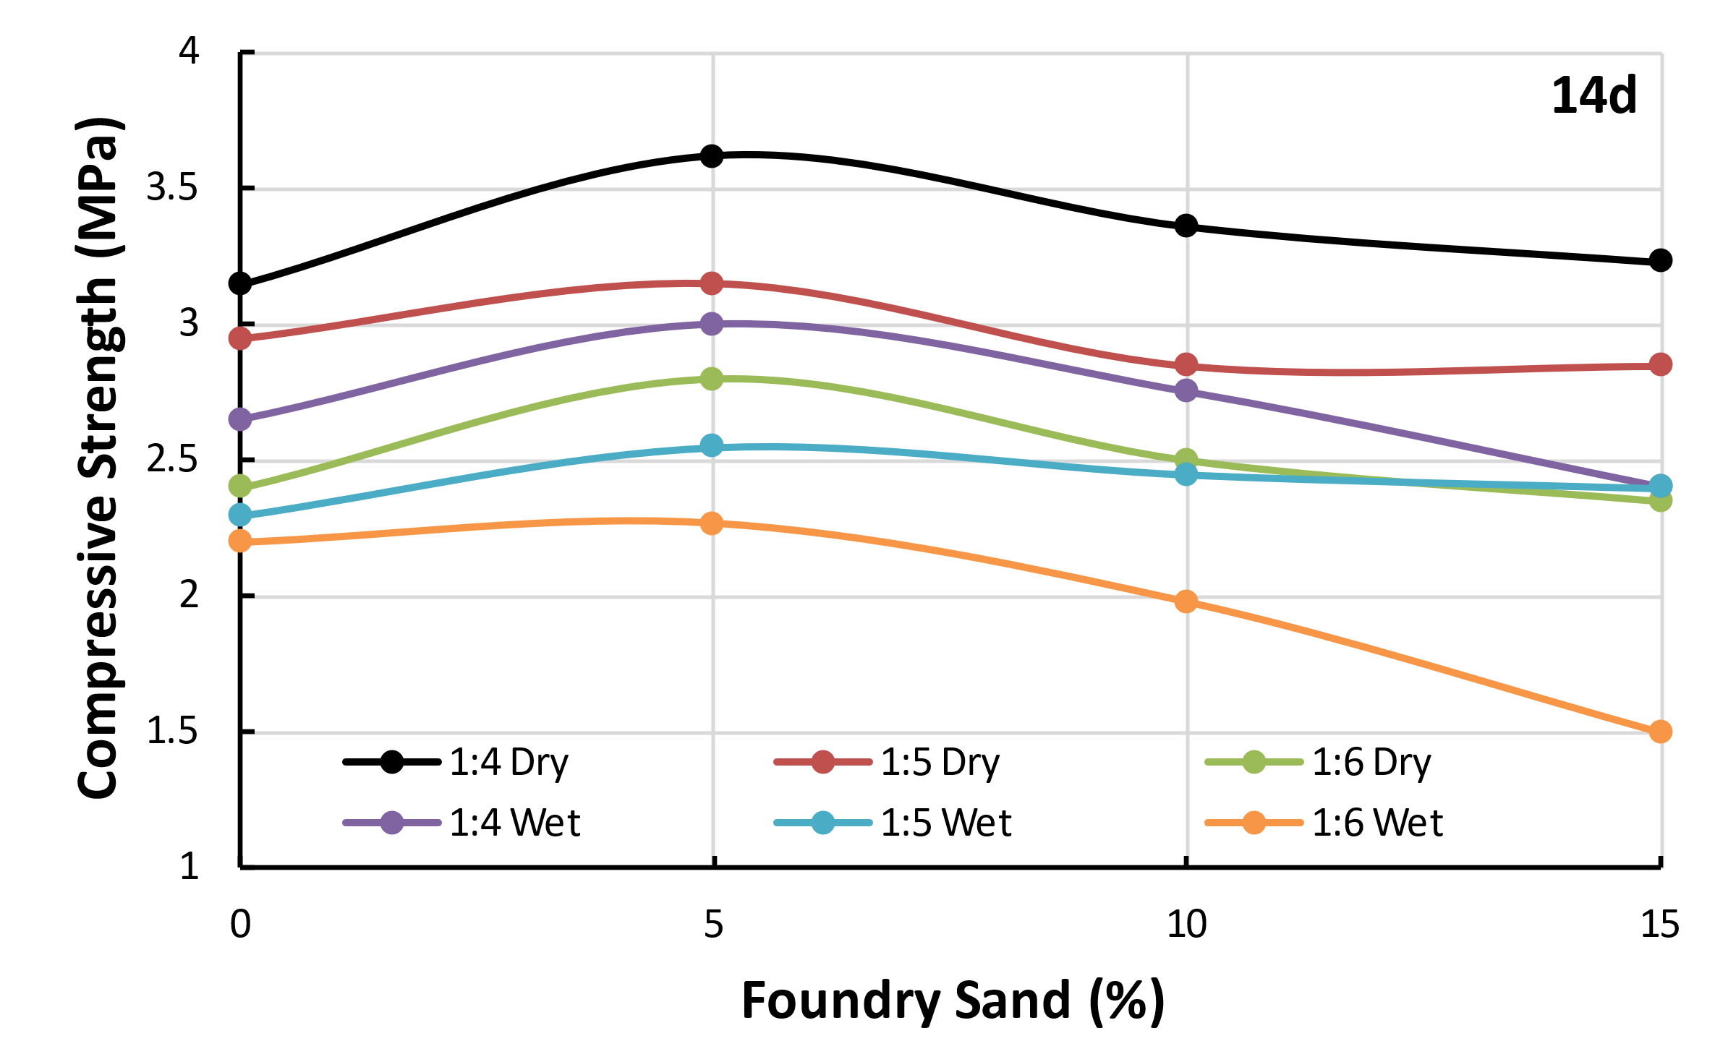
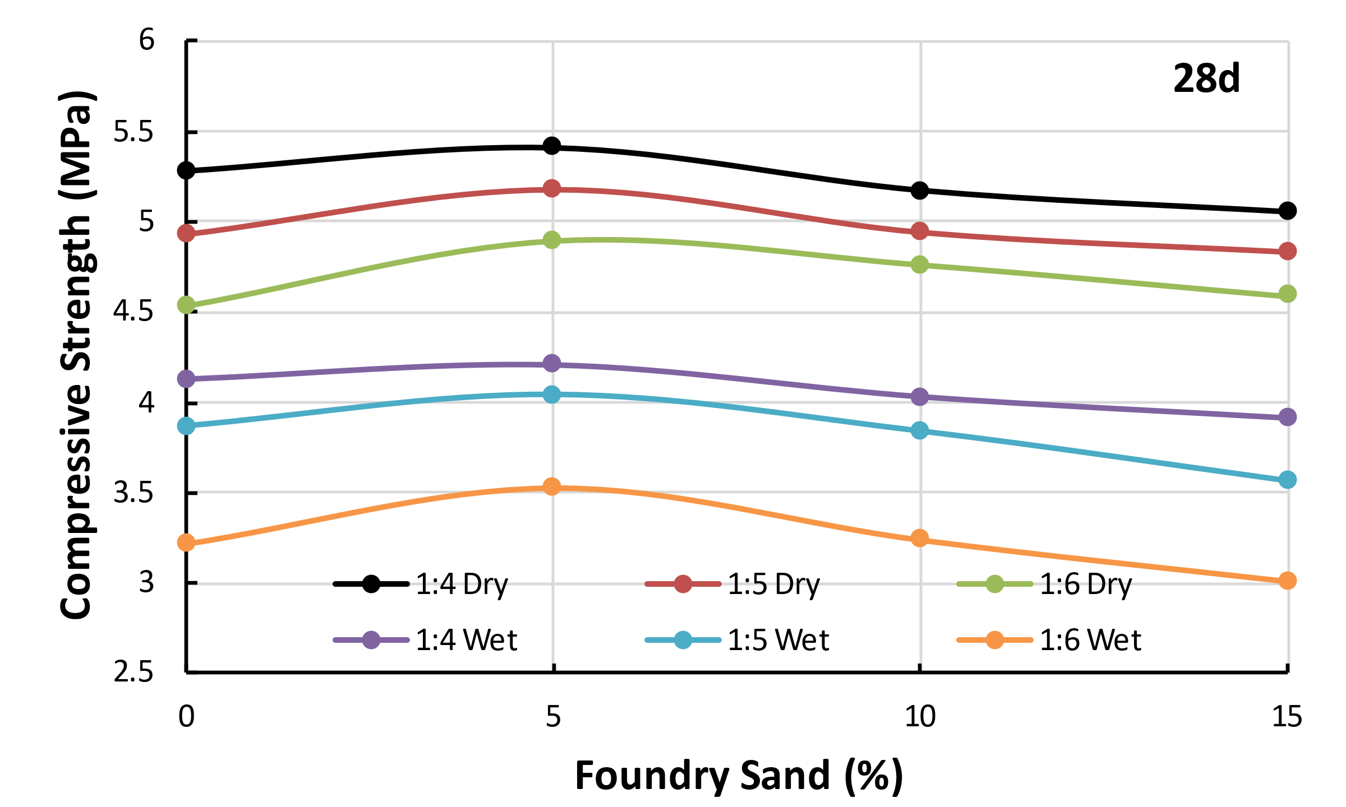
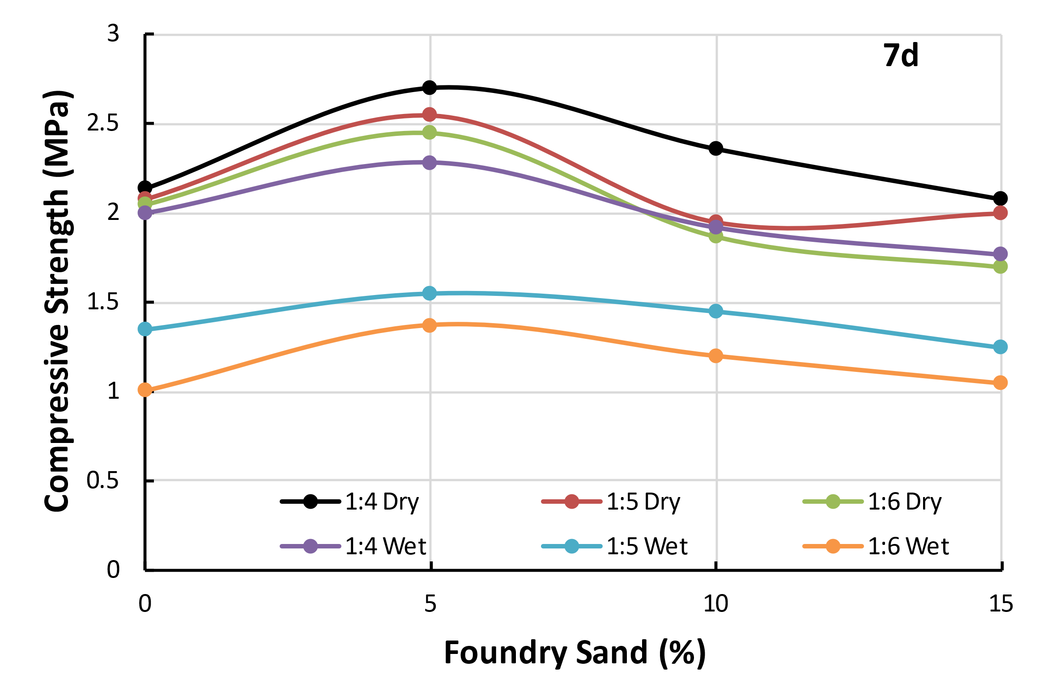
The compressive strength of the blocks is a measure of its capacity to carry load in compression. The study shows that compressive strength of the soil cement blocks was affected with the cement content, foundry sand content and curing period. The results of the study show that the compressive strength increased with the increase in cement content and the blocks of mix proportion 1:4 showed the highest strength. But the compressive strength of blocks of mix proportions 1:5 and 1:6 is nearly the same (Fig. 1). Soil blocks with 5% foundry sand showed the highest increase in strength irrespective of the cement content and the curing period. At 5% replacement foundry sand increased the interparticle friction by improving the interaction between the soil particles in the soil-foundry sand-cement matrix but on further increase created a porous matrix leading to decrease in strength. After 7d of curing, an increase of 22% in the dry compressive strength is observed at 5% foundry sand replacement while in case of wet compressive strength the increase is 35%. The rate of increase in strength is higher with longer period of curing. It can be observed from Fig. 1c that the strength nearly doubled from 2.14 MPa at 7d to 5.28 MPa after 28d of curing. Also, leaner mixes show higher rate of strength gain at higher curing period of 28d. Wet compressive strength reflects the strength of the block in adverse and extreme conditions like heavy and prolonged precipitation or flooding. The wet compressive strength is lower than the dry compressive strength (Fig. 1).
Fig. 1 Dry and Wet Compressive Strength of Soil Cement Blocks Replaced with Foundry Sand
Tensile Strength
The trend of tensile strength of the soil cement blocks mimicked that of compressive strength and was controlled by cement content, foundry sand replacement and curing period. The tensile strength was considerably lower than that of compressive strength. The soil cement block of 1:4 mix proportion exhibited a tensile strength of 1.18 MPa after 28d of curing, which was the maximum tensile strength in the investigation. The tensile strength of soil cement blocks with higher cement content (i.e.,) 1:4 mix proportion was higher, around 33% more than that of soil cement blocks of 1:6 mix proportion. Also, on replacing soil with 5% foundry sand, the tensile strength increased by 14% after 7d curing. Though an increase in tensile strength with curing period was observed (Fig. 2), the rate of strength was lower (i.e.,) the increase in tensile strength was 9% after 28d curing. The increase in foundry sand beyond 5% resulted in a reduction in tensile strength. For example, after 7d curing, a decrease of 27% was noted in soil cement blocks but after 28d curing, the reduction in strength was 16% with foundry sand replacement of 15%.
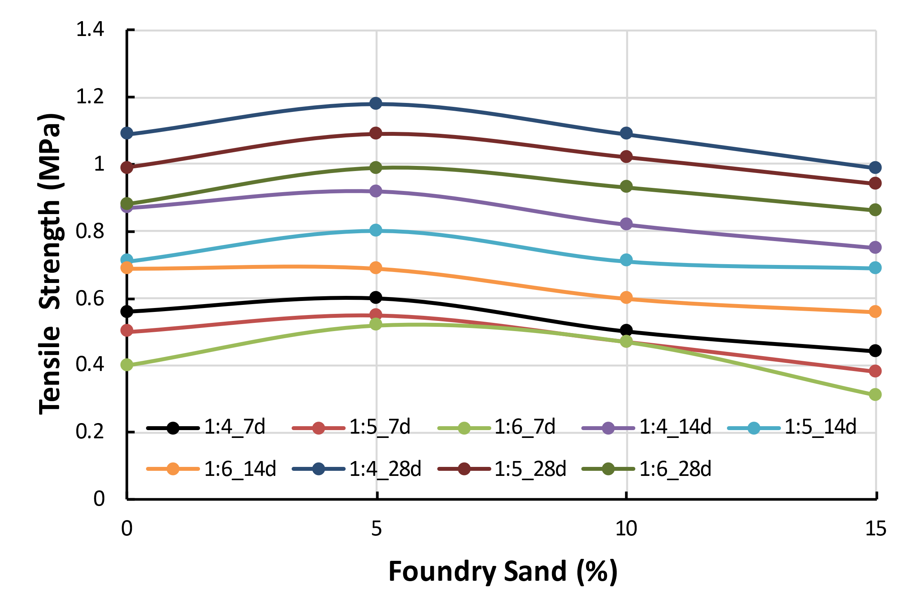
Fig. 2 Effect of Foundry Sand on Tensile Strength of Soil Cement Blocks
Water Absorption
Water absorption is an important property to qualify the soil cement blocks as a masonry unit. Water absorption decreased with increase in cement content and days of curing. A 41% rise in water absorption was noted for soil cement blocks of 1:6 mix ratio compared to blocks of mix proportion 1:4. Similarly, water absorption also increased with the increase in foundry sand content. Soil cement blocks with 5% foundry sand replacement exhibited a lesser tendency to absorb water than blocks with 15% foundry sand replacement. Addition of 5% foundry sand showed 10% increase in water absorption and this was because of the porous nature of foundry sand. Fig. 3 shows the effect of cement content, foundry sand content and curing period on water absorption.
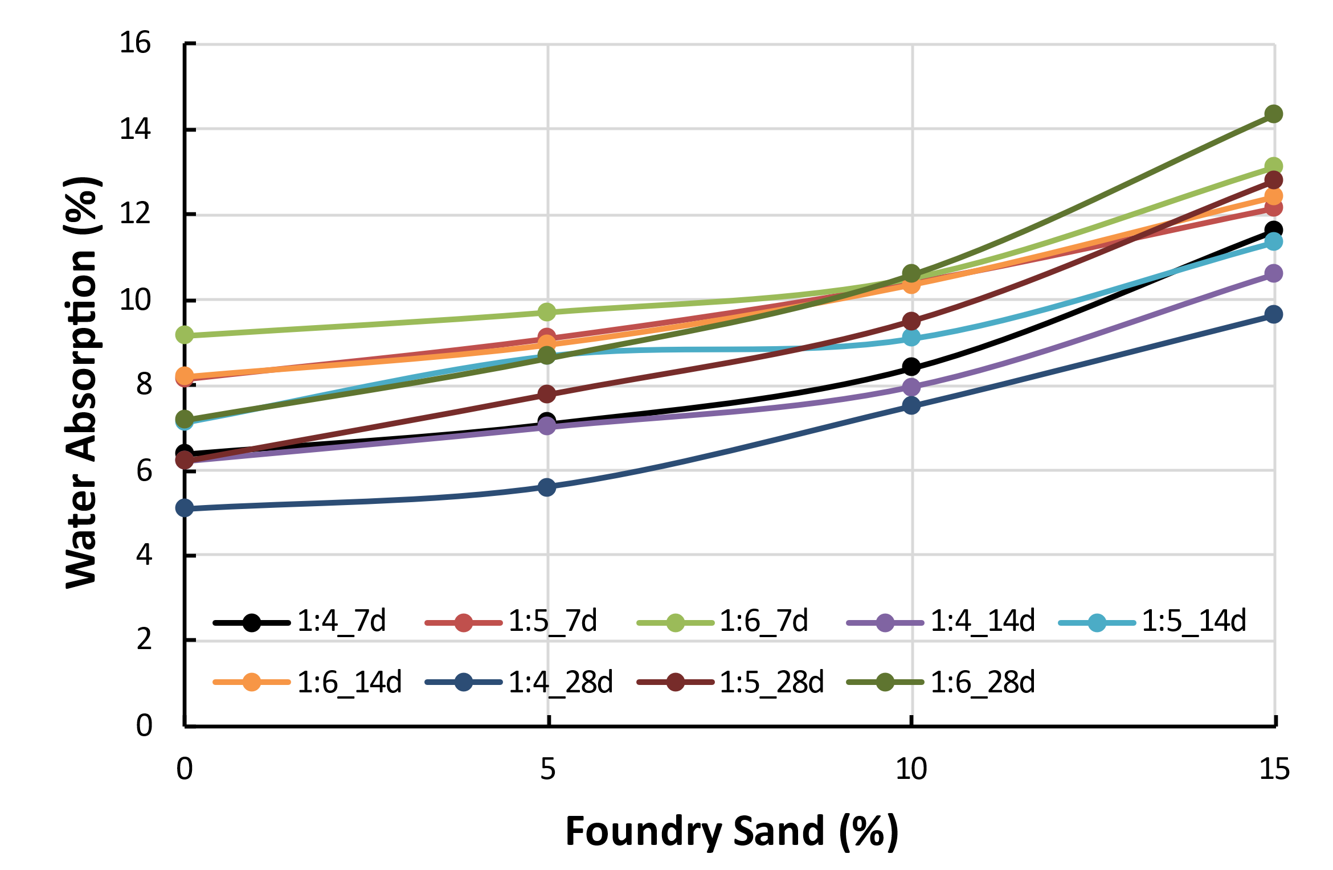
Fig. 3 Water Absorption of Soil Cement Blocks Replaced with Foundry Sand on Aging
Conclusion
The study was conducted on the impact of cement ratio on soil-cement blocks and the replacement of sand with foundry sand gave the following results
- The dry compressive strength was found to be higher for 1:4 ratio compared with other ratios which indicated that increase in cement content increases the strength by 10.63 %.
- Addition of 5% foundry sand showed a higher increase in strength compared to 10% and 15 % additions of foundry sand by 2.46 % and 6.6 % respectively. This showed that the optimum percentage replacement of foundry sand is 5%.
- There was a considerable increase in strength between 14 and 28 days. The rate of increase was found to be higher between 7 and 14 days. Thus, the rate of increase decreased with increase in number of days of curing
- Wet compressive strength showed the same pattern as dry compressive strength. The value was found to be permissible i.e. 20% lesser than dry compressive strength
- Tensile strength was marginal as the blocks were stronger in compression than in tension. They follow the same pattern as compressive strength. 1:4 mix ratios had 19.19 % more strength compared to 1:6 ratios. Addition of 5 % foundry showed an increase in strength over 10 % and 15 % by 8.2 % and 19.1 % respectively. The rate of increase in strength was found to be 53.3 % between 7 and 14 days. Thus, the rate of increase decreased with increase in number of days of curing
- Water absorption was found to be lesser in 1:4 ratio due to higher cement content. 5% addition of foundry sand showed lesser water absorption. 15% addition of foundry sand showed higher water absorption due to surface porosity, which was 45 % more compared to that of the control mix. 1:6 ratio had higher water absorption by 36.6 %.
References
[1] IS 3495 Parts 1-4 : Methods of Tests of Burnt Clay Building Brick. IS 3495 1992 - Parts 1 to 4 - METHODS TESTS Burn. CLAY Build. BRICKS, 1992, 1–7.
[2] 1077:1992, I. Is1077. Bur. Indian Stand., 1992.
[3] IS 5816-1999. Indian Standard Splitting Tensile Strength of Concrete- Method of Test. Bur. Indian Stand., 1999, 1–14.

