An Approach for Making Education Skill-Based with NEP 2020 Vistas

Parnab Ghosh
Assistant Professor
Department of Education
Panskura Banamali College (Autonomous)
E-Mail ID: pg_doc@rediffmail.com
Contact:8017744359

Abstract
The NEP 2020 vision aims to empower youth by providing them with a set of vocational, marketable, and entrepreneurial skills at various stages of training and education. Students will benefit from skill development by gaining greater career possibilities and becoming self-employed professionals. By 2025, the NEP hopes to have provided vocational skills to half of all students. These vocational training programs will begin in elementary school and continue through higher education, based on the interests and needs of individual students. The NEP-based model will use a skill-based education approach to teach students employable and self-sufficient (atmanirbhar) skills compatible with 4^{t} Industrial Revolution (4IR). This paper has tried to find out and highlight different standpoints for transforming education skill-based and making students employable from the policy perspectives.

Keywords: Vocational, Marketable, and Entrepreneurial skills, Self-Employed Professionals, Skill-Based Education, Vocational Training Programmes, Employable and Self-Sufficient Skills

Introduction

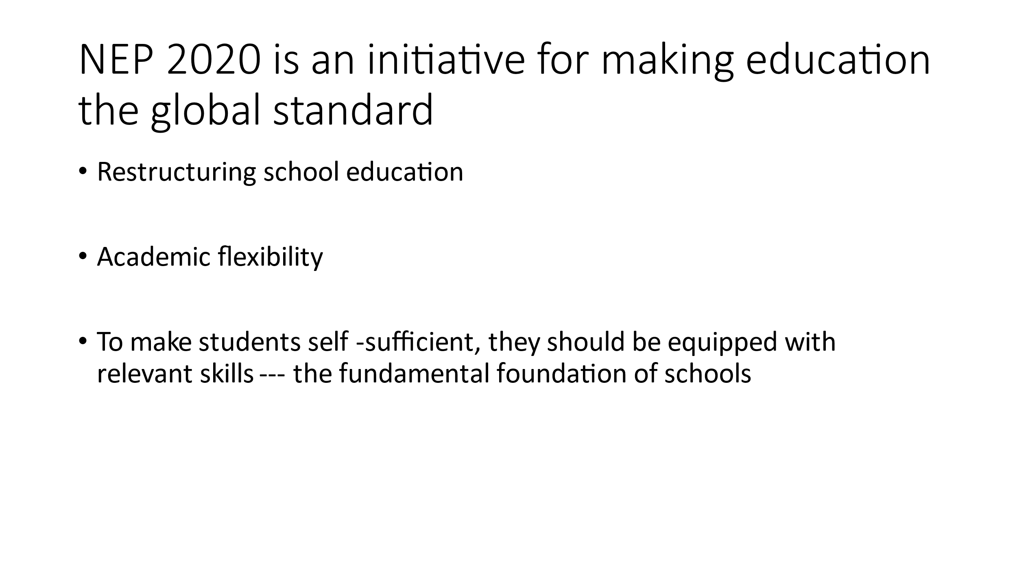
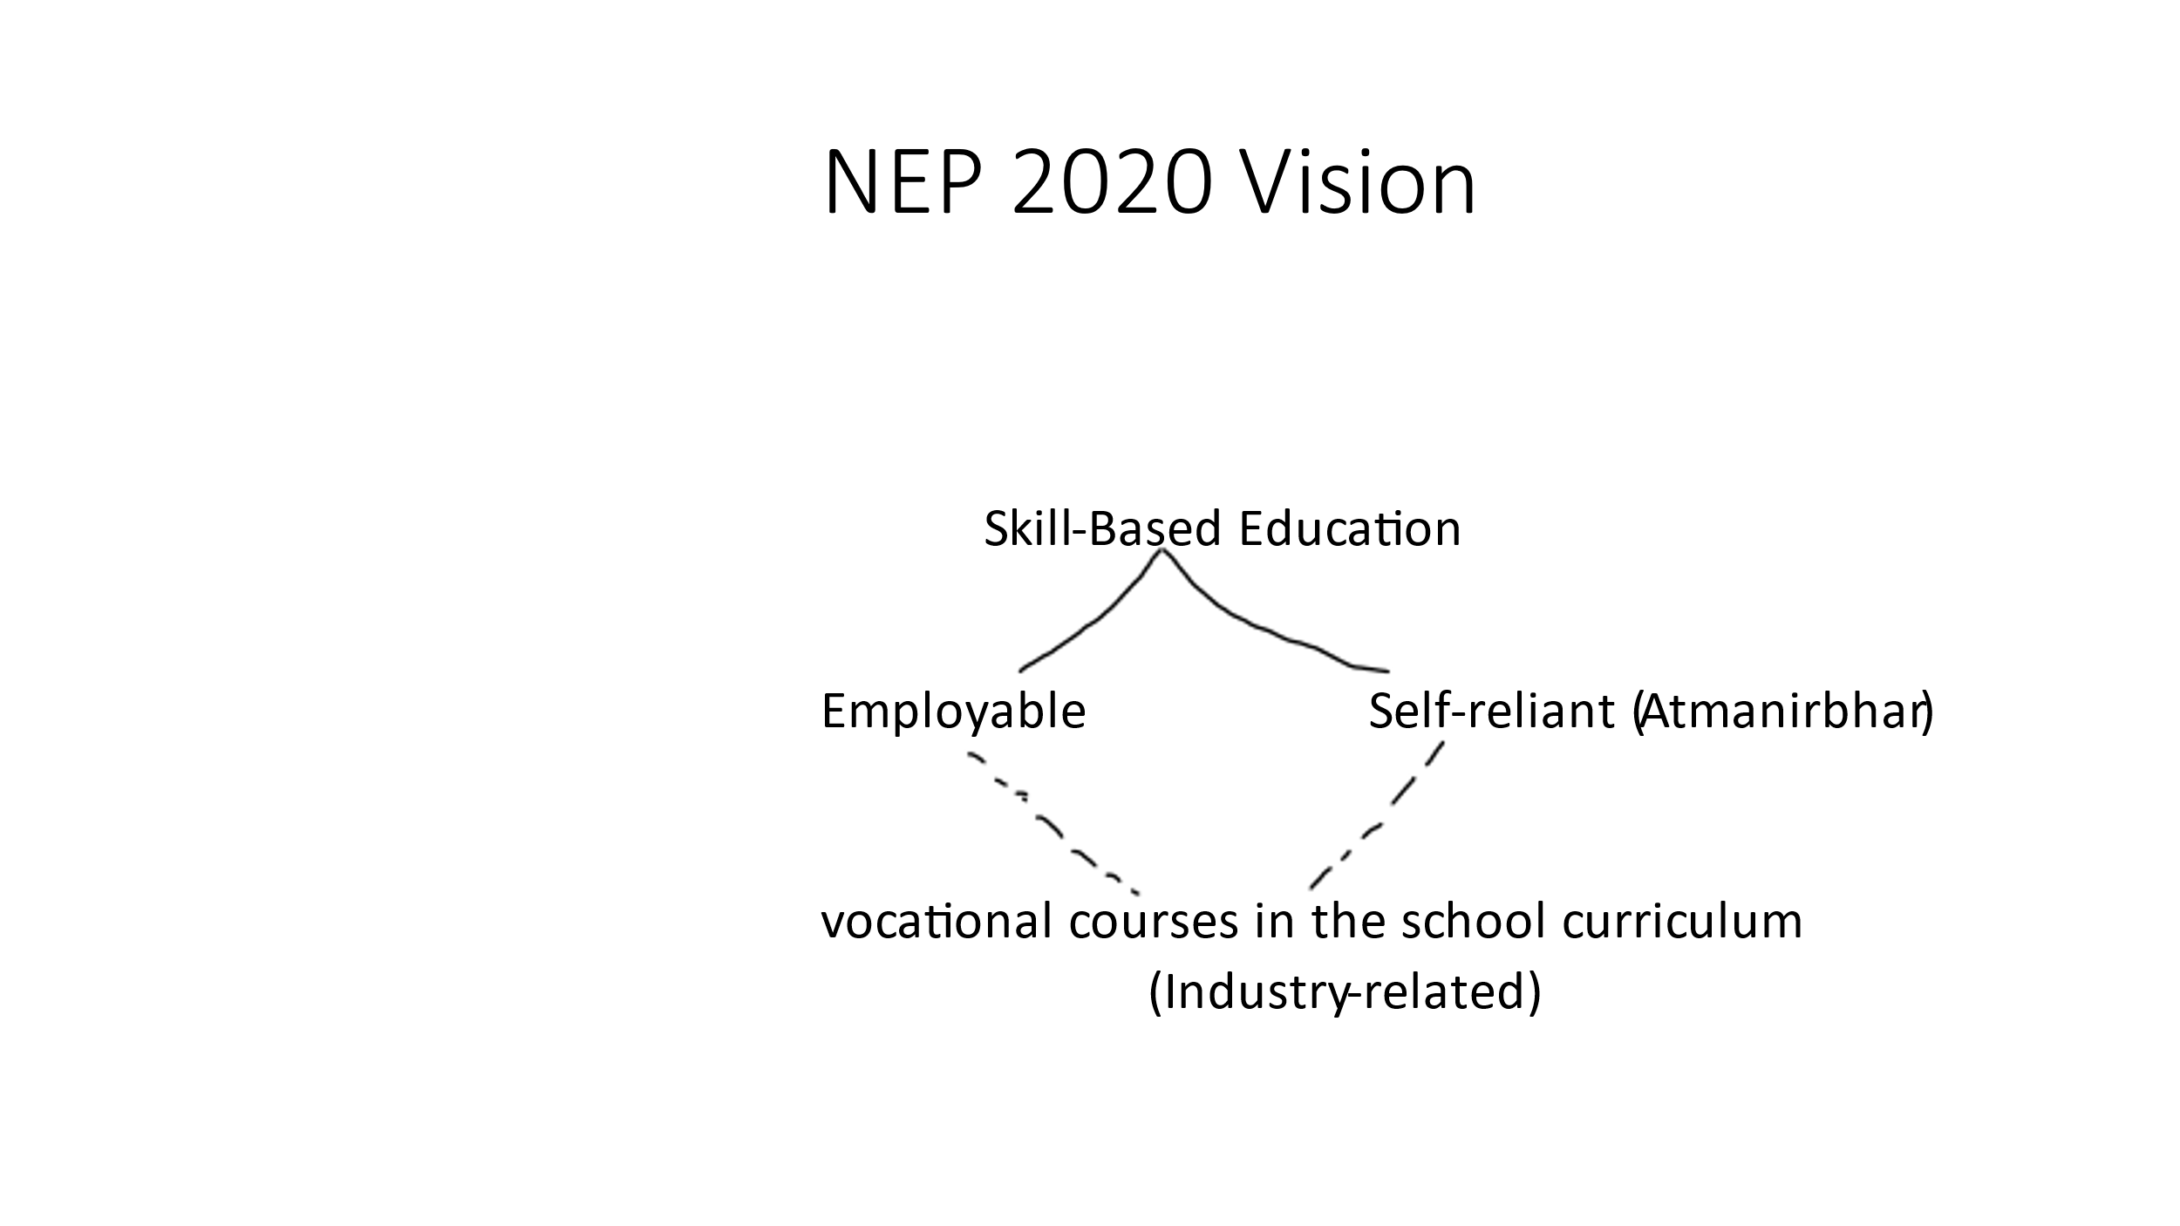
The new education policy provides a ray of optimism for the Indian educational system. The National Education Policy (NEP) 2020, which was recently introduced, has come to the rescue, serving as a comprehensive basis for the evolution of Indian education. NEP 2020, which replaces NEP 1986 as India's third education policy, aims to bring our education system up to worldwide standards. This policy tries to restructure school education by emphasizing academic flexibility. Rapid changes in the country, coupled with a rise in technology, have created a niche for employees with industry-specific knowledge or skill sets. To assist India in achieving its progressive aim of self-sufficiency, the working-age population must be equipped with relevant skills that should be taught as a fundamental foundation in schools. The NEP-based strategy will use a skill-based education approach to teach pupils employable and atmanirbhar abilities. More vocational courses will be introduced to the curriculum and taught at every university/college across the country to make this more practical. These brief job-focused vocational courses will be critical in developing trained graduates who are ready for the industrial revolution.
The vocational level subjects will also be included in the school education curriculum, allowing pupils to gain hands-on experience in areas such as electrical repair, horticulture, plumbing, and carpentry.
Statistical Data Review
In India, only 45.6 percent of college graduates are job-ready (India Skills Report, 2019). The Labor Force Participation Rate (the percentage of people of working age who are employed) is a dismal 49.8% (Periodic Labour Force Survey, 2018). This provides a bleak picture of the options available to college graduates. The Covid outbreak has only made matters worse. Despite these harsh facts, the Indian population's average age is only 29 years old. (State of the Urban Youth, India 2012: Employment, Livelihoods, Skills Report, 2013). In India, half of the population is under the age of 25 (2011 Census of India). These data show that India is a place of youthful people eager to be educated and explored.

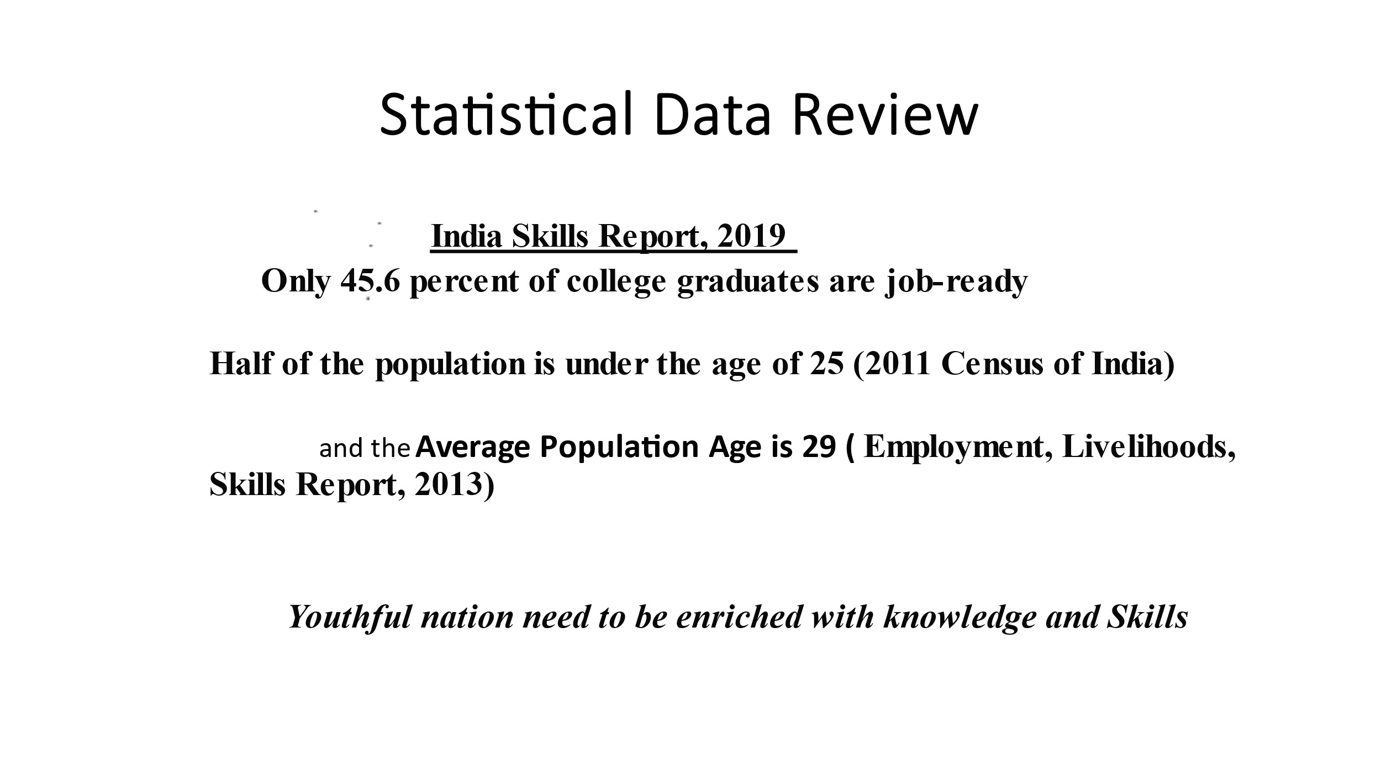

For a long time, the lack of skills, vocational education, and apprenticeship among today's youth has been a source of concern. As a result, when the government decided to address these concerns head-on, the National Education Policy became a road map for achieving pre-determined objectives.

NEP 2020’s Objectives to Make education Skill-Based
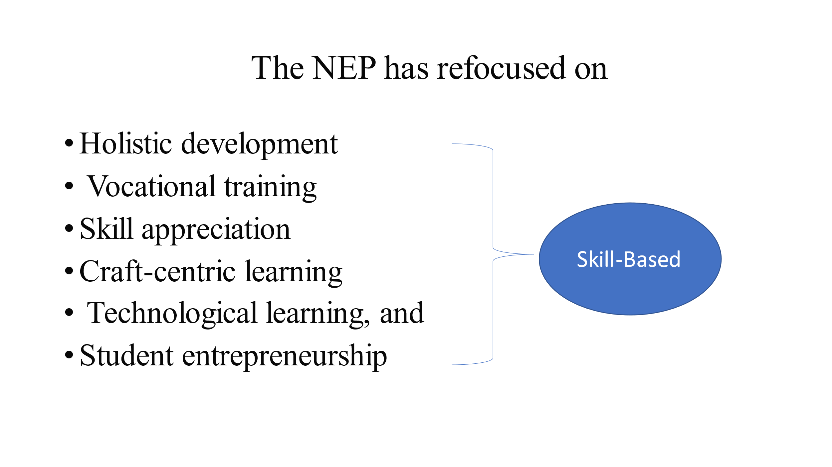

The current government has responded to the aspirations and desires of today's youth by enacting a new National Education Policy. The NEP has refocused its efforts on holistic development, vocational training, skill appreciation, craft-centric learning, technological learning, and student entrepreneurship to better prepare today's youth for the world and to put them in positions to achieve their goals and lead this transformation. The skill-focused measures include:
• Analytical, mathematical, and cognitive learning skills are emphasized in the NEP 2020. It also intends to increase the use of computerized evaluation methods in educational institutions around the country.
• The National Educational Policy has attempted to re-imagine the early introduction of vocational education and give it the weight it deserves. Vocational education simply educates students for work in a skilled trade. It achieves this by combining application-based learning with theory and cognitive skill development. Over the next decade, vocational education will be systematically integrated into school and higher education. District authorities will choose the vocational education priority areas based on a skill gap analysis and mapping of local opportunities. The policy proposes to vocational education be mainstreamed in schools and higher education institutions. By 2025, 50 percent of Indian students will have received vocational training.
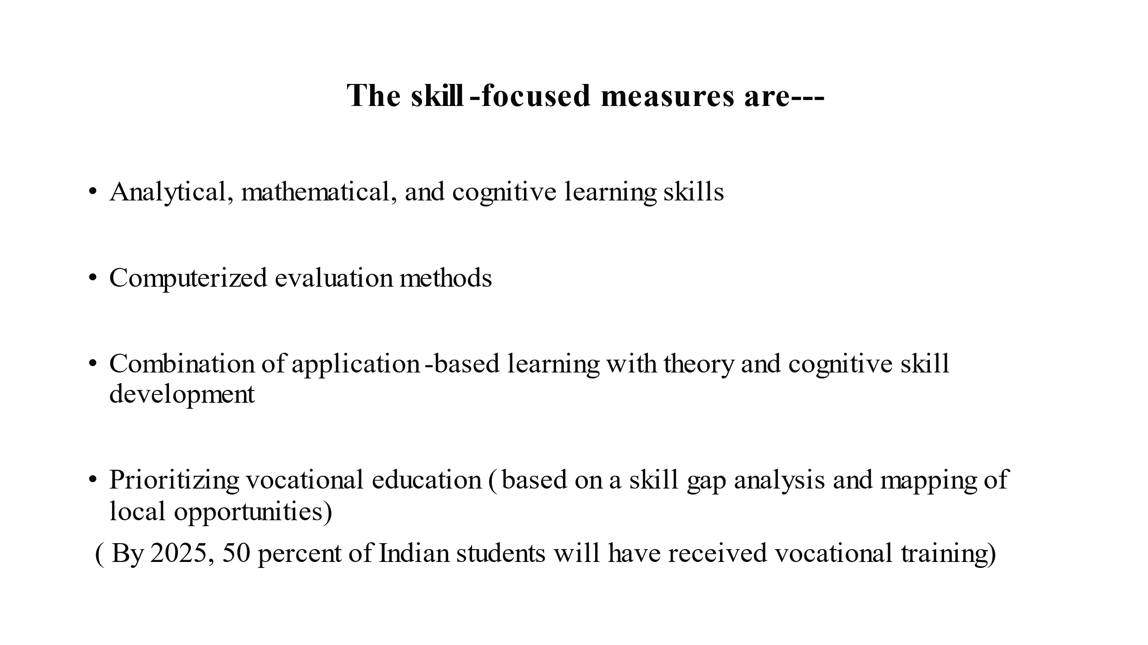

Adults would be able to actively engage in skill upgrading through a revised curriculum and open learning system outlined in the policy. This much-needed change in emphasis on vocational education follows a warning from UNICEF in 2019. According to a survey produced by the prestigious organization, by 2030, roughly 53% of Indian kids will be unprepared for jobs in the twenty-first century. India, on the other hand, appears to be repositioning itself on the global map, taking advantage of its demographic dividend, with a reorganized vocational education policy.
• The policy lays out a strategy for bringing together a diverse range of multidisciplinary subjects, from humanities and sciences to social sciences, technical and vocational fields, as well as cultivating a social engagement ethic and soft skills like communication and debate.
• In addition, the NEP intends to implement school internships and apprenticeships to promote craft-based learning. District authorities would map the priority areas based on local requirements once more. The 'fun' course, as defined, will expose students to provide experience in skill-based vocations such as carpentry, electrical work, pottery making, and so on.

•The country's higher education courses now have various entry and exit points, which is another significant step toward the objective of an upskilled India. Students would not have to wait until they completed the entire degree to earn a certificate and be recognized as graduates, as they did previously. Multiple exit points would allow for certification after one year, a diploma after two years, and a traditional degree after three years. Along with academic principles, skill-oriented application-based learning will also be given due weight.
• The NEP anticipates the inclusion of coding into the curriculum as early as class 6, addressing the technological needs of the twenty-first century. Due to the increasing demand in the technological sector, the policy reinstates the need to upskill and nurture today's youngsters with basic coding ideas from an early age.
• The policy also aims to encourage problem-solving, creative, and analytical thinking along with communication skills.

Better skill training and holistic development will be the pillars on which India's future (which has over 65 percent of the population under 35 years old, according to the 2011 Census of India) will be built. The problem was neatly summarised in the National Skill Development Mission of 2015, which stated that Our country is currently facing a dual challenge of paucity of highly trained workforce, as well as non-employability of large sections of conventionally educated youth, who possess little or no job skills. These are the challenges that the National Education Policy of 2020 wants to address to alleviate the majority of the concerns that our young face.

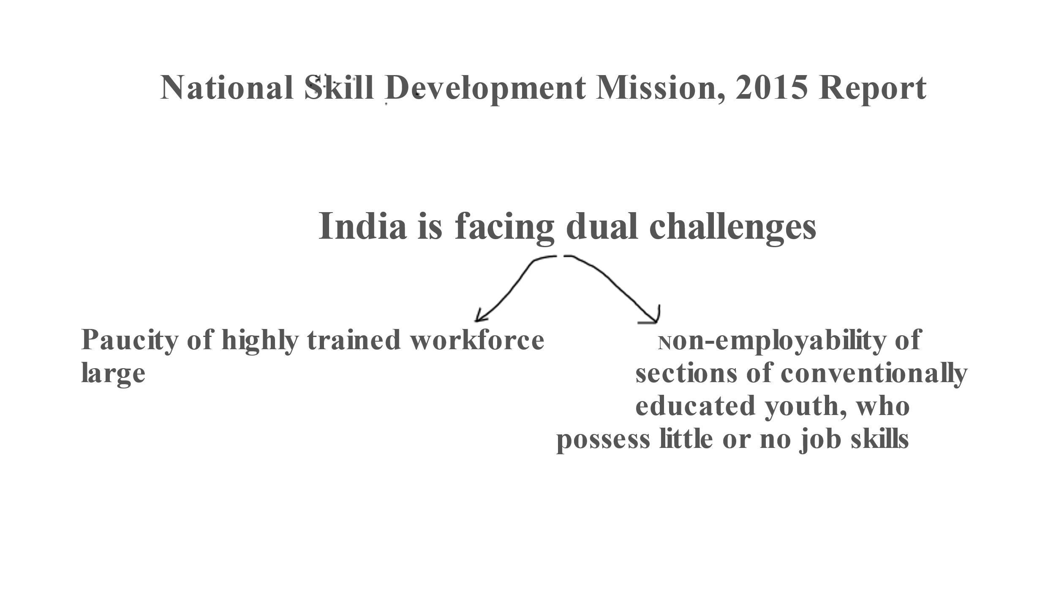

Major Recommendations in NEP 2020 for Structuring Skill-Based Education

• There will be no rigid distinctions between the arts and sciences, curricular and extracurricular activities, vocational and academic streams, or other fields of study to avoid damaging hierarchies and barriers. (NEP 2020: Principles)
• From pre-school to Grade 12, a comprehensive and coordinated effort will be made to ensure universal access and provide the opportunity to all students in the country to receive quality holistic educational experience including vocational education. (NEP Para 3.1)
• The Secondary Stage will be four years of multidisciplinary study, building on the middle stage's subject-oriented pedagogical and curricular approach but with more depth, attention to life aspirations, flexibility, and student choice of courses. Students, for an instance, would be allowed to quit after Grade 10 and re-enter in the next phase to pursue vocational or other courses available in Grades 11- 12, including at a more specialized school if desired. (NEP Para 4.2)
• Students will have more flexibility and choice of subjects to study, especially in secondary school, including physical education, arts and crafts, and vocational skills, so that they can create their study and life goals. (NEP Para 4.9)
• Integration of vocational education programmes into mainstream education throughout time, starting with early vocational exposure in middle and secondary school. (NEP Para 16.4)
•Students would have access to 'LokVidya,' or vital occupational knowledge generated in India, through incorporation into vocational education courses. (NEP Para 16.5)
• Over the following decade, vocational education will be gradually integrated into all schools and colleges. Choice-based on skills gap analysis and mapping of local opportunities will be focus areas for vocational education. To manage this initiative, the Ministry of Human Resource Development (renamed Ministry of Education) will form a National Committee for the Integration of Vocational Education (NCIVE), which will include specialists in vocational education and representatives from across Ministries, as well as industry. (NEP Para 16.6)
• Individual institutions that are early investors must innovate to uncover successful models and practices, which they can subsequently share with other institutions through NCIVE-created platforms. Higher education institutions will test various vocational education and apprenticeship approaches. These higher education institutions will collaborate with companies or corporates to establish incubation centers. (NEP Para 16.7)
• For each discipline, career, and profession, the National Skills Qualifications Framework will be more specified. In addition, Indian standards will conform to the International Labour Organization's International Standard Classification of Occupations. The recognition of previous knowledge will be based on this Framework. Dropouts from the formal system will be reintegrated through this method, which aligns their practical experience with the appropriate level of the Framework. The credit-based Framework will also help students move between general and vocational education. (NEP Para 16.8)
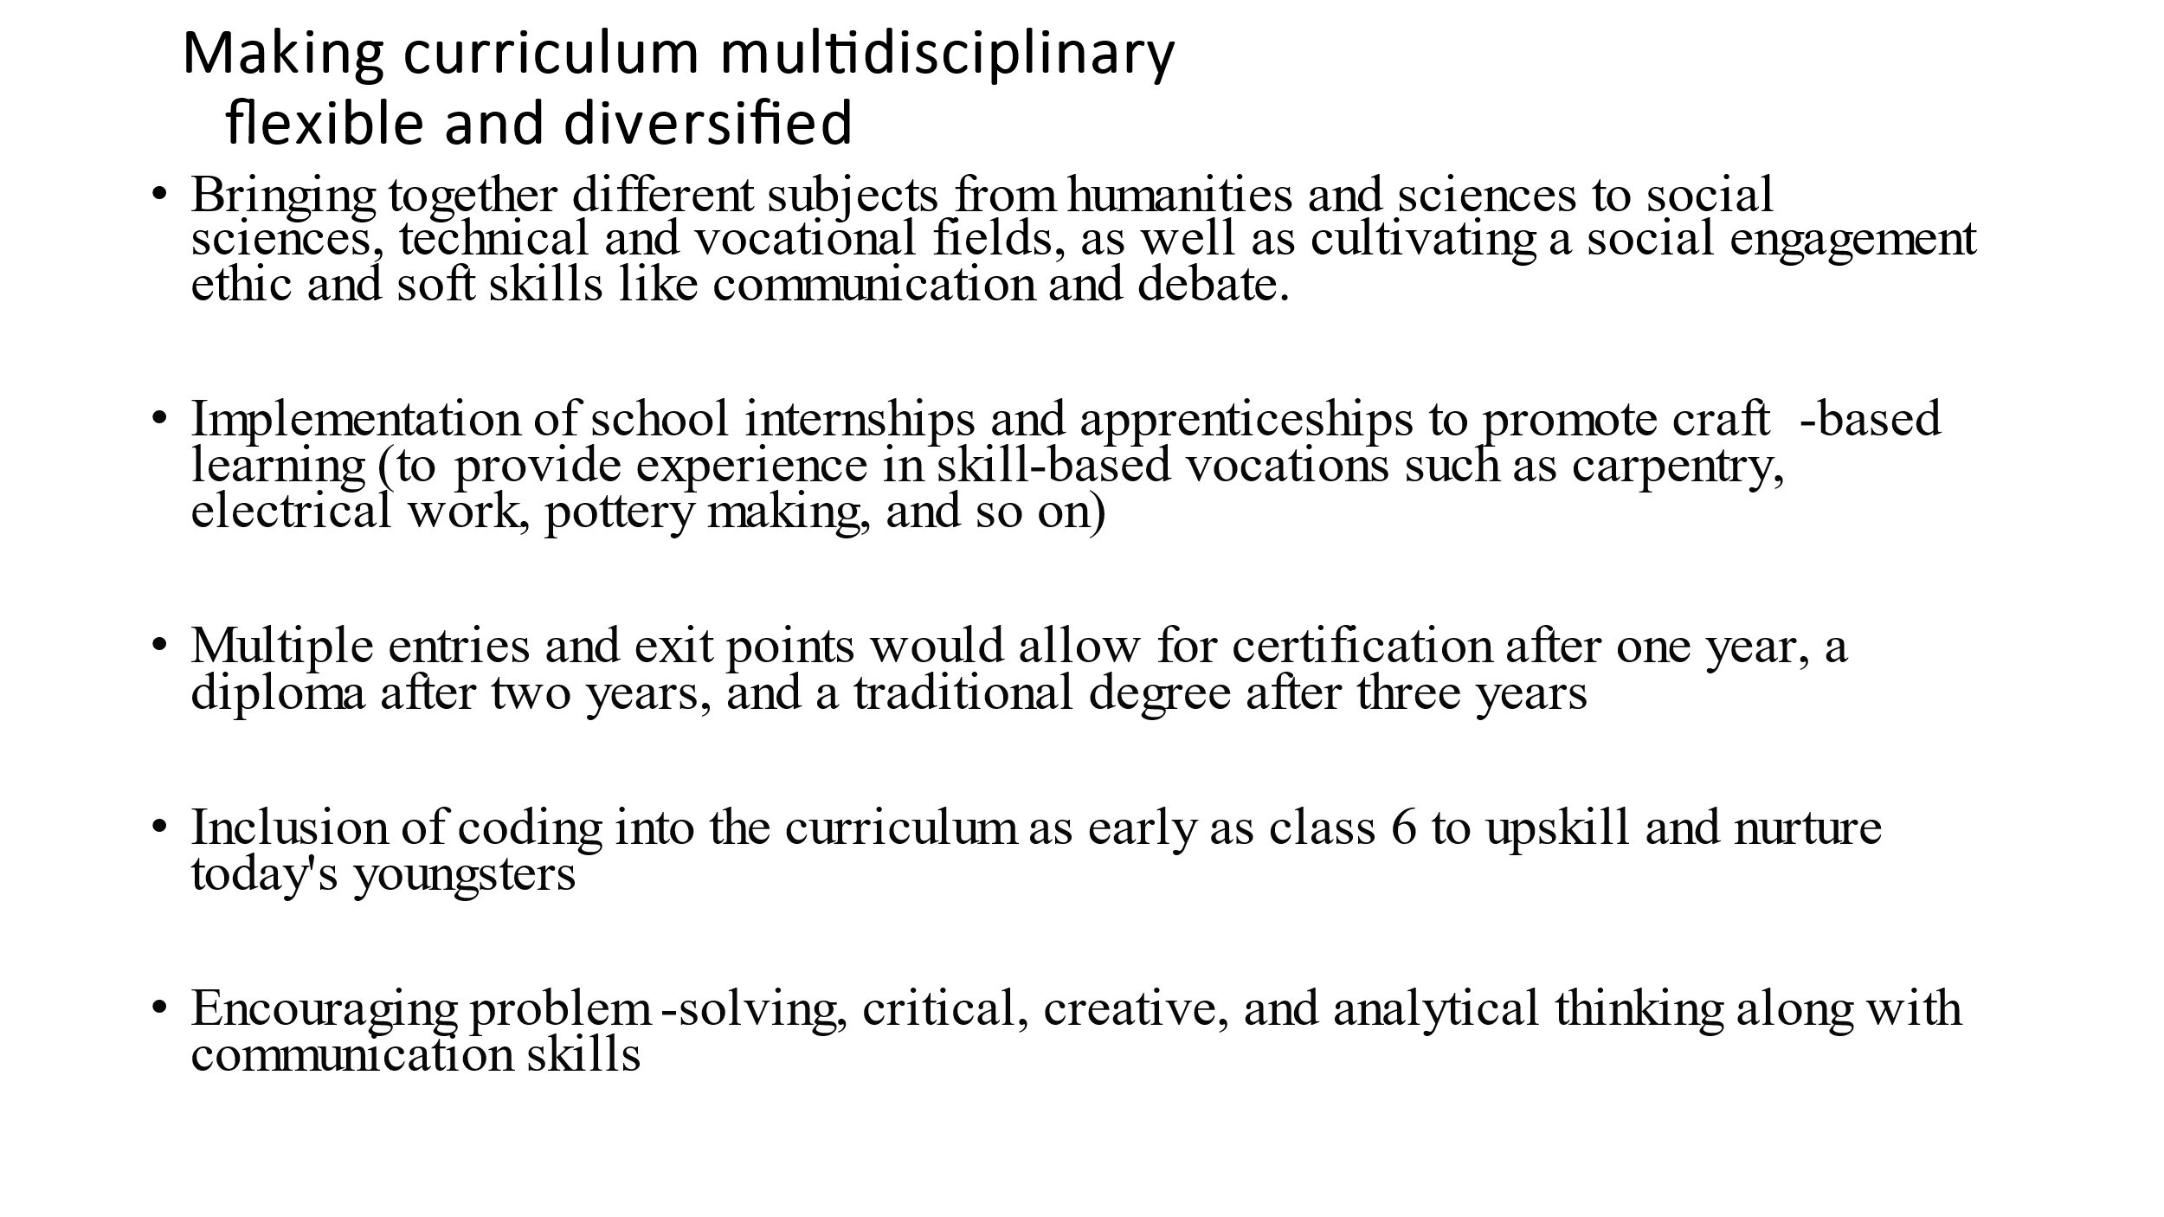

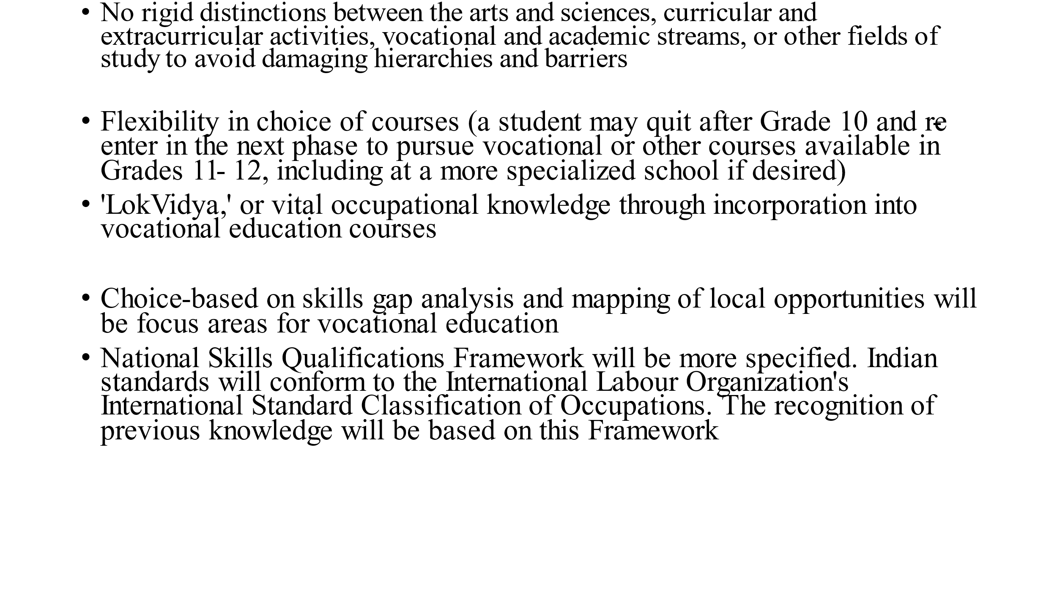

Upskilling Entrepreneurship—A Pathway of Self-Reliance
Creativity, entrepreneurship, and networking are driving forces in the new world of work. Through the learning process and environment, these principles must be instilled in the learner. Schools must provide teachers the autonomy to design courses that allow learners to investigate, explore, experiment, and invent while balancing the curriculum load for teachers to inspire innovation or entrepreneurship and creativity in the classroom. Schools and businesses may form partnerships to establish incubators. All occupational courses must have an emphasis on developing financial literacy and personal financial management skills in learners to make them atmanirbhar.
NEP 2020: A Technical Corporate Perspective
NEP 2020 will also be a driving force for Ed-Tech businesses that are developing comprehensive technologies such as Learning Management Systems, Online Labs, ERP software, and other similar products. Even the National Education Technology Foundation (NETF) will promote current Ed-Tech goods and solutions to harness the country's education system. There will be no disconnect between the extra-curricular, co-curricular, or curricular spheres among the Arts, Science, and Humanities streams, or across vocational streams, according to the policy. Children will have the option of choosing the subjects they want to study. Integrating vocational training, internships, and practical experience into the curriculum can help graduates improve their problem-solving, decision-making, and hands-on experience. By 2025, at least 50% of students in the school and higher education systems will have had exposure to vocational education, according to the policy.
Curricular Challenges for NEP 2020
In this high-tech automated environment, while displacing low-skilled employment, the demand for human talents is outstripping the supply, according to the World Economic Forum report -The Future of Job Skills. Infosys and Wipro, two of India's largest IT companies, agree that while conventional occupations are being atomized, employees are being reassigned to more complex initiatives such as machine learning and artificial intelligence, which demand critical and creative problem-solving skills. The Program for International Student Assessment (PISA) is a global study that evaluates member countries' educational systems by assessing the academic performance of 15-year-old students in reading, mathematics, and science literacy. The last time Indian schools took part, they came in 72nd out of 73 countries, trailing only Kyrgyzstan. This highlighted the reality that, despite being informal education, most kids have not developed literacy and numeracy skills appropriate for their age.
As a result, NEP2020 has implemented pedagogical reforms, including an increased curricular focus on literacy and numeracy at the foundational and preparatory levels, as well as the introduction of hands-on learning and experiential pedagogy along with mandatory testing in classes III, V, and VIII to track learners’ progress. Our ongoing involvement in international examinations like PISA will keep us informed about how capable Indian students are in comparison to students from other countries.
Reforming and Restructuring Indian Education
'Vocational education will be integrated into all school and higher education institutions progressively over the next decade according to the NEP2020 considering global educational reforms. The focus of NEP2020 is on vocational and skill education for pupils to prepare employable youth. 'Skills gap analysis and mapping of local opportunities will be used to rethink courses, disciplines, streams, and subjects.' By 2022, the barriers to science, humanities, and business education should hopefully be broken down and replaced with a flexible, multidisciplinary, competency-based curriculum of choice.
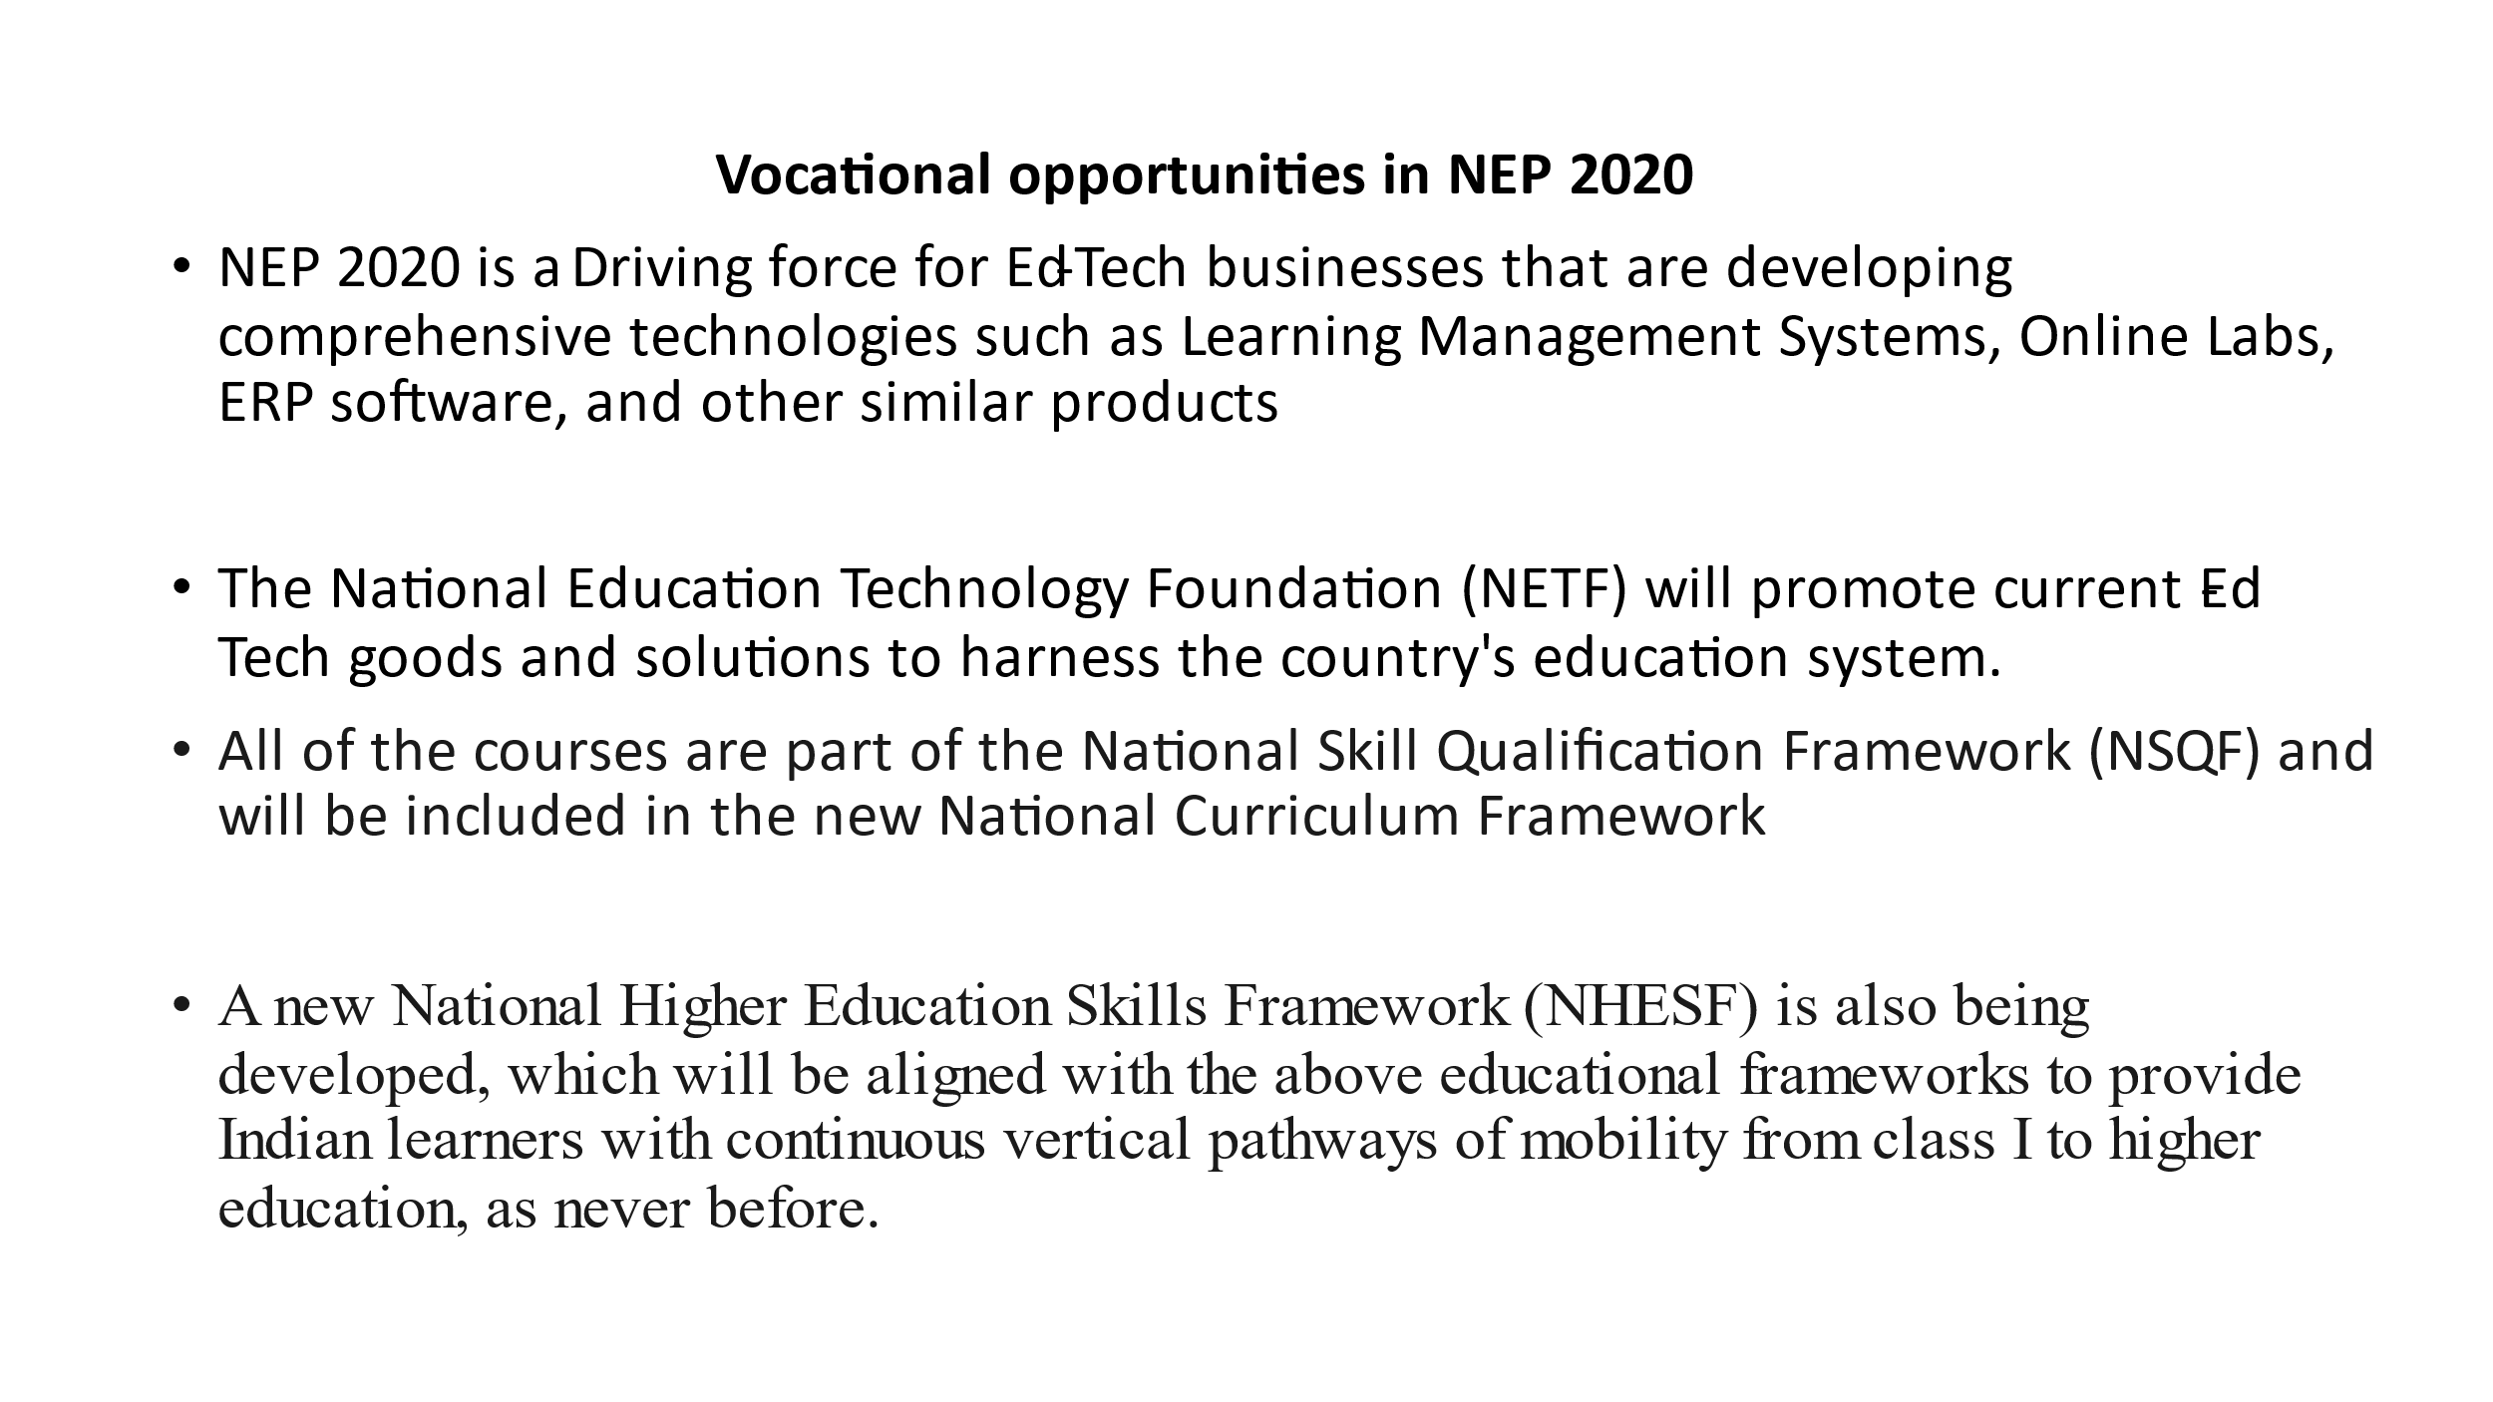

CBSE proclaimed the adoption of Competency-based Education in May 2020, as part of the NEP mandate. The competency-based curriculum emphasizes the development of real-world skills. The training content includes real-world case studies and workplace simulations for critical thinking and creative problem-solving. Learning takes place in a professionally designed work environment, complete with an interactive and experiential pedagogy and various possibilities for problem-solving in a realistic workplace. As a result, at the end of the courses, students will have gained both knowledge and domain-specific abilities in their chosen subjects, making them fit for the workplace. Nearly one-third of all CBSE affiliated schools now offer vocational courses, with private institutions driving demand for new vocational courses. Despite the COVID pandemic, private and international CBSE schools have responded spectacularly this year, with approximately 4500 CBSE affiliated schools implementing a vocational education approach from class VI onwards ( http://cbseacademic.nic.in/skill-education.html ). The vocational/skill courses are offered in almost all sectors, with a special emphasis on IT applications and new technologies, BFI (Banking, Finance, and Life Insurance), Financial Marketing Management, Medical Diagnostics, Retail Services & Operations, Hotel Management & Catering Technology, Tourism & Travel, and so on.
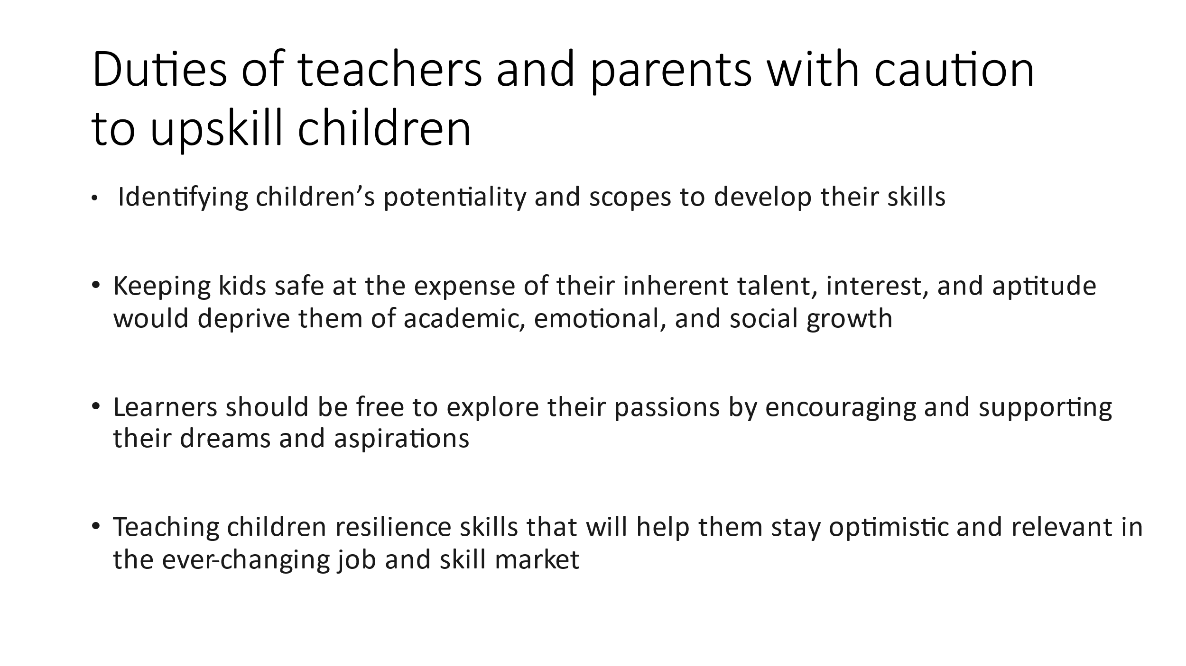

All of the courses are part of the National Skill Qualification Framework (NSQF) and will be included in the new National Curriculum Framework, which is set to debut in 2021. A new National Higher Education Skills Framework (NHESF) is also being developed, which will be aligned with the above educational frameworks to provide Indian learners with continuous vertical pathways of mobility from class I to higher education, as never before.
Conclusion
The National Education Policy (NEP 2020) announced by the Indian government last year is still in its early stages of implementation, but it will be critical in preparing students to work in the sector. When it comes to children's career planning, schools, teachers, and parents must be proactive and encouraging. Assist them in identifying their potential and identifying chances to develop these skills. Keeping kids safe at the expense of their inherent talent, interest, and aptitude would deprive them of academic, emotional, and social growth. Learners should be free to explore their passions by encouraging and supporting their dreams and aspirations, as a personal achievement in life is dependent on the development of socio-emotional neural networks in the brain from childhood. While a result, as you educate and upskill children, teach them resilience skills that will help them stay optimistic and relevant in the ever-changing job and skill market.

Web References
NEP2020: Education for employability (indiatimes.com)
NEP 2020 Will Encourage Skill Development & Boost Employability (sarvgyan.com)
NEP_Final_English_0.pdf (education.gov.in)
NEP 2020 ‘ENABLES SKILLS’ FOR THE 21ST CENTURY ASPIRATIONAL INDIA (skillenable.com)
NEP 2020: Implementation challenges - EducationWorld
background_note_Reimagining_Vocational_Education_Skill_building_revised.pdf

