EMERGING TECHNOLOGIES FOR SUPPLY CHAIN MANAGEMENT

Mr. Manjunatha M.G Dr. Raja Roy Choudhury

Department of Management Group CEO

Chhatrapati Shivaji Maharaj University, Darwin Platform Group of

Kanpur. Companies, Mumbai.

ABSTRACT
Emerging technologies are disruptive and are going to impact Business in a big way. They can not only change the way companies’ function, but also can change Business Models. These technologies are not reached maturity and the benefits they promise are perceived as hype by Executives. But the Companies cannot ignore the impact and far-reaching consequences of these technologies. The rapid advancement of these technologies are remaking business supply chains to transform the way they deliver value. Organizations need to have an approach to integrate Emerging Technologies with Supply Chains that will enhance Customer Value. Supply Chain Operations Reference (SCOR) Model is taken as a base to assess the benefits of Emerging technologies. This Model provides the means of integration and a measure of value after integration. The integration of Emerging Technologies with SCOR Model should also be linked with Enterprise Strategy objectives to have a seamless integration. This paper provides a theoretical Model for integrating Emerging Technologies with Supply Chain that will integrate with Enterprise Objectives.

INTRODUCTION

This collection of papers explores the research and practices on the broad theme of “Emerging Technologies for Supply Chain Management”. The papers were given at the roundtable entitled “Emerging Trends of Technologies in Supply Chain Management” that the School of Business and Administration organized in collaboration with Penang Skills Development Centre on 12th and 13th of January 2017. There were twenty-four academics and twenty- six industry practitioners who attended the two-day roundtable to exchange information pertaining to the emerging technologies for supply chain management. The emerging technologies discussed in the roundtable were Supply Chain 4.0, Internet of Things (IoT), big data, electronic procurement and robotics in warehouse. Emerging technologies for supply chain management may include robotics, smart warehousing, 3D printings, big data, IoT and artificial intelligence. These technologies are now affecting every component of supply chain, namely customer fulfillments, supplier sourcing, purchasing, distribution, transportation and warehousing. These emerging technologies potentially contribute to effectiveness, efficiency, shorter lead-time and cost savings to supply chain. However, the emerging technologies may potentially cause job loss to lower level or clerical workforce. In order to stay relevant in the industry, supply chain professionals need to be well versed to utilize these emerging technologies. The IoT is the network of physical devices, vehicles and other items embedded with electronics, software, sensors, actuators and connectivity which enables these objects to connect and exchange data. Machine to machine (M2M) connection is the new frontier of IoT, which refers to all technologies that allow systems to communicate with other devices of the same type. Apart from this, there are machine to person (M2P) and person-to-person connections. With all these connections of IoT, supply chain professionals could connect and exchange data very effectively with all their supply chain partners, namely suppliers, customers, transporters, distributors, retailers and warehouses. The related supply chain partners will have full visibility into the needs and changes of each other in real time. Automated robotic applications such as self-driving trucks and automatic drones now become viable solutions for warehousing and transportation. The advantage of robotic applications is that they are capable to work 24 hours every day. However, robots may not be able to perform high-level decision-makings for warehousing and shipping. Hence, savvy companies come out with synergistic scenarios where robots perform repetitive and routine tasks so that humans could focus on strategic tasks. Alternatively, a co-robot or cobot is a robot, which could be physically interacting with humans to perform tasks. These robots are potentially very useful for loading, unloading and picking of products in the warehouse.
The artificial intelligence could be utilized by purchasing professionals to source, identify and match the items with the suitable suppliers. It can also be used to alert purchasing professionals about the potential price increase and commodity shortage. In addition, the artificial intelligence can be used to alert supplier contract renewal and administration. The technology of 3D printing is very useful for products with high mix/low volume. It can be used to print spare parts, sunset products or aftermarket products. It also contributes to inventory reduction and cost savings by eliminating tool and die fabrication. The advent of technology and its application to the Supply Chain Management processes can either be viewed as a disruptive intrusion into the functioning of the processes or an opportunity to embrace the new digital approach. This will lead to enormous benefits to the Supply Chain Industry. This excellent collection of articles will be an invaluable resource material to students and practitioners of Supply Chain Management.

INTERNET OF THINGS AND SUPPLY CHAINS
A Framework for Identifying Opportunities for Improvement and its Application Internet of Things (henceforth, “IoT”) is defined as “a network of physical objects that contain embedded technology to communicate and sense, or interact with their internal states or the external environment” (World Economic Forum 2015). It is considered a key technological development that will contribute to the emergence of the Fourth Industrial Revolution (i.e., Industry 4.0), and is counted among the nine component technologies in the Industry 4.0 platform (Rose, Lukic, Milon and Cappuzzo 2016). Despite its argued revolutionary potential, the implications of IoT remain unclear to a vast majority of firms (The MPI Group 2016). The World Economic Forum (2015) equates this state of ambiguousness with the stat

understanding of the potential applications of the Internet in 1990s; it predicts that the IoT will dramatically transform the world just as the Internet did.

The juxtaposition of IoT’s revolutionary potential and the lack of understanding of its implications are troublesome for the firms seeking to harness the technology’s capabilities to seek competitive advantage. Given the technology’s newness, a few cases of success or failures of firms using IoT have been documented. Therefore, it remains unclear what a firm needs to do to improve the performance of its supply chain using the IoT capabilities. This paper seeks to shed some light on this matter by making three contributions. One, the paper highlights the salient features of the IoT that distinguish it from the present-day solutions commonly used for managing the supply chains. This distills the unique features of IoT as a technology that provides an information ecosystem for managing supply chains. Two, this paper presents a framework that can be used to envision the applications of IoT to improve performance of supply chains. Finally, the paper applies this framework to explore the ways in which IoT capabilities can be used to improve the supply chain in the “Beer Distribution Game” — one of the most widely-played management simulation games in the world (Sterman 1989), and a related version of that supply chain.

The rest of this paper is organized as follows. The Literature Review section provides a brief review of the pertinent literature. I summarized a few fundamental publications of IoT, and highlighted that IoT is an information technology revolution. I reviewed a few seminal works in the management literature that explore the role of information on the operational performance of supply chains. Building on this foundation, I propose a generic framework to explore novel opportunities for improving the performance of supply chains using IoT capabilities. The next section examines a Framework envisioning the effects of IoT on supply chains, and illustrates the application of this framework to use the IoT capabilities to improve the supply chain in the “Beer Distribution Game” (Sterman 1989) and a variation of the supply chain. The reason for choosing this supply chain is threefold: the “Beer Distribution Game” is one of the best-known management simulation games and has been played by thousands of people worldwide. The supply chain in this game is simple and representative of real-world supply chains, and the game is designed to demonstrate the effect of information availability (local vs. global) on the performance of supply chains. The last section concludes the paper by commenting on the efficacy of IoT for improving supply chain performance.

LITERATURE REVIEW

The IoT has been called “a global infrastructure for the information society, enabling advanced services by interconnecting (physical and virtual) things based on existing and evolving interoperable information and communication technologies” (Rose, Eldridge and Chapin 2015). It has also been described as “the point in time when more “things or objects” were connected to the Internet than people” (Evans 2011), which is estimated to have been reached between 2008 and 2009. The same report predicts that by year 2020, 50 billion devices will be connected to the Internet; another report predicts that the number will reach 100 billion by 2025 (Rose, Eldridge and Chapin 2015). The explosive growth of connected devices is no longer limited to smartphones and tablet computers, which provided the impetus for the trend. A recent definition of IoT by Rose et al. (2015) highlighted the increasing variety of “things” being connected to the Internet: “consumer products, durable goods, cars and trucks, industrial and utility components, sensors, and other everyday objects are being combined with Internet connectivity and powerful data analytic capabilities that promise to transform the way we work, live and play”. Rose et al. (2015) identified five technological advances as the enablers of the IoT revolution: ubiquitous connectivity, widespread adoption of the IP-based networking, cloud computing, miniaturization of computing devices, and advances in data analytics.

The different definitions of the IoT have one thing in common: they all project the IoT as a revolution of the information and communications technology. It is important to recognize this aspect when exploring the implications of IoT for supply chains. The important role of information in the management of supply chains has been examined in the scholarly and practitioner-focused literature. Deficient information sharing is one of the primary causes of emergence of the “Bullwhip effect,” a term used to describe the phenomenon in which a manufacturer of a product experiences high variability in the orders for that product compared to the retailer selling it, even when the market demand for the product had no variation (Sterman 1989). Lee et al. (1997) attribute this effect to the distortion of information about the market demand as the information travels from the retailer to the manufacturer through the parties involved in the supply chain. Due to the negative effect of variability on the efficient functioning of a supply chain, the bullwhip effect and the potential remedies to eliminate it have been extensively studied. Some of today’s widely used industry practices, such as sharing point-of-sales data with the manufacturer, vendor managed inventory (VMI), etc., are intended to alleviate the deleterious consequences of the bullwhip effect.

Various types of information pass through the supply chains and influence their operations. Lee and Whang (2000) described five types of information shared in a supply chain: inventory levels, sales, demand forecasts, order status, and production schedule. The information transfer takes place via different modes such as direct information transfer (through electronic data interchange, vendor manager inventory, etc.), transfer through a third party, or through an information hub. The information shared influences the behaviors of the parties using it. As a result, any distortion of the information can cause unintended disturbances in the supply chain. Lee et al. (1997) suggested four potential causes of information distortion that create the bullwhip effect.

      - Demand signal processing, in which the retailer’s orders to the wholesaler (who would then order from a distributor or the manufacturer) are based on the updated demand forecast, instead of the actual demand.
      - Rationing game, in which the retailer orders more than what is needed if he/she anticipates that the wholesaler, would allocate less than what was ordered.
      - Order batching, in which the retailer orders periodically from the wholesaler and, as a result, the finite demand information is lumped into one order.
      - Price variations, in which retailer orders different order quantities in response to the actual and anticipated changes in price.

The net result of each of these four is that the orders placed by the retailer to the wholesaler exhibit a pattern different from that of the market demand.

Human biases also influence the information shared in the supply chain. Croson and Donohue’s (2006) examination of the behavioral causes of bullwhip effect showed that the decision makers’ under-weighing of the supply line — i.e., not considering fully the amount of goods ordered but not received yet, as partly responsible for the phenomenon. Furthermore, their study showed that the tendency to under weigh the supply line persisted even when information on inventory levels was shared with the decision makers. Thus, it is not just the distortion of information shared in the supply chain that leads to the bullwhip effect; natural biases present in human decision-making are also partly responsible. Adverse effects of human involvement in the making of operational decisions are also observed in other decisions made in supply chains. For instance, Schweitzer and Cachon (2000) showed through experiments that human decision makers order suboptimal quantities when making one-time purchase decisions, such as ordering goods to fulfill a season’s demand. These deviations from the optimal quantity are systematic, and can result in potential loss of revenue, especially more for high-margin products (Ho, Lim and Cui 2010). Some fundamental human biases, such as overconfidence, are shown to be the root causes of this effect (Ren and Croson 2013).

Using a different information and decision-making ecosystem such as the IoT may cure such supply chain maladies related to information exchange and human decision-making biases. Some of the emerging researches on implications of IoT for supply chain management suggest that the IoT capabilities can help companies improve the efficiency of their supply chain operations and facilitate innovation (Rong, Hu, Lin, Shi and Guo 2015). In addition, IoT capabilities can also be used to track goods geographically and over time (as well as people; however, ethical ramifications of tracking people need to be considered), provide improved situational awareness, facilitate sensor- driven decision making, automate production processes, optimize resource use, and allow real-time sensing of unpredictable conditions (Chui, Löffler and Roberts 2010).

A study of the IoT in logistics (Macaulay, Buckalew and Chung 2015) jointly published by the leaders in the domains of IoT (CISCO) and logistics (DHL), notes that IoT can enhance an organization’s capabilities for measuring, controlling, automatizing, optimizing, learning, and monitoring various activities in the supply chain. The paper provides examples to illustrate how IoT could improve the outcomes of logistics processes. These examples include improvement of operational efficiency (fleet and traffic management, resource and energy monitoring, and connected production floor), improvement of safety and security (equipment and employee monitoring, health monitoring, physical security), enhancement of customer experience (connected retail, context-aware offers to customers), and creation of new business models (firms become service providers, usage-based insurance). The report concludes by providing three use-cases of IoT in logistics: warehouse operations, freight transportation, and last-mile delivery.

A few studies have explored the effects of IoT in specific industries. A graduate thesis and a subsequent article by researchers at the Malaysia Institute for Supply Chain Innovation explored the implications of IoT on the chemical industry (Phadnis 2015; Ravi and Wu 2015). The researchers mapped the existing flows of goods and information at a construction chemicals business, documented the state- of-the-art of the IoT capabilities, and then conjectured various ways in which IoT capabilities could realistically be employed to enhance various activities in the supply chain (such as process control, production planning, procurement, order fulfillment, etc.). They noted several potential benefits from the application of IoT: lower variability in ordered and shipped quantities, higher revenue with the same or lower finished goods inventory levels, lower work-in-progress and raw material inventories, fewer lost sales, automated procurement and production planning, improved process quality and safety, and so on.

Another study explores the impact and the applications of IoT on the high-tech industry (Biswas, Ramamurthy, Edward and Dixit 2015). This whitepaper describes how IoT can increase sales and improve operations for four types of firms in the high-tech industry: semiconductor firms, contract manufacturers, distributors, and original equipment manufacturers (OEMs). The potential improvements in supply chain operations resulting from the application of IoT cited in the study include increase in the yield of semiconductor fabrication facilities, improvement of asset utilization, predictive maintenance, facilitation of anti-counterfeiting measures, improvement of product quality through more effective collaboration between the OEM and its supplier for product design and development, and so on.

The extant studies exploring the potential effects of using IoT to manage supply chains typically identify specific benefits (and threats). Some of these studies list the implications of IoT in more generic terms (e.g., Chui et al. 2015; Macaulay et al. 2015; Phadnis 2015; Rong et al. 2015; etc.), while others discuss them in the context of particular industries (e.g., Biswas et al. 2015; Macaulay et al. 2015; Ravi and Wu 2015). However, no comprehensive framework for exploring the implications of IoT for the management of supply chains has yet emerged in the literature. The present study seeks to fill this gap by providing a generic framework that can be used to explore novel opportunities for enhancing the performance of supply chains in a chosen industry.

Framework for Envisioning Effects of IoT on Supply Chains
Given that IoT provides a new way of gathering and sharing information to make operational decisions for managing the supply chain, the proposed framework is based on the theoretical foundation of information processing and decision-making in management. In the theoretical discourse on the association between information processing and decision-making in organizations, Tushman and Nadler (1978, 614) noted “information processing refers to the gathering, interpreting, and synthesis of information in the context of organizational decision

making.” They elaborated the distinction between data and information by noting that information refers to the data that are “relevant, accurate, timely and concise” that can “effect a change in knowledge.” In another influential early work on information processing in organizations, Kiesler and Sproull (1982) called “managerial problem sensing” a precondition for managerial decision making and action, and suggested that problem sensing consists of three processes: noticing (i.e., gathering data), interpreting the data to assign it actionable meaning, and incorporating the information with other information. These three processes parallel the three steps in organizational information processing identified by Tushman and Nadler (1978). The gathering data, interpreting it into information, and the change in knowledge effected by incorporation of new information, also called sense making, is central to the functioning of organizations because “it is the primary site where meanings materialize” and “inform and constrain (organizational) identity and action” (Weick, Sutcliffe and Obstfeld 2005). Thus, data gathering, data sharing, data interpretation and decision-making are the fundamental processes in the information-processing model of organizations.

Building on this theoretical foundation, I propose a framework for exploring the effects of IoT capabilities on the performance of supply chains. The framework consists of three components: data gathering, data sharing, and interpretation and decision-making. For each component, the framework describes the salient ways in which IoT differs from the information technology solutions used for managing supply chains at present. The framework is presented in Figure 1 as described below.
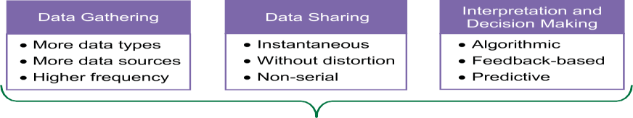

Figure 1. Framework for exploring opportunities to improve supply chain performance using Internet of Things (IoT)

DATA GATHERING

One of the fundamental drivers of the growth of IoT is the increasing variety of objects connected to the Internet. As Macaulay et al. (2015) pointed out, “With the advent of IoT, Internet connections now extend to physical objects that are not computers in the classic sense and, in fact, serve a multiplicity of other purposes.” Such objects may include “consumer products, durable goods, cars and trucks, industrial and utility components, sensors, and other everyday objects” (Rose et al. 2015). Different objects will collect and share different types of data, such as heart rate from a fitness tracker, driving speed of a car, or level of ink remaining in a printer cartridge. Thus, a natural consequence of the variety of objects connected to the Internet is that an IoT information ecosystem will gather more types of data.

The number of objects connected to the Internet is projected to reach 50 billion by 2020 (Evans 2011) and 100 billion by 2025 (Rose et al. 2015). This equates to an average of more than six connected objects per living human being by 2020 and over twelve by 2025. Thus, the same kind of data may be available from multiple sources. One example of this is the driving speed data from multiple connected cars in one geographic area. This information can be used to compute the average and variance of driving speed at a particular location at a given time. Thus, the IoT information ecosystem will also have more sources contributing the data of a given kind. More data points enable computation of reliable statistics.

Finally, due to their automated nature, data collection and transmission can both be performed more frequently than what may be plausible with the human involvement in either collection and/ or transmission of data. Therefore, the third distinguishing feature of the IoT information ecosystem is that it allows more frequent data collection.

DATA SHARING

A second fundamental driver of the growth of IoT is the widespread ability to connect computational devices to the Internet (Rose et al. 2015). In IoT, communication among devices is enabled not only by the commonly-used information technologies such as wired connections, local wireless networks (e.g., Bluetooth, Wi-Fi, RFID), and wide-area telecommunication networks (e.g., EDGE, 3G, LTE), but also by “operational technologies” such as the “more specialized, and historically proprietary, industrial network protocols and applications that are common in settings such as plant floors, energy grids, and the like” (Macaulay et al. 2015, 4). The “always-on” connectivity allows the devices to share the collected data instantaneously.

The automated nature of data sharing also obviates the need for human operators to collect, process, or analyze the data before it is shared. Sharing data in the raw form is advantageous because the data get shared without getting subjected to human biases that are known to influence selective collection and processing of data (Ditto and Lopez 1992; Edwards and Smith 1996; Kunda 1987). One of the robust findings in psychology informs that people “are likely to examine relevant empirical evidence in a biased manner” when they hold strong opinions about the issue (Lord, Ross and Lepper 1979). Automated data sharing can circumvent this problem. Therefore, the second key feature of an IoT information ecosystem is that data are shared without distortion.

Finally, connectivity over the Internet allows the connected devices to exchange data with each other or a common cloud-based platform directly (with the appropriate communications protocol), regardless of their place in the supply chain. Thus, a firm can exchange relevant data with another firm in its supply chain even if the firms are not direct suppliers or customers of each other. For example, the point-of-sales data at a retail store does not have to reach the product’s manufacturer from the retailer, through a distributor and a wholesaler; the point-of- sales data at a store can be sent either directly to the manufacturer or uploaded to a cloud-based platform where the manufacturer can access it. Thus, the third distinguishing feature of the IoT information ecosystem is that it allows data to be shared in a non-serial fashion with the supply chain partners.

INTERPRETATION AND DECISION MAKING

Another fundamental driver of the growth of the IoT is the advance in data analytics (Rose et al. 2015). Macaulay et al. (2015, 6) noted that “the use of analytics and complementary business applications (e.g., data visualization) is crucial if organizations are to capture and make sense of the data generated from connected devices”. The automated processing of data ensures that the analysis is not influenced by human biases (e.g., Kunda 1987; Lord et al. 1979). It also ensures that data are analyzed consistently using the predefined algorithms. Of course, the use of algorithms is not a panacea: the design and selection of algorithms themselves are not immune to human biases and can arguably have monumental consequences, such as the 2008 Global Financial Crisis (O’Neil 2016). Firms need to be aware of these dangers. However, well-designed algorithms can make data processing consistent and free it from the vagaries of biased human decision making. Thus, one salient feature of the IoT information ecosystem is its algorithmic decision making.

The second important feature of IoT-based decision-making is the ability to get quick and frequent feedback. Due to the automated collection and instantaneous sharing of data, an IoT- controlled system can take several small actions, measure outcomes, obtain feedback, and make corrections based on the feedback. This rapid action-correction loop could be prohibitively expensive with human involvement in data collection, sharing or decision- making. Management research has long established that “if the action-outcome-feedback links are short and frequent, the individual (or, firm) is in a good position to learn about, and thus comprehend, the probable effects of actions on outcomes: short links enhance the ability to improve decision making by taking corrective actions” (Hogarth and Makridakis 1981, 120). Thus, the second key feature of the IoT information ecosystem is the feedback-based nature of decision-making.

Finally, the vast amount of data collected through IoT devices can enable predictive decision- making. More accurate forecasts, enabled by larger volume of relevant data, can help optimize a particular system with fewer resources. For example, more data about sales or online searches can help predict demand with smaller variance, and as a result, a supply chain can provide the same level of product availability with smaller inventory. Thus, the third distinguishing feature of the IoT information ecosystem is the predictive decision making.

Application of framework
In this section, I demonstrate the use of the above framework by applying it to envision opportunities for improving the performance of an existing supply chain using IoT capabilities. I use the supply chain depicted in the “Beer Distribution Game” (Sterman 1989) and one variation of it for the demonstration. I choose this supply chain because of its simple structure and its familiarity to a large number of management scholars and practitioners. I begin with a brief description of the supply chain in the Beer Distribution Game and follow it up with a depiction of the modified supply chain designed by deploying IoT capabilities.

The “Beer Distribution Game”
The “Beer Distribution Game” is a “role-playing simulation of an industrial production and distribution system” (Sterman 1989, 326). It was developed in the 1960s at the Massachusetts Institute of Technology to demonstrate some key dynamics in the supply chain. It has been played all over the world by thousands of people “ranging from high school students to chief executive officers and government officials” (Sterman 1989). The supply chain in the game delivers one product (i.e., cases of beer) through four stages or echelons — retailer, wholesaler, distributor and factory, with only one firm at each echelon. The retailer orders the product from the wholesaler to meet the market demand; the wholesaler fulfills the demand from its inventory, and orders the product from the distributor, who in turn, fulfills the demand from its inventory and orders the product from the factory, which produces (i.e., brews) the necessary quantity to meet the demand. There is a lag of two weeks between the placement of an order and receipt of the goods between each pair of consecutive stages. The game is played over several “periods,” with each period equivalent to one week. The objective of the game is to minimize the total cost for the supply chain over the duration of the play. Each case of beer carried in the inventory costs $0.50 per week, and each lost sale due to not having any inventory at the retailer costs $1 per week.

Each firm, manned in the game by a player, has to make only one decision in each period: determine the quantity to order in the next period. The only exception is the factory, which decides the quantity of beer to produce (i.e., place an order on itself). The key feature of this game is that each player (i.e., firm) “has good local information but severely limited global information” (Sterman 1989, 328). The players are told not to communicate with each other; thus, no player except the retailer has any knowledge of the consumer demand in the market. Furthermore, the market demand is not known in advance; the retailer discovers the market demand as the game progresses. The players are told of the two types of costs incurred in the game and the game’s objective of minimizing the total cost. However, they are not given specific guidelines for determining their order quantities. Thus, each player may decide the quantity to order based on the quantity of the product ordered by his/ her customer, his/her interpreted pattern of customer’s orders, his/her anticipated future orders, and any other metrics he/she considers relevant for determining the order quantity.

The customer demand is set at four cases per week for each of the first four weeks of the game. The demand experiences one unannounced one-time increase to eight cases per week in week five; after that, the demand remains stable at eight cases per week for the rest of the game. This one small change creates major fluctuations in the supply chain. Sterman (1989) noted that almost all runs of the Beer Distribution Game exhibit the same three qualities: oscillation, amplification, and phase lag. Order quantities and inventory levels of all four firms oscillate over time. The inventory levels of the retailer decline first, followed by the decline in inventory levels of wholesaler, distributor, and the factory in that order. The declines generally cause severe shortages throughout the supply chain. To compensate for this, the players increase their order quantities. This swings the inventory levels in the opposite direction, and the “inventory in many cases substantially overshoots its initial levels” (p. 330). The magnitude of orders is amplified from the retailer to the factory; the peak order rate at the factory can be about twice as high as that at the retailer. Finally, because of the time lags between the stages, the order quantities exhibit a phase lag, such that the peak orders at the factory occur, on average about four weeks after the peak orders at the retailer.

These phenomena are also observed in the real world. Sterman (1989, 3) noted that the “production- distribution networks in the real economy exhibit the three aggregate behaviors generated in the experiment, i.e., oscillation, amplification from retail sales to primary production, and phase lag.” The oscillations are caused by the failure to account for the goods in the pipeline (i.e., the products ordered but not received yet) when placing orders, as well as incorrect assumptions about market demand. The amplifications are the result of lack of visibility to the true demand for the parties’ upstream in the supply chain and their over- adjustments to the disturbances observed in their own demand. Another result of the lack of visibility is that the players representing the firms’ upstream in the supply chain have incorrect assumptions about the true demand. Sterman (1989, 335) showed that “the majority of subjects (playing the wholesaler, distributor, or factory roles in the game) judge that customer demand was oscillatory,” when in reality, it is stable throughout the game barring one fluctuation in week five. Finally, the phase lag is a natural result of the time lags in the placement of orders by the parties in the supply chain.

Overall, three aspects of this supply chain engender this phenomenon: lack of visibility of market demand to all parties except the retailer, the time lag between placing and receiving the orders, and the failure to keep track of the inventory in transit. The decision makers in the game use an anchoring-and-adjustment heuristic (Tversky and Kahneman 1974) to determine the order quantity: they anchor on the expected demand from their customers and then adjust the order quantity to “reduce the discrepancy between the desired and actual stock” and “maintain an adequate supply line of unfilled orders” (Sterman 1989, 324).

“Beer Distribution Game” with IoT Ecosystem
In this section, I describe how the framework presented earlier can be used to think of ways in which the potential causes of the undesirable dynamics in the Beer Distribution Game’s deploying IoT capabilities can mitigate supply chain. To do this, I present a list of initiatives, envisioned with the help of the framework, to improve the supply chain performance using IoT capabilities. The initiatives are presented in Table 1 below. I first present three initiatives targeted to improve the performance of the supply chain described in the Beer Distribution Game (Section I of Table 1), which is a rather simplified version of a real-world supply chain. Following this, I present four initiatives to improve the performance of a modified version of the supply chain based on the game (Section II of Table
1).

Table 1. Initiative to improve performance of supply chain in the “Beer Distribution Game” using IoT capabilities

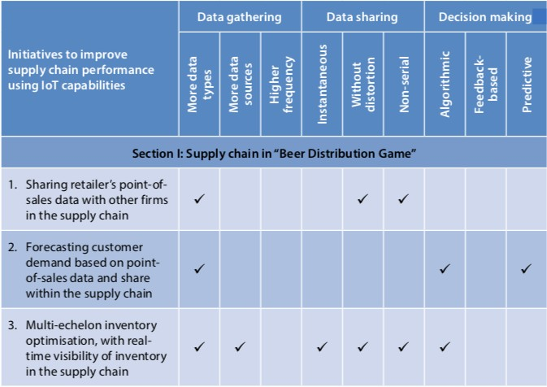

Table 2. “Beer Distribution Game”

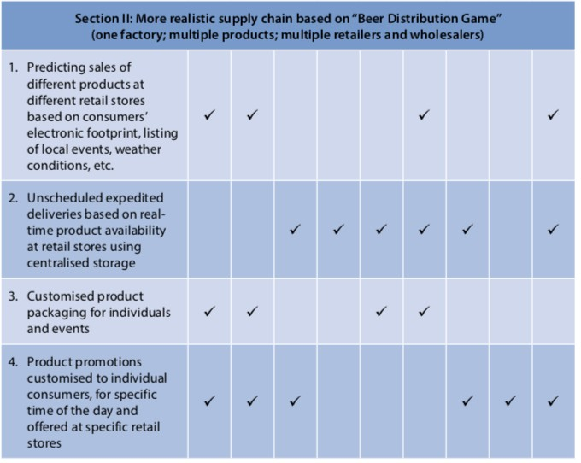

Initiatives for Supply Chain in “Beer Distribution Game”
The first initiative is to share point-of-sales data from the retailer with the wholesaler, distributor and the factory. This involves collecting new type of data (i.e., retail sales), and sharing it without distortion (i.e., sharing raw sales data, instead of order data from retailer and other firms) in non-serial manner (i.e., the sales data is sent directly from the retailer to the wholesaler, distributor, and factory, instead of having to traverse serially through the supply chain). This provides complete visibility to all the players about the nature of market demand, and can help make correct assumptions about market demand by three firms that do not see the market demand directly. This can result in lowering the total cost by reducing the overall inventory carried in the supply chain, while simultaneously increasing product availability by reducing the stock-out situations.

The second initiative is to forecast customer demand based on point-of-sales data and share it with all firms in the supply chain. The first one enables this initiative. Besides the features of the framework used to enable the first initiative, this initiative involves the use of algorithmic and predictive decision-making (i.e., a forecasting heuristic to predict demand, although a very simple forecasting algorithm can suffice in the Beer Distribution Game) instead of relying on manual judgment to determine order quantities, as done in the game. It also involves the use of more types of data: the firms can develop one forecast of the market demand and share it among all four parties in the supply chain. The benefit of this initiative is that it allows all parties in the supply chain to work to meet one common goal. The outcome of this initiative is the same as the first: it can lower cost by reducing inventory in the supply chain and, simultaneously, increase product availability.

The third initiative is to provide real-time visibility of inventory in the supply chain and use multi- echelon inventory optimization. Inventory visibility in the supply chain described in the Beer Distribution Game can be enabled by attaching RFID tags or similar sensors to the cases of product shipped, which can be scanned and retagged as they move from one facility to another. This initiative involves the use of more types of data (i.e., product location) collected from more sources (i.e., the location data is collected from several cases of beer from a single batch) and shared instantaneously, without distortion (i.e., raw location data, instead of a summary report about the amount of product at a location) in a non-serial manner (i.e., shared with all parties in the supply chain through a common platform), so that the inventory in the supply chain could be optimized using sophisticated algorithms (i.e., using multi-echelon inventory management algorithms, instead of manually determining the optimal inventory levels at each echelon). The benefit of this initiative may be particularly evident when the consumer demand experience a small change — which disturbs the equilibrium in the game and causes severe oscillations of inventory levels and order quantities in the supply chain — as the adjustments to the inventory levels are based on a multi-echelon inventory optimization algorithm, instead of the overcorrection of a human decision maker typically observed in the game. Thus, the result is a more cost-effective response to unexpected changes in demand.

Initiative for Revised “Beer Distribution Game” Supply Chain
The following describes a more realistic version of the supply chain based on the game, without deviating too far from the original design, to demonstrate the benefit of the proposed framework for identifying opportunities for improving performance of the supply chain. Assume that the supply chain consists of one factory, one or more distributors and wholesalers, and multiple retailers each with one or more stores. We still assume that the supply chain delivers the same category of product, but now assume that there are multiple product variants made by the factory and delivered through the supply chain. We assume that consumers have preferences amongst the different variants of the product. Section II in Table 1 presents four initiatives for improving this supply chain.

The first initiative is to predict sales of different products at different stores (i.e., different geographic regions). This initiative uses more types of data (i.e., consumer profiles based on web and social media activity, geo track records from mobile phones or fitness trackers, listing of events that influence product consumption in a region, regional weather, etc.) collected from more sources (i.e., from more consumers), shared in a non-serial manner (i.e., over a cloud platform with all parties in the supply chain) and processed to identify demand patterns using predictive machine learning algorithms. The benefit of this initiative is that it enables the use of causal forecasting models to predict demand. This can forecast demand more accurately based on the demand drivers, instead of using simple time-series extrapolations of historical patterns. This can improve product availability as well as reduce product spoilage due to inventory aging and obsolescence.

The second initiative is to offer unscheduled expedited deliveries from a centralized warehouse, based on real-time product availability at retail stores. This initiative uses data about stock levels in retail stores collected frequently (i.e., using real-time inventory updates based on point-of-sales transactions), transmitted instantaneously and without distortions (i.e., as raw inventory data) in a non-serial manner (i.e., shared with all relevant supply chain players over a common platform) for algorithmic predictive analysis to determine if any unscheduled expedited deliveries need to be made to any stores to avoid loss of sales due to product stock outs. The benefit of this initiative is that it allows a retailer to augment periodic store replenishments with expedited deliveries to minimize stock outs and lost sales. Thus, the supply chain becomes more agile in responding to unexpected changes in the market demand.

The third initiative is to allow products to be customized for individuals and/or for special occasions, such as birthdays, anniversaries, and other special events. This initiative relies on the use of more data (i.e., consumer biographic details and product preferences from social media, product and/or packaging designed by consumers for the special event on the company’s social media interface), more sources of data (i.e., data from more consumers) shared without distortion in a non-serial manner (i.e., shared by consumer directly with the producer, instead of going through the retailer). The benefit of this initiative is that consumers can customize products for their own events, and the producer’s factory can ship the product directly to the consumer instead of sending the customized product through the four-tiered supply chain.

The fourth initiative is to create product promotions customized for individual consumers, for specific time of the day, and offered at convenient retail stores. This initiative relies on usage of more types of data (i.e., consumer’s social media profiles, shopping habits and product preferences, present location, etc.) collected from more sources of data at high frequency (i.e., data collected regularly for a large number of consumers), as well as algorithmic and predictive decision making (i.e., the use of algorithms to identify the optimal offers for each consumer for a specific time of the day and offered at a particular retail location). Furthermore, the algorithms can be feedback-based so they can learn by measuring the “hit rate” (i.e., the proportion of time a consumer bought the marketed product) and updating the algorithm itself to improve the hit rate. This can increase sales due to better matching of product offering with customer needs (i.e., higher value).

In conclusion, this section portrays the use of the framework to identify opportunities for improving the performance of a supply chain. In this case, the illustration is made by identifying the opportunities for the supply chain in the “Beer Distribution Game,” and then for a more realistic version of the same supply chain. The examples presented for this context are meant to be illustrative and not exhaustive. The opportunities for improving the supply chains described above are practically unlimited; the few initiatives mentioned in this paper are a small tip of the iceberg.

DISCUSSION

It is widely believed that the IoT will radically transform today’s supply chains. Several publications describe the potential benefits and threats of IoT (e.g., Biswas et al. 2015; Chui et al. 2010; Evans 2011; Macaulay et al. 2015; Phadnis 2015; Rose et al. 2015; The MPI Group 2016). However, no generic framework has yet emerged that can describe IoT’s implications for supply chains. This study takes a step to fill this gap in the literature. It presents a framework, based on the theoretical foundation of information processing in organizations, to explore the implications of IoT for the management of supply chains.

One of the basic tenets of the information processing model of organizations states that “the greater the task uncertainty, the greater the amount of information that must be processed among decision makers during task execution in order to achieve a given level of performance” (Galbraith 1974, 28). Given that a fundamental task of supply chain managers is to make operational decisions that seek to achieve an optimum level of performance in uncertain conditions, the proposed framework can help one explore the opportunities for deploying the IoT capabilities to elevate the performance of supply chains from their present levels.

The proposed framework is illustrated by applying it to identify opportunities for improving the performance of two supply chains: supply chain in the “Beer Distribution Game” (Sterman 1989) and a version of that supply chain modified to include more real-world features. The opportunities presented here are certainly not exhaustive, but are chosen to illustrate the framework in a concise manner.

Although this paper focuses on identifying opportunities for improving supply chain performance using the IoT, several issues need to be addressed before the implementation can be realized. Firms in a supply chain collaborating through a cloud-based IoT solution need to ensure that the devices used for collecting and sharing information are secure to prevent malicious hacking of the network or snooping attempts for industrial espionage. Firms will also need to use devices and cloud platforms with compatible information-exchange protocols to enable inter-device communication. Uninterrupted power supply and network connectivity will be necessary for optimum performance of a supply chain’s IoT implementation. Furthermore, ethical issues related to individual privacy need to be addressed before information about individual consumers can be collected and used for commercial purposes. Data ownership issues will also need to be addressed for the data collected from consumers as well as individual firms.

Assuming the implementation hurdles can be overcome, the opportunities for improving performance of supply chains by leveraging IoT capabilities are practically limitless. They are bounded only by our creativity. A framework based on a strong theoretical foundation, such as the one presented in this study, can help practitioners identify such opportunities. After all, we strongly believe that “nothing is as practical as a good theory” (Lewin 1945).

ROBOTICS IN SUPPLY CHAIN

- Introduction
Ernst & Young (2015) identified six megatrends that have the present and future capabilities to disrupt and reshape the world. These are: digital future; entrepreneurship growth, global marketplace; urban world; resourceful planet; and health re-imagined. Hausmann et al. (2015) elaborated on McKinsey’s seven important trends that are shaping or will shape the Transport and Logistics sector over the coming years:

- New solutions from unexpected competitor.
- The digital frontier.
- Burdening capital expense (capex) as a prerequisite for competitiveness.
- The impact of deregulation on growth and competition.
- Consolidation and cooperation across the network.
- Increased volatility of demand and input factors, and
- Megacities and selected emerging trade routes.

More recently, according to the Logistics Bureau (2017), the six supply chain trends you cannot afford to ignore are:

- Warehouse Robotics in the Supply Chain.

- Autonomous Road Transportation.

- The Blurred Line Between Logistics and Technology Services.

- The Appeal of Supply Chain Social Responsibility.

- The Race for the Last Mile, and

- The Rise of the Virtual Logistics Team.

In a survey of managers at freight forwarders by the shipping software company Freightos Ltd., 68% said warehouse robotics would profoundly impact their industry (Chao 2016). According to the report from Tractica (2017), a market intelligence firm, warehousing and logistics robot units will grow from 40,000 units in 2016 to 620,000 in 2021. According to the market research study released by Technavio (a leading market research company with global coverage), the global material handling robotics market is expected to exceed USD20 billion by 2019, growing at a Cumulated Average Growth Rate (CAGR) of more than 8% during the forecast period (Modern Materials Handling 2016). Robotic shipments are expected to reach USD22.4 billion in global market value by the end of 2021, up from an estimated USD1.9 billion in 2016 (Reese 2017). Morgan Stanley quotes an International Federation of Robotics report that says million new robots will be installed in factories over the next three years (Garcia 2017).

Financially, Manyika et al. (2015) quoted McKinsey’s estimation of a potential economic impact on the scale of USD3.9 trillion – USD11.1 trillion in 2025 for Internet of Things (IoT) applications. According to the World Economic Forum (WEF), by 2022, 1 trillion sensors will be connected to the Internet, unleashing a torrent of data. By using technology such as machine learning, Artificial Intelligence (AI) and IoT to improve supply chain transparency, leaders in the back office are able to drive product excellence, accelerate time to market and develop new products and services (Patel 2016).

The head of logistics at SAP, Hans Thalbauer says the future of the digital supply chain is robotics and automation; industries are becoming smarter, as the entire process, from demand to delivery, occurs automatically; however, robotics and automation need to be effectively integrated into the overall business processes (Francis 2017). In an annual survey by the logistics industry group, MHI and Deloitte, 80% of manufacturing and supply chain executives said that the digital supply chain will be the predominant model within five years, while 61% of respondents said robotics and automation are a source of either disruption or competitive advantage. Within the next two years, Robotics and Automation adoption is expected to reach a 63% adoption rate, followed by IoT at 54% and Predictive Analytics at 52% (Business Wire 2017).

Accordingly, the International Labor Organization said about 56% of Southeast Asian salaried employment is at risk of displacement by technology over the next 20 years (Garcia 2017). Across the economy, almost 25 million jobs will be lost to automation in the next 10 years, while the new technology will create 15 million jobs, according to the research firm, Forrester (Clark and Bhasin 2017).

Based on Accenture’s Strategy Supply Chain Workforce Research 2016, supply chain executives believe digital advances will augment the supply chain workforce. They expect supply chain roles over the next three years to change most significantly in the following ways:

    - 65%: More forward looking, with strategic decisions to support business goals.
    - 51%: More data-driven decision making requiring more analytical skills, and 46%: More automation of transactional activities and exception handling (Kreutzer, Meyer and Puertas 2017).
Industry 4.0, which started with the computerization/automation of the manufacturing environment is now spilling onto the supply chain area.
The following sections will elaborate on the robotics and innovations occurred at DB Schenker, scrutinisation into the emerging trends of robotics and automation in the supply chain sector, and followed by the discussion held during the SCM Seminar held on 12 and 13 February 2017.

Robotics and innovations in DB Schenker: implementing the next generation of e- commerce in supply chain
Since the beginning of trade, man has constantly been on the lookout for ways and means to improve the supply chain, be it to resolve an operational difficulty or to improve the effectiveness and efficiency of the supply chain. Technology has played an important role in these improvements, in the form of robotics (including automation) and innovation.

The early forms of robotics in the supply chain tend to be rigid, inflexible and mechanised with large form factors. Their roles are mainly in the material handling arena and range from the simple pallet jacks and forklifts. Later forms tend to be more automated and included the conveyor belts and Automated Storage and Retrieval Solutions (ASRS). The technological advancements in robotics today have produced robots that are flexible, versatile and come in all sizes.

The demand of the marketplace and the boom of e-commerce has resulted in the next wave of technology innovation in Artificial Intelligence (AI) or robotic automation applications leveraging on cloud computing and IoT. Out of these innovations is the Automated Guided Vehicles (AGV), an ASRS goods-to-man picking solution that is essentially a robot that utilizes barcodes, QR codes, etc., to navigate the warehouse. This system improves efficiency and accuracy in storing and picking of goods.

There were three initials competing AGVs in the American and Europe markets (Wurll 2015):

- Kiva Systems founded in 2003 and acquired by Amazon in 2012.
- G-Com System developed by Grenzebach in collaboration with Swisslog and introduced at BLG Logistics, Frankfurt, Germany in 2014.
- Swisslog’s CarryPick System implemented for Lekmer at DB Schenker, Stockholm Arlanda, Sweden in 2015.

E-commerce companies such as Amazon in the USA pioneered the AGVs in its supply chain, with logistics companies such as DB Schenker in Sweden, Europe adopting the solution to participate in the e-commerce boom. When Amazon acquired Kiva Systems (now known as Amazon Robotics) in 2012, they gained competitive advantage in improved order picking productivity, reduction in labor needs and reduction in training time. The use of robots also improves product inventory control and increases order accuracy.

DB Schenker Logistics is the first 3PL worldwide to implement the Swisslog’s CarryPick system, an Automated Guided Vehicle (AGV), a goods-to-man picking solution. The adoption of this solution is part of DB Schenker’s strategy to strengthen its position in the e-commerce logistics market by implementing the next generation of e-commerce.

Combined with an integrated parcel delivery system, the solution is currently being implemented for Lekmer.com, one of Scandinavia’s largest online toy retailers. The modular CarryPick goods-to- man system uses low-profile self-driving robot vehicles (AGVs guided by QR codes on the floor) to drive underneath mobile racks and deliver them to the picking workstations. From there, workers pick andlace the requested items in shipping boxes. This implementation resulted in a reduction of real estate by 20% and manpower by 65%.
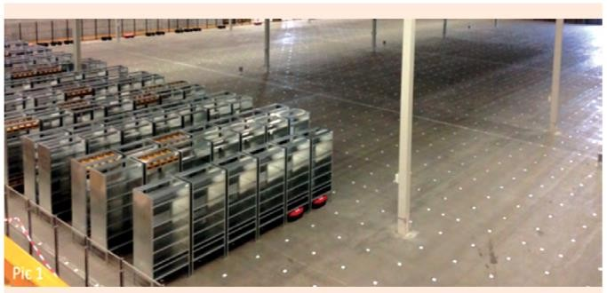

Figure 2. Rack layout in CarryPick System (Wurll 2015)

The CarryPick Systems enhanced productivity through improved order fulfillment in picking, packing and shipping process through goods-to-man system, resulted in speeding up of warehouse operations and decreasing labor requirements. It improves productivity by reducing training and down time, and increasing order accuracy and product inventory accuracy. It also resulted in electricity cost savings, as the warehouse can be kept dark.
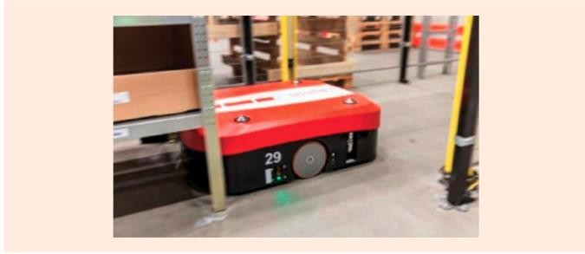

Figure 3. An AGV drives underneath mobile racks (DB Schenker 2017)

Since 2015, top pure-play logistics corporations have made 26 investments and/or acquisitions totaling 13 each year, while logistics tech start-ups were on pace to raise $5 billion through over 300 deals in 2016, according to CB Insights, a venture capital database (Robotics and Automation News 2017). uShip, the online shipping marketplace and freight automation software provider, has closed a $25 million Series D round led by DB Schenker, one of the world’s largest logistics companies and an existing uShip partner. DB Schenker’s funding comes on the heels of unprecedented investment in logistics and supply chain technology. DB Schenker is investing in shaping the future of digital logistics. In July 2016, DB Schenker and uShip announced a milestone five-year agreement worth tens of millions to create Drive4Schenker, an online trucking platform, powered by uShip PRO, uShip’s enterprise freight automation technology. Also, Drive4Schenker recently launched in Germany will continue to be rolled out across Europe, optimising management of 5,000 loads per day with 30,000 DB Schenker transport providers. Expanding its successful partnership will expedite and streamline transport management and help DB Schenker, as a market leader in European land transport, to handle even larger volumes of freight.

AKTA project is another DB Schenker project. The Automation of Kitting, Transport and Assembly (AKTA) project is being funded by VINNOVA, Swedish Agency for Innovation Systems, and will be conducted between Autumn 2016 and Winter 2018. The project has a budget of over Swedish Krona (SEK) six million (approximately USD750,000) and is being conducted in partnership with FlexLink, AB Volvo, Schenker Logistics AB, Lorentzen & Wettre AB, CEJN AB, Väderstad AB and Mälardalen University, and Robotdalen (Robot Valley).

Emerging trends of robotics and automation in supply chain
In the past decade, Radio-frequency identification (RFID) is a device much used in supply chain applications. RFID is an embedded device which may be considered to be the intelligent agent of the product to which it is attached, since it can actually direct the entire lifecycle of the product, including its use in automated decision making and control functions connected with the product in subsequent manufacturing downstream of the supply chain (Kiritsis et al. 2003). Results indicate that RFID appears to be a disruptive technology as it supports new business models, entails major redesign of existing processes and fosters a higher level of electronic integration between supply chain members (Louis et al. 2005). RFID real-time data can be used to support dynamic scheduling in manufacturing and supply chain management so as to control production execution and logistics planning (Brewer et al. 1999).

Reported by Poon et al. (2009), RFID technology was adopted to facilitate the collection and sharing of data in a warehouse, and the feasibility of radio frequency identification case-based logistics resource management system (R-LRMS). According to Zhong et al. (2015), radio frequency identification (RFID) has been widely used where production resources attached with RFID facilities are converted into smart manufacturing objects (SMOs), and enormous data could be collected and used for supporting further decision-making in a holistic Big Data approach from massive RFID-enabled shop floor logistics data.

Tsai (2011) found two major benefits after the RFID system was implemented in the semiconductor testing company, one being to improve efficiency, reduce human error, and eliminate manual processes, while the other was enterprise process automation. However, the use of RFID is not without obstacles. According to Angeles (2005), one of the major technical issues with RFID readers is the collision problem, which occurs when readers are reading many chips in the same field. Therefore, RFID technologies should be implemented proactively, i.e. make the ROI case, choose the right RFID technology, anticipate RFID technical problems, leverage pilot project learning experiences, and manage the IT infrastructure issues of data management concerns and integration with back- end applications.

For Industry 4.0 to be realized, the supply chain has to become a completely integrated ecosystem that is fully transparent to all the players involved — from the suppliers of raw materials, components and parts, to the transporters of those supplies and finished goods, and finally to the customers demanding fulfillment. Companies that get there first will gain a difficult-to-challenge advantage in the race to Industry 4.0. The real goal will be the many new business models and revenue streams, which digital supply chain will open up (Schrauf and Berttram 2016). Industry 4.0 technologies can enable greater operational flexibility, reduce operational costs, drive more modular and adaptable automation, and promote business growth (Taliaferro et al. 2016).

According to Brody and Pureswaran (2013), three new technology revolutions — 3D printing, intelligent robotics and open source electronics promise unprecedented supply chain upheaval, thus companies and governments must understand and prepare for this new software-defined supply chain. Lee et al. (2016) suggested that the Technological Disruptions in Delivery are Advanced Algorithms and Analytics, Drones, Delivery Robots and Driverless or Autonomous Cars.

According to Merlino and Sproģe (2017), a new wave of Artificial Intelligence applications can approach and solve definitely many problems of Planning and Control of Supply Chain, while robotics is already transforming all the operational areas in Materials Handling as Amazon or Ali Baba, and Big Data new approaches can fully exploit the strategic potential of information available in supply chain areas.

Regionally, Kerry Logistics, a leading logistics service provider in Asia, has introduced six fully automated and programmed robotic butlers at its flagship facility PC3 in Hong Kong to meet the ever-growing consumer demands in online shopping, to become one of the first 3PLs in Asia to adopt robotic butlers in its operations to enhance fulfilment efficiency and accuracy (Kerry Logistics 2015). In Malaysia, MIMOS, the national R&D centre in ICT, is collaborating with China on research and development on smart manufacturing technology (Sebastian 2015). Johor Corp (JCorp) and Indian Investment Development Authority have invited Beijing Huize Boyuan Robot to invest RM15 billion on Robotic Future City, an industrial robotics hub and an R&D centre that creates 1,000 job opportunities (The Star, 30 April 2017).

In terms of human resources, Gartner, Inc. (a leading research and advisory company for business leaders) predicts that by 2020, 10 per cent of large enterprises in supply-chain- dependent industries will have created a chief robotics officer (CRO) position to oversee the blending of human and robotic workers (Pettey 2017), and high-velocity distribution centres need highly trained professionals to manage these highly automated operations, such as IT engineers, maintenance employees, and operations analysts (Taliaferro et al. 2016).

BIG DATA IN SUPPLY CHAIN

- Introduction
Big data is no longer a new concept. The International Data Corporation (Morris et al. 2014) predicts that digital data will grow from 2.8 trillion gigabytes in 2012 to 40 trillion gigabytes by 2020. Implications on the domain of supply chain operation model (SCOR) can be seen on processes related to supply planning, sourcing, make and deliver processes. In the planning stage, data are analyzed to predict market and consumer trends. During the sourcing process, big data enables more effective and faster supplier search, supplier negotiations, and supplier evaluation and supplier selection. Data connectivity and databases are used during the make process to ensure the right supply-demand of inventories, schedules and automation of process within the array of manufacturing processes. In the shipment delivery stage, the various applications of big data improve the precision and delivery cycle time. Disruptive progress on Internet of Things (IOT) and e-commerce compel corporate leaders and operations managers to innovate and invest in the application of big data in the supply chain. Big data in supply chain is already here

Data explosion and ripe for commercialization
Conceptually, big data is a term that describes the large volume of data. Industry players have categorized big data into three (3) mainstreams, namely Volume, Variety and Velocity, since early year 2000. Enormous sources of data acquired from business transactions, social media and machine- to-machine interactions from different organizations in the value chain pose data storage challenges. New technology such as Hadoop (an open source, Java-based programming framework) supports the processing and storage of extremely large data sets in a distributed computing environment. Innovations in RFID tags, sensors and smart metering addressed the velocity of data streams to manageable real time. The variety of data exists in structured or unstructured format. The structured data exist in numeric forms such as traditional databases or unstructured text documents, email, video, audio, stock ticker data and financial transactions. Recent development has also identified that data variability affects handling, and veracity affects quality of data and subsequently accurate analysis. The challenges related to data volume, variety, velocity, variability and veracity keep increasing.

As data centric technologies mature and become more accessible, organizations in supply chain are innovating new approaches to apply and introduce new data-driven products and services. Figure 1 illustrates the benefits of big data.
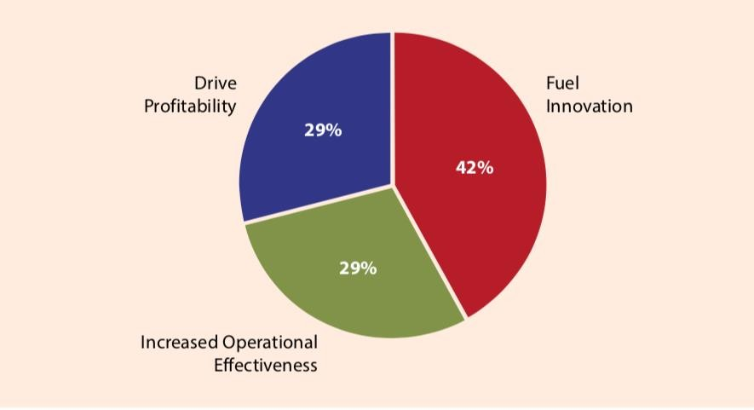

Figure 4. Benefits of big data (Hagen, C and Khan, K 2014)

The value from big data comes from the processing and analysis of it to provide insights on products and services. The insights link suppliers, manufacturers and retailers to customers into a more efficient supply chain. The commercialization of big data in supply chain requires significant efforts to align the data value with targeted users, the breadth and depth of service offered, improving the customer support infrastructure and data storage accessibility. The sweeping changes in big data technologies and management approaches need to be accompanied by dramatic shifts in the manner data supports decisions and product/service innovation.

Big data enables supply chain in a big way
Conceptually, a supply chain involves bidirectional flows of information, products and cash. The bidirectional flows between suppliers, service providers, manufacturers and final customers occur through different supply nodes. Transactional data have been conventionally designed as Enterprise Resource Planning (ERP), Advanced Planning System (APS) or even customized supply chain execution tools to improve supply chain response between stakeholders. With the advent of data explosion, the pervasive use of big data in data mining and analytics transforms supply chain through new forms of data, solves existing business problems and creates new opportunities. For example, e-retail giant Amazon.com handles millions of back-end operations everyday, as well as queries from more than half a million third-party sellers in a capacity of terabytes. eBay uses two data warehouses (in petabytes range) as well as Hadoop cluster for search, consumer recommendations and merchandising (Wikipedia). Essentially, big data enables the supply chain in multiple ways as articulated in the following framework:

- Responsive sensing analytics: The traditional supply chain model relies on historical data such as order or shipment data, to sense demand and react with series of supply chain solutions. However, such a business model creates a disadvantage where the supply chain is poor at sensing and responding to demand and supply changes. Recent development in data mining, text mining, and rule-based ontologies allow supply chain operations to understand their customers better. The digitalization of business has allowed supply chain organizations to listen cross-functionally to customer sentiments and use advanced analytics to test market response. The data related to these feedback mechanisms is either sourced from internally established data warehouse, procured from large database service providers or from social media.

- Predictive supply chain scenario planning: Current data structure within the supply chain is somewhat hard coded. Often, the data structure produces response based on average value and non-complex “if-then-else” logic. The disadvantage is the inherent inflexibility to support complex scenario planning. Supply chain managers who need more flexible options are turning to predictive analytics or rules-based ontologies to map out “multiple ifs to multiple then” through learning systems.

- Making delivery channels effective and visible: Competitive development in e-commerce makes supply chain managers reconsider their delivery channel programmed. Rapid digitalization of data and the widespread use of digital devices on various platforms offer new business solutions to different industries. For example, in the brick-and-mortar retail industry and the fast-moving goods supply chain, operation managers are aware that consumer decisions are made on the shelf but the data they see and respond to every day is limited to their own company data. The enormous data integration (ranging up to petabyte) acquired through Point of Sales, Radio Frequency Identification Tag (RFID), barcode information from mobile, social and e-commerce data enables the smooth integration of the supply chain delivery mechanism to rely heavily on sensors, which in turn rely more on the volume of data. RFID sensors send high volumes of data in different format or pattern, with improved recognition system and adaptive infrastructure, which makes the delivery channel more effective and efficient. The volume, depth and variety of data transacted across supply chain organizations provide real time data feed. The impact of relocation, mapping data and visualization of supply sensing transmission through sensors on items, totes, trucks and rail cars, or containers transforms supply chain visibility.

- Digitized manufacturing and services: The advent of IOT requires supply chain managers to think differently in the manufacturing and service sectors. The extensive expectation of mobility and digital inputs from sensors requires manufacturers to react in real time rather than to event-based execution model. Production scheduling, planning and maintenance programmed are facilitated by machine output or machine learning through extensive data transacted. In the service sector, the use of such mobility and digital inputs transforms the service industry. For example, airplanes automatically communicate the performance status of the equipment on board upon landing, expensive earth movers in remote locations transmit signals regularly, and electricity-generating windmills send signals at regular intervals to control towers. These signals are then used to plan the maintenance servicing and parts replacement. The manner of data streaming at high volumes and high variety transforms the IOT in the service industry.

The enormous data application represents a critical source of business insights and information that creates a competitive advantage for the multiple stakeholders in a supply chain. Big data improves operational efficiency and profitability through speed or visibility, thus improving the overall stakeholders’ relationship. The enhanced agility and responsiveness leads to competitive and shorter time to market especially in the supply chain IOT, and ultimately higher revenue recognition and competitive advantage.

Getting the supply chain ready
In order to harvest the positive impact on the supply chain, organizations need to innovate the approaches on big data. Firstly, the supply chain stakeholders need to redesign the market dynamics to reflect end-consumers by incorporating and segmenting the data usage and analysis in business processing to different target market. It needs to consider how different consumer groups across the value chain will consume and benefit from the data. Secondly, the supply chain manager needs to adjust, modify, implement incremental improvements, or re- engineer the manufacturing or service model to take advantage of the data stream. Improvement or investment within the upstream to downstream data chain management (hardware or software) should not be ignored. For example, part of resolving data-related issues may require reloading of data sets, running queries to ensure data integrity and consistency, or conducting data quality checks. Effective change management is required to deliver the optimized business processes, which translate to increase or create new revenue streams. Responsive and agile supply chain needs to design effective alternate data storage infrastructure. An optimal data storage infrastructure should deliver targeted service quality with optimized service delivery costs. This is in turn supports data replication strategy within the supply chain network, thus improving retrieval data. Staying ahead of the game through data analysis, visualization of data sets, statistics, algorithm, machine learning, knowledge on open sources tools, or programming languages help a supply chain’s product and service research development. Unknowingly, many technology or service-based companies are sitting on untapped sources of revenue in the form of operational data. It is important that enterprises leverage their human resource and staffing teams to attract and retain these skill sets to support their data-driven product portfolio.

TECHNOLOGIES FOR PROCUREMENT: CURRENT TRENDS AND EMERGING TRENDS

- Introduction
Electronic procurement (e-procurement) is the use of electronic methods in every stage of the procurement processes from identification of requirement, through to supplier sourcing, request for quotation, purchase order issues, payment and contract management. The current technology of e-procurement has been available since beginning of 21st century. The issue is, not all procurement professionals have been fully implementing this e-procurement until now. Nevertheless, the emerging trends of procurement technologies such as artificial intelligence, Procurement 4.0, Big data, 3D printing and Internet of Things (IoT) have begun to affect procurement professionals.

A study conducted for 830 procurement decision makers across the United Kingdom, Europe and North America shows that 68% of companies have automation, 59% implement e- sourcing, 54% have predictive analytics and 54% have IoT. However, most of the companies which adopted these technologies are located in North America and their workforce is greater than 3000. In addition, North America is 8% more likely to adopt these technologies as compared to Europe. In spite of the importance of technologies in procurement, talent in technology is only ranked as the sixth most important skills and only 17% of procurement department claim the technology skills gap (Avery 2015). This scenario poses a challenge to procurement professionals who have yet to adopt the emerging technologies, especially those located in developing countries.

Current technology of electronic procurement
The two core processes of e-procurement (electronic procurement) are e-sourcing and e- requisition. E sourcing uses the Internet to make decisions and form strategies pertaining to how and where to obtain products and services. E-sourcing is more for contractual processes with the tools of e-tendering and e-RFQs (request for quotation and e-auctions) (Baily, Farmer, Crocker, Jessop and Jones 2008). E-requisition is the web-based application used to process and monitor purchase requisition; it is more transactional with the tool such as e-catalogues. E-requisition may be called as e-ordering.

The main predictor for adoption of e-procurement techniques was perceived drivers. The perceived drivers included better decision making, better inventory management, increasing order accuracy, increasing the visibility of suppliers’ products, reducing cycle time for order completion, easy to try or switch to new suppliers, reducing inventory cost, reducing price and reducing transaction cost. Internal and information barriers were significant predictors for e- procurement in the new buying situations. The internal barriers of e-procurement comprised of lack of IT system integration with the partners, inadequate technological infrastructure of business partners, inadequate in-house technological infrastructure and IT personnel, changing the way people work, lack of top management support, lack of corporate strategy and high technological implementation cost. Information barriers of e-procurement included the concerns about security, confidentiality and privacy of information exchange (Abu-Elsamen, Chakraborty and Warren 2010). The electronic execution of procurement activities improved supplier partnership, supplier performance, buyer performance, process integration and process automation (Tai, Ho and Wu 2010).

Organization acceptance is likely to be a stronger predictor of performance than intensity of use for e-procurement of MRO (maintenance, repair and overhaul) items. It is because indirect materials and services are distributed across different departments. Hence, the potential benefits of e-procurement are expected to be greater when the application is deployed organization-wide. However, multiple dimensions of infusions can interact with one another and affect performance. The research suggested that when the intensity level is low, higher performance can be achieved through higher acceptance. However, when the intensity is high, performance does not receive an additional benefit from higher acceptance. As such, procurement managers may need to focus more on the level of organizational acceptance rather than the level of intensity of use in order to increase the potential benefits. It is suggested to focus on improving one usage dimension at a time in order to successfully infuse e- procurement in that dimension, before turning attention to the other dimension, akin to a staged implementation approach (Yu, Mishra, Gopal, Slaughter, Mukhopadhyay 2015).

Blue Cross Blue Shield of Rhode Island (BCBSRI) implemented the procure-to-pay solution to tie in all the processes, goals and strategies. It selected Puridiom 4.0 Enterprise Cloud solution, which enabled automation of the antiquated and manual P2P (procure to pay, from point of order to payment). This subsequently enhanced the procurement team’s ability to influence supplier spend or total spending on suppliers. Furthermore, the solution enabled suppliers to transact electronically with BSBSRI. It also increased efficiency of the cost accounting and finance teams, while allowed the procurement team to negotiate fast-pay discounts. In addition, it allowed the company to track cost saving and ensured it ties in with the budget; it assisted in measuring and improving supplier performance. It assisted procurement to focus its resources on high value items and strategic activities.

L. A case study of e-requisition
A case study of e-requisition was conducted in a multinational company located in Malaysia. A comparison was made between the MRO purchase before and after using e-requisition. Before the implementation of e-requisition, the traditional MRO purchase involved a lot of processes with long lead-time. It starts with the requestor who submits the request using purchase requisition (PR) to the procurement department manually. The procurement department will consolidate all the requisitions from various departments to finalize the total requirement. Once the quantity is determined, the procurement department will send out an RFQ (Request for Quotation) to at least 4 to 5 qualified suppliers. The qualified suppliers will have to produce a sample each, together with quotation for approval. Upon receipt of samples with price, the procurement department will call for a tender committee comprising of the requestor’s department heads, finance, procurement and warehouse, to decide on the price and quality of samples. Once finalized, the purchasing department will place orders for the uniforms from the approved supplier decided by the tender committee. Then, the supplier will deliver the uniforms and shoes to the warehouse once the buyers place an order. The warehouse will keep the uniforms and shoes as a stock item. When required, each individual department will take out the uniforms and shoes from the warehouse accordingly.

Kindly refer to the following Figure 5 for the traditional purchasing flow, which takes almost 32 days.
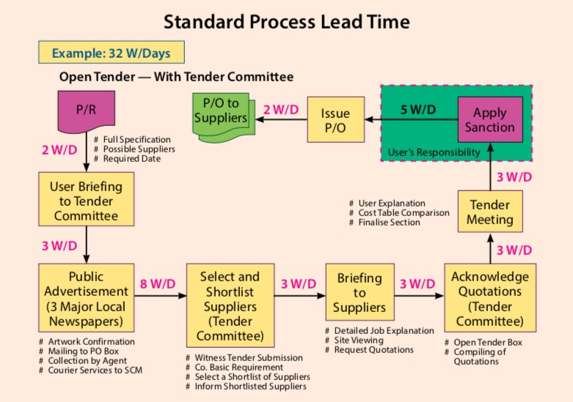

Figure 5. A traditional purchasing flow

However, after implementing e-requisition, the purchasing cycle is reduced tremendously. The procurement department can send the employees’ data to the qualified supplier pertaining to the name of each employee, date of employment, size of uniforms and shoes. The supplier can utilise all the employees’ information to prepare the uniforms and shoes as required. The shoes and uniforms will be delivered to the employees personally when they are due for collection. In this way, the warehouse does not have to keep the inventory. The company can eliminate the inventory-carrying costs. The employees can key in their employees’ number and acknowledge the receipt with a password and the receiving data can be forwarded to the Finance department for payment. In this process, the Finance department can verify the actual receipt of the uniforms and shoes from the employees personally. This process will eliminate all paperwork such as purchase requisitions, purchase orders, acknowledgement of receipt from the warehouse, inventory recording at the warehouse, and also matching of documents by the Finance department.

E-sourcing
Tata Motors used the e-sourcing of Ariba Sourcing to manage the procurement of direct materials, indirect goods, services and MRO. It saved $175 million from the cost base after two years. The e-sourcing Tata Motors started with direct materials as its comprised three- quarters of the vehicle cost (Supply Chain Europe 2007).

E-auctions create an environment where suppliers bid against each other for a contract. This environment encourages competition with the result that goods and services are offered at their current market value (CIPS). In order to hold a successful e-auction event, the procurement must understand the supplier market, identify potential suppliers, assess their capabilities and the total cost of doing business with suppliers, present suppliers with a complete set of prints, specifications and requirements, and honestly communicate the way in which competing suppliers will be judged and selected. Online auctions can be efficient and bring cost saving if the process is executed properly. Hence, a critical component to a successful auction is a dedicated buyer who is willing to allocate sufficient resources to design an equitable and well- specified auction event. However, price is only one dimension in a buyer-supplier relationship. There is a need to incorporate non-price attribute into the assessment of auction success (Elmaghraby 2007).

A new business process is involved to convert a traditional business process to an electronic format. Two factors of successful design of e-business protocols include identifying the functional difference between traditional and e-business, and recognizing functional
limitations of cryptographic technology when it is applied to the actual business process. The security requirements for an e-tender submission protocol are submission hiding, submission binding and submission time integrity. Submission hiding ensures no party can reveal any electronically submitted e-tender document before the designated tender opening. This is to ensure the security of every party’s tender strategy before the tender closing time. Submission binding could detect any party who altered or deleted any tender submission after the tender closing time. This will prevent the business conspiracy between the principal and its favoured tenders. Submission time integrity is to ensure that the time of tender submission can be recorded in a reliable manner. This is to provide reliable evidence on whether a tender is submitted on time (Du, Foo, Boyd 2008).

A case study of e-sourcing

A case study of a company in Penang discovered many benefits of e-sourcing by using the tools of e-bidding or e-tendering. The lead time required from request till complete of the sourcing procedure without e-sourcing will take about 20 days, with various manpower involved. However, by using e-sourcing, the procurement department can reduce 50% of the total processing time (from 20 days to 10 days) through e-bidding. The process is also reduced from 8 steps to 7 steps. This method is transparent. It also creates a level playing field for all vendors. The details are illustrated in the following Figure 2.

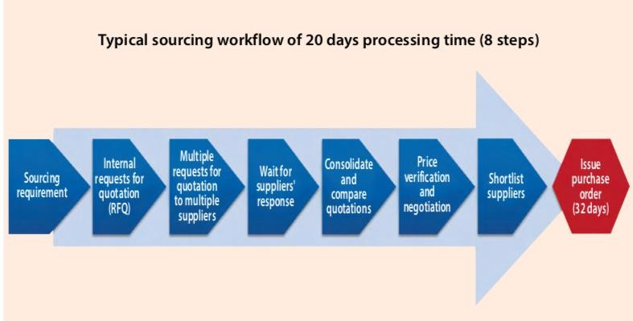

Figure 6. Workflow of 20 days

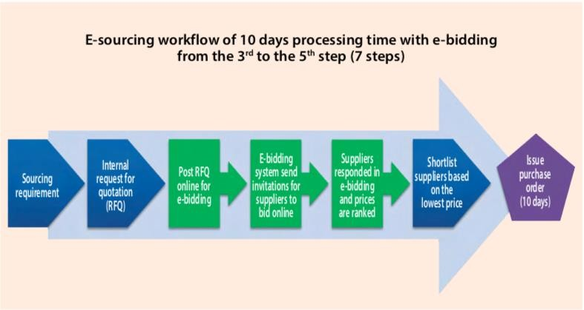

Figure 7. The processing time of typical sourcing vs. e-bidding sourcing

The advantages of e-sourcing by using the tools of e-bidding or e-tendering are summarized as follows:

- Procurement professionals do not have to take the suppliers to visit the site.
- It is sufficient to obtain a blueprint with all technical specifications for various types of items, brands and models indicated as per requirement, and forward to all qualified suppliers for quotation.
- In the event, any supplier who needs more information can indicate their requests in the bulletin board. The reply will be notified to all invited suppliers.

The case study also found that e-sourcing could reduce costs in the following ways:

- Reduce time in obtaining quotations.
- Reduce manpower.
- Create level playing field with proper control.
- Demonstrate fairness and transparency with audit trails.
- Eliminate accusations or allegations of unfair practices.

The following Figure 3 shows an example of how e-bidding enables price reduction. The bidding started with the lowest quote at RM3.2 million. The e-bidding allowed the competitors to see each other’s price though the names of the competitors were not disclosed. As such, all the three vendors were given equal opportunity to review and revise their price. The bidding started at 10:00 am and ended at 11:30 am on that particular day. By allowing auto time extension of 15 minutes to 11:45 am, they were able to achieve the cost reduction from RM2.75 million to RM2.7 million as shown in the chart (additional reduction of RM50K).
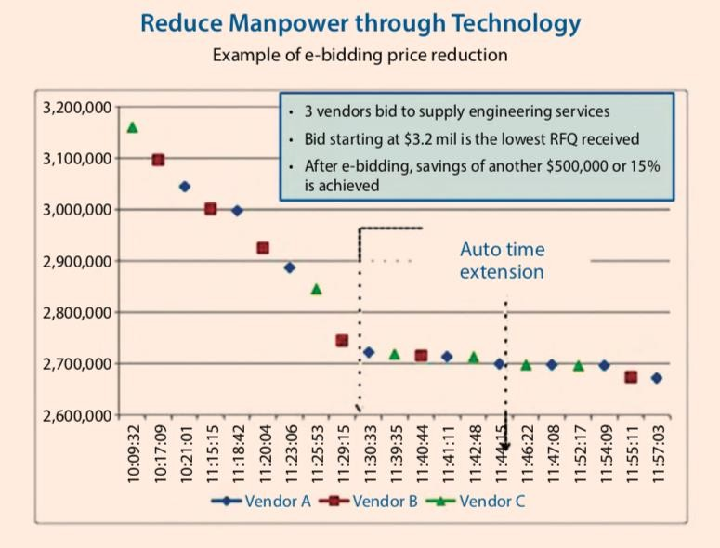

Figure 8. E-bidding price reduction

For example, there is a company named BidAsia, which provides an online procurement auction platform for bidders to compete dynamically with multiple bid price submissions in real time. Buyers get instant responses from suppliers. Table 3 shows the three options of its quotation. The prices are just a guide and it may change from time to time depending on demand and supply.

Table 3. Example of quotations

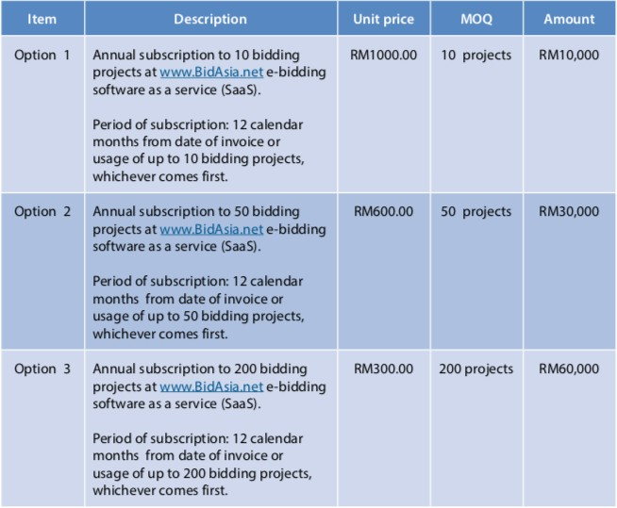

Emerging trends of technologies in procurement
Emerging trends of technologies affecting procurement management include Procurement 4.0, Big data, Internet of Things (IoT), 3D printing, robotics and cognitive procurement. Emerging trends of technologies require procurement managers to possess critical thinking to identify information that is both relevant and actionable. Procurement must have associative thinking to look clearly at unrelated factors and see a previously undetected connection; it includes the ability to recognize patterns and decide what they mean. Procurement must make fast decisions, and be proactive to come out with real-time solutions to manage real-time data. The emerging technologies require procurement to master mainstream technology to solve procurement problems. The IoT will provide plenty of information, which requires procurement to be innovative in using it (APN Consulting 2017). A supply chain roundtable conducted in Penang in year 2017 discovered that the abovementioned emerging technologies in procurement are still in the infancy stage and are not commonly adopted by multinational companies located in Penang.

Procurement 4.0 and big data in procurement
In Procurement 4.0, the strategic procurement is crucial and the procurement workforce is shrinking because it becomes autonomous in many aspects. Traditional purchasing will become obsolete.

Due to the knowledge of purchased materials and supply markets, procurement could increase its distinctive value proposition from being a cost center to a profit center. Procurement could utilize customer data to manage their incoming transportations and material inventory. Procurement could also share the customer data with their suppliers. In turn, suppliers are capable of designing products, which are efficient in cost and function.

New technologies in Industry 4.0 will lead to changes of purchased items in procurement. Procurement will be required to source more frequently for new technology items, such as intelligent sensors, communicating actuators and associated controllers and software. The purchase of electronics items will grow but others may shrink or disappear. Moreover, the service procurement will increase tremendously which leads to many contracting approaches. There will be many intellectual property implications around the ownership of the data collected by sensors when the end products are sold and in use. Who owns the rights to this data, the sensor supplier, the control system or the software provider?

In order for data integration to take place, procurement will need to get suppliers on board. Data integration will then lead to supplier risk management to detect supplier failure (Geissbauer, Weissbarth, Wetzstein 2016). Procurement could use digital supplier scorecards, objectives and improvement tracking. Automated tracking of target achievement could be used as well (Schreiber, Janssen, Weaver, Peintner 2016). As Procurement 4.0 data integration takes place, procurement will play an integral role in getting suppliers on board and optimizing the end-to-end supply chain.

“Big data” is defined as any analysis activity with a purpose to get more insight from the large amount of data in order to generate business values. Many procurement organizations have yet to fully leverage this large amount of data from internal and external sources. Big data is helpful in updating the risks from suppliers and sourcing markets, such as natural disasters or bankruptcies. Big data solution could discover new opportunities to reduce sourcing costs. Big data could potentially improve efficiency from 10% to 30%. With big data, data-oriented evidence for all product quality and delivery issues becomes possible. The first step of big data initiative is to generate hypotheses on what correlations among the available data might have actual business value. The second step is to identify all potentially relevant data sources to support the business case. The third step is to quickly build prototypes to verify correlations and support the hypotheses. The final step is to implement a robust IT-based solution specifically for the most urgent and critical correlations. It is important to start small with rapid prototypes before implementing a full-fledged solution (Sauter 2014).

Smart technologies and algorithms allow huge volumes of data from various sources to be aggregated, processed and analyzed. The resulting analyses can be used to understand suppliers and supply markets, which can automatically drive procurement decisions. The big data could provide information to optimize maintenance services and the inventory management of spare parts (Geissbauer, Weissbarth and Wetzstein 2016).

Predictive information about where and when to expect the next failure will offer an opportunity to optimize maintenance services and the availability of spare parts. Procurement is to ensure that the analysis of big data is maximized to benefit both the focal companies and their suppliers (Geissbauer, Weissbarth and Wetzstein 2016).

Supplier innovation management could be achieved by linking the R&D strategy with the procurement strategy supported through digital dashboards. Procurement could establish laboratories to be shared with the key suppliers with the intention to encourage innovation through design thinking and rapid prototyping. Big data and advance analytics could be utilized to detect new technologies, material substitutes and new suppliers. In addition, crowd sourcing is another way of innovation (Schreiber, Janssen, Weaver and Peintner 2016).

Digital technologies contribute to collaboration of procurement in the entire value chain, from sourcing to contract negotiations; order delivery; payment and supplier management. Digital procurement processes include digital request for quotations, supplier financial analysis, procurement risk analysis, verification and e-signatures. These processes go beyond purchase- to-pay, with only limited manual support required. They reduce costs and free up highly qualified procurement staff from routine and repetitive tasks (Geissbauer, Weissbarth and Wetzstein 2016).

Internet of Things (IoT) and procurement
IoT will enable procurement to know exactly what is being used and what is needed. The ability to forecast the needs will also improve procurement and contract management. IoT requires procurement to be flexible and efficient. Procurement workflows will need to be mobile and connected just like everything else. Procurement will be able to analyze the insights from users’ purchases and activities in a mobile and connected way (Spend Matters 2015). IoT may improve the communication and trust between buyers and suppliers.

IoT may help procurement to gain visibility in their spending and to analyze the suppliers and the equipment they use. IoT could provide updates about the new suppliers and directly send them an invitation for quotation after the necessary approvals. IoT assists procurement to create and monitor supplier contracts. It also alerts procurement for any suppliers who do not fulfill the contractual commitments (Bhavesh Shah 2015).

IoT will automate tactical tasks of procurement, which enable procurement functions to be more strategic. One of the challenges of IoT is that procurement will have to align processes and systems with other business units, which may have different processes and needs of IoT. With greater process automation and intelligence data, it is a real challenge for procurement to find staff with technological skills in addition to business degree graduates with passion for procurement (York 2015).

IoT enables devices and solutions for procurement to monitor inventory and issue orders. IoT could alert procurement when inventory is getting low in the warehouse. IoT provides insightful window of performance for outsourcing suppliers. In order to realize the benefits of IoT, procurement must have the right systems and processes in place to manage the high volume of data from IoT devices and solutions (Kinder 2014).

Due to the growth of new technology and process digitization, procurement needs to change and update the traditional procurement methods. New suppliers with breakthrough technologies may be required. Long-term contract of 3 years with suppliers may not be applicable for certain areas of procurement. Alternatively, supplier contracts need to incorporate the opportunities to adopt new technologies (Granger 2016).

3D printing and procurement

The engineers may try to use 3D printing to bypass procurement, as parts will be made at the point of use rather than in a distant factory. It potentially shifts some global sourcing to local sourcing. As costs reduce, it may become cheaper and easier to procure certain specialized 3D printed items from suppliers on a local basis, rather than plan and procure through larger distribution networks. This will lead to a change in working practices, which could have a knock-on effect in other areas of the enterprise and alter timings across the board.

“3D printing enables much faster prototyping, shorter lead times and creates an environment where direct communication of standard design files is much easier. 3D printing has high potential value for rapid prototyping and manufacturing of customized, unique and complex products and parts. For many high volume, standardized and cheap items though, mass- production will likely remain the manufacturing technique of choice for the foreseeable future” (Spend Matters 2015).

3D printing enables “less push and more pull” of supplier delivery. It could reduce obsolescence caused by economic of scale. It encourages Just-in-time inventory, less stocking of raw materials and work in progress by utilizing on-demand production. Suppliers could perform 3D printing in smaller factories close to the buyers in order to achieve localization and lower shipping costs. However, 3D printing triggers unanswered questions to intellectual property rights. Instead of selling physical goods, the right of the design could be sold (Wilson 2015). There is potential threat or legal risks when companies use 3D printing for objects under patent protection. Procurement could work with suppliers to produce driven mass customization and build to order products (Cube 2014).

Ford used 3D printing to make prototypes of automotive parts in 2013. General Motor used 3D printing to save the time required to make prototypes in the year 2014. 3D printing contributes to cutting down tooling costs (Cube 2014). Any increase of unit price from 3D printing is now offset by the elimination of shipping and inventory carrying costs (Cube 2014). Anything the company can print by themselves may not be purchased externally. Suppliers just need to send the data for printing. It means MRO and spare parts may not need to be purchased but printed internally. Only bulk items need to be purchased (Gracht, Guinipero and Schueller 2016).

Robotics and procurement

Procurement automation is no longer optional. In fact, it is a key strategy to achieve operational excellence (Supply Chain Management Review 2012). The procurement trend now is, old jobs are going away and new jobs are emerging. Most traditional or repetitive procurement activities are now automated. These include purchase order generation, change of orders, and spend analytics and exception detection. Even sourcing functions are going to be performed by cognitive tools that effectively learn from human professionals. These functions may include supplier identification, request for quotation, analysis and scoring. Negotiation could be streamlined as standard agreements and click- through of terms for ordinary purchases. Ultimately, the fewer jobs that remain are going to have higher competency, higher pay and are more strategic. Managing supplier relationships becomes more important than negotiating supplier contracts (Huber 2015). The robots can send out requests for bids and procurement will be notified once the bids have been received. The procurement can then decide which bid to accept based on the information provided by the robot (Jain and Woodcock 2017).

Cognitive procurement
Cognitive procurement is the application of cognitive computing systems, which combines a series of capabilities including big data analytics, nature language processing and machine learning, to analyze and process large volume of data and provide procurement with the enhanced intelligence and guidance needed to make smarter and faster decisions in supplier management (Bartolini 2017). Hence cognitive procurement is also known as application of artificial intelligence (AI) in procurement. Cognitive procurement could potentially be utilized for spot buying. Once pricing falls below a certain threshold, the system could identify it and alert category managers to purchase the commodity. The notification could also suggest which market to focus on, which suppliers to contact and the best negotiation strategy (Bartolini 2017).

Cognitive procurement could present an “in context” data-driven and scientifically based approach to procurement that analyses large volumes of internal data. This will enhance the decision making process of procurement (Bartolini 2017). For example, if the analysis requires five suppliers to bid for an e-sourcing, the sourcing tool may pause the decision until the five suppliers are invited. In addition, the tool could propose suppliers based upon the criteria included.

Cognitive procurement contributes to dynamic supply risk modeling and alerting. It could leverage the power of multiple data sources in order to stay abreast of the future risk landscapes. It can also automatically adjust themselves in accordance to the risk landscapes changes (Bartolini 2017) . For instance, if a political instability happens in the country of a supplier, cognitive procurement will provide an early warning to enable procurement to prepare for contingency plans.

By generating real-time visibility of spend data, cognitive procurement helps to drive cost reduction, cost compliance and any exceptions. The Singapore government used artificial intelligence to identify and prevent procurement fraud. The artificial intelligence algorithm analyses procurement request and tender approvals (Darbie and Chandra 2016). If this is the case, artificial intelligence could potentially be used to identify and prevent procurement fraud in industrial organizations.

Cognitive procurement could be used to analyze the supplier contracts by identifying the various clauses and terms, build a library of the most commonly used contracts and capture important metadata in the contracts. In addition, cognitive procurement has the capability to proactively alert procurement of critical upcoming events on contract deadlines, renewals and thresholds. Furthermore, cognitive procurement could recommend new contracts based on the frequency usage of existing contracts and similarities between contracts. A machine can learn and it means that its recommendations will become more accurate over time. If the procurement staff accepts or rejects recommendations, the system will learn from them to develop a preference scheme (Maltaverne 2017).

Predictive maintenance and cognitive procurement will order replacements parts before a machine breaks down. As such, procurement could focus their attention on the process efficiency of strategic MRO procurement tasks (Gracht, Guinipero and Schueller 2016).

Cognitive procurement could estimate the global sourcing potential for an item by comparing its unit price, quality and technology requirement with the current database. Cognitive procurement could assess which supplier is most likely to meet the sourcing needs. In addition, it can recommend selecting a specific supplier. After the suppliers are selected, the system will continue to monitor the selected suppliers based on their promised delivery, quality and cost reduction. A series of automated mitigating actions will be triggered for exceptions; procurement will only be alerted if the actions fail to get the supply back on track (Jain and Woodcock 2017).

Procurement staff will become an expert on the procurement of professional services. Procurement activities such as supplier audits, supplier meetings and supplier workshops could take place in the virtual worlds. Procurement professionals could carry out these activities with a headset and personal avatar. In this scenario, the procurement’s added value depends on data management insight and intelligent algorithms. Future procurement requires a substantial commitment to technology as well as internal and external IT expertise. Procurement becomes intensively digitalized, automated, autonomous and networked. Digital talents become very important for procurement. Procurement must become the company’s central business partner for innovation. Procurement has to be more interdisciplinary level, developing more technical skills and participating in product development process. Procurement does not replace globalization with localization, but rather combines both strategies to create maximum value (Gracht, Guinipero and Schueller 2016).

Blindly trusting artificial intelligence could be a risk. Hence, machines should not only present results, but should briefly explain how the results are derived. Procurement professionals should demonstrate critical thinking and have the final say, but not the machine. The enormous cost to gather enough data to train the machine poses another challenge to cognitive procurement (Maltaverne 2017). Therefore, the procurement professionals have to assess the potential of cognitive procurement to decide the timelines of adopting it.

With many jobs taken by artificial intelligence, procurement professionals will have to focus on strategic directions, genuine skills and judgments that are not easily replicated by artificial intelligence (Smith and Osagie 2016). Procurement professionals are recommended to develop a big data strategy; invest in building data science talent and capabilities; maintain and build organizational expertise; track innovations and stay abreast of the cognitive procurement technology marketplace and prepare, knowing that the pursuit for cognitive procurement is going to be iterative (Bartolini 2017).

THE IMPACT OF INDUSTRY 4.0 ON SUPPLY CHAIN

- Introduction
Industry 4.0 refers to the current trend of automation and data exchange in manufacturing technologies. It consists of cyber-physical systems, the Internet of Things (IoT), cloud computing and cognitive computing. Supply chain is an important pillar of Industry 4.0 as supply chain includes the flow of products or services from the first supplier until the end customer. Supply Chain 4.0 happens through the application of Industry 4.0 innovations in supply chain.
This paper explains the impact of Industry 4.0 on supply chain, with emphasis on digitalizations of supply chain. Digital supply chain may be defined as supply chain that has been driven by innovation of information technologies. Today the digital environment has evolved over time and technology has been part of the human lifestyle. Technology innovation is ever competing to improve or replace the current systems. The future of supply chain will change with ever- changing technologies.

Automation has affected supply chain with examples of autonomous shipping trucks and warehouse robotics. More and more areas may be automated with new technology being introduced to the supply chain and the trend will continue. Hence, supply chain professionals need to get prepared to master these technologies in order to stay relevant.

This article starts with how industry revolution affects supply chain and ended with the status of Supply Chain 4.0 in the Indian context.

Industry revolution and supply chain revolution
The First Industrial Revolution is widely taken to be the shift from our reliance on animals, human effort and biomass as primary sources of energy to the introduction of mechanical production facilities by utilizing water and steam power. The term supply chain was not used in those days. Sugarcane molasses were shipped from Caribbean to New England for distilleries to transform it into rum. Besides consuming locally, the drinks were sold in bottles and barrels in Europe and Atlantic. However, shipment across countries was not common in other parts of world.

The Second Industrial Revolution started at the end of the 19th century and the first two decades of the 20th century, and brought major breakthroughs in the form of electricity distribution, both wireless and wired communication, the synthesis of ammonia and new forms of power generation. The industrial revolution in this stage introduced labor division and mass production. The term supply chain was still not common at those days. However, global supply network was initiated with the introduction of steamships. Raw cottons from southern United States were shipped to the cotton mills in England. The finished cloth was then shipped to the whole world.

The Third Industrial Revolution started in 1950s with the development of digital communication systems, with advanced computing power that enables new ways of generating, processing and sharing information. This contributed to automation in production. Shipping revolution started and introducing standardized containers that could be sealed and loaded into ships used the term logistics. In addition, the standardized containers could be passed on to the trucks and trains. By 1990s, the term “supply chain” was introduced. The technologies of mobile telephony and Internet were used for information sharing among the supply chain partners, namely suppliers, distributors, transporters, retailers and manufacturers.

The Fourth Industrial Revolution involves entirely on new capabilities for human beings and machines by using cyber-physical systems. While these capabilities are reliant on the technologies and infrastructure of the Third Industrial Revolution, the Fourth Industrial Revolution represents totally new ways whereby technology becomes embedded within societies or even human bodies (Davis 2016). We are now at the beginning of a revolution that is fundamentally changing the way we live, work and relate to one another. The current industrial revolution gives birth to Supply Chain 4.0.

Supply Chain 4.0
Knut Alicke et al. (2016) explains that in Supply Chain 4.0, supply chain management applies Industry 4.0 innovations with IoT, advanced robotics, analytics and big data to jump start performance and focus on customer satisfaction. Supply chain concept has gone through tremendous changes over the years and is heading towards Industry 4.0 or digitization and automation, which will lead to the following:

      - Speed — it enables faster processing in terms of lead-time to meet customer demand in the supply chain.
      - Agile and flexible to changes as demanded by customers.
      - Customized in nature to fulfill customer needs.
      - Accurate data recording within the supply chain.
      - Efficiency, which leads to high performance and great results.

Customer perspectives are a great concern of late and more emphasis needs to be addressed constantly. With the new technology today, consumers are more demanding and tend to source effortlessly via social media that is widely available at their fingertips.

The following are some of contributions from Supply Chain 4.0:

- Automated factory production provides constant feedback on production capacity and information on shipment-production status.
- Autonomous trucks move products to warehouses with live transit-location updates via satellite link.
- Automated warehouses use machine to handle all operations, from picking to transporting products, with continuous information on product status.
- Products are dispatched from warehouses to stores and online retailers based on anticipated demand.
- Customers could track order status and input a new delivery destination.
- Drones perform last-mile delivery and return pickups.

Automation of both the physical and planning from end to end into a single seamless supply chain with minimal human intervention will happen in the future. The network will self-setup and is continuously optimized to ensure optimal fit for the business requirements where the system leverages high degree of transparency and dynamic planning to drive advanced demand, for example special delivery times with low truck utilization.

Supply Chain 4.0 increases operations efficiency
By leveraging on Supply Chain 4.0, it will improve all areas of supply chain management. At the end, the improvement enables a step change in service, cost, capital and agility.

The value drivers are the key strategic tactics that will be driven across the end to end supply chain through planning, physical flow, performance management, order management, collaboration and supply chain strategy to achieve the whole objectives of managing the organization’s capital, cost and service to maintain its agility.

By implementing Supply Chain 4.0, there is potential increase of operational effectiveness of supply chains through adopting new technologies and eliminating waste. This potential may include 30% lower costs, 75% fewer lost sales and decrease in inventory of up to 75%, while increasing the agility of the supply chains (Alicke et al. 2016).

Transformation into digital supply chain
Understanding Supply Chain 4.0 is one aspect. Wanting to be transformed into a digital chain would require three key enablers, which are; a clear definition, new capabilities and a supportive environment.

Recruiting of data specialists is typically required for the new capabilities of digital supply chain. The final prerequisite is the implementation of a two-speed architecture/organization. This means that the establishment of the organization and IT landscape must be accompanied by the creation of an innovation environment with a start-up culture (Alicke et al. 2016).

According to Mussomeli et al. (2015), there is a shift from a linear traditional supply chain (Figure 1) into a digital supply chain network (Figure 2). The digital connectivity and technology capabilities should reduce the latency between new information and material movements. Stakeholders have very little visibility in the linear supply chain compared to the digital supply network capabilities. The digital supply networks create connectivity with a multidirectional communication system in contrast to a traditional disconnected system.

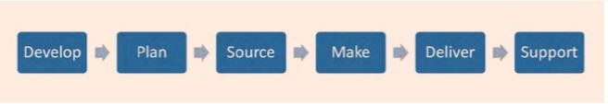

Figure 9. Traditional supply chain

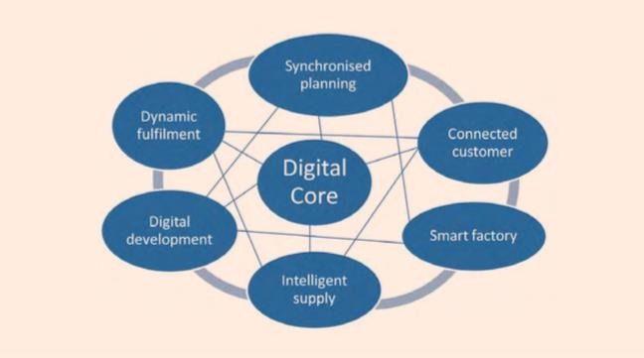

Figure 10. digital supply chain networks

The system may look simple in the diagram, however the complexity is immense and a lot of study from stakeholders is required to look at the nitty-gritty of the implementation, taking into account its returns.

Schrauf et al. (2016) illustrated that supply chain will change with the advent of digital supply chain, silos will dissolve and every link will have full visibility throughout the network. The digital supply chain is based on the concept of Industry 4.0 whereby companies are orientating themselves towards a full implementation of digital technologies throughout the supply chain.

The following are the four stages of maturity towards a digital supply chain:

      - Digital novice. These companies have yet to embark on the journey. Their supply chain processes remain discrete, carried out by individual departments and business units.
      - Vertical integrator. Companies at this stage have managed to integrate their supply chain processes internally, across departments and functions.
      - Horizontal collaborator. In this stage, companies have learned to work with their supply chain partners to set business goals, define and carry out common processes, and achieve a fair degree of transparency throughout the chain.
      - Digital champion. These companies have achieved the highest level of collaboration with partners and transparency in operations, while developing mutually beneficial processes and analytical techniques to optimize the whole supply chain.

Digital supply chain is simply called Supply Chain 4.0 and is very much an Industry 4.0 concept with the implementation of digital technologies.

Current practices of Supply Chain 4.0
Hoberg and Alicke (2016) of McKinsey & Company explained the importance of customer experience, as they are the source of income to any organization. With the implementation of Supply Chain 4.0 especially with digital capabilities, customers will benefit from more choices, and added convenience with simpler and more reliable processes.

Within any organization, all the departments need to work together to a seamless integrated process supported by technology so that their customers see the entire organization as one. Organizations need to continuously improve and look for opportunities to provide the best customer experience in order to sustain their business with the aid of technologies.

“Tomorrow’s challenges” shows that a company like Adidas sees the need to use whatever resources they could leverage in its entire supply chain including technology to gain more sales and grow their business. The use of machine and devices to meet customers’ demand as continuous improvement is the key to the success of every organization to be ahead of competition. The initial investment may sound costly but over the long strategic plan, it can recover the returns.

Likewise Amazon also shares the same experience and has put in effort to beef up its supply chain in embracing technology into its system in order to stay competitive.

In short, the digital revolution is creating a whole new paradigm for what used to be the supply chain. It was once about delivering the right quality at the lowest cost, with the agreed service level; now it is about increasing sales, creating more value and capturing it (Cordon 2017).

Logistics, an important element of supply chain, which focuses on transportation, distribution and warehousing, is also greatly impacted by Industry 4.0. Tronina (2017) illustrated that logistics would focus even harder on information technology, digitalization and optimization of logistic processes by using the cutting edge innovations of the world-class modern technologies. Modern logistics, so called Logistics 4.0, is more often and more readily implemented in modern enterprises that want to develop their business. Logistics companies, especially those large, dynamic companies wishing to compete in the rapidly growing market, need to strive to be a market leader by all means if they want to maintain their status and position in the market.

The competition between enterprises is visible considering the choice of technologies, development of ready-made tools and implementing them depending on the needs of given companies, or establishing cooperation with implementing companies which create custom- ready solutions for TSL industry (such as transportation, shipping and logistics companies).

Internet of Things (IoT) in logistics
IoT affects logistics, an important element of supply chain. Robert Bosch GMBH corporate website (2017) explains the hectic activity in a logistics center and how Bosch implements Industry 4.0. In 2016, Bosch has initiated to automate its forklift trucks that are driving between warehouse shelves and storage areas, picking up the goods at exactly the right place, and then placing them right where they belong.

Many new ways of optimizing processes are emerging for the company capitalizing the Cloud. The forklift trucks are more efficient with the available data input into its systems to enable the most efficient route to be used and driving profiles are constantly stored in the database. The database also benefits the manufacturers of forklift trucks. They can make their customers additional offers and equip their vehicles with sensors and software from the start. Retrofitting would no longer be necessary if the forklift trucks were to one day become part of the networked intra-logistics.

Flexibility is the key to enable agile capabilities in Industry 4.0. Zenoway solution is currently being introduced at the Bosch site of BSH Hausgeräte GmbH in Traunreut near Munich. Data is considered the basis for intelligent production and new business models in logistics, where IoT-Clouds is the key to efficiently use data.

Forster (2017) explains that a digital supply chain is a basic requirement for Logistics 4.0 for the future. Visibility is essential today and the transportation businesses greatly rely on IoT. Digital supply chain is getting more important for companies that have great concerns on Industry 4.0. Hence, development for the next generation is inevitable though it is still in the infancy stage. Proactive companies can take the opportunities to spearhead projects in developing future digital systems and gadgets to support the logistics industry.

Kennedy (2017) on “How will the driverless revolution change transportation service?” emphasized the effects of the way service industry in particular transportation has evolved over time, whereby currently the technology has widely changed the way the business has been run.

Companies like Uber, Google and Tesla believe in technology and thus they keep on investing on self-driving technology and it will soon hit our roads. The impact will definitely take over some of the human tasks; at the same time, transportation companies will benefit, as they do not have to deal with drivers’ issues, while at the same time, able to run their operations more efficiently.

At this moment, the legal issues have to be addressed by government if they allow driverless commercial vehicles on the roads. Some countries may embrace this new concept, which is not seen in some other countries. In due time, there is a possibility to see driverless commercial vehicles operating and most likely to start in a more developed country due to its infrastructure and mature society.

Outlook in India on Supply Chain 4.0
In any situation, there seems to be two sides of a coin. It can be seen as a threat or an opportunity to embrace the new approach of the digital world. How is that in the context of the Indian scene? In some public news and articles published, there are many views and news related to Industry 4.0 in the country and it includes Supply Chain 4.0. The Ministry of International Trade and Industry (MITI) have been quite active in initiating the move to include some of the local Indian companies to participate in Industry 4.0.

Capabilities need to involve a large group to enable the concept of Supply Chain 4.0 to be realized, and it also includes stakeholders, not just the industry players but also from the government departments concerned. A task force has been set up with the various agencies within the government departments and their areas of responsibility, namely:

- Infrastructure and ecosystem — the Ministry of Communication and Multimedia
- Funding and incentives — the Ministry of Finance
- Talent and human capital — the Ministry of HR & Ministry of Higher Education
- Technology and standards — the Ministry of Science, Technology and Innovation
- SMEs and Industry 4.0 — the Ministry of International Trade and Industry

They had included some main players from the different industries in a seminar, including some of the government agencies to see how the government can assist in any way to realise that Malaysia is heading towards the future. A timeline chart has been planned for year 2017 to move forward in the cabinet.
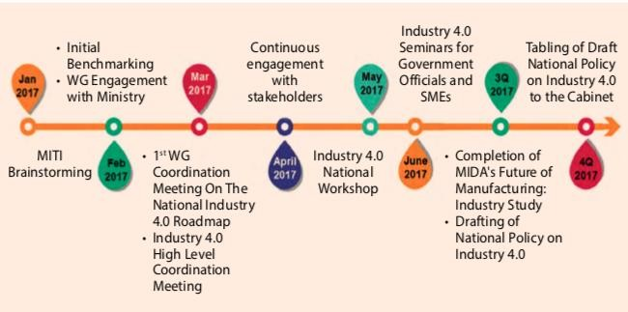

Figure 11. Timeline chart for year 2017

Source: Ministry of International Trade and Industry (MITI)

By end 2017, the government drafted the National Policy on Industry 4.0, which also included the national vision TN50, and tax budgeting for year 2018 for planning ahead.

The industry players and their stakeholders have to ponder as below:

- Comprehensive national level strategy — no clear overarching policy on Industry 4.0.
- Infrastructure and ecosystem — energy, telecommunication, ecosystem gaps.
- Targeted incentives and funding — broad-based.
- Human capital and talent — labor intensive and mismatch of skill sets.
- High initial investment — substantial capital expenditure.
- Lack of standards and technology — harmonization, integration, reliability.

Resources are the key to future planning and to enable this to materialize, all the stakeholders need to look at this area where there may be job loss due to the changes. In fact, this has been shown in the previous industry evolution whenever new equipment and/or gadgets were being introduced. For example, the computers have replaced many clerical jobs and automation has taken over certain manpower in the manufacturing industry.

- REFERENCES

- http://www.tlog.lth.se/fileadmin/tlog/Utbildning/Kurser/Logistik_i_foersoerjningskedjor/Lectures/SCOR_LTH_Pres.pdf
- https://news.sap.com/2018/03/what-is-artificial-intelligence/
- http://usblogs.pwc.com/emerging-technology/briefing-ai/
- http://usblogs.pwc.com/emerging-technology/ai-everywhere-nowhere-part-1-tempered-excitement/
- Emerging Trends of Technology for Supply Chain Management, WOU, Press 2018

