Biosensor for tissue engineering: Bio-analytical tool in Therapeutics
, Dr. Harjinderpal Singh Kalsi¹, Dr. Gaganjyot Kaur²
1. Department of Physis, Guru Nanak Khalsa college Art, science, and commerce Autonomous, Matunga, Mumbai 400019, India.
2. Guru Nanak Institute for Research and development, Guru Nanak Khalsa college of Art, Science and Commerce Autonomous, Mumbai- 400019, India
Abstract:
In recent years biosensors have gained attention in medicine, nanotechnology, and tissue engineering (TE) in addition to other fields that include food, beverages, environmental and agricultural applications. TE and regenerative medicine have presented tremendous potential for the development of engineered tissue constructs that help restore the damaged functions of diseased or damaged tissue and organs. Biosensors have become an integral part of TE systems specially microfluidic tissue engineering models as they can sense specific biological molecules within the miniaturized tissue constructs in real-time, at very low concentration levels, through ultrasensitive optical, electrochemical, or acoustic sensing systems. In recent protocols for TE we face the challenges of incapability to control/ monitor cellular functions and various properties (biological, mechanical, electrochemical and others) which has increased the demand and led to the development of more sensitive nano and carbon based biosensors. Based on recent advances in this domain the chapter aims to explain the basic biosensor models that are being used in tissue engineering. Concepts of nano-biosensor, bringing a new boon to this tool by combining biological signal and therapeutic delivery systems for in-vivo screening and treatment. Through this chapter we focus on the new trends which have been developed for increasing specificity and sensitivity of biosensors including carbon-nanotubes (CNTs), quantum dots (QDo), graphene oxide biosensor, Micro and Nano electromechanical system MEMS/NEMS. Carbon nanotubes (CNTs) provide support for immobilization of biological molecules at their superficial surface and combine electrochemical characteristics properties which make them suited for the transduction of biological signals associated with the recognition of biomolecules in disorder. The binding, conducting properties of gold, metallic nanoparticles (GNPs, SNPs) and metal oxides provide antimicrobial properties. The fluorescence properties of quantum dots have made them very useful in TE applications.
Key words: Tissue engineering, Nanobiosensor, carbonnantubes, quantum dots.

- Introduction to Biosensor and Tissue Engineering
Engineering and sensing technology, which also covers biology, chemistry, and physics, now have a competitive edge thanks to biosensors. In essence, biosensors are made up of biological samples that serve as receptors, transducers, and detectors for the chemical, electrical, and optical changes that occur within them and are then turned into detectable signals. [1] The area of tissue engineering is extremely fascinating and multifaceted, and it plays a crucial part in fusing the philosophies of alternative materials to either replace damaged tissue or encourage endogenous regeneration. The first selective and specific biosensor was created by Clark and Lyons in 1962. They created a biosensor called a glucose sensor to assess blood glucose levels using the glucose oxidase enzyme, which also corresponded with blood glucose levels.[2]. The tissue engineering has become major technology in the medical era to overcome the limitations of graft and organ rejection, transplantation and repair of functional tissue and the specificities in the site of regeneration. The receptors in biosensor are of biological elements such as DNA, protein, RNA metabolites, whole cell organelles or cells and transducers like electrochemical, optical, piezoelectric, acoustics and calorimetric. Medically, biosensors are intended for analysis of diseases in more prices and accurate for detecting pathogens toxins and tumor and biomarkers to identify the onset of various disorders at an initial stage. Biosensors have shown the tremendous potential in the field of tissue engineering. In the medical period, tissue engineering has developed into a prominent technology to get beyond the issues with graft and organ rejection, transplantation, functional tissue repair, and site-specific regeneration. Biosensors use transducers like electrochemical, optical, piezoelectric, acoustic, and calorimetric devices as their receptors, which can be biological materials like DNA, protein, RNA metabolites, complete cell organelles, or cells. In the medical field, biosensors are designed to analyse diseases more cheaply and accurately by seeing viruses, poisons, tumours, and biomarkers to spot the start of different conditions at an early stage. Tissue engineering has a tonne of promise, as demonstrated by biosensors.

- Basic Approach to Nano-Biosensor: background and concepts
Nanotechnology offers a unique solution to the detection of biomolecules in biosensors. The nanofiber sensors have a much higher surface-area-to-volume ratio than their macro-scale counterparts and can be easily integrated into other devices such as lab-on-a-chip systems.[3] Nanobiosensor is a source for the analysis of biological agents such as antibodies, nucleic acids, bacteria, and metabolites. Its purpose is to bind biomolecules of interest to bioreceptors, and to regulate the physiochemical signal associated with binding. Later, the transducer captures and converts the physiochemical signal into an electrical signal. By definition “Nanobiosensors are devices that measure a biochemical or biological event using any electronic, optical, or magnetic technology through a compact probe”(fig 1).[5] They also possess electrochemical properties that allow them to manifest biological signaling and transduction mechanisms. These properties make them ideal for use in biosensing.[6] The nanobiosensor may be homogeneous or heterogeneous, ranging from 1-100nm making them exclusively sensitive in diagnosis.[7] Most electronic and mechanical properties of some nanomaterials including nanotubes, nanorods, nanowires, nanoparticles, and thin films consisting of crystalline matter are well known and utilized in improving transduction mechanisms and biological signaling.[4]. In the biomedical, nanoparticles are used for controlled drug delivery, imaging of specific sites, probing of DNA structures, identifying biomolecular, gene/drug delivery, photothermal ablation of cells, and, most recently, TE.[8]. It has improved the mechanical and biochemical performance for instance gold nanoparticles have properties of conjugation and conductance which have been extensively used, the antimicrobial properties of silver and other metallic/metal oxides nanoparticles, the fluorescence properties of quantum dots, and the unique electromechanical properties of carbon nanotubes (CNTs) have made them very useful in abundant TE applications.[3]
Biomolecules
Transducer
Bioreceptor
Detector
signal

Fig 1: General representation of Nanobiosensor

  - Carbon Nanotube Biosensor:
Carbon Nanotubes (CNTs) are also known as Buckytubes, Japanese scientist named Sumio Iijima in 1991 marked the evidence of multi-walled (MCNTs) followed by the single-walled CNTs [9]. The hollow cavity of CNTs provides a chemically inert environment, and it is also a potential site of magnetic/electromagnetic response for novel nanobiosensor technologies and nanoreactors through electromagnetic or electric impulses.[10], [11] They display carefully crafted carbon atoms connected by sp2 bonds, resulting in fibres that are steady and rigid. By providing a base to conjugate other compounds at their surfaces and shells without losing their properties, they give both exohedral and endohedral functionalization properties. Following conjugation, these CNTs could cross the cell membrane and enter the cell, making them an excellent choice for use as biosensors. [9] Generally categorized into two types: single-walled carbon nanotubes (SWNTs), which are constructed from a single graphene sheet "rolled" into a tube, and multi-walled carbon nanotubes (MWNTs), which comprise several concentric tubes sharing a common axis. MWNTs can have a variety of morphologies, including "hollow tube," "bamboo," and "herringbone," depending on how they are created. These tubes have sidewalls made of a hexagonal lattice of carbon atoms, similar to the atomic planes of graphene. Typically, one-half of a fullerene-like molecule is layered over the ends of the tube. The geometric configuration of the carbon atoms at the seam of the cylinders serves as a basis for categorizing SWNTs. While the bulk of SWNTs have armchair (m = n) or zigzag (m = 0) conformations, most SWNTs are chiral (m 6= n).[12]–[14] (fig 2)
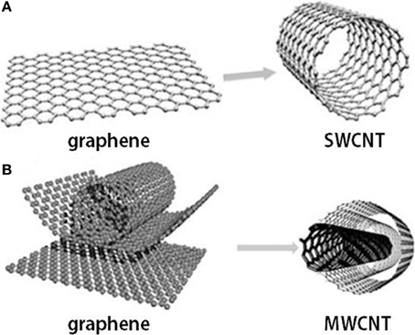

Figure 2: Graphene and carbon nanotubes as (A) single-wall carbon nanotube (SWCNT) and (B) multi-wall carbon nanotube (MWCNT) structures[15] The Rise of Carbon Nanotube Electronics - Embedded Computing Design
With the demand for CNTs in the nanobiosensor, there are three methods proposed to synthesize them :1 Arc discharge, 2: Laser ablation 3: Chemical vapor deposition (CVD, of which synthesizing CNTs by CVD is much cost-effective as it requires low temperature and pressure yielding a highly efficient and purified form. Functionalization of CNTs is required as they have a large capacity and stable structure of inner tubes making them insoluble in many solvents. The scientist has involved three approaches to achieve this viz Covalently linking chemical groups to the skeleton of CNTs,2. Adsorption of various functional molecules to CNTs, 3. Endohedral filling of the internal cavity of CNTs [16][17]. Hence for the application as a biosensor, the surface is modified by covalent and non-covalent immobilization of gold, silver, platinum, graphene, glass, and silica particles thus increasing the solubility and electron rate transfer.[18], [19] The chemical modification of the surface of the CNTs has great properties on the formation of subtle functional groups that prevent accumulation, improve host compatibility and boost solubility in different solvents. Electrochemical CNTs have been developed to detect ions, metabolites, and protein biomarkers. For instance, several CNT-glucose biosensors based on the conjugation of glucose oxidase have been engineered, Patolsky et al. reported on the structural alignment of glucose oxidase (GOx) on electrodes using SWNTs as electrical connectors between the enzyme redox centers and the electrode[9] Electrochemical biosensors based on functionalized CNTs have further been developed for detection of nitric oxide, epinephrine sensing, and dopamine monitoring in rat striatum[9], [18] In current discoveries, a large variety of amperometric biosensors based on CNT-modified electrodes have been engineered. Fei and co-workers carried out the detection of cysteine on Pt/CNT electrodes by cyclic voltammetry. Antiochia et al. reported an amperometric CNT-biosensor developed by coating CNT with a polymer of dihydroxybenzaldehyde and Fayazfar et al. reported a new platform based on electrochemical growth of gold nanoparticles on aligned MWNTs for sensitive label-free DNA detection of the TP53 gene mutation. Over the more current years, new peers of nano-immunosensors have been engineered by immobilizing recombinant antibodies or antibody fragments onto CNTs, nanowires, nanoparticles, and quantum dots, thereby enhancing binding capacity and sensitivity thresholds compared to more traditional biosensors.[9]

Fig 3: carbon Nanotube: Cancer detection, HIV virus diagnosis, DNA sensing, Glucose monitoring and Enzyme detection

  - Quantum Dots Based Biosensor:
“A semiconductor crystal of nanometer dimensions with distinctive conductive properties determined by its size”. As they have exceptional properties of optical and fluorescence they are used extensively in biosensing since the 1980s. It was discovered by Ekimov. QDs have high quantum yields, narrow band emission with a wide-ranging excitation wavelength, resistance to photobleaching, relatively lengthy luminescence lifetime (>10 ns), and a high surface-area-to-volume ratio that allows efficient functionalization with biomolecules, (fig 4).[20]

Fig 4: Relation of quantum dot size and wavelength excitation to the frequency
They are semiconductors composed of CdTe, CdSe, GaAs, PbSe, InP, etc.) with a diameter range of 2–10 nm. Since the heavy metals are involved in the synthesis QDs are considered toxic and they are less biocompatible. Several different approaches are taken to make it biocompatible, for example, there are core-shell assemblies in which a semiconductor shell, naturally zinc sulfide (ZnS), stabilizes the core; furthermore, an additional capping or coating using biocompatible materials or polymeric layers (such as PEG) to the QD core-shell helps to diminish toxicity. These smart dots have application in immunofluorescence assays, as a very small amount is required to produce the signal. Li et. Al used lateral flow strips which had copper carrying protein to step quantitate the nitrate ceruloplasmin in blood. It has shown a very important application in the detection of pathogens i.e E.coli by combining the immunomagnetic separation (IMS) and the QD fluorescence.[4][20] The iron oxide core-gold shell (Fe₃O₄@Au) magnetic nanoparticles modified with biotinylated antibodies captured the E. coli in solution, and then chitosan‐coated CdTe quantum dots (CdTe QDs) modified with a secondary antibody were added in solution. The bacteria were removed from the matrix by employing the IMS technique for fluorescence analysis. Xu et al. displayed that identification and specific labeling of targeted DNA sequences can be skillful by employing green, blue, and red QDs in different combinations. Peculiar spectral barcodes were obtained with the mixture of these QDs that allowed a high degree of multiplexing, which is necessary for complex genetic analyses.[20] Graphene quantum dots (GDots) have unique properties of quantum internment and zig-zag edge effects. The ultra-nanosized GDots with a wide range of excitation/emission spectrum are promising aspirants for applications in electronic, photoluminescence, electrochemical, and electrochemiluminescence sensors creation for various chemical and biological analyses. The colors of Gdots are related to the basic factors such as size, shape, excitation, pH, band gap, degree of oxidation, surface functionalization, and doping of S and N. The synthesized Gdots are very convenient for detecting any positively charged ions (cationic) such as Ag2+ and Fe3+ through charge-to-charge interactions. A Gdot-based electrochemiluminescence sensor was investigated for detecting Cd2+, cysteine, and ATP. Low cytotoxicity, low cost, excellent solubility, and ease of labeling of Gdots are also attractive for application in the development of novel electrochemical biosensors [4][21]
  - MEM/NEM Biosensor:
A contemporary standard of chemical and biological sensors built on micro and nano cantilevers has been made possible by the remarkable advancements in micro and nano-electromechanical systems (MEMS; NEMS). These sensors take advantage of the mechanical energy that occurs naturally and is used as a platform for extremely sensitive chemical and biological sensors. These nanosystems offer more sensitive, specific, accurate, and profitable devices with excellent reproducibility. Three components make up NEMS/MEMS cantilever-based biosensors: Cantilever transducer element, sensing biolayer, and readout system are the first three components. In order to create micro- and nano-cantilevers, materials as diverse as silicon oxide, silicon nitride, polycrystalline silicon (polysilicon), SU-8, and metal sheets can be used in bulk or surface micromachining.

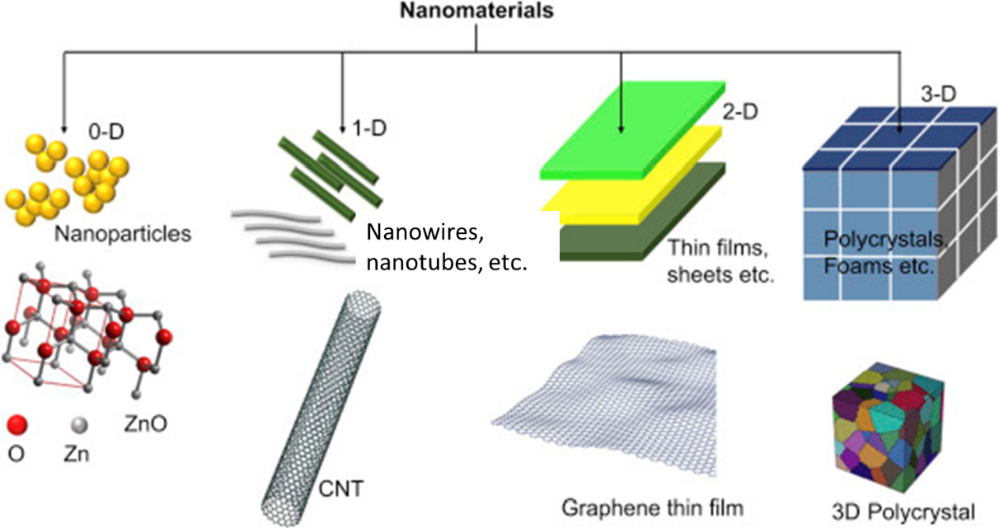
Fig 5:Classification of nanomaterial according to their dimensions (Malhotra & Ali, 2018).Figure adapted with permission from Elsevier
3. Epitomes of Nano-Biosensor
To evaluate drug-target interactions, there is an increasing need for high-throughput, low-cost, extremely sensitive approaches. Biological agents such as antibodies, nucleic acids, viruses, and metabolites can all be found using a nanobiosensor. In order to transmit data and information about the behaviour and characteristics of nanoscale particles to the macroscopic level, nanosensors operate on the nanoscale, which is measured at the level of a single molecule at a distance of 10-9 m. Nanosensors can be used to monitor physical factors like temperature at the nanoscale or to detect chemical or mechanical information, such as the presence of chemical species and nanoparticles. Nanosensors have a variety of uses, including I nanochips for identity authentication, (ii) active transport tracking devices, and (iii) virus detection and hygiene/disease control in cattle., food inspection, intelligent food packing, intelligent storage, and so forth. The basic idea is to bind desired bioanalytes to bioreceptors, which then modifies the physiochemical signal connected to the binding.
Different types of nanosensors follow different detection principles: optical nanosensors measure the change in light intensity; electrochemical nanosensors measure the change in electrical distribution; piezoelectric nanosensors measure the change in mass; calorimetric nanosensors measure the change in heat. When an ammonia molecule is present in carbon nanotube-based sensors, it reacts with water vapor and makes the carbon nanotube more conductive by donating an electron. In contrast, if a molecule of nitrogen dioxide is present, it will make the carbon nanotube less conductive by stripping an electron from the nanotube.
Recent advances in experimental and analytical techniques have enabled researchers to explore the limits within which nanostructures can operate. These studies help one establish whether these devices provide consistent performance throughout their operational lifetime thus defining their suitability for future applications. Cantilever biosensors are ultra-high sensitivity electromechanical sensors that have been successfully used for the label-free detection of large numbers of biological entities. They are emerging as a technology that appears attractive for high-throughput drug discovery applications.

  - Nanowire nanosensors
Nanowire-based nanosensors have emerged as a powerful tool due to their ultrasensitivity, ultraselectivity, and direct detection of chemical and biological species. These nanosensors can detect proteins, small organic molecules that bind to proteins, viruses and DNA, and are used in drug discovery, disease diagnosis and genetic testing.
Carbon nanotubes (CNTs) are one-dimensional (1-D) nanoscale structures based on graphene sheets and exhibit exotic material properties ranging from mechanical to electronic device properties [20,21]. The graphene-based structure of CNTs gives them unique attributes such as very high mechanical strength, ballistic charge transport, and many other electronic device properties. Since the CNT structure is derived from graphene [22], all carbon atoms make up the entire surface, making the CNTs more unique for sensor studies. Any change in surface structure during interaction with reactant molecules results in a change in their electronic properties, enabling detection of the analyte molecules under study. In fact, the CNTs offer very good detection sensitivity for a range of analytes such as gaseous molecules, organic charge-transfer complexes, proteins, DNA and antibodies. CNT is an excellent electrical and thermal conductor. In addition, its small size leaves room for the development of an ultra-small sensor, which is in the micron or even nano range. CNT arrays are hierarchical structures with unique advantages over isolated structures. CNT-array-based nanoelectrodes, called nanoelectrode arrays (NEAs) have been investigated for their unique applications such as chemical and biological sensors [23-26].
  - Cantilever Sensors
Microcantilever-based sensors offer many applications for a wide range of novel sensors in the detection of various analytes in a liquid, gaseous, or vacuum medium. These sensors offer high sensitivity, low cost, fast response, and high specificity without the need for pre-analysis labeling. Derived from atomic force microscopy (AFM),[27] which is capable of imaging a surface with nanoscale resolution by measuring the tiny force between a sharp tip of a suspending cantilever and the surface, microcantilever sensors do not require a sharp tip or a sample surface; instead, it is used to sense a biochemical reaction taking place on the cantilever surface by measuring its nanomechanical response.[28]

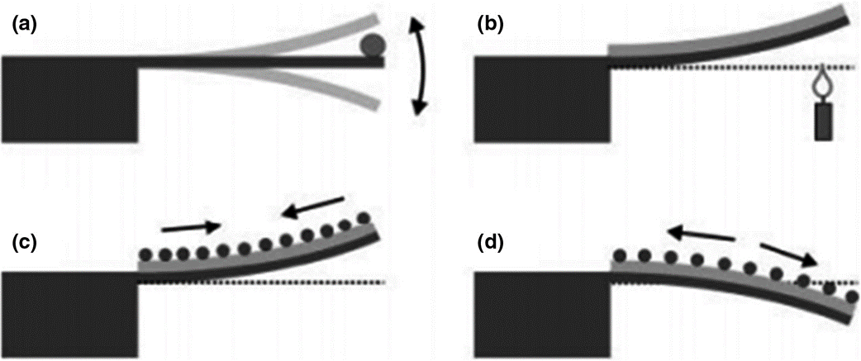

Med Devices & Sens, Volume: 4, Issue: 1, First published: 29 November 2020, DOI: (10.1002/mds3.10156)
Fig 6: Cantilever sensor operation mode: (a) detecting mass variations on the cantilever by deviations in resonance frequency; (b) bimetallic mode detecting temperature variations by a static bending; and (c, d) surface stress mode, where asymmetric molecular binding to the cantilever's top or bottom surface leads to an overall cantilever bending. For example, adsorption on the top surface can either cause tensile stress (c), bending the cantilever upwards, or compressive stress (d), bending the cantilever downwards (Fritz, 2008). Figure reproduced with permission from The Royal Society of Chemistry

The major advantages of microcantilevers sensors include label-free detection, small size, rapid response, high sensitivity, and the ability for high-throughput and multiplexed detection of various substances. Microcantilever sensors detect molecular binding on the cantilever surface through its nanomechanical motion, without the need for fluorescent or radioactive labeling. The signal transduction of microcantilever sensors is rapid because the small-scale devices have relatively high mechanical self-resonance frequencies in solution. Hence, the microcantilever platform is well suited to real-time monitoring of biomolecular interaction events on a sub-millisecond timescale. [29] One of the major challenges in microcantilever biosensing research is to reliably and efficiently functionalize each suspended microcantilever beam on an array with different bio/chemical molecules. This can be done either with microcapillaries. [30,31] Microcapillaries are relatively easy to handle and suitable for functionalizing cantilevers in small amounts.
  - Optical sensing
There have been many attempts at glucose monitoring using different signal transduction mechanisms as well as different glucose recognition elements. The methods used to determine the concentration of glucose in blood and body fluids can be divided into two broad groups, namely (a) spot sampling and (b) continuous glucose monitoring (CGM). Commercially available finger-prick glucometers and urine test strips demonstrate the spot sampling method of glucose estimation. Based on the positioning of the sensor as well as its design and detection mechanism, the CGM sensors are commonly classified into categories such as invasive (subcutaneous sensors, microdialysis modules, intravenously implantable sensors), minimally invasive (micropore, microneedle) and noninvasive (transdermal and optical) methods
Most of the commercially available glucose sensors are designed and developed with the intention of detecting blood glucose concentration, i. H. to target extracellular glucose. Nevertheless, the monitoring or visualization of intracellular glucose in living cells has recently received much attention due to the need to elucidate mechanisms underlying the development of insulin resistance syndrome in diabetics. Intracellular glucose, unlike glucose-6-phosphate, has not often been considered as a signaling molecule for glucose repression and other glucose-triggered regulatory events, probably because of their allegedly low concentration, but mainly because of the lack of suitable methods to measure intracellular glucose concentration to be followed in living cells.
One of the most widely reported FRET designs for glucose sensing employs Concanavalin A (ConA).[32] Concanavalin A is a plant lectin protein originally extracted from the jack-bean, Canavalia ensiformis. It selectively binds to α-mannopyranosyl and α-glucopyranosyl residues found in various sugars, glycoproteins, and glycolipids. ConA binds reversibly with glucose (and mannose).

- Application of Nano-biosensor in Tissue engineering
Biosensor-based devices provide a practical method for detecting a variety of signals from tissue, suggesting that they could be used to diagnose diseases. Traditional neurological disease diagnosis takes time and is inconvenient because it requires a doctor to examine the patient's symptoms, and there is a chance that about 40% of people won't be diagnosed with some disorders, such Parkinson's disease (PD), at an early stage. Cell-based biosensors have also shown to be useful in neurological research, and MEA technology is the main method for identifying problems in neural circuits and physiology. Recently, Li et al. used magnetic graphene nanoparticles to produce a reversible electrode for quickly diagnosing Alzheimer's disease. They attached the antibody for the biomarker Amyloid-beta peptide 1-42 (A-42) of Alzheimer's disease to a magnetic nitrogen-doped graphene (MNG). The magnetic MNG immunocarriers could then be dropped onto an Au electrode surface that has a tapping permeant magnet on the underside of the electrode, quickly creating an Alzheimer's disease biosensor. The employed MNG biosensors could then be taken out, and by swapping the tapped permeant magnet, the Au electrode could be recreated. [1], [4]
Bioelectric activity is another crucial myocardial function that helps gauge the condition of the heart's tissues. In general, the cardiomyocytes that are driven to modify their action potential of their cellular membrane are the ones that may provide bioelectrical activity; with the change of action potential, the heart can be induced to produce a synchronised pumping behaviour.via this organized electrical propagation. Therefore, a continuous electrocardiogram (ECG) monitoring technique provides a clinical standard method to detect the cardiac rhythm signal for diagnosing cardiac related diseases. Lee et al. created a compact wearable flexible cardiac sensor that incorporates an electrode, a near-field communication chip, and a battery in polyurethane substrates to readily monitor heart rhythm signals. As a cardiac patch, Feiner and a colleague created a biodegradable electrical scaffold. As a passivation layer, the gold electrodes are placed on an electrospun albumin-fiber scaffold. Due to its unique design, the flexible cardiac patch can detect the signal produced when heart cells spontaneously contract and additionally deliver external electrical stimulation to control this contraction.
Chemical or pharmacological toxicity can emerge as a result of mitochondrial malfunction. HepG2 cell-based liver organoids were cultivated in a microfluidic device by Balvi et al. as a tissue model. It gives the microdevice, which serves as a biosensor, the ability to track the dynamics of mitochondrial failure by continuously measuring the metabolic activity of liver organoids. The liver organoid-based approach enables evaluation of the safety and impact of drug concentration on mitochondrial damage by measuring the oxidative phosphorylation of glycolysis or glutaminolysis.[2], [7], [22]
Studies on cancer have been conducted during the previous few decades. Traditionally, cancer research has concentrated on developing novel, effective treatment approaches for treating cancer disorders. But occasionally, cancer patients are only diagnosed when it's too late, which means they miss the greatest window for treatment. As a cancer-on-a-chip model, Kamei and a colleague merged a microfluidic chip, heart, and liver cancer cells. A dual biomarkers-label chip (VEGF- and PSA-labeled) was created by Pan et al. for prostate malignancies and associated circulating tumour cells. Hu and his colleagues also created another kind of detectable visible signal-amplifiable biosensor. They overcame the difficulty of low expression of EV-associated RNA in malignancies by using a nanoparticle-based device to harvest extracellular vesicle (EV)-associated RNA in cancers at early stage are difficult for detection.[1], [4], [21]
In tissue engineering applications, biosensors can create selective, sensitive, and quick diagnostic tools. Biosensors, which combine biological, chemical, and physical technologies, offer a method to real-time and on-site monitor micro biophysiological signals in comparison to typical ELISA analytical procedure. Although biosensors have advanced significantly over the past ten years, there are still some issues that need to be resolved. The scaling-up process and the long-term stability of commercial goods provide the biggest difficulties for biosensors. Currently available biosensors are typically displayed as prototypes in research labs or academic departments.

[1] Y. C. E. Li and I. Chi Lee, “The Current Trends of Biosensors in Tissue Engineering,” Biosensors, vol. 10, no. 8, 2020, doi: 10.3390/bios10080088.
[2] A. P. F. Turner, “Biosensors: Sense and sensibility,” Chem. Soc. Rev., vol. 42, no. 8, pp. 3184–3196, 2013, doi: 10.1039/c3cs35528d.
[3] A. Hasan, M. Morshed, A. Memic, S. Hassan, T. J. Webster, and H. E. S. Marei, “Nanoparticles in tissue engineering: Applications, challenges and prospects,” Int. J. Nanomedicine, vol. 13, pp. 5637–5655, 2018, doi: 10.2147/IJN.S153758.
[4] A. T. Banigo, T. O. Azeez, K. O. Ejeta, A. Lateef, and E. Ajuogu, “Nanobiosensors: Applications in biomedical technology,” IOP Conf. Ser. Mater. Sci. Eng., vol. 805, no. 1, 2020, doi: 10.1088/1757-899X/805/1/012028.
[5] K. Tsukakoshi and K. Ikebukuro, “Sensitive and homogeneous detection system with aptamer-based biosensor,” Sensors Mater., vol. 28, no. 10, pp. 1083–1089, 2016, doi: 10.18494/SAM.2016.1270.
[6] A. Solaimuthu, A. N. Vijayan, P. Murali, and P. S. Korrapati, “Nano-biosensors and their relevance in tissue engineering,” Curr. Opin. Biomed. Eng., vol. 13, pp. 84–93, 2020, doi: 10.1016/j.cobme.2019.12.005.
[7] S. Prasad, “Nanobiosensors: the future for diagnosis of disease?,” Nanobiosensors Dis. Diagnosis, p. 1, 2014, doi: 10.2147/ndd.s39421.
[8] J. Shi, A. R. Votruba, O. C. Farokhzad, and R. Langer, “Nanotechnology in drug delivery and tissue engineering: From discovery to applications,” Nano Lett., vol. 10, no. 9, pp. 3223–3230, 2010, doi: 10.1021/nl102184c.
[9] C. M. Tîlmaciu and M. C. Morris, “Carbon nanotube biosensors,” Front. Chem., vol. 3, no. OCT, pp. 1–21, 2015, doi: 10.3389/fchem.2015.00059.
[10] S. K. Law, “Mini-Review for an Electrocatalytic Application of Carbon Nanotube in Medical Fields – Tissue Engineering, Drug Delivery, Cancer and SARS-CoV-2,” Biointerface Res. Appl. Chem., vol. 13, no. 1, 2023, doi: 10.33263/BRIAC131.043.
[11] P. M. Ajayan and R. Vajtai, “Properties and Applications of Carbon Nanotubes,” Carbon Filaments Nanotub. Common Orig. Differing Appl., vol. 6, pp. 315–330, 2001, doi: 10.1007/978-94-010-0777-1_23.
[12] S. Adhikari and R. Chowdhury, “The calibration of carbon nanotube based bionanosensors,” J. Appl. Phys., vol. 107, no. 12, 2010, doi: 10.1063/1.3435316.
[13] S. Manzetti, D. Vasilache, and E. Francesco, “Emerging carbon-based nanosensor devices: structures, functions and applications,” Adv. Manuf., vol. 3, no. 1, pp. 63–72, 2015, doi: 10.1007/s40436-015-0100-y.
[14] V. Harish et al., “Review on Nanoparticles and Nanostructured Materials: Bioimaging, Biosensing, Drug Delivery, Tissue Engineering, Antimicrobial, and Agro-Food Applications,” Nanomaterials, vol. 12, no. 3, 2022, doi: 10.3390/nano12030457.
[15] R. Vidu, M. Rahman, M. Mahmoudi, M. Enachescu, T. D. Poteca, and I. Opris, “Nanostructures: A platform for brain repair and augmentation,” Front. Syst. Neurosci., vol. 8, no. JUNE, 2014, doi: 10.3389/fnsys.2014.00091.
[16] C. Ziegler, Cell-based biosensors, vol. 366, no. 6–7. 2000. doi: 10.1007/s002160051550.
[17] H. Gergeroglu, S. Yildirim, and M. F. Ebeoglugil, “Nano-carbons in biosensor applications: an overview of carbon nanotubes (CNTs) and fullerenes (C60),” SN Appl. Sci., vol. 2, no. 4, pp. 1–22, 2020, doi: 10.1007/s42452-020-2404-1.
[18] S. Same and G. Samee, “Carbon nanotube biosensor for diabetes disease,” Crescent J. Med. Biol. Sci., vol. 5, no. 1, pp. 1–6, 2018.
[19] B. Cardenas-Benitez, I. Djordjevic, S. Hosseini, M. J. Madou, and S. O. Martinez-Chapa, “Review—Covalent Functionalization of Carbon Nanomaterials for Biosensor Applications: An Update,” J. Electrochem. Soc., vol. 165, no. 3, pp. B103–B117, 2018, doi: 10.1149/2.0381803jes.
[20] Z. Altintas, F. Davis, and F. W. Scheller, “Applications of quantum dots in biosensors and diagnostics,” Biosens. Nanotechnol. Appl. Heal. Care Diagnostics, pp. 185–199, 2018, doi: 10.1002/9781119065036.ch9.
[21] A. Hasan et al., “Recent advances in application of biosensors in tissue engineering,” Biomed Res. Int., vol. 2014, 2014, doi: 10.1155/2014/307519.
[22] A. Sadana, N. Sadana, and R. Sadana, “Nanobiosensors,” A Fractal Anal. Chem. Kinet. with Appl. to Biol. Biosens. Interfaces, no. 1989, pp. 69–96, 2018, doi: 10.1016/b978-0-444-63872-4.00004-x.

