The Benefits and Applications of Liquid Crystal Doped Nanoparticle System

Ayushi Rastogi^{1, 2*} | Abhilasha Singh³
¹Department of Physics, University of Lucknow | ³Department of Physics, J.S.S. Academy of Technical Education, Banglore – 560060, Karnataka, India
Lucknow - 226007, U.P., India
²Department of Humanities and Applied Sciences (Physics)
School of management Sciences, Engineering College (SMS)
Email: sweetayushi19@gmail.com; rastogiayu19@gmail.com
Abstract

Research on liquid crystals and its applications has been frequently paying attention on optical and display devices as well as its innovative and assorted relevance in the nanoscience and nanotechnology fields. Alteration in the physical assets of liquid crystals have been mainly made to a major extent by the addition of dopant/foreign entity or functional nanoparticles of varying shape and size like arbitrary spherical wires and discs, rods. Suspension of nanomaterials in liquid crystals with a certain surface anchoring energy induces an orientation deformation in the surrounding environment of liquid crystals, generating topological defects in nanoparticles vicinity. The defect points are produced around nanoparticles through the elastic distortion force on adjacent nanomaterials at a range of up to a few micrometer. Thus, the patterning and orientation of liquid crystal molecules is achieved through self-organization of liquid crystal molecules. Formation of lyotropic liquid crystal phases are known in the presence of isotropic host solvents by employing nanoparticles like graphene oxide, nanotubes and rods. These consequences lead to opulence of new applications, some of which will be discussed in this chapter.

Keywords— Quantum dots, Carbon nanomaterials, Liquid Crystals, Applications
- Introduction
In the recent decades the scientists have encouraged their global attention towards the diversity of novel fields away from display applications—for instance, elastomer robots, energy conservation, novel optical devices, telecommunication, nano-/micromanipulation, biotechnologies, sensors, information storage, just to name a few [1-3].
These fascinating innovative applications are moderately singular and distinguish from display world and are further exhilarating and thrilling due to their uniqueness that escorts to a new - fangled episode for liquid crystals, machineries, technology, equipments and materials blueprint. Concurrently, ground-breaking, pioneering and inventive expansions have been prepared in the nanotechnology and nanoscience fields, accompanying to the nativity of a series of contemporary nanomaterials [1-3]. Incontrovertibly, when these brand new nanomaterials stumble upon liquid crystals, an exceedingly appealing and exceptional synergy will be pragmatic, guiding to a profusion of utterly innovative and prospective applications [4 - 7].
Nano structured materials to liquid crystalline mesogens creates a colloidal dispersion [8, 9] and the fresh materials are predictable to perform in a different way from their specific entities (nanomaterials and liquid crystals) both on the microscopic plus macroscopic level [10, 11]. There are three fundamental motives to process a liquid crystal– nanomaterial composite system: (i) Alteration of the prime physical or chemical characteristics of the pure liquid crystals [12]; (ii) Controlling and organizing nano structured materials in liquid crystals in order to change the nanomaterials properties [12]; and (iii) to achieve additional/supplementary functionalities and characteristics that are accessible from neither the liquid crystalline mesogens nor the nanometer scale materials in their native states [13]. The fast advancement of liquid crystal - nanocomposite system led to recognition of mesophase orientation and interactions which generates sturdy impression of nanomaterials on the liquid crystalline hosts [14, 15] and vice versa i.e., the nanomaterials orientational and positional order rearrangement by liquid crystal matrix [14]. The coupling of long - range orientation order and extraordinary properties of dopant in liquid crystals permit us to modify or even inflict exceptional physical assets on the liquid crystal – nano composites by addition of distinct nanomaterials in it [7].
In this chapter, we discuss about the recent investigations on the liquid crystal nanomaterials interaction which leads to superior physical properties for novel applications in diverse fields [3]. This chapter is also focused on the consequences based on enhanced electro-optical and other physical properties of liquid crystals doped with different nanoparticles. The emphasis is laid on the liquid crystalline materials for the anisotropic nanoparticles self assembly into lyotropic mesophases and biological overview of liquid crystal nanoparticle composites, i.e., biosensors. However, more description can be found in a recently published review by Kato et al. [16] and the book by Li [17].

II. Role of nanoscale materials in modifying the physical properties of liquid crystals
The recognition of liquid crystals in the commercial display applications has been made by its outstanding electro - optic performance. Consequently, the anisotropic nature of liquid crystal molecules modifies its physical parameters such as optical refractive index, dielectric constant, response to external stimuli and elastic constants. However, conventional liquid crystal mixtures can no longer fulfill the escalating requirement of visual necessity in LCDs with the rapid development in technological field. Hence new materials need to be synthesized in order to meet these demands that provides shorter response times, lower driving voltage and higher color contrast ratio in LCDs. Concurrently, improvement in physical properties which are essential for scientific research, technological and industrial areas can be gained through the synthesization and growth in materials such as sophisticated materials, biosciences, nanotechnologies and novel optical devices. Recently, the introduction of various well developed and well synthesized nanodopants into liquid crystal is one of the chief key in order to transform their physical properties.
Reznikov et al. first reported the lower operating voltage, enhanced dielectric response and induced linear response to the applied electric field [18] by dispersing low concentrations of ferroelectric particles Sn₂P₂S₆ in nematic ZLI - 4801. The argument was made on the improvement in the liquid crystal orientation by the coupling of spontaneous polarization of the ferroelectric nanoparticles and the liquid crystal via an elastic field through the dispersion of ferroelectric nanoparticles that efficiently advances the electro - optical performance of liquid crystals [19].
Just like ferroelectric nanoparticles, the improvement in the electro - optical and other physical parameters of liquid crystals can be potentially made through the modification in the orientation order of liquid crystal which has been anticipated to the electrostatic interactions between liquid crystal molecules and gold nanoparticles [20]. Elkhalgi et al. reported the electro-optic response, dielectric permittivity and thermodynamics of a nematic 6CHBT doped with gold nanoparticles [21]. It was found that the first phase transition temperature, dielectric permittivity for the mixtures was raised and the threshold voltage was decreased due to the enhanced nematic ordering. Apart from that, the promotion in the reorganization and orientation of liquid crystal molecules, in the existence of gold nanoparticles dopant was possible by the application of an electric field. Moreover, an increase in ionic conductivity and dielectric constant was noticed in the gold nanoparticle dispersed in columnar discotic HAT4 suspensions [22].
The enhancement in the induced morphological changes by increase in remotely trigged local temperature has been made using the functional nanomaterials liquid crystal composites as reported in [23]. Such materials are driven by light where the light energy is converted into heat energy when photothermal nanomaterial absorbs the light resulting to a local increase in temperature.

- Quantum dot in liquid crystals [24- 26]

As described in [24- 26], QDs are have distinctive physical characteristics like large absorption cross - section, broad excitation spectra, fluorescence emission tunibility, high quantum yields, excellent stability and long lifetimes with exceptional colour purity. The exceptional photonic properties can be added to liquid crystals as a result of using QDs as a nanodopant in liquid crystal materials such as LC lasers. Nanomaterials with fluorescence emission, surface Plasmon resonance (SPR) effects and other meticulous optical characteristics provides exclusive photonic properties to liquid crystal materials. Conversely, liquid crystals act as dynamic medium for modifying and tuning optical properties of nanoscale materials externally through its long range elastic anisotropies and large refractive index. Such multifunctional mixtures provide the roadmap for the recognition of distinguished new optical devices.
A.1. Core/Shell quantum dots versus bare quantum dots [27]
There is increase in dielectric loss, loss factor or tan delta and decrease in conductivity due to surface defects on bare core quantum dots. This shows the adverse consequence of surface defects on dielectric properties of quantum dots. Therefore, the formation or deposition of different shells and multishells is necessary on the quantum dots surface to obtain reduce dielectric loss. The reason for the decline of loss factor in core/shell quantum dots is the surface defects passivation that results easiness in charge carrier tunneling. The fabrication of electronic devices and nano circuits that attracted the attention of global community involves the implementation of nano - composite matrices with CdSe based QDs. For the design and manufacturing of more efficient devices the study and evaluation of QDs dielectric properties is very much significant in order to find the best candidate in prevailing conditions. As described in [27], the introduction of first and second layer of shells or multishell structures on CdSe QDs decreases the dielectric permittivity, loss, tan δ and enhances the ac conductivity of QDs which has been due to the surface passivation that has a vital role in conductivity enhancement and accordingly suppresses dielectric losses and dissipation factor. These properties are mainly influenced by charge tunneling phenomenon i.e., reduce trapping of charge carriers with better charge tunneling to outer layers.
- Graphene and its derivatives in liquid crystals [28- 32]

Carbon nanomaterials are another kind of nanomaterials for manipulating the physical parameters of liquid crystal materials. Carbon nanotube, carbon nanospheres, fullerene, graphene oxides and graphene have fascinated the consideration due to their striking physical and chemical properties. Graphene oxide (GO), synthesized by oxidation of graphene is voluntarily dispersible in water due to its hydrophilic nature. GO actually forms a lyotropic liquid crystal in many solvents as well as in water. It can be converted into conducting reduced graphene oxide (rGO) by chemical or thermal reduction methods and partly retrieving the conductivity of neat graphene. A large number of reports have shown development in the electro - optic performance of thermotropic liquid crystal doped with graphene oxide (GO) [28 - 32]. As described in [33], a small amount of nanomaterials can make composites with customized physical properties and improved electro - optical performance for instance, a higher birefringence, a shorter response time, a larger dielectric anisotropy, a lower threshold voltage, enhanced nonlinear - optical properties, better contrast, etc., which has immense potential for the devise of next generation liquid crystals instruments and tools involving tunable lasers, liquid crystals displays, nonlinear - optical valves for photonic information processing systems, telecommunication and filters, electro - optical switchers and shutters and various other features of modern technology. Presently, experimental results are still open to doubts, lacking reliability and are inconclusive. Therefore, further research is needed in both experimental as well as theoretical approach for the near future in order to recognize the foremost fundamental features that are directed to the variation of liquid crystal based composite properties. Uplifting an understanding of the later will provide the path for an optimized improvement of new equipments for enhanced future machineries.
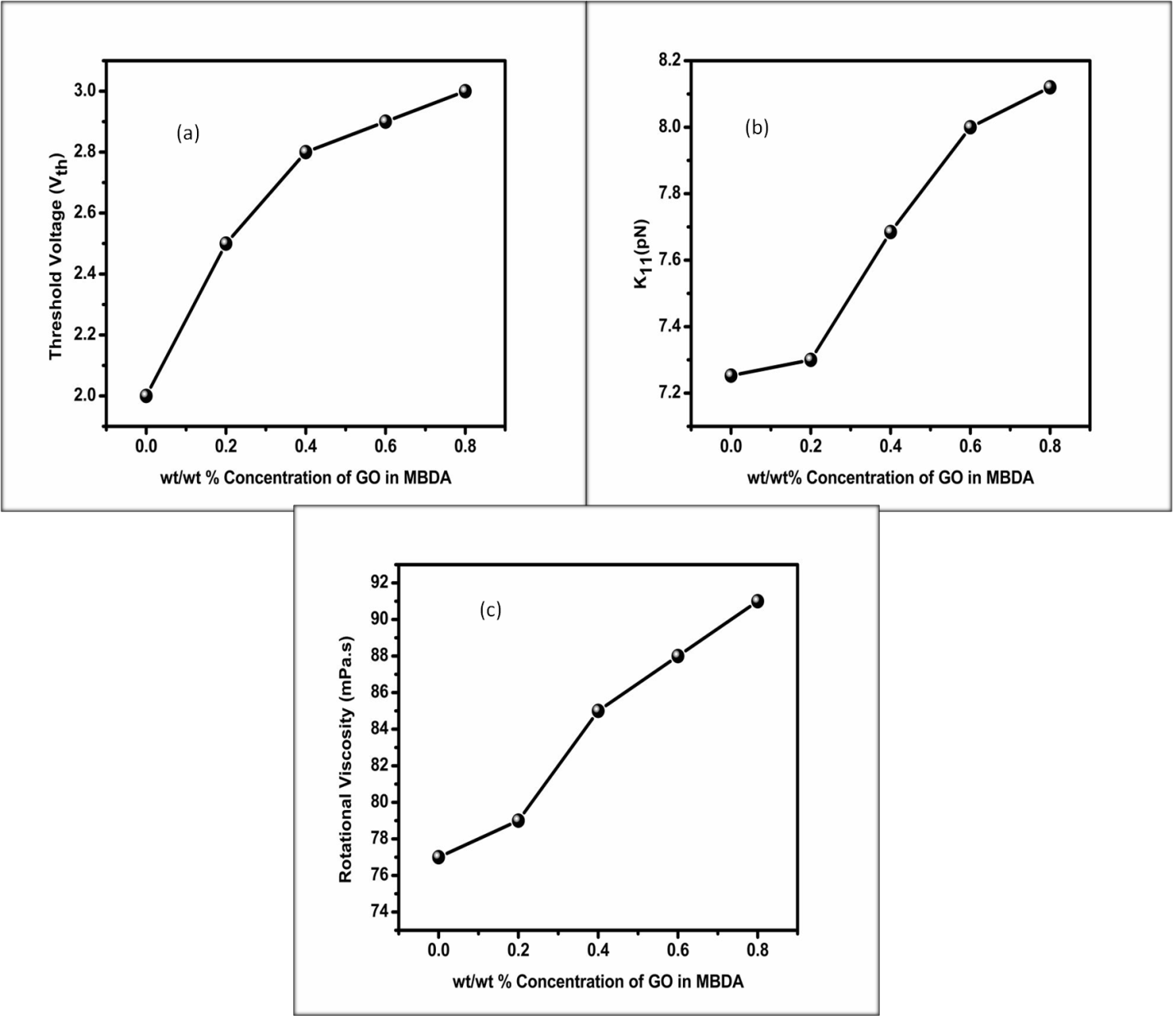

Figure 1: Dependence of (a) threshold voltage, (b) splay elastic constant and (c) rotational viscosity on wt/wt. % concentration of graphene oxide in nematic liquid crystal (MIX 1, MIX 2, MIX 3 and MIX 4) at 54 ºC in aligned sample cells. Reproduced from Ref. [31].
The key idea of using liquid crystal materials for biosensing approach is using nematic liquid crystal with a definite alignment either planar or homeotropic at an aqueous phase interface [34, 35]. One of the advantages of using oil palm leaf (OPL) nanosphere is its application in supercapacitors. The large surface area, improves charge holding capacity, and low cost [36] makes activated carbon nanospheres (ACNs) most popular among carboneous materials [37, 38] as shown in table 1. The pore size of activated carbon nanoparticles include; macropores (> 50 nm), mesopores (2 –50 nm) and micropores (< 2 nm) [36- 38]. The most important role is played by the involvement of micropore in the internal surface area. The porosity and large surface area makes ACNs applicable in supercapacitors. Oil palm leaf based nanoparticles doped E 48 liquid crystal find its potential application in biosensors, supercapacitors, display as well as non display devices.
Table 1: Comparison of specific capacities, surface area, pore volume and average pore size of activated carbons [36].
Specific Capacity Specific Capacity  BET  Pore Volume  Pore Size  Carbon | (F g⁻¹) | (F cm⁻²) | (m² g⁻¹) | (cc g⁻¹) | (Å)
M-10 | 55.95 | 0.041 | 1370 | 0.500 | 9.12
M-14 | 57.20 | 0.0047 | 1223 | 0.561 | 9.60
M-15A | 78.10 | 0.043 | 1800 | 0.629 | 9.17
M-15B | 55.80 | 0.034 | 1624 | 0.563 | 9.37
M-15C | 63.34 | 0.042 | 1518 | 0.600 | 9.79
M-20 | 100 | 0.046 | 2130 | 0.709 | 14.73
M-30 | 62.9 | 0.024 | 2571 | 1.230 | 14.95
A-10 | 35.3 | 0.031 | 1150 | 0.424 | -
A-20 | 41.20 | 0.020 | 2012 | 0.902 | 14.23
SACF-20 | 48.8 | 0.027 | 1839 | 0.699 | 9.74
SACF-25 | 27.9 | 0.011 | 2371 | 0.977 | 11.93

- Tin oxide nanoparticles in ferroelectric liquid crystal [39]
The stability of tin oxide (SnO₂) towards atmospheric environment is moderate. It is perfunctorily hard and can resist elevated temperature. For optoelectronic point of view, the material properties possess the combination of high electrical conductivity with optical transparency. As cited in reference [39], the significant alteration in the alignment properties of composites is made through the self assembled 2D array by ferroelectric liquid crystal (FLC) molecules and tin oxide nanoparticles interactions. Phase transition temperature varied with the dispersion of nanoparticles in FLCs system. The capability of tin oxide nanoparticles to trap the ionic impurities in pure FLC consequently results in reduced relative permittivity, ac conductivity and dielectric loss for the mixtures. The reduction in UV absorbance with quenched PL emission of the neat FLC system was observed hence tin oxide nanoparticles behave as luminescence quencher.
Figure 2: (A) Schematic representation of the tin oxide NPs dispersed FLC system showing 2D arrays of nanoparticles. (B) Polarizing optical micrographs (POM) of (a) neat FLC (b) 0.1 wt% SnO₂-FLC composite (c) 0.5 wt% SnO₂-FLC composite in the SmC* phase. The blue arrow is showing the rubbing direction and crossed arrows; polarizer (P) and analyser (A). (For interpretation of the references to colour in this figure legend, the reader is referred to the Web version of this article.) (C) Differential scanning calorimetry (DSC) curves of (a) neat FLC, (b) 0.1 wt% SnO₂-FLC composite (c) 0.5 wt% SnO₂-FLC composite. The DSC scan rate was 2 �C/min for all the samples. (Reproduced with permission from Mater. Chem. & Phy. Elsevier) [39].
- Zinc ferrite nanoparticles in nematic liquid crystal [40]
In zinc ferrite nanoparticles iron on the Zn surface behaves as surfactant molecules absorbing the mobile ions present in liquid crystals medium. Consequently, dispersion of ZnFe₂O₄ NPs in host liquid crystal matrix has potential to tailor the properties of pure liquid crystal such that the dispersed system becomes suitable for the use in liquid crystal based devices. Variation in the surface topology with ferronematics droplets have been observed after dispersion of ZnFe₂O₄ nanoparticles in 7CB [40]. Birefringence enhancement was revealed. Remarkable increase in dielectric constant was revealed on the basis of ZnFe₂O₄ nanoparticles and nematic liquid crystal interaction. Non monotonous dependence with decreased dissipation factor was observed with dopant concentration. Loading of dopant leads to shift in the high relaxation frequency to lower frequency regime. Improvement in the ac conductivity was found. The aim of this work was to purify pure nematics from impurity ions. The existence of memory was observed. The charge trapping capability of ZnFe₂O₄ nanoparticles had been explained on the basis of super paramagnetic nature of these magnetic nanoparticles. The increased magnetization of nanoparticles was attributed to small size of these particles causing increase in the inversion parameter. The ZnFe₂O₄ nanoparticles showed S- formed hysteresis loops and non cancelled magnetic moments which indicated its super paramagnetic nature [40]. It exhibited coexistence of ferromagnetic and anti - ferromagnetic phases. The ferromagnetic part saturates when applied field increases but antiferromagnetic part increases linearly and never saturates. S- Like hysteresis loop showed presence of curvature and linear parts [40].
Figure 3: Variation of the (A) transverse component of the permittivity ${(ε}_{⊥}^{'})$, (B) parallel component of the permittivity with frequency in planar alignment mode for pristine and zinc ferrite NPs dispersed in 7CB, (C) Variation of $ε_{∥}^{'}$ and$ε_{⊥}^{'}$with temperature at 10 kHz frequency for the pristine and zinc ferrite NPs dispersed nematic 7CB systems. (Reproduced with permission from [40] Liq. Cryst. Taylor & Francis)

- Novel Applications
- Superior and efficient bio based ionic liquid crystal electrolytes for supercapacitors [41 - 49]
- Sophisticated LCDs with excellent image intrinsic worth [50]
- Wireless temperature and bio Sensors based on a nematics as variable capacitance [51 - 56]
- Liquid Crystal based Lens [57]
- Waveguide application [58 - 60]
- Textile industries etc. [31]
E.1. High performance bio based ionic liquid crystal electrolytes for supercapacitors [41- 49]
In the present century, the ever - increasing requirement in order to tackle the challenges and rising large - scale energy stipulation the extremely proficient and environmentally sustainable production and energy storage is mandatory. Advancement, Design and progression of new materials and manufacturing system that authorize accurate control over the electrochemical performance and electrolytes conductivity is vital for accomplishing such objectives. The reported work of [41- 44], on an exploitation of ionic liquid crystal electrolyte resulting from a non degradable source: cashew nut shell liquid. They studied the structural and mesogenic phase formation by adopting different methods by synthesizing imidazolium-based ionic liquid crystal (PMIMP) derived from cardanol. A current density of 0.37 A/g, 80% capacitance retention after 2000 cycles with outstanding cycle stability and a specific capacitance of 131.43 F/g measured in a symmetrical supercapacitor made - up of mesoporous carbonaceous electrodes using PMIMP as electrolyte [43]. All these exceptional assets of the synthesized ionic liquid electrolyte recommended its relevance as well-organized, nature sociable and reasonably worth electrolyte for energy harvesting devices.
Figure 4: (A) (a) DSC heating and cooling scans of PMIMP showing thermotropic behavior and corresponding variation in conductivity and (b) thermotropic variation in viscoelastic moduli of PMIMP. PLM images of (c) focal conic domains of columnar phase and (d) smectic F phase formed. (B) (a) Rectangular CV curve of the super capacitor containing PMIMP electrolyte at different scan rates; (b) galvanostatic charge− discharge profiles of the device at various current densities. (C) (a) Nyquist and (b) Bode impedance plots of PMIMP-based supercapacitors. (D) Cycling stability of PMIMP-based supercapacitor. First ten cycles are given in the inset. Reproduced with permission from ACS sustainable chemistry &engineering [43].
Electrical energy storage is an indispensable methodical spot that demands unfathomable research. A sustainable manner for stable and reliable energy storage is obtainable by electrolytic batteries and capacitors. Batteries offers discharge of energy with high power density. Corresponding to them, electrolytic capacitors are also competent to discharge with elevated energy density [41]. Supercapacitors with characteristics intermediary to electrolytic capacitors and batteries portrays advanced cycle lives, easy, simple and flexible models and foster charge−discharge rates which make them potential contender in military equipments, in hybrid transportation structure, electronic instruments and medical diagnostic appliances [41]. The fabrication and proposal of novel electrode materials, novel electrolytes and novel electrochemical hypothesis lead to the improvement in tuning machinery efficiency and its performance by its energy density [42, 43]. The extortion of superior performance from both organic and aqueous electrolytes by using carbonaceous supercapacitors reported by [44, 45]. The ionic liquid crystal fluids have better electrochemical window and improved conductivity to be appropriate in electrochemical energy devices as competent electrolytes [46, 47]. The improved replacement for conventional electrolytes is considered to be the ionic fluids and ionic mesogenic liquids with mutual properties of both organic and aqueous electrolytes [48, 49].
E.2 Sophisticated LCDs with excellent image intrinsic worth [50]
The heated debatable question to get answer is ‘LCD vs. OLED: who wins?’ The technological machineries used in scientific areas have own pros and cons. A review work of H. Chen et al., [50] exemplifies current progress in LCDs from following performance parameters: contrast ratio, viewing angle, and response time which conclude the ultimate professed image superiority. Enhancement in LCD efficiency with extremely low viscosity materials, quantum dots and novel machinery structures were investigated, together their operational methods explored. Another round of LCD innovation is around the corner.
The improvement in the contrast ratio of vertically aligned LCDs from 5000:1 to 20,000:1 was elaborated by H. Chen et al. [50]. The implementation of local fainted backlight was required to increase contrast ratio to 1,000,000:1. Along with other stupendous features, such as superior resolution density, enhanced peak brightness, low cost and long lifetime, LCD would continue its supremacy in the predictable future.
Figure 5: Schematic diagram and working principle of the proposed backlight with a functional reﬂective polarizer (FRP) and a patterned half-wave plate. (TN: twisted nematic alignment; HG: homogeneous alignment). Reproduced from Ref. [50], with the permission of Springer Nature.
E.3 Wireless temperature and biosensors based on nematics as variable capacitors [51- 56]
As described in the reported work of [51], the growth in the wireless communication system with novel technologies like the Internet of Things (IoT) is integrated in various smart sensors that reduce the installation and system costs. These sensors replace the weird and tedious approaches that were used in the past. It simplifies deployment with flexibility and deal with a new set of applications. The proposal of wireless temperature sensor based on nematics as variable capacitance is regarded as a proof of concept for prospective applications. J. C Torres et al. [51] proposed a simple equivalent circuit and evaluated the performance analysis for the wireless temperature sensor. This sensor prototype was the commencement of new biomedical sensors.
The geometry and design of temperature sensors based on liquid crystals has been proposed for potential wearable applications. The high thermo - optic coefficient [52] of liquid crystals makes them a better candidate as a base for high sensitivity temperature sensors [52]. Its sensitivity is determined from the geometry and design parameter of liquid crystal as well as the initial alignment of liquid crystal molecules and thickness of sample cell. Such materials are composed of nanoscale elongated organic molecules producing an orientational order. The important requirement for liquid crystal based temperature sensors is the anisotropic property of mesogens that provides limiting operating range up to clearing point. There are several liquid crystals that are synthesized with very broad temperature ranges from 35 ºC 5 CB to higher than 180 ºC in other kind of liquid crystals [54, 55]. Biological applications of nematic liquid crystals doped with porous carbon quantum dots have been described elsewhere [56]. Popov et al. [57] exemplified the label free method of immune detection using nematic liquid crystals and biomolecular nanoparticles as shown in figure 5 – 7.
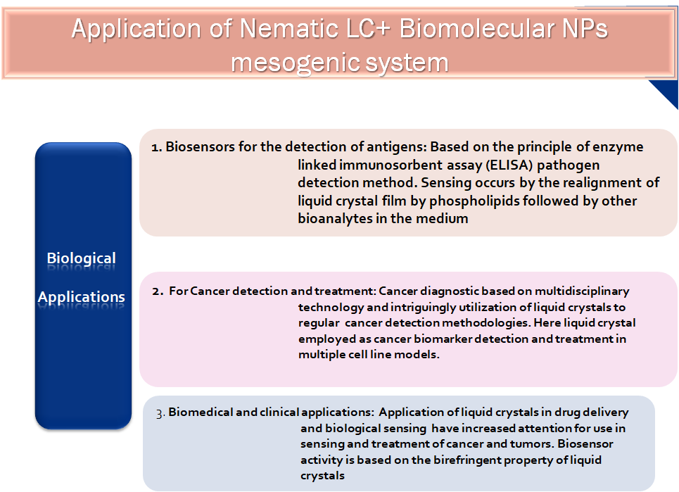
Figure 6: Biological applications of nematic liquid crystal- biomolecular loaded system [57].
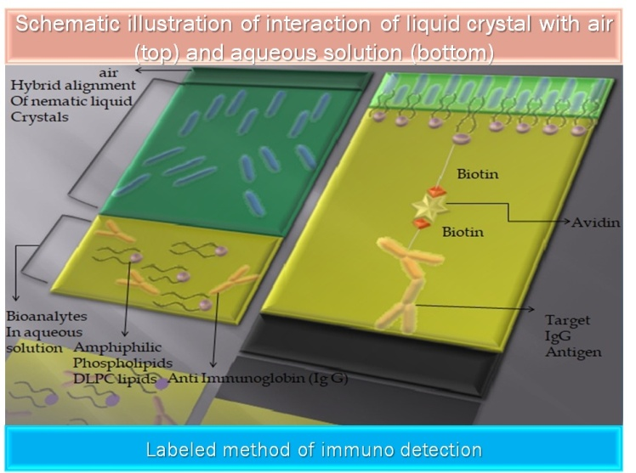
Figure 7: Schematic illustration of label method of immuno detection using interaction of nematic liquid crystal with air and aqueous solution [57].
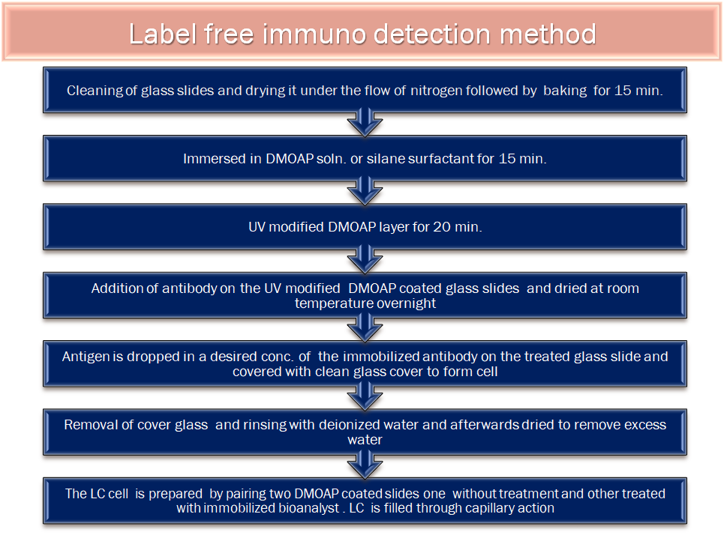
Figure 8: Flow chart representation of label free method of immuno detection [57].
E.4 Liquid crystal lens with modified performance [58]
As reported in the work of C. J. Hsu et al., [58] it reveals the design criterion of a floating ring electrode (FRE) embedded liquid crystal lens. The impact of FRE on the electro - optical performance of a hole - patterned liquid crystal lens were effectively revealed. Results have shown that the potential in the center of aperture hole (AH) gets strengthened by reducing the addressing voltage of the liquid crystal lens and the FRE is close to the hole-patterned electrode. The tunable focal length range was also broadened. On the contrary, when the FRE was close to the liquid crystal layer, the wave front aberration of the liquid crystal lens was suppressed because the embedded FRE increases the gradients of the fringing electric field and the associated phase profile near the AH periphery. The suppressed wavefront aberration exhibited a low root-mean-square error and an excellent modulation transfer function curve. However, the FRE close to the liquid crystal layer inevitably increases the addressing voltage of the liquid crystal lens because the FRE near the AH periphery gathers the fringing electric field around the AH periphery.
Figure 9: Schematics of (a) FRE-top, (b) FRE-inplane, (c) FRE-middle, and (c) FRE-bottom LC lenses. The red symbols indicate the FRE positions [58].
Figure 10: Calculated potential distribution in the LC layers of (a) FRE-top, (b) FRE-inplane, (c) FRE-middle, and (d) FRE-bottom LC lenses. The color indicates the potential intensity. (e) Calculated capacitances of the lens cells. (f) Measured frequency-dependent capacitances of the FRE-top, FRE-inplane, FRE-middle, and FRE-bottom LC lenses. (g) Voltage-dependent focal lengths of the FRE-top, FRE-inplane, FRE-middle, and FRE-bottom LC lenses. (h) Measured focusing spot sizes and calculated diffraction-limited values of the FRE-top, FRE-inplane, FRE-middle, and FRE-bottom LC lenses addressed at MaxP [58].
E.5 Waveguide application of liquid crystals
Communication system is basically a collection of discrete networks, transmission systems, tributary stations, relay stations and data terminal equipments that are interconnecting and interoperating to form an integrated whole. The machineries are technically compatible, respond to controls and operate in union. Diverse wired and wireless infrastructure coexist in a seamless, all purpose network architecture platform used to migrate multiple communications. Staying ahead of the curve to ensure infrastructure is equipped to handle today’s demand and tomorrow’s innovation is the expertise. Researchers [59], in their constant efforts towards progress, find it essential to establish better, quicker and more numerous communication system.
The inclusion of Liquid Crystals in waveguides potentially reduces the cost of production and allocate for integration of waveguides directly into fiber optic networks which permits more direct optical switching and fewer cable lines. This technology i.e. liquid crystal waveguides has significantly reduces the infrastructure design obligatory to take fiber optic technology to both commercial and residential applications. The tremendous possibilities offered through this photonic structure are based on periodic modulation of refractive index controlled by an electric field. It has been investigated that the voltage-tunable array of liquid crystal waveguide allows the linear and non linear propagation of light which finds its application in the study of discrete optical phenomenon [60]. Such novel geometry exhibits potential for the recognition of multifunctional routers and all optical signal processors with liquid crystal. Vescent photonics [61] developed a new technology based on electro - optic waveguide platform that provides unprecedented voltage control over optical phase delays circumventing their historical limitations. The large optical phase delays in such technology enable the construction of new class of photonic devices for example 2-D analog non-mechanical beam steerers, chip scale tunable lasers, chip scale fourier transform spectrometer, tunable micro ring resonators, tunable lenses, optical time delay devices, optical switches etc. The liquid crystal waveguide photonic architecture has applications in the defense markets: remote sensing, laser illumination, phased array radar and many more. Various uses of liquid crystal waveguides require active control over light like optical computing, telecommunications, holography and industrial process analysis.
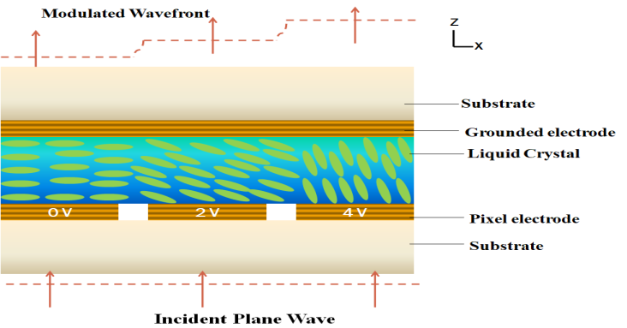
Figure 11: Photonic application of liquid crystals [62].
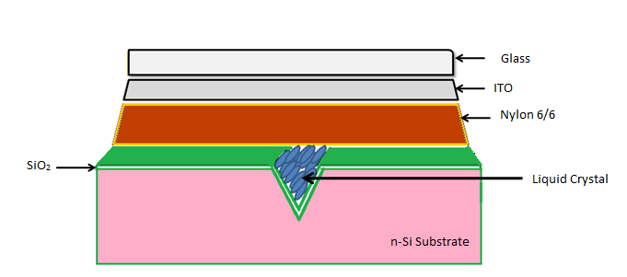
Figure 12: Waveguide application of liquid crystals [62].

III. Conclusion
This chapter gave a general overview of liquid crystal systems doped with nanoparticles, along with information on their advantages and uses. Different characterization methods, including SEM, TEM, and XRD, have shown that nanoparticles, despite their small size, have a large surface area, making them a good candidate for a variety of applications. Additionally, the optical characteristics are also dominating at that scale, which highlights the significance of the doped materials in a variety of applications, including photocatalysis, solar energy, biological, optical electronics, and many others. The precise shape, size, and magnetic characteristics of a liquid crystal system doped with nanoparticles may be controlled using synthetic approaches.
IV. Conflict of Interest
The authors have no potential conflict of interest to report.
REFERENCES
- Y. Shen, I. Dierking, Appl. Sci. 2019, 9, 2512; doi:10.3390/app9122512
- J. P. F. Lagerwall, G. Scalia, A new era for liquid crystal research: Applications of liquid crystals in soft matter nano-, bio- and microtechnology. Curr. Appl. Phys. 2012, 12, 1387–1412.
- R. Stannarius, Liquid crystals: More than display fillings. Nat. Mater. 2009, 8, 617–618.
- C. Tschierske, Liquid crystal engineering—new complex mesophase structures and their relations to polymer morphologies, nanoscale patterning and crystal engineering. Chem. Soc. Rev. 2007, 36, 1930–1970.
- J. W. Goodby, I. M. Saez, S. J. Cowling, V. Görtz, M. Draper, A. W. Hall, S. Sia, G. Cosquer, S.-E Lee, E. P. Raynes, Transmission and amplification of information and properties in nanostructured liquid crystals. Angew. Chem. Int. Ed. 2008, 47, 2754–2787.
- H. Qi, T. Hegmann, Impact of nanoscale particles and carbon nanotubes on current and future generations of liquid crystal displays. J. Mater. Chem. 2008, 18, 3288–3294.
- I. Dierking, Nanomaterials in liquid crystals. Nanomaterials 2018, 8, 453.
- Y. A. Garbovskiy, A. V. Glushchenko, Liquid crystalline colloids of nanoparticles. In Solid State Physics; Academic Press: Cambridge, MA, USA, 2010; Volume 62, pp. 1–74.
- P. Poulin, H. Stark, T.C. Lubensky, D. A. Weitz, Novel colloidal interactions in anisotropic fluids. Science 1997, 275, 1770.
- O. C. Farokhzad, R. Langer, Impact of nanotechnology on drug delivery. ACS Nano 2009, 3, 16–20.
- M. W. Chik, Z. Hussain, M. Zulkefeli, M. Tripathy, S. Kumar, A. B. A. Majeed, K. Byrappa, Polymer-wrapped single-walled carbon nanotubes: A transformation toward better applications in healthcare. Drug Deliv. Transl. Res. 2018, 9, 578–594.
- S. Y. Park, D. Stroud, Surface-enhanced plasmon splitting in a liquid-crystal-coated gold nanoparticle. Phys. Rev. Lett. 2005, 94, 217401.
- P. A. Kossyrev, A. Yin, S. G. Cloutier, D. A. Cardimona, D. Huang, P. M. Alsing, J. M. Xu, Electric field tuning of plasmonic response of nanodot array in liquid crystal matrix. Nano Lett. 2005, 5, 1978–1981.
- M. Yada, J. Yamamoto, H. Yokoyama, Direct observation of anisotropic interparticle forces in nematic colloids with optical tweezers. Phys. Rev. Lett. 2004, 92, 185501.
- A. Lapanik, A. Rudzki, B. Kinkead, H. Qi, T. Hegmann, W. Haase, Electrooptical and dielectric properties of alkylthiol-capped gold nanoparticle–ferroelectric liquid crystal nanocomposites: Influence of chain length and tethered liquid crystal functional groups. Soft Matter 2012, 8, 8722–8728.
- T. Kato, J. Uchida, T. Ichikawa, T. Sakamoto, Functional liquid crystals towards the next generation of materials. Angew. Chem. Int. Ed. 2018, 57, 4355–4371.
- Q. Li, Nanoscience with Liquid Crystals; Springer: Berlin, Germany, 2016.
- Y. Reznikov, O. Buchnev, O. Tereshchenko, V. Reshetnyak, A. Glushchenko, J. West, Ferroelectric nematic suspension. Appl. Phys. Lett. 2003, 82, 1917–1919.
- F. Li, O. Buchnev, C. I. Cheon, A. Glushchenko, V. Reshetnyak, Y. Reznikov, T. J. Sluckin, J. L. West, Orientational coupling amplification in ferroelectric nematic colloids. Phys. Rev. Lett. 2006, 97, 147801.
- S.K. Prasad, M.V. Kumar, T. Shilpa, C.V. Yelamaggad, Enhancement of electrical conductivity, dielectric anisotropy and director relaxation frequency in composites of gold nanoparticle and a weakly polar nematic liquid crystal. RSC Adv. 2014, 4, 4453–4462.
- H.H.M. Elkhalgi, S. Khandka, U.B. Singh, K.L. Pandey, R. Dabrowski, R. Dhar, Dielectric and electro-optical properties of a nematic liquid crystalline material with gold nanoparticles. Liq. Cryst. 2018, 45, 1795–1801.
- M. Mishra, S. Kumar, R. Dhar, Effect of high concentration of colloidal gold nanoparticles on the thermodynamic, optical, and electrical properties of 2, 3, 6, 7, 10, 11-hexabutyloxytryphenylene discotic liquid crystalline material. Soft Matter 2017, 15, 34–44.
- H.K. Bisoyi, A.M. Urbas, Q. Li, Soft materials driven by photothermal effect and their applications. Adv. Opt. Mater. 2018, 6, 1800458.
- J. Mirzaei, M. Reznikov, T. Hegmann, Quantum dots as liquid crystal dopants. J. Mater. Chem. 2012, 22, 22350–22365.
- S.K. Gupta, D.P. Singh, P.K. Tripathi, R. Manohar, M. Varia, L.K. Sagar, S. Kumar, CdSe quantum dot-dispersed DOBAMBC: An electro-optical study. Liq. Cryst. 2013, 40, 528–533.
- A. Rastogi, G. Pathak, A. Srivastava, J. Herman, R. Manohar, Cd1-x ZnxS/ZnS core/shell quantum dots in nematic liquid crystals to improve material parameter for better performance of liquid crystal based devices. J. Mol. Liq. 2018, 255, 93–101.
- N. Gheshlaghi, M. Faraji, H.S. Pisheh, Structural dependent, dielectric and conduction analysis of CdSe based quantum dots, SN Applied Sciences (2019) 1:401 | https://doi.org/10.1007/s42452-019-0451-2
- M. Gökçen, M. Yıldırım, O. Köysal, Dielectric and ac electrical conductivity characteristics of liquid crystal doped with graphene. Eur. Phys. J. Appl. Phys. 2012, 60, 30104.
- T.M. Alam, C.J. Pearce, Impact of graphene incorporation on the orientational order of graphene/liquid crystal composites. Chem. Phys. Lett. 2014, 592, 7–13.
- S. Al-Zangana, M. Iliut, M. Turner, A. Vijayaraghavan, I. Dierking, Properties of a thermotropic nematic liquid crystal doped with graphene oxide. Adv. Opt. Mater. 2016, 4, 1541–1548.
- A. Rastogi, R. Manohar, Effect of graphene oxide dispersion in nematic mesogen and their characterization results, Applied Physics A (2019) 125:192 https://doi.org/10.1007/s00339 019-2493-0
- Y. Shen and I. Dierking, Perspectives in Liquid-Crystal-Aided Nanotechnology and Nanoscience, Appl. Sci. 2019, 9, 2512; doi:10.3390/app9122512
- V.K. Gupta, J.J. Skaife, T.B. Dubrovsky, N.L. Abbott, Optical amplification of ligand-receptor binding using liquid crystals. Science 1998, 279, 2077.
- S. Mohamed, Oil Palm Leaf: A New Functional Food Ingredient for Health and Disease Prevention, Food Process Technol 2014, 5:2, DOI: 10.4172/2157-7110.1000300
- A. Kumar, G. Hegde, S. Aruni Bt Abdul Manaf, Z. Ngaini and K. V. Sharma, Catalyst free silica templated porous carbon nanoparticles from bio-waste materials, Chem. Commun., 2014, 50, 12702, DOI: 10.1039/c4cc04378b
- D. Arvind and G. Hegde, Activated Carbon Nanospheres Derived from Biowaste Materials for Supercapacitor Applications-A Review, doi: 10.1039/C5RA19392C, RSC Advances, 2012, 00, 1-3, 5
- Gomaa A. M. Ali, A. Divyashree, S. Supriya, K. Feng Chong, A. S. Ethiraj, M. V. Reddy, H. Algarni and G. Hegde, Carbon nanospheres derived from Lablab purpureus for high performance supercapacitor electrodes: a green approach, Dalton Trans., 2017, 46, 14034, DOI: 10.1039/c7dt02392h
- B. E. Conway, Electrochemical supercapacitors: scientific fundamentals and technological applications, 2013
- K. Agrahari , T. Vimal , A. Rastogi , K. K. Pandey , S. Gupta , K. Kurp , R. Manohar, Materials Chemistry and Physics 237 (2019) 121851
- F. P. Pandey, A. Rastogi, R. Manohar, R. Dhar & S. Singh, Dielectric and electro-optical properties of zinc ferrite nanoparticles dispersed nematic liquid crystal 4’-Heptyl-4-biphenylcarbonnitrile, 2019 https://doi.org/10.1080/02678292.2019.1701111
- F. Beguin, E. Frackowiak, Supercapacitors: Materials, Systems, and Applications; Wiley-VCH: Weinheim, 2011.
- F. Beguin, V. Presser, A. Balducci, E. Frackowiak, Carbons and Electrolytes for Advanced Supercapacitors. Adv. Mater. 2014, 26 (14), 2219−2251.
- R. Sasi, S. J. Devaki, S. Sarojam. High performance biobased ionic liquid crystal electrolytes for supercapacitors. ACS sustainable chemistry &engineering. 2016, 4 (6), 3535 - 3543. 10.1021/acssuschemeng.6b00585
- V. Ruiz, T. Huynh, S. R. Sivakkumar, a. G. Pandolfo, Ionic Liquid−solvent Mixtures as Supercapacitor Electrolytes for Extreme Temperature Operation. RSC Adv. 2012, 2, 5591−5598.
- G. P. Pandey, Y. Kumar, S. A. Hashmi, Ionic Liquid Incorporated Polymer Electrolytes for Supercapacitor Application. Indian J. Chem. - Sect. A Inorganic, Phys. Theor. Anal. Chem. 2010, 49 (5−6), 743−751.
- M. P. S. Mousavi, B. E. Wilson, S. Kashefolgheta, E. L. Anderson, S. He, P. Bühlmann, A. Stein, Ionic Liquids as Electrolytes for Electrochemical Double-Layer Capacitors: Structures That Optimize Specific Energy. ACS Appl. Mater. Interfaces 2016, 8 (5), 3396−3406.
- X. Tong, V. Thangadurai, Hybrid Gel Electrolytes Derived from Keggin-Type Polyoxometalates and Imidazolium-Based Ionic Liquid with Enhanced Electrochemical Stability and Fast Ionic Conductivity. J. Phys. Chem. C 2015, 119 (14), 7621−7630.
- A. J. R. Rennie, V. L. Martins, R. M. Torresi, P. J. Hall, Ionic Liquids Containing Sulfonium Cations as Electrolytes for Electrochemical Double Layer Capacitors. J. Phys. Chem. C 2015, 119 (42), 23865−23874.
- A. J. R. Rennie, N. Sanchez-Ramirez, R. M. Torresi, P. J. Hall, Ether-Bond-Containing Ionic Liquids as Supercapacitor Electrolytes. J. Phys. Chem. Lett. 2013, 4 (17), 2970−2974.
- H. Chen & S-T Wu, Advanced liquid crystal displays with supreme image qualities, Liquid Crystals Today 28 (2019) 4–11. https://doi.org/10.1080/1358314X.2019.1625138
- J. C. Torres , B. G. -Cámara , I. Pérez , V. Urruchi and J. Manuel Sánchez-Pena, Wireless Temperature Sensor Based on a Nematic Liquid Crystal Cell as Variable Capacitance, Sensors 2018, 18, 3436; doi:10.3390/s18103436
- J. Li, S. Gauzia, S.-T. Wu, High temperature-gradient refractive index liquid crystals. Opt. Express 2004, 12, 2002–2010.
- D.-K. Yang, S.-T. Wu, Liquid Crystal Materials. In Fundamentals of Liquid Crystal Devices, 2nd ed.; Yang, D.-K., Wu, S.-T., Eds.; JohnWiley and Sons, Ltd.: Chichester, UK, 2014; pp. 191–212. ISBN 9781118752005.
- J.C. Torres, B. García-Cámara, I. Pérez, V. Urruchi, J.M. Sánchez-Pena, Temperature-phase converter based on a LC cell as a variable capacitance. Sensors 2015, 15, 5594–5608.
- S.M. Kelly, M. O’Neil, Liquid crystals for electro-optic applications. In Handbook of Advanced Electronic and Photonic Materials and Devices, Ten-Volume Set; Nalwa, H.S., Ed.; Academic Press: Burlington, VT, USA, 2001; Volume 7, pp. 1–66.
- A. Rastogi, F. P. Pandey, G. Hegde, R. Manohar, Time-resolved fluorescence and UV absorbance study on Elaeis guineensis/oil palm leaf based carbon nanoparticles doped in nematic liquid crystals, J. Mol. Liq. 2020, 304, 112773.
- P. Popov, L. W. Honaker, E. E. Koijmann, E. K. Mann, A. I. Jakli, A liquid crystal biosensor for specific detection of antigens, Sensing and bio-sensing research. 2016, 8, 31–35.
- C. J. Hsu, K. Agrahari, P. Selvaraj, R. Manohar, C.Y. Huang, Vol. 9, No. 8 / 1 August 2019 / Optical Materials Express 3226
- S. E. Miller, Waveguide as a communication medium, Bell System Tech. J. 33, 1209 (1954)
- K.A. Brzd¥kiewicz, M.A. Karpierz, A. Fratalocchi, G. Assanto, E. Nowinowski-Kruszelnicki, Nematic liquid crystal waveguide arrays, Opto-Electronics Review 13 (2005) 2 107-112
- S. R. Davis, G. Farca, S. D. Rommel, S. Johnson, M. H. Anderson, Vescent Photonics Inc., 4865 E. 41st Ave., Denver CO 80216, Proc. of SPIE Vol. 7618 76180E-1.
- A. D. Alessandro, B. Bellini, D. Donisi, R. Beccherelli, R. Asquini, Nematic Liquid Crystal Optical Channel Waveguides on Silicon, IEEE Journal of Quantum Electronics. 2006, 42(10):1084 - 1090

