Swelling and shrinkage phenomena in soils
Jyoti Bala¹ | Jagriti Patel²
Ph.D. Research Scholar, | Ph.D. Research Scholar,
Department of Soil Science and Agricultural Chemistry, | Department of Soil Science and Agricultural Chemistry,
Indira Gandhi Krishi Vishwavidyalaya, Raipur (CG) 492012 | Indira Gandhi Krishi Vishwavidyalaya, Raipur (CG) 492012
E-mail: jyoti15official@gmail.com | E-mail: pateljagriti06@gmail.com

ABSTRACT
Swelling and shrinking in soils occur as a result of the changes in volume of soil with the corresponding changes in the soil’s water content. The proportion of swelling and shrinking is determined by the type and quantity of the clay minerals present in the soil. They are important from the point of view of structural engineers as well as for the agriculturalists due to their swell- shrink behaviour. Therefore, it is important to understand the soils showing swelling and shrinking behavaiour, the mechanisms behind the behaviour and the consequences due to them. This chapter gives a brief knowledge about the swelling and shrinkage phenomena in soils, their behaviour, the reasons behind their behaviour and the mechanisms responsible for it, as well as how to measure the swell-shrink potential of the soils.
- INTRODUCTION
The specific volume change of soil in relation to its water content is defined as soil shrinkage, and it is primarily caused by properties of swelling in clay (Stirk, 1954). This process when reversed with the changes in water content is called as swelling, which is a reverse of shrinkage. The type and quantity of clay, the initial compaction condition, and additional elements like the depositional environment, which affects both particle arrangement and overburden pressure as well as the degree of weathering, all influence how much the volume changes with changes in water content (Nelson and Miller, 1997; Yong and Warkentin, 1975). Although to a varying extent, factors that affect swelling are anticipated to also affect shrinking. Shrinkage occurs as a result of the changes in volume of the soil plasma and, to a lesser extent, structural porosity with water content. The plasma is composed of soil colloidal constituents and is often called as clay matrix. Expansive clay minerals, in particular, expand by absorbing water and contract, or shrink, as they release water and dry out. The ability of clays to absorb water varies according to their structure. 10% expansions are common in the most expansive clays. Because of their shrink-swell behavior, these soils pose a significant risk to structural engineers all over the world, with the cost of mitigation alone running into billions of pounds each year. These soils, which can be found in humid and arid/semi-arid environments, typically contain some form of clay mineral, such as smectite or vermiculite, and their expansive nature can cause significant damage to properties and infrastructure.
Shrinkage in soils generally occurs on the surface layers of the soil. The processes that cause a reduction in the soil moisture content and thus, shrinkage and shrinkage cracks (hairline cracks that are usually less than 2m in length and do not extend across the entire concrete slab) include: (i) evaporation process in dry climates from the soil surface, (ii) low ground water table, (iii) soil desiccation by trees during brief periods of drought in humid environments. As the moisture content in soil decreases, surface tension increases which result in an increase in the capillary stress in the pore spaces. This results in a decrease in the overall soil volume as the increased surface tension makes the adjacent soil particles to pull closer towards each other. As the process continues, the overall soil volume continues to reduce, and there comes a point where there is no further reduction in volume but the magnitude of moisture saturation remains 100%, which is called as the shrinkage limit (SL) (Figure 1). As the climate changes and the shrunken soils regain water, they start swelling. Expanding soils, often referred to as swelling soils, are those that increase in volume when exposed to moisture. Water molecules are drawn into spaces between the soil plates when water is introduced to the expansive soils. The plates are pushed apart as more water is absorbed, increasing the soil pore pressure. This chapter will provide the reader about the mechanisms behind the swelling and shrinking behavior of soils.
- STATES OF HYDRATION IN CLAY
Normally, clay particles are never in dry state completely. When they are placed in an oven for 24 hours at 105°C (standard for drying the soil materials), they still hold certain amounts of water adsorbed in them. This strong affinity for water is due to the hygroscopic nature of clay soils, which is described as the capability of clays to sorb and condense water vapor from air (Harter, 1986). Even soils which are said to be in ‘air-dry’ state also have several percent of mass wetness (its exact amount is dependent on the type and amounts of clay present, and humidity of the surrounding air). When the soils are in oven-dry state, water molecules are so tightly held with the clay particles that they are considered as a part of the clay. As water is added to the soils, the films of water surrounding every clay particle thickens and the water molecules added become loosely held. The factor that strongly influences the entire physical behavior (i.e. strength, plasticity, consistency and water and heat conduction) of clay soils is the magnitude or degree of hydration, which is defined as the mass of water in relation to the mass of clay present.
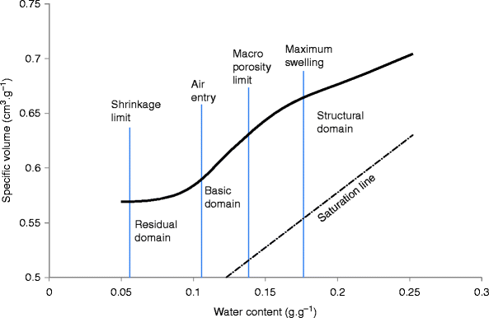
Figure 1. A type of shrinkage curve in an undisturbed sample of soil showing points of transition between shrinkage domains.
- MECHANISM BEHIND THE SWELLING AND SHRINKAGE BEHAVIOUR
Water gets attached to the surfaces of clay through mechanisms which include:
- dipolar electrostatic attraction,
- orientation of water molecules to the charged sites,
- hydrogen bonding with the oxygen atoms exposed on clay crystals
- adsorbed cations associated with the clay (it depends on the type of cations present and clay’s cation adsorption capacity).
Swelling pressures develop when a confined body of clay comes into contact with or is allowed to sorb water from an external solution. Swelling pressure can be described as the pressure applied to a soil body which is allowed to imbibe water, for preventing it from expanding, or it can be defined as the pressure which is exerted by a confined soil body on the walls of a rigid container when the soil is exposed to imbibe water from a reservoir at atmospheric pressure. It depends upon the difference in osmotic pressures between the external solution and the adsorbed water. The enveloping water thickness in a partially hydrated micelle is less than the potential thickness of the fully expanded diffuse double layer. If available, the truncated double layer will tend to expand to its full potential thickness and dilution by osmotic absorption of additional water. Each micelle’s swarm of positively charged cations repels those of the adjacent micelles as it expands. As a result, the micelles tend to push apart. Although this causes the system to swell as a whole, it may have the internal effect of closing the large pores (reducing the system’s permeability).
Since there are often twice as many monovalent cations as divalent cations, the osmotic attraction of a clay assemblage for “external” water is typically twice as high with the former. Therefore, swelling is highest in the presence of distilled water as the external solution and monovalent cations like sodium. When calcium occurs as a dominating cation in the exchange complex, there is a great reduction in swelling. The similar effect is caused when trivalent aluminum is present at low Ph. The factors which suppress swelling also includes high salinity of the soil solution. But when a saline soil, in which there is a predominance of sodium salts, is leached of the excess salts with fresh water, without adding concurrently gypsum or calcium ions, swelling occurs as a result of the predominance of sodium ions in the adsorbed phase.
Therefore, swelling is dependent on:
- kind and quantity of the clay present,
- specific surface area of clays (generally, swelling increases as the specific surface area increases)
- soil particles orientation or arrangement,
- presence of cementation between the particles (by such materials like aluminum or iron oxides, carbonates or humus).
- Depth of layers of soil (when there is swelling of soils in the surface layers on wetting and subsequent shrinking of soils on drying, the underlying layers of soil get prevented from swelling due to the confinement of the upper layer soil, which is called as the overburden pressure or the envelope pressure).
When a clay body that has been hydrated is dried, shrinkage takes place instead of swelling. When the process of shrinking begins in the field, the surface soil starts forming various cracks, that disrupts the mass of soil into various fragments, ranging from small microaggregates to macroaggregates and /or large blocks (Figure 2). For example, as occurs in soils rich in montmorillonite clays. When exposed to alternating wetting and drying, such as in a semiarid region, such soils heave and then settle, forming wide, deep cracks and slanted sheer planes that extend deep into the soil profile.
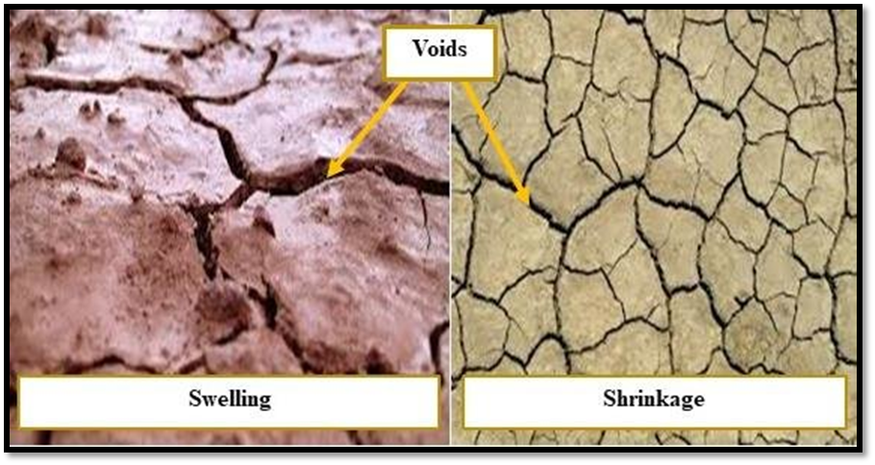
Figure 2. The figure is showing how the soils look at the time of swelling and shrinkage.
The main environmental reasons that contribute to swelling and shrinking of soils are:
- normal seasonal movements brought on by variations in rainfall and vegetation growth;
- enhanced seasonal movements brought on by trees, their severe pruning or by removing trees or hedges;
- subsidence for long time when there is development of water deficit for a long time;
- heave for long time when the there is dissipation of a persistent water deficit;
- increase in susceptibility of the surface soils when there is reduction in its density.

- SWELL- SHRINK BEHAVIOUR
The configuration of the thin crystal lattice layers that clay particles create determines their shape. In shrink-swell clays, water is attracted to and held between the crystalline layers (and on their surfaces) in a firmly bonded "sandwich," according to the molecular structure and arrangement of the clay crystal sheets. Water molecules’ electrical dipole structure causes an electrochemical attraction to the microscopic clay sheets. Adsorption is the process by which these molecules become attached to each other. The greatest affinity for water is shown by Na-smectite clays, which include montmorillonite, which can adsorb enormous amounts of water molecules between their clay sheets. Theoretically, they can increase in volume by an 800-fold factor, leading to the dispersion of clay platelets by removing repulsive interlayer forces. As a result, they have a significant shrink-swell potential, similar to vermiculite and chlorite, which also show crystalline swelling.
Water molecules between the clay sheets in saturated clay shrink-swell soils cause the bulk volume of the soil to increase or decrease with changes in water content (Fig.3). This absorption process weakens the inter-clay bonds, resulting in a decrease in soil strength. The water between the clay sheets is released as moisture is reduced by evaporation or gravitational forces, resulting in an overall decrease in the volume of soil or shrinkage. The process also results in voids and desiccation cracks. Shrinkage and swelling typically take place up to a depth of around 3 m in the near-surface, however this might change depending on the climate. The initial water content, internal structure, void ratio, type and quantity of clay minerals and vertical stresses in expansive soils, all affect their shrink and swell potential (Bell & Culshaw, 2001). These minerals, which include smectite, montmorillonite, nontronite, vermiculite, illite, and chlorite control the soil's natural expansiveness. Generally, the shrink-swell potential increases with the soil mineral concentration. However, the presence of other non-swelling minerals like quartz and carbonite may mitigate these effects (Kemp et al. 2005).
As long as the water content of the soil is fairly constant, even soils with a high shrink-swell potential won't typically pose any problem. This is governed by the mineralogy and water conditions of the soil, fluctuations in the water content, and the geometry and rigidity of a building built on it (Houston et al. 2011). Suction or variations in water content in a partially saturated soil enhance the risk of harm, while clay mineralogy in a fully saturated soil regulates the shrink-swell behavior.
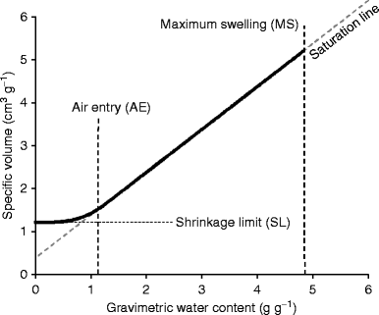
Figure 3. A type of shrinkage curve in clay soils depicting the phenomena of swelling and shrinking
- EFFECT OF SOIL SWELLING
Changes in soil volume can have both negative and positive effects on human activities. The destruction of buildings, roads, and pipelines in uncropped soils, as well as the leaching of fertilizers and chemicals below the root zone through desiccation cracks, are unfavorable effects caused by pass flow. Horizontal cracks in these soils disrupt water capillary flux. Swelling clays, on the other hand, can be utilized for sealing the hazardous waste landfills. This sealing prevents contaminants from migrating downwards into the groundwater. When cropped soils dry, the formation of a dense pattern of cracks improves water drainage and soil aeration while decreasing surface runoff in sloped areas. The recovery of porosity damages by compaction is closely related to soil cracking. Drying results in the development of tensile stress, which lead to the creation of primary, secondary and tertiary cracks. These cracks, then represent the void spaces and the walls of aggregates formed later on. This path is thought to restore the soil porosity in a layer of previously compacted soil.
- METHOD FOR ASSESSING THE SWELL-SHRINK POTENTIAL
Coefficient of Linear Extensibility (COLE) is one of the methods which helps in characterizing the variation in soil volume at 1/3rd atm. water retention, i.e. at field capacity to the oven dry condition.
COLE = (v_{1/3atm} – v_{dry})^{1/3} – 1
Where, v_{1/3 atm}. is the volume of soil at 1/3 atm. retention of water and v_{dry} is the volume of soil at conditions of oven drying. A range of shrink-swell potential of soil can be distinguished according to COLE:
Swell-shrink potential of soil COLE
Low <0.03
Moderate 0.03 – 0.06
High 0.06 – 0.09
Very High >0.09
CONCLUSION
The most major geological hazards that afflict residential properties and other low-rise structures globally and cost billions of pounds each year are subsidence and heave brought on by shrink-swell soils. They cost property owners more money on average each year than earthquakes, floods, landslides, hurricanes, and tornadoes all together. Therefore, the behaviour of these swell-shrink soils should be understood well and managed accordingly in order to avoid the geological hazards and for the sustenance of agricultural production system. The subsidence or heave caused due to the changes in water content of the soil should kept fairly constant, and other factors like presence of tree roots, geology and clay minerology and climate should be addressed accordingly.
REFERENCES
Stirk, G.B., 1954. Some aspects of soil shrinkage and the effect of cracking upon air entry into the soil. Australian Journal of Soil Research, 5, 279–290.
Nelson, J., Miller D.J. (1997) Expansive soils: problems and practice in foundation and pavement engineering. John Willey & Sons Ltd, New York.
Yong, R.N., Warkentin, B.P. (1975) Soil properties and behavior. Elsevier Scientific Publishing Company, New York
Harter, R.D. (1986). "Adsorption Phenomena." Van Nostrand Reinhold, New York.
Bell, F.G. and Culshaw, M.G. 2001. Problem soils: a review from a British perspective. In: Jefferson, I., Murray, E.J., Faragher, E. and Fleming, P.R. (eds) Problematic Soils Symposium, November 2001, Nottingham, 1–35.
Kemp, S.J., Merriman, R.J. and Bouch, J.E. 2005. Clay mineral reaction progress – the maturity and burial history of the Lias Group of England and Wales. Clay Minerals, 40, 43–61.
Houston, S.L., Dye, H.B., Zapata, C.E., Walsh, K.D. and Houston, W.N. 2011. Study of expansive soils and residential foundations on expansive soils in Arizona. Journal of Performance of Constructed Facilities, 25, 31–44.

