Micro-propagation for fruit crops, a technology of production virus free plants
Shiwanand Pandey¹, Gaurav Singh Vishen² and Krishna Kumar Mishra³
¹ Chandra Shekhar Azad University of Agriculture and Technology Kanpur (Uttar Pradesh) 208002
²Sam Higginbottom University of Agriculture, Technology and Sciences, Naini, Prayagraj, Uttar Pradesh 211007
³Gopal Narayan Singh University, Sasaram-Tilauthu Rd, Jamuhar, Bihar 821305
Email Corresponding Author:Pshiwanand94@gmail.com
Abstract
Micro-propagation for fruit crops is a most promising area of application at present time and giving an out look into the future. The rapid and fast production of disease free, high quality and uniform planting material is only possible through micro-propagation. New opportunities have been constructed for producers, farmers and nursery owners for high quality planting materials of fruits as well as other horticultural crops. Planting materials production can be carried out throughout the year irrespective of season and weather because of control environment. However micro-propagation technology is expensive as compared to conventional methods of propagation by means of seed, cuttings and grafting, budding etc. Therefore it is essential to adopt measures to reduce cost of planting materials production. Low cost production of plants requires cost effective practices and optimal use of equipment to reduce the per unit cost of plant production.
Key word: Conventional, Disease, Micro-propagation, Production, Rapid
Introduction
Micro-propagation is the yielding of new plants under the ultra controlled environment within the culture vessel i.e., bottle and test tube. Commercial micro-propagation began in the United States in 1965 with orchid plants production. The first tissue culture Laboratory in India was established at Delhi University Delhi in 1950s. Micro-propagation is the widely applied aspect of plant biotechnology and as a result over 100 tissue culture laboratories have been established in different states of India. Undeniably the most useful upshot of tissue culture has been in the micro-propagation of vegetables, ornamentals, fruits, plantation crops forest trees, medicinal and aromatic plants. At present most of the large commercial tissue culture laboratories are functional in states like Andhra Pradesh, Maharashtra, Karnataka and Kerala. Banana is the largest sold micro-propagated planting material of fruit crop in India and abroad. Strawberry is also catching up popularity of micro-propagation in our country.
Historical Background of Micro-propagation In 1902, a German physiologist, Gottlieb Haberlandt was the first who culture isolated single palisade cells from leaves in knop’s salt solution enriched with sucrose. The cells remained alive for up to one month, increased in size, accumulated starch but failed to cell division. Though he was unsuccessful but laid down the bases of tissue culture technology for which he is regarded as the father of plant tissue culture. Why do micro propagation? A single explant can be multiplied into several thousand plants in less than a year and allows fast commercial propagation of new cultivar. Once established, a plant tissue culture line can give a continuous supply of young planting material throughout the year. In plants which affected to virus diseases, virus free explants (new meristems tissue is usually used for virus free planting materials production) can be cultivated to provide virus free plants. Plant tissue barks can be frozen, and then regenerated as new plants through tissue culture. Plant cultures in approved media are easier to export than are soil grown plants, as they are pathogen free and take up little space . Micro-propagation In vitro propagation of plants vegetative by tissue culture to produce genetically similar copies of a new plants is referred to as micro-propagation or clonal propagation. Micro-propagation is a proven means of producing millions of identical plants under a controlled and aseptic condition, independent of seasonal constraints. It’s not only provide economy of time and space but also gives greater result and allows further augmentation of elite disease free propagules. The size of explant may vary from as small as 1.0-5.0 mm long meristem tip for meristem culture to a piece of shoot several centimeters long. Advantages of micro propagation
- From one explants to many propagules rapidly
- Multiplication in controlled environment lab conditions
- Continuous propagation out of year
- Potential for disease free plant propagules
- Inexpensive per plant once established laboratory
- Precise crop production scheduling
- Reduce stock plant space
- Long term germplasm storage in minimize spaces
- Production of difficult to propagate species
Disadvantages of micro propagation
- Specialized equipment/facilities required
- More technical expertise required
- Protocols not optimized for all species
- Relatively expensive to set up
Basic requirements of micro-propagation
In micro-propagation techniques, there is some basic requirement, viz
- Aseptic condition
- control of temperature
- Proper culture medium
- Sub-culturing
Other Implications of Micro propagation-
In addition to major uses of tissue culture technique for rapid and clonal multiplications of plants, this techniques is highly important for several purpose as under
- Production and maintains of pathogen like virus free stock plants
- Continuing in vivo conservation of germplasm
- Regeneration and selection of transgenic plants
- Conservation of germplasm
Micro-propagation Procedure
There are basically four stages of micro-propagation process, these are:
- Stage I- Explants establishment
- Stage II- Shoot multiplication
- Stage III- Root formation
- Stage IV- Acclimatization
- Stage I-The production of explants depends on various factors such as the source of explants, type of explants such as root, stem and leaf from mature or immature plants, explants sterilization, in vitro culture conditions such as culture media, composition, humidity temperature and light etc. The explants showing growth are considered established.
- STAGE II- The production of explants is sub-cultured after 2-3 weeks in shoot multiplication medium. Auxins like IBA, NAA, 2,4-D and cytokinins like BAP, Kinetin is used in culture medium. It is well known fact that cytokinins enhance shoot multiplication.
- STAGE III- The in vitro regenerated shoots are rooted in the medium containing auxins like IBA, NAA and 2,4-D. The rooting can also be induced when in vitro shoots are exposed to stress conditions.
- STAGE IV- The in vitro plantlets thus seized are hardened/ acclimatized before transfer in the field. The hardening is necessary as the tissue culture imitative plants grow under high humidity conditions, have open stomata, lower epi-cuticular wax, thus leading to increased transpiration losses of moisture and resulting in mortality of plants.
Basis for plant tissue culture
Two plant hormones affect plant differentiation i.e. auxin and cytokinin
Generally the ratio of these two hormones can determine plant development
- High Auxin + Low Cytokinin = Root development
- High Cytokinin + Low Auxin = Shoot development
- Auxin and Cytokinin Equal = Callus development
Culture media have been developed by various workers in different crop species. The culture media developed by Murashige and Skoog (1962) and Gamberg, et al. (1968) are used with some modifications in various crop species. Transfer of tissue or callus from old culture media to fresh culture media is called sub-culturing. This is essential to maintain good health of the callus or tissues, because after some period, some nutrients are depleted in the culture media.
SOME factors are essential in the success of tissue culture
- Sterilization of equipment, glassware and the media
- Collection of tissue
- Sterilization of tissue
- Media composition
- Inoculation of tissue
- Incubation
TYPES OF CULTURE IN MICROPROPAGATION
- Callus culture
- Suspension culture
- Root tip culture
- Leaf Primordial/ leaf culture
- Shoot tip/ meristem culture
- Anther/ pollen culture
- Ovule/ embryo culture
- Protoplast culture

- Callus culture strings the initiation and continued proliferation of undifferentiated parenchyma cells from explants tissue or clearly defined semi solid media.
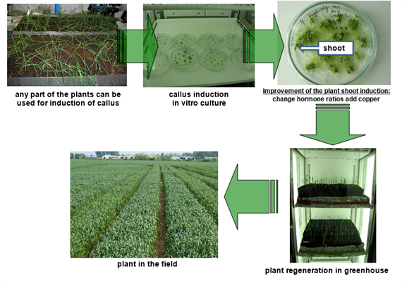
- Suspension culture
- A suspension culture defined to cell tissue, dispersed and growing in an aerated liquid culture medium is placed in a liquid medium and shaken vigorously and balanced dose of plant hormones.
- Cytokinin induced adventitious buds of fruit plants in a suspension culture, sub-culture for a week.
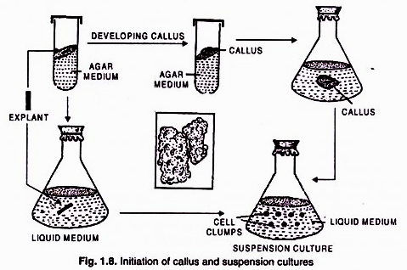

- Root tip Culture Isolated root tips of apical produce in-vitro root systems with indeterminate growth habits. These were among the first kinds of plant tissue cultures (White, 1934) and remain important research tools in the study of development phenomena.

- Leaf Primordial Culture
Leaf culture is a form of tissue culture in which excised leaves, leaf primordial and leaf material, are grown on a sterile growth medium. Mature leaves can be kept healthy under culture conditions for considerable periods. Leaf primordia have been used to study growth and differentiation processes of fruit plants.
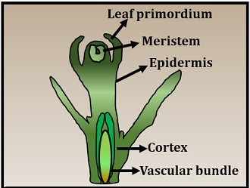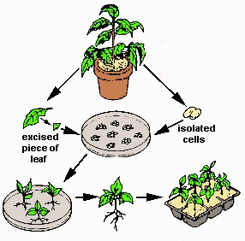
- Shoot tip/ Meristem Culture
- The culture of terminal part of shoot to a plant in-vitro condition or in lab called shoot tip culture.
- Mostly the shoot tip cultures used for obtain disease free plant without genetically changes.
- The shoot tip plant are more efficient to cultivation of differentiation in-vitro because cells of them newly generated and healthy comparison to other parts.
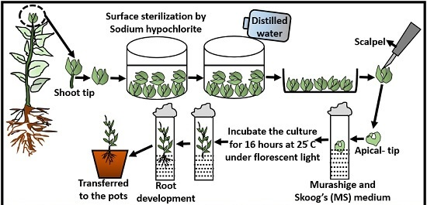

- Pollen/Anther culture
Pollen culture (microspore culture) is a technique in which haploid plants are obtained from isolated pollen grains culture of pollen grains which germinate in-vitro. while in anther culture those are obtained from pollens, by placing anthers on a suitable, synthetic culture medium
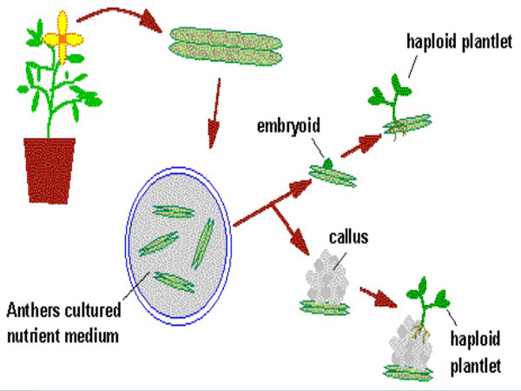

- Ovule/ovary Culture
Ovule culture technique is utilized for development of hybrids which normally fail to develop due to the abortion of the embryos at early stage of initiation. Ovules can easily be excised from the ovary of explants and cultured a basal culture medium. The loss of hybrid embryo due to premature abscission of fruits may be prevented by ovule culture. In some study, addition of fruits/ vegetables juice increases the initial growth.
- Protoplast culture
Protoplast culture involved the regeneration of the cell wall around the protoplast membrane. Once the cell wall has formed, cell division must be initiated in the new cell.
Importance of protoplast -
- Study of osmotic behavior
- Study of IAA action
- Study of plasma lemma
- Study of cell wall formation
- Organelle isolation
- Study of morphogenesis
- Virus uptake and replication
- Study of photosynthesis
- Gene transfer
Micro-propagation of Fruit Crops
- Among fruit crops banana and strawberry are being propagated commercially on large scale.
- Grapes can be regenerated from auxiliary shoots, adventitious budding and via somatic embryogenesis but none of these methods as yet allows mass clonal propagation.
- Pomegranate has been micro-propagated through shoot-tip culture.
- Many reports have been published on the successful regeneration of kinnow from nucellus tissue but till date it has not been propagated commercially
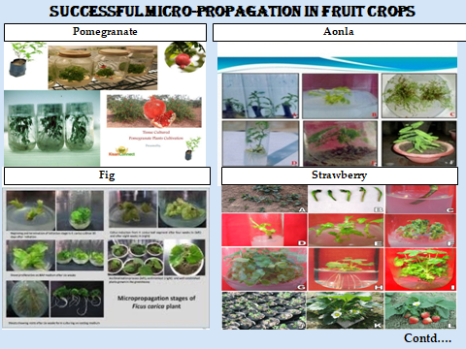

Application of Micro-propagation in fruit crops
- Clonal Propagation
- Soma Clonal Variation
- Production of Virus free Plant
- Production of Synthetic Seed
- Somatic Hybridization
- In-vitro Plant Germplasm Conservation
- Mutation Breeding
- Molecular Farming
- Genetic Engineering
- Clonal Propagation
Clonal propagation defined the process of asexual reproduction by multiplication of genetically identical copies of individual plants. The clonal propagation is rapid method and has been adopted for commercialization of important plants such as - Banana, strawberry, Apple and Pear etc.
Benefits
- Rapid and fast multiplication of superior clones produced by throughout year, irrespective of seasonal variations.
- Multiplication of pathogen and disease free plants, e.g. virus free plants of Apple, Strawberry, Banana and Pear etc.
- Multiplication of sexually derived sterile hybrids fruit plants.
- It is cost effective process as it requires minimum growing space because it is practice in laboratory.
- Soma Clonal Variation
The genetic variation found in-vitro cultured cells are collectively explained as soma clonal variation and the plants derived from such cells are known as ‘soma clones’. Larkin and Scowkraft in (1981) coined a general term ‘somaclonal variation’.
Basic features of Soma Clonal Variation- variation in structure and number of chromosome is commonly observed Regenerated plants with altered chromosomal changes often show changes in leaf shape and colour, habit, growth rate and sexual fertility.
It is generally heritable mutations and persists in plant population even after plantation into the field.
Advantages of Soma-clonal Variation–
- Helps in fruit crops improvement
- Generate additional genetic variants.
- Plants with tolerant and resistant to toxins, high salt, herbicides and even mineral toxicity.
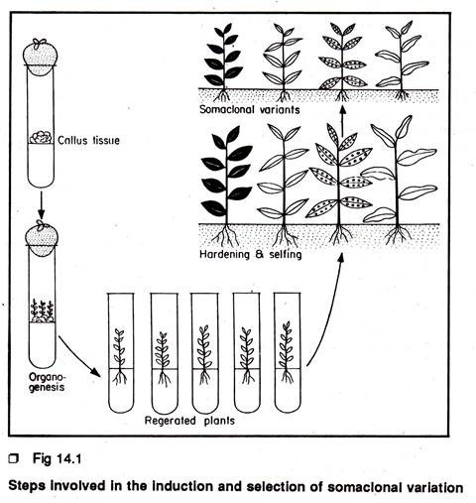
Soma clonal variation in different crops
Variation presence |  |  | Variation absence
Fruit | Explant source | References | Fruit | Explant source | References
Kiwifrui | Leaf blade and petiole | Prado, et.al.  (2008) | Banana | Shoot tip | Ray, et. al. (2006)
Oil palm | Zygotic embryo | Rival, et. al. (2013) | Almond | Axillary branching | Martins, et. al. (2004)
Papaya | Axillay shoot tip | Kaity, et. al. (2009) | Vitis Sp. | Nodal segment | Alizadeh, et. al. (2008)
- Production of Virus-free Plant
- In tissue culture application produced pathogen and virus free plants. The viral disease is plants transfer easily and lower the quality and yield of the plants.
- It is very difficult to cure and treat the virus infected plants therefore the plants breeders are always interested in developing and growing virus free plants.
- In some fruit plants has become possible to produce virus free plants through tissue culture at the commercial level.
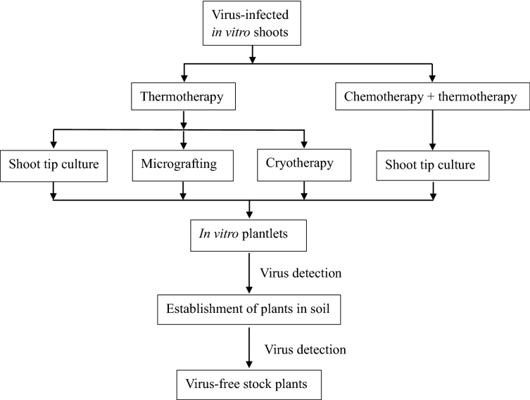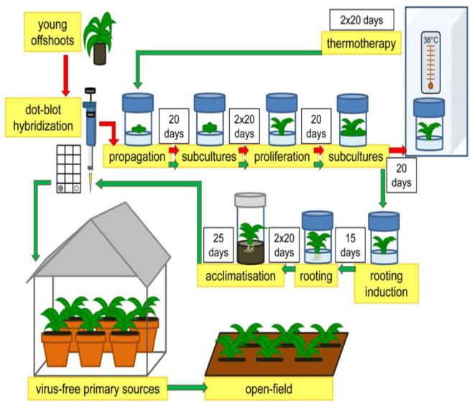
- Production of Synthetic Seeds
In synthetic seeds the somatic embryos are encapsulated in a suitable source (e.g. sodium alginate), along with substances like fungicides, insecticides and herbicides, these artificial seeds can be utilized for the rapid and bulk propagation of desired plant species as well as herbicides varieties.
Encapsulation methods for synthetic seed
(A) Dropping procedure –
- The most useful encapsulation system drip seeds 2-3 % sodium alginate drops from at the tip of the funnel and the somatic embryos are inserted
- Keep the encapsulation embryos complex in calcium salt for 20 min.
- Rinsed the capsules in water for cleaning and then stored in air tight container.
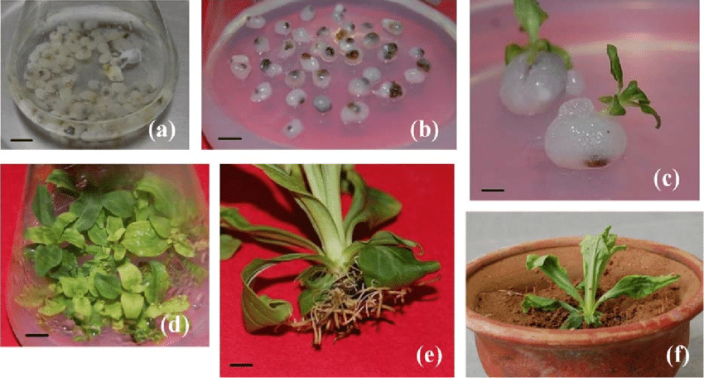
Synthetic seed production process
Explant selected from healthy plant

Induced callus in explant

Somatic embryo induced in callus

Somatic embryo proliferated

Maturation of somatic embryo

Encapsulation of somatic embryo

In-vitro germination

Acclimatization, induce fruit

Produce synthetic seed
Somatic hybridization
Isolation of protoplast desired species/varieties

Fusion of protoplast of desired species/varieties

Identification of selection of somatic hybrid cells

Culture of hybrid cells

Regeneration of hybrid cells

Advantages of somatic hybridization
- Production of heterozygous lines in the single species which cannot be propagated by vegetative means like cutting, layring, budding, grafting .
- Studies on the fate of plasma genes.
- Production of unique hybrids of nucleus and cytoplasm.
Constraints of somatic hybridizations
- Low regeneration of hybrid plants.
- Non- viability of fused products.
- No more successful in all plants.
- Generation of unfavorable hybrids.
- Shortage of an efficient method for selection of hybrids.
- No confirmation of expression of particular trait in somatic hybrids.
In-vitro Germplasm Application
- Germplasm defined as the sum total of genes present in a crop and its related species.
- The conservation of germplasm involves the preservation of the genetic diversity of a particular species.
- This will insure the opportunity of valuable germplasm to breeder to develop new and improved varieties.
- Germplasm conservation depending on the crop species and method of sustentation of genetic resources from 1 to 15 years.
- Important method for conservation of germplasm is cryopreservation
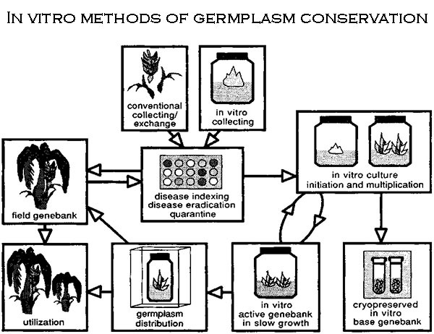

- Cryopreservation
- The germplasm is reserved as a very low temperature using solid carbon dioxide (at-79 °C)
- Adopting low temperature deep freezers (at -80 ° C)
- Adopting vapor nitrogen (at -150 ° C)
- Adopting liquid nitrogen (at -196 ° C)
- Any tissue from a plant can be used for cryopreservation like embryos, ovules, meristems, seeds, cultured plant cells, calluses, etc.
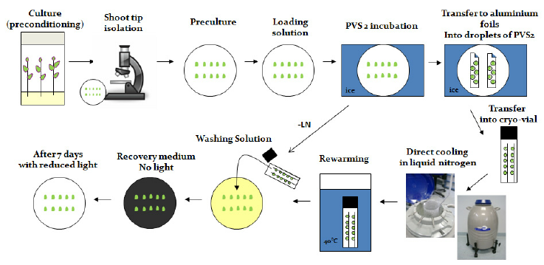
- Mutation Breeding
- Mutagenic agents, such as certain chemicals and radiation then can be used to induce mutations and resulted genetic variation from which desired mutants may be selected.
- Mutation induction has become a proven may of creating variation within a fruit plants variety.
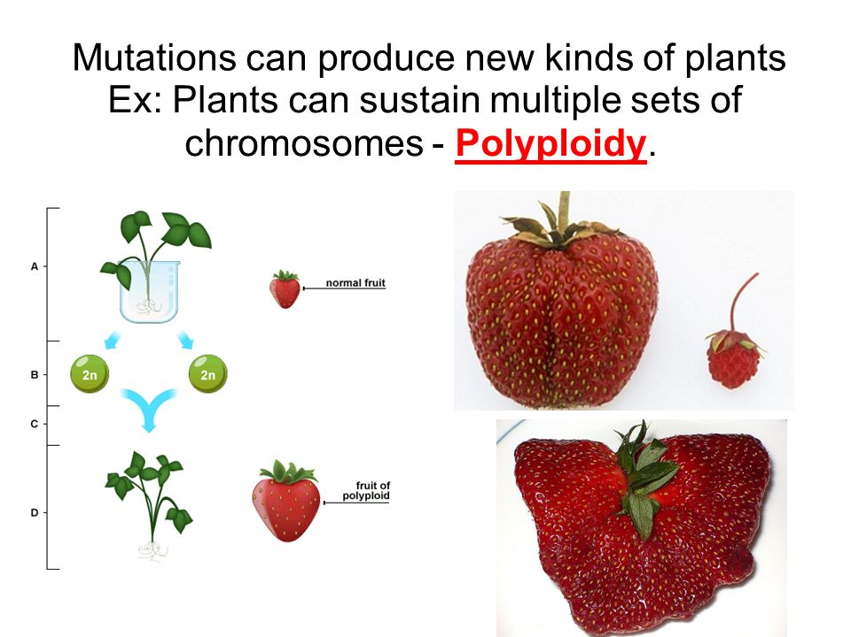
Mutation Breeding Procedure
Take shoot-tip area of explants size (0.2 mm)

Cultured on shoot induction medium

Stem segments incubated in growth chamber for 2 days

Active the lateral vegetative buds

Transferred into 50ml plastic tubes

35-40 ml Ethyl Methane Sulphonate (EMS) solution and placed on a shaker

60-90 RPM for the convenient time

Explant were washed with sterile water 4-5 times

Shaken in sterile water at 60-90 RPM for 1 hrs.

Treated and washed stem segments were cut into small pieces about length of 4-5 mm

Transferred to fresh SIM for incubation in the growth chamber set at 25 ° C (± 1), 16/8

Light/ dark light intensity with 1500-2500 LUX for 3-4 weeks.
- Molecular Farming
- Molecular farming is the use of plant cells/ tissue cultured, whole plant or in vitro for the production of valuable recombinant proteins
- The advantages of plant based systems can be summarized as follows-
- Plants are less expensive to setup and maintain than cultured cells.
- Plant based systems are extremely versatile.
- Which has been established as economically viable alternative to mainstream production system and cells cultivated in large scale bioreactors?

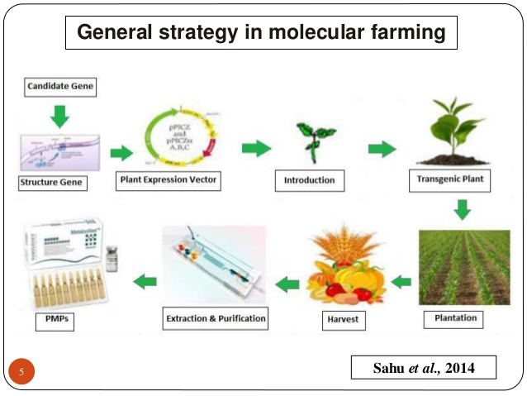

- Genetic Engineering
- Although genetic engineering and hybridization by conventional breeding can augment genetic variation in plants.
- In terms of quick returns, the time needed to produce a new genotype can be a critical factor for its commercial exploitation
Commercial application of genetic engineering
- In commercial horticultural production, research has centered mainly on fruits crop genetic engineering with limited amount on fruit crops
- Although genetically engineered crops are in widespread cultivation, most are horticultural.

References
- Buhara, Y. Buhara, Y. A., Mohammed, A., Mohammed, M., Arslan, M. Arslan, G. Ekrem, G. E. (2015) Clonal propagation and synthetic seed production from nodal segments of Cape gooseberry (Physalis peruviana L.), a tropical fruit plant. Journal of Agriculture and Forestry 39(5):797-806
- Chang, S., Mahon, E.L., MacKay, H.A., Rottmann, W.H., Strauss, S.H., Pijut, P.M. Powell, W.A., Coffey, V., Lu, H., Mansfield, S.D., (2018) Genetic engineering of trees: Progress and new horizons. Vitr. Cell. Dev. Biol. Plant. 54, 341–376
- Damiano, C., Frattarelli, A., Shatnawi, M. A., Wu, Y., Forni, C. andEngelmann, F. (2003). Cryopreservation of temperate fruit species:quality of plant materials and methodologies for gene bank creation.Acta Hortic 623:209–215.
- Das, D. K., Nirala, N. K., Reddy, M. K., Sopory, S. K. and Upadhyaya, K.C, (2006). Encapsulated somatic embryos of grape (Vitis vinifera L.):an efficient way for storage and propagation of pathogen free plantmaterial. Vitis. 45:179–84.
Yusuf, A. O., Culham, A., Aljuhani, W., Ataga, C. D., Hamza, A. M. (2015) Genetic diversity of Nigerian date palm (Phoenix dactylifera) germplasm based on microsatellite markers. Journal of Bioscience and Biotechnology, 7, 121–132.
- David, H., Domon, J. M., Savy, C., Miannay, N., Sulmont, G., Dargent,R. and David, A. (2006) Evidence for early stages of somatic embryo development in a protoplast-derived cell culture of (Prunus avium). Physiol Plant. 85:301–307
- Hussain, A., Ahmed, I. Q., Nazir, H. and Ullah, I. (2012) Plant Tissue Culture: Current Status and Opportunities, Recent Advances in Plant in vitro Culture, Annarita Leva and Laura M. R. Rinaldi (October 17th 2012).
- Isac, V.and Coman, M. (2012) Validated protocols for micropropagation of some fruit species to produce pre-basic plant material. Fruit growing research (XXVIII):1-5.
- Prado, M. J., Gonzalez, M. V., Romo, S., Herrera, M. T. (2007) Adventitious plant regeneration on leaf explants from adult male kiwifruit and AFLP analysis of genetic variation. Plant Cell Tissue and Organ Culture 88(1):1-10
- Rai, M. K., Jaiswal, V. S. and Jaiswal, U. (2009) Encapsulation of shoottips of guava (Psidium guajava L.) for short-term storage and germplasm exchange. Sci Hortic. 118:33–38
- Sahu, P. K., Tarun, Patel, S., Sahu, P., Singh, S., Tirkey, P. and Sharma, D. (2014) Molecular Farming: A biotechnological approach in agriculture for production of useful metabolites. International Journal of Research in Biotechnology and Biochemistry. (2): 23-30.
- Setargie, A., Mekbib, F. and Abraha, E. (2015) In vitro Propagation of Papaya (Carica papaya L.). World Journal of Agricultural Sciences 11 (2): 84-88.
- Sharma, S., A. Prakash and T. Ajinath (2009) In vitro propagation of Citrus rootstocks." Notulae Botanicae Horti Agrobotanici Cluj-Napoca 37(1): 84-88.
- Singh, P., Patel, R. M. and Kadam, S. (2013) n vitro mass multiplication of pomegranate from cotyledonary nodal explants cv. Ganesh. African Journal of Biotechnology. 12(20) 2863-2868.
- Tomar, U. K. and Dantu, P. K. (2013) Protoplast Culture and Somatic Hybridization. Cellular and Biochemical Sciences Book. 31 (8):885-890.

