**Futuristic Trends in Agricultural Engineering & Food Sciences**

**Chapter**

**High Throughput Phenotyping in Plants**

**Authors**

**Mr. Ankit R. Chaudhary**

Department of Genetics and Plant breeding,   
N. M. College of Agriculture, Navsari Agricultural University, Navsari, Gujarat, India

Phone number: +91 8530828687; Email: ankitc034@gmail.com

**Mr. Deepak D. Sharma**

Department of Genetics and Plant breeding,   
N. M. College of Agriculture, Navsari Agricultural University, Navsari, Gujarat, India

Phone number: +91 9898788039; Email: [deepakdsharma1995@gmail.com](mailto:deepakdsharma1995@gmail.com)

**Mr. Apurv M. Patel**

Department of Plant Pathology,

N. M. College of Agriculture, Navsari Agricultural University, Navsari, Gujarat, India

Phone number: +91 9328313603; Email: apurvpatelcm@gmail.com

**Abstract**

The need for the quantitative analysis of structure, organization and function of huge number of plans is accepted by the plant research community and hyped to the growth in the demands of novel traits in crop breeding. Precision phenotyping remains a barrier despite the widespread use of next-generation sequencing and SNP genotyping technologies, linkage mapping and GWAS studies to understand the genetic makeup and architecture of traits important for agricultural crops. Traditional phenotyping, which require intensive labor work, time, low outcome, expensive, and some destructive methods found to be sometimes harmful to plants. High-throughput phenotyping has a clear purpose of bridging the gap between genomics and phenomics. This chapter offers thorough information regarding the utility and benefits of high throughput phenotyping in plants.

**Introduction**

Plant science and agricultural development have a huge challenge in ensuring that food output is adequate to meet the requirements of an ever-increasing population would reach up to more than 9 billion by 2050. So, Efficient breeding techniques such as NGS (next generation sequencing) helps in genetic improvement of the crop but traditional phenotyping is time consuming and labor intensive. Advances in high throughput phenotyping is required because it offered the large mapping populations for phenotyping more efficiently and rapidly.

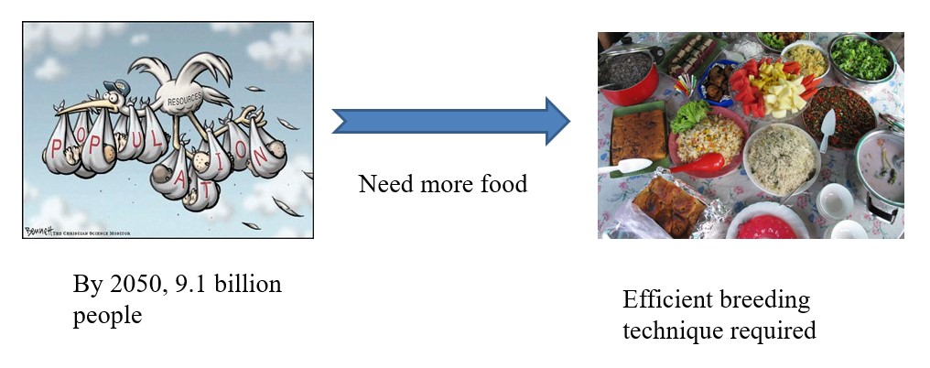

Recently the advance technology of DNA based sequencing paved the way for significant achievement in comprehending crop genomes and that shifted the direction of bottleneck and now the phenomics is found to be the limiting factors in research related to plant sciences. As a result of this trend, high throughput phenotyping technologies recording high density phenotypic data for traits which can be linked or associated to the genetic information for required for progress in crop improvement are needed.

Even after these advancements, the generation of phenotypic data continues to lag behind our current capacity to generate high-throughput genotypic data, resulting in a "phenotypic limiting factor or bottleneck" that is impeding plant breeders' growth. As a result, high throughput phenotyping is currently being used to address such issues.

**What is Phenomics?**

**Phenome = Gene × Environment** or the expression of genome as a trait in a prevailing environment. Also explains how the genetic make-up of an organisms determine the function appearance and performance. Or phenotypic analysis of genome information. Or understanding phenotypic expression at a systems level.

1. **Forward phenomics:** Forward phenomics use phenotyping techniques to select potentils genotypes with required characters from a huge collection of germplasm. Thesis results in the selection of one of the best variety and germplasm line (Kumar *et al.,* 2015)
2. **Reverse Phenomics:** here in reverse phenomics deals with discovering or understanding the mechanism. The best varieties or lines are already identified and are examined to understand the genetic makeup and the responsible mechanism behind the desirable expression of the traits required. (Kumar *et al.,* 2015**)**

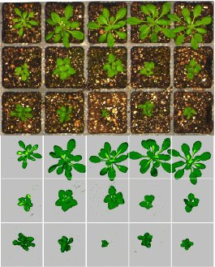

Plant phenotyping refers to a collection of methods and techniques for measuring growth of the plant, compositions, performance and architecture at different scales. When we do it the traditional manner, phenotyping the population is commonly considered as the labor intensive, most time-consuming and technically demanding part. As there requirement to conduct trails in replication at multiple locations with different environment over many seasons, traditional phenotyping is generally labour demanding, time consuming, low throughput, expensive, and often destructive to plants. Current phenotyping technologies need a delayed and expensive damaging harvest at specific time or at a specific phenological stage, also to evaluate allelic variation, phenotyping work must be done extremely carefully and complexity has made crop breeding programs to make a single measurement of final yield for the plots in contrasting environment over different seasons. As a result, we should use high throughput phenotyping to get around this traditional phenotyping barriers.

High throughput phenotyping employs robots, environmental control with high precision, and remote sensing methods to measure the growth and performance of plants in greenhouses or growth chambers. Genetics and plant breeding, physiology, bioinformatics, and engineering are all part of the high throughput phenotyping technique. This is a step in the direction of precision breeding.

1. Global distributional map of infrastructures for plant phenotyping, indicating that Australia and Europe leading in static phenotyping facilities (Figure 1A), but that investments in the United States and China were expanding.
2. The number of phenotyping successes and agricultural phenomics-related articles published in the last 20 years (Figure 1B).
3. Infrastructure classification. (More than 82 automated indoor phenotyping platforms have been developed throughout world, with controlled environments accounting for 59% of these infrastructures and field platforms accounting for just 18%) (Figure 1C).
4. Species summary from IPPN surveys (2014 and 2016) (Figure 1D).
5. The distribution map of the research papers regarding high-throughput crop phenotyping by various researchers of different fields, location/region, document type, and species explained (Figure 1E).

**Figure 1: The Current Status of Global Phenotyping (Yang *et al*., 2020)**

There is an automated facility named LeasyScan at ICRISAT (Hyderabad). LeasyScan is a high-throughput phenotyping tool that was launched in 2014 with the goal of measuring two features as leaf area and leaf conductance faster which are important for the adaption of plant in drought condition.

The computerized platform for high-throughput which is based on 3-D pictures enables researchers to examine plant phenotypes in more depth and undertake plant screening at large-scale to incorporate it into the breeding and genomics activities to accelerate the progress for superior, drought-resistant crops. The PlantEye® scanner consists of a camera with a 45º angle that produces 3-D pictures, is used by the LeasyScan platform. The scanning device can scan around 3200 to 4800 plots per two hours. The leaf area, angle, average leaf area and plant height are then calculated using a series of algorithms. There are sectors preset regions scanned by the scanner with a width of 65 cm and a length of either 40 or 60 cm. The platform has a grid of barcodes that may be used to reposition the scanner in the y and z axes. On the top of an irrigation boom, eight scanners are installed. There are two major specifications considered while designing the platform that are the movements of the scanners at a constant speed and space above the pots

To have a robust data basis, phenotyping investigations need a large sample size. As a result, autonomous handling greatly aids image and data acquisition. So that, either the plants are transported towards the cameras (plant-to-sensor) or sensing equipment moves towards the samples (sensor- to-plant).

Sensor to plant

Plant to sensor

Plant-to-sensor allows in-house image acquisition conditions with a top-and-side perspective. Sensor-to-plant technology keeps the plants in place, while top-view imaging equipment travels through the growing region.

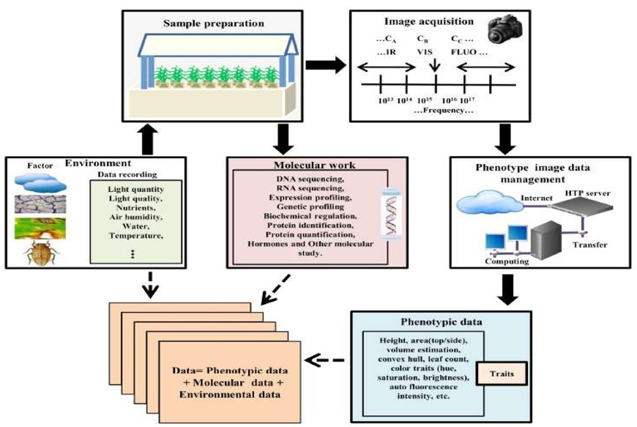

**Figure 2.** **High-throughput plant phenotyping and data accumulation (Rahaman *et al*. 2015)**

Plants are cultivated in a controlled environment in order to prepare samples. Each plant that has received a specific treatment regarding mutation and stress therapy, is housed in a container with a nutrition source that can be managed. The platform then selects genotypes and takes multiple top/side view photos automatically. The recorded images are then transferred and managed by the data-management system with recording environmental data and genotype information. The image data is then utilized to compute phenotypic attributes using image processing technologies. In varied environmental conditions, data mining approaches are used to reduce phenotype-genotype models. (Figure 2)

The plant phenotyping can be done at different organizational levels, from the field and canopy to the entire plant, organ, tissue, cellular level (even subcellular level also). Phenotypic traits of interest can be classified as physiological, performance-related and structural traits. And this plant phenotyping is the qualitative or quantitative investigation of trait of interest at different organizational level at a specific genomic state and particular environmental conditions. This is represented as a single column of yellow cubes that may be positioned anywhere in the cube (See figure 3).



**Figure 3. Levels of Plant Phenotyping and Factors Influencing the Phenotype (Dhondt *et al.,* 2013)**

A phenom represents all kind of potential phenotypes of a genotype in various environmental conditions, and is depicted by a combination of red and yellow cubes. Plant phenomics is the study of phenomes of multiple genomic expression states, which are demonstrated by the yellow, red, and blue cubes. Different environmental conditions and genomic expression states are shown by light-colored cubes.

**PHENOTYPING TECHNOLOGY AND PLATFORM**

The visible and infrared light spectrum may be captured using a number of cameras. VIS (Visual Inertial System) cameras assess the phenotypic or morphological and colour characteristics of plants by detecting light in the visible range between 400 and 700 nm (Figure 4).

**Figure 4. Variety of Imaging Cameras (Fahlgren *et al.,* 2015)**

The light in the range of 700 to 1400 nm is denoted as Near-infrared (NIR) light and is detected by infrared (IR) cameras, which are used for capturing images in the night. NIR cameras used to detect water content of the leaves by detecting the NIR and short-wave infrared light in a particular region. Long-wave infrared light emitted by leaves, whose intensity is dependent on the temperature is detected by thermal infrared (TIR) cameras.

From 350 nm to 2500 nm, hundreds of spectral bands are detected by hyperspectral cameras. After excitation, specialised imaging equipment detect chlorophyll fluorescence (Figure 4).

**Novel high-throughput phenotyping techniques**

1. **Scanning by visible light (RGB)**

**Red, green, and blue (RGB) image:** Sensing visible wavelengths (400 to 700 nm). It is most easily accessible sensor. Also called VIS (Visual Inertial System). High-resolution colour images for comprehensive morphological and growth phenotyping *i.e.*, node number, growth phase, nutrient deficiency, disease and senescence analysis were taken. High-resolution colour images taken from the top and several sides.

Because it captures photos of most morphological or phenotypic aspects of plants, like complete or partial plants images, shoot biomass, plant structure, leaf area, leaf density, height, and colour, the band sensor named as RGB is the most economical and accessible device. RGB offers a wide range of applications because of its quick and inexpensive measurement. RGB images can also be used to extract detailed information on water deficit or stress from its shape, solidity, and other apparent characteristics.

1. **Far-infrared (FIR) imaging**

Far-infrared, often known as thermal imaging, is a kind of imaging that examine temperature. They target light in the far infrared range of the spectrum (15mm-1mm).

FIR used:

* To monitor and compute temperature changes within a single plant's leaves or between different plants.
* The changes in stomatal conductance, or the water evaporation rate from stomata, or pores of leaves, are measured. To determine the rate of photosynthesis, stomatal conductance can be utilized.
* The change in temperature can be detected by the thermal sensor occurred due to transpiration, stomatal closure. Thermal imaging can therefore be used to evaluate the characteristics based on temperature like stomatal conductance, transpiration rate and water content.

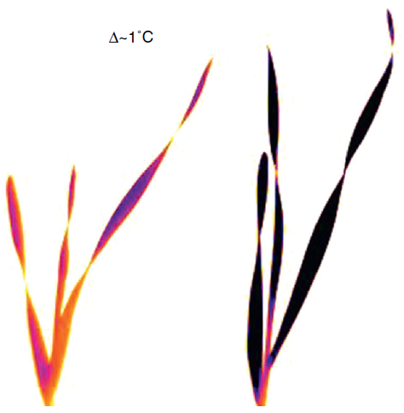

**Figure 5b. Thermal image of a wheat trial imaged from a cherry picker. (Furbank and Tester, 2011)**

**Figure 5a. Thermal photos of salt-treated durum wheat seedlings (Furbank and Tester, 2011)**

Thermography can be used as to examine the leaf or canopy temperature at both the single plant level (Figure 5a) or at the plot level (Figure 5b). Figure 5 depicted the thermal images of seedlings of wheat (durum) which are given salt treatment for three days before measurement compared to control. The difference between the temperature of control and treatment seedlings is around 1º C. Figure 5b displays a thermal picture taken from a cherry picker of a wheat experiment. The average temperature of each plot is compared and then images are processed to minimize or eliminate the soil signals. The adjustments were made for heat balance and solar fluxes. Through following technique differences in water extraction or stress tolerance can be found. As a result, with good environmental control, this difference may be utilized to test for osmotic stress tolerance.

1. **Near-infrared (NIR) imaging**

The water content and conductance in soil and leaves are studied using near-infrared (NIR) cameras. They utilize light in the NIR range (700–1300 nm) of the spectrum. Plant green area has the maximum reflection rates between 700 and 1300 nm NIR wavelengths. Plant tissues reflect NIR above 1300 nm as well, albeit at a much lower rate. The following exercise cause the scattering of wavelengths within the leaf mesophyll, which are then absorbed by water in the later stage. Such qualities demonstrate compatibility or tolerance in drought conditions. Plants are grown in transparent pots to facilitates the photography of the developing roots. The NIR readings in the soil are used to compute the water quantity removed by roots from soil and to determine the where and amount of water used by the plant.

Spongy layer present backside of leaves that reflects lot of light in NIR range, after dehydration or stress condition this spongy layer get collapsed hence reflect less NIR light but same visible range. Thus, we can differentiate healthy plant from sticky plant.

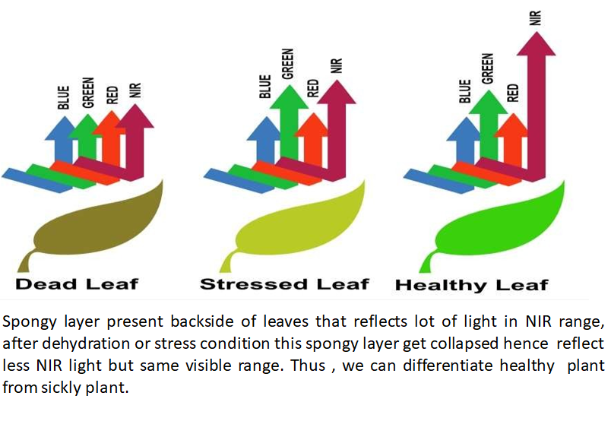

By sensing the parameter like pixel of an image and measuring the infrared fluctuations, the classifier can distinguish between them. As seen in the picture, it separates the photographs using three colours: dead leaf- brown, stressed leaf- light green and healthy leaf- dark green. The presence of dead leaf in the fields indicates the quality of crop. Because these leaves are a plant's primary source of nutrition, it's critical to detect any dead or stressed leaves in the field. Such leaves are removed and sufficient nutrients are provided for the crops in order to preserve high-quality goods.

1. **Fluorescence imaging**

**What is fluorescence?**

Fluorescence can be described as the light that is emitted by absorbing the radiation of shorter wavelengths.

* Plant health and photosynthesis are studied using fluorescence imaging.
* Responses to biotic and abiotic stress
* Chlorophyll content
* Chlorophyll fluorescence is the first observable change occur in plant due to the change in performance of the photosynthesis before any of the parameter that can be measured making it feasible to notice when plants are performing well, or stressed, at a very initial stage at young age.

The chlorophyll complex is the portion of the plant that fluoresces. When the chloroplasts are exposed to blue light, part of the absorbed light is re-emitted by the chlorophyll. Fluorescence imaging is the imaging of these fluorescence signals using CCD (charge-coupled device) cameras that are sensitive to fluorescence signals and create two forms of fluorescence: red to far-red and blue to green, which is the basis underpinning multicolor fluorescence imaging. The origins of

Barbagallo *et al*., 2003

**Figure 6.**

blue and green fluorescence emission are cinnamic acids, which are mostly found in cell walls, and the origins of red and far-red fluorescence emission are chlorophyll molecules from chloroplasts in leaf mesophyll cells (Figure 6b). Changes in fluorescence emission are used as a stress indicator, and the Chlorophyll fluorescence ratio F690/F735 indicates chloroplast content. Various ratios are determined and utilized as a stress indicator based on this fluorescence.

1. **Hyperspectral Imaging**

Hyperspectral imaging has the capability of detecting certain diseases. Plant disease detection using technical sensors is divided into

1. Detection (*i.e.*, deviation from healthy),
2. Identification (*i.e.*, diagnosis of specific symptoms among others, differentiation of various diseases)
3. Quantification (*i.e.,* disease severity is measured, e.g., percentage leaf area affected)

These sensors are lightweight and inexpensive in comparison. As a result, they're often employed in unmanned airborne vehicles (UAVs) for airborne applications. HSI (Hyper Spectral Imaging) utilized for biotic and abiotic stress monitoring and screening in plant phenotyping and precision agriculture. Hyperspectral sensor setups typically consist of:

(a) hyperspectral sensor

(b) light source (artificial or sunlight), and

(c) control unit for measuring and saving hyperspectral images.

These component units can be installed over variety of carrier platforms, including tractors, robots, drones, aircraft, satellites and vehicles, as well as carried in the hand. The HSI data is stored in a hyperspectral data cube. The spatial information in a 2-D picture is provided by the data cube.

1. **Magnetic Resonance Imaging (MRI)**

MRI is used to study plant roots by employs radio waves and a magnetic field to visualize them. The geometry or the arrangement of roots cab be viewed in the 3D form as growing in the soil. As a result, some studies using MRI imaging discovered that the largest root densities results in larger water content changes.

Dusschoten *et al*.,2016

1. **Root phenotyping**

Root phenotyping is nothing more than a visual representation of the excavated root system. Camera systems are placed into the soil *via* tiny Plexiglas tubes and analysed (the effect of water uptake by soil in its electrical properties).

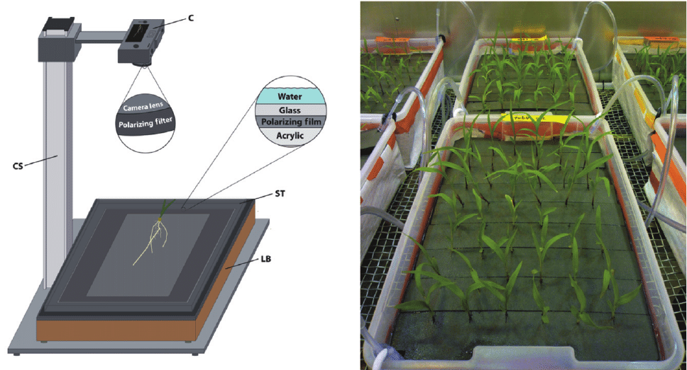

To direct observe and roots imaging, phenotyping platforms with aeroponic or hydroponic growth systems are used. As a result, high throughput phenotyping of roots may be accomplished utilising 2-D and 3-D root analysis, as well as hydroponic culture methods for direct observation and imaging of roots.

1. **2-D Phenotyping of root**

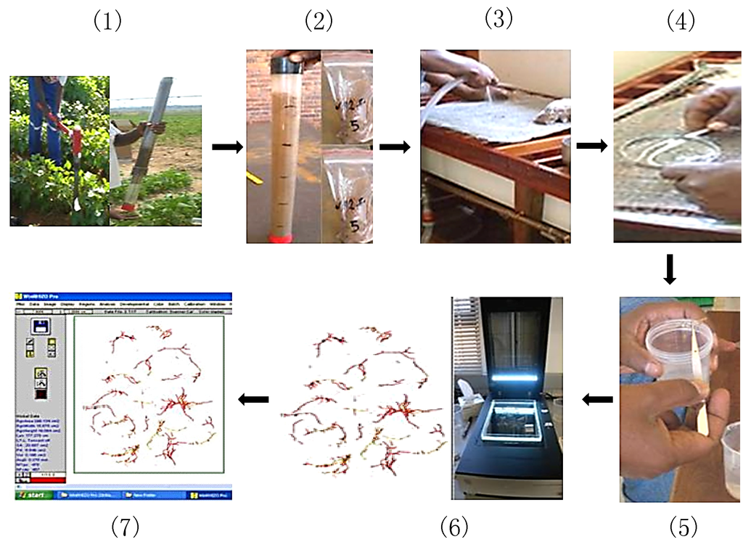

**The steps involved in analysing morphology of roots.**

1: Soil coring;

2: Division of soil sample

3: Cleaning the roots

4: Separating roots from soil

5: Roots preservation (25 % ethanol)

6: Roots Scanning using an Epson Perfection root scanner

7: Using Winrhizo programme, analyse the scanned root images.

1. **3-D PHENOTYPING**

Custom software (Sun Microsystems) created in a programming language Java, was used to analyse the pictures collected by the 3D imaging device. This software reconstructs 3D root system models from different 2D image sequences and quantifies 3D root system features. The RootReader3D software includes a variety of viewing interfaces as well as mouse and keyboard commands to allow batch analysis of the entire root system automatically as well as semiautomated modification, selection, separation, labelling, and measurement of individual roots, root components, and zones of interest within the root system.

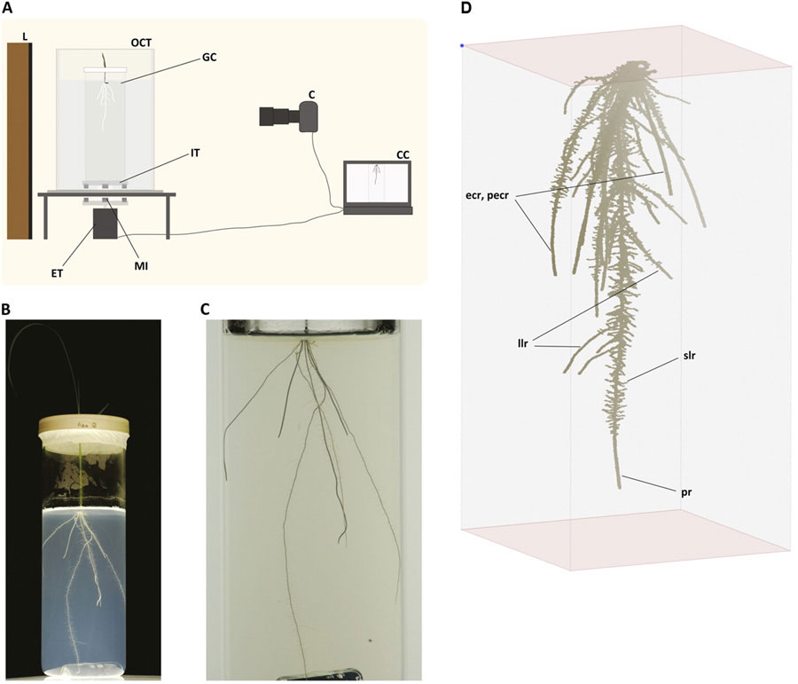

1. **Hydroponic**

Rhizoponics is a new kind of hydroponic rhizotron system that has been applied to Arabidopsis thaliana. The system permits characterising the RSA (Root System Architecture) and development of shoot from seedling to adult stages, i.e., from seed to seed, at the same time. The benefits of hydroponics, such as root environment management and easy access to the roots for measurements or sample, are available with this system. It can be utilised in controlled cabinets since it is entirely moveable and inexpensive.

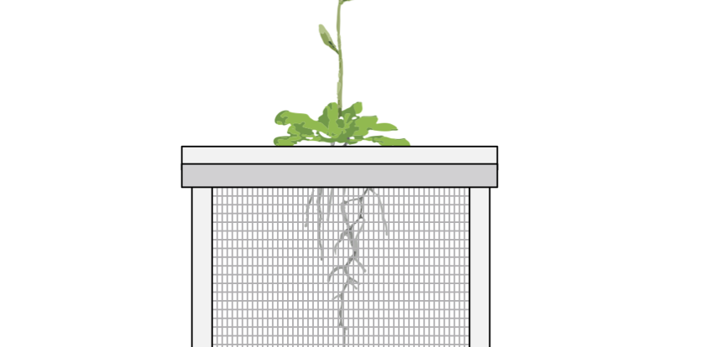

**Various instruments used for acquiring raw data from field plots**

* **Photodiodes**: Sensors with specified bandwidths at a cheap cost.
* **High intensity light emitting sensors:** Providing new possibilities for active sensing. High intensity light sensor: e.g., LED, LEDs have been proposed as a primary light source for indoor agricultural production.
* **Infrared imagery:** Precise infrared thermometers and commercial digital cameras were used.
* **Stereo image analysis**: Characterise plant height, leaf shape, and distribution of leaf angles. As a result, in a stereo image analysis, an area based binocular stereo system was constructed, which is made up of commercially accessible components and enables for three-dimensional reconstruction of canopies in the field.
* **Mini Plant Photosynthesis Meter**

It is based on a novel, improved measurement concept and incorporates the most recent advances in optics and electronics. It much smaller and lighter in weight with high quality and accuracy with stable and reproducible measurement.

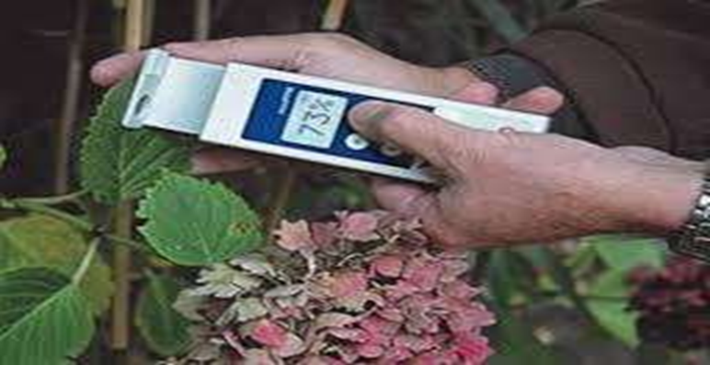

The plant's chlorophyll fluorescence, a very faint optical signal, is used to make the measurement. It is invisible, yet the device detects it and properly measures it. As a result, we have immediate access to information on plant health and growth. The gadget can also detect whether the crop has been treated with herbicides. The miniPPM is an effective instrument for climate control in greenhouse horticulture. The gadget can also indicate whether the crop is stressed owing to too much light or a lack of water. The equipment is used for plant breeding in the United States. Spruce and pine seedlings are subjected to stress (frost, heat) and thereafter measured. Those with the greatest photosynthesis are chosen to be grown further. We can collect measurements in seconds using this tool.

**Integrated management of FBP**

1. **Phenonet: a smart sensor network**

Temperatures of the canopy, soil temperature, soil moisture, incoming solar radiation, and micrometeorology are all monitored. The data is collected and sent through the mobile phone network to a server where it can be seen in real time on the internet. The improvement accuracy and speed of plant breeding can be done integrating the information with each plant’s phenotypic trait which helps in better selection.

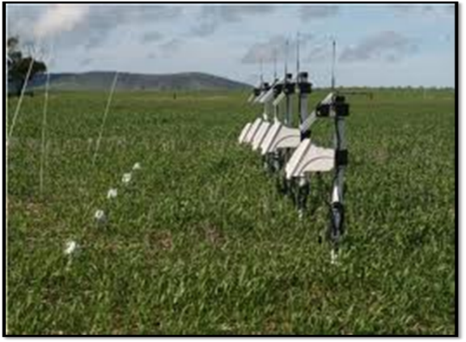

1. **PlantScan**

PlantScan, which combines a variety of digital imaging technologies, will aid in the examination of plant morphology.

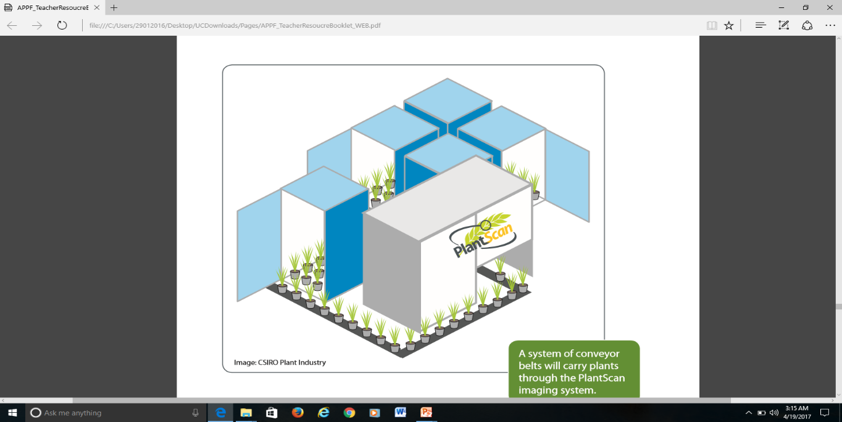

1. **The phenomobile**

The Phenomobile is a vehicle that drives across a field of plants while simultaneously measuring three rows of plants at the same time.

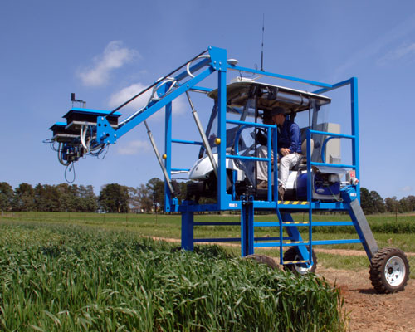

The equipment carried by the Phenomobile includes:

* Digital cameras
* Far infrared thermometers
* A stereo-imaging system of two digital cameras to create 3D reconstructions of plots
* Spectral reflectance sensors

1. **Blimp**

The blimp is equipped with infrared and digital colour cameras that can be operate at a height of 10 to 80 metres above the field. The infrared thermography and colour photos will reveal the relative variances in canopy temperature, which indicate how much water the plants are using.



1. **The Phenotower**

The phenotower gathers infrared thermography and field plots colour images from 16 m above the crop canopy. At a single moment in time, data is utilized to compare leaf greenness, canopy temperature and ground cover amongst genotypes.

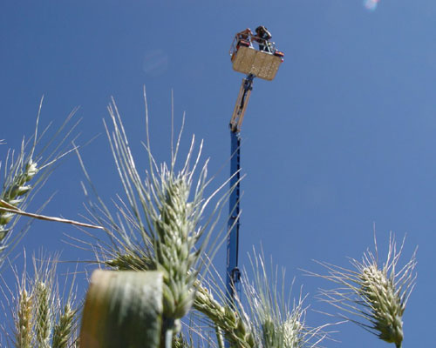

1. **Cropatron**

The Cropatron will provide controlled environments directly to the field, allowing scientists to investigate how climate change affects crops.

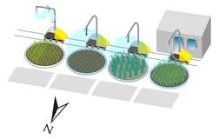

**The various environmental conditions that must be regulated, including:**

* Temperature and humidity
* Light levels and daylength
* Carbon dioxide levels.
* Water availability

1. **Pathatrons**

Pathotrons are dome or canopy-like structures that can hold plant disease-causing agents so that their effects can be studied without damaging the environment.

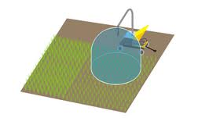

**Table 1.1 List of high-throughput phenotyping software and image analysis**

|  |  |  |
| --- | --- | --- |
| **Roots** | WinRHIZsOTron | Root volume, diameter, area, surface area, and root length, are all measured. |
|  | KineRoot | Root growth and curvature are measured. |
| PlaRoM | Under diurnal or circadian growth cycles, measures root extension and growth features. |
| EZ-Rhizo | 2D RSA analysis |
| GiA Roots | 2D RSA analysis |
| GROWSCREEN-Rhizo | 2D root architecture parameters and shoot biomass assessment |
| RootTrace | Root length and curvature measurements |
| DART | 2D root system architecture analysis |
| Smart Root | For complicated root systems, quantify root growth and architecture. |
| Root Reader3D | 3D root system architecture analysis |
| RootReader2D | 2D root system architecture analysis |
| GROWSCREEN-Root | Predict the root system architecture using a tree model. |
| Growth Explorer | 2D examination of plant root development patterns |
| RooTrak | 3D root architecture of a soil-grown plant |
| **Shoot/leaves** | WinFolia | Broad leaf area, morphology, and disease analysis are all measured. |
|  | TraitMill | Platform for evaluating the impact of transgenes derived from plants on agronomically important traits. |
| PHENOPSIS | Water deficit-related parameters like as leaf number, leaf area, root development, and transpiration rate can all be measured automatically. |
| LeafAnalyser | Variation in leaf morphology is investigated. |
| LAMINA | Measures the size (area) and form of leaves (blade measurements) |
| HYPOTrace | Hypocotyl growth rate and hook angle are measured. |
| HTPheno | Plant height, breadth, and anticipated shoot area are all measured. |
| LEAFPROCESSOR | Different leaf geometries are measured. |
| LEAF-GUI | Analyzes the macroscopic structure of leaves' veins. |
| Canopy Analysis | Extracts forest canopy cover |
| Assess | Analyzes leaf area, disease percentage, root length, lesion count, and ground cover percentage. |
| LemnaTec 3D  Scanalyzer | Color, shape, size, and architecture are all analysed on a high-throughput platform. |
| GROWSCREEN  FLUORO | Growth and chlorophyll-fluorescence analysis on a same platform |
| **Seeds/grain** | WinSEEDLE | Seed and needle volume and surface area are measured. |
|  | SHAPE | The contour form is extracted from a full colour bitmap picture. |
| ImageJ | General image analysis software for area. size, and shape: applied to grain |
| SmartGrain | High-throughput measurement |

**Relevance of High Throughput Phenotyping**

* Identification of stress in plant.
* Rapid and efficient screening for mutants.
* Disease outbreak detection and monitoring in the field.
* Make germplasm screening easier.
* Study of various physiological processes.
* Detection of root attack by pathogens.
* Modelling of biomass production.
* Facilitate selection of superior genotypes from breeding population.
* Permit systematic study of pleotropic effect of the gene.
* Allow large genomic information to specific phenotypes.
* Crop improvement.
* Accurate phenotyping in speed breeding or precision farming.

**Conclusion**

* Current high-throughput field phenotyping methods gives promising results which can be used as a basis to develop improved techniques to achieve reliable time and cost-efficient phenotyping platforms, which could be useful for precision breeding and to assist breeding programmes by monitoring important known traits or identifying novel traits.
* Combining the high-throughput phenotyping technology and large-scale QTL analysis, not only greatly expanded our knowledge of the plant dynamic development process but also provided a new strategy for breeders to optimize plant architecture towards ideotype breeding.
* Image-based phenotyping can be the basis for monitoring the rate of leaf development in field crops like rice, wheat, maize in the early vegetative stages, and simulate it for different growth stages for different genotypes in a controlled environment.

**References**

1. Clark, R. T., MacCurdy, R. B., Jung, J. K., Shaff, J. E., McCouch, S. R., Aneshansley, D. J., & Kochian, L. V. (2011). Three-dimensional root phenotyping with a novel imaging and software platform. *Plant physiology*, **156**(2), 455-465.
2. Dhondt, S., Wuyts, N., & Inzé, D. (2013). Cell to whole-plant phenotyping: the best is yet to come. *Trends in plant science*, **18**(8), 428-439.
3. Fahlgren, N., Gehan, M. A., & Baxter, I. (2015). Lights, camera, action: high-throughput plant phenotyping is ready for a close-up. *Current opinion in plant biology*, *24*, 93-99.
4. Furbank, R. T. and Tester, M. (2011). *Trends in Plant Science.* 16: 635–644.
5. Kumar, J., Pratap, A., & Kumar, S. (Eds.). (2015). *Phenomics in crop plants: trends, options and limitations* (Vol. 1, p. 310). New Delhi: Springer India.
6. Li, L., Zhang, Q., & Huang, D. (2014). A review of imaging techniques for plant phenotyping. *Sensors*, **14**(11), 20078-20111.
7. Mahlein, A. K., Kuska, M. T., Behmann, J., Polder, G., & Walter, A. (2018). Hyperspectral sensors and imaging technologies in phytopathology: state of the art. *Annual review of phytopathology*, 56, 535-558.
8. Mir, R. R., Reynolds, M., Pinto, F., Khan, M. A., & Bhat, M. A. (2019). High-throughput phenotyping for crop improvement in the genomics era. *Plant Science*, **282**, 60-72.
9. Rahaman, M. M., Chen, D., Gillani, Z., Klukas, C., & Chen, M. (2015). Advanced phenotyping and phenotype data analysis for the study of plant growth and development. *Frontiers in plant science*, ***6***, 619.
10. Roshni, P. and Prajwala, K.A. (2019). Phenomics: Approaches and Application in Crop Improvement. *Current Journal of Applied Science and Technology*. **33**(3): 1-10.
11. van Dusschoten, D., Metzner, R., Kochs, J., Postma, J. A., Pflugfelder, D., Bühler, J., ... & Jahnke, S. (2016). Quantitative 3D analysis of plant roots growing in soil using magnetic resonance imaging. *Plant physiology*, **170**(3), 1176-1188.
12. White, J. W., Andrade-Sanchez, P., Gore, M. A., Bronson, K. F., Coffelt, T. A., Conley, M. M., ... & Wang, G. (2012). Field-based phenomics for plant genetics research. *Field Crops Research*, **133**, 101-112.
13. Yang, W., Feng, H., Zhang, X., Zhang, J., Doonan, J. H., Batchelor, W. D., ... & Yan, J. (2020). Crop phenomics and high-throughput phenotyping: past decades, current challenges, and future perspectives. *Molecular Plant*, **13**(2), 187-214.