Next Generation Sequencing : A Paradigm shift in the elimination of TB.

Siddhant Shetty,
Fellow, Department of Infectious Diseases
PD Hinduja Hospital and Medical Research Centre,
Mumbai, India
drsiddhantshetty@gmail.com

Priti Kambli,
PhD student, Department of Microbiology,
PD Hinduja Hospital and Medical Research Centre,
Mumbai, India
priti_kambli88@rediffmail.com

Camilla Rodrigues,
Head, Department of Microbiology,
PD Hinduja Hospital and Medical Research Centre,
Mumbai, India
dr_crodrigues@hindujahospital.com

Keywords: TB; sequencing; molecular diagnostics; drug resistance; whole genome sequencing.

I. TB : PROBLEM STATEMENT

Tuberculosis (TB) is a significant public health problem and is still far from elimination. In 2020, an estimated 10 million people fell ill with tuberculosis (TB) worldwide including 1.1 million children and a total of 1.5 million people died from TB (including 214 000 people with HIV). Worldwide, TB is the 13th leading cause of death and the second leading infectious killer after COVID-19 (above HIV/AIDS). India has the largest number of tuberculosis (TB) patients worldwide, accounting for over 25% of global cases. The COVID-19 pandemic has made matters worse due to neglect and interruption of previously well established programs for the control and elimination of treatable diseases like HIV and TB.

II. DRUG RESISTANCE AND CURRENT CHALLENGES IN THE ELIMINATION OF TB

Even though the infrastructure for detecting cases of TB and starting the patients on treatment, and their monitoring has been put in place through the RTNCP (Revised National Tuberculosis Control Program), our current challenge is of drug resistance. This problem has stemmed through rampant empiric use of TB drugs, under-dosing patients, non-compliance and interruption of treatment. Rapid urbanisation and people living in close proximity has also made the spread of these resistant strains easier in the last few decades.

WHO recommends routine testing for resistance to RIF and INH of all TB patients, while fluoroquinolones (FQs) should be tested for use in RIF- and INH resistant TB [4]. The mechanisms of resistance to INH and FQs are well understood, and molecular tools for their detection are commercially available; however, the genotypic drug-susceptibility testing (DST) assays for these drugs are less sensitive than those for resistance to RIF, and additional phenotypic testing is necessary to detect resistance missed by genotypic DST.

The rates of primary drug resistant tuberculosis (DR-TB) is high especially in urban regions where people live in close contact, like Mumbai, to the extent of 20% in certain areas as per surveillance data. Multi-drug resistance (MDR) and Extensive drug resistance (XDR) in previously treated patients is generally attributed to sequential selection of drug resistant mutants during inadequate therapy, whereas for new patients, which are on the rise off late, are due to transmission of a resistant strain. This is compounded by problems associated with currently available large scale diagnostic techniques. MDR-TB treatment differs from susceptible TB by means of longer treatment duration (6-9 months vs 18-24 months), use of daily injectables, higher cost and worse drug toxicities, many of which are irreversible. Subjecting a patient to drug toxicity without strong evidence of drug susceptibility in todays era is unjustified.

In our cohort, >5 months typically pass from diagnosis to MDR-TB treatment. Most MDR-TB in our cohort is resistant to either quinolones or 2nd-line injectable drugs (Pre-XDR-TB, 40%) or to both those drug classes (XDR-TB, 24%). Sole reliance on rapid molecular tests such as Xpert MTB/RIF (“GeneXpert”) and Xpert MTB/RIF Ultra (“GeneXpert Ultra”) in our setting would provide most MDR-TB patients with potentially inadequate treatment. When patients with incomplete DST receive ineffective treatment, they suffer unnecessary toxicity and may develop additional resistance. In addition to the personal impact, this prolongs community transmission. One study at our centre reported that pre-XDR and XDR-TB patients took longer to convert their sputum cultures than those with MDR-TB, indicating longer transmission in homes, offices, and communities.

TB diagnostics used currently can be broadly classified into phenotypic methods and genotypic methods. The phenotypic method consists of TB MGIT (Mycobacterial growth Inoculation tube) culture and subsequent drug susceptibility testing (DST). Genotypic methods consist of the Xpert MTB/RIF, Xpert MTB/RIF Ultra, Line Probe Assays (LPA) and Sequencing techniques.

III. CURRENT TB DIAGNOSTICS (AND THEIR LIMITATIONS) : PHENOTYPIC

For decades, the world health organization (WHO) standard for determining drug resistance in clinical MTB isolates has been culture based Drug Susceptibility testing (DST). The effective diagnosis and treatment of MDR-TB/XDR-TB relies on universal access to accurate DST on the culture growth. Conventionally, DST for MTB depends on culture and DST in liquid or solid media in biosafety level 2/3 laboratories, which are not available everywhere. Unfortunately, phenotypic results are only obtained after weeks to months of incubation, typically needing 3-6 weeks for a growth which is very crucial time for a TB patient to be started on directed treatment.

Many studies have also shown that drug resistance in M. tuberculosis is absolutely not a homogeneous biological body, it is rather heterogeneous. In precise, different levels of phenotypic drug resistance are found in MTB: low-level, moderate-level and high-level drug resistance and these different levels of phenotypic drug resistance are associated with distinct genetic mechanisms. In general, there is a good correlation between the resistance and genetic mechanism. In conclusion, the term “resistance” with respect to MTB is by no means a simple homogeneous category, but is rather heterogeneous and often composed of low-level, moderate-level and high-level drug resistance. Clinical resistance is determined on breakpoints of therapeutic drug failure during treatment. However, the DST ignores low-level resistance mechanisms that increase the MIC without hitting the breakpoint, therefore indicating a possible evolutionary trend towards high resistance. This apparently has important biological associations. It is possible that low-level drug resistance does not correspond to clinical resistance; contrariwise, in the presence of a high-level resistance, the drug is of little or with no clinical benefit. The clinical implications of moderate levels of resistance are unclear, and need to be included more fully in coming studies taking into account PK/PD (Pharmacokinetic/Pharmacodynamic) parameters. However, changes in our methods for drug susceptibility testing are necessary to address these issues. Most vital are standardised protocols for quantitative DST of both first-line and second-line drugs as a requirement for prospective studies addressing the impact of resistance heterogeneity on treatment results, i.e. by correlating data from quantitative resistance testing with clinical outcome. Additionally, phenotypic testing for drugs such as pyrazinamide often lack precision and reproducibility. Given the inadequate number of drugs available for the management of XDR TB, it is important to take advantage of those that could possibly be used in a MDR-TB to treat a substantial proportion of corresponding cases. TB culture has lower sensitivity compared to the molecular techniques, but has very high specificity since it doesn’t detect inactive bacilli like the molecular techniques.

IV. CURRENT TB DIAGNOSTICS (AND THEIR LIMITATIONS) : GENOTYPIC

There are a number of genotypic tests recommended by WHO for diagnosis of MDR- and XDR-TB, including cartridge-based nucleic acid amplification tests and line probe assays that can be implemented in peripheral TB laboratories. Over the last several years, rapid molecular testing for drug resistance in MTB, predominantly by GeneXpert MTB/RIF, has been a game changer for detection of DR-TB. It has a reported sensitivity of 98% in smear positive cases and 70% in smear negative cases. The Xpert MTB/RIF detects TB bacillus and Rifampicin resistance but does not detect resistance to drugs other than Rifampicin, and certain mutant loci detected on the rpoB gene for Rifampicin resistance have questionable clinical significance. The Xpert MTB/RIF Ultra has better sensitivity (detects 2 loci on the TB bacillus instead of 1 on its predecessor) which comes at the cost of specificity, detecting some false positives, especially in samples from unsterile sites. The earlier concept of isolated rifampicin resistance representing MDR-TB (Multi-drug resistant TB - defined as resistance to both Isoniazid and Rifampicin) is now becoming irrelevant with the recent rise in isolated isoniazid resistance leading to treatment failures in “drug susceptible” TB.

This drawback of the GeneXpert detecting only Rifampicin resistance (thus missing out on certain Isoniazid mono-resistant strains) has been partially overcome by introducing the 1st line LPA which detects Isoniazid resistance along with Rifampicin resistance, however with limited availability.

These resistance interpretations in molecular tests are established on the basis of rapid detection of genetic mutations, however, they are an indirect measure and only consider a limited number of gene targets, leading to incomplete DST results.

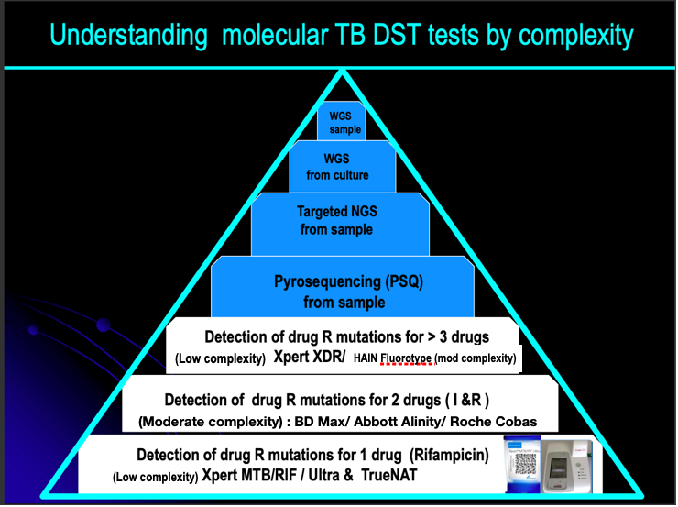

Figure 1 : Hierarchy of molecular drug sensitivity testing in Tuberculosis

V. SEQUENCING FOR THE DIAGNOSIS OF DRUG RESISTANT TB

The molecular tools currently employed in TB diagnosis target only the “hot-spot” regions of a few genes to detect resistance to a restricted number of drugs, and do not always report the exact nucleotide change upon which a prediction of phenotypic resistance is based. All-in-one solutions are needed to guide individualised clinical decisions for the most complicated resistant cases, at least at a reference laboratory level.

Sequencing is the latest molecular technique which has the ability to promptly diagnose DR-TB directly from samples. Sanger DNA sequencing, developed in the 1970s, enabled the first gene and genome sequences but remained limited in its application due to the complexity and high sequencing costs when applied to extended genomic regions. The sequencing output increased tremendously with the advent of pyrosequencing and then of NGS methods in the mid-2000s when costs plummeted.

Sequencing Workflows have the following steps:
- DNA Extraction
- Library Preparation
- Cluster Generation
- Sequencing
- Data Analysis

The absence of integrative vectors and low mutation rate make the M. tuberculosis genome well suited for sequencing. The one technical challenge is the presence of repetitive and hard-to-sequence regions with high GC content. These require sufficient genome-wide sequencing depth to sequence more accurately, which has cost implications.

Pyrosequencing (PSQ) is the currently used sequencing technique in molecular TB diagnosis, currently validated for liquid samples, which can detect the TB bacillus and also resistance to 5 drugs including first line and second line drugs. Its disadvantages are that it is slightly less sensitive than the GeneXpert Ultra and is expensive, and hence not easily available. Currently, there is just one centre doing the test in the entire city of Mumbai. Even though the LPA and PSQ provide rapid, reliable results, they remain limited to the genes associated with XDR-TB defining drugs.

Next Generation Sequencing (NGS) techniques consist of Targeted NGS (tNGS) and Whole Genome Sequencing (WGS). WGS is usually performed on culture isolates, as direct testing of clinical samples by WGS results in sequencing all the genetic material, including vast amounts of human DNA and that of other commensal organisms [4]. In contrast, tNGS can be applied directly to clinical samples. This is similar to current molecular testing in that it amplifies only the genetic targets of interest. Instead of probes to detect variants, however, deep sequencing of the amplified fragments is performed, providing nucleotide-level detail as well as high-resolution detection of minor variants in mixed populations [4].

Unlike Whole Genome Sequencing (WGS) that is currently best performed on TB isolates, Targeted, amplicon-based deep sequencing has the ability to promptly diagnose DR-TB directly from uncultured sputum samples. tNGS provides rapid sequence information for a greater number of loci than existing molecular tests, and the bioinformatics can be performed on a simple automated web based pipeline. One of the tNGS platforms is Deeplex Myc-TB (Genoscreen, Lille, France) that detects targets in 18 drug resistance associated genes in MTB, namely rpoB (Rifampicin); katG, fabG1, ahpC, inhA (Isoniazid/Ethionamide); pncA (Pyrazinamide); embB (Ethambutol); gidB, rpsL, rrs, tlyA, eis (Aminoglycosides); gyrA, gyrB (Fluoroquinolones); ethA (Ethionamide); rplC, rrl (Linezolid); rv0678 (Bedaquiline/Clofazimine). It also enables simultaneous species identification and detection of hetero-resistance. Newer platforms such as Oxford Nanopore Technologies (ONT) and Bacteriochek TB (ABL) offer 16 gene and 13 gene targets respectively. With a turnaround time of 2-3 days, tNGS solutions currently seems to be one of the most attractive, affordable and accessible methodologies for DST.

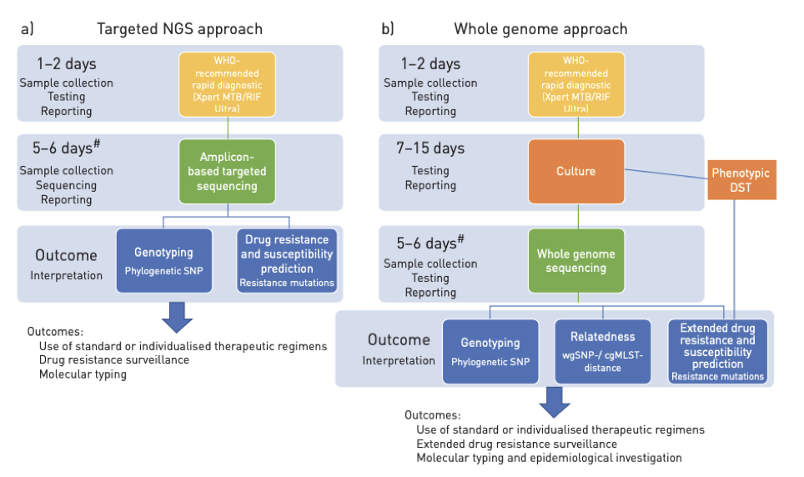

Figure 2 : targeted Next Generation Sequencing vs Whole Genome Sequencing [6]

Whole Genome sequencing (WGS) provides complete genome information but is currently performed primarily on grown Mycobacterium tuberculosis (MTB) isolates. WGS on sputum is still an evolving technology that needs relatively high quantity and good quality DNA to generate adequate depth. Primary culture can take weeks to provide viable results, thus delaying DST informed treatment decisions. While WGS performed on uncultured sputum samples is an evolving technology, it remains expensive and requires complicated bioinformatics infrastructure, limiting its widespread adoption to high-income countries. Whole genome sequencing (WGS) offers unprecedented resolution for genotyping, outbreak investigation and determination of known sequence variants involved in antimicrobial resistance, which deep sequencing of selected genomic regions (targeted NGS) can further illuminate. WGS-based approaches have been proposed for surveillance of bacterial pathogens included in the “priority list” by the World Health Organization (WHO). At present, proof-of-principle and validation studies have been conducted for WGS from culture samples of Escherichia coli, Klebsiella pneumoniae, Staphylococcus aureus, Streptococcus pneumoniae, Pseudomonas aeruginosa, Salmonella spp., Acinetobacter spp., Neisseria gonorrhoeae and Clostridium difficile included in this list, in addition to the globally established priority group Mycobacterium spp. (including Mycobacterium tuberculosis).

VI. NGS : NEED OF THE HOUR

Molecular diagnostics such as Line Probe Assay (LPA) and GeneXpert that are based on rapid detection of genomic mutations associated with resistance has shown to be alternative to phenotypic DST. The reduction in time to diagnosis of MDR-TB using Xpert MTB/RIF has been seen, but such tests do not allow clinicians to select optimal drug treatment (and have not been associated with mortality reductions). If therapy were determined by Xpert MTB/RIF alone, rifampin-resistant patients in Mumbai would receive drugs to which 67-96% of patients are resistant, leaving an important role for NGS. Similarly, other current rapid tests (line probe assays and pyrosequencing) evaluate genes associated with isoniazid, quinolone, and injectable drugs, but do not fully evaluate treatment options for such patients. Ideally, such rapid tests should be screening tools to rule out resistance, with positive results triggering NGS to evaluate alternative drug options.

Next-generation sequencing (NGS) has great potential as a method for rapidly diagnosing drug resistant tuberculosis (DR-TB) in diverse clinical reference laboratory settings worldwide. The NGS approach overcomes many of the significant challenges associated with conventional phenotypic testing as well as the limitations of other less comprehensive molecular tests by providing rapid, detailed sequence information for multiple gene regions or whole genomes of interest. However, the acceptance of these technologies for DR-TB diagnosis has been delayed by concerns regarding costs, addition into existing laboratory workflows, technical training and skill requirements for application of the technology, and the need for expert guidance regarding the management and clinical interpretation of sequencing data.

Targeted New Generation Sequencing (tNGS) provides rapid sequence information for a greater number of loci than existing molecular tests, and can be performed using cloud-based analysis platforms. This method has been found to be highly accurate with an easy to perform workflow and a simplified analytic pipeline that does not require significant bioinformatics expertise at the local lab, and can be adapted to include new loci as knowledge evolves regarding the specific mutations associated with resistance to new drugs. Although rapid molecular assays like Xpert MTB/RIF and Line Probe Assays exist, these assays screen only a small number of genomic loci commonly associated with drug resistance, leaving many potentially clinically relevant drug resistance-associated loci unevaluated. Whole genome sequencing (WGS) offers the opportunity to screen not only the loci included in rapid molecular tests, but also other known resistance-associated loci not screened by them, thereby enabling identification of new drug resistance-associated mutations that are not explained by currently available diagnostics at significantly shorter turnaround time.

A. Whole Genome Sequencing (WGS) for Mycobacteria
WGS of MTB has two main corresponding uses in clinical microbiology and public health:
- To predict drug-resistant phenotype.
- The determination of genetic similarity which can categorise transmission chains in potential outbreak. Both of these can have direct advantage to patient.

In the TB diagnostic workflow, the advantages of WGS are clear when compared to standard DST; results can be interpreted several weeks earlier and in near future, this will only become faster and cheaper. Till WGS can be routinely done on sputum, compared to current molecular tests, results will be delayed by 1-2 weeks. The immensely increased progress in WGS results means a more accurate and complete picture of resistance prediction than is currently possible.

B. WGS in Drug Resistance
WGS is a great tool for differentiating between re-infection and persistent infection in isolates taken at different times from a single patient. WGS was used to demonstrate that reinfection and persistent infection in Multi-Drug Resistant MDR-TB based on the number of Single Nucleotide Polymorphisms (SNPs), i.e. 2 SNPs within 8 months for persistent infection vs >60 SNPs within 2 years for re-infection.

C. Direct DNA from Sputum and WGS
All the above studies describing the WGS and their clinical applications utilise the DNA from the cultured isolates; however, a further 1-2 weeks could be saved if the culture step is eliminated. WGS applied direct to sputum (Fig. 3) is a difficult problem as it depends on the load of organisms and the presence of contaminating human and non-mycobacterial DNA. There are 2 recent studies that have attempted to address this problem, where sputum was being tried as the direct source for WGS.

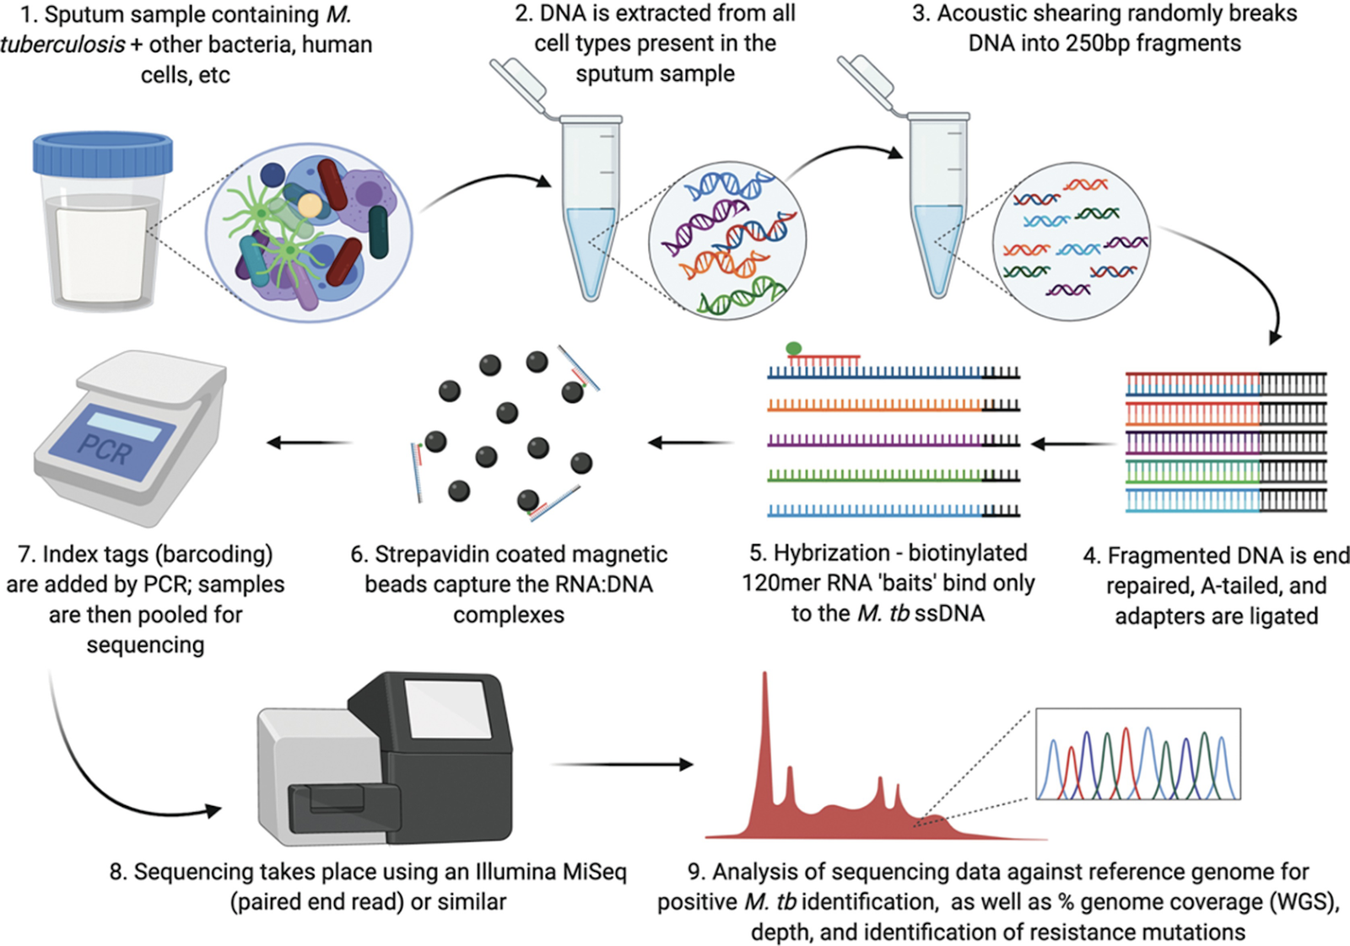

Figure 3 : Whole Genome Sequencing from sputum sample [7]

The ongoing need for culturing poses a challenge to the full implementation of NGS as an effective alternative to conventional methods (e.g. Xpert MTB/RIF), particularly in resource-limited settings. Efforts are thus being made to develop protocols for WGS directly from clinical specimens. Such procedures include differential lysis steps, TB enrichment and automated DNA purification. These methods remain expensive at present and are challenged by the low starting material of M. tuberculosis and contamination with other genetic material (human and oral flora). Targeted approaches taking advantage of the selective amplification of phylogenetic and drug-resistance-related regions may represent a suitable alternative for direct sequencing.

To fully implement NGS into routine workflows, methods need to enter validation and certification programmes. Performance, accuracy and reproducibility, quality control steps, quality thresholds (e.g. on the depth/breadth of genome coverage), use of standards and development of standard operating procedures, impact on turnaround times and clinical management must all be assessed or evaluated. Microbiology laboratories introducing these technologies will undergo external proficiency testing programmes that are already implemented in TB for molecular testing. Simple but comprehensive clinical reports are crucial to help clinicians arrive at the best decisions in the management of TB cases. Although there is a huge amount of data generated by NGS, our knowledge as to all its meaning remains incomplete, and development of how best to report on this data in the meantime remains ongoing. A report should at least give information on sequencing quality and identification of mutations to infer genotyping and drug resistance profiles, and provide details on the exact nucleotide changes and standardised prediction of resistance levels (ideally based on a literature review of minimum inhibitory concentration data).
WGS and targeted NGS approaches promise to become the future standard for DST and epidemiological investigation in TB, and for other high-priority bacterial pathogens. Additional work is needed to address the feasibility of WGS from clinical specimens, to standardise and automate the laboratory procedures and post-sequencing analyses, and to implement the NGS platforms in low-resource, high-burden settings.

VII. NEXT GENERATION SEQUENCING : REAL WORLD EXPERIENCE

A study [2] conducted at Hinduja Hospital, Mumbai in 2019-2020 compared the tNGS directly from sputum samples to the results with GeneXpert MTB/RIF, LPA, PSQ, and phenotypic DST. tNGS directly from uncultured sputum samples provided rapid results that achieved excellent agreement with phenotypic testing for isoniazid and rifampin, and second-line injectable drugs, with very good agreement with phenotypic testing for fluoroquinolones, resulting in an overall sensitivity of 83.5%, which was similar to that of line probe assays. This technique predicted the same drug resistance profiles for all drugs tested with overall sensitivity and specificity of 83.5% and 100%, respectively compared to phenotypic DST using very little quantity of sputum sample. It identified MTB and predicted the drug resistance successfully for 97.5% of smear and Xpert MTB/RIF positive samples tested. In addition, tNGS directly from sputum samples provided lineage and predictions of bedaquiline, clofazimine, linezolid, and pyrazinamide resistance, offering benefit beyond that of existing molecular tests and in line with updated MDR-TB treatment guidelines. In addition, due to its high sequencing depth, tNGS was able to identify resistance missed by other rapid molecular tests. No resistance associated mutations were identified by tNGS on cultured isolates that were not identified by tNGS from uncultured sputum samples, so both methods provided the same overall results for all samples.

Another study [1] from India has used WGS on enhanced sputum samples and have concluded that this technique predicted drug resistance with an overall sensitivity and specificity of 90.9% and 95.0%, respectively compared to phenotypic DST using very little sputum sample. A few studies [3,5,6] conducted in Europe have reported high efficacy of the tNGS in detecting TB and drug resistance associated genes.

In 2011, Gardy et al [8] was the first study to utilise WGS as they described the transmission dynamics of an outbreak among 32 MTB isolates obtained from a three year period in British Columbia, Canada. Contact tracing had suggested a single outbreak but WGS was able to give a higher resolution by showing two distinct lineages. They were able to show presence of super-spreaders (individuals likely to spread the disease to others) within the outbreak. Walker et al [9] followed up by showing microevolution of strains within community outbreaks that could not be detailed by the conventional genotyping tools. They were able to infer direction of transmission through setting an upper threshold of 5 SNPs, identified super-spreaders and estimated mutation rate at 0.5 SNPs/genome/year. Other recent studies have demonstrated the advantage of WGS in investigating community outbreaks over the conventional methods and this is important for optimising local or international control measures.

WGS at the frontline has the potential to minimise turn-around time, empower hospital-based microbiology, and have a positive impact on local activities like infection control initiatives. Because of the large amount of data provided by WGS, there is a significant progress in our understanding of the complexity and multifactorial processes involved in antibiotic resistance. Furthermore, knowledge about possible aspects that contribute to drug resistance were expanded through identification of mutations within genes or intergenic regions that are under convergent evolution which could confer selective advantage in presence of drugs. Another recent study by Coll et al [10] applied genome-wide association study (GWAS) approach to analyse 6,465 MTB clinical isolates from more than 30 countries. They established new epistasis relationships among resistance associated genes and identified additional resistance-associated genes, novel mutations to drugs such as cycloserine, para-aminoslicyclic acid and ethionamide, efflux pumps. These provide new targets for molecular diagnostics and development of therapeutics against resistant MTB strains. WGS has also provided a system for differentiating clinical isolates into major lineages and sub-lineages by using a nomenclature framework which paves way for further investigations into lineage or sub-lineage specific patho-biological characteristics. Understanding of lineage is of importance to tuberculosis control as it has been shown that strain type may play a role in disease outcome, clinical presentation, transmission, variation in vaccine efficacy and emergence of drug resistance.

Laboratories have thus seen an accumulation of methods from which they must choose, and a given specimen or isolate may be tested across a variety of methods. A natural consequence is that discrepancies between methods may be encountered. Such discrepancies may be of little consequence in certain scenarios, such as Streptomycin resistance in settings that use primarily Isoniazid, Rifampicin, Pyrazinamide, and Ethambutol, but they may have critical implications for treating MDR-TB in areas where the arsenal of drugs is limited in number and potency. Discordance is becoming a troublesome aspect for microbiologists and clinicians and will likely increase in frequency as new methodologies are adopted, yet its extent has not received enough attention. Discordances between molecular and phenotypic tests invariably occur. Root causes range from pre, post and analytic errors to co-existence of non-tuberculous mycobacteria, silent mutations, mutations outside the resistance-determining region, non-canonical mutations conferring increased MICs below the Critical Concentration (CC) in some phenotypic DSTs, and hetero-resistance (either due to mixed infections with two or more MTB strains or to the endogenous development of two populations following inadequate treatment) . Some of the discordances are due to borderline resistance or resistance due to the different CCs used for DST setting. MIC values help resolve such disagreements. The documented imperfect agreement between genotypic and phenotypic DST results also makes the choice of a tiebreaker limited and interpretation of the clinical implication of the reported discordance more challenging.

VIII. NGS : THE FUTURE??

Therefore, we describe a culture-free WGS method for identification of MTB and prediction of drug resistance. Rapid molecular testing for drug resistance MTB is predominantly done by Xpert MTB/RIF, which has proved to be revolutionary for the diagnosis of drug resistance TB. However, despite its speed and ease of use, this assay only detects resistance to rifampicin, which is not sufficient to determine appropriate treatment in regions with high circulating drug resistance like Mumbai. LPA also provide rapid, reliable results, but remain limited to the genes associated with XDR-TB-defining drugs.

WGS technique predicted the same drug resistance profiles for all drugs tested with good overall sensitivity and specificity, compared to phenotypic DST using very little pus DNA. WGS has been compared directly from uncultured pus samples to each of these methods and found to have good sensitivity and specificity for the XDR-TB-defining drugs, when the technology was assessed directly from pus samples compared to phenotype. In addition, WGS directly from pus samples provided lineage and predictions of linezolid, and pyrazinamide resistance, offering benefit beyond that of existing molecular tests and in line with updated MDR-TB treatment guidelines. Sequencing uncultured pus samples also reduces the turnaround time from 4 to 6 weeks for phenotypic testing to 3 days. In addition, this method is highly accurate with an easy to perform workflow and a simplified analytic pipeline that does not require significant bioinformatics expertise at the local lab, and can be adapted to include new loci as knowledge evolves regarding the specific mutations associated with resistance to new drugs. In addition, due to its high sequencing depth, WGS was able to identify resistance missed by other rapid molecular tests. Conventional molecular tests may miss resistance detection due to presence of heterogeneity. Discordance between WGS and other molecular tests are also observed.

The treatment for DR-TB is now slowly transitioning away from injectable drugs and the use of linezolid and newer oral drugs like bedaquiline and delamanid in the current regimens will only increase the relevance go tNGS and could potentially decrease the need for phenotypic testing of all isolates for those drugs.

A major limitation to the development and diagnostic utility of sequence-based technologies and of next-generation molecular diagnostics for comprehensive genotypic DST is the lack of a standardised, comprehensive catalogue of mutations and their association with drug resistance for use by test developers and end users [4]. Continuing technical uncertainty about the number, identity and clinical interpretation of genomic resistance-determining regions has limited broad uptake and the clinical relevance of these tests, especially for new and repurposed drugs. A high-quality, comprehensive catalogue of confidence-graded MTBC genetic markers of phenotypic resistance is necessary to distinguish clinically significant resistant variants from those that are not associated with resistance or those for which there are already sufficient data.

The World Health Organisation (WHO) is currently cataloguing the data of mutations associated with drug resistance from all over the world. It is thus creating an index which will connote the level of confidence of the mutation in causing a particular drug resistance, thereby dictating if a particular drug can be used to treat a particular patient or not. They are currently classifying the mutations in the catalogue into 5 categories.
Group 1: Associated with resistance
Group 2: Associated with resistance – interim
Group 3: Uncertain significance
Group 4: Not associated with resistance – Interim
Group 5: Not associated with resistance

Thus, when we have large scale data available in the future, a sample will be run on the system after enrichment, its mutations assessed and compared to the database available and its interpretation as to the drugs which can be used, and not, will be provided by the software with a turnaround time of 3 days, and probably lesser in the future. Hence we are heading towards a world of individualised TB treatment compared to the currently used algorithm based mass scale treatment protocols. The drawbacks will be scaling the availability and cost of this technology.

Future WGS tools may need to incorporate additional loci such as atpE, pepQ, and the multiple loci associated with delamanid and pretomanid resistance before it can truly replace phenotypic testing. In summary, our results suggest that WGS directly from uncultured pus samples is a valuable tool with the potential to replace phenotypic DST for drug resistant tuberculosis for rapid resistance and DST in TB diagnostics. WGS directly from uncultured pus samples provided rapid results that achieved excellent agreement with phenotypic testing for isoniazid and rifampicin, and second-line injectable drugs, with very good agreement with phenotypic testing for fluoroquinolones. The faster turnaround, adaptability to newly identified resistance-associated loci, and ability to detect mixed infection are important advantages compared to the conventional molecular assays.

WGS currently takes weeks to culture sufficient MTB DNA. To shorten time to results, WGS needs to move beyond this limitation. WGS evaluates all DNA in a sample, so 75% of sputum sequencing reads align to human DNA. Recent attempts to overcome this limitation have tried shotgun sequencing, lysis of human DNA, hybridized precipitation using RNA baits, amplicon sequencing and single molecule overlapping reads. Amplicon sequencing is promising due to speed, reliably, and high depth, but it can only evaluate so many targets at a time. Attempts at lysis of human DNA and enrichment of MTB DNA have also been promising, but are not yet consistent enough for DST. Studies of WGS directly from sputum have not been applied yet to large numbers of samples, to smear negative samples, in clinical cohorts with outcome data, or at sufficient depths to evaluate 2nd line drug resistance in the majority of samples tested.

IX. CONCLUDING NOTE:

For accurate diagnosis and treatment of TB, detection of MTB and testing for drug resistance is of paramount importance. Cheap test cost is a very important factor such that available treatment reaches the common people at the earliest. Therefore, it is essential to advance alternative cheaper technology for the detection of MTB to ensure that low and middle income countries (LMICs) also benefit from them.

WGS and tNGS directly from uncultured pus samples is a feasible and timely alternative to phenotypic DST and seemed feasible and timely alternative to phenotypic DST and seemed feasible in a high-incidence setting, with a potential to completely replace the phenotypic DST in the future. The comprehensive resistance targets coverage and its capability to detect mixed infection are important advantages compared to conventional molecular assays. WGS directly from pus samples will be useful for moving NGS into clinical setting from research setting. The comprehensive resistance targets coverage, and its capability to detect mixed infection are important advantages compared to conventional molecular assays. The faster turnaround, adaptability to newly identified resistance-associated loci, and ability to detect mixed infection are important advantages compared to the conventional molecular assays. Transforming this new technology from a research setting to a clinical setting in a high TB burden country like ours is a challenge for the next few decades to come.

References :

[1] Lakshmi Soundararajan, Priti Kambli, Sushri Priyadarshini, Biswajit Let, Sakthivel Murugan, Chitra Iravatham, Jeffrey A. Tornheim, Camilla Rodrigues, Ravi Gupta, V.L. Ramprasad, Whole genome enrichment approach for rapid detection of Mycobacterium tuberculosis and drug resistance-associated mutations from direct sputum sequencing, Tuberculosis, Volume 121, 2020, 101915, ISSN 1472-9792, https://doi.org/10.1016j.tube.2020.101915.

[2] Kambli P, Ajbani K, Kazi M, Sadani M, Naik S, Shetty A, Tornheim JA, Singh H, Rodrigues C. Targeted next generation sequencing directly from sputum for comprehensive genetic information on drug resistant Mycobacterium tuberculosis. Tuberculosis (Edinb). 2021 Mar;127:102051. doi: 10.1016/j.tube.2021.102051. Epub 2021 Jan 8. PMID: 33450448.

[3] Jouet A, Gaudin C, Badalato N, Allix-Béguec C, Duthoy S, Ferré A, Diels M, Laurent Y, Contreras S, Feuerriegel S, Niemann S, André E, Kaswa MK, Tagliani E, Cabibbe A, Mathys V, Cirillo D, de Jong BC, Rigouts L, Supply P. Deep amplicon sequencing for culture-free prediction of susceptibility or resistance to 13 anti-tuberculous drugs. Eur Respir J. 2021 Mar 18;57(3):2002338. doi: 10.1183/13993003.02338-2020. PMID: 32943401; PMCID: PMC8174722.

[4] Catalogue of mutations in Mycobacterium tuberculosis complex and their association with drug resistance. Geneva: World Health Organization; 2021. Licence: CC BY-NC-SA 3.0 IGO.

[5] Feuerriegel S, Kohl TA, Utpatel C, Andres S, Maurer FP, Heyckendorf J, Jouet A, Badalato N, Foray L, Fouad Kamara R, Conteh OS, Supply P, Niemann S. Rapid genomic first- and second-line drug resistance prediction from clinical Mycobacterium tuberculosis specimens using Deeplex-MycTB. Eur Respir J. 2021 Jan 5;57(1):2001796. doi: 10.1183/13993003.01796-2020. PMID: 32764113.

[6] Whole Genome Sequencing of Mycobacterium tuberculosis
Andrea M. Cabibbe, Timothy M. Walker, Stefan Niemann, Daniela M. Cirillo
European Respiratory Journal Jan 2018, 1801163; DOI: 10.1183/13993003.01163-2018

[7] Brown, A.C. (2021). Whole-Genome Sequencing of Mycobacterium tuberculosis Directly from Sputum Samples. In: Parish, T., Kumar, A. (eds) Mycobacteria Protocols. Methods in Molecular Biology, vol 2314. Humana, New York, NY. https://doi.org/10.1007/978-1-0716-1460-0_20

[8] Gardy, J. L. et al. Whole-genome sequencing and social-network analysis of a tuberculosis outbreak. N. Engl. J. Med. 364, 730–739 (2011).

[9] Walker TM, Kohl TA, Omar SV, Hedge J, Del Ojo Elias C, Bradley P, Iqbal Z, Feuerriegel S, Niehaus KE, Wilson DJ, Clifton DA, Kapatai G, Ip CLC, Bowden R, Drobniewski FA, Allix-Béguec C, Gaudin C, Parkhill J, Diel R, Supply P, Crook DW, Smith EG, Walker AS, Ismail N, Niemann S, Peto TEA; Modernizing Medical Microbiology (MMM) Informatics Group. Whole-genome sequencing for prediction of Mycobacterium tuberculosis drug susceptibility and resistance: a retrospective cohort study. Lancet Infect Dis. 2015 Oct;15(10):1193-1202. doi: 10.1016/S1473-3099(15)00062-6. Epub 2015 Jun 23. Erratum in: Lancet Infect Dis. 2017 Nov 21;: PMID: 26116186; PMCID: PMC4579482.

[10] Coll F, Phelan J, Hill-Cawthorne GA, Nair MB, Mallard K, Ali S, Abdallah AM, Alghamdi S, Alsomali M, Ahmed AO, Portelli S, Oppong Y, Alves A, Bessa TB, Campino S, Caws M, Chatterjee A, Crampin AC, Dheda K, Furnham N, Glynn JR, Grandjean L, Minh Ha D, Hasan R, Hasan Z, Hibberd ML, Joloba M, Jones-López EC, Matsumoto T, Miranda A, Moore DJ, Mocillo N, Panaiotov S, Parkhill J, Penha C, Perdigão J, Portugal I, Rchiad Z, Robledo J, Sheen P, Shesha NT, Sirgel FA, Sola C, Oliveira Sousa E, Streicher EM, Helden PV, Viveiros M, Warren RM, McNerney R, Pain A, Clark TG. Genome-wide analysis of multi- and extensively drug-resistant Mycobacterium tuberculosis. Nat Genet. 2018 Feb;50(2):307-316. doi: 10.1038/s41588-017-0029-0. Epub 2018 Jan 22. Erratum in: Nat Genet. 2018 Apr 19;: PMID: 29358649.

