Advanced Trends in Biotechnology
Mrs. Poonam Nilesh Chougule
Assistant Professor, Department of Pharmacognosy
Ashokrao Mane College of Pharmacy, Peth-Vadgaon. 416112
Kolhapur, Maharashtra, India.
pnchougule1008@gmail.com
Ms. Aishwarya Prakash Bhosale
Assistant Professor, Department of Pharmacognosy
Ashokrao Mane College of Pharmacy, Peth-Vadgaon. 416112
Kolhapur, Maharashtra, India.
aishubhosale1010@gmail.com

I. BIOPROCESSING

Fermentation is the process of utilizing metabolic and enzymatic activities of micro-organisms to transform organic compounds. Micro-organisms play central role in this biochemical process. The diverse array of metabolic networks, very high metabolic turnover due to high surface to volume ratio, and adaptability of micro-organisms to different metabolic environment makes them useful in comparison with plant and animal cells. Industrially important micro-organisms include bacteria, yeast, moulds and actinomycetes.
Rate and yield of product formation is influenced by rate of bio-mass formation, oxygen supply, pH, temperature, nutrient and substrate availability, accumulation of inhibitory intermediates etc.
A. Bioprocessing Techniques:
In-situ recovery of fermentation product:
In most of the fermentation process, accumulation of product in fermenter inhibits further formation of the product called product-inhibited fermentations. This inhibition can be prevented or reduced by continuous removal of fermentation product called in-situ recovery of fermentation product. Various processes of in-situ recovery of fermentation product are,
a. Vacuum fermentation:
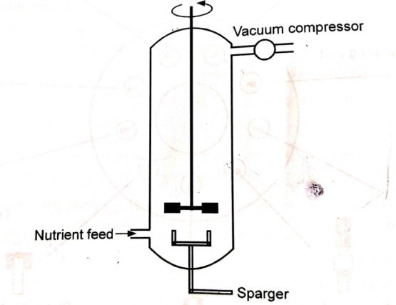

Fig. 1. Vacuum fermenter
Employed for volatile fermentation product, for example ethanol from concentrated sugar feed. This is done by maintaining fermenter under vacuum, which enables removal of volatile fermentation product as they boil off at normal temperature of the Fermentation process.
b. Flash fermentation:
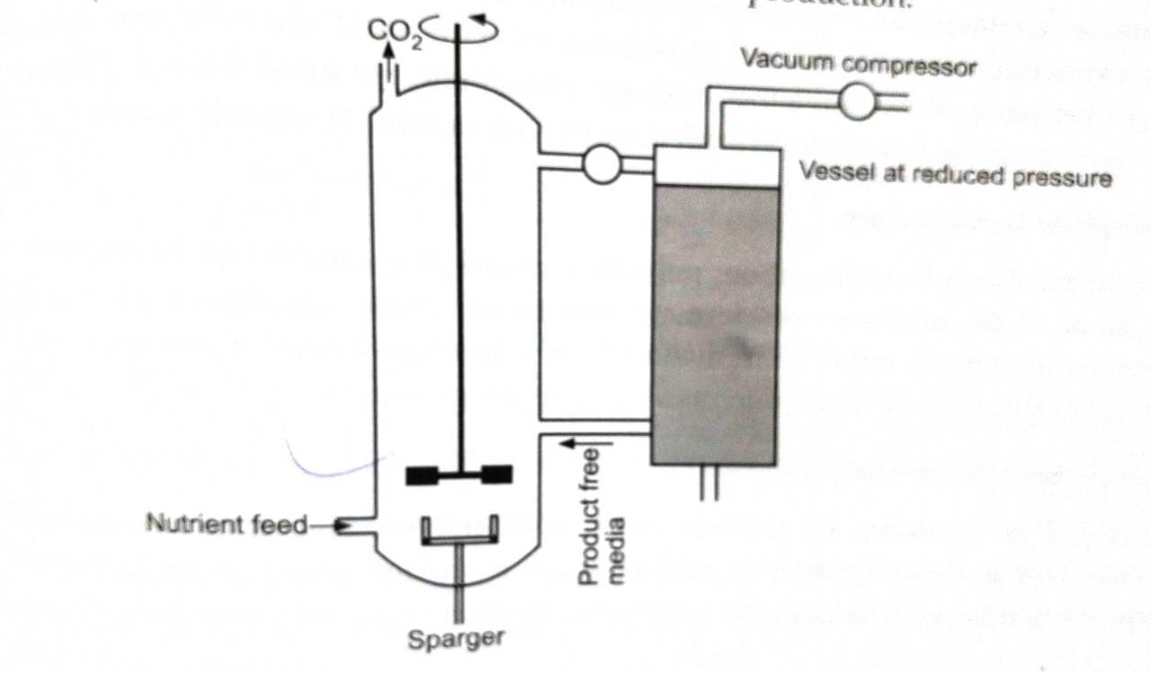
Fig. 2 Flash fermenter

Fermentation is operated at atmospheric pressure, while broth is to be taken into a vacuum chamber, where volatile product boils off continuously. Zymomonas mobilis or Candida acidothermophiluma are employed in ethanol production.
c. Extractive fermenter:
Employed in fermentative production of butyric acid, valeric acid and caproic acid. Such products are separated from fermenter-contents by contacting broth with suitable organic solvent, insoluble in broth, while solublizing the product. This dissolved product is subsequently recovered by distillation or by back extraction into some solution. Fermenter contents can be contacted with organic solvent within fermenter buffer separate extraction vessel. Examples of organic solvents used are n-hexane, n-decane, iso-octane, kerosene, di-iso-amylether, tri-butyl phosphate, iso-amyl alcohol, toluene etc.
In some cases aqueous two phase system is employed instead of organic solvents.
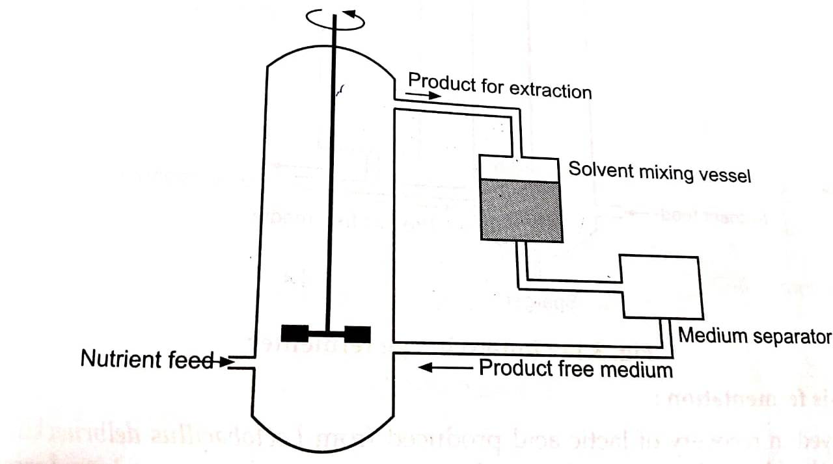
Fig. 3 Extractive fermenter

d. Adsorption fermentation:
Adsorbents like activated carbon, polymeric resins and others can be employed to remove some of the product from fermentation broth. These adsorbents are contacted with fermentation broth either in fermenter or in a separate vessel. Their application is limited because of toxicity to the microbes carrying fermentation.

e. Ion-exchange fermentation:
Employed in recovery of salicylic acid from naphthalene and also of certain antibiotics. This is done by directly adding anion exchange resins or by adding them after wrapping into cellophane paper to prevent direct contact with microbial cells.
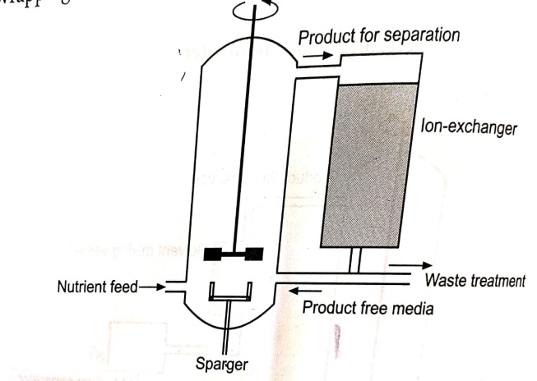

Fig. 4: Ion-exchange fermenter

f. Dialysis fermentation:
Employed in recovery of lactic acid produced from Lactobacillus delbrueckii. Dialysis membrane (a selectively permeable membrane) separates fermenter into fermentation zone and medium reservoir. Medium diffuses into fermentation zone and product formed diffuses into medium reservoir, leading into no accumulation of the ermentation product into fermentation zone.
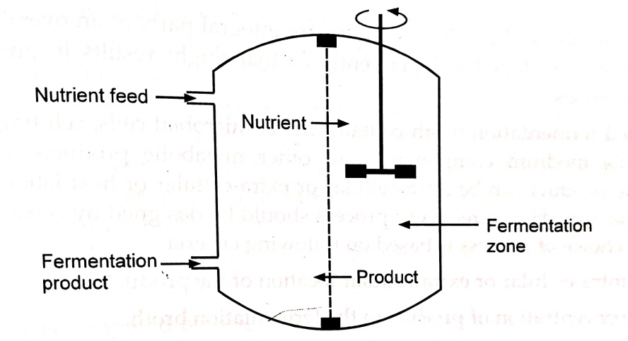
Fig. 5: Dialysis fermenter

II. BIOSEPARATION

It is defined as process steps used to purify the products from bioreactors (such as fermentors): downstream processing steps which may include extraction, precipitation, electrophoresis, and chromatography.
A. Technique: DOWN STREAM PROCESSING
Harvesting, recovery, purification and final processing of fermentation product to make it suitable for its intended use after the completion of fermentation are called down stream processing (DSP).
The success of fermentation is mainly governed by these recovery processes which may involve as low as 15% and as high as 70% of the production cost. It usually involves three major stages,
1. Separation of the cells and cell debris from fermentation broth.
2. Isolation of rather impure product from the fluid.
3. Purification of the product.

Fermentation broth

Removal of solids Cell disruption

Primary isolation of product

Concentration

Purification

Final processing of purified product

Fig. 6: Stages of product recovery from harvested fermentation broth
As fermentation and product recovery as integral parts of an overall process, more of them can be developed independently as that might results in problems and un necessary expenses.
Harvested fermentation broth contains intact microbial cells, cell fragments, soluble and insoluble medium components and other metabolic products, along with the product. The product can be intra-cellular or extra-cellular or heat-labile or sensitive to some other factors. Hence recovery process should be designed by considering all the factors. The choice of process is based on following criteria,
1. The intra-cellular or extra-cellular location of the product.
2 The concentration of product in the fermentation broth.
3. The physico-chemical properties of the product. 4. The intended use of the product.
5. The minimal acceptable standards of purity. 6. The magnitude of bio-hazards of the product or broth.
7. The impurities in the fermenter broth.
8. The market price of product.
The cells and cell fragments after cell disruption in intra-cellular product and without cell disruption in extra-cellular product, and larger particles are removed in the initial stage usually by centrifugation and or filtration. The remaining broth is then fractionated or extracted into major fractions using ultrafiltration, reverse osmosis, adsorption or ion-exchange or gel-filtration, affinity chromatography, liquid-liquid two-phase aqueous extraction or precipitation. The impure product thus obtained is then purified by fractional precipitation, chromatographical techniques and crystallization. This can be then processed to get finished product. This all involves different physical, chemical and biological techniques.
Removal of microbial cells and other larger particles involves initial foam separation and solid-liquid separation is used for separation of whole cells from culture broth, removal of cell debris, protein precipitate, inclusion bodies etc. The unit operations commonly employed are centrifugation and filtration. Because of the small size of microbial cells, yeasts and bacteria are usually homogenously suspended in the fermentation broth, some bacteria form slime layers, lead to separation problems. Filamentous fungi, forming networked structure are difficult to be de-watered.
Filtration retains larger particles (to that of pore size of filter) and allows passage of liquid through the filter. Particles are retained as a cake in cake filtration. Flow through filter medium is dependent on area of filter, flow resistance by filter and flow resistance by cake formed. Examples of filter media to be used are sintered, metal, cloth, synthetic fibers, synthetic membranes, cellulose, glass wool and ceramics etc. They may work on different principle.
Out of various available filtration equipment, vacuum filters are most frequently used for clarification of filtration broth containing 10 to 40 % solids by volume and particles of size ranging from 0.5 to 10 um. The best known vacuum filters used in initial DSP are rotary drum vacuum filter and filter press. Rotary drum vacuum filter is used for filtration of filamentous fungi and yeast cells. It has advantage of simplicity. effectiveness, low power consumption and contained operation. It comprises a rotating drum maintained under reduced internal pressure, partially immersed in a tank containing fermentation broth. While rotating with 0.25 to 5 rp.m. it picks up the particles, drawing filtrate and retaining cake on the drum surface. It is available in the filter areas ranging from 2 to 80 m².
Filter press is composed of series of perforated plates mounted on suitable support. These plates are covered with filter medium (cloths) to create series of cloth walled chambers into which broth is forced under pressure. Solids are retained on the filter medium and filtrate is discharged through the filter bed. Filter sizes available with filter press are from 120 cm² to 14400 cm².
Membrane filter presses are also employed where cake chamber is covered with rubber membrane, inflated using air or water, allowing in-situ compaction of the cake. It gives higher yield and dried cake but involves higher capital investment. When filtration is not a satisfactory method to remove micro-organisms and other particles, centrifugation can be employed. Batch centrifuges due to limited capacity, are not suitable for large scale separation. Separation of solids from liquid broth with in gravity can be explained by Stoke's law of sedimentation.
By dividing these two equations one can measure separating power of a centrifuge compared with gravity called relative centrifugal force.
Hence angular velocity and diameter of centrifuge are major factors to be considered in optimizing rate of separation with centrifuge. Numbers of centrifuges are varying in their r.p.m. and relative maximum capacities, and few to mention are the perforated bowl basket centrifuge, tubular-bowl centrifuge, decanter centrifuge, multi chamber centrifuge, disc-bowl centrifuge etc.
Pre-treatment (conditioning of the broth) is some times employed to alter biomass size, viscosity of fermentation liquor and interactions between biomass particles. Filter aid (diatomite, perlite, inactive carbon) can be added into the fermentation broth for pre-coating of the medium. Flocculating agents (like cellulosic polycations, synthetic polymers, inorganic salts or mineral hydrocolloids) can be added into broth, can lead into agglomeration of individual cells or cell particles into large flocks, facilitating separation by centrifugation. Floatation can be employed by either spraying gas or by generating very fine bubbles in the broth. This gas absorbs particles which float on the surface as foam, which can be then collected and separated.
When product is intra-cellular, cell wall will interfere with the release of cellular contents, some methods are employed to disintegrate the cell, to release the product. Various methods available for cell disruption are,
A. Physico-mechanical methods
1. Liquid shear
2. Solid shear
3. Agitation with abrasives
4. Freezing-thawing
5. Ultrasonication
B. Chemical methods
1. Detergents
2. Osmotic shocks
3. Alkali treatment
4. Enzyme treatment

A) Physico-mechanical methods:
1. Liquid shear:
It is most widely used method of cell disruption in large scale enzyme purification technique. High pressure homogenizers and APV-Manton Gaulin homogenizer are employed. Microbial slurry is allowed to pass through a non-retum valve and impinges against the operative valve set at selected operating pressure. Slurry passes through a narrow channel between valve and impact ring followed by sudden pressure drop at the exit of cells at the narrow orifice. This large pressure drop will cause cavitations on the slurry and shocked wave thus produced will disrupt the cells. Various working pressures are employed. Darbishire has recommended the need for cooling the slurry to 0-40°C to minimize loss of heat-labile enzyme because of heat generated during the process.
2. Solid shear:
It is employed by freezing broth at about -25°C and then passing through small orifice. Disruption will be because of liquid shear through narrow orifice and solid shear of ice-crystals. Hudges press and X-press are used. E.g. 90% cell disruption of S. cerevisiae is achieved with sample temperature of -35°C and X-press temperature of -20°C with throughput of 10 kg yeast cells-paste per hr. The technique is ideal for cell disruption when product is thermolabile.
3. Agitation with abrasives:
Abrasives (mechanically resistant material) like alumina, glass, ceramics, and titanium compounds are added into the broth and then mechanically stirred, in disintegrator. Mills like 'Netsch Lm 20' containing series of rotating discs, agitator blades are employed.
4. Freezing-thawing :
Freezing and then thawing of the microbial cell will cause formation of ice-crystals, expanding by thawing to lead to subsequent cell disruption. The technique has some disadvantages like slowness of the process and limited release of cell components and hence employed in combination with others.
5. Ultrasonication:
High frequency vibrations about 20 KHz generated at the tip of ultrasonic probe creates shock waves causing cell disruption. Method is very effective in small scale but suffers from some serious drawbacks on large scale application like high power consumption, large heating effect and short working life of probes.
B) Chemical methods:
1. Detergents:
Number of detergents like quaternary ammonium compounds, SLS, SDS, triton-X-100 can cause lipoprotein damage and will disrupt cell membrane, to release intracellular components. As they can cause protein denaturation they are to removed before further purification stages can be undertaken.
2. Osmotic shock:
Sudden change in salt concentration of the dispersion medium can cause cell disruption. Although the effect on microbial cell is minimal, some enzymes like luciferase from Photobacterium fischeri are extracted successfully with this technique.
3. Alkali treatment:
Alkali stable fermentative product, which will tolerate pH of 11.5 to 12.5 for 20 to 30 min can be extracted by alkali treatment, which will cause hydrolysis of microbial cell wall leading into cell disruption.
4. Enzyme treatment:
Hydrolysis of some specific bonds in cell wall of microbial cell can be affected with some enzymes like lysozymes and enzyme extracts of leucocytes. Though it is the most gentle method available for cell disruption, it is expensive and presence of enzyme can make the DSP more complicated.
None of the above method is ideal hence combination of physico-mechanical method with chemical lyses has been suggested to enhance efficiency in cell disruption with time and energy saving, facilitating the subsequent processing. After separating the cells and larger particles, the filtrate broth will contain 85 to 98% of water with the product. Removing water from the broth to get concentrated product is costly and is achieved by different techniques like evaporation, liquid-liquid extraction, membrane filtration, precipitation, chromatography etc
C. Evaporation:
It is simple but energy consuming process of water removal. Often applied on large scale normally by using steam as a heat source. The basic unit called evaporator consists of heating section to which the steam is fed separating concentrate and vapour, condenser to condense vapour, the required vacuum, product pumps and control equipment etc.
Several such evaporators are developed.
1. Falling film evaporators: In which broth to be concentrated flows down the long tubes distributing uniformly over heating surface as a thin film. The vapours flow in the same direction increasing linear velocity of the liquid, thereby increasing the heat transfer.
2. Plate evaporators: Where heating surface is the plate instead of tubes of falling film evaporators.
3. Forced film evaporators: Employed for viscosity fluids which a mechanically driven.
4. Centrifugal forced film evaporators: Which will further reduce the residence time, which was few minutes in former and few seconds in forced film evaporators, hence can be even employed for heat-labile product, where evaporation takes place on heated conical surface or plates over which liquid flows through the centrifugal force produced by the rotatory ball.
D. Liquid-liquid extraction:
It is a DSP applied in a large scale fermentation for concentration and purification. Done by the use of solvent in which desired product is preferentially soluble. As solubility is a major criteria in the extraction, polarity of the product, hence dielectric constant (which is measure of molar polarization of a compound) are the properties which will play major role in the selection of solvent and ultimately in the success of extraction.
Extraction in organic solvent is achieved by,
1. Physical extraction: Is employed for non-ionizable compounds where compound distributes itself, with its physical preference, between two phases.
2. Dissociative extraction: Difference in dissociation constant of ionizable compounds is exploited to achieve separation, which is often large enough to overcome an adverse ratio of partition coefficient e.g. extraction of penicillin and some other antibiotics.
3. Reactive extraction: In which a carrier like aliphatic amine or phosphorous compound is added, which forms solvation bond or stoichiometric complex with the product, reducing aqueous solubility of complex. This complex will thus carry the product molecule into organic phase, hence useful in extraction of hydrophilic product like organic acids.
Multistage extraction (counter-current extraction): is also employed with high extraction yield, which also saves solvent and time.
The different types of extraction equipment available are mixer settlers, column and centrifugal extractors. Since solvent used are expensive and their disposal is environmentally sensitive they are recovered and re-circulated in extraction process. The success of process is also dependent on efficient solvent recovery.
Solvent recovery: It is done by distillation unit achieved by,
1. Evaporation of solvent from raffinate by aid of heat.
2. Vapour-liquid separation in a column to separate component with their boiling point and volatility.
3. Condensation of vapour to recover more volatile solvent.
This is achieved by use of batch distillation plant with tray or perforated plate column or by continuous distillation plant with tray or perforated plate column. The distillation is continued till satisfactory recovery of low boiling (more volatile) component(s).
Disadvantages of solvents used in conventional extraction (toxicity and flammability) can be overcome by using supercritical fluid (SCF) extraction. SCFs are materials that exist as fluid above their critical temperature and pressure and their solvent properties are highly sensitive to change in temperature and pressure. Hence they provide the opportunity of tailoring the solvent strength to a given application. Supercritical CO, is most commonly used SCF because of its low critical temperature (31.3°C) and pressure (72.9 bars).
Use of organic solvents has limited application in the processing of sensitive Biologicals (proteins), which are thus extracted by aqueous two phase system (ATPS). number of hydrophilic polymers added into aqueous phase till two or more immiscible aqueous phase are formed. The phase separation can be improved by use of Large centrifugal separators c or magnetic separators. Systems available include
1. Non-ionic polymer/non-ionic polymer/water example: PEG/Dextran/Water
2 Polyelectrolytic/Non-ionic polymer/water example: Sodium carboxy methyl cellulose/PEG/ Water
3. Polyelectrolytic/Polyelectrolytic/water example: Sodium dextran sulphate/ Sodium carboxy methyl cellulose/Water
4. Polymer/Low molecular weight component/Water example: Dextran/Propyl alcohol/Water.
Distribution of product between phases is characterized by partition coefficient and influenced by number of factors like temperature, type and molecular weight of polymer, salt concentration, ionic strength, pH, and properties and molecular weight of product.
E. Membrane Filtration:
Microfiltration and Ultrafiltration-
Semi-permeable membranes are utilized to separate molecules/particles bigger than pore size which are retained while permitting the passage of smaller molecules through pores. Type of driving force, size of pores in each filter make them different from other.
Microfiltration is used for the separation of particles of diameter between 0.02 to 10 μm. Ultrafiltration between 0.001 to 0.02 um and reverse osmosis or hyperfiltration for diameter lesser than 0.001μm.
Separation of solids with membrane was initially done by dead-end filtration, in which feed allowed to flow on to the membrane, retaining particles and allowing permeation of smaller particles (to the pore size of membrane). Deposition of particles on membrane leads into cake formation, reducing flow through the membrane. They were replaced by cross-flow or tangential flow filtration, where flow of feed stream and membrane surface is maintained parallel leading into formation of thin cake. In hollow fiber system, feed is allowed to pass through central core of hollow fibers, permitting permeate to pass from one end and retentive from the other.
Micro/macro porous membrane matrices with ion-exchange groups and affinity legands called membrane absorbers are also employed. These absorbers bind with proteins from the feed pumped over them. These products can then be desorbed using solvent system as in chromatography.
F. Pervaporation:
It is one of the membrane filtration technique employed in separation of volatile products. The technique combines permeation through membrane and evaporation achieved by a low pressure on downside of the membrane.
The membranes employed are homogenous swollen polymers (like poly-dimethyl siloxane). The trans-membrane flux of the various components is governed by differences in their vapour pressure and permeability of the membrane.
G. Perstraction:
It combines membrane filtration and solvent extraction. Membrane works as barrier between aqueous feed and solvent used to separate hydrophobic substances, while membrane protects cells from toxicity and inhibitory effects of solvents used in extraction.
H. Precipitation:
It can be conducted at various stages of product recovery. Usually carried out in a batch made in stirred tanks. Precipitate and larger particles are allowed to settle into the tank and supernatant mother liquor is removed to separate aggregate slurry for further separation by filtration and centrifugation. This is achieved by external interest. The factors employed are, factors, which decrease the solubility of product of
1. Addition of neutral salts like ammonium and sodium sulphate. Salt removes water from surface of protein revealing hydrophobic patches, which come in contact with each other thus leading into precipitation.
2. Addition of organic solvent like chilled acetone; ethanol is employed to reduce dielectric constant of the broth resulting in enhanced electrostatic interactions between protein molecules leading into precipitation, E.g. Dextrin, proteins.
3. Non-ionic polymers such as PEG can be used in precipitation of Addition of PEG causes reduction in effective quantity of water available for protein salvation and hence precipitation.
4. Charged polymers like polyethyl amine, polyacrylic acid are employed. They will react with oppositely charged protein molecules leading into neutralization, causes precipitation.
5. Change in temperature is also employed. It leads to increased hydrophobic interactions and hence precipitation of heat sensitive proteins.
6. Change in pH of broth until isoelectric point is reached and pH equals pl. Since, molecules do not posses any charge, lead to decreased solubility, hence precipitation.
7. Protein binding dyes like triazine dyes are even employed to bind with certain classes of proteins to be precipitated.
8. Affinity precipitants, able to bind and hence precipitate proteins selectively, is current area of interest in precipitation of proteins. The polymers employed are chitosan, alginate, gallactomanan, poly (N-isopropyl acrylamide), HPMC etc.
I. Chromatography:
Is a technique employed in isolation and purification of fermentation product.The components to be separated are distributed between a stationary phase and a mobile phase. Stationary phase is packed column of uniformly sized particles equilibrated with suitable solvent. While mobile phase is solvent which moves in this packed column. The mixture to be separated is packed into column followed by mobile phase. Elution of components is achieved by
1. Isocratic mode
2. Gradient mode.
In isocratic elution, same mobile phase is employed throughout the process and separation is dependent on retention time of components in the column. While in gradient elution mobile phase is continuously changed to facilitate release of the elute from the column, monitored continuously (by measuring UV absorbance at 280 nm for proteins).
Various chromatographic purification techniques are, employed in protein separation and purification-
1. Adsorption chromatography
a. ion-exchange chromatography
b. hydrophobic interaction chromatography
c. affinity chromatography
2. Size exclusion (gel filtration) chromatography
3. Chromatofocusing
4. High performance liquid chromatography (HPLC) Immobilized metal-ion affinity chromatography
5. Covalent chromatography etc.
The separation is based on size, shape, characteristics of surface groups and recognition properties of protein molecules to be eluted.
Organic, inorganic; synthetic and natural chromatographical materials are employed such as agarose, cellulose, composites of agarose and dextran, composites of agarose and polyacrylamide, composites of agarose and porous kieselghur, composites of polyacrylamide and dextran, cross-linked acryl amide, cross-linked dextran, ethylene glycol methacrylate co-polymer, hydroxylated acrylic polymers, hydroxylated methacrylate polymers, polyacrylamide, polystyrene/divinyl benzene, porous silica, rigid organic polymers etc.
Ideally matrix should be inert, to prevent non-specific adsorption; rigid, to resist high flow rates; chemically stable to withstand harsh cleansing procedures; bead shaped for good flow properties; porous to provide high surface area and to allow free passage of molecules.
I.1. Adsorption chromatography:
It involves binding of solute to the solid matrix primarily by weak Van Der Waal's forces, involving different mechanism.
I.2. Ion-exchange chromatography:
Is far most widely employed technique because of its general applicability, good resolution and high capacity. Components are separated on the basis of the difference in their surface charges. These ionically bonded molecules are separated from matrix, either by increasing concentration of salt ions which compete for the same binding site on the ion-exchanger or by change in pH of eluant. In displacement chromatography, heavily charged molecules are employed to displace the bound component.
Two types of ion-exchangers employed are,
1. Anion-exchangers with positively charged groups Eg diethyl aminoethyl (DEAE), quaternary amino compounds.
2. Cation-exchangers with negatively charged groups E.g. carboxymethyl sulphonate etc.
I.3. Hydrophobic interaction chromatography (HIC):
It involves hydrophobic interactions between hydrophobic ligands, aryl or alkyl side chains on the gel matrix and hydrophobic amino acids in proteins. Hence separation is based on differences in the contents of hydrophobic amino acids on protein surface. Initial binding is achieved at high salt concentration which favours hydrophobic interactions while elution is achieved either by lowering salt concentration or temperature or by decreasing the polarity of the medium.
I.4. Affinity chromatography:
It works on the principle of molecular : recognition. The ligand is immobilized on solid matrix and is used to fish out the ligate (molecule containing complementary structure). This binding is then reversed by changing the buffer conditions.
I.5. Size exclusion (Gel exclusion/Gel permeation/Gel filtration) chromatography:
It works on the principle of molecular size. Smaller molecules diffuse into gel t and to the greater extent than the larger one. And when elution starts, larger molecules which are still in voids in the gel will be eluted first. Wide ranges of gels are a Eg cross-linked dextran (sephadex and sephacryl) and cross-linked agarose (sepharose with various pore sizes depending on fractionation range required. rapidly available
I.6. HPLC:
Is high resolution chromatography, in which nature of column packing is improved (smaller, more rigid and more uniform in size) leading into better resolution (minimum peak broadening of elute). High pressure is employed to drive solvent through this column packing. However because of high investment and operating cost it is generally employed for analytical works and not for preparative separations
J. Final Processing:
Fermentative products like low molecular weight bulk solvents or organic acids are formulated as concentrated solutions after removing most of the water. In case of antibiotics, citric acid, sodium glutamate etc., when high purity of the product required, they are crystallized from solution at required degree of purity, by addition of salts. Proteins are formulated either as solutions, suspension or dry powders. A variety of stabilizers are added including, salts like ammonium sulphate or sodium chloride polyhydric alcohols like sorbitol or glycerol and polymers like PEG, bovine serum albumin etc. to prolong their shelf life.
Bulk enzymes are commonly marketed as concentrated liquid but dry product is most preferred, with decreased volume (hence cost of transport) and decreased denaturation reactions. Depending on the mechanism of heat transfers dryers can be classified into,
1. Contact dryers E.g. Drum dryer
2. Convection dryers E.g. Belt dryer, fluidized dryer
3. Radiation dryers E.g. Freeze dryer, Spray dryer
Spray drying and freeze drying are the two most preferred DSP methods. Spray drying involves generation of tiny droplets of product containing liquid through a nozzle or rotating atomizing disc into the stream of hot gas. Water in the droplet evaporates leaving behind solid product particles.
Freeze drying or lyophilization is one of the least harsh methods of protein drying The material to be dried is firstly frozen in an ideally below its glass transition temperature and then dried by sublimation in a high vacuum. Heat transfer under high vacuum is solely via contact and not by convection, hence one need to operate drying at low vacuum. Various additives added in the fluid to be lyophilized, includes lyoprotectants (to protect proteins during lyophilization) mannitol (to prevent product blow out during lyophilization) and solubilizing agents. Presence of all these additives influences the glass transition temperature and hence freezing temperature prior to drying.
By monitoring DSP, one can keep control over the presence and concentration of target molecule and can take appropriate measures if process shows unexpected performance. Various signals can be used to monitor DSP like, UV absorbance, conductivity, pH, molecular size, enzyme activity, protein monitoring, bio-specific binding reactions etc. Sampling should be done with great care while monitoring asepsis of the process. Flow injection analysis (FIA) explained earlier, has proven superior in this context.

III. BIOCATALYSIS:

This is a broad term meaning the conversion of chemicals by a biological cata lyst. This can be a whole organism (Bioconversion), or an enzyme isolated from an organism (Biotransformation).
Biocatalysis is a powerful approach, because biological systems are usua lly highly specific about the chemistry that has to be performed to keep them alive. Thus, biocatalysis is used to make specific changes to molecules where a "standard" chemical reaction might attack the whole molecule ("regiospe cific changes"), or generate one chiral enantiomer.
Biocatalysts work at moderate temperatures and pressures, which can save energy, materials, and engineering costs. They also generally avoid the use of dangerous reagents such as heavy metals or toxic gasses, which can be very expensive to dispose of after the chemistry is complete. With growing con cern about the release of chemicals into the general environment, this is becoming a more and more pressing reason to use biocatalysis. Biocatalysis usually avoids expensive reagents as well, such as rare metal catalysts, but this advantage can be negated by the cost of the biocatalyst itself.

IV. BIOREACTOR:

A bioreactor is a vessel in which a biological reaction or change takes place, usually a fermentation or biotransformation. Bioreactors, and indeed fer mentation and biotransformation, are central to much of biotechnology everything from baking bread to producing genetically engineered Interferon takes place in a fermentation, and hence uses a bioreactor.
Bioreactors are conventionally divided up into three size classes: laborat ory, pilot and production systems. Laboratory bioreactors cover bench-top fermentors (up to 3 liters volume) and larger, stand-alone units (up to about 50 liters). These are used for research, and are usually used to create the fermentation process. Pilot plant fermentors are used to scale up a fermentation process (see separate entry), and to optimize it. They are typically between 50 and 1000 liters. Pilot plants have to be quite flexible to allow for process optimization. Production units can have any capacity, but usually hold at least 1000 liters, and can go up to the 1000 000 liters of the ICI Pruteen plant. They generally are much more specialized than pilot plants, being designed to operate one process with maximum efficiency. There are a number of separate entries about bioreactors. They cover different types of bioreactors:
1. tank bioreactors (which is most of them)
2. immobilized cell bioreactors
3. fiber and membrane bioreactors digestors.
Other simpler types of reactors are not covered specifically. These include pond reactors and tower fermentors. Pond reactors are basically ponds: they are used mainly for growing algae. Often they are called oxidation ponds, because their large surface area allows for more rapid oxygen transfer: because of this they are useful for reducing the BOD of liquid waste. Tower reactors are relatively simple towers in which nutrient is injected at the base: the flocculent organisms settle at the base of the tower, and the product is col lected at the top through a series of baffles which separate foam from bulk liquid. They are used typically for anaerobic fermentation, that is fermenta tion where no air is needed, as for example in brewing. Fermentation mater ial is injected at the base of the tower.
A further general type of reactor is the plug flow reactor. Here, a substrate flows past a plug of solid support material, emerging from the end changed by the plug. Often the reactor is essentially a pipe, although it is sometimes a flat bed. This is in fact a bioreactor equivalent of column chromatography (see Chromatography). Many plug flow reactors have some stirring in the flow mechanism to even out the reaction across the "plug."
Many of the classifications of bioreactors and fermentors depend on how the materials in them are cycled and recycled. One extreme is the completely mixed bioreactor, in which the contents are mixed uniformly during their passage through the reactor, and then pass en masse to the next stage. Most bioreactors take some of the output, usually some of the biomass, and feed it back into the reactor again.
In almost all bioreactors, mixing the contents is important to their effi ciency. Often this is achieved through the use of stirring paddles or turbines. The inflow of gas can be used to stir the fermentor contents too, as in the airlift fermentor or the deep jet fermentor, where an air jet often starting above the liquid content of the reactor, plunges into the liqui and stirs it without the need for mixers. Other topics covered under fermentation include:
⚫ Fermentation process
⚫ Gas transfer
⚫ Sensor systems
⚫ Substrates (what the microorganism grows on).
A. Bioreactor control:
Very small and simple bioreactors, such as garden composts or "home brew ing," can run successfully without any control on what happens. Any larger process requires control on the process to make sure that the conditions chemical additions, pH, gas content, temperature control, and so on remain appropriate for the reaction. Large fermentation systems can have thousands of sensors linked to hundreds of control valves. As the exact efficiency of a bioreactor can be critical to whether it is economic to run or not, such control systems are a very important topic in a range of biotechnology. Bioreactor control is complex for two reasons.
First, most biological systems are themselves complicated. A fermentor growing a microorganism must be monitored to keep the concentration of substrate chemicals, the pH, the gas levels, the temperature, the cell mass, and the amount of product material within tight boundaries, as otherwise the yield of product will decline, and at worst the organisms will die completely. In particular, in continuous bioreactors these conditions must be monitored in real time (i.e. as they happen, also called "online"), and cannot be mon itored offline (i.e. put on a laboratory bench and analysed tomorrow).
Second, many of the key parameters are hard to measure. The method used to measure something must be sterilizable, because it is going to measure it inside the bioreactor. This means, usually, that it must stand up to autoclav ing, live steam, corrosive chemicals, or all three. Thermometers and pH meters can be built to do this quite easily. Chemical and biomass measure ment are very much harder to do. A great deal of ingenuity has been spent on devising "non-contact" or "non-invasive" sensors for bioreactor control. Among the success stories are:
⚫ Capacitative and inductive sensors for biomass. Alternating electric fields are affected in a characteristic way by biomass in the liquid between two electrodes. This can be used to find out the amount of biomass there. It does not work with only small amounts of biomass.
⚫ Real-time offline sensors. These take a sample out of the bioreactor and then measure its properties. Providing the test is fast, this works OK, and the test does not have to be sterilized. However, it is expensive and complicated to engineer to ensure both speed and sterility.
⚫ Chemometrics to estimate things you cannot measure directly. Chemometrics is the use of sophisticated statistical techniques to identify the concentration of one chemical species from the spectral "signature" of a complicated mix ture. It is a related idea of the use of "surrogate measures," things which behave the same way as what you are trying to measure, but are not that thing. An example would be to measure cloudiness (turbidity) in a micro organism culture as a surrogate for biomass-it is not actually measuring biomass, but usually it comes out with a pretty close approximation.
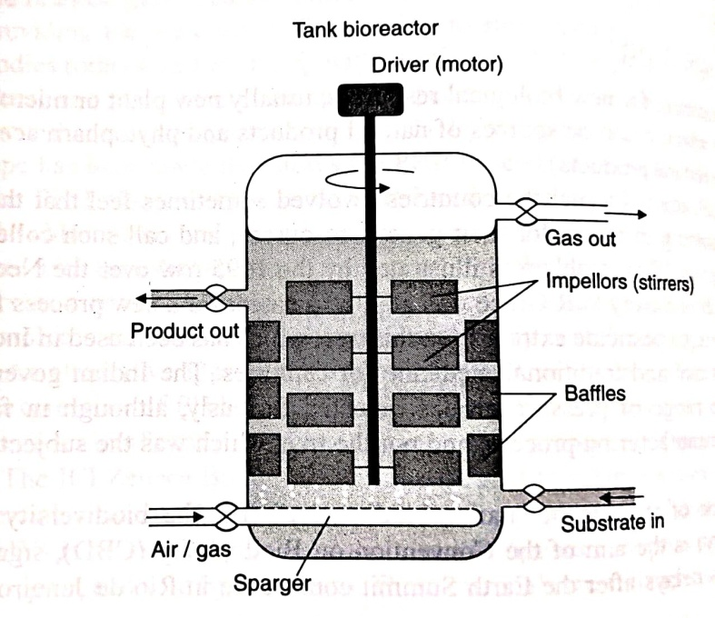
Fig.7. Bioreactor tank
Bioreactor control also needs complex algorithms to make it work. These are among the few applications of artificial intelligence techniques (see sepa rate entry) to biotechnology. Expert systems and neural nets are among the systems that have been used with some success in controlling the more complex bioreactors.

V. BIOENERGY/BIOMASS:

Bioenergy is one of many diverse resources available to help meet our demand for energy. It is a form of renewable energy that is derived from recently living organic materials known as biomass.
Biomass means any bulk biological material, and by extension any large mass of biological matter. Fermentations generate biomass as well as the fermentation product, and it is important to control the amount of biomass to maintain the rate of fermentation. Active biomass the amount of living cells in fermentation is most relevant. However, this can be hard to meas ure, as a recently dead cell looks very like a living cell.
Biomass products are ones made from the biomass of your process. Usually, in a fermentation system, the biomass is a side product, or even a waste. However, some processes grow plants, fungi or bacteria specifically for their biomass.
Algal biomass: Single-celled plants such as Chlorella and Spirulina are grown commercially in ponds to make food materials. Spirulina enjoyed a vogue as a health food a few years ago, due to an unfounded belief that it was extraordinarily nutritious. Like most algae (including some seaweeds) it is quite a good food, but Spirulina is not outstanding. Chorella is grown commercially to make into fish food: it is fed to zooplankton (microscopic animals), and these in turn are harvested to feed the fish in fish farms. This is a way of concentrating sunlight into food in a more convenient and controllable way than normal farming.
Plant biomass: Crop plants such as sugar cane have also been grown for biomass. This is usually used as the start of a chemical production process (as growing plants for food is usually called farming). Most of this is to make fuel ethanol-see Biofuel.

VI. RECOMBINANT-DNA

INTRODUCTION
Recombinant DNA technology was introduced way back in earlier 1960's, however, the techniques were employed mostly in the academic investigations related to the basic mechanism's of the cell function. In a few cases they were applied by small biotechnology companies that sought to utilize the procedure for the production of potential therapeutic proteins and drugs, rather than the typical heterocyclic organic chemicals More recently this technology has emerged as a recognized and powerful tool for facilitating more classical pharmaceutical and drug development research efforts. The advent of classical recombinant DNA technology provided ppportunities for large scale production of therapeutics or human derived proteins and peptides. In addition it offers potential for remodelling of protein drugs for site specificity, reduced immunogeneity, stability and improved pharmacokinetics etc.
The reader might be familiar with genetics as it has been discussed at length in previous chapters. Still to prime up the memory and to give a little background of the Central Dogma of Biology, which establishes that information for development, organization and functioning of living systems is stored in discrete units (genes) certainly within the linear deoxyribonucleic acid (DNA) molecule of each cells. At appropriate times, portions of the DNA information are transferred by transcription from the gene into linear ribonucleic acid (RNA) molecules for translation into functionally active proteins.
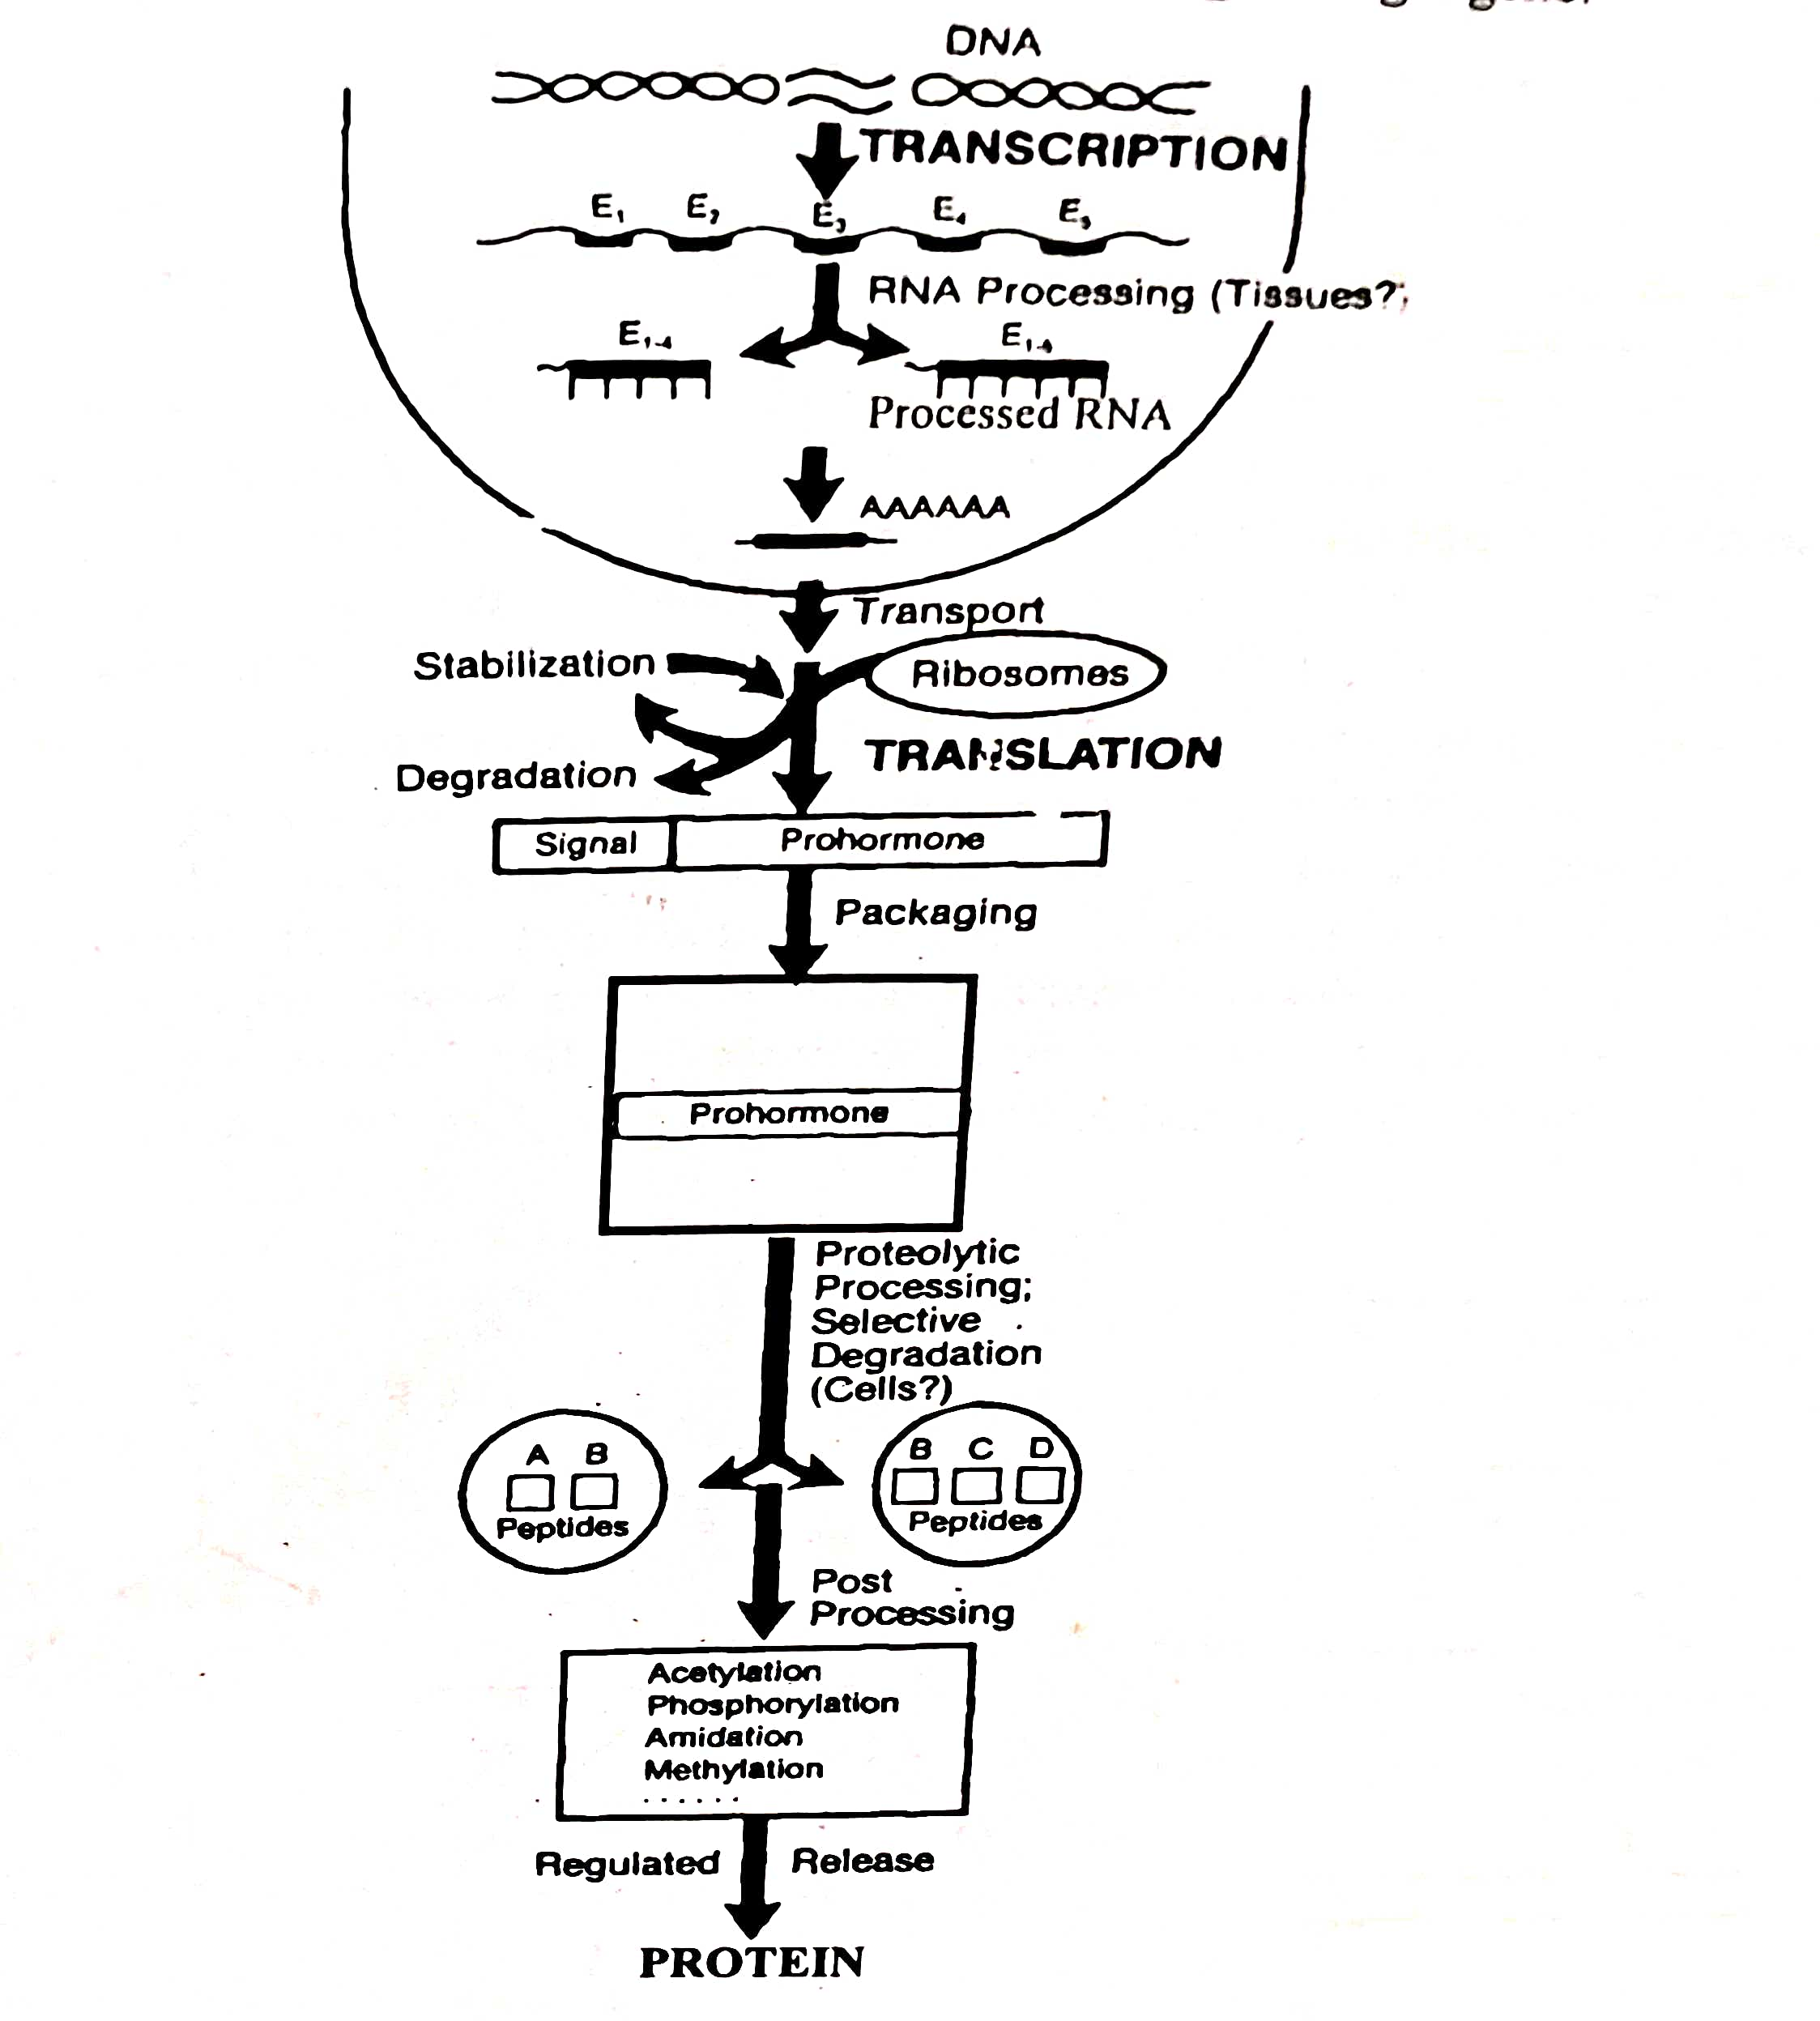
Fig. 8. Genetic Regulation Cycle Within a Particular Cell

The basic building blocks of DNA are nucleotides consisted 2-deoxyribose linked through the position to one of the nucleic acid base, guanine (G), thymine (T), cytosine (C), or adenine (A) and linked within a single strand, i.e. the linear DNA molecule through a phosphate ester bond formed between 5' position of deoxyribose of one nucleoside and 3' position of deoxyribose moiety on the adjacent nucleotide. DNA exists as a double helix with one linear strand proceeding in the 5' to3' direction and the other aligned parallel to it but in opposite direction i.e., 3' to 5. The two strands are held together by the hydrogen bonds in which Cs pair with Gs and Ts pair with As. The resulting DNA forms two complementary strands such that the sequential order of the nucleotides of one of the strands (a gene) can be exactly copied into a messenger RNA (mRNA) molecule (copying of both strands occurs during cell division). RNA also uses four nucleotides (uridine in place of thymidine) that are attached to ribose (instead of deoxyribose) sugars as the backbone. RNA, are single stranded since their synthesis depends upon opening of stranded DNA where RNA polymerase copies one strands through the use of the base pairing principle.
The mechanism of converting linear nucleotides sequence information into linear array of amino acids (proteins) depends upon the recognition of nucleotide triplet (usually AUG for methionine) near 5' end of the mRNA, which encodes the first amino acid (N-terminal). Each amino acid is carried by single t-RNA possessing a specific recognition site triplet (again complementary bases pairing is used). The t-RNA triplet complementary for the next three nucleotides in the mRNA binds and transfers its amino acids. This event continues until a stop codon (e.g. UAG) frame is arrived. The complete translation of mRNA occurs in the ribosomes (a RNA and protein complex) and results in a cellular protein. The protein serves many functions within the cell, ranging from enzymatic machinery of energy metabolism and structural components of membrane to the very specialized function of different cell types. However, it is important that the Central Dogma and the triplet coding systems remain consistent from bacteria to humans, thus, the tools developed over many years of research by microbiologists can be utilized, effectively in designing and engineering of target gene.

VII. CELL FUSION

The fusion of two cells together results in a new cell which has all the genetic material of the two original cells, and hence is a new type of cell. The abil. ity to fuse different types of cell-from the same species or from different species has been used widely in biotechnological research. Common meth ods used include:
A. Electroporation
This is opening cells by exposing them to a strong electric field. This can be used to get large molecules into the cells, or to fuse cells together.
Transformation of cells-getting DNA into them can be achieved simply by exposing the cells to a suitable electric field while they are in a solution of the DNA. The electric field seems to modify the lipid membrane that surrounds the cells, and greatly increase the rate at which pinocytosis, a normal mech anism by which cells take up chemicals from solution, takes DNA into the cell. It is not widely used for bacterial cells, where other methods have been devel oped which are quite reliable. However, electroporation is discussed fairly extensively when talking about getting DNA into plant protoplasts and Fugen-mediated fusion. Some chemicals, such as polyethylene glycol (PEG), can make cells fuse together: they are called fusogens. PEG is a polymer which binds into the lipid membrane of cells and causes it to merge with any other lipid membranes around.
a. Virus-mediated fusion:
Some viruses have lipid coats which fuse with the membrane of cells when the virus infects that cell. Thus, they also act as fusogens. Viral fusogens were discovered before PEG's fusogenic properties were, but PEG is preferred now because it is easier to get hold of and less potentially hazardous. animal cells, and to a lesser extent into fungal cells. Amaxa specialize in technology to do this.
b. Fusing cells:
This was the first application of electroporation. Protoplasts of plant cells or whole animal cells, can be made to fuse by putting them next to each other and exposing them to a strong electric field, a process called electrofusion. Typically, the cells are exposed to a low electric field, which induces a dipole in the cells and causes them to line up. They are then exposed to a quick pulse of very high voltage to make their membranes "leaky" and so to fuse. There seems to be no limit to the types of cells which may be fused together using this technology. Applications in plant genetics include making hybrid plants and making polyploid plants.
There has been some work on using electroporation to deliver drugs, specif ically DNA and peptides, directly into the skin cells. This certainly works to some degree: it is possible that the matrix around the skin cells protect them from the damage that electroporation usually does to cells in culture.

VIII. BIOREMEDIATION

Bioremediation is the use of biological systems usually microorganisms-to clean up a contaminated site ("the environment"). The same approach (although different technologies and organisms) are also used for "bioscrub bing"-removing waste materials from flue gases. Bioremediation is an indus try with a turnover around $20 billion globally, mostly treating contamination in soil, often getting rid of heavy metals (cadmium, lead, mercury, arsenic), petroleum compounds, and trichlorethylene solvent. The term "bioremedia tion" does not usually cover sewage treatment (see separate entry). There are four basic approaches to cleaning up contaminated soil using
Biology:
Stimulation. Here we stimulate local microorganisms to metabolize the contaminants, by giving them other nutrients, oxygen, or other chemicals. This is cheap, but may not be very effective. A widely used example is the use of a combination of nitrate and phosphate as a stimulant for soil micro organisms to metabolize BTEX. (BTEX, or BTX, is a mixture of benzene, toluene, ethylbenzene and xylenes, commonly used solvents that are also a common residue from crude oil spills. They move readily into groundwater, and once there persist for years in poorly oxygenated environments.)
A. Augmentation:
This is adding new organisms to the site. These can be tailored to clean up the specific contaminant involved, but this can be costly. They must also be supplied with nutrients and often with oxygen as well.
B. Land farming:
The contaminated soil is mixed with normal surface soil (plus or minus added bugs) and aerated by tilling. This is easy to implement and effective, but you need a large area to spread the soil out. Related is in situ composting, where the contaminated soil is piled up with bacterial and nutrient sources.
C. Tank bioreactor:
If a target site is very highly contaminated, or too cold or dry for bacteria to flourish in, then the soil can be placed in a tank bioreac tor and the bioremediation carried out there. These bioreactors essentially large insulated tanks into which soil or waste is placed with a bacterial ino culum. Air is blown through the mass to keep it oxygenated. This is an expensive option.
A critical limiting factor in all these processes is usually supplying the microorganisms with oxygen. Oxygen can be dissolved in water which is then pumped into the site, generated locally using chemicals (like chlorate or perchlorate, coupled with organisms that can break it down to relatively harmless chloride and oxygen), or pumped in as air. Perchlorate itself is a widely found environmental contaminant, particularly from munitions man ufacture: the same bacteria could break this perchlorate down, although this has not been used in environmental clean-up yet.
For many bioremediation approaches, added microorganisms that can break down a type of contaminant are needed, as such organisms, while pres ent in the soil, would be too rare or work too slowly to clean up a contamina tion site or handle a waste stream on their own. Using such a microorganisms consists of selection, optimization of physiology, and inoculation.
Selection of the microorganism (see also Strain isolation)-Typically, bioremediation methods use a consortium of organisms, rather than a single organism, which can catalyze the breakdown of different components of a pollutant or can perform different parts of the breakdown of a complex molecule. Even so, some molecules are quite hard to destroy--PCBs can be dechlorinated by obligate anaerobes (bacteria killed by oxygen), and the car bon skeleton broken down by aerobes (organisms needing oxygen): however clearly these two cannot work together at the same site.
In theory, genetic engineering could produce even better bioremediation organisms, and the first patent for a genetically engineered bacterium was for an oil-eating Pseudomonas. However, the concern about release of GM organisms into the environment has stopped this line of research being applied.
Development of organism physiology-The scientist develops a cocktail of nutrient to boost the rate at which the soil organisms break down the target chemicals, a mixture often called an enhancer. (If the soil bacteria could do this on their own, there would not be an environmental problem.) Designs of enhancers are complex, as they must direct the bacterium's metabolism towards digesting the target chemicals, and not just feed the bug. Inoculation of the environment-The microorganism is introduced into the site, usually with a nutrient mix and enhancer, and often nitrogen and phosphorus so that the bacterium's growth is limited only by the availability of the (carbon-based) contaminant. The main cause of failure of practical bioremediation projects is that the organism selected cannot perform the breakdown at a useful rate at the site, despite performing well in the laboratory. Clays, for example, are particu larly poorly suited to bioremediation: because they are very densely packed, water penetrates them very slowly and air hardly at all.
Typical target compounds are chlorinated aromatics (although disposing of PCBs has met with only limited success), vinyl chloride, solvent residues, gasoline fractions, and crude oil. Alpha Environmental has hit the headlines on several occasions with its oil-eating bacterial preparation, used to digest oil spills at sea into soluble molecules which other bacteria can digest. Its most public application was in the Persian Gulf in 1991. Other non-organic materials also can be metabolised if their end-product is non-toxic or volatile: selenium has been removed from soil by conversion to volatile com pounds or elemental selenium, and nitrates have been removed from sewage waste by biological reduction to nitrogen gas for decades.

IX. BIOMARKER

Introduction:
The use of biomarkers in basic and clinical research as well as in clinical practice has become so commonplace that their presence as primary endpoints in clinical trials is now accepted almost without question. In the case of specific biomarkers that have been well characterized and repeatedly shown to correctly predict relevant clinical outcomes across a variety of treatments and populations, this use is entirely justified and appropriate. In many cases, however, the “validity” of biomarkers is assumed where, in fact, it should continue to be evaluated and reevaluated. This article will consider the current conceptual status of biomarkers as clinical and diagnostic tools and as surrogate endpoints in clinical research with the goal of providing context for interpreting studies that rely heavily on such biological measures.
What is a Biomarker?
The term “biomarker”, a portmanteau of “biological marker”, refers to a broad subcategory of medical signs – that is, objective indications of medical state observed from outside the patient – which can be measured accurately and reproducibly. Medical signs stand in contrast to medical symptoms, which are limited to those indications of health or illness perceived by patients themselves. There are several more precise definitions of biomarkers in the literature, and they fortunately overlap considerably. In 1998, the National Institutes of Health Biomarkers Definitions Working Group defined a biomarker as “a characteristic that is objectively measured and evaluated as an indicator of normal biological processes, pathogenic processes, or pharmacologic responses to a therapeutic intervention.” A joint venture on chemical safety, the International Programme on Chemical Safety, led by the World Health Organization (WHO) and in coordination with the United Nations and the International Labor Organization, has defined a biomarker as “any substance, structure, or process that can be measured in the body or its products and influence or predict the incidence of outcome or disease” An even broader definition takes into account not just incidence and outcome of disease, but also the effects of treatments, interventions, and even unintended environmental exposure, such as to chemicals or nutrients. In their report on the validity of biomarkers in environment risk assessment, the WHO has stated that a true definition of biomarkers includes “almost any measurement reflecting an interaction between a biological system and a potential hazard, which may be chemical, physical, or biological. The measured response may be functional and physiological, biochemical at the cellular level, or a molecular interaction.” Examples of biomarkers include everything from pulse and blood pressure through basic chemistries to more complex laboratory tests of blood and other tissues. Medical signs have a long history of use in clinical practice—as old as medical practice itself—and biomarkers are merely the most objective, quantifiable medical signs modern laboratory science allows us to measure reproducibly. The use of biomarkers, and in particular laboratory-measured biomarkers, in clinical research is somewhat newer, and the best approaches to this practice are still being developed and refined. The key issue at hand is determining the relationship between any given measurable biomarker and relevant clinical endpoints.

X. BIOFUELS

Biofuels are fuels made from bulk biological materials such as cane sugar or wood pulp. There are a range of ways of converting these rather bulky, incon venient fuel materials into fuels which are useful for industrial or transport use, or as starting materials for the chemical industry. Converting biomass into replacements for gasoline has attracted a lot of interest in the 1980s after the "oil crisis" of the late 1970s, went out of fashion in the 1990s, but is start ing to be reconsidered widely again with the rise in concern about global warming and almost continuous armed unrest in the Middle East.
Many wet biomass materials, such as starch, sugar, bagasse (the solid residue left after the juice has been squeezed from cane sugar), sewage, waste waters, etc. can be used to make ethanol or methane by fermentation. Ethanol for use as a fuel is made from cane sugar by fermentation and distillation in commercial quantities in Brazil, where the economics are unusually favorable, and "Proalcool" is a major fuel there: 14M tonnes of maize flour was fermented into 1.3 billion gallons of fuel ethanol in 1999. In the United States, fuel alcohol is made by fermentation of corn (maize) starch: ethanol made in this way is sometimes called "agricultural ethanol." Methanol has also been suggested, but is harder to make and more corrosive. Methane is widely used as a heating fuel, and some biofuel methane has been tried out for electric power generation (see separate entry on Biogas).
Another wet biomass is cellulose, which cannot be readily converted to bio fuels because few organisms can break down the tough cellulose fibers into sugars. Companies such as Novozymes are working on using cellulases enzymes that break down cellulose-in biofuel production. However, at the moment this is not economic.
A more developed version of this is biodiesel, the methyl ester of plant fatty acids (made by transesterification of plant oils). Esters are less chem ically corrosive than alcohols, and so are easier on the engine. World produc tion capacity now at about 200 000 tonnes/year, 85% of it made from canola (rapeseed). (Compare this to something like I billion tonnes of conventional fossil fuel used in land vehicles every year.) Biodiesel is being used experi mentally in city buses in France, Italy, and Germany, with results that sug gest it is economically comparable to fossil fuel diesel. Engines running on biodiesel emit less smoke (carbon particles), and almost no sulfur oxides: however, the exhaust is said to smell like French fries.
Some crops are grown specifically to provide the raw material for fuel pro duction in this way they are called energy crops. The other route to making biofuels is chemical. If any dry biological matter is heated up slowly, it undergoes "pyrolysis" (literally "breakdown by fire"), generating a complex mixture of oily materials and charred polymers. These oils can be distilled in the same way that conventional mineral oil can be, to give fractions with similar properties to gasoline, diesel, lubricating oil, etc. The charred remains can themselves be burned, possibly to heat the pyrolysis reactors and stills. So far no-one has succeeded in making this sort of process competitive with mineral oil production.

XI. FERMENTATION TECHNIQUE

A. Introduction:
A central discipline of traditional biotechnology, and a key part of all biotech nology today, is fermentation. This is the growth of microorganisms, and encompasses a wide range of technologies which are dealt with in different entries in this book. Fermentation includes:
Bioreactor design the design of the container in which fermentation is to take place. Substrates what the microorganisms are to grow on.
Growth rates and conditions under which the organism will grow and produce what we want (which are often mutually exclusive).
Supports-whether the organism is to be on solid supports or in suspension. Fermentation processes-how you arrange to do the fermentation. There is also a wide range of options in the downstream processing (see separate entry).
Fermentation processes Strictly speaking, fermentation is microorganism metabolism under anerobic conditions on a carbon substrate. However, it has been extended to mean growing microbes in liquid under any conditions.
There are three general ways in which fermentations are done, each with a variety of associated terms. In all cases, there are some common terms in bacterial growth, such as the bacterial doubling time (the time needed to double the number of bacteria there): these are discussed further in the entry on cell growth.
Common terms:
For all bioreactor processes, the first thing that happens is that the bioreactor is sterilized. This can be done with steam, chemicals, washing or some combination of them. Often fermentors have a "disinfection cycle," which is an automatic series of operations that cleans and disinfects the machine ready for the next use. The fermentation is then started with an inoculum, a small, actively growing sample of the organism to be cultured. Fermentation then proceeds according to one of the schemes below.
Batch fermentation:
Here the reactor is filled with a sterile nutrient substrate and inoculated with the microorganism. The culture is allowed to grow until no more of the product is being made, when the reactor is "harvested" and cleaned out for another run. The culture goes through lag. log stationary, and death phases (see Cell growth). Depending on what the product is, the "useful" part of the growth cycle can be any one of these four stages, although it is usually the growth or stationary phases.
Fed batch fermentation:
Here the batch culture is fed a batch of nutrients before it gets to the stationary phase, so that it never runs out of nutrients At the same time some of the fermentation is removed and taken off for processing, so the microorganisms do not run out of space or poison themselves.
Continuous culture:
This is the logical extension of Fed Batch fermentation. The fermentor is fed continuously with nutrient and the culture medium removed continuously. This has some advantages over Fed Batch systems in that the culture conditions are always the same, but also is harder to control. This is essentially a large-scale chemostat.
Cascade fermentation:
Here the fermenting "liquor" is passed through a series of ferments, so that more and more of the product builds up each time. Each step can then be optimized for a specific condition. A typical example would be in brewing, where the beer would be fermented in several stages to increase the alcohol content, each stage using yeast adapted to working in alcohol of that concentration. At the end of each stage the yeast is separated from the beer and used again in that stage, while the beer goes on to the next one.

B. FERMENTER: CONSTRUCTION, WORKING AND TYPES:
Fermenter is physical or conceptual container of fermentation, maintained favorable physico-chemical and environmental conditions for the operation of desired biological process. It is vessel in which micro-organisms are brought in contact with feed (substrates, reagents) with provision for their addition and removal.
Fermentation can be batch operated or continuous. In batch fermentation organisms inoculated into the fermenter, feeded with suitable nutrient and substrate. After defined period process is terminated and fermenter contents are harvested, separated, are recovered and purified. While in continuous culture fermentation there has to be continuous feeding of sterile medium and continuous exit of desired product. Product yield is more in continuous fermentation than batch operated but requires stringent maintenance of asepsis and steady state environment. Bioreactor is the vessel for cultivating eukaryotic cell artificially at maintained parameters and should not be confused with fermenter. While considering the fragility of eukaryotic cell, there are some differentiations in the mechanics of bioreactor. In practice bioreactors are even referred to as fermenters.
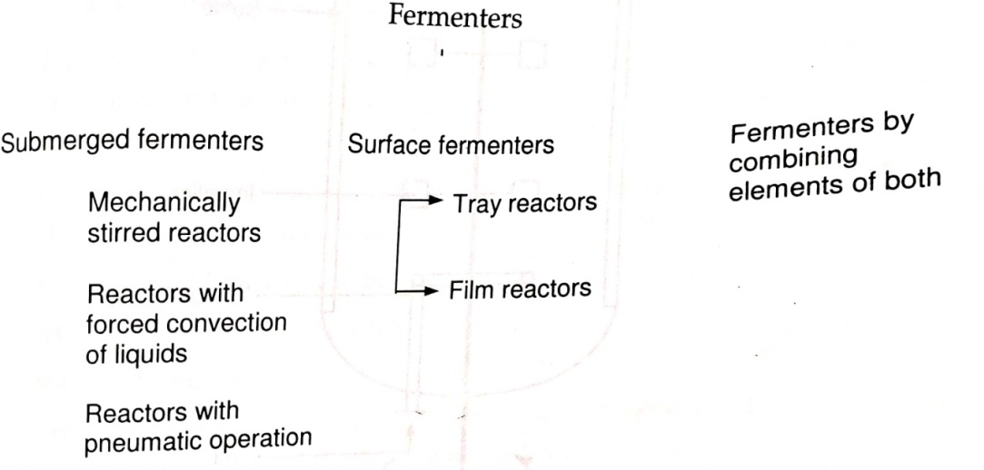

Fig. 9: Types of industrial fermenters

Small (bench) scale fermenters are autoclavable while large scale fermenters are sterilized by in-situ sterilization. Submerged fermenters are used in suspended growth system, where organisms are dispersed in nutrient liquid medium at maintained physico-chemical and environmental conditions. On the basis of mechanism of agitation, which will increase frequency of exposure of cells to the nutrient supply, these types of fermenters are further classified into,
B.1. Mechanically stirred fermenters:
Some of the types of mechanically stirred fermenters are (In tree diagram format)
a) Stirred tank fermenter
b) Drought tube reactor
c) Stirred multi-stage fermenter
d) Paddle wheel reactor
e) Mechanically stirred loop reactor

Mechanically Stirred Fermenters

Stirred tank Drought tube Stirred multistage Paddle wheel Stirred loop

Stirred tank fermenter is most applicable fermenter in modern fermentation biotechnology. It is equipped with one or more mechanical agitator for the homogenous mixing of fermenter content, additionally provided with sparring of sterile air.
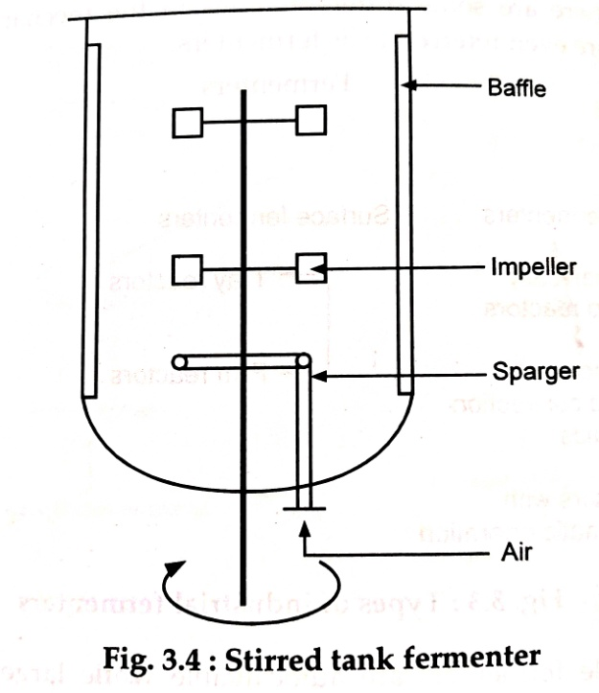

Fig. 10 : Stirred tank fermenter

It has advantages of flexibility in design and is used in a range of sizes from 11 to 100 ton capacity. Usually constructed as an up-right cylinder to facilitate addition and removal. Vessel is 30 to 50% larger in capacity than the require culture volume, leaving head-space to allow dis-engagement of liquid droplets from exhaust gas and to provide room for foaming. The height to diameter ratio (aspect ratio) of the vessel is 3:5. The agitators consist of one or more impellers mounted on a shaft, driven by motor. Provisions are made to reduce vibration and is mechanically sealed to prevent contents exposure to atmosphere and also provided with wall mounted baffles to prevent swirling and vortexing of the fluid.
B.2. Forced convection fermenters:
Where agitation is affected by movement of gases through liquid contents by pump instead of mechanical stirrer. Two designs are available involving liquid movement and gas entertainer. In the loop fermenter gas distribution device is subsidiary vessel, where liquid saturated with this gas is circulated by forced convection into the fermenter vessel. While in deep jet fermenter gas is entertained into a high power jet of liquid into the liquid of the fermenter. It has some basic advantages,
a) Reduced risk of contamination, because of the absence of mechanical agitator.
b) Reduced consumption of power.
c) Reduced evaporation of water from fermenter liquid, as stream of air makes small contribution to cool the fermentation.
Two different types of forced convection fermenters are,
1. Gas lift (including air-lift) fermenters.
2. Sparged tank (bubble column) fermenters.
In the air-lift fermenters, internal movement is achieved by sparging part of vessel with gas. Fluid volume of the vessel is divided into two interconnected zones by means of baffle or draft tube.
The sparged zone is known as the riser and which does not receive sparged air is down-comer. There can be different designs in air-lift bioreactor,
a) Draft tube internal loop bioreactor.
b) Split cylinder internal loop bioreactor.
c) External loop bioreactor.
For optimal gas-liquid mass transfer performance, the ratio of the cross-sectional area of riser to down-comer is maintained between 1.8 to 4.3. Internal loop bioreactors are more commonly used in commercial production than external loop designs. Because of their suitability with shear-sensitive cultures, due to least shear stress, air-lift reactors are more suitable for cultivating fragile animal cells, in protein production, than stirred tank reactors. They are even more effective in suspending solid contents than bubble column reactors because of their greater heat and mass transfer capacities.

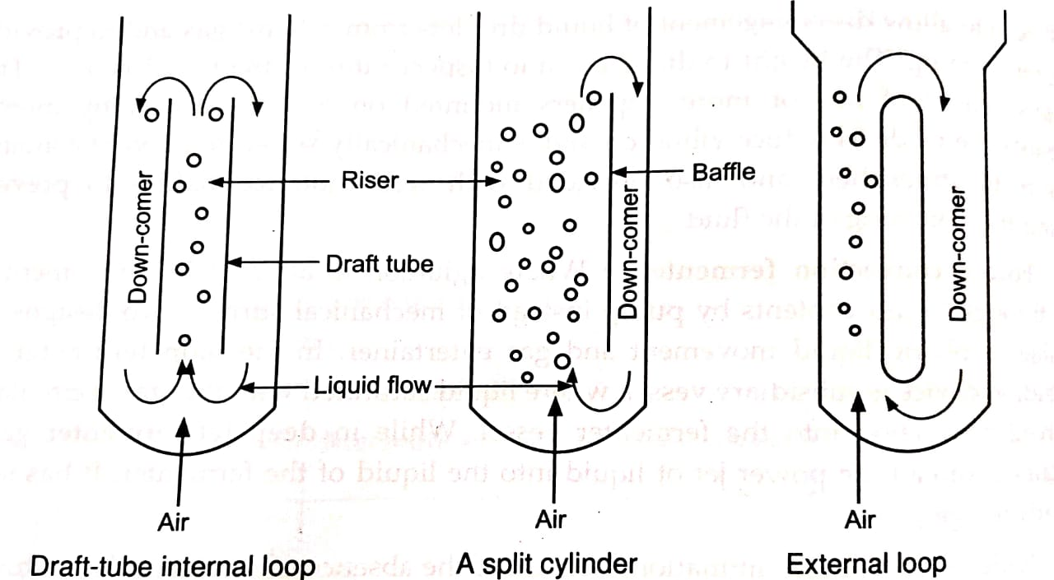
Fig. 11. Bubble column reactor
B.3. Bubble column reactor:
It is a cylindrical column with 4: 6, height: diameter ratio, in which gas is sparged at the bottom through nozzle, or perforated pipes or sintered glass or metal micro-porous spargers. Rate of oxygen transfer, mixing and other performance parameters of reactor are governed by gas flow rate and rheological properties of fluid. Vertical baffles and corrugated sheet packing are plates, generally provided to improve mass transfer in the vessel. In bubble column aeration velocity can be as maximum as 0.1 m/s, which can be expressed as superficial gas velocity, defined velocity of gas attained when it passes uniformly through the empty vessel.

Superficial gas velocity = Volume gas flow rate (m³/s)
Cross-sectional area of vessel (m²)

Superficial gas velocity that is limited to the value because, when it exceeds gas bubble will coalesce to form slugs, will carry liquid out of the system and will also reduce the efficiency of gas dissolution by reducing gas liquid interfacial area.
B.4. Pneumatic fermenters:
Fluidized bed reactors and packed column reactors are examples of some of the other bioreactors, used in the special cases. Fluidized bed bioreactor is an example of pneumatic bioreactor used in fermentation involving fluid with suspended particulate (immobilized) biocatalyst (enzyme) or cell particles or microbial flocks.
These particulates are fluidized with up-coming stream of liquids. In contrast with bubble column, top section of the reactors is expanded to reduce superficial velocity of fluidized bed to the level to keep solids in suspensions, and hence a solid sets in this area called the setting zone and is then dropped into fluidized zone, remaining always in the reactor while liquid flows out.
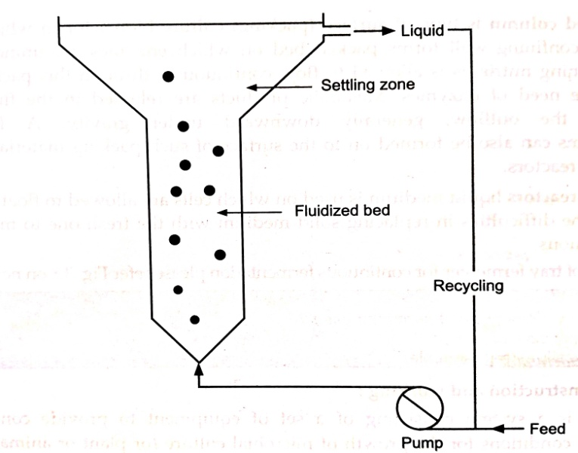
Fig. 12. Fluidized Bed reactor

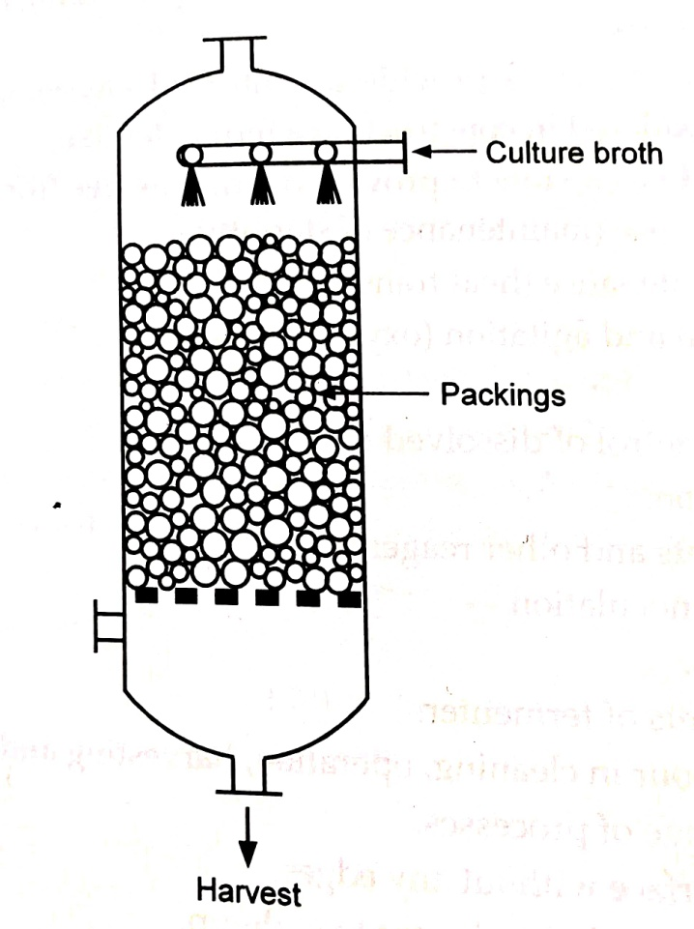
Fig. 13. Packed bed fermenter

B.5. Packed bed column is type of surface (packing) culture bioreactor in which solid particle with confining wall forms packed bed on which enzymes are immobilized A fluid containing nutrients is allowed to flow continuously through this packed bed to provide the need of enzymes. Metabolic products are released in the fluid and removed in the outflow, generally downward under gravity. Al whit micro-organisms can also be formed on to the surface of such packing material which is called film reactors.
In the tray reactors liquid medium is used on which cells are allowed to float. This is to overcome the difficulties in replacing solid medium with the fresh one to make the process continuous.
Fermenter: construction and working:
Fermenter is a system consisting of a set of equipment to provide controlled environmental conditions for the growth of microbial culture (or plant or animal cells, else wise called bioreactor), in order to produce some valuable products by using cells metabolic machinery in liquid (or solid) medium while preventing entry and growth of atmospheric micro-organisms.
The function of fermenter is to provide a controlled environment, hence various designing aspects are considered in constructing a fermenter like,
1. The vessel should be capable to provide operations free from contamination, for even its long term use (maintenance of sterility).
2 Temperature maintenance (heat transfer rate).
3. Adequate aeration and agitation (oxygen transfer rate).
4 . pH control.
5 Monitoring and control of dissolved oxygen.
6. Power consumption.
7. Feeding of nutrients and other reagents.
8. Access points for inoculation. Sampling facilities.
10. Loss of containments of fermenter.
11. Minimal use of labour in cleaning, operation, harvesting and maintenance.
12. Suitability with range of processes.
13. Smooth internal surface without any edges.
14. Use of fittings and geometry relevant to scale-up.
15. Non-toxic to the micro-organisms cultivated.
16. Safety.
17. Level of sophistication.

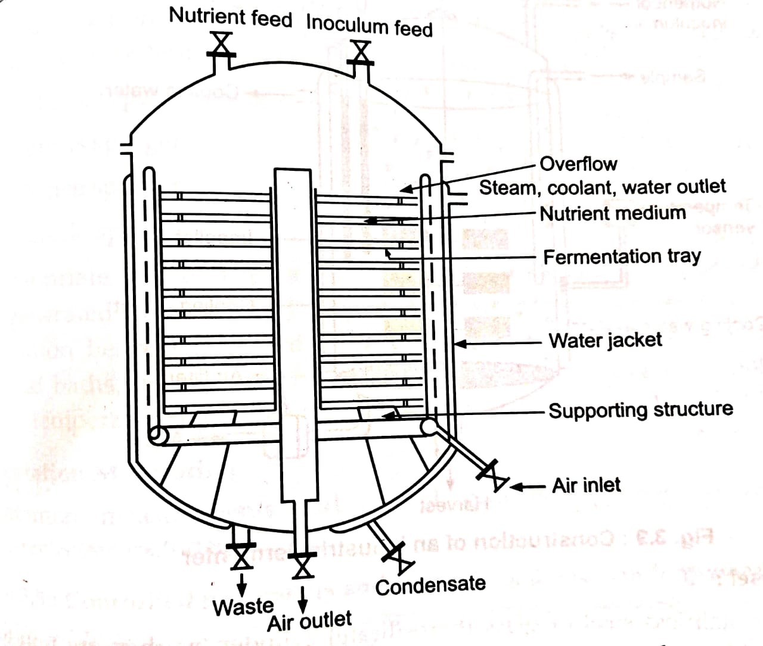

Fig. 14: Design of tray fermenter for continuous fermentation

Depending on these factors governed, fermenters are designed within required capacity by using cheapest material of construction, enabling satisfactory results. Typical fermenter consists of,
1. The culture vessel.
2. Associated equipment for supply of nutritional and environmental parameters.
3. Associated equipment for measurement and control of physico-chemical, biological and environmental parameters of the fermentation.
C. Fermentation Monitoring:
Common measurements and control systems employed in association with fermenter vessel includes,
Table.1.: Controlled parameters and monitoring devices in fermentation monitoring

Controlled Parameters | Monitoring Device
Agitator speed control (0 to 1000 rpm) | Tachometer
Air flow (0 to 6 lit/min)  Constant water flow | Flow meter  Rota meter
Temperature (8 to 60 °C ± 1°C) | Mercury in glass thermometer  Electrical resistance thermometer  Thermister
Pressure (2000 mbar) | Bourdon tube  Pressure gauze  Diaphragm gauze  Pressure sensors  Piezoelectric transducers
pH range (2 to 12±0.1) | pH meter
DO, range (0 to 100%) | DO, analyzer (galvanic, polarographic)  Pneumatic oxygen analyzer
Other gases | CO, analyzer  Mass spectroscopy  Gas chromatography
Redox potential | pH meter  DO2 analyzer  DCO2 analyzer  Oxygen analyzer  Polarographic probes  Galvanic probes
Stability (>98%)

Power input | VOM, torque
Rheology of fluid | Tube, cone-plate.  concentric  Viscometers cylinder
Foam | Foam sensing and control unit
Cell concentration | Gravimetric dry weight  Turbidimetry
Sate of culture | Enzyme probes  Metabolic heat substrate analysis  Substrate concentration

Measurement and control of all these existing defined environmental conditions and biological variable is called fermentation monitoring.
Physicochemical monitoring is achieved by sensors, basically of three different types,
1. These which comes in contact with the containments of fermenter during measurement. E.g. pH probes, DO, electrodes.
2. These which comes in contact with fermenter containments after its withdrawal from the fermenter. E.g. exhaust gas analyzer.
3. These which do not come in contact with the fermenter-contents e.g. tachometer.
Sensors are categorized on the basis of applications into on-line sensors, in-line sensors and off-line sensors. First two sensors are integral parts of fermenters, where in line sensors are used for the direct control of fermentation process and not on-line sensors. In addition to this ideal situation can be achieved by use of some additional sensors like,
- Ion-specific sensors, to measure NH4+, Ca++, K+, Mg++, PO4--, SO4--.
- Enzyme and microbial electrodes, to monitor the presence of some specific chemicals like amino acids, ammonia, carbohydrates, cholesterol, triglycerides, lactate, acetate, oxalate, methanol, ethanol, urea, penicillin, creatine etc.
- Near IR spectroscopy, to simultaneously estimate fat (in medium), teichoic acid (in biomass) and antibiotic (product).
- Mass spectroscopy, to monitor gas partial pressures (O, CO, CH, etc.), dissolved gases (O2, CO2, CH4, etc.) and volatile substances (methanol, ethanol, acetone etc).
Thus fermentation monitoring is generally achieved by on-line measurements of physico-chemical variables like pH, DO2, DCO2, and biological variables like substrates, metabolites, products and biomass. Continuous culture system offers more flexibility than batch fermentation in on-line monitoring. Off-line monitoring of the process also includes bio-separation and monitoring biological activity of desired components is called as bio-process monitoring. Sophisticated techniques like HPLC, capillary electrophoresis (CE) and mass spectroscopy (MS) are employed in such monitoring.
Computers are applied too in monitoring fermentation process. The technique called flow injection analysis (FIA) is used in monitoring containment of fermenter which is analogous to clinical auto-analyzer system; slugs sample with an interval and examine it to check stage of fermentation reaction. The system has different merits over initial on line, off-line and in-line methods of monitoring,
1. High frequency of sampling and analysis.
2. Integration with any sample preparation process.
3. Maintenance of stable baseline.
4. Easy calibration.
5. Flexibility in selection of chemical principles of analysis or sensors, to be used.

XII. APPLICATION WITH TECHNOLOGY:
A. Antibiotics-
In 1928 the term antibiotic had appeared firstly in French Microbiological literature on antibiosis. The term antibiotic was coined and introduced by Selman Waksman in 1942, meaning 'A chemical substance derived from micro-organisms which has capacity, of inhibiting growth and even destroying, other micro-organisms in dilute solution Penicillin is the first major antibiotic commercially produced from microbial source. Its role in treatment of life threatening infections, led into invention of thousands of antibiotics, now available for therapeutic use.
Antibiotics have wider agricultural uses as feed additives, growth stimulants, pesticides besides there use in the treatment of infections in man, animals and to a small extent in plants. Waksman's definition can now be broadened to include all microbial compounds which can selectively affect various biochemical growth processes, at low concentrations, in humans, animals, plants or micro-organisms. They are generally considered as secondary metabolites (idiolites), non-essential for producing micro organisms.
Example: Tetracycline-
More than 30 years have elapsed since the discovery of tetracycline antibiotic and its, chemistry, pharmacology, biosynthesis, mechanism of antibiotic action and producer organisms are well understood. Streptomyces aurafaciens (employed in the production of tetracycline) and Streptomyces rimosus (employed in the production of oxytetracycline) were studied extensively. More than fermentatively produced tetracycline series of semi synthetic tetracycline were also investigated.
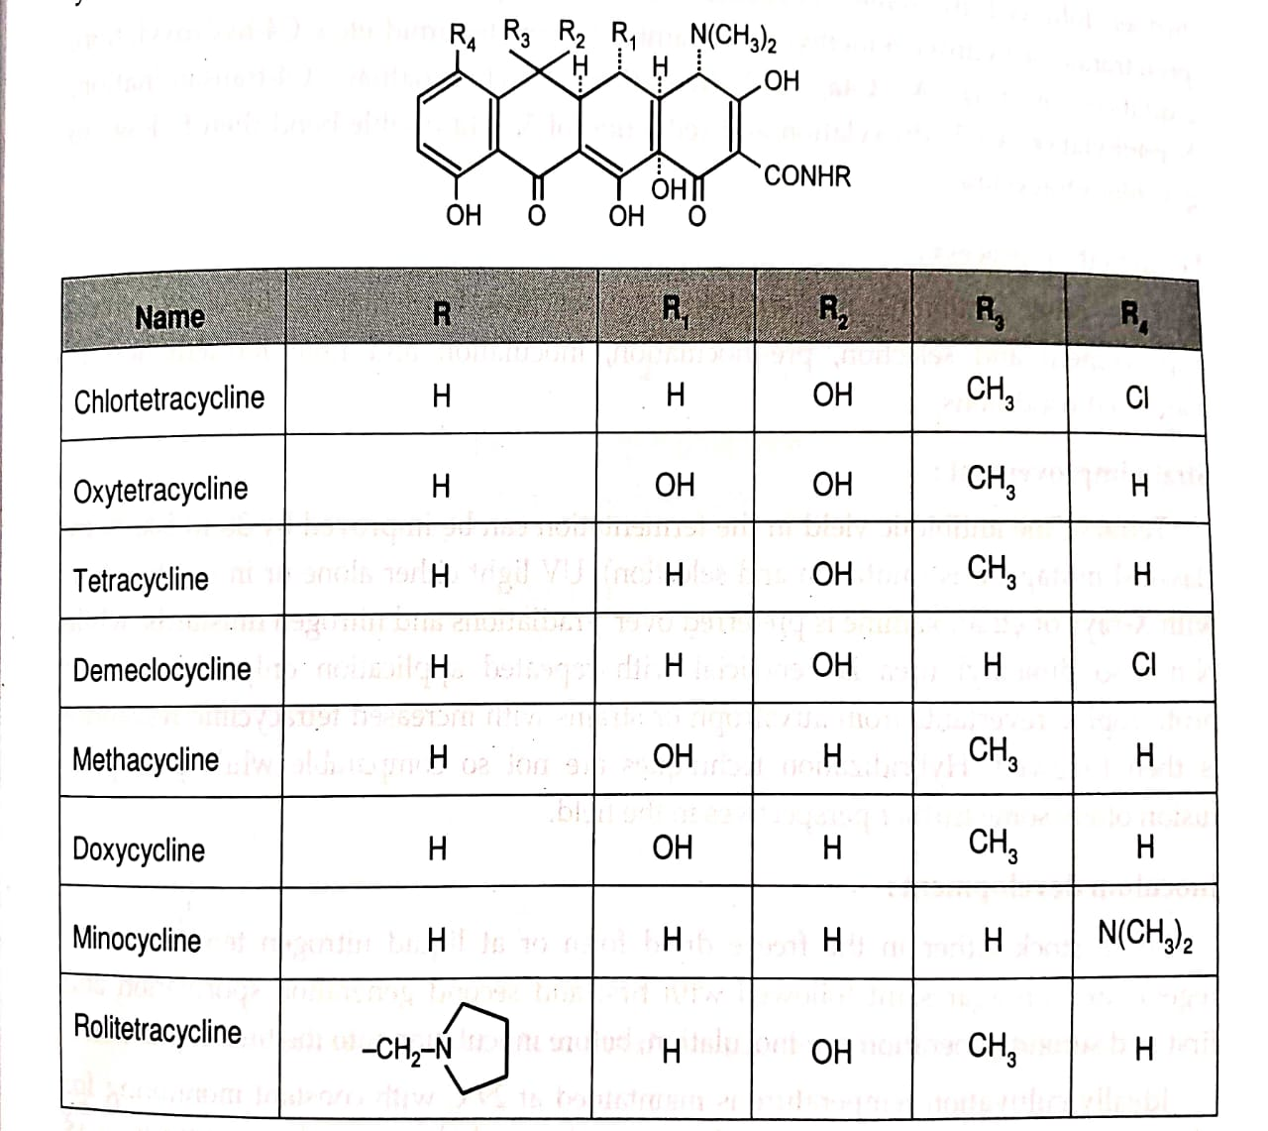
Fig. 15. Chemistry of Tetracycline antibiotics.

a. Biosynthesis:
The genetic analysis of Streptomyces rimosus has revealed the genes responsible for tetracycline production. The position of some loci was found responsible for the biosynthesis of oxytetracycline in the lower arc of the map. Genes for the later step in biosynthesis were found to be located in the small chromosomes between markers proA and adeA, with the gene for co synthetic factor I. Genes for earlier biosynthesis are at the region diametrically opposite to the first, between markers ribB and cysD. Extra chromosomal DNA have also been found taking part in the control of biosynthesis.
Experimental findings in the study of biosynthesis of chlortetracycline are, initial formation of linear 'oligoketidamide chain' through head to tail condensation of one unit of malonamic acid and eight units of malonic acid. It is followed by methylation at C6, reduction at carbonate, dehydration of alcohol to C7-C8 olefin and cyclization. Ths is further followed by some enzymatic reactions to produce pretetramids (6-methyl pretetramid, 4-hydroxy-6-methyl pretetramid, 6-deoxytetramid etc.). C4-hydroxylation, oxidation of ring A, C4a, C12a-hydration, C7-chlorination, C4-transamination, N-methylation, C6-hydroxylation and reduction of 5a-11a double bond then follows to get chlortetracycline.
b. Fermentation process:
Like other antibiotic fermentations, tetracycline fermentation involves, strain improvement and selection, pre-inoculation, inoculation and final fermentation in controlled conditions.
c. Strain improvement:
Tetracycline antibiotic yield in the fermentation can be improved by 30 to 500 % by classical mutagenesis (mutation and selection). UV light either alone or in combination with X-rays or ethanolamine is preferred over y-radiations and nitrogen mustards, while N-nitroso dimethyl urea is beneficial with repeated application only. Selection of prototrophic revertants from auxotroph or strains with increased tetracycline resistance is then followed. Hybridization techniques are not so comparable while protoplast fusion offers some further perspectives in the field.
d. Inoculum development:
Spore stock either in the freeze dried form or at liquid nitrogen temperature is regenerated on agar slant followed with first and second generation sporulation and first and second generation pre-inoculation, before inoculation into the final fermenter.
Ideally cultivation temperature is maintained at 29°C with constant monitoring for pH, residual sugar, CO,, biomass density and morphology etc. The composition of inoculation media is made similar to the fermentation media to ensure short lag phase.
The inoculation media is composed of,
Table 2 : Inoculation media in tetracycline fermentation

Carbohydrate (sucrose and molasses) | 2.5% w/v
Soybean meal | 1.7% w/v
Corn steep liquor
CaCO3 | 0.2 to 0.3% w/v
NaCl
KH2PO4
Vegetable oil | 0.2%

Mother stock
(freeze dried at LN temperature)

7 to 10 days First sporulation on agar slant

14 days Second sporulation on Millet flasks

10"spores/m inoculation broth

24 to 26 hrs First submerged generation in pre-inoculation tank

7 to 10 days 5% of pre-inoculation broth

18 to 20 hrs First submerged generation in inoculation tank

5 to 10% of inoculation broth

100 to 200 hrs Production culture in the fermenter

Fig. 16: Steps in the inoculum development of tetracycline fermentation

e. Media:
Like nutritional media in fermentation of other antibiotics, tetracycline fermentation media includes carbon source, organic nitrogen source, buffers, inorganic salts and antifoaming agents. Sucrose (molasses), starch, glucose are the 'C' sources employed, starch being preferable for prolonged fermentation upto 200 hrs. Corn-steep liquor, soybean meal, peanut meal are natural organic nitrogen sources. Calcium carbonate resists the pH change and is additionally useful by its binding with the formed tetracycline, preventing product accumulation and hence further inhibition of product formation.
Animal, vegetative oils and semi synthetic antifoaming agents like propylene glycol and silicones are also employed. Typical medium employed in pilot-scale oxytetracycline fermentation is,
Table.3. Medium employed in pilot-scale
Starch | 12+4%
Technical amylase | 0.1%
Yeast | 1.5%
CaCO3 | 2%
(NH4)2SO4 | 1.5%
Lactic acid | 0.13%
Lard oil | 2%
Total inorganic salts | 0.01 %

f. Fermentation monitoring:

Table.4. Parameters to be controlled during fermentation are
Stirring (2.5-3Kw/m³)
Aeration (up to 0.8 medium volume/min.)
Oxygen over pressure (up to 0.1 MPa)
Temperature (29± 01 °C)
PH
Oxygen content of medium (at least 20% saturation)
CO₂
Medium composition
Carbohydrate concentration
Antibiotic concentration
NH4 and NH2-N
Sterility
Macroscopic and microscopic state of culture
Biomass contents etc.

g. Product recovery and purification:
Various methods of extractions and purification are employed after initial separation of mycelium from broth by filtration and or centrifugation. Amphoteric nature of the product and possibilities of their polymerization or rearrangement are considered in designing DSPs for tetracycline.
The methods employed in isolation are,
1. Adsorption on inert substrate like diatomaceous earth or activated charcoal followed by chromatography and selective extraction.
2. Extraction from acid or alkaline medium and most frequently with 1-butanol.
3. Direct extraction by acidification, precipitation of Ca" with ammonium oxalate with addition of quaternary ammonium compounds as carriers and extraction with an organic solvent.
4. Precipitation from dilute solutions of aryl azosulfonic acid dyes.
5. Precipitation with alkaline earth metal compounds or primary and secondary alkyl amines.
6. Salting out the antibiotic with NaCl from the aqueous to the organic (1-butanol) phase.
It is then purified by crystallization as salts (E.g. hydrochlorides) or bases, from boiling solvents like lower alcohols, ketones, aliphatic ethers of ethylene glycol etc., performed most efficiently at 2°C for 3 hrs. The analysis includes paper chromatography, TLC, gel-chromatography, HPLC and ion-exchange chromatography, absorption and fluorescence spectroscopy and polarography. Two microbiological assays, a turbidometric method using Micrococcus pyogenes and cylinder-plate method using Bacillus cereus are also employed.

B. Dextran:
It is one of the polysaccharide polymer used as plasma extenders, produced by growing Leuconostoc mesenteroids in sucrose containing medium. It occurs as a slime, which interfere with crystallization and clogs pipes and filters. It is a large, water soluble polymer of glucose, formed by partial hydrolysis of sucrose substrate (molecular weight =40,00,000), with average molecular weight of 40,000, 70,000 and 75,000.
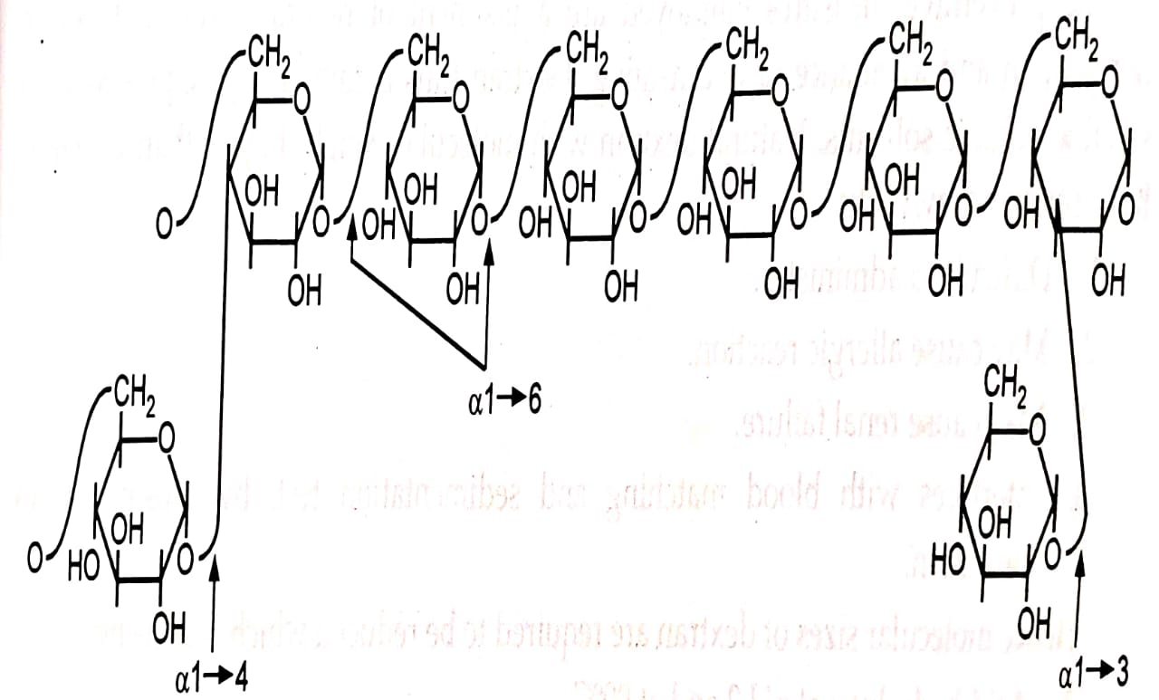
Fig. 17: Chemistry of dextran

Structurally, they are long, slender molecules of un-branched chain of glucose units joined by 1: 6 glucosidic linkages, or highly branched polymers consisting of short chains of a 1:6 units with α-1--2, α-1--3 and or α-1--4 branching, dependant on the strain and species of bacteria employed.
Dextran 70: with molecular weight 70,000 is administered intravenously in doses of 500 ml of 6% saline solution.
Dextran 40: with molecular weight 40,000 at 10% concentration.
Dextran with molecular weight greater than 1 lakh has side effects of sensitivity reactions. In persons sensitive towards dextran 70 and 40, dextran 1 (molecular weight, 1,000) can be administered before IV administration, which reduces occurrence of anaphylaxis by factor of 15 to 20 times. Branching in dextran is responsible for allergic reactions.
a. Bioconversion of dextran :
The organisms producing an enzyme 'dextran-sucrase, which converts sucrose into dextran and fructose by straight-transglycosylation.

n Sucrose Dextran sucrose n(Glucose-H2O) + n Fructose
Dextran
Fructose produced is used by the organisms.

b. Fermentation process:
Fermentative production of dextran is similar in many respect to the antibiotic production. It involves strain development, inoculum preparation followed by growth in seed tanks and finally into the fermenters (capacity 4500 dm³). Basic differences include,
1. No stringent asepsis: As enzyme production and action on sucrose is rapid.
2. No need of aeration: As aeration inhibits the process.
3. Precautions to be taken to prevent hydrolysis of sucrose in sterilization of culture media.
The preventive measures employed are adjustment of neutra medial pH before sterilization and avoidance of overheating. Dextran thus obtained is precipitated with suitable organic solvents. Natural dextran with molecular weight higher than 2.5 lakhs have serious drawbacks,
1. Difficult to administer.
2. May cause allergic reaction.
3. May cause renal failure.
4. Interferes with blood matching and sedimentation test, by causing raulex formation.
Hence molecular sizes of dextran are required to be reduced which is done by,
1. Acid hydrolysis at pH 2 and at 90°C.
2. Thermal degradation at 160°C in the presence of sodium sulphite (to prevent oxidative deterioration) and calcium carbonate (to neutralize acidity).
3.Ultrasonic bombardment of the molecules.
4. Seeding the fermenter with low molecular weight dextran, which works as template in dextran production.
The very small molecular weight dextran, below 60,000 also has some drawbacks, like rapid excretion in the urine and passage into the tissue fluids causing an adverse osmotic pressure.
To obtain clinical grade dextran the neutralized hydrolysate is subjected to a long process of fractional precipitation, with the use of water-miscible organic solvent (in which dextran is soluble E.g. acetone or alcohol), under controlled conditions. The required fraction is gradually separated by repeated re-treatment of either precipitate or supernatant fluid. The selected fraction is further purified to remove,
1. Reducing sugars mainly fructose, which is byproduct, by solvent precipitation.
2. Solvents employed in the fermentation, by evaporation under reduced pressure.
3. Inorganic salts, specially phosphates which precipitates during sterilization and storage by mixed bed ion exchanger.
4. Color by adsorption on activated charcoal.
5. Pyrogen by adsorption on asbestos or cellulose derivatives.
6. Micro-organisms by membrane filtration.

C. Vitamins:
C.1. Vitamin B2 (Riboflavin):
Riboflavin (7,8-dimethyl-10-(1-D-ribityl) isoalloxazine) is a essential vitamin, for the growth and reproduction of human and animals. It was firstly isolated from milk and synthesized by fermentation in 1935. It is hygroscopic, sensitive to alkalis and decomposed by UV light.
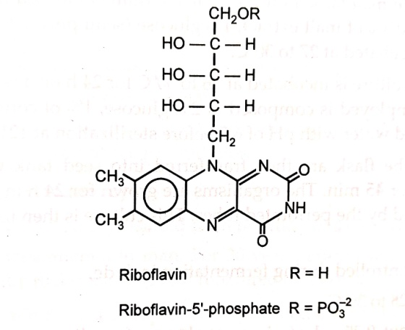
Fig. 18. Chemistry of Riboflavin

Riboflavin is produced commercially by fermentation and is also synthesized chemically. Various microbial sources employed in the production are,
Ascomycete: Erymothecium ashbyi
Ashbya gossypii
Yeasts: Candida guillieimondia
Candida flareri

It is a byproduct of the acetone-butanol fermentation with Clostridium butilicum and Clostridium acetobutilicum. Erymothecium ashbyii and Ashbya gossypii are plant pathogens and effluent residues from the process are discarded only after sterilization.
a. Media:
Media for ascomycete riboflavin includes, glucose, sucrose and maltose as 'C' source; peptone, corn-steep liquor and animal stick liquor as 'N' source and biotin, thiamine and meso-inositol for optimal growth of micro-organisms; and some additional agents like antifoam.
Table. 5. Following media is recommended for maximum yield.
Glucose | 2%
Corn-steep liquor | 1.8 to 2%
Animal stick liquor | 1%
Anti-foam. | small qty.

The medium is sterilized at 135°C for 5 min., after prior adjustment of pH to 4.5.
b. Inoculum development and fermentation process:
Ashbya gossypii are maintained on the agar medium composed of 0.5% of peptone, 0.3% of yeast extract, 0.3% of malt extract, 1% glucose (semi purified) and 2% agar, with weekly subculture; incubated at 27 to 30°C.
A loopful of 24 h culture is incubated at 26 to 30°C for 24 h on a reciprocating shaker. The broth medium employed is composed of 2% glucose, 1% of corn-steep liquor, 0.5% animal stick liquor and water with pH of 6.5 before sterilization at 121°C for 30 min.
The contents of the flask are then transferred into seed tank with a medium of similar composition for 45 min. The organisms are grown for 24 h in the seed fermenter with aeration provided by the perforated tubes. This culture is then used to inoculate the fermenter.
The parameters controlled during fermentation include,
1. Temperature: 28 to 30°C
2. Aeration about 0.25 ml of air per volume of medium per min, sufficient for adequate mixing of fermenter contents, without hampering the growth.
Various attempts that combined to study biosynthetic pathway of riboflavin in ascomycete fermentation, can be demonstrated in three phases,
1. Rapid growth of ascomycete with little riboflavin production. Glucose is rapidly utilized (oxidized) resulting into accumulation of pyruvic acid and hence pH decrease. The glucose is exhausted and growth ceases.
2. Sporulation resulting into pyruvate concentration, ammonia accumulation because of increased deaminase activity, hence pH increase. This is followed by rapid synthesis of cell bound riboflavin in the form of flavin adenine dinucleotide (FAD) and some flavin mononucleotide (FMN), rapid increase in catalase activity and disappearance of cytochromes.
3. Autolysis resulting into free release of riboflavin into the medium.
Some other workers have demonstrated that purine and or purine precursor stimulates riboflavin production as it is used by micro-organisms to construct the middle and right hand rings of riboflavin molecule.
Rudeot (1945) invented riboflavin production from Erymothecium ashbyii by use of carbohydrate free media containing 10 to 90% of proteinacious material, a metabolizable lipid and nutrients like peptone with inorganic salts. Gaden, Pitosiava and Winoker (1954) demonstrated Erymothecium ashbyii fermentation for riboflavin production by use of clarified citrus molasses (1.5%) in the presence of yeast extract and peptone.
c. Product recovery and purification:
Process involved in the product recovery and purification of riboflavin includes,
1. Extraction with butanol followed by use of other solvents like petroleum ether and acetone.
2.Chemical precipitation with soluble reducing agent and finely divided diatomaceous earth.
3.Adsorption on fuller's earth, silica gel and further elution with aldehyde, ketone or alcoholic solution of an organic base.
4.Action of reducing bacteria or chemical reducing agent to convert riboflavin into less soluble form and hence precipitation.

C.2. Vitamin B₁₂ (Cobamide)

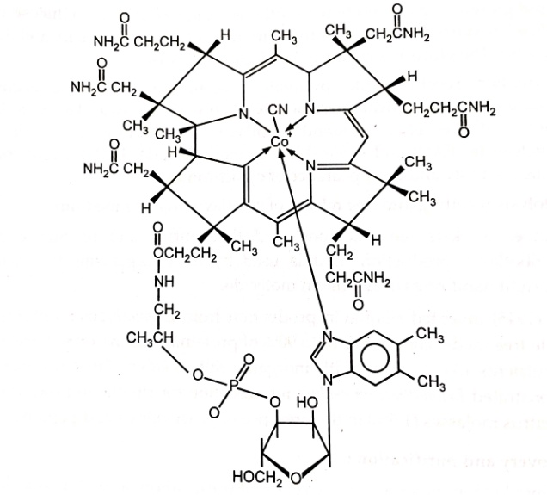
Vitamin B₁₂ (Cobamide)
Fig. 19: Chemistry of vitamin B₁₂

The discovery of vitamin B₁₂resulted from isolation of a curative agent from liver for treatment of pernicious anemia in man. For 20 years, efforts were made to isolate this compound and finally Rickes et. al. (1948) recovered and crystallized it as vitamin B₁₂.
Chemically vitamin B₁₂ is a group of closely related cobamides which demonstrates varying effects on animal growth, known to increase utilization of vegetable proteins. It is red, cobalt containing substance that has characteristic UV absorbance, affected acid and base, destroyed by extreme pH, light and reducing agents.
The molecule has modified porphyrin unit (a class that include heme of hemoglobin and chlorophyll of plants) called corrin ring, nearly polar, and co-ordinating a trivalent cobalt ion, cyanide ion is co-ordinated to cobalt. The corrin is derived from porphobilinogen units, the biogenetic precursor of the porphyrin system. CH₂ COOH
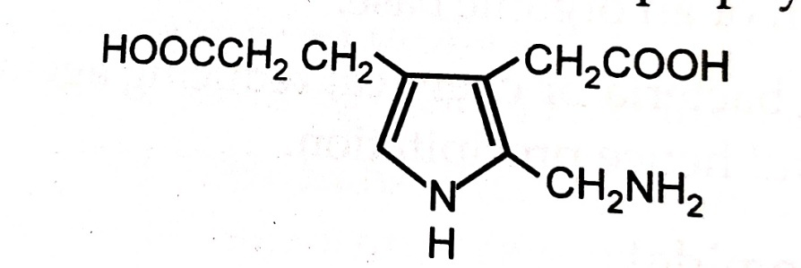

Fig. 20.: Structure of porphobilinogen

Many microorganisms produce at least small amount of cobamide, particularly bacteria and actinomycetes. Industrial production of vitamin B2 is achieved by submerged cultivation of following micro-organisms with aeration and agitation, lasting for 3 to 5 days,

Table. 6. Micro-organism species.
Streptomyces griseus
Streptomyces olivaceus
Bacillus megaterium
Bacillus coagulans
Pseudomonas dentrificans
Propionibacterium freudenreschii
Propionibacterium shermanii
Proteus and Pseudomonas sp.

Fermentative production from Streptomyces olivaceus:
(a) Inoculum development:
It is done by maintaining organisms on slant culture and inoculating then into 100 to 250 ml of broth contained in Erlenmeyer flasks. Organisms from these flasks, kept on shaker are inoculated into inoculation tank either once or twice or thrice. The composition medium, Bennett's agar is employed in the inoculum development,

Table. 7. Composition medium, Bennett's agar is employed in the inoculum
Yeast extract | 1 gm/lit
Beef extract | 1 gm/lit
N-Zamine A  (enzymatic hydrolysate of casein) | 2 gm/lit
Glucose | 10 gm/lit
Agar | 15 gm/lit
Distilled water | 1000 ml
pH adjusted to 7.3 with NaOH

(b) Production media:
Production medium employed in the cobamide fermentation usually consists of 'C' source, 'N' source, source of cobalt and other sources. 5% of the inoculum in production medium is found satisfactory for fermentation.

Table. 8. Production medium
Distiller's soluble | 4%
Dextrose | 0.5 to 1%
CaCO3 | 0.5%
COCl2 , 6H2O | 1.5 to 10 ppm.
pH adjusted to 7.0 with NaOH

(c). Fermentation monitoring:
1. Temperature: about 80°F.
2. pH: There are few pH falls in the process. In the first 24 h it is due to rapid sugar consumption, which rises after 2 to 4 days due to lyses of mycelium. pH is maintained at 5 with HSO, and small amount of reducing agent like sodium sulphite.
3. Aeration : 0.5 volume air/volume medium/min.
4. Agitation
5. Foaming: As it is serious problem in cobamide fermentation, many anti foaming agents like soybean oil, corn oil, lard oil and silicones are employed in controlling the foam formation.
6. Sterility.
(d) Product recovery and purification:
Various steps employed in isolation of cobamide from mycelium and fermenter content and purifications are.
1. Heating fermeter contents to boiling at pH 5 or below to liberate cobamide from mycelium.
2. Filtration to remove mycelium.
3. Treatment with cyanide to convert cobalmin to cynocobalmin.
4. Adsorption on activated charcoal, bentonite. Fuller's earth, ion-exchange resins and then elution with aqueous mixture solvents of organic bases to HCl.
5. Single step extraction into an organic solvent (E.g. phenol).
6. Counter-current extraction between cresol, amylphenol or benzyl alcohol and water.
7. Precipitation as copper or zinc-cyanide-cynocobalmin.
8. Purification of zinc salts after dissolving in the slight acid solution and then raising pH to bring about the precipitation of zinc hydroxide, which eliminates many impurities.
9. Chromatography on alumina and final crystallization from methanol-acetone, ethanol-acetone or acetone-water.
To use as a feed supplement, vitamin B2 concentrates need to be obtained by evaporating final fermented broth to dryness. Broths containing 30% of solids are evaporated in vacuum to the solid content of 15 to 20% and then either drum or spray dried.

D. Microbial Enzymes:
Micro-organisms are the most convenient source of enzymes. They are adaptive or constitutive. A constitutive enzyme is always produced by the cell in its usable amount regardless of presence or absence of substrate. Adaptive enzymes are produced only in response to the presence of particular enzyme substrate. They can be intra-cellular, typically in the case of E. coli and extra-cellular as in Bacillus species.
Commercial production of microbial enzymes utilizes various fungi, bacteria and yeast, and enzymes from these sources may vary somewhat in pH and temperature optima as well as in characteristics. There is great variation in various genera for their ability to produce specific enzyme, which extends to the species and even to strains within the species.
Genetic stability of microbial strains plays important role and hence must be preserved in such a manner so as to maintain their enzyme producing ability. So they are carefully selected for their enzyme producing ability and genetic stability under particular conditions employed in the fermentation.
Commercially produced microbial enzymes and their sources are discussed in plant cell culture. Fermentative production of enzymes from microbial sources is economical on large scale due to use of in-expensive media and short fermentation cycles. Uniformity in each batch can be ensured, the harvest can be conveniently scheduled to fit DSPs, choice of enzyme to be fermented can be scheduled to match sales demand and enzyme productivity and application can be improved many fold by fermentation process development, strain improvement and by genetic engineering. Entirely novel enzymes can also be formed.
a. Biochemical fundamentals:
In optimizing enzyme production in microbial fermentation, an understanding of genetic regulation of enzyme synthesis becomes necessary. There are many important factors that can influence enzyme biosynthesis,
1. Enzyme induction:
Enzyme synthesis is normally repressed and they are only produced in the presence of an inducer. Inducer is normally the substrate in the presence of which cell produces enzyme. Catabolic enzymes are generally inducible e.g. invertase in the presence of sucrose, amylase in the presence of starch and B-glycosidase in the presence of galactoside. In some enzyme biosynthesis product or its intermediate works as an inducer e.g. penicillin G amidase in presence of phenylacetate, lipase in presence of fatty acids, xylanases in presence of xylobiose etc. Co-enzymes can even act as inducer E.g. thiamine for pyruvate-decarboxylase.
However addition of costly inducers (pre-sterilized) make the process expensive and hence the process can be modified by use of constitutive mutants, regulatory mutants that produce enzymes without inducer dependency.
2. Feedback repression:
Accumulation of final product can cause repression of the enzyme synthesis. The problem is solved by employing mutants lacking feedback repression.
3. Nutrient repression:
The cell produces enzyme for the assimilation of most easily metabolized or most readily available form of nutrient. Hence production of un-necessary enzymes can be controlled by nutrient repression. The best example is control caused by the presence of glucose where it shut downs the production of enzymes involved in the metabolism of other related and non related compounds.
Recombinant techniques have had profound effect on microbial production of enzymes. The technique has allowed the transfer of genes producing useful enzymes from one organisms to the more stable production host micro-organisms, the industrial fermentation of which is then carried out.
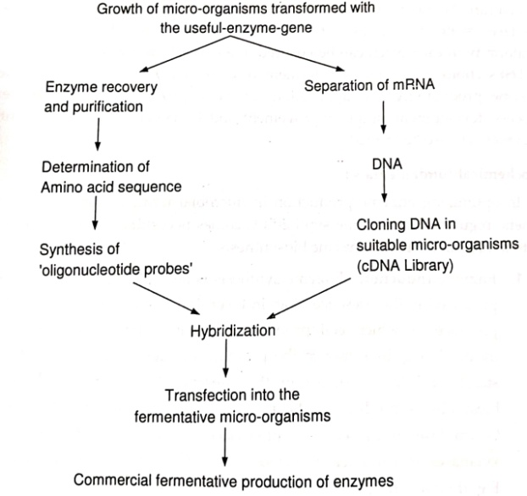
Fig. 21. Cloning strategy for enzyme.

b. Fermentation process:
Selection of source of micro-organisms for enzyme production is done to achieve desired properties like high enzyme yield, stability, independence of inducers, good and easy recovery etc.
Medial ingredients are limited to the substances that are readily available in large quantities at low cost and are nutritionally safe. Some of the commonly used substrates are starch hydrolysate, molasses, corn-steep liquor, whey, cereals etc. Enzymes are commercially produced by
1. Solid substrate method: The enzyme producing micro-organisms are cultured on the surface of suitable semisolid substrate, usually moist wheat or rice bran with added salts, in the metal trays up to a depth of 10 cm, at controlled conditions of indirect aeration, pH, temperature and most importantly sterility. Examples of enzymes produced by solid substrate fermentation are fungal amylase (Aspergillus oryzae), protease (Aspergillus oryzae, A. niger), pectinase (Aspergillus niger), lactase (Aspergillus oryzae), rennet (Mucor pusillus) etc.
The disadvantages of the method are,
a) Requirement of more space
b) Requirement of more labour
c) Greater risk of contamination
d) Non-compatibility with modern methods of control
e) Non-compatibility with automation.
2. Submerged liquid system: Is widely used method in microbial enzyme production. The system is same as in antibiotic fermentation; composed of cylindrical tank of stainless steel (10-50 m³) equipped with an agitator, aeration device, cooling system and associated system to measure and control various parameters of fermentation.
After completion of fermentation, fermenter liquor (after cell disintegration in intracellular enzymes) is subjected to rapid cooling at about 5°C to reduce deterioration. Followed by a separation of microbial cells and cell debris by centrifugation and or filtration at controlled pH. The process can be improved by use of filter-aids like calcium phosphate, diatomaceous earth etc. The enzymes are then separated and purified from broth by precipitation with acetone, alcohol or inorganic salts (ammonium/sodium sulphate), fractional precipitation, chromatography, freeze drying etc. The method overcomes drawbacks of surface fermentation but requires high initial cost investment.
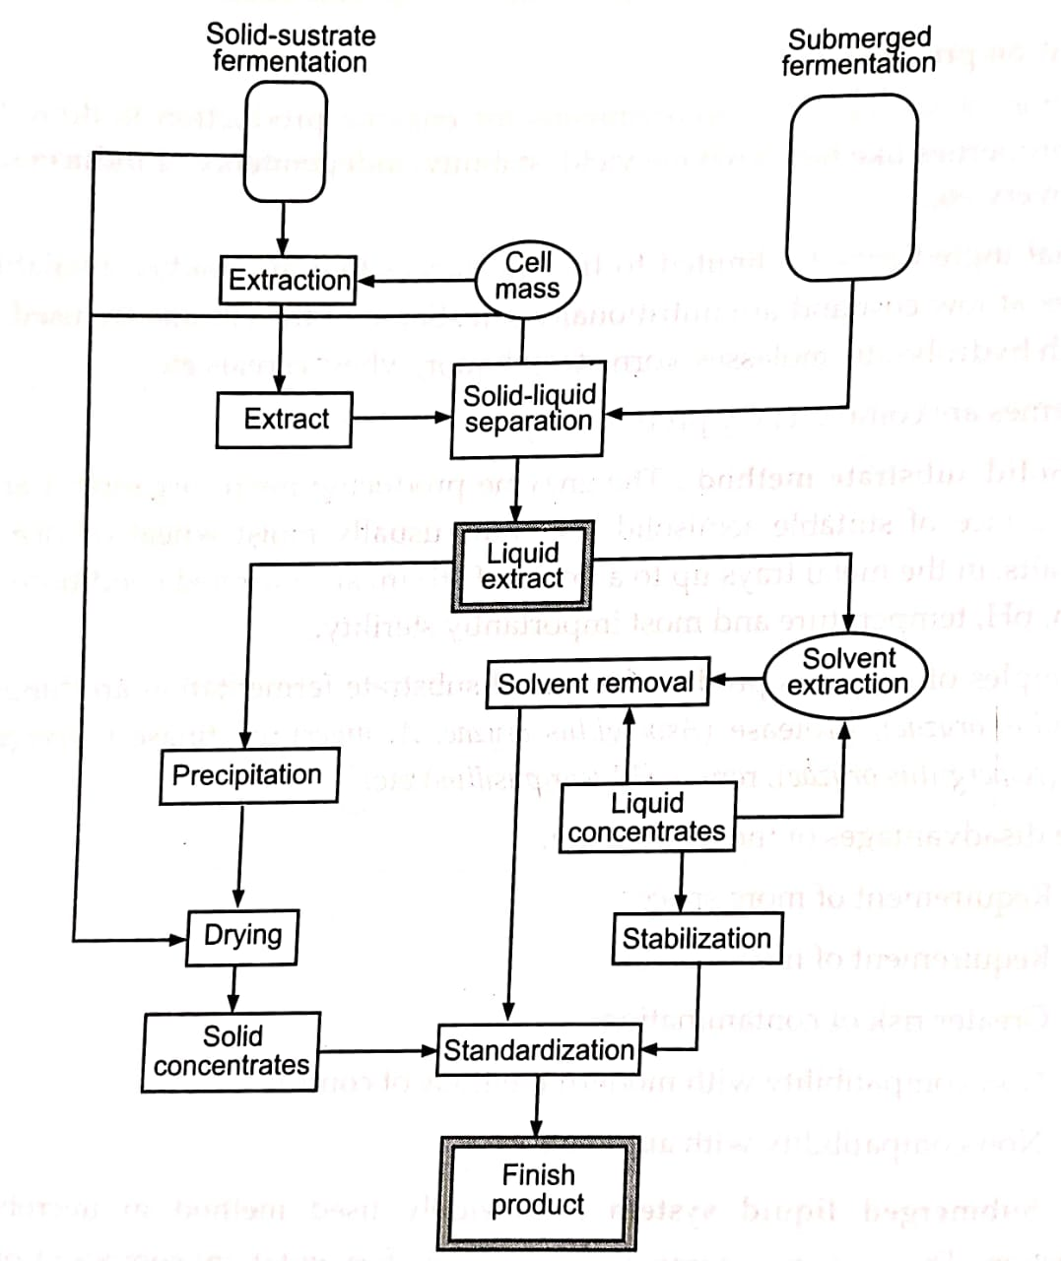
Fig. 22. Layout of enzyme production and purification.

E.g. α-Amylases:
It is produced as fungal a-amylases from Aspergillus niger B., A. oryzae and bacterial a-amylases from Bacillus amyloliquefaceins and Bacillus licheniformis. Fungal a-amylases can be synthesized by surface culture fermentation and submerged liquid system. Media employed for submerged fermentation is,
Table. 9. Media employed for submerged fermentation

Corn starch | 24 g/lit
Corn-steep liquor | 36 g/lit
KCl | 0.2 g/lit
Na2HPO4 | 4.7 g/lit
CaCl2 | 1 g/lit
MgCl2.6H₂O | 0.2 g/lit

Table. 10. Bacterial a-amylase is produced by submerged culture by use of following media
Ground soy meal | 1.85%
Yeast extract | 1.5%
Distiller's soluble | 0.76%
Casein hydrolysate | 0.65%
Lactose | 4.75%
MgSO4, 7H2O | 0.04%
Antifoaming agent | 0.05%
Water | 90%

Fermentation monitors are maintained at temperature 30 to 40°C and pH 7 as amylase is denatured at pH below 6. Production begins when the bacterial count reaches 10° to 100 cells per ml after 10 to 20 h, and continues for other 100 to 150 h. Bacterial α-amylases are preserved in 20% of NaCl.

Bibliography:
- Anathnarayan R, Panikar C. K. J., Textbook of Microbiology, 6 Edition, 2000, Orient Longman.

- Bainse William, Biotechnology from A to Z. 2 Edition, 2002. Oxford University Press.

- Berger S. L., et. al., Methods in Enzymology. 1992 Academic Press Inc., CA. Bills D. D., Kung S. D.. Biotechnology and Food Safety Boston, Mass: 1990, Butterworth-Heinemann Publishing.

- Bourgaize David, Jewell T. R., Buiser R. G., Biotechnology Demystifying the Concepts, 2003, Pearson Education (Singapore) Pvt. Ltd.

- British Pharmacopoeia, 1993, London, HMSO.

- Brooks G., Biotechnology in Health Care, 1 Edition, 1998, Pharmaceutical Press, London.

- Carter S. J., Cooper and Gunn's Tutorial Pharmacy, 6 Edition, 1996, CBS Publishers and Distributors, Delhi. Casida L. E., Industrial Microbiology, 2000, New Age International, Delhi.

- Collins H., Beale A. J.. Safety in Industrial Microbiology and Biotechnology 1992. U.K.

- De Kalyan Kumar, Plant Tissue Culture, 1" Edition, 1997, New Central Book Agency (P) Ltd. Foye W. O., Lemke T. L., Williams D. A., Principles of Medicinal Chemistry. 4th Edition, 1995, Lippincott Williams and Wilkins, New York.

- Frazier W. C., Westhoff D. C., Food Microbiology, 4th Edition, Tata McGraw Hill, New Delhi. Freifelder Molecular Biology, 2nd Edition, 1998, Narosa Publishing House.

- Gennaro A. R., Remington-the Science and Practice of Pharmacy, 20 Edition, 2002. Lippincott Williams and Wilkins, New York.

- Glick B., Pasternak J., Molecular Biology: Principles and Applications of Recombinant-DNA, 3rd Edition, 2003, ASM Press, Washington.

- Gupta P. K., Elements of Biotechnology, 1 Edition, 2001, Rastogi Pub., Meerut Halvorson H. O., Pramer D., and Rogul M., Engineered Organisms in the Environment: 1985. Scientific Issues

- Higgins, Best D.J. and Jones J., Biotechnology: Principles and Applications, 1985, Blackwell Scientific Publications, Boston, MA.

- Hugo W. B., Russell A. D., Pharmaceutical Microbiology, 6 Edition, 1998, Backwell Science Jay James M., Modern Food Microbiology, 4th Edition, 1996, CBS Publishers and Distributors, Delhi.

- Kumar H. D., Textbook of Biotechnology, 2 Edition, 1991, Affiliated East West Press Pvt. Ltd., New Delhi.

- Kung S. D., Bills D. D., and Quatrano R, Biotechnology and Food Quality, Boston, Mass: 1989, Butterworths Publishing.

- Lindsay R. D., Willis B. J., Biotechnology Challenges in the Flavour and Food Industry, New York, NY: 1989, Elsevier Applied Science. Mansi E. L., Bryce C. F. A., Fermentation Microbiology and Biotechnology, 2002, Taylor and Francis Group.

- Nelson D., Cox M., Lehninger Principles of Biochemistry, 3 Edition, 1993, CBS Publishers and Distributors, Delhi, Patel A. H., Industrial Microbiology, 1984, Macmillan Ltd., Delhi.

- Pharmacopoeia of India, 1985, Govt. of India, Ministry of Health and Family Welfare. Prasad B., Veterinary Pharmaceuticals, 4th Edition, 2001, CBS Publishers and Distributors, Delhi. .

- Ratledge Colin and Kristiansen Bjorn, Basic Biotechnology, 2003, Cambridge University Press. Razdan M. K., An Introduction to Plant Tissue Culture, 1993, Oxford IBH Pub., New Delhi.

- Reed Gerald, Prescott Dunn's Industrial Microbiology, 4th Edition, 1987, CBS Publishers and Distributors, Delhi. Roitt I., Brostoff J., Male D., Immunology, 6th Edition, 2002, Masby Pub., New York.

- Rudolf F. B., Mcintire L. V., Biotechnology Science, Engineering and Ethical Challenges for the 21" Century, Joseph Henry Press.

- Schmid Rolf D., Pocket Guide to Biotechnology and Genetic Engineering, 2003, Wiley-VCH, Verlag GmbH and Co., KGaA, Weinheim. Singh B. D., Biotechnology, 2001, Kalyani Publisher.

- Smith John, Biotechnology, 3 Edition, 1990, Cambridge University Press, Stanbury P. F., Whitekar A. and Hall S. J., Principles of Fermentation Technology. 2nd Edition, 1997, Aditya Books (P) Ltd., New Delhi.

- Tortora G., Funke B., Case C., Microbiology-An Introduction, 5 Edition, 1995, The Benjamin Cummings Pub. Company Inc.

- Trevan Keshav, Biotechnology, 4th Edition, 1990, New Age International Ltd. Pub., New Delhi.

- Trevan M. D., Boffey S., Goulding K., Biotechnology the Biological Principles, 7th Edition, 1997, Tata McGraw Hill, New Delhi.

- Vandamme E. J., Biotechnology of Industrial Antibiotics, Dekker. Vyas S. P., Kolhi D. V., Methods in Biotechnology and Bioengineering. 1 Edition, 2002, CBS Publishers and Distributors, Delhi. Vyas, S. P., Dixit V. K., Pharmaceutical Biotechnology, 1 Edition, 1999, CBS Publishers and Distributors, Delhi.

- Walker J. M., Gingold E. B., Molecular Biology and Biotechnology, 1 Edition, 1999, Panima Pub., New Delhi, Bangalore.

- Wang C.Y. Huang L (1987a) Biochim. Biophys. Res. Commun., 147, 980-895 Wang CY. Huang L (1987b) Proc. Natl Acad Sci. USA, 84, 7851-7853,Wang, CY. Huang L (1989) Biochemistry. 28, 9508-9514

- Wang, K.C. Verret, C.R. Ya, RK, Gershon, RK. Lee, S. (1987) Immunobiology, 174, 139-145 Wang, S. Lee. R.J., Cauchon, G., Gorenstein, D.G. Low, P.S. (1995) Proc. Natl. Acad. Sci. U.S.A., 92, 3318 3322 Wasser, N.M.. Alving, CR. Richards, RL. (1994) Immunomethods. 4, 217-222

- Weber, B.A. Border, N. Regen, SL (1987) J.Am. Chem. Soc., 119, 4419-4421

- Weinstein, 1 N. Magin R.L. Yatvin, M.B., Zaharko, D.S. (1979) Science, 204, 188-191

- Weinstein, J.N. Yoshikami, S., Henkart, P. Blumenthal. R. Hagins, W.A. (1977) Science, 189, 485.

- Weir, D.M. (1980) Immunol. Today, 1, 45-51. Weissmann, G. Bloom garden, D., Kaplan, R., Cohen, C., Hoffstein, S., Collins, T., Gotlieb, A., Nagle, D. (1975) Proc. Natl. Acad. Sci. USA, 72(1), 88-92.

- Widder, K.J. Senyei, AE, Ranney, D.F. (1979) Adv. Pharmacol. Chemother. 16, 216

- Wolff, B. Gregoriadis, G. (1984) Biochim. Biophys. Acta., 802, 259-273.

- Wright, JJ, Illum, L (1992) Active targeting of microcapsules and microspheres to specific regions. In: Microcapsules and Nanoparticles in Medicine and Pharmacy, Donbrow, M. (Ed.) CRC Press, Boca Raton, 281-297.

- Yachi, K. Kikuchi, H. Yamauch, H., Hirota, S. Tomikawa, M. (1995) J. Microencapsulation, 12(4), 377-388 Yamauchi, H., Yano, T., Kato, T., Tanaka, L, Nakabayashi, S., Higashi, K., Miyoshi, S., Yamada, H. (1995) Int. J. Pharm., 113, 141-148.

- Yamazaki, N., Kojima, S., Gabius, S., Gobius, HJ. (1992) Int. J. Biochem., 24, 99-107.

- Yatvin, M.B., Krentz, W., Horwitz, B.A., Shinitzky, M. (1980) Science, 210, 1253-1255 Yatvin, M.B. Muhlensiepen, H., Porschen,w, Weinstein, J.N., Feinendgen, L.E. (1981) Cancer Reserch, 41, 1602-1607
- Yeung, V.W., Nixon, J.R. (1988) J. Microencapsulation, 5. 331-337.

