Biosensor for tissue engineering: Bio-analytical tool in Therapeutics
, Dr. Harjinderpal Singh Kalsi¹, Dr. Gaganjyot Kaur²
1. Department of Physis, Guru Nanak Khalsa college Art, science, and commerce Autonomous, Matunga, Mumbai 400019, India.
2. Guru Nanak Institute for Research and development, Guru Nanak Khalsa college of Art, Science and Commerce Autonomous, Mumbai- 400019, India
Abstract:
In recent years biosensors have gained attention in medicine, nanotechnology, and tissue engineering (TE) in addition to other fields that include food, beverages, environmental and agricultural applications. TE and regenerative medicine have presented tremendous potential for the development of engineered tissue constructs that help restore the damaged functions of diseased or damaged tissue and organs. Biosensors have become an integral part of TE systems especially microfluidic tissue engineering models as they can sense specific biological molecules within the miniaturized tissue constructs in real-time, through incredibly sensitive optical, electrochemical, or acoustic sensor methods, very low concentration levels can be detected. In recent protocols for TE, we face the challenges of incapability to control/ monitor cellular functions and various properties (biological, mechanical, electrochemical and others) which has increased the demand and led to the development of more sensitive nano and carbon based biosensors. Based on recent advances in this domain the chapter aims to explain the basic biosensor models that are being used in tissue engineering. Concepts of nano-biosensor, bringing a new boon to this tool by combining biological signal and therapeutic delivery systems for in-vivo screening and treatment. Through this chapter we focus on the new trends which have been developed for increasing specificity and sensitivity of biosensors including carbon-nanotubes (CNTs), quantum dots (QDo), graphene oxide biosensor, Micro and Nano electromechanical system MEMS/NEMS. Carbon nanotubes (CNTs) provide support for immobilization of biological molecules at their superficial surface and combine electrochemical characteristics properties which make them suited for the transduction of biological signals associated with the recognition of biomolecules in disorder. The binding, conducting properties of gold, metallic nanoparticles (GNPs, SNPs) and metal oxides provide antimicrobial properties. The fluorescence properties of quantum dots have made them very useful in TE applications.
Key words: Tissue engineering, Nano biosensor, carbonnantubes, quantum dots.

- Introduction to Biosensor and Tissue Engineering
Engineering and sensing technology, which also covers biology, chemistry, and physics, now have a competitive edge thanks to biosensors. In essence, biosensors are made up of biological samples that serve as receptors, transducers, and detectors for the chemical, electrical, and optical changes that occur within them and are then turned into detectable signals. [1] The area of tissue engineering is extremely fascinating and multifaceted, and it plays a crucial part in fusing the philosophies of alternative materials to either replace damaged tissue or encourage endogenous regeneration. The first selective and specific biosensor was created by Clark and Lyons in 1962. They created a biosensor called a glucose sensor to assess blood glucose levels using the glucose oxidase enzyme, which also corresponded with blood glucose levels.[2]. The tissue engineering has become major technology in the medical era to overcome the limitations of graft and organ rejection, transplantation and repair of functional tissue and the specificities in the site of regeneration. The receptors in biosensor are of biological elements such as DNA, protein, RNA metabolites, whole cell organelles or cells and transducers like electrochemical, optical, piezoelectric, acoustics and calorimetric. Medically, biosensors are intended for analysis of diseases in more prices and accurate for detecting pathogens toxins and tumor and biomarkers to identify the onset of various disorders at an initial stage. Biosensors have shown the tremendous potential in the field of tissue engineering. In the medical period, tissue engineering has developed into a prominent technology to get beyond the issues with graft and organ rejection, transplantation, functional tissue repair, and site-specific regeneration. Biosensors use transducers like electrochemical, optical, piezoelectric, acoustic, and calorimetric devices as their receptors, which can be biological materials like DNA, protein, RNA metabolites, complete cell organelles, or cells. In the medical field, biosensors are designed to analyze diseases more cheaply and accurately by seeing viruses, poisons, tumor’s, and biomarkers to spot the start of different conditions at an early stage. Tissue engineering has a tons of promise, as demonstrated by biosensors.

- Basic Approach to Nano-Biosensor: background and concepts
Nanotechnology offers a unique solution to the detection of biomolecules in biosensors. The nanofiber sensors have a much higher surface-area-to-volume ratio than their macro-scale counterparts and can be easily integrated into other devices such as lab-on-a-chip systems.[3] Nano biosensor is a source for the analysis of biological agents such as antibodies, nucleic acids, bacteria, and metabolites. Its purpose is to bind biomolecules of interest to bioreceptors, and to regulate the physiochemical signal associated with binding. Later, the transducer captures and converts the physiochemical signal into an electrical signal. By definition “Nano biosensors are devices that measure a biochemical or biological event using any electronic, optical, or magnetic technology through a compact probe”(fig 1).[5] They also possess electrochemical properties that allow them to manifest biological signaling and transduction mechanisms. These properties make them ideal for use in biosensing.[6] The nanobiosensor may be homogeneous or heterogeneous, ranging from 1-100nm making them exclusively sensitive in diagnosis.[7] Most electronic and mechanical properties of some nanomaterials including nanotubes, nanorods, nanowires, nanoparticles, and thin films consisting of crystalline matter are well known and utilized in improving transduction mechanisms and biological signaling.[4]. In the biomedical, nanoparticles are used for controlled drug delivery, imaging of specific sites, probing of DNA structures, identifying biomolecular, gene/drug delivery, photothermal ablation of cells, and, most recently, TE.[8]. It has improved the mechanical and biochemical performance for instance gold nanoparticles have properties of conjugation and conductance which have been extensively used, the antimicrobial properties of silver and other metallic/metal oxides nanoparticles, the fluorescence properties of quantum dots, and the unique electromechanical properties of carbon nanotubes (CNTs) have made them very useful in abundant TE applications.[3]
Biomolecules
Transducer
Bioreceptor
Detector
signal

Fig 1: General representation of Nanobiosensor

  - Carbon Nanotube Biosensor:
  - Carbon nanotubes (CNTs) are also known as bucky tubes, and in 1991 a Japanese scientist named Sumio Iijima marked evidence for multi-walled (MCNTs), followed by single-walled CNTs [9]. The cavities of CNTs provide a chemically inert environment and are also a potential site for new nanobiosensor technologies and nanoreactor magnetic/electromagnetic responses via electromagnetic or electrical impulses. The result is a stable and rigid fiber. It imparts both external and internal functionalization properties by providing a base for bonding other compounds to the surface or shell without loss of properties. After binding, these CNTs can cross cell membranes and enter cells, making them an excellent choice for use as biosensors. [9] Generally he falls into two types. Single-walled carbon nanotubes (SWNTs), in which a single sheet of graphene is “rolled” into a tube, and multi-walled carbon nanotubes (MWNTs), which consist of multiple concentric tubes. share a common axis. MWNTs can have different morphologies, such as 'hollow tubes', 'bamboo' and 'herringbone', depending on how they are manufactured. These tubes have sidewalls made of a hexagonal lattice of carbon atoms, similar to the atomic planes of graphene. Typically, half of the fullerene-like molecules are layered on both ends of the tube. The geometry of the carbon atoms at the interface of the cylinder is the basis for SWNT classification. Most SWNTs have a chair (m = n) or zigzag (m = 0) conformation, whereas most SWNTs are chiral (m 6 = n) [12]– [14] (Fig. 2). .
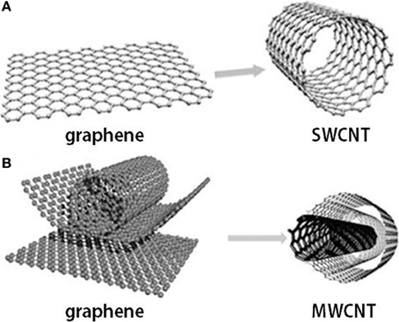

Figure 2: Graphene and carbon nanotubes as (A) single-wall carbon nanotube (SWCNT) and (B) multi-wall carbon nanotube (MWCNT) structures[15] The Rise of Carbon Nanotube Electronics - Embedded Computing Design
Considering the demand of CNTs in nanobiosensors, three methods have been proposed to synthesize them. Pressure results in highly efficient and purified forms. Functionalization of CNTs is needed because they have a large volume and a stable structure of inner tubes, which makes them insoluble in many solvents. Scientists have used three approaches to achieve this, namely chemical groups, and the backbone of CNTs, 2. adsorption of various functional molecules onto CNTs, and 3. inclusion filling of the inner cavities of CNTs. [16][17]. Therefore, for biosensor applications, surfaces are modified by covalent and non-covalent immobilization of gold, silver, platinum, graphene, glass, and silica particles, thereby increasing solubility and electron velocity transfer. [18], [19] The surface modification of CNTs has excellent properties in forming subtle functional groups that prevent accumulation, improve host compatibility, and enhance solubility in various solvents. Electrochemical CNTs are designed to detect ions, metabolites, and protein biomarkers. For example, several CNT-glucose biosensors based on the binding of glucose oxidase have been constructed. [9] Functionalized CNT-based electrochemical biosensors were further developed for nitric oxide detection, epinephrine sensing, and dopamine monitoring in the rat striatum [9], [18] recent findings developed various amperometric biosensors based on CNT-modified electrodes. Fei et al. performed detection of cysteine ​​on his Pt/CNT electrodes by cyclic voltammetry. Antioch et al. reported an amperometric CNT biosensor developed by coating CNTs with a polymer of dihydroxybenzaldehyde, and Fayazfar et al. reported a new platform based on the electrochemical growth of gold nanoparticles on. Recently, novel nanoimmunosensors have been developed by immobilizing recombinant antibodies or antibody fragments on CNTs and nanowires., nanoparticles, and quantum dots, thereby enhancing binding capacity and sensitivity thresholds compared to more traditional biosensors.[9]

Fig 3: carbon Nanotube: Cancer detection, HIV virus diagnosis, DNA sensing, Glucose monitoring and Enzyme detection

  - Quantum Dots Based Biosensor:
“A semiconductor crystal of nanometer dimensions with distinctive conductive properties determined by its size”. As they have exceptional properties of optical and fluorescence, they are used extensively in biosensing since the 1980s. It was discovered by Ekimov. QDs have high quantum yields, narrow band emission with a wide-ranging excitation wavelength, resistance to photobleaching, relatively lengthy luminescence lifetime (>10 ns), and a high surface-area-to-volume ratio that allows efficient functionalization with biomolecules, (fig 4).[20]

Fig 4: Relation of quantum dot size and wavelength excitation to the frequency
Quantum dots are semiconductors made of CdTe, CdSe, GaAs, PbSe, InP, etc., with diameters ranging from 2 to 10 nm. Because heavy metals are involved in their synthesis, quantum dots are toxic and biocompatible. considered to be of low quality. Various approaches have been pursued to achieve biocompatibility. Additionally, toxicity can be reduced by covering or coating the QD core envelope with a biocompatible material or polymer layer (such as PEG). These smart dots find application in immunofluorescence assays due to the very small amount required to generate a signal. Love Al continuously quantified blood nitrate ceruloplasmin using lateral flow strips containing copper-containing proteins. It has very important applications in pathogen detection. E. coli demonstrated by a combination of immunomagnetic separation (IMS) and QD fluorescence [4][20]. Biotinylated antibody-modified iron oxide core/gold shell (Fe3O4@Au) magnetic nanoparticles captured E. coli in solution, and then secondary antibody-modified chitosan-coated CdTe quantum dots ( CdTe-QDs) were captured. Bacteria were removed from the matrix using IMS technology for fluorescence analysis. Xu et al. Demonstrated that various combinations of green, blue, and red QDs can be used to successfully discriminate and specifically label DNA target sequences properties of quantum internment and zig-zag edge effects. To create electrical, photoluminescence, electrochemical, and electrochemiluminescence detectors for diverse chemical and biological studies, ultra-nanosized GDots with a broad variety of excitation/emission spectra are interesting alternatives. The basic characteristics of Gdots, including as form, structure, activation, pH, energy gap, degree of oxidation, surface modification, and doping of S and N, all affect their appearance. Through charge-to-charge interactions, the synthesized Gdots are highly useful for detecting any positively charged ions (cationic), including Ag2+ and Fe3+. The detection of Cd2+, cysteine, and ATP was explored using a Gdot-based electrochemiluminescence sensor. Gdots' low cytotoxicity, low cost, great solubility, and simplicity of labelling make them an appealing material to use in the creation of innovative electrochemical biosensors. [4][21]
  - MEM/NEM Biosensor:
A contemporary standard of chemical and biological sensors built on micro and nano cantilevers has been made possible by the remarkable advancements in micro and nano-electromechanical systems (MEMS; NEMS). These sensors take advantage of the mechanical energy that occurs naturally and is used as a platform for extremely sensitive chemical and biological sensors. These nanosystems offer more sensitive, specific, accurate, and profitable devices with excellent reproducibility. Three components make up NEMS/MEMS cantilever-based biosensors: Cantilever transducer element, sensing biolayer, and readout system are the first three components. To create micro- and nano-cantilevers, materials as diverse as silicon oxide, silicon nitride, polycrystalline silicon (polysilicon), SU-8, and metal sheets can be used in bulk or surface micromachining.

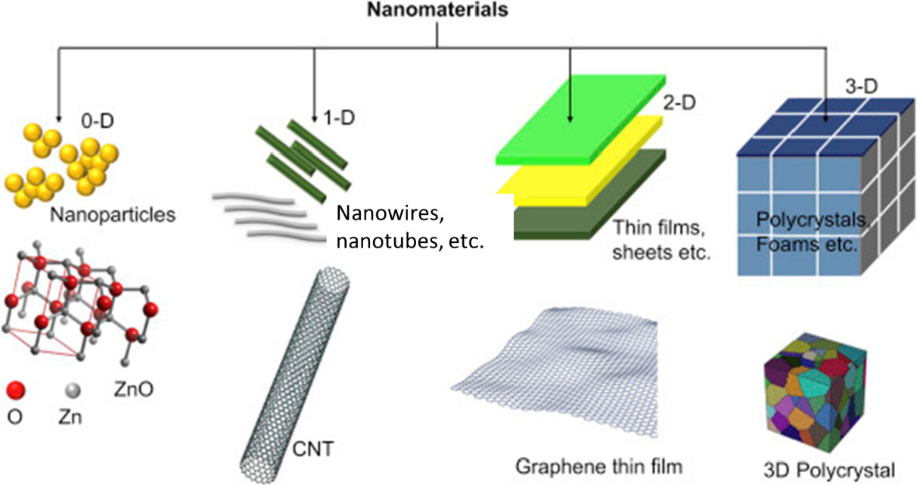
Fig 5:Classification of nanomaterial according to their dimensions (Malhotra & Ali, 2018).Figure adapted with permission from Elsevier
3. Epitomes of Nano-Biosensor
To evaluate drug-target interactions, there is an increasing need for high-throughput, low-cost, extremely sensitive approaches. Biological agents such as antibodies, nucleic acids, viruses, and metabolites can all be found using a nanobiosensor. To transmit data and information about the behaviour and characteristics of nanoscale particles to the macroscopic level, nanosensors operate on the nanoscale, which is measured at the level of a single molecule at a distance of 10⁻⁹ m. Nanosensors can be used to monitor physical factors like temperature at the nanoscale or to detect chemical or mechanical information, such as the presence of chemical species and nanoparticles. Nanosensors have a variety of uses, including I nanochips for identity authentication, (ii) active transport tracking devices, and (iii) virus detection and hygiene/disease control in cattle., food inspection, intelligent food packing, intelligent storage, and so forth. The basic idea is to bind desired bioanalytes to bioreceptors, which then modifies the physiochemical signal connected to the binding.
Different types of nanosensors follow different detection principles. Optical nanosensors measure changes in light intensity. Electrochemical nanosensors measure changes in electrical distribution. Piezoelectric nanosensors measure mass changes. Colorimetric nanosensors measure thermal changes. When ammonia molecules are present in carbon nanotube-based sensors, they react with water vapor and donate electrons, making the carbon nanotubes more conductive. In contrast, the presence of nitrogen dioxide molecules reduces the conductivity of carbon nanotubes by stripping electrons from the nanotubes.
Recent advances in experimental and analytical techniques have enabled researchers to explore the limits of how nanostructures work. These studies will help determine whether these devices will perform consistently throughout their operating life and define their suitability for future applications. Cantilever biosensors are ultrasensitive electromechanical sensors that have been used for label-free detection of numerous biological entities. They have emerged as attractive techniques for high-throughput drug discovery applications.

  - Nanowire nanosensors
Nanowire-based nanosensors have emerged as a powerful tool due to their ultrasensitivity, ultraselectivity, and direct detection of chemical and biological species. These nanosensors can detect proteins, small organic molecules that bind to proteins, viruses, and DNA, and are used in drug discovery, disease diagnosis and genetic testing.
Carbon nanotubes (CNTs) are one-dimensional (1-D) nanoscale systems based on graphene sheets and exhibit exclusive cloth homes starting from mechanical to digital tool homes [20,21]. The graphene-based shape of CNTs offers them attributes together with very excessive mechanical energy, ballistic fee transport, and many different electronic device homes. since CNT structure is derived from graphene [22], all carbon atoms make up the complete surface, making the CNTs extra specific for sensor studies. Any alternate in surface structure for the duration of interplay with reactant molecules outcomes in a trade of their digital residences, enabling detection of the analyte molecules under look at. In fact, the CNTs offer excellent detection sensitivity for a number of analytes which include gaseous molecules, natural rate-switch complexes, proteins, DNA and antibodies. CNT is an amazing electric and thermal conductor. in addition, its small length leaves room for the improvement of an extremely small sensor, that is inside the micron or even nano range. CNT arrays are hierarchical systems with advantages over isolated structures. CNT-array-primarily based nanoelectrodes, known as nanoelectrode arrays (NEAs) had been investigated for his or her applications which includes chemical and organic sensors [23-26].
  - Cantilever Sensors
Applications for a wide variety of new sensors in the detection of different analytes in liquid, gaseous, or vacuum media are abundant using microcantilever-based sensors. Without the necessity for labelling before analysis, these sensors provide great sensitivity, cheap cost, rapid response, and high specificity. Micro-cantilever sensors can also be employed with sharp tips and are derived from atomic force microscopy (AFM) [27], which can scan surfaces with nanoscale resolution by measuring tiny forces between the sharp tip of the cantilever and the surface. No gratuity is required. a turn-up example would be, it is used to detect biochemical reactions occurring at the cantilever surface by measuring the nanomechanical response [28].

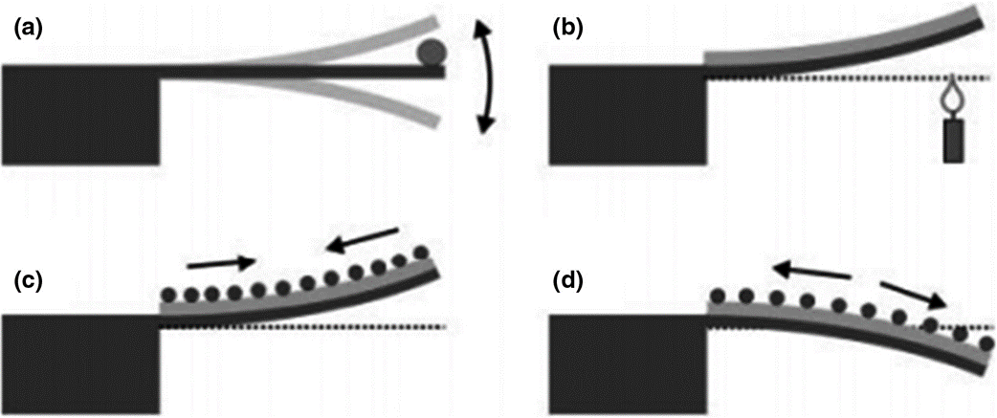

Med Devices & Sens, Volume: 4, Issue: 1, First published: 29 November 2020, DOI: (10.1002/mds3.10156)
Fig 6: Cantilever sensor operation mode: (a) detecting mass variations on the cantilever by deviations in resonance frequency; (b) bimetallic mode detecting temperature variations by a static bending; and (c, d) surface stress mode, where asymmetric molecular binding to the cantilever's top or bottom surface leads to an overall cantilever bending. For example, adsorption on the top surface can either cause tensile stress (c), bending the cantilever upwards, or compressive stress (d), bending the cantilever downwards (Fritz, 2008). Figure reproduced with permission from The Royal Society of Chemistry
The Label-loose detection, tiny size, quick reaction, high sensitivity, and the capacity for multiplexed and high-throughput substance detection are among the key benefits of microcantilevers sensors. Without the need for fluorescent or radioactive labelling, microcantilever sensors identify molecule attachment at the cantilever floor through its nanomechanical motion. Microcantilever sensors have quick signal transduction because small devices have extremely high mechanical self-resonance frequencies. Subsequently, the microcantilever platform is well perfect to real-time tracking of biomolecular interaction occasions on a sub-millisecond timescale. [29] one of the predominant challenges in microcantilever biosensing research is to functionalize each suspended microcantilever beam reliably and effectively on an array with one of a kind bio/chemical molecule. this can be finished either with microcapillaries. [30,31] Microcapillaries are fantastically smooth to handle and suitable for functionalizing cantilevers in small amounts.
  - Optical sensing
Many attempts have been made to track glucose using extraordinary transcoding mechanisms and specific glucose recognition elements. Strategies used to determine glucose recognition in blood and skeletal fluids can be divided into two broad groups, namely (a) spot checks and (b) continuous glucose monitoring (CGM). increase. Commercial blood glucose meters and urine dipsticks demonstrate a sampling approach to glucose measurement. Based on sensor placement, in addition to layout and detection mechanism, CGM sensors are typically classified as invasive (subcutaneous sensors, microdialysis modules, intravenous implantable sensors), minimally invasive (micropores, microneedles), non-invasive They fall into categories such as invasive. (Percutaneous and optical) techniques, namely H. Target extracellular glucose. Despite the fact that tracking or visualizing intracellular glucose in living cells is currently of great interest because it's important to understand the mechanisms underlying how insulin resistance syndrome develops in diabetes patients. Contrary to glucose-6-phosphate, intracellular glucose is not thought of as a signalling molecule for glucose restraint or other glucose-induced modulation of intracellular concentration of glucose observed in living cells. Concanavalin A is used in one of the most well-known FRET systems for glucose sensing (ConA). [32] The jack-bean, Canavalia ensiform is the original source of the plant lectin protein concanavalin A. It binds specifically to the -mannopyranosyl and -glucopyranosyl residues present in a variety of sugars, glycoproteins, and glycolipids. Glucose and ConA have reversible binding (and mannose).

- Application of Nano-biosensor in Tissue engineering
Biosensor-based devices provide a practical method for detecting a variety of signals from tissue, suggesting that they could be used to diagnose diseases. Traditional neurological disease diagnosis takes time and is It is challenging because a doctor must assess the condition of the patient, and there is a potential that 40% of people won't get an early diagnosis for some conditions, such Parkinson's disease (PD). Cell-based biosensors have also shown to be useful in neurological research, and MEA technology is the main method for identifying problems in neural circuits and physiology. Recently, Li et al. used magnetic graphene nanoparticles to produce a reversible electrode for quickly diagnosing Alzheimer's disease. They attached the antibody for the biomarker Amyloid-beta peptide 1-42 (A-42) of Alzheimer's disease to a magnetic graphene doped with nitrogen (MNG). The tapping permeant magnet on the underside of the electrode may then be used to tap the magnetic MNG immunocarriers onto the surface of the Au electrode, quickly creating an Alzheimer's disease biosensor. The employed MNG biosensors could then be taken out, and by swapping the tapped permeant magnet, the Au electrode could be recreated. [1], [4]
Bioelectric activity is another crucial myocardial function that helps gauge the condition of the heart's tissues. In general, the cardiomyocytes that are driven to modify their action potential of their cellular membrane are the ones that may provide bioelectrical activity; with the change of action potential, the heart can be induced to produce a synchronised pumping behaviour.via this organized electrical propagation. In order to identify the cardiac rhythm signal and diagnosis disorders related to the heart, a continuous electrocardiogram (ECG) monitoring technology is provided. Including Lee et. al created a compact wearable flexible cardiac sensor that incorporates an electrode, a near-field communication chip, and a battery in polyurethane substrates to readily monitor heart rhythm signals. As a cardiac patch, Feiner and a colleague created a biodegradable electrical scaffold. As a passivation layer, the gold electrodes are placed on an electrospun albumin-fiber scaffold. The flexible cardiac patch's innovative design enables it to both detect the signal generated when heart cells spontaneously contract and to give external electrical stimulation to regulate this contraction.
Chemical or pharmacological toxicity can emerge as a result of mitochondrial malfunction. HepG2 cell-based liver organoids were cultivated in a microfluidic device by Balvi et al. as a tissue model. It gives the microdevice, which serves as a biosensor, the ability to track the dynamics of mitochondrial failure by continuously measuring the metabolic activity of liver organoids. By monitoring the oxidative phosphorylation of glycolysis or glutaminolysis, the liver organoid-based method produces evaluation of the safety and effectiveness of drug concentration on mitochondrial damage..[2], [7], [22]
Studies on cancer have been conducted during the previous few decades. Traditionally, cancer research has concentrated on developing novel, effective treatment approaches for treating cancer disorders. But occasionally, cancer patients are only diagnosed when it's too late, which means they miss the greatest window for treatment. Kamei and a colleague coupled a microfluidic chip, heart, and liver cancer cells into a "cancer-on-a-chip" model. Pan et al. developed a dual biomarkers-label chip (VEGF and PSA-labeled) for prostate cancer and related circulating tumour cells. Another class of biosensor with the ability to amplify visual signals was also developed by Hu and his coworkers. Extracellular vesicle (EV)-associated RNA in tumours at early stages are difficult to detect, but they addressed the challenge of low expression of EV-associated RNA in malignancies by employing a nanoparticle-based device to extract EV-associated RNA.[1], [4], [21]
In tissue engineering applications, biosensors can create selective, sensitive, and quick diagnostic tools. In contrast to the standard ELISA analytical process, biosensors, which integrate biological, chemical, and physical technologies, provide a mechanism to real-time and on-site monitor micro biophysiological signals. Although biosensors have advanced significantly over the past ten years, there are still some issues that need to be resolved. The major challenges facing biosensors are scaling up and the long-term stability of products. Prototypes of currently available biosensors are regularly on exhibit in academic or research facilities.

[1] Y. C. E. Li and I. Chi Lee, “The Current Trends of Biosensors in Tissue Engineering,” Biosensors, vol. 10, no. 8, 2020, doi: 10.3390/bios10080088.
[2] A. P. F. Turner, “Biosensors: Sense and sensibility,” Chem. Soc. Rev., vol. 42, no. 8, pp. 3184–3196, 2013, doi: 10.1039/c3cs35528d.
[3] A. Hasan, M. Morshed, A. Memic, S. Hassan, T. J. Webster, and H. E. S. Marei, “Nanoparticles in tissue engineering: Applications, challenges and prospects,” Int. J. Nanomedicine, vol. 13, pp. 5637–5655, 2018, doi: 10.2147/IJN.S153758.
[4] A. T. Banigo, T. O. Azeez, K. O. Ejeta, A. Lateef, and E. Ajuogu, “Nanobiosensors: Applications in biomedical technology,” IOP Conf. Ser. Mater. Sci. Eng., vol. 805, no. 1, 2020, doi: 10.1088/1757-899X/805/1/012028.
[5] K. Tsukakoshi and K. Ikebukuro, “Sensitive and homogeneous detection system with aptamer-based biosensor,” Sensors Mater., vol. 28, no. 10, pp. 1083–1089, 2016, doi: 10.18494/SAM.2016.1270.
[6] A. Solaimuthu, A. N. Vijayan, P. Murali, and P. S. Korrapati, “Nano-biosensors and their relevance in tissue engineering,” Curr. Opin. Biomed. Eng., vol. 13, pp. 84–93, 2020, doi: 10.1016/j.cobme.2019.12.005.
[7] S. Prasad, “Nanobiosensors: the future for diagnosis of disease?,” Nanobiosensors Dis. Diagnosis, p. 1, 2014, doi: 10.2147/ndd.s39421.
[8] J. Shi, A. R. Votruba, O. C. Farokhzad, and R. Langer, “Nanotechnology in drug delivery and tissue engineering: From discovery to applications,” Nano Lett., vol. 10, no. 9, pp. 3223–3230, 2010, doi: 10.1021/nl102184c.
[9] C. M. Tîlmaciu and M. C. Morris, “Carbon nanotube biosensors,” Front. Chem., vol. 3, no. OCT, pp. 1–21, 2015, doi: 10.3389/fchem.2015.00059.
[10] S. K. Law, “Mini-Review for an Electrocatalytic Application of Carbon Nanotube in Medical Fields – Tissue Engineering, Drug Delivery, Cancer and SARS-CoV-2,” Biointerface Res. Appl. Chem., vol. 13, no. 1, 2023, doi: 10.33263/BRIAC131.043.
[11] P. M. Ajayan and R. Vajtai, “Properties and Applications of Carbon Nanotubes,” Carbon Filaments Nanotub. Common Orig. Differing Appl., vol. 6, pp. 315–330, 2001, doi: 10.1007/978-94-010-0777-1_23.
[12] S. Adhikari and R. Chowdhury, “The calibration of carbon nanotube based bionanosensors,” J. Appl. Phys., vol. 107, no. 12, 2010, doi: 10.1063/1.3435316.
[13] S. Manzetti, D. Vasilache, and E. Francesco, “Emerging carbon-based nanosensor devices: structures, functions and applications,” Adv. Manuf., vol. 3, no. 1, pp. 63–72, 2015, doi: 10.1007/s40436-015-0100-y.
[14] V. Harish et al., “Review on Nanoparticles and Nanostructured Materials: Bioimaging, Biosensing, Drug Delivery, Tissue Engineering, Antimicrobial, and Agro-Food Applications,” Nanomaterials, vol. 12, no. 3, 2022, doi: 10.3390/nano12030457.
[15] R. Vidu, M. Rahman, M. Mahmoudi, M. Enachescu, T. D. Poteca, and I. Opris, “Nanostructures: A platform for brain repair and augmentation,” Front. Syst. Neurosci., vol. 8, no. JUNE, 2014, doi: 10.3389/fnsys.2014.00091.
[16] C. Ziegler, Cell-based biosensors, vol. 366, no. 6–7. 2000. doi: 10.1007/s002160051550.
[17] H. Gergeroglu, S. Yildirim, and M. F. Ebeoglugil, “Nano-carbons in biosensor applications: an overview of carbon nanotubes (CNTs) and fullerenes (C60),” SN Appl. Sci., vol. 2, no. 4, pp. 1–22, 2020, doi: 10.1007/s42452-020-2404-1.
[18] S. Same and G. Samee, “Carbon nanotube biosensor for diabetes disease,” Crescent J. Med. Biol. Sci., vol. 5, no. 1, pp. 1–6, 2018.
[19] B. Cardenas-Benitez, I. Djordjevic, S. Hosseini, M. J. Madou, and S. O. Martinez-Chapa, “Review—Covalent Functionalization of Carbon Nanomaterials for Biosensor Applications: An Update,” J. Electrochem. Soc., vol. 165, no. 3, pp. B103–B117, 2018, doi: 10.1149/2.0381803jes.
[20] Z. Altintas, F. Davis, and F. W. Scheller, “Applications of quantum dots in biosensors and diagnostics,” Biosens. Nanotechnol. Appl. Heal. Care Diagnostics, pp. 185–199, 2018, doi: 10.1002/9781119065036.ch9.
[21] A. Hasan et al., “Recent advances in application of biosensors in tissue engineering,” Biomed Res. Int., vol. 2014, 2014, doi: 10.1155/2014/307519.
[22] A. Sadana, N. Sadana, and R. Sadana, “Nanobiosensors,” A Fractal Anal. Chem. Kinet. with Appl. to Biol. Biosens. Interfaces, no. 1989, pp. 69–96, 2018, doi: 10.1016/b978-0-444-63872-4.00004-x.

