**CURRENT APPROACHES IN DRUG DISCOVERY**

1. **DRUG DISCOVERY: AN INTRODUCTION**

Drug discovery is a process by which new drug molecules or new chemical entities are recognized for treating various disorders or diseases. The health care systems constantly require the discovery of new drugs to address the medical needs of diseased patients across diverse populations in the world. Hence the research and development sector of any country facets steep emphasis on drug discovery, design and development. From ages, serendipity i.e. the accidental discovery of drugs and drugs from natural sources like plants, were the two primary approaches in discovering new drugs. As understanding and unveiling of the technology has enhanced, new techniques and strategies have hit the screen to discover the drugs at a faster momentum. However the pros and cons always exist for new scenario.

The scientists have started to understand the disease at a molecular level with the progress of proteomics, genomics and computational approaches. Discovering and developing one new drug takes between 10-15 years from the time it is available for patient care. Nearly, out of 5000-10000compounds that enter the research and development pipeline, ultimately only one drug may receive the approval (Figure 1).

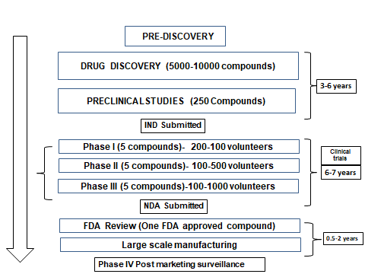

**Figure 1: The drug discovery and development process**.

Finding a new drug candidate requires 3-6 years of early research as part of the discovery process. The researchers hope to have at least one drug candidate ready to move into clinical trials by the end of the development process.

1. **The drug discovery process**

The process of drug discovery is initiated by gaining the knowledge from prediscovery which involves understanding the disease.

**Prediscovery**

Scientists and researchers have engaged in the prediscovery process to identify the underlying cause of disease conditions. They try to understand how genes change or mutate and how this changes the proteins they encode.

The affected proteins then interact with one another to bring about changes in the cell, which then provokes transformation in the specific tissue and finally results in the disease.

Drug discovery process has four steps

* Target Selection/ Identification
* Target Optimization
* Lead Discovery
* Lead Optimization

1. **Target Identification**

It involves identification of molecular targets that are involved in disease progression. After figuring out the underlying cause of a disease, researchers typically choose a "target." Usually, the target is a single molecule involved in a particular disease, such as a gene or protein. The selected target should be “drugable” i.e. it should potentially interact with and get influenced by a drugmolecule. The biochemical classes which can serve as drug targets include G-protein coupled receptors, enzymes, hormones, ion channels and nuclear receptors. Various techniques like genomics, proteomics and bioinformatics are enabling the target identification process much easier.

1. **Target Validation**

Target validation involves testing the target to confirm its role in the disease. It involves proving the fact that manipulating the molecular target can provide therapeutic benefit for patients. This step is imperative to the scientists to opt for research that is promising to yield a clinical drug candidate. Researchers validate whether that particular target is compatible to the disease being studied through sophisticated experiments in both living cells and animal models of disease.

1. **Lead Discovery**

Lead discovery involves exploring of small molecules called ‘leads’, which could modulate the protein function or disease condition. If successful, the lead compound may become a brand-new medication after extensive years of testing. The ways to locate the lead compound are as follows: (Figure 2)

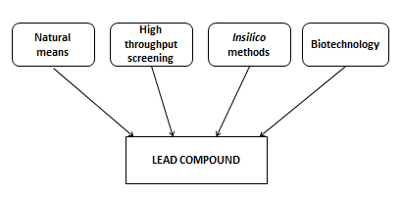

**Figure 2: Important methods of lead discovery**

The discovered lead compounds are subjected to series of pharmacokinetic tests to assess the safety of lead compounds. The methods of discovery of lead compounds are discussed in detail in the next part under the approaches concept.

1. **Lead optimization**

Lead optimization process transforms the structures of lead candidates to upgrade their pharmacokinetic properties. This enhances safety and efficacy profile of a lead compound while reducing the potential side effects. Hundreds of analogues of leads can be made and tested on biological systems to study the structure-activity relationship (SAR).

1. **Approaches in Drug Discovery**

There are many ways as to how drugs or leads can be discovered. Herein I discuss about the ancient methods adopted for drug discovery and elaborate how there was paradigm shift towards the modern approaches. These strategies in drug discovery can be broadly categorized into

* Historical approaches
* Modern approaches

1. **Historical approaches**

These types of approaches employ the ancient methods to discover the new drugs. They are further classified into

* Serendipity
* Traditional approach (from natural sources)

**Serendipity**

“Accidental discovery of drugs” is called serendipity. The best and the well-known examples of serendipitous discovery are penicillin-an antibiotic, cisplatin- an anticancer agent (Figure 3), and there are many more.





**Figure 3: Chemical structures of penicillin and cisplatin discovered by means of serendipity**

Here in I discuss about some of the drugs which are serendipitously discovered by enhancing their properties using SAR.

For example, the drug disulfiram (Antabuse), used for treating chronic alcoholism was developed based on the fact reported by the workers of rubber industry that they gained the distaste for alcohol. This is because, during rubber manufacturing process, an anti-oxidant was employed which presented the normal oxidation of alcohol and builded up the acetaldehyde which was so unpleasant that the workers preferred not to drink. So this anti-oxidant became a lead compound for the development of an antabuse agent disulfiram.

There are many other drugs which paved their way into the market by means of serendipity. Few to represent we have aminoglutethimide which is being used as anticancer agent was actually prepared to be an antiepileptic drug. Clonidine, designed to be a vasoconstrictor, employed in nasal drops, also confessed that it can cause marked decrease in blood pressure and hence is being used as potential antihypertensive agent. Many other drugs like Isoniazid, sildenafil, chlorpromazine, imipramine are all discovered serendipitously. Researcher should really have broad sense to recognize and analyze the molecules by means of serendipity.

**Traditional approach (from natural sources)**

Traditional approach involves discovering the lead molecules from natural sources like plants, microorganisms and marine sources.

**Plants:** These are the sources which are plentiful in biologically active compounds, serving the major need of today’s medicine. Most of the drugs used today are either obtained directly from natural sources or develop from a lead compound which is of natural origin. The active principle present in the plants is usually responsible for biological activity. Most of the natural products have complex structures which makes its synthesis ambiguous to the chemist. For example, the antimalarial drug artemisinin contains the most unstable trioxane ring, which the medicinal chemist finds it difficult to incorporate in the structure. Inspite of many challenges, plants have always been the prosperous source for the lead compounds like morphine, cocaine, digitalis, quinine, nicotine and muscarine etc.

**Microorganisms:** the microbes such as bacteria and fungi cater as wealthy sources for lead compounds and ultimately the drugs. Discovery of penicillin captivated interests of scientists to screen the microorganisms. This led to the discovery of some of the best antibacterial agents like cephalosporin, tetracycline, aminoglycoside and chloramphenicol antibiotics. Not only the microorganisms, but also their microbial metabolites also provided the lead molecules. For example, asperlicin, an antagonist of cholecystokinin (CCK), a peptide hormone was isolated from *Aspergillus alliaceus*. Lovastatin, the first clinically approved statin is also a fungal metabolite. Rasfonin, isolated from the fungus of New Zealand, promotes apoptosis in cancer cells but not in the normal cells, serving as a promising lead compound to discover new anticancer agents.

**Marine sources:** It is a blissful discovery that the marine microorganisms, sponges, corals and fish have wealth of active principles with anticancer, anti-inflammatory and anti-viral activities.

Eg: Marine cynobacterium has the active component curacin A, which exhibits good antitumor activity. Many other antitumor agents from marine sources include elentherobin, bryostatin, dolastatins etc.

To screen large number of natural sources, the technique called High throughput screening (HTS) is widely used.

**High throughput screening (HTS)**

HTS is considered as standard method for drug discovery and development by pharmaceutical industries. This technique screens large number of compounds (up to 106) of a series by using automated robotic systems in a cost effective manner. The basic motive of HTS is to speed up the drug discovery process and to produce “hits” which are active on to the target. It is a tool for running millions of compounds in a short period of time. To achieve its goal, HTS employs robotics, efficient detectors and software for its instrumentation and also processing of data.

HTS tests the compounds and performs two promising roles

1. To test the ability of compounds to modify the target
2. To test the selectivity of compounds on to the chosen targets

HTS will not identify the drugs or evaluate their toxicity and bioavailability rather it identifies the leads ad supports its optimization. The culmination revealed that HTS helps in the further drug discovery process.

The basic steps of HTS include

* Preparation of sample libraries
* Establishment of a method suitable for lab automation
* Configuration of robotic workstation
* Acquisition and handling of data

The sample used in HTS is usually cellular or biochemical in nature. In HTS, the samples are arranged in arrayed format and the sample carrier is the microplate. Various types of formats include 384, 1536 or 3456 well plates. Generally, the HTS assay is performed in a single well with low amounts of reagents (miniaturization) with no further manipulation. The major issues associated in setting up the automated screening are stringent assay and effective quality control. The robotic workstation speeds up the data acquisition. The robotic system manages the microplates from station to station and aids in several steps such as reagent addition, mixing, incubation and detection.

In HTS, data acquisition is performed by various optical instruments like fluorescent or luminescent detection, colorimetry or light scatter etc. These instruments quantify the amount of light produced by the sample. The detection methods include FRET, fluorescence intensity and polarization, time resolved fluorescence like HTRF, LANCE and luminescence such as NanoBRET and Alphascreen.

1. **Modern approaches**

Modern drug discovery is a capital-intensive process which accounts for large investments by pharmaceutical industries as well as governments. Regardless of many advances, drug discovery is a lengthy, expensive and difficult process. These approaches are classified as (Figure 4)

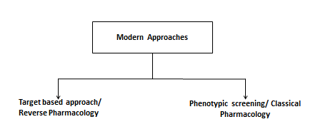

**Figure 4: Modern approaches of drug discovery**

The novel drug discovery strategies are amalgamation of both molecular and empirical approaches.

**Target based approach/ Reverse Pharmacology/Molecular approaches**

Target based drug discovery (TBDD) has made its ravishing mark in the field of drug discovery incorporating advanced techniques in it and standing as the prior approach for the discovery of first-in-class medicines. A target is a term which is applied to a range of biological entities like proteins, genes and RNA. Selection of molecular targets based on disease understanding is a dominant paradigm in drug discovery. In the past 3 years, TBDD has emerged as a dominant strategy of discovering drugs. TBDD believes that drugs act typically by engaging a molecular target. On a broader sense, in the process of TBDD, defining a specific target which plays a key role in the disease should be the first and foremost step followed by screening of compounds against known targets associated with the pathogenesis of disease.

Advantages

* TBDD utilizes the straightforward, biochemical assays which can be carried out in an automated and rapid screening system.
* They are very less time consuming to carry out
* The key advantage of target based approach is the application of molecular and chemical knowledge to investigate the specific hypothesis

Various approaches under TBDD include

Poly pharmacology

Computational approaches/ Insilico approaches/ system based drug discovery

Fragment based drug discovery.

**Poly pharmacology**

The interaction of drug molecules with multiple targets can be called as poly pharmacology. Concisely it can be described as “One drug multiple targets”, i.e. single drug acts on multiple disease pathways to elicit the pharmacological action. This approach made its ravishing entry to cause paradigm shift in the drug discovery. The basic objective of polypharmacological approach is drug repurposing i,e. discovery of off targets for the existing drugs which needs integration of information from various disciplines like CADD, synthetic chemistry, preclinical and clinical studies. This strategy involves drug interactions with multiple targets involved in complex signalling and therapeutic pathways for one or more disease states. Therefore, in poly pharmacology, we should logically develop drugs that can interact with a variety of important targets influencing the pathogenesis of a particular disease. To achieve these goals, it is very much essential to adopt computational techniques for the development of mode, curation of data and for quantitative predictions.

Poly pharmacology has two approaches

* Single drug interacting with multiple targets in one disease pathway
* Single drug interacting with multiple targets in multiple disease pathways

The poly pharmacology databases have been developed including STITCH, Polypharma, Super Target, IBIS, SIDER. The better understanding of algorithms used in this method will enable to develop novel techniques for poly pharmacology studies. Various methods used to predict the unknown targets for small molecules can be categorized as

Structure based methods

Ligand based methods

System biology methods

The programs designed and the algorithms employed in the above methods are presented in table 1(Chaudhari et al)

|  |  |  |
| --- | --- | --- |
| Methods | Algorithms Used | Web links |
| **Structure based methods** | | |
| DOCK | Geometric shape matching algorithm, anchor and grow algorithm | http://dock.compbio.ucsf.edu/ |
| INVDOCK | Geometric algorithm | http://bidd.nus.edu.sg/group/softwares/invdock.htm |
| idTarget | Modified DOCK algorithm | http://idtarget.rcas.sinica.edu.tw |
| DRAR-CPI | Connectivity maps with DOCK6 algorithm | http://cpi.bio-x.cn/drar/ |
| TarFisDock | Modified DOCK algorithm | http://www.dddc.ac.cn/tarfisdock/ |
| Glide | Stochastic search algorithm | http://www.schrodinger.com/Glide |
| FRED | Stochastic search algorithm | https://docs.eyesopen.com/oedocking/fred.html |
| SiteEngines | Geometric hashing method | http://bioinfo3d.cs.tau.ac.il/SiteEngine/ |
| SuMo | Geometric matching of triplets | http://sumo-pbil.ibcp.fr/cgi-bin/sumo-welcome |
| IsoMIF Finder | FLAP algorithm, Tanimoto coefficient | http://bcb.med.usherbrooke.ca/imfi.php |
| BioGPS | FLAP algorithm | NA |
| PocketMatch | Greedy alignment algorithm, PM scoring method | http://proline.physics.iisc.ernet.in/pocketmatch/ |
| PARIS | Convolution kernel based method | http://cbio.ensmp.fr/paris/paris.html |
| BSAlign | Subgraph algorithm | http://www.aungz.com/BSAlign/index.htm |
| PharmMapper | Kabsch algorithm | http://59.78.96.61/pharmmapper/ |
| TRAP | MD simulation, ARDR, and PCA | http://trapp.h-its.org/trapp/ |
| GANDI | Genetic algorithm with tabu search | http://www.biochem-caflisch.uzh.ch/download/ |
| AutoT&T | Automatic tailoring and transplanting algorithm | http://www.sioc-ccbg.ac.cn/software/att2/ |
| ReCore | Geometric rank searching algorithm | https://www.biosolveit.de/ReCore/ |
| AutoGrow | Click chemistry assisted evolutionary algorithm | http://autogrow.ucsd.edu |
| **Ligand-based methods** | | |
| SEA | Chemical similarity, Kruskal’s algorithm | http://sea.bkslab.org |
| TarPred | Extended-connectivity fingerprint 4 (ECFP4), Tanimoto Coefficient | http://www.dddc.ac.cn/tarpred |
| SuperPred | Extended-connectivity fingerprint 4 (ECFP4), Tanimoto Coefficient | http://prediction.charite.de |
| SwissTarget | Chemical and structure similarity | http://www.swisstargetprediction.ch |
| **System biology methods** | | |
| Cmap | Pattern matching | https://www.broadinstitute.org/cmap/ |
| STITCH | Text mining | http://stitch.embl.de/ |
| LINCS Canvas Browser | LINCS database browser | http://www.maayanlab.net/LINCS/LCB/ |
| Ingenuity Pathway Analysis® | Pathway analysis | http://www.ingenuity.com/ |

**Table 1. Methods and algorithms used in poly pharmacology (Chaudari et al)**

Inspite of its efficient growth, the major challenge associated with this approach is insufficient knowledge of pathways at the molecular level which can cause unnecessary side effects and adverse effects. This approach is being used to overcome the drug resistance problems.

**Computational approaches/ Insilico approaches/ system based drug discovery**

The concept of computer aided drug discovery (CADD) amalgamates the knowledge of molecular, chemical and the systematic information to design small molecules with controlled toxicity and minimal side effects. This system based drug discovery can be broadly categorized into

* Ligand based drug discovery approach or Knowledge based approach
* Structure based drug discovery approach

**Ligand based drug discovery approach (LBDD approach)**

LBDD approach is employed for drug discovery process when the structure of the target is unknown or its crystal structure is hard to obtain. LBDD also known as “knowledge based drug design” obtains fundamental features from drugs and established a model to anticipate the drug properties i.e. LBDD ligand information is used to acquire the biological and chemical properties.

This approach works on the chemical similarity concept which infers that if any two molecules share identical structures, then they are likely to exhibit similar biological properties. Chemical descriptors like molecular weight and lipophilicity predicts the significant pharmacokinetic and pharmacodynamic properties of the ligand. Lipinski’s rule of five is an example which illustrates the set of rules to discriminate drugs from non-drugs.

LBDD process has three key steps (Figure 5)

* Chemical search is made for the target molecules
* Identical ligands with similar biological properties are identified
* Original ligands are modified to propose new molecules with enhanced activities.



**Figure 5: The process of LBDD (Yu-Chen Lo et al)**

In ligand based approach, target prediction can be inferred by comparing among the ligands which share the highest chemical similarity. CHEMBL, Pubchem, Binding DB and Drug Bank are the major chemical bioactivity databases developed for selection of ligand which attributes highest chemical similarity.

The major limitation of ligand based approach is that there is no cut off for chemical similarity which defines biological similarity also called as bioactivity cliffs. Hence the approaches like SEA (Similarity ensemble approach) is introduced which calculates the similarity values using the algorithm BLAST.

Major techniques used in ligand based approach include Virtual Screening, QSAR and pharmacophore modelling. Let us discuss them here.

**Virtual Screening**

Virtual screening (VS), an integral part of drug discovery process can be defined as “a process of automatically evaluating very large libraries of compounds” using computer programs. This technique analyzes whether the compound is likely to be a lead compound for particular target or not. It involves the search of pharmacophores required for activity, or docks the compounds into target binding sites to discover new lead molecules (Figure 6).

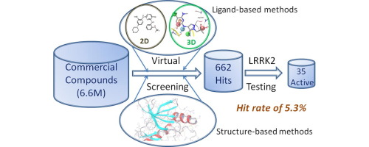

**Figure 6: Virtual screening process**

From among several thousands of compounds available for testing, VS chooses the compounds which are likely to be active and can make good interactions with the protein or receptor or enzyme. The results obtained from VS process can be efficient to carry out further experimental screening.

Virtual screening can be

- Ligand based VS

- Structure based VS

- QSAR based VS

**Ligand based VS** involve developing a receptor model, basedon the given set of ligands known as pharmacophore models. The proposed ligand is then compared with pharmacophore model to analyze its compatibility to bind with receptor. The soft wares which aid in ligand based VS are LiSiCA, Ligprep, Lig and scout, ConfGen, InterLig etc. LiSiCA (Ligand Similarity using Clique algorithm) software searches for 2D and 3D similarities of proposed ligand with that of database of ligands represented in Mol2 format. Similarities among the drug candidates are indicated as Tanimoto coefficients and are ranked accordingly.

**Structure based VS** involves docking of ligand to the target and then analyzing its scoring function. Itutilizes 3D structure of protein format obtained from X-ray crystallography, NMR, docking technique and finalizes chooses the best compound with good binding score for further biological evaluation. The softwares used for structure based VS are MTi open screen, protein preparation wizard, open Babel, Swiss param etc.

**QSAR based VS** is the most powerful method to predict the biological property of novel compounds because it can produce hits at high, fast and good rate. The general scheme of QSAR based VS approach is represented in the figure 7.

The QSAR models are developed based on the data sets collected from external sources following the OECD guidelines. Then these models are used to identify the chemical compounds which are active from among large chemical libraries. It is crucial to notice that modern VS employ additional steps to filter in its work flow. For eg: a) Empirical rules are set based on the Lipinski’s rule of five b) Chemical similarity cutoff’s c) QSAR filters.



**Figure 7: QSAR based virtual screening**

**Pharmacophore modelling**

Pharmacophore is defined by IUPAC as “A pharmacophore is an ensemble of steric and electronic features that is necessary to ensure the optimal supra molecular interactions with a specific biological target and to trigger or block its biological response”. When molecules are in 3D format, pharmacophore representation annotates that the molecule is collection of features at 2D level and 3D level. The pharmacophore finger print identifies each molecule as a particular data string. In a ligand, the possible three-point and four-point sets of pharmacophoric points are determined. The distance between feature points is evaluated by measuring the bonds and the resulting fingerprint determines every possible combination at the predefined positions in the string. Such fingerprints assess the similarity between the molecules or ligands.

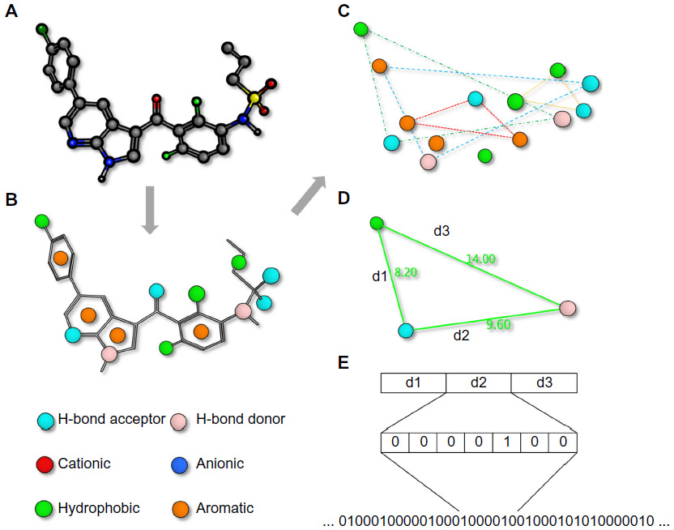

**Figure 8: Pharmacophore fingerprints (Quing X et al 2014) A) Small molecule ligand finger print with Pharmacophore fingerprint. B) Molecular interaction features annotated into the string. C) Distances are calculated by means of bond length or through the space. D) Frequency of occurrence is stored in the string E) Such strings are used for similarity comparison between the molecules**

**Structure based drug discovery (SBDD) approach**

In SBDD approach, synthetic compounds are designed from thorough knowledge about active sites of protein targets associated with particular disease. If the validated disease target with complete crystal structure is available, SBDD can be employed to find the ligands which can bind to the receptors of interest. This approach integrates many applications of traditional biology and medicinal chemistry techniques such as NMR, X-Ray crystallography, genomics, combinatorial chemistry, computer modelling of molecular structure, cellular biology involved in protein characterization.

Identifying the target protein in advance and elaborating its molecular structure enables the design of more optimal drug which can bind with the protein. The potential drug molecules which can bind with receptors are called ligands. They serve as a key for receptor lock. Computer aided drug discovery has become an indispensible tool in drug design and discovery. It employs various drug design softwares to discover biologically active compounds.

The process of SBDD (Figure 9) has following steps

* The disease's pathological condition is taken into account when selecting the protein target
* The 3D structure of the enzyme or the protein is determined by X-ray crystallography
* Insilico studies are conducted to identify the potential ligands.
* Molecular modelling procedures are followed to synthesize the promising compounds.
* Biological properties such as affinity, potency and efficacy are evaluated
* Finally the 3D structure of the ligand-receptor complex is solved.



**Figure 9: The process of SBDD**

The major technologies employed in SBDD include X-ray crystallography, structure based virtual screening, molecular docking etc. Let us discuss about molecular docking, a major revolution brought in the field of drug discovery.

**Molecular Docking**

In drug discovery process, molecular docking stands as an attractive target to understand the biomolecular interactions of ligand and the target. This information provided by docking, can be used to suggest the binding energy, free energy and stability of the complexes.

Molecular docking's primary goal is to achieve an optimized conformation with lower binding free energy. A typical docking work flow can be depicted as (Figure 10)

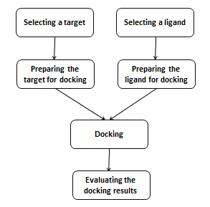

**Figure 10: The workflow of docking process**

The above key steps of docking are common for all docking protocols. The two major pre-requisites for all docking methods are

* Scoring function: to rank various drug candidates
* Search method: to explore state variables

The scoring function can be empirical, force field based or knowledge based. Search methods can be of systematic and stochastic. In docking, the target which is determined by x-ray crystallography or NMR is chosen. The docking tools will not let the target to be flexible. So the targets is prepared before docking, to account for solvent effects, induced fit, receptor flexibility and calculate the binding free energies. Once the target is prepared, the next goal is to choose the ligand sets to dock with the target.

Molecular docking involves exploring the search space Insilico, and to determine the best binding mode. Docking tools such as Autodock, FlexX, GOLD, DOCK6, FLOG, LibDock, SANDOCK, ICM3.4 etc are used for docking. Docking results are evaluated based on the chemical complementarity between ligand and the protein, satisfying the hydrogen bond donors and acceptors, side chain interaction with ligand and the receptor, burying of hydrophobic groups of the ligand in the hydrophobic pockets of the receptors etc. All these parameters are evaluated and scores are analyzed.

**Fragment based drug discovery**

The fragment based drug discovery (FBDD) of small molecules that bind to targets like proteins is established as efficient technique in drug discovery and development. HTS was reliable technique for screening large libraries of compounds but the major drawback with HTS was to maintain the diversity and quality of large libraries of compounds and most of the compounds were not drug like molecules. So the genuine hits may not act like efficient starting points for drug discovery and development. When the hit produced by HTS binds with target protein it was not clear that which part of the molecule contributes to most of the binding energy. But the fragment based methods involve the contribution description of even weakly binding small molecules.

FBDD involves designing of potent small molecule ligands from low molecular mass fragment molecules. These fragments will generally abide to Rule of Three I.e. molecular mass <300 Da, up to 3 hydrogen bond donors, up to 3 hydrogen bond acceptors and calculated log P (ClogP) of <3.

**FBDD Process**

The process of FBDD involves 3 stages (Figure 11)

* Fragment library design
* Fragment screening
* Fragment elaboration



**Figure 11. Workflow of FBDD process (Scott et al)**

**Fragment Library Design**

This step involves design and accumulation of a library of fragment molecules. Primarily the compounds which follow the rule of three and the compounds which facilitate the fragment elaboration are selected into the library. The unstable or the toxic scaffolds such as alkylating or acylating groups should be avoided.

**Fragment Screening**

The fragments bind with the targets and their binding affinities range from 0.1-10mM. High concentration of fragments are required a compared to that of HTS. The following biophysical screening method are employed to detect the binding affinities

X-Ray crystallography

NMR, Mass Spectroscopy

Fluorescence based thermal shift (TS)

Surface Plasmon Resonance (SPR) and Virtual Screening.

**Fragment Elaboration**

The structural binding information and the quantitative data obtained enables to rationally design and synthesize fragment hits. The binding mode of the fragments is determined by spectroscopic techniques. This step involves fragment merging, fragment linking and fragment growing.

Fragment merging incorporates the common structural features in various overlapping molecules into a single fragment based on the structural information of other fragments. The fragment linking joins the two fragments that bind at the non-overlapping site and fragment growing involves synthesis of set of fragments that bind at a single site.

**Phenotypic screening/ Classical Pharmacology/Empirical approaches**

Screening of small libraries of compounds containing small molecules, natural products or their extracts in whole organism or intact cells to identify the substances with desirable therapeutic effect or to identify the compounds which have the ability to modify the cell’s phenotype is called phenotypic screening or classical pharmacology.

In contrast to TBDD, phenotypic screening does not rely on knowing the identity of compound or its role in disease. A key benefit of this approach is to have the capability to identify the biological mechanisms. In the recent past, phenotypic screening was considered to be a successful strategy to discover first-in-class medicines and the reason was attributed to the identification of molecular mechanism of action.

The two main approaches of phenotypic drug discovery (PDD) are

*In-vivo* assays

*In-vitro* or cell based assays

*In-vivo* assays will screen the compounds in preclinical disease models or animal models. The drawback with these assays is that they use low-through put intricacies. Cell based (*In-vitro*) assays present an advantage in that they can easily adopt to high throughput screening techniques.

In PDD, compound selection is the key step because it defines the sampled chemical space and aids in the identification of hits which serve as starting points in drug discovery and development (Figure 12). The two key points employed in compound selection include

* Focusing on the structural aspects or chemical class of compounds
* Identifying the compounds with similar structural aspects as that of other hits or similar activity profiles



**Figure 12: Structure based and Phenotype based expansions (Haasen et al)**

**References**

1. Sausville, E. A. (2012). Drug Discovery. Principles of Clinical Pharmacology, 507–515.

# Emanuel G, MarcelDe G, Brenda BD, Clark E. Discovery of LRRK2 inhibitors by using an ensemble of virtual screening methods.Bioorganic and Medicinal Chemistry letters.2017: 27 (11); 2520-2527.

# Quing X, Lee XY, De Raeymaeker J, Tame J, Zhang K, De Maeyer M, Voet A. Pharmacophore modeling: advances, limitations, and current utility in drug discovery. Journal of receptor, ligand and channel research. Vol 7 2014

1. Chaudhari R, Tan Z, Huang B, Zhang S. Computational polypharmacology: a new paradigm for drug discovery. Expert Opinion on Drug Discovery, 12(3), 2017, 279-291.
2. Scott DE, Coyne AG, Sean A. Hudson SA, Abell C. Fragment-Based Approaches in Drug Discovery and Chemical Biology. Biochemistry. 2012, 51, 4990−5003
3. Haasen D, Schopfer U, Antczak C, Guy C, Fuchs F, Selzer P. How Phenotypic screening influenced drug discovery: Lessons from five years of practice. ASSAY and Drug Development Technologies. 15(6), 2017.