Name | Ms. Joshita Sharma
Designation | Assistant Professor
Department | Amity School of Communication
Name of the Institute | Amity University
City, State, and Country | Jaipur, Rajasthan, India
Official Email ID | joshitaamity@gmail.com
Personal Email ID | joshitaamity@gmail.com
Mobile Number | 8561868591
WhatsApp Number | 8561868591

INTRODUCTION

The metaverse, which combines our physical reality with virtual and augmented reality, will usher in a 3D internet (AR and VR). At least, that is the vision of tech titans and designers. We can expect the metaverse to grow popular in 2022 because of companies like Microsoft, Meta (formerly Facebook), Epic Games, and Nvidia's keen interest in it. As gamers create their own realms, they have some of the earliest metaverse experiences. The metaverse is a logical next step for the gaming industry because it provides a realistic virtual experience. The metaverse has the potential to boost game engagement, virality, and monetization. Virtual worlds are massively multiplayer online computer-generated contexts in which multiple individuals from various geographical locations can interact in real-time for work or play.
The Internet of Things will be crucial in combating one of the most perilous threats hovering over the Metaverse sphere. That is, Metaverse's ability to extract data from the physical world and inject it into the virtual world. To achieve the desired results, the data mapped from the real world must be accurate, planned, secure, relevant, and real-time. Whereas IoT has been in the business for many years and has thousands of cameras, sensors, and tech devices in its cluster, it is a major occasion for the Metaverse to generate buzz.
Neal Stephenson coined the term "metaverse" to describe a virtual reality-based digital replacement in his dystopian science fiction novel Snow Crash in 1992. Humans, as avatars, interact with each other and software agents in this novel's three-dimensional virtual reality, which employs the metaphor of the physical world. When it comes to 3D virtual environments it is computer-based simulated 3D platforms on which many users can interact and create content. One of the most significant potential learning benefits of 3D environments is the innovation of an appreciation for the intricate systems we encounter in our daily lives.
Understanding 3D Virtual Environment

Augmented reality (AR) is the real-time digital information that is integrated with the user's environment. Unlike virtual reality (VR), which creates a new arbitrary environment, users of augmented reality (AR) experience a real-world environment with derived visual images superimposed on top of it. Augmented reality is used to either optically alter natural environments or to provide users with additional information. The significant advantage of AR is that it integrates digital and three-dimensional (3D) components with a person's experience of the real world. AR has a broad array of applications, from evaluation to entertainment.

Virtual reality (VR) is a computer-generated environment with realistic-looking scenes and objects that captivates the user in their surroundings. This environment is witnessed using a Virtual Reality headset or helmet. VR allows us to immerse ourselves in video games as if we were one of the characters, learn how to perform heart surgery, and improve the quality of sports training to achieve peak performance.

The metaverse is an intended addition to existing wired technology, so general-purpose computers and cell phones, as well as augmented reality (AR), mixed reality, virtual reality (VR), and virtual world technologies, could all provide access to the metaverse. One example of business and commercial interest in metaverse-related research and technology is Facebook, which purchased the virtual reality firm deals in IoT device Oculus in 2014 and announced plans to build a 3-D virtual community to connect various services.
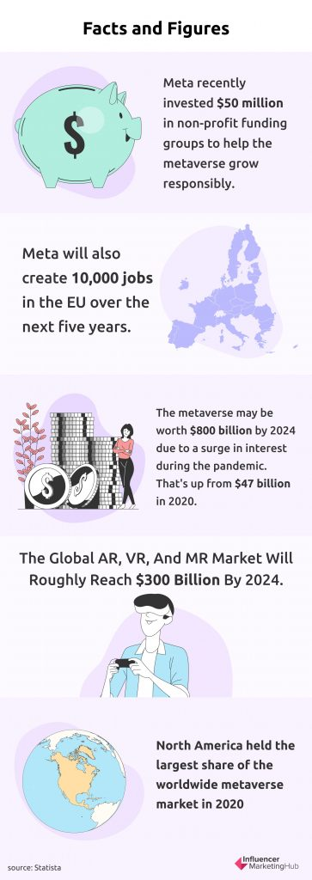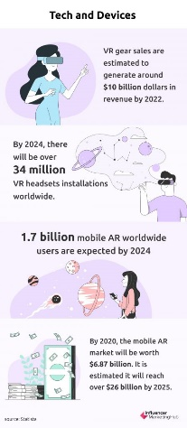
(https://influencermarketinghub.com/metaverse-stats/)
(https://influencermarketinghub.com/metaverse-stats/)

Metaverse Specialized Implementations
Gaming: In Metaverse, you will be able to engage in games as your intended character. Soon, you will be able to feel, touch, and engage with 3D materials, individuals, and characters in gameplay.
Virtual Home: Meta's first qualitative study is interpretive to be Virtual Home. We will be able to develop any type of digital area or interactive 3d world around us, according to Zuckerberg.
Concerts: Filmmakers and instrumentalists may hold concerts in the Metaverse digital environment. Fans around the world will be able to stream the performance online. It will also have an influence on the cinematic universe.
Traveling and planning to meet: In the metaverse, you can virtually meet with your family and acquaintances and even divulge a digital meal with them.
Trading: In the metaverse, you will be able to buy and sell almost anything with cryptocurrencies like NFTS nowadays.

IoT devises to experience 3D virtual environment
AR Glasses: Augmented Reality (AR) glasses are metaverse equipment that should not be underestimated. These are intellectual wearables that enable embodied experiences.
VR Headset: Oculus rift use technologies such as rotating machines, accelerometers, inertial measurement units, and so on, as well as a 3-dimensional head-mounted display that provides individual images for each eye. These are already becoming increasingly popular among metaverse devices.
VR Gloves: Virtual Reality (VR) objects can be felt as if they were real using VR gloves, also known as meta-haptic gloves. Then it might sound insane, but companies such as HaptX have already offered such hyper-real interactions.
Wrist-Based Bands: Meta is a precursor in proposing this new AR gadget that can read motor activity and facilitate more easily engage with the virtual world.
At this preliminary phase, the concept of the metaverse does not need to be denigrated. Matter of fact, the assumption that the concept is still in its early stages enables us to determine whether we want to create a particle universe that excludes the digital oppressed or a universe that can permeate time and space constraints to give human creativity a new lease on existence. Whatever path the technology takes, it is indisputable that the metaverse is here to stay. As a result, it is essential to become intimately familiar with the equipment necessary to embark on this journey. With so many brands offering good products, the only thing that must be comprehended is the foundations of such devices.
The metaverse is turning into a real thing with 3D virtual environment and wide use of IoT devices as mentioned, and because of this innovation, our reality will become virtual in the upcoming period. Virtual reality will emerge and steer our interactions to new heights. As a result of this technology, many people will find work, and millions will be introduced to a new technological sensation.

On August 15, 2022, Mark Zuckerberg announced the launch of Horizon Worlds in France and Spain by tweeting a screenshot of his digital avatar standing in front of the Eiffel Tower and what I presume is supposed to be the Sagrada Famlia. Unfortunately for him, the internet quickly began dragging and parody the screenshot of the virtual reality platform — most likely because the graphics were directly analogous to the Teletubbies game for the PlayStation One, as one Twitter user put it.

Zuckerberg has apparently seen the memes and wishes to inform you that Meta is hard at work on the graphics. On Friday, he shared some new screenshots of himself on Facebook and Instagram, uncovering a significantly more accurate depiction of himself. The complete environmental design and avatar design is in 3D form an indirect depiction of the metaverse with help of IoT device.
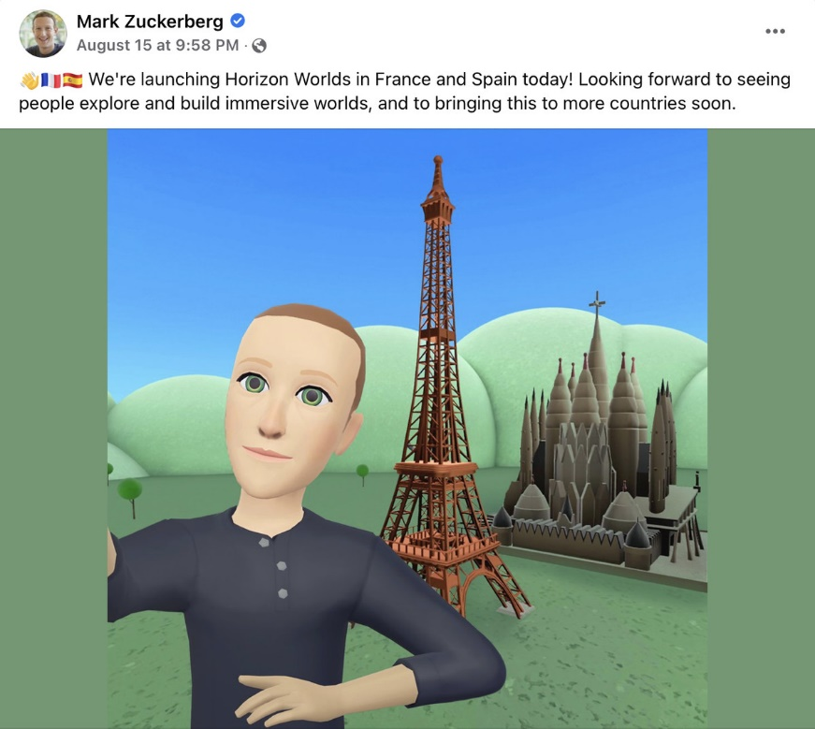
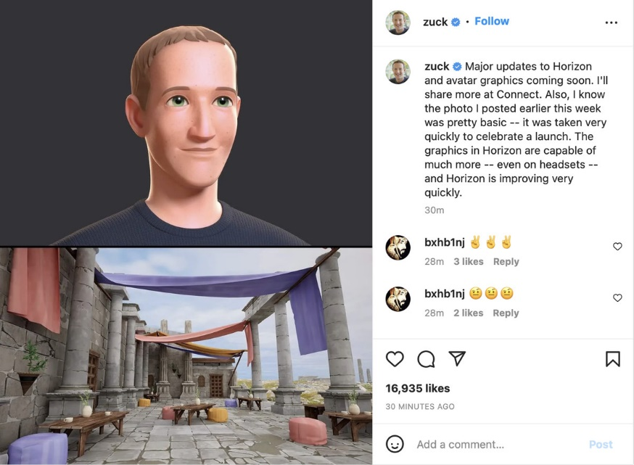
He admits that the authentic screenshot isn't particularly flattering. "I know the photo I posted earlier this week was pretty simple — it was taken quickly to commemorate a launch." Horizon's graphics are capable of much more — even on headsets," he said.

OBJECTIVES OF THE STUDY
The study has been carried out with the following objectives:
1. To examine the 3D virtual environment in the metaverse and its new verse.
2. To examine the future of metaverse and the role of IoT devices in the successful integration of Virtual realism experience and interaction with 3D environments.

RESEARCH METHODOLOGY
Research is classified based on its fundamental purposes. The role of IoT devices in the successful integration of Virtual realism experience and interaction with 3D environments, as well as a revolutionary development. The study utilizes exploratory research to examine a metaverse, 3D virtual environment, and how IoT is enhancing the metaverse experience.

FINDINGS

In conclusion, the chapter approach indicates that the metaverse has rebuilt the future of 3D virtual experiences through the standardization of VR and IoT. The revolutionary time has culminated in a need for a more engaging experience and engagement with the social 3D virtual perspective. The study's conclusions indicate that "Metaverse and IoT intend to develop future technologies of Virtual 3D environment as a strong instrument for human connection with the virtual and real-world replacing screens." The globe has undergone a substantial technological change.
The Metaverse is a 3D virtual arena in which users may escape physical reality by wearing precise gear perhaps with a headset. It considers the use of virtual and augmented reality to allow users to move between the actual and virtual worlds. Consider it an unprecedented internet paradigm in which consumers may surf the internet without sitting in front of a device. The Metaverse and IoT will be powered by one another. While IoT will allow Metaverse to analyse and interact with the real world, it will also serve as a 3D user interface to IoT devices, paving the way for a new tailored IoT user experience. Both the Metaverse and the Internet of Things will assist the world in making data-driven decisions with minimal training and mental energy. The next big thing will be the realistic and hyper-interactive 3D virtual environments in Metaverse.
RECOMMENDATIONS
Studies in the future may attempt to bring the virtual world into a new environment by blending physical and digital worlds to allow users and avatars to interact with each other, providing infinite possibilities for innovative applications and posing new research challenges. Metaverse as a future Internet for business, socialization, escapism, and youth development in densely integrated, engaging experiences and associated with social 3D virtual perspectives. It creates a whole new environment by hybridizing the physical and digital worlds, enabling users and avatars to interact with one another, opening up infinite possibilities for advancements, and posing new research impediments. Future research may expose the utility of the metaverse in the expansion of multimedia and the Internet for business.
LIMITATION OF THE STUDY
The purpose of this study was to outline the integration of metaverse 3D virtual environments with IoT devices leading to a new customized user experience. Technology has undergone a profound transformation. The present metaverse experience was not apposite to match the standards of real life and emerging capabilities in virtual reality.
The other limitation of this study is the accuracy of data which require to be organized, meaningful and secured in a real-time experience.
CONCLUSION

The study has highlighted that metaverse is a 3D virtual environment where users can extricate physical reality through wearing special gear headsets, metaverse may become a real-life sooner than we imagine. This will lead to faster progress of IoT devices and services. The metaverse encourages the user to cross the line between the real world and the imaginative world. It focuses on developing the experience of internet products and services without being obligated to sit in front of the screen.
The study asserts that metaverse and IoT are the future of the next tech-savvy generation, and they will significantly change how we perceive and interact with the internet, impacting all fields which include entertainment, e-commerce, social media, architecture, art, design, and education.
A new customized user experience will be possibly attributable to the ideal fusion of the metaverse and IoT.

REFERENCES

1
2
3
4
5
6
7
8
9
10

