Effect of Fiber Content and Length on the Mechanical Properties of Fragrant Screw Pine Fiber Reinforced Vinyl Ester Composite

S.Venkatarajan
Department of Physics
Alagappa Chettiar Government College of Engineering and Technology
Karaikudi, India
venkatrajan69@gmail.com
C.Subbu
Physics Department
Alagappa Government Arts College
Karaikudi, India
subbucphysics@gmail.com

A.Athijayamani
Department of Mechanical Engineering
Alagappa Chettiar Government College of Engineering and Technology
Karaikudi, India
athimania@gmail.com

ABSTRACT
The content, length, composition, and orientation of the natural fibers as well as the strength of the interfacial region between the matrix and fiber are some of the main factors of the mechanical properties of a plant-based natural fiber-reinforced polymer composite. This communication focused on the influence of fiber geometries such as fiber length and content on the mechanical properties of vinyl ester composites reinforced with fragrant screw pine fibers. Using the hand lay-up method, fragrant screw pine fiber/vinyl ester composites with fiber lengths of 3 mm and 13 mm were developed for the range of 8.43 to 45.3 vol.% by volume fraction. Mechanical tests on composite samples were conducted; the composite’ mechanical properties were evaluated. Increase of fiber content up to 35.57vol.% increases the tensile, flexural, and impact strength of composite; after that, it began to decrease for two cases of fiber length. Fiber content increased from 8.43 to 45.3 vol.% increasing the tensile and flexural modulus values. For all fiber contents, composites with fiber lengths of 13 mm exhibit the highest mechanical properties in comparison to composites having a fiber length of 3 mm. This study found that the optimal fiber content for achieving the best mechanical performance in FSP/vinyl ester composites is 35.57 vol.%.
Keywords— Fragrant screw pine fiber, Vinyl ester, Composites, Mechanical properties.

INTRODUCTION

Natural cellulose fibers' potential in polymer-based composites has received significant consideration in recent years among material researchers and scientists worldwide due to their eco-friendliness and better mechanical characteristics [1, 2]. Plant-based cellulose fibers are an attractive alternative to man-made synthetic fibers used in polymer composites due to their availability, renewability, low density, and low cost, as well as their satisfactory mechanical properties [3]. Banana Fiber (BF)-reinforced polyurethane (PU) composites with conductive polypyrrole (PPy) coatings were created and studied by Merlini et al. [4]. Conducting fibers can be active as reinforcement for polymer matrices because it was shown that PU/PPy-BF composites had improved mechanical properties than pure PU and PU/PPy. Sujaritjun et al. [5] investigated the tensile properties of polylactic acid (PLA) composites reinforced with untreated and flexible epoxy-treated bamboo, vetiver grass, and coconut fibers. The modification of epoxy using flexible surface treatment significantly improved the tensile strength of the bamboo fiber and coconut fiber-reinforced PLA composites. In comparison to vetiver grass and coconut fibers, bamboo fiber proved to be the most effective reinforcement. Chen et al. [6] evaluated the effect of isocyanatoethy methacrylate treatment on the water absorption and mechanical properties of hemp fiber-reinforced unsaturated polyester composites. The results showed that fiber treatment increased the mechanical properties and water resistance of the resulting composites while decreasing the impact strength.
Udaykumar et al. [7] evaluated the flexural behavior of a hand lay-up short coir fiber-reinforced polypropylene composite with varying fiber percentages. The results show that flexural properties increase as fiber percentage increases; however, beyond a certain fiber weight fraction, the properties decrease. It was determined that polymer composites with 20% coir reinforcement and a thickness of 4mm exhibited a higher percentage of elongation. The effects of water absorption on the tensile properties of woven sisal/cotton/polyester hybrid composites were investigated by Naveen et al. [8]. The results show that water absorption reduced the tensile properties of the resulting composites.
The mechanical characteristics of epoxy and short jute fiber-reinforced epoxy composite in random form were studied by Bisaria et al. [10]. Jute fibers of varying lengths of 5 to 20 mm were incorporated into an epoxy resin matrix during the hand lay-up method to produce composite materials. According to the results, the composite with 15 mm of fiber length was found to have the maximum levels of mechanical capabilities, while the composite with 20 mm of fiber length had the highest levels of impact properties. The effects of pineapple leaf fiber (PLF) loading and their alkali treatment on the properties of PLF/polypropylene (PP) composites were studied by Kasim et al. [11]. The compression molding method was used to fabricate the composite material with random orientation of PLF and also with five different fiber content of PLF (30 to 70% by weight). The voids percentage and interfacial adhesion between the pineapple leaf fiber and polypropylene affected the mechanical characteristics of the pineapple leaf fiber/polypropylene composite. Finally, the results revealed that the pineapple leaf fiber/polypropylene composite with a composition ratio of 30wt.% has shown better mechanical properties compared to other composition ratios. Gerald Arul Selvan and Athijayamani [12] investigated the mechanical characteristics of fragrant screw pine fiber-reinforced unsaturated polyester composites as a function of fiber length, fiber treatment, and water absorption. The tensile, flexural, and impact properties of composites were found to decrease as the percentage of water particle uptake increased. After 3 hours of alkali treatment with 3% NaOH, the percentage of water particle uptake of the composite was reduced. The FTIR, EDS, and SEM were used to examine the chemical composition, the elemental composition of the fiber, and surface morphology of the composite, respectively. Wan Mohamed et al. [13] developed the 60/40 blend of High-Density Polyethylene and natural rubber with fiber diameters of 125, 250, and 500 µm with fiber contents of 10 to 30%. At 20% fiber content and a 250 m fiber size, the maximum tensile strength, and tensile modulus were achieved. Impact strength steadily reduced at fiber sizes of 125 µm and 250 µm as the proportion of fiber content increased. For all of the sizes being studied, 10% fiber content resulted in the highest tensile strain at break and the lowermost amount of water uptake. Keeping the view of the above literature review, in this paper, the Fragrant Screw Pine (FSP) fibers reinforced vinyl ester composites are prepared for five different fiber loadings (10 to 50 vol.%) and two different fiber lengths (3 and 13 mm) using hand lay-up technique. The influence of fiber content and length on the mechanical properties of composites is evaluated.

EXPERIMENTAL DETAILS

Materials and preparation of composites
Fragrant screw pine (FSP) fibers were used as reinforcing agents without any modifications. Commercially available vinyl ester resin (Satyan Polymer) was used as a polymer matrix. Methylene ethyl ketone peroxide as promoters, cobalt 6 percent naphthenate as catalysts, and N-N dimethyl aniline as accelerators were utilized with resin matrix. All the chemical agents employed in this investigation were supplied by GVR Enterprise, in Madurai, Tamil Nadu, India.
A mold measuring 150 mm x 150 mm x 3 mm was used to make FSP fiber-reinforced vinyl ester composites. To make it easier to remove the composite from the mold box after curing, wax was first placed within the mold box as a releasing agent. The vinyl ester resin and calculated amount of fibers were then mechanically stirred for 30 minutes. After adding the accelerator, catalyst, and promoter, the mixture was mixed for another 15 minutes to achieve homogeneity before being placed in the mold. The mold was then allowed to cure for 24 hrs at ambient temperature and pressure under a 60 kg weight. Composite plates after curing were then removed and used for further investigation.

Testing of composite specimens
Tensile tests were performed on specimens by a computerized UT machine. The tests were carried out under ASTM D-638. The tensile modulus is calculated using the slope of the stress-strain curve's initial straight line. The three-point bending tests (flexural properties) were assessed on the same computerized UT machine by ASTM D-790. The tests were conducted at ambient temperature. The slope of the initial straight line of the stress-strain curve determines flexural modulus. The Tinius Olsen Impact machine was used to perform the Izod impact test on composite specimens per ISO 180.

RESULTS AND DISCUSSION

Mechanical properties of composite (fiber length = 3 mm)
Figure 1 displays the variations of mechanical properties of the FSP fiber/vinyl ester composites with various fiber contents. The results demonstrated that the values of the tensile property of the FSP fiber/vinyl ester composites are dramatically rising with the increase in fiber content. The mechanical property (tensile strength and young’s modulus) of composites were lower than those of the neat resin sample at 8.43vol.%. The mechanical property (tensile strength and young’s modulus) values of the neat resin sample are reached by composites, which are 26.19vol.%. The highest tensile strength value was recorded at 35.57 vol.%. When compared to the pure resin sample, an improvement of 34.56% is attained at 35.57 vol.% composite. Composites with 26.19 vol.% and 45.3vol.% fiber content has almost the same value of tensile strength. The tensile modulus value increased from 8.43 to 45.3 vol.% as fiber content increased. The maximum tensile modulus value is found in composites containing 45.3 vol.% of FSP fibers. The tensile modulus improved by nearly 11.17%, when compared with the neat resin samples.

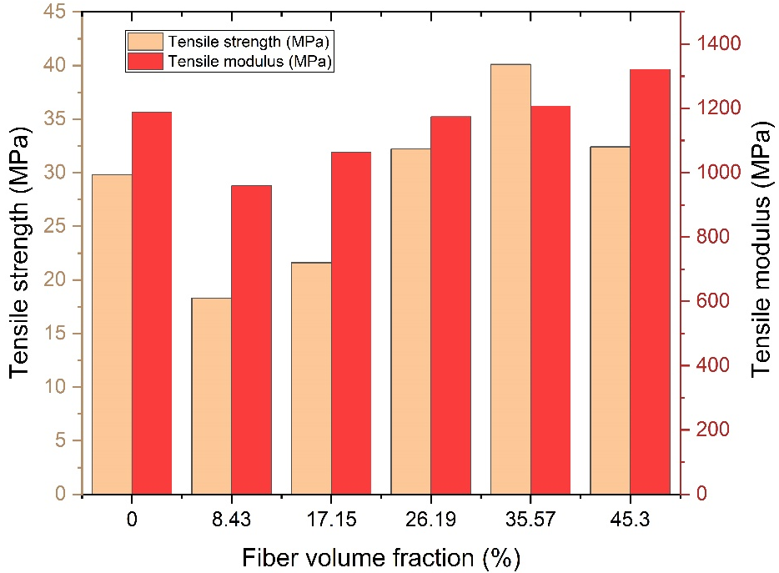
Figure 1: Variation of tensile properties based on the fiber loading in FSP fiber/vinyl ester composites

Figure 2 illustrates how the fiber content in the composite influences its flexural strength. Composite flexural strength has increased up to 48.1 MPa as the increase of fiber content in the composites up to 35.57vol.%. As the fiber content continued to increase, the flexural strength continued to decrease. The Flexural strength of a composite with 45.3 vol.% fiber content is 36.2 MPa. According to the graph, the recorded flexural strength is higher at the fiber content of 26.19vol.% than at the fiber content of 45.3 vol.%. Additionally, it has been found that an increase in fiber content decreases flexural strength above 35.57 vol.%. Figure 2 clearly shows that the increase in fiber content increases the flexural modulus of the composite up to 45.3 vol.%. The flexural modulus of the composite is inferior to that of the pure resin sample at lower fiber content (8.43vol.%). Because the fiber density is lower than the resin, the load is not properly transmitted to the fiber at this stage.
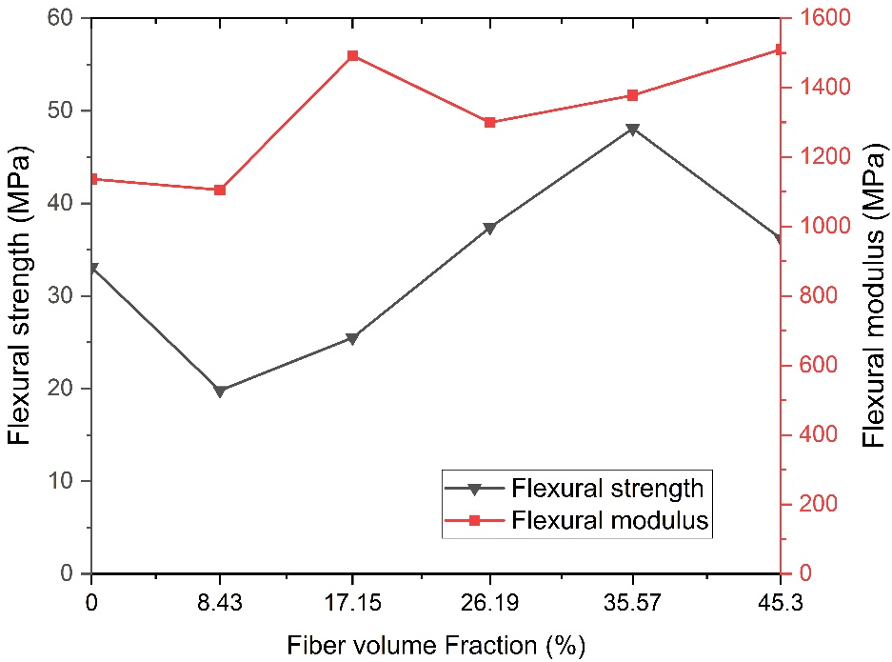

Figure 2: Variation of flexural properties based on the fiber loading in FSP fiber/vinyl ester composites

The effect of fiber content on the composites' impact strength has been seen in Figure 3. As seen in Figure 3, the FSP fiber/vinyl ester composite showed an increasing trend in impact strength from 8.43 to 35.57vol.%. The FSP fiber/vinyl ester composites' maximum impact strength value (1.39 KJ/m2) was observed for 35.57 vol.% of the composite. Compared to the pure resin sample, the impact strength has increased by 59.77 %. The composite with a fiber content of 8.43vol.% had minimum impact strength of 0.62 KJ/m2.

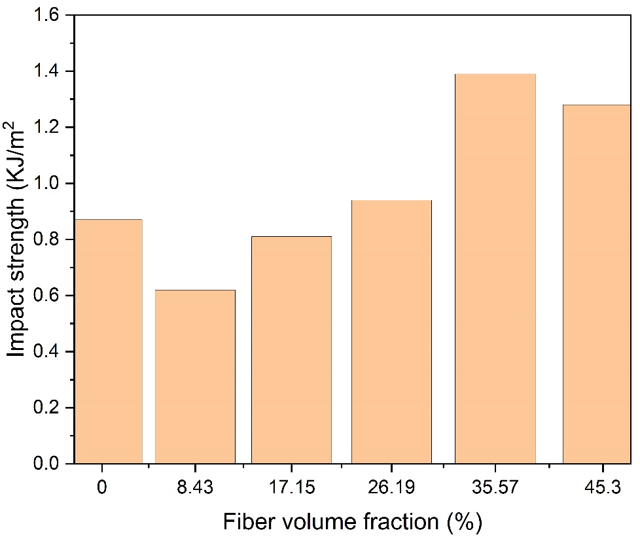
Figure 3: The impact strength of FSP fiber/vinyl ester composites

Mechanical properties of composite (fiber length = 13 mm)

In general, adding fibers to a polymer resin matrix improves the mechanical properties of polymer composites knowingly because the fibers have higher property values than the polymer matrices. Figure 4 depicts the tensile properties of FSP fiber-reinforced vinyl ester composite with a change in FSP fiber loading. At 17.15 vol.%, composites achieve the ultimate strength of the unreinforced resin sample. The tensile strength of composite increased with fiber loading up to 35.57vol.%, i.e., the highest tensile strength (46.2 MPa), and then decreased. Tensile strength improved by nearly 55.03% when compared to the unreinforced resin specimen. The resin was unable to completely wet the FSP fibers after the fiber loading of 35.57 vol.%, which resulted in weak interfacial bonding between the fiber and matrix. In comparison to 45.3vol.% composite, 26.19vol.% composite has a greater value of tensile strength. The young’s modulus values of composites increased linearly from 8.43 to 45.3 vol.%. At 26.19vol.%, the composite reaches the young’s modulus of the unreinforced resin sample. The highest tensile modulus value was found at 45.3 vol.% composite. In comparison to the pure resin sample, an improvement of 17.56% was achieved.
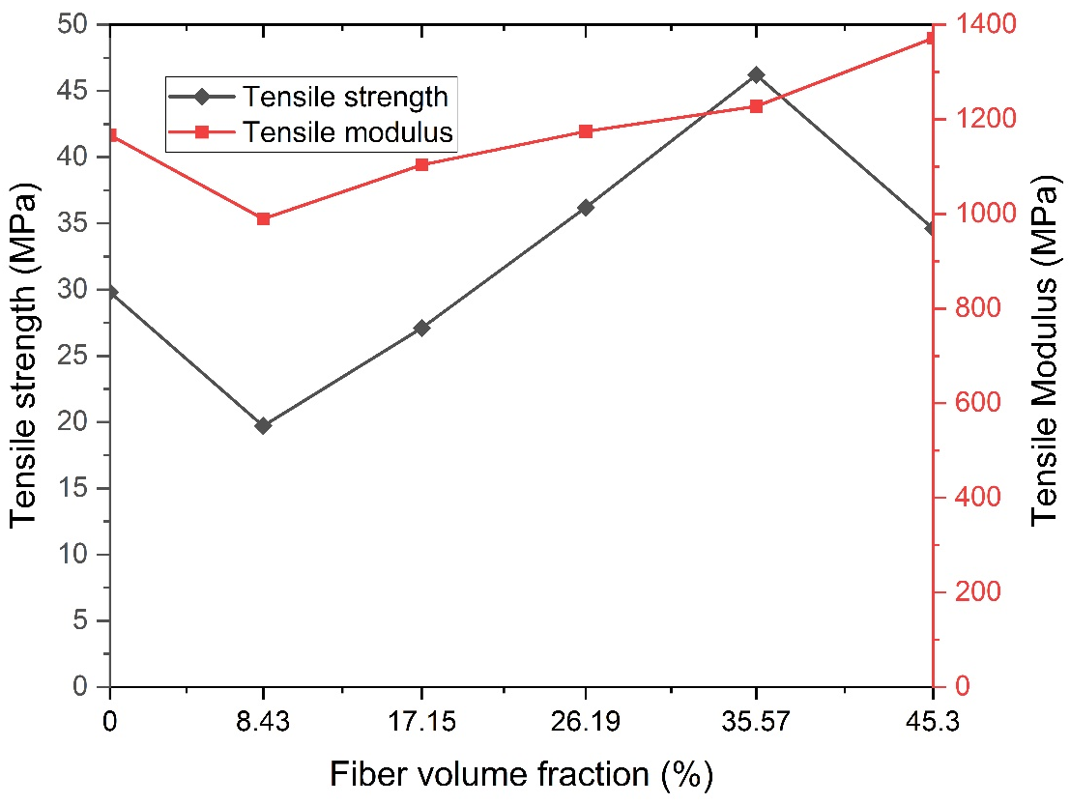
Figure 4: Variation of tensile properties based on the fiber loading in FSP fiber/vinyl ester composites

Figure 5 demonstrates how the vinyl ester composite’ flexural strength is greatly impacted by the addition of fiber. The composite having a fiber volume percentage of 35.57 vol.% had the highest flexural strength. The interaction between the fiber and matrix can be used to explain why flexural strength decreases as FSP fiber content increases. The compatibility of fiber and resin matrix decreases as the amount of FSP fibers in the composite increases. Flexural strength and modulus were found to be around 47.8MPa and 1579.8 MPa, respectively, at fiber contents of about 45.3 vol.%. The flexural modulus of the FSP fiber/vinyl ester composites was found to increase steadily with the increase of fiber content, with 35.57 vol.% fiber content increasing by 19.91% and 45.3vol.% increasing by 35.37 %.
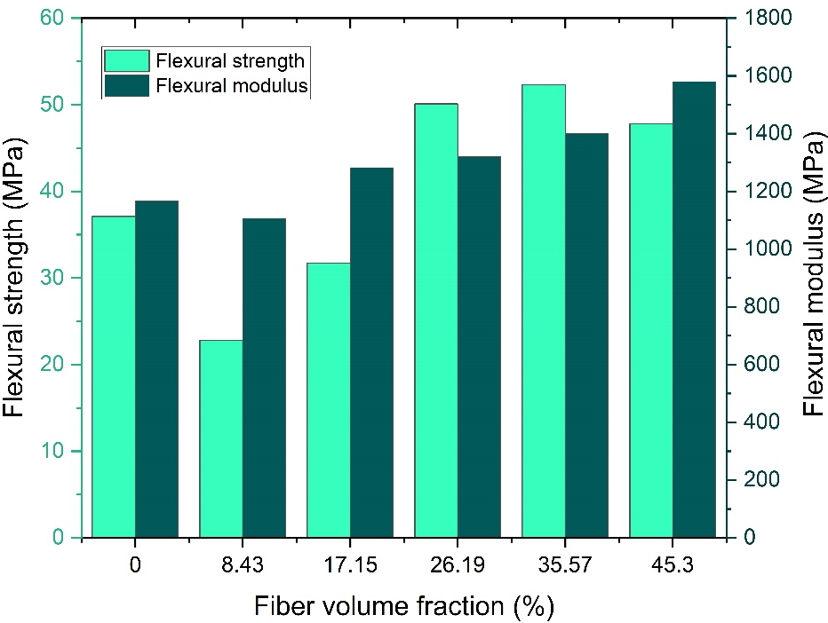
Figure 5: Variation of flexural properties based on the fiber loading in FSP fiber/vinyl ester composites
Figure 6 shows the impact strength of FSP fiber/vinyl ester composites. Composites can withstand 17.15vol.% of the impact of a pure resin sample. It was discovered that impact strength increases up to 35.57vol.% before beginning to decrease. When compared to a pure resin sample, a 64.37% improvement at 35.57vol.% composite was seen. When compared to specimens made of 35.57vol.% composite, 45.3vol.% composite showed a 10.49% drop in impact strength. Initial results show a 17.24% reduction at 8.43vol.% composite when compared to the unreinforced resin sample. The impact strength increased with fiber content after 8.43vol.%.
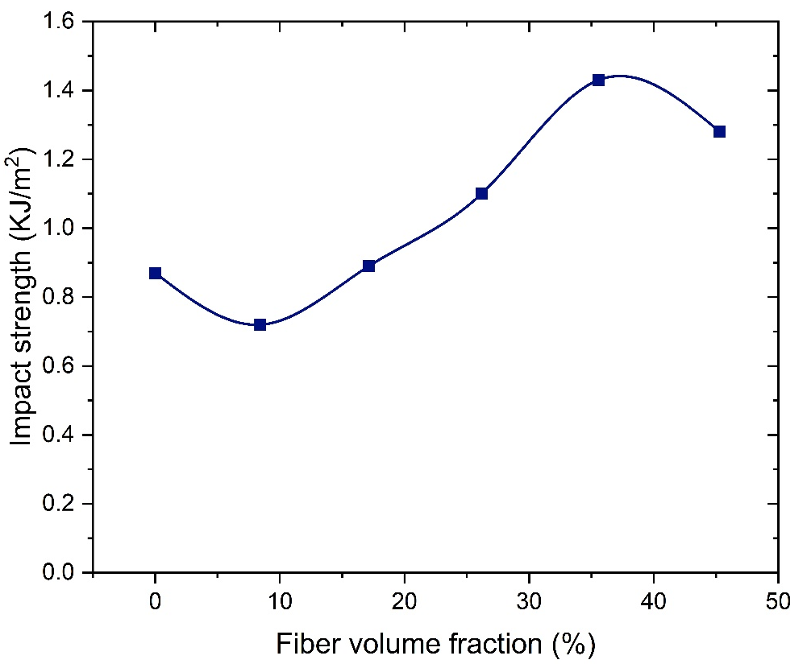
Figure 6: The impact strength of FSP fiber/vinyl ester composites

Figures 1 to 6 show that in all combinations of fiber contents, fiber reinforcement in resin matrix has a considerable influence on the mechanical characteristics of composites. At the strength values of composites with fiber lengths of 13 mm, a substantial difference can be seen. In all cases of fiber contents, composites with fiber lengths of 3 mm also exhibit a reasonable change in mechanical characteristics. It was determined that the compatibility between FSP fibers and the vinyl ester is minimal. The major problem with plant-based natural cellulose fibers was their hydrophilic nature on the surface, which affects the interfacial bonding between the hydrophilic fiber and a hydrophobic matrix. According to the preceding discussion, the optimal fiber content for achieving the best mechanical characteristics in FSP fiber-reinforced vinyl ester composites was 35.57vol.%.

CONCLUSION

This paper presents the experimental investigation results of the mechanical characteristics of FSP fiber-reinforced vinyl ester composites. Both the fiber loading and the fiber length have a significant impact on the mechanical characteristics (tensile strength, flexural strength, and impact strength) of the FSP fiber-reinforced vinyl ester composite material. Up to a 35.57 vol.% increase in the fiber content, mechanical properties increases; after that, it began to decrease for two cases of fiber length. When comparing composites having a fiber length of 3 mm, those with 13 mm fibers exhibit the highest level of mechanical characteristics. The values of the tensile and flexural modulus increased as the fiber loading increased from 8.43 vol.% to 45.3 vol.%. The composite material's impact strength increased as the fiber loading increased.

REFERENCES
- A.K. Sinha, H.K. Narang, and S. Bhattacharya, “Mechanical properties of natural fibre polymer composites”. J. Polym. Eng., vol. 37, pp. 879-895, 2017.
- E.L. Bourhis, F.Touchard, “Mechanical Properties of Natural Fiber Composites”, Encyclopedia of Materials: Composites, vol. 3, pp 135- 148, 2021.
- M. Asim, M. Jawaid, K. Abdan, M.R. Ishak, O.Y. Alothman, “Effect of Hybridization on the Mechanical Properties of Pineapple Leaf Fiber/Kenaf Phenolic Hybrid Composites”, J. Renew. Mater., vol. 6, pp.38-46, 2018.
- C. Merlini, S.D.A.S. Ramôa, and G.M.O. Barra, “Conducting polypyrrole-coated banana fiber composites: Preparation and characterization”, Polym. Compos., vol.34, pp. 537-543, 2013.
- W. Sujaritjun, P. Uawongsuwan, W. Pivsa-Art and H. Hamada, “Mechanical property of surface modified natural fiber reinforced PLA biocomposites”, Energy Procedia, vol.34, pp.664-672, 2013.
- T. Chen, W. Liu and R. Qiu, “Mechanical properties and water absorption of hemp fibers –reinforced unsaturated polyester composites: Effect of fiber surface treatment with a heterofunctional monomer”, BioRes., vol.8, pp. 2780-2791, 2013.
- P.A. Udaykumar, S. Rajanna, and Ramalingaiah, “Studies on effects of short coir fiber reinforcement on flexural properties of polymer matrix”, Int. J. Eng. Res. Technol., vol. 03, pp. 37-41, 2014.
- J. Naveen, T.P. Sathish Kumar, and S. Satheesh Kumar, “Effect of Moisture Absorption on the Behavior of Woven Hybrid Natural Reinforced Polymer Composites”, Int. j. innov. res. sci. technol., vol. 3, pp. 1091-1095, 2014.
- H. Bisaria, M.K. Gupta, P. Shandilya, R.K. Srivastava, “Effect of Fibre Length on Mechanical Properties of Randomly Oriented Short Jute Fibre Reinforced Epoxy Composite”, Mater. Today: Proc., Volume 2, pp. 1193-1199, 2015.
- A.N. Kasim, M.Z. Selamat, N. Aznan, S.N. Sahadan, M.A. Mohd Daud, R. Jumaidin, and S. Salleh, “Effect of pineapple leaf fiber loading on the mechanical properties of pineapple leaf fiber - polypropylene composite”, Jurnal Teknologi., vol. 77, pp. 117–123, 2015.
- M. Gerald Arul Selvan, and A. Athijayamani, (2016). “Mechanical properties of fragrant screw pine fiber reinforced unsaturated polyester composite: Effect of fiber length, fiber treatment and water absorption”, Fibers and Polym., vol. 17, pp. 104-116, 2016.
- W. Wan Mohamed, A. Baharum, I. Ahmad, I. Abdullah, and N. Zakaria, "Effects of fiber size and fiber content on mechanical and physical properties of mengkuang reinforced thermoplastic natural rubber composites", BioRes., vol. 13, pp. 2945-2959, 2018.

