**Synthesis of 1,2-dibenzylidenehydrazine** **derivatives catalyzed by Copper oxide Nanoparticles**

Nitin Dighore, Priya Dahare, Suresh Gaikawad, Anjali Rajbhoj

Department of Chemistry

Dr. Babasaheb Ambedkar Marathwada University,Aurangabad

Maharashtra, India

anjali.rajbhoj@gmail.com

**ABSTRACT**

Electrochemically synthesized copper oxide nanoparticles were tested very effectively as a catalyst on the synthesis of 1,2-dibenzylidenehydrazine derivatives. The copper oxide nanoparticles very efficiently catalyzed various aromatic aldehyde with hydrazine sulphate gives corresponding 1,2-dibenzylidienehydrazine derivatives. The reaction were shorter reaction time, greener solvent ethanol-water at reflux condition, with high yield and minimum environmental effect were important features of the reaction. The catalyst is inexpensive, stable and reused catalyst up to third cycle gave excellent yield.

**Keyword**: Electrochemical synthesis, tetra butyl ammonium bromide, Copper oxide nanoparticles, 1,2-dibenzylidenehydrazine derivatives

1. **INTRODUCTION**

Azines, N-N linked diimines, are extremely useful compounds and recently they have received attention because of their utility in a number of interesting reactions [1], their biological properties and their potential application in bond formation, liquid crystals, nonlinear optical materials confirmed [2]. The azines are an important class of molecules because many compounds of pharmacological interest can be synthesized [3]. Azines are useful for the isolation, purification, and characterization of carbonyl compounds [4]. There are several advantages to make derivatives or protection of azines: (1) economic advantage resulting from the low cost of only one-half equivalent of protective group, (2) easy isolation of the products resulting from the symmetrical structure with high melting points and (3) easy identification of the products resulting from the fully conjugated and colorful structures [5-6]. Applications of azines include possible nonlinear optical materials [7] and conducting polymers (polyazine) [8]. Azine derivatives display important biological properties and are important for drug development [2]. Complexes of titanium, zirconium, cobalt, uranium and iron are capable of cleaving the N-N bond in azines [9-12]. They have considerable interest for their properties and useful applications in coloring and dyeing processes [13]. Azines, R1R2C=N–N=CR1R2, have attracted great attention in organic synthesis as they are good for obtaining various heterocyclic compounds [14-15]. These compounds constitute an important class of compounds with unexpected biological activities [16-17].

Different synthetic pathways can be employed to prepare azines. Symmetrical azines have been synthesized by Saaz co-worker the condensation of aldehydes or ketones with hydrazine in ethanol solution under reflux conditions [18]. In the past few years, the study of new procedures in chemical industries that are less hazardous to human health and the environment has received extensive attention. We report herein our progress toward the establishment of a new protocol for preparation of azines with common additives.

Commercially available BiCl3 had been widely used as a Lewis acid catalyst for aldol reaction, hetero Diels-Alder reaction, ring opening of epoxides with aromatic amines, deoxygenative allylation of substituted benzylic alcohols with allyl trimethyl silane, and for three-component synthesis of β-amino carbonyl compounds. But BiCl3 is highly hygroscopic and difficult to handle as it is toxic and causes irritation to the gastrointestinal and respiratory tract. In addition, this catalyst cannot be reused. Bismuth chloride is to be loaded on a support material for easy handling and utilization. Clays function as efficient catalysts for various organic transformations due to their Bronsted and Lewis acidities in their natural and ion-exchanged forms. Commercially available Mont K10 clay has been used extensively as a catalyst for many organic transformations [19-22]. The usual method for the preparation of azines involves treatment of carbonyl compounds with hydrazine hydrate and acetic acid in ethanol was developed [23]. A number of methods have been reported for the synthesis of azines under various conditions [24-27] but most of them require elevated temperatures and complex catalysts. Hence, there is a need to develop a simple, eco- friendly method under mild conditions for the preparation of azines. In this work on the synthesis of azine derivatives with copper oxide nanoparticles in ethanol solvent, herein we report a recyclable, easily separable, ecofriendly and highly effective catalytic system CuO nanoparticles loaded.

1. **EXPERIMENTAL**
2. **Materials**

The AR grade tetra butyl ammonium bromide (TBAB), tetrahydrofuran (THF) and acetonitrile (ACN) were purchased from Aldrich and S.D. Fine chemicals and used as such. The copper metal sheet act as sacrificial anode and platinum sheet as inert cathode having thickness 0.25 mm and purity 99.9% was purchased from Alfa Asaer. The specially designed electrolysis cell with a volume capacity of 30 ml was used. The prepared copper oxide nanoparticles were characterized by UV-Visible, XRD, SEM-EDS techniques. The UV-Visible studies were recorded [JASCO 503] spectrophotometer using a quartz cuvette with ACN / THF (4:1) as reference solvent. The X-ray powder diffraction patterns of the copper oxidenanoparticles were recorded on Bruker 8D advance X-ray diffractometer using CuKα radiation of wavelength = 1.54056 Å. To study the morphology and elemental composition in copper oxide nanoparticles were examined using energy dispersive spectrophotometer (EDS), the SEM analysis were carried out with JEOL; JSM- 6330 LA operated at 20.0kV and 1.0000nA. 1H NMR and 13C NMR spectra were recorded on a Bruker AvIII HD-300 MHz FT‐NMR spectrometer with CDCl3 as a solvent and the chemical shift values recorded as δ (ppm units).

B**. Synthesis of copper oxide Nanoparticles**

Reetz proposed an electrochemical reduction method [28] including both oxidation of bulk metal and reduction of metal ions for size selective preparation of tetra alkyl ammonium salt stabilized metal nanoparticles. In the initial experiment we have used a copper metal sheet (1x1 cm) as anode and a platinum sheet (1x1 cm) as the cathode. These two electrodes placed parallel to one another and were separated by 1.0cm in 0.01 M solution of TBAB prepared in ACN/THF (4:1) served as the supporting electrolyte. The electrolysis process was then carried out by applying current 6 mA for 2.0 hrs. The colloidal solution thus obtained was kept in air tight glass bottle to settle for a day. The agglomerated solid sample was separated from the solution by decantation and washed three to four times with THF. The washed samples were then dried under vacuum condition in desiccator and stored in air tight container for characterization.

C. **Present work**

Electrochemically prepared copper oxide nanoparticles were tested as a catalyst on the synthesis of 1,2-dibenzylidenehydrazine derivatives (Scheme 1). The copper oxide nanoparticles showed very efficiently catalyzed various aromatic aldehyde with hydrazine sulphate reflux at 80 ºC in ethanol-water solvent gives corresponding 1,2-dibenzylidenehydrazine derivatives.



**Scheme 1**

D. **General procedure of synthesis of 1,2-dibenzylidenehydrazine**

A mixture of aromatic aldehyde (2mmol), hydrazine hydrate sulphate (1mmol) and copper oxide nanoparticles (100mg) (Scheme 1) was reflux in ethanol: water (1:1) at 80 ºC till the completion of reaction monitored by TLC (ethyl acetate and n-hexane 7:3). After completion of reaction solid product obtained was dissolved in 10ml ethyl acetate and concentrated on rotavapor. Finally pure product was obtained by recrystallization and authentic samples were characterized by FTIR, 1HNMR and 13CNMR.

E. **Spectral data of representative compound**

1] (1E,2E)-1,2-Dibenzylidenehydrazine 3a. Yellow solid: Yield 90%: melting point-93-94 ˚C; 1H NMR(400 MHz, CDCl3): δ 7.07 (1H, mm, CH), 7.28 (1H, m, CH), 7.49 (1H, m, CH), 7.65 (1H, t, CH), 8.28 (1H, m, CH), 8.48 (1H, s, CH=N); 13C NMR (100 MHz, CDCl3): d 128.41 (CH of Ar), 128.72 (CH of Ar), 130.76 (CH of Ar), 132.31 (C of Ar) 164.80 (C of CN).

2] (1E,2E)-1,2-Bis(3-nitrobenzylidene)hydrazine 3e. FTIR (KBr νmax/cm-1) :3153, 1662, 1598, 1448, 1314, 1283,1217,1163, 1054, 1007, 923, 858, 832, 787 and 665 cm-1; 1H NMR(400 MHz, CDCl3) δ ppm : 7.77 (t, 1H, CH of Ar), 8.28(d, 1H, CH of Ar), 8.35 (d,1H, CH of Ar), 8.74 (S,1H, CH of benzylidenimin), 8.86(s, 1H, CH of Ar); 13C NMR (100MHz, CDCl3) δ ppm (Fig S5): d 122.41(CH of Ar), 125.35(CH of Ar), 130.07 (CH of Ar), 134.31 (C of Ar), 135.23 (CH of Ar), 148.12 (C of Ar), 160.09 (C of CN).

**III. RESULT DISCUSSION**

1. **UV-Visible spectroscopy**

Metallic nanoparticles exhibit surface plasmon resonance (SPR) and is not observed in bulk metal. The electrochemical synthesis of Cu nanoparticles capped with capping agents TBAB at 6 mA/cm2 current density has been carried out in the present study. Copper oxide nanoparticles exhibits maximum absorption at 640 nm (Figure S1). This absorption band can be attributed to the surface plasmon resonance peak of copper oxide nanoparticles.



**Figure 1 UV-visible spectrum of copper oxide nanoparticles**

1. **FTIR Spectroscopy**

In IR spectrum (Figure 2) peak appears at 3424 cm-1 which can be attributed to the hydroxyl groups, which indicate hygroscopic nature of copper oxide nanoparticles. Peaks at 2962 cm-1, 2872 cm-1 & 1589 cm-1 are due to the C-H stretching & bending respectively. 1662 cm-1 is peak due to N+R4 symmetrical ion. Peak at 1388 cm-1 can be attributed to the C-C stretching and at 1064 cm-1 to C-N stretching. Some of the peaks reflect in the range of 879 cm-1 that are due to bending mode of vibrations of M-O-M bending (M=Cu) and the peak at 660 cm-1 are the stretching of mode of vibration of Cu-O.

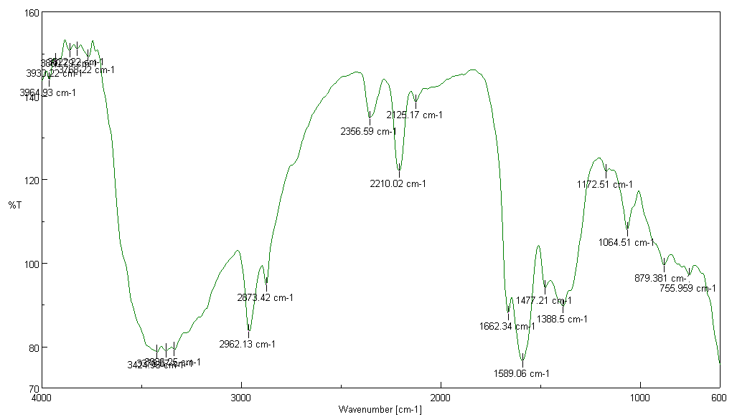

**Figure 2 FTIR Spectrum copper oxide nanoparticles**

1. **X-Ray diffraction**

XRD diffraction pattern (Figure 3) of copper oxide nanoparticles capped with 0.01M concentration of TBAB at 6 mA/cm2 current density. The lattice parameters a = 4.653, b = 3.410, c = 5.4089 at β = 99.480. The strong and sharp peaks were obtained at planes (-111), (111), (012), (020), (120) & (121) indicating the monoclinic structure of copper oxide nanoparticles which were found to be highly crystalline in nature. XRD plots show the intense peaks of TBAB for (111) plane the full width of half maximum (FWHM) value were 1.5609 showed average crystallite size 5.34nm.

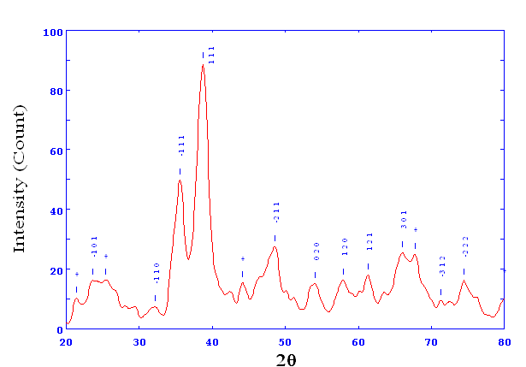

**Figure 3 XRD pattern of copper oxide nanoparticles**

1. **Scanning Electron Microscopy**

To study the surface morphology and elemental composition, the SEM with EDS were investigated systematically. Figure 1b shows that nanoparticles have irregular shape and the distribution was not uniform and also shows presence of porous nanoparticles with dense agglomerated. The EDS spectra of copper nanoparticles excited by electron beam (20 kv) show peaks for the elements of C, O, Br and Cu as observed which confirm formation of copper oxide nanoparticles.



**Figure 4 SEM image of copper oxide nanoparticles**

1. **Catalytic activity of copper oxide nanoparticles**

We reveal herein for the first time, the copper oxide nanoparticles catalyzed 1,2-dibenzylidenehydrazine with a variety of aldehydes ( Scheme 1) by simple reflux at 80ºC in ethanol-water(1:1) greener solvent. In the present work, attempt is made to optimize the reaction condition by using 3 nitro-benzaldehyde and hydrazine sulphate as a model reaction at different solvents and amount of catalyst used. From Table 1, it can be seen that the best ratio of copper oxide nanoparticles to starting material is 100mg. There is considerable increase in the yield of product when the concentration of copper oxide nanoparticles increases from 20mg to 100mg. But when we increased catalyst quantity to 120 mg there is no considerable change in reaction time and yield of product.

**Table 1 Screening of catalyst copper oxide NPs for the synthesis of 1, 2-dibenzylidenehydrazine**

|  |  |  |  |  |  |  |
| --- | --- | --- | --- | --- | --- | --- |
| Entrya |  | Catalyst amount (mg) |  | Time(min) |  | Yieldb(%) |
| 1 |  | 20 |  | 30 |  | Trace |
| 2 |  | 40 |  | 30 |  | 36 |
| 3 |  | 60 |  | 30 |  | 66 |
| 4 |  | 80 |  | 30 |  | 92 |
| 5  6 |  | 100  120 |  | 30  30 |  | 96  96 |

a3 Nitro- benzaldehyde (2mmol), hydrazine sulphate (1mmol) and copper oxide NPs (100mg) in ethanol:water (1:1) reflux at 80 ºC. b Isolated yield

In this study, the effect of different solvent was investigated and given in Table2. The choice of solvent proved critical. We observed that polar solvents such as methanol, ethanol, acetonitrile, afford better yield than nonpolar ones and mixture of ethanol-water (1:1) is most effective solvent affording maximum yield of product.

**Table 2 Optimization of solvent in synthesis of 1,2-dibenzylidenehydrazine**

|  |  |  |  |  |  |  |
| --- | --- | --- | --- | --- | --- | --- |
| Entrya |  | Solvent |  | Time(min) |  | Yieldb(%) |
| 1 |  | ACN |  | 180 |  | 54 |
| 1 |  | Toluene |  | 180 |  | 32 |
| 2 |  | THF |  | 180 |  | 35 |
| 4 |  | Methanol |  | 120 |  | 72 |
| 5 |  | Ethanol |  | 60 |  | 86 |
| 6 |  | Ethanol:water (1:1) |  | 30 |  | 94 |

a3 Nitro- benzaldehyde (2mmol), hydrazine sulphate (1mmol) and copper oxide NPs (100 mg) in ethanol:water(1:1) reflux at 80ºC. b Isolated yield

After optimizing the conditions, the generality of this method was examined by the reaction of cyclohexanone with several aldehydes bearing electron withdrawing groups (such as nitro, chloro and hydroxyl) and electron donating groups (such as methyl, methoxy and N-dimetyl). The entire product reacted in a similar manner producing moderate to good yield of expected product. The para substituted aromatic aldehyde reacted in a shorter reaction time as compared with ortho and meta substituted aromatic aldehyde and electron donating substituted aldehyde required more time and comparative less yield result summarized in Table 3.

**Table 3. Synthesis of 1, 2-dibenzylidenehydrazine derivatives using CuO NPs catalyst**

|  |  |  |  |  |  |
| --- | --- | --- | --- | --- | --- |
| Productsa | R | Time (min) | Yieldb (%) | Melting point (˚C) | |
| Found | Reported |
| 3a | H | 45 | 90 | 93-94 | 92-93 [29] |
| 3b | 4-Cl | 35 | 95 | 207-209 | 208-210 [27] |
| 3c | 2-Cl | 40 | 91 | 141-142 | 142-144 |
| 3d | 4-NO2 | 30 | 94 | 297-299 | 299-300 [27] |
| 3e | 3-NO2 | 30 | 96 | 195-196 | 198-199 [27] |
| 3f | 2-OH | 35 | 94 | 213-214 | 216-217 [30] |
| 3g | 4-N(CH3)2 | 40 | 91 | 214-215 | 215-216 [29] |
| 3h | 4-CH3 | 50 | 88 | 156-158 | 159-160 |
| 3i | 4-OMe | 45 | 89 | 166-168 | 166-169 [29] |

aAromatic aldehyde(2mmol), hydrazine sulphate (1mmol) and copper oxide NPs (100 mg) in ethanol:water (1:1) reflux at 80ºC. bIsolated yield.

In this study, the catalyst was recovered and reused. The catalyst was recovered by a simple work‐up using centrifugation and then it was washed with ethanol and reused. The reused catalyst gave excellent yield and was used in mentioned reaction for three times, the observations in Table 4 reveal that as the number of the cycles of catalyst increases the activity decreases.

**Table 4. Reusability of CuO NPs catalyst in synthesis of 1,2-dibenzylidenehydrazine**

|  |  |  |  |  |  |
| --- | --- | --- | --- | --- | --- |
| **Cycle** | **Fresh** | **First** | **Second** |  | **Third** |
| aYield (%)b | 96 | 94 | 90 |  | 85 |

a3 Nitro- benzaldehyde(2mmol), hydrazine sulphate (1mmol) and copper oxide NPs (100mg) in ethanol water(1:1) reflux at 80ºC. b Isolated yield

**CONCLUSION**

We have demonstrate mild, easy and greener approach for the synthesis of 1,2-dibenzylidinehydrazine derivatives using copper oxide nanoparticles as heterogeneous catalyst. These results show that, copper oxide nanoparticles were efficient, stable, nontoxic and reusable catalyst. They give good yield of product in shorter reaction time in presence of green solvent ethanol: water. Since short reaction time, appropriate yield and simple reaction make this method attractive alternative to existing method.

**Acknowledgment*:*** TheDepartment of Chemistry acknowledges the financial assistance by UGC-SAP-DRS scheme-1. We acknowledge the characterization facility by SEM & EDS from STIC Cochin. One of the author (ASR) is thankful for financial assistance from Major Research project [F. No. 832/2010(SR)], University Grants Commission, New Delhi.

**REFERENCES**

1. J. M. Hopkins, M. Bowdridge, K. N. Robertson, T. S. Cameron, H. A. Jenkins and J. A. Clyburne, J. Org. Chem. **66,** 2001,pp 5713-5716.
2. C. Y. Wu, Y. Chen, S. Y. Jing and W. S. Hwang, Polyhedron **25,** 2006, pp 3053-3065.
3. H. S. Machado and A. J. Hinchliffe, *Mol. Struct*. **339,** 1995, pp 255-258.
4. T. W. Greene and P. G. Wuts, Protective Groups in Organic Synthesis, 2nd ed.: Wiley:New York,1999, p. 24.
5. M. Tajbakhsh, R. Hosseinzadeh, F. Ramazanian-Lahmali and M. J. Sadatshahabi, Chin. Chem. Soc., **52** 2005, pp 1005-1009.
6. B. P. Bandgar and S. S. Makone, J. Chin. Chem. Soc. **47,** 2000, pp. 575-577.
7. H. S. Nalwa, A. Kakatu and J. Mukoh, Appl. Phys. **73** 1993, pp. 4743.
8. E. C. Kesslen and W. B. Euler, Chem. Mater*.* **11,** 1999,pp.336-340.
9. M. Rep, J. F. Kaagman, C. J. Elsevier, P. Sedmera, J. Hiller, U. Thewalt, M. Horacek and K. Mach,Organomet. Chem., **597** 2000, pp.146-156.
10. T. Zippel, P. Arndt, A. Ohff, A. Spannenberg, R. Kempe and U. Rosenthal, Organometallics**17** 1998,pp. 4429-4437.
11. J. L. Kiplinger, D. E. Morris and C. J. Burns, Organometallics **21(15),** 2002, pp. 3073-3075.
12. A. Zimniak and G. J. Bakalarski, Mol. Struct. **597** 2001, pp. 211-221.
13. A. H. Ammar, B. A. El-Sayed and E. A. El-Sayad, J. Mat. Sci. **37** 2002, pp. 3255-3260.
14. R. M. Mohareb, J. Z. Ho and F. O. Alfarouk, Journal of the Chinese Chemical Society, **54(4)** 2007, pp.1053-1066.
15. R. Manikannan, R. Venkatesan, S. Muthusubramanian, P. Yogeeswari and D. Sriram Bioorganic and Medicinal Chemistry Letters, **20(23)** 2010, pp. 6920-6924.
16. V. M. Kolb, D. H. Hua and W. L. Duax, J.of Org.Chem*.*, **52(14),** 1987, pp. 3003-3010.
17. V. M. Kolb and D. H. Hua, Journal of Organic Chemistry, **49(20),** 1984, pp.3824-3828.
18. D. Sanz, M. A. Ponce, R. M. Claramunt, C. Fernandez-Castano, C. Foces-Foces and J. Elguero, J. Phys. Org. Chem. **12,** 1999, pp. 455-469.
19. T. K. Huang, R. Wang, L. Shi and X. X. Lu, Catalysis Communications **9(6)** 2008, pp. 1143-1147.
20. T. Joseph, G. V. Shanbhag, D. P. Sawant and S. B. Halligudi, J. of Molecular Catalysis A, 250, 2006 pp. 210-217.
21. F. R. Criśostomo, R. Carrillo, T. Martın and V. S. Martın, Tetra. Lett., **46(16)** 2005, pp.2829-2832.
22. T. Kawabata, T. Mizugaki, K. Ebitani and K. Kaneda, Tetra. Lett.,44(51) 2003, pp. 9205-9208.
23. A. I. Vogel, Text book of Prac. Org. Chem., ELBS Longman, London, UK, 4th edition, 1978.
24. H. M. Nanjundaswamy and M. A. Pasha, Synth. Commun., 36(21), 2006, pp. 3161-3165.
25. S. N. Shah and N. K. Chudgar, Molecules, 5(4), 2000, pp. 657-664
26. H. Eshghi and M. Hosseini, Journal of the Chinese Chem. Soc., 55(3), 2008, pp. 636.
27. J. Safari and S. Gandomi-Ravandi, Synthetic Communications, 41(5) 2011, pp. 645-651.
28. M. T. Reetz, W. Helbig and S. A. Quaiser Chem. Mater. 7 1995, pp. 2227-2228.
29. H. Loghmani-Khouzami, M. M. Sadeghi, J. Safari, M. S. Abdorrezaie and M. Jafapisheh*,* J. Chem. Res. Synop. 2001 pp. 80-81.
30. A. M Stephen, T. Schalkwyk and N. Ravenscroft, ARKIVOC **III**2002 pp. 103-111.