A Study on Taxonomy, Elements and Types of Design
Madhusudhana Reddy Barusu  Electronics and Communication Engineering  Ravindra College of Engineering for women  Kurnool, A.P, India  Madhu.barusuau@gmail.com | M. Sailaja  Computer Science and Engineering  Ravindra College of Engineering for women  Kurnool, A.P, India  sailajacse@recw.ac.in | R. Deepthi Crestose Rebekah  Computer Science and Engineering  Ravindra College of Engineering for women  Kurnool, A.P, India  rdeepthicse@recw.ac.in | N. Manjula  Computer Science and Engineering  Ravindra College of Engineering for women  Kurnool, A.P, India  manjulacse@recw.ac.in | V. Prema Manvi  Computer Science and Engineering  Ravindra College of Engineering for women  Kurnool, A.P, India  premacse@recw.ac.in

ABSTARCT

Creating a system, object, activity, or process requires a plan or specification. A design is the result of that plan or specification in the shape of a prototype, final product, or method. The verb design conveys the action of producing a product. Different types of designs help to make the product or prototype useful and long-lasting. To make a successful composition, the design elements are the building blocks for a Visual artist or a graphic designer.

Keywords—Design, Taxonomy, Elements of Design.

INTRODUCTION
Purpose of Design:
The design of any object is very important as the design will impact the users experience and emotions. The design also decides how a user receives and get influenced with the product. So, the design of any object is important. The design of any product is defined as the way to decide the shape or specifications or construction of product as process or prototype in physical or virtual mode.

A good design should be innovative, product useful, reliable, and long-lasting and ecofriendly.

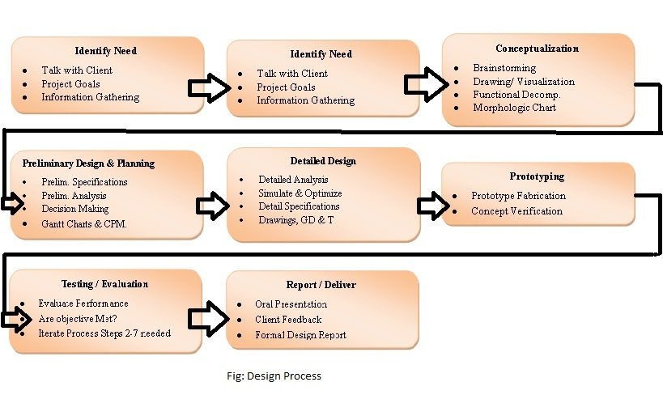

TAXONOMY OF DESIGN
Each and every design is required to describe with some technical terms, which are taxonomy of the design. Some of the taxonomy of the design is given below
- Architectural Design: The space for the people to live such as buildings, houses.
- Design of Spaces: The spaces are designed according to the utilization such as residential or educational.
- Industrial Design: The commercial tools use full for the humans such as artifacts and body of the cars etc., are designed at a spaces called industrial designs
- Graphic Design: Recreate meaningful visual messages such as magazines and posters.
- Fashion Design: The basic needs such as cloths and luxurious products such as jewelry design is termed as fashion design.

- Textile Design: Combination of methods involved in Graphic Design with the methods involved in Industrial Design and Fashion Design, consists of configuring fabrics and patterns of the textile industry.
Eg: prints, yarns, embroidery, fibers.
- Interactive Design: Focus on software and digital interface design.

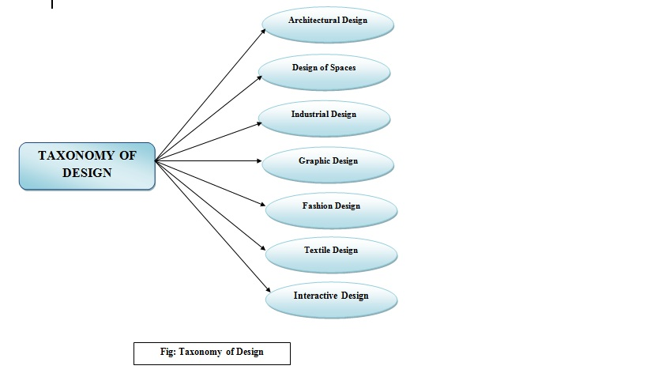
Fig. Taxonomy of the design

- ELEMENTS OF DESIGN

Every object in our surroundings is made up of design elements. Nothing exists within the absence of these components. The designer is liable for understanding the power of these elements and formatting them in accordance with design principles.
1. Color – It is commonly mentioned as hue. The word color refers to a specific colour or light wavelength that can be found in the colour spectrum and that moves in a circle from red to yellow to green to blue and back to red.
2. Line - A line may be a point in motion that has only one dimension. A line has both an edge in space and a direction. The variables such as position, size, space and orientation define the line.

3. Mass - Mass and volume are interchangeable during this context. A mass may be a solid body or a collection of visual elements that together form a solid form. Volume may be a three-dimensional shape made up of length, width, and depth. Points, lines, and planes are all components of three-dimensional forms. A mass may be a two-dimensional representation of a three-dimensional form.
4. Movement – The movement of the product explains about orientation, blurring of action, etc., which is actually not a animation, but may be byproduct of movement of other design elements.
5. Space – Any element of a two- or three-dimensional, defined by using other elements is called a space.
6. Texture - A two-dimensional design technique that uses various drawing and media techniques to duplicate three-dimensional surfaces. Touch or visual experience is employed to experience three-dimensional surfaces.
7. Value – The darkness or lightness of a space is defined as value.

- VARIOUS TESTING METHODS FOR A SUCCESSFUL DESIGN

The various testing methods which are involved in successful design of a product are:

- Concept validation: It helps to generate the ideas which won’t work before we haven’t spent too much time and money on them.

- Usability Task analysis: Helps you quickly identify the blockers, bugs and gaps in usability of the product.

- First click Testing: It shows which buttons, icons and other navigational elements in which the users are failing to avoid or notice on the product.

- Card Sorting: It shows the users creativity and helps to make sense the user’s journey for customers.

- Tree Testing: It is used to validate the design and creating a clear, intuitive navigation experience for user.

- User Feedback: Targets onsite feedback testing to understand the user’s mind to make use of specific features.

- Split Testing: It iterates the design and provides different options to lower the risk factor for new design ideas.

REFERENCES
1.The Design Management Institute DMI Value Index 2015, retrieved from https://www.dmi.org/page/2015DVIandOTW
2.Martin, R. (2009) The Design of Business, Harvard Business School Press.
3.Quayle, M. (2017) Designed Leadership. Columbia University Press
4.Liedtka, J. (2018, Sept-Oct) Why Design Thinking Works, Harvard Business Review
5.Walker, R. (2003, Nov 30) The Guts of a New Machine. New York Times Retrieved http://www.nytimes.com/2003/11/30/magazine/30IPOD.html
6. Brown. T. (2008) Design Thinking Thoughts: Definitions of Design Thinking retrieved from https://designthinking.ideo.com/?p=49

