A comprehensive review on novel immunotherapy for proliferative disease : cancer vaccine

Raj Baldhaª, Sachin Rathodª, Janki Patel^{a,#}

ªDepartment of Pharmaceutics, Parul Institute of Pharmacy and Research, Faculty of Pharmacy, Parul University,Waghodiya-391760, Vadodara, Gujarat, India.

Corresponding author:
Dr. Janki Patel (M.pharm, Ph.D)
Email id: janki0410pharma@gmail.com
Contact no: +91-9429846506

Abstract

In terms of detecting existing tumors and avoiding recurrence, Cancer vaccines that are therapeutic are being developed. The central tenet of effective immunotherapy is that the human immune system is capable of detecting and killing tumor cells, Although the results of clinical trials, primarily in the metastatic environment, have been sobering, the hypothesis remains plausible. To make real progress in the potential clinical application of cancer vaccines, we believe that a paradigm shift in the way clinical trials are conducted and the concepts they explore is required. Firstly, we need to reassess if the metastatic atmosphere is the suitable venue for studying these agents. Second, we need to find consensus on the most significant biological endpoints and easily assess the potential of vaccines to meet these endpoints. Thirdly, research into ways to stimulate the immune system beyond the initial stimulation provided by a vaccine is essential. Eventually, it would be useful to slim down the vast range of vaccine channels in order to facilitate analysis of findings across multiple trials.
Key Words: Cancer, vaccine, Clinical trial, immune system

Introduction

Vaccine:

Vaccine, suspension of microorganisms or toxins that are depleted, destroyed or fragmented, or of antibodies or lymphocytes that are given mainly for preventing disease. A vaccine may give active immunity against a particular pathogen by activating the immune system to attack the agent. Vaccines are typically given by injection (parenteral administration), but some are also provided by oral, or nasal spray (in the case of flu vaccine). Vaccines that are applied to the mucosal membranes, For example, the linings of the stomach and nasal passages appear to induce a higher antibody response and may be the most effective route of administration (1-4) ⁽¹⁻⁸⁾.

Properties of an ideal vaccine (5-7) ⁽⁹⁻²⁰⁾
- Give protection for the rest of your life.
- Normally defensive against every types of organisms
- Protect the outbreak of disease.
- Inhibit immunity as soon as possible.
- Appropriate for all subjects (the old & very young)
- Transmit maternal protection to the foetus
- Require few immunizations to induce protection
- It is not necessary to administer by injection (oral, intranasal, transcutaneous)
Stabilized, affordable, and secure

Types of vaccines (8):
Vaccines are available in a variety of sizes and shapes. Each style is designed to teach the immune system how to fight specific germs and diseases that they can induce. When developing vaccines, scientists consider the following factors
  - How your immune system reacts to the germ
  - Who should be vaccinated against the virus?
  - The most effective technology or method for developing the vaccine.
  - Researchers consider a number of factors when deciding which type of vaccine to develop.
Vaccines are divided into different categories:
- Vaccines that have been live-attenuated
- Vaccines that have been inactivated
- Vaccines that are sub-unit, recombinant, polysaccharide, or conjugate
- Vaccination against toxoids
- Vaccines that are conjugated
- Vaccines which are related to DNA
- Vaccines which have Recombinant vector

Vaccines that have been grew up
In the lab, live, attenuated vaccines elicit a weakened form of the living microorganism that cannot cause disease.Since they are the nearest thing to a normal outbreak, live, attenuated vaccines are successful “teachers” of the immune system.Vaccines against measles, mumps, and chickenpox, for example (9) (10) ⁽²¹⁻²⁵⁾.

Vaccines that have been inactivated
Inactivated vaccines are made by destroying the disease-causing microbe with chemicals, heat, or radiation. These vaccines are more stable and safe than live vaccines.Because disease-causing microbes which are dead can't mutate back to their original form.Vaccines against measles, polio, hepatitis A, and rabies, for example (11, 12).

Vaccines that are sub-unit, recombinant, polysaccharide or conjugate
Sub-unit vaccines activate the immune system more rapidly, and they only contain the essential antigens, not any of the microbe's other molecules.Some of these vaccines use epitopes, which are very specific parts of the antigen that antibodies or T cells recognise and bind to.Example is Plague immunization ⁽²⁹⁻³¹⁾

Vaccination against toxoids
A toxoid vaccine may be the response for bacteria that secrete toxins or toxic compounds.When a bacterial toxin is the main cause of disease, these vaccines are used.Toxins can be made inactive by treating them with formalin, according to scientists. Toxoids, or “detoxified” toxins, are safe to use in vaccines.Example Crotalus atrox toxoid is a toxoid used to protect dogs from rattlesnake bites (13) ⁽³²⁻³⁴⁾.

Vaccines that are conjugated
Researchers may attempt to develop a conjugate vaccine for the outer layer of sugar molecules called polysaccharides found on many dangerous bacteria.Antigens are obscured by polysaccharide coatings on bacteria, preventing infants and young children's immune systems from recognizing or responding to them.For instance, the Haemophilus influenza type B vaccine (14).

Vaccines which are related to DNA
Many such vaccines are still in the developmental process, but they show a lot of potential, and some of them are being studied in humans.Immunization has reached a new level of complexity thanks to DNA vaccines.These vaccines bypass the entire organism and its materials, going straight to the source of the problem: the genetic material of the microbe.For example, the influenza vaccine (15).

Vaccines which have Recombinant vector
Recombinant vector vaccines are conceptual vaccines that function similarly to DNA vaccines but carry microbial DNA to body cells from an attenuated virus or bacterium. The virus or bacterium that acts as the carrier is referred to as a "vector.”DPT is a good example (16) (17).

Importance of vaccine:
From birth, several various viruses, bacteria and other microbes are continually introduced to us. Many are not risky, many are useful, but some can cause illness. The body's immune system protects us from pathogens. When we are exposed to bacteria, our immune system initiates a series of reactions in order to neutralize the bacteria and minimize their harmful effects. Lifelong defense (immunity) is also offered from exposure to an infectious illness, so we cannot catch the same disease again. The microbe is "remembered" by our immune system (18).

WHAT IS IMMUNOTHERAPY:

  - The immune system, also known as the body's defence system, is a collection of specialized cells and tissues that work together to combat infection and disease. Biological therapies, also known as immunotherapy, are cancer-fighting or cancer-prevention treatments that rely on the immune system.
  - Immunotherapy is a cancer treatment that makes use of the body's own immune system⁽⁴⁷⁾.

WHAT IS CANCER:
- Our fundamental units are cells. When they become too old or weakened, they develop, split, and die. Then, in their place, new cells appear.
- Cancer arises when this orderly mechanism is interrupted by genetic changes. Cells begin to proliferate at an uncontrollable pace.
- A tumour may be cancerous or benign, and these cells can form a mass called a tumour.
- A malignant tumour is one that has the ability to develop and spread to other areas of the body.
- The term "benign tumour" refers to a tumour that can develop but will not spread.
- Some cancers do not produce a tumour. Leukemia, certain types of lymphoma, and myeloma are among them (19).

What are cancer vaccine:
A cancer vaccine is a vaccine that is used to cure or prevent cancer in people who are at high risk of receiving it. Therapeutic cancer vaccines are vaccines that are used to treat cancer that has already grown. Oncoviruses are responsible for some cancers, such as breast cancer and some liver cancers. Vaccines against current cancers are now being created by scientists. Cancer vaccines train the immune system to identify cancer cells as harmful and destroy them (20).
There are different kinds of cancer vaccines:

1. A cancer vaccine that is specific

2. Vaccine against all cancers

Each cancer vaccine works on the same basic principle: it stimulates the immune system, which produces specific cells that kill cancer cells and prevent relapses(21)(22).

History of cancer vaccine:

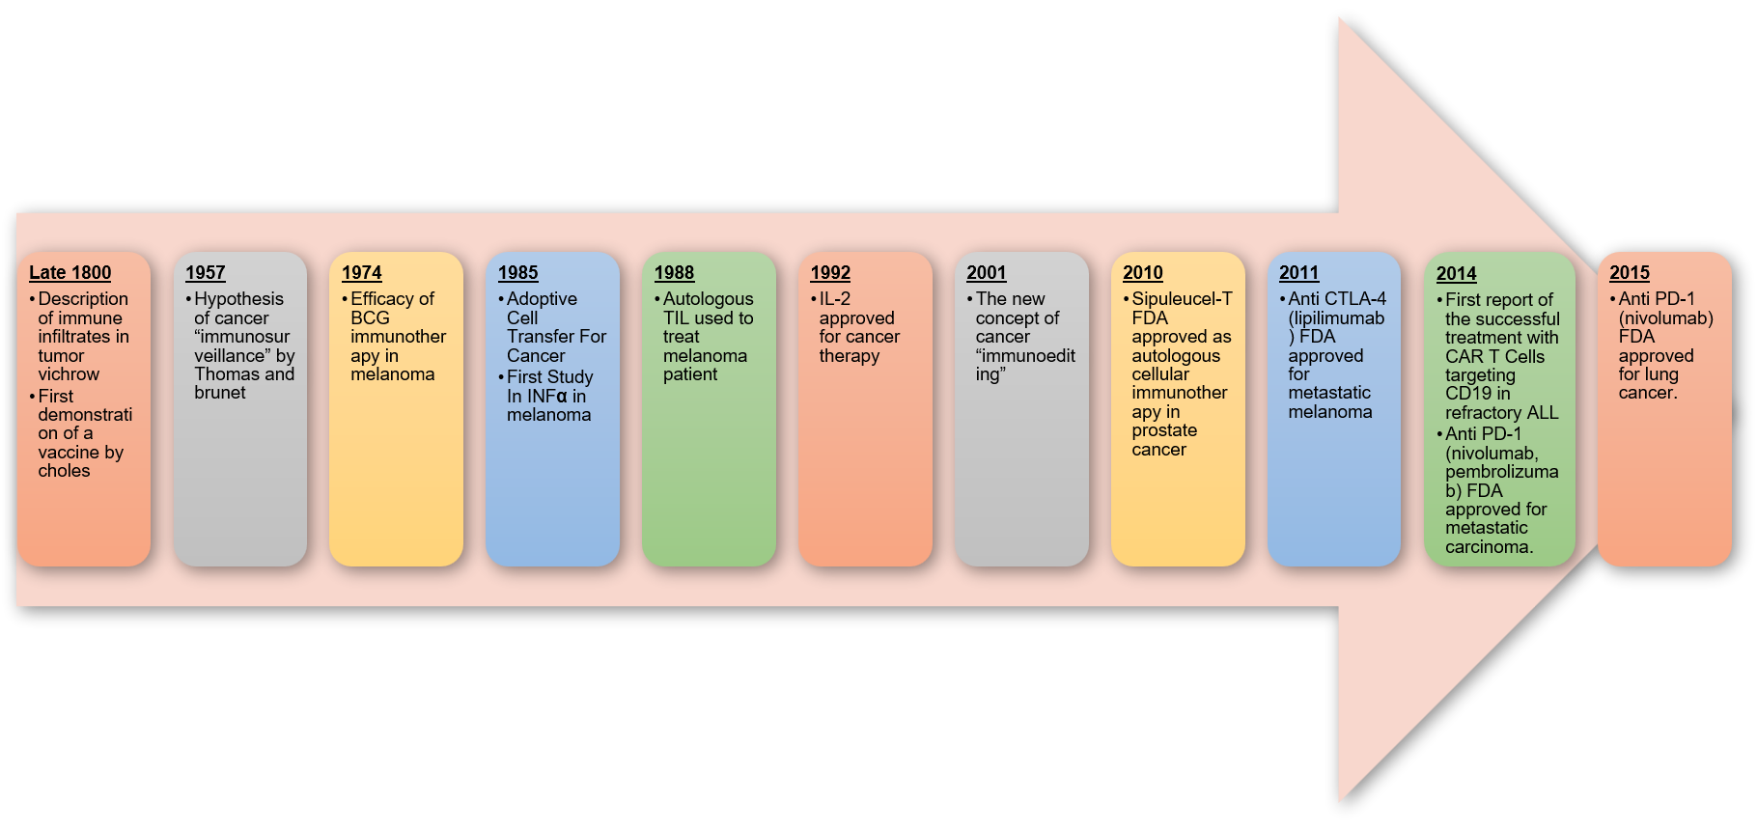

Figure 1: Historical development of cancer vaccine

Anti-tumor response of prophylactic vaccine (23)
This medication is supplied to many people who have been diagnosed with premalignant changes in their tissues and are at a high risk of contracting cancer.Antigens derived from vaccines, as well as immunomodulatory agents, are used to activate Langerhans's cells.T cells and B cells that contain tumour specific antibodies (23) become stimulated when the tumour antigen is exposed to them.Following the formation of memory cells, the clonal expansion process occurs.In the future, When a tumour becomes large enough, the marker travels to lymph nodes, reactivating tumor-specific memory cells.The immune system's secondary response
- A large number of effectors T cells exist.
- Antibody titer is high

The tumour will be unable to grow large as a result of a secondary immune response, and will be easily removed.

Anti tumor response of therapeutic vaccine
When the tumour interacts with the immune system, it is given after the diagnosis. • Vaccine to activate Langerhans's cells (autologous/defined tumour antigen + immunomodulators).Acquired by activated Langerhans cells and presented to T cells(24).B-cell mobilization, clonal expansion, and tumor-specific antibody production. Their function is suppressed by an immunosuppressive tumour microenvironment.Determination of tumour heterogeneity As a result, tumour antigen expression is lost, or immune effectors become resistant, allowing immune evasion to occur.Tumor cells with antigens that T-cells and antibodies don't recognise. They are immune to being destroyed by the immune system.

Types of cancer vaccines:
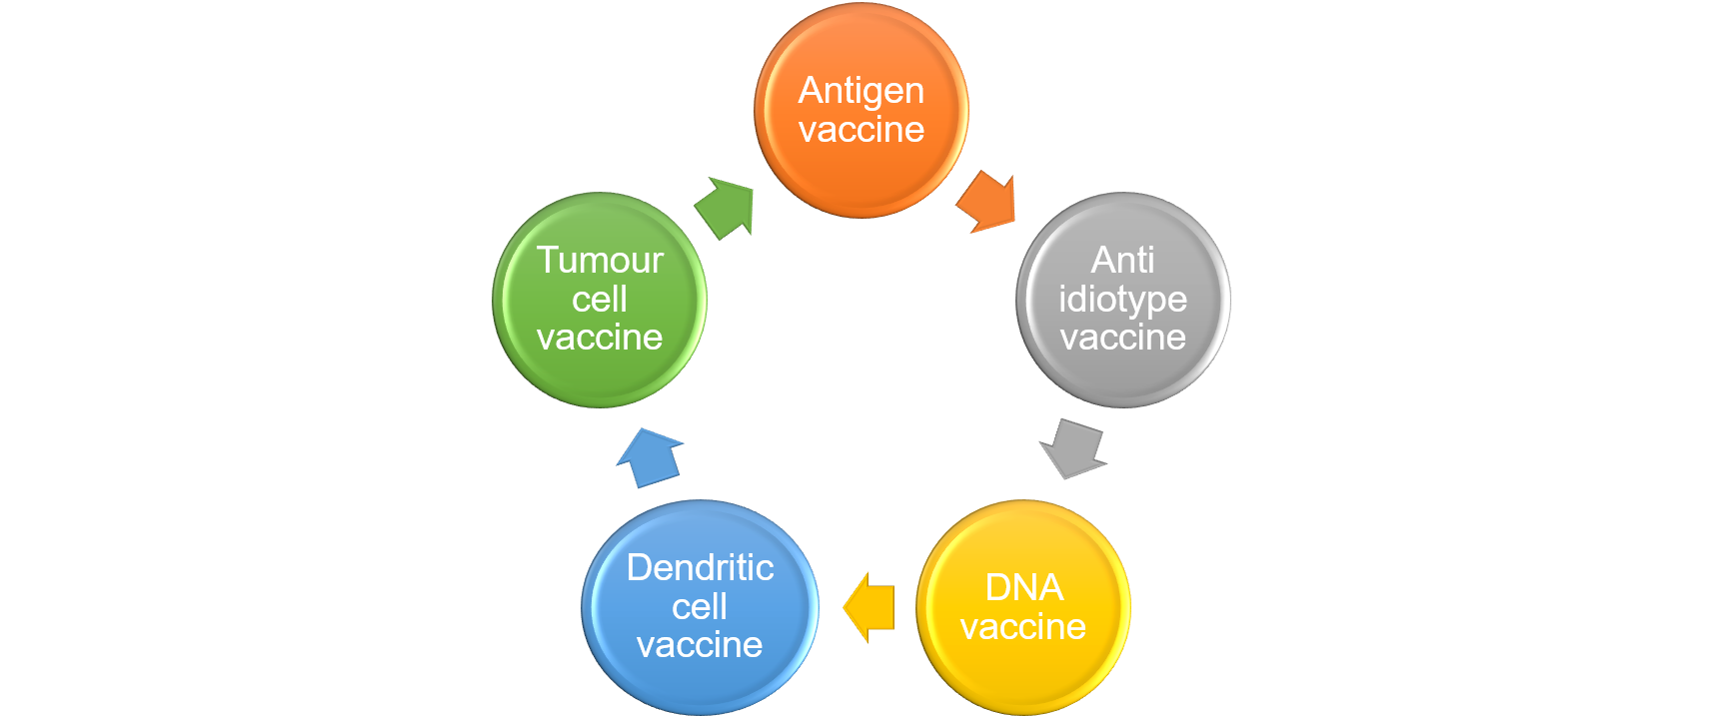
Figure 2: Different type of cancer vaccines

Antigen vaccine:
To activate the immune system, tumor-specific antigens (proteins found on tumour cells) are used.When these antigens are injected into a patient's cancerous area, the immune system responds by producing more antibodies or cytotoxic T lymphocytes (also known as killer T cells) to attack the antigen-bearing cancer cells.Multiple antigens may be used in this type of vaccine to differ the immune system response (25).Use of an antigen-based vaccine does not necessitate the use of a tumour cell that has been updated. Isolation of a particular antigenic gene or peptide sequence for use as a vaccine against benign diseases (26).

Anti-idiotype Vaccines
Idiotype antibodies are antibodies that function as antigens, causing an immune response (27). Antibodies may function as antigens, causing an immune response, according to the theory. This theory may be extended to the production of a vaccine in which antibodies (that mimic cancer cells) are administered into cancer patients to cause an immune response,lymphoma is the primary goal (28).Antibody from a cancer patient was isolated because the person's immune system was compromised and the antibody's concentration was poor. When a person is diagnosed with cancer, his or her immune system is likely to become stimulated in response to tumour antigen. In humans and mice, antibodies bind to tumour associated antigen (TAA) (29).

Dendritic Cell Vaccines:
Monocytes degrade antigens on cancer cell surfaces into smaller fragments, which they then present to killer T cells as immune system required posters (30).Dendritic cells are derived from each patient, and immune cell stimulants are used to mass-produce dendritic cells in the lab; these dendritic cells are then exposed to antigens from cancer cells to make dendritic cell vaccines.After injecting this mixture of dendritic cells and antigens into the patient, the dendritic cells work to programme the T cells (31).These vaccines are also being researched for prostate cancer, melanoma, breast cancer, thyroid cancer, colorectal cancer, kidney cancer, leukaemia, and non-Hodgkin lymphoma.

Vaccines for Tumor Cells (Autologous/Allogeneic Tumor Cells):
Tumor cells, both autologous and allogeneic One of the first tumour vaccines to be used, it contains all of the special tumour antigens that the immune system needs to mount a successful anti-tumor response (32).A second benefit is that tumour cell-based immunisation enables cancer vaccines to be produced without understanding the antigens.Irradiation makes entire tumour cells healthy for use.When injected into the body, a particular immune response is activated. The body attacks cells that are identical to those that remain in the body (33).Autologous means the tumour cells were taken from the patient's own body. Allogenic means that the tumour cells were taken from someone other than the patient. There are several epitopes that have been identified.

DNA vaccine:
Parts of the patient's Genetics are inserted into the surviving cells, instructing them to produce specific antigens on a regular basis.The immune system responds to this DNA vaccine by developing more T cells and increasing antigen production (19).The goal of these vaccines is to maintain a steady supply of antigens in the body so that the immune response to cancer can continue (34).

Mechanism of cancer vaccine:
Antigens are molecules found on the outside of cells that the body perceives as harmful. Antigens are attacked by the immune system, which is then released from them. This leaves a "memory" in the unsusceptible system, which later causes it to fight specific antigens (35).Antibodies used in cancer treatment aid the resistant framework's ability to locate and eliminate antigens. Malignancy particles are antigens present on the surface of disease cells that are not found on healthy cells (36) (37). The atoms circulate as antigens as certain particles are offered to an organism by an antibody.They provide instructions to the immune system about how to diagnose and eliminate illness.Any immunizations against malignant growth are customised to the child. This means they're only meant for one person. Specific tumour scans are removed during a surgical procedure, and this form of immunisation is used. Other malignant development immunizations are not tailored and depend on disease antigens that aren't necessary for a specific individual. These immunizations are added to the outside of tumour cells and given to people whose cancers contain certain antigens.Many cancer vaccines are delivered solely by clinical trials, which are randomised studies using volunteers. In 2010, the FDA approved sipuleucel-TT for the Prostate cancer that has spread to other parts of the body is treated (Provenge). Sipuleucel-T is customised for each individual based on a set of factors: The white blood cells in a man's blood are segregated from his blood. And body relies on white blood cells for protection (38).
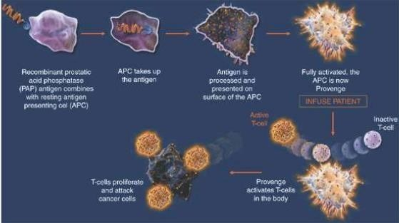
(Mechanism of action of sipuleucel T, Fig. 3)

Figure 3: Mechanism of action of cancer vaccine

Another vaccine uses a damaged bacterium, called Bacillus Calmette-Guérin, that is injected into the bloodstream (BCG). This damaged bacteria activates the immune system in order to combat early-stage bladder cancer.

Cancer vaccine preparation:
Cancer vaccines are created using a person's own cancer cells or cancer cells grown in a lab .Cancer cells that have been treated with heat or radiation become dormant and can be used to produce vaccines.Certain proteins extracted from cancer cells may be used to develop a cancer vaccine.

Adjuvants' role in cancer vaccines:
Adjuvants are agents that are applied to vaccines that help them induce stronger anticancer immune responses.In the production of vaccines, adjuvants play a number of functions. They broaden the effect of vaccines in a variety of ways, in addition to the conventional task of strengthening antigen immunogenicity.However, depending on the condition for which the vaccine must be administered, caution must be exercised when choosing an adjuvant for a specific vaccine formulation.
Following are some of the most critical positions that adjuvants play:
- Boost total functional and antibody titres (highest dissolution of a sample that causes a positive test). For effective immunisation (39), reduce the number and amount of vaccine doses.
- Vaccine formulations for human use need to be stabilised.
- Improve immunogenicity in patients who are less immunogenic, such as the elderly and children.
- Increase the duration of the response by extending the presence of antigen in the blood.
- Macrophages and lymphocytes are activated (40).
- Encourage cytokine production.
- In combination vaccines, overcome competition.
- Increase the effectiveness of cell-mediated and mucosal immunity.
BCG (Bacillus Clamette Guerin) is a bacteria used to treat bladder cancer in its early stages. A catheter is used to pump fluid from the bladder. BCG works by directing the immune cells in the body to the bladder, where they can kill cancer cells (41).

Advantage of cancer vaccines:
Immunotherapy treats cancer cells more precisely than conventional treatments like surgery, chemotherapy, and/or radiotherapy, resulting in higher reaction rates and patient satisfaction.Tumor-associated antigens, tumor-specific antigens, cancer germline antigens, and virus-associated antigens are also targets for cancer vaccines. Peptide/protein-based cancer vaccines, cell-based cancer vaccines, and DNA/RNA (gene)-based cancer vaccines all use adjuvants.The new cancer vaccines could be able to cure the disease by treating complex antigens and private epitopes. Personalized immunotherapies based on neoantigens are being developed now, and they are predicted to be very successful in regulating tumour growth.A better knowledge of T cell activation and function has assisted advancements in cancer vaccine technology. Virus vector vaccines, cellular vaccines, peptide vaccines, and DNA or RNA-based molecular vaccines are among the cancer therapy platforms currently being developed.

Side effects:
Every one has aware of vaccines being given to healthy patients to help them prevent diseases like measles and chickenpox. To start an immune response in the body, these vaccines use infected or dead germs such as viruses or bacteria. Preparing the immune system to defend against these germs will help people from getting sick.Many vaccination used to function the same way, except they allowed cancer cells to enter the immune system.Following such treatments, the aim is to either treat or discourage cancer from developing. However, such medications are now available that could potentially aid in the prevention of certain cancers.

Challenges of using treatment cancer vaccines
- Cancer cells begin as healthy cells in a person's body.
- Rather than detecting and combating the cells, the immune system can choose to ignore them.
- With just a vaccine, it is difficult to eliminate larger or more advanced tumours. (40)This is why physicians sometimes prescribe a cancer vaccine in addition to other treatments. As a result, Cancer treatment vaccination, according to some experts, could be more effective for smaller tumours or cancer in its early stages(42).

Recent development in cancer vaccines:
(dcs' functional plasticity: subsets)

Many people are concerned about subsets. Human lcs that have been activated by IL-15 have CTL reactions. Human lcs are excellent at producing CTL responses ex vivo, according to at least four lines of evidence:1) The number of lcs containing an MHC class I peptide increases dramatically when peptide-specific naive CD8+ T cells proliferate.2) lcs prime naive CD8+ T cells to be more aggressive against the peptide/MHC class I complex; 3) lcs prime naive CD8+ T cells to make more cytotoxic molecules like granzymes. A, B, perforin, and high cytotoxicity are all visible; and3) lcs are useful for period cross-presentation.4) Through IL-12, human CD14+ dermal dcs elicit potent humoral responses. Dcs create two different ways of distinguishing between Ab-secreting cells: a direct path via DC-B interaction and an indirect path via IL-21 activation, resulting in T follicular helper-like cells.Vaccines based on dcs that express lcs' molecular signatures, such as IL-15 dcs, may thus be the most powerful CD8+ T cell.

Functional plasticity of DCS: maturation signals

This is a sign that you're progressing in your life. Resting and activated dcs, as well as immature and advanced dcs, exist. In response to the signal, dcs will be activated/matured, and the type of adaptive immunity elicited will be determined by the nature of the signal.
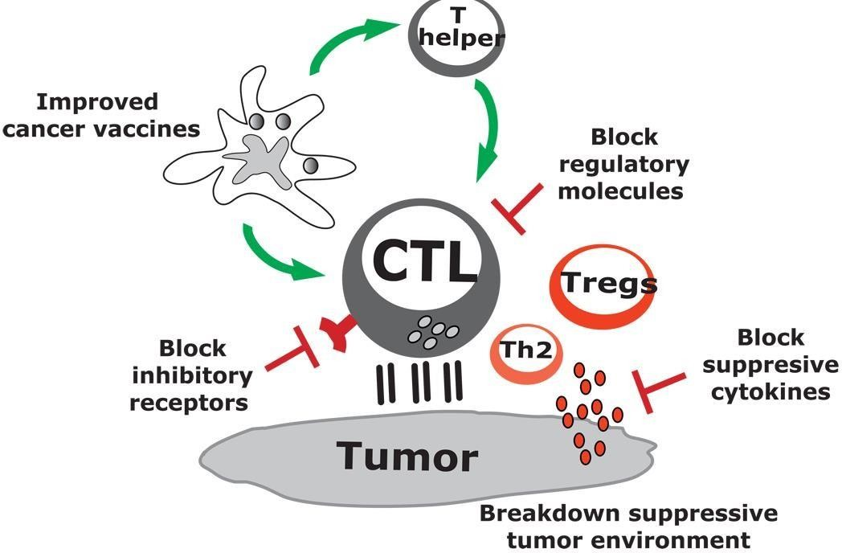
DC vaccines in combination therapies

Figure 4: Combination of cancer vaccines
As seen in Figure 4, In a small percentage of patients, recent effective immunotherapy studies have shown stable tumour regression. Current treatments, on the other hand, have been proven to be ineffective due to the infiltration of the immune system by myeloid-derived suppressor cells (43), aggressive type 2 T cells, and Tregs.We need to develop new and updated methods to increase cancer adaptive immunity, help defeat Tregs, and break down the immunosuppressive tumour microenvironment in order to enhance the therapeutic effectiveness of immunotherapy (44). This would be supported by combination therapy that address all three primary components.

Cancer vaccines in clinical trials and cancer vaccines that have been approved: (45)
Onyvax:
Anti-idiotype vaccine 105AD7 monoclonal antibody (46).It's a drug that's used to treat advanced colorectal adenocarcinoma.The vaccine can be given intramuscularly with the alum adjuvant or endemic with the BCG vaccine (47).

Oncovax
For Stage II colon cancer, an autologous vaccine has been developed (48).In 2006, the FDA granted it fast-track status.STUDY: 254 patients were randomly allocated to receive oncovax or a placebo.Improves 5-year longevity and the time for recurrences.Relative risk loss of 57.1 percent (48).

Cancer VAX
In the treatment of melanoma stage III, it is used in combination with surgical treatment (49).This vaccine is provided in combination with the BCG vaccine to improve the cellular immune response (50).

NY-ESO-1 Peptide Vaccine
It's an endermic treatment for soft tissue sarcomas that express NY-ESO-1, LAGE antigen NY-ESO-1, or LAGE antigen NY-ESO-1, or LAGE antigen (51).A subcutaneous injection of granulocyte-macrophage colony stimulating factor (GM- CSF) will be given in addition to the vaccine.Anti-idiotype Monoclonal Antibody 11D10 Vaccine and Antiidiotype Monoclonal Antibody 3h1 Vaccine.They are used to treat patients with non-small cell lung cancer who are in stages II or IIIA (T1-3, N1-2, M0)It is given between 14 and 45 days after the service is completed.

GP100 AND MART-1
Patients with stage 3 or 4 cutaneous melanoma OR stage 3 or 4 ocular or mucosal melanoma are offered a vaccination therapy that includes Tyrosinase, GP100, and MART-1 peptides, as well as an alum adjuvant (52). Interleukin-12 and granulocyte-macrophage colonystimulating factor (GM-CSF) are also used in addition to the vaccine (53).

ALVAC- CEA/B7.1:
For the prevention of metastatic colorectal cancer, a deactivated virus strain is being studied.Antigens present in viruses are similar to those found in colorectal tumours (54).The vaccine is given along with chemotherapy as soon as the patient is diagnosed.

VG-1000 Vaccine

This vaccine is especially useful in the treatment of cancers and melanomas.Patients who have had chemotherapy or radiation have a slower response to VG-1000 because their immune systems have been compromised; (55)however, patients who have not had any radiation or chemotherapy have a decent response, assuming that it could be used as a first-line treatment for those newly diagnosed with cancer to help prevent recurrence.

HSPPC-96, or Oncophage®
The vaccine is a heat-shock antigen, a type of compound that has been shown to work in autologous treatment (56).The therapeutic agent is extracted from the tumours of particular patients and is adapted to their needs.Antigens from The therapeutic agent is derived from the tumours of specific patients and tailored to their requirements (57).Melanoma are used in the HSPPC-96 vaccine.Most of these antigens are specific to melanoma, such as MART-1 and GP100 (58), while others are present in a variety of cancers.

Sipuleucel-T:
Adenovirus vaccine has been approved for the therapy of asymptomatic or mildly symptomatic metastatic castrate-resistant (hormone-refractory) prostate cancer (59) (60). PAP (prostatic acid phosphatase) is a protein found in 95% of prostate tumours.

HPV Vaccine
Gardasil: Gardasil has also been approved by the FDA for use in women and children aged 09 to 26 years old to help reduce cervical, vaginal, and vulvar cancers.Female and male anal cancer. Warts on the genital area of men and boys. It guards against the human papillomavirus (HPV) (HPV) (23).
Cervarix:
HPV infection is also prevented by this vaccination. In the year 2006, the first HPV vaccine was released.On November 4, 2016, the Advisory Committee on Immunization Practices (ACIP) and the Centers for Disease Control and Prevention (CDC) released guidelines.At this time, HPV vaccination is not recommended for women over the age of 26. Long-term clinical studies revealed that HPV vaccination offered women-only minimal to no protection against HPV-related diseases. Getting routine cervical cancer screening, as recommended, is the safest way to prevent cervical cancer in women over the age of 26 (61). Vaccines are bivalent, trivalent, or ninevalent, meaning they protect against two, four, or nine different types of HPV.

Gardasil 9
Gardasil 4 was approved by the FDA in 2006, and Gardasil 9 was approved in December of 2014.HPV styles 6 and 11 cause genital warts (condyloma acuminata).Gardasil 9 is prescribed for the treatment of the following diseases in boys and men aged 9 to 26 years.Genital warts are caused by HPV types 6 and 11. (condyloma acuminata) (62).Gardasil 9 is available in 0.5 ml doses.Gardasil 9 should be given intramuscularly in the upper arm's deltoid region or the thigh's higher anterolateral section.Both three vaccines are administered over the course of six months in a sequence of three doses into muscle tissue (63)(64).In October 2016, the FDA recommended a two-dose Gardasil 9 vaccine regimen for boys and girls aged 9 to 14 years old (the second dose will be given 6–12 months after the first).

Conclusion and perspective:
The historical experience with therapeutic cancer vaccines coupled with fundamental advances in understanding of the immunobiology of cancer have provided a road map for future vaccine development. The key challenges that must be overcome are identifying antigens and vaccine vectors that will lead to strong and broad T cell responses, tailoring vaccine designs to achieve optimal antigen presentation by professional APCs, and finding combination partners employing complementary mechanisms of action to overcome the diverse methods that cancer cells use to evade and suppress the immune system. In recent years, the feld has risen to meet this challenge, with many encouraging upgrades to antigen selection and vaccine designs. Combination strategies with a variety of
other agents, including immunotherapies, chemotherapies, and radiotherapy, have also been investigated in preclinical and clinical studies. These refnements will need to be validated in appropriately designed, randomized, phase 3 studies. Consequently, despite decades of lackluster progress, therapeutic cancer vaccines are now primed to emerge as central components of cancer therapy due to these advancements in biology and technology.
Finally, it is anticipated that cancer vaccines will benefit from advances in the speed, cost, and efciency of molecular sequencing, artifcial intelligence, and cellular engineering. These techniques may enable the quick and complete interrogation of the immune response (changes in immune
milieu, tumor immune escape mechanisms) to a cancer vaccine, allowing subsequent vaccines to be tailored based on this response.
Reference :
1. Almeida J, Edwards DC, Brand C, Heath TJTL. Formation of virosomes from influenza subunits and liposomes. 1975;306(7941):899-901.
2. Morein B, Simons KJV. Subunit vaccines against enveloped viruses: virosomes, micelles and other protein complexes. 1985;3(2):83-93.
3. Crisci E, Bárcena J, Montoya MJI. Virus-like particle-based vaccines for animal viral infections. 2013;32(3):102-16.
4. Morein B, Sundquist B, Höglund S, Dalsgaard K, Osterhaus AJN. Iscom, a novel structure for antigenic presentation of membrane proteins from enveloped viruses. 1984;308(5958):457-60.
5. Crouch C, Daly J, Henley W, Hannant D, Wilkins J, Francis MJVi, et al. The use of a systemic prime/mucosal boost strategy with an equine influenza ISCOM vaccine to induce protective immunity in horses. 2005;108(3-4):345-55.
6. Osterhaus A, Weijer K, UytdeHaag F, Jarrett O, Sundquist B, Morein BJTJoI. Induction of protective immune response in cats by vaccination with feline leukemia virus iscom. 1985;135(1):591-6.
7. Poland GA, Jacobson RMJNEJM. The age-old struggle against the antivaccinationists. 2011;364(2):97-9.
8. Dubé E, Vivion M, MacDonald NEJErov. Vaccine hesitancy, vaccine refusal and the anti-vaccine movement: influence, impact and implications. 2015;14(1):99-117.
9. Laxminarayan R, Ganguly NKJHA. India’s vaccine deficit: why more than half of Indian children are not fully immunized, and what can—and should—be done. 2011;30(6):1096-103.
10. Shaw J, Long SSJTJoP. Public discourse on measles, a shot in the arm for vaccination. 2015;167(2):477-80.
11. Leask J, Kinnersley P, Jackson C, Cheater F, Bedford H, Rowles GJBp. Communicating with parents about vaccination: a framework for health professionals. 2012;12(1):1-11.
12. Albertson JP, Clegg WJ, Reid HD, Arbise BS, Pryde J, Vaid A, et al. Mumps outbreak at a university and recommendation for a third dose of measles-mumps-rubella vaccine—Illinois, 2015–2016. 2016;65(29):731-4.
13. Zhang Y, Zeng G, Pan H, Li C, Hu Y, Chu K, et al. Safety, tolerability, and immunogenicity of an inactivated SARS-CoV-2 vaccine in healthy adults aged 18–59 years: a randomised, double-blind, placebo-controlled, phase 1/2 clinical trial. 2021;21(2):181-92.
14. Xia S, Zhang Y, Wang Y, Wang H, Yang Y, Gao GF, et al. Safety and immunogenicity of an inactivated SARS-CoV-2 vaccine, BBIBP-CorV: a randomised, double-blind, placebo-controlled, phase 1/2 trial. 2021;21(1):39-51.
15. Hammitt LL, Akech DO, Morpeth SC, Karani A, Kihuha N, Nyongesa S, et al. Population effect of 10-valent pneumococcal conjugate vaccine on nasopharyngeal carriage of Streptococcus pneumoniae and non-typeable Haemophilus influenzae in Kilifi, Kenya: findings from cross-sectional carriage studies. 2014;2(7):e397-e405.
16. Waight PA, Andrews NJ, Ladhani SN, Sheppard CL, Slack MP, Miller EJTLid. Effect of the 13-valent pneumococcal conjugate vaccine on invasive pneumococcal disease in England and Wales 4 years after its introduction: an observational cohort study. 2015;15(5):535-43.
17. Vesikari T, Forsten A, Bianco V, Van der Wielen M, Miller JMJTPidj. Immunogenicity, safety and antibody persistence of a booster dose of quadrivalent meningococcal ACWY-tetanus toxoid conjugate vaccine compared with monovalent meningococcal serogroup C vaccine administered four years after primary vaccination using the same vaccines. 2015;34(12):e298-e307.
18. Rezaei T, Khalili S, Baradaran B, Mosafer J, Rezaei S, Mokhtarzadeh A, et al. Recent advances on HIV DNA vaccines development: Stepwise improvements to clinical trials. 2019;316:116-37.
19. Lopes A, Vandermeulen G, Préat VJJoE, Research CC. Cancer DNA vaccines: current preclinical and clinical developments and future perspectives. 2019;38(1):1-24.
20. Polack FP, Thomas SJ, Kitchin N, Absalon J, Gurtman A, Lockhart S, et al. Safety and efficacy of the BNT162b2 mRNA Covid-19 vaccine. 2020.
21. Bartsch SM, O'Shea KJ, Ferguson MC, Bottazzi ME, Wedlock PT, Strych U, et al. Vaccine efficacy needed for a COVID-19 coronavirus vaccine to prevent or stop an epidemic as the sole intervention. 2020;59(4):493-503.
22. Rittig SM, Haentschel M, Weimer KJ, Heine A, Müller MR, Brugger W, et al. Long-term survival correlates with immunological responses in renal cell carcinoma patients treated with mRNA-based immunotherapy. 2016;5(5):e1108511.
23. Babu RA, Kumar KK, Reddy GS, Anuradha CJJoOS. Cancer vaccine: a review. 2010;2(3):77.
24. Giarelli EJO. Cancer vaccines: a new frontier in prevention and treatment. 2007;21(11 Suppl Nurse Ed):11-7; discussion 8.
25. Shankaran V, Ikeda H, Bruce AT, White JM, Swanson PE, Old LJ, et al. IFNγ and lymphocytes prevent primary tumour development and shape tumour immunogenicity. 2001;410(6832):1107-11.
26. Neek M, Kim TI, Wang S-WJNN, Biology, Medicine. Protein-based nanoparticles in cancer vaccine development. 2019;15(1):164-74.
27. Kieber-Emmons T, Monzavi-Karbassi B, Pashov A, Saha S, Murali R, Kohler HJFio. The promise of the anti-idiotype concept. 2012;2:196.
28. Palomba MLJCor. Active immunotherapy: current state of the art in vaccine approaches for NHL. 2012;14(5):433-40.
29. Naveed A, Rahman SU, Arshad MI, Aslam BJTMC. Recapitulation of the anti-idiotype antibodies as vaccine candidate. 2018;3(1):1-7.
30. Santos PM, Butterfield LHJTJoI. Dendritic cell–based cancer vaccines. 2018;200(2):443-9.
31. Saxena M, Bhardwaj NJTic. Re-emergence of dendritic cell vaccines for cancer treatment. 2018;4(2):119-37.
32. Kozłowska A, Mackiewicz J, Mackiewicz AJG. Therapeutic gene modified cell based cancer vaccines. 2013;525(2):200-7.
33. Seledtsov V, Goncharov A, Seledtsova GJB, Pharmacotherapy. Multiple-purpose immunotherapy for cancer. 2015;76:24-9.
34. Wahren B, Liu MAJV. DNA vaccines: Recent developments and the future. 2014;2(4):785-96.
35. Tiwari N, Gheldof A, Tatari M, Christofori G, editors. EMT as the ultimate survival mechanism of cancer cells. Seminars in cancer biology; 2012: Elsevier.
36. van Andel H, Kocemba KA, Spaargaren M, Pals STJL. Aberrant Wnt signaling in multiple myeloma: molecular mechanisms and targeting options. 2019;33(5):1063-75.
37. Fu L, Chen L, Yang J, Ye T, Chen Y, Fang JJC. HIF-1α-induced histone demethylase JMJD2B contributes to the malignant phenotype of colorectal cancer cells via an epigenetic mechanism. 2012;33(9):1664-73.
38. GuhaThakurta D, Sheikh NA, Fan L-Q, Kandadi H, Meagher TC, Hall SJ, et al. Humoral immune response against nontargeted tumor antigens after treatment with sipuleucel-T and its association with improved clinical outcome. 2015;21(16):3619-30.
39. Banday AH, Jeelani S, Hruby VJJI, immunotoxicology. Cancer vaccine adjuvants–recent clinical progress and future perspectives. 2015;37(1):1-11.
40. Bowen WS, Svrivastava AK, Batra L, Barsoumian H, Shirwan HJErov. Current challenges for cancer vaccine adjuvant development. 2018;17(3):207-15.
41. Iqbal NT, Hussain RJTiV. Non-specific immunity of BCG vaccine: a perspective of BCG immunotherapy. 2014;3:143-9.
42. Kwok M, Fritsch EF, Wu CJJBCD. Cancer and COVID-19: on the quest for effective vaccines. 2021;2(1):13.
43. Iclozan C, Antonia S, Chiappori A, Chen D-T, Gabrilovich DJCi, immunotherapy. Therapeutic regulation of myeloid-derived suppressor cells and immune response to cancer vaccine in patients with extensive stage small cell lung cancer. 2013;62(5):909-18.
44. Wang T, Wang D, Yu H, Feng B, Zhou F, Zhang H, et al. A cancer vaccine-mediated postoperative immunotherapy for recurrent and metastatic tumors. 2018;9(1):1-12.
45. Johnson DB, Puzanov I, Kelley MCJI. Talimogene laherparepvec (T-VEC) for the treatment of advanced melanoma. 2015;7(6):611-9.
46. John J, Alex SS, Alex R, Thomas I, Mathew A. VACCINES FOR LIFE STYLE DISEASES REVIEW.
47. John J, Alex SS, Alex R, Thomas I, Mathew A. PHARMACEUTICAL SCIENCES.
48. Hanna J, Michael G %J Human vaccines, immunotherapeutics. Immunotherapy with autologous tumor cell vaccines for treatment of occult disease in early stage colon cancer. 2012;8(8):1156-60.
49. Jung S-H, Lee H-J, Lee Y-K, Yang D-H, Kim H-J, Rhee JH, et al. A phase I clinical study of autologous dendritic cell therapy in patients with relapsed or refractory multiple myeloma. 2017;8(25):41538.
50. Correale P, Botta C, Ciliberto D, Pastina P, Ingargiola R, Zappavigna S, et al. Immunotherapy of colorectal cancer: new perspectives after a long path. 2016;8(11):1281-92.
51. Miller MJ, Foy KC, Kaumaya PTJDm. Cancer immunotherapy: present status, future perspective, and a new paradigm of peptide immunotherapeutics. 2013;15(82):166-76.
52. Aris M, Zubieta MR, Colombo M, Arriaga JM, Bianchini M, Alperovich M, et al. MART-1-and gp100-expressing and-non-expressing melanoma cells are equally proliferative in tumors and clonogenic in vitro. 2012;132(2):365-74.
53. Tarhini AA, Leng S, Moschos SJ, Yin Y, Sander C, Lin Y, et al. Safety and immunogenicity of vaccination with MART-1 (26-35, 27L), gp100 (209-217, 210M), and tyrosinase (368-376, 370D) in-adjuvant with PF-3512676 and GM-CSF in metastatic melanoma. 2012;35(4):359.
54. Ashraf N, Mahipal A, Kim RJCCCR. Viral Vector Vaccines to Treat Colorectal Cancer. 2013;9(4):398-405.
55. John J, Alex SS, Alex R, Thomas I, Mathew A. VACCINES FOR LIFE STYLE DISEASES REVIEW. 2012.
56. Camarero J, Ruiz SJHv, immunotherapeutics. Cancer immunotherapy products: regulatory aspects in the European Union. 2012;8(9):1354-9.
57. Valle I, Tramalloni D, Bragazzi NJJopm, hygiene. Cancer prevention: state of the art and future prospects. 2015;56(1):E21.
58. Randazzo M, Terness P, Opelz G, Kleist CJIjoc. Active‐specific immunotherapy of human cancers with the heat shock protein Gp96—revisited. 2012;130(10):2219-31.
59. Huber ML, Haynes L, Parker C, Iversen PJJotNCI. Interdisciplinary critique of sipuleucel-T as immunotherapy in castration-resistant prostate cancer. 2012;104(4):273-9.
60. Mulders PF, De Santis M, Powles T, Fizazi KJCI, Immunotherapy. Targeted treatment of metastatic castration-resistant prostate cancer with sipuleucel-T immunotherapy. 2015;64(6):655-63.
61. Draper E, Bissett SL, Howell-Jones R, Waight P, Soldan K, Jit M, et al. A randomized, observer-blinded immunogenicity trial of Cervarix® and Gardasil® human papillomavirus vaccines in 12-15 year old girls. 2013;8(5):e61825.
62. Godi A, Panwar K, Haque M, Cocuzza CE, Andrews N, Southern J, et al. Durability of the neutralizing antibody response to vaccine and non-vaccine HPV types 7 years following immunization with either Cervarix® or Gardasil® vaccine. 2019;37(18):2455-62.
63. Cuzick JJErov. Gardasil 9 joins the fight against cervix cancer. 2015;14(8):1047-9.
64. Kunda NK, Peabody J, Zhai L, Price DN, Chackerian B, Tumban E, et al. Evaluation of the thermal stability and the protective efficacy of spray-dried HPV vaccine, Gardasil® 9. 2019;15(7-8):1995-2002.

