The Role of Succession Planning in Continuity of Family Business Firms
Mr. Shaurya A. Shah
Agarwal Vidya Vihar English Medium College,
Surat, Gujarat, India.
Sas.acc@avvcollege.org
ABSTRACT
One of the biggest challenges family businesses face is how to successfully manage succession from one generation of leaders to the next. Many family businesses lack a succession planning strategy. Succession planning is how a business plans for the future. This chapter contributes to the existing understanding of this complex and difficult process by exploring how successors use family business succession stories to legitimize their succession rights. Family businesses make up a significant share of GDP and employability in today's economy, and their continuity and transition to a new generation is a key challenge. The results show that family businesses have characteristics that distinguish them from other businesses, presenting experiences and obstacles that can jeopardize their continuity, especially succession. Furthermore, these companies often have a long-term vision, with family-centered decision-making and greater stability while the founder is the leader. This research contributes to deepening knowledge about the family business, especially the problems posed and experienced in the process of inheritance from the first to the second generation. This chapter can be helpful to family-owned and operated businesses by providing lessons learned on how to ensure organizational sustainability and develop a successful succession plan.
Keywords:- Family business, Succession planning, Succession Plan.

- INTRODUCTION

“Change is constant in our culture and our communities”. Business continuity refers to the organization’s ability to ensure that qualified and competent employees are always available and in place to carry out their job functions. Succession planning is one such strategy that helps the organization address Human Resource issues related to the aging workforce, increasing retirement eligibility, Potential skill shortages, and internal competency gaps. Family businesses are characterized by the intersection of the family and business system, which gives them a uniqueness that differentiates them from other forms of business. When the time comes for a business owner to hand over the reins of the business to someone else, it is significant to already have a plan outlining the transition to ensure a smooth handover. Succession planning is a complex process, although breaking it down into its component parts makes developing one a whole lot easier. Many factors are to be considered while forming a successful succession plan including determining the value of the business; settling tax and debt obligations; choosing and working with the successor(s) and communicating the plan to all interested parties. Family businesses are unique and what makes them unique is the family composition involved. Many family businesses have successfully managed their family components. Globally, about 35% of Fortune 500 companies are family businesses. From world-famous large companies like Tatas, Birlas, Adanis, and Jindals to SMEs and MSMEs, the majority of businesses in India have been run by families for generations, while the majority of home business owners want their business to be passed on to the next generation, It is estimated that 70% will not survive the 2nd generation and 90% will not make it to the 3rd generation.

- DEFINING A FAMILY BUSINESS

According to R. G. Donnelley, “Family business is a firm which has been closely identified with at least two generations of a family and when this link has had a mutual influence on the company policy and on the interests and objectives of the family.”
P. Davis defined “Family businesses as “Businesses where policy and decision are subject to significant influence by one or more family units. This influence is exercised through ownership and sometimes through the participation of family members in management. It is the interaction between two sets of organizations, family, and business that establishes the basic character of the family business and defines its uniqueness.”
So, in totality, a family business can simply be defined as a business that includes two or more members of a family with financial control of the company. Family businesses are one of the most popular form of economic organizations, known for their agility and resilience to the external environment.

- WHAT IS FAMILY BUSINESS SUCCESSION?
Family business succession is the process of transitioning the management and the ownership of the business to the next generation of family members. Family members play a controlling role in both the management succession as well as the ownership succession. The family business succession process is governed by the technical components, which are typically worked out between the current owners and their trusted advisers.
Succession planning is a process for identifying and developing new leaders, who can replace old leaders when they leave, retire or die. Succession is the transition of the family business and ownership from one generation to another. It is a continual process, which integrates education, planning and management for ensuring continuity of the business from generation to generation. Succession planning increases the availability of experienced and capable employees that are prepared to assume these roles when it is required.

- NECESSITY OF A SUCCESSION PLAN
A succession plan is critical for larger companies, from lower supervisory roles to top-level managerial positions, when an owner retires, sells the business, or passes away. This approach is more conducive to identifying, developing, and keeping key leadership personnel, and avoiding a shortage of skilled and knowledgeable employees during and after the transition period. Advantages that a Family owned firm can get from a well-framed Succession plan for Business may be:- Business continuity; Key Management Personnel appointment and choice, Conflict Resolution amongst stakeholders; Separation of ownership and management, Decision-making for growth, Professional approach to business, Emotions vs professionalism on governance, Creation of Value for shareholders, employees, investors, lenders, and enhancement of environmental, social and corporate responsibility with professional management. At this point, it should be noted that succession planning is an important part of how a family business works.

- TYPES OF BUSINESS SUCCESSION

There are majorly eight ways in which business succession can be implemented: (a) sell the business to one or more key employees (maybe family members), (b) sell to all employees using an Employee Stock Ownership Plan (ESOP), (c) sell to one or more co-owners (maybe family members), (d) sell to an outside third party, (e) engage in an Initial Public Offering (the family may retain the public stock), (f) retain ownership but become a passive owner, and (g) liquidate. For purposes of this study, a succession plan that is other than to a family member does not indicate failure. The use of any of these transfer methods does not indicate a desire for the family to stop operating as an economic unit with a desire to reinvest proceeds into other business entities (Zellweger et al., 2011).
Cabrera-Suárez et al. (2001) suggested that succession is a multi-stage process, not an isolated event, that includes the involvement of the successor in the business and a simultaneous decrease in time the predecessor is involved in the business until a real transfer of power in the organization takes place. It is a slow, evolutionary, and mutual role adjustment process between the founder and the next generation family member in which the successor enters the business at a lower level and eventually assumes top management functions and receives appropriate training. Ideally, succession should be timed to coincide with when the successor is well prepared, the business is in good condition, and economic turbulence is not extreme. The health educational progress and age of the parties are also crucial timing factors (Dyer, 1986). Furthermore, having set long-term succession dates may keep the business from transferring to the next generation at an opportune time.

- EFFECT OF FAMILY COMPONENT IN BUSINESS

The Three-Circle Model of the Family Business System was developed at Harvard Business School by Renato Tagiuri and John Davis in 1978. The three-circle model described below is often used to illustrate the interaction/impact of family composition on the management and ownership of family businesses. The three-circle model is represented by the ownership circle, the management circle, and the family circle. The ownership circle and the management circle are common to all companies. Family circles are unique to family businesses and this is what sets them apart from non-family partners. Family circles tend to be much larger and have a much larger impact on business ownership and management. Indeed, in many family businesses, ownership is wholly owned by the family, and management is wholly or primarily owned by the family. In these situations, learning how to effectively manage family composition is even more important. The ability of family businesses to outperform their non-family counterparts and successfully pass on the business to the next generations depends heavily on their ability to manage the “family composition.” their family".

Figure:-1 Three Circle Model of Family Business System
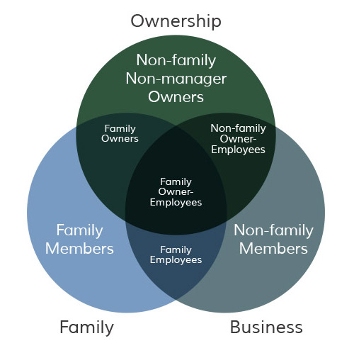

Figure:-1. (Source :- TAGIURI AND DAVIS, 1982)

FAMILY BUSINESS SUCCESSION MODEL WITH FAMILY COMPONENT
The following model is intended to illustrate how to effectively manage the all-important family component or family circle during the succession process.

Figure:-2 Family Business Succession Model
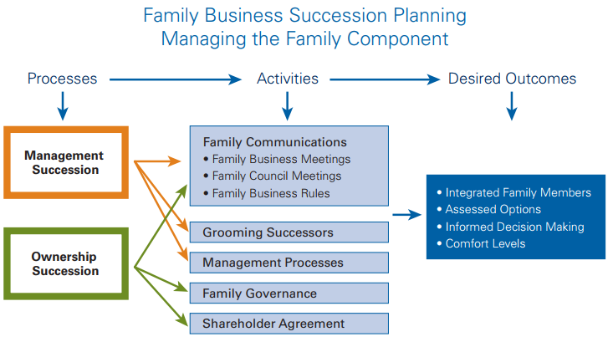

Figure:-2. (Source :- KPMG Enterprise centre for Family Business)

- succession processes

Family business succession planning consists of two processes, the “management” succession process, and the “ownership” succession process. Multiple inheritance operations are described for each of the two processes to achieve the desired inheritance result. We recommend that the management succession process be completed first so that the asset succession plan reflects and supports the management succession process.
- Succession Activities
The model shows several family business inheritance activities designed to integrate family members into the management and inheritance process. Activities also aim to make family members comfortable with the inheritance process and its results. The ultimate aim is to enable family members to make informed decisions about their personal and collective lives and future in managing and owning a family business. Establishing family communication activities, such as family business meetings for active family members, family council meetings for extended families, and business rules family, will act as a guide to the overall process of inheritance. Management succession activities also include the preparation of successors and the incorporation of active family members into a number of key management activities.
The model also shows the process of property inheritance, including a list of inheritance operations involving family members. These activities include the same communication channels as outlined in the leadership succession process. Property inheritance also includes matters of family governance and shareholder agreements. Each of these property inheritance operations is discussed in Section Four. Management and inheritance operations can be performed concurrently. However, it is recommended that the management succession process/plan be conducted or implemented before proceeding with asset inheritance activities. You will notice that the activities recommended for family management Communication (family business meetings, family board meetings, and family rules) are the same for management processes and inheritance of ownership. What will be different is the type of inheritance problem solved in the family meeting. It is strongly recommended that any process of management or ownership succession be undertaken, starting with family communications.

- Desired Outcomes
Inheritance operations are described in the above model to achieve the desired inheritance results. By involving family members in the process and providing enough comfort for current and future owners of the family business, informed decisions can be made. If the current owners are not comfortable enough with the proposed financial arrangements, management succession plans or property succession plans, they are unlikely to give up. The owners invested too much in the family business to pass it on without the necessary assurance that it would continue to grow. Additionally, owners want to be sure that family and key employees, often referred to as the extended family, are taken care of as well. The same can be said for the next generation. If the next generation is not comfortable enough with the proposed roles and responsibilities of the leadership succession team, compensation philosophy, wealth distribution, and financing of the ownership transition, they are very may delay or delay the readiness to execute the inheritance plan. Therefore, the sooner relief operations begin, the more likely each side is to build its own safe zone. The higher the participants' comfort level, the easier it was for them to make decisions. Therefore, developing a succession process with activities that will provide options, gauge comfort, and allow family members to make informed decisions is critical to success.

- COMPONENTS OF A SUCCESSFUL SUCCESSION PLAN
The following checklist will act as a guide to things that need to be considered when it is decided to start work on a succession plan for business.
Table :-1 Components of Successful Succession Plan
GOALS AND OBJECTIVES  o Identify the need for a succession plan  o Develop vision, goals, and objectives  o Establish personal retirement goals  o Identify family/stakeholder goals  o Establish a team of professional  advisors | DECISION MAKING  o Involve family members in the decision-making process  o Establish a method for dispute resolution  o Communicate your wishes to family/  stakeholders. | SUCCESSOR(S)  o Identify successor(s)  o Ownership  o Management  o Provide training to build a vision for the future of  the business  o Provide support to successors
ESTATE PLANNING  o Address taxation implications to the owner/  business upon sale or transfer of ownership  o Develop an estate and personal financial plan for the owner, spouse, and the succeeding generation  o Detail retirement income needs  o Provide for involved and non-involved  family members | CORPORATE STRUCTURE AND  TRANSFER METHODS  o Is business to be transferred to family  members, or sold?  o Define roles and responsibilities for  family members and key employees  o Fill key management positions  o Identify role(s) for retiring owner  o Restructure the business, if required  o Consult with professionals (lawyer,  accountant, financial advisor, business  broker, appraiser, etc.) | EXIT STRATEGY  o Determine the method of transfer  o Establish a timeline for implementation of the  succession plan  o Publish the plan so that affected individuals are aware.  o Communicate regularly with all parties.  Review the Plan on a regular basis and  update as necessary.

Figure:-3. (Source:- Succession Planning 101 Book Community Futures)

- CONCLUSION
The role of family businesses in society has changed radically in recent times. Yesterday was a family business. Today, it's a family-like business. And in the future, this day will be the family's business and the desire for the company and the family. As companies go through different stages of the life cycle, issues of leadership and succession become important. While companies vary in their dynamics, a succession strategy that provides certainty, continuity, and effective leadership – both at the executive and board levels – must be fundamentally Accepted. Despite the importance of succession planning, business enterprises are constantly bogged down by more visible and tangible problems. Therefore, today's business enterprises increasingly require a planned succession to run the organization in the right direction, which in turn will lead the collective and ultimately lead the development of the nation.

REFERENCES
[1] Panjwani, A., Aggarwal, V., & Dhameja, N. (2008). Family business: Yesterday, today, tomorrow. Indian journal of
industrial relations, 272-291.
[2] Moren Lévesque, Annapoornima M. Subramanian,Family firm succession through the lens of technology intelligence, Journal of Family Business Strategy,Volume
13, Issue 2,2022,100485,ISSN 1877-8585, (https://www.sciencedirect.com/science/article/pii/S1877858522000031)
[3] Dutta, S. (1997). Family business in India. SAGE Publications Pvt. Limited.
[4] John A. Davis. 2022. Three-Circle Model of the Family Business System | Davis and Tagiuri. [online] Available at: <https://johndavis.com/three-circle-model-
family-business-system/> Transitioning your business. KPMG. (n.d.). https://home.kpmg/xx/en/home/services/enterprise/transitioning- your-business.html
[5] (n.d.). Https://Www.financialexpress.com/Industry/Sme/Cafe-Sme/Msme-Eodb-Succession-Planning-in-Family-Businesses-Key-Challenges-for-Small-Businesses-to-Address-for-Successful-Transition/2610631/.
[6] (n.d.).https://www.financialexpress.com/industry/india-at-75-family-businesses-that-reform-rethink-and-reinvent-rule/2625086/.
[7] Family business case studies in India kenya - value added coaching. (n.d.). from https://www.valueaddedcoaching.com/resources.html
[8] De Massis, A. V., & Rondi, E. (2020). COVID-19 and the future of family business research. Journal of Management Studies, 57(8), 1727-1731.
[9] Paola Rovelli, Marcos Ferasso, Alfredo De Massis, Sascha Kraus, Thirty years of research in family business journals: Status quo and future directions,
Journal of Family Business Strategy, 2021, 100422, ISSN 1877-8585, https://doi.org/10.1016/j.jfbs.2021.100422.
[10] Habbershon, T. G., & Williams, M. L. (1999). A resource‐based framework for assessing the strategic advantages of family firms. Family business review, 12(1), 1-25.
[11] Lindow, C. M., Stubner, S., & Wulf, T. (2010). Strategic fit within family firms: The role of family influence and the effect on performance. Journal of Family Business Strategy, 1(3), 167-178.
[12] Morris, M.H., Williams, R.W. and Nel, D. (1996), "Factors influencing family business succession", International Journal of Entrepreneurial Behavior & Research, Vol. 2 No. 3, pp. 68-81. https://doi.org/10.1108/13552559610153261

