A look on the Importance Of Cloud Computing in E-commerce
S M Firdaus Zaki Rizviª , Amar Nath Chatterjee^{b,*}

ªDepartment of Mathematics and IT, Magadh University, Bodh-Gaya, Bihar–824234(India)
^{b}Department of Mathematics, K.L.S. College, Nawada, Magadh University, Bodh-Gaya, Bihar – 805110 (India)

∗ Corresponding author.
E-mail address: anchaterji@gmail.com (A.N. Chatterjee).

Abstract
Cloud Computing has totally changes the world of computing as well as business, now a days it is very hot and popular topic of discussion. It was already announced by Google in 2007.Cloud computing is a channel through which the deliverance of services and resources using the internet medium is possible easily. The Cloud computing is useful for small as well as big business and organization. Many E-commerce (online )businesses are running over cloud server. Cloud provides different services, using cloud computing we can get many benefits than traditional computing system , it provides many facilities such as large mobile storage, cost saving on large scale, well-built and superior protection, access from everywhere, power saving and environment friendly, these are basic benefits of cloud computing. Now it is very important for an organization or individual to reallocate from customary computing to cloud computing because they benefiting from it. Recently there are many different types of cloud computing services are available on very flexible cost models, such as, subscription and lease based cost models services for illustration, Remote Desktop Session Host (RDSH) used for cloud Terminal, Software as a Service (SaaS) provide facility to utilize software services on rent and Platform as a Service (PaaS) Provide facility to taket computing infrastructure on rent on minimum monthly or yearly cost. The Storage as a Service (STaaS) provide facility to use huge memory space on rent at a minimum cost and Security as a Service (SeaaS) provides a strong cloud based security applications. likewise, the Infrastructure as a Service (IaaS) provide facility to take computing infrastructure on lease that reduces the establishment cost for any individual or organization. By means of services, cloud computing offers more benefits than conventional computing.
Keywords:- E-commerce; Cloud Computing; Host and Client ; Online Business Model: IT Industry; Data science.
1. Introduction
As It was announced by Google in 2007 that the Cloud Computing has get a lot of attraction of the technologist of IT industry and business man because Cloud computing is very speedily developed from logical concept to real Application. Cloud computing is a group of technologies for storing and accessing of data and computing services over the internet. In cloud computing data doesn't store on your personal computer. The availability of cloud computer services is on demanded such as data servers, data storage, networking, databases, etc. The main goal of cloud computing is to give access permission to data centers (centralized virtual server) to many users. And the users can also access data from a remote server which connected to a centralized. It is a structure of application-based software which stores data on remote servers and it can be accessed by the internet. The cloud computing works , can be divided into two parts front-end and backend. The user access data stored in the cloud through front-end using an internet browser or a cloud computing software. The responsible of primary component of cloud computing is to securely storing data and information at the backend. It includes data storage servers, computers, databases, and central servers. And it is possible by cloud computing that a user can use many different gadgets such as laptop, personal computers, smart phones and other computing machines which connect virtually to the cloud. And the user also called client is able to use and make changes to the data stored on cloud by himself with a minimum rent cost charges by cloud owner. Client need not buy or pay extra for hardware because it’s a shared resource facility over the internet,
Now a day’s cloud computing demand of every sectors such as business world and other firms are changing the of traditional way of record keeping to cloud based infrastructure format, because its very beneficial and easy to retrieve data in case of disaster on local server or machine. Data can be access and updated from anywhere at any time. E- Commerce is such an industry which is get birth by the features of Cloud Computing. Here in this paper we are going to discuss the impact of cloud computing on traditional E-Commerce completely in respect of technology, service and industry sequence, and will advice our suggestion to develop E-Commerce business in the era of cloud computing.

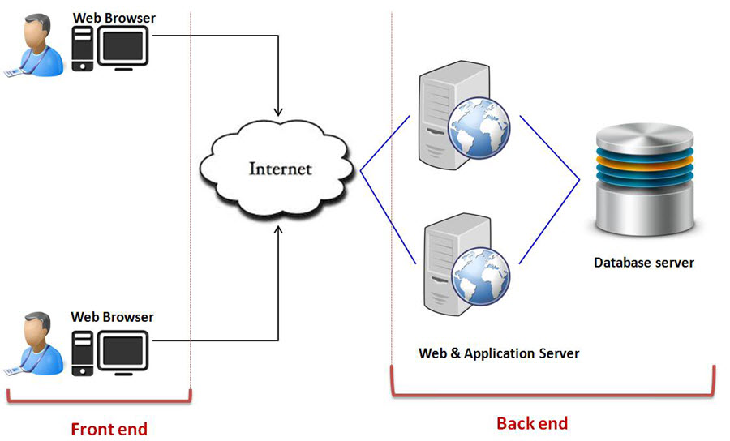

Cloud computing provides shared resources software and information to the various computers and devices on demand because cloud computing is an internet based.
2. Service Models of the Cloud Computing.
Manly there are three service models for cloud computing are:
i. Software as a service (SaaS).
In this model vendor or provider’s hosted applications which running on a cloud infrastructure(internet) and available to different customer devices through a thin customer interface such as a Web browser. Benefit of this model is that instead of purchasing the software subscribe it for monthly rental on internet, even a particular piece of software can be subscribe.
ii. Platform as a service (PaaS).
In this cloud infrastructure can customized applications with the help of programming languages and tools supported by the provider ( java, python, .Net)
iii. Infrastructure as a service (IaaS)
It allow access to the infrastructure and computing resources such as storage, networks, and other fundamental computing resources in a virtualized manner where the customer is able to establish and run any software, which can consist of operating system and applications. It is a cost reduces internet based IT infrastructure
The main motto of cloud computing is to recognize the network is a high performance computer which is to authorize the users to keep all the records and services, and data information into cloud storage and get access all kinds of services from cloud only via their remote login or remote terminal tools after connected to the internet. When the user used cloud services, they observe that it’s a virtual view and the records and services are really give out to different locations in cloud. The propensity that data and all services will be transformed to web network is to be projected to apply more services and to store more information on the cloud network. As we already know that Cloud service is completely based on Web Services and all the Web Services are based on Internet network . On the Internet there are many types of security weakness due to its openness and the chance of attacks and threats are always high. And the cloud computing services will have to face always a high range of security problems. Recently there are already more different types of security software technologies for Web Services are came in picture, so this is big implication for us to solve security related problems of cloud service using the existing security information system. The Cloud computing architecture is to provide suitable, on-requirement based network access to a common collection of configurable computing resources such as internet, websites, grids, applications software, clients, servers, storage, and the facilities that can be fast provisioned and get feel free with least management effort or communications with service provider. These cloud models improves availability and is composed of four deployment models, five significant characteristics along with three service models.

3. Important features of Cloud Computing
Here I am discussing some important features of the cloud computing that generated by cloud characteristics.

3. 1 . Resources Pooling
Resources pooling is most significant features of the cloud computing because through this uniqueness the cloud computing service provider can distribute resources between many users and providing each user with a different set of facilities and services as per the requirements. In cloud computing resource pooling is multi-client strategy system which is applied for data storage, data processing and bandwidth-provided services. And in this whole process the real time administration that allocating resources does not clash with the client services.

3. 2 On-Demand Self-Service
This is also an important and necessary features of Cloud Computing. It enable the client to all the time supervise the servers uptime, caliber, and selected network storage. It is a basic features of Cloud computing, and a client be able to similarly manage the computing abilities as per his necessity..

3. 3. Easy Maintenance
It is the best features of cloud that the servers can be easily maintain and the downtime is very low and even in some situations, there is no downtime. Cloud Computing comes up with bring up to date every time by steadily building it better.
The updates are well-matched with the devices and execute faster than previous along with the bugs which are predetermined.

3.4. Scalability and Rapid Elasticity
It is a main important feature and advantage of cloud computing and it is its fast scalability. This cloud feature enables the operation on low cost for workloads that need a vast number of servers but only for a short period of time. Many clients have such workloads, which can be run on very less cost because of the fast scalability of Cloud Computing.

3. 5. Large Network Access
The consumer can also use the stored data of the cloud or upload the data over the cloud from any place in the world just with the help of a computing machine and an internet link. These capabilities are accessible all over the the world via net and can access through the internet connection.

3. 6. Availability
The working capabilities of the Cloud can be customize as per the use or requirements and also can be extend as per the need . It analyzes the use of storage and allows the user to buy more Cloud storage if required for a little l amount.

3. 7. Automation System
This a special features of Cloud computing that it can automatically examine the data required and favor a measuring caliber at a few phases of services. We can easily watch, control, and report the usage of data and the clients activity over the cloud network . It will provide transparency for the host and the customer.

3. 8. Inexpensive
This cloud computing features help us to reduce the IT infrastructure expenditure of individual or organization level. It is a one-time investment over the IT assets as the Organization or individual (host) has to buy the storage over the cloud and a minute part of it can be distributed to the many Organizations or individuals that save the host from the paying of heavy monthly or yearly costs. Only they have to pay that amount which is used up on the basic maintenance and a few more expenditure that are very less.

3. 9. Safety
Safety of data over the cloud is one of the key features of Cloud computing.. It build a copy or print of the data stored to prevent the stored from lost even if one of the servers gets damaged.
The data are stored in the huge storage capacity devices that is extremely secure and which cannot be hacked or unauthorized utilized by any other person. The storage service is very rapid and reliable.

3. 10. Payment as per requirements.
Payment in cloud computing is totally depend upon user requirements. The, the user has to pay only for that service or the space they are using. There is no any hidden or extra charges that is to be paid by user. The facility is available on low-cost and most of the time few space is allotted for free.

3. 11. Calculated Service
This is a major Cloud computing features that are utilized to monitor and control the entire system and the organization uses it for recording. This resource consumption is calculated by supporting charge-per-use of capabilities.
It means that the utilized resources are virtual server instances that are consecutively in the cloud are getting watched and measured and reported by the service provider. Finally we can say that a user has to as per the utilization to manufacturer organization as it happen in cellular company.
4. Litrature review:
As the paper completely concentrate on how the impact of cloud computing make changes in E-Commerce business.
As it appears that the impact of cloud computing has been discussed by different Articles or literatures in last decades. Pravin S Rotkar and Gayatri Butey [1] finding the factors that the lack of technical training and technical resources it preventing the educational information in remote area of India. Most of the rural India is unskilled and unaware with these technologies. Finally it concluded that the cloud computing can easily solve these problems. This paper conclude the possible advantages to get educational information by cloud computing from anywhere. It is important and meaningful for cloud computing Applications that all the possible advantages of cloud computing can be only discussed after a deep study on it. Kashefi F, at al [2] Analyzes that the it should present a new methodology of cloud computing to improve it. The paper define the positive impact of cloud computing on e-commerce industry based on the case study of big companies and organizations such as Amazon and Fipkart, now a days these e-commerce sites are reached remote areas and the people are facilitates from it.
4. E-Commerce technical Architecture:
The main working process of ecommerce is that the exchange of products and services by internet. Generally e-commerce architecture is composed of two layers. First layer is technical architecture that is combination of physical devices (hardware) and logical applications (software) and the second layer is business model through which transaction is possible that is based on technical architecture. According to Laudon[3] the base layer of E-commerce is Technical Architecture. All marketing and business strategies of E-commerce can be realize on the basis of Technical Architecture, because technical architecture is main premises of online products in addition to security and exchange services.
Basically cloud computing is not very new mode of computing it is only the transformation of traditional distributed and grid computing mode to cloud architecture.
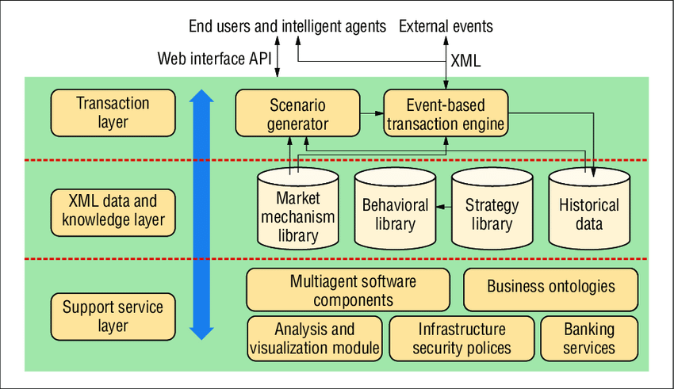
E-Commerce Technical Architecture

Conclusion
The interaction of cloud computing is producing new ecosystem that will encapsulate all the facilities and resources of E-commerce in the new service modes. These are the Companies who control and maintain the servers, maintain the activeness of the server and take care over all security and tasks of it. The association also buys the software and the licenses for the action of their business. All these things protect by the monthly fee that they are expecting from the organizations they are serving. They are listening cautiously on providing ranked service as if they not succeed to do so they will be at the back in the contest. This web-based system can only access through the internet.

Cloud Computing has different types of advantages which are serving both hosts and the individual client or organization. A host also construct of a range of profit that provide benefit to the customers. There are a countless of safety element which is a hopeful point along with it the execution time is very low and one can easily upload and download data quickly. The organization nowadays is in huge need of the data storage capability and the Big Data companies provide them very easily.

Declaration of Competing Interest
The authors declare it that they have no known competing financial interests or personal relationships that could have appeared to influence the work reported in this paper.

References

[1] Pravin S Roatkar and Gayatri Butey(Feb-2021). Impact of cloud computing in India on E-commerce,
Reseaechgate.
[2] Daping Wang, (2013), Influences of cloud computing on E-Commerce Business and Industry. Journal of
Engineering and Applications,6p.
[3] F. Kashefi, M. Majd, M. Darbandi, H. Purhosein, K. Alizadeh and O. Atae, “Perusal about Influences of Cloud
Computing on the Processes of These Days and Presenting New Ideas about Its Security,” The Proceedings of
the 5th International Conference on Application of Information and Communication Technologies (AICT),
Baku, 12-14 October 2011,
[4] Sagar Choudhary1, Garima Pundir2, Yashveer Singh3. International Research Journal of
Engineering and Technology (IRJET) e-ISSN: 2395-0056 Volume: 07 Issue: 01 | Jan 2020.
[5] Manish Kumar- Bhagwant Institute of Technology, Muzaffarnagar, UP. Shivani Chauhan
Assistant Professor Bhagwant Institute of Technology, Muzaffarnagar, UP. Ajay Singh
Assistant Professor Bhagwant Institute of Technology, Muzaffarnagar, UP, International
Journal of Computer Science and Mobile Computing, Vol.8 Issue.1, January- 2019.
[6] Sunil Kumar and Maninder Singh, Department of Computer Science, Punjabi University,
Patiala. Article Published : 12 Apr 2017
[7] T. Karnwal, S. Thandapanii, A. Gnanasekaran, “A filter tree approach to protect Cloud
Computing against Xml DDoS and http DDoS Attack”. In: Intelligent Informatics, pp. 459–
469. Springer, 2013.

