Energy-Efficient and High-performance IoT-based Wireless Sensor Network architecture for Precision Agriculture Monitoring using Machine Learning Techniques

Charles Rajesh Kumar. J
Department of Electronics and Communication Engineering, Vinayaka Mission’s Kirupananda Variyar Engineering College, Vinayaka Mission’s Research Foundation (Deemed to be University), Salem, Tamil Nadu, India.
charlesece@yahoo.com

D.Vinod Kumar
Department of Biomedical Engineering, Vinayaka Mission’s Kirupananda Variyar Engineering College, Vinayaka Mission’s Research Foundation (Deemed to be University), Salem, Tamil Nadu, India.
vino.kd@gmail.com

Mary Arunsi. B
Medical Officer, Chinmaya Mission Hospital, Indira Nagar, Bengaluru, Karnataka, India.
dr.maryarunsi@gmail.com

M.A.Majid
Department of Electrical and Computer Engineering, College of Engineering, Effat University, Saudi Arabia.
moabdulmajid@effatuniversity.edu.sa
D.Baskar
Department of Electrical and Electronics Engineering, Annai Teresa College of Engineering, Viluppuram, Tamil Nadu, India.
basindia.kd@gmail.com

ABSTRACT
An automated irrigation system is developed to maximize the utilization of irrigation water for crops. Automation irrigation systems are designed using the Internet of Things (IoT), wireless sensor networks (WSN), and Machine Learning (ML) techniques and help in precision agriculture (PA). In this research, the IoT and WSN are innovatively coupled to create an intelligent remote crop monitoring system to use water in farming land space effectively. Appropriate sensors are used to measure the temperature and moisture of the root area. Two groups have been formed with the sensor information such as “require water” and “not require water” and saved on the server. The device intelligently determines whether the field needs water and automatically turns "ON" or "OFF" the motor, saving the farmer's time and human labor. ML Classifiers such as K-NN, Naive Bayes, and SVM decide if watering is required. ML classification performance measures demonstrate that the K-NN classifier outperforms the other two models considered for this investigation.

Keywords— Wireless Sensor Networks(WSN); Energy efficiency; Internet of Things (IoT); Precision agriculture (PA); Machine Learning (ML); K-Nearest Neighbor (K-NN); Naive Bayes (NB); Support Vector Machines (SVM).

INTRODUCTION

Food needs have expanded due to the planet's rapidly increasing population of humans. Given the planet's finite resources, it is challenging to meet the world's food needs [1]. Technological innovations are applied in agriculture to boost productivity and overcome this problem. Precision agriculture (PA) uses IoT devices and near- and remote-sensing methods to keep track of crop conditions at various growing phases. PA entails collecting and processing a sizable volume of agricultural health data. The health of crops is influenced by many factors, including water content and temperature, among others. With the help of PA, a farmer may accurately determine the conditions for a healthy crop and when, where, and in what quantity these conditions must exist. This necessitates gathering a considerable amount of data from various sources and areas of the farm, including soil nutrients, the existence of weeds and pests, plants' chlorophyll levels, and several environmental factors. To generate agronomic advice, all gathered data must be analyzed. For example, plants' chlorophyll content (amount of greenness) indicates the nutrients required depending on their development phase. These data are integrated with information about the soil characteristics where the crop will be grown, including the climate prediction. The amount of a specific fertilizer that should be administered to that crop the following day is calculated using all the data that has been gathered. Farmers must receive agronomic advice properly and follow its suggestions to increase yields. WSN consists of several nodes coupled to track and record the physical state of the environment, which is the primary driver of the PA. Figure 1 shows the various application of WSN-based IoT in agriculture monitoring. Every wireless node comprises a microcontroller, sensors, a radio transceiver, and additional circuitry that allows it to connect to a gateway and transmit data that the sensor has acquired [2]. Sensors gather data by measuring the physical parameters and sending it to the controller, who then sends it to a portable device or the cloud. The agriculture industry has a variety of needs, including those related to soil characteristics, crop varieties, climate, fertilizer classes, and water necessities. The needs of crops vary based on the crops grown in the same area and the same plant grown on other lands with various climatic conditions. Sensors keep track of how these crop factors change over time. The size and expenditure of sensors have decreased due to the rapid development of WSN technologies, making it possible to use them in various fields, including agriculture. Sensors keep track of how these crop factors change over time. The size and expenditure of sensors have decreased due to the rapid development of WSN technologies, making it possible to use them in various fields, including agriculture. Table 1 lists the most popular agriculture sensors to record crops' environmental factors. A WSN typically comprises one or more wireless nodes linked by sensors. These nodes, which are tiny units, are in charge of data collection [3]. There are two kinds of nodes: source nodes that gather information and sink nodes or gateway that obtain data from source nodes. Compared to a source node, a sink node is more computationally powerful. When selecting wireless nodes, there are memory, area, energy, data rate, and cost restrictions. Table 2 compares various wireless nodes and lists their standard specifications. MICA2 is seen as more appropriate than the other wireless nodes due to its numerous extension connectors, which enable it to interface with various sensors. Cyber-physical systems typically integrate sensor networks with embedded computers to monitor and regulate the physical environment. Feedback loops enable these external stimuli to self-activate computing, control, and communication.
WSN-based farming applications

Livestock and crop monitoring

Monitor the quality of environment

Monitoring of soil condition

Precision Agriculture

Health monitoring

Reducing the release of pollutants

Machinery control system

Controlling pests and using fertilizers

Horticulture
Management of water

Tracking animals

Irrigation

Managing landslides

Monitoring the quality of a food product

Monitor and control the Greenhouse environment

Management of harvest

Climate predictions

Monitoring the quality of water

Monitoring the forest

Figure 1: Application of IoT-based WSN in agriculture monitoring

The suggested system comprises three layers: the physical layer, where all sensory data is gathered; the network layer, where data is transported to the cloud; and the decision layer, where information is interpreted and processed to arrive at judgments based on observation. IoT-based systems face several difficulties due to the exponential growth of devices. The key issues underlying the IoT-based design are a requirement of minimal latency and minimum energy consumption, better use of bandwidth, and sporadic Internet access. Similar to a conventional IoT network, every node broadcasts information to a distant cloud, causing cloud congestion. The most advanced solutions to these problems, which lessen the cloud's computational load, are fog and computing [4]. Fog computing's primary objective is to save bandwidth and power, which improves service quality for end-users. Energy efficiency is the essential factor to consider while creating any fog design. To extend the network's lifespan by evenly distributing the power among interconnected nodes, a protocol that is energy-efficient is required for a fog-supported WSN. PA has only been extensively applied in a few developed countries, even with all the IoT-related advancements. Due to a lack of resources, emerging economies like India do not frequently use remote sensing approaches to assess crops' health, reducing productivity [5]. Due to its vast fertile territory and climate changes, which allow for the cultivation of various crops, India is primarily an agricultural nation. Despite having access to many environmental assets, India struggles to produce large yields. Conventional farming methods employed for crop healthiness monitoring and yield analysis are the leading cause of poor productivity. These methods are entirely based on the instincts and knowledge of farmers. In the case of ample agricultural land, monitoring the crop requires frequent field visits, which is quite time-consuming and challenging. In this instance, the area being attacked by insects and pests is not correctly monitored, which may lead to excessive insecticide and pesticide application that harms crop nourishment.

Table 1: List of the most popular agriculture sensors to record crops' environmental factors.
S.No | Acquired parameters | Name of the Sensor
1 | Conductivity, The moistness of the soil, Temperature of the soil | ECH2O-soil_moisture sensor
2 | Temperature , Humidity | SHT71and SHT75-Humidity & temperature sensor
3 | Conductivity, Soil Moisture, Soil Temperature, Salinity level | HydraProbe-Water soil sensor
4 | Air_Temperature, Air_Humidity, Air_Pressure | XFAM_115_KPASR-Pressure_sensor.
5 | The moistness of the soil, Temperature of the soil | MP406-Soil-moisture-sensor
6 | Air Pressure, Wind Speed, Air_Temperature, Air_Humidity | Met Station One-(MSO)weather sensor
7 | Conductivity, Soil Moisture, Salinity level, Soil Temperature, | ECE250-Electrical conductivity sensor
8 | Air Pressure, Air Humidity, Air Temperature. | HMP45C-Temperature and Relative humidity sensor.
9 | Soil Moisture, Soil Temperature | POGO-Wireless Soil sensor
10 | Air Pressure, Wind Speed, Air Humidity, Air Temperature | CM-100-Weather Sensor
11 | Plant Temperature, Air Temperature | 107-L-BetaTherm100K6A1B Thermistor
12 | Hydrogen level in Plant, Plant Temperature, CO2, Plant Wetness, Plant Moisture, Photosynthesis, Air humidity, Air temperature. | Cl-340-Photo synthesis system
13 | Plant Temperature, Plant Wetness, Plant Moisture | 237-L-Leaf Wetness sensor
14 | CO2, Plant Temperature, Photosynthesis, Plant Moisture, Plant Wetness. | PTM-48A-photosynthesis monitor
15 | Plant Temperature, CO2, Plant Wetness, Hydrogen. | NTMSenseH-R-Hydrogen sensor
16 | Plant Temperature | LT-2M-Leaf temperature sensor
17 | Photosynthesis | CM1000-Chlorophyll meter
18 | CO2, Plant Moisture, Photosynthesis | TPS-2 portable photosynthesis
19 | Photosynthesis | YSI6025-chlorophyll sensor
20 | Plant Temperature, Plant Moisture | TT4-multi-sensor thermocouple
21 | Plant Temperature, Plant Wetness, Plant Moisture | LW10-leaf wetness/Rainfall sensor

Actuators and sensor systems are part of the field layers. Actuators and sensor systems are part of the field layers. The sensors measure light intensity, temperature, humidity, electrical conductivity, PH, soil moisture, etc. The actuators are capable of carrying out orders from higher-tier units. The short-range wireless communication modules are Wi-Fi and Zigbee, and the long-range wireless communication modules are cellular and LoRa. A fog computing layer's architecture is constructed to gather detected information from deployed sensor nodes and execute the needed data-processing tasks for intelligent collection, minimizing the traffic of the network and lowering power expenses. The fog layer, often referred to as a local gateway, develops the core elements of a given process model locally before transmitting them effectively and compactly to the cloud. As a result, there is a significant reduction in top layers' latencies and expenses. The gateway unit data obtained is constantly moved to a cloud computing environment. As a result, the layer of cloud computing allows farmers to utilize a knowledge-based directory to save various data types, including all the pertinent details, about available farming and equipment possibilities. At the front-end layer, the user can see the outcomes of data analytics. When an event is triggered, it can show prompt alerts on the user's mobile phone. Figure 2 shows the end-to-end communication for PA.
Table 2: Various wireless nodes and their standard specifications.
S.No | Wireless Node | Microcontroller | Extension connectors (pins) | Data Speed/rate | Existing sensors
1 | MICA2 (MOTE-KIT4x0) | ATmega128L | 51 | 38.4K Baud | Accelerometer, GPS, Magnetometer, Video, Sounder, Acoustic, Relative humidity (RH), Barometric Pressure, Humidity, Light, Temperature.
2 | TelosB | TIMSP430 | 6 , 10 | 250 Kbps | Humidity, Temperature, Light
3 | IRIS | ATmega128L | 51 | 250 Kbps | Microphone, Magnetometer, Sounder Video Sensor, Acoustic, Accelerometer, RH, GPS, Barometric Pressure, Temperature, Humidity, Light
4 | MICA2DOT | ATmega128L | 19 | 38.4 K Baud | RH, Acoustic, Accelerometer, Temperature, Barometric Pressure, Humidity, Light, GPS.
5 | MICAz | ATmega128L | 51 | 250 Kbps | Microphone, Magnetometer, Sounder, Video Sensor, Acoustic, Accelerometer, RH, GPS, Barometric Pressure, Temperature, Humidity, Light
6 | Cricket | ATmega128L | 51 | 38.4K Baud | Sounder, Magnetometer, Microphone, Sensor, Video, Ultrasonic, Barometric Pressure, Acoustic, RH, GPS, Humidity, Temperature, Light, Accelerometer.
7 | Imote2 | Marvell-XScalePXA271 | 40,20 | 250 Kbps | Accelerometer, Humidity, Temperature, Light.

In a smart irrigation system, the solenoid valves and IoT-based WSN regulate water flow based on soil moisture and provide real-time monitoring to farmers far from the farms. The system measures the soil's humidity and temperature utilizing the soil sensor and then waters the crops accordingly. Farms with intelligent irrigation systems can check their irrigation systems automatically, eliminating the need for manual checking. The IoT-based WSN system enables crop monitoring.
Gateway
Wireless Communication modules: LE, ZigBee, Zwave, WiFi, LoRa, 3G/4G/5G, GSM

End User
Sensing and Actuators

Figure 2: The common architecture of PA system.
The sensor node connects the irrigation system to the mobile phone and regulates the time intervals between irrigation cycles and water flow from the pump. Artificial intelligence and Machine learning (ML) are changing the farms into smart farmlands called Precision agriculture (PA). The next agricultural revolution will be driven mainly by ML and IoT-based WSN. One of the critical determinants of farm productivity and hydrological cycles is soil moisture, and accurate soil moisture forecasting is crucial for water-efficient use and management [6]. Farmers in the agricultural industry will benefit from forecasts of soil moisture. Soil moisture is important because of the following reasons: 1. Soil water acts as a solvent and a transporter for food nutrients to promote crop growth.2. The quantity of water that is available affects a crop's production.3. The water content of the soil itself is a nutrient.4. The flow of water in the soil controls the soil's temperature.5. The metabolic processes of microorganisms demand soil water.6. Soil water aids in the biological and chemical processes of the soil. 7. Soil water is necessary for photosynthesis. Soil moisture can be predicted using ML approaches such as PCA, linear regression, Naive Bayes, and support vector machine regression. But because soil moisture is affected by many structural details and climatic variables, it is challenging to create the perfect mathematical model for predicting soil moisture. Using suitable ML approaches is crucial to increasing model performance and prediction accuracy. The following is a breakdown of the article's structure. Section 2 discusses the technologies for wireless communication, and Section 3 explains the related works. The proposed methods are elaborated in Section 4, and Section 5 covers the results and discussion. Section 6 concludes the paper.

WIRELESS COMMUNICATION TECHNOLOGIES

Due to the explosive growth of IoT devices and WSN technology over the past few decades, numerous communication protocols have been developed [7]. Each protocol has unique specifications such as bandwidth, the number of available channels, data rate, batteries' timing, cost, etc. The wireless communication techniques are compared and shown in Table 3. ZigBee, 6LoWPAN, Wi-Fi, RFID, BLE, ZigBee, ZigBee, and Cellular are various wireless communication technologies.

Table 3: The wireless communication techniques utilized in PA.
S.No | Communication protocols | Topology | Data Speed/rate | Power | Physical Range | Standard
1 | Wi-Fi | Star | 1to 54 Mbps | Medium | 50 m | IEEE 802.11
2 | 6LoWPAN | Mesh, Star | 0.3 to50 Kbps | Low | 2–5 km (urban),  15 km (suburban) | IEEE 802.15.4
3 | RFID | Peer-to-Peer (P2P) | 50 tags per second | Ultra low | 10–20 cm | RFID
4 | ZigBee | Star, Tree, P2P, Mesh | 250 Kbps | Low | 10–100 m | IEEE 802.15.4
5 | Bluetooth | Star, Bus | 1to 2 Mbps | Low | 30 m | IEEE 802.15.1
6 | LoRaWAN | Peer-to-Peer, Star | 27 to 50 Kbps | Very low | 5km to 10 km | IEEE 802.11ah

Cellular
Applications requiring a high data rate are best suited for cellular technologies. It may use GSM, 3G, 4G and 5 G cellular connection technologies to deliver reliable high-speed Internet connection while using more energy. It requires the deployment of infrastructure, ongoing operational expenses, and support of people under a centralized management authority. Cellular technology is an excellent choice for underground WSN, security techniques in agriculture, and projects involving smart homes, for instance [8], even if it consumes more battery power. In [9], an integrated farm monitoring system that uses IoT and smartphone applications is presented. With this system, farmers can remotely monitor their farms' soil moisture, pH level, leaf wetness period, humidity, and environmental temperature. The device provides fresh insights to influence decision-making by instantly analyzing the climate and soil conditions in a specific location where the crop is cultivated.

Low power wireless personal area networks (6LoWPAN )
6LoWPAN is the first IP-based protocol utilized for IoT communication. With IPv6 capability for IEEE 802.15.4 connections, the 6LoWPAN protocol establishes itself as the first IoT standard. It is a standard protocol for implementing IPv6 on WSN made up of low-power wireless modules. Due to its small low power and bandwidth requirements, 6LoWPAN is inexpensive. Multiple topologies, including mesh and star topologies, are supported by 6LoWPAN. IoT-based smart agriculture is proposed in [10] using 6LoWPAN. A 6LoWPAN-capable wireless sensor network was discussed, which is used to track the soil characteristics of crops.

ZigBee
The Zigbee protocol was created for personal area networks, and it is a standard-based wireless technology. ZigBee is frequently used in PA to track temperature, pressure, oxygen, radiation, PH, pollutants, parasites, etc., affecting crops' health [11]. The sensor network is utilized in agriculture, where data is transferred via Zigbee and stored in microcontrollers. Farmers are using the data gathered from the sensors that have been installed in the field. Zigbee is excellent for short- or medium-distance applications with high data need because of its constrained range coverage and improved data rates. It supports tree, star, and mesh topologies and enables multi-hop data transfer. It supports many nodes and is simple to install, and it also has a flexible network configuration and a prolonged battery life. It has a narrow range, slow data throughput, and less safety compared to Wi-Fi-based technologies.

Bluetooth low energy (BLE)
The data collected from sensor nodes deployed throughout agricultural land can be observed utilizing Bluetooth low energy (BLE) mesh technologies [12]. The IoT will enable farmers to connect to their farms through the cloud. With relatively little human work, inexpensive, and less energy consumption, the system allows farmers to monitor various field conditions remotely and make decisions that would boost crop yield. BLE suits IoT applications require reduced latency, low bandwidth, and short distances. Less setup time, Nodes in a star topology have complete support, and less energy consumption is among BLE's critical benefits over existing Bluetooth technologies. It only has a 10-meter range, which is pretty short. Moreover, its limitations on communication between devices, lack of security, and potential connection loss during transmission is negative.

Radio frequency identification (RFID)
The development of RFID sensing technologies has unleashed a new wave of agricultural applications [13]. The IoT technology uses sensors and RFID. Utilizing RFID communication protocols, the sensor data is gathered and delivered to the cloud. For instance, in an irrigation system, the sensor collects data regarding moisture and temperature. The sensor data is sent to the cloud using RFID communication protocol, and based on the soil's water content, the user can manage the water pump. With the help of IoT sensors, RFID crop tagging, and network communications, farmers can follow each step of the growing, harvest, and distributing processes. Farmers may boost yields and spot any problem areas that might affect their production by using reliable data from each plant.

Wireless Fidelity(Wi-Fi)
The WiFi protocol supports IEEE 802.11n, 802.11g, 802.11b, and 802.11a. The system comprises the sensor to measure temperature, wetness in the soil, level of water and humidity, etc., along with a wireless fidelity module (WiFi). The sensors gather information about environmental changes and wirelessly transmit it to the cloud using a WiFi module. Over a WiFi connection, a web server receives the sensed information. The web server archives the data that has been received and offers up-to-the-minute reports on the weather and crops [14].

Long Range Wireless Area Network (LoRaWAN)
IoT applications may overcome bandwidth, power, and coverage limitations that are the primary shortcomings of traditional wireless communication technologies using the enhanced service provided by LPWAN technology. The LoRaWAN protocol, also known as LoRa in the LPWAN domain, offers additional benefits for creating IoT applications in the agriculture sector, such as robustness, security, and scalability. Due to its extensive range and low energy consumption, LoRaWAN is often utilized in agricultural applications [15].

RELATED WORKS

IoT-based WSN Irrigation System
Agricultural activity automation can change the farm industry from laborious and static to intelligent and dynamic, resulting in increased productivity with less human supervision. The nodes of the WSN carry out the acquisition, gathering, and interpretation of data, such as soil temperature and moisture. Such information can automate agriculture irrigation while reducing water use, which has positive financial and environmental effects. Joaquín Gutiérrez et al. [16] proposed an automated irrigation system using WSN and the GPRS module. Appropriate sensors are used to measure the temperature and moisture of the root area. A gateway device manages sensor data, activates actuators, and transmits messages to a web application. A microcontroller-based gateway was designed with an algorithm based on temperature and moisture levels of soil threshold values to regulate water supply to the crops. The target plant is an organic sage. The sensors measure soil moisture and temperature, and a PIC24Fj64GB004 microcontroller and photovoltaic panels are utilized. Standards and protocols are ZigBee, GPRS. The programming languages are SQL server and C#. Nelson Sales et al. [17] presented an innovative irrigation design using WSN, actuators, and the cloud. The target plant is a peach tree. The sensors measure soil moisture and weather forecast, and an MSP430F2274 microcontroller and electro valve are utilized. Standards and protocols are IEEE802.15.4, ZigBee, GPS, GPRS, and HTTP. The programming languages are model view controller and JSON. M Monica et al. [18] suggested an IoT-based self-regulating irrigation scheme using Bluetooth, GSM, sensors, and the cloud. The farmers can keep an eye on the variables through the mobile app coupled with cloud storage. The proposed method effectively identifies a technique to preserve water by studying and contrasting the data from the prior year with the current data. The target plant is groundnut. The sensors measure moisture, light, and temperatures, and an ATMEGA328 microcontroller and pump are utilized. Standards and protocols are Bluetooth, GSM, and Wi-Fi. The programming language used is Sparkfun. S.Vaishali et al. [19] proposed an IoT-based intelligent irrigation monitoring and managing solution integrated with mobile devices. The primary goal of the proposed method is to use a smartphone to monitor the water supply for the crops constantly. The sensors measure soil moisture and temperatures, and a Raspberry pi and pump motor is utilized. Standards and protocols are Bluetooth. The programming language used is Python. Md Shadman Tajwar Haque et al. [20] presented an IoT-based agriculture irrigation tracking and control solution. The system uses node microcontrollers (ESP8266) for numerous methods that can be monitored and managed via the cloud. The microcontroller continuously tracks the states of numerous farm components and relays the information to the central control unit. After reviewing this data, the user can decide what steps to take, such as giving each micro-controller a specific task. The sensors measure soil moisture and temperatures, and a Raspberry pi, solar cell, and pump are utilized. Standards and protocols are MQTT, Wi-Fi. The programming language used node.js. Thilina N. Balasooriya et al. [21] proposed an IoT-based intelligent irrigation system. The system uses a PH sensor and soil moisture sensors. Microcontrollers are used for real-time data processing in a cloud environment, making it possible to check the pH and soil moisture levels continuously. Farmers can use the suggested technology to monitor and manage their watering system and plant environment through a smartphone app. The irrigation is regulated using WiFi-enabled microcontrollers, sensors, and the cloud. Ravi Ranjan Sah et al. [22] proposed an IoT-based irrigation system. The proposed system utilizes an Arduino UNO as its microcontroller and a GSM 900 module to interact with the farmers on a 2G phone. The automation process automatically determines whether the soil is dry or wet, applies the necessary irrigation, and notifies the farmer of the situation so that they may keep an eye on the farm even while not physically present. M. Benedict Tephila et al. [23] proposed an IoT-based automated irrigation system. The proposed system automatically controls time, steers clear of under- and over-irrigation problems, distributes water more efficiently, and monitors water reserves. The system uses open-source clouds, field-deployed sensors, sinks, and fusion centers for intelligent irrigation. In terms of the percentage of packets delivered, the number of packets sent to their destination, the length of the network's stability, and power use, the result is evaluated to that of other existing approaches.

Machine learning approach for smart decision
The various techniques for raising crops are still largely conventional and even outdated. Choosing the proper crop for the correct non-biological and biological components is still tricky for farmers. Thus, various AI techniques (ML methods) have been suggested by multiple researchers to increase crop productivity. Rahul Katarya et al. [24] summarized the different ML techniques such as KNN, Neural networks, Ensemble-based models, and similarity-based models. They made the most significant suggestions, resulting in higher returns and minimal resources and capital usage. Salma Zakzouk et al. [25] compared the various supervised ML algorithms for automatic irrigation of rice plants. Multiple sensors measure soil moisture, humidity, temperature, and time. The algorithms investigated are Random forest, logistic regression, decision tree, and KNN. These various models are trained and tested using approximately 100,000 datasets. The findings demonstrate that the Random Forest classifier has a 99.9% accuracy rate, which is the highest. K. Ibrahim Mohammad Abuzanouneh et al. [26] suggested an intelligent irrigation scheme based on IoT for PA using ML algorithms. The suggested method enables sensing the farmland's parameters and making the proper irrigation selections. The presented concept uses various IoT-based sensors for soil moisture, light, humidity, and temperature. The sensor information is also sent to a cloud server for analysis and decision-making. The artificial algae algorithm (AAA) and the least-squares-support vector machine (LS-SVM) model were integrated to decide whether irrigation is necessary. The model's accuracy is 97.5%, with guaranteed more acceptable performance. Emna Ben Abdallah et al. [27] proposed ML techniques for irrigation prediction. The ML approach utilized is Feature selection combined with various Regression techniques. The significance of the features is evaluated using SelectKBest, Recursive Feature, Random Forest, and Elimination (RFE) algorithms to accurately calculate the ideal amount of water required for a plant. Various regression techniques are developed based on the collection of useful features. The numerous models utilized in this approach are trained and tested employing a dataset that has been compiled on various crops like grapes, tomatoes, and lemons and includes multiple features such as crop data, irrigation data, soil data, and meteorological data. Anat Goldstein et al. [28] proposed a method to facilitate irrigation planning using ML algorithms. The sensors gather soil moisture data for monitoring crops in real-time. The study uses the data to forecast irrigation recommendations and monitor and control the yield. On this dataset, various regression (Gradient Boosted Regression Trees) and classification (Boosted Tree Classifier) techniques were used to create models that could forecast the weekly irrigation plan suggested by the agronomist. Ashutosh Bhoi et al. [29] offered an automated precision irrigation strategy based on IoT for effective water use with minimal human involvement. Multiple ML-based regression and classification models are combined with intelligence. The testing results show that the support vector regression (SVR) and KNN classifier-trained systems are pretty efficient. Andre Gloria et al. [30] presented a real-time irrigation technique based on IoT using ML algorithms. The developed method comprises wireless sensors and actuators network. This mobile app allows the user to consult not only the information collected in real-time but also their history and act in accordance with the information it evaluates. ML-based adaptation approaches for agricultural irrigation systems to determine a suitable time to supply water to crops were investigated. Various ML algorithms studied were Support Vectors Machines, Decision Trees, Neural Networks, and Random Forest. The Random forest approach showed the best result of 84.6% compared to other ML algorithms considered in the study. The system's adoption discovered the designed solution's effectiveness and ability to save up to 60% of water.

THE PROPOSED IoT-BASED WSN SYSTEM FOR IRRIGATION

IoT-based WSN Irrigation System
The agricultural industry currently uses WSNs for a variety of purposes. Smart fertilization, Smart irrigation, greenhouse monitoring, and intelligent pest control are prevalent uses. Once the WSN integrates with the IoT, its full potential will be realized. An intelligent irrigation design was developed to maximize water utilization for agriculture crops. The smart irrigation strategy can reduce the amount of water entering the crop field by turning the motor off automatically without human interference, depending on the soil's water content. The process can also be manual. The user can observe the surface soil moisture, and a signal is produced when a particular threshold is reached. A smartphone app allows the user to "OFF" or "ON" the motor. Figure 3 shows the proposed irrigation system. A real-time sensor node system based on IoT was created to regulate the water amount utilized in PA.
Web interface for the subscriber (Subscriber unit)
Sensing Unit
- Moisture Sensor
- Temperature sensor
Processing_Module
- A “panStamp” receiver node
- Gateway (Raspberry Pi)
- Messaging protocol (MQTT)

Persistence Unit
- MySQL

Actuation Unit
- Pump
- Motor driver

Figure 3: The proposed architecture of the intelligent irrigation system

Sensing module
Soil moisture sensors (SEN-13637), soil temperature sensor (DS18B20), Wireless node/mote (panStamp NRG 2.0). Panstamp is a compact and energy-efficient wireless sensor mote that can be programmable from Arduino IDE. It employs a transceiver (CC1101 RF) integrated into an MSP430 core to create the System on a Chip (CC430F5137). SEN-13637 comprises two pads and works as a variable resistor when combined. The conductivity between the pads improves with soil moisture, lowering resistance. The operating range of DS18B20’s operating temperature range is between -55 to 125 Celcius. The devices are powered using a 5V DC battery. Figure 4 shows the block diagram of the sensing unit.

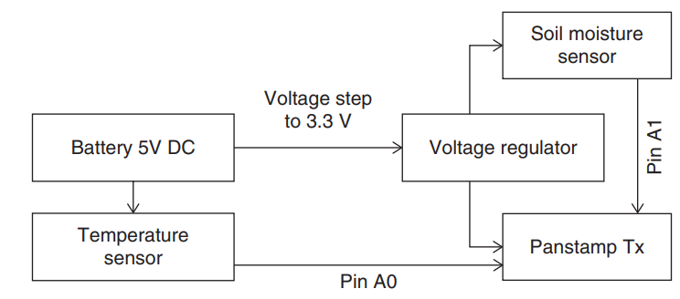
Figure 4: The block diagram of the sensing unit of the proposed architecture.

Processing module
A panStamp receiver node in the processing unit collects sensory information from farms that may be far away from the user and delivers the data to the gateway. Here the Raspberry Pi is the gateway. A low-cost, low-energy embedded board is utilized in the suggested IoT-based system. The Raspberry pi should have sufficient speed to execute ML algorithms to facilitate cloud transmission and gather information from several sensor nodes. Selecting the suitable communication protocol from the many already in use is crucial, including HTTP, MQTT, AMQP, and CoAP. We choose the MQTT protocol because of its ability to transmit brief messages and minimal bandwidth consumption, making it perfect for Machine to Machine (M2M) connections. MQTT is an IoT device's communication standard that deals with messages, clients, servers, brokers, and topics. Clients are any applications or devices that make use of MQTT. The client performs the "publish" and "subscribe" operations. Whenever the client transmits the information to the server, the technique is called a "publish." The data sent by the server to the client is called a "subscription." The client's ability to "publish" and "subscribe" to messages is made possible by the server. A server handles the client's network connection, receives the client's messages, handles unsubscribe and subscribe requests, sends the client's application messages, and terminates the client's network connection. The term "topic" refers to the broker's method of filtering messages for every connected client. Messages are sent via a topic (a provided information channel). The broker obtains published messages, and customers who have previously subscribed receive the information from the broker. An open-source message broker Mosquitto is utilized, which implements the MQTT protocol. The Mosquitto is appropriate for single-board computers with minimal power consumption, like the Raspberry Pi. When deciding which Web servers are best for the suggested system, Flask, Nginx, and Lighttpd are considered. Lighttpd stands out among them as the high-performance web server, an excellent option for embedded devices. Lighttpd provides auto-indexing, load balancing, and tolerance for faults capabilities when "Flask" and "Nginx" are compared. Flask is a lightweight structure with essential features, including a quick debugger and an integrated development server. Flask is the best choice because the Web server won't be doing any severe load tasks in our situation. The capacity to communicate directly with the broker is the most critical component of a web interface.

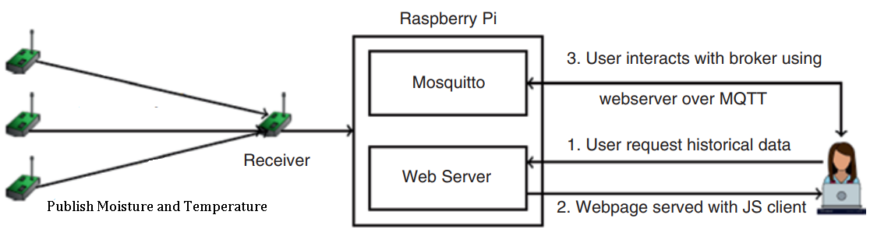
Figure 5: Transfer of information within the processor unit

Any interaction requires a client to broker a connection established via the web server (Raspberry Pi). The Raspberry Pi hosts the app's web pages, and the Raspberry Pi serves as a Mosquitto/Broker and a web server. Figure 5 shows the transfer of information within the processor unit. The server provides web pages to the client, and the client can use the standard HTTP request technique to get them. The web page uses the MQTT protocol to communicate with the broker. The "Eclipse Paho MQTT" JavaScript library is utilized to create the "MQTT client." The browser uses web sockets to interface with MQTT.

Actuation module
Figure 6 shows the actuation module of the proposed system. The Raspberry Pi is connected to an L298N dual H-bridge motor driver and a DC motor (12V, 200-300mA). One silicone tube is employed to draw water from the tank, while another, with a flow rate of 100 mL per minute, is operated to water the plants. The motor driver is performed using a 5 to 46 V DC power supply with a maximum 2A peak current.
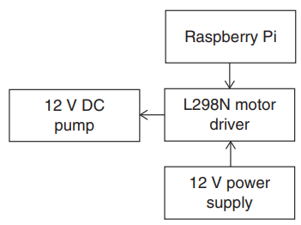
Figure 6: The actuation module of the proposed system

Using Raspberry Pi, the sensed data are sent to the server. The real-time data from the sensors that measure the temperature and moisture content of the soil are displayed in real-time graphs when the client login into the mobile application. The user can switch "ON" the motor remotely using the mobile application if they see that the moisture in the soil measurement is under the threshold or that the temperature is higher than the threshold value. The motor status is changed to "ON" when the server receives this instruction. The motor is switched “ON” to pump water to the crops when the motor driver receives an “ON” status signal from the controller (Raspberry Pi). The user can "OFF" the motor manually or automatically whenever the ground is sufficiently moist. The motor status is switched to "OFF" when the server obtains the instruction. The motor driver gets a signal from the gateway to stop the motor when it notices the "OFF" status.

The subscriber module
The subscriber module involves designing and implementing an online user interface for subscribers. The farmer would have access to a web interface that would allow them to "subscribe" to “Topics” or to the act of "publishing" that involves transmitting messages. The online web user interface supports log monitor format and data visualization with historical data utilizing the tabular form. Python was chosen to run tasks on the Web server, and the CSS and HTML form the basis of the Web interface. The feature of Web sockets in the broker (Mosquitto) is made use of using JavaScript. The libraries are available in JavaScript, making it easier to interact with Mosquitto. After inputting the broker's username, port, and login information, the user's data is provided to the Mosquitto broker to verify the subscriber's authenticity.

Peristence module
The data is transmitted to the subscriber node from wireless nodes over MQTT. The data packets are stored in a MySQL database so they may be accessed later. MySQL is an open-source relational and large-scale database. Because MySQL is built on a client-server model, an SQL server that supports multithreading and multiprocessing is necessary. Due to its scalability and support for multiuser characteristics, MySQL is an ideal choice for distributed applications. The persistence module is shown in Figure 7.

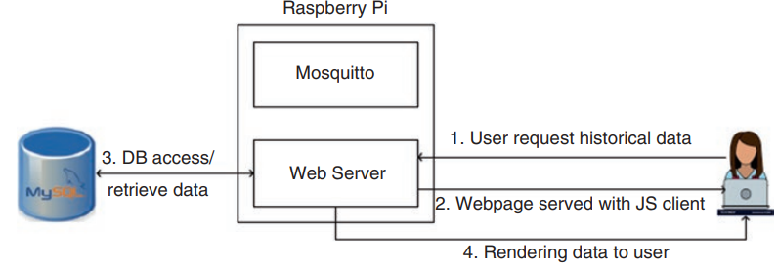
Figure 7: The persistence module of the proposed architecture

Machine learning approach for smart decision
The proposed architecture based on ML is shown in Figure 8. It comprises three layers 1. A layer for data collection and management, 2. Layer for data processing, and 3. An application layer.

Layer for data collection and management
The IoT components are primarily located in the collection and management Layer. It consists of two parts, one for motor control and the other for data collection. WSN and wireless communication technologies such as ZigBee are implemented with moisture and temperature sensors. These sensors' outputs are read by a Raspberry Pi attached to a gateway node by ZigBee, which then utilizes web services to transfer the information to the server. A Raspberry Pi or Arduino Uno node controls a relay switch attached to a water pump. The categorization model triggers a web service that controls the node. PHP was utilized to create the web service and Set up Windows' Apache_Web_Server to execute PHP.

Layer for data processing
The process flow diagram for decision support is shown in Figure 9. Three elements needed for data processing are 1. A centralized database, 2. A decision support system to forecast irrigation requirements, and 3. A web service to manage the water pump. The server receives the data from the data collection and management layer, which is then sent and placed into the MySQL database. Two groups have been formed with the sensor information such as “require water” and “not require water” and saved on the server. The device intelligently determines whether the field needs water and automatically turns "ON" or "OFF" the motor, saving the farmer's time and human labor. The classification model is built with the clustered data using classification models such as KNN, Naive Bayes, and SVM. The water motor can be started and stopped using a web service. This PHP-based web service transmits signals to the Raspberry pi or Arduino-Uno to operate the relay switch, which starts and stops the water motor. Additionally, it notifies the user when irrigation is necessary.

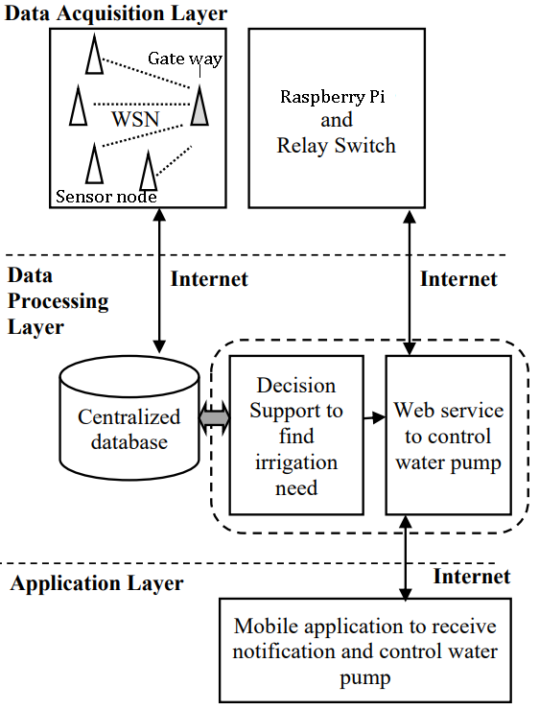

Figure 8: The proposed architecture based on ML.

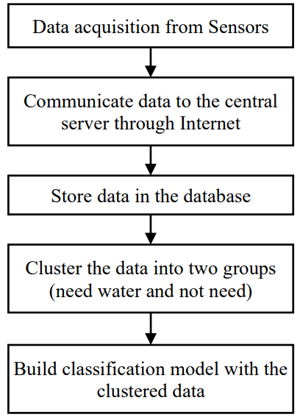

Figure 9: The process flow diagram for decision support

Application layer
A mobile application for a user's smartphone is running in the application layer. When the web application notifies the user, the notification outlining the field's requirement for irrigation is displayed, and the motor is turned ON. The user can manually manage the motor utilizing the mobile app as well. This relay switch is attached to a Raspberry Pi or an Arduino Uno, and the mobile app furnishes information to the web service, which controls it. The flow diagram for controlling the relay switch is shown in Figure 10.

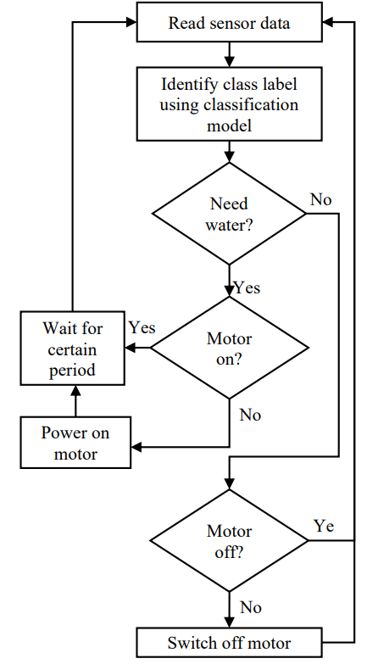
Figure 10: The flow diagram for controlling the relay switch

RESULTS AND DISCUSSIONS

IoT-based WSN Irrigation System
The Web interface gives users access to tabular and plotted historical information for any node. The Web server receives a request via the HTTP protocol, consults the databases, and then returns the user's responses. Since this capability deals directly with the Web server, the user need not be linked to the Mosquitto broker to fetch data. The Web application allows frequent and real-time temperature and soil moisture data monitoring, allowing the user to remotely switch "ON" and "OFF" the motor in the field as needed. After continuously updating the device on the Web server and checking it, the motor is switched "ON" or "OFF" using the control signal generated by the Raspberry Pi. The location of the node can be fetched through google Maps. Real-time monitoring of temperature and moisture is shown in Figure 11.

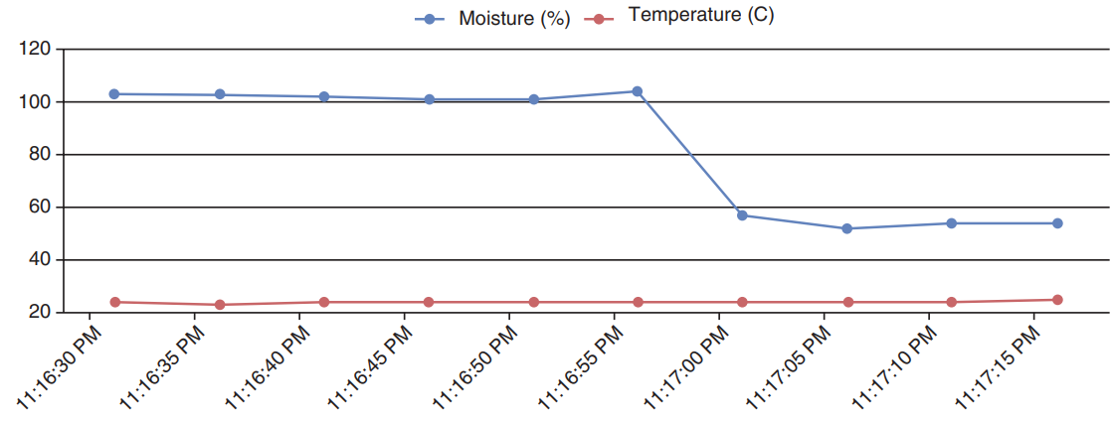
Figure 11: A real-time monitoring of temperature and moisture.

Machine learning approach for prediction of soil moisture
The suggested method offers an automated decision-making system that sends water to the field when required using IoT-based WSN and data mining approaches. The gathered information is transmitted to the server over the internet. The server machine houses a database for storing received data, a decision support model for processing it, and web service for controlling a relay switch. The user's Android-based smartphone is running an app. The user can physically operate the motor while still receiving the notification on their smartphone from wherever they are. Accuracy, recall, and precision, which is provided in equations (1), (2), and (3), are the performance measures taken into account to assess the classification model in the decision support procedure. The suggested method would make it easier for the user to drive when he is out of stations instead of going to the farm. Additionally, the user can manually regulate the motor, which would be helpful for him in critical instances. The created system lessens the user's human labor and aids in irrigating the field only when necessary, ensuring that the required volume of water is utilized efficiently. The suggested method uses ML data mining approaches, allowing the model to learn from primary information before making decisions based on new data. It avoids integrating the intelligent irrigation systems with just thresholds. ML Classifiers such as KNN, Naive Bayes, and SVM decide if watering is required. ML classification performance measures demonstrate that the K-NN classifier outperforms the other two models considered for this investigation, as shown in Table 4. The K-NN aids farmers in timely irrigation of their fields and efficient water utilization.

$Accuracy=\frac{True Positive+True Negative}{The total_number of positive_samples + The total_number of negative_samples}$ (1)
$Recall=\frac{True Positive}{True Positive + False Negative}$ (2)
$Precision =\frac{True Positive}{True Positive + False Positive}$ (3)

Table 4: Performance Matrices of various algorithms
Name of the Classifier | Performance indicators
 | Accuracy | Recall | Precision
Support Vector Machines (SVM) | 90.01 | 87.03 | 89.11
Naive Bayes (NB) | 88.86 | 86.84 | 86.45
K-Nearest Neighbor (K-NN) | 92.16 | 90.11 | 91.05

CONCLUSION

Since water availability will continue to be a global problem in the future decades, managing water in agriculture presents significant challenges. Therefore, precision irrigation(PA) is presented as a novel approach to boost agricultural productivity and control water excess utilizing cutting-edge technologies like cloud computing, WSN, and IoT. We have explored the most popular wireless technologies and the overall design of IoT-based irrigation methods. The main goal of developing intelligent irrigation systems based on the IoT and WSN is to reduce labor costs, time spent on tasks, and water usage. A real-time, low-cost automatic watering design based on IoT and WSN is created. Sensing information is sent to the Raspberry Pi, a system's computing unit, and MQTT protocol were employed to gather data from several sensor nodes. The Mosquitto serves as a message broker. Suppose the measured moisture content of the soil is below the appropriate threshold. In that case, the farmer can immediately control the motor using a mobile application, minimizing the amount of water and energy wasted. The sensor information is then grouped into two groups and saved on the server. ML Classifiers such as KNN, Naive Bayes, and SVM decide if watering is required. ML classification performance measures demonstrate that the K-NN classifier outperforms the other two models considered for this investigation. The created system lessens the user's human labor and aids in irrigating the field only when necessary, ensuring that the required volume of water is utilized efficiently. With the advancement of technology, rule-based irrigation systems have been created. In rule-based systems, the system verifies a threshold before turning "ON" or "OFF" the motor.

REFERENCES

- P. Vootla, F. Al Remeithi, S. A. Bariaghabr and F. Al Mansoori, "Food waste — A global challenge to sustainability," 2018 Advances in Science and Engineering Technology International Conferences (ASET), 2018, pp. 1-5.
- Charles Rajesh Kumar. J, Vinod Kumar. D, Mary Arunsi. B, Baskar. D, M.A. Majid, "Energy-Efficient Adaptive Clustering and Routing Protocol for Expanding the Life Cycle of the IoT-based Wireless Sensor Network," 2022 6th International Conference on Computing Methodologies and Communication (ICCMC), 2022, pp. 328-336.
- Charles Rajesh Kumar. J, Vinod Kumar. D, Mary Arunsi. B, Baskar, "Energy-Efficient and Secure IoT architecture based on a Wireless Sensor Network Using Machine Learning to Predict Mortality Risk of patients with CoVID-19," 2021 6th International Conference on Communication and Electronics Systems (ICCES), 2021, pp. 1853-1861.
- C. R. Kumar and A. Ibrahim, "VLSI design of energy efficient computational centric smart objects for IoT," 2018 15th Learning and Technology Conference (L&T), 2018, pp. 129-138.
- T. Thaher and I. Ishaq, "Cloud-based Internet of Things Approach for Smart Irrigation System: Design and Implementation," 2020 International Conference on Promising Electronic Technologies (ICPET), 2020, pp. 32-37.
- S. Prakash, A. Sharma and S. S. Sahu, "Soil Moisture Prediction Using Machine Learning," 2018 Second International Conference on Inventive Communication and Computational Technologies (ICICCT), 2018, pp. 1-6
- S. Al-Sarawi, M. Anbar, K. Alieyan and M. Alzubaidi, "Internet of Things (IoT) communication protocols: Review," 2017 8th International Conference on Information Technology (ICIT), 2017, pp. 685-690.
- X. Zhang, A. Andreyev, C. Zumpf, M. C. Negri, S. Guha and M. Ghosh, "Thoreau: A subterranean wireless sensing network for agriculture and the environment," 2017 IEEE Conference on Computer Communications Workshops (INFOCOM WKSHPS), 2017, pp. 78-84.
- Manoj A. Patil, Amol C. Adamuthe, A.J Umbarkar, “Smartphone and IoT Based System for Integrated Farm Monitoring,” Techo-Societal 2018, pp. 471-478, 2018.
- Z. Suryady, M. H. M. Shaharil, K. A. Bakar, R. Khoshdelniat, G. R. Sinniah and U. Sarwar, "Performance evaluation of 6LoWPAN-based precision agriculture," The International Conference on Information Networking 2011 (ICOIN2011), 2011, pp. 171-176.
- S. Prakash, "Zigbee based Wireless Sensor Network Architecture for Agriculture Applications," 2020 Third International Conference on Smart Systems and Inventive Technology (ICSSIT), 2020, pp. 709-712.
- N. Shanbhag, S. Tambosker, R. Bhagat, V. Gaonkar, D. Rodrigues and F. Leitao, "Design of Sensor Nodes for Agricultural field monitoring Using IoT and BLE mesh technology," 2020 IEEE 7th Uttar Pradesh Section International Conference on Electrical, Electronics and Computer Engineering (UPCON), 2020, pp. 1-6.
- A. Motroni et al., "An RFID Tracking System for Agricultural Safety," 2021 IEEE International Conference on RFID Technology and Applications (RFID-TA), 2021, pp. 28-31.
- V. K. Akram and M. Challenger, "A Smart Home Agriculture System Based on Internet of Things," 2021 10th Mediterranean Conference on Embedded Computing (MECO), 2021, pp. 1-4.
- Dushyant Kumar Singh,Rajeev Sobti,Anuj Jain,Praveen Kumar Malik,Dac-Nhuong Le, “LoRa based intelligent soil and weather condition monitoring with internet of things for precision agriculture in smart cities,” IET Communications,vol.16, no. 5, pp. 604-618, 2022.
- J. Gutiérrez, J. F. Villa-Medina, A. Nieto-Garibay and M. Á. Porta-Gándara, "Automated Irrigation System Using a Wireless Sensor Network and GPRS Module," in IEEE Transactions on Instrumentation and Measurement, vol. 63, no. 1, pp. 166-176, Jan. 2014.
- N. Sales, O. Remédios and A. Arsenio, "Wireless sensor and actuator system for smart irrigation on the cloud," 2015 IEEE 2nd World Forum on Internet of Things (WF-IoT), 2015, pp. 693-698.
- M. Monica, B. Yeshika, G. S. Abhishek, H. A. Sanjay and S. Dasiga, "IoT based control and automation of smart irrigation system: An automated irrigation system using sensors, GSM, Bluetooth and cloud technology," 2017 International Conference on Recent Innovations in Signal processing and Embedded Systems (RISE), 2017, pp. 601-607.
- S. Vaishali, S. Suraj, G. Vignesh, S. Dhivya and S. Udhayakumar, "Mobile integrated smart irrigation management and monitoring system using IOT," 2017 International Conference on Communication and Signal Processing (ICCSP), 2017, pp. 2164-2167.
- M. S. Tajwar Haque, K. Abdur Rouf, Z. A. Khan, A. Emran and M. S. Rahman Zishan, "Design and Implementation of an IoT based Automated Agricultural Monitoring and Control System," 2019 International Conference on Robotics,Electrical and Signal Processing Techniques (ICREST), 2019, pp. 13-16.
- T. N. Balasooriya, P. Mantri and P. Suriyampola, "IoT-Based Smart Watering System Towards Improving the Efficiency of Agricultural Irrigation," 2020 IEEE Global Conference on Artificial Intelligence and Internet of Things (GCAIoT), 2020, pp. 1-7.
- R. R. Sah, R. Khatri, T. Basotra and A. Chauhan, "IoT Based Irrigation System -A Farmer Friendly Version," 2021 3rd International Conference on Advances in Computing, Communication Control and Networking (ICAC3N), 2021, pp. 677-681.
- M. B. Tephila, R. A. Sri, R. Abinaya, J. A. Lakshmi and V. Divya, "Automated Smart Irrigation System using IoT with Sensor Parameter," 2022 International Conference on Electronics and Renewable Systems (ICEARS), 2022, pp. 543-549.
- R. Katarya, A. Raturi, A. Mehndiratta and A. Thapper, "Impact of Machine Learning Techniques in Precision Agriculture," 2020 3rd International Conference on Emerging Technologies in Computer Engineering: Machine Learning and Internet of Things (ICETCE), 2020, pp. 1-6.
- S. Zakzouk, M. Ehab, S. Atef, R. Yousri, R. M. Tawfik and M. S. Darweesh, "A Comparative Study of Machine Learning Techniques for Automatic Rice Crop Irrigation," 2021 17th International Computer Engineering Conference (ICENCO), 2021, pp. 46-50
- K. Ibrahim Mohammad Abuzanouneh, F. N. Al-Wesabi, A. Abdulrahman Albraikan, M. Al Duhayyim, M. Al-Shabi et al., "Design of machine learning based smart irrigation system for precision agriculture," Computers, Materials & Continua, vol. 72, no.1, pp. 109–124, 2022.
- Emna Ben Abdallah, Rima Grati, Malek Fredj & Khouloud Boukadi, “A Machine Learning Approach for a Robust Irrigation Prediction via Regression and Feature Selection,” International Conference on Advanced Information Networking and Applications [AINA 2022: Advanced Information Networking and Applications], 2022, vol.449, pp.491-502.
- Anat Goldstein, Lior Fink, Amit Meitin, Shiran Bohadana, Oscar Lutenberg, Gilad Ravid, “Applying machine learning on sensor data for irrigation recommendations: revealing the agronomist’s tacit knowledge. Precision Agriculture, vol.19, pp.421-444,2018.
- Ashutosh Bhoi, Rajendra Prasad Nayak, Sourav Kumar Bhoi , Srinivas Sethi, “Automated Precision Irrigation System Using Machine Learning and IoT. In: Udgata, S.K., Sethi, S., Srirama, S.N. (eds) Intelligent Systems. Lecture Notes in Networks and Systems, vol 185, pp.275-282, 2021.
- Glória A, Cardoso J, Sebastião P, “Sustainable Irrigation System for Farming Supported by Machine Learning and Real-Time Sensor Data”, Sensors, vol.21, no.9, pp.3079, 2021.

------------------------------------------------------------------------------------------------------------------------------------------------------------------------

