RECENT ADVANCES IN TRANSGENIC BREEDING
C. D. Prajapati
Ph.D. Scholar: Dept. of genetics and plant breeding,
C. P. College of Agriculture,
Sardarkrushinagar Dantiwada Agricultural University,
Sardarkrushinagar, 385505
chirag120397@gmail.com

K. D. Gajjar
Ph.D. Scholar: Dept. of genetics and plant breeding,
C. P. College of Agriculture,
Sardarkrushinagar Dantiwada Agricultural University,
Sardarkrushinagar, 385505
kgajjar31@gmail.com

R. S. Solanki
Ph.D. Scholar: Dept. of genetics and plant breeding,
C. P. College of Agriculture,
Sardarkrushinagar Dantiwada Agricultural University,
Sardarkrushinagar, 385505
srs75531@gmail.com

D. P. Joshi
Ph.D. Scholar: Dept. of genetics and plant breeding,
C. P. College of Agriculture,
Sardarkrushinagar Dantiwada Agricultural University,
Sardarkrushinagar, 385505
dhruvj4696@gmail.com

R. R. Vaid
Ph.D. Scholar: Dept. of genetics and plant breeding,
C. P. College of Agriculture,
Sardarkrushinagar Dantiwada Agricultural University,
Sardarkrushinagar, 385505
rahulpatel5767@gmail.com

ABSTRACT
The recent rapid climate and increasing global population have led to an increased incidence of abiotic stress and decreased crop productivity. Transgenic breeding offers a suitable alternative to conventional breeding to achieve plant genetic improvements. Transgenic breeding approaches allow us with access to identify the, miRNAs, candidate genes and transcription factors (TFs) that are involved in specific plant processes. Production of transgenic plants is reported in many crops but commercialization is limited to few selected crops, such as cotton (Gossipium hirsutum L.), corn (Zea mays L.), soybean (Glycine max L.) and canola (Brassica napus L.). Some of the recent advances in transgenic breeding gives opportunity to create better transgenes with precise gene insertion and specific character expression. Clean gene/ marker-free technology is one such advancement that transforms plants using two separate vectors, one carrying transgene and other carrying selectable marker gene. CRISPR-Cas-9 based base editing also offers the introduction of point mutation without generating double stranded brakes. Evolution in grafting process by placing non genetic engineered part on genetic engineered root stock is also modern approach in this field.
Keywords: candidate genes, miRNAs, Transcription factors
INTRODUCTION
Genetic improvement of crop plants, domestic animals and useful micro-organisms, through genetic engineering, in relation to their economic use for mankind is referred to as transgenic breeding. Over the last two decades, transgenic breeding techniques demonstrated remarkable developments in manipulations of the genes for the induction of desired characteristics into transgenic plants. Genetic engineering and plant transformation have played a pivotal role in crop improvement via introducing beneficial foreign gene(s) or silencing the expression of endogenous gene(s) in crop plants. In last 22 years, the global area of transgenic crops has increased significantly from 1.7 million hectare in 1996 to 191.7 million hectare in 2018. The majority of the transgenic area is covered by soybean which is up to 48.2%. Maize stands second with 32% of total transgenic area followed by cotton with 13.5% of area. (Fig 1).
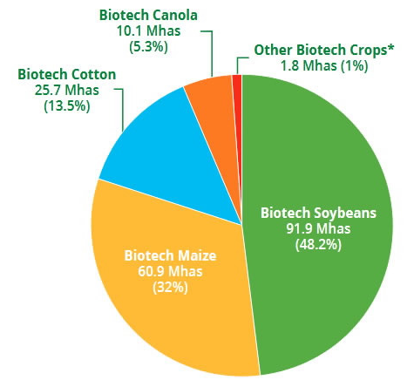
Fig 1. Transgenic crops in 2019 (area and adoption rate)
The basic four concepts on which transgenic breeding works are transgenesis, cisgenesis, intragenesis and genome editing. Transgenesis includes insertion of foreign gene from sexually incompatible species whereas, cisgenesis involves sexually compatible species. Intragenesis means insertion of recombinant genetic elements in which one or more components (gene, promoter and terminator) are isolated from different genes within the sexually compatible gene pool and genome editing describes introduction of targeted mutation at specific loci in the genome. (Fig. 2)
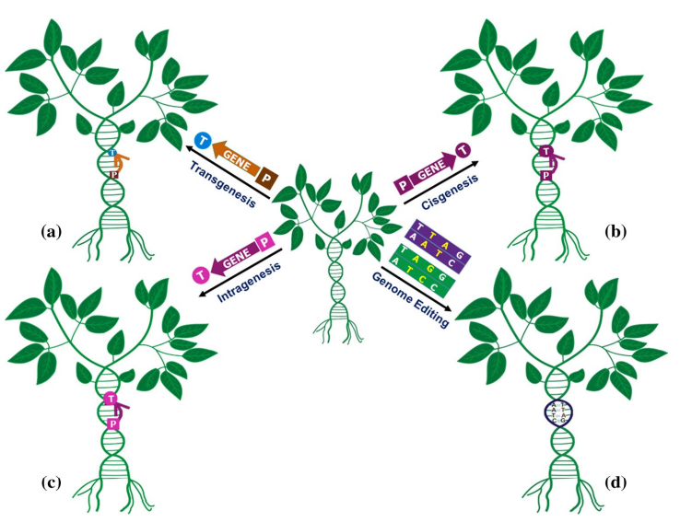
Fig 2. Illustration of various transgenic breeding techniques utilized for generation of improved crop plants.

ADVANTAGES OF TRANSGENIC BREEDING
- Rapid method of crop improvement
- Overcome crossing barriers
- Evolution of new genotypes
- Genetic improvement of allogamous and autogamous crop plants
- Effective for genetic improvement of monogenic characters

TRANSGENIC BREEDING APPROACHES
Genetic transformation
- Physical method
- Biological method
- Chemical method
- In planta transformation
- Herbicide resistant gene now in the field

Genome editing tools
- Site-directed nucleases (SDN)1/2/3
- Zinc Finger Nucleases
- TALE Nuclease
- CRISPR/CAS 9

THE RECENT ADVANCES

1. Chloroplast Genetic Engineering
In the Nicotiana benthamiana, the control of Helicoverpa armigera was more stable and effective when the overexpressing of dsRNA targeting the acetylcholinesterase gene was integrated into the chloroplast genome than it was integrated into the nuclear genome. Higher chloroplast numbers in each cell and the its genome polyploidy allow the insertion of several transgene copies in a single cell, resulting in uniform and strong protein accumulation levels.
Recombinant protein accumulation in transgenic chloroplasts can lead to less cytotoxicity in plant cells than cytosolic protein storage. In addition, the maternal inheritance of chloroplasts in most crops prevents the transgene from being transmitted via pollen to other plant species
Furthermore, transgenic plants may optionally be generated without any antibiotic resistance marker gene, and because chloroplasts support the formation of disulfide bonds, they represent excellent bio-factories for mammalian proteins that require this form of folding. The typical vector for the chloroplast genome transformation should contain gene of interest, selectable marker gene driven by an organelle-specific promotor and 50- and 30- UTR (UnTranslated Region). (fig. 3)

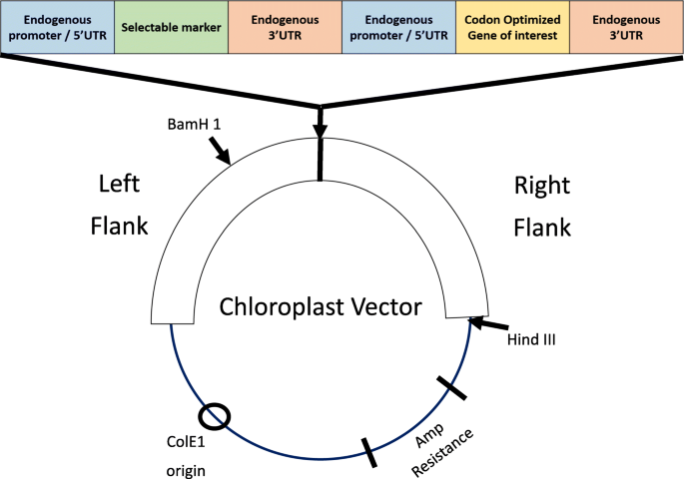
Fig. 3. Typical vectors for chloroplast genome transformation

Chloroplast engineering is also helpful in various fields viz. Therapeutic protein, biofuel, phytoremediation, improved crop production and industrial enzymes.
2. Base editing
The introduction of multiple double-strand breaks simultaneously within the genome via CRISPR or other tools carries the risk that the edited cells’ intrinsic DNA repair systems will make mistakes, introducing changes into the genome that could lead to cellular transformation and cancer. Base editing is a novel technology that has the potential to generate gene knockouts or to correct certain errors or mutations in the DNA of intact cells. Although CRISPR, ZFNs, or TALENs can achieve this number of gene knockouts, they do this through the introduction of double-strand breaks, which is less than ideal. Base editing does not need to introduce double strand breaks to modify a base pair, so the chance of large alterations in the genome, such as chromosomal translocations, is substantially reduced. This offers a very attractive safety profile as the gene editor of choice for cell therapy. (Fig. 4)
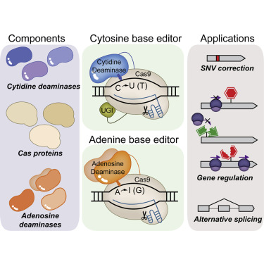
Fig. 4. Base editing procedure
3. Clean gene/ marker free technology
- Need for marker free transgenics
Marker genes generally have little agronomic value after selection events. The protein products of such genes could be toxic to human/animals. These marker genes could be passed on from transgenic crop to some other organism and could damage the environment. In situations requiring more transformations into cultivars and the presence of a particular marker gene in a transgenic plant one should use of the same marker in subsequent transformation. For public acceptance of transgenics, keeping in mind ecological and food safety, marker free transgenics should be developed. The generation of transgenic plants by the elimination of the “problematic” selectable marker genes from the genome of the transgenic plants or avoiding the use of selectable marker genes in the beginning of transformation by a marker-free vector is known as clean gene technology.
This procedure can be carried out through four methods

(i) Co-transformation and segregation
Selectable marker gene and gene of interest are introduced on separate T-DNAs present in to two different agrobacterium strains (A) On separate vector in same agrobacterium strain or (B) on the same vector. The two genes can also be delivered by direct transfer method such as particle bombardment. If the gene of interest and selectable marker gene are integrated at unliked positions, progeny plants with only the gene of interest can be obtain after sexual propagation. (Fig. 5)

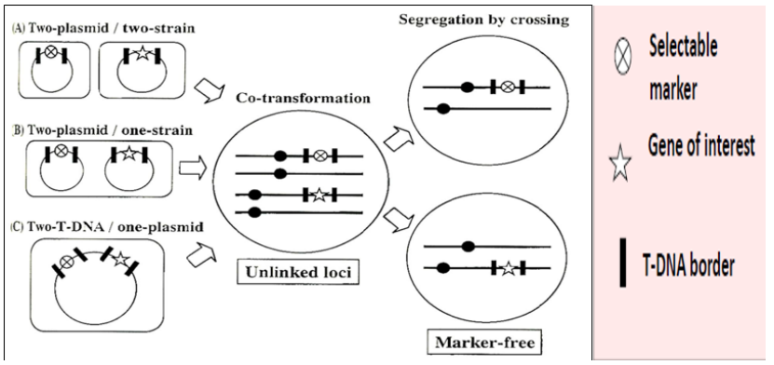
Fig. 5 Co-transformation and segregation

(ii) Site specific recombination
Removal of selectable marker genes can be achieved by site specific recombination systems. The cre lox system is derived from the bacteriophage P1 and consists of two components 1. Two loxP sites, each having 34bp inverted repeats cloned in direct orientation flanking the DNA sequence 2. The cre gene encoding a recombinase protein that specifically binds loxP sites and excises the intervening sequence by catalysing a cross over between the repeated lox sites. The strategy involves the generation of plants that express the cre gene and crossing them with the plants in which the selectable marker gene is introduced between two lox sites. In the F₁ generation, the selectable marker gene is excised due to expression of cre recombinase. The cre gene is then segregated away in the subsequent generation. (Fig. 6) Besides cre lox system other site-specific recombination system include, the flippase recognition target or frt system.
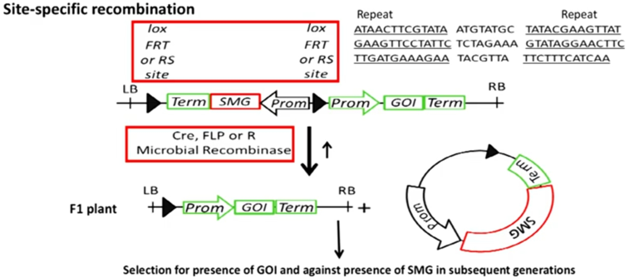
Fig. 6 Site specific recombination
(iii) Transposon based marker excision
This system is primarily based on the fact that the DNA sequences located in the AC-DS repeats are excised along with the AC-DS element. Agrobacterium mediated transformation is carried out to transfer the selectable marker gene that is cloned as a part of transposable element i.e AC and the gene of interest, with both genes laying within the T-DNA borders. Alternatively, the AC can be introduced by crossing another transgenic carrying AC. Transposition may result in re-insertion of modified element along with a selectable marker gene. A free insertion occurs in an unlinked position, marker free progeny may be obtained after crossing and segregation. Alternatively, if no re-insertion occurs after excision of the modified transposable element, it can also result in to loss of selectable marker gene. (Fig. 7)
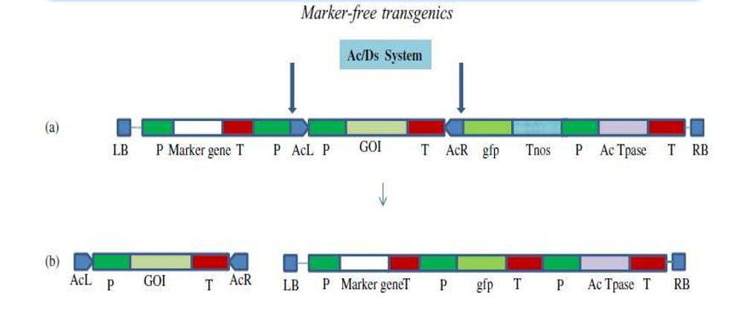
Fig. 7. Transposon based marker excision
(iv) Homologous recombination-based marker excision
Homologous sequences may be the plastid promotors prrn and transcription terminators present on the vector used for the insertion of transgene. Recombination via the plastid promotors or the transcription terminators repeats yields two stable marker free transplastomic DNA carrying only the gene of interest 1 via recombination event R2 (Fig. 8) or the gene of interest 2 via recombination event R1. While the gene for the selectable marker aadA, coding for spectinomycin resistance was removed. The promotor or terminator sequences were not repeated in the final product.
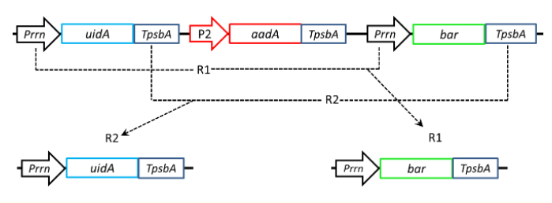
Fig. 8. Homologous recombination-based marker excision
These processes can be hence summarized as: due to the undesirable effects a need to avoid use of selectable marker genes in transformation methods or to remove selectable marker genes after their use in selection of transformations is over such that the transformed plants finally do not express them. Selectable markers can be avoided totally and identification or transformations could be done using pcr but it is very tedious or markers that enable selection without being potentially hazardous could be used like mannose phosphate isomerase which enable growth on mannose medium. If transformants are generated carrying both the gene of interest and the selectable marker gene, then the latter can be removed by methods like co-transformation and segregation, site-specific recombination or transposon-based excision.
(V) Trans-grafting
Trans-grafting refers to grafting of a non-transgenic scion onto a transgenic rootstock. Some desirable characteristics of the rootstock, such as dwarfing or disease resistance, are conferred upon the scion by the vascular transport of RNA, hormones or signaling proteins, but the shoot, leaves, and fruits remain transgene-free. In grapevine, non-transgenic scions were grafted onto rootstocks engineered to produce an antimicrobial peptide and a protein that inhibits cell wall degradation. (Fig. 9) Transgenic rootstocks can therefore improve the production of commercially important fruit trees but the fruits and seeds do not carry any exogenous DNA.
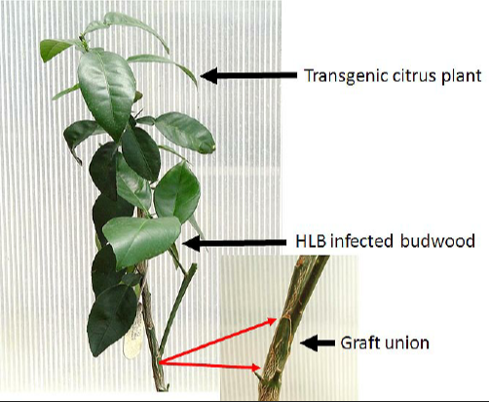
Fig. 9. Transgenic plant challenge via grafting with HLB-infected sweet orange budwood after 8 months of inoculation.

FUTURE DIRECTIONS
Zygotes and Pollen as Delivery Targets
Plant material, such as zygotes and pollen have the potential to avoid protoplast regeneration. Rice zygotes can be created by uniting isolated egg and sperm cells, a process known as gamete fusion. Cell walls are immature during the early stages of gamete fusion, allowing to perform PEG-mediated transfection of preassembled CRISPR/Cas9 RNPs. After 30–40 days of culture, 14–64% of the generated plants from the zygotes contained CRISPR-induced mutations. This approach is promising and could be applied to other species with available gamete fusion and regeneration protocols. Pollen manipulation could also circumvent many of the tissue culture and regeneration problems. Pollen grains in many plant species are permeable through apertures of 5–10 µm in diameter and thus are theoretically amenable to the delivery of preassembled RNPs using nanotechnological approaches.

Nanoparticles for Cargo Delivery
Nanoparticles (<100 nm) have been successfully used to deliver DNA, RNA and proteins into plant cells. Polyethyleneimine (PEI)-coated Fe₃O₄ magnetic nanoparticles were used to carry exogenous DNA plasmids into the pollen grains of several dicot plants, including cotton, pepper, pumpkin and cocozelle. The DNA-loaded nanoparticles were combined with pollen in solution and subjected to a magnetic field to enhance the movement of the particles to the bottom of the recipient and into the pollen grains in a process known as magnetofection. Artificial pollination using magnetofected pollen produced genetically modified seeds. This approach could be used to introduce preassembled RNPs into pollen instead of DNA.
LIMITATIONS IN TRANSGENIC BREEDING

- Low frequency
- It requires high technical skill
- Transgenic breeding is unable to transfer polygenic traits
- It can have adverse effect on natural evolution.
- Position effect
- Pleiotropic effect
- Instable performance

REFERENCES
Adem, M.; Beyene, D. and Feyissa, T. (2017). Recent achievements obtained by chloroplast transformation. Plant method. 13:30.
Gomez, M. L.; Hewitt, S.; Capell, T. and Christou, P. (2021). Transgenic and genome-edited fruits: background, constraints, benefits, and commercial opportunities. Horticulture Research. 8:166.
Kumar, K.; Gambhir G.; Dass, A.; Tripathi, A and Singh A. (2020). Genetically modified crops: current status and future prospects. Planta. 251:91.
Singh, B. D and Shekhavat, N. S. (2020). Gene editing principles and application. Scientific publications. 154-189.
Tsaftaris, A. S.; Palidoros, A. N. and Karavangeli, M. (2014). Transgenic crops: recent developments and prospects. Biological resource management: pp-187-203.

