Digital Image Processing Techniques in Civil Engineering : A Review

Mr. Mahankali Sreenath
PhD Research Scholar, Dept. of Civil Engineering
Jawaharlal Nehru Technological University,
Ananthapuramu, Andhra Pradesh State, India
Email: mahankalisreenath.m@gmail.com

Dr. Valikala Giridhar
Professor, Dept. of Civil Engineering
KSRM College of Engineering,
Kadapa, Andhra Pradesh, India
Email: drgiridhar@ksrmce.ac.in

ABSTRACT
Civil Engineering is one of the oldest and traditional branches of Engineering. From time to time Civil Engineering has gone through various changes, modifications, developments. The field of electronics engineering, however, only gained popularity in the 20th century. The most important step in modern research is the integration of old fields like civil engineering with modern fields like electronics and artificial intelligence. Even the New Educational Policy (NEP 2020) of India supports multidisciplinary research in order to broaden the scope of the branches. The present chapter examines how Civil Engineering and its specializations relate to Digital Image Processing Techniques, one of the key instruments of Electronics.
Keywords—Civil Engineering, Digital Images, DIP Techniques, Image Processing, Electronics

INTRODUCTION
In the earlier days of ages, the fundamental mode of transferring data and storing it was in the form of Paper. But with the advancements in the technology electronic storage has been trending for cloud computing. In the present 21st Century, a revolution came in the field of computers and electronics creating prodigious platforms to the various fields of science and technology which make researchers extend these techniques across all fields. Even though all the other fields of science and technology progressed in digitalization, the Civil Engineering field is lagging behind other fields [1]. According to the latest survey conducted by Committee for European Construction Equipment (CECE) in the Europe, the least digitized sector is Construction or Civil Engineering industry. Factors influencing the digitization in Civil Engineering sector include environmental, climatic and economic challenges within the industry. From the last few years the research is carried in computer-aided monitoring systems and various simulations using image processing, Artificial Intelligence, Machine Learning, etc., helped in analyzing of the projects in much construction related organizations [1–7]. As a result there were several researches conducted targeting in 3D imaging technology for project monitoring, management of Construction activities at site [9, 10], Safety precautions at site [8] and even quality control also [6,7]. This chapter emphasizes mostly on Applications of Digital Image Processing Techniques in Civil Engineering. Recent advancements in Civil Engineering utilizing Computer and Electronics are explained briefly.
Image processing is one of the techniques where the analysis is done by pictorial information in order to attain better interpretation. Digital image processing (DIP) is concerned with performing systematic analysis of images using computers, whereas computer vision is concerned with creating models, data extraction, and information from photos [11]. In the present days of Research many applications are Combination of Digital Image Processing (DIP) and computer vision technologies [12-14]. Evolution of image processing by ages has been presented in Figure 1. Image processing and its applications started way back in 1920’s in the field of paper industry where an image is sent from London to New York by a submarine cable. By passing of ages it merged with computer technology in 1960 in the field of remote sensing, astronomy, etc. [15-17].
Further applications of Image Processing were induced in the fields of medicine, industries, and even in Forensic Sciences in the early 2000’s. Evaluation of Digital Image Processing along the ages is shown in Figure 1. While entering into the 21st century, the application of image processing along with computer technology became one of the needs across every discipline. Universally, with the introduction of new technologies there are wide changes day by day, and with the introduction of new technologies like Artificial Intelligence and Machine Learning it must deal with a diversified variety of challenges such as optimization and predicting the results very precisely. The advancements in the image processing makes us advantageous in providing innovative solutions to key challenges, achieving the results very precisely with very low cost and very less time, extending the future scope of research to be done by the researchers, and enabling the acquisition of accurate information from hypothesis testing systems. Compared to the Earlier days, at present because of revolution in the field of communication and internet connectivity it becomes very easy to upload the Digital Images taken at the construction site [6] which can be used for monitoring, milestones planning, etc.
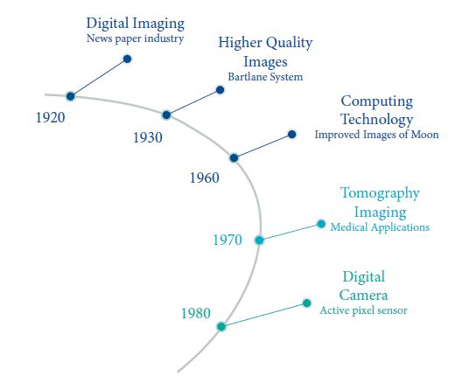
Figure 1: Evaluation of Digital Image processing by ages
The objective of this chapter is to introduce the young researchers about the potential of image processing in civil engineering. In the following sections of the chapter, the procedure of digital image processing, applications of digital image processing techniques in the field of Civil Engineering is explained briefly. Finally, the challenges and future scope of image processing were discussed.

METHODOLOGY
Digital Image Processing is one of the fast growing Technology in the recent times. To understand the Digital Image Processing, terminology related to it is to be understood. Some common Terminology related to the concept is as follows:
Image: An image may be defined as a 2D picture that has the same or similar appearance to a subject. Subject may include an object like Human figures, Animals, Trees, Body Physiology, etc., Where as in terms of mathematics an image can be defined as a two-dimension function, f(x, y), where x and y are spatial (plane) coordinates
Digital Image: Digital Image is a discreet representation of an image using 0 and 1 (binary) as used in computing
Pixel: Pixel can be defined as a elementary unit of a Image. An image is made up of number of pixels. For example in the present days a camera may be specified as 16Mega Pixels it mean an image taken by that particular camera consists of 16 x 10⁶ (Mega) number of Pixels.
Pixel Number: Every Pixel is having a particular intensity and it is defined as Pixel Number. Pixel Number can simply define as one of the shade. For a Grey Image, pixel number varies from 0 to 255 and for a color image it varies from 0 to 65535. A random Digital Image along with its Pixel Numbers is shown in Figure 2.
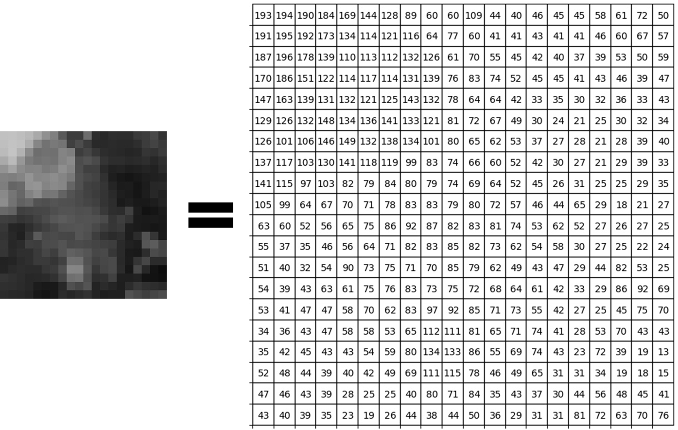
Figure 2: Digital Image Pictorial form and Pixel Number form
Grey Image: Grey Image is simply one in which the only colors are shades of grey. The pixel numbers of a grey image ranges from 0 (Black) to 255 (White). Grey Image is most important as it is having a confined data and easy to analyze the Image.
Color Image: Color image is a three band monochrome images consisting of Red, Green and Blue colors. The pixel numbers of a grey image ranges from 0 to 65535.These type of images are having large data and make very complex to analyze the image.
Histogram: The word ‘Histogram’ is not a new terminology in Image Processing. It is a very regularly used term in the field of Statistics. The histogram of a digital image is a distribution of its discrete intensity levels in the range. It is a graphical representation of image. A sample Histogram of a Digital Image is shown in Figure 3.
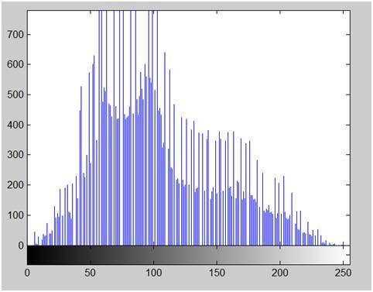
Figure 3: Histogram Sample

DIGITAL IMAGE PROCESSING IN VARIOUS FILEDS

The digital image processing systems are used by many researchers to work on a variety of applications, and each system has its own unique methods and algorithms for solving problems. The various other fields where Image Processing technology is employed are as follows:

Food Technology and Agriculture
The area with the greatest potential for adoption of this technology is the use of computer vision for quality evaluation of processed foods, fruits, and vegetables, as analysis may be based on a standard requirement in existing automated controlled circumstances. Because there is more variation in quality, more sophisticated methods are required for the automated grading of fresh produce, and produce orientation may also affect the findings [34]. Image processing has been shown to be a useful tool for analysis across a range of applications and fields. In the agricultural industry, factors including canopy, yield, and product quality were crucial from the farmers' perspective. The cost of expert counsel is frequently prohibitive, and getting an expert's services often takes time. Since image processing was an efficient instrument for parameter analysis, the availability of communication networks in combination with image processing can transform the situation so that you can get expert advice quickly and affordably. The survey focuses on the use of imaging methods, weed detection, and fruit grading in the sector of agriculture. In comparison to conventional methods, the parameter analysis has proven to be more precise and quicker. Image processing applications can enhance decision-making for tasks like measuring vegetation, irrigation, fruit sorting, etc. [35]
The various attributes of an agricultural and food product, such as size, shape, color level, pictorial information, etc., in a digital image can be used to measure the quality and standard level of an agricultural and food product (such as a guava, berry, orange, etc.) through comparison and verification using a predefined large database for the right application [36].

Medical Sciences
In the field of Medical Science, computer technology has become one of the parts and plays a very important role, and in case of Medicine the results are almost 100% accurate. In the field of medicine, the technology is used for many inventions in treatment and service to the patients. Visual inspection is another name for visual examination, which is the evaluation of anything solely with the eyes. The effects of diseases vary according to the skin color of an individual's body and are dependent on their natural growth and look. With the use of computer-aided devices like MRI scanners, X-Ray machines, etc., image processing is utilized in medical science to test or analyze specific body sections for internal and external evaluation. There should be a vast database needed for a certain disease for different scenarios in order to recognize the appearance and symptoms of a disease with the aid of a visual system [37, 38].

Security
Digital images are also utilized in communication systems to efficiently transfer data and information from one communication channel to another. For today's professional researchers, security is defined as the saving, safeguarding, and securely transmitting of data information on an urgently based assignment. With the aid of digital picture processing, encryption, cryptography, and steganography are therefore frequently employed for secure communication [39].

Civil Engineering
To prevent accidental injuries, behavior study of building safety systems is essential. Accelerometers have historically been used to measure dynamic actions in civil engineering, but high-speed cameras and image processing methods can also be very useful in this field [40]. Digital image processing is essential for analyzing old, damaged buildings that can be protected from further mishaps. It's also beneficial to determine how much longer a building can last and make the most of it [33].
Many other applications of Digital Image Processing Techniques in the field of Civil Engineering are discussed briefly in the next section.

DIGITAL IMAGE PROCESSING IN CIVIL ENGINEERING

In the recent times, due to increase in the population and establishment of new industries, companies, etc, there is a very high demand for infrastructure development and consequently influencing the modern technology advancements in the field of Civil Engineering. In the olden days, a multistoried building is a dream project to the society where as at present multistoried buildings have become very regular type of structures. This is because of technology intervention in the field of Civil Engineering. Many researchers concentrated to work in finding solutions to the problems raised by the technical expertise and society. Traditional or Convention methods for inspection or monitoring include visual assessment. On the other hand, a thorough inspection will reveal information that can be used to make various connections to determine structural integrity. It provides countless subsections for developing image processing applications. The following are the specializations in the branch of Civil Engineering where applications of Digital Image Processing techniques were used and briefly discussed.
- Structural Engineering and Constructional Management
Structural engineering starts with study of properties of construction materials to attaining target strength as per the requirement. The behavior of any material is dependent on its morphological properties, and image processing is a very powerful tool to gather this information [25]. Digital Image Correlation (DIC) is used to measure deflection or deformation and strain. It was measured by taking Digital Images of the specimens before applying load and after application of load [26, 27]. In case of size distribution of particles Digital Image analysis may applied[25]. Digital Image Techniques has versatile abilities to extend use in structural health monitoring [28]. Aggregates, One of the important construction materials used in preparation of concrete, play a vital role in construction of pavements. Aggregate gradation can be done using Image Processing [29]. Researchers even applied Image Processing Techniques in optical identification and analysis of mineral aggregates from demolition and constructional waste [30]. Digital Image Processing Techniques are applied to predict compressive strength of Concrete and can be used as one of the Non Destructive Tests on Concrete [32]. Image Processing can be applied on old monuments where strength of Historic Stones is to be predicted without any destruction [33]
- Construction Safety
In the recent times, major projects such as High Rise Buildings, Dams, Highways, Flyovers, Metro Works etc., are going on all over the world in the field of Civil Engineering. The execution of such large scale projects involves both humans and heavy equipment and addresses site circumstances, concurrent activities, safety considerations, real time progress, etc. Drone technology is now proving to be quite efficient for doing various surveys. The technique was initially used for risk assessment, disaster monitoring, etc., but it is also becoming well known for civil engineering projects. These surveys' collected data can be examined for use in civil engineering applications. Even Unmanned aerial vehicles (UAVs) were used for construction [31]. The most important safety issues at construction sites have drawn researchers to innovative methods of safety assessment. This method uses feature extraction and morphological operators for image filtering to undertake dynamic measurement in the field of civil engineering [8].
- Hydrology and Water Resource Engineering
Sustainable development requires careful management of the distribution of water on Earth and how it interacts with both natural and manmade materials. Computing technology offers a framework for interpretation as well as simulating the behavior of water bodies along with their surroundings. Recently river behavior was studied by taking the river-bed photographs. An image processing method was applied by fusing feedback pulse couple neural network (FPCNN) [21–24] and multilevel thresholding for image segmentation and grain size distribution [21].
- Environmental Engineering
Environmental Engineering is one of the specializations of Civil Engineering in which pH of water is estimated by Digital Image Processing Technique. Digital Images of water are taken during the titration and digital images are analyzed to determine the pH value of the test sample [41]. Digital Images of Water samples to predict pH value is shown in Figure 4. In addition, to estimate the settling velocity of particles in the sedimentation process of water purification, Digital Image Processing Techniques may be used. Images are captured when water is used in the process of sedimentation and it is concluded that particles of same size but of spherical shape have high settling velocity than other shapes like ellipsoid, plate etc.., [42].
Figure 4: Digital Images for Testing pH of Water
- Remote Sensing and GIS
Remote Sensing (RS) and Geographical Information System (GIS) is one of the latest branches of Civil Engineering which combine feature extraction and analysis of land surface or earth data without any physical contact with the surface. This specialization is used for preparing master plans of cities, resource allocation, planning of water retention structures like dams, change detection, hazard monitoring and extent mapping, risk assessment [18] and so on.
In case of tunneling work, to identify location and directions of weak planes, 2D geotechnical maps are used. In particular, the complexity of the tunnel work location and the use of heavy machinery such as TBM (Tunnel Boring Machines) require remote monitoring. So, to overcome cost and time consuming research, researchers have adopted an image processing approach. Image acquisition of tunnel facing, its processing is used for rock mass rating, geological features (faults, joints etc.) and interpolation technique on two consecutive images established in 3D visualization [19]. One of the recent research studies focused on the 1st trial on rock face characterization using images. Comprehensive geological mapping of the rock can be done by taking the images of rock surface. Additional rock mass parameters obtained through mapping are useful for tunnel stability assessment and support phases [20].
In GIS & Remote Sensing, images of a certain large area are captured by satellites and those captured images are analyzed by digital image techniques to generate Digital Thematic Maps [9].

CONCLUSIONS

Computer vision is a term used in civil engineering to describe artificial intelligence and machine learning. It is also closely related to image processing. Civil engineers have the potential to take on the challenges of managing multiple tasks at once owing to imaging software. Construction material manufacturers are going to benefit significantly from this automation. Although various image processing methods have been created and applied in the field of civil engineering, there are still numerous unexplored areas. An up-to-date review of image processing uses in civil engineering is given in this study. The future scope of this study can be considered as the use of handy tools (mobile camera) for image acquisition, transferring, and processing image data. In conclusion, this research article offers a projection of image processing trends and advances as they relate to civil engineering. This will helps researchers in studying about the evaluation, case studies and potential applications of image processing in the field of civil engineering.

ACKNOWLEDGEMENT
Authors acknowledge Jawaharlal Nehru Technological University (JNTUA), Ananthapuramu and Kandula Sreenivasa Reddy Memorial College of Engineering (KSRMCE), Kadapa for supporting in all the aspects in publication of this chapter.

REFERENCES

- K. Ali, A. Woldesenbet, and S. Rokooei, “Integration of augmented reality building information modeling, and image processing in construction management: a content analysis,” in Proceedings of the AEI 2017. American Society of Civil Engineers, Oklahoma, Oklahoma, April 2017.
- M. Ehrhart and L. Werner, “Development and evaluation of a long range image-based monitoring system for civil engineering structures,” in Proceedings of the Structural Health Monitoring and Inspection of Advanced Materials Aerospace, and Civil Infrastructure 2015, SPIE, San Diego, CA, USA, March 2015
- M. Ehrhart and L. Werner, “Image-based dynamic deformation monitoring of civil engineering structures from long ranges,” in Proceedings of the Image Processing: Machine Vision Applications VIII, SPIE, San Francisco, CA, USA, February 2015.
- A. V. Vasileva, A. S. Vasilev, and I. A. Konyakhin, “Vision- based system for long-term remote monitoring of large civil engineering structures: design, testing, evaluation,” Measurement Science and Technology, IOP Publishing, vol. 29, no. 11, Article ID 115003, 2018.
- J. S. Bohn and J. Teizer, “Benefits and barriers of construction project monitoring using high-resolution automated cameras,” Journal of Construction Engineering and Management, vol. 136, no. 6, pp. 632–640, 2010.
- J. Yang, M.-W. Park, P. A. Vela, and M. Golparvar-Fard, “Construction performance monitoring via still images, time- lapse photos, and video streams: now, tomorrow, and the future,” Advanced Engineering Informatics, vol. 29, no. 2, pp. 211–224, 2015.
- M. Golparvar-Fard, F. Peña-Mora, and S. Savarese, “Automated progress monitoring using unordered daily construction photographs and IFC-based building information models. ASCE,” Journal of Computing in Civil Engineering, vol. 29, no. 1, 2015.
- B. Ferrer, J. C. Pomares, R. Irles, J. Espinosa, and D. Mas, “Image processing for safety assessment in civil engineering,” Applied Optics, vol. 52, no. 18, p. 4385, 2013.
- L. Y. Chen, M.-Y. Wang, C.-C. Chao, and W. Lo, “Assessment of asphalt concrete pavement quality by using infrared thermal imaging technology,” Journal of Marine Science and Technology, vol. 23, no. 3, pp. 331–338, 2015.
- Q. Chen and Y. Chen, “Construction material concrete quality detection method based on ultrasonic tomography technology,” in Proceedings of the 2020 IEEE International Conference on Industrial Application of Artiﬁcial Intelligence (IAAI), Harbin, China, December 2020.
- O. H. Babatunde, L. Armstrong, J. Leng, and D. Dean, “A survey of computer-based vision systems for automatic identiﬁcation of plant species,” Journal of Agricultural Informatics 6 Journal of Agricultural Informatics, vol. 6, 2015.
- Q. Huang and S. K. Bhatia, “Application of digital image processing in morphological analysis of geotextiles,” in Proceedings of the Digital Image Processing: Techniques and Applications in Civil Engineering American Society of Civil Engineers National Science Foundation Engineering Foundation, Kona, Hawaii, USA, March 1993.
- R. Chaney, K. Demars, D.-J. Jang, J. Frost, and J.-Y. Park, “Preparation of epoxy impregnated sand coupons for image analysis,” Geotechnical Testing Journal, vol. 22, no. 2, p. 153, 1999.
- A. H. Aydilek, S. H. Oguz, and T. B. Edil, “Digital image analysis to determine pore opening size distribution of nonwoven geotextiles,” Journal of Computing in Civil Engi- neering, vol. 16, pp. 280–290, 2002.
- E. Masad and K. Sivakumar, “Advances in the characterization and modeling of civil engineering materials using im- aging techniques,” Journal of Computing in Civil Engineering, vol. 18, no. 1, p. 1, 2004.
- Gonzalez, Rafael C. Digital image processing. Pearson education india, 2009.
- Salunkhe, Ashwini A., et al. "Progress and Trends in Image Processing Applications in Civil Engineering: Opportunities and Challenges." Advances in Civil Engineering 2022 (2022).
- Z. Q. Chen and T. C. Hutchinson, “Urban damage estimation using statistical processing of satellite images: 2003 Bam Iran earthquake,” in Proceedings of the Color Imaging X: Processing, Hardcopy, and Applications SPIE, San Jose, CA, USA, January 2005.
- S.-S. Leu and S.-L. Chang, “Digital image processing based approach for tunnel excavation faces,” Automation in Con- struction, Elsevier BV, vol. 14, no. 6, pp. 750–765, 2005.
- A. Gaich and G. Pischinger, “3D images for digital geological mapping,” Geomechanics and Tunnelling, Wiley, vol. 9, no. 1, pp. 45–51, 2016.
- F.-J. Chang and C.-H. Chung, “Estimation of riverbed grain- size distribution using image-processing techniques,” Journal of Hydrology, vol. 440-441, pp. 102–112, 2012.
- M. Ye, “A novel image fusion algorithm based on local contrast and improved PCNN model,” in Advanced Materials Research, vol. 108-111, pp. 21–26, Trans Tech Publications, Ltd, 2010.
- L. Jiang, D. Zhang, and L. Che, “Texture analysis-based multi- focus image fusion using a modiﬁed Pulse-Coupled Neural Network (PCNN),” Signal Processing: Image Communication, vol. 91, Article ID 116068, 2021.
- Y. Liu, X. Chen, Z. Wang, Z. J. Wang, R. K. Ward, and X. Wang, “Deep learning for pixel-level image fusion: recent advances and future prospects,” Information Fusion, vol. 42, pp. 158–173, 2018.
- M. Coster and J.-L. Chermant, “Image analysis and mathematical morphology for civil engineering materials,” Cement and Concrete Composites, Elsevier BV, vol. 23, no. 2-3, pp. 133–151, 2001.
- N. McCormick and J. Lord, “Digital image correlation for structural measurements,” Proceedings of the Institution of Civil Engineers - Civil Engineering, Thomas Telford Ltd, vol. 165, no. 4, pp. 185–190, 2012.
- A. Suleiman and A. Ahmadreza Hedayat, “Digital image correlation and its application in an undergraduate civil engineering materials laboratory,” 2014, https://1library.net/ document/yjv3jkpy-digital-image-correlation-application- undergraduate-engineering-materials-laboraa.
- T. Ramos, A. Furtado, S. Eslami et al., “2D and 3D digital image correlation in civil engineering - measurements in a masonry wall,” Procedia Engineering, Elsevier BV, vol. 114, , pp. 215–222, 2015.
- A. Golalipour, E. Jamshidi, Y. Niazi, Z. Afsharikia, and M. Khadem, “Effect of aggregate gradation on rutting of asphalt pavements,” Procedia - Social and Behavioral Sciences, Elsevier BV, vol. 53, pp. 440–449, 2012.
- K. Anding, D. Garten, and E. Linß, “Application of intelligent image processing in the construction material industry,” ACTA IMEKO, vol. 2, no. 1, p. 61, 2013.
- P. Liu, A. Y. Chen, Y.-N. Huang et al., “A review of rotorcraft Unmanned Aerial Vehicle (UAV) developments and appli- cations in civil engineering,” Smart Structures and Systems, Techno-Press, vol. 13, no. 6, pp. 1065–1094, 2014.
- Mahankali, Sreenath, and Giridhar Valikala. "Comparison of Compressive Strength of M30 Grade Concrete with Destructive and Nondestructive Procedures Using Digital Image Processing as a Technique." Advances in Civil Engineering 2022 (2022).
- Ozkaya, Suat Gokhan, et al. "Image processing based analysis of the compressive strength for the stones used in historical masonry structures." International Journal of Computer Science and Software Engineering 6.10 (2017): 216-222.
- Narendra V G Hareesh K S, “Quality Inspection and Grading of Agricultural and Food Products by Computer Vision- A Review “International Journal of Computer Applications (0975 – 8887)Volume 2 – No.1, May 2010
- Vibhute, Anup, and Shrikant K. Bodhe. "Applications of image processing in agriculture: a survey." International Journal of Computer Applications 52.2 (2012).
- Zhao, Jun, Joel Tow, and Jayantha Katupitiya. "On-tree fruit recognition using texture properties and color data." 2005 IEEE/RSJ International Conference on Intelligent Robots and Systems. IEEE, 2005.
- Wei, Li-sheng, Quan Gan, and Tao Ji. "Skin disease recognition method based on image color and texture features." Computational and mathematical methods in medicine 2018 (2018).
- Bhadula, Shuchi, et al. "Machine learning algorithms based skin disease detection." International Journal of Innovative Technology and Exploring Engineering (IJITEE) 9.2 (2019): 4044-4049.
- Abdullah, Ako Muhammad, and Roza Hikmat Hama Aziz. "New approaches to encrypt and decrypt data in image using cryptography and steganography algorithm." International Journal of Computer Applications 143.4 (2016): 11-17.
- Ferrer, Belen, et al. "Image processing for safety assessment in civil engineering." Applied optics 52.18 (2013): 4385-4390.
- Beycioǧlu, A., Çomak, B., & Akcaabat, D. (2017). Evaluation of pH value by using image processing. Acta Physica Polonica A: Special Issue of the 3rd International Conference on Computational and Experimental Science and Engineering (ICCESEN 2016), 132(3), 1142–1144. https://doi.org/10.12693/APhysPolA.132.1142
- Kim, D., Son, Y., & Park, J. (2018). Prediction of Settling Velocity of Nonspherical Soil Particles Using Digital Image Processing. Advances in Civil Engineering, 2018. https://doi.org/10.1155/2018/4647675

