Analysis of Atmospheric Parameters using Remote sensing and ArcGIS

Yogesh Pratap, Yogesh Kumar Goswami, Kumar Shanu, Sanjeev Sharma*, Inderpreet Kaur, Hari Kumar Singh
Department of Electronics and Communication Engineering,
F.E.T, MJP Rohilkhand University, Bareilly
*R. D. Engineering College, Ghaziabad
harsdik@gmail.com
valiant.yogesh@gmail.com
yk460723@gmail.com
kumarshanu.ec@gmail.com

ABSTRACT
In the present day, the majority of the world's population lives in urban regions. In developing countries, people are leaving rural areas and the much-known fact is that the population is increasing quickly. In some years from now, the above-mentioned two factors will be considered to impel over 1.5 billion people into urban areas, which in some cases are already congested. The circumstances that many fresh urban dwellers find on arrival simply mix the circumstances. For the most part, urban growth falls outside proper planning controls, thus rising economic and social pressures and causing health and hygiene tribulations. The main rewards of Remote Sensing with GIS are to solve the problems caused due to overcrowding and make proper, land-efficient, and sustainable urban models for cities. ArcGIS is a tool used for the analysis and mapping of regions and cities.
Keywords-Remote sensing, GIS, ArcGIS.

REMOTE SENSING
Remote Sensing is the process in which we accumulate information about a geographical area or an object without making physical contact. We acquire information about the earth and other planets and it is used in manifold fields including geography, land surveying, commercial, economic and urban planning.
Nowadays when we use remote sensing it generally refers to the usage of satellite and aircraft sensors to capture the images of an object and region. and most important advantage of remote sensing is that we can gather data from a specific period. Or if I break this into simpler words then remote sensing refers to camera sensors in satellite and aircraft that allows us to capture images of a region. it helps us to analyze the study region with data from a specific period which we get with the help of remote sensing.

Remote sensing is of two types and which are given below
- Active remote sensing
- Passive remote sensing

Active remote sensing
In this remote sensing, active sensors are used for data accumulation. Active sensors emit some energy (electromagnetic) toward Earth’s surface and then it senses the reflection of the emitted energy (electromagnetic).
Passive remote sensing
In this remote sensing, passive sensors are used for data accumulation. Passive sensors do not emit any energy towards the Earth’s surface these sense by reflected light emitted by the sun.

GIS (Geographic Information System)

GIS stands for a geographic information system that consists of mainly three functions create, analyze, manage, and map all types of data. And it helps the user to understand variation in data, and relationships and helps in better management and efficient decision making. Alike remote sensing, gis is also used in various fields like commercial, planning, transport, and telecommunications. GIS works on coordinates and which are represented by x, y, and z axis where x represents longitude, y represents latitude, and z represents elevation.
GIS is used in many fields but a few of them I have listed here
- Urban planning
- Analysis of atmospheric parameters
- Agriculture
- Business, marketing, and sales.
- Oil spill
GIS helps us to visualize, analyze and manage map data by forming new map layers and scenes of any region and this helps us to make better decisions and that’s why it is so useful in urban planning. And it also helps us to analyze the environment effectively.

ArcGIS
ArcGIS is the paid package software, server software, and geographic information system (GIS) services created and maintained by Esri (Environmental Systems Research Institute). ArcGIS was introduced in 1999. It works in 2D and 3D for cartography and apparition and includes Artificial Intelligence (AI). Esri also provides server-side ArcGIS software for web maps, known as ArcGIS Server.

METHODOLOGY

Firstly download India’s map Shapefile from the GADM website it is of the administration category and save it into the folder which is connected to the arc catalog.
- Now open the shape file in Arc Map and work on it. And make a separate layer for the Uttar Pradesh shape file from India’s map shape file. The figure below shows India’s shape file.
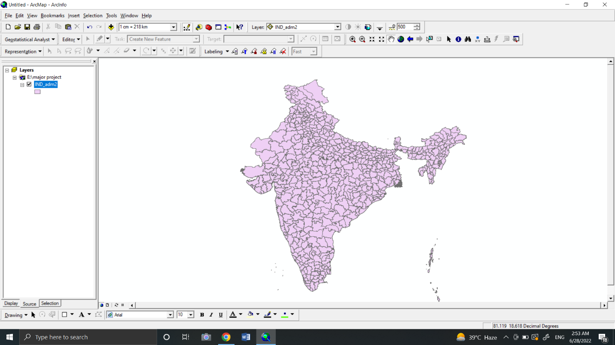
For that, open an attribute table( a table in which all kinds of descriptive information is stored about India.
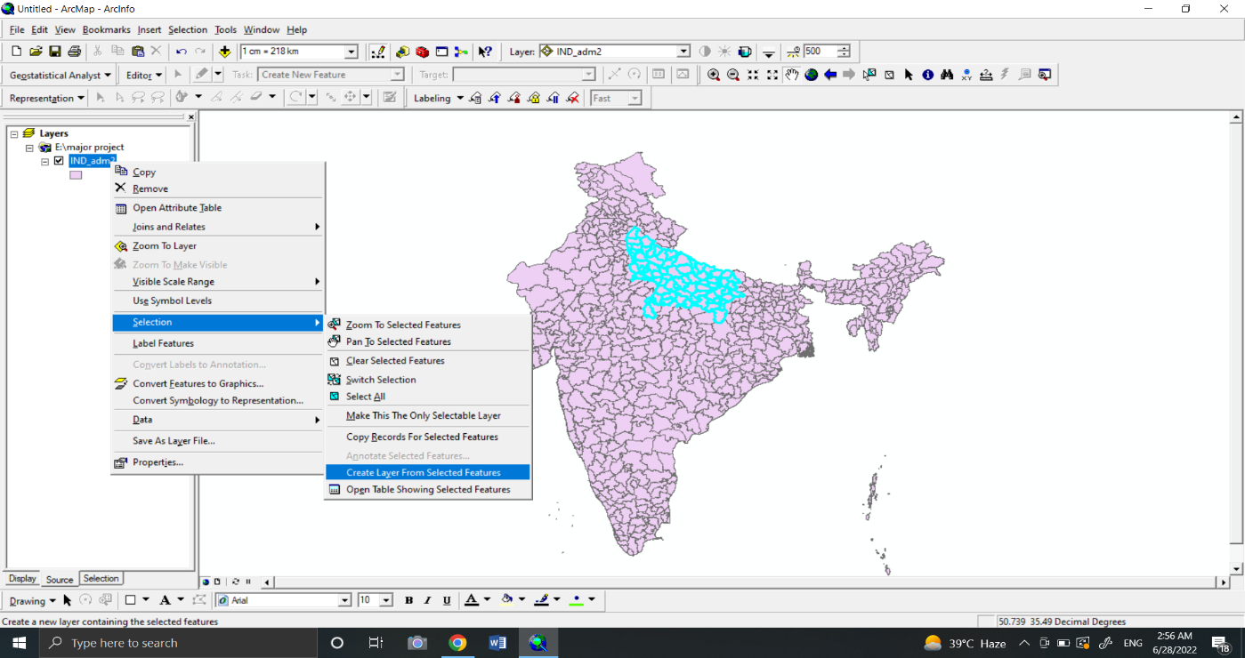
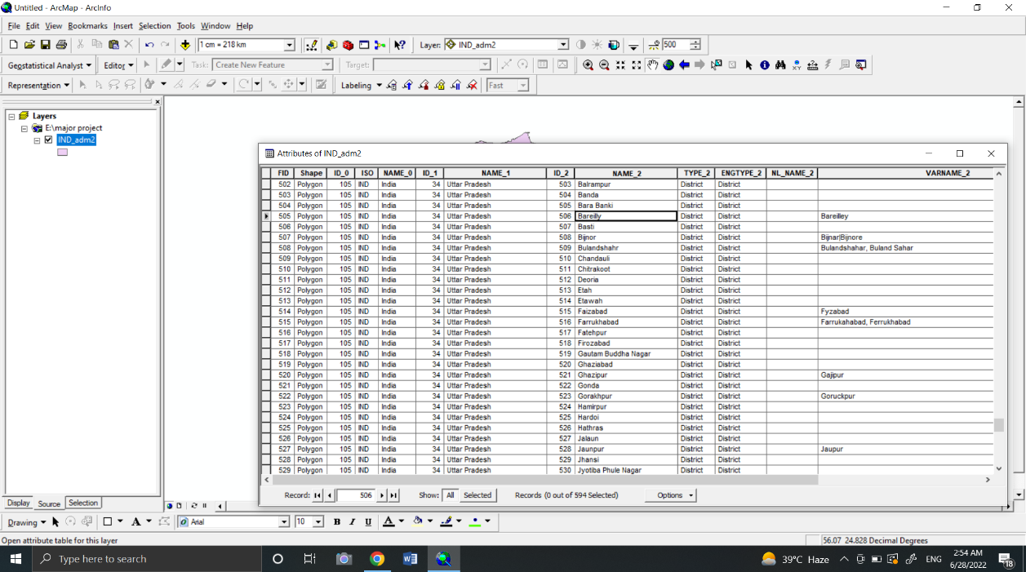
Now we will select the Uttar Pradesh state selecting by attributes from India’s shapefile which is under the ‘NAME_1’ category, then Uttar Pradesh map gets highlighted in India’s shapefile then we’ll create a separate layer for Uttar Pradesh. Now we will do the same for the Bareilly map.

As we get Uttar Pradesh as a separate layer then we will open the attribute table of the Uttar Pradesh map layer.
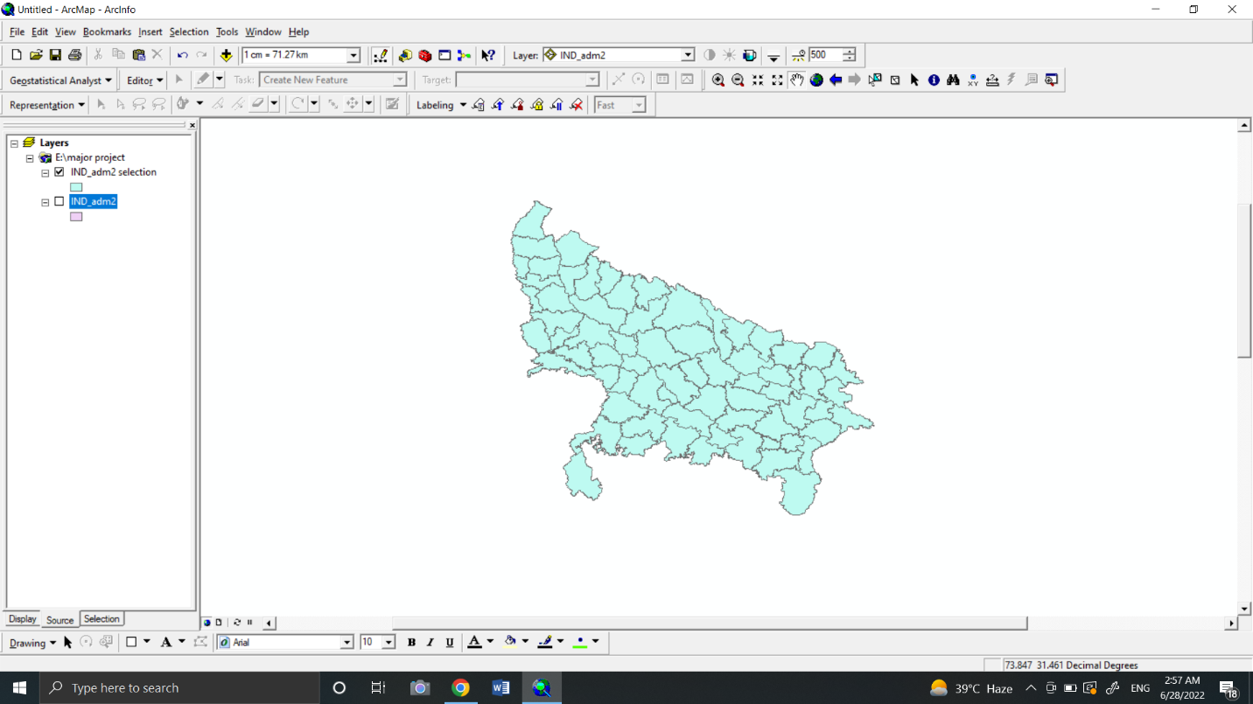
Uttar Pradesh shape file
Now we will open an attribute table of Uttar Pradesh then we will select Bareilly city. It is shown below figure.
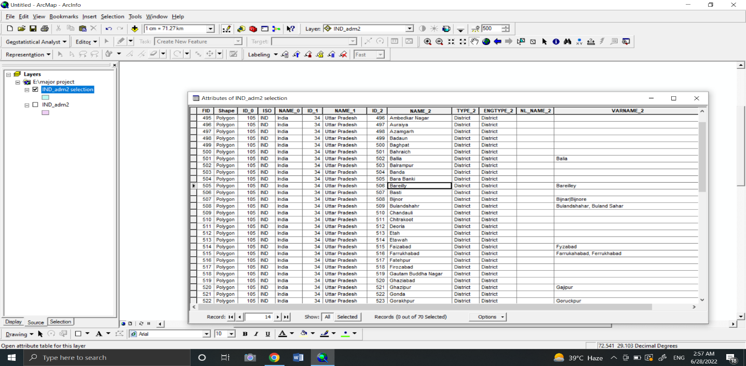
Then we will create a separate layer of Bareilly map shape file which looks like the below figure.
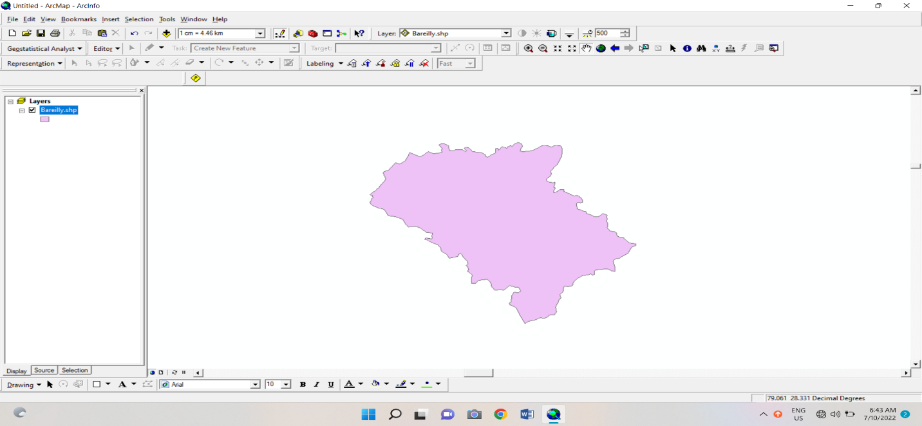

Now we have got the Bareilly map shape file and we need to focus on our second step
This is to get data on our atmospheric parameters like annual radiation, annual rainfall, and annual humidity for 20 years and we will get this data from the websites like power data access viewer. And we download the data from the website.
Randomly we selected 23 to 25 locations of Bareilly along with their coordinates, now we will make an excel sheet of the parameters for 20 years, which contains FID, Coordinates, Rainfall/Radiation/Humidity, and Years.
Then we insert excel sheets in Arc map with the toolbar into x and y format, and we select the coordinate system as WGS1984 (world geographic coordinate system). Now we are all set to run a spatial analyst tool (Spatial Analysis refers to the operation from which we will get the result which shows variation in data over a period. Spatial analysis is often based on techniques of symbolizing data, like Geo-referencing and it helps us to visualize ).
There are three operations we run are given below
- IDW(Inverse Distance weighting)
- Spline
- Kriging
Now we will see what the above operation does to the inputs we have given in the software or other what they mean.
- Inverse distance weighting (IDW) is a tool of interpolation in the spatial analyst tool in ArcMap, which insert the unknown value in the known values just like we calculate the slope of two values and we place unknown values in known values to predict geographic coordinates of a region.
- A Spline is a tool in interpolation that helps us to calculate the values with a mathematical function by reducing a surface curvature and it results in the surface which passes through the input points.
- Kriging is also a tool in interpolation which consist of two steps firstly it includes probing mathematical analysis of the data and second it has a variation model which shows the variation in form of map layers and it variates the surface.
.
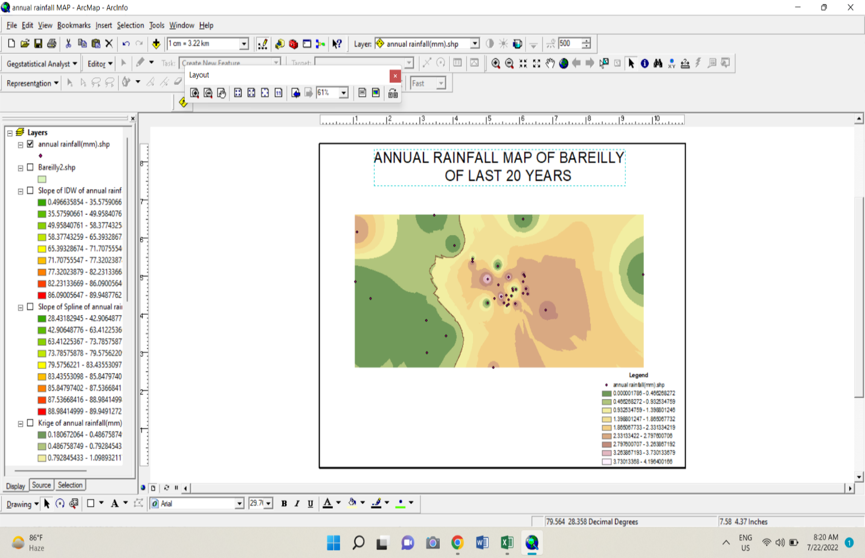
The results we obtained from the process are given below

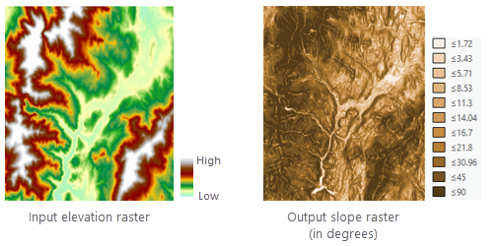
Annual rainfall map of Bareilly

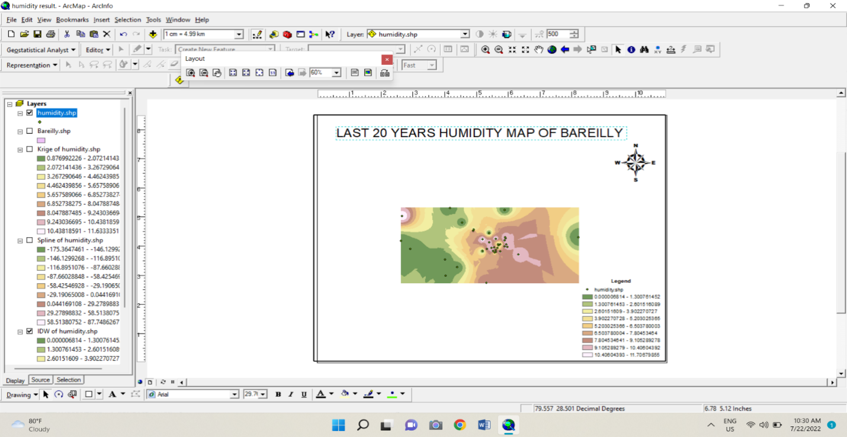
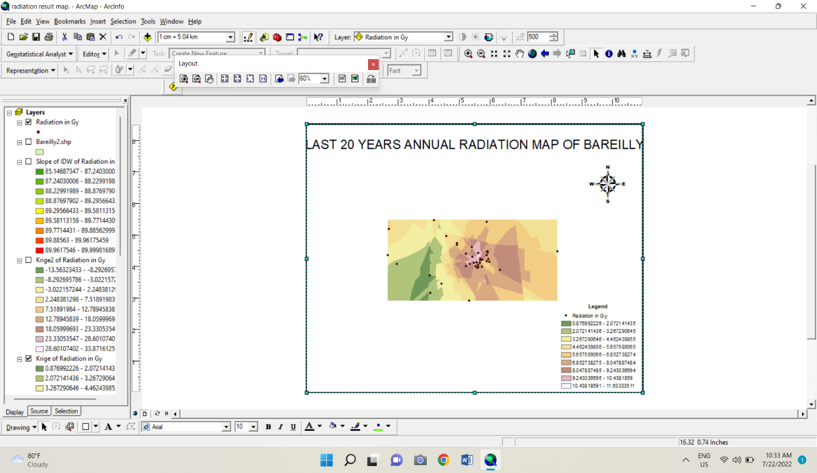
Annual humidity map of Bareilly
Annual radiation map of Bareilly
After these results we obtained from the process, we will run a few more operations for properties of our parameters like slope, contour, mean, median, and standard deviation.
Like before we will define each one by one and after we will see the result of each operation.
- A Slope is a tool in the spatial analyst toolbar. It identifies the sharp slope in data.
- It uses 3 by 3 cells to compute the value and the surface algorithm allows from 3 by 3 to 15 by 15.

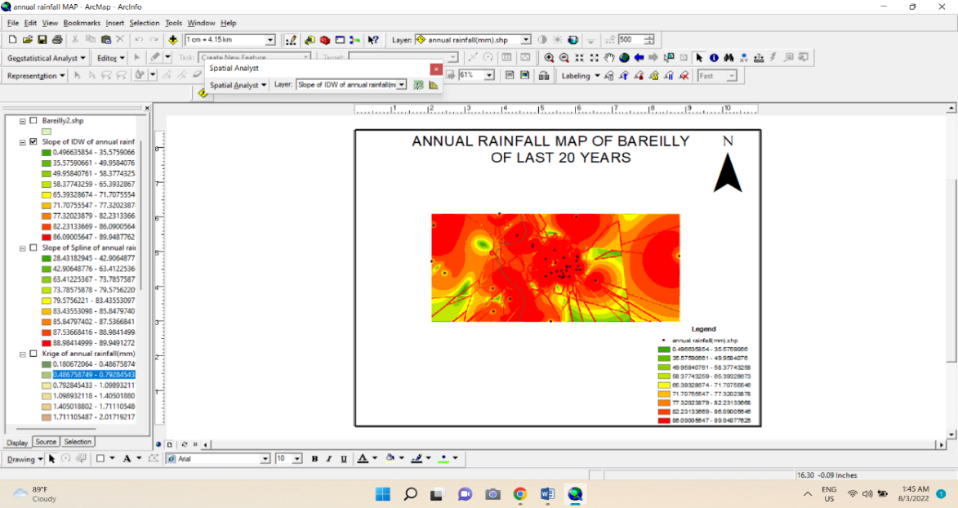

- A contour is consist of imaginary lines which form a shape or something. It is a tool in the spatial analyst toolbar and it is a function of two variables that forms a curve it has a constant value and equal values are joined in a curve.

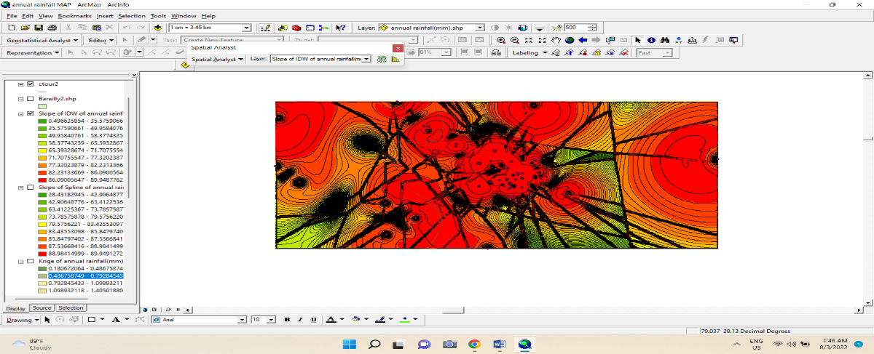

- A mean center is a tool we used it tool calculate the mean of X and Y points and It is used projected data to measure the distance and project it accurately. So basically it is a mean of X and Y points.
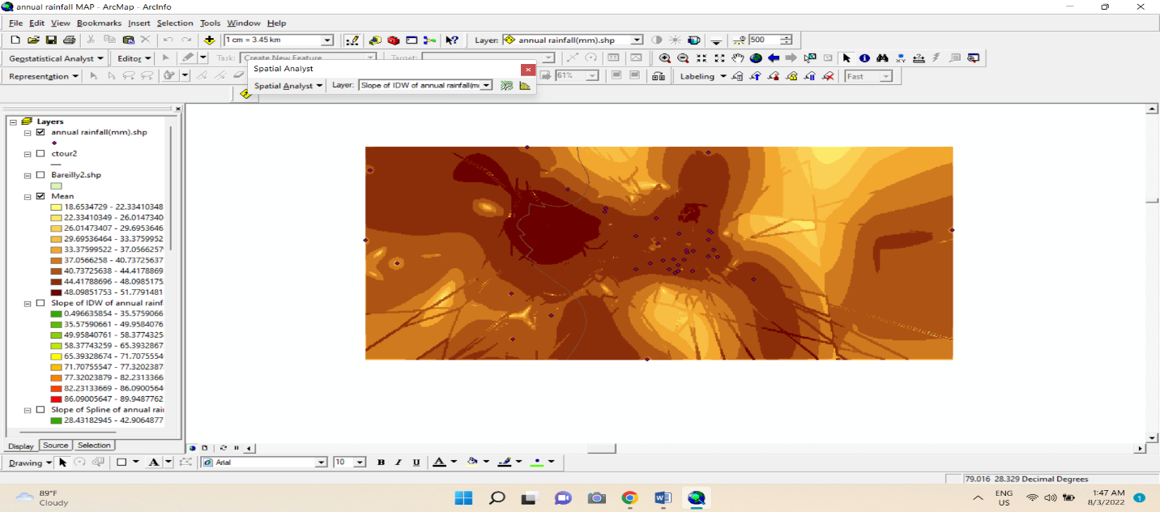

- The Median Center tool is used to measure the possibility that being strong and outliers. It helps us to
Find/symbolizes the locations which minimize the travel from it to another feature dataset.
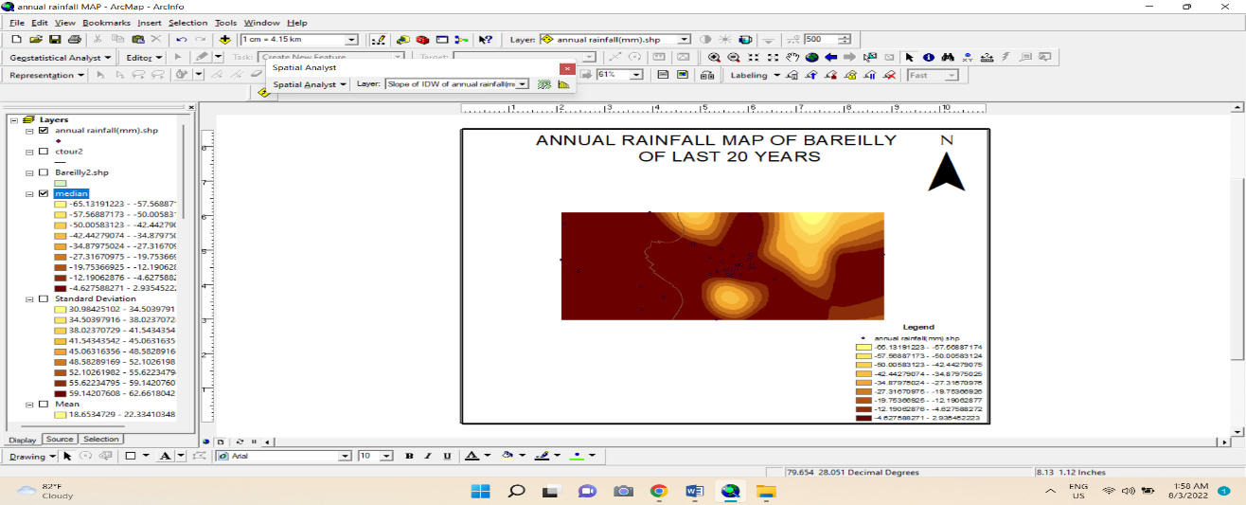
- ArcMap also calculates standard deviation. when we calculate the standard deviation there is a class difference is created with equal ranges. And it is a type of analytical method or type of map which shows how much difference is there in mean.
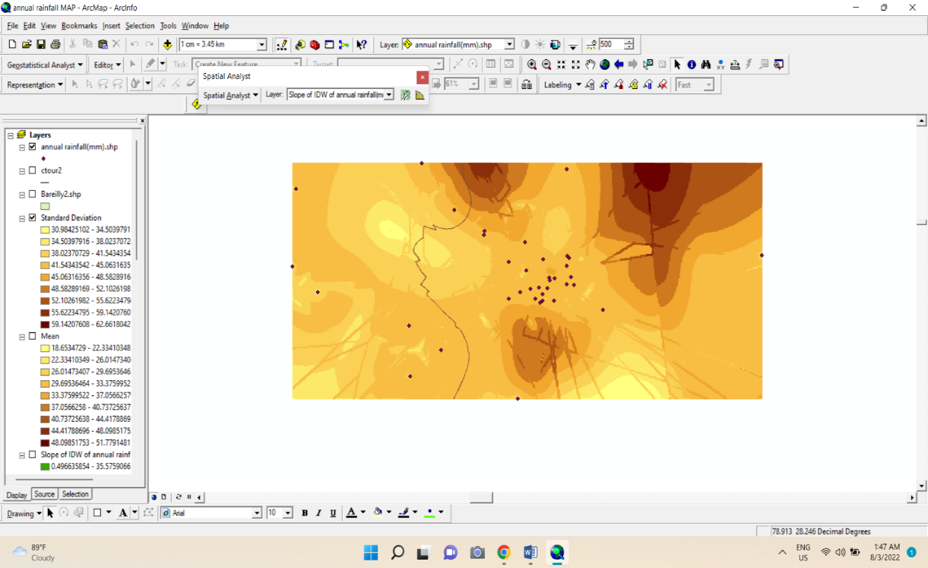

- The Majority Filter is a tool in which we need to satisfy two criteria before an alternative can occur the number of adjacent cells is sufficiently high and cells must be similar to roughly the center of the filter kernel.
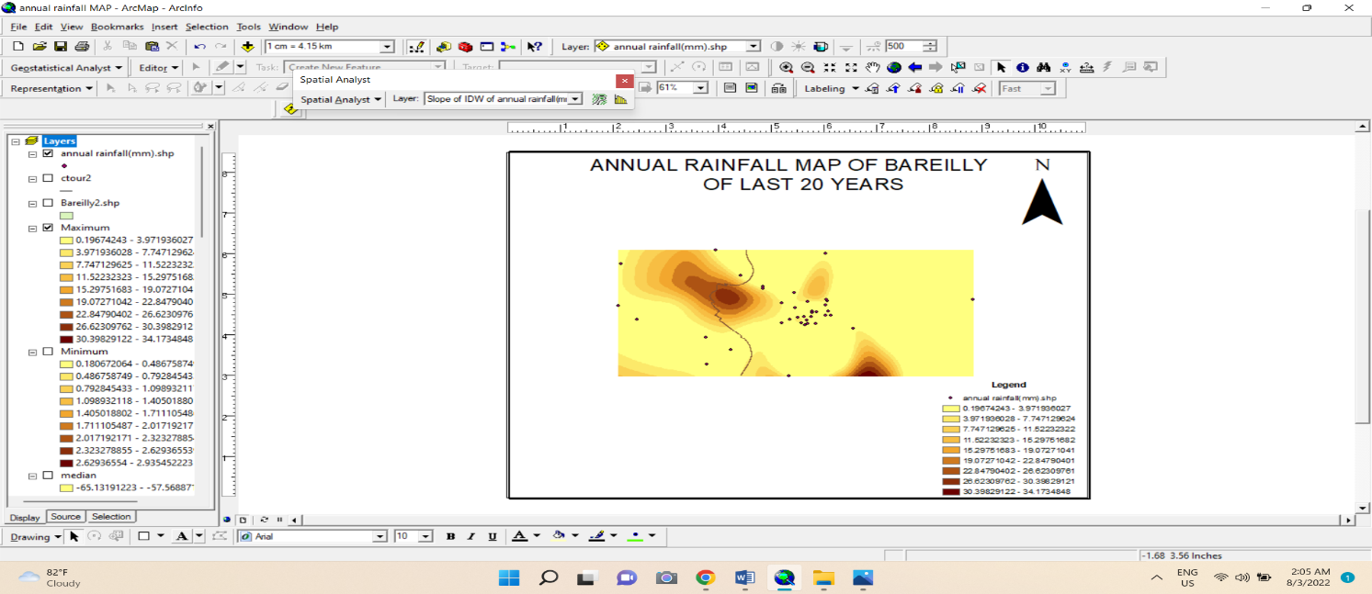
- Minority Analysis is a tool that helps us to classify the data in an image. And it is a zonal analytical tool specifically used for raster datasets which helps us to calculate sum, mean, average, minimum, and maximum.
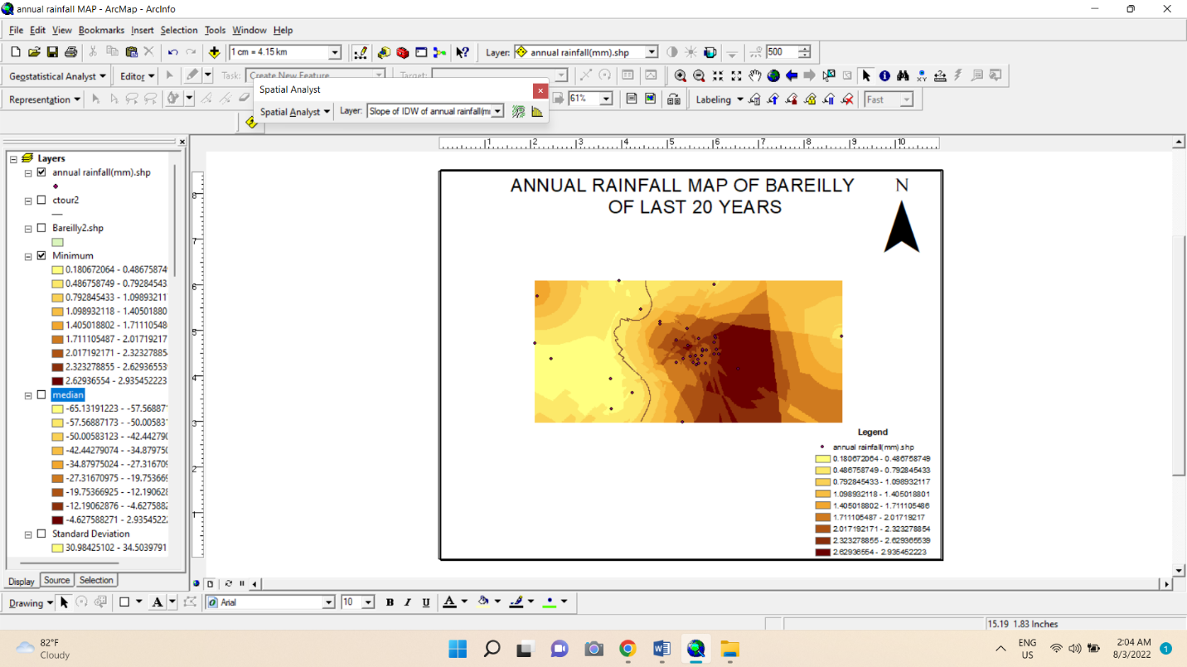

Uses of spatial analysis
A statistical analyst is a tool in ArcMap that helps us to solve complex location-based problems. Spatial analysis is two types of raster data and vector data and here we have used both and we used to classify levels of the parameters like rainfall, radiation, and humidity. And we used three tools of spatial analyst tools IDW, Kriging, and Spline.
.
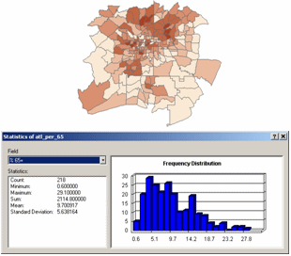
Another use of the spatial analyst tool is to summarize the data we input into the operation. And there are five types of spatial operations given below
- Queries and reasoning is the most basic analytical operation.
- Measurements are numbers that describe aspects of geographic data.
- Transformations are simple techniques to convert one dataset into another dataset.
- Summaries attempt to capture the sense of the dataset in one or two numbers.
- Optimization is the normal method designed to select the ideal location for objects with well-defined criteria

In the example below spatial analyst, the tool is used in a map.
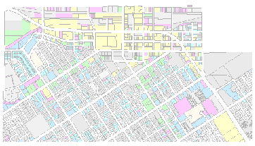
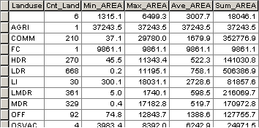

Statistical analysis is also used to store the information about the region we are studying and the above table is an attribute table that consists of various information of region like min_area specifies it is a piece of information related to the area. In sum, an average area is also given here. It is a tabular file that contains all the information about the region we are studying.
Annual rainfall map of Bareilly

The above map is the resulted map of rainfall parameters for over 20 years period. As we have already discussed that we made an excel sheet in which we stored rainfall data of the Bareilly region and we inserted an ArcMap in X and Y format in the toolbar.
And then we selected the coordinates and axis longitude as the X axis and year as the Y axis after that we run the operation and we jumped onto the spatial analyst tool and there we run three operations we discussed earlier
IDW
Kriging
Spline
Cel statistics – mean, median, standard deviation.
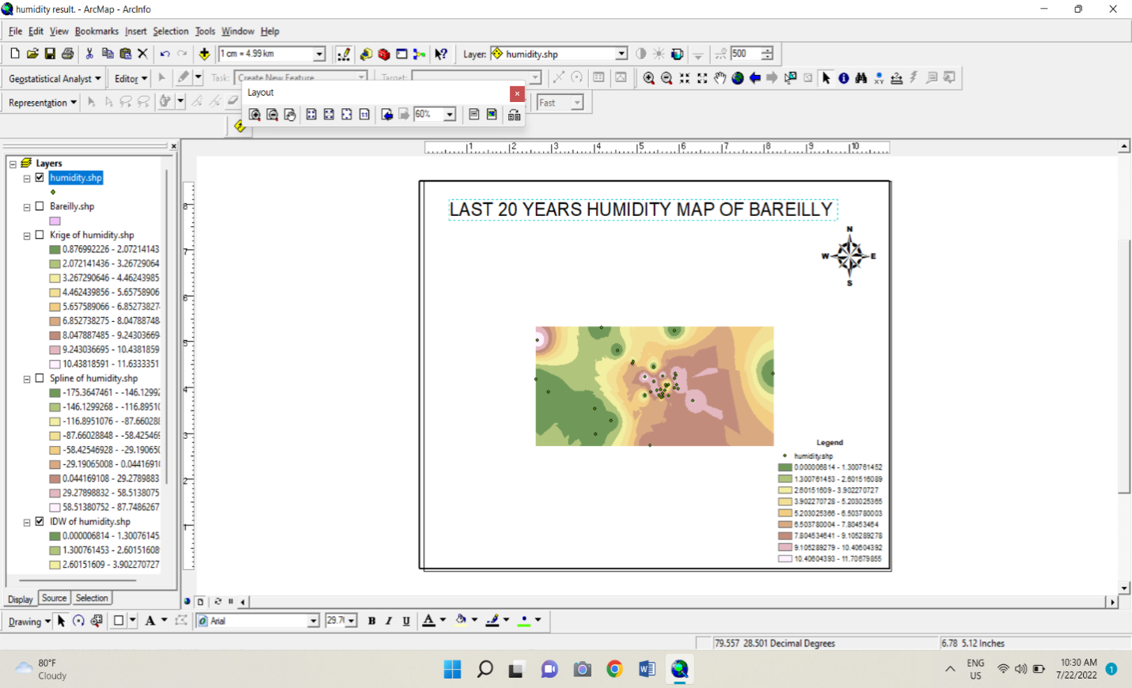
Annual humidity map of Bareilly

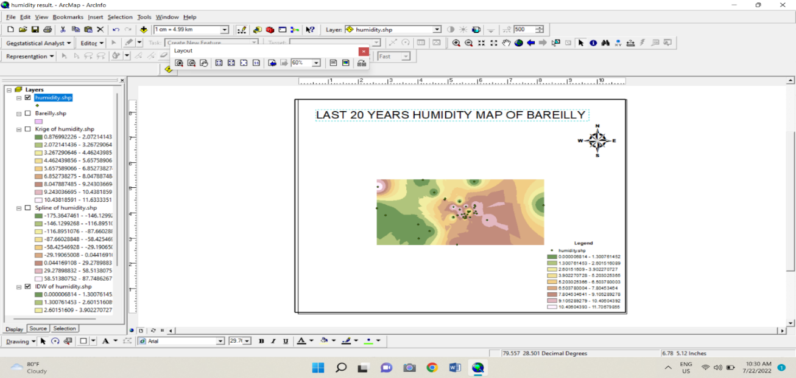
Annual radiation map of Bareilly
CONCLUSION
Our analysis of atmospheric parameters is completed. Here we used Remote Sensing and GIS to gather some information related to the parameters like Rainfall, Humidity, and Radiation. To gather some information first we need to be specific about the region we want to study and here we have selected the Bareilly region because it looks practical to choose a region in which you live. As we have discussed earlier we have extracted and formed a Bareilly layer and after that, we inserted the coordinates of Bareilly in ArcMap in the toolbar as X and Y coordinates.
Then we run the operation spatial analyst under which there is a classification and we run all three of them and we understood the various uses of Remote Sensing and GIS which saved us from lots of problems. And these are used in urban planning and two factors which are needs to be controlled are given below
- Government rules and policies.
- Environmental balance

Our study indicates the uses of Remote Sensing and Geographic Information systems for urban planning. The study also shows GIS and Remote sensing is used for capturing high pixels image of the study region. GIS helps us to visualize and study a map of a region. The study addresses a typical problem faced by the government urban planners, GIS also helps us to classify the land cover of the region. The region of our study was Bareilly; Uttar Pradesh.

REFERENCES

1.AnjiReddy.M, 2001 textbook of RS and GIS, second edition, B.S publications, Hyderabad.
2. International Conference on Environmental Management, B.S. Publications.
3. Batty M, 1992, Urban modeling computer graphic and geographic information systems environment, Environment and Planning Board.
4.D.P.Tiwari, Challenges in Urban Planning for local bodies in India, I.A.S., Commissioner& Director, Town, and Country Planning, Bhopal.
5. Dr.S.P.Sekar 2000, GIS Application for Urban Planning ± A Case study of Tinidivanam Town, Tamil Nadu, GIS Development.
6. Encyclopedia of Environmental Sciences 1992, revised volume 15.
7. Govt. of India, 1988, Report of National Commission on Urbanization, Volume ± VI, Published by Govt. of India.
8.G.K.Tripathy, Urban Planning and information system for Municipal corporations, Tata Infotech Ltd, Mumbai.
9. Municipal Geographic Information Systems 2001, A note to the Empowered Committee (EC), APUSP/Governance & Reform component/Municipal GIS/Note to EC/10 Nov 21.
10.1989, National Remote Sensing Centre, Department of Space, Govt. of India.
11. National Urban Information System 2008 (NUIS), Manual for thematic mapping using high-resolution satellite data and geospatial techniques by National Remote sensing Agency, Urban studies &Geoinformatics Group, dept. of space, Govt of India, Hyderabad.
12. NRSA, 1994, Mapping and Monitoring Urban sprawl Hyderabad city.
13. Anderson, J.R., E.E. hardy, J.T. Roach, and R.E. Witmer, 1976. Reston, VA.Professional Paper 964, 28pp.
14.AnneVernezMoudon and Michael Hubner (2004) Monitoring Land Supply with GeographicData Systems, John Wiley and Sons Publication, New York.

15.AnneVernezMoudon and Michael Hubner (2004) Monitoring Land Supply with Geographic Information Systems, John Wiley and Sons Publication, New York.

16. Annemarie Schneider et.al., 2005, Urban Growth in Chengdu, Western China: Application of Remote Sensing to Assess Planning and Policy Outcomes, Environment and Planning B Planning and Design June 2005 vol. 32 no. 3 Pages. 323-345.

17. Ansari, J.H. (2009). Revisiting urban planning in South Asia. Regional Study Prepared for Revisiting Urban Planning: Global Report on Human Settlements.

18. Anthony Gar-on Yeh et. al., 1997, An integrated remote sensing and GIS approach in the monitoring and evaluation of rapid urban growth for sustainable enhancement in the Pearl River Delta, China, International Planning Studies Volume 2, Issue 2, 1997.

19. Arvind C. Pandy and M. S. Nathawat 2006. Land Use Land Cover Mapping Through Digital Image Processing of Satellite Data A case study from Panchkula, Ambala, and Yamunanagar Regions, Haryana State, India.

20. Atkinson-Palombo, C., and Kuby, M. (2011). The geography of advanced transit-oriented development in metropolitan Phoenix, Arizona, 2000–2007. Journal of Transport Geography, 19, 189–199.

21. Audirac, Ivonne (ed.) 1997. Rural Sustainable Development in America. John Wiley and Sons.

