Technological Advancements and Innovations in Total Hip Arthroplasty: The Future Ahead
Authors: Dr. Narendra Singh Kushwaha, Dr. Mohammad Baqar Abbas, Dr. Prakash Gaurav Tiwari, Dr. Shailendra Singh
Introduction
Hip replacement surgery has been documented in the literature since the 1940s [1,2]. Low-friction total hip arthroplasty, developed by Sir John Charnley in the 1960s [3,4], was first used in clinical practise. Because to the inadequate design of the implants, the undersized femoral components, the subpar cementing technique, the periprosthetic osteolysis, and the extensive wear of the polyethylene liner, the early results of THA with and without bone cement were disappointing [5–12]. THA has, however, steadily improved over the past three decades (e.g., greater understanding of cementing procedures, better acetabular and femoral component design, and refined implantation surgical techniques), leading to considerable improvements in implant survival and clinical outcomes. THA is regarded as a landmark procedure in the history of modern medicine, and clinical outcomes over the previous 30 years have demonstrated that it is one of the most successful and effective surgical techniques for treating a variety of pathological hip conditions [13].
Total joint arthroplasty has experienced an increase in the use of 3D printing technologies in recent years. By using this technology to develop patient-specific guidance, patient-specific instrumentation (PSI) enables the operating surgeon to precisely position the implants in accordance with the preoperative strategy [14]. Additionally, the ability of 3D printed metal to mimic the pore size and elasticity of trabecular bone opens up a wide range of possibilities for cementless implants [15].
Technical goals for THA include restoring native hip biomechanics and achieving correct implant location. In order to reduce human error and increase implant placing precision, computer navigation and robotics have been developed as a result of advancements in surgical technology. With the aid of preoperative CT scans, this cutting-edge technology typically allows surgeons to plan and carry out the best acetabular implant sizing and positioning in order to achieve the desired femoral offset, inclination, anteversion, and leg-length correction while maintaining hip stability [16].

Future of Total Hip Arthroplasty
Particularly in the area of orthopaedic surgery, technology offers some incredibly interesting uses. However, one may wonder if these technological advancements actually improve THA and how this compares to contemporary cutting-edge treatment.
Virtual Reality and Surgical Training
Future surgeons have typically been trained on cadavers through cadaver dissection since Rembrandt's time in the 17th century [17]. This approach involves the potential risk of infecting trainers and trainees, necessitates unique circumstances, is expensive, occasionally challenging to set up, and requires special conditions [18]. Thanks to "virtual" surgical simulation, which just needs special glasses and a set of controls connected to a laptop computer, it is possible to mimic exactly how it feels to be in the operating room using virtual reality. This simulation, which can be accessed from anywhere and offers a limitless number of practise hours, enables the learning and consolidation of surgical methods and manoeuvres [19]. Consequently, execution mistakes could be minimized while still allowing for continuous operator evaluation [20]. Furthermore, by coordinating their efforts, multiple operators can "operate" concurrently remotely on the same surgical site. Overall, virtual reality brings up many opportunities for total joint replacement [21], not just for technical skill development [22]. Utilizing this cutting-edge technology, surgeons can practise using new instruments and test out novel surgical techniques.
The difficult learning curve and technically challenging steps in arthroplasty may also be greatly aided by virtual reality. Segmenting a technique into manageable, smaller jobs and verifying the learning curve are the first two steps. As a result, a proficiency-based strategy may be used, in which unskilled surgeons advance in steps only after meeting competency benchmarks [23]. A rising amount of research is pointing to virtual reality's potential in orthopaedic teaching. A comprehensive analysis of 18 primary research found that VR produced substantial advancements and "real-world" benefits in knee and shoulder arthroscopic operations, but that there was insufficient evidence to warrant its use in arthroplasty [24]. Cost-effectiveness studies are also necessary to determine whether the higher expense of simulators is justified.
3D Printing and Orthopedics
Today, 3D printing is regarded as an industrial revolution. We have grown accustomed to the "subtractive" production of implants, in which the final implant design is created by manually or automatically revising metal subtraction to get the desired features from a mould made by forging [25]. Applications in orthopaedics are still restricted, mostly due to the length of time needed to process these successive layers to produce an implant of the acceptable quality and the high cost of mass production. Custom-made devices, such as prototypes or case-specific implants, as well as medical equipment produced in small quantities are now used in orthopaedics [25].
In orthopaedics, for instance, functional models can be created directly from computer plans using PSI (patient-specific instrumentation) for knee prostheses [26], single-use instruments for specific indications, particularly in maxillofacial surgery, or prototypes intended for the evaluation of new implants. A significant use is the addition of metal to intricate structures such porous surfaces in accordance with a predetermined design [27], replicating the 3D structure of the cortical bone in perfect cohesiveness with the substrate [15]. This is widely used in the cementless implantation of knee prosthetic cups and tibial endplates [28, 29]. Additionally, this technology makes it possible to replicate precisely the same complex bone structures, such as specifically designed implants for severe bone loss utilised in tumour surgery [25].
Due to the enormous cost associated with the technological needs of prosthetic surgery, notwithstanding the existing limitations, it is therefore an incredibly promising technology for the future. Additional factors to take into account include the time required for large-scale production as well as the regulatory requirements for the validation of implants made in 3D.
Robotics in Total Hip Arthroplasty
Although robotic-assisted hip arthroplasty has been tried before, it needs to be revisited since new technology allows for improved planning and user experience and is anticipated to produce significantly better results than earlier versions [31].
There is a risk that all systems and all approaches will be grouped together when analysing any type of robotic or computer-assisted surgery [32]. Resisting this is necessary. Robotic-assisted surgery is currently a very competitive business, and each system must produce its own evidence-based data and be evaluated separately [34]. In a similar spirit, robotics is distinct from navigation and must be assessed with a flexible perspective [33]. In arthroplasty surgery, particularly in the knee, navigation frequently improved implant delivery accuracy without changing results [34]. Modern robotics offers a lot more, and it may eventually enable us to supply the patient-specific functional plans required for each patient with precision, accuracy, and ability [35]. Robots can operate in a variety of ways. Some are independent, whilst others are active-restricted and, in essence, controlled surgical slaves by the surgeon. The Mako system, an active-constrained system that delivers a 3D plan based on CT scanning to the surgeon so that they can subsequently optimise the intended surgery on that basis, is now the most extensively utilised system for hip arthroplasty.
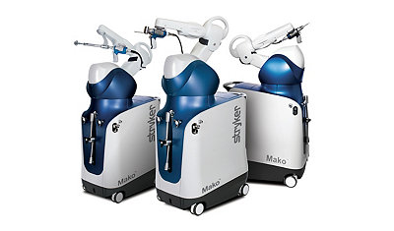
Stryker Mako Robotic Arm. (https://www.stryker.com/us/en/portfolios/orthopaedics/joint-replacement/mako-robotic-arm-assisted-surgery.html)
Once the bone has been registered intraoperatively, precise bony preparation with robotic arm-assisted reamers and excellent implant delivery are made possible [36]. With manual procedures, poor accuracy and low precision are currently the norm; the objective is to move from this level to high accuracy and high precision, which are required to create patient-specific designs [37]. This journey also calls for a clear understanding of the outcomes we hope to achieve for each patient, and one advancement is the planning for robotic THA, which enables knowledge of spinopelvic parameters and intraoperative analysis of potential impingement [38], whether it be implant-on-bone or bone-on-bone, and enables us to minimise it.
A segmented CT scan was the first step in the workflow for robotic THA, from which a was then acquired [39]. Standard surgical exposure is used, however to enable registration, arrays are affixed to both the femur and the pelvis. After that, the bone is prepped with the aid of a robotic arm and a computer, and the components are precisely implanted to allow for the reproduction of length, offset, and centre of rotation [15].
Due to the fact that the robotic arm delivers a surgeon-led strategy, this makes the surgeon's role crucial. This is simple to incorporate into an experienced surgeon's workflow, which will help with both routine and complex cases. However, it also creates an excellent opportunity to gather a wealth of data generated throughout every step of that journey, from the CT through planning, changes to the plan, and final execution leading to the patient's ultimate outcome [39]. Soon, we will be able to apply machine learning and artificial intelligence to help create better plans for surgeons who may perform fewer operations [40].
Robotic technology, 3D planning, and execution have also aided in our understanding of our long-term objectives. To provide individualised THA, we need to be aware of each patient's functional hip position [35]. Robotic-arm assisted surgery will ultimately be recognised as a cost-effective strategy [39, 42] and an essential tool in the surgical toolbox [40] by doing this, as well as by lowering complications, readmission and revision rates, and enhancing patient satisfaction [41].
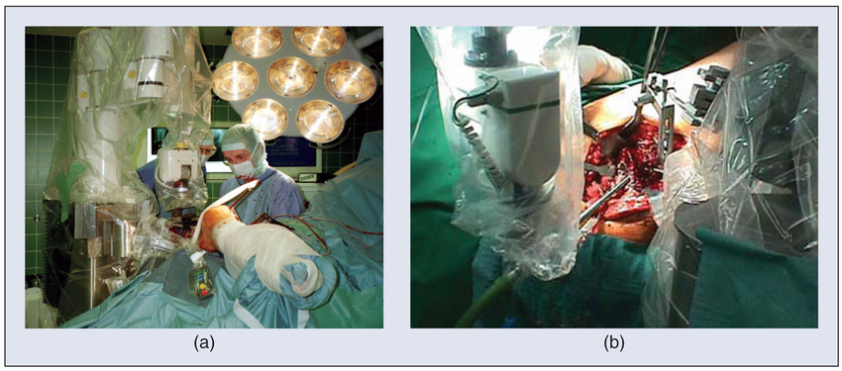

The ROBODOC system for orthopedic surgery. (a) The robot is being used for total hip replacement surgery. (b) Close-up of robotic milling of femur.

(https://www.researchgate.net/figure/The-ROBODOC-system-for-orthopedic-surgery-a-The-robot-is-being-used-for-total-hip_fig2_43352313)

Implants in THA
Larger femoral heads
Since they improve the hip's range of motion prior to impingement and subsequently lower dislocation rates, larger femoral heads have been employed in THA more frequently over the past ten years [43]. According to numerous arthroplasty registries [44-46], the most popular femoral head diameters are 32 and 36 millimetres. The corrosion at the taper-trunnion interface, which could cause groyne pain and shorten the life of THA, is one alleged drawback of bigger heads [47]. In terms of dislocation rate and implant survival, 32 mm and 36 mm heads appear to be superior depending on the articulating materials. Up until recently, there were no long-term studies that supported the security of femoral heads larger than 36 mm.
Dual Mobility Cups
In France, dual mobility cups have been in use for many years, but their use was not widespread. Outside of France, the use and ubiquity of dual mobility have dramatically expanded during the previous 10–15 years [48, 49]. A lesser risk of instability is provided by dual mobility cups, which increase range of motion, head-to-neck ratio, and jump distance [50, 51]. In both initial and revision THA, dual-mobility cups reduce the rate of dislocation [52]. Intra-prosthetic dislocation and increased wear are issues with dual-mobility cups [53]. In patients who are at risk for instability after an initial or revision THA, dual mobility is a fantastic alternative [54]. Additionally, even after going through rigorous testing and certification procedures, some potentially undiscovered side effects of new THA implants can only be discovered after extended follow-up.
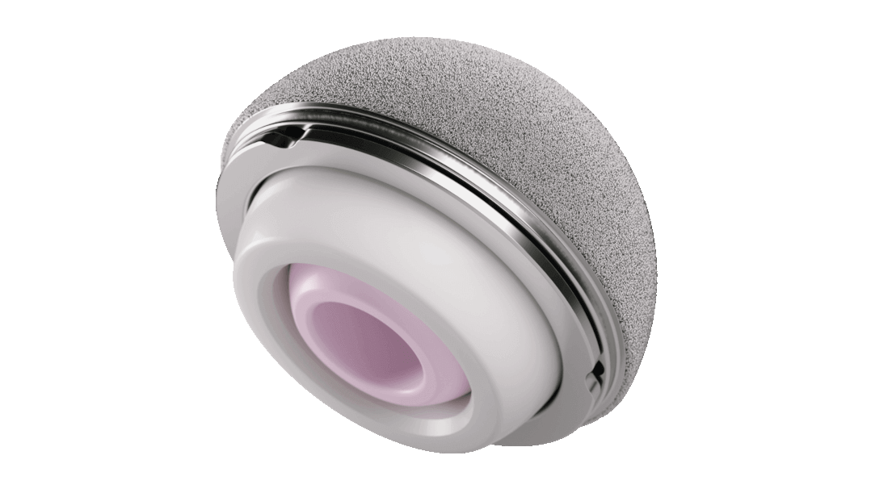
Dual mobility cup. (https://www.jnjmedtech.com/en-US/product/pinnacle-dual-mobility-liner)
Conclusion
Total hip replacement is a safe operation with a big effect size that offers patients significant improvements at a reasonable price. However, there has been a noticeable increase in the total number of THAs carried out globally, along with a substantial rise in the proportion of younger patients receiving THA. The best functional outcomes are essential since this generation is more demanding and frequently looks forward to returning to sports. Along with the developments and discoveries in the field, this shift in the population's interest in THA shows that significant advancements are still possible.
A better education for the upcoming generation of hip arthroplasty surgeons is made possible by the use of virtual reality in total hip arthroplasty. It can also make it easier to test out new methods and equipment. However, applications in total hip arthroplasty are still limited due mostly to time and expense constraints. Three-dimensional printing opens up several options. Promising technology called 3D printing can be utilised to create patient-specific instruments, case-specific implants, and prototypes. Despite the lack of long-term data supporting increases in quality of life, robotic technology and computer-assisted surgery have shown superiority in the radiographic placement of implants.
Early findings indicate that the use of a robotic arm assists in precise and repeatable implant location, with combined anteversion and centre of rotation being extremely important measures. To minimise impingement and ease the transition to "individualised THA" in the future, it is essential to comprehend the functional hip position and pelvic alignment.
Robotic technology also offers enormous possibilities for data collection, starting with CT scans and continuing through implant positioning planning and execution. Big data combined with artificial intelligence and machine learning will enable us to customise our approach and better comprehend the processes required to attain personalised treatment. AI and machine learning can also help our surgical plan run more smoothly and reach doctors outside of the elite, high-volume arthroplasty specialists.

References
- Law WA. Post-operative study of vitallium mould arthroplasty of the hip joint. J Bone Joint Surg Br. 1948;30:76-83.
- Smith-Petersen MN. Evolution of mould arthroplasty of the hip joint. J Bone Joint Surg Br. 1948;30:59-75.
- Charnley J. Anchorage of the femoral head prosthesis to the shaft of the femur. J Bone Joint Surg Br. 1960;42:28-30.
- Charnley J. Arthroplasty of the hip. A new operation. Lancet. 1961;1:1129-32.
- Amstutz HC, Campbell P, Kossovsky N, Clarke IC. Mechanism and clinical significance of wear debris-induced osteolysis. Clin Orthop Relat Res. 1992;(276):7-18.
- Chandler HP, Reineck FT, Wixson RL, McCarthy JC. Total hip replacement in patients younger than thirty years old. A five-year follow-up study. J Bone Joint Surg Am. 1981; 63:1426-34.
- Collis DK. Cemented total hip replacement in patients who are less than fifty years old. J Bone Joint Surg Am. 1984; 66:353-9.
- Cooper RA, McAllister CM, Borden LS, Bauer TW. Polyethylene debris-induced osteolysis and loosening in uncemented total hip arthroplasty. A cause of late failure. J Arthroplasty. 1992;7:285-90.
- Goetz DD, Smith EJ, Harris WH. The prevalence of femoral osteolysis associated with components inserted with or without cement in total hip replacements. A retrospective matched-pair series. J Bone Joint Surg Am. 1994;76:1121-9.
- Gruen TA, McNeice GM, Amstutz HC. “Modes of failure” of cemented stem-type femoral components: a radiographic analysis of loosening. Clin Orthop Relat Res. 1979;141: 17-27.
- Phillips FM, Pottenger LA, Finn HA, Vandermolen J. Cementless total hip arthroplasty in patients with steroidinduced avascular necrosis of the hip. A 62-month followup study. Clin Orthop Relat Res. 1994;(303):147-54.
- Salvati EA, Cornell CN. Long-term follow-up of total hip replacement in patients with avascular necrosis. Instr Course Lect. 1988;37:67-73.
- Reese A, Macaulay W. Hybrid total hip arthroplasty: stateof- the-art in the new millennium? J South Orthop Assoc. 2003;12:75-8.
- Rivière C, Harman C, Logishetty K, Van Der Straeten C (2020) Hip replacement: Its development and future. In: Personalized Hip and Knee Joint Replacement. Rivière C, Vendittoli P-A. Springer International Publishing, pp. 23–32.
- Haddad FS, Plastow R (2020) Is it time to revisit cementless total knee arthroplasty? Bone Jt J 102, 965–966.
- Kayani B, Konan S, Thakrar RR, Huq SS, Haddad FS (2019) Assuring the long-term total joint arthroplasty: A triad of variables. Bone Jt J 101B, 11–18.
- Hayashi S, Naito M, Kawata S, Qu N, Hatayama N, Hirai S, Itoh M (2016) History and future of human cadaver preservation for surgical training: from formalin to saturated salt solution method. Anat Sci Int 91, 1–7.
- Benninger B, Maier T (2015) Using ATP-driven bioluminescence assay to monitor microbial safety in a contemporary human cadaver laboratory. Clin Anat 28, 164–167.
- Bartlett JD, Lawrence JE, Stewart ME, Nakano N, Khanduja V (2018) Does virtual reality simulation have a role in training trauma and orthopaedic surgeons? Bone Jt J 100B, 559–565.
- Logishetty K, Rudran B, Cobb JP (2019) Virtual reality training improves trainee performance in total hip arthroplasty: A randomized controlled trial. Bone Jt J 101-B, 1585–1592.
- Laverdière C, Corban J, Khoury J, Ge SM, Schupbach J, Harvey EJ, Reindl R, Martineau PA (2019) Augmented reality in orthopaedics: A systematic review and a window on future possibilities. Bone Jt J 101-B, 1479–1488.
- Lohre R, Bois AJ, Pollock JW, Lapner P, McIlquham K, Athwal GS, Goel DP (2020) Effectiveness of immersive virtual reality on orthopedic surgical skills and knowledge acquisition among senior surgical residents. JAMA Netw Open 3,e2031217.
- Sirimanna P, Gladman MA (2017) Development of a proficiency- based virtual reality simulation training curriculum for laparoscopic appendicectomy. ANZ J Surg 87, 760–766.
- Bartlett JD, Lawrence JE, Stewart ME, Nakano N, Khanduja V Does virtual reality simulation have a role in training trauma and orthopaedic surgeons? Bone Jt J 100B, 559–565.
- Levesque JN, Shah A, Ekhtiari S, Yan JR, Thornley P, Williams DS (2020) Three-dimensional printing in orthopaedic surgery: A scoping review. EFORT Open Rev 5, 430–441
- Hooper J, Schwarzkopf R, Fernandez E, Buckland A, Werner J, Einhorn T, Walker PS (2019) Feasibility of single-use 3D-printed instruments for total knee arthroplasty. Bone Jt J 101-B, 115–120.
- Tanzer M, Chuang PJ, Ngo CG, Song L, TenHuisen KS (2019) Characterization of bone ingrowth and interface mechanics of a new porous 3D printed biomaterial. Bone Jt J 101-B, 62–67.
- Sporer S, MacLean L, Burger A, Moric M (2019) Evaluation of a 3D-printed total knee arthroplasty using radiostereometric analysis. Bone Jt J 101-B, 40–47.
- Hasan S, Hamersveld KTV, Vande Mheen PJM, Kaptein BL,
- Nelissen RGHH, Toksvig-Larsen S (2020) Migration of a novel
- McDonnell JM, Ahern DP, O’Doinn T, Gibbons D, Rodrigues KN, Birch N, Butler JS (2020) Surgeon proficiency in robotassisted spine surgery a narrative review. Bone Jt J 102, 568–572.
- Vermue H, Lambrechts J, Tampere T, Arnout N, Auvinet E, Victor J. 2020. How should we evaluate robotics in the operating theatre? Bone Jt J 102 B, 407–413.
- Robinson PG, Clement ND, Hamilton D, Patton JT, Blyth MJG, Haddad FS (2019) A systematic review of robotic-assisted unicompartmental knee arthroplasty: Prosthesis design and type should be reported. Bone Jt J 101 B, 838–847.
- Laende EK, Richardson CG, Dunbar MJ (2019) A randomized controlled trial of tibial component migration with kinematic alignment using patient-specific instrumentation versus mechanical alignment using computer-assisted surgery in total knee arthroplasty. Bone Jt J 101 B, 929–940.
- Oussedik S, Abdel MP, Victor J, Pagnano MW, Haddad FS (2020) Alignment in total knee arthroplasty. Bone Jt J 102 B, 276–279.
- Kayani B, Konan S, Huq SS, Ibrahim MS, Ayuob A, Haddad FS (2019) The learning curve of robotic-arm assisted acetabular cup positioning during total hip arthroplasty. HIP Int. https://doi.org/10.1177/1120700019889334.
- Banger MS, Johnston WD, Razii N, Doonan J, Rowe PJ, Jones BG, MacLean AD, Blyth MJG (2020) Robotic arm-assisted bi-unicompartmental knee arthroplasty maintains natural knee joint anatomy compared with total knee arthroplasty: A prospective randomized controlled trial. Bone Jt J 102 B, 1511–1518.
- Kayani B, Konan S, Ayuob A, Ayyad S, Haddad FS (2019) The current role of robotics in total hip arthroplasty. EFORT Open Rev 4, 618–625.
- Abdelfadeel W, Houston N, Star A, Saxena A, Hozack WJ (2020) CT planning studies for robotic total knee arthroplasty what does it cost and does it require a formal radiologist reporting? Bone Jt J 102, 79–84.
- Haddad FS, Horriat S (2019) Robotic and other enhanced technologies: Are we prepared for such innovation? Bone Jt J 101-B, 1469–1471.
- Kayani B, Konan S, Tahmassebi J, Rowan FE, Haddad FS (2019) Infographic: Robotics are guiding arthroplasties to less pain and faster recovery. Bone Jt J 101B, 22–23.
- Clement ND, Deehan DJ, Patton JT (2019) Robot-assisted unicompartmental knee arthroplasty for patients with isolated medial compartment osteoarthritis is cost-effective: A Markov decision analysis. Bone Jt J 101-B, 1063–1070.
- Tsikandylakis G, Overgaard S, Zagra L, Kärrholm J (2020) Global diversity in bearings in primary THA. EFORT Open Rev 5, 763–775.
- Swedish Hip Arthroplasty Register Annual Report 2017. https:// shpr.registercentrum.se/shar-in-english/the-swedish-hip-arthroplasty- register/p/ryouZwaoe. Accessed 2 Jan 2021.
- Norwegian National Advisory Unit, on Arthroplasty and Hip Fractures June 2019 – Nasjonalt Register for Leddproteser. http://nrlweb.ihelse.net/eng/Rapporter/Report2019_english.pdf.
- The National Joint Registry 16th Annual Report 2019 [Internet] – PubMed. https://pubmed.ncbi.nlm.nih.gov/32744812/. Accessed 2 Jan 2021.
- Muratoglu OK, Bragdon CR, O’Connor D, Perinchief RS, Estok DM, Jasty M, Harris WH (2001) Larger diameter femoral heads used in conjunction with a highly cross-linked ultra-high molecular weight polyethylene: A new concept. J Arthroplasty 16, 24–30.
- Kreipke R, Rogmark C, Pedersen AB, Kärrholm J, Hallan G, Havelin LI, Mäkelä K, Overgaard S (2019) Dual mobility cups: Effect on risk of revision of primary total hip arthroplasty due to osteoarthritis: A matched population-based study using the nordic arthroplasty register association database. J Bone Jt Surg – Am 101, 169–176.Heckmann N, Weitzman DS, Jaffri H, Berry DJ, Springer BD,
- Lieberman JR (2020) Trends in the use of dual mobility bearings in hip arthroplasty. Bone Jt J 102-B, 27–32.
- Mohaddes M, Cnudde P, Rolfson O, Wall A, Kärrholm J (2017) Use of dual-mobility cup in revision hip arthroplasty reduces the risk for further dislocation: analysis of seven hundred and ninety one first-time revisions performed due to dislocation, reported to the Swedish Hip Arthroplasty Register. Int Orthop 41, 583–588.
- Neri T, Boyer B, Batailler C, Klasan A, Lustig S, Philippot R, Farizon F (2020) Dual mobility cups for total hip arthroplasty: Tips and tricks. SICOT-J 6, 17.
- Khoshbin A, Haddad FS, Ward S, O hEireamhoin S, Wu J, Nherera L, Atrey A (2020) A cost-effectiveness assessment of dual-mobility bearings in revision hip arthroplasty. Bone Jt J 102-B, 1128–1135.
- Fabry C, Langlois J, Hamadouche M, Bader R (2016) Intraprosthetic dislocation of dual-mobility cups after total hip arthroplasty: potential causes from a clinical and biomechanical perspective. Int Orthop 40, 901–906.
- Jones CW, De Martino I, D’Apolito R, Nocon AA, Sculco PK, Sculco TP (2019) The use of dual-mobility bearings in patients at high risk of dislocation. Bone Jt J 101-B, 41–45.

