Noise Reduction and compression of Very Low Frequency (VLF) Transients using Wavelet Based Techniques

D.K. Sondhiya  School of Science  SAGE University Bhopal, India | Preeti Singh  Department of Physical Sciences  Rabindra Nath Tagore University, Bhopal, India
S.K. Kasde
Department of Physics
Government College Bhainsdehi, Betul, India

ABSTRACT
Over past few decades’ ambient environmental noises increased tremendously due to manmade and natural factors. The reasons for these noises are noisy heavy engine, pumps, spacecraft, lighting and earthquake. These noises often degrade the quality of Very Low Frequency signal. Therefore lot of information associated with these signals are lost. To retrieve signal with significant geologic information various Denoising methods were used, which is based on linear pass band filter, but their efficiency is reduced in case of Very Low Frequency (VLF) signals. This is due to the fact that VLF signals are Non-Gaussian, which contains Gaussian background and narrow pulses by lighting discharge, Power Line Harmonic Radiation (PLHR) and sometime due to earthquake and Volcanic eruptions. Here we discuss VLF signal denoising methods based on wavelet thresholding. We show that thresholding the wavelet coefficients of a VLF signal allows to restore the complete shape of the original signal. In this approach we substantially improve the performance of classical wavelet denoising algorithms, both in terms of SNR and in terms of visual artifacts.
Keywords - VLF signal, Wavelet Transform, wavelet thresholding, Filter bank

- Introduction
The estimation of signal in the presence of noise is an important task in signal processing. Noises in the signals are defined as the unwanted frequency content in the observed signal. Generally noises are considered to be the undesired parts of the signal. A presence of noise always masks the signal and hides its relevant features. In order to derive the important characteristics of signals denoising procedure involve the use of linear Band Pass Filter (BPF) [1]. The family of BPF is based on phase properties, so it is very effective for the denoising of stationary signals but its efficiency reduced when signals are non-stationary in nature. The alternative solution of this problem is the Weigner filter which focuses on elimination of mean square error between observed and denoised signals [2]. These methods do not hold good for the VLF transients because these transients are highly non-stationary in nature. Therefore for the reduction of noise from VLF signal wavelet based denoising techniques were used. Here, we apply denoising [3] and compression [4] technique for the VLF transient noise reduction and compression.
- Wavelet analysis
In wavelet analysis correlation is calculated between the signal and wavelet function$ψ\left(t\right)$ known as Mother Wavelet. The similarity between the signal and mother wavelet is computed for different time intervals and results are represented in two or three dimensional form.
Mother wavelet satisfied the following criterion:
- A wavelet must have finite energy
$$E=\int_{-∞}^{∞}{{\left|ψ(t)\right|}^{2}<∞} (1)$$
The energy $E$ equals the integrated squared magnitude of the analyzing function $ψ(t)$ and must be less than infinity.
- If $\hat{f}\left(ω\right)$ is the Fourier transform of the wavelet $ψ\left(t\right),$ the following condition must hold
$${ C}_{ψ}=\int_{0}^{∞}{\frac{{\left|\hat{f}\left(ω\right)\right|}^{2}}{f}df<∞} \left(2\right)$$
This condition implies that the wavelet has no zero frequency components$\left(ψ\left(0\right)=0\right),$ i.e. the mean of the wavelet $ψ\left(t\right)$ must be equal to zero. It is known condition of admissibility. The value of $C_{ψ}$ depends on chosen wavelet.
- For complex wavelets the Fourier transform $ψ\left(f\right)$ must be both real and vanish for negative frequencies.
- Wavelet Transform and its types
There are two types of Wavelet transform
- Continuous Wavelet Transform (CWT)
- Discrete Wavelet Transform (DWT)
- Continuous Wavelet Transform (CWT)
The families of wavelets $ψ_{x,s}\left(t\right)=\frac{1}{\sqrt{s}}ψ(\frac{t-x}{s})$ are obatained by introducing a scale factor $s$ and translation$x.$ The wavelet transform of a function$f\left(t\right)$is given by:
$$Wf\left(x,s\right)=\frac{1}{\sqrt{\left|s\right|}}\int_{-∞}^{∞}{f\left(t\right)ψ^{*}}\left(\frac{t-x}{s}\right)dt (3)$$
$Wf(x,s)$ measure the variation of $f(t)$ in neighborhood of$x$ whose size is proportional to $s.$ When scales $s$ goes to zero, the decay of wavelet coefficients characterizes the regularity of $f(t)$in the neighborhood of $x$[5].
To normalize the energy of VLF signals at various scales the wavelet coefficients are divided by the factor$\sqrt{\left|s\right|}$ and also $ψ(t)$ localized in frequency and time. Increasing the value of $s$ decrease the time resolution $∆t$ and increases the frequency resolution$∆f$. It is well established that $∆t.∆f$ is constant, which implies that $∆f$ is proportional to$f$, or
$$\frac{∆f}{f}=c (4)$$
Where $c$ is constant, which implies that frequency resolution is constant in wavelet analysis.
To calculates the value of CWT discrete value of scaling parameter$s$ and translation$x$ parameter are used. The resulting wavelet coefficients are called wavelet series. The constant relative frequency resolution of the wavelet analysis is known as the constant Q property. It is the quality factor of filter defined as the center frequency $f_{c}$ divided by the bandwidth $f_{b}$ [6]. A dyadic sample grid for the scaling seems to be very suitable for the constant Q analysis. Dyadic grid discretizes the scale parameter on a logarithmic scale and the time parameter is also discretizes with respect to the scale parameter. The most natural choice to construct a wavelet series looks series like:
${ Wf}_{m,n}=\int_{-∞}^{∞}{f\left(t\right)ψ_{m,n}\left(t\right)dt, }$ With $ψ_{m,n}=s_{0}^{-\frac{m}{2}}ψ\left(s_{0}^{-m}t-nτ_{0}\right) (5)$
Here integer’s $m$ and $n$ control the wavelet dilation and translation. For a dyadic grid, $s_{o}=0$ and $τ_{0}=1$. Discrete dyadic wavelets are chosen in such way that they are orthogonal to each other and normalized to have unit energy. This condition allows the reconstruction of the original signal by
$$f\left(t\right)=\sum_{m=-∞}^{∞}{\sum_{n=-∞}^{∞}{{Wf}_{m,n}ψ_{m,n}}\left(t\right) }(6)$$
The CWT gives good frequency resolution for high frequencies (small scales) and a good time resolution for low frequencies (large scales).
In multi-resolution analysis scale $s$ is used instead of frequency, large scale gives a global view of signal which provides information about the lower frequencies and small scale takes a short detailed look and revealing high frequency information. These scales are corresponds to a central analyzing frequencies and also inversely proportional to that frequency.
Most often used wavelet for analysis purpose is Morlet wavelet, which is obtained by using a Gaussian (bell shaped) window:
$ψ\left(t\right)=g\left(t\right)e^{-j2πf_{c}t},$ $g\left(t\right)=\sqrt{πf_{b}}e^{\frac{t^{2}}{f_{b}}} (7)$
Where center frequency $f_{c}$ and the bandwidth parameter $f_{b}$ of the wavelet are the tunning parameters. Together they determine the number of cycles in analyzing function. For the Morlet wavelet scale and frequency are coupled as
$$f=\frac{f_{c}}{s} (8)$$
The true discrete wavelet transform makes use of filter banks for the analysis and synthesis of the signal.
- Discrete wavelet transform
In discrete time, it is found that the orthonormal bases are much easier to design and interpret than their continuous equivalent. To makes this possible a structure called filter bank is used. The expanded filter bank has the same time-frequency resolution properties as the wavelet transform. During the analysis and synthesis parts a filter bank produces coefficients on several levels.
Filter banks
Filter banks is a collection of discrete filters with a common input and/or a common output. Figure 1 shows a filter bank of two channels. It separates the frequency content of a signal in to two frequency bands of equal width using a low pass filter $L\left(z\right)$and a high pass filter$H\left(z\right)$. The outputs of these filters are called sub-bands and the technique is known as sub-band coding [6]. Output of each filters contain half the frequency content, but an equal amount of samples as the input signal. The two outputs together contain the same frequency content as the input signal; however the amount of the data is doubled. Hence, down sampling by a factor two $\left(↓2\right)$ is applied to the outputs of the filters in the analysis bank.

H(z)
↓2
$$H^{,}(z)$$

↑2

$$f(t)$$
$$y(t)$$

L(z)

↓2
$$L^{,}(z)$$

↑2

Analysis bank
Synthesis bank

Figure 1: A filter bank of two channels
To reconstruct the original signal synthesis filter bank is used [7]. During the process of reconstruction signals are up-sampled by factor $\left(↑2\right)$ and passed through $L^{'}\left(z\right)$ and$H^{'}\left(z\right)$. These filters are same as the filters in the analysis bank. The sum of outputs of synthesis bank filters provides the reconstructed signal.
Down and up sampling
Down sampling by a factor 2 is seems to be logical after the application of analysis bank as the information is not double so no need to double the number of samples. The down sampling operation saves only the even numbered components of the filter output; hence it is non-invertible. So there is a possibility of losing information since half of the data is discarded. In the frequency domain the effect of discarding information is called aliasing. If the Shannon sampling theorem is met, no loss of information occurs [7] - [8]. The sampling theorem of Shannon states that down-sampling a sampled signal by a factor M produces a signal whose spectrum can be calculated by partitioning the original spectrum into M equal bands and summing these bands.
In the synthesis bank the signals are first up sampled before filtering. The up sampling by a factor 2 is performed by adding zeros in between the samples of the original signal. Note that first down sampling a signal and then up sampling it again will not return the original signal.

$x=\left[\begin{matrix}. \\ \begin{matrix}x(0) \\ \begin{matrix}x(1) \\ x(2) \\ x(3)\end{matrix} \\ x(4)\end{matrix} \\ .\end{matrix}\right]$ $\left(↓2\right)=\left[\begin{matrix}. \\ \begin{matrix}x(0) \\ x(2) \\ x(4)\end{matrix} \\ .\end{matrix}\right]$ $\left(↑2\right)\left(↓2\right)=\left[\begin{matrix}. \\ \begin{matrix}x(0) \\ 0 \\ x(2)\end{matrix} \\ \begin{matrix}0 \\ x(4) \\ .\end{matrix}\end{matrix}\right] (9)$

The transpose of $\left(↓2\right)$ is$\left(↑2\right)$. Since the transposes come in reverse order, synthesis can be performed as the transpose of the analysis. Furthermore$\left(↑2\right)\left(↓2\right)=I$, since $\left(↑2\right)$ is the right-inverse of $\left(↓2\right)$ [7]. This shows that it is possible to obtain the original signal again with up and down-sampling. By first inserting zeros and then removing then the original signal is obtained again.
Perfect reconstruction
For perfect reconstruction to be possible, the filter bank should be biorthogonal. Furthermore to guarantee a perfect reconstruction some designing criterion for preventing the aliasing and distortion should be fulfilled for both the analysis and synthesis filters [7].
In the two channels filter bank of Figure 1, the filters $L\left(z\right)$ and $H\left(z\right)$ split the signal into two frequency bands. If the filters were perfect brick-wall filters, the down sampling would not lead to loss of information. However ideal filters cannot be realized in practice, so a transition band exists Figure 2. Besides aliasing, this leads to an amplitude and phase distortion in each of the channels of the filter band.

$$\left|H\right|$$
$$\left|L\right|$$

$$\frac{1}{2}f_{n}$$
$$f_{n}$$

Figure 2: Phase Response of Two channel Filter Bank
For the two channel filter bank of Figure 1, aliasing can be prevented by designing the filters of the synthesis filter bank as:
$${ L}^{'} \left(z\right)=H\left(-z\right) (10)$$
$${ H}^{'} \left(z\right)=-L(-z) (11)$$
To eliminate the distortion, products filter${ P}_{0}\left(z\right)=L^{'}\left(z\right)L(z)$ is defined. Distortion can be avoided if $H^{'}\left(z\right)$
${ P}_{0}\left(z\right)-P_{0}\left(-z\right)=2z^{-N}$ $(12)$
Where N is the overall delay in filter banks. $N^{th}$ Order filter produces a delay of N samples (Schneider, 2001).
Condition to construct a perfect reconstruction filter
- Design a low-pass filter $P_{0}$ satisfying equation (12)
- Factor $P_{0}$into $L^{'}\left(z\right)L(z)$ and use equation (10) and equation (11) to calculate $H\left(-z\right)$ and $H^{'}\left(z\right)$
The design of the product filter $P_{0}$ of the step and the factorization of the second step can be done in several ways.
Multiresolution Filter Banks
L(z)
H(z)
$$↓2$$
$$↓2$$

L(z)

H(z)

$$↓2$$

$$↓2$$

L(z)

H(z)

$$↓2$$

$$↓2$$

$$↑2$$

$$↑2$$
$$H^{'}(z)$$
$$L^{'}(z)$$

$$↑2$$

$$↑2$$

$$H^{'}(z)$$

$$L^{'}(z)$$

$$↑2$$

$$↑2$$

$$H^{'}(z)$$

$$L^{'}(z)$$

Level 1
Level 2
Level 3
Level 3
Level 2
Level 1
$$x(n)$$
$$y_{3}(n)$$
$$y_{2}(n)$$
$$y_{1}(n)$$
$$y_{0}(n)$$
$$\hat{x}(n)$$
$$y_{3}(n)$$
$$y_{2}(n)$$
$$y_{1}(n)$$
$$y_{0}(n)$$

- Synthesis Bank

- Analysis Bank

Figure 3: Three Channel Filter Bank

It is possible to obtained multiresoution of signal at different frequencies resulting in Discrete Wavelet Transform (DWT). Remember that the discretized version of CWT is not equal to the DWT; the DWT uses filter banks whereas the discretized CWT uses discretized versions of the scale and dilatation axes.
The low-pass and high pass filtering branches of the filter bank gives the approximation and details of the signal under consideration. A filter bank with three level in shown in Figure 3. If high resolution is required the filter bank can be expanded to any desired arbitrary level. The coefficient$y_{l}\left(x\right)$represents the lowest half of the frequencies in $x\left(n\right)$ also dwonsampling doubles the frequencies resolution. As a result time resolution is half i.e. half numbers of samples are presents in$y_{l}(x)$.
Wavelet Filters
The relationship between the CWT and DWT is not very clear. In CWT wavelet have a central frequency and works as a band-pass filter in the convolution of the wavelet function with the signal. The combination of low-pass filter, down sampling and high-pass filter act as a band-pass filter.
For the easy comparison between the DWT and CWT, the filter bank of Figure 3 can be redrawn in Figure 4. An increase in rate of down sampling leads to a larger time grid for the lower frequencies (higher scale). It also possible to interpret the filter as the wavelet functions at various scales. These wavelet functions are not accurately scaled form of each other, if the numbers of levels are increased and the impulse responses of the particular filter converge to a stable waveform the $L\left(z\right)$and $H\left(z\right)$ are the wavelet filters. The subsequent filters then become scaled versions of each other. Such wavelet filters are said to be regular [9]. The wavelet filter can be classified into two classes orthogonal and biorthogonal filters.

$$H_{h}(z)$$
$$H_{lh}(z)$$
$$H_{llh}(z)$$
$$H_{lllh}(z)$$
↓2
↓4
↓8
↓8
↑2
↑4
↑8
↑8
$$H_{h}^{'} (z)$$

$$H_{lh}^{'}(z)$$

$$H_{llh}^{'}(z)$$
$$H_{lllh}^{'}(z)$$
$$y(n)$$
$$c_{h}(k)$$
$$c_{lh}(k)$$
$$c_{llh}(k)$$
$$c_{lllh}(k)$$
$$y(n)$$

Figure 4: Equivalent of Figure 3

For the easiest construction of limit functions the impulse responses are calculated from the reconstruction path. Starting from the lower branch of synthesis bank, which consists of low-pass filters and up sampling in between. Both filters are FIR filters from the definition of Quadratic Mirror Filter (QMF). After several iterations if the impulse response of this sequence converges to a final function $l(n)$ for which the following difference equation holds [10]
$$∅\left(t\right)=\sum_{n=0}^{N}{l\left(n\right)∅(2t-n)} (13)$$ This function is known as scaling function of the wavelet. The final function for the band pass sequence is obtained in the same way, except for one high-pass filter at the start of the filter sequences. This function $h_{c}$(t) is known as the wavelet$ψ(t)$:
$$ψ\left(t\right)=\sum_{n=0}^{N}{h\left(n\right)ψ(2t-n)} (14)$$
The subband with wavelet $c_{lll}$ is called the approximation subbanb$cA$ and contains the lowest frequencies. The other subbands are called detail subbands$cD$ and give detail information of the signal. The wavelet coefficients represent the signal content in the various frequency bands.
For a p-level decomposition, the highest observed frequency of wavelet approximation coefficients $c_{lll}$ as a function of sample frequency $f_{s}$ can be calculated as
$${ f}_{l}=\frac{f_{s}}{2^{p+1}} (15)$$
The frequency content of the approximation frequency band$cA$ and detail frequency bands $cD$ can be calculated as
${ f}_{cA}=[0, 2^{-p-1}f_{s}$] $(16)$
$${ f}_{cD_{p}}=[2^{-p-1}f_{s, }2^{-p}f_{s}] (17)$$
The success of a particular decomposition strongly depends on chosen wavelet filters and also depends on signal properties. In DWT there is a trade off between the order of the wavelets and the computation time. Higher order wavelets are smoother and give better resolution between various frequencies, but it take large computation time.
- Wavelet Based Noise Reduction Techniques
The result of VLF transients decomposition by Wavelet transforms is a matrix whose coefficients represent the transients in the corresponding transform domain. Coefficient matrix contains all the information necessary to reconstruct the VLF transients. The large coefficients represent good correlation between the input VLF transients and decomposing basis conversely the small coefficients represents poor correlations between them. If VLF transients are reconstructed by neglecting the some of the smaller coefficients the reconstructed transients would still maintain the original shape of original VLF transients. However there would be inevitable distortion introduced form simply neglecting some of the component necessary for the perfect reconstruction.
The basic idea of noise reduction is to judicially choose the wavelet coefficients in order to preserve the complete shape of transients while removing that coefficient which represents the noise. Two properties of the wavelet based transforms assist in separating the noise coefficient form the rest. First, the proper choice of the basis to match the signal characteristic, the resulting decomposition will have a low information cost and will contain relatively few significant coefficients. Second, for input transients that are a zero mean random process with uncorrelated samples (white noise) the transform coefficients will remain uncorrelated. If this transients are additionally Gaussian distributed the wavelet coefficients will be Gaussian and independent.
The addition of noise to an input signal will produced noisy coefficients with the noise contributing to all coefficients but the signal contributing to relatively few coefficients. In other words, for suitable chosen basis applied to decompose a noisy input good correlation will be produced with the signal (resulting in a few large coefficient) and poor correlations will be produced with noise (resulting in small coefficient). Observation of these properties leads to the idea of establishing a cut off level (threshold) for those coefficients to be retained.
The general denoising procedure can be summarized as follows:
- Decompose the input into a suitable basis using wavelet based transforms.
- Suppress the noisy coefficients by applying a non-linear thresholding method.
- Reconstruct the signal using the inverse transform.
- The Noise Estimation
The estimation of proper denoising level is most important step in the noise reduction process. Generally it is done by threshold the signal from a specified level. The general methodology for calculating a threshold is based on the statistical properties of the transformed coefficients.
If the coefficients of transformed are viewed as a series of noisy observations$w_{i}$, then from the multivariate normal decision theory, we are given observations $w={(w_{i})}_{i=1}^{n}$ according to
$w_{i}=θ_{i}+εz_{i}$ $\left(i=1,…, n\right), (18)$
Where $z_{i}$ are independent and identically distributed (i.i.d) as $N\left(0,1\right), ε>0$ is the known noise level and $θ=\left(θ_{i}\right)$ is the quantity of interest (signal to retained).
To solve this problem it is very necessary to assume or compute a value of$ε$. Donoho and Jonhstone [11] estimates the value of $ε$ as the absolute median deviation$E$ of the coefficient at finest scale divided by $0.6745$. To explain the result consider a random variable$X=\left\{x_{i}\right\}$ which is independently and identically distributed (i.i.d)$N\left(0,ε\right)$and define $E$ as:
$E=median\left|x_{i}-median(X)\right|=median\left|x_{i}\right|$ $(19)$
The second term in the equation results forms the definition of$X$. Next, define $q_{1}$and $q_{2}$ as two values of $X$ that it bounds the center 50% of the distribution$X=\left\{x_{i}\right\}$ as depicted in Figure 5. From the table of standard normal distribution$q_{2}=-q_{1}=0.6745ε$. The absolute value of $X$ will have $50\%$ of its values bounded by $0≤X≤q_{2,}$so that$median\left|x_{i}\right|=q_{2,}=E=0.6745ε$, or $ε=E/0.6745.$
This method of estimation of the noise standard deviation $σ$is robust because the transform coefficients at the finest scale will be essentially due to the noise and any small number of coefficients due to the signal will not grossly affect the median.

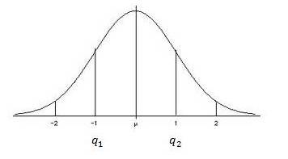

Figure 5: Normal distribution curve indicating center 50%
Once the noise level of the transformed data is estimated a threshold value can be set. The simplest choice is to set the threshold ${(T}_{u})$ at some constant multiple of the noise standard deviation (e.g.,$T=m*o$, where $m$ typically lies in the interval $2<m<5$. Four methods of computing a threshold value are described below.
- The Universal Threshold
The universal threshold value is based on a statistical theorem [12]. For better understanding, consider an independent and identical distribution (i.i.d) $N\left(0,ε\right)$of variables${ X}_{i}$, then as$N→∞$,
$P\left(\max_{i}\left|X_{i}\right|≤T_{u}\right)=1$ $(20)$
Where $T_{u}$ is given by
${ T}_{u}=σ\sqrt{2\log\left(N\right)}$ $\left(21\right)$
Equation (20) indicates that for a Gaussian distributed random variable $X$in the limit of large samples sizes$N$ there is no element $X_{i}$ will have a magnitude greater than the quantity$T_{u}$ , which is known as Universal threshold.
To understand the rationales for this threshold consider a VLF transient $"s"$ as a vector of zeros, so that the transform coefficients $\left\{D_{j,t}^{(s)}\right\}$ are a portion of an i.i.d Gaussian sequence $\left\{e_{j,t}\right\}$ with zero mean and variance$σ_{ε}^{2}$ . Then, as$N→∞$, we have
$P\left[max\left\{\left|D_{j,t}^{(s)}\right|≤T_{U}\right\}\right]≡P\left[max\left\{\left|e_{j,t}\right|≤T_{U}\right\}\right]→1$ $(22)$
Hence, asymptotically we will correctly estimate the signal vector. Universal thresholding typically removes all the noise but in process some small signal coefficients are mistakenly set to zero. Universal thresholding ensures that the reconstructed transients are at least as smooth as the true deterministic signal with high probability. If $σ_{ε}^{2 }$is unknown as is frequently the case in applications a practical procedure is to estimate it is based upon the median absolute deviation (MAD) standard deviation estimate using just the $N/2$ level $j=1$ coefficients in $D_{1}^{(s)}.$ By definition this standard deviation estimator is
${ \hat{σ}}_{MAD}≡\frac{median\left\{\left|D_{1,0}^{(s)}\right|,\left|D_{1,1}^{(s)}\right|,…, \left|D_{1,\frac{N}{2}-1}^{(s)}\right|\right\}}{0.6745} (23)$
The factor $0.6745$ rescales so that ${\hat{σ}}_{MAD}$ is also a suitable estimator for the standard deviation for Gaussian white noise.${\hat{σ}}_{MAD}$ was calculated from the elements of $D_{1}^{(s)}$because the smallest scale wavelet coefficients should be noise dominated with the possible exception of the largest values. The MAD standard deviation estimate is designed to be robust against large deviations and hence should reflect the noise variance rather than the signal variance.
- Steins Unbiased Risk Estimator (SURE) Threshold
Donoho and Johnstone [13] proposed a new method of threshold calculations known as SURE threshold which is based on the work of Stein [14] in the field of multivariate normal distributions. This statistical method calculates the estimated mean square error (risk) for a range of threshold values and selects that threshold value $(T_{s})$ with the resulting minimum risk.
- Hybrid Threshold
The SURE threshold $(T_{s})$ is known to provide inaccurate results in case of low signal energy. In such cases estimated threshold is biased unfavorably by dominating noise coefficients and produced a faulty threshold values. The hybrid method threshold ${(T}_{H })$is selected between (${ T}_{u})$ and $(T_{s})$ based on detected signal energy. It will select ($T_{s})$ only if sufficient information exists that the signal is significant.
- MiniMax Threshold
The minimax principle is used to construct optimum estimators in the field of statistics. It is designed to select the choice of estimators that minimizes the worst case (maximum) errors of the set. Application of this method to wavelet thresholding [11] which is expanded on by Bruce and Gao, [15] where they tabulate the values of MiniMax thresholds TM as a function of the sample size.
- Wavelet Thresholding Methods
Once a threshold value is established a number of methods exist to apply the threshold to suppress or modify the coefficients of the decomposition ($D_{j,t}^{(s)}$). Two different methods of thresholding are generally used in denoising problem known as hard and soft threshoding.
- Hard Thresholding
The non-linear hard thresholding function $y_{hard}$ is defined as:
$y_{hard}=\left\{\begin{aligned} D_{j,t}^{(s)} \left|D_{j,t}^{(s)}\right|>thr thr≥0 \\ 0 \left|D_{j,t}^{(s)}\right|≤thr\end{aligned} \right. (24)$
here “thr” is the threshold estimated by user [16]. It retained the entire transformed coefficient having the magnitude above this threshold value and all other are set to zero. A great limitation of this method is that it removes all fine details below threshold value which produce fictitious oscillations and create contrast where none previously existed.
B. Soft Thresholding
The non-linear hard thresholding function $y_{soft}$ is defined as:
$y_{soft}=\left\{\begin{aligned}sign\left(dD_{j,t}^{(s)}\right).\left(\left|dD_{j,t}^{(s)}\right|-thr\right) \left|D_{j,t}^{(s)}\right|>thr,thr≥0 \\ 0 \left|D_{j,t}^{(s)}\right|≤thr\end{aligned}\right.$ $(25)$
In soft thresholding also known as “wavelet shrinkage” all the transform coefficient with magnitude smaller than the threshold value $“thr”$ are set to zero and the entire remaining coefficient are reduced in the magnitude by the amount of the threshold value. The advantage of this method is that the results are not as sensitive to the precise value of the threshold $“thr”$ selected as in the keep or kill strategy of hard thresholding. The disadvantage of this method is that the general shape of the signal might be slightly affected because the large coefficients are modified using this scheme.
- Translational Invariant Denoising
Wavelet denoising with DWT sometimes results in production of artifacts which occur due to the unfortunate alignment of signal discontinuity with the decomposing wavelet at a given shift and scale. These artifacts take the form of spurious oscillations in the neighborhood of the signal discontinuity. To eliminate these phenomena Coifman and [15] proposed a wavelet denoising strategy called Cycle Spinning (CS) denoising algorithm. They improved the wavelet thresholding methods by averaging the all translations of estimation of the degraded signal. The CS algorithm was conceived to suppress the artifacts in the neighborhood of the discontinuities introduced by the DWT and it implies the rejection of the translation dependency. For a range of delays data is shifted and its DWT is computed therefore the result is unshifted. This process is repeated for a range of shifts and obtained several results are averaging, in this way a quasi shift-invariant DWT is implemented. The degree of redundancy of this transform is proportional to the number of shifts of the input signal produced. CS over the range of all circular shifts of the input signal is equivalent with a translation-invariant WT. if $s(i)$ is the original signal and$s\left(i-p\right)$ is the translated signal the wavelet coefficients of the original and translated signals can be very different and they are not related by a simple translation or permutation,
$s_{B}^{p}\left(α\right)=〈s\left(n-p\right),g_{α}\left(n\right)〉=〈s\left(n\right),g_{α}\left(n+p\right)〉 (26)$
The vectors $g_{α}\left(n+p\right)$are not generally in the basis$B={\left\{g_{α}\right\}}_{α∈A}$, therefore the estimation of the translated signal is not related to the estimation of$s$. This new algorithm yields an estimate $\hat{u^{p}}$ for every translated version$s^{p}$ of the original signal:
$\hat{u^{p}}=Ds^{p }= \sum_{α∈A}{a^{p}\left(α\right)s_{B}^{p}(α)g_{α}} (27)$
The Translation Invariant Wavelet Thresholding $(TIWT)$ based on CS, is obtained by averaging all these estimations after being translated in the inverse sense:
$$TIWT\left(s\right)= \frac{1}{\left|I\right|}\sum_{p∈I}{{\hat{u}}^{p}(i+p)} (28)$$ The Gibbs effect is considerably reduced by the translation invariant wavelet thresholding /since the average of different estimations of the signal reduces the oscillations.
VI. Data
To test the performance of algorithm for noise reduction and compression. VLF signal containing whistlers and hiss transients are taken form French Micro satellite DEMETER during 2004-2010 for the mid latitude.
VII. Wavelet Based Noise Reduction Algorithm
A. DWT and Universal Thresholding
The observed VLF signal consists of VLF transients with some type of atmospheric noises analytically written as:
$s=x+ε$ $(29)$ Where $x$ is a VLF transient and $ε$ represents $N$ dimensional vector of independent and identically distributed (i.i.d) Gaussian noise each random variable having variance${ σ}_{ϵ}^{2}$.
For the purpose of denoising via thresholding Dohono and Johonstone, [11] recommended firstly computing a level $J_{0}$ partial DWT giving coefficient vectors $cD_{1}^{(s)},…., {cD}_{J_{0}}^{(s)}$ and${ cA}_{J_{0}}^{(s)}$. Component-wise, we have:
${cD}_{j,t}^{\left(s\right)}=d_{j,t}+e_{j,t}$ $(30)$
$j=1,…, j_{0}; t=0,…., N_{j}-1.$($j_{0}$ must be specified by the user)
Hence, only the coefficients in the ${cD}_{k}^{(s)}$ vectors are subjected to thresholding; i.e., the elements of ${c A}_{J_{0}}^{(s)}$ are untouched so that portion of $s$ is automatically assigned to the signal$X$.
Next a threshold must be chosen. A key property about an orthonormal transform (such as the partial DWT) of i.i.d Gaussian noise is that the transformed noise has the same statistical properties as the untransformed noise so that $\left\{e_{j,t}\right\}$are also i.i.d Gaussian with mean zero and variance$σ_{ε}^{2}$ . For this purpose Universal threshold was used.
Finally, for ${cD}_{j,t}^{(s)}, j=1, …, J_{0}$ and $t=0,…, N_{j}-1,$we apply a chosen thresholding rule such as hard thresholding to obtain the threshold coefficients$\left\{c{\hat{D}}_{j,t}^{(s)}\right\}$, which are then used to form${\hat{ cD}}_{j}^{(s)}, j=1, …, J_{o}$. D is estimated as $\hat{X}$ obtained by inverse transforming $c{\hat{D}}_{1}^{(s)}, …, {\hat{cD}}_{J_{0}}^{(s)}$ and${ \hat{cA}}_{J_{0}}^{(s)}$.
VIII. Denoising Algorithm
This section provides an algorithm for denoising the VLF transients.
- Normalizing the Noise
The threshold values are computed as a multiple of the estimated noise standard deviation σ. Once σ has been estimated the input signal can be scaled in such a way that noise appears at unit variance. This permits the threshold value to be computed independent of the signal. Scaling of the input to produce $N (0,1)$ noise is accomplished by using the normnoise.m function of Wavelab.700 toolbox [17] and is also required preprocessing for use of all denoising tools.
- Segmenting the VLF transients
Segmentation the data in to blocks prior to processing serves two purpose. First, it provides the opportunity to handle large amount of stored data and allow the extension of technique for the case of continuous data stream. Second, it provides a way to adjust the algorithm parameters for the changes in the data stream over time. It is necessary to update noise estimates and the selection for each segment.
VLF transients was segmented in to dyadic length blocks of $32768 (2^{15})$ points. Dyadic length blocks were chosen simply to avoid the need to zero pad the data prior to wavelet-based dyadic decomposition. Longer or shorter lengths could provide same results but the lengths less than a few hundred points were found to perform poorly. This is attributed to the statistical nature of the threshold calculations and their assumption of large sample sizes. In addition sampling frequency of VLF signal recorded by DEMETER satellite was$40 kHz$, so $32768$ points approximately represents $0.81 sec$ of VLF signal. This is sufficient interval to assume the VLF noise to be stationary.
- Signal Decomposition
Selection of proper wavelet basis plays an important role in the results obtained by the analysis and affects the overall performance of the denoising technique. Unfortunately there is no precise wavelet basis which is suitable for all kinds of signal and also there is no criterion for the selection of best wavelet basis. It is done by the direct comparison of result using different wavelet basis. The VLF transients to be studied here can be separated into two classes. Class I data which contains short duration VLF whistler transients and class II data which contains primarily harmonic signals such as VLF Hiss and chorus. Morlet wavelet is used for the decomposition of both types of transients. The selection of best basis for the data set is determined via the Best Basis algorithm.
- Thresholding
The algorithm permits the selection of either of the three threshold methods. It also permits the use of any estimated value of threshold. In this work the combination of soft thresholding with modified universal threshold value T_{u} and level dependent the thresholding is used for the noise reduction and compression purpose.
- Reconstruction
Each cleaned segment is individually transformed back to the signal domain and the segments are weighted and overlapped to allow for smooth reconstruction. Figure 6 shows block diagram of the denoising algorithm using modified universal wavelet thresholding.

Observed VLF Signal
Normalization of Observed VLF signal
Wavelet Decomposition of VLF signal
Wavelet Threshold
Inverse Wavelet transform of VLF signal
Denoised VLF signal

Figure 6: VLF transients Denoising algorithm using Wavelet thresholding
IX. Performance Analysis of Proposed Denoising Algorithm Based on Wavelet Thresholding
In proposed noise reduction algorithm Quadratic Mirror Filters (QMF) are used to smooth the signal observed at the normalization stage. In the next stage transients are decomposed in various sub-bands with “Morlet” wavelet function with level of decomposition 5. The high amplitude DWT coefficient represents signal and low amplitude coefficients represents noise. It considered that some samples of noisy signal contain only noise; consequently selecting these coefficients advanced analysis of signal noise is possible for the better characterization of transients.
The value of threshold is estimated by modified universal threshold function given in equation (21). Finally this estimated value is used with the soft thresholding method to reconstruct the signal. The waveform of transients observed with their denoised version is illustrated in Figure 7 and Figure 8.
To test the performance and usefulness of algorithm signal to noise ratio (SNR) and crest factor (C.F) are calculated for the observed and denoised signal. The result is summarized in a Table 1 and Tables 2.
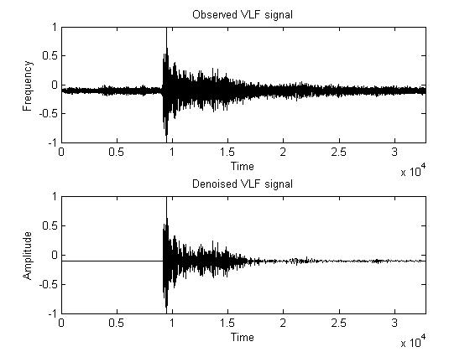
Figure 7: Waveform of VLF Signal (Whistler) observed by DEMETER satellite (Upper panel) and Denoised signal (Lower panel)
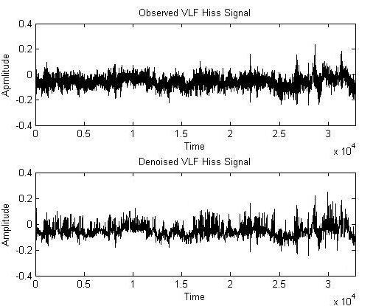

Figure 8: Waveform of VLF Signal (Hiss) observed by DEMETER satellite (Upper panel) and Denoised signal (Lower panel)
- Signal to Noise Ratio (SNR)
SNR is a very popular and effective method in signal processing. SNR is used to quantify how much the signal has been corrupted by noise. It is defined as the ratio of signal power to noise power of corresponding signal. Analytically it is given by:
$SNR=10\log_{10}\left(\frac{P_{signal}}{P_{noise}}\right)=P_{signal}-P_{Noise}\left(indb\right)$ $\left(31\right)$
Denoising is successful when post SNR is higher than the pre SNR values [18]. Results shows that for VLF whistlers post SNR is high as compare to pre SNR.

- Crest Factor (CF)
It is the measurement of waveform of signal calculated from the peak amplitude of the waveform divided by the RMS value of the waveform [19]:
$CF=\frac{{\left|x\right|}_{peak}}{x_{rms}}$ $(32)$
Where ${\left|x\right|}_{peak}=$amplitude of waveform
$x_{rms}=$RMS value of waveform

Table 1: Performance of algorithm for VLF Whistlers

Signal | Nos of Sample | SNR (in db) | Creast Factor
Observed | 32768 | 11.89 | 8.21756
Denoised | 32768 | 12.73 | 8.23699

Table 2: Performance of algorithm for VLF Hiss

Signal | Nos of Sample | SNR (in db) | Creast Factor
Observed | 32768 | 22.5667 | 3.3571
Denoised | 32768 | 25.004 | 3.2154

Visual analysis
For the visual analysis of observed and denoised signals spectrogram are used in this work. Spectrograms are the visual representation of signal in time-frequency plane. The spectrogram of observed and denoised VLF whistlers and hiss are depicted in Figure 9 and Figure 10. It needs to mention that proposed algorithm not only provide improved value of SNR but also reveal the fine structure of transient.
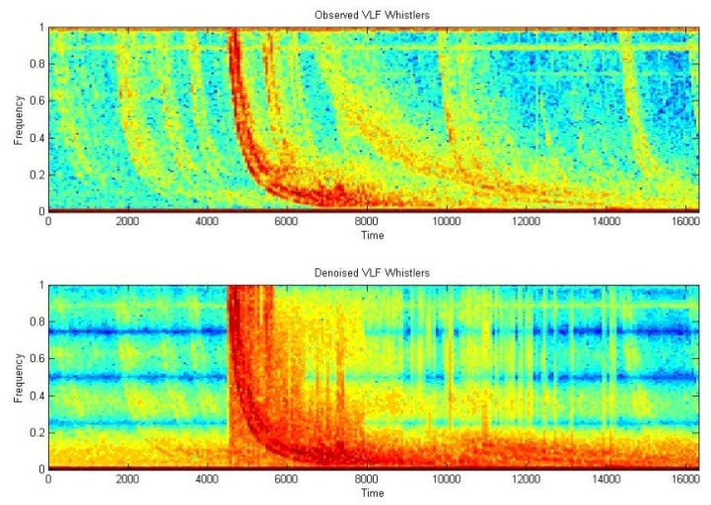
Figure 9: Spectogram of VLF Signal (Whistler) observed by DEMETER satellite (Upper panel) and Denoised signal (Lower panel)

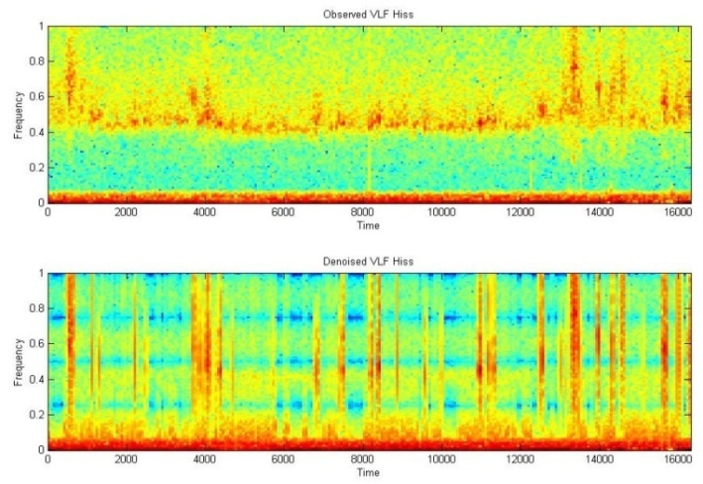
Figure 10: Spectogram of VLF Signal (Hiss) observed by DEMETER satellite (Upper panel) and Denoised signal (Lower panel)
X. Noise Reduction with Wavelet Based Compression Technique
Natarajan [20] developed a technique for the removal of random additive noise form signals. It does not require any prior knowledge of the signal or its noise characteristics which is very essential in traditional filtering technique. Natarajan [21] suggested that it is possible to use any compression technique for signal noise reduction. He used piecewise linear compression for these type of filtering. Jeffryes [22] described the method of seismic data compression. He achieved the data compression by splitting the data in to subsets and applying requantization level to those subsets which depends on a numbers representing the subset and on time. Kiely [23] use sub band coding for seismic data compression system. Huang [24] discuss scenario of using principle component analysis as a foundation for atmospheric data retained and compression of uncelebrated and non-normalized Interferograms. Stromberg et al., [25] used Low bit-rate efficient compression for seismic data. Hedstrom et al., [26] propose a scheme for data compression designed for Amplitude Modulated Signal Sideband (AM-SSB) speech signal Time-Frequency masking. An ideal signal compression system focuses on reducing the amount of redundant data while preserving the integrity of signals. In the last few years many signal compression technique based on wavelet transform have been developed [27] – [33]). In this section signal compression technique based on by level thresholding sometime known as level dependent thresholding is used. That method better suited for hardware implementation without compromising on performance.
Level Dependent Thresholding
The compression technique is derived from the Birge-Massart strategy [34]. This strategy is characterized by the three parameters; J the level of decomposition, M is the length of the coarsest approximation coefficients and $α$ which is always real and greater than 1.
The strategy is such that:
- At level $J_{0}+1$ (and coarser levels) everything is kept.
- For level $J$ from 1 to $J_{0}$, the $n_{J}$ larger coefficients in absolute value are kept using this formula:-
$${ n}_{J}=\frac{m}{{\left(J_{0}+1-J\right)}^{α}} (33)$$
The suggested value for $α$ is 1
Now, suppose that L denote the length of the coarsest approximation coefficients in the case of VLF transients. On the basis of value of L three different choices scarce high, medium and low are proposed for M for which M=L, M = 1.5*L and M = 2*L respectively.
Balance Sparsity-Norm.
Let c denote all the detail coefficients; two curves are built associating for each possible threshold value t, two percentages:
- The 2-norm recovery in percentage
- The relative sparsity in percentage obtained from the compressed VLF
transient by setting to 0 the coefficients less than t in absolute value
A default is provided for the 1-D case taking t such that the two percentages are equal.
Remove Near 0.
Let c denote the detail coefficients at level 1 obtained from the decomposition of the VLF transients to be compressed, using db1. The threshold value is set to median (abs(c)) or to 0.05*max(abs(c)), if median(abs(c)) = 0.
XI. Proposed Algorithm Using By-Level Wavelet Thresholding for Noise Reduction and Compression
The system used for signal compression is depicted in Figure 10. Implementation of this compress algorithm involves three main steps:-
- Wavelet Decomposition
- Thresholding the detail coefficient
- Reconstruction
VLF whistler and hiss has been observed by DEMETER satellite during Sep, 2009 at Indonesia. The waveform of these signals with their compressed signal is shown in Figure 11 and Figure 12.

Observed VLF Signal
Normalization of Observed VLF signal
Wavelet Decomposition of VLF signal
Wavelet Threshold (By-Level thresholding)
Inverse Wavelet transform of VLF signal
Output VLF signal

Figure 11: Block diagram of VLF signal Noise reduction and compression
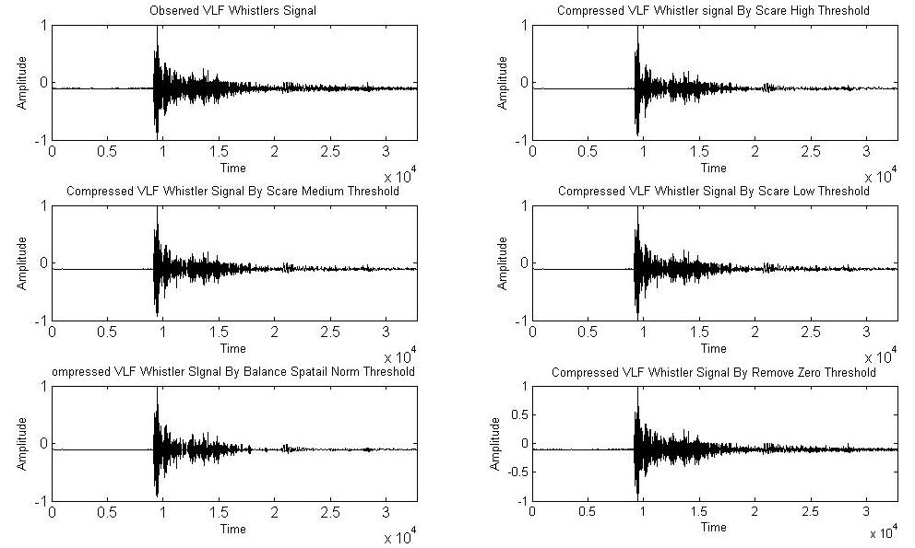
Figure 12: Waveform of observed and Compressed VLF Whistlers signal

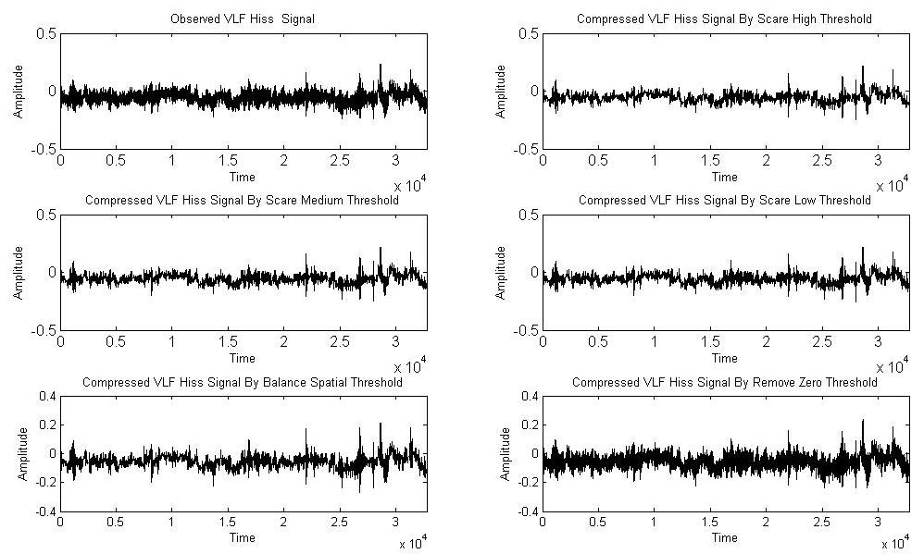

Figure 13: Waveform of observed and Compressed VLF Hiss signal

Compressed versions of transients are obtained using “db1” mother wavelet and 50000 numbers of samples. In compression process obtained signal are audible and we can still recognized these signals by hearing. During the compression process different thresholding such as Scare high (SH), Scare Medium (SM), Scare Low (SL), Balance Spatial Norm (BSN) and Near Zero (NZ) method are applied and tested over a large number of observed signals. At this stage required truncate coefficients are obtained and used to reconstruct the signal. Different results were obtained allowing efficient evaluations and comparisons of the used methods and parameters.
XII. Performance Analysis of Proposed Noise Reduction Algorithm Based on Level Thresholding
To test the performance of proposed algorithm percentage of zeros (% Z) and percentage of energy retained (% ER) are also calculated with SNR and CF for every observed and compressed signal. The results are summarized in Table 3 and Table 4.
Table 3: Performance of Level dependent Thresholding for VLF Whistlers signal

Signal | Thresholding | % E.R. | Nos of Zeros | SNR | CF
Observed | - | - | - | 14.42 | 14.14
Compressed | SH | 72.29 | 94.29% | 15.03 | 14.14
Compressed | SM | 78.08 | 92.99% | 14.55 | 13.16
Compressed | SL | 82.50 | 91.70% | 14.35 | 13.25
Compressed | BSN | 91.15 | 91.80% | 13.79 | 12.56
Compressed | NZ | 99.97 | 99.97% | 14.43 | 12.01

Table 4: Performance of Level dependent Thresholding for VLF Hiss signal

Signal | Thresholding | % E.R. | Nos of Zeros | SNR | CF
Observed | - | - | - | 24.39 | 4.27
Compressed | SH | 72.29% | 94.29% | 24.99 | 4.24
Compressed | SM | 78.08% | 92.99% | 24.90 | 4.22
Compressed | SL | 82.50% | 91.70% | 24.80 | 4.27
Compressed | BSN | 91.15% | 91.80% | 24.04 | 4.12
Compressed | NZ | 99.97% | 99.97% | 24.13 | 4.11

In the proposed algorithm thresholding is applied on each wavelet coefficient individually. We retained maximum $99.97\%$ and minimum $72.00\%$ of signal energy using the different thresholding methods. Most of the coefficients shows high retained energy and enhanced SNR values. An enhanced SNR value shows the enhancement in signal quality; hence it is also possible to remove the unwanted noise form signal using compression technique. The value of C.F. is approximately same in most of the cases except scare high method.
XIII. Conclusion
In this chapter two different algorithm based on wavelet thresholding were proposed for the noise reduction and compression of VLF signal observed by DEMETER satellite. For this purpose soft thresholding is used. It is found that the underlying set of wavelet coefficient describing the observed signal excites the Gibbs phenomena which demands stability of representation. To maintain the stability of representation translation invariant denoising is used. Proposed denoising algorithm is depends on resolution hence to increased the resolution level chosen threshold function must be changed. No further enhancements were achieved beyond level of decomposition 5. The algorithm is particularly more important when signal contains the same variation pattern like VLF Hiss. It also provides more detail picture of Whistlers transients.
We test the performance of our algorithm over two type of VLF signal (Whistlers, Hiss), but it can be easily extended to other type of VLF signals. A slight modification of constraint may also be performed in order to achieve restoration of VLF signal that have been compared within an orthogonal basis.
REFERENCES
[1] S. Umbaugh, “Computer Vision and Image Processing.” Prentice Hall, PTR, New Jersey, 1998
[2] K. Toyamu, K. Krumm, B. Brumitt and B. Meyers, “Wallflower: Principles and practice of background maintenance”, Computer vision, The proceeding of seventh IEEE international conference, 1999.
[3] D. L. Donoho, ”De-noising by Soft Thresholding”, Technical Report no.409, Stanford University, December 1992.
[4] J. Karam and R. Saad, “The Effect of Different Compression Schemes on Speech Signals”, International Journal of Biological and Life Sciences 1:4, 2005.
[5] S.G. Mallat and W.L. Hwang, “Singularity Detection and Processing with Wavelets”, IEEE Transactions on Information Theory, vol. 38, 1992, pp. 617–643.
[6] M.G.E. Schneiders, “Wavelets in control engineering”, Master’s thesis, Eindhoven University of Technology, 2001.
[7] G. Strang and T. Hguyen. “Wavelets and Filter Banks”, Wellesley-Cambridge Press, second edition, 1997.
[8] B. D. Kraker, “A numerical-experimental approach in structural dynamics”, Technical report, Eindhoven University of Technology, Department of Mechanical Engineering, 2000.
[9] I. Daubechies, “Ten lectures on wavelets”, Society for industrial and Applied Mathematics , PA, 1992.
[10] P.S. Addison, “The Illustrated Wavelet Transform Handbook”, IOP Publishing Ltd, 2002.
[11] D. Donoho and I. Jonhstone, “Ideal Spatial Adaptation by Wavelet Shrinkage”, Biometrika, Journal of the American Statistical Association, Vol. 81, issue 3, 1994, pp.425-455.
[12] M. Leadbetter, G. Lindgren and H. Rootzen, “Extremes and Related properties of random sequences and Process”, Speinger-verlag, New York, 1983.
[13] D. Donoho and I. Johnstonne, “Adapting to Unknown Smoothness via Wavelet Shrinkage”, Vol. 90, 1200-1244, 1995.
[14] C. Stein, “Estimation of the Mean of a Multivariate Normal Distribution”, Annals of Statistics, vol. 9, 1981, pp. 1135-1151.
[15] A. Bruce, H. Gao and Waveshrink, “Shrinkage Functions and thresholds”, Technical Report, Statsci Division of Mathsoft, Inc, 1995.
[16] R. Coifman and D. Donoho, “Translational-Invariant Denoising”, Internal Report, Department of Statistics, Stanford University, 1995.
[17] C.S. Buckheit, D. Donoho and J. Scargle, “Wavelab.700”, http://www.wavelab/playfair.stanford.edu, 1996.
[18] S. Mallat, “A Wavelet Tour of Signal Processing: The Sparse Way”, Academic Press, 2008.
[19] P.D. Hill, B.W.V Lee, J.S. Osborne, E.L. Osman, “Palatal snoring identified by acoustic crest factor analysis", PHYSL MEAS, vol. 20, issue 2, 1999, pp. 167-174.
[20] B.K. Natarajan, “Filtering random noise via data compression”, Proceeding IEEE Data Compression Conf., Snowbird, Utah, 1993, pp. 60-69.
[21] B. Natarajan, “A General Technique for Filtering Random Noise”, Computer Systems Laboratory, 1994.
[22] B.P. Jefryes, “Data compression for Seismic Signal data” United States patent, patent number 593370. 3,1999.
[23] A. Kiely and F. Pollara, “Subband Coding Methods for Seismic Data Compression”, DCC, 1995.
[25] J.O. Stromberg, R. Coifman, A. Vassiliou, A.Z. Averbuch and F. Meyer, “Low bit-rate efficient compression for seismic data”, IEEE transactions on image processing, vol. 10, issue 12, 2001, pp. 1801-1814.
[25] P. Hedström and J. Arbring, and J.M. Johansson, “Data Compression using Time-Frequency masking for TDOA localization of Radio Transmitters” RF Measurement Technology Conference, Gävle, Sweden, 2011.
[24] Z. Huang, “3D Laser holographic interferometry measurements”, Phd thesis, The University of Michigan, 2006
[27] J. Chen, S. Itoh and T. Hashimoto, “ECG data compression by using wavelet transform” IEICE Trans. Inform. Syst. Vol. E76-D, issue 12, 1993, pp.1454–1461.
[28] Y. Xu, J.B. Weaver, M. Denni, J. Healy and L.U. Jian, “Wavelet Transform Domain Filters: A Spatially Selective Noise Filtration Technique”, IEEE Transactions on Image processing, vol. 3, 1994.
[29] Y.K. Sun, “Wavelet Transform and its Applications”, China Machine Press, Beijing, 1998, pp. 219-244. (in Chinese).
[30] B.A. Rajoub, An efficient coding algorithm for the compression of ECG signals using the wavelet transform. IEEE Transactions on Biomedical Engineering, vol. 49, issue 4, 2002, pp. 355–362.
[31] S. Sunjay “High Performance Computation by Graphics Processor Unit Technology for Geophysical Seismic Signal Processing”, Search and Discovery Article, 4072, 2011.
[31] I.B. Ciocoiu, “ECG Signal Compression Using 2D Wavelet Foveation”, International Journal of Advanced Science and Technology, Vol. 13, 2009.
[33] J. Jing, M. Lidong, J. Shijin, J. Lin, “A Signal Denoise Algorithm based on Wavelet transform” American Journal of Engineering and Technology Research, vol. 11, issue 9, 2011.
[34] J. Karam and R. Saad, “The Effect of Different Compression Schemes on Speech Signals”, Inter-national Journal of Biomedical Sciences, vol. 1, issue 4, 2006, pp. 230-234.
[34] J. Karam, “A Global Threshold Wavelet-Based Scheme for Speech Recognition”, Third International conference on Computer Science, Software Engineering Information Technology, E-Business and Applications, Cairo, Egypt, Dec. 27-29, 2004.

