Green synthesis of nanoparticles

Garima Choudhary1, Nikita Sharma1 and H.L.Singh1

1Department of Chemistry , School of Liberal Arts and Sciences, Mody University of Science and Technology, Lakshmangarh, Sikar 332311, Rajasthan, India.

Author/s email addresses: [**garimachoudharymanjhu@gmail.com**](mailto:garimachoudharymanjhu@gmail.com)

1. ABSTRACT

2. INTRODUCTION

3. GENERAL PROCEDURE

4. SPECTRAL STUDIES

5. FUTURE SCOPE

1. **ABSTRACT**

Green nanoparticle producing using biological systems, particularly plant extracts, is a growing subject in nanotechnology. Synthetic concoctions and physical tactics have been in use for many years, the recognition of their hazardous effects on human well being and condition has affected significant global views for the scholars. Green synthesis is now in use very large scale. Present time green synthesis of nanoparticles with the help of plant extracts and their metabolites is held in large criteria. The main target of Green synthesis of nanoparticles is to minimize the waste and toxic harmful products. Green synthesis is an environmental friendly synthesis. In this study, silver nanoparticles were studied using ginger extract and one silver salt (silver nitrate) as a precursor. As well as, cobalt nanoparticles were studied using neem (azadirachtaindica) leaves extract and cobalt chloride as a precursor, we were also studied palladium nanoparticles using curry leaves extract. The synthesized nanoparticles were characterized by their melting points, ultraviolet-visible spectroscopy (UV-Vis) and infrared spectroscopy (IR).

**2. INTRODUCTION**

Nanotechnology is an associative area which specially covers with the creation of nanoparticles. The area of nanotechnology is topmost working research field in contemporary science. In other words particles with a size are less than hundreds nanometer are mentioned to as nanoparticles. Microorganisms can also be making use of build nanoparticles [1]. Nanomaterials are showing variable physical, chemical and biological properties differentiate to their macro scale equivalents. Usually metal nanoparticles can be produced and balanced by various methods like physical and chemical methods [2].Nanotechnology clasps a favourable time ahead for the composition and expansion of countless new products that are used in too soon observation, cure and avoidance of many infections [3]. The uses of nanotechnology in medication and drugs and its development in it have transformed the 20th century. The nanotechnology is also known as nanomedicine [4].Nanoparticles are used in proton or radiation therapy for cancer cells inhibition and conservation of neighbouring well tissue. Nanoparticles are antiviral, antibacterial and antifungal mediums. Nanoparticles also used in bioimaging and molecular diagnosis [5].UC San Diego researchers are developing a method to collect and breakdown nanosized exosomes in order to look for biomarkers. Specialists at UC San Diego are putting up a pancreatic disease database. The main goal of medicine is to detect health problems early and provide appropriate treatment. Cancer, diabetes, depression and a slew of other disorders are all too frequent in today’s fast – paced world. Nanorobots and microchips are examples of nanotechnology. The majority of biosensors are used for diagnostic purposes.

Inflammation of the bones metal nanotechnology is the most recent development. These are also effective in formation of osteoblasts. These nanoparticles are extremely small particles. Nitric acid coated nanoparticles are one of the treatments that are used to treat skin infections. The protein thrombin has a direct interaction with FeO nanoparticles. Because it participants in the thrombin – antithrombin reaction, thrombin gives protection against antithrombin. Tissue repair is a procedure. Nanoparticles work in tendem and causing penetration of anti- inflammatory medicines through the skin. Nanotechnology is also significant in the treatment of cardiovascular and respiratory illnesses. Nanomaterials are being employed to enhance the function of the cardiac muscles. As a result carbon nanofibers encased in PLGA for a specific purpose and increase the size of the heart muscles [6].

Nanoparticles are also used in the agricultural issues and research.

* We will concentrate on reports of nanoparticles being used as plant nutrients and plants growing boosters; enhance bacterial growth and transporters of standard drugs. Silver, cobalt, magnisium, palladium and mamy nanoparticles are used as a pesticides and fertilizers [7]. When we will use to minimum chemicals for the agricultural issues, we will pretend the environment from harmful chemicals that’s reason nanoparticles should be used in agriculture [8]. Nanoparticles are used in cosmetics because smaller size of nanoparticles these are very simply entering in blood capillaries with the help of epidermis [9].Nanoparticles are used in cosmetics because nanoparticles give extra stability and sensible properties. For example – zinc oxide nanoparticle are used in sunscreen creams. Silver nanoparticles are used in cosmetics because these are an antimicrobial agents [10].The COVID 19 epidemic necessitates a thorough examination of existing nanotechnologies. Nanotechnology efforts to producing vaccinations and treatments for the devastating pandemic remain insufficient. As a goal of current status of nanotechnology in the manufacturing of medicines and vaccines [11].Due to the high prices and virulent of physical and chemical processes, the need for green nanoparticle manufacturing has skyrocketed. As a result, in quest of less expensive options, researchers have begun to use biotic parts in their studies for example microbes, organic molecules, plants and plants – derived compounds that serve as eliminator agents [12]. Due to small size nanoparticles are used as a catalyst. Although a huge number of effective high temperature methods were established over the twentieth century, a substantial section of the old heterogeneous catalysis group is now included into the nanoparticle group [13]. Gold containing nanoparticles are used to as heterogeneous catalysts [14]. Nanoparticles are used in organic synthesis as a catalyst, example – hydrogenation and coupling reactions of carbon – carbon [15]. Silver nanoparticle possess Antitumour[16], Antibacterial [16], Antimicrobial[17], Drug delivery[18], Cancer treatments[18], Optical receptors [18].Similarly Cobalt nanoparticle possess Antibacterial [19]and Cytotoxic activity [19].Palladium nanoparticles are found to be very much effective against toxic azo dyes[20] and shows Antibacterial[20] as well as Antifungal properties[20]

**3. General procedure for the synthesis of NPs**:

In the natural environment various processes are available for the synthesis of nano and micro-scaled materials that have contributed to the development of this relatively new and largely unexplored area of research on the biosynthesis of nanoparticles. All the green materials like – neem, ginger and curry leaves are natural and freshly. Reagents were obtained from commercial suppliers and were not purified. The reactions were monitored by TLC. UV and IR spectra were recorded by UV and IR spectrometer.

* 1. :- Silver nanoparticles:- [Complete process is showing in Figure 3.1]
* 60 grams of ginger extract is taken.
* 60 grams of ginger extract add 300 ml of distilled water.
* Boil at 80 degree Celsius for 2 hours on water bath until it reduces to half.
* Prepare a solution of silver nitrate in 0.1 gm solution (kept overnight).
* Add silver nitrate solution in Ginger extract in 1:4, and kept on megnaticstirr for 2 hours. The colour of solution is changed.
* Kept this solution overnight.
* This mixture is kept overnight will now centrifuged.
* Then finally washed with ethanol and kept in oven for drying. The progress of process was monitored by TLC.
* Colour of extract – light yellow
* Colour of solution – light pink
* Colour of final mixture solution – dark brown

3.2:- Cobalt nanoparticles:-

* 40 grams of freshly cut neem leaves taken.
* 40 grams of leaves add 200 ml distilled water.
* Boil at 80 degree Celsius for 2 hours on water bath until it reduces to half.
* Prepare a solution of cobalt chloride in 0.03114 grams solution (kept overnight)
* Add cobalt chloride solution in neem leaves extract in 1:4 ratio we have to taken , and kept on megnaticstirr for 2 hours
* Kept this solution overnight
* This mixture is kept overnight will now centrifuged.
* Then finally washed with ethanol and kept in oven for drying.
* After drying, we got the cobalt nanoparticles.
* The progress of process is monitored by TLC.

3.3:- Palladium nanoparticles:-

* 10 grams of freshly cut curry leaves taken.
* 10 grams of leaves add 50 ml distilled water.
* Boil at 80 degree Celsius for 2 hours on water bath until it reduces to half.
* Prepare a solution of palladium chloride in 0.1 M solution.(kept overnight)
* Add palladium chloride solution in curry leaves extract in 1:1 ratio
* Kept this solution overnight.
* The mixture is kept overnight will now centrifuged
* Then finally washed with ethanol and kept in oven for drying.
* The progress of process was monitored by TLC.

Then finally we got the palladium nanoparticles.

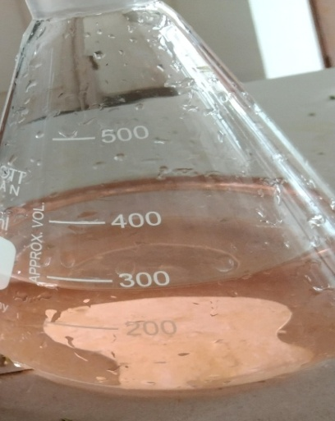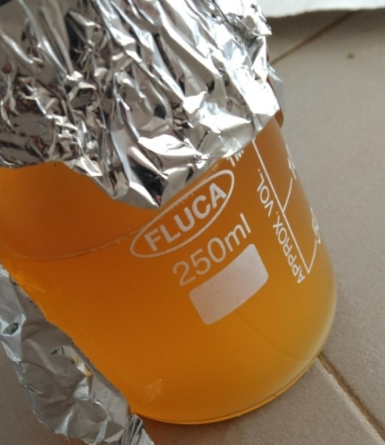

3.1(a). 3.1(b)

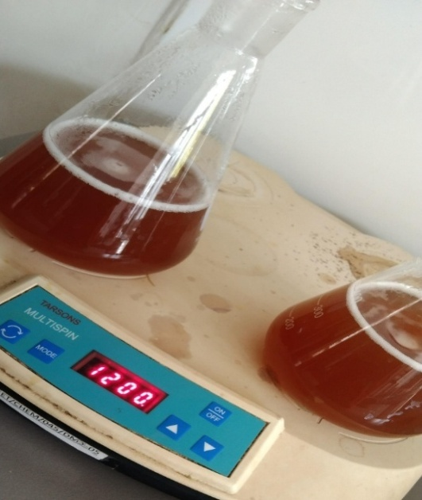

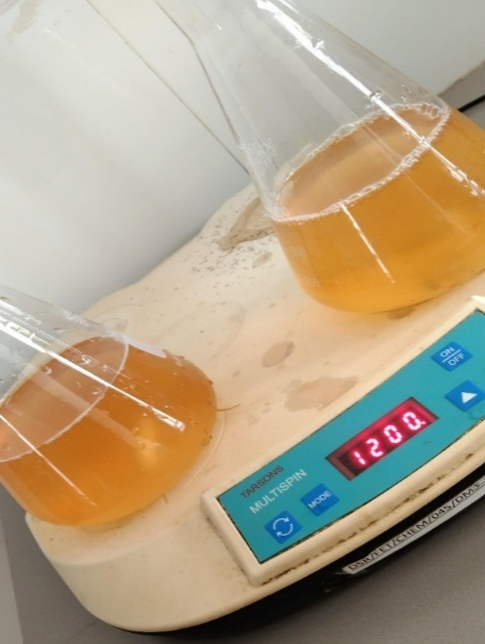3.1(c) 3.1(d)

Fig.3.1 Silver nanoparticle process

**4. SPECTRAL STUDIES**

The spectroscopic characterization data of Palladium, cobalt and silver NPs are given below:

**1. Palladiun NPs**

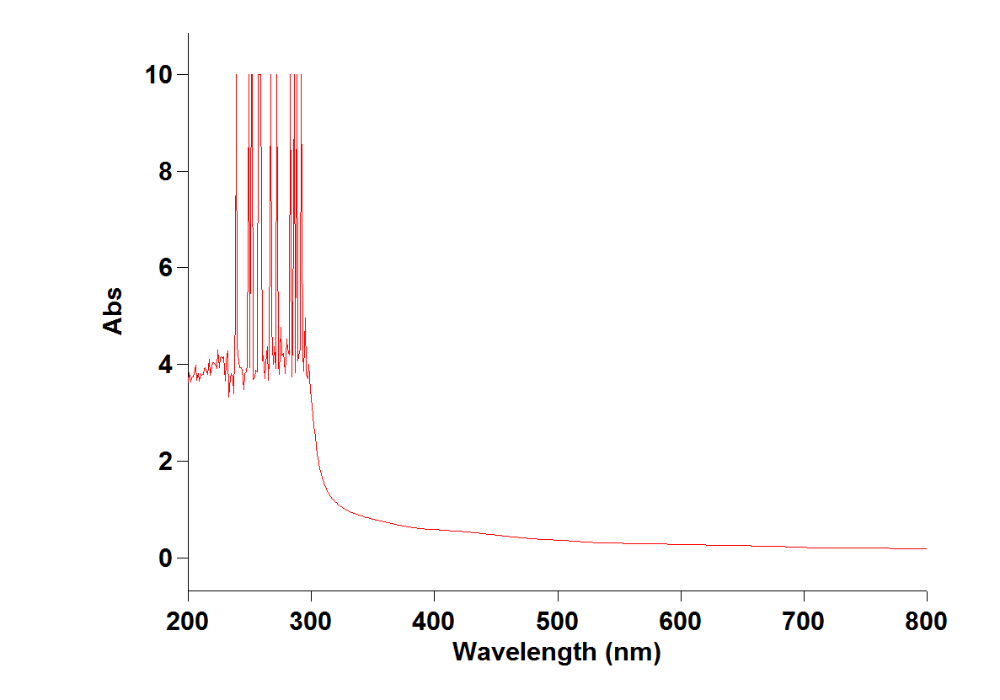

**Figure 4.1(a): UV-visible spectrum of Palladium Nanoparticles**



**Figure 4.1(b): IR Spectrum of Palladium Nanoparticles**

**2. Cobalt NPs**

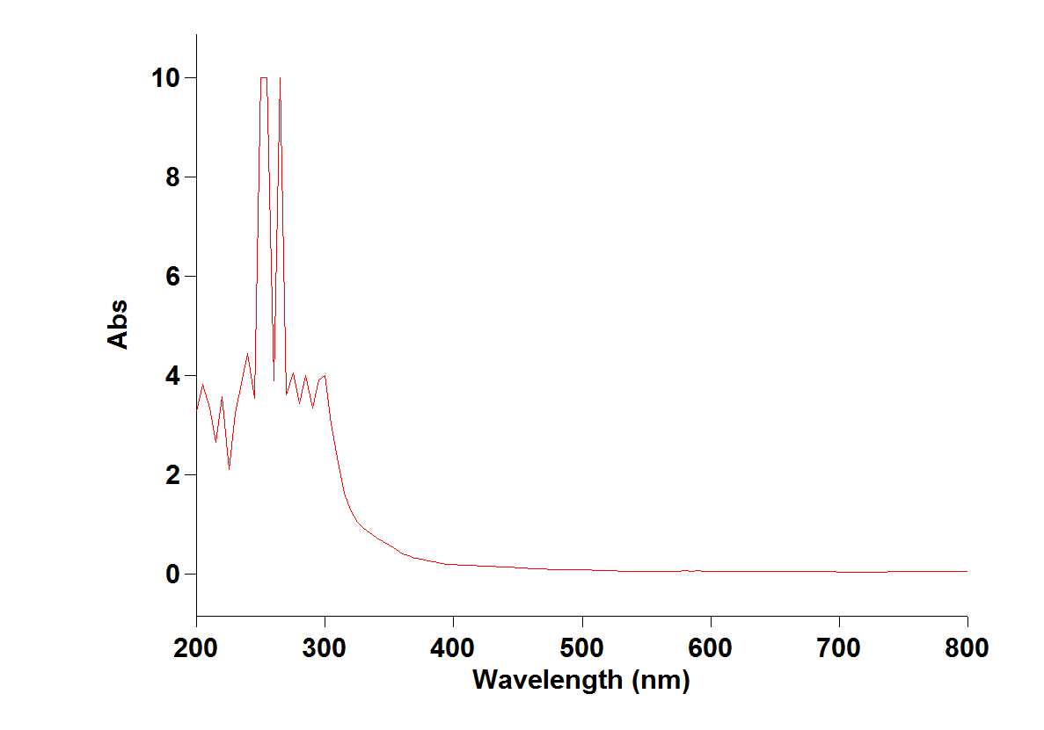

**Figure 4.2(a): UV-visible spectrum of Cobalt Nanoparticles**



**Figure 4.2(b): IR Spectrum of Cobalt Nanoparticles**

**3. Silver NPs**

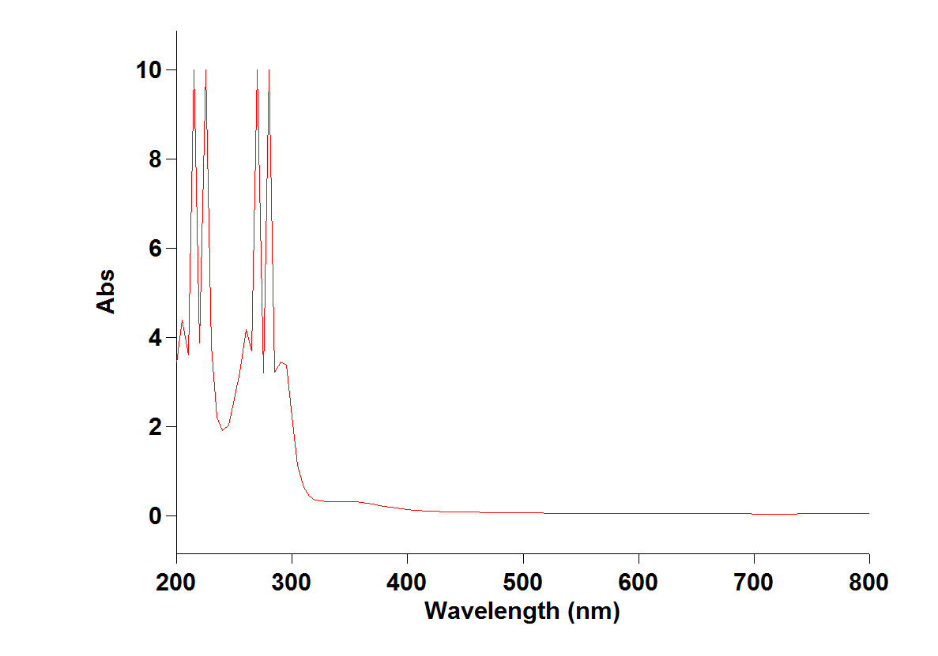

**Figure 4.3(a): UV-visible spectrum of Silver Nanoparticles**



**Figure 4.3(b): UV-visible spectrum of Silver Nanoparticles**

**5. FUTURE SCOPE**

Green synthesis of nanoparticles from natural substances is emerging as an important area in nanotechnology. The use of natural resources for production of nanoparticles is sustainable, eco-friendly, inexpensive and free of chemical contaminants for the biological, medical, agricultural and many applications where purity of nanoparticles is of major concern. Useful and common nanomaterials can be produced on large scale. The green methods do not need harsh or toxic chemicals. The waste product of palnt extracts are non toxic and easier to dispose off. Furthermore, nanoparticles synthesized via green route are more stable and effective in comparison with these produced by physico- chemical methods. The majority of greener synthetic efforts reported earlier and dedicated to Ag and palladium nanoparticles, which may be due to their importance in disinfection science. This report devoted to several other metals and its oxides by viz. PdCl2, AgNO3 and CoCl2 nanoparticles synthesized by green methods which have imperative roles in human welfare. The most of these investigations have been carried out in research laboratories in small scale and researchers are engaged to explore the potential and applications of nanoparticles at large scale in agricultural field, medical and environment and many more to fulfil the future demands of growing population of world and to provide best services for human welfare.

Our present work brings forth a novel method for the synthesis of Schiff bases using microwave irradiation which offers significant improvements over existing conventional procedures. This simple technique affords various schiff base derivatives with short reaction times, excellent yields and without formation of undesirable side products.

**REFERENCES :-**

[1] Girish K, Article in Asian journal of pharmaceutical and clinical research: March 2018

[2] Virender K Sharma, Ria A, Yngard, Yekaterina Lin, Advances in colloidal and interface science 145(2009)83-96

[3] ThanaaI.Shalabh, Ola A. Mahmoud, GihanA.ElBatouti, EbtihagE.Ibrahim. 2015, 5(2):23-29

[4] UmamaYezdani, MohdGayoor Khan, NileshKushwoh, Arvind Verma, Fezal Khan, World journal of pharmacy and pharmaceutical sciences 7(11):1612-1633(2018)

[5] Barros Z Klebouiski, Joanna Depciuch, MaglalenaParlinska–Wojtan and JarwkBaran, International journal of molecular sciences. Int.J.Mol.Sci.2018, 19, 4031

[6] MuneezaMuneer, Shahzad Sharif Mughal , SumairaPervez , Maryam Mushtaq , NageenaShabbir , Asma Aslam , Ali Raza Ayub , SaquibShafique ,Faheem Abbas , The international journal of global sciences (Tijogs).ISSN print :2663-0141 : ISSN online .2663- 015x

[7] Yuri.SPestovsky and Agustino Martinez – Antonio, American scientific publishers (ASP). Vol.17, 8699-8730, 2017

[8]RaghvendraPratap Singh, Rahul Handa, Geetanjali Manchanda, Elsevier journal of controlled release .volume 329, 10 January 2021, pages 1234-1248

[9]Silpa Raj, Shoma Jose, U.S Sumod and M.Savitha, journal of pharmacy and Bioapplied sciences J.pharmBioapplied Sci.2012jul- Sep; 4131: 186-193

[10]Swati Gajbhiye, Satish Sakharwade, Vol.6, no.1, March 2016

[11] Mohammed Ali Dheyab, Pegah Moradi , Khaniabadi, Azlan Abdul Aziz , Mahmood S.Jameel , BaharakMehrdel , Ammar A.Oglat and Hawraa Ali Khaleel. Photodiagnosisphotodyn 2021 Jun; 34: 102287

[12] TejaswiThunugunta, Anand C Reddy, Lakshman Reddy DC, Green synthesis of nanoparticles: current prospectus Doi: 10.1515/ntrev- 2015- 0023

[13] Didier Astruc. ACS publications, cit this: chem.Rev. 2020, 120, 2, 461-463

[14]Meenakshi Sundaram Sankar. ACS publications .cite this – chem Rev.2020, 120, 3890-3938

[15] Didier Astruc, Jaime Ruiz Aranzaes.Angewandtechemie International edition/Volume 44, issue 481 p. 7852-7872 (2005)<https://doi.org/10.1002/anie.200500766>

[16] K.praveen Kumar, Willi Paul, Chndra P.Sharma. Article in Journal of Biosciences September 2012

[17]Palanivel Velmurgan , Krishnan Anbalagan , Min Cho ,Sang-Myeong Lee, Jung – Hee Park See-Gang Oh, Keuk-Soo Bang, Byung-Taek Oh . Published – 26March 2014

[18] Jagpreet Singh , Tanushree Dutta, Ki- Hyun Kim ,MohitRawat , PallabiSamddar and Pawan Kumar .journal of nanotechnology

[19] Rama Koyyati, Kurunakar Rao Kudle and Pratap Rudra Manthur Padigya. Vol.9, no.3, p 466-472, 2016

[20]Sapana Jadoun, RizwanArif, Nirmala Kumari Jangid, Rajesh Kumar Meena.Environmental Chemistry Letters 13 August 2020.