Innovative Applications with IoT for
Smart-Home Applications

Mrs M. Amitha,
Asst. Professor,
Dept. of Computer Science
Bhavan’s Vivekananda College,
Secunderabad, Telangana, India
maramamitha@gmail.com

Abstract
Smart homes have evolved from electromechanical to the centralized and semi-automated control of environmental systems, whereas Internet-of-Things (IoT) is the expansion to these with internet services. IoT has become an integral part of the home and uses of new technologies in IoT environment are increasing rapidly. Smart Homes in IoT environment or IoT based Smart Homes are those, wherein household devices/home appliances which are connected with the internet using proper network architecture and standard protocols are monitored and controlled remotely.
Here, in this article, I would like to present IoT based solutions for automatic water supply for the plants, App based smart door lock system for the home security and App based home electrical appliance control system.

Keywords— Smart home, Internet-of-Things (IoT), Arduino.

INTRODUCTION
Sensor based water supply control for the plants is an IoT solution where we can save water, electrical energy and time for supplying the water to the home garden, in this solution I used Soil Moisture sensor, Arduino as the controller and a relay module as a pump driver. The Arduino code is written in such a way that the IoT device senses the moisture level and will activate the driver to start the pump for watering the plant; driver will be deactivated automatically when the moisture reaches the predefined level.
App based smart door lock system for the home security is a Wireless signal based IoT solution where we can lock and unlock the door by using a Mobile App. IoT device has been programmed in such a way that the App communicates with the IoT device over the Bluetooth and sends the lock/unlock signals and energizes and de-energizes door lock actuator.
App based home electrical appliance control system is wireless signal based IoT solution where we can control and automate the electrical appliances such as Lights and Fans by using a Mobile App. IoT device has been coded in such a way that the App communicates over the Bluetooth and sends the ON/OFF signals activates/de-activates the device driver to control the appliance.

- IoT and Control modules used
- Arduino Uno board for the IoT programming
Arduino is an open source electronics prototyping platform based on flexible, easy-to-use hardware and software. It is intended for hobbyists or anyone interested in creating interactive objects or environments.
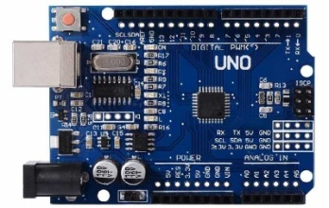

Fig: 1.Arduino Uno

- Soil moisture sensor
Soil moisture sensor measures the volumetric water content in soil. Reflected microwave radiation is affected by the soil moisture and is used for remote sensing in agriculture. These sensors measure the volumetric water content indirectly using properties like electrical resistance, dielectric constant or interaction with neutrons as proxy for moisture content.

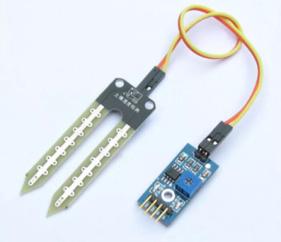

Fig:2. Soil moisture sensors

- Relay Module
Relays are switches that open and close circuits electromechanically or electronically. Relays control one electrical circuit by opening and closing contacts in another circuit. It is mainly used to control a high powered circuit using a low power signal.

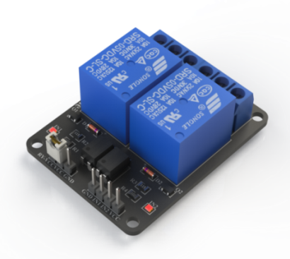

Fig:3. Relay Module

- Bluetooth module(HC-05)
Bluetooth module used in this project is HC-05, which supports master and slave mode serial communication (9600-115200 bps) SPP and UART interface. Using these features it can communicate with other Bluetooth-enabled devices like mobile phones, tablets and laptops. The module runs on 3.3V to 5V power supply.

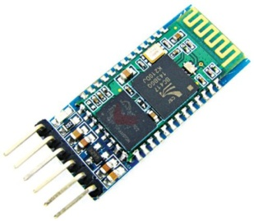

Fig:4. Bluetooth Module(HC-05)

- Servo Motor
Servos have integrated gears and a shaft that can be precisely controlled. Standard servos allow the shaft to be positioned at various angles, usually between 0 and 180 degrees. Continuous rotation servos allow the rotation of the shaft to be set to various speeds.

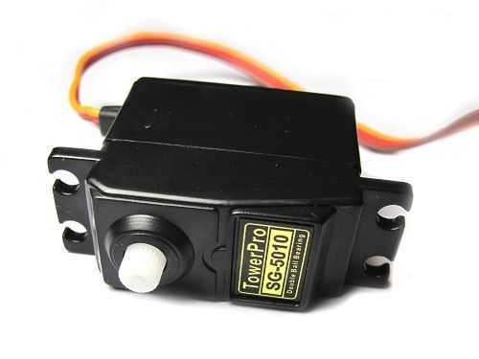
Servo motors have three wires: power, ground, and signal. The power wire is typically red, and should be connected to the 5V pin on the Arduino board. The ground wire is typically black or brown and should be connected to a ground pin on the Arduino board. The signal pin is typically yellow, orange or white and should be connected to a digital pin on the Arduino board.

Fig: 5. Servo Motor

- Water supply control for the plants is a sensor based IoT solution

Components Used
Hardware-
- Arduino UNO
- Relay Module (Pump Driver)
- Soil moisture sensor
- Submersible water pump

SOFTWARE:
Open source Arduino IDE.

Principle of working :

Principle behind working of this project lies in the functioning of soil moisture sensor. We are using a sensor to know whether the soil is dry or wet. In semi state , the submersible pump is connected to the relay as output such that if the sensor is dry the pump waters the soil until and unless the sensor is externally removed. In auto state , the
submersible pump is connected to the relay as output in such a way that even if the sensor is wet , the pump goes into off mode automatically as time duration is declared. The state of sensor is changed using a switch.

Circuit Diagram:

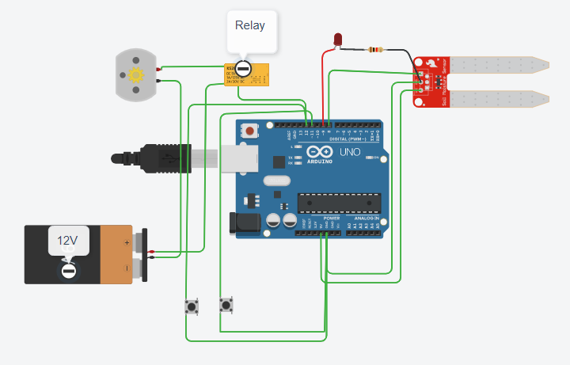

CODE for the IoT

int waterpump = 12;
int sensor = 8;
int ledPin = 9;
int switchPin_semi=11;
int switchPin_auto=10;
int val;
int semival;
int autoval;
int pumpStatus=0;
oid setup() {
Serial.begin(9600);
pinMode(12, OUTPUT);
pinMode(8, INPUT);
pinMode(9,OUTPUT);
pinMode(switchPin_semi,INPUT_PULLUP);
pinMode(switchPin_auto,INPUT_PULLUP);
}
void loop() {
val =digitalRead(8);
semival=digitalRead(11);
autoval=digitalRead(10);
if(val==1 && pumpStatus==0)
{
digitalWrite(12, LOW);
pumpStatus=1;
digitalWrite(9,HIGH);
}

if(semival==LOW && pumpStatus==1)
{
if(val==0)
{
digitalWrite(12,HIGH);
pumpStatus=0;
digitalWrite(9,HIGH);
}
}
else if(autoval == LOW && pumpStatus==1)
{

delay(10000);
digitalWrite(12, HIGH);
pumpStatus=1;
digitalWrite(9,HIGH);
}
Serial.println("Sensor " + String(val));
Serial.println("Pump status " + String(pumpStatus));
Serial.println("Switch auto " + String(autoval));
Serial.println("Switch semi " + String(semival));
delay(1000);
}

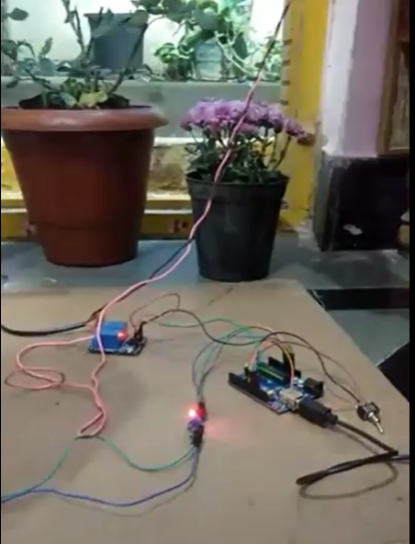

Fig : 6. Live Working Model

- App based smart door lock system for the home security
The modern design of smart homes has focused on smart controls and convert conventional switches to centralize control system. The smart home technologies have focused on networking (wiring and wireless systems), controlling (remote control, smart phones, and web browsers), and smart devices (green, energy consumption, security, environment, and entertainment).
An illustration of smart home technology is shown in the picture.
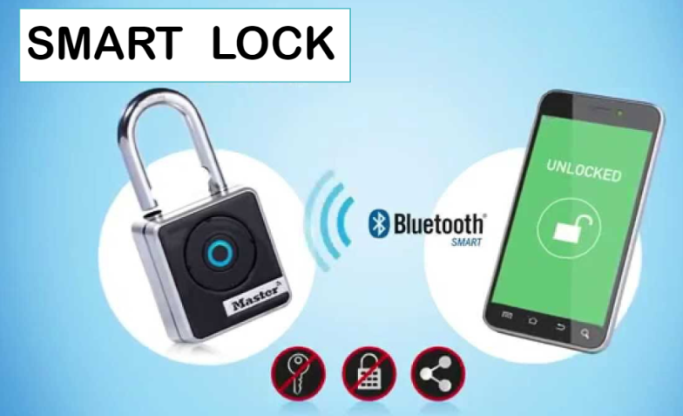

COMPONENTS USED
- Servo Motor
- Arduino UNO
- Bluetooth Module(HC-05)

Mobile App used:
- Bluetooth controller on/off

CIRCUIT DIAGRAM:

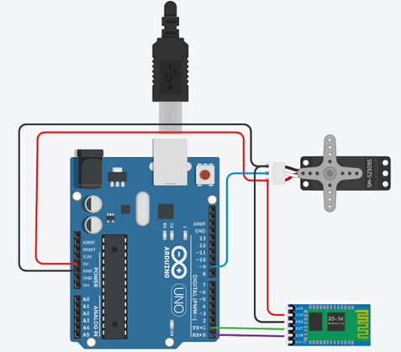

CODE for the IoT:
#include<Servo.h>
Servo myservo;
int state=0;
int lock=0;
void setup() {
Serial.begin(9600);
myservo.attach(9);
}
void loop() {
if (Serial.available()>0)
{
state=Serial.read();
Serial.print(state);
delay(1000);
if(state==0 && lock==1)
{
Serial.println("door is unlocked");
myservo.write(0);
lock=0;
}
else if(state==1 && lock==0)
{
Serial.println("door is locked");
{
Serial.println("door is unlocked");
myservo.write(0);
lock=0;
}
else if(state==1 && lock==0)
{
Serial.println("door is locked");
myservo.write(45);
lock=1;
}
}
}
myservo.write(45);
lock=1;
}
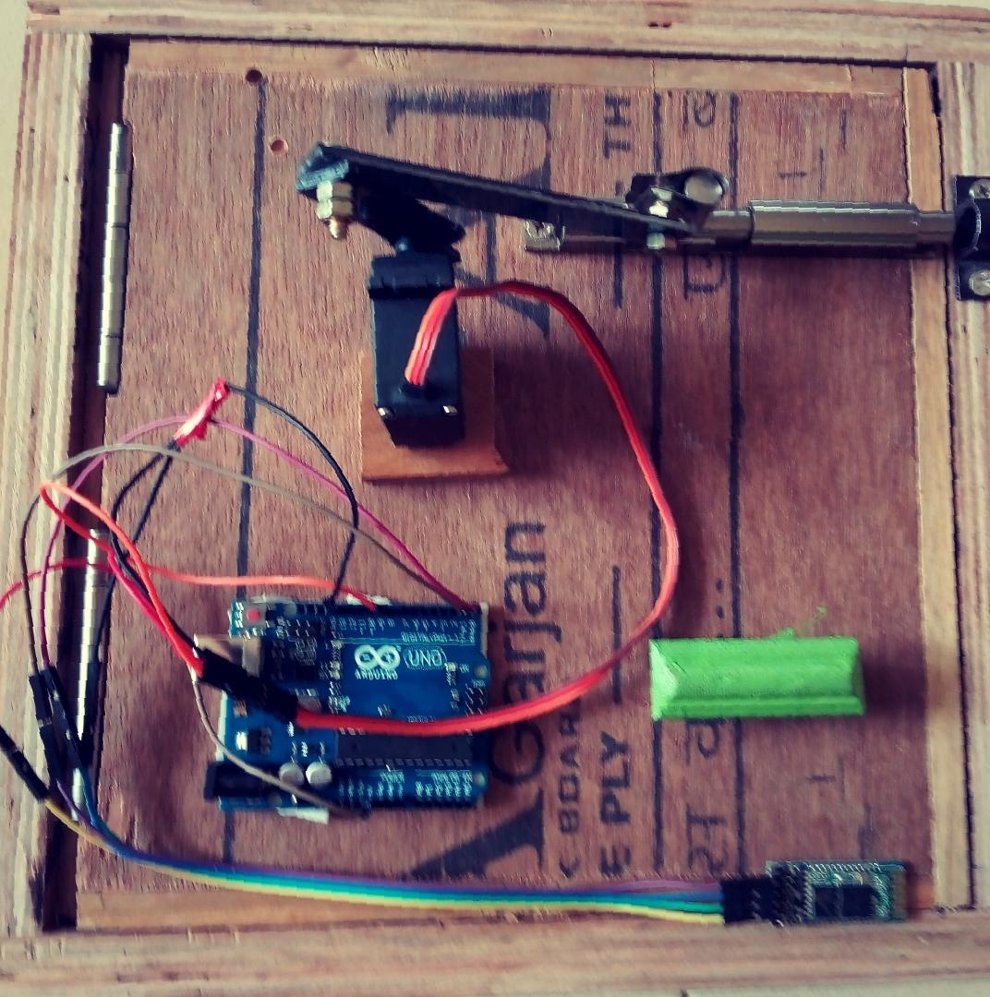
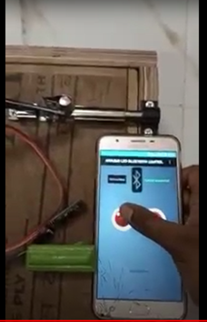

} Fig : 7. Live Working Model

FUTURE IMPLEMETATION OF SMART LOCK
This simple fingerprint door unlock project using Arduino can be very useful for door security, forensics, crime investigation, personal identification, attendance system and much more. In future, there could be many more applications like fingerprint based driving license, bank accounts operation and so on.
A key is normally used for traditional door opening, but it provides very poor security. In this fingerprint door unlock project, only when an authorized person places a finger on the sensor, the door unlocks and the LCD displays a welcome message along with that person’s name.
Digital code lock or digital combination lock is a type of digital lock where a combination of digits/characters or both are used for unlocking . This article is about a simple digital code lock using Arduino. Here the code consists of a combination of digits from 1 to 6. There are separate keys for locking and unlocking the system. The system can be unlocked by pressing the unlock button after entering the correct combination of digits. A hex key pad is used as the input device. Only the first two rows of key (1, 2, 3, A, 4, 5, 6, B) are used in this project. A is used for locking the system and B is used for unlocking the system.

The security can be implemented by using the following methods:
- Password protected security lock.
- RFID recognition.
- The most secure way- Biometric (Finger Print) scanning.

- App based home electrical appliance control system.
Nowadays, people have smart phones with them all the time. So it makes sense to use these to control home appliances. Presented here is a home automation system using a simple Android app, which you can use to control electrical appliances with clicks or voice commands. Commands are sent via Bluetooth to Arduino Uno. So you need not get up to switch on or switch off the device while watching a movie or doing some important work.

Components Used :
- Auduino Uno
- Bluetooth module .
- 4 Channel Relay module.

Mobile App used:
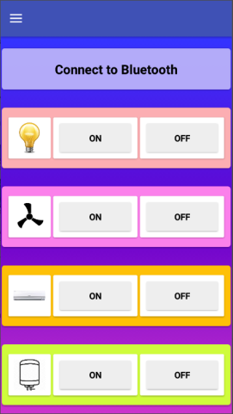
Arduino Bluetooth Home Automation : Arduino Bluetooth Controller is android application which is used to control 4 channel relay module via Bluetooth with Bluetooth serial communication module which support HC-05, HC-06, or HC-07, Using Arduino
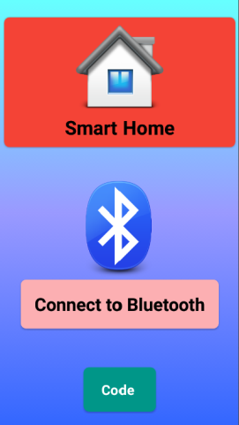

Circuit Diagram:

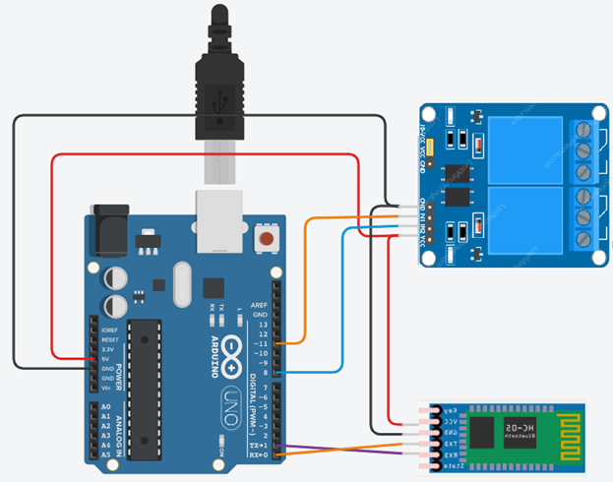

Code for the IoT:

char getChar=' ';

void setup()
{
pinMode(13,OUTPUT);
digitalWrite(13,LOW);
pinMode(11,OUTPUT);
digitalWrite(11,LOW);
pinMode(8,OUTPUT);
digitalWrite(8,LOW);
Serial.begin(9600);
Serial.flush();
}
void loop()
{ //Serial.flush();
if(Serial.available()<1)
return;
getChar=Serial.read();
Serial.println(getChar);
switch(getChar)
{
case 'a':digitalWrite(13,HIGH);
break;
case 'b':digitalWrite(13,LOW);
break;
case 'e':digitalWrite(11,HIGH);
break;
case 'f':digitalWrite(11,LOW);
break;
case 'i':digitalWrite(8,HIGH);
break;
case 'j':digitalWrite(8,LOW);
break;
}}

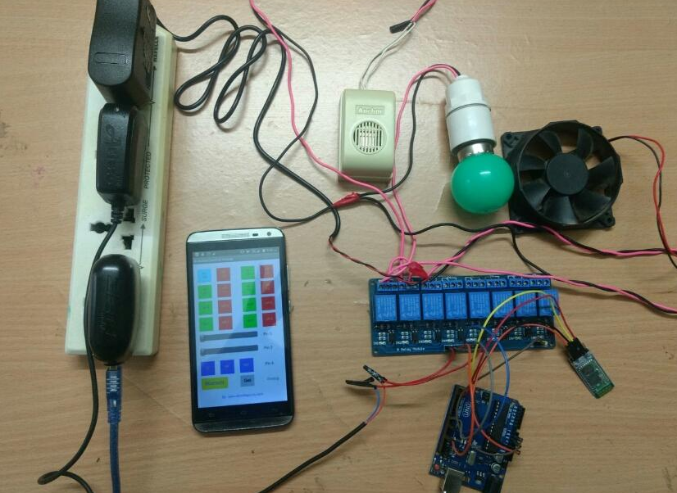

Fig : 8. Live Working Model

REFERENCES

- https://www.migatron.com/ultrasonic-detections-and-control-applications/
- https://circuitdigest.com/arduino-home-automation-projects
- https://www.makerspaces.com/wp-content/uploads/2017/02/Arduino-For-Beginners-REV2.pdf
- https://www.halvorsen.blog/documents/technology/resources/resources/Arduino/Programming%20with%20Arduino.pdf
- http://engineering.nyu.edu/gk12/amps-cbri/pdf/ArduinoBooks/Arduino%20Programming%20Notebook.pdf
- Magazines- Electronics for you
- Magazines-ElectrickIndia
- https://www.elprocus.com/arduino-projects/

