A review on Pomegranate biology and Ethno medicinal application

Sutapa Mandal, Tuhin Ghosh*
Department of Chemistry (UG & PG), Durgapur Government College, Durgapur, Dist: Paschim Bardhaman, West Bengal-713214, India
*Corresponding author: tuhinghoshbuchem@gmail.com

ABSTRACT
The Pomegranate (Punica granatum L.) is an ancient fruit that has been remaining the same with time. After the discovery of agriculture about 10,000 years ago, it has been reported that it was grown in Egypt. It was found in the Indus Valley so early that pomegranate has a Sanskrit name. Now, pomegranate is cultivated in subtropical and tropical areas in much-changing weather throughout the world. The pomegranate has charming biochemistry, and different classes of compounds found in it have been discussed in this study. Its importance lies mostly in its nutritional, medicinal, and ornamental properties and its high consumption as food and industrial value. In addition to the basic biology of the plant, the phytochemicals extracted from the different parts of it and their bioactivity has been briefly described in this study.

Keywords- Punica granatum L., Phytochemicals, Biotechnology, Antibacterial Effect, Ethnomedicinal use

INTRODUCTION
Pomegranate (Punica granatum L.) is rich in a number of bioactive compounds. There are so many phytochemical compounds with different biological properties present therefore it has been used as ethnomedicine. Pomegranate has a great nutritional (when consumed as raw fruit or juice) value. Apart from being eaten fresh, pomegranate juice is consumed by people all over the world. About 100 g arils provide 72 kcal of energy,1.0 g protein, 16.6 g carbohydrate, 1 mg sodium, 379 mg potassium,13 mg calcium, 12 mg magnesium, 0.7 mg iron, 0.17 mg copper,0.3 mg niacin, and 7 mg vitamin C (Grove and Grove, 2008). For its great nutritional value, it has achieved the title of “super-food”. Nowadays, studies on the antibacterial properties of different parts of plant extracts are of great interest. Research on pomegranate is increasing due to its great nutritional values and medicinal uses. In a number of studies, it has been found that pomegranate extracts have many potential effects including antibacterial, antifungal, antiviral, and some other activities. The pharmaceutical, pharmacological and medicinal bioactivities of compounds (including tannins, flavonoids, alkaloids, organic acids, triterpenes, steroids, etc.) from different parts of the pomegranate plant impart hypolipidemic, antioxidant, antiviral, anti-neoplastic, anticancer, antibacterial, anti-diabetic,anti-diarrheal, helminthic, vascular and digestive protection and immunomodulation effects. Pomegranate plant parts and their extracts are also used as cosmetics. For example, different fractions of pomegranate extract facilitating skin repair in a polar manner have been described by Aslam et al. (2006).

BIOLOGICAL GROWTH
The plants are small trees about 5–10m high, although some are small (1–2 m) with smooth stems and dark gray bark, the branches are sometimes spiny. Leaves are opposite or sub-opposite to each other, simple, 2–8 cm long, glossy, and bright green, and flowers are terminal. The flower comes into this tree on the new branches of that year after one month of the bud breaking, on spurs or short branches in general. Flowers can come single, or in a cluster form. Three types of flowers can appear in a single tree at the same time. It is a very common one, long-styled perfect flower having larger ovaries set more fruit than short style types, short styles are either intermediate or male in nature. The ratio of these two flower types changes from cultivar to cultivar. Fruits are generally globose in shape or somewhat flattened, 5–12 cm in diameter, the pericarp is smooth and the seeds are surrounded by juicy arils, which are edible (Fig.-2).
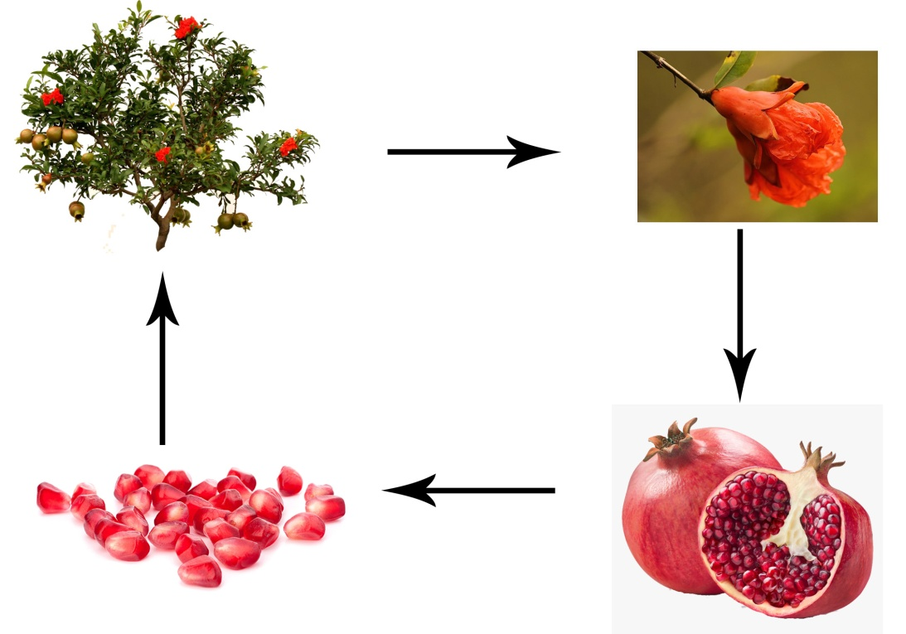

Fig.-2: Pictorial representation of the Pomegranate fruit cultivation.

PHYTOCHEMICALS
In accordance with a number of literature reports, it contains chemical constituents like ellagitannins, phenols, tannins, punicic acid, flavonoids, anthocyanins, estrogenic flavonoids, and flavones (Table-1). Among these some shows antibacterial activity. There are several potentially active phytochemicals like lignins, sterols, and terpenoids in the seeds, bark, and leaves; alkaloids in the bark and leaves; fatty acids and triglycerides in seed oil (Newman et al., 2007). The juice obtained from these arils contains anthocyanins, ellagic acid glycosides, free ellagic acid, ellagitannins, and gallotannins. Ellagitannins are water-soluble (punicalagin), and small amounts of procyanidins (prodelphinidins and gallocatechin) and anthocyanins are present in the husk and fruit membrane. The delphinidin derivatives are not generally observed and the cyanidin and pelargonidin derivatives are present in both membranes and juice. Pomegranates and pomegranate juice show different biological activity for the presence of antioxidant phenolic compounds. The investigation of biology, bioactivity, and metabolism of the pomegranate polyphenols is going on in order to understand their role in health promotion and medicinal use.

Table-1: Some phytochemicals extracted from pomegranate:

Sl. No. | Name | Chemical Formula | Plant Part
1 | (-)-Catechin | C15H14O6 | Fruit Juice
2 | Ellagic acid | C14H6O8 | Fruit, pericarp, bark
3 | Linolenic acid | C18H30O2 | Seed oil
4 | Punicic acid | C18H30O2 | Seed oil
5 | Testosterone | C19H28O2 | Seed oil
6 | Sedridine | C8H17NO | Bark
7 | Chlorogenic acid | C16H18O9 | Fruit Juice

APPLICATION
ANTIBACTERIAL ACTIVITY
As per various literature reports, this fruit contains several chemical constituents that show antioxidant activity. The tannin-rich ellagitannins and phenolic acids of pomegranate may show antibacterial activity. It has been reported that among all the chemical compounds present in pomegranate phenolic compounds, especially gallic acid, was the most important and active one against bacteria. The fruit contains large amounts of tannins (25%) and secondary metabolites are the reason behind the antibacterial activity. It contains another chemical constituent Carvacrol methyl ether, thymol that has an antimicrobial effect. This effect could be explained by secondary metabolites. It has also been reported that the antibiotic activity of some substances (chloramphenicol, gentamicin, ampicillin, tetracycline, and oxacillin.) is increased in presence of pomegranate extract. Pomegranate peel extract had a greater antibacterial effect than the seed extract.

Anti-carcinogenic effect
It has been reported that Pomegranate seed oil (PGO) can inhibit colon cancer in rats. In western countries, colon cancer is mostly found but dietary intake of conjugated linolenic acid (CLN ) may have an inhibitory effect on colon carcinogenesis. There is a considerable amount of punicic acid, c9,t11, and c13-conjugated linolenic acid (CLN) in pomegranate seed oil. In a report, Kohno et al. explained that dietary administration of PGO rich in c9,t11, and c13-CLN, even at the low dose of 0.1% CLN, inhibits the development of azoxymethane-induced colonic adenocarcinoma in rats significantly but does not cause any adverse effects.
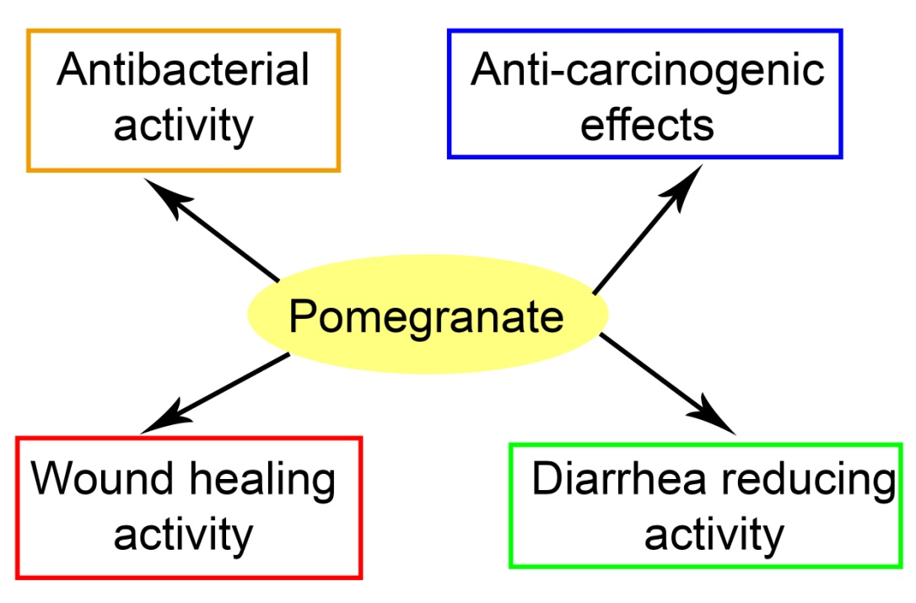

Fig.-1: Some applications of Pomegranate fruit.
POMEGRANATE SEED EXTRACT TO REDUCE DIARRHEA
Gastrointestinal motility could be inhibited by a methanolic extract from pomegranate seeds. It has been reported that the tannins present in the extract are that phytochemicals which are responsible for this activity. Tannins react with the proteins present and form tannates, which cause denaturation of the original protein. In this way, the secretions from the intestinal mucosa is being reduced.

WOUND HEALING ACTIVITY
Pomegranate peel extract exhibited good healing activity, with a very faster rate. It has been described that the healing power is due to the presence of polyphenol in the methanolic extract. The polyphenols can interact with the proteins and are able to precipitate them, and thus the wound healing process occurs through pomegranate peel extract.

CONCLUSION
This study includes biological growth, and a brief discussion on the phytochemicals present in different parts of pomegranate (peels, seeds, barks, etc). It contains a number of chemical constituents that have been used as medicine from ancient history. This report also aims to discuss the activities of different extracts of pomegranate.

REFERENCES
1. Vaya, J. and Aviram, M., Nutritional antioxidants: mechanisms of action, analyses of activities and medical applications, Curr. Med. Chem. Imm. Endoc. Metab. Agents, 1, 99, 2001.
2. Pomegranate Ancient root to modern medicine Edited by Navindra P.Seeram, Risa N Schulman and David Haber
3. Yaser Nozohour, Reza Golmohammadi, Reza Mirnejad, Majid Fartashvand Antibacterial Activity of Pomegranate (Punica granatum L.) Seed and Peel Alcoholic Extracts on Staphylococcus aureus and Pseudomonas aeruginosa Isolated From Health Centers J Appl Biotechnol Rep. 2018, 5(1): 32-36
4. H., Rezaei, K., Rashidi, L., 2008. Extraction of essential oils from the seeds of pomegranate using organic solvents and supercritical CO₂. J. Am. Oil Chem. Soc.85, 83–89.
5. Abd-Rabou, S., Simmons, A.M., 2010. Augmentation and evaluation of a parasitoid, Encarsiainaron, and a predator, Clitostethus arcuatus, for biological control of the pomegranate whitefly, Siphoninus phillyreae. Arch. Phytopathol. Plant Prot. 43, 1318–1334.
6. Jaime A., Teixeira da Silva, Tikam Singh Rana, Diganta Narzary, Nidhi Verma, Deodas Tarachand Meshram, Shirish A. Ranade, Pomegranate biology, and biotechnology: A review, 2013 Elsevier
7. Halvorsen, B.L. et al., A systematic screening of total antioxidants in dietary plants, J. Nutr., 132, 461, 2002.
8. Kelawala, N.S. and Ananthanrayan, L., 2004 Antioxidant activity of selected foodstuffs, Inter. J. Food and Nut., 55, 511.
9. Chu, Y.F., and Liu, R.H., 2004 Novel low-density lipoprotein (LDL) oxidation model: antioxidant capacity for the inhibition of LDL oxidation, J. Agric. Food. Chem., 52, 6818.
10. Burton, G.W., Joyce, A., and Ingold, K.U., 1983 Is vitamin E the only lipid-soluble, chain breaking antioxidant in human blood plasma and erythrocyte membranes?, Arch. Biochem. Biophys., 221, 281.
11. Klouche, K. et al., 2004 Mechanism of in-vitro heme-induced LDL oxidation: effects of antioxidants, Eur. J. Clin. Invest., 34, 619.
12. Maor, I. et al., 1997 Plasma LDL oxidation leads to its aggregation in atherosclerotic apolipoprotein E-deficient mice, Arterioscler. Thromb. Vasc. Biol., 17, 2995.

