Chapter
Sustainablity of Health And Health Provison
Author
Mr. Pankaj Singh Rana

Nurse Practitioner, AIIMS Hospital Rishikesh, Dehradun Uttrakhand

Sustainability refers to support of ecological, human and economical health. As The World Health Organisation (WHO) defines a “Sustainable Healthcare System as a system that improves, maintains or restores health, while minimizing negative impacts on the environment and leveraging opportunities to restore and improve it, to the benefit of the health and well-being of current and future generations”(1). Sustainability itself means that projects or policies that is beneficial today without abandoning out social, environmental and personal health in future. Health provisions are investment of combine money, manpower and drugs to deliver the health services(2). Judicious use of environmental resourcesis applicable to all sector including health sector which is harmony between the environment and health delivery system. Limited resources availability for a vast population is required for sustainable use of health provision to provide people with best health facilities, to Improve health outcomes and decrease the inequities in both responsiveness and health.Ensuring environmental conservationand simultaneously providing health services is why the sustainability of health provision is needed. During COVID 19 pandemic global loss of life and health occurred with huge environmental impact. Several studies revealed that huge waste was generated during pandemic. “The WHO Global analysis of health care waste in the context of COVID-19: status, impacts and recommendations bases its estimates on the approximately 87,000 tonnes of personal protective equipment (PPE) that was procured between March 2020- November 2021. Most of this equipment is expected to have ended up as waste”. The Sustainable Development Unit (SDU) in 2008 which was established by NHS to assess the environmental impact of health sector and enforce focus on sustainability triad(3). A study by Peng.et.al (2020) revealed that only China generate 463 tons of waste daily whereas 12,740 tons of medical waste was generated by Indonesia after first case of COVID 19 (4). Globally it was seen that PPE has gained attention for its plastic waste which was huge burden on environment where as many developing countries are incapable for proper segregation and biomedical waste management (5). Sustainability include three pillars which are environment safety, social equity and economic stability but sustainability in health provision includes systemsmanagment as a fourth dimension.

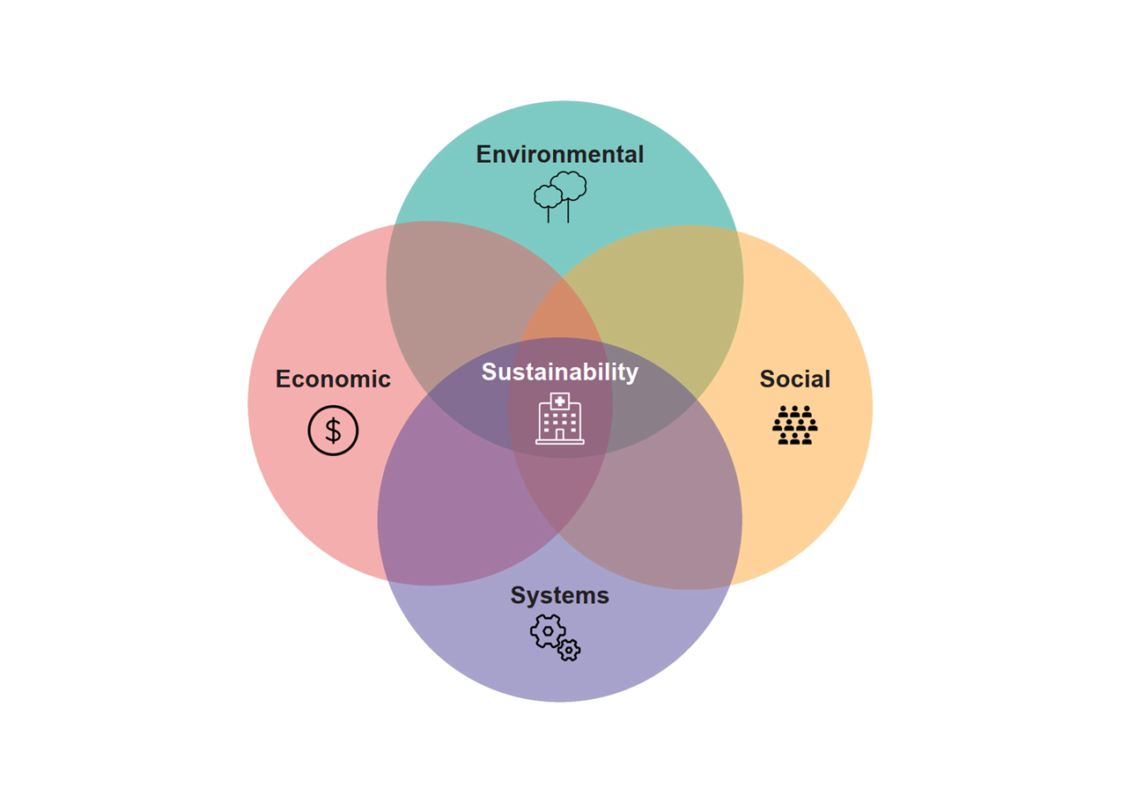
The traditional pillars of sustainability: social, environmental and economic, in addition to systems sustainability in the context of healthcare. Sketch by: Shari Blanch

ENVIRONMENTAL SUSTAINABILITY
Collaboration of health and environment is need of the time. Maximum use of renewable resources and use of nature in reducing of energy consumption is required. Health sectors must be provided with guidelines that will decrease the burden on environment and simultaneously providing best health facilities. Environment sustainability can be possible by implementing following steps.

Use of nature and alternative energy resources
- Improvement in building for ventilation by use of large window for nature light and warmth.
- Use of 5 stars’ energy certified electrical appliances such as fridge, AC, electric fan, motion sensor lights etc.
- Plantation indoor for purifying air. Use of trees in cafeteria for shades.
- Use of solar energy by using rooftop solar panel.
- Harvesting rain water which can be used in gardening and toilet purpose.
- Use of renewable items which will decrease the carbon foot print.
- Use of electric vehicle inside the campus and cooperating with the local public transport to promote public transports.
- Providing free parking and token to person who are using electric or hydrogen fuelled vehicle to promote use of carbon free vehicles.

Waste management
Waste generation from the hospitals and clinics has major consequences to environment. Improper waste management and disposal should have strict rules and regulation and punishment should be given by law. Hospitals single handily produces 5 million tons of waste worldwide. Many developing countries does not have proper biomedical waste management policies. Two major steps that should be taken are.

- Waste segregation
Hospital should have policies for proper segregation of waste such as general, sharp, infectiousetc. which will reduce the chance of infection, needle stick injury, proper handling of waste and recycling and special treatment for hazardous waste.

- Proper waste management
Waste management is only effective when there is proper segregation of waste. Waste management is done sustainable way so it should not harm environment. Waste must be treated before sending waste to nature like waste which are undergoing incineration or transferred to landfill. Use of various method for reuse of medical equipment’s such as disinfection, autoclaving and microwave sterilization.

Water preservation and treatment
- Hospitals and clinics should treat their waters by using water treatment plan so it can be used for gardening and watering plants.
- Rain water harvesting system must be installed in health facility
- Use and maintenance of water sources like toilet flushes, shower etc.
- Immediate fixation of leakage pipes.
- Upgrading more efficient refrigeration and HVAC systems.

Promoting sustainable healthcare culture
Ensuring the environmental sustainability the health care providers must have basic sense to ensure maximum use of energy efficient resources and cautious use of environmental resources.
- Encouraging health care provider to go green.
- Cultivating workplace with mind-set to achieve goal with minimum harm to environment
- Educating the health care provider for benefits implementation of green practice at home and workplace

SOCIAL SUSTAINABILITY
Social sustainability has been a key role in health care which not only focuses on mitigating patient’s illness but also enhancing participation in the learning and preventive behaviours.Social sustainability in health care with collaboration with the stake holder is only viable when institution and stakeholder collaborate with each other. Some key factors that included in social sustainability are
- Hospitals centre of attention should be prevention of diseases and promotion of health by alternative therapies like yoga, massage, exercise, vaccination etc.
- Encouraging infection control practice in hospital by developing guidelines and SOP.
- Focusing on department with are important and receive large number of patients so it can deliver crucial services and promote positive health outcomes.
- Regular feedbacks and routine patient complaints should be top priorities which will enhance effectiveness of care and their empathy level.
- Health facilities should be accessible (24x7) affordable to people of low income stature.
- Facilitating access to healthcare by decentralizing primary care by opening various small health care centre at various parts of states.

ECONOMICAL SUSTAINABLITY

Economical sustainability are the practices that ensures the economic growth of health care in long term without compromising the health services and other health care sustainability dimensions. The economic dimension embrace strategies that promotes profits, cost effectiveness, health promotion, research and developments. All though economical sustainability are direct and indirect effects of social and environmental factors but some strategies which improves economical sustainability are

- Energy conservation through use of renewable resources to decrease cost of electricity.
- Recycling of products helps in reduction of cost.
- Purchasing from local partner which will boast local production with reduce cost of transportation and interference of middle man.
- Bulk purchase of good also helps to cut cost of product.
- Improving capacity of health care worker by promoting education and skill to improve their services.
- Partnership with government will help to reduce hospital burden on both patient and hospital and simultaneously increasing hospital income.

SYSTEM SUSTAINABLITY

System sustainability is forth new pillar in health care. While traditional pillar applied on many other sectors but this pillar encompasses the complexities of the health care setting. This factor is mostly neglected but very important aspect of heath care domain. The health system has four level of framework: the patient, health care provider, the organization and the performance. The system sustainability can be improved by following factors:

Staff retention:
- Providing regular salary hike and promotion with time.
- Incentivising healthcare worker for good performance.
- Providing facilities like parking, housing traveling etc.
- Providing healthy environments for patients and staff.
- Providing with leaves and easy approachable higher level of management.

Use of latest technology
- Use of latest equipment’s for the procedures.
- Easy handling and training should be given to all staffs.
- Use of NIS in hospital so easy communication can be done between different departments.
- Making central data base for all the patients data at particular point so easy access could be available.

CONCLUSION
The overall result of health care sustainability is to improve quality of care, consolidating social, cultural, economical and environmental issues. New research and laws are yet to be discovered making health care more sustainable. Health care sustainability can only be effective with judicious use of resources for fostering communities with equal accessible and affordable health care facilities.

REFERENCES

- Nicol E. (2018). Sustainability in healthcare: efficiency, effectiveness, -economics and the environment. Future healthcare journal, 5(2), 81. https://doi.org/10.7861/futurehosp.5-2-81
- Syafinaz S.I , Haslinda I N, Azreena E. 1 , Arinah W.D.S1 , Musheer J.1 , Juni M.H(2016). HEALTH CARE PROVISION AND EQUITY in malaysia. International Journal of Public Health and Clinical Sciences,. Vol. 3:No. 4 2289-7577.
- de Preux, L., &Rizmie, D. (2018). Beyond financial efficiency to support environmental sustainability in economic evaluations. Future healthcare journal, 5(2), 103–107. https://doi.org/10.7861/futurehosp.5-2-103
- Peng, J., Wu, X., Wang, R., Li, C., Zhang, Q., & Wei, D. (2020). Medical waste management practice during the 2019-2020 novel coronavirus pandemic: Experience in a general hospital. American journal of infection control, 48(8), 918–921. https://doi.org/10.1016/j.ajic.2020.05.035
- Chowdhury, T., Chowdhury, H., Rahman, M. S., Hossain, N., Ahmed, A., &Sait, S. M. (2022). Estimation of the healthcare waste generation during COVID-19 pandemic in Bangladesh. The Science of the total environment, 811, 152295. https://doi.org/10.1016/j.scitotenv.2021.152295

