HEALTHCARE UTILISATION AND EXPENDITURE PATTERN OF CONSTRUCTION LABOURS IN KOZHIKKODE
Fasla Rahman K Research Scholars in Economics PG And Research Department Of Economics Government Arts and Science College, Calicut
Dr. Shaheed Ramzan C.P Associate Professor PG And Research Department of Economics Government Arts and Science College, Calicut

Abstract
Health is an essential component of human life, and without it, no one can expect to fully benefit from social and economic progress. Health is now often viewed as a key indicator of societal progress. There are two ways in which health and development are linked. Better health benefits development in a variety of ways. Similarly, it is claimed that economic development fosters healthy living circumstances. It is consequently critical to eradicate and reduce diseases and illnesses that disproportionately impact the poor and underprivileged due to a lack of clean and sanitary living conditions, dangerous drinking water, and sanitation issues. . Simultaneously, establishing a higher-quality and more widespread network of health-care facilities is critical in combating common diseases and injuries. Health plays a crucial part in modern economic growth, and a healthy workforce is widely acknowledged as the key to long term economic success. Human capital has been the foundation of modern economic progress (good health - longer, healthier, more productive human lives). Various economists have demonstrated that health and economic prosperity are linked in two ways. The current study uses an empirical survey to investigate health care consumption and expenditure patterns among a sample of construction workers in Kozhikode.

Keywords: Healthcare Utilization, Healthcare Expenditure, Unorganized Labours , Construction Labours,
Introduction
According to India's constitution, health is a state topic. Every state must make efforts to improve the health and living standards of the targeted population, with public health advancement as its primary function. The way health care is delivered affects access. Since the last two decades, India's healthcare industry has seen enormous progress.
The significant improvement in health metrics such as infant mortality, maternal mortality, and life expectancy at birth, among others, demonstrates this. Despite these gains, India's healthcare system still has significant flaws and inefficiencies. Recognizing the importance of health as a driver of economic growth, emerging countries are attempting to devote a larger percentage of their GDP to healthcare. However, governments in developing nations such as India face a significant obstacle in dedicating a bigger share of their limited resources to the health sector, because it does not provide the short-term advantages that a neo liberalized society would expect. The ensuing disparities in health indices across socioeconomic categories necessitate governmental initiatives aimed at achieving equitable healthcare sector expansion.
A large portion of developing and underdeveloped countries‟ population depends upon informal sources for seeking healthcare. Due to the fear of high healthcare costs and its impoverishing impact, quite often, people take recourse to traditional healers, self-medication and drug sellers for medication. All the above options are not at preferable and desirable as they are risky and of lower quality compared to professional care.
This article aims to look at the healthcare utilization and expenditure pattern of construction labors in Kozhikode. Construction activity is an integral part of a country's infrastructure and industrial development; it includes hospitals, schools, townships, offices, houses, and other buildings, urban infrastructure (including water supply sewerage, drainage) highways, roads, ports, railways, airports, power system, irrigation and agriculture systems, telecommunications etc. The construction becomes the basic input for socio–economic development of country. Besides, the construction industry generates substantial employment and provides a growth impetus to other sectors through backward and forward linkages. Therefore, this vital activity is nurtured for the healthy growth of the economy. The Government of India has done massive investment in the creating physical infrastructure during the 10 plan. Therefore, the construction industry would play a crucial role in this regard and it will gear itself to meet the challenges. In order to meet the intended investment targets in time, the current capacity of the domestic construction industry would need to strengthened.

Objectives
- To analyze the healthcare utilization among different income group
- To determine the pattern of healthcare utilization and healthcare expenditure of household
- To study the factor determining household healthcare utilization behavior.

Methodology
To examine the objectives, both primary data and secondary data have been used. To identify and assess the factor that determining the healthcare utilization, expenditure pattern, a detailed primary survey has been conducted. Multistage sampling method is adopted. In the first stage Karassery Panchayath, Mukkam at Calicut district were selected. In the second stage out of total wards 2 wards were selected by using simple random sampling. In the third stage 25 construction labours from each ward selected randomly. Thus a total 50 sample were selected. Secondary data can be collected from various website, newspaper, books etc.
Data Analysis And Findings

Financial status
As per the financial status of respondents are shown in the table 1, financial status play a major role in determining the healthcare utilization. It shows that 56% are belongs to BPL category and 44% are belongs to APL category.

Financial status | Frequency |  | Percentage
APL  BPL  Total | 22 |  | 44
 | 28 |  | 56
 | 50 |  | 100

Income of the household
Monthly family income is also an important factor for determining the healthcare utilization.
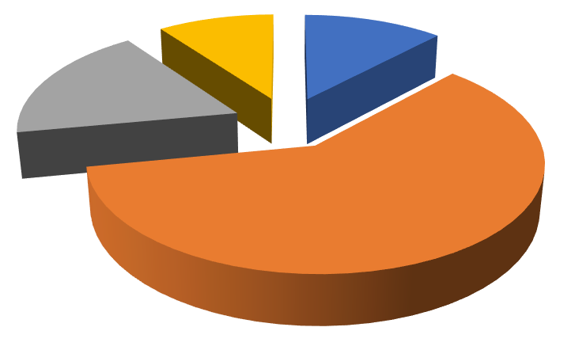

12
%
60
%
18
%
10
%
INCOME OF THE HOUSEHOLD
Below 10000
10000-20000
20000-30000
Above 30000
From the sample study among 50 households, it can be observed that most of the people have a monthly income between 10000-30000 categories. Table shows 9 families were included in the 20000-30000 category and 6 families are in the below 10000 income categories. While only 6 families were included in the above 30000 income categories. From the analysis it follow that majority of household belong to middle and low income group.
Average income of household is also been calculated. It is estimated that as an average a family has Rs.19400 as their monthly income

Income and healthcare utilization
It is important to analyze how people utilize available healthcare facilities depending on their income. Among the sample, majority households are come in middle income group that is 10000-20000, in which 13 households prefer for health center and 11 household prefer more on private hospitals and remaining 6 households prefer public hospitals. The income level 20000-30000, in which 6 families give important to private hospital and only 2 &1 prefer public and health centre respectively. The higher income group that is income level above 30000, they prefer private hospital but in case of lower income below 10000, they prefer more on Health centers for their healthcare utilization. Because it is less expensive.
Types of chronic diseases

1
11
6
4
1
6
2
1
4
13
1
0
2
4
6
8
10
12
14
Below10000
10000-20000
20000-30000
Above 30000
no:of respondents
income of the households
income and healthcare utilisation
Private
Public
Health centre
It is important to analyze the person suffering from various chronic diseases. Now a day the chronic diseases among people rapidly increasing. The present study states that out of 50 households 48% of people suffering the diabetes diseases. 20% suffering various types of allergy problem. Around 8% suffering the diseases like asthma, heart diseases and kidney diseases. Cancer and Thairoid incurred people percentage is same as 4%.

%
48
%
8
%
8
%
4
%
4
%
8
20
%
Chronic diseases among respondents
Diabetes
Heart diseases
Kidney diseases
Thairoid
Cancer
Asthma
Alargi

Medicinal system preference`
The following table depicts the type of medicinal system adopted by household.
Medicinal system | frequency | Percentage
Ayurveda | 1 | 2
Allopathic | 41 | 16
Homeopathy | 8 | 82
Public healthcare system in Kerala mainly consists of Allopathic, Ayurveda, and Homeopathy. There was a tendency among the keralites to excessively depend on Allopathic, in spite of its harsh consequences. The finding of the present study was a clear evidence for this tendency, where 82% of households depend on Allopathic. This was mainly because the people were yet suspicious about the success of Ayurveda and Homeopathy.`

Factors influencing healthcare utilization
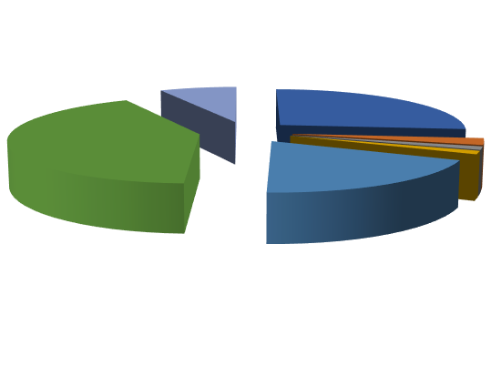

27
%
2
%
1
%
1
%
19
%
42
%
8
%
factors influencing healthcare utilisation
Family income
Familiarity of doctors
Reputation of hospital
Advice from others
Fee charged
Accessibility
Augmented facility

There are so many factors that influence the household healthcare utilization. In the choice of healthcare utilization accessibility and income level of household influences 42% and 27% respectively. Fee charged also a determining factor it influence 19% on the healthcare utilization.8% of peoples preferring hospitals based on augmented facilities. Familiarity of doctors, advice from others and reputation of hospital least influence the healthcare utilization, that is 2%, 1% and 1% respectively.

3.1 Consumption expenditure

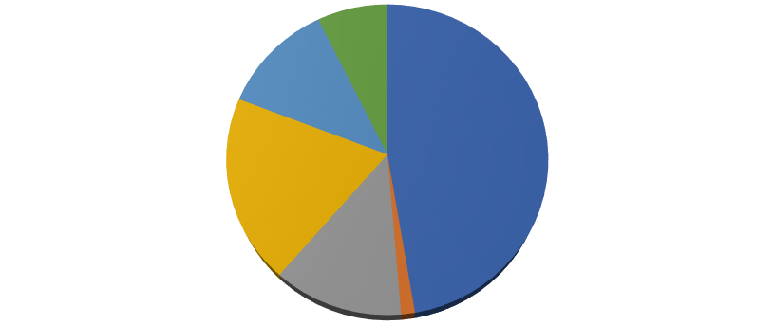

47
%
1
%
13
%
20
%
12
%
7
%
CONSUMPTION EXPENDITURE /MONTH
Food
Rent
Education
Health
Transportation
Clothes
People spend most of their income for consumption expenditure. From the study to analyze the consumption expenditure of households it reveals that out 0f total consumption expenditure 47% of expenditure spend on food and 20% of expenditure spend on health . Consumption expenditure for education and transportation comes only 13% and 12% respectively.

Financial sources to meet healthcare expenditure
Now a day the health expenditure is increasing. People use many ways to meet healthcare expenditure. Below figure shows that 73% households depends on their current income to meet their health expenditure.17% households depends on borrowing from relatives and friends to meet their out of pocket expenditure.6% household utilize health insurance and 2% utilize both the support of charity organization and savings in the bank account to meet healthcare expenditure
.

Monthly medical healthcare expenditure

11
%
48
%
16
%
16
%
9
%
MONTHLY MEDICAL EXPENDITURE
Practitioners fee
Medicine
Diagnostic tests
Surgery and hospitalization
Transportation cost
The figure shows that out of total medical expenditure medicine plays a major role that is 48% of expenditure is spend on medicinal purposes.out of total medical expenditure Incase of diagnostic test , surgery and hospitalization household face 16% and 11% on practitioners fee and remaining 9% for transportation cost.

INCOME AND MEDICAL EXPENDITURE

0
5
10
15
20
25
BELOW 10000
10000-20000
20000-30000
ABOVE 30000
INCOME AND MEDICAL EXPENDITURE
2000
ABOVE
1000-2000
BELOW 1000
The graph reveals the relationship between income medical expenses. There are 50 sample respondents in which 12% people income level is below 10000 in monthly. Their medical care expenses are below of 1000 rupees. It shows that low income people spending on health care also very low. The income level 10000-20000, there are 60% people are came under the range. Among these a large number of household monthly medical expenses is under the level of 1000-2000. Only 4 families medical spending is above 2000.
Income level 20000-30000, in which earning includes 9 numbers of households. Their medical expenditure pattern shows that around 6 families medical spending is 1000-2000. Monthly expenses of 2 families are above 2000.
The higher income earning household medical expenditure pattern that is above 30000 shows that, there are only 10% households include under this range of income. Among 4 household spending is above of 2000 per monthly. It shows that higher income earning people spending on healthcare also higher them.

Findings
The major findings of the above study are the following;
- Majority of the respondents are secondary education qualification.
- Most of the respondents are belongs to BPL families.
- Majority of the family belongs to middle income group

Healthcare utilization pattern
- Income earnings influence the selection of hospitals.
- High income earning households are chosen private hospitals and low income earning family choose only health Centre and public hospitals.
- Majority of households from both Hindu and Muslim prefer to private hospitals.
- The study found direct relationship between education and healthcare utilization. Higher educated family prefer private hospital where as lower educated prefer health centers and public hospitals.
- At the time of maternity household prefer private hospitals because of providing more effective treatment, privacy and good facilities.
- Majority of household prefer private hospital for their children healthcare.
- Most of the household provide vaccination to their child.
- Majority of persons are suffering from diabetes diseases.
- Allopathic treatment is the first choice of the majority of the family.
- Accessibility of healthcare services, family income of the households and fee charges are major determining factors influencing healthcare utilization.
Health expenditure pattern
- Out of total consumption expenditure on an average, people spend 20% on health.
- Majority households have a health insurance scheme.
- About 44% households postponed their medical treatment due to lack of income and self medication
- Out of total medical expenditure people spend a huge amount for medicine.
- The study found that, direct relationship between medical expenditure and family income earning. Higher the income, higher will be the expenditure for medical purposes.

Suggestion
- Provide Temporary financial assistance to needy families .
- Government should effectively implement the child and maternal health programmes.

CONCLUSION
Health is the state of being free from illness or injury and healthcare is the maintenance and improvement of physical and mental health, especially through the provision of medical services. In today’s hectic world that lives in, maintaining good health is very important. Health care is important to any society in order to promote betterment of the society.
In the present study , an attempt was made to analyze the healthcare utilization and expenditure pattern of construction labours . The choice of healthcare service provider and the subsequent utilization of healthcare services is a complex multifaceted process. That is characterized by low rates of utilization of highly subsidized public healthcare services and greater utilization of higher priced private healthcare services. There is a direct relationship between income and healthcare utilization and the income and health expenditure. At present the health care centers are considered as major source of profit and hence more and more private hospitals are sprouting in city and also most of the people prefer allopathic treatment of government. Middle income group spend substantial amount of income for health expenditure.
References
- M. Karpagam, Some Aspects of the Theory of Health Economics and their Application to Hospital, M.Phil. Dissertation, University of Madras, December 1981.
- P.G.K. Pankiar and C.R. Soman, Health Status of Kerala – Paradox of Economic Backwardness and Health Developments, Centre for Development Studies, Thiruvananthapuram, 1984.
- P. Ghai, Management of Primary Health Care, Interprint, New Delhi, 1985.
- Drummond, Michael Sloddart, G.L. On Torrance, Methods for the Economic Evaluation of Health Care Programmes, Oxford University Press, Oxford, 1986.
- M. Kataria and O.P. Srivastava, “Cost Analysis of Primary Health Centres”, WHO Funded Research Project, Department of Statistics and Demography, National Institute of Health and Family Welfare, New Delhi, 1989, pp.61-79.
- D. Banerjee, “Class Inequalities and Unequal Access to Health Services in India”, Social Action, Vol.39, July-September, 1989. 7Debabar Banerji, “A Socio-Cultural Political and Administrative Analysis of Health Policies and Programmes in India in the Eighties: A
Critical Appraisal”, Lok Prakash, New Delhi, August 1990.
- Mead Over, Economics for Health Sector Analysis – Concepts and Cases, Economic Development Institute of the World Bank, Washington, D.C., U.S.A., 1991.
- C. Tiwari, “Strengthening the Health Delivery System”, Yojana, Republic Day Special, January 1992
- Kenneth Lee and Anne Mills, The Economics of Health in Developing Countries, Oxford University Press, Oxford, 1983.
- Mead Over, “Economics for Health Sector Analysis-Concepts and Cases”, Economic Development Institute of the World Bank, Washington, D.C., U.S.A., 1991.

