PROBIOTICS: ORGANISMS FOR LIFE
Dr. Janki Patel, Sohil Ajani, Priyam Maheshwari, Hardik Pawar
Affiliation Address: Department of Pharmaceutics, Parul Institute of Pharmacy and Research, Faculty of Pharmacy, Parul University, At. Po Limda, Ta. Waghodiya-391760, Dist.Vadodara, Gujarat, India. Emailid:janki0410pharma@gmail.com Contact no: +91-9429846506

ABSTRACT
Probiotics, live cells with various beneficiary attributes, have been broadly analysed and researched monetarily in various unmistakable ways inside the world. Their advantages to human and animal prosperity have been shown in many legitimate explore. Lactobacillus and Bifidobacterium are the most probiotic packs, anyway, there are gives an account of the probiotic capability of Bacillus, Yeasts, Pedi coccus and Lactococcus. A couple of the perceived probiotic strains show proficient mitigating, antiallergic and other essential properties. The commitment of probiotics in forestalling and therapy of diabetes, stoutness, malignant growth and different illnesses connected with pathogenic organisms is a thrilling and quickly propelling examination field. Isolated from that, the use of dairy and non-dairy things animates the obstruction very surprising ways.
Keywords-Probiotics, Organisms. Lactobacillus. Bifidobacterium
INTRODUCTION
Probiotic is a relatively recent word for micro-organisms that have beneficial effects for humans and animals. It is derived from the term 'for life,' which is a modern idiom. These microorganisms play a role in preserving health by contributing to the microbic balance of internal organs. Probiotic microbes include a large number of strains from the genera Eubacterium and Bifidobacterium. They play a critical role in shielding the organism from harmful microorganisms while also strengthening the host's system.
Probiotics can be used in both farm and non-farm products. They are often ingested in conjunction with antibiotic medical treatment (for some illnesses), which kills the duct's microbic flora gift (both the targeted and harmful microbes). ^{[1]} To ensure a positive balance of helpful particles inside the microorganism, regular intake of food containing probiotic microorganisms is recommended. The study of new microbes for potential probiotic bacteriotherapy applications has significantly aided detailed studies of probiotics.
WHAT ARE PROBIOTICS
Probiotic is gotten from the Greek language 'genius profiles,' which addresses 'forever.'Probiotics are described as an adjustment of microbial variety in the human body that replaces destructive organisms with great microorganisms.
Probiotics square measure delegated living microorganisms which are managed in a protected way to permit them to live inside the viscus climate. They ought to well affect the host. ^{[2]}
Lilly and Stillwell ^{[3]} authored the saying "probiotic" in 1965 to describe "substances discharged by one being that animate the development of another."
Parker ^{[4]} begat the term probiotics in 1974, expressing those probiotics are "life forms and substances that add to colonic microorganism balance." ^{[5]}
The possibility of an activity on the stomach microflora, and, surprisingly, that of live microorganisms, evaporated in further developed ideas.
Probiotics were depicted by Salminen et al. ^{[6]} as "food containing live microorganisms helpful to wellbeing," while Marteau et al. ^{[7]} recognized them as "microbial cell arrangements or segments of microflora cells that advantageously affect wellbeing and prosperity."
A few normal implications allude to probiotics as having a pharmacotherapeutic impact. For instance, Charteris et al. ^{[8]} depicted probiotics as "microorganisms that, once ingested, may have a beneficial outcome in the counteraction and treatment of a particular pathologic condition."Probiotics might be viewed as helpful specialists since they have been demonstrated to be significant in the pathogenesis of numerous epithelial pipe contaminations.
Various parts of the expression " 'probiotic' have been utilized throughout the long term, however the one carried out by the United Nations Food and Agriculture Organization (FAO)/World Health Organization (WHO) ^{[9]} is the most broadly acknowledged. The International Scientific Association for Probiotics and Prebiotics ^{[10]} best represents the profundity and extent of probiotics today: "live microorganisms that, when controlled in fitting amounts, give a medical advantage on the host." This idea envelops significant setting of the utilization of living organic entities for wellbeing purposes, however it doesn't confine the term's application to oral probiotics with gooey outcomes. ^{[11]}
For example, Havenaar et al. ^{[12]} planned the following criteria to choose a probiotic:
- Adhesion to animal tissue cells,
- Total host protection,
- Susceptibility & resistance to internal organ acidity and lymphatic gland secretions
- Antimicrobial characteristics
- Inhibition of pathogenic microorganism permeability,
- Antibiotic resistance screening,
- Tolerance to food and beverage additives, and its food matrix stability

PROBIOTICS AND IT’S HISTORY
The starting points of cultured dairy ranch items had been followed as far as possible back to the beginning of human advancement; they're even recorded in the Bible and Hindu hallowed books. A considerable lot of the traditional soured milk or proper dairy ranch items like kefir, kumis, dahi (yogurt), and so forth appear to have flourished because of favourable environmental circumstances ^{[13]}. These items, a large number of which are still broadly consumed, were customarily utilized pharmacologically and remedially before the presence of microorganisms was found. ^{[14]}

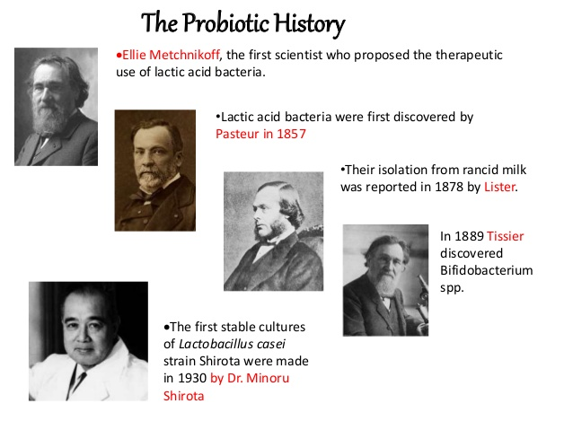
Ilya Ilyich, a bacteriologist who won the Nobel Prize in medication in 1908, connected the body period of bacterium gift in yogurt to wellbeing and life span. ^{[15]}
It is the situation of possibly hurtful nasogastric smelly cycles that can be disturbed by adding Lactobacilli into the body, dislodging poison creating microbes, expanding life, and upgrading wellbeing. ^{[16]} In 2002, the World Health Organization (WHO) distributed rules that characterize the stuff for an item to be marked as a probiotic. ^{[17]}
It was only after the turn of the century that plainly enteral microflora served various jobs, including metabolic and organic cycles along with protection.
• Metabolic capability - The aging of non-edible healthful debasements and unconstrained discharge, energy utilization as short-chain unsaturated fats, age of antihemorrhagic component, and particle ingestion are instances of metabolic utilitarian regions.
• Natural capability - The tropical components region unit aided the guideline of conceptive cell multiplication, advancement and separation, as well as the framework's development and equilibration

BACTERIA AND PROBIOTIC MICROBES
Late probiotic research means to portray every individual's regular, stable stomach microbiota, as well as evaluate the species creation and centralizations of different microscopic organisms in various pieces of the stomach.
Peevish gut disorder is brought about by species that have been isolated from the remainder of the body to give site-explicit way of behaving. ^{[18]} The accompanying genera are currently the most well-known probiotic strains: Eubacterium, genuine microscopic organisms, and Bifidobacterium; be that as it may, different species, for example, Enterococci and yeast strains have likewise been utilized as probiotics.

A. Family Bifidobacterium
Bifidobacterium is a sort of microscopic organisms that has a place with the family Bifido. Tessier, was quick to disengage and recognize bifidobacteria, which he called genuine microbiota bifidum, bar molded, non-gas-creating, thermophilic microorganisms with bifidobacterial morphology, which he tracked down in the stool of breast-fed babies.
Gram-positive, non-spore framing, non-motile, and catalase-negative anaerobic microscopic organisms are the most widely recognized grouping frameworks. ^{[19]} They are in various shapes, including short, sinuate bars, club-molded poles, and separated framed poles.

B. Family Lactobacillus and Genus Eubacterium
Filipino was the principal researcher to foster a kind of obvious microorganisms Acidophilus, a typical term Lactobacilli, in 1990.
Lactobacilli are gram-positive bars as well as coccobacilli that don't frame spores and in this manner are non-lashed. ^{[20]}
Lactobacilli are tracked down in different environmental specialties in the stream and organic cycle frameworks, and they are a significant piece of man's and creatures' honesty of the first microbiome. They're seldom connected to settings of channel and extraintestinal hypersensitive response, and the strains utilized in innovation are believed to be non-pathogenic and solid.
OTHER PROBIOTIC MICROBES
Bacilli, genuine microbes clausii, genuine microorganisms Cereus, genuine microorganisms coagulants, and genuine microscopic organisms licheniformis are a portion of the organic entities concentrated on in this class ^{[21]}.Probiotic microorganism spores are utilized in various ways, from dietary enhancements to development advertisers and handling (e.g., Shrimp). ^{[21]}
Anti-microbials are prompted that can be utilized with probiotic plans containing specific genuine microorganisms species in light of the fact that these strains are impervious to them (e.g., B. clausii). ^{[22]}
B. coagulants is utilized to regard stiffness as an integral medication. ^{[23]}
B. subtilis has been concentrated hereditarily and physiologically, and it is firmly connected with natto, a Japanese delicacy. Admission of this substance actuates the framework while likewise diminishing coagulation by fibrinolysis.
Enterococcus, Bacillus, genuine microbes, Lactobacillus, parasite family, and Saccharomyces sort are probiotic microorganisms utilized in domesticated animals details.
Enterococcus faecium is the most regularly involved Enterococcus species in business probiotics. To keep away from contamination by Enterobacteria enterica ssp., Enterococcus faecium should be available. ser. enterica Typhimurium is a kind of microorganisms. ^{[24]}

Table 1: Probiotic Micro-organisms
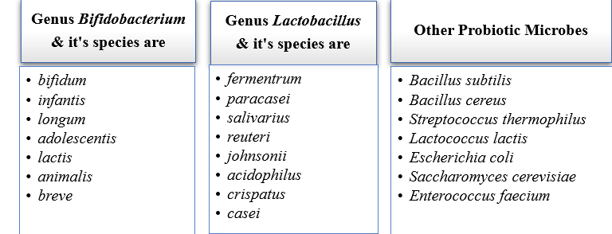

PROBIOTICS MOA
As indicated by Oelschlaeger ^{[29]}, probiotic impacts can be separated into three methods of activity:
- Probiotics can possibly tweak the host's safeguards, both in the endogenous and nonheritable frameworks.This system of activity is probably going to be fundamental for the avoidance and counteraction of irresistible illnesses, as well as the therapy of (persistent) multiplication of the epithelial pipe or its parts.This probiotic impact might be significant in keeping host cells from developing.
- Probiotics can promptly affect commensal and additionally unfortunate microorganisms.
- Probiotic impacts aided the entry of microorganism materials like poisons and host items, like gastrointestinal juice, salts and dietary enhancements. These and different exercises can bring about poison inactivation and detoxification of the host and food parts inside the stomach.
Polymer or peptidoglycan, which are vital parts of the miniature - creatures cells, might be fundamental for its probiotic sufficiency. ^{[30]}

Figure2: MOA OF PROBIOTICS
PROBIOTICS & IT’S WORKING
Probiotics are living micro-organisms (bacteria and yeast etc) that provide you with health benefits when you consume them. They are naturally present in some fermented foods, added to many types of food products, and are available as a dietary supplement. Probiotics mainly work in the gastrointestinal (GI) tract, where they can affect your gut microbiome (gut microbiome).
These microbiomes are made up of many micro-organisms (mainly bacteria), which live primarily in your large intestine. When you eat or drink enough probiotics, they help protect your GI tract from harmful microorganisms, improve your digestion and gut function, and may also provide other health benefits.Common probiotics include Lactobacillus, Bifidobacterium, Saccharomyces, Streptococcus, Streptococcus, Enterococcus (Enterococcus), Escherichia (Escherichia), and Bacillus.
Probiotic microorganisms are designated by their genus, strain & species. An example is Lactobacillus rhamnosus GG. In this example, Lactobacillus is the genus, Rhamnosus species, and the GG strain. This micro-organism is also known by its abbreviation LGG.
Probiotics are living bacteria, which are good for your health. It is considered particularly beneficial for the digestive system. Often people consider bacteria to be the cause of diseases and illnesses only, but both beneficial and harmful bacteria are present inside your body. Probiotics are considered "good bacteria" or "supportive bacteria" for your health, as they help keep intestines healthy.

PROBIOTICS QUANTIFICATION
Culture-free methodologies have emerged because of the appearance of organic science. Systems that use the boundary and saved locales of the 16S rRNA, specifically, have been viable in describing the digestive vegetation. The utilization of 16S rRNA considers the distinguishing proof of microorganisms that are either free - living or have kicked the bucket during handling and stockpiling. ^{[27]}
Strategies that assist the generally utilized polymerase with binding response (PCR) give speedy quantitative and subjective information on the definition of the Pathogenic microbiota. ^{[28]}
PROBIOTICS' SAFETY
In susceptible individuals, probiotics are responsible for four types of side effects: general infections, harmful metabolic activities, unnecessary immune activation, and cistron transfer. ^{[25]}
Primitive carboxylic acid bacterium (LAB) [Lactic acid bacteria] farm strains ^{[26]} have a long history of healthy use. Since humans started to eat coarse milk, LAB, along with a number of other eubacteria and Enterococcus species, has been consumed on a daily basis.
There are three methods for determining the safety of a probiotic strain:
- Study of the strain's inherent properties
- Studies of the strain's pharmacological medication (survival, bowel function dose- response relationships, and tarnished as well as membrane layer treatment)
- Research on the strain's relationships with the host.
HUMAN HEALTH & PROBIOTICS
Impedance of framework problems, prompt help of obstruction, counteraction against voyager's side effect, decrease of hypercholesterolemia, anticipation against colon and bladder disease, trap of life systems, and unfavorably susceptible response are a couple of the numerous remedial uses of probiotics. ^{[31]}
Maldonado Galdeano et al. ^{[32]} investigated the exhibition of coarse milk containing Eubacteria casei DN114001 on the vague hindrance, intensifying the intrinsic immunologic reaction inside the stomach, and saving the intestinal physiological condition.
Arunachalam et al. researched B. lactis HN019 dietary admission and found that a many somewhat short dietary system (a month and a half) is adequate to present discernible insusceptible framework enhancements.
There have been a few examinations on the viability of probiotics against Helicobacter pylori, a Gram-negative microorganisms connected to peptic ulcer sickness, heartburn, and colon disease.
Clinical preliminaries have shown the adequacy of probiotics in forestalling the dynamic treatment of scarcities, colitis, and fiery entrail sickness.
PROBIOTICS FOOD & BEVERAGES
Father of medicine, a medical practitioner, Elie Metchnikoff once wrote: 'Let food be thy drugs, and drugs be thy food.'
In recent years, the idea of food with therapeutic value has been called 'functional foods'. ^{[33]}
A probiotic can also be used as a food supplement. Food containing some health-promoting component(s) on the furthest side traditional nutrients are referred to as functional foods. Delicate foods, medicative foods, nutraceuticals, medicinal foods, superfoods, foodiceuticals, and medication foods are all terms for functional food products.
In particular, the phrase relates to a food which has been modified to make it 'functional.' The introduction of probiotics is one method for making foods more functional. Probiotic cultures are used to create new food items. ^{[34]}

PROBIOTICS IN DAIRY PRODUCTS
The food substrate is an important consideration in the development of probiotics. Probiotic growth, survival & productivity are influenced by fat content, macromolecule variation, polysaccharides metabolites, as well as pH scale.
Cheese, sausage, parmesan, hummus, mayonnaise yoghurt, frozen desserts, and substitute farm products are the most commonly used matrices in probiotic food.^{[35]}
It's conceivable that adding any prebiotics to probiotic ice creams, frozen desserts, etc. will enhance their properties. Polyose is undeniably advantageous to ice cream firmness, melting properties, and dripping periods. ^{[36]} Probiotics have also been delivered via aerated farm (e.g., chocolate mousse). ^{[37]}

PROBIOTICS IN NON-DAIRY PRODUCTS
Various sorts of non-dairy probiotic items like organic products, vegetables, vegetables, and oats utilize different grids. So, as they in all actuality do have supplements like minerals and nutrients, dietary strands and cancer prevention agents, foods grown from the ground are viewed as savvy grids.
Prado et al. framed a survey of perhaps a couple kinds of non-dairy probiotic food, refreshments and beverages.
The consideration of probiotics in organic product juices requires corrosive wellbeing. ^{[38]} Gelatine and vegetable gum are undeniably viable in giving corrosive touchy Bifidobacterium as well as Eubacteria with dependable security.
In the particular occurrence of cereals, probiotic microorganism, aging can be valuable to the decrease of non - edible sugars, the development of the norm and measure of fundamental amino acids, and the stock of the vitamin B complex gathering, as well as the corruption of phytosterols and mineral detoxify (e.g, manganese, iron, zinc, and calcium). ^{[39]}
PROBIOTIC APPLICATIONS IN ANIMAL FEED & AQUACULTURE

• Insusceptible reaction improvement
• Immunization adjuvant
• Expanded lactose resilience and absorption
• Critical Reduction of digestive pH
• Gainful effect on gastrointestinal microflora
• Upgrades in gastrointestinal capability
• New immunizations are being created.
• Intense the runs alleviation and counteraction
• Biosynthesis of vitamin B supplements: (Folic corrosive)
• Cholesterol bringing down
• Minimization of smelling salts as well as other poisonous parts
• Direct the assimilation of mineral, gases and water.
• Forestall multiplication of pathogenic microflora.
• Fortify the invulnerable framework.
• Hostile impact on destructive microorganisms.
• Produces vitamin K, cynocobalamine, thiamine, folic corrosive, biotin.
• Further develops assimilation and increments digestive motility.[40]
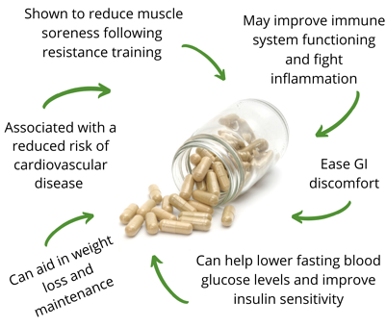

Figure 3 : Application of Probiotics
Table 2 : Marketed Products : ^{[41]}

BRAND NAME | PROBIOTIC STRAIN | FOOD TYPE
Yakult | Lactobailluscasei | Milk drink
Provie | Lactobaillus plantarum | Fruit drink
Hellus | Lactobaillus fermentum | Dairy product
Activia | Bifidusactiregularis | Creamy yogurt
Yosa | Bifidobacterium lactis  Lactobaillus acidophilus | Yogurt like oat product
bactisubtil | Bacillus subtilis | Freeze dried product

BENEFITS OF PROBIOTICS
Probiotics have many benefits from a health standpoint. The benefits of probiotics depend on the way it works. Following are some benefits of probiotics.
- Probiotics help increase immunity.
- Probiotics supplements also improve mental conditions.
- It can reduce some allergies and eczema.
- It helps in reducing the symptoms of digestive disorders.
- Probiotics help to give your body the correct shape (Shrewed look).^{[42]}

- Probiotics are used to create a natural balance in intestinal bacteria. Increasing the number of bad bacteria present in the intestines and decreasing the number of good bacteria is called imbalance. This imbalance occurs due to any disease, medication such as antibiotics and contaminated diet etc.

This imbalance causes problems in your digestive system, allergies, mental problems, obesity, and other troubles. Thus, it is helpful in controlling & balancing the good friendly bacteria in the digestive system.

- Probiotic contains lactic acid bacteria which convert lactose sugar present in milk into lactic acid. Probiotic foods also prevent colon cancer.

- It also controls cholesterol. Blood pressure is also controlled by the use of milk and formulated food products.

- It is also beneficial for the immune system of the human body, which enables the body to protect itself from germs.

- Probiotics are helpful in keeping the heart healthy

Probiotics help keep your heart healthy by reducing LDL (bad) cholesterol. Blood pressure is also controlled by the use of milk and formulated food products. . Some lactic acid-forming bacteria break down bile in your intestines and lower cholesterol. Bile is a naturally occurring liquid, a large part of which is cholesterol, and it helps in digestion.

- Lactobacillus and Bifidobacterium food and supplements also help in the prevention of diarrhea.

- Consumption of probiotics also controls infectious bowel disease and hyper sensitivity response in adults. Problems in absorption of micro minerals can also be eliminated by their use.

- Infectious diseases: Apart from this, it is also helpful in controlling diseases caused by probiotic infection. It also organizes lactose intolerance in the body. Due to the amount of lactose, many times children and adults are unable to digest milk, it is called lactose intake. Milk intake is essential for children as it is a major source of calcium. Probiotic bacteria are helpful in this.^{[43]}
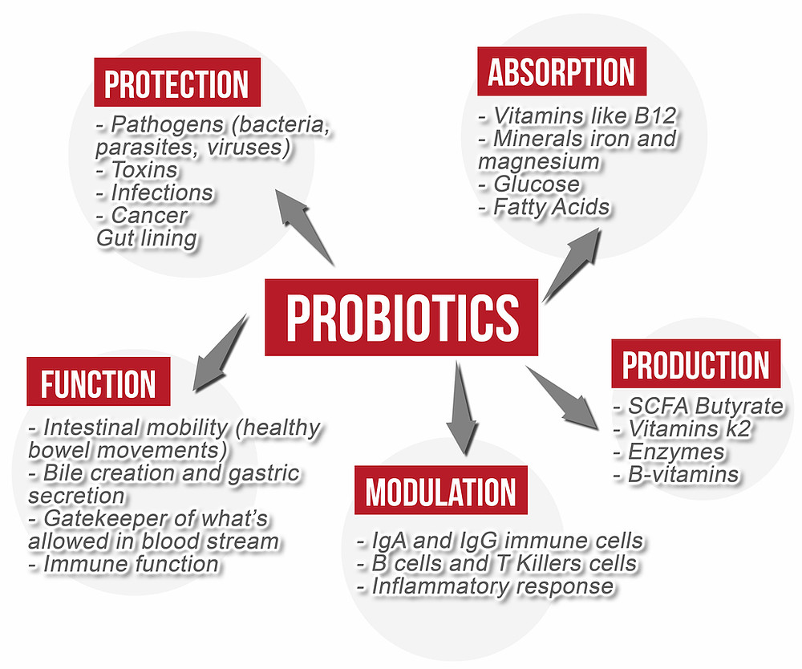
Figure 4: Beneficial effects of probiotics on human body

CONCLUSION
Probiotics are living microorganisms, saw as in "fermneted: yeast" food varieties. Different examinations show that the equilibrium or lopsidedness of microorganisms present in the stomach related framework is connected with your great wellbeing. Probiotics keep up with the equilibrium of microscopic organisms present in the digestion tracts and are useful in keeping us sound.
Similarly, as with other regular prescriptions for infection and disorder, probiotics make less side impacts and intricacies, and there is no way of going too far, requiring the utilization of a drug or the oversight of a subject matter expert.
Probiotics are extremely valuable in stomach related framework, contamination illnesses, the runs, weight reduction, sensitivities, resistance, in keeping the heart sound, we likewise concentrated on which food sources do probiotics get from.Eating an eating regimen that contains probiotics gives you numerous different advantages too to decrease weight, processing and safe framework. Probiotic is an incredible choice for the treatment of weight to mind sicknesses. Probiotics have fundamental useful properties that could meet most of our dietary and restorative supplementation purposes.
REFERENCES
- R. Agheyisi, The probiotics market: Ingredients, supplements, foods, Report code: FOD035B, BCC Research, Wellesley, MA, USA (2008) (http://www.bccresearch.com/report/ FOD035B.html)
- M.R. Gismondo, L. Drago, A. Lombardi, Review of probiotics available to modify gastrointestinal flora, Int. J. Antimicrob. Agents, 12 (1999) 287–292.
- D.M. Lilly, R.H. Stillwell, Probiotics: Growth-promoting factors produced by microorganisms, Science, 147 (1965) 747–748.
- R.B. Parker, Probiotics, the other half of the antibiotic story, Anim. Nutr. Health, 29 (1974) 4–8
- J. Fioramonti, V. Theodorou, L. Bueno, Probiotics: What are they? What are their effects on gut physiology? Best Part. Res. Clin. Gastroenterol. 17 (2003) 711–724.
- S. Salminen, A. von Wright, L. Morelli, P. Marteau, D. Brassart, W.M. de Vos, R. Fondén, M. Saxelin, K. Collins, G. Mogensen, S.E. Birkeland, T. Mattila-Sandholm, Demonstration of safety of probiotics – A review, Int. J. Food Microbiol. 44 (1998) 93–106
- P.R. Marteau, M. de Vrese, C.J. Cellier, J. Schrezenmeir, Protection from gastrointestinal diseases with the use of probiotics, Am. J. Clin. Nutr. (Suppl.), 73 (2001) 430–436.
- W.P. Charteris, P.M. Kelly, L. Morelli, J.K. Collins, Selective detection, enumeration and identification of potentially probiotic Lactobacillus and Bifidobacterium species in mixed bacterial populations, Int. J. Food Microbiol. 35 (1997) 1–27.
- Food and Agriculture Organization/World Health Organization (FAO/WHO), Health and nutritional properties of probiotics in food including powder milk with live lactic acid bacteria, Report of a Joint FAO/WHO Expert Consultation on Evaluation of Health and Nutritional Properties of Probiotics in Food including Powder Milk with Live Lactic Acid Bacteria, Córdoba, Argentina (2001) (http://www. who.int/foodsafety/publications/fs_management/en/probiotics.pdf).
- G. Reid, M.E. Sanders, H.R. Gaskins, G.R. Gibson, A. Mercenier, R. Rastall et al., New scientific paradigms for probiotics and prebiotics, J. Clin. Gastroenterol. 37 (2003) 105–118.
- G. Reid, Safe and efficacious probiotics: What are they? Trends Microbiol. 14 (2006) 348–352.
- R. Havenaar, B. Ten Brink, J.H.J. Huis isn’t Veld: Selection of Strains for Probiotic Use. In: Probiotics: The Scientific Basis, R. Fuller (Ed.), Chapman & Hall, London, UK (1992) pp. 151–170.
- Hosono: Fermented Milk in the Orient. In: Functions of Fermented Milk: Challenges for the Health Sciences, Y. Nagasawa, A. Hosono (Eds.), Elsevier Applied Science, London, UK (1992) pp. 61–78.
- Shortt, The probiotic century: Historical and current perspectives, Trends Food Sci. Technol. 10 (1999) 411–417
- I.I. Metchnikoff, P. Chalmers Mitchell: Nature of Man or Studies in Optimistic Philosophy, Kessinger Publishing, Whitefish, MT, USA (1910)
- M. Del Piano, L. Morelli, G.P. Strozzi, S. Allesina, M. Barba, F. Deidda et al., Probiotics: From research to consumer, Dig. Liv. Dis. (Suppl. 2), 38 (2006) 248–255.
- Food and Agriculture Organization/World Health Organization (FAO/WHO), Guidelines for the evaluation of probiotics in food, Report of a Joint FAO/WHO Working Group on Drafting Guidelines for the Evaluation of Probiotics in Food, London, Ontario, Canada (2002) (http://ftp.fao.org/es/ esn/food/wgreport2.pdf).
- E. Isolauri, S. Salminen, A.C. Ouwehand, Probiotics, Best Pract. Res. Clin. Gastroenterol. 18 (2004) 299–313.
- B. Sgorbati, B. Biavati, D. Palenzona: The Genus Bifidobacterium. In: The Lactic Acid Bacteria, Vol. 2, B.J.B. Wood, W.H. Holzapfel (Eds.), Chapman and Hall, London, UK (1995) pp. 279–306.
- W.P. Hammes, R.F. Vogel: The Genus Lactobacillus. In: The Lactic Acid Bacteria, Vol. 2, B.J.B. Wood, W.H. Holzapfel (Eds.), Chapman and Hall, London, UK (1995) pp. 19–54.
- S. Salminen, E. Isolauri, E. Salminen, Clinical uses of probiotics for stabilizing the gut mucosal barrier: Successful strains and future challenges, Antonie van Leeuwenhoek, 70 (1996) 347–358.
- F. Coppi, M. Ruoppolo, A. Mandressi, C. Bellorofonte, G. Gonnella, A. Trinchieri, Results of treatment with Bacillus subtilis spores (Enterogermina) after antibiotic therapy in 95 patients with infection calculosis, Chemioterapia, 4 (1985) 467–470.
- D.R. Mandel, K. Eichas, J. Holmes, Bacillus coagulans: A viable adjunct therapy for relieving symptoms of rheumatoid arthritis according to a randomized, controlled trial, BMC Complement. Altern. Med. 10 (2010) Article No. 1.
- O.B. Maia, R. Duarte, A.M. Silva, D.C. Cara, J.R. Nicoli, Evaluation of the components of a commercial probiotic in gnotobiotic mice experimentally challenged with Salmonella enterica subsp. enterica ser. Typhimurium, Vet. Microbiol. 79 (2001) 183–189.
- P. Marteau, Safety aspects of probiotic products, Scand. J. Nutr. /Näringsforskning, 45 (2001) 22–30.
- F. Gasser, Safety of lactic acid bacteria and their ocurrence in human clinical infections, Bull. Inst. Pasteur, 92 (1994) 45–67.
- B. Spanggaard, I. Huber, J. Nielsen, T. Nielsen, K.F. Appel, L. Gram, The microflora of rainbow trout intestine: A comparison of traditional and molecular identification, Aquaculture, 182 (2000) 1–15.
- C. Bunthof, T. Abe, Development of a flow cytometric method to analyze subpopulations of bacteria in probiotic products and dairy starters, Appl. Environ. Microbiol. 68 (2002) 2934–2942.
- E.J. Vollaard, H.A.L. Clasener, Colonization resistance, Antimicrob. Agents Chemother. 38 (1994) 409–414.
- Q. Shu, H. Lin, K.J. Rutherfurd, S.G. Fenwick, J. Prasad, P.K. Gopal, H.S. Gill, Dietary Bifidobacterium lactis (HN019) enhances resistance to oral Salmonella typhimurium infection in mice, Microbiol. Immunol. 44 (2000) 213–222.
- Lourens-Hattingh, B.C. Viljoen, Yogurt as probiotic carrier food, Int. Dairy J. 11 (2001) 1–17..
- C. Maldonado Galdeano, A. de Moreno de LeBlanc, E. Carmuega, R. Weill, G. Perdigón, Mechanisms involved in the immunostimulation by probiotic fermented milk, J. Dairy Res. 76 (2009) 446–454
- S. Scheinbach, Probiotics: Functionality and commercial status, Biotechnol. Adv. 16 (1998) 581–608.
- F. Holm, Gut health and diet: The benefits of probiotic and prebiotics on human health, The World of Ingredients, 2 (2003) 52–55.
- A.Y. Tamime, M. Saarela, A. Korslund Søndergaard, V.V. Mistry, N.P. Shah: Production and Maintenance of Viability of Probiotic Micro-Organisms in Dairy Products. In: Probiotic Dairy Products, A.Y. Tamime (Ed.), Blackwell Publishing, Oxford, UK (2005) pp. 44–51.
- C. Alamprese, R. Foschino, M. Rossi, C. Pompei, L. Savani, Survival of Lactobacillus johnsonii La1 and influence of its addition in retail-manufactured ice cream produced with different sugar and fat concentrations, Int. Dairy J. 12 (2002) 201–208
- L.C. Aragon-Alegro, J.H. Alarcon-Alegro, H.R. Cardarelli, M.C. Chiu, S.M.I. Sadd, Potentially probiotic and synbiotic chocolate mousse, LWT-Food Sci. Technol. 40 (2007) 669– 675.
- F.C. Prado, J.L. Parada, A. Pandey, C.R. Soccol, Trends in non-dairy probiotic beverages, Food Res. Int. 41 (2008) 111–123.
- Blandino, M.E. Al-Aseeri, S.S. Pandiella, D. Cantero, C. Webb, Cereal-based fermented foods and beverages, Food Res. Int. 36 (2003) 527–543
- Aquaculture /FAO/ Food and Agriculture Organization of the United Nations, 2019
- Vijay kumar, Bindu naik, et.al. Probiotics media: significance, challenges, and future perspective -a mini review Open Access Food Production, Processing and Nutrition
- C. J. Ziemer and G. R. Gibson, “An overview of probiotics, prebiotics and synbiotics in the functional food concept: perspectives and future strategies,” International Dairy Journal, vol. 8, no. 5-6, pp. 473–479.
- R. D. Berg, “Probiotics, prebiotics or "conbiotics"?” Trends in Microbiology, vol. 6, no. 3, pp. 89–92.

