A Survey on Technological Advancements of Scalable Computing Tools and Paradigms

Tanvir Habib Sardar
Dept. of CSE
GITAM School of Technology
GITAM University, Bangalore, India
tsardar@gitam.edu
Sk Jamil Ahmed Department of CSE
Alvas Institute of Engineering and Technology, Moodbidri, Karnataka
jamil.pace@gmail.com
Rashel Sarkar
Department of CSE
University of Science and Technology, Meghalaya
sarkarrashel@gmail.com

ABSTRACT

The recent development in technological products in the computer-based computing domain has significantly improved existing computing architectures and proposed novel computing systems in many cases. These computing systems are scalable, run-time efficient, and flexible with the tradeoff of complexity and expansiveness. This paper aims to provide a comprehensive view of the latest computing technologies. The article has section-wise presented the modern computing technologies and their sub-categories. Suitable figures are provided in places to provide a pictorial depiction of different technologies. Similarly, tabular data-wise explanations are also provided to showcase the differences between other computing technologies and paradigms.

Keywords—HPC, Parallel and distributed computing; Quantum computing; Exascale computing;

Introduction
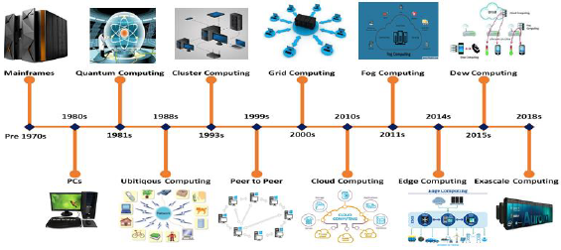
Computing is a broad term primarily referring to the computer-based processing of accomplishing an objective-oriented task [1]. Historically, computing has evolved as the Hardware, Software, and network paradigms have emerged or modified. The first computing model was mainframe (pre-1970s), followed by PCs (the 1980s), Network-based Cluster computing (1993) [2], and Grid computing (2000) [3]; in the 2010s Cloud computing [4] was developed to work using high-speed network connectivity. However, the network technologies and modern intelligent devices-based advancements such as IoT, smart cities, smart grids, augmented reality and computer vision generated new challenges to cloud computing. The traditional cloud computing models are based on centralized computation and storage system, which is incapable of the above-specified advancements. To incorporate the requirement, cloud-based computing is developed to fog computing (2011) [5], mobile edge computing (2014) [6], and dew computing (2015) [7]. With the advancement in semiconductor technology, High Performance Computing (HPC) has emerged as a solution for engineering computational solution models [8]. Moore's law [9] asserts that the number of transistors incorporated into a VLSI chip will roughly twofold every 24 months. However, Moore's law appears to have not worked for the last couple of years as the transistors are no longer doubling every two years. This makes an excellent issue for Exascale [10] and Zettascale [11] computing paradigms beyond 2018s. It is also assumed that post-2025, the sizes of transistors will be so small and would end up generating so much heat that traditional silicon chip technology would become a failure. The researchers are trying to find out a solution to this problem through quantum computing [12]. The above-specified timeline for computing technological enhancement is provided in figure 1.
Fig. 1. Evolution of Computing Technologies
The major changes in computing technologies happened due to exponential progress in CPU processing speed, networking, and storage capabilities. Modern computing technologies can be divided into High-Performance Computing (HPC), Distributed computing, and Jungle computing technologies. Figure 2 summed up these computing technologies and their subsequent categories. HPS is categorized into Supercomputing and Quantum Computing. The former is again classified into Petascale computing, Exascale computing, and Zettascale computing.
Similarly, Distributed computing is classified into Peer-to-Peer computing, Cluster computing, Grid computing, and Cloud computing. Cloud computing is further developed into Fog computing, Mobile edge computing, Mist computing, and Dew computing. All of the above-specified types of computing systems are presented using a pictorial view in figure 2.

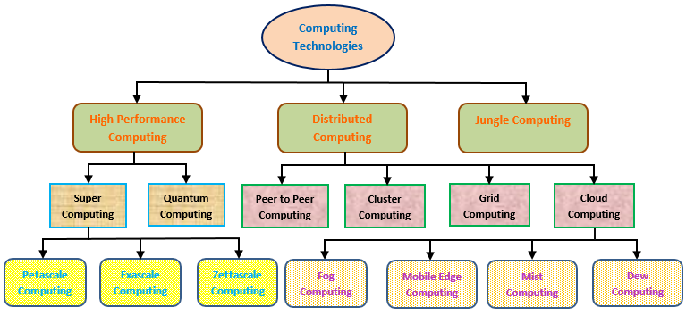

Fig. 2. Categorization of Different Computing Techniques

High Performance Computing
High Performance Computing (HPC) uses supercomputers and immensely parallel computing methods to deal with multifaceted processing challenges using automated simulation, data modeling, and analysis. HPC accumulates many technologies including different processing architectures, software tools, algorithms, and storage and network hardware to create a framework to solve higher computational issues. HPC is especially useful for solving complex numerical applications, data-intensive jobs, and big data processing. This has made HPC a lucrative choice for computation-intensive data fields such as engineering problem solving, big data processing, deep learning, scientific data processing of laboratory data, biomedical data processing, climate modeling, aerospace, physics, etc. HPC is further classified into Supercomputing and Quantum computing.

- Supercomputing
Supercomputing resembles the complex and data-intensive processing of large datasets using the best usage of the underlying computing resources [13]. The processing usually is divided into suitable parts and the parts works parallels and up to some level, independently. The significant role played by supercomputing is that it can process large and complex datasets in a time efficient fashion which is not possible using traditional computing systems.
Supercomputing can perform petaflop operations per second by processing data based on a network of CPUs, each with many cores while having own local memory to execute algorithms. In a supercomputing machine, the software programs are divided into different chunks, known as threads, which runs independently on the processor cores. This paradigm of processing made the supercomputing highly time-efficient. Some modern supercomputers have 1,00,000 or more cores in its processing unit. This enables the CPUs to work in Petascale range which is 1*1015 FLOPs. The first Petascale computer arrived at 2008. However, Exascale (1*1018 FLOPs) is the recent trend in 2021-22 [14]. Figure 3 shows the supercomputing timeline. Exascale computing is facing then challenges regarding power consumption and hardware cost and failure issues. Also, the software tool design is very tricky for Exascale computing architectures [15].
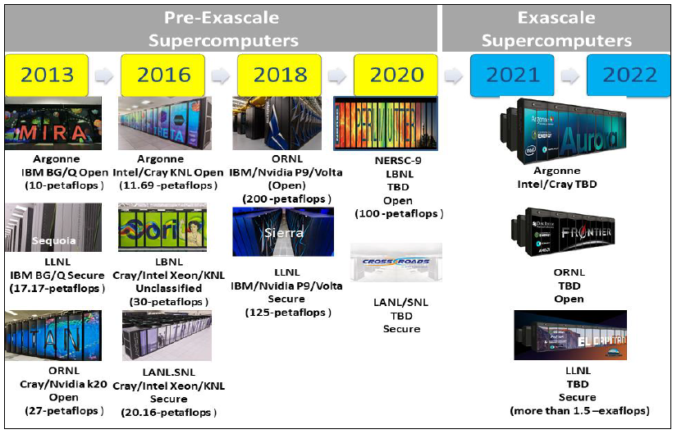
Fig. 3. The Supercomputing Timeline
In a hypothetical situation, we are going to enter into Zettascale computing with 1*10²¹ operations/s in 2035 [16].

- Quantum Computing
Quantum computing is based on quantum physics which deals with the behavior and characteristics of the energy of atoms and subatomic particles. This computing technique works with nanoscale devices and a very cold temperature of intergalactic space. The idea of quantum computing was first introduced in the early 1980 to deal with high-scale computing needs that a traditional computer can’t handle. Quantum computing works on the concept of quantum bits which carries the information in horizontal and vertical polarization states of the superposition theorem of quantum physics.
A comparison between quantum computing and traditional computing is described through the pictorial presentation in table 1.
Table 1. Traditional Vs Quantum Computing
Traditional Computing | Quantum Computing
Bit based on voltage or charge | Quantum bit based on the direction of an electron spin
Achieved by logic gates e.g. NOT, AND, OR etc. | Achieved by Quantum logic gates
It is governed by classical physics | It is governed explicitly by quantum mechanics
Utilize binary codes i.e. bits 0 or 1  to represent information | Utilize Qubits i.e. 0, 1, and both of them simultaneously to run machines quicker.
Represented by Boolean Algebra | Represented by linear algebra over Hilbert Space
Quantum computing is expected to work with traditional computing systems. Whenever a traditional computing system is heavier to carry a workload, the Quantum Processing Unit (QPU) will provide the required support to the traditional computer.

Distributed Computing
Distributed computing [17] is a cumulative and cooperative computing system that shares the memory, processing, and data distribution through network-based connected computing devices. Distributed computing can be classified into peer-to-peer, cluster computing, Grid computing, and Cloud computing. Table 2 provides the comparison between the distributed computing techniques.

- Peer-to-peer (P2P) Computing
P2P [18] is a distributed architecture based on computer networks. Peers are the non-prioritized equivalent computing devices that cooperate and swap workloads by interchanging among themselves. They act as clients and servers at the same time. The popularity of P2P comes with the file sharing needs, without a centralized server. Any commodity hardware with a P2P app connected to the internet can be served as a P2P computing cluster.
The advantages of P2P lie in its network management and scaling factors [19]. The disadvantages of P2P lie in the complications in data backup and security issues [20].

- Cluster Computing
The multiprocessor-based supercomputing is quite costly. Cluster computing [21] is developed as a solution to this. In cluster computing, many systems with different hardware features are represented as a single system. The systems are interconnected by networks and generally governed by specialized software.
The advantages associated with cluster computers are that they are very scalable, and cheap but comparatively better performance providers, high availability, and flexibility [22]. However, the disadvantages of cluster computing lie in the high latency and low bandwidth as compared to symmetric multiprocessors, and computing losses as all cluster machines are generally not used always [23].

- Grid Computing
In Grid computing [24], the computing nodes don’t share their hardware strength prior. Users get the resources as per the need of computing without knowing where the resources are exactly placed and their hardware and software technologies. Generally, the nodes are personal or organizational property organized to give heterogeneous resource usage [25].
The advantages of grid computing are its ease of collaboration and usage of existing software, cost-effectiveness, no single point of failure, and its capability to solve larger problems in a relatively smaller time [26]. The disadvantages lie in challenging interconnectivity issues, customization, and licensing issues [27].

- Cloud Computing
The most popular alternative to traditional computing is cloud computing [28] [29]. In 2006, the Amazon Elastic Cloud made the term popular [30]. Cloud computing is a framework to employ demand-based flexible access to web-connected internet to gain the configurable computing resources from vendors with lesser management efforts.
Cloud can be classified as the offering it provides by Software as a Service (the interface of the software is provided). Platform as a service (vendor controls the OS, data storage, networking, etc. The customer handles the applications), and Hardware as a service (outsource of storage, hardware, servers, and network components).
The advantages of cloud computing are it is pay-per-use, inexpensive storage capacity, ease in backup and data recovery, accessibility, and scalable and easy software updates. The disadvantages are the security of data and applications sometimes solely lies on the service provider, making it venerable. Also, due to slow internet, the time delay is a major concern for cloud-based systems.
Table 2. Distributed Computing Types and Comparisons
Criteria | Peer-to-Peer Computing | Cluster Computing | Grid Computing | Cloud Computing
Virtualization | Limited | Limited | Half | Essential
Ownership | Shared Ownership | Single Ownership | Multiple Ownership | Single Ownership
Standards | No Standard | Virtual Interface  Architecture | Some Open Grid Forum | Web Services (SOAP and  REST)
Operating System | Windows or Mac OS or  Linux | Windows or Linux | Any standard (dominated  by UNIX) | A hypervisor runs multiple  OS
Resource Management | Peer-to-peer | Centralized | Distributed | Centralized and Distributed

Post Cloud Computing Paradigms
Pervasive computing [31] in the new post cloud era computing research domain. In Pervasive computing, the daily usable objects are incorporated with processors and chips to enable them to communicate among themselves, without the end user connectivity. The computing devices are connected to themselves using the network. The Apple Watch is a brilliant example of pervasive computing.
The cloud computing model of centralized storage and processing is difficult to adapt to the pervasive computing era. This led to academicians proposing post cloud era computing models [32]. The post cloud computing model’s basic idea of aim, technology, and applications are the same in the sense that they try to incorporate the cloud infrastructure close to the devices to time efficiently process the needed computing at the local device processing unit. The post cloud era computing techniques are briefed below. A comprehensive comparison between these post cloud computing techniques are provided in table 3.

- Fog Computing
Introduced in 2012 by Cisco, Fog computing is designed to overcome the issues associated with IoT applications. In Fog computing, based on a networked framework, the widely distributed sensor-generated IoT data is managed from the source of data generations to the sources of data storage, either through data centers or by cloud storage. So basically Fog provides intermediate services among the cloud web services and sensor-based IoT data sources. The Fog nodes provide decentralized data processing. Generally, Fog nodes make use of traditional computer network components such as switches, routers, and proxy servers to connect with IoT sensors.
The advantages of Fog computing lie in its capacity in dealing with real-time data analysis, distributed use of storage and computing at Fog nodes, reduction of network bandwidth requirement, etc. The disadvantage of Fog computing is it depends on many links to data flow between the physical layer to the digital layer making a high chance of network failure.

- Edge Computing
Edge computing refers to the process of localized computing at the network edge devices (such as sensor gateway devices etc.) which are placed near the sensors. Thus, making the devices process the data without using the cloud infrastructures. Edge computing can make real-time computing as the processing happens near the devices.
The advantages of Edge computing are its capacity to process data in real-time, keeping the secret data only and devices while sending other data selectively to the cloud, etc. The disadvantages of Edge computing lie in its lesser scalability, interoperability, no resource pooling support, and localized data processing restricting the use of data to the cloud level.

- Mist Computing
The network extreme edge computing at the microcontroller and sensor level is known as Mist computing. The microcontroller and microcomputer-based process data by the Mist computing is used to further send it to the Fog computing node and then subsequently to the cloud. Mist computing is very useful for devices which mobile and serves a single purpose (for example, public transportation-based sensor devices).
The advantage of Mist computing is it is capable of local decision making while preserving batter power and bandwidth, and usage of data access techniques that guarantees data privacy. The disadvantage of fog computing lies in its capacity the process only lightweight data in a limited range of tasks.

- Dew Computing
Without any support from centralized resources, Dew computing provides micro services on end-user devices. The end user devices may be a robot, laptop, or mobile devices. It can cooperate with cloud and fog computing models. The scalability is the key objective aimed at developing the Dew computing models where processing is distributed among many heterogeneous and self-adaptive devices.

Table 3. Comparison between Post Cloud Computing Paradigms
Criteria | Dew Computing | Mist Computing | Edge Computing | Mist Computing
Service Location | At edge network | At edge network | At edge network | Within the Internet
Latency | Negligible | Very low | Low | Low
Geo-distribution | Highly distributed | Highly distributed | Distributed | Semi centralized
Target users | Purely mobile users | Semi mobile  users | Semi mobile  users | General internet users
Hardware | Very limited capabilities | Limited  capabilities | Limited  capabilities | Scalable capabilities
Internet dependency | Not essential | Not essential | Every access  time | Every access time
Client-Server connectivity | No | Yes | Yes | Yes

Jungle Computing
While many programming problems are solved based on the proposed solutions provided above, there are many real-world scenarios where an adequate solution to the extensive computing need is yet to fill up. The revolutionary changes in several types of computing and their subsequent enhancements to support cluster, cloud, and multi-core technologies such as GPUs have led to the need to incorporate heterogeneous, complex, and hierarchical computing systems to occur for quality problem-solving.
A Jungle computing [33] system consist of providing all available resources of computing (such as clusters, grids, clouds, mobiles, laptop, and even supercomputers) to the users so as to solve certain purposes.
However, Jungle computing is associated with many challenges. The key challenge is to make a uniform single kernel from the different kernels from different computing models objectified at different platforms. Also, the mapping of the kernel to the resource is a dynamic issue. The problem is to what degree the transparent and dynamic migration of compute kernels in Jungle computing systems can be enabled with run-time support.

Conclusion
This paper has discussed the computing technologies available to date. At first, the computing is divided into HPC, cloud computing, and jungle computing. Each of these fields is then elaborated with sub-categorical representations. The paper has provided the computing concepts using depiction and explanations and also used tabular data for comparative explanation and evaluation.

References
- Sardar, Tanvir Habib, and Zahid Ansari. "An analysis of MapReduce efficiency in document clustering using parallel K-means algorithm." Future Computing and Informatics Journal 3, no. 2 (2018): 200-209.
- M. Obali, A. E. Topcu, "Comparison of cluster, grid and cloud computing using three different approaches", 23nd Signal Processing and Communications Applications Conference (SIU), pp. 192–195, 2015.
- R. Guharoy, S. Sur, S. Rakshit, S. Kumar, A. Ahmed, S. Chak- borty, S. Dutta, M. Srivastava, "A theoretical and detail approach on grid computing a review on grid computing applications", 8th Annual Industrial Automation and Electromechanical Engineering Conference (IEMECON), 2017.
- B. K. Rani, B. P. Rani, A. V. Babu, "Cloud computing and inter clouds types, topologies and research issues", Procedia Computer Science, vol. 50, pp. 24–29, 2015.
- P. Bellavista, J. Berrocal, A. Corradi, S. K. Das, L. Foschini, A. Zanni, "A survey on fog computing for the internet of things, Pervasive and Mobile Computing", vol. 52, pp. 71–99, 2019.
- M. Satyanarayanan, "The emergence of edge computing", Computer, vol. 50, pp. 30–39, 2017.
- Y. Wang, "Definition and categorization of dew computing", Open Journal of Cloud Computing (OJCC), vol. 3, pp. 1–7, 2016.
- M. Tripathy, C. R. Tripathy, "A comparative analysis of some high performance computing technologies", International journal of advanced computer technology, vol. 3, pp. 1149–1156, 2014.
- M. N. O. Sadiku, S. M. Musa, O. M. Musa, "High-performance computing: A primer", International Journal of Advanced Research in Science, Engineering and Technology, vol. 4, pp. 4661– 4663, 2017.
- E. Abraham, C. Bekas, I. Brandic, "Preparing hpc applications for exascale: challenges and recommendations", 18th Int. Conf on Network-Based Information Systems, pp. 401–406, 2015.
- X. LIAO, K. LU, C. YANG, J. LI, Y. YUAN, M. LAI, L. HUANG, P. LU, J. FANG, J. REN, J. SHEN, "Moving from exascale to Zettascale computing: challenges and techniques", Front Inform Technol Electron Eng, vol. 10, pp. 236–1244, 2018.
- T. A. Shaikh, R. Ali, "Quantum computing in big data analytics: A survey", 2016 IEEE International Conference on Computer and Information Technology, pp. 112–115, 2016.
- X. Hu, M. Niemier, "Cross-layer efforts for energy efficient computing: towards peta operations per second per watt", Front In- form Technol Electron Eng, vol. 19, pp. 1209–1223, 2018.
- Performance development, https://www.top500.org/ statistics/perfdevel (2019).
- J. Zhai, W. Chen, "A vision of post-exascale programming", Front Inform Technol Electron Eng, vol. 19, pp.1261–1266, 2018.
- Z. Xu, X. Chi, N. Xiao, "High-performance computing environment: a review of twenty years of experiments in china", International journal of advanced computer technology, vol. 3, pp. 36–48, 2016.
- Sardar, Tanvir Habib, and Zahid Ansari. "Partition based clustering of large datasets using MapReduce framework: An analysis of recent themes and directions." Future Computing and Informatics Journal 3, no. 2 (2018): 247-261.
- H. Wang, H. Takizawa, H. Kobayashi, "A dependable peer-to- peer computing platform", Future Generation Computer Systems, vol. 23, pp. 939–955, 2007.
- D. Castella, F. Solsona, F. Gine, "Discop: A p2p framework for managing and searching computing markets", Journal of Grid Computing, vol. 13, pp. 115–137, 2015.
- C. P. Miguel, J. M. Alonso, A. Mendiburu, "High throughput computing over peer-to-peer networks", Future Generation Computer Systems, vol. 29, pp. 352–360, 2013.
- Sardar, Tanvir Habib, and Zahid Ansari. "Detection and confirmation of web robot requests for cleaning the voluminous web log data." In 2014 International Conference on the IMpact of E-Technology on US (IMPETUS), pp. 13-19. IEEE, 2014.
- Sardar, Tanvir Habib, and Zahid Ansari. "An analysis of distributed document clustering using MapReduce based K-means algorithm." Journal of The Institution of Engineers (India): Series B 101, no. 6 (2020): 641-650. H. Singh, G. Singh, "Task scheduling in cluster computing environment", International Conference on Futuristic Trends on Computational Analysis and Knowledge Management (ABLAZE), pp. 316–321, 2015.
- Ansari, Zahid, Asif Afzal, and Tanvir Habib Sardar. "Data categorization using hadoop MapReduce-based parallel K-means clustering." Journal of The Institution of Engineers (India): Series B 100, no. 2 (2019): 95-103.
- S. N. Pardeshi, C. Patil, S. Dhumale, "Grid computing architecture and benefits", International Journal of Scientific and Research Publications, vol. 3, pp. 1–4, 2014.
- J. Yu, R. Buyya, "A taxonomy of workflow management systems for grid computing", Journal of Grid Computing, vol. 3, pp. 171– 200, 2006.
- L. Li, Y. Wang, Y. Yang, Z. Tian, "Utility-based computing model for grid", Proceedings of the First International Conference on Semantics, Knowledge, and Grid (SKG 2005), 2005.
- Q. Chen, Q. N. Deng, "Cloud computing and its key techniques", Jr. of Computer Applications, vol. 4, pp. 25–62, 2009.
- N. Sadashiv, S. D. Kumar, "Cluster, grid and cloud computing: A detailed comparison", Proceeding of the 6th International Conference on Computer Science and Education (ICCSE), pp. 477–482, 2011.
- B. Rajkumar, Y. C. Shin, V. Srikumar, B. James, B. Ivona, "Cloud computing and emerging it platforms: Vision, hype, and reality for delivering computing as the 5th utility", Future Generation Computer Systems, pp. 599–616, 2009.
- K. Sakamura, N. Koshizuka, "Ubiquitous computing technologies for ubiquitous learning", IEEE International Workshop on Wireless and Mobile Technologies in Education (WMTE’05), 2006.
- D. Sehrawat, N. S. Gill, "Emerging trends and future computing technologies: A vision for smart environment",International Journal of Advanced Research in Computer Science, vol. 9, pp. 839–842, 2018.
- Abdelsamea, Amany, Salwa M. Nassar, and Hesham Eldeeb. "The past, present and future of scalable computing technologies trends and paradigms: a survey." International Journal of Innovation and Applied Studies 30, no. 1 (2020): 199-214.

