Multi-omics Technology Based Biomarkers

¹Pedamallu Niharika
Department of Pharmaceutical Chemistry,
¹SIMS College of Pharmacy,
Guntur, Andhra Pradesh, India
Email:niharika.mpharm12@gmail.com

¹S. Manohar Babu
Department of Pharmacology,
¹SIMS College of Pharmacy,
Guntur, Andhra Pradesh, India
Email: manoharsitty@yahoo.co.in
¹G. Mercy
Department of Doctor of Pharmacy,
¹SIMS College of Pharmacy,
Guntur, Andhra Pradesh, India
Email:mercy.avutapalli888@gmail.com

¹Akula Prabhu Sangeetha
Department of Doctor of Pharmacy,
¹SIMS College of Pharmacy,
Guntur, Andhra Pradesh, India
Email:aps.sangeetha222@gmail.com

²Satya Narayan Tripathy ³Rajib Lochon Maharana
Dept. of Pharmaceutical Analysis Specialist
²School of Pharmacy & Life Sciences ³Formulation Development Centre
Centurion University of Technology and Dr. Reddy’s Lab Ltd, IPDO
Management Bachupally, Hyderabad
Email:mrsntripathy@gmail.com Email:rajiblochon1986@gmail.com

ABSTRACT
Ovarian oncogenesis pathways have recently been investigated using multi-omics techniques, which assimilate data from genomics (DNA), transcriptomics (RNA), proteomics (proteins), and metabolomics (metabolites). These molecular signatures are helpful for elucidating the development and progression of ovarian cancer (OC) and have been identified through the use of current multi-omics approaches. High-throughput omics technologies have accelerated the identification of numerous potential biomarkers in recent years. An overview of the current state in this domain is offered with examples of genomics, proteomics, transcriptomics, metabolomics and microbiomics biomarkers in the field of oncology, along with some proposed ways to accelerate their validation. The utilization of multi-omics data has enhanced our understanding of the disease and enabled the identification of valuable OC based biomarkers. In this chapter, efforts are made to emphasize potential applications of multi-omics for finding novel biomarkers and enhancing clinical evaluation.

Keywords—Infection, biomarker, multi-omics, women health, rare diseases, ovarian cancer

INTRODUCTION

Diseases are triggered by shift patterns in the regulation of genes or by the combined effects of multiple genes and the environment on a particular organ or tissue. These diseases make their presence known through significant alterations in human physiology, which provides the foundation for clinical chemistry and enables it to contribute significantly to the diagnostic process and subsequent therapeutic interventions. DNA, RNA, proteins, lipids, and metabolites are all part of the complex network of molecules that are involved in the biological mechanism of disease. The term "biomarker" refers to "a characteristic that is objectively measured and evaluated as an indicator of normal biological processes, pathological processes, or pharmacological responses to a therapeutic intervention." According to this definition, a biomarker is "a characteristic that is objectively measured and evaluated as an indicator of normal biological processes, pathological In general, an ideal biomarker should be able to detect a fundamental feature of a specific disease; validated in and confirmed by those specific disease cases; precise, in that it should be able to detect the early stages of this specific disease and differentiate it from other similar disease cases or family members of that disease; simple to perform; reliable; non-invasive; and inexpensive, if at all possible. In addition, an ideal biomarker should be able to distinguish itself from other similar disease cases or family members of that disease (Ziad J Sahab et al 2007).

The omics methodology is a comprehensive examination of the roles that these molecules play in the function of living organisms. Different omic methods accessible include genomics, epigenomics, transcriptomics, proteomics, metabolomics, lipidomics and immunomics. Genomics refers to the study of genetic variants in order to investigate associations with diseases, responses to treatments, and prognoses. Epigenomics, on the other hand, is the study of the reversible change of DNA and the proteins that are connected with it. (Yehudit Hasin et al 2017). The field of epigenomics investigates the role that interactions between genes and the environment play in the onset, progression, prevention, and treatment of disease. The study of RNA transcripts is known as transcriptomics, and it is used to identify biological pathways, track changes that occur during the progression of disease, and distinguish healthy individuals from diseased ones. Figure 2 presents an overview of the processes that are involved in genomics and transcriptomics. As shown in figure 3, proteomics is both the scientific study and the technological process of isolating and identifying proteins from basic biological samples. The study of proteomics defines the biological and functional role that proteins play, reveals their biological mechanisms and their use as biomarkers and drug targets, and measures the proteins that are involved in both normal and pathological states in order to gain an understanding of the disease process. Integrative analysis of multi-omics data for the discovery and functional studies of complex human disorders (Yan V. Sun and Yi-Juan Hu, "Integrative analysis of multi-omics data for discovery and functional studies of complex human diseases," Adv Genet., 93, 147–190, 2016) The study of metabolomics elucidates the low molecular weight proteins that are unique to cells, tissues, and biological fluids, as well as the profile of metabolic pathways that are active in various systems of an organism. Using metabolomics to explore biomarkers of drug addiction (Ghanbari, Susan Sumner Reza, "Using metabolomics to examine biomarkers of drug addiction," Trends in Molecular Medicine, volume 24, number 197-205, February 2018) The field of immunomics focuses on the comprehensive study of the genes and proteins that make up the immune system. This study contributes to a better understanding of the dynamic link that exists between cells and the web of responses that occur in response to a stimulus or a disease. "Learning the Human Immunome: The Complexity of Comprehensive Leukocyte Immunophenotyping," (Angélique B and J. Philip 2014).

A single omic technique cannot, on its own, completely reveal the intricate details of a disease. As shown in Figure 1, an integrative investigation of various omics methodologies, often known as a multi-omics strategy, can give comprehensive information on molecular function, the genesis of disease, diagnostic biomarkers, and potential therapeutic targets for drug discovery.

BIOMARKER DISCOVERY

The search for one-of-a-kind disease biomarkers has become increasingly important in light of the emergence of diseases that are resistant to detection and treatment. This results in an improvement in the disease's diagnosis, prognosis, as well as the medication discovery process and therapy methods. The search can be carried out in one of two ways: a method based on hypothesis testing or an approach based on discovery, both of which are detailed in table 1. A biomarker can be derived from a mechanistic knowledge of a disease using the hypothesis-based search method, whereas the discovery-based method focuses on the changes that take place in molecular species throughout the illness state. The found biomarkers can be placed into one of three categories: risk, diagnostic, or prognostic biomarkers. When it comes to the early diagnosis of a disease, a panel of molecules, as opposed to a single biomarker, provides greater sensitivity as well as specificity. (Jason E. 2013)

BIOMARKERS IDENTIFIED THEOUGH MULTI-OMICS APPROACH

The most common type of cancer that affects women's gynaecological systems is ovarian cancer. Ovarian cancer is known as a "silent killer" since its early signs are not easily recognisable, it is often diagnosed in its advanced stages, and it has a high rate of recurrence. cAMP response element binding protein, also known as CREB, is a transcription factor that activates the transcription of genes necessary for embryogenesis and also plays a role in the process of malignant transformation of cells. CREB binds to the DNA sequence that can be found at cAMP response elements. Because CREB is overexpressed in many tumour cells, including those of non-small cell lung cancer, glioblastoma, leukaemia, breast cancer, and melanoma, CREB1 has emerged as a promising candidate for use as a biomarker for a variety of cancers. Ovarian cancer cells have been shown to have high levels of CREB1 expression, which is linked to a number of negative outcomes associated with the disease, including a poorer prognosis and a lower chance of survival. (Ju-Yueh Li et al., 2020). "Multi-omics study finding important biomarkers in ovarian cancer," by Ju-Yueh Li, Chia-Jung Li, Li-Te Lin, and Kuan-Hao Tsui, will be published in Cancer Control, volume 27, pages 1-10, in the year 2020.

An extremely rare form of epithelial ovarian cancer, low-grade serous ovarian carcinoma (LGSOC) has a median survival time of just 10 years from the time of diagnosis. Through a multi-omic and data-integration strategy, a correlation between mutations in the gene for mitogen-associated protein kinase (MAPK) and LGSOC was discovered, introducing MEK as a therapeutic target and MEK inhibitor medications for efficient therapy. (Raunak Shrestha et al. 2021). Multiomics Characterization of Low-Grade Serous Ovarian Carcinoma Identifies Potential Biomarkers of MEK Inhibitor Resistance," Raunak Shrestha, Marta Llaurado Fernandez, Amy Dawson, Joshua Hoenisch, Stanislav Volik, Yen-Yi Lin, Shawn Anderson, Hannah Kim, Anne M. Haegert, Shane Colborne, Nelson K.Y. Wong, Brian McConeghy, Robert H. Bell,

Exosomes are double-membrane vesicles of 30-150nm that are released by immunological, cancer, and mesenchymal stem cells and separated from plasma, serum, breast milk, saliva, urine, and ascites. They include proteins, lipids, viral particles, and RNAs (messenger, micro, long non-coding, circular). Exosomes help cells communicate with one another and share resources and information. They control cellular processes in both normal and abnormal conditions. The unique molecular content, components, and behaviours of exosomes generated by cancer cells as compared to healthy cells position them as promising potential biomarkers for gynecologic cancer risk assessment and detection. Cancer, angiogenesis, metastasis, immunological regulation, and treatment resistance can all flourish in an exosome-friendly environment. (Ye Miaomiao 2022). Nucleic acids and proteins carried by exosomes of different origins as prospective biomarkers for gynecologic malignancies, (Miaomiao Ye, et al., 2022).

Members of the Minichromosome Maintainance (MCM) family are a collection of genes that regulate early embryogenesis, cell division, as well as genome integrity and participation in homologous recombination repair. Using a multi-omic approach, specifically epigenomics and transcriptomics, researchers were able to determine that MCM plays a role as an oncogene and contributes to the proliferation of tumour cells. Because of this, MCMs serve as a biomarker for cancer. MCM attaches to the enzymes that are responsible for replicating DNA and dividing cells, which speeds up the spread of cancer. The upregulation of MCM2, MCM3, and MCM 7 mRNAs in endometrial cancer is helpful in diagnosis, while MCM 7 is helpful for pathological staging, prognosis, and as a therapeutic target. (Hua Lan 2021)

A ailment or illness is considered to be rare when it only affects five people out of every 10000 people in Europe or when it affects less than 200,000 people in the United States. The clinical heterogeneity of the condition, the failure of clinical trials, and the restricted number of therapeutic alternatives are the major problems associated with the development of drugs for rare diseases. There are 6000 to 8000 uncommon diseases known to exist in the globe at this time, yet only 5% of these have therapies that are considered acceptable. Because of this, it is necessary to speed up the process of identifying biomarkers and developing drugs. The application of genomic, epigenomic, and transcriptome approaches has resulted in an improvement in diagnostic accuracy and contributed to the development of new medicines. Differential methylation was identified as a possible marker of retinitis pigmentosa, Fuchs endothelial corneal dystrophy, IgA nephropathy, and polycystic kidney disease by multi-omic investigations. (Kerr K, 2019, Jason E, 2013; Quezada, 2017; M. Cronin et al. 2007; T.F. Imperiale et al. 2014; C.Q. Chang et al. 2014; P.C. Boutros, 2015).

CONCLUSION
Ovarian cancer (OC) is a diverse infection that, among gynaecological malignances, has the worst prognosis and the utmost fatality rate. Ovarian cancer has the uppermost mortality rate. The mainstream of people who have OC are typically diagnosed at a later point in the disease's progression because there are no distinct early signs. Therefore, there is an immediate need for improved biomarkers of OC that may be used in research and clinical practise. Over the course of the past ten years, we have witnessed an acceleration in the rate of progress made in sequencing and biotechnology methods. A preinvasive form of breast cancer known as ductal carcinoma in situ, or DCIS, has a very varied risk of progressing into an invasive form of the disease and increasing the likelihood of the patient's death. Many women who have been diagnosed with DCIS are now receiving excessive treatment because there are no reliable markers to accurately track the course of the disease. There is a need for reliable and predictive biomarkers that may be retrieved from molecular or genetic profiles in order to differentiate between DCIS instances that are likely to require medication and those that should be left untreated. Researchers established a structured machine learning approach that enacts multi-omics feature selection and model regularization for the purpose of identifying biomarker combinations that could be used to differentiate low-risk DCIS lesions from those with a higher likelihood of progression. These Potential biomarker configurations could be used to mark a distinction between lesions with a higher likelihood of progression and those with a low probability of progression.
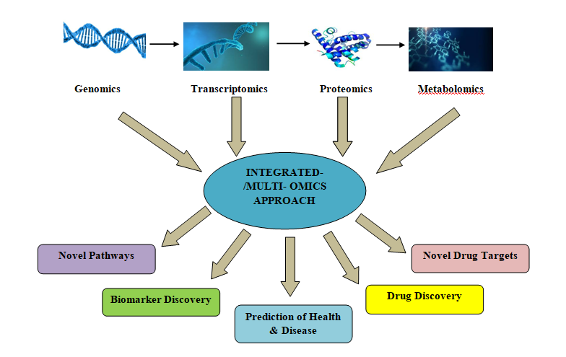
Figure 1: Multi-omics approach and applications

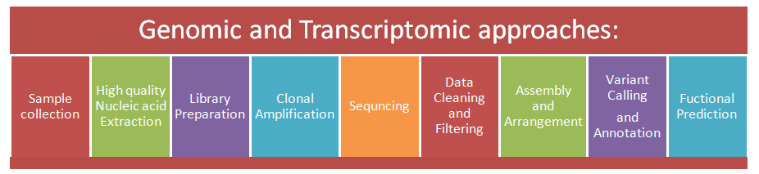

Figure 2: Steps involved in genomic and transcriptomic strategies

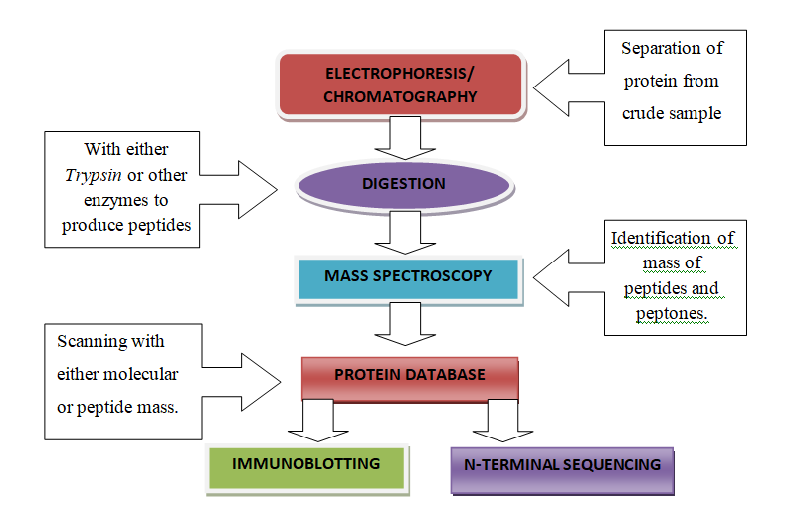
Figure 3: Steps involved in proteomic approach

Table 1: Process for Biomarkers Identifictions and its applications

S.No | BIOMARKER IDENTIFICATION PROCEDURE
 | Approaches | Methods | Applications
1. | DATA-DRIVEN APPROACH  Data Reduction  - Complex dataset is made easier to understand  - Eliminates noise | Trend Analysis | - Determines association between expression levels of particular pair of gene and a variable protein during disease  - Reveals statistically relevant patterns in gene expression profiles
 |  | Clustering | - Groups data according to the interactions among the elements  - Best suited for initial screening and biomarker verification.
 | Classification  - Predicts class membership for the existing data | Regression | - Most successful method  - Selection of biomarkers according to predictive power and estimates the relationship among a set of molecules to create a panel
 |  | Support Vector Machine | - Selects biomarkers from high density datasets
 |  | Decision tree and Random Forest | - Builds a tree of questions to identify markers
 |  | Artificial Neural Networks | Machine learning approach which resemble biological neural networks  ANN consists of nodes and links.  - Used to acquire panel of biomarkers
 |  | Relative Gene Expression Analysis | - Determines the differences in expression of pair of gene and proteins in disease and non-disease states
 | Visualisation  - Obtaining results from data through summarising and generating an image | Principal Component Analysis | - Reduce the magnitude of complex datasets and reveals the important influencing factors.  - Graph visualizes strength of separation of factors in disease and non disease state and helps in successful identification of biomarkers
 |  | Network Analysis | - Network forms are best for representation of large datasets and reveal some biological relationships in expression profiles.  - Network form consists of clusters and communities which help in suggesting the new regulatory mechanisms.
2. | KNOWLEDGE-DRIVEN APPROACH  - Integrates heterogenous data, interprets the results and faciltates in undestanding disease and biological process | Protein-Protein Interactions | - Helps in identification of underlying mechanisms of disease progression.  - Includes experimental identification, characterization and interpretation of protein-protein interactions and application of computational approaches
 |  | Pathway Analysis | - Identifies differentially expressed gene related to function  - Done in three steps a) choosing pre-existing gene set, b)asking functionally relevant questions, c) statistical testing  - Correlates differently expressed pathways with phenotypes.
 |  | Text mining | - Exploration of knowledge from the existing biomedical literature  - Done in three steps a) recognizing terms b) identification of relationship between terms c) discovering new relationship  - Powerful biomarker discovery and validation tool.

REFERENCES

- Yehudit Hasin, Marcus Seldin, Aldons Lusis, “Multi-omics approaches to disease,” Genome Biology vol. 18, pp. 83, 2017
- How To Maximize Insights From Precious Samples: The Power Of Multi-Omics ilumina nature research custom media Coppens, S. et al. AJHG 108(5), 840-856 (2021). Ramaswami, G., et al. Nat Commun 11, 4873 (2020). Bonder, M.J., et al. Nat Genet 53, 313–321 (2021). Koido, M., et al. Nat Med 26, 1541–1548 (2020). Zhou, Y., Ulland, T.K. & Colonna, M. Front Aging Neurosci. 9;10:202 (2018)
- Indhupriya Subramanian, Srikant Verma, Shiva Kumar,Abhay Jere and Krishanpa Anamika, “Multi-omics Data Integration, Interpretation, and Its Application,” Bioinformatics and Biology Insights, vol 14, pp. 1–24,
- Ziad J Sahab, Suzan M Sumaan, Qing-XiangAmy Sang, “Methodology and Applications in disease biomarker identification in human serum,” Biomarker insights, vol. 2, pp.21-43,2007
- Yan V. Sun, Yi-Juan Hu, “Integrative analysis of multi-omics data for discovery and functional studies of complex human diseases,” Adv Genet., 93, pp. 147–190, 2016
- Ju-Yueh Li, Chia-Jung Li, Li-Te Lin, Kuan-Hao Tsui, “Multi-omics analysis identifying key biomarkers in ovarian cancer,” Cancer Control, vol. 27, pp. 1-10, 2020.
- Raunak Shrestha, Marta Llaurado Fernandez, Amy Dawson, Joshua Hoenisch, Stanislav Volik, Yen-Yi Lin, Shawn Anderson, Hannah Kim, Anne M. Haegert, Shane Colborne, Nelson K.Y. Wong, Brian McConeghy, Robert H. Bell, Sonal Brahmbhatt, Cheng-Han Lee, Gabriel E. DiMattia, Stephane Le Bihan, Gregg B. Morin, Colin C. Collins, and Mark S. Carey, “Multiomics Characterization of Low-Grade Serous Ovarian Carcinoma Identifies Potential Biomarkers of MEK Inhibitor Sensitivity and Therapeutic Vulnerability,”Cancer Res, vol. 81, pp.1681–94, 2021.
- Miaomiao Ye, Jing Wang, Shuya Pan, Lihong Zheng, Zhi-Wei Wang, Xueqiong Zhu, “Nucleic acids and proteins carried by exosomes of different origins as potential biomarkers for gynecologic cancers,” Molecular Therapy: Oncolytics, vol. 24, pp. March 2022
- Hua Lan, Jing Yuan, Xingyu Chen, Chu Liu, Xiaohui Guo, XinyuWang, Jiarui Song, Ke Cao, Songshu Xia, “Multiomics profiling of the expression and prognosis of MCMs in endometrial carcinoma,” Bioscience Reports, vol. 41, pp. BSR20211719, 2021
- Kerr K, McAneney H,McKnight AJ, “Protocol for a scoping review of multi-omic analysis for rare diseases,” BMJ Open, vol. 9, pp. e026278, 2019 doi:10.1136/bmjopen-2018-026278
- Jason E. McDermott, Jing Wang, Hugh Mitchell, Bobbie-Jo Webb-Robertson, Ryan Hafen, John Ramey, and Karin D. Rodland, “ Challenges in Biomarker Discovery: Combining Expert Insights with Statistical Analysis of Complex Omics Data,” Expert Opin Med Diagn. , vol. 7, pp. 37–51, January 2013.
- Quezada, H., Guzmán-Ortiz, A.L., Díaz-Sánchez, H., Valle-Rios, R. and Aguirre-Hernández, J., 2017. Omics-based biomarkers: current status and potential use in the clinic. Boletín Médico Del Hospital Infantil de México (English Edition), 74(3), pp.219-226.
- M. Cronin, C. Sangli, M.L. Liu, M. Pho, D. Dutta, A. Nguyen, et al. Analytical validation of the Oncotype DX genomic diagnostic test for recurrence prognosis and therapeutic response prediction in node-negative, estrogen receptor-positive breast cancer. Clin Chem., 53 (2007), pp. 1084-1091.
- T.F. Imperiale, D.F. Ransohoff, S.H. Itzkowitz, T.R. Levin, P. Lavin, G.P. Lidgard, et al. Multitarget stool DNA testing for colorectal-cancer screening. N Engl J Med., 370 (2014), pp. 1287-1297.
- C.Q. Chang, A. Yesupriya, J.L. Rowell, C.B. Pimentel, M. Clyne, M. Gwinn, et al. A systematic review of cancer GWAS and candidate gene meta-analyses reveals limited overlap but similar effect sizes Eur J Hum Genet., 22 (2014), pp. 402-408.
- P.C. Boutros. The path to routine use of genomic biomarkers in the cancer clinic Genome Res., 25 (2015), pp. 1508-151.

