STATIC ANALYSIS OF MULTISTORIED RC FRAMED BUILDING USING ETABS

Dharmesh N
Assistant Professor
Department of Civil Engineering
RNS Institute of Technology,
Bengaluru, Karnataka, India
dharmesh.sd34@gmail.com

Arjun P
Assistant Professor
Department of Civil Engineering
RNS Institute of Technology,
Bengaluru, Karnataka, India
arjunp68@gmail.com

Madhusudhana Y B
Assistant Professor
Department of Civil Engineering
RNS Institute of Technology, Bengaluru, Karnataka, India
madhuyb8889@gmail.com

ABSTRACT
In the present study modeling and analysis of G+3 storeys (4 storeys excluding headroom) RC building is done in ETABS Software. Totally thirteen 3D RC framed building models are considered for the seismic analysis having plan dimensions of 10.5m x13m with a storey height of 3.2m each and the depth of foundation is taken as 1.5 m (Total height of building including depth of foundation and headroom is 17.5 m). As per IS-1893: 2016, Part-1, the equivalent static lateral force method is considered for all thirteen buildings for all Zones (II, III, IV & V) and Soil conditions (Hard, Medium & Soft Soil) respectively. The response quantities are mode period, storey displacement, and base shear obtained from those models, and the results are tabulated. Further work has been carried out for the cost analysis of with and without earthquake building models. The concrete quantity and steel quantity has been estimated separately and tabulated for different zones and soil conditions. The estimated costs are compared for all building models (with and without earthquakes) and the results are tabulated. The displacement and base shear values are maximum in zone-V, and soil-3 when compared with all zones and soil conditions. The estimation cost is maximum in zone-V compared with all other models.

Keywords—Static analysis, ETABS, mode period, base shear, cost analysis

INTRODUCTION
An earthquake is a sudden shaking of the ground caused by the movement of the earth’s crust. In general, there are different types of seismic waves some are called surface and body waves. This tends to do is make the ground shake and make the structure fall. These waves combined are body waves and surface waves create a repel in the ground which ultimately results in additional forces on the building. These different waves will end up resulting in different kinds of ground movements; this could be very complex to very simple. All the ground movement or all the forces that are generated due to an earthquake can be simply broken down into three mutually perpendicular vectors. There will be some kind of force that will be generated in the x, y & z-directions, which will result in the movement of the building or ground itself in the x or y, or z-direction, and the combination of these three results in varying complexity of ground movements. When it comes to earthquakes the horizontal forces due to earthquakes are usually predominant. In this study IS 1893:2016, part-1 is used for the analysis of thirteen RC framed buildings to know the response of base shear, mode period, and storey displacements for equivalent static lateral force method by ETABS software.

METHODOLOGY

Static analysis is to be carried out for all Zones (II, III, IV &V) and Soil conditions (Hard, Medium & Soft) for G+3 RC framed building.

IS:456-2000 is adopted for the design of RC members such as beams, columns, and slabs.

IS 1893-2016 part-1 is adopted for earthquake analysis.

Individual quantities are taken from different building elements to know the variation of quantities and cost in different zones and soil conditions.

DESCRIPTION AND MODELING OF BUILDING
A 3D RC framed building having dimensions 10.5m x 13m x 16m (excluding the depth of foundation), has been considered for static analysis. Thirteen building models are considered for parametric studies, they are:
Model-1: Reinforced concrete building without earthquake analysis
Model-2: Reinforced concrete building with earthquake analysis for all zones and soil conditions.
The density for reinforced concrete, brick masonry, and cinders are taken as 25 kN/m³, 19.2 kN/m^{3,} and 8.8 kN/m³ as per IS 875-1987, part 1. The imposed loads for roof and floor slab are taken as 2 kN/m² and 0.75 kN/m² for headroom as per IS 875-1987, part 2. The floor finishes on the roof and floor slabs are taken as 1 kN/m² and 0.25 kN/m² for the headroom. Characteristic strength of concrete and steel are taken as 25 and 415 N/mm² respectively.
Note: Beams, columns, and slabs self-weight are taken by ETABS software. 25% of the imposed load to be considered for calculation of seismic weight.
The calculation of sunken load on slabs, staircase load, and wall loads on beams are shown below.
Depth of sunken slab = overall depth of beam - depth of the slab
= 450-125=325mm
Sunken load = depth of sunken slab x density of cinders
= 0.325 x 8.8
= 2.86 kN/m²

Staircase load = waist slab thickness x (Stair length/2) x density of RCC
= 0.15 x 1.5875 x 25
= 11.9 kN/m
Wall load = wall thickness x (storey height – depth of beam) x density of the brick
- Main walls = 0.23 x (3.2-0.45) x 19.2 = 12.14 kN/m
- Partition walls = 0.10 x (3.2-0.45) x 19.2 = 5.28 kN/m
The parameters used for the equivalent static lateral force method as per IS 1893:2016, part-1 are shown below.
Zone = II, III, IV & V
Soil conditions = Hard soil, Medium soil, Soft soil
Response reduction factor =3 & 5 for ordinary and special moment resisting frames.
Important factor =1
Time period wall, $T_{a}=\frac{0.09h}{\sqrt{D}}$
X-direction, $T_{a}=\frac{0.09X16}{\sqrt{10.5}}=0.455 s$
Y-direction, $T_{a}=\frac{0.09X16}{\sqrt{13}}=0.4 s$
Table 1 shows the building sectional properties for the seismic analysis.
Table 1: Sectional properties of RC framed buildings
Members |  | Without earthquake | With earthquake
Beams |  | 230mm x 380mm  230mm x 450mm | 230mm x 450mm  230mm x 600mm
Columns |  | 230mm x 450mm  230mm x 600mm | 230mm x 450mm  230mm x 600mm  230mm x 750mm
Slabs |  | 125mm | 125mm
Walls | Main walls | 230mm | 230mm
 | Partition walls | 100mm | 100mm

Figure 1 shows the plan and 3D view of RC framed building for the seismic analysis.

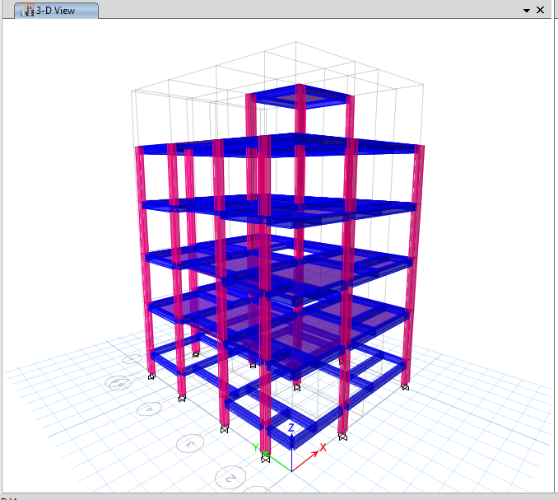
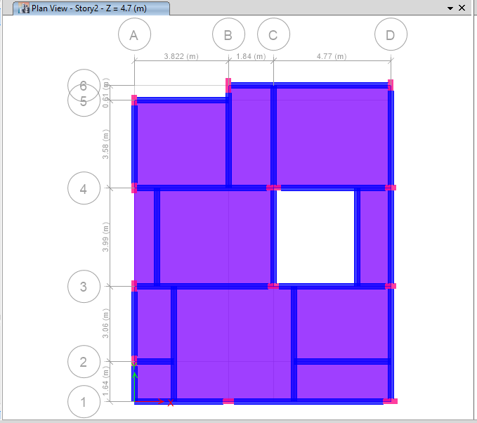
Figure 1: Plan and 3D view of RC building

RESULTS AND DISCUSSIONS
Based on the seismic analysis of RC framed buildings, the response quantities such as mode period, base shear, and storey displacements have been taken for all zones and soil conditions. The cost analysis for all buildings is calculated and the results are tabulated.

1) Mode Period
Table 2: Mode period for without earthquake analysis

Model | Mode Period (s)
 | Mode 1 | Mode 2 | Mode 3
Model-1 | 0.891 | 0.847 | 0.693

Table 2 shows that the mode period for G+3 stories buildings (without earthquake) is 0.891 sec along Y-direction, 0.847 sec along X-directions, and 0.693 sec in Torsion mode. The mode period is increased by 5% and 22% in mode-1 compared with mode-2 and mode-3.
Table 3: Mode period for with earthquake analysis

Model- 2 | Soil 1 |  |  | Soil 2 |  |  | Soil 3
Zones | Mode 1 | Mode 2 | Mode 3 | Mode 1 | Mode 2 | Mode 3 | Mode 1 | Mode 2 | Mode 3
Zone 2 | 1.182 | 1.037 | 0.976 | 1.164 | 1.046 | 0.871 | 1.158 | 1.073 | 0.84
Zone 3 | 1.109 | 0.968 | 0.83 | 1.105 | 0.97 | 0.83 | 1.094 | 0.95 | 0.83
Zone 4 | 1.093 | 1.014 | 0.832 | 1.105 | 0.97 | 0.819 | 1.094 | 0.95 | 0.816
Zone 5 | 0.972 | 0.855 | 0.728 | 0.99 | 0.848 | 0.717 | 0.956 | 0.82 | 0.733

Figure 2: Mode period for with earthquake analysis

Figure 2 shows that the mode period increases in mode-1 when compared with mode-2 and mode-3 for all zones and soil conditions respectively. As zone (II, III, IV, V) and soil (Hard, Medium, Soft) increases with a decrease in mode period because mode period is inversely proportional to stiffness. The column and beam sections are increased with an increase in zones and soil depending on design criteria. As section increases with an increase in stiffness so mode period will slightly decrease with an increase in zones and soils. The mode period is around 5-15% and 20-30% increases in mode-1 compared with mode-2 and mode-3 for all zones and soil conditions respectively.
2) Mode Shapes
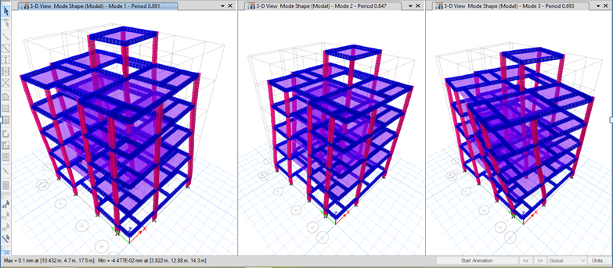
Figure 3: Mode shapes without earthquake analysis
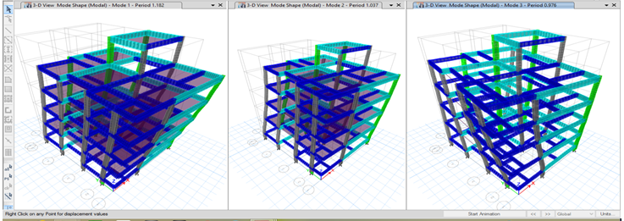
Figure 4: Mode shapes without earthquake analysis (Zone-2, Soil-1)
3) Base shear
Table 4: Base shear for different zones and soil conditions along X and Y direction
Models | Base shear (kN)
 | Soil 1 |  | Soil 2 |  | Soil 3
 | VX | VY | VX | VY | VX | VY
Zone 2 | 344.3903 | 383.1342 | 386.8024 | 386.8024 | 384.6083 | 384.6083
Zone 3 | 557.722 | 620.4657 | 623.5939 | 623.5939 | 624.9232 | 624.9232
Zone 4 | 503.5718 | 560.2237 | 567.0345 | 567.0345 | 567.167 | 567.167
Zone 5 | 782.8003 | 870.8653 | 869.9302 | 869.9302 | 873.7641 | 873.7641

Figure 5: Base shear for different zones and soil conditions along X and Y direction
Figure 5 shows that the base shear decreases by 12% and 11% in soil-1 compared with soil-2 and soil-3 for zone-2 along X-direction. Similarly slight variations of base shear along the Y-direction. The increase in base shear in zone-5 was nearly 55%, 28%, and 35% compared to zone-2, zone-3, and zone-4 for soil-1 along the X and Y-direction respectively. The base shear increases with an increase in zones and soil conditions along X and Y-directions.
4) Displacement
Table 5: Displacement (mm) for soil-1 along X-direction
No. of stories | Displacement (mm)
 | Zone 2 | Zone 3 | Zone 4 | Zone 5
Storey 6 | 19.7 | 28.2 | 28.5 | 29.8
Storey 5 | 18.4 | 26 | 26.1 | 27.5
Storey 4 | 15.4 | 21.6 | 21.7 | 22.8
Storey 3 | 10.8 | 15.1 | 15.1 | 16
Storey 2 | 5.5 | 7.7 | 7.6 | 8.1
Storey 1 (ground level) | 0.8 | 1.1 | 1 | 1.1

Figure 6: Displacement (mm) for soil-1 along X-direction
Figure 6 shows that the increase in displacement in storey-6 was around 95-96% in all zones compared to the bottom storey for soil-1 along the X-direction. The increase in displacement in zone-5 was nearly 33%, 5%, and 4% compared to zone-2, 3, and 4 for soil-1 along the X-direction at the top floor.
Table 6: Displacement (mm) for soil-2 along X-direction
No. of stories | Displacement (mm)
 | Zone 2 | Zone 3 | Zone 4 | Zone 5
Storey 6 | 22.6 | 24 | 31.5 | 33.4
Storey 5 | 20.9 | 22.1 | 29.1 | 30.8
Storey 4 | 17.5 | 18.4 | 24.2 | 25.6
Storey 3 | 12.3 | 12.9 | 16.9 | 17.9
Storey 2 | 6.3 | 6.5 | 8.6 | 9.1
Storey 1 | 0.9 | 0.9 | 1.2 | 1.3

Figure 7: Displacement (mm) for soil-2 along X-direction
The increase in displacement in zone-5 was nearly 33%, 28%, and 5% compared to zone-2, 3, and 4 for soil-1 along the X-direction at the top floor.
Table 7: Displacement (mm) for soil-3 along X-direction
No. of stories | Displacement (mm)
 | Zone 2 | Zone 3 | Zone 4 | Zone 5
Storey 6 | 25 | 25.8 | 29.9 | 31
Storey 5 | 23.1 | 23.8 | 27.7 | 28.6
Storey 4 | 19.2 | 19.8 | 23.1 | 23.7
Storey 3 | 13.5 | 13.9 | 16.2 | 16.6
Storey 2 | 6.8 | 7 | 8.2 | 8.4
Storey 1 | 0.9 | 1 | 1.1 | 1.2

Figure 8: Displacement (mm) for soil-3 along X-direction
The increase in displacement in zone-5 was nearly 19%, 16%, and 3% compared to zone-2, 3, and 4 for soil-1 along the X-direction at the top floor.
Table 8: Displacement (mm) for soil-1 along Y-direction
No. of Stories | Displacement (mm)
 | Zone 2 | Zone 3 | Zone 4 | Zone 5
Storey 6 | 28.1 | 32.7 | 38 | 39.4
Storey 5 | 26.5 | 30.7 | 35.6 | 36.9
Storey 4 | 21.9 | 25.4 | 29.3 | 30.2
Storey 3 | 15.3 | 17.7 | 20.5 | 20.9
Storey 2 | 7.7 | 9 | 10.4 | 10.4
Storey 1 | 0.9 | 1.1 | 1.2 | 1.2

Figure 9: Displacement (mm) for soil-1 along Y-direction
Figure 9 shows that the increase in displacement in storey-6 was around 95-96% in all zones compared to the bottom storey for soil-1 along Y-direction. The increase in displacement in zone-5 was nearly 28%, 17%, and 3% compared to zone-2, 3, and 4 for soil-1 along Y-direction at the top floor.
Table 9: Displacement (mm) for soil-2 along Y-direction
No. of stories | Displacement (mm)
 | Zone 2 | Zone 3 | Zone 4 | Zone 5
Storey 6 | 26.7 | 33.8 | 37.5 | 40.5
Storey 5 | 25.1 | 31.9 | 35.3 | 38
Storey 4 | 20.7 | 26.2 | 29.1 | 31.2
Storey 3 | 14.4 | 18 | 20.3 | 21.7
Storey 2 | 7.2 | 9.1 | 10.3 | 11
Storey 1 | 0.9 | 1.1 | 1.2 | 1.3

Figure 10: Displacement (mm) for soil-2 along Y-direction
The increase in displacement in zone-5 was nearly 34%, 16%, and 7% compared to zone-2, 3, and 4 for soil-2 along Y-direction at the top floor.
Table 10: Displacement (mm) for soil-3 along Y-direction
No. of stories | Displacement (mm)
 | Zone 2 | Zone 3 | Zone 4 | Zone 5
Storey 6 | 24.9 | 32.8 | 36.9 | 37.9
Storey 5 | 23.3 | 30.8 | 34.5 | 35.5
Storey 4 | 19.2 | 25.5 | 28.5 | 29.2
Storey 3 | 13.4 | 17.8 | 19.9 | 20.4
Storey 2 | 6.8 | 9.1 | 10.1 | 10.3
Storey 1 | 0.8 | 1 | 1.2 | 1.2

Figure 11: Displacement (mm) for soil-3 along Y-direction
The increase in displacement in zone-5 was nearly 34%, 13%, and 2% compared to zone-2, 3, and 4 for soil-3 along Y-direction at the top floor.
5) Estimation for RC Building
Table 11: Cost estimation for building elements
Zones | Soil | Concrete quantities (m³) | Rates  (Rs.) | Amount  (Rs.) | Steel quantities (tonnes) | Rates  (Rs.) | Amount | Amount  concrete+steel  (Rs.)
Without  earthquake |  | 177.289 | 2600 | 460951 | 15.48 | 46000 | 712080 | 1173031
Zone 2 | Soil-1 | 205.95 | 2600 | 535470 | 15.194 | 46000 | 698924 | 1234394
 | Soil-2 | 204.1 | 2600 | 530660 | 16.73 | 46000 | 769580 | 1300240
 | Soil-3 | 201.109 | 2600 | 522883 | 16.69 | 46000 | 767740 | 1290623
Zone 3 | Soil-1 | 216.901 | 2600 | 563943 | 20.56 | 46000 | 945760 | 1509703
 | Soil-2 | 218.032 | 2600 | 566883 | 19.53 | 46000 | 898380 | 1465263
 | Soil-3 | 224.065 | 2600 | 582569 | 19.05 | 46000 | 876300 | 1458869
Zone 4 | Soil-1 | 203.792 | 2600 | 529859 | 18.54 | 46000 | 852840 | 1382699
 | Soil-2 | 209.933 | 2600 | 545826 | 18.04 | 46000 | 829840 | 1375666
 | Soil-3 | 214.613 | 2600 | 557994 | 18.51 | 46000 | 851460 | 1409454
Zone 5 | Soil-1 | 240.659 | 2600 | 625713 | 22.96 | 46000 | 1056160 | 1681873
 | Soil-2 | 236.147 | 2600 | 613982 | 22.81 | 46000 | 1049260 | 1663242
 | Soil-3 | 252.19 | 2600 | 655694 | 22.94 | 46000 | 1055240 | 1710934
The total quantities for concrete and steel and cost estimations are calculated individually for all 13 buildings (without and with earthquakes considering all zones and soil conditions) as shown in above Table 11. It clearly shows that the quantities for concrete and steel and cost estimation increase with an increase in zones and soil conditions. The recent schedule of rates (SR), 2600/- is taken for concrete per m³ and 46000/- for steel per tonne. The estimation and cost are maximum in zone 5 compared with all other zones and without the earthquake model. When compared without the earthquake model, the cost increases by 10%, 24%, 20%, and 45% in zone-2, 3, 4, and 5 for soft soil.

CONCLUSION
The equivalent static lateral force method is adopted for the seismic analysis. The response quantities such as base shear, mode period & storey displacement are tabulated and discussed in the previous section. Based on the results and discussion the conclusions are drawn.
- Mode period increases in mode-1 when compared with mode-2 and mode-3 for all zones and soil conditions respectively. As zone (II, III, IV, V) and soil (Hard, Medium, and Soft) increase with a decrease in Mode period because Mode period is inversely proportional to stiffness. The column and beam sections are increases with an increase in zones and soil and this depends on design criteria. As section increases with an increase in stiffness. So, the mode period will slightly decrease with an increase in zones and soils.
- Base shear is maximum in zone-5, and soil-3 when compared with all zones and soil conditions because the mass participation factor is more in this zone compared with all other models. This shows base shear is directly proportional to the weight of the building.
- The displacement is maximum in zone-5, and soil-3 when compared with all zones and soil conditions because the stiffness participation factor is less in this zone compared with all other models. Stiffness decreases with an increase in displacement. This shows that stiffness is inversely proportional to displacement. The displacement is maximum along Y-direction compared with the X-direction because the length of the member is more in Y-direction. As length increases with a decrease in stiffness.
- It clearly shows that the quantities for concrete and steel and cost estimation increase with the increase in zones and soil conditions.
- The quantities for concrete are less in all models when compared with steel and cost estimation is also more in steel compared with concrete. The estimation and cost are maximum in zone 5 compared with all other zones and without the earthquake model. When compared without the earthquake model, the cost increases by 10%, 24%, 20%, and 45% in zone-2, 3, 4, and 5 for soft soil.

REFERENCES
- Arvind reddy& R.J.Fernandes, “Seismic analysis of RC regular and irregular frame structures”, International Research Journal of Engineering and Technology (IRJET) Volume: 02 Issue: 05, 2015.
- IS 875: (1987), “Code of practice for Design Loads (other than Earthquake) for Buildings and Structures”, Part 1: Dead loads, Part 2: Imposed loads, Bureau of Indian Standards, New Delhi,
- IS 456: (2000), “Plain and reinforced concrete code of practice-Code of practice”, Bureau of Indian Standards, New Delhi, 4th Revision.
- IS 1893: part 1 (2016), “Criteria for Earthquake Resistant Design of Structures”, part 1 General provisions, and Buildings (6th Revision), Bureau of Indian Standards, New Delhi.
- Mohammad Umar, “Reinforced Concrete Buildings of Seismic Behaviour under Significance of Fluctuating Frequency” International Journal of Advance Research in Science and Engineering, 2015.
- Pankaj Agarwal and Manish Shrikhande (2006), “Earthquake Resistant Design of Structures”, PHI Learning Pvt. Ltd.,.
- Smita, “Study of irregular multi-storey RC frame subjected to seismic condition analysis with STAAD Pro V8i software”, International Journal of Innovative Research in Advanced Engineering, 2020.

