Pharmaceutical Preparations and Drug Delivery System: A Basic Element for Pharmaceutical Industry
Feran Singh^{1*}
¹ Department of Pharmacology, ShriRam college of pharmacy Banmore, Morena, M.P., 476444
Feranale756@gmail.com
Pankaj Sharma²
² Department of Pharmaceutics, ShriRam college of pharmacy Banmore, Morena, M.P., 476444
Pankajsharma2232gmail.com
Sarvesh Bhargava²
² Department of Pharmaceutics, ShriRam college of pharmacy Banmore, Morena, M.P., 476444
Sarveshbhargava1988@gmail.com
Vinay Jain³
³ Department of Pharmacognosy, ShriRam college of pharmacy Banmore, Morena, M.P., 476444
Vinni77@gmail.com
ABSTRACT
Starting with different drug administration methods, this is an overview of drug delivery systems (DDS). The descriptions of various medication formulations, drug delivery systems, and targeted drug delivery systems follow. Delivering proteins and peptides has unique difficulties. The delivery of drugs is thought to be improved by nanoparticles, which can be both pharmacological and diagnostic in nature. The advancement of personalised medicine, which encompasses pharmacogenomics, pharmacogenetics, and pharmacoproteomic, will be made easier by improvements in medication administration. The ideal DDS, commercial considerations, present successes, difficulties, and possibilities are also covered.
The pharmaceutical active component can be released via the drug delivery method to produce the desired therapeutic effect. The low bioavailability and erratic plasma drug levels of conventional drug delivery methods (tablets, capsules, syrups, ointments, etc.) prevent them from delivering sustainable delivery. The entire therapy procedure may be ineffective without a reliable delivery mechanism. To achieve optimal efficacy and safety, the medicine must also be administered at a precisely regulated rate and at the intended spot. The issues with traditional medication delivery are addressed by the invention of controlled drug delivery systems. Over the last 20 years, controlled drug delivery systems have seen a significant change, progressing from large- and nanoscale to intelligent focused delivery. The first section of this study offers a fundamental overview of drug delivery methods with a focus on the medication's pharmacokinetics. It also talks about the limits of traditional medication delivery methods. Drug delivery systems are also covered in detail, along with design factors, categories, and illustrations. Additionally, the use of stimuli-responsive and intelligence materials for targeted and smart medication administration is presented together with recent key discoveries. The obstacles and potential prospects for regulated medication distribution are discussed in the paper's conclusion.
Keywords: Drug Delivery System, Pharmaceutical Industry, Active Pharmaceutical ingredient, Excipients, Solid, Semi Solid, & Liquid Dosage Forms
- INTRODUCTION
According to the FDA, an API is a substance that has been approved to be used in the official pharmacopoeia and is intended to be used in the diagnosis, treat, mitigation, or prevention of illness. Drug delivery is a method of giving a patient their medication in a way that precisely raises the concentration of drug in particular areas of the body over others [1]. Any delivery method should aim to extend, contain, and target the medicine with a safe interaction in the sick tissue. Every dosage form consists of both a drug's active pharmaceutical components (APIs) and excipients or additives, which are substances that aren't actually drugs (Figure 1). The actual chemical elements utilised to cure illnesses are known as APIs [2].
- NEED FOR A DOSAGE FORM
Drug delivery systems (DDS) are often favoured since it is extremely unusual to employ active pharmaceutical ingredients (APIs) "as they are" in clinical settings. For particularly powerful medications (such as low mg and g dosages), API storage and accurate dosing might be challenging or unattainable [3]. Drugs can be degraded at the site of administration (for example, low pH in the stomach), and they may cause local inconveniences or damage when the drug concentration is very high at the location of administration, making prescribed medication into the body cavities (rectal, vaginal) impractical and unfeasible [3]. Some APIs can benefit from less exposure to external elements (light, humidity, temperatures, and pH), or they need to be chemically modified because they are environment sensitive. due to the intrinsic uncertainty increases, stabilised. Patients are less likely to comply with APIs because they often have undesirable organoleptic (taste, odour, and adherence) [2].
Dosage form = Active Pharmaceutical ingredient (API) + Excipient/ Additives
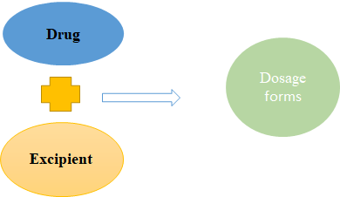
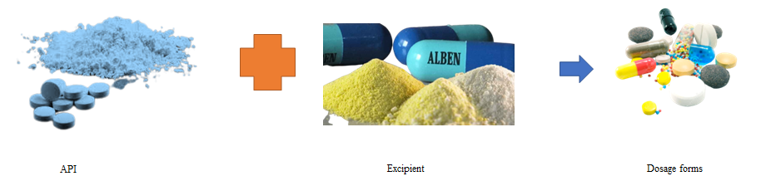
Figure 1. Dosage form composition.

Class I  greater solubility increased permeation | Class II  minimal solubility increased permeation
Class III  greater solubility minimal permeation | Class IV  minimal solubility minimal permeation

Solubility: Volume of water required to dissolve the highest dose strength across the physiological pH Range
Figure: 2 Biopharmaceutics Classification System
- EXCIPIENTS
Table 1 Common excipients used in tablets
S.N. | Excipient | Function | Examples
 | Diluents | supplying in bulk and enabling precise dosage of powerful substances | Lactose, dextrin, glucose, sucrose, and sorbitol are examples of sugar compounds. Silicates, calcium and magnesium salts, potassium or sodium chloride, and other inorganic materials
 | Binders, compression aids, granulating agents | Combine the materials for the tablet to give it shape and mechanical strength. | mostly made of natural or synthetic polymers, such as derivatives of cellulose, starches, sugars, and sugar alcohols.
 | Disintegrants | Help the tablet's active component to be released and increase the surface area for disintegration in the digestive system. | substances that expand or dissolve in water, such as crospovidone, alginates, and derivatives of cellulose
 | Glidants | By lowering friction and adhesion between particles, improve the flow of powders during tablet production. utilized as anti-caking agents as well | Silicon and other silica compounds in colloidal form
 | Lubricants | They may, however, impede disintegration and dissolution in a manner similar to glidants. Despite the fact that some substances, such starch and talc, have both effects, the characteristics of glidants and lubricants are different. | Sea salts and stearic acid (e.g., magnesium stearate)
 | Tablet coatings and films | Protect the pill from the elements (air, light, and moisture), boost the mechanical strength, cover the flavour and odour, make swallowing easier, and help customers identify the product. can be used to alter how the active substance is released. flavourings and colorings possible | film coating made of natural or manmade polymers has now supplanted sugar (sucrose). Enteric coatings employ insoluble in acid polymers, like cellulose acetate phthalate, to postpone the release of the active substance.
 | Colouring agents | Enhance patient acceptance, facilitate identification, and stop counterfeiting. Boost the stability of medications that are light-sensitive. | mostly manufactured colours and natural pigments. It is also possible to employ substances that are natural food pigments themselves.
[4-7]
- DIFFERENT ROUTES OF DRUG ADMINISTRATION
Dosage forms can be administered through different routes based on the target site, duration of treatment and the physicochemical attributes of the drug [9]. The most common dosage forms comprise tablets, capsules, pills, ointments, syrups and injections. Various routes of drug administration are tabulated in Table 1 and Figure 3. The preferred route of drug administration depends on three main factors: The part of the body being treated, the way the drug works within the body and the solubility and permeability of the drug. For example, certain drugs are prone to destruction by stomach acids after oral administration resulting in poor bioavailability. Hence, they need to be given by the parenteral route instead. Intravenous administration of drugs gives 100% bioavailability [9].

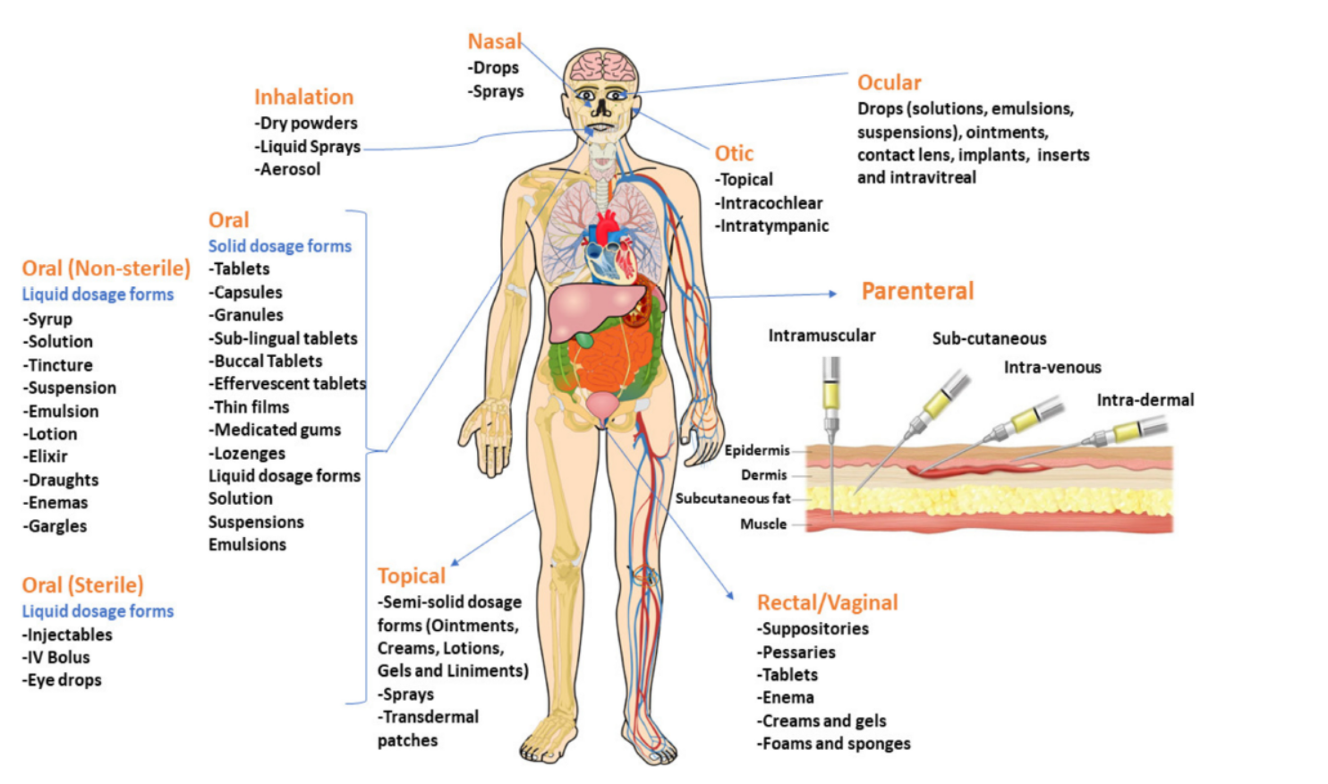
Figure 2. Various routes of drug administration.
- Solid Dosage Forms
(Solid dosage forms are further divided into the two main categories of single dose and bulk dosage based on the type of dose.
(a) Unit dose: Every dosage is predetermined and prepared as a distinct dosage form, and the patient must take one unit at a time. of each prescribed dose. Tablets, capsules, pills, lozenges, chewable effervescent tablets, and powder form inhalation in metered-dose containers are a few examples of unit pharmaceutical formulations.
(b) Bulk dose: As the name implies, this is a solid powder in bulk, not individually dosed, (Figure 3). With bulk powders, dose dumping is a significant issue. Bulk powders, on the other hand, are typically used as dressing powder for surgical and wound wounds. Insufflation powder, dressing powder, etc. are a few instances of bulk dosage forms [10].
- Tablets
Compress and granulating are used to generate tablets, which can be produced in a variety of forms (round, oval or square shape). Binders, gelling agents, and lubricants are commonly added as active ingredients to enhance tabletting. Excipients are added to pills to facilitate their simple digestion. The tablet's coating of colours, sweeteners, and flavourings makes the pill smoother and simpler to swallow while also helping to hide the taste of the other components. Additionally extending shelf life and providing environmental protection, tablet coating [10,12] Tablets that are placed under the tongue or between the mouth and cheek, respectively, are known as buccal tablets and are solid unit dose forms. Sublingual/buccal delivery methods have several benefits, including: The oral mucous membranes allow for quick drug dissolution and absorption into the bloodstream. By doing this, the liver's drug-metabolizing enzymes and the acid and enzymatic milieu of the stomach are avoided [11,12]. Effervescent tablets are made to release carbon dioxide when they come into contact with water and dissolve quickly afterward. These uncoated tablets contain carbonates or bicarbonates that quickly react in water to release carbon dioxide and acids (citric or tartaric acid).
Capsules, Lozenges, Pills and Granules
A capsules is a solid dosage form that contains the medication ingredients inside of a soluble shell. The flavour of the medication's ingredients is covered up by the capsules, and the medicine seldom interacts with the active ingredients. There are two categories for capsules: Soft-shelled capsules are mostly utilised for hydrophobic medicines and oily active ingredients that are suspended or dissolved in oil. Hard-shelled capsules are used to encapsulate dry, powdered components. Lozenges as chewy solid unit dose form that include the medication loaded in a caramel-flavored foundation comprised of sugar and gums. The gum gives the lozenge cohesion and strength while also allowing for a delayed release of the medication. Common applications of chewable tablets include the localised gradual release of demulcents, anaesthetics, and cough medicines in the mouth/pharynx. Using polymers and other additives to compress API into rounded masses for oral delivery, pills are solid unit dosage forms. Crystals are solid, dry aggregates that come in single-dose sachets and can be swallowed whole or dissolved in water before use (Figure 3). When introduced to water, effervescent granules produce carbon dioxide in a manner like effervescent pills.[10].
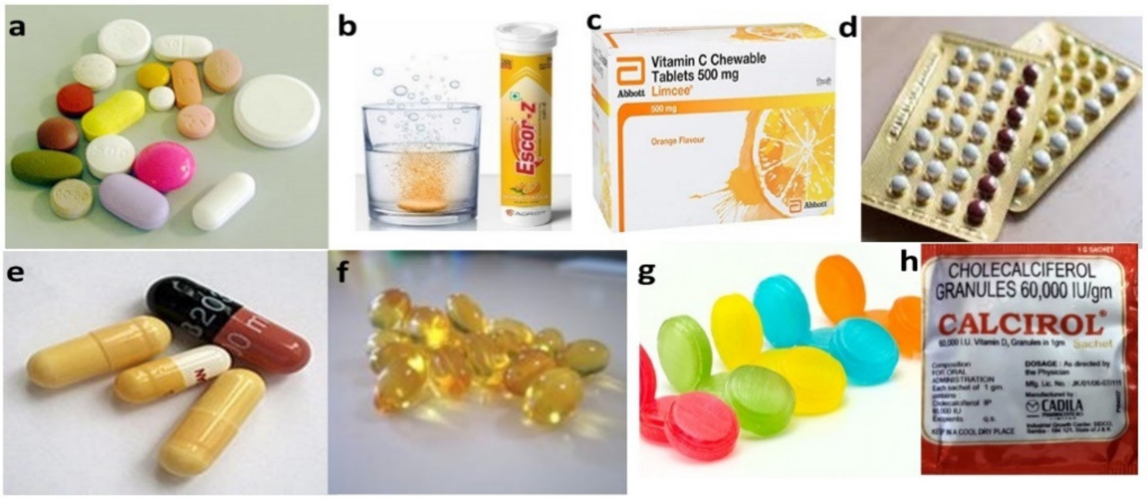
Figure 3. Solid unit dosage forms: (a) Tablets, (b) Effervescent tablets, (c) Chewable tablets, (d) Pills, (e) Hard-gelatine capsules, (f) Soft-gelatine capsules, (g) Lozenges. (h). Granules.
- Bulk Solid Dosage Forms
Large powder are transdermal patches compositions made up of free, dry, solid particles with varying degrees of fineness. With or without excipients, one or more active substances are present, and if necessary, coloration and flavored agents are added. This is prepared for interior or exterior administration and stored in widemouthed, airtight bulk glass or plastic containers. There are two categories of internal usage bulk powders. Since each dose is measured differently by the patient, bulk powders are frequently constrained by erroneous dosage. As a result, they are frequently made using non-potent medications including enemas, antacids, purgatives, etc. The powder is then commonly dissolved into water before consumption. Divided powders are single-dose powders (such as a little sachet) that have a more precise dosing control than bulk powder [10].
Semisolid Dosage Forms
To apply to skin or mucous membranes (in the nasal, vaginal, or rectal cavities) for medicinal, preventative, or aesthetic purposes, tablet and capsule forms are of a semisolid consistency. Ointments, creams, gel/jelly, lotions, pastes, suppositories, and transdermal patches are examples of semisolid dose forms (Figure 4) [13]. By applying semisolid dosage forms locally and externally to the target site, the likelihood of adverse effects is decreased. It is practical for individuals who are asleep or who have trouble receiving medication orally. It is more stable than liquid dose forms and an appropriate dosage form for bitter medications [14].
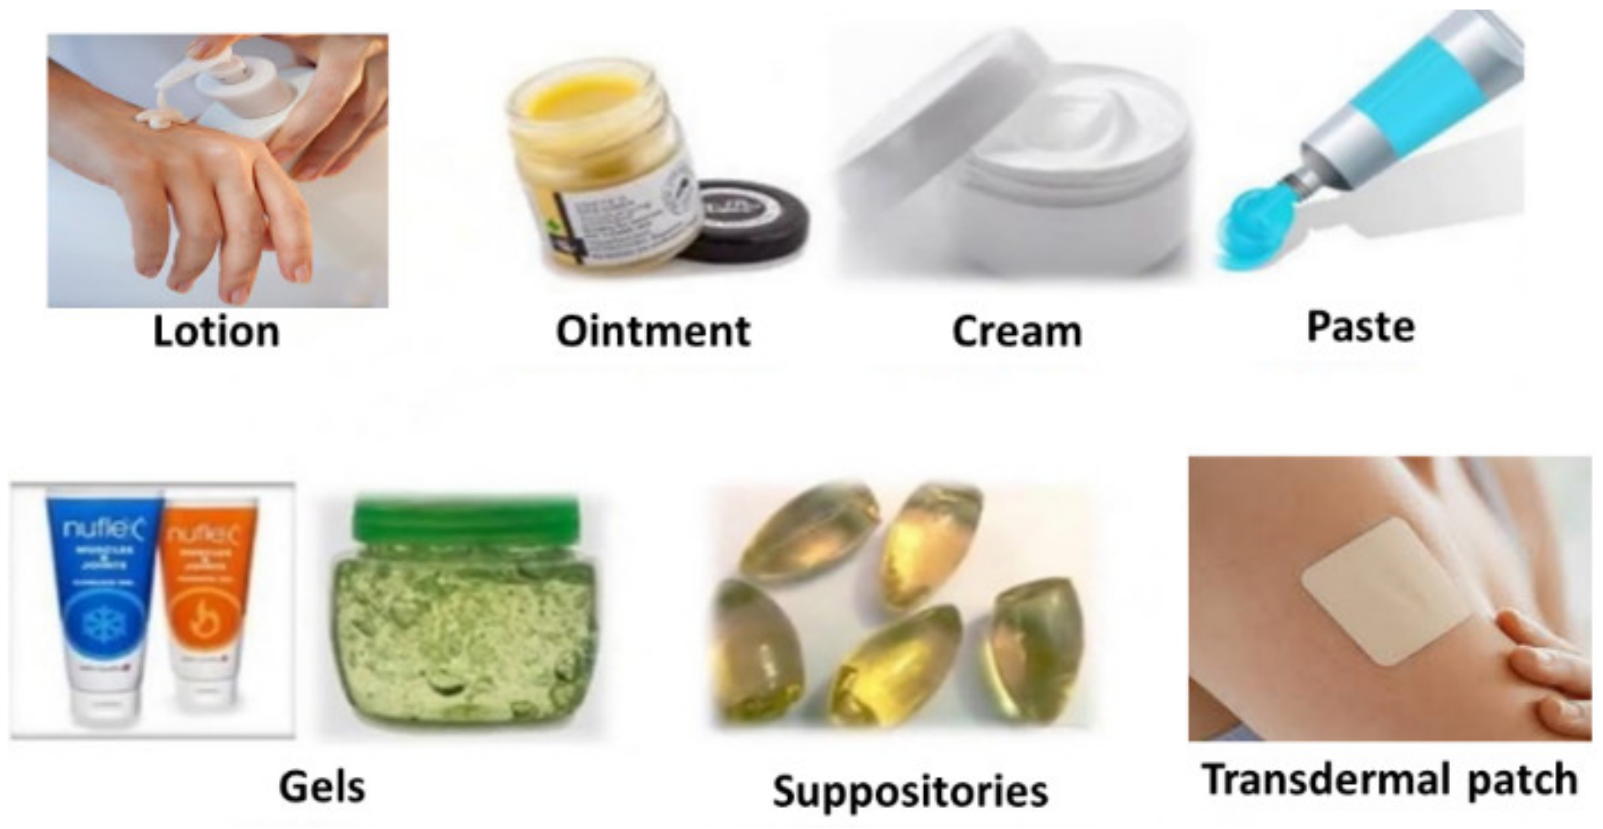
Figure 4. Semisolid dosage forms.
- Ointments
To apply to skin or mucous membranes (in the nasal, vaginal, or rectal cavities) for medicinal, preventative, or aesthetic purposes, semisolid dosage forms are of a semisolid consistency. Ointments, creams, gel/jelly, lotions, pastes, suppositories, and transdermal patches are examples of semisolid dose forms (Figure 4 and Table 2) [13]. By applying semisolid dosage forms locally and externally to the target site, the likelihood of adverse effects is decreased. It is practical for individuals who are asleep or who have trouble receiving medication orally. It is more stable than liquid dose forms and an appropriate dosage form for bitter medications [14].
- Creams
Skincare products are semisolid dosage forms that are relatively soft, simple to spread, and frequently include more than 20percentage water and volatile chemicals and less than 50% hydrocarbons (waxes or polyols) as the drug's foundation. Oil-in-water (O/W) and water-in-oil (W/O) cream bases are two different types of emulsification that are utilized as the foundation for cream products. Small oil globules spread in a continuous aqueous phase stabilised by surfactants make up oil-in-water (O/W) creams [15]. Because they are less oily and may be easily removed with water, petroleum creams are more aesthetically pleasant. Small droplets of water are spread across a continuous oily phase in water-in-oil (W/O) creams. Hydrophobic medications are easily integrated into W/O creams and provide greater moisture than O/W creams barriers to stop moisture loss from the cytoplasm, the skin's outermost layer.[14]
- Liquids (Gels) and Lotions
Gels are semisolid systems in which the liquid phase is contained in a 3-dimensional polymer matrices with a high level of physical or chemical cross-linking (made from natural or synthesised gums) [16]. They are utilised in lubrication products, cosmetics, medicine, and even as a delivery system for spermicides injected into the vagina [14]. An aqueous fluid preparation for friction-free external usage is a lotion. To lessen evaporation, they are immediately applied to the skin or poured onto an appropriate dressing before being covered by a waterproof dressing [14].
- Pastes
In essence, a paste is an ointment that has had a significant number of insoluble materials added. The system stiffens when there is a lot of particle debris present. Paste has less penetration, less maceration, and less heat than ointment. They create a strong perimeter of protection when applied to the skin [15]. Before certain toxic chemicals reach the skin, the solids they contain can absorb and, as a result, neutralise them. The paste, like the ointment, creates a seamless coating that is largely water-impermeable [16]. The film may be used as an effective sunscreen since it is opaque, unlike the ointment. The paste is less oily because the fluid hydrocarbon percentage is absorbed by the particle [14].
- Transdermal Patches
An adhesive medicinal patch used to apply a particular amount of medication to the skin to enter the bloodstream is known as a transdermal patch or skin patch. Transdermal patches are a highly advised therapy choice for people who are unable to take oral dose forms or oral drugs that have unbearable side effects [17]. However, this cannot be used to manage severe pain or in clinical settings when a quick medication titration is necessary. The transdermal patch is composed of two layers a backing film and a medication enclosed in a film or adhesive on the second layer. The membrane, which is a thin film, regulates how quickly the medicine diffuses from the patch to the skin. The patch's sticky coating aids in its adhesion to the skin [18]. The film-coated tape is immediately included into the patch design as a useful layer or outer lining. Before placing the patch to the skin, the release liner is removed to protect the sticky side of the patch that will come into touch with the skin. [19]. Transdermal patches are classified into four types based on the drug loading type: Matrix, reservoir, multilaminate, and drug-in-adhesive. The first type is a single-layer/multilayer drug-in-adhesive transdermal patch, in which the drug is directly incorporated into the adhesive; the second type has a separate drug-containing layer, which is considered to be a drug reservoir; the third, called matrix transdermal patches, have a drug layer comprising a semisolid matrix containing a drug solution or suspension; and the fourth one is multilaminate having different layers of drugs (Figure 4). The molecular weight of the drug should be less than 500 Daltons to formulate as a transdermal patch. The drug should be sufficiently lipophilic for easy permeation through the skin. The dosage of the drug depends on the duration for which the patch is worn. The first commercially available patch was scopolamine for motion sickness [20].
- Suppositories
A tiny, round or cone-shaped semisolid dosage form called an AA suppository is put into a bodily orifice (such as the vaginal cavity), where it dissolves or melts to release the medication and have local or systemic therapeutic effects. Natural fat (cocoa butter) or polyethylene glycol (Carbowax) and glycerol serve as the major excipients in suppositories. The rectum is highly vascularized; thus they function quickly and avoid the liver first-pass metabolic [14,22]. They are only meant to be injected in the anus.
- Liquid Dosage Forms
A suitable solvent or solvents are used to dissolve or disperse the API and excipients in liquid dosage forms, which are pourable pharmaceutical formulations. These are meant to provide an immediate therapeutic response in patients who have difficulty ingesting solid dose forms. There are two types of liquid dosage forms: dry powders that need to be reconstituted and ready-to-use liquids. These can be delivered parenterally (injectable, ocular, nasal, optic, and topical) or orally (syrups, suspensions, etc.). While parenteral liquid dosage forms are available in both sterile and non-sterile formulations, oral liquids are typically non-sterile (Figure 5). Based on the number of phases present, liquid dosage forms are divided into two categories: monophasic (solutions) and biphasic (suspensions and emulsions) [23].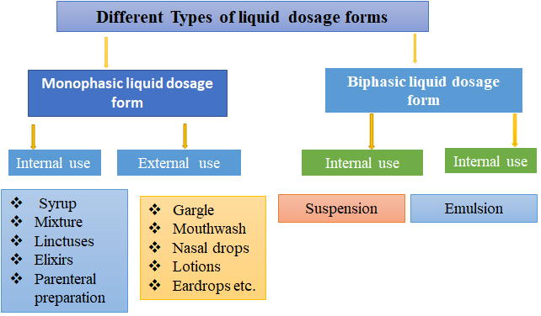
Figure 5. Liquid Dosage Forms

Advantages and disadvantages of solutions as dosage forms
- Advantages
Medication may be designed for any route of administration and is immediately ready for absorption. No need to shake the container makes swallowing easier in challenging situations.
Disadvantages
Drug stability is frequently decreased in solution, making it challenging to disguise disagreeable flavours and making the containers more likely to shatter. Technical precision is required to quantify dosage while administering medications, therefore a measurement instrument is required [24].
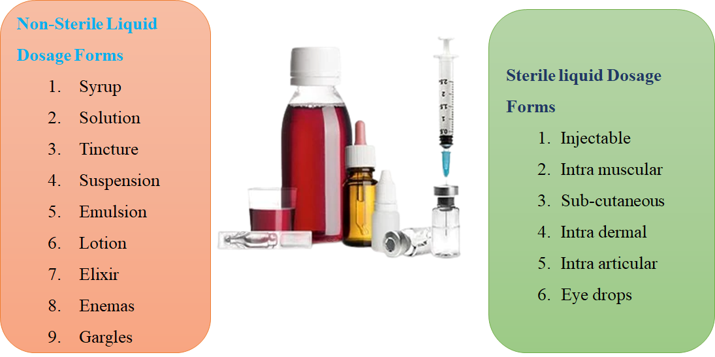
Figure 6. Sterile and non-sterile liquid dosage forms
- Oral liquid pharmaceutical dosage forms
Oral fluids are homogeneous liquid preparations, often a suspension of one or more active substances in a suitable liquid basis or a solution, emulsion, or combination of those components. Either directly or after dilution, they are prepared for oral delivery. They might comprise additional ingredients including appropriate dispersing, solubilizing, wetting, emulsifying, stabilising, suspending, and thickening agents as well as antibacterial chemicals for preservation. They could also include the appropriate sweeteners, flavourings, and colorings. [25]
- Syrup
A second active substance is present in solution in the syrup, a poisonous oral liquid. To prevent crystallisation or alter solubilization, taste, and other base qualities, sorbitol may be added to this base, which often contains substantial amounts of sucrose or other sugars. Other sweeteners, such as saccharin, and thickening agents may be present in sugarless syrup. Ethanol 95 percent may be used in syrup as a preservative or as a flavouring solvent. In order to preserve the microbiological quality of the preparation, antimicrobial agents may be added to syrups.
- Oral suspension
An oral liquid that has an additional active component contained in a suitable base is known as an oral suspension. Suspended solods can segregate for a while when kept, but they are quickly re-distributed when shaken. When creating oral suspensions with suspended particles, it is important to make sure that particle size is under control for the preparation's intended purpose.
- Solution
An oral liquid called an oral solution is one that has one or more active components that have been dissolved in an appropriate base measurement tool, such a dropper.
- Drop
With the use of an appropriate measurement tool, such as a dropper, an oral drop is a liquid that has been prepared to be ingested in small quantities.
- Emulsion
An oral emulsion is a liquid that is taken orally and contains an additional active component that is unstable in water. Stabilized oil-in-water dispersions may also contain dissolved particles in any or both phases of the preparation. Although the two preparatory phases can readily be combined by shaking, they can also separate. When properly shaken, the product is completely stable to deliver a homogenous dosage.
- Mixture
An oral liquid made up of one or more active substances that have been suspended or dispersed in a suitable base makes up the combination. While kept for a while, suspended solids may separate, shaking makes them readily re-suspended.
- Linctus
Linctus is a vicious oral liquid with one or more active substances mixed in a base that is acceptable and often has a greater concentration of sugar. Generally speaking, linctus are created to cure a cough, and these are taken with out inclusion of water.
- Elixir
This is a transparent, flavoured oral beverage with a high concentration of sucrose that may also contain ethanol (95%) or ethanol that has been diluted [26]. It comprises one or more active substances that have been dissolved in a suitable base.
- DRUG DELIVERY SYSTEMS
- Pharmacokinetics
What the body "does to the medication" is what it is. Absorption, distribution, metabolism, and elimination are all included. Drug Absorption shown in figure .7
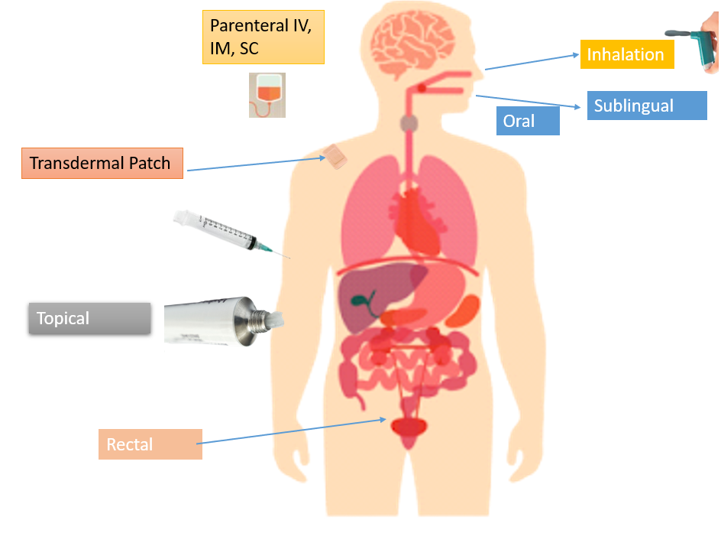
Figure .7 Drug Absorption
Drug absorption is the process by which an unaltered drug moves from of the site of delivery to the systemic circulation. It is the transfer of a medication into the bloodstream from the place of administration. The way that drugs are absorbed depends on several different things. It contains:
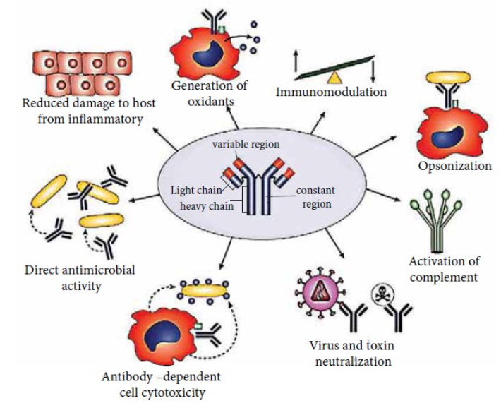
Figure 8. Factors influencing drug absorption
physiological characteristics of the medication, such as how fat-soluble form is better absorbed than water soluble form. Drug administration methods, such as intravenous, allow drugs to reach the bloodstream directly. Food, such as milk and milk derivatives, reduces absorption. The absorption of oral iron is increased by the presence of other medications, such as ascorbic acid. Drug absorption is decreased by gastrointestinal and other illnesses, such as gastroenteritis.
- Drug Distribution
The reversible transport of a medicine from the circulation to the body's extravascular fluids and tissues is referred to as drug distribution (for example, fat, muscle, and brain tissue). Drugs are absorbed and then enter the bloodstream. Drugs must first pass the capillaries barrier to reach the interstitial space from the serum before continuing through the cell membrane to reach the intracellular fluids.
- Drug Metabolism
Metabolism, sometimes referred to as biotransformation, is the chemical modification of a drug in a live body. Drug metabolism mostly occurs in the liver, although it can also occur in the GI tract, kidney, lungs, blood, skin, and placenta.
- Drug Excretion
Drug excretion is the process through which a drug and its metabolites are eliminated from the body. The kidney is the primary organ via which medications are excreted; other organs include the lungs, bile, faeces, perspiration, saliva, etc.[27]
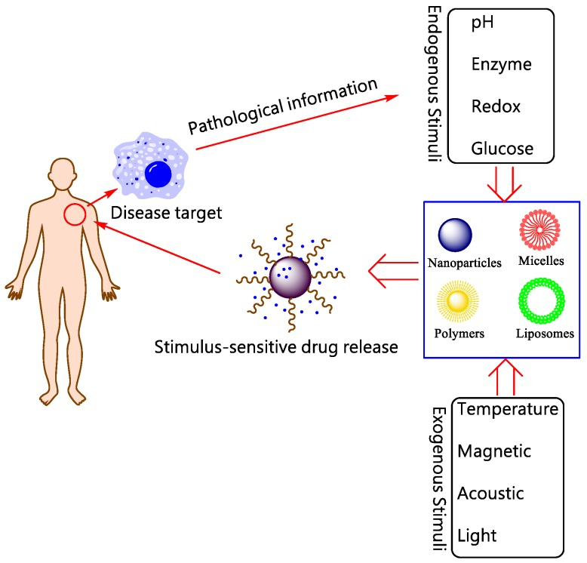
Figure 9. Schematic illustration for stimuli-responsive DDSs.
Table 2. Microspheres: as carriers used for novel drug delivery system:
S.N. | Type of microsphere | Application
 | Bio adhesive microspheres | medication distribution through the buccal, oral, ocular, nasal, and colon GI - Glipizide, Nasal - Gentamicin, and Insulin Insulin in the colon and methyl prednisolone in the eyes
 | Magnetic microspheres | used it for directing medications to tumour areas, protein purification, cell isolation, and DNA analysis (Doxorubicin)
 | Floating microspheres | Carriers for drugs like antiviral, antifungal and antibiotic agents (so called absorption windows), non-steroidal anti-inflammatory drugs, Prednisolone, Lansoprazole
 | Radioactive microspheres | in order to diagnose - Diagnostic radioembolization using human serum albumin macroaggregated to 99mTc (MAA) 99mTc-sulfur colloid for thrombus imaging in deep vein thrombosis 90Y microspheres are used for radioembolization of liver and spleen tumours, and 212Pb-sulfur colloids are used for local radiotherapy.
 | Polymeric microspheres | delivery of vaccines for hepatitis, influenza, pertussis, and diphtheria Easy-to-degrade medication administration via oral route: Using DNA plasmids for gene therapy, insulin and LHRH delivery medication distribution under control following local application: release of hormones, peptides, and proteins over a long period of time
[28]
Table 3. Possible advantages and disadvantages of biomaterials and extracellular vesicles as a drug delivery system.
Funding
Biomaterials | Extracellular vesicles
Advantage | Advantage
- Control and targeted drug release.  - Scalable, cost effective.  - Customized modification for personalized medicine.  - Drug delivery to the intended administration route.  - Temperature responsive. | - Bioavailability and biocompatibility.  - Batter BBB permeability.  - Carry biomolecules DNA, RNA, proteins, and small molecules.  - Natural, safe and efficient in delivering their cargo.  - Can be used for targeted drug delivery.  - Delivery with or without modification.
Disadvantage | Disadvantage
- Strategies evolving for drug delivery across BBB  - Studies indicated the degree of toxicity. (cytotoxicity, inflammation, immunotoxicity). | - Lack of controlled release mechanism.  - Interaction of drug with components.  - Mechanism of drugs of drugs to the target and immune clearances is understudied.

References
- Langer, R. Drug delivery and targeting. Nature 1998, 392, 5–10.
- Benoit, D.S.; Overby, C.T.; Sims, K.R., Jr.; Ackun-Farmmer, M.A. Drug delivery systems. In Biomaterials Science; Elsevier: Amsterdam, The Netherlands, 2020; pp. 1237–1266.
- Langer, R. New methods of drug delivery. Science 1990, 249, 1527–1533. [CrossRef]
- Chaudhari, S.P.; Patil, P.S. Pharmaceutical excipients: A review. IJAPBC 2012, 1, 21 34.
- Jain, K.K. An overview of drug delivery systems. Drug Deliv. Syst. 2020, 2059, 1–54.
- Patel, H.; Shah, V.; Upadhyay, U. New pharmaceutical excipients in solid dosage forms-A review. Int. J. Pharm. Life Sci. 2011, 2, 1006–1019.
- Kalasz, H.; Antal, I. Drug excipients. Curr. Med. Chem. 2006, 13, 2535–2563. [CrossRef] [PubMed]
- Ku, M.S. Use of the biopharmaceutical classification system in early drug development. AAPS J. 2008, 10, 208–212. [CrossRef] [PubMed]
- Verma, P.; Thakur, A.; Deshmukh, K.; Jha, A.; Verma, S. Research. Routes of drug administration. Int. J. Pharm. Stud. Res. 2010, 154–59.
- Augsburger, L.L.; Hoag, S.W. Pharmaceutical Dosage Forms-Tablets; CRC Press: Boca Raton, FL, USA, 2016.
- Qiu, Y.; Chen, Y.; Zhang, G.G.; Yu, L.; Mantri, R.V. Developing Solid Oral Dosage Forms: Pharmaceutical Theory and Practice; Academic Press: Cambridge, MA, USA, 2016.
- 1Mahato, R.I.; Narang, A.S. Pharmaceutical Dosage Forms and Drug Delivery: Revised and Expanded; CRC Press: Boca Raton, FL, USA, 2017.
- Bora, A.; Deshmukh, S.; Swain, K. Recent advances in semisolid dosage form. Int. J. Pharm. Sci. Res. 2014, 5, 3596.
- Niazi, S.K. Handbook of Pharmaceutical Manufacturing Formulations: Volume Four, Semisolid Products; CRC Press: Boca Raton, FL, USA, 2019.
- Mahalingam, R.; Li, X.; Jasti, B.R. Semisolid dosages: Ointments, creams, and gels. Pharm. Manuf. Handb. 2008, 1, 267–312.
- Allen, L.V., Jr. Basics of compounding: Tips and hints, Part 3: Compounding with ointments, creams, pastes, gels, and gel-creams. Int. J. Pharm. Compd. 2014, 18, 228 230.
- Prausnitz, M.R.; Langer, R. Transdermal drug delivery. Nat. Biotechnol. 2008, 26, 1261–1268. [CrossRef] [PubMed]
- Prausnitz, M.R.; Mitragotri, S.; Langer, R. Current status and future potential of transdermal drug delivery. Nat. Rev. Drug Discov. 2004, 3, 115–124. [CrossRef] [PubMed]
- Al Hanbali, O.A.; Khan, H.M.S.; Sarfraz, M.; Arafat, M.; Ijaz, S.; Hameed, A. Transdermal patches: Design and current approaches to painless drug delivery. Acta Pharm. 2019, 69, 197–215. [CrossRef] [PubMed]
- Dhiman, S.; Singh, T.G.; Rehni, A.K. Transdermal patches: A recent approach to new drug delivery system. Int. J. Pharm. Pharm. Sci. 2011, 3, 26–34.
- Perrigo. Transderm-Scop, Scopalamine Transdermal Patch. Available online: https://investor.perrigo.com/2019-10-03-Perrigo- Announces-the-Relaunch-of-the-AB-Rated-Generic-Version-of-Transderm-Scop-R-1-5-MG (accessed on 15 August 2021).
- Gad, S.C. Semisolid dosages: Ointments, creams and gels. In Pharmaceutical Manufacturing Handbook: Production and Processes;John Wiley & Sons: Hoboken, NJ, USA, 2008; Volume 5, pp. 267–312.
- Rubio-Bonilla, M.V.; London Bonilla, M.V.; Londono, R.; Rubio, A. Liquid dosage forms. In Pharmaceutical Manufacturing Handbook: Production andProcesses; John Wiley & Sons: Hoboken, NJ, USA, 2008; Volume 5, pp. 313–344.
- SolutionsCopyright Pharmaceutical Press www.pharmpress.com
- Pharmaceutical guidelines ankur Choudhary https://www.pharmaguideline.com/2013/03/oral-liquid-pharmaceutical-dosage-forms.html
- https://www.pharmaguideline.com/2013/03/oral-liquid-pharmaceutical-dosage-forms.html
- https://www.brainkart.com/article/Pharmacokinetics_35547/
- Ramteke K.H1,Jadhav V.B2 , Dhole S.N.3, Microspheres: as carrieres used for novel drug delivery system, Modern College of Pharmacy (For Ladies), Moshi, Pune 412508, Maharashtra State, India., IOSR Journal of Pharmacy (IOSRPHR) ISSN: 2250-3013, Vol. 2, Issue 4 (July2012) PP 44-48 www.iosrphr.org

