Antimicrobial Resistance and Human-Microbe Symbiosis
Analyzing through One Health Perspective
Srijan Goswami*
Indian Council of Complementary Therapy and Allied Sciences, Provaspally, Ichapur. 743144, Dist. 24 Parganas (N). W.B. India.
Email: srijangoswamiigmgs@gmail.com
Chiranjeeb Dey
Department of Zoology for UG and PG Studies, Serampore College, 9 William Carey Road, Serampore, 712201, Dist. Hooghly, W.B. India
Email: chiranjeeb123@gmail.com
Ushmita (Gupta Bakshi) Goswami
NIVA Homoeo Pharmacy and Laboratory (P) Ltd. Patulia, Titagarh, 700119.
Dist. 24 Parganas (N). W.B. India.
Email: ushmitaguptaisctas@gmail.com
*Corresponding Author: Email: srijangoswamiigmgs@gmail.com
Abstract
Antimicrobial Resistance (AMR) is one of the major concern for global health development and safety. The emergence and spread of drug-resistant pathogens (Superbugs) that have acquired new resistance mechanisms, leading to antimicrobial resistance, continues to threaten our abilities to treat common and advanced (life threatening) infections. Globalization has led to unprecedented increases in the movements of people, animals, and food commodities which provide opportunities for global spread of resistant organisms. Combatting the rising threat of AMR therefore requires global concerted actions and commitment of everyone. The present paper points out some of the conceptual mismatches, and one-sided approaches that gave birth and nurtured the crisis called “Antimicrobial Resistance. Also attempts to answer fundamental questions as, where did we go wrong? And how did we end up creating a global crisis instead of minimizing it?”
Keywords: One Health Concept, Human Microbiome, Evolutionary Medicine, Rudolf Virchow, Germ Theory, Whole Person Healing, Public Health, Environmental Health, Holistic Science, Reductionistic Science, Evidence Based.

Introduction
In year 1945, Sir Alexander Fleming mentioned in The New York Times that, “In such a case the Thoughtless Person playing with Penicillin treatment is morally responsible for the death of man who finally succumbs to infection with the Penicillin-Resistant Organism”. Blinded by little knowledge about Nature and access to technology at our hand to manipulate it, we have become the “Thoughtless Person” that Sir, Alexander Fleming mentioned. We are facing a formidable threat in that many microorganisms which were initially sensitive to antibiotics has now become resistant and this is a matter of serious concern (Calderone, 2015). The World Health Organization (WHO) listed AMR among one of the major concern for global health development and safety. The emergence and spread of drug-resistant pathogens that have acquired new resistance mechanisms, leading to antimicrobial resistance, continues to threaten our abilities to treat common and advanced (life threatening) infections. Especially alarming is the rapid global spread of multi- and pan-resistant bacteria (also known as superbugs) that cause infections that are not treatable with existing antimicrobial medicines such as antibiotics. Conventional science have introduced several disciplines and technological advancements to address the threat of AMR. But the reality is, the spread and impact of AMR increased exponentially with the rise in advancement of modern technologies (Abramson, 2008) (Hegde, 2014) (Antimicrobial Resistance, 2020). This brings us to a very fundamental question “if we are practicing evidence based science, then where did we go wrong? And how did we end up creating a global crisis instead of minimizing it?”
The answer lies in the way we use “Science” to understand “Nature”. Through reductionistic approach, at present date we may have achieved great technological advancements, but, in the process we have severely crippled the quality of public health and the surrounding environment. This paper points out some of the conceptual mismatches, and one-sided approaches that gave birth and nurtured the crisis called “Antimicrobial Resistance”. It has become our common practice to put all the blame of diseases and associated health concerns solely on microorganisms, inherited genes and abnormal physical parameters. In pursuit of proving ourselves superior and establish global medical monopoly we have endangered the fate of mankind. We, the members of scientific community, have a moral responsibility of safeguarding the future of mankind by ethically deciding what is right and what is easy.
Current Scenario of Antimicrobial Resistance (AMR)
“We are speeding up the development and spread of resistance dramatically by using antibiotics too much and often in the wrong contexts”… WHO | Commentaries-2015, November 20
According to the reports published in the official website of Centers for Disease Control and Prevention (CDC), antimicrobial resistance (AMR) is potentially affecting healthcare, veterinary, food safety and agricultural aspects, making it one of the world’s most urgent public health problems. CDC’s Antibiotic Resistance Threats in the United States, 2019 (2019 AR Threats Report) concluded that in the United States, at least 2.8 million people are infected with antibiotic-resistant bacteria or fungi, and more than 35,000 people die as a result every year. This report mentions that in 2017, 223,900 cases of Clostridioides difficle occurred and at least 12,800 individuals died of it (What Exactly Is Antibiotic Resistance?, 2020) (Antibiotic-Resistant Germs: New Threats, 2021). Annually in the United States, more than $4.6 billion is the estimated national cost for addressing infections caused by multi-drug resistant germs identified in the report (Nelson et al., 2021). Studies have shown that ~30 million pounds of antibiotics are used in United States each year. Out of which 25 million pounds are used in animal husbandry for disease prevention and growth promotion, and only 2 million pounds are given for specific animal infections. The researchers found and measured low concentration of antibiotics in foods and in various waterways and reported that overuse and misuse of antibiotics results in food-borne infections that are resistant to antimicrobials. Naturally Salmonella is found in 20% of ground meat, but the constant exposure of farm animals has made 84% of Salmonella resistant to specific antibiotics contributing to 80% of salmonellosis in human (or 1.4 billion cases/year). ~20% of farm chickens are contaminated with Campylobacter jejuni, at present date ~54% of the microbe are resistant to anti-Campylobacter antimicrobial substances (Agger, 2002) (Null, 2011).
According to the Global Antimicrobial Resistance and Use Surveillance System (GLASS), the rate of resistance to ciprofloxacin varied from 8.4% to 92.9% for Escherichia coli and from 4.1% to 79.4% for Klebsiella pneumoniae. In 2019, GLASS gathered data from several countries on blood-stream infections due to Methicillin Resistant Staphylococcus aureus (MRSA) and 3rd Generation Cephalosporin Resistant Escherichia coli. The approximate rate of resistance for MRSA was found to be 12.11% and 3GC-resistant Escherichia coli to be 36.0% (Antimicrobial Resistance, 2020).
Multi-drug resistant Mycobacterium tuberculosis (MDR-TB) strains poses a major threat in containing the global tuberculosis epidemic. MDR-TB requires long duration treatments that are not only expensive but also less effective as compared to non-resistant TB. The failure of “Last Resort” tuberculosis medications have exponentially increased the concern globally (Antimicrobial Resistance, 2020). Antiviral drug resistance is an increasing concern in immunocompromised patient populations, where ongoing viral replication and prolonged drug exposure lead to the selection of resistant strains. Resistance has developed to most antivirals including antiretroviral (ARV) drugs (Antimicrobial Resistance, 2020).
The CDC assessed antibiotic-resistant bacterial infections according to seven factors: clinical impact, economic impact, incidence, 10-year projection of incidence, transmissibility, availability of effective antibiotics, and barriers to prevention (Antibiotic-Resistant Germs: New Threats, 2021). The threat level of each bacteria was then classified as “urgent,” “serious,” or “concerning”. In general, threats that are urgent or serious require more monitoring and prevention activities, whereas those considered concerning require less.
- Urgent Threats - Clostridium difficile, Carbapenem-resistant Enterobacteriaceae (CRE), and Drug-resistant Neisseria gonorrhoeae (Antibiotic-Resistant Germs: New Threats, 2021).
- Serious Threats - Multidrug-resistant Acinetobacter, Drug-resistant Campylobacter, Fluconazole-resistant Candida (a fungus), Extended spectrum beta-lactamase-producing Enterobacteriaceae (ESBLs), Vancomycin-resistant Enterococci (VRE), Multidrug resistant Pseudomonas aeruginosa, Drug-resistant non-typhoidal Salmonella, Drug-resistant Salmonella Typhimurium, Drug-resistant Shigella, Methicillin-resistant Staphylococcus aureus (MRSA), Drug-resistant Streptococcus pneumoniae, and Drug-resistant tuberculosis (Antibiotic-Resistant Germs: New Threats, 2021).
- Concerning Threats - Vancomycin-resistant Staphylococcus aureus (VRSA), Erythromycin-resistant Group A Streptococcus, and Clindamycin-resistant Group B Streptococcus (Antibiotic-Resistant Germs: New Threats, 2021).
The concerns relating to antimicrobial resistance is so vast, that it is not possible to include all the details in a small article. Though the data mentioned is just the tip of the iceberg, but through that we still can realize the seriousness of the present crisis.
Antimicrobial Resistance (AMR): How did we get there?
Contributing Factor 1: Our Fascination towards “Germ Theory”.
“Knowledge advances not by repeating known facts, but refuting false dogmas”
…Karl Popper, n.d.
The prevailing ideology of Germ Theory.
The concept of using antimicrobials for treating diseases, began with the introduction of “Germ Theory” by Girolamo Fracastoro (in 1546), Louis Pasteur (in 1850s), and Robert Koch (in 1880s). The “Germ Theory” states that, human diseases are caused by germs (or microbes), which is specific for that disease and one must be able to isolate the microbe from the diseased human being. For example, the bacteria Mycobacterium tuberculosis is attributed as the organism responsible for causing the disease tuberculosis because when the biological sample of the suspected patient is tested, Mycobacterium tuberculosis is obtained. If the microorganism causes illness, then the ideal approach would be to synthesize medications that neutralizes or eliminates the microorganism under consideration. Thus, the “Antimicrobial” group of drugs were introduced consisting of four basic categories, antibacterial/antibiotics, antivirals, antifungals, and antiparasitic agents. And through dedicated research, the scientific community isolated and acquired a range of antimicrobial agents, both natural as well as artificial, that can be used to protect ourselves from disease causing microorganisms (Goswami & Bakshi, 2020) (Calderone, 2015) (Hegde, 2014) (Moynihan & Cassels, 2006).
Analyzing why “blindly following Germ Theory” is not right?
The Father of Pathology, Rudolf Virchow explained that “germs seek their natural habitat”, the diseased tissue, rather than being the cause of the diseased tissue. That means germs are the result and not the cause of pathological change that have occurred previously. Unfortunately this concept is not taught in conventional curriculum and are considered as non-evidence based ideology. If observed and analyzed carefully, the present day “Epidemiological Triad” scientifically validates the explanation given by Rudolf Virchow. According to the Centers for Disease Control and Prevention (CDC), the Epidemiological Triad (also known as Disease Triangle) is the traditional model for assessment of the cause of “Infectious Diseases” (CDC, 2012). Infectious Diseases are illness caused by germs (microorganisms) that enter the body, and multiply, by a process called “Infection” (Who We Are | NCEZID | CDC, 2017). The Epidemiological Triad is a concept that illustrates the importance of considering host, pathogen and environmental conditions as a whole, as the critical factors necessary for a disease to develop, because these three factors interrelate in a variety of complex ways to produce disease (CDC, 2012).
- Three major factors are taken into consideration namely the host, the environment and the pathogen (CDC, 2012).
  - The host (susceptible) represents the organism in which certain disease takes place.
  - The environment represents both the internal environment of the host’s body as well as the external environment in which the host lives and interacts with.
  - The pathogen (infectious microorganisms) represents the agent that possess the potential to causes disease when it enters host’s body. The pathogen (pathological state generators) may be living or non-living. The presence of pathogen alone is not sufficient to cause disease.
- The disease cannot occur in the condition where the host is present, the environment is present but the pathogen is absent (CDC, 2012).
- The disease cannot occur in the condition where the host is present, the pathogen is present but the environment is absent (CDC, 2012).
- The disease cannot occur in the condition where the host is absent but the pathogen and the environment are present (CDC, 2012).
- For a disease to occur it is necessary for all the three factors to be present at the same time. So a disease can only occur if host is present, the pathogen is present and the favorable environment is also present (CDC, 2012).
All these factors are scientifically proven by several researchers around the world independently and are accepted as an evidence based model. Thus, the question arises, in practice of medicine, while recording a case, we only consider the pathogen factor while treating a patient, believing that the “Germs” are responsible for the disease(s) and antimicrobial medications are prescribed that kills or arrests the microorganism(s) under consideration. The two other factors i.e. the host and the environment are completely ignored. So how can one conclude that the pathogen is the main and the only cause, when it is proven and accepted that for a disease to take place all the three factors must be present or else, if a single factor is missing then disease cannot occur. How can one claim to cure a disease by fixing only one of the factor (the microorganism) and totally excluding the other two, i.e. by rejecting the host factor and the environment factor? Figure 1 provides the relation between Modern Science, Germ Theory, and theory given by Rudolf Virchow.
If our existing treatment protocol based on “Germ Theory” holds true, then the concept of “Epidemiological Triad” for infectious diseases need to be updated. And if the “Epidemiological Triad” holds true, then our conventional treatment protocol based on ‘Germ Theory” needs to change, as both of them are contradictory.
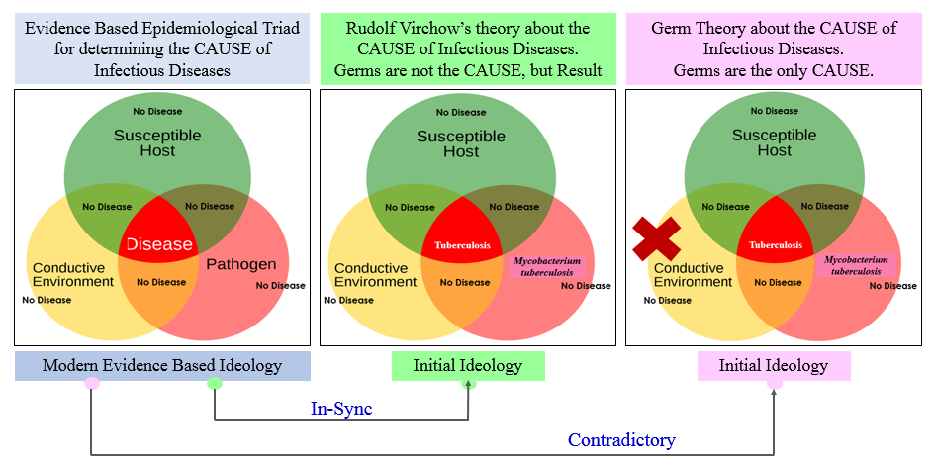
Figure 1: Relation between Modern Science, Germ Theory, and Theory given by Rudolf Virchow.
Contributing Factor 2: Selective promotion of “Reductionistic Approach” as the only way of Scientific Studies.
“Major weakness of reductionism is that the controlled setting may not reflect real life.”
The prevailing ideology of Reductionism.
Science is a medium for understanding how Nature functions. This understanding can be achieved in two ways, the reductionistic approach, and the holistic approach.
- Reductionism views the universe (for example Nature or Human Body) as a machine made out of various parts that are discretely functional and each of these component parts can be isolated and studied separately. This ideology believes the addition or removal of component parts does not produce a significant effect on the overall functioning of the system. In case the system breaks down efforts are made only to detect and fix the part that appears to have malfunctioned. It does whatever it takes to fix the part that appeared to have malfunctioned and does not consider the overall effect the approach makes on the system (Goswami & Bakshi, 2020) (Hegde, 2014) (Lipton, 2016).
- Holism views the universe (for example Nature and Human Body) as a system made out of interrelated and inseparable parts that function in a synchronized manner. Each component part is inseparably interconnected with each other and thus cannot be studied in isolation. The addition or removal of component parts produces a dynamic effect on the overall functioning of the system. In case the system breaks down detecting and fixing the part that appeared to have malfunctioned will not solve the issue. The emphasis is made to identify the actual cause that resulted in the malfunctioning of the component part and restoring the overall balance (Goswami & Bakshi, 2020) (Hegde, 2014) (Lipton, 2016).
Analyzing why “biased application of Reductionism to understand Nature” is not right?
In conventional science, it is our tendency to break a component into small bits and pieces and study everything discretely. And depending on the data obtained from bits and pieces we superimpose it on the whole structure, and this is the fundamental error we perform in understanding Nature. For example, water, if studied through reductionism, should behave as “highly combustible substance” because the components hydrogen is highly combustible substance and oxygen promotes combustion when studied in isolation. But we all know this is not the case, instead, when hydrogen and oxygen forms water molecule (i.e. becomes whole) the reacting elements loses their identity and starts acting completely different. Instead of behaving as combustible chemical, water helps bring down the temperature of combustible substance below its ignition range, thus used to control fire. Figure 2 represents the concept that whole is more than sum of its parts. This is fundamental chemistry that does not go by the ideology of reductionism, and unfortunately we never felt the need to question the legitimacy of the approach (Goswami & Bakshi, 2020) (Hegde, 2014) (Lipton, 2016, 2017) (Null, 2011).
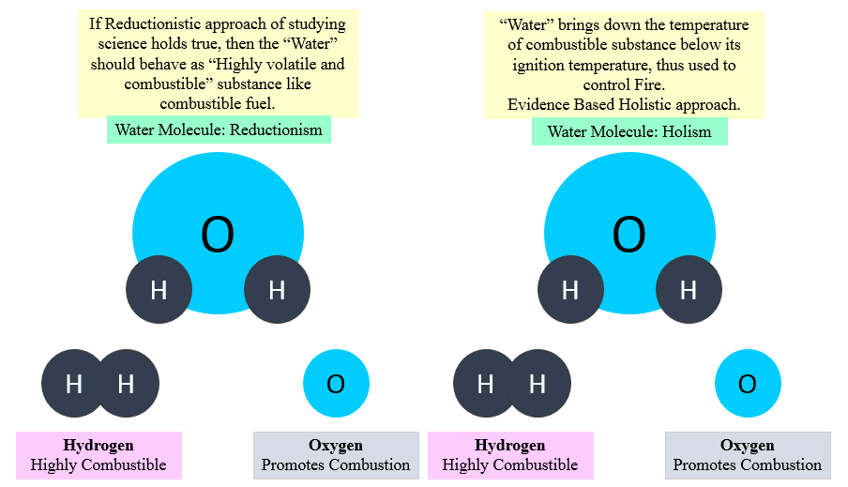
Figure 2: The whole is more than sum of its parts.
The “Germ Theory” is the result of this reductionistic approach, in which we assumed that curative treatment for infectious diseases and subsequent restoration of health can be achieved by killing suspected microorganisms with selected antimicrobial agents. Form reductionistic perspective using antimicrobial agents for killing suspected microorganisms may seem a logical thing to do. But by doing so we have ignored the environmental aspects that led to development of conditions favorable for the proliferation of microorganism under consideration, the effect of artificial antimicrobials on host microbiome, the effect on inherent defense mechanism of host as well as effect on natural immunomodulatory responses of the host. Figure 3 and 4 presents the “Germ Theory” and use of antimicrobial drugs from reductionistic as well as holistic perspective respectively (Goswami & Bakshi, 2020) (Hegde, 2014) (Lipton, 2016, 2017) (Null, 2011).
Both reductionism and holism allow us to understand Nature from a different perspective and are equally important in scientific studies. It is naïve and completely unscientific to embrace the one approach and completely exclude the other one. It is because of this bias incomplete understanding of the science persists in our community. Not being able to perceive Nature as it is, is our own fault. One need to realize that manipulating the experimental outcomes under laboratory settings is not going to change the ways Nature is meant to function. It is wise to acknowledge the fact that the wisdom of Nature is much greater than all the combined knowledge that human beings have gathered through time. This is the essence of understanding Science and it is time to implement this mindset practically before it’s too late. This unbiased mindset will make scientific studies more elaborate, error-free, complete, and evidence-based (Goswami & Bakshi, 2020).
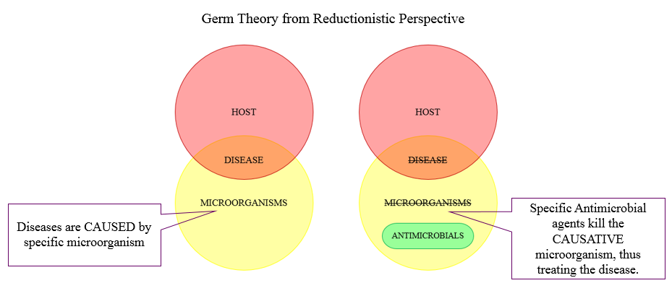
Figure 3: The Germ Theory and effect of Antimicrobial agents from Reductionistic perspective.
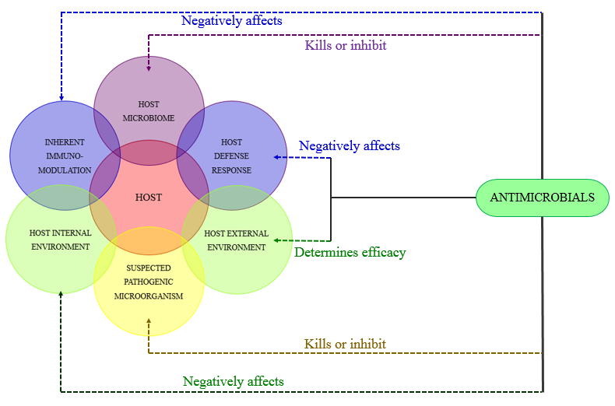
Figure 4: The Germ Theory and effect of Antimicrobial agents from Holistic perspective.
Contributing Factor 3: Lacking the basic Understanding of Health
Correct outcome can never be achieved with incomplete understanding,
Even if the intention is good and pure.
Definition of “Health” and Conventional Treatment Protocol (w.r.t. Antimicrobial Drugs)
The World Health Organization (WHO) plays an essential role in the global governance of health and disease; due to its core global functions of establishing, monitoring and enforcing international norms and standards, and coordinating multiple actors toward common goals (Ruger et al, 2009). The World Health Organization (WHO, 1948), defines “Health” as “a state of complete physical, mental and social wellbeing and not merely the absence of any disease or infirmity”. But conventional medicine being based on reductionistic approach, consider “Health” to be limited only to physical body along with associated diseases and infirmities. According to the conventional ideology every organ or components of a body are regarded or viewed as discrete units working in isolation with respect to other organs or components of that body. This is why in case of any disease the treatment procedures are performed and medications are prescribed with intention of providing relief to the particular organ under consideration. What are the effects and consequences of treatment and medication imposes on the other components of the body and overall health of an individual is beyond the scope of this treatment. So, based on this reductionistic ideology, specific microorganisms are identified as the cause of disease (as evident in physical body) and addressed with the use of one or combination of antimicrobial drugs (believing the antimicrobial drugs only destroys the microorganism under concern) (Goswami & Bakshi, 2020) (Hegde, 2014).
Analyzing how “Incomplete understanding of Health is related to rise in AMR”
We believe that diseases are caused by pathogenic microorganisms, our inherited genes and disturbed physical parameters. Based on the 1948 definition of Health, four dimensions are attributed, the Physical Dimension, Mental Dimension, Social Dimension and Spiritual (Environmental) Dimension (Goswami & Bakshi, 2020).
- Physical Dimension - Physical dimension is the only visible dimension of health. It represents the actual physical body. All the normal physiological processes and pathological states comes under the physical dimension. Derangement that are observable in the physical body comes under physical dimension (Hegde, 2014) (Lipton, 2016, 2017).
- Mental Dimension – First of all we must not confuse “mind” with “brain”. One should realize that mind is not the brain, or not present inside the brain. Brain is a component of physical dimension. It is believed that mental or psychological aspects are the result of co-ordination between genetic control, nervous system and endocrine system, but this idea is not completely true. In fact, it is one’s thought, intellect, emotions, perception etc. together constitutes mental dimension. Healthy mental state have positive influential effect on physical body, while unhealthy mental state have negative influential effect on human body (Hegde, 2014) (Lipton, 2016, 2017).
- Social Dimension – The social dimension of health refers to one’s ability to make and maintain meaningful relationships with others. Behaving appropriately by maintaining socially acceptable standards in a relationship is a sign of good social health. The factors that constitute social dimension which have both positive and negative influential effect on mental dimensions and by extension affects the physical dimension. So, in many pathological states that are evident in the physical body, their actual cause might be present at the social dimension. In such cases just addressing the physical body will not suffice (Hegde, 2014) (Lipton, 2016, 2017).
- Spiritual / Environmental Dimension – The first thing we have to understand that spirituality has nothing to do with religion. The term spiritualty is derived from the word “spirit” which means “to breathe”. Spiritual dimension represents a person’s interconnectedness with the environment he lives in. It represents believing in the fact that we human beings are intricate part of the nature. Each and every action that we make have influential effects on fellow organisms and the environment we live in. Similarly, the environment we live in and the fellow organisms those are present around us also influences our existence. So, our interaction with the environment we live in, our response to climatic conditions, our interaction with other organisms in the environment and response to natural energies or natural forces guides our life. This universal interconnectedness strongly influences the social dimension, which as a result modulates one’s mental sphere and consequently the effect is observed on the physical body (Hegde, 2014) (Lipton, 2016, 2017).
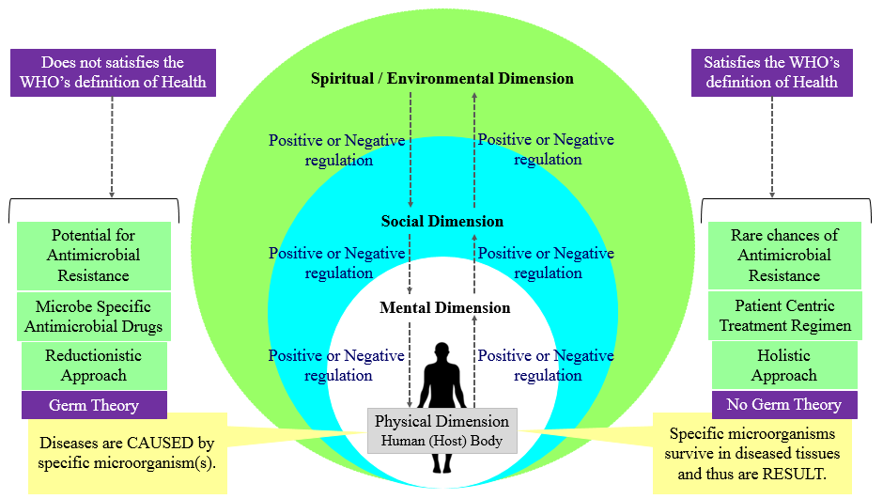
Figure 5: Reductionistic Germ Theory, the meaning of Health, and the Crisis of Antimicrobial Resistance.
In conventional practice, when we administer antimicrobial agents to destroy the suspected pathogenic microorganisms present in the host’s body (physical level), based on “Germ Theory”, we are only considering the physical wellbeing along with associated infirmities. As shown in figure 4, the host, even if we consider the physical dimension as everything, then also there exists critical factors like the host’s microbiome, host’s defense response, host’s inherent immunomodulatory capabilities, host’s internal and external environment and lastly the suspected pathogenic microorganism(s). Not considering these factors while designing treatment protocols leads to rise in disasters like the crisis of Antimicrobial Resistance (Lazar, 2018) (Hegde, 2014).
So, from the discussion it is clear that reductionistic “Germ Theory” does not satisfy the definition provided by WHO in reference to restoration of Health, but the theory of Rudolf Virchow is in sync with the definition. Thus, if the WHO (1948) definition of Health holds true, then the existing protocol of treating infectious diseases with antimicrobial agents needs modification. And if the existing protocol of treating infectious diseases with antimicrobial agents holds true, then the WHO (1948) definition of Health need modification, as they are contradictory.
Contributing Factor 4: Keeping Evolutionary Biology out of Medical Curriculum – The reason of Conceptual Mismatch
“Seen in the light of evolution, biology is perhaps, intellectually the most satisfying and inspiring science. Without that light it becomes a pile of sundry facts --- some of them interesting or curious but making no meaningful picture as a whole”.
…Theodosius Dobzhansky
The fundamental answer to why so many humans are now getting sick from previously rare illnesses is that many of the body’s features were adapted in environments from which we evolved, but have become maladapted in the modern environment we now have created. This idea known as Mismatch Hypothesis, is the core of new emerging field of Evolutionary Medicine, which applies evolutionary biology to health and disease.
…Daniel E. Lieberman, Paleoanthropologist, Harvard University
The meaning of Health, legitimacy of reductionistic Germ Theory and antimicrobial drugs in absence of Holistic Evolutionary Biology.
From studying evolutionary biology we get to know that during the course of time the primitive organisms proliferated, evolved, and achieved greater structural and functional complexity, starting from bacteria and amoeba sequentially up to the mammals. In the field of Lifesciences emphasis is made on studying the Evolutionary Lineage (Reductionistic Approach) and unfortunately, the underlying Evolutionary Pattern (Holistic Approach) has been overlooked. This is why in conventional medical science we only consider the physical dimension and do not acknowledge the mental and social dimensions. Also, in physical dimension, human body is only considered as a combination of human cells, organs and tissues. Thus, a suspected microorganism(s) which does not seems to be a part of human body, when found in the diseased tissue are attributed as the cause of the disease. Since, according to conventional treatment protocol, human body is only made up of human cells, using antimicrobial chemicals to destroy the suspected microorganism(s) appears to be scientific and safe. In healthcare, animal farming, agriculture and food industry the antimicrobial chemicals are being used everywhere and in every aspect. This has led to uncontrolled overuse and misuse of medically important antimicrobial agents resulting in formidable crisis called antimicrobial resistance (Sahtouris, 2000, 2018) (Lipton, 2016, 2017) (Hegde, 2014).
Analyzing why including holistic Evolutionary Biology in basic Medical curriculum help understand the multidimensional concept of Health
The approach of the practice of medicine is deeply linked to our understanding of evolutionary biology. When one understands the evolutionary patterns along with the evolutionary lineage the relation between the dimensions of health becomes evident. Let us now understand this evolutionary pattern in brief. The process starts with the emergence of a new organism (for example: Organism A). Organism A proliferates for billions of years and during that process, they mature, mutate, and achieves the highest level of intelligence and functioning. Once the Organism A has achieved its maximum level of functional potential, it enters the next level where the individual cells start coming together and form a colony. They start sharing awareness and information and learns to live together. Then various colonies integrate to form a community that eventually becomes a new organism itself. This entire process makes up the first cycle (Hegde, 2014; Hegde, 2015; Lipton, 2015; Lipton, 2016). The cycle 2 is the repetition of the entire process where the new organism (Organism B) proliferates and starts to maximize its intelligence and functional capabilities then starts forming a colony and subsequently integrates and forms community. This processes progresses as evolving spiral and we go each turn of the loop we get a higher level of organization and higher level of evolution (Figure 6.A.) (Sahtouris, 2000, 2018) (Lipton, 2016, 2017) (Hegde, 2014). Let us now relate this pattern with the real life example (Figure 6.B.). The Organism A is the Bacterium, the simplest form of life (a single cell) proliferated, mutated and achieved its maximum intelligence and functional capabilities. Then each of these single cells came together and formed colonies. As a colony each cells communicated with each other and shared their awareness and after a certain time they integrated and formed a structure called biofilm. Biofilm created a boundary for the integrated colonies, where they started sharing and working with each other, specializing their functions and integrating their activities. Through this process they evolved into a completely new organism, Organism B (Amoeba like advanced cells). Amoebas then for next billions of years proliferated, mutated, and achieved its maximum intelligence and functional capabilities. Amoebas evolved from colony of bacteria but it is now an individual organism. After reaching its full potential, each Amoeba came together and formed colonies, integrated to form community and the process continued. This evolutionary spiral is progressive in nature. As shown in figure 6B the first twist of the spiral was the Bacterium, the first single celled organism on the planet. The next twist represents the Amoeba (or cells with higher functional complexity), a community of Bacterium living under one membrane called biofilm. Each of these cells proliferated, formed colonies and integrated itself to form Human Beings. Human body is made out of about 60 trillion individual cells that came together and created a community where they survive together in harmony and maximize the functional capabilities and intelligence of the system. So an individual is actually a community of 60 trillion cells working in a synchronized manner. In the next twist of the spiral we, the human beings came together and formed communities where we work together with each other and share our intelligence and awareness. The individuals of various communities comes together and forms a functional society. Society is the result of collective intelligence and awareness (psychology) of each and every individual who are part of it. So even if from the reductionistic point of view we may consider ourselves as individuals but in reality we are part of the society (the super organism) (Sahtouris, 2000, 2018) (Lipton, 2016, 2017) (Hegde, 2014)
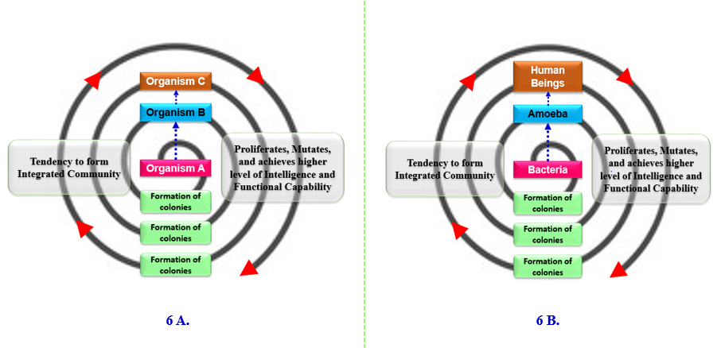
Figure 6 (A and B): Evolutionary pattern describing origin of symbiotic association between human and microorganisms (The Human Microbiome Symbiosis).
When holistic evolutionary biology is included with the conventional medical science, the complete meaning of WHO definition of Health becomes easily understandable and relatable. The evolutionary pattern not only provides the link between different dimensions of health but also validates that the physical body of human being in itself is multifactorial. By including the science of evolutionary biology in medicine it can be realized that the complete understanding of health and disease is possible only through integrated approach, in that human body is made up of approximately 10 ⁻¹⁴ human cells (~23000 human genes) and 10 ⁻¹⁴ million microorganisms (called human microbiome comprising of ~9 million germ genes). These human microbiome have a symbiotic relationship with the human beings and is equally important as any vital organ of the body. Disturbance in the balance between the human microbiome and human cells lead to life threatening complications. So the “Germs” are not our enemy, but friends, essential for survival. The 23000 human genes won’t function without the influence of these host microbiome. Antimicrobials are chemicals that kills or inhibits the growth of microorganisms. Antimicrobial agents when enters human body does not discriminate between host microbiome and suspected pathogenic microorganism, it destroys all equally. It is like bombing an entire city full of innocent citizens in order to eliminate one suspected criminal hiding there. The suspected microorganism is destroyed by the action of selected antimicrobial agent, so are the significant section of host microbiome, creating sure possibility of unwanted, unpredictable and uncontrollable iatrogenic conditions (Appanna, 2018) (Goswami, 2008) (Goswami & Bakshi, 2020) (Meyer, 2014) (Sahtouris, 2018). Figure 7 demonstrates the importance of including evolutionary biology in practice of medicine.
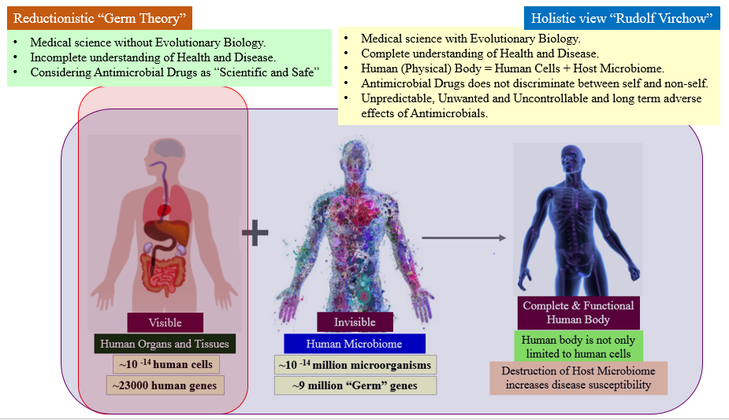
Figure 7: Importance of including Holistic Evolutionary Biology in Medicine
Contributing Factor 5: Considering Genetic Mutations as the Cause of Antimicrobial Resistance.
The Expression of a given Gene results from the synchronized action of Multidimensional Factors that are beyond the control of the Gene itself.
Analyzing why considering Genetic Mutation as the Cause of AMR from Reductionistic Perspective leads us to an incomplete and faulty conclusions
Analysis of genetic mutations are the fundamental aspect of AMR related research. The slightest change in the genetic sequence of microorganism can make it resistant against a range of antimicrobial substances. The scientific community has identified and documented wide range of medically important mutations associated with AMR. On top of that, the ability of microorganisms to transfer the antimicrobial resistance (AR), through mobile genetic elements (MGEs) among themselves, adds on to the rapid spread of multidrug resistance (MDR) (McMillan et al. 2019). During the initial stages of introduction, the scientific community did not realize the importance of the prediction made my Sir Alexander Fleming in relation to antimicrobial resistance. Conventionally whenever a microorganism is found to survive a group of antimicrobial agents to which it was previously sensitive, the genetic sequence of that microorganism is thoroughly studied. The comparative analysis of genes reveals single or multiple changes in the sequence that can be traced to their gain in resistance capability. Since the mutation in the genetic sequence are found only in the microorganisms showing resistance, thus leads us to the assumption that genetic mutations are the cause of AMR. If considered from reductionistic perspective, the assumption appears to be logical. And based on that assumption advanced concepts are formed and sophisticated technologies are implemented to address and overcome the crisis of AMR. But despite of all efforts, the situation is constantly getting out of our control. This brings us to an important question, why did the gene mutate? Or what are the factors that favored the genetic mutation?
The answer becomes clear if the scenario is considered from holistic perspective of Epigenetics. What if, the genetic mutation that are observable through sequence analysis are the result and not the cause. The actual cause of antimicrobial resistance is multidimensional or multifactorial. The first question to be asked is “Why or what forced the genetic sequence to change?” We have to understand that the Darwin’s law of survival of the fittest and struggle for existence applies to all living organism. Just like any other organism on this planet, the microorganisms also thrive, adapt and evolve in response to the environment they are living in. We, the human beings, in order to ensure our existence and protect ourselves from existing natural threats (let’s say microorganisms), we have manipulated and exploited nature in wrong contexts. In doing so we have misused one of the limited and valuable natural resource called antimicrobial substances. When we expose or pollute or surrounding environment with too much of antimicrobial chemicals, we create a state of challenge for the microorganisms that cohabit the same environment. In order to survive, the microorganisms need to reshuffle their genetic sequence based on the signals received from their surroundings. The microorganisms that did not receive the signal of environmental stress, did not feel the need to change their genetic sequence. Thus, the genetic mutation that are observable are in fact the result or outcome of the environmental degradation. And these external factors that triggers a series of chemical changes inside the cytoplasm and nucleus of the microorganism, thus forcing the gene(s) to mutate, is not under the control of the gene itself. So this brings us to the theory given by Sir, Rudolf Virchow, that germs are not the cause of the disease, instead, the germs are the result.
For easy understanding let us first consider the existing approach, where Mutated DNA Sequences are considered as the cause of antimicrobial resistance. As represented in figure 8, if Mutated DNA Sequences are considered as the cause of AMR, then it becomes a logical approach to isolate and sequence the mutated gene so that information can be gathered about the change that has happened. The genetic sequencing helps in performing the study and analysis at proteomic level. The knowledge base gathered from genetic and proteomic sequence analysis are then applied in developing novel genetically engineered antimicrobial chemicals, designing broad range drug based therapeutics, and strategizing and implementing public health protocols. These information are also implemented in epidemiological studies, agricultural and animal farming, food processing and safety to name a few. If Mutated DNA Sequences are the real cause then AMR can be effectively addressed by applying these approaches in regulated manner.
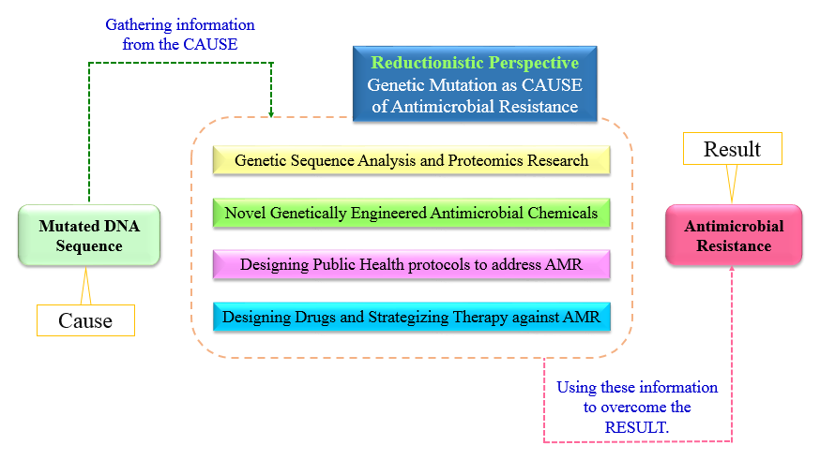
Figure 8: Genetic Mutations as a Cause of Antimicrobial Resistance – Reductionistic Perspective
But if considered from one-health or holistic perspective, as shown in figure 9, the entire outcome becomes different. What if the Mutated DNA Sequences are the result and not the cause? As shown in figure 9, the normal microbial gene(s) are forced to mutate in response to constantly increasing environmental stress factors like antimicrobial chemicals from food processing industries, anthropogenic antimicrobial chemicals in the environment, the microflora of the host’s body, defense and immunomodulatory capability of host, antimicrobial chemicals in agriculture and animal farming industries and the list goes on. These multidimensional environmental stress factors are the actual cause of AMR crisis. So, if this is the case then gathering information from the Mutated DNA Sequences (The Result) and implementing the same information obtained from the result on the result itself is not going to address the AMR crisis (The Effect), because the Epigenetic Factors (The Cause) remains unaddressed. Just treating the results with novel antimicrobial chemicals or technologies may provide momentary satisfaction to our scientific minds but in long run it will definitely generate more and more deadly, unpredictable and uncontrollable AMR crisis. It is high time to redefine the “Cause”, “Result”, and “The Effect” and realize the environment is the key role-player and not the germs.
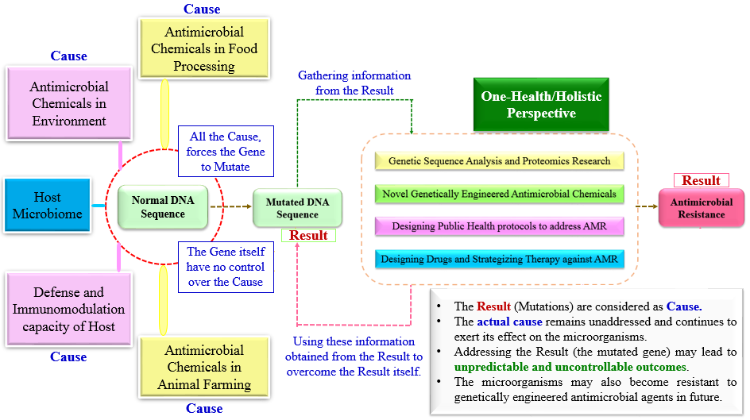
Figure 9: Epigenetic Factors [The Cause] forces Microbial Genes to Mutate [The Result] and thus leading to Antimicrobial Resistance [The Outcome]: One-Health / Holistic Perspective
Contributing Factor 6: Neglecting the Human body’s Intelligence
“Whenever the immune system successfully deals with an infection, it emerges from the experience stronger and better able to confront similar threats in future. Our immune system develops with natural infections. If at the first sign of infection, we jump in with antibiotics, we do not give immune system the chance to grow stronger”…Andrew Weil, MD.

Man would have been extinct long ago, if we were to believe that drugs, preventive screening of apparently healthy population and our hi-tech interventions are the ones that keep people alive on this planet. Evolutionary changes, based on our environment, kept us going for so long without the assistance of any hi-tech stuff. This is the intelligence of the body …Dr. B. M. Hegde
Analyzing why these “Negligence” is responsible for present Crisis of Antimicrobial Resistance
Similar to the Germ Theory, we also have fascination for Darwinian ideology of “Struggle for Existence” and the “Survival of the Fittest”. But as mentioned in earlier section, rarely do we implement these concepts in conventional medical science. Nature have provided bacteria and fungus the ability to synthesize and secrete antimicrobial chemicals. The ability helps the microbes achieve two major functions, survival (in Nature) and protection (from the competitive species of microbes). Thus the antimicrobial agents helps bacteria and fungus in their survival by protecting them from other kind of microorganisms. The functions are achieved either by killing the competitive microorganisms or by stopping their growth. Thus, the antimicrobial agents are defense system of the microorganisms. Just like Nature provided microorganisms with antimicrobial chemicals, human beings are bestowed with robust and sophisticated immune system. In the course of evolution human beings struggled with the adversities, adapted and developed sophisticated organ systems, specific cells and a diverse range of antimicrobial chemicals capable of protecting against all kinds of foreign microbial threats. Through the course of evolution, human system acquired ~60 trillion symbiotic microorganisms, in the form of human microbiome, that are crucial for survival (Ursell, 2012). These microorganisms not only protects the human body from invading pathogenic microorganisms but also helps maintain the homeostasis (Hegde, 2014) (Lipton, 2016, 2017).
The host’s microbiome plays important function in the training and development of major components of the host’s innate and adaptive immune responses, while the immune system orchestrates the maintenance of key features of host-microbe symbiosis (Zheng et al, 2020). The immune system has largely evolved as a means to maintain the symbiotic relationship of the host with these highly diverse and evolving microbes. When operating optimally, the synchronized interplay between immune system and microbiota allows the induction of protective responses to pathogens and the maintenance of regulatory pathways involved in the maintenance of tolerance to innocuous antigens (Belkaid et al, 2014). The microbiota consists of a dynamic multispecies community of bacteria, fungi, archaea, and protozoans, bringing to the host organism a set of cells and genes more numerous than its own. Among the different non-sterile cavities, the human gut harbors the most complex microbiota, with a strong impact on host homeostasis and immunostasis, being thus essential for maintaining the health condition (Lazar et al., 2018).

However, in present time overuse of antimicrobial and chemotherapeutic agents, disease promoting dietary habits, environmental degradation, and elimination of constitutive partners (for example, nematodes) has selected for a microbiota that lack the resilience and diversity required to establish balanced immune responses (Belkaid et al, 2014). Although antibiotics confer significant health benefits in treating or preventing bacterial infections, an accumulating wealth of evidence illustrates their detrimental effect on host-microbiota homeostasis, posing a serious menace to the global public health (Shekhar & Petersen, 2020). Studies have shown that antibiotics alter the host’s microbiome in such a way that are able to reduce the ability of immune cells to eliminate foreign pathogens (Zusi, 2017). Continuous exposure to antimicrobial drugs, leads to dysbiosis in the host’s body. This phenomenon is proposed to account for some of the dramatic rise in antimicrobial resistance, autoimmune and chronic inflammatory disorders, reflect increased susceptibility to a wide spectrum of diseases, including iatrogenic infection, in later life, hypersensitivity reactions, and even cancer (Zheng et al, 2020) (Belkaid et al, 2014) (Lazar et al., 2018) (Shekhar & Petersen, 2020) (Zusi, 2017). The medical world is learning the hard way the need to respect this capacity of the body and not to interfere too much, too soon with modern gadgets and powerful drugs, hurting the native wisdom of the body and its in-built protective mechanisms.

Antimicrobial Drugs: The Life Saving Natural Resource
Widespread use of antibiotics promote the spread of antibiotic resistance. Smart use of antibiotics is the key to controlling its spread…Dr. A.P.J. Abdul Kalam
The antimicrobial drugs have undoubtedly saved people from life threatening diseases, time after time. The beginning of antibiotic revolution was marked by the discovery of penicillin in 1928 by Sir Alexander Fleming. 1950s and 1970s are considered as the golden era of antibiotic discovery, but unfortunately no new classes of antibiotics have been discovered since then. There is no doubt that antibiotic era revolutionized the treatment of infectious diseases worldwide, however our inclination towards reductionistic approach and greed to prove our superiority over Nature, we have developed and nurtured the global crisis called Antimicrobial Resistance. This is a problem that surfaced shortly after the introduction of penicillin, and because of our lack of scientific understanding, the usefulness of these natural resources have now become compromised (Adedeji, 2016) (Calderone, 2015) (Gotzsche, 2013) (Ventola, 2015).
Nature have provided human beings with their inbuilt doctor that in modern day known as the immune system or healing mechanisms of the body. As explained in earlier section that each and every cell has their own intelligence, gathered from their ancestors based on their environment and associated evolutionary changes (Lipton, 2017) (Sahtouris, 2018). Human cells have survived on the planet from millions of years and possesses huge amount of information about the Nature that is around them. Each and every cell that makes up a human body have their own individual consciousness which can be termed as the intelligence of the body. So each and every cell’s own wisdom is much greater as compared to all the amount of knowledge gathered by human from literatures and media combined. Body knows how to defend itself from threats found in nature, how to adjust itself according to the environment and knows very well how to heal itself. Human body is well equipped to protect itself from diverse array of threats. But there comes a time when the body’s natural healing ability needs some extra push. This is where outside intervention in the form of drugs (in this context antimicrobial drugs) are required. Drugs are just like a tool that helps in achieving the healing processes by up-regulating or down-regulating certain biochemical pathways, and should only be used when body’s healing system requires help in form of external intervention. Antimicrobial drugs are excellent in addressing emergency, critical and surgical cases where immediate quick fixes are important (Goswami & Bakshi, 2020) (Hegde, 2014).
Antimicrobial Resistance and One Health: Need for coordinated action.
“Between animal and human medicine there are no dividing lines, nor should there be. The object may seem different but the experience obtained constitutes the basis of all medicine.”
…Rudolf Virchow, Father of Pathology
“The only effective way to address the global issues such as Antimicrobial Resistance, Foodborne Zoonoses, and Emerging Threats is through open, inter-sector collaborations, including experts and authorities from animal health, public health, food safety and the environment, i.e. One Health”
…Hein Imberechts, One Health EJP Scientific Coordinator
Integrated multisectoral and multidimensional approach is required to address the anthropogenic crisis of Antimicrobial Resistance (AMR). The scientific community have acknowledged that human health and environment are related and cannot be separated from each other and thus brought together multiple sectors and stakeholders engaged in human, terrestrial and aquatic animal and plant health, food and feed production and the environment in order to communicate and work together in the design and implementation of programs, policies, legislation and research to attain better public health outcomes by addressing the global health crisis. This coordinated, collaborative approach is termed as One Health, which states that the health of people is connected to the health of animals and the environment. In past few years, the concept of One Health has received remarkable momentum. The World Health Organization (WHO), the Food and Agriculture Organization (FAO) and the World Organization for Animal Health (OIE) speak with one voice and take collective action to minimize the emergence and spread of AMR. The aim is to: ensure that antimicrobial agents continue to be effective and useful to cure diseases in humans and animals; promote prudent and responsible use of antimicrobial agents; and ensure global access to medicines of good quality. The initiatives such as the Antimicrobial Resistance Multi Partner Trust Fund (AMR MPTF), the Global Antibiotic Research & Development Partnership (GARDP), AMR Action Fund and other funds and initiatives have been established to design and implement strategic framework of interventions to slow the emergence and reduce the spread of AMR. WHO is working closely with FAO and OIE in a ‘One Health’ approach to promote best practices to reduce the levels of AMR and slow its development (Guardabassi et al., 2020) (Antimicrobial resistance, 2020) (McEwen et al, 2018).
The Conclusion
The whole structure of science gradually grows, but only as it is built upon a firm foundation of past research…Owen Chamberlain
The antimicrobial resistance is an anthropogenic crisis. Because of bias in knowledge and incomplete understanding of Nature, we have nurtured the crisis that have become a global concern. Like other natural resources, through overuse and misuse, we have overexploited a group of life-saving drugs known as antimicrobials. To combat this crisis the scientific communities are developing strategies to understand the mechanisms of antimicrobial resistance, alternative strategies to overcome antimicrobial resistance, ways to control resistant infection, novel drug development, and genetic and proteomic studies. But all these efforts will be of no use if we continue to approach the scientific studies based on reductionistic Germ Theory. Time after time, scientific evidence have proved the inadequacy of the reductionistic Germ Theory, but unfortunately we are still holding on to this ideology. The conventional “Epidemiological Triad”, WHO definition of Health, holistic evolutionary medicine, and most recent “One Health Initiative”, all provide strong scientific basis to Rudolf Virchow’s theory that germs seek their natural habitat, the diseased tissue, rather than being the cause of the diseased tissue. That means germs are the result and not the cause of pathological change that have occurred previously. This One Health Concept has been accepted and endorsed by various organizations around the world namely the European Commission, the US Department of State, US Department of Agriculture, US Centers for Disease Control and Prevention (CDC), World Bank, World Health Organization (WHO), Food and Agriculture Organization of the United Nations (FAO), World Organization for Animal Health (OIE), United Nations System Influenza Coordination (UNSIC), various Universities, NGOs and many others. So, it is high time that a holistic and multisectoral approach should be implemented in addressing the rising threat of Antimicrobial Resistance along with promotion of improved infection prevention and control measures thereby progressively reduce the usage of antimicrobial agents, because AMR does not recognize the human-animal-environment border. Finally we need to remember that:
Antimicrobial substances are Life Saving Natural Resource, limited in quantity and type, thus should be used responsibly and to be preserved for appropriate situations.

References
- Abramson, J. (2008). Overdosed America: The Broken Promise of American Medicine (Illustrated ed.). Harper Perennial.
- Adedeji W. A. (2016). THE TREASURE CALLED ANTIBIOTICS. Annals of Ibadan postgraduate medicine, 14(2), 56–57.
- Agger, W.A. (2002). Antibiotic resistance: unnatural selection in the office and on the farm. WMJ 101 (5): 12-3.
- Antibiotic-resistant Germs: New Threats. (2021, March 2). Centers for Disease Control and Prevention. https://www.cdc.gov/drugresistance/biggest-threats.html0.
- Antibiotics alter the infectious microenvironment and may reduce the ability of immune cells to kill bacteria. (2017, November 30). Wyss Institute. https://wyss.harvard.edu/news/antibiotics-alter-the-infectious-microenvironment-and-may-reduce-the-ability-of-immune-cells-to-kill-bacteria/
- Antimicrobial resistance. (2020, October 13). World Health Organization. https://www.who.int/news-room/fact-sheets/detail/antimicrobial-resistance
- Appanna V.D. (2018) The Human Microbiome: The Origin. In: Human Microbes - The Power Within. Springer, Singapore. https://doi.org/10.1007/978-981-10-7684-8_1.
- Belkaid, Y., & Hand, T. W. (2014). Role of the microbiota in immunity and inflammation. Cell, 157(1), 121–141. https://doi.org/10.1016/j.cell.2014.03.011
- C.D.C. (2012). Principles of Epidemiology | Lesson 1 - Section 8. Deputy Director for Public Health Science and Surveillance, Center for Surveillance, Epidemiology, and Laboratory Services, Division of Scientific Education and Professional Development. https://www.cdc.gov/csels/dsepd/ss1978/lesson1/section8.html.
- Calderone, J. (2015, August 7). Penicillin’s discoverer predicted our coming post-antibiotic era 70 years ago. Business Insider. https://www.businessinsider.in/latest/penicillins-discoverer-predicted-our-coming-post-antibiotic-era-70-years-ago/articleshow/48393377.cms
- Goswami, A. (2008) Creative Evolution: A Physicist’s Resolution between Darwinism and Intelligent Design. Quest Books. U.S.
- Goswami, S., & Bakshi, U. G. (2020, November 24). Understanding Classical Naturopathy: The Hippocratic Way of Healing | Taylor & Francis Group. Taylor & Francis. https://www.taylorfrancis.com/chapters/edit/10.1201/9781003003182-11/understanding-classical-naturopathy-hippocratic-way-healing-srijan-goswami-ushmita-gupta-bakshi
- Gotzsche, P. (2013) Deadly Medicines and Organized Crime: How Big Pharma has Corrupted Healthcare. Paperback Edition. CRC Press.
- Guardabassi, L., Butaye, P., Dockrell, D., Fitzgerald, J. R., & Kuijper, E. (2020). One Health: a multifaceted concept combining diverse approaches to prevent and control antimicrobial resistance. Clinical Microbiology and Infection, 26(12), 1604–1605. https://doi.org/10.1016/j.cmi.2020.07.012
- Hegde, B.M. (2014) What Doctors Don’t Get to Study in Medical School. India, Paras Medical Publisher.
- Lazar, V., Ditu, L. M., Pircalabioru, G. G., Gheorghe, I., Curutiu, C., Holban, A. M., Picu, A., Petcu, L., & Chifiriuc, M. C. (2018). Aspects of Gut Microbiota and Immune System Interactions in Infectious Diseases, Immunopathology, and Cancer. Frontiers in Immunology, 9. https://doi.org/10.3389/fimmu.2018.01830.
- Lipton, B.H. (2016) The Biology of Belief, Unleashing the Power of Consciousness, Matter & Miracles. 18th Reprint. India: Hay House Publishers.
- Lipton, B.H. and Bhaerman, S. (2017) Spontaneous Evolution: Our Positive Future and A Way to Get There from Here. First Indian Paperback Edition. Hay House Publishers.
- McEwen, S. A., & Collignon, P. J. (2018). Antimicrobial Resistance: a One Health Perspective. Microbiology spectrum, 6(2), 10.1128/microbiolspec.ARBA-0009-2017. https://doi.org/10.1128/microbiolspec.ARBA-0009-2017
- McMillan et al. (2019). Antimicrobial Resistance Genes, Cassettes, and Plasmids Present in Salmonella enterica Associated with United States Food Animals. Front. Microbiol. https://doi.org/10.3389/fmicb.2019.00832.
- Meyer, S. (2014) Darwin’s Doubt: The Explosive Origin of Animal Life and the Case for Intelligent Design. Paperback Edition. HarperOne.
- Moynihan, R. and Cassels, A. (2006) Selling Sickness: How the World's Biggest Pharmaceutical Companies Are Turning Us All into Patients. Paperback Edition. Nation Books.
- Nelson, R. E., Hatfield, K. M., Wolford, H., Samore, M. H., Scott, R. D., Reddy, S. C., Olubajo, B., Paul, P., Jernigan, J. A., & Baggs, J. (2021). National Estimates of Healthcare Costs Associated With Multidrug-Resistant Bacterial Infections Among Hospitalized Patients in the United States. Clinical Infectious Diseases, 72(Supplement_1), S17–S26. https://doi.org/10.1093/cid/ciaa1581
- Null, G. (2011) Death by Medicine, Revised Paperback Edition, United States, Praktikos Books.
- Ruger, J. P., & Yach, D. (2009). The Global Role of the World Health Organization. Global health governance : the scholarly journal for the new health security paradigm, 2(2), 1–11.
- Sahtouris, E. (2000) EarthDance: Living systems in Evolution. Paperback Edition. iUniverse.
- Sahtouris, E. (2018) Gaia’s Dance: The Story of Earth and Us. Paperback Edition. Createspace Independent Pub.
- Shekhar, S., & Petersen, F. C. (2020). The Dark Side of Antibiotics: Adverse Effects on the Infant Immune Defense Against Infection. Frontiers in Pediatrics, 8. https://doi.org/10.3389/fped.2020.544460.
- The History of Antibiotics. (n.d.). HealthyChildren.Org. Retrieved July 29, 2021, from https://www.healthychildren.org/English/health-issues/conditions/treatments/Pages/The-History-of-Antibiotics.aspx.
- The History of Antibiotics. (n.d.). HealthyChildren.Org. Retrieved July 29, 2021, from https://www.healthychildren.org/English/health-issues/conditions/treatments/Pages/The-History-of-Antibiotics.aspx.
- Ursell, L. K., Metcalf, J. L., Parfrey, L. W., & Knight, R. (2012). Defining the human microbiome. Nutrition reviews, 70 Suppl 1(Suppl 1), S38–S44. https://doi.org/10.1111/j.1753-4887.2012.00493.x.
- Ventola C. L. (2015). The antibiotic resistance crisis: part 1: causes and threats. P & T : a peer-reviewed journal for formulary management, 40(4), 277–283.
- What Exactly is Antibiotic Resistance? (2020, March 13). Centers for Disease Control and Prevention. https://www.cdc.gov/drugresistance/about.html.
- Who We Are | NCEZID | CDC. (2017, August 28). Centers for Disease Control and Prevention (CDC). https://www.cdc.gov/ncezid/who-we-are/index.html.
- Zheng, D., Liwinski, T. & Elinav, E. Interaction between microbiota and immunity in health and disease. Cell Res 30, 492–506 (2020). https://doi.org/10.1038/s41422-020-0332-7.

