Pharmaceutical Preparations and Drug Delivery System: A Basic Element for Pharmaceutical Industry
Feran Singh^{1*}
¹ Department of Pharmacology, ShriRam college of pharmacy Banmore, Morena, M.P., 476444
Feranale756@gmail.com
Pankaj Sharma²
² Department of Pharmaceutics, ShriRam college of pharmacy Banmore, Morena, M.P., 476444
Pankajsharma2232gmail.com
Sarvesh Bhargava²
² Department of Pharmaceutics, ShriRam college of pharmacy Banmore, Morena, M.P., 476444
Sarveshbhargava1988@gmail.com
Vinay Jain³
³ Department of Pharmacognosy, ShriRam college of pharmacy Banmore, Morena, M.P., 476444
Vinni77@gmail.com
ABSTRACT
The drug delivery system enables the release of the active pharmaceutical ingredient to achieve a desired therapeutic response. Conventional drug delivery systems (tablets, capsules, syrups, ointments, etc.) suffer from poor bioavailability and fluctuations in plasma drug level and are unable to achieve sustained release. Without an efficient delivery mechanism, the whole therapeutic process can be rendered useless. Moreover, the drug has to be delivered at a specified controlled rate and at the target site as precisely as possible to achieve maximum efficacy and safety. Controlled drug delivery systems are developed to combat the problems associated with conventional drug delivery. There has been a tremendous evolution in controlled drug delivery systems from the past two decades ranging from macro scale and nano scale to intelligent targeted delivery. The initial part of this review provides a basic understanding of drug delivery systems with an emphasis on the pharmacokinetics of the drug. It also discusses the conventional drug delivery systems and their limitations. Further, controlled drug delivery systems are discussed in detail with the design considerations, classifications and drawings. In addition, nano-drug delivery, targeted and smart drug delivery using stimuli-responsive and intelligent biomaterials is discussed with recent key findings. The paper concludes with the challenges faced and future directions in controlled drug delivery.
Keywords: Drug Delivery System, Pharmaceutical Industry, Active Pharmaceutical ingredient, Excipients, Solid, Semi Solid, & Liquid Dosage Forms
- INTRODUCTION
A drug (API) is a substance (recognized in official pharmacopoeia) intended for use in the diagnosis, cure, mitigation, treatment, or prevention of disease as per the FDA. Drug delivery is a technique of delivering medication to a patient in such a manner that specifically increases the drug concentration in some parts of the body as compared to others [1]. The goal of any delivery system is to extend, confine and target the drug in the diseased tissue with a protected interaction. Every Dosage form is a combination of drug/active pharmaceutical ingredients (APIs) and the non- drug component called excipients/additives (Figure 1). APIs are the actual chemical components used to treat diseases [2].
- NEED FOR A DOSAGE FORM
Generally, drug delivery systems (DDS) are preferred because direct clinical use of the active drug substances (APIs) “as they are” is very rare due to several reasons: API handling and accurate dosing can be difficult or impossible for very potent drugs (e.g., low mg and µg doses) [3]. Administration of drugs into the body cavities (rectal, vaginal) can be impractical and unfeasible as they can be degraded at the site of administration (e.g., low pH in the stomach) and may cause local irritations or injury when the drug concentration is high at the site of administration [3]. Some APIs are sensitive to the environment and can benefit from reducing the exposure to environmental factors (light, moisture, temperature and pH), or they need to be chemically stabilized due to the inherent chemical instability. APIs mostly have unpleasant organoleptic qualities (taste, smell and compliance), which reduce patient compliance [2].
Dosage form = Active Pharmaceutical ingredient (API) + Excipient/ Additives
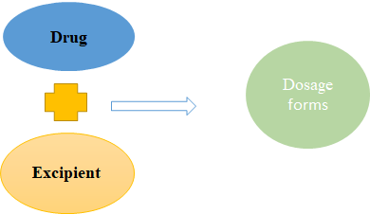
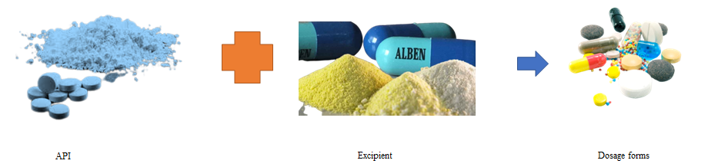
Figure 1. Dosage form composition.

Class I  High solubility high permeability | Class II  Low solubility high permeability
Class III  High solubility low permeability | Class IV  Low solubility low permeability

Solubility: Volume of water required to dissolve the highest dose strength across the physiological pH Range
Figure: 2 Biopharmaceutics Classification System
- EXCIPIENTS
One or more of the excipients that are generally utilized in formulations include: colouring agents, suspending agents, binding agents, solvents and lubricants, perfumes, sweetening agents, flavouring agents, solubilizing agents and antioxidants [4]. A filler is included to increase the size of the tablet (e.g., lactose) as often the amount of "active ingredient" is so small that the dosage form would be too tiny to handle without filler. Binders are added to hold the tablet together after it has been compressed and prevent the break-down into separate pieces (e.g., starch, HPMC, etc.) [6]. Disintegrants help the dosage form to break down into small fragments after ingestion, which allows the medicine to dissolve
and be absorbed by the body so that it can act more rapidly [6]. The glidants prevent lump formation by reducing the friction between particles and improve the flowability of the tablet granules or powder. Anti-adherents stop the powder from sticking to the machines during manufacturing. Lubricants ensure the smooth surface of dosage form, by reducing the friction between the walls of the tablets and the die cavity during ejection. Flavouring agents help to mask the unpleasant odour and colourants are added to aid in recognition and aesthetics [7].
- DIFFERENT ROUTES OF DRUG ADMINISTRATION
Dosage forms can be administered through different routes based on the target site, duration of treatment and the physicochemical attributes of the drug [9]. The most common dosage forms comprise tablets, capsules, pills, ointments, syrups and injections. Various routes of drug administration are tabulated in Table 1 and Figure 3. The preferred route of drug administration depends on three main factors: The part of the body being treated, the way the drug works within the body and the solubility and permeability of the drug. For example, certain drugs are prone to destruction by stomach acids after oral administration resulting in poor bioavailability. Hence, they need to be given by the parenteral route instead. Intravenous administration of drugs gives 100% bioavailability [9].

Table 1. Route of Drug Administration.
Oral | Swallowed by Mouth as a Tablet, Capsule, Lozenge, or Liquid
Buccal | Held inside the cheek
Sub- lingual | Placed below the tongue
Enteral | Delivered directly into the stomach or tntestine
Inhalable | Breathed in through a tube or mask
Nasal | Given into the nose by spray or pump
Ophthalmic | Given into the eye by drops, gel, or ointment
Rectal | Inserted into the rectum
Vaginal | Inserted into the vagina
Topical | Applied to the skin
Transdermal | Given through a patch placed on the skin
Intramuscular | Injected into the muscle with a syringe
Intravenous | Injected into a vein or an IV line
Subcutaneous | Injected just under the skin

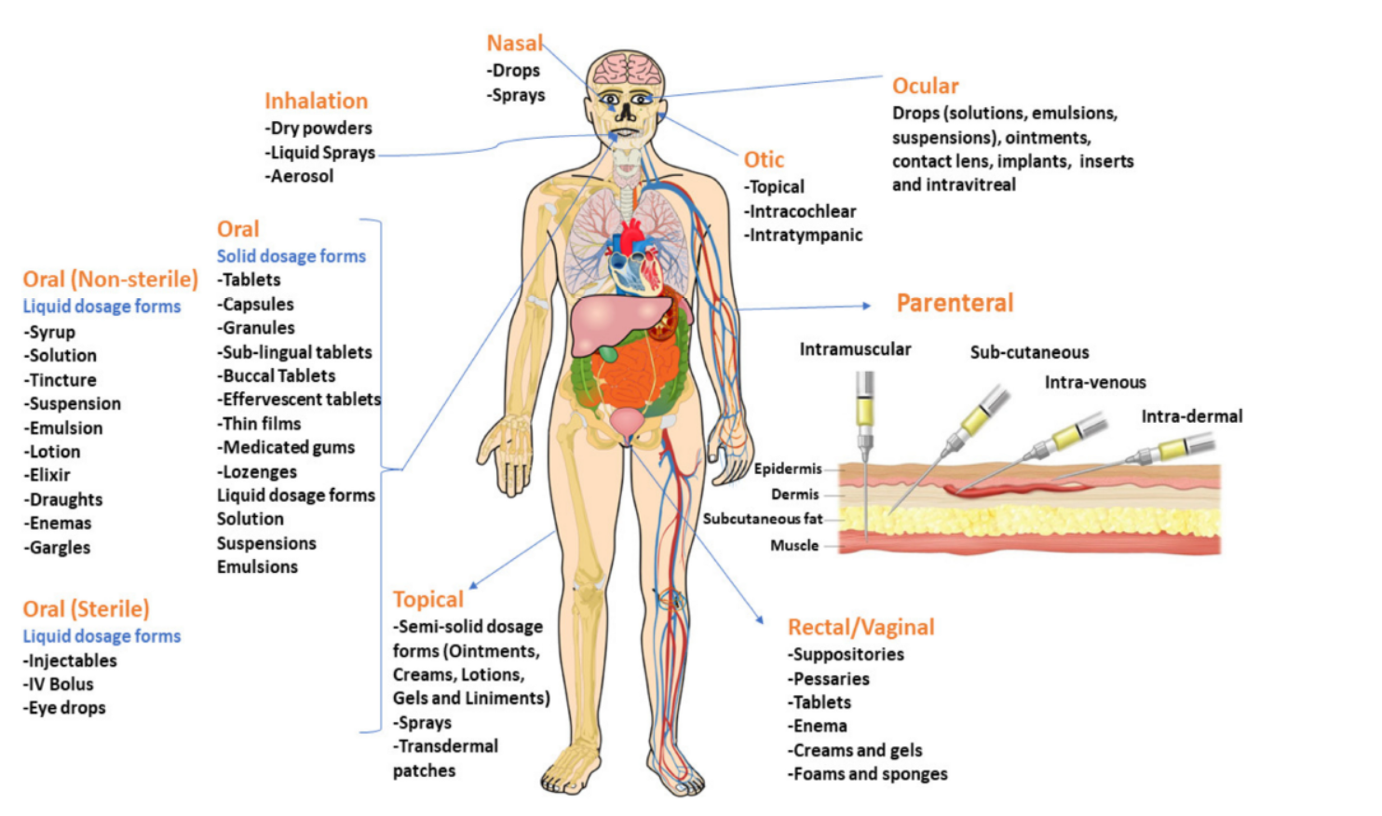
Figure 2. Various routes of drug administration.
- Solid Dosage Forms
Solid dosage forms are further classified into two main categories based on the type of dose, i.e., unit dose and bulk dose.
(a) Unit dose: Each dose is fixed and formulated as a separate dosage form and the patient needs to take a single unit of a specific dose at a time. Examples of unit dosage forms include tablets, capsules, pills, lozenges, chewable effervescent tablets and dry powder inhalation in metered-dose container
(b) Bulk dose: As the name itself says, it is a bulk solid powder where the individual dos is not formulated (Figure 3) [10,11]. Dose dumping is a major problem with bulk powders. However, bulk powders are generally used as dressing powder for surgical and injury wounds. Examples of bulk dosage forms include insufflation powder, dressing powder,etc. [10].
- Tablets
A tablet is a solid unit dosage form that is manufactured by compression and wet/dry granulation into different shapes (round, oval or square shape). For efficient tabletting, binders, glidants and lubricants are often added as excipients. To enhance the easy breakdown of tablets in the digestive tract, disintegrants are added. The tablet coating with pigments, sweeteners, and flavouring agents helps to mask the taste of other ingredients and makes the tablet smoother and easier to swallow. Tablet coating also offers environmental protection and extends the shelf life [10,12]. Sublingual and Buccal tablets are also solid unit dosage forms administered by placing them under the tongue and between the gum and cheek, respectively. Advantages of sublingual/buccal delivery systems include: The medications dissolve rapidly and are absorbed through the mucous membranes of the mouth into the systemic circulation. This avoids the acid and enzymatic environment of the stomach and the drug-metabolizing enzymes of the liver [10,12]. Effervescent tablets are designed to evolve carbon dioxide when in contact with water and disintegrate within a few minutes. These are uncoated tablets consisting of acids (citric or tartaric acid) and carbonates or bicarbonates which react rapidly in water and release
carbon dioxide. They are intended to be either dispersed or dissolved in water before intake to offer very rapid tablet dispersion and dissolution and release of the drug. It tastes similar to a carbonated drink (e.g., antacids). Chewable tablets are chewed before swallowing. They are designed for administration to deliver the drug by mastication. They are very useful for children and the elderly (e.g., vitamin products) [10,12].
- Capsules, Lozenges, Pills and Granules
A capsule is a unit solid dosage form where the drug components are enclosed in a soluble shell. Capsules help to mask the unpleasant taste of its contents and the drug has limited interaction with the excipients. Capsules are classified into two types: Hard-shelled capsules, which are used to encapsulate dry, powdered components; soft-shelled capsules, principally used for hydrophobic drugs and oily active substances that are suspended or dissolved in oil. Lozenges are chewable solid unit dosage forms, where the drug is loaded in a caramel base made up of sugar and gum; the latter provides cohesiveness and strength to the lozenge and enables slow release of the drug. Lozenges are traditionally used for local slow release of demulcents, anaesthetics and cough remedies in the mouth/pharynx. Pills are solid unit dosage forms made by compressing API with adhesives and other excipients into rounded masses for oral administration. Granules are solid, dry aggregates provided as a single-dose in sachets which can either be placed on the tongue and consumed with water or dissolved in water before taking (Figure 3). Effervescent granules evolve carbon dioxide similar to effervescent tablets when added to water. Figure 6 represents the
examples of solid unit dosage forms [10].
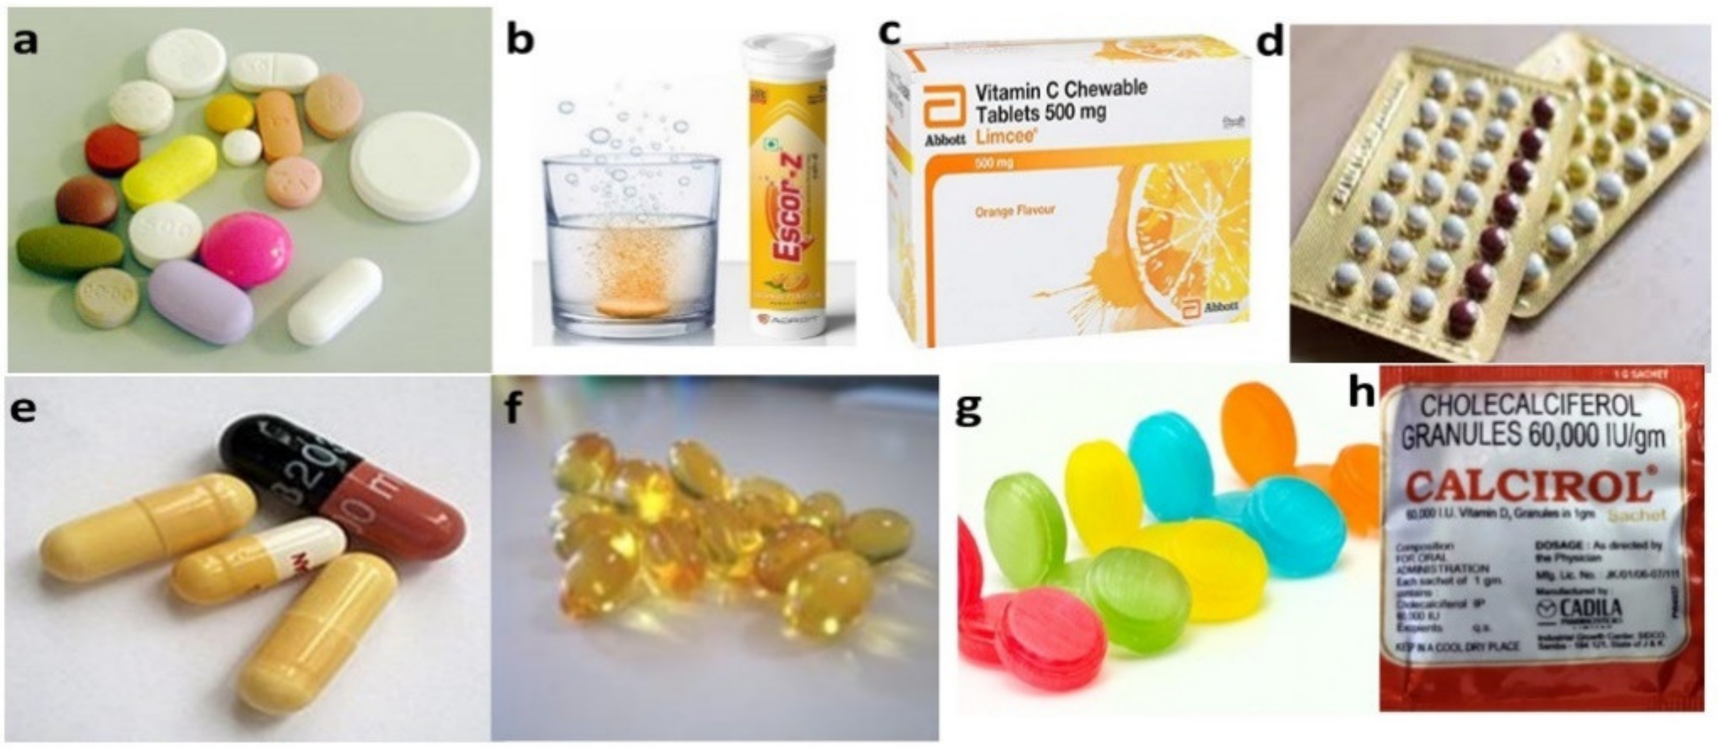
Figure 3. Solid unit dosage forms: (a) Tablets, (b) Effervescent tablets, (c) Chewable tablets, (d) Pills, (e) Hard-gelatine capsules, (f) Soft-gelatine capsules, (g) Lozenges. (h). Granules.
- Bulk Solid Dosage Forms
Bulk Powders are multidose formulations comprising loose, solid and dry particles of variable fineness. One or more active ingredients are present with or without excipients
and, if needed, colouring and flavouring agents are added. These are packed in widemouthed, air-tight, bulk containers made of glass or plastic, and are intended for either internal or external administration. There are two kinds of bulk powders intended for internal use. Bulk powders are often limited by inaccurate dosage, since the patient measures each dose varyingly. Hence, they are usually formulated with non-potent drugs such as laxatives, antacids, purgatives, etc., The powder is then typically dispersed in water or dissolved before taking. Divided powders are single-dose of powder (for example, a small sachet) with more accurate control on dosage than bulk powder [10].
- Semisolid Dosage Forms
Semisolid dosage forms are of semisolid consistency intended to apply onto skin/mucous membranes (nasal, vaginal or rectal cavities) for therapeutic, protective or cosmetic applications. Semisolid dosage forms include ointments, creams, gel/jelly, lotions, pastes, suppositories and transdermal patches (Figure 7 and Table 2) [13]. Semisolid dosage forms are used externally and locally at the target site, which reduces the probability of side effects. It is convenient for unconscious patients or patients who have difficulty in oral administration. It is a suitable dosage form for bitter drugs and more stable than liquid dosage forms [14].
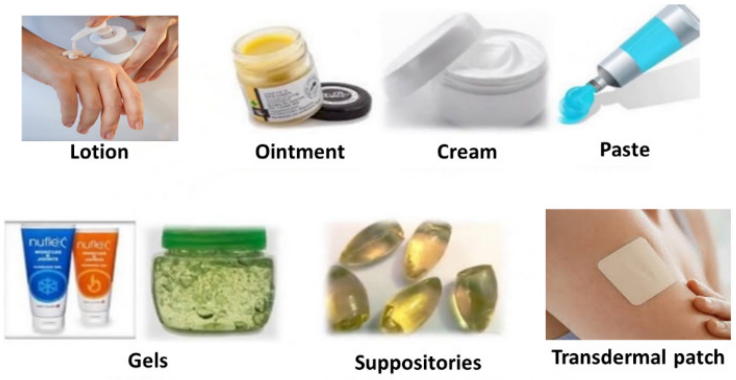
Figure 4. Semisolid dosage forms.
- Ointments
Ointments are oil-based semisolid formulations where the base is usually anhydrousn and immiscible with skin secretions. These are made of less than 20% water and volatile substances, and more than 50% of hydrocarbons (waxes, or polyols) as the vehicle, due to which retention time for ointments is high and spread ability is less. Hence, ointments may be used as emollients or to apply suspended or soluble drugs to the smaller portions of skin for a longer duration [14,15].
- Creams
Creams are relatively soft, easy to spread, semisolid dosage forms which often contain more than 20% water and volatile substances and less than 50% hydrocarbons (waxes or polyols) as the base for the drugs. Cream bases are emulsions that are classified into two types: Oil-in-water (O/W) creams and water-in-oil (W/O) creams. Oil-in-water (O/W) creams are comprised of small oil globules dispersed in a continuous aqueous phase stabilized by surfactants [15]. Oil-in-water creams are more cosmetically tolerable as they are less greasy and simply washed off using water. Water-in-oil (W/O) creams are comprised of small droplets of water dispersed in a continuous oily phase. Hydrophobic drugs can easily be incorporated into W/O creams and, are also more moisturizing than O/W creams as they offer an oily barrier to prevent moisture loss from the outermost layer of the skin, the stratum corneum [14]
- Gels (Jellies) and Lotions
Gels are semisolid systems in which the liquid phase is confined in a 3D polymeric matrix (made up of natural or synthetic gums) with a high degree of physical or chemical cross-linking [16]. They are used in medicine, in cosmetics, for lubricating purposes and also as a drug carrier for spermicides used in the vagina [14]. A lotion is an aqueous fluid preparation for external use without friction. They are applied to the skin directly or poured on a suitable dressing and covered with a waterproof dressing to reduce evaporation [14].
- Pastes
A paste is basically an ointment with a high percentage of insoluble solids added. A large amount of particulate matter stiffens the system. As compared to the ointment, paste has lower permeability, lower maceration and lower heat. When applied to the skin, they form a good protective barrier [15]. The solids they contain can absorb and therefore neutralize certain harmful chemicals before they reach the skin. Like the ointment, the paste forms a complete film that is relatively impermeable to water [16]. Unlike the ointment, the film is opaque, so it can be used as an effective sunscreen. Since the fluid hydrocarbon fraction is absorbed by the particles, the paste is less greasy [14].
- Transdermal Patches
A transdermal patch or skin patch is an adhesive drug patch that is placed on the skin to deliver a specific dose of drug into the blood through the skin. For patients who are unable to take oral dosage forms or oral medications that cause intolerable side effects, the use of transdermal patches is strongly recommended as a treatment option [17]. However, this is not an appropriate method to control acute pain or clinical situations that require rapid titration of the drug. The transdermal patch is made up of a backing film, which is second layer consists of a drug contained in a film or adhesive. The membrane is a thin film that controls the diffusion rate of the drug from the patch to the skin. The adhesive layer helps the patch adhere to the skin [18]. As a functional layer or outer lining, the film-coated tape is directly integrated into the patch design. The release liner protects the sticky side of the patch which is going to be in contact with the skin and is removed before applying the patch to the skin [19]. Transdermal patches are classified into four types based on the drug loading type: Matrix, reservoir, multilaminate and drug-in-adhesive. The first type is a single-layer/multilayer drug-in-adhesive transdermal patch, in which the drug is directly incorporated into the adhesive; the second type has a separate drug-containing layer, which is considered to be a drug reservoir; the third, called matrix transdermal patches, have a drug layer comprising a semisolid matrix containing a drug solution or suspension; and the fourth one is multilaminate having different layers of drugs (Figure 8). The molecular weight of the drug should be less than 500 Daltons to formulate as a transdermal patch. The drug should be sufficiently lipophilic for easy permeation through the skin. The dosage of the drug depends on the duration for which the patch is worn. The first commercially available patch was scopolamine for motion sickness [20].
- Suppositories
A suppository is a small, round or cone-shaped semisolid dosage form that is inserted into a body orifice (rectum, vagina) where it dissolves or melts to release the drug and exert local or systemic therapeutic effects. Suppositories are made up of natural fat (cocoa butter) or polyethylene glycol (Carbowax) and glycerol as main excipients. They are exclusively intended to be introduced in the anus and show a rapid onset of action since the rectum is highly vascularized; besides, they bypass the hepatic first-pass metabolism [14,22].
- Liquid Dosage Forms
Liquid dosage forms are pourable pharmaceutical formulations comprising of API and excipients either dissolved or dispersed in a suitable solvent/s. These are intended to offer a fast therapeutic response in people with trouble swallowing solid dosage forms. Liquid dosage forms are available as ready-to-use liquids or dry powders for reconstitution. These can be administered by oral (syrups, suspensions, etc.) and/or parenteral (injectable, ophthalmic, nasal, otic and topical) routes. Oral liquids are generally nonsterile, while the parenteral liquid dosage forms are offered as sterile and non-sterile formulations (Figure 9). Liquid dosage forms are classified based on the number of phases present into two types: Monophasic (solutions) and biphasic (suspensions and emulsions) [23].
Advantages and disadvantages of solutions as dosage forms
- Advantages
Drug available immediately for absorption flexible dosing, may be designed for any route administration. No need to shake container facilitates swallowing in difficult cases.
- Disadvantages
drug stability often reduced in solution difficult to mask unpleasant tastes bulky, difficult to transport and prone to container breakages technical accuracy needed to measure dose on administration measuring device needed for administration some drugs poorly [24].
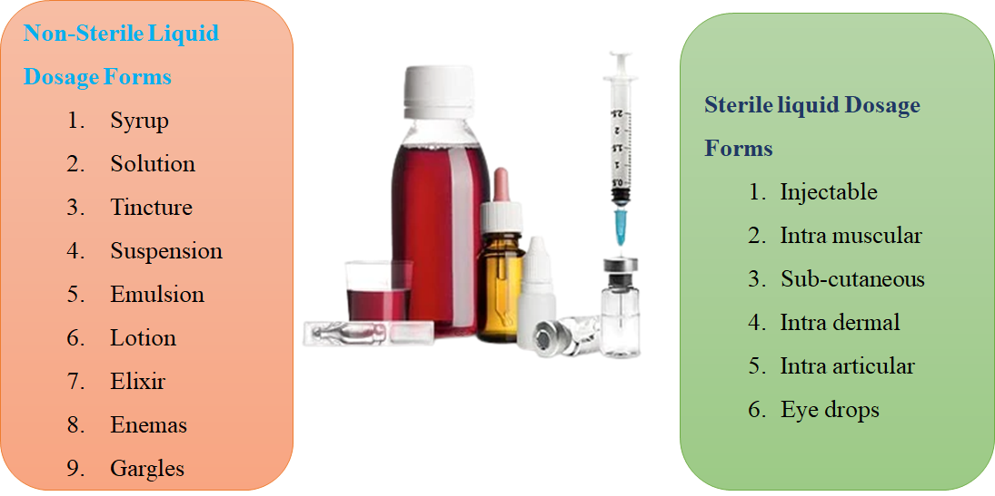
Figure 5. Sterile and non-sterile liquid dosage forms
- Oral liquid pharmaceutical dosage forms
Oral liquids are homogenous liquid preparation, usually a solution, an emulsion, or a suspension of one or more active ingredients in a suitable liquid base. They are prepared for oral administration either as such or after dilution. They may be container other substances such as suitable dispersing, solubilizing, wetting, emulsifying, stabilizing, suspending, thickening gents and antimicrobial substances for preservatives. They may be also containing suitable sweetening, flavouring agents and colouring agents.[25]
- Syrup
The syrup is a vicious oral liquid that contain one more active ingredient in solution. This base generally contains large amount os sucrose or other sugars to which sorbitol may be added to inhibit crystallization or to modify solubilization, taste and other base properties. Sugarless syrup may contain other sweetening agents as saccharin and thickening agents. Syrup may contain ethanol 95% as a preservative or as a solvent for flavours. Antimicrobial agents may be added to syrups to maintain the microbial quality of preparation.
- Oral suspension
Oral suspension is an oral liquid that contains one more active ingredient suspended in a suitable base. Suspended solods may separate a time on keeping but are easily re-dispersed on shaking. In the manufacturing of oral suspensions containing suspended particles, it should be ensured that particle size should be controlled regarding the intended use of the preparation.
- Solution
Oral solution is an oral liquid that contains one or more active ingredients dissolved in a suitable base measuring device such as a dropper.
- Drop
Oral drop is a liquid that is prepared to take in small quality with the help of a suitable measuring device such as dropper.
- Emulsion
Oral emulsion is an oral liquid that contains one more active ingredient that are unstable in the water phase and stabilized oil-in-water dispersions either or both phases of the preparation may contain dissolved solids. Both phases of the preparation may separate but are easily mixed by shaking. The preparation is fully stable to give a homogeneous dose when after proper shaking
- Mixture
The mixture is an oral liquid containing one or more active ingredients suspended or dispersed in a
Suitable base. Suspended solids may separate on keeping for a time period but are easily re suspended on shaking.
- Linctus
Linctus is a vicious oral liquid that contains one or more active ingredients dissolved in a suitable base that generally contains a higher Concentration of sucrose. Linctus’s are generally prepared for treatment of a cough, and these are taken without addition of water.
- Elixir
This is clear, flavored oral liquid containing one or more active ingredients dissolved in a suitable base that contains a high proportion of sucrose and may also contain ethanol (95percent) or a diluted ethanol[26].
References
- Langer, R. Drug delivery and targeting. Nature 1998, 392, 5–10.
- Benoit, D.S.; Overby, C.T.; Sims, K.R., Jr.; Ackun-Farmmer, M.A. Drug delivery systems. In Biomaterials Science; Elsevier: Amsterdam, The Netherlands, 2020; pp. 1237–1266.
- Langer, R. New methods of drug delivery. Science 1990, 249, 1527–1533. [CrossRef]
- Chaudhari, S.P.; Patil, P.S. Pharmaceutical excipients: A review. IJAPBC 2012, 1, 21 34.
- Jain, K.K. An overview of drug delivery systems. Drug Deliv. Syst. 2020, 2059, 1–54.
- Patel, H.; Shah, V.; Upadhyay, U. New pharmaceutical excipients in solid dosage forms-A review. Int. J. Pharm. Life Sci. 2011, 2, 1006–1019.
- Kalasz, H.; Antal, I. Drug excipients. Curr. Med. Chem. 2006, 13, 2535–2563. [CrossRef] [PubMed]
- Ku, M.S. Use of the biopharmaceutical classification system in early drug development. AAPS J. 2008, 10, 208–212. [CrossRef] [PubMed]
- Verma, P.; Thakur, A.; Deshmukh, K.; Jha, A.; Verma, S. Research. Routes of drug administration. Int. J. Pharm. Stud. Res. 2010, 154–59.
- Augsburger, L.L.; Hoag, S.W. Pharmaceutical Dosage Forms-Tablets; CRC Press: Boca Raton, FL, USA, 2016.
- Qiu, Y.; Chen, Y.; Zhang, G.G.; Yu, L.; Mantri, R.V. Developing Solid Oral Dosage Forms: Pharmaceutical Theory and Practice; Academic Press: Cambridge, MA, USA, 2016.
- 1Mahato, R.I.; Narang, A.S. Pharmaceutical Dosage Forms and Drug Delivery: Revised and Expanded; CRC Press: Boca Raton, FL, USA, 2017.
- Bora, A.; Deshmukh, S.; Swain, K. Recent advances in semisolid dosage form. Int. J. Pharm. Sci. Res. 2014, 5, 3596.
- Niazi, S.K. Handbook of Pharmaceutical Manufacturing Formulations: Volume Four, Semisolid Products; CRC Press: Boca Raton, FL, USA, 2019.
- Mahalingam, R.; Li, X.; Jasti, B.R. Semisolid dosages: Ointments, creams, and gels. Pharm. Manuf. Handb. 2008, 1, 267–312.
- Allen, L.V., Jr. Basics of compounding: Tips and hints, Part 3: Compounding with ointments, creams, pastes, gels, and gel-creams. Int. J. Pharm. Compd. 2014, 18, 228 230.
- Prausnitz, M.R.; Langer, R. Transdermal drug delivery. Nat. Biotechnol. 2008, 26, 1261–1268. [CrossRef] [PubMed]
- Prausnitz, M.R.; Mitragotri, S.; Langer, R. Current status and future potential of transdermal drug delivery. Nat. Rev. Drug Discov. 2004, 3, 115–124. [CrossRef] [PubMed]
- Al Hanbali, O.A.; Khan, H.M.S.; Sarfraz, M.; Arafat, M.; Ijaz, S.; Hameed, A. Transdermal patches: Design and current approaches to painless drug delivery. Acta Pharm. 2019, 69, 197–215. [CrossRef] [PubMed]
- Dhiman, S.; Singh, T.G.; Rehni, A.K. Transdermal patches: A recent approach to new drug delivery system. Int. J. Pharm. Pharm. Sci. 2011, 3, 26–34.
- Perrigo. Transderm-Scop, Scopalamine Transdermal Patch. Available online: https://investor.perrigo.com/2019-10-03-Perrigo- Announces-the-Relaunch-of-the-AB-Rated-Generic-Version-of-Transderm-Scop-R-1-5-MG (accessed on 15 August 2021).
- Gad, S.C. Semisolid dosages: Ointments, creams and gels. In Pharmaceutical Manufacturing Handbook: Production and Processes;John Wiley & Sons: Hoboken, NJ, USA, 2008; Volume 5, pp. 267–312.
- Rubio-Bonilla, M.V.; London Bonilla, M.V.; Londono, R.; Rubio, A. Liquid dosage forms. In Pharmaceutical Manufacturing Handbook: Production andProcesses; John Wiley & Sons: Hoboken, NJ, USA, 2008; Volume 5, pp. 313–344.
- SolutionsCopyright Pharmaceutical Press www.pharmpress.com
- Pharmaceutical guidelines ankur Choudhary https://www.pharmaguideline.com/2013/03/oral-liquid-pharmaceutical-dosage-forms.html
- https://www.pharmaguideline.com/2013/03/oral-liquid-pharmaceutical-dosage-forms.html

