SMART SENSORS: WORKING AND IT’S APPLICATIONS

Ashish Gupta¹, Indra Nath Sahu¹, Amit Alok Herenz¹, Rahul Deo Sah¹, Syed Jaffar Abbas¹
Department of Computer Applications and Information Technology, Dr. Shyama Prasad Mukherjee University¹,
Ranchi, Jharkhand, India.
drgupta1910@gmail.com, rc.insahu@gmail.com, amitalokherenz@gmail.com, rahuldeosah@gmail.com, sjaranchi@gmail.com.

ABSTRACT

In the field of instrumentation, sensors are playing a very important role. Presently, most of the sensors used are smart. In case of smart sensors, the sensing elements and the related electronics are integrated on the same chip. So, the integration of electronics and sensors for creating an intelligent sensor is known as a smart sensor.
Smart sensors can make sensible decisions. These sensors have many advantageous features like fast signal conditioning, auto-calibration, high reliability, small physical size, higher Signal to Noise (S/N) ratio, self-testing, detection and prevention of failure. So, the main objective of this article would be to discuss about the smart sensor, it’s working, and it’s applications.

Keywords—smart sensor; formatting; style; styling; insert (key words)

I. Introduction: What is a Smart Sensor?

A smart sensor is a device which uses a transducer to gather data/information from physical environment, performs predefined and programmed function and then transmits it through a networked connection.
Some of the important features of the smart sensor are as follows: smart calibration and compensation, multi-sensing capacity, self-identification, digital sensor data, sensor communication for configuration of remote and remote monitoring, etc.
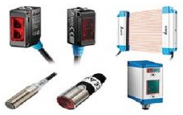
Figure 1: Smart Sensors

II. Working Principle of Smart Sensors

Smart sensors work on the following principle: they capture the data from physical environments and convert their physical properties like presence of humans, mass, temperature, pressure or speed into calculable electrical signals. These sensors include a Digital Motion Processor (DMP) which is one type of microprocessor that allows the sensor to perform onboard processing of the data like filtering noise else performing different kinds of signal conditioning.

Smart sensors performs four main functions namely:

1. Measurement: Measurements are simply taken through detecting physical signals & changing them into electrical signals. So this will help in monitoring and measuring things like temperature, traffic, & industrial applications.
2. Configuration: Configuration function is a significant feature as it allows the smart sensor to detect position otherwise installation errors
3. Verification: The verification function has different uses like nonstop supervision of sensor behavior, using a set of supervisory circuits or equipment executed within the sensor.
4. Communication: Lastly, the communication feature allows the sensor to converse to the main microcontroller/microprocessor.

III. Block Diagram of a Smart Sensor

The block diagram of the smart sensor is shown in the figure given below. The block diagram consists of different blocks like sensing unit, signal conditioning, analog to digital convertors, application algorithms, local user interface, memory, and communication unit or transceiver.

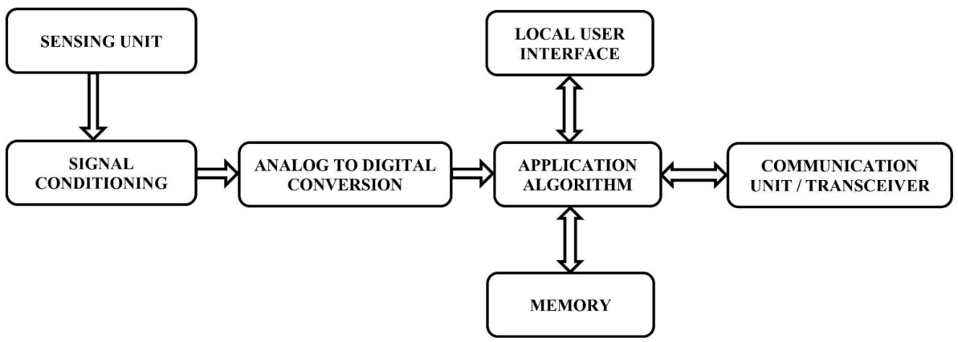
Figure 2: Block Diagram of a Smart Sensor

The main functions of the various blocks of the Sensors are –

1. Sensing Unit: It detects the changes in physical parameters and correspondingly generates an electrical signals equivalent to it.
2. Signal Conditioning Unit: The signal conditioning unit controls the signal to meet the necessities of next-level operations without losing data.
3. Analog to Digital Converter: ADC converts the signal from analog to digital format and sends it to the microprocessor.
4. Local User Interface: The local user interface or LUI is a panel-mounted device used to allow building operators to monitor and control system equipment.
5. Application Algorithm: The signals from smart sensors reaches here and process the received data based on the application programs previously loaded here and generates the output signals.
6. Memory: It is used to store media for saving received & processed data.
7. Communication Unit: The output signals from the application algorithm or microprocessor are transmitted to the main station through the communication unit. This unit also gets command requirements from the key station to execute specific tasks.

IV. Types of Smart Sensor

There are different types of smart sensor which are commercially available and are explained below.
(a) Level Sensors: A level sensor is one type of device used to monitor, measure and maintain the liquid levels. Whenever the level of liquid is sensed, this sensor changes the data into an electric signal.
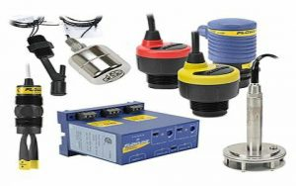
Figure 3: Level Sensors
Level sensors are further classified into two types: point level and continuous level.
(i) A point level sensor is used to specify whether a liquid has achieved an exact point within a container. (ii) A continuous level type sensors are used to provide precise measurements for liquid level.
These sensors are mainly used in different industries like automotive, manufacturing, and also in household applications.

(b) Temperature Sensors: Temperature sensors are used to measure temperatures like liquid temperature, air temperature, or solid matter temperature. These sensors are available in different types which use different principles to measure the temperature like RTDs, NTC thermistors, thermopiles and thermocouples. These sensors are mainly used in medical devices, computers, automobiles, cooking appliances and other types of machinery.
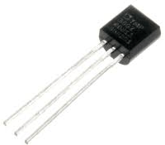
Figure 4: Temperature Sensors

(c) Pressure Sensors: A pressure sensor is a transducer that changes the mechanical pressure input into an electrical output signal. There are different types of pressure sensors available based on capacity, size, sensing technology, measurement method and output requirements. These sensors play a key role in monitoring pipelines and give an alert to supervisors if there are any leaks otherwise irregularities so that they can repair or maintain pipelines.
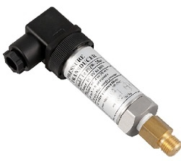
Figure 5: Pressure Sensors

(d) Infrared Sensors: An infrared sensor is an electronic device used to emit light to detect some object in the surroundings and measures the objects’ heat and detects the motion. Generally, all the objects will emit some form of thermal radiation within the IR spectrum which is invisible but the IR sensor can sense these radiations.
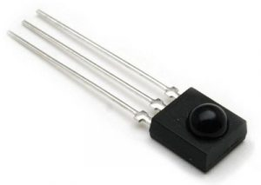
Figure 6: Infrared Sensors
IR sensor includes a transmitter like an IR LED and receiver as an IR photodiode. For infrared transmission, three types of media are used vacuum, atmosphere and optical fibers. These sensors are used in night vision devices, radiation thermometers, IR tracking, IR imaging, etc.

(e) Proximity Sensors: A smart sensor like a proximity sensor is used to notice the existence of objects in its surrounding area without contacting them. These sensors are frequently used in collision avoidance systems and collision warnings. This sensor uses light, sound, IR radiation otherwise electromagnetic fields to notice an object.
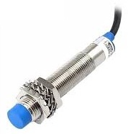
Figure 7: Proximity Sensors
These sensors are applicable in consumer robotics, industrial applications and also utilized in vehicles to detect the physical contact of other vehicles and also for parking-assist functions.

(f) Air Quality Detection Sensors: Air quality detection sensors are electronic devices that are used to detect and monitor the air pollution within the air in the nearby area. So, these sensors efficiently work for indoor and outdoor purposes. Air quality sensors are capable of checking the CO2 concentrations through VOC (volatile organic compounds) that have methane and ammonia as gases.
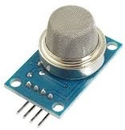
Figure 8: Air Quality Detection Sensors

(g) Motion Sensors: Motion sensors are electronic devices, used to detect movement inside and surroundings of your home and give an alert. For instance, this sensor can activate the lights once it detects you while entering into a room otherwise, they can give an alert once an intruder is trying to enter your home. These types of sensors are mainly used in homes, security systems, paper towel dispensers, phones, virtual reality systems and game consoles.
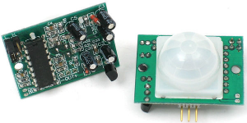
Figure 9: Motion Sensors

(h) Smart Plant Sensors: Plant sensors are advanced gardening sensors used to provide the data to the user from stem surface, leaf to root probes to feed the plants. They explain to us what nourishment and care are required for the plant.
Figure 10: Plant Sensors

This sensor is very simple to use by placing it into the soil of the plant pot beside the potted plant. After that, it monitors the level of moisture, light intensity, the temperature automatically to maintain the plant properly. The current plant sensors give an alert through smartphones to keep checking your plant’s condition remotely and take appropriate action.

(i) Smart Climate Sensors: Smart climate sensors are used to gather the data of barometric pressure, temperature and humidity that assist in evaluating the exact weather conditions and calculate as well. These sensors will assist you in setting your plan accordingly because these sensors are connected through your Smartphone to send alerts throughout the frequent changes within the weather. These sensors are essential for gardening and are connected to smart irrigation systems.
Figure 11: Climate Sensors

V. Difference between Normal Sensor and Smart Sensor
The difference between a normal sensor and a smart sensor includes the following.

Normal Sensor | Smart Sensor
A normal sensor is a device which detects the physical change and chemical environment. | The part of a sensor is known as a smart sensor that is used for the computer.
A normal sensor doesn’t include a DMP or digital motion processor. | A smart sensor includes a DMP or Digital Motion Processor.
The normal sensor includes three components namely sensor element, packaging and connections, and signals processing hardware. | Smart sensors include different components like amplifiers, transducers, analog filters, excitation control, and compensation sensors.
The different types of normal sensors are pressure, position, temperature, vibration, force, humidity and fluid property. | The different types of smart sensors are electric current, level, humidity, pressure, proximity, temperature, heat, flow, etc.
Normal sensor output cannot be used directly because we should convert it into a usable format. | The output of the smart sensor is ready to use.
Normal sensors are preferred while designing a device which requires complete control on sensor input. | Smart sensors are generally preferred over normal sensors because they include natural processing capabilities.
Normal sensors inexpensive because they contain fewer components. | Smart sensors are expensive as compared to normal sensors.

VI. Advantages of Smart Sensors

The advantages of the smart sensor include the following.
- These are small in size.
- These sensors are very easy to use, design and maintain.
- The performance level is higher.
- Speed of communication and reliability is higher due to the direct conversion with the processor.
- These sensors can perform self-calibration and self-assessments.
- These sensors can notice issues like switch failures, open coils and sensor contamination.
- These sensors optimize manufacturing processes easily that need changes.
- They can store many systems’ data.

VII. Disadvantages of Smart Sensors

The disadvantages of the smart sensor include the following.
- Smart sensors’ reliability is one of the major drawbacks because if they are stolen or get damaged then they can affect a lot of systems badly.
- It needs both sensors and actuators.
- Sensor calibration has to be managed by an external processor.
- High complexity in wired smart sensors, so the cost is also very high

VIII. Applications

The applications of the smart sensor include the following: These sensors play a key role in monitoring different industrial processes like data collecting, measurement taking and transmitting the data to centralized cloud computing platforms wherever data is collected & analyzed for different patterns. So, this collected data can be simply monitored at any time by decision-makers.
Smart sensors are used mainly for monitoring and control mechanisms in different environments like water level and food monitoring systems, smart grids, traffic monitoring and control, environmental monitoring, conserving energy in artificial lighting, monitoring of the remote system, and fault diagnostics of equipment, transport and logistics, agriculture, telecommunications, industrial applications, animal tracking, etc.
The most widely used smart sensors are as follows: AWR1243, AWR1443, AWR1642, CC2650STK, etc.

IX. Smart Sensor Technology for the Internet of Things (IoT)
Internet of Things (IoT) applications — whether for city infrastructures, factories, or wearable devices — use large arrays of sensors collecting data for transmission over the Internet to a central, cloud-based computing resource. Analytics software running on the cloud computers reduces the huge volumes of generated data into actionable information for users, and commands to actuators back out in the field.
Sensors are one key factor in IoT success, but these are not conventional types that simply convert physical variables into electrical signals. They have needed to evolve into something more sophisticated to perform a technically and economically viable role within the IoT environment.
The smart sensor is also a crucial and integral element in the internet of things (IoT), the increasingly prevalent environment in which almost anything imaginable can be outfitted with a unique identifier and the ability to transmit data over the internet or a similar network. One implementation of smart sensors is as components of a wireless sensor and actuator network (WSAN) whose nodes can number in the thousands, each of which is connected with one or more other sensors and sensor hubs, as well as individual actuators.
There are countless use cases for smart sensors. They are very commonly used in industrial environments and are the driving force behind Industry 4.0. Factories often use smart temperature sensors to make sure machines aren't overheating, and vibration sensors to make sure machines aren't at risk of vibrating loose. Smart sensors also enable process control, such as monitoring a process, like manufacturing an item, and making any adjustments that might be required to meet quality or production goals. This was once a manual process, but smart sensors can be used to automate process control.
Smart sensors also play a key role in modern security systems. Thermal imaging sensors can be used to detect an intruder's body heat. Similarly, devices such as smart locks, motion sensors, and window and door sensors are commonly connected to a common network. This enables the security sensors to work together to paint a comprehensive picture of the current security status.
SMART sensors are the typical sensors that hold wireless communication and embedded microprocessors, that hold the potentiality to monitor, examine and maintain a particular system. This was the ultimate result of the finite fabrication, smart structures and designs of the experienced engineers, who have managed to create a smarter future from the core of intelligence and creativity. This is the new step of sensors which was created to enhance the abilities of a normal sensor.
The ability to monitor simultaneously assures safety too. The main difference between the traditional sensors and smart sensors is that, the smarts ones have wider intelligence ability when compared to the traditional sensors. The common function of a normal sensor is to sense information and then transform it in the form of electrical signals. The normal sensors have three crucial parts which are:
- Sensing element (Transistor, Capacitors, Photo Diode etc).
- Conduction of signals and processing.
- Sensor Interface.
There are several technologies that are involved in the working of this type of sensor, this technology give the sensor its ubiquity and make them the “smart” way of sensing.
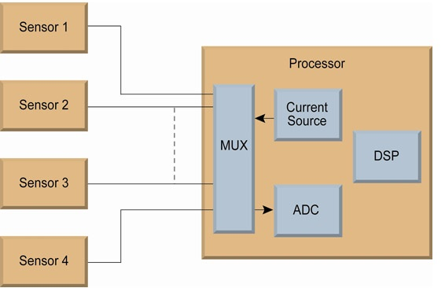
Figure 12: Simple Representation of Wireless Sensor System

Micro Electro Mechanical Systems (MEMS): This system helps the sensor to work in a smarter way, by allowing them to handle huge amount of data in just a fraction of second. The usual data that gets recollected by the sensor are worked with the microprocessors, which through advanced computation clear or store the data.
Such type of technology makes these sensors more adaptable and enhances its self-calibration abilities. The main fundamental to the smart sensing era lies in the monitoring system that are well supported by the conventional instruments and computational technology to bring something robust like SMART sensors.

Very Large-Scale Integration Technology (VLSI): The devices that are part of the Micro Electro Mechanical System are developed with the help of Very Large-Scale Integration Technology. This means that, the components are able to perform both mechanical and electrical functions. The tools of MEMS can be used in any environment. Along with that, this technology even brings the chemical phenomenon that is required for sensing that converts the recorded data to electrical signals that can be used in form of processing, display, recording and transmission. The main thing that is granted by this technology to the smart sensing device is its minimalistic design and the small shape.

Importance of Wireless Sensors for Smart Sensing Technology: Wireless technology is the heart and core of SMART sensors. The wireless technology makes sure that the sensor can be fixed anywhere without the complications of handling any type of wire, or its related fixing. Recently, several work and research has been placed in this sector to bring affordable wireless sensors, which are cost-effective and easy to use. This work has developed immensely and today one can explore the wireless sensors at acceptable rates, avoiding the chaos of cabling and lining.

X. What Does The IoT Expect of its Sensors?

Sensors have traditionally been functionally simple devices that convert physical variables into electrical signals or changes in electrical properties. While this functionality is an essential starting point, sensors need to add the following properties to perform as IoT components:
- Low cost, so they can be economically deployed in large numbers
- Physically small, to “disappear” unobtrusively into any environment
- Wireless, as a wired connection is typically not possible
- Self-identification and self-validation
- Very low power, so it can survive for years without a battery change, or manage with energy harvesting
- Robust, to minimize or eliminate maintenance
- Self-diagnostic and self-healing
- Self-calibrating, or accepts calibration commands via wireless link
- Data pre-processing, to reduce load on gateways, PLCs, and cloud resources
Information from multiple sensors can be combined and correlated to infer conclusions about latent problems; for example, temperature sensor and vibration sensor data can be used to detect the onset of mechanical failure. In some cases, the two sensor functions are available in one device; in others, the functions are combined in software to create a ‘soft’ sensor.

XI. Smart Sensors Networks Applications

1. Industrial: In industries machines and equipment are monitored and controlled for pressure, temperature, humidity level, and also for vibrations. A Smart Sensor can monitor all these parameters at one go and also connects to the network without any other hardware assistance. This helps to maintain machinery and also ensure safety for employees handling the machinery.
2. Finger Recognition: A fingerprint sensor scans and captures a digital image of the fingerprint pattern. The image captured is called livescan. Using that live scan a biometric template will be created and stored for matching.
3. Pattern Recognition: When the sensor detects the contours of an object, it compares with them and also with models in a reference image.
4. Telecommunication: A smart card similar to SIM card, called a Wireless Identity Module (WIM), Using this card e-commerce transaction can be done with 100 percent security using encryption and digital signature.
5. Smart Dust: Smart dust is a hypothetical wireless network of tiny microelectromechanical (MEMS) sensors, robots, or devices, which can detect (for example) light, temperature, or vibration. The devices will eventually be the size of a grain of sand, or even a dust particle, with each mote having self-contained sensing, computation, communication, and power.
6. Biomedical Applications: Many smart sensors for biomedical applications have also been developed by using chip technology .e.g. biochips Cyto-sensor micro-physio-meter: biological applications of silicon technology.
7. MEMS and Process Control: MEMS(Micro-Electro-Mechanical Systems) are very small physical systems. MEMS sensors are a combination of electrical and mechanical components. MEMS uses a modified integrated circuit (computer chip) fabrication techniques and materials to create these very small mechanical devices.
8. Defence Applications: Smart cameras can detect objects, perform crowd pattern analysis, secure zone intrusion detection and so on by using advanced software analytics and report alarms using IP network facilities in them. Smart Sensors are also used in monitoring EMI fatigue loading, thermal cycling vibration and shock levels, corrosive environments.

XII. Conclusion

Chip manufacturers and researchers have been responding to the IoT’s need for smart sensors. This has partly been a matter of adding intelligence and communications capabilities to the basic transducer function, but it also involves improved fabrication. By integrating the MEMS sensor elements and CMOS computing components onto a single substrate, smart sensors can be implemented in small, low-cost packages that can be embedded in space-constrained applications with resilience to their environmental conditions.
Accordingly, IoT designers can source the sensors that they need — small, cheap, resilient, and low-power enough for ubiquitous deployment, while having the intelligence to deliver useful information as well as raw data. They also facilitate more flexible, granular automation, as they can accept incoming commands for recalibration to accommodate production changes.

REFERENCES

[1] Jacopo Iannacci. Microsystem based Energy Harvesting (EH-MEMS): Powering pervasivity of the Internet of Things (IoT) – A review with focus on mechanical vibrations, Journal of King Saud University – Science: 2019; 31(1): 66-74.
[2] Safwat and A. Ismail. A General-Purpose Single-Slope MEMS Capacitive Sensors Interface Circuit For IoT Applications: 2020 June 16-19; Montreal, QC, Canada: 2020 18th IEEE International New Circuits and Systems Conference (NEWCAS). August 2020.
[3] I Irwandi et al. MEMS and IoT Applications in ISLE-based STEM Physics Learning Media for Mechanics Topic with LabVIEW Integration L 2019 October 16-17; North Sumatera Province, Indonesia: 2020 J. Phys.: Conf. Ser. February 2020.
[4] Phua, W.K. Rabeek, S.M. Han et al. AIN-Based MEMS (Micro-Electro-Mechanical System) Hydrophone Sensors for IoT Water Leakage Detection System. Water 2021; 13(8):1-12
[5] Avraham, M. Golan, G. Vaiana et al. Wafer-Level Packaged CMOS-SOI-MEMS Thermal Sensor at Wide Pressure Range for IoT Applications. Eng. Proc: 2020: 2(1);1-7
[6] J. Iannacci. RF–MEMS for High–Performance and Widely Reconfigurable Passive Components – A Review with Focus on Future Telecommunications, Internet of Things (IoT) and 5G Applications, Journal of King Saud University – Science: 2017;29(4): 436-443
[7] I. Akita, T. Okazawa, Y. Kurui. A Feedforward Noise Reduction Technique in Capacitive MEMS Accelerometer Analog Front-End for Ultra-Low-Power IoT Applications. IEEE Journal of Solid-State Circuits: 2020; 55(6):1599-1609
[8] Xu, Q., Yang, Z., Sun, Y. et al. Shock-Resistibility of MEMS-Based Inertial Microswitch under Reverse Directional Ultra-High g Acceleration for IoT Applications. Sci Rep: 2017; 7(1); 1-9
[9] Clark, J. Self-Calibration and Performance Control of MEMS with Applications for IoT. Sensors: 2018: 18(12); 18: 1-19.
[10] A. Attaran and R. Rashidzadeh. Chipless Radio Frequency Identification Tag for IoT Applications. IEEE Internet of Things Journal: 2016; 3(6):1310-1318
[11] Aditya Khatokar J., Mounisha M., Nayana M.A. Battery Management System: A Survey. Journal of Industrial Safety Engineering: 2020; 7(1): 29–35.
[12] Aditya Khatokar J, Nayana M A, Soundarya N et al. Electric Vehicles: Transition to Green Zone. Trends in Transport Engineering and Applications: 2020; 7(2): 12–17.
[13] Raksha K.P., Rajani Alagawadi, Nisha N. Advancement of Nanotechnology in Batteries. International Journal of Energetic Materials: 2020; 6(2): 18–24.
[14] Vinay N., Aditya Khatokar J., Ajay Sudhir Bale. Analysis on Synthesis of Quantum Dots with Their Applications on Photochemistry. International Journal of Photochemistry. 2020; 6(1): 1–11
[15] Ajay Sudhir Bale, Bharath G, Kiran Mohan M S. Thin-Films: Study of Medical, Display and Environmental Applications. International Journal of Energetic Materials: 2020; 6(1): 1–6.
[16] Ajay Sudhir Bale, Suhaas V. Reddy, Shivashankar A. Huddar, Electromechanical characterization of Nitinol based RF MEMS switch. Materials Today: Proceedings: 2020: 27(1); 443-445
[17] Ajay Sudhir Bale, J. Aditya Khatokar, Shantanu Singh. 2020, September. Nano-sciences fostering cross domain engineering applications. [online] Available from: https://doi.org/10.1016/j.matpr.2020.09.076.
[18] J. Aditya Khatokar, N. Vinay, Ajay Sudhir Bale et al. 2020, December. A study on improved methods in Micro-electromechanical systems technology. [online] Available from:
https://doi.org/10.1016/j.matpr.2020.10.993.
[19] Ajay Sudhir Bale, J. Aditya Khatokar, M.S. Kiran Mohan et al. 2021, February. Nanotechnology as a tool for treating cancerous tumours. [online] Available from: https://doi.org/10.1016/j.matpr.2020.12.1175.
[20] S. A. Huddar, B. G. Sheeparamatti and A. S. Bale. Study of pull-in voltage of a perforated SMA based MEMS Switch: 2017 August 10-12; Vellore, India: 2017 International conference on Microelectronic Devices, Circuits and Systems (ICMDCS). December 2017
[21] Ajay Sudhir Bale, Harish Koujalgi. Quality Factor analysis for Nitinol based RF MEMS Resonator. International Research Journal of Engineering and Technology (IRJET):2017; 4(7): 3219-3222.
[22] Ajay Sudhir Bale, Suhaas V Reddy and Subhashish Tiwari. Effect of residual stress on resonant frequency in Nitinol based thin film resonator: 2020 April 9-10; place, Tamil Nadu, India: IOP Conference Series: Materials Science and Engineering. 2020
[23] Kishan Das Menon H, Aditya Khatokar J, Ajay Sudhir Bale. Enhanced Railway Operations Using Automated Locomotive Simulator. Trends in Transport Engineering and Applications: 2020; 7(1): 17–23.
[24] Ajay Sudhir Bale, Hosamani Ummar Farooq N, Shivashankar Huddar. Automated Diesel transfer system using PLC. Journal of Industrial Safety Engineering: 2019; 6(1): 8–14.
[25] Venkatesh M S, Manoj Patil, Ajay Sudhir Bale et al. Design of Remotely Monitorable Low Power Phototherapy Unit for Treatment of Neonatal Hyperbilirubinemia: 2017 September; Davangere, India: National Conference at Bapuji Engineering College. November 2019.
[26] Aditya Khatokar J., Nayana M.A., Ajay Sudhir Bale. A Survey on High Frequency Radios and their Applications. Journal of Industrial Safety Engineering: 2020; 7(1):7–12.
[27] Harish Koujalgi, Ajay Sudhir Bale. Biometric Based Automatic Ticket Vending Machine for Indian Railways. International Research Journal of Engineering and Technology (IRJET):2017; 4(7): 3235- 3238.
[28] Aditya Khatokar J, Nayana M A, Kishan Das Menon H. A Study on Various Approaches in Remote Sensing. Journal of Telecommunication, Switching Systems and Networks: 2020; 7(2): 32–37.
[29] J. Aditya Khatokar, N. Vinay, B. Sanjay et al. 2021, March. Carbonnanodots: Chemiluminescence, fluorescence and photoluminescence properties. [online] Available from:
https://doi.org/10.1016/j.matpr.2021.02.582.
[30] S. S. Kumar, A. Sudhir Bale, P. M. Matapati and V. N. Conceptual Study of Artificial Intelligence in Smart Cities with Industry 4.0: 2021 March 4-5; Greater Noida, India: International Conference on Advance and Innovative Technologies in Engineering (ICACITE). April 2021.
[31] A. S. Bale, S. Saravana Kumar, P. Rao and A. K. J. A Recent Trend in DC Microgrid: 2021 March 4-5; Greater Noida: India: International Conference on Advance Computing and Innovative Technologies in Engineering (ICACITE). April 2021.

