TopicHub

Pankaj Kunekar  pankaj.kunekar@vit.edu  Department of Artificial Intelligence and Data Science,  VIT Pune  Pune 411037, Maharashtra, India | Mihir Deshpande  mihir.deshpande20@vit.edu  Department of Artificial Intelligence and Data Science,  VIT Pune  Pune 411037, Maharashtra, India | Adwait Gharpure  adwait.gharpure20@vit.edu  Department of Artificial Intelligence and Data Science,  VIT Pune  Pune 411037, Maharashtra, India
Vedant Gokhale  vedant.gokhale20@vit.edu  Department of Artificial Intelligence and Data Science,  VIT Pune  Pune 411037, Maharashtra, India | Aayush Gore  aayush.gore20@vit.edu  Department of Artificial Intelligence and Data Science,  VIT Pune  Pune 411037, Maharashtra, India | Harsh Yadav  harsh.yadav20@vit.edu  Department of Artificial Intelligence and Data Science,  VIT Pune  Pune 411037, Maharashtra, India

Abstract —Managing different assessment schemes has been a tedious task for teachers as well for students. Creating different spreadsheets for every assessment makes the work clumsier and difficult to manage and also makes it hectic for students and teachers to maintain and assess them.
To solve this problem,the presented work created a single platform to assess, manage all the respective subject’s assignments and all the work. This will boost up the academic process and help professors and students to easily and efficiently go through their academics.Students can also form groups with other students and can get approved by the respective faculty.
Keywords— react, web-development, express, mongodb;

Introduction

The term "web technology" refers to all forms of technology used largely on the World Wide Web. It's an information system where Uniform Resource Locators may identify papers and other online resources. The usage of web technology is essential in order remotely managing and getting information [1].
The advantages of web technology in our day to day life and in education after the pandemic are known to all. This enables us to save time and unnecessary efforts. We aim to achieve this goal. In college, students have a multitude of assessments in addition to exams that are important, assessments like group discussions, viva Voce exams, seminars, course projects and more, keeping track of all these is a tiresome process. Students and teachers currently use informal means like excel spreadsheets and WhatsApp groups to bring some structure and communicate. These methods can bring trouble for students that are out of the loop. We aim to solve this problem using TopicHub

TopicHub is a web-based application that helps students and faculties to comfortably select the assignment topics and easily grade them. This project is based mainly on MERN stack and is developed with the emerging technologies such as ReactJS which help in creating an optimized frontend of our app, Express JS as Backend for creating API’s, Mongo-DB as database, also used chakra for the UI of our web Application.

Literature Review

This section concentrates on the related work done and the types of applications designed by the researchers.

A Student-Teacher Project Management Tool known as Protrack is a web based tool to create teams among students in cooperation with the teachers [1].

Nicoletta et al. focuses on TPK, the intersection between technology knowledge and knowledge as a crucial field of investigation [2].
College ERP Using MERN Stack application was developed for an engineering college to maintain and facilitate ease of access to information using MERN [3].

Using JavaScript to Build High-Performance Network Programs author discusses the importance of NodeJs in the web development field [4].

Using Node.Js to Build High Speed and Scalable Backend Database Server author discusses the use case of Node Js in building the backend for a project [5].

Full Stack Web Development Teaching promotes learning and skill enhancement in the field of Web development with the emerging technologies [6].

The New Era of Full Stack Development concentrates on concise study of the evolution of full stack web development.The author discusses different technologies of full stack development [7].

8.Database-Driven Web Development Fundamentals discusses the fundamentals of database management in the development of web technologies [8].

Modern web application development technologies discuss the evolution of modern web technologies and also discusses the uses of web development in various fields [9].

Django-Based Web Application to Empower Skilled People work focuses on how Django can be useful in web development and future uses of the same [10].

HTML Educational Node.js System (HENS): An Applied System for Web Development introduces the reader to the Node JS and HTML framework for web development [11].
Web development with node.js: work demonstrates step-by-step instructions to develop a web application and deploy it on Heroku [12].

REST API Development with Node.js: discusses the development of REST API’s using Node Js in the web development domain [13].

Using Express.js to Create Node.js Web Apps: demonstrates the integration of ExpressJS with Node js [14].Pavate et al. [15] introduced JavaScript framework for designing single page applications.

Programming Web Services on the Cloud with Node.js demonstrates working of web services in integration with cloud services such as MySQL,MongoDb [16].

Many authors have concentrated on teaching learning process with using of modern technologies [17-18].

In this work we are concentrated on teaching and learning by introducing innovative technical concepts in the learning process.

System Design

TopicHub is a web based application that is used to keep track of all your assessments in a class. The system consists of two modes - one for the students and one for the instructor. The app is designed in a way where students and teachers can collaborate for transparency and clarity

      - Students view as shown in figure 1. When students access TopicHub, they can use the options to Join a class, Create/Join a group with different members of the class, access their subjects and subject teachers. They can also view their previous assessments in a modal in their subjects page, and choose the topic name for a new assessment that their teacher starts. The student can also view his/her information on the “My Profile” page.
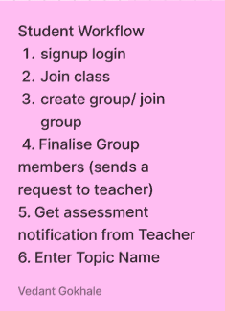
Figure 1: Student view

      - Teacher View
When teachers use TopicHub, they can start a new class and share the class code with students, appoint different subject teachers for different subjects, start new assessments, approve/ reject the topic selected by the students, and allot marks on assignments after evaluation as shown in figure 2. This makes the whole process smooth and easier.
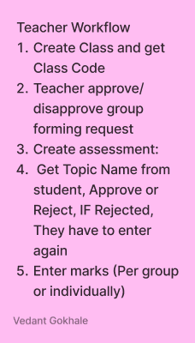
Figure 2: Teachers View

      - Flow diagram

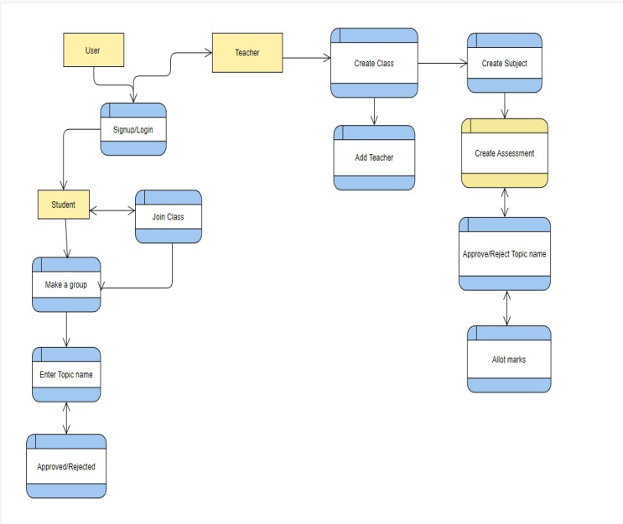

Figure 3: System flow

Figure 3 shows the system flow of the proposed system. In that main modules represented using yellow boxes and submodules represented using blue boxes.

results and discussions

We have created the WebApp for the desired task which is where students can be able to add topics and the faculty can approve it.
Basically we created two login options:
1. For Students
2. For Teachers

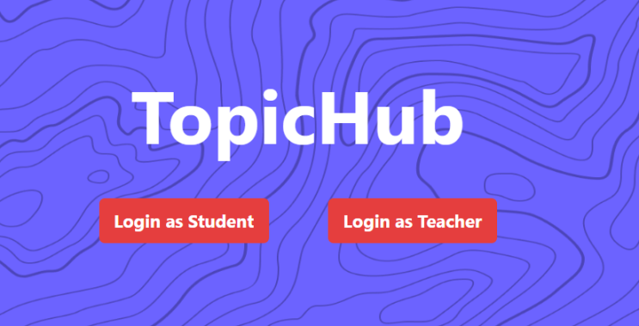
Figure 4: Home page of the designed model

We also created two schemas in the database for achieving this as shown in figure 4.
- In student’s login we implemented options like join class using ID, create a group, join a group, share group link etc.
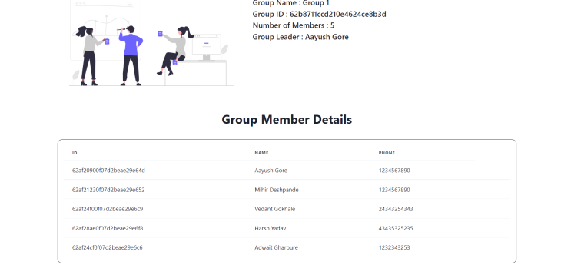
Figure 5: Group member module details

The figure 5 shows the list of group members who have joined the group.
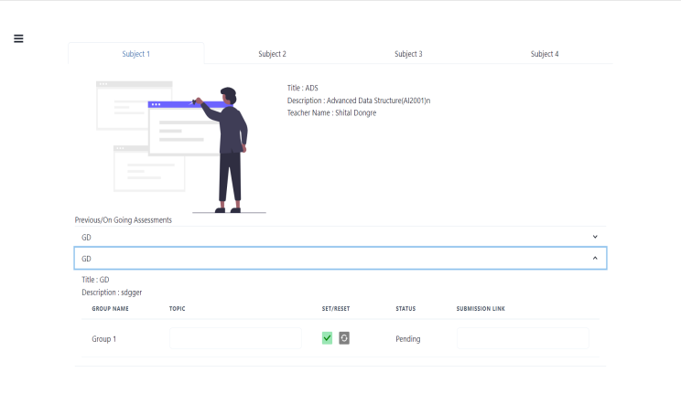
Figure 6: Process student submission
The figure 6 shows how the students can submit their topics and get accepted by the respected tutor.
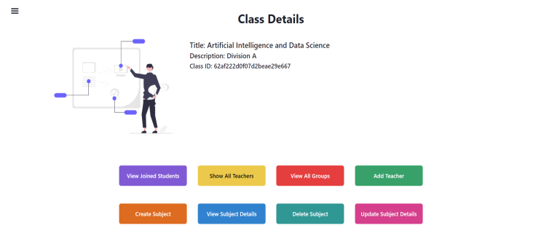
Figure 7: Class details
The figure 7 shows the options the class teacher has to grade, view , assess students. The proposed system applied and analyzed inDepartment of Artificial Intelligence and Data Science,VIT Pune

The observations show many of the students and teachers liked the App. Around 122 students joined and out of that 90 students feel comfortable of using the same and among 30 teachers all 30 liked app and given some suggestions for improvement.

Future Scope

As our project is highly scalable, we can implement various modules for more interaction between students as well as students and teachers like chatbots, video conferencing, etc. Also, we can add various features like where we can share assignments, docs, or the link to them. This project could be used by different universities for their own internal assessments.

Conclusion

Nowadays web applications are used in various different sectors. Web applications based on modern technologies are easy to scale and easy to run, and can be operated remotely from any part of the world. Though different applications are available currently, there is not a single web application that has both teacher and student interaction. Topic Hub gives a one-stop solution to get rid of different spreadsheets and provides an easy to manage application that can be used by both teachers as well as students simultaneously.

REFERENCES

- Dr. V. Vijayakumar, R. Pradeepkumar, S. Siddharthan, C. Harish Mohan, V. Deepak Kumaran,"Protrack: A Student-Teacher Project Management Tool", Turkish journals of computer and mathematics education/ Volume :12 No. 10(2021)/page no 3173 to 3186
- Blas, Nicoletta Di et al. “A Portal of Educational Resources: Providing Evidence for Matching Pedagogy with Technology.” Research in Learning Technology 22 (2014): n. pag. 1-26
- Dr. Ritesh Patil, VaishaliGentyal, VaishnaviMudaliar, GauriKanpurne, DevyaniAmbi,"College ERP Using MERN Stack",International Journal of Scientific Research in Computer Science, Engineering and Information Technology, ISSN 2456-3307
- Tilkov, Stefan and Steve Vinoski. “Node.js: Using JavaScript to Build High-Performance Network Programs.” IEEE Internet Computing 14 (2010): 80-83.
- S. L. Bangare1 , S. Gupta2 , M. Dalal3, A. Inamdar,"Using Node.Js to Build High Speed and ScalableBackend Database Server ",International Journal of Research in Advent Technology (E-ISSN: 2321-9637) Special Issue National Conference “NCPCI-2016”, 19 March 2016
- Anna Petrikoglou,Theodore H. Kaskalis,"Full Stack Web Development Teaching: Current Status and a New Proposal",WEBIST 2019: Proceedings of the 15th International Conference on Web Information Systems and TechnologiesSeptember 2019 Pages 218–225
- AkshatDalmia , Abhishek Raj Chowdary, 2020, “The New Era of Full Stack Development”, international journal of engineering research & technology (IJERT) Volume 09, Issue 04 (April 2020).
- Valentine, T. (2021). Database-Driven Web Development Fundamentals. In: Database-Driven Web Development. Apress, Berkeley, CA. https://doi.org/10.1007/978-1-4842-5970-2_1
- Modern web application development technologies. A I Dzhangarov et al 2021 IOP Conf. Ser.: Mater. Sci. Eng. 1155 012100
- AfrojSatwilkar ,TusharSawant , VaibhavShirke , Santosh V. Jadhav "Django Based Web Application to Empower Skilled People" Iconic Research And Engineering Journals Volume 4 Issue 11 2021 Page 119-120
- B. Carter, "HTML Educational Node.js System (HENS): An Applied System for Web Development," 2014 Annual Global Online Conference on Information and Computer Technology, 2014, pp. 27-31, doi: 10.1109/GOCICT.2014.25.
- Jung, S. (2018). Web Development with Node.js. Journal of Computing Sciences in Colleges 33(6), 154-156.
- Doglio, F. (2018). API Design Best Practices. In: REST API Development with Node.js .Apress, Berkeley, CA. https://doi.org/10.1007/978-1-4842-3715-1_2
- Mardan, A. (2018). Using Express.js to Create Node.js Web Apps. In: Practical Node.js. Apress, Berkeley, CA. https://doi.org/10.1007/978-1-4842-3039-8_2
- Aruna Pavate Pranav Nerurkar,"Study of angular js: a client side javascript framework for single page applications" International journal of contemporary research in computer science and technology,2015, vol 4, issue 4 pp 92-96
- Ortiz, A.: Programming web services on the cloud with Node.js. In: SIGCSE 2016, Memphis, TN, 2–5 March 2016
- A. Pavate, A. Chaudhary, P. Nerurkar, P. Mishra and M. Shah, "Cuisine Recommendation, Classification and Review Analysis using Supervised Learning," 2020 International Conference on Convergence to Digital World - Quo Vadis (ICCDW), 2020, pp. 1-6, doi: 10.1109/ICCDW45521.2020.9318646.
- Aruna Pavate. (2021), " Innovative trends that influence on teaching and learning process towards the revolution education 4.0", European Journal of Volunteering and Community-based Projects, 1(4), 1–19. https://doi.org/10.5281/zenodo.5816257

