Chapter No 3
EARTH’S MOVEMENT
Earth Movement : Earth movement concept, Causes of Earth movement, Types of Earth movement- Slow and Secular earth movement, Fast and sudden earth movement, Folding- Types, Faulting –Types.
Earthquake- Definition, causes, World distribution of earthquake zones, Effects of Earthquakes.
Volcanoes- Definition, Types of volcanoes, causes of volcanoes, Landforms formed by volcanism, Effects of Volcanoes, World distribution of Volcanic zone
Unit No :-1
EARTH MOVEMENT
MEANING :
There is a large variety of landforms on the surface of the earth. These includes continents, oceans, mountains, plateaus, plains, valleys, delta and a post of others. The continents & the oceans are the first order landforms which are very huge in diamension & shape. Mountains, plains, plateaus are the second order type landforms which founds on the continents & oceanic surface and comparatively smaller in size & diamension from them. Then valleys, Gorges, delta,waterfalls etc are the third order type landforms which is/was formed due to the weathered action of external forces and found on the earth surface.Thus these large variety of landfroms are formed &deformed on the surface of the earth due to the unending interaction between the internal &external forces. so the earth surface is not stable at every time. Every second, some of the disturbances are taking place in any part of the earth. These all kinds of disturbanes on the earth surface is caused by the internal forces hidden in the crust.Thus the changes which are taking place on the face of the earth due to internal forces within the crust is describes as earth movement.
EARTH MOVEMENT
The term ‘Earth movement’ indicates that the movement of the surface of the earth has had been takes place due to the internal or endogenetic forces which are originated in the interior of the earth.
These internal or endogenetic forces or earth movements are constuctive & destuctive types on the earth surface.
CAUSES OF EARTH MOVEMENT
Earth movement can takes place on the earth surface due to internal forces/endogentic forces which are originates in the interior of the earth due to the following reasons.
1) Presence of Radio-Active material.
In the interior of the earth much of radio-active materials are distributed at some places & depths. These radio-active materials like of Uranium & Thorium radiates a tremendous heat through their nuclear diffission and increase the interior temperature of the earth. Due to the excessive heat, the adjoining rocks are melted and magam is formed. This magam tries to overcome on the earth surface and thus the endogenetic forces are orginated in the interior of the earth.
2)Decreasing incumbent pressure-
Sometimes, an overlying pressure on the interior rocks are decreased due to some reason like digging of wells, or excavative of ores through mines, then the melting point of such rocks would as decresed that they melted at prevailing high temperature of interior earth. Thus magma have had been formen and it tries to overcome on the earthsurface & this is known as internal forces.
3) Dislocation &Displacement of rocks.
In the interior of the earth, the expansion & contraction of rocks are responsible for disintegration & decomposition of that rocks and due to this reason, the dislocation & displacement of rocks occurs inside the earth. Such this process is termed as earth movement.
FORCES RESPONSIBLE FOR FORMATION & DEFORMATION OF LAND FORMS ON THE EARTH SURFACE:-
These are two types of forces which are always responsible for changing the face of the earth surface or formation &deformation of landforms on the earth surface i.e. internal forces and external forces.

Types of Earth Movement-
Earth movement/Endogenetic Forces
I|
___________________________________
      - | |
Sudden& Fast Earth movement Slow & Secular Earth movement
------------------------------------------ Diastrophism
I I I
Earthquakes Volcanism ------------------------------------
| |
          - Epeirogenic movement Orogenic movement
(Continental building) (Mountain building)
______|_____ | _____|____
Upword Downward | |
Movement movement Compressional Teusional

INTERNAL FORCES/ENDOGENIC FORCES/ENDOGENETIC FORCES :-
The forces, which are originated in the interior of the earth, are called endogenetic/endogenic/internal forces. These are called as tectonic forces. They appears on the earth surface as diastrophism and volcanism form. The land masses either rises or subsides under the influence of such forces.
EXTERNAL FORCES/EXOGENIC FORCES/EXOGENETIC FORCES.
The forces which are originated on the surface of the earth through the atmosphere media and active on the earth surface only, are called external forces or exogenetic forces. Running water, blowing wind,Sliding glacier, percolating underground water and striking ocean waves are the external forces & it is known as agents of change. These external forces are constantly busy in changing the face of the earth through weathering &denudation work.These are called as as processes.
Thus there is unending struggle between the endogenetic &exogenetic forces. When an endogenetic forces brings the unevennness in the earth’s surface and exagenetic forces are constantly busy in levelling the ruggedness of the earth
Earth movement may be classified into mainly two groups on the basis of period which has \had been taken by themselves to appear /visible on the earth surface.
SUDDEN & FAST EARTH MOVEMENT /SUDDEN FORCES.
When the effect of the earth movement appears on the earth surface suddenly or abruptly and they finishes within earth surface suddenly or abruptly and they finishes within a very short period of time, is known as sudden & fast earth movement.
Their effects may appear in a very short duration of time. There are two kinds of sudden earth movement viz i) Earthquake ii)Volcanoes.
SLOW & SECULAR EARTH MOVEMENT.
When the effect of the earth movement appears on the earth surface very very slowly and they extends upto a very longer period of time, is known as slow and secular earth movement.
Their effects may be seems/visible after a longer duration of time is known as slow and secular earth movement.
Their effects may be seen/visible after alonger duration of time. These slow & secular earth movement has been classified into two types on the basis of direction of movement on the crust as i) Vertical Earth movement/Radial earth movement & ii) Horizontal earth movement.

VERTICAL /RADIAL EARTH MOVEMENT./ EPEIROGENETIC EARTH MOVEMENT/ EPIROGENIC MOVEMENTS)
The word Epeirogenetic\Epeirogenic is derived from the word “Epeirs” which means “Continents”. Hence it is called as continental building movement because a very large/extensive earth’s portion can be evolved in the movement is parallel to the radii of the earth or perpendicular to the earth surface. So it is also known as radial earth movement or vertical earth movement. Depending upon their direction, they can be either upward or Downward forces.
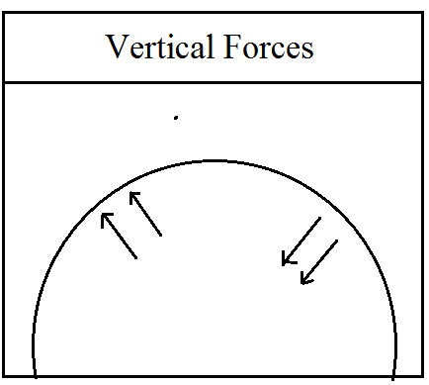
Upward Forces-
The forces acting upwords from the centre of the earth are called upward forces. They result in rising of the land forms such as big plateaus and an extensive plains. e.g. African plateau, Russian plateau &U.S.A’s central plain had been emerged of rise of coast in Kathiawar peninsula of India. Many coral reefs are found at sufficient height above sea level in India and pacific ocean.
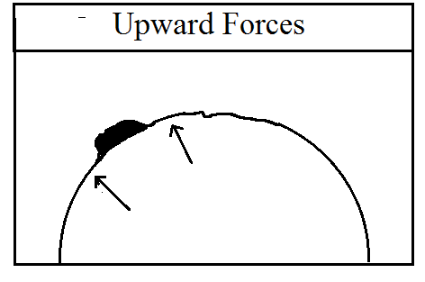
Downward Forces-
These forces act downwards towards the centre of the earth. The landmasses are submerged under the influences of downward forces. Many areas of carboniferous forests have/had been submerged under the sea several times and led to the formation of coal. The excavation near Bombay has proved the existence of submerged forest. Tobago coral reef near west Indies island submerged into Caribbean sea.
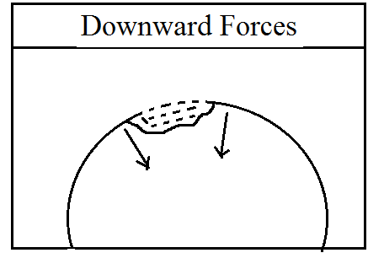

B)HORIZONTAL EARTH MOVEMNT /OROGENETIC/OROGENIC EARTH MOVEMENT
The word ‘orogenic’ is derived from the word ‘orog’which means mountain. Hence they are called mountain building movements, because all folded mountains have had been formed by this movement on the earth surface.
The direction of action of such movement is perpendicular to the radii of the earth or parallel to the earth surface. so it is known as Horizontal earth movement or tangential force These are of two types i.e.i) Compressional and ii) Tension which leads to the formation of mountains.
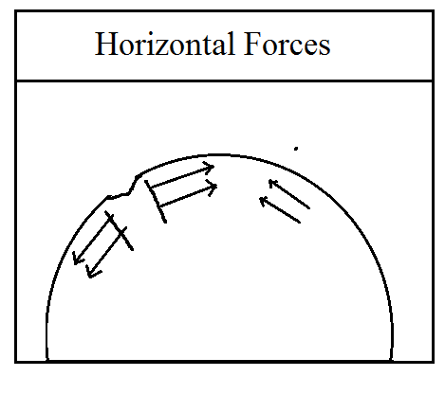

COMPRESSIONAL FORCES.
When the horizontal /lateral forces inside the earth’s crust moves from two opposite direction to a common point, then it is called as compressional forces.
These compressional force leads to the bending of soft rock layers/strata and these bending rock structure is known as folding and warping. The effect of compressional forces is best seem on the soft rock structured earth surface. e.g. Alps Range in Europe. Himalayan Range in Asia are the best examples of folding on the earth surface.
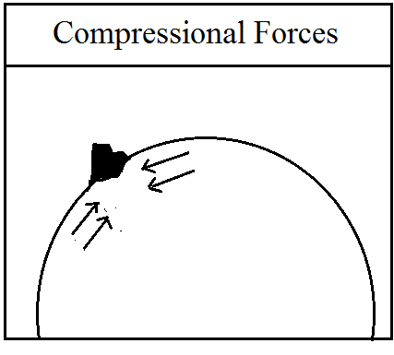

Compressional forces causes crustal bending leading to the formation of folds or crustal warping leading to local rise or subsidence of crustal parts. The effect of compressional forces seems on the soft structured sedimentary rocks which leads to the formation of fold and folding mountain.
When crustal parts moves towards each other under the influence of horizontal or convergent forces and the movement of crustal rocks undergo the process of crustal bending in two ways eg 1) Warping 2) Folding
Warping :- Whenever the malleable typed sedimentary rocks are formed into very extensive concaved or convexed flat surface due to less powered compressional forces on an extensive but thinner rock strata, then this process is known as warping.
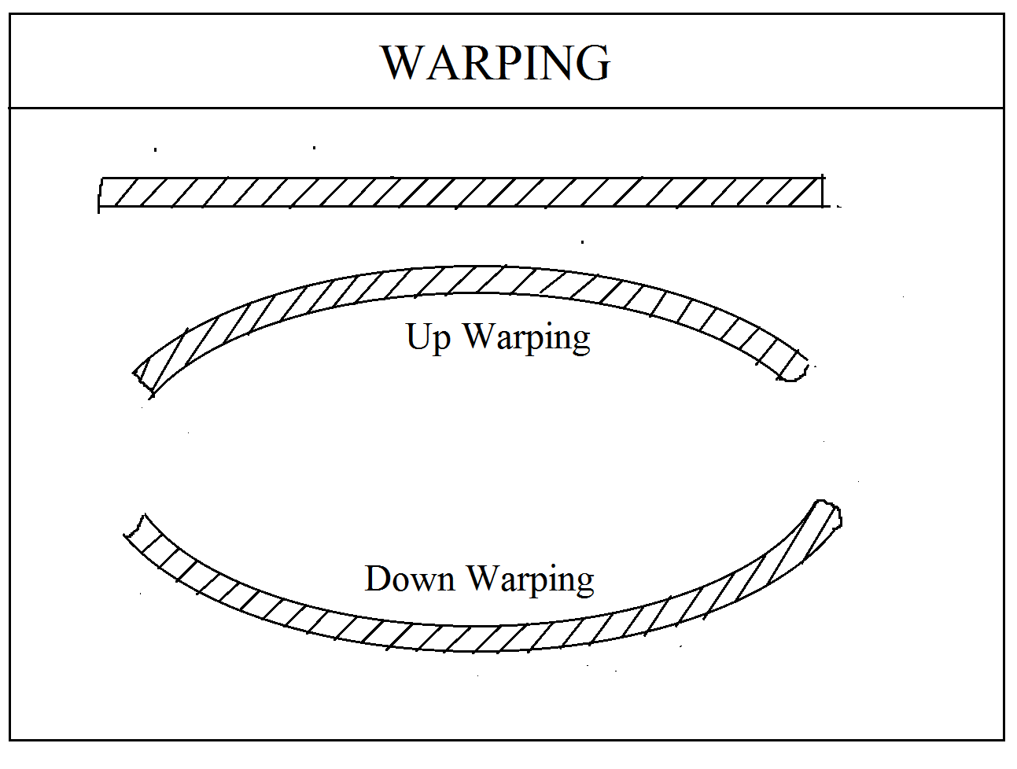
These are two types of warping viz up warping and Down warping
The process of crustal warping affects larger areas of the crust where in the crustal parts either wrapped upwards or downwards. The upwards rise of crustal parts due to the compressional forces resulting from convergent horizontal movement is called up warping while the bending of the central partr downward in the form of a basin or depression is called down wrapping.
TENSIONAL FORCES.
When the horizontal/lateral forces inside the earth’s crust moves at two opposite different directions from/the common point, then these forces is known as tensional forces.
The tensional forces are responsible for breaking of hard rock strata at the some angle and thus breaking or fracturing of rock strata with their subsequent sliding is known as faulting /fracturing.
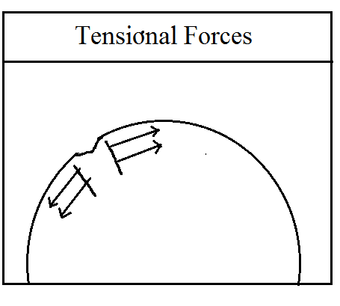
LANDFORMS ASSOCIATED WITH HORIZONTAL MOVEMENT.
FOLDING –
Folding is the diastrophism action. When the compression takes place on the earth’s crust due to the action of endogenetic forces, a part of the earth’s crust is raised to form a fold or folding. The compressed area is contracted &assumed a wavelike formation. The upper fold part is known as anticline while the down fold part is known as syncline. The two sides of the fold are called limbs.
eg. The alpine Range in Europe, Himalaya Range in Asia continent, The Rockies mountain in North American continent & the Andres mountain in south America continent are the best example of folding in the world.
FAULTING-
This is a diastrophism process. When the tensional takes place on the earth’s crust due to the action of endogenetic forces ,a part of the earth’s crust is broken to from a fault or faulting the tensional area is expanded &assumed a step like formation.
The place along which the fault takes place is known as fault plane. One part of a fault is thrown upwards is known as up thrown side. Similarly, the downthrown part is called as Downthrown side. The line along which the fault takes place on the surface is known as fault line.
BLOCK MOUNTAINS/(HORST)
Sometimes, two faults take place adjacent to each other in such a way that their planes are inclined opposite to each other. This happens due to tension in the crust. A part of land block is depressed so that the remaining block stands conspicuously above the surrounding. Mountains formed in this way are called block mountains or Horst.
These mountains have steep slopes and broad tops Black forest and Vosges are the examples of block mountains in Europe. The Vindhyachal and Satpura of India & Salt Range of Pakistan are also example of block mountain.
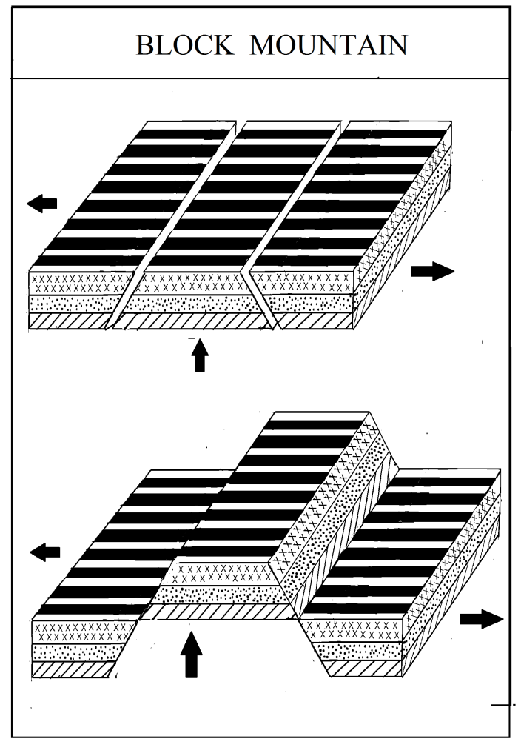
RIFT VALLEY-
Sometimes, two adjacent parallel fault takes place in the rock strata in such a way that their faulting planes are inclined opposite to each other.This happens due to tension in the crust. At that time, whenever a middle portions sinks down and stands below the level of surroundings area. Then this valley is known as rift valley.
The best example of a rift valley is that of Rhine river in Europe.It has Block forest &Vosges on either side. Folding

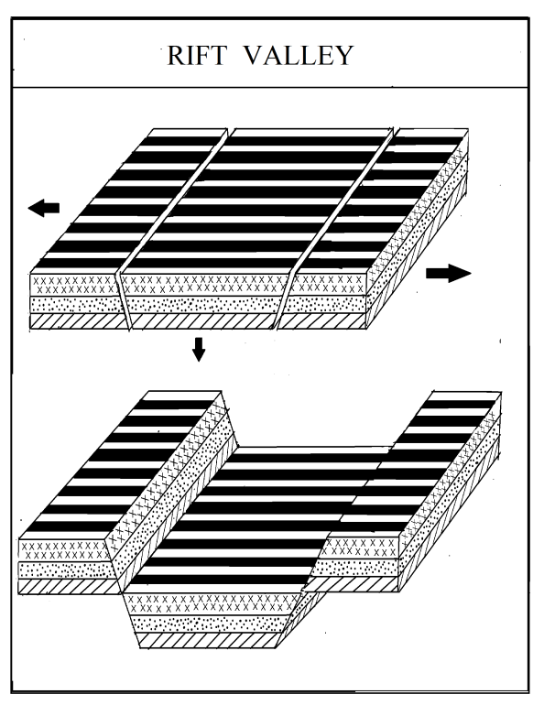

Folding is a diastrophism action that means it requires very very long time of period for completion and continuous. Whenever the compression forces takes place on the earth sedimentary crust , then this rocks squeezed and compressed in such a way that its some part may be raised while other part may be depressed like of wave formation. This process is known as folding. The upper fold part is known as anticline while the downward part part is known as syncline and the two sides of the fold is known as limbs.
For example, Alpine range of Europe continents, Himalaya range of Asia continents, Rockies mountain range of North America and Andes mountain range of South America continents.
  - 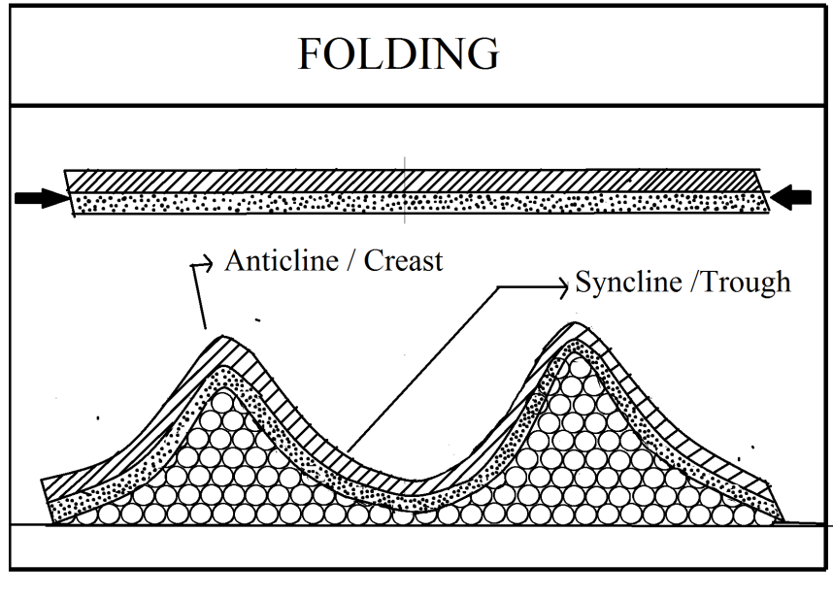

Anticline is a fold that is convex up and has its oldest beds at its core. The term is not to be confused with antiform, which is a purely descriptive term for any fold that is convex up. Therefore if age relationships between various strata are unknown, the term antiform should be used.
A syncline is a fold with younger layers closer to the center of the structure. Synclines are typically a downward fold, termed a synformal syncline (i.e. a trough); but synclines that point upwards, or perched, can be found when strata have been overturned and folded (an antiformal syncline).
Types of Fold:
The nature of folds depends upon several factors e.g. the nature of rocks, the nature and intensity of compression forces, duration of the operation of compressive forces etc. The elasticity of rocks largely affects the nature and magnitude of folding process . the softer and more elastic rocks are subjected to intense folding while rigid and less elastic rocks are mainly moderately folded. Based on the inclination of the limbs, folds are divided into following types.
Symmetrical Folds: Whenever the two compressive forces applies equal and regularly with same magnitude and intensity, then both limbs of folds equally inclined to each other with constant slope and it is known is symmetrical folds. Generally theses type of folds are rarely found earth surface. Generally a dome shaped mountains have/had been formed through this processes. Sometime the deposits of crude oils are found at the foothills of this fold.
Sometime the deposits of crude oils are found at the foothills of this fold.
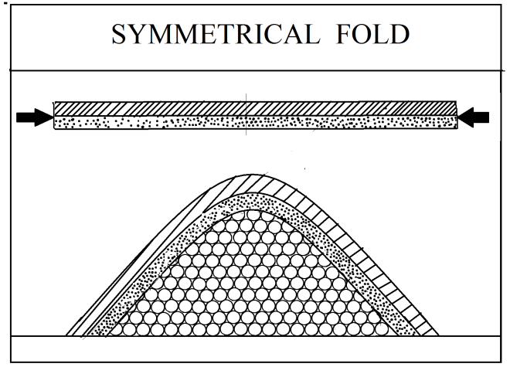
Asymmetrical Folds : Whenever the two opposite forces of compression forces acts on soft sedimentary rock strata in unequal intensity and magnitude nature, then one limb of fold became a gentle from low magnitude inducing force while another limb became steep slope from comparatively high magnitude inducing force, then this type of fold is known as asymmetrical fold. Generally this type of folds are found in Himalaya ranges which shows a greater variation in northern and southern slope of Himalaya.
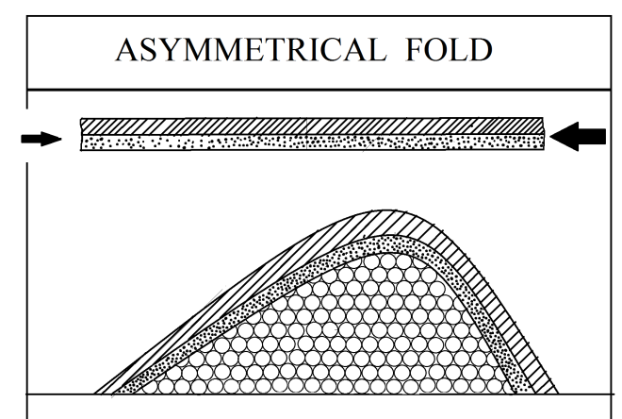
Monoclinal Fold. : Whenever the intensity and magnitude of induced force from one side is comparatively more than other side, then one limb of these fold became very steep slope that utmost vertically to ground while another limb of fold became gentle slope. Such fold is known as monoclonal fold.
Local warping in horizontal strata. Rock beds lying at two level separated by steep inclined limbs. It is form by vertical movement and generally found fault below monocline. a step-like fold in rock strata consisting of a zone of steeper dip within an otherwise horizontal or gently-dipping sequence
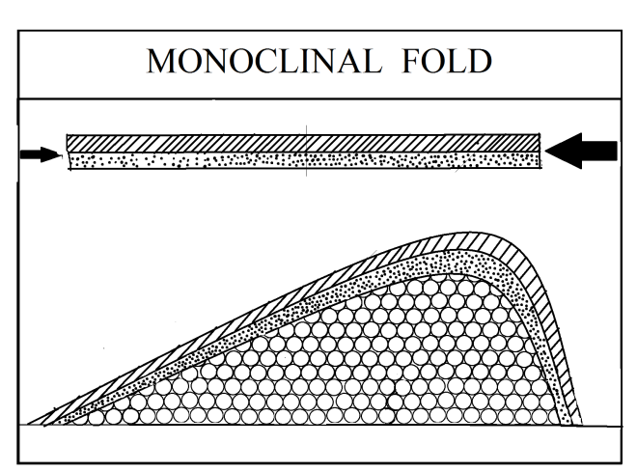
Isoclinal Folds :
These are formed whenever the intensity and magnitude of the one sided inducing the compressional forces exceeds so stronger to other sides that these two limbs became parallel but not to ground.It is known as isoclinals folds.
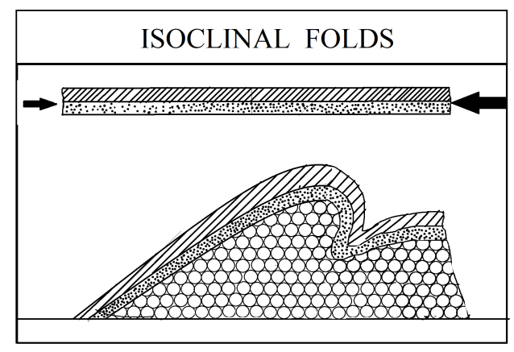
Recumbent Folds :
These are formed whenever the intensity and magnitude of the one sided inducing the compressional forces exceeds so stronger to other sides that these two limbs became parallel with horizontal to ground. It is known as recumbent folds.
Recumbent fold has an essentially horizontal axial plane. linear, fold axial plane oriented at low angle resulting in overturned strata in one limb of the fold.

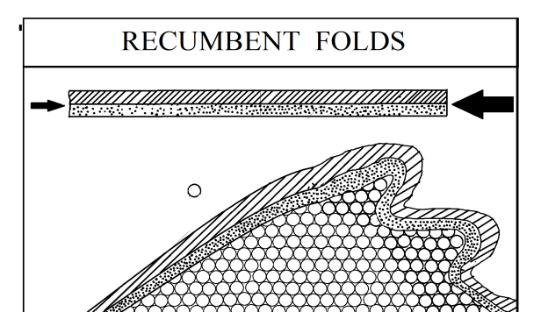

Overturned Folds :
Overturned folds are those folds in which one limb of the fold os thurst upon another fold due to induced compressional forces.
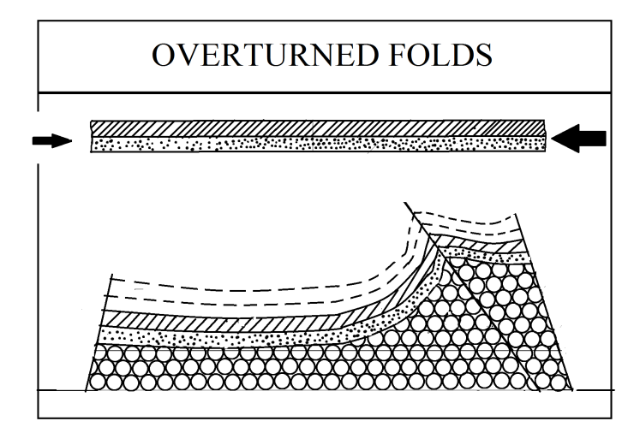
Fan fold :-
It represents an extensive and broad fold consisting of several minor anticlines and synclines. Such folds resembles a fan. Such a feature is called anticlonirium / synclonirium
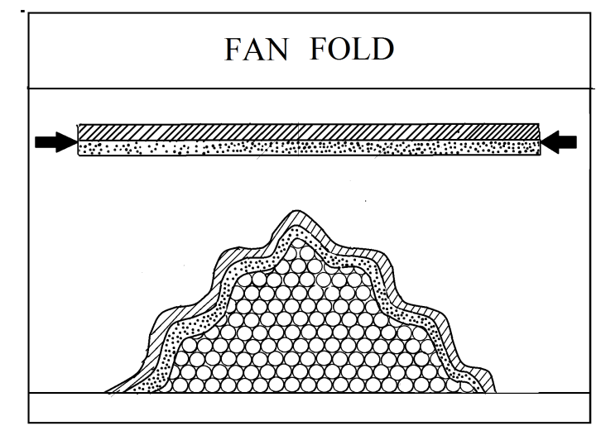
Open Folds :-
Open folds are those in which the angle between the two limbs of the fold is more than 90˚ but less than 180˚. Such open folds are formed due to wave like formation because of moderate nature of compressive forces.
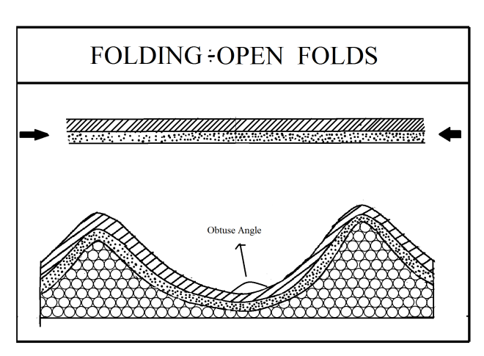
Closed Folds
Closed folds are those folds in which the angle between the two limbs of a fold is acute angles. Such a folds are formed because of intense compressive forces.
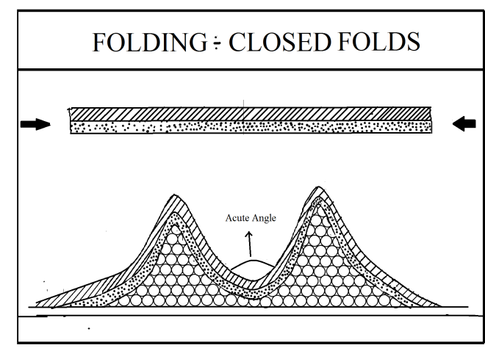
Nappes
Nappes are the result of complex folding mechanism caused by intense horizontal movement and resultant compressive forces,
Whenever the intensity of induced compressional forces exceeds beyond its bearing capacity, at that time , the limbs are broken and became reverse wrapped on the another, limb.
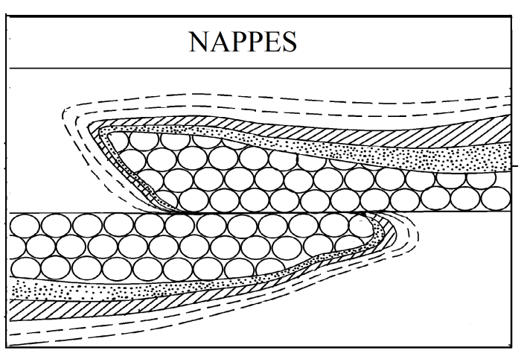

FAULTING-
This is a diastrophism process. When the tensional takes place on the earth’s crust due to the action of endogenetic forces ,a part of the earth’s crust is broken to from a fault or faulting the tensional area is expanded &assumed a step like formation.
The place along which the fault takes place is known as fault plane. One part of a fault is thrown upwards is known as up thrown side. Similarly, the downthrown part is called as Downthrown side. The line along which the fault takes place on the surface is known as fault line.
A fault plane may be vertical, or inclined or horizontal or curved or at any angle type. The movement responsible for the formation of a fault may operate in vertical or horizontal or in any direction. During the formation of a fault the vertical displacement or rock blocks may occur upto several hundred meters and horizontally the rock blocks may be displaced upto several kilometers but it does not mean that the total displacement occurs at a single time.
- Fault Plane :- Fault plane is that plane along which the rock blocks are displaced by tensional and compressional forces acting vertically or horizontally or inclining or curving or any other form.
- Fault dip :- It is the angle between the fault plane and horizontal plane.
- Hanging Wall :- The blocks of the fault which lies above the fault plane.
- Heave :- Horizontal displacement of blocks in a fault is called heave
- Throw :- The vertical distance between two displaced blocks of fault along the fault plane.
- Fault Scrap :- It is the steep wall like slope caused by faulting of the crustal rocks.
Types of Fault :-
The different types of faulting of the crustal rocks are determined by the direction of motion along the fracture plane. Generally, the relative movement or displacement of the rocks block/ slip of the rock block occurs approximately into two directions as dip-slip movement and strike slip movement.
Dip Slip Faults :- When the displacement of rock blocks takes place upwards or downwards along the radii of the earth due to tensional forces, then these faults are called as dip slip faults. Depends upon the direction of vertical movements of rock blocks , it may be grouped as normal fault and reverse fault.
Strike Slip fault :- When the displacement of rock blocks takes place laterally towards its right or left, perpendicular to the radii of earth, due to tensional forces, then these faults are called as strike slip faults. It may be left lateral/ sinistral fault and right lateral / dextral faults.
Slip faults :- The combination of normal and wrench faults are called as oblique slip faults.

Types
- Normal Fault :-
A normal fault is one in which the hanging wall moves downward in comparison with the adjoining footwall along the fault plane. It is formed by tensional force. The important characteristics by which it may be recognized, is that the horizontal distance (heave) between two blocks on either side increases as the vertical displacement (throw) increases. The fault plane is usually between 45˚ and the vertical. It is the dip slip faults.
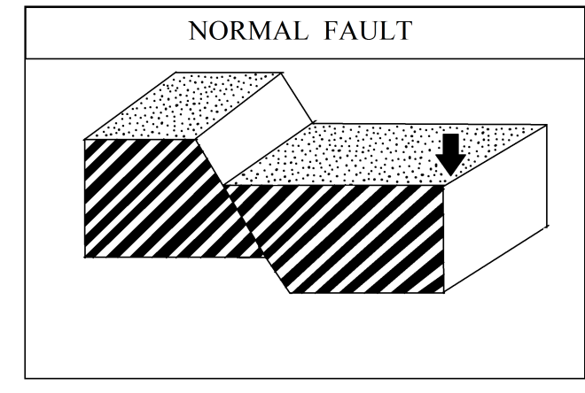
- Reverse Fault:-
A reverse fault is one in which the hanging wall moves upward in comparison with the footwall. The horizontal displacement (heave) reduces as the vertical displacement (throw) increases. It is formed by compressional forces. When the compressive forces exceeds the strength of the rocks, one block of the fault overrides the another, and the resultant fault is called as over thrust fault.
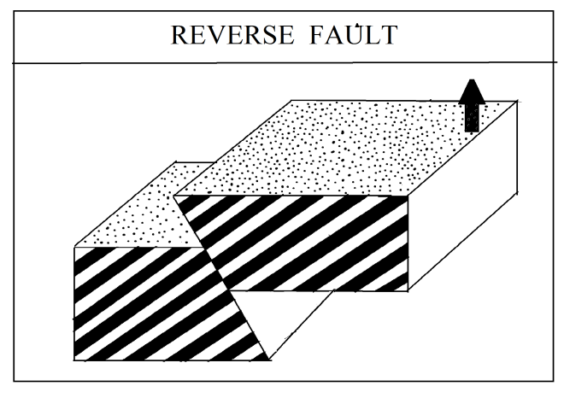
- Lateral Fault :-
These are formed when the rock blocks are displaced horizontally along the fault plane due to horizontal movement. These are called left lateral or sinistral faults when the displacement of the rock blocks occurs to the left on the far side of the fault and right lateral or dextral fault when the displacement of rock blocks takes place to the right on the farside of the fault. In majority of the cases, there are no scrapes in such in such faults if they occur at all, they are very low height.

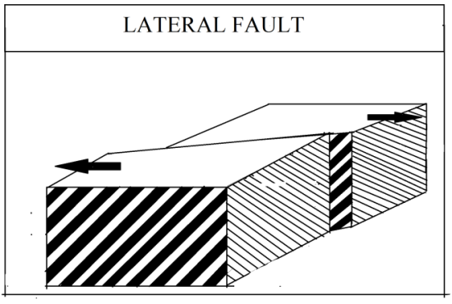

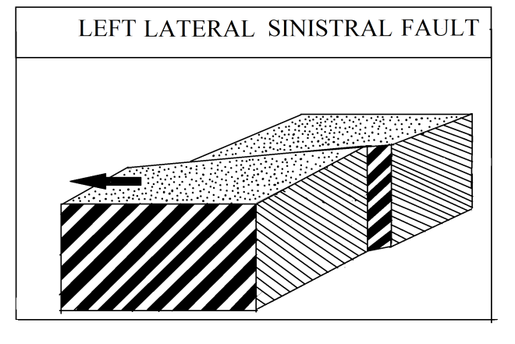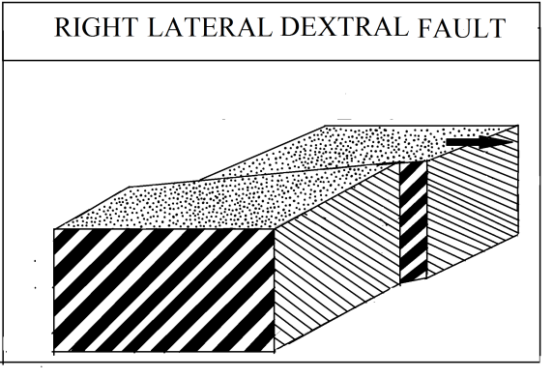
- Step Faults :-
Whenever the series of faults occur in any area in such a way that the slopes of all the fault planes are in same direction , the resultant faults are called as step faults.
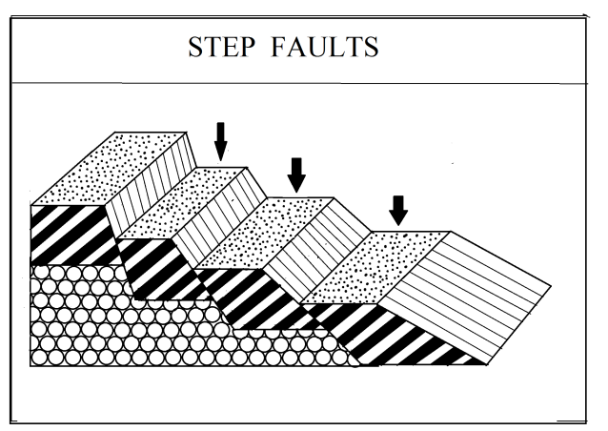

Unit 2
Earthquake
Earthquakes definition :-
- The vibration or movement caused in earth crust by sudden movement or volcanic eruption is called as earthquake.
- When the earth surface experiences the shocks and vibration due to the tectonic movement is known as earthquakes.
- An earthquake is a suddenly temporary motion or a series of motion which originate in a limited region and then spread out from the place of origin in all directions.
- An earthquake is a vibration or oscillation of the surface of the earth caused by a transient disturbance of the elastic or gravitational equilibrium of rocks at or beneath the earth surface.
The important elements of the earthquakes : -
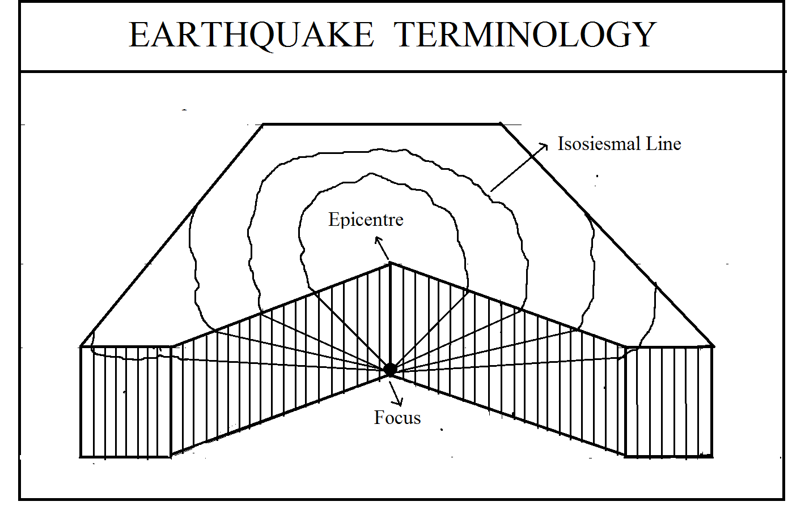
- Focus :- It is the place of origin of earthquake . It lies usually beneath the earth at varying depth. Usually the earthquakes originate at a point many kilometres deep under the earth surface. It is called as focus. According to the some scientist, it is is not a point, it is a limited area.
- Epicenter :- The point on the earth surface vertically above the focus is known as epicenter. It is the place on the focus where the first shock felts.
- Isoseismal Line :- It is an imaginary line, drawn on map connecting the places of uniform intensity of earthquakes. The intensity of earthquakes are measured by seismograph in Richtor scale with the help of Mercali’s scale.
- Seismic waves :- These are three type of earthquake waves viz i) primary waves, ii) secondary waves and iii) surface waves.
Classification of earthquakes :-
According to the geologist Guttenberg and C. F. Richtor , the earthquakes can be divided into three types on the basis of its origin depth below the earth surface.
- Normal and Shallow earthquakes : The origin of the focus of earthquake lies below the earth's surface up to 70 kilometre depth.
- Intermediate earthquakes :- The origin of the focus of the earthquake lies in between 70 kilometre to 300 kilometre depth below the earth surface.
- Plutonic and deep seated earthquakes :- The origin of the focus of the earthquake lies in between 300 km to 800 kilometre depth below the earth's surface.
Causes of earthquakes :-
There are many causes which are responsible for the origin of earthquakes on the earth surface.
- Volcanic eruption :-
At the time of volcanic eruption, the hot Magma is erupted with greater force violently due to force of ejected materials, the earth is shaken and earthquake takes place on the earth surface. Generally the earthquake belts are found along the belt of volcanoes.
When the hot magma, stream gases, steams tried to overcome on the earth surface, due to greater pressure in the interior of the earth, it causes vibration in the crust and an earthquake is said to have occurred. There is a close relationship between volcanoes and earthquakes.
- Faulting :-
In the interior of the earth due to the action of internal forces, the compressional and tensional forces of the earth movement causes the breakage of rock strata and layer and faulting action takes place. At the time, these rocks are dislocates along the actual faulting line from their original place towards the other place and at that moment the earth surface is vibrated. Such type of earthquake is known as tectonic earthquakes. In 1943, such type of earthquake was takes place in Bihar and Assam in 15 August 1950 .
- Recrystallization of rocks in the interior of the earth :-
In the interior of the earth at greater depth some minerals of rocks are recrystallised due to the present internal high temperature and chemical reaction processes. At that time of new crystallization, the shape and form of mineral rocks is changed and these rocks are this located from their original place and the earth surface or earth is vibrated. such type of earthquake is called as plutonic earthquakes.
- Vertical displacement of rocks :-
Whenever the vertical force acts upon the integrated continuous rocks from above and below, then a strain is induced in it and discontinuous rock mass is strained within its elastic limit. Whenever these elastic limits goes beyond its capacity, then these rock masses are broken into fragmented blocks of rocks and these broken rock masses tries to come their original place after strain release. Such a way that , in this processes the movement of rock masses take takes place and it exerts pressure on the adjoining rocks and earth surface is vibrated which is termed as earthquake earthquakes are takes place. This process is known as elastic rebound process of rocks.
- Isostatic Dis-djustment :-

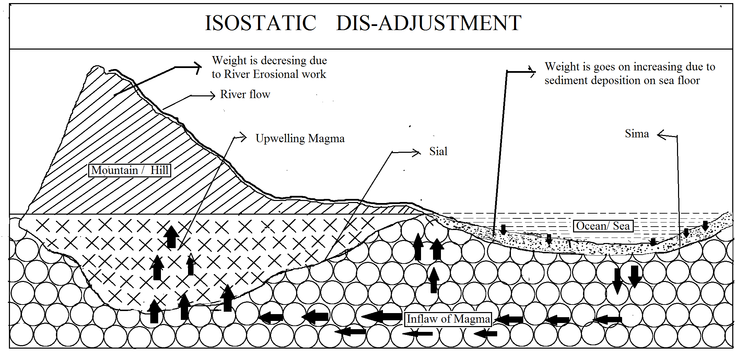

The isostatic balance is not always mentioned between the raised and depressed landforms on the earth surface due to the continuous interaction between the internal and external forces of the earth surface. Whenever the erosional takes place on the mountain by flow of river, then the weight of mountain of the earth surface. Simultaneously the deposition takes place on the sea beds due to bringing sediments by river flow and the weight of sea bed goes on increasing. Due to this continuous process of erosion at one side and deposition to another side, an isostatic imbalance is introduced in the earth crust. The geomorhological processes tries to remove this isostatic imbalance in the earth’s crust in which the decreasing weight of mountain should be increased up to the its level of increasing weight of sea beds. For this isostatic adjustment purpose, the magma formation takes place under the simatic sea bed and it flaws towards the below mountain. Whenever the magma flaws from beneath the sea beds towards the beneath mountain , then earth surface is vibrated and it is known as earthquakes. Sometimes magma tries to overcome on the earth surface by finding fractures and cracks within crust and when it succeeded , then an earthquake takes place with formation of folded mountain. For example, the earthquake which hit Uttarkashi in December 1991 was due to the isostatic dis- adjustment.
- Plate tectonic movement :-
The plate tectonic theory is based on the assumption that the plates are formed of crust and some part of the mental having the thickness between 50 Km to 150 Km. They are of both ocean and continental crust. These are 06 major plates and 20 minor plates. These all plates are floating on a hot liquid low viscous material zone which is known as asthenosphere. These plates of earths crust are moving in different ways due to the variation in the direction of movement. These are three type of plate margins and boundaries have had been formed viz i) convergence ii) divergence and iii) transform boundaries.
- Margin of Convergence :- Such margin and boundary is marked by collision of two different or same plates moving from different directions and collided or subducted to each other. Their foreland edge of plates are devasted and disrupted. In convergence processes, the continental plates to continents, oceanic plates to oceanic or oceanic to continental plates are collided to each other where surface area have/had been reduced.
- Divergent boundary :- It is one in which two same or different plates are moving away in opposite direction from a common point i.e. continental to continental, oceanic to oceanic plates. In this divergence margin process, a reptile / fracture line is formed along the boundary line through which magma is erupted and then it is known as mid ridge.
- Margin of lateral movement :- All the plates from two sides move parallel to each other and slide along common margin. Such margin is called as transform margin. Transform fault is formed along these boundaries.
Various kinds of tectonic movements are takes place along all these boundaries the earthquakes are originated. But the maximum earthquakes take place along the zone of subduction.
- Accumulation of water and storage of water :-
Whenever there is a large scale accumulation of water bodies takes place in lakes, dams, reservoir, then the stored volume of water exerts pressure on the earth surface which causes strain in the underlying rocks of crust. Whenever the induced strain becomes too much goes beyond rocks elasticity, then these rock mass broken and vibration and displacement of broken rock masses takes place. These type of earthquakes are related to big dams, reservoirs which are constructed across river for irrigation and agriculture development. In 1968, an earthquake was hitted due to the accumulation of water behind the Koyna dam.
- Local causes :-
Earthquakes takes place due to the local causes such as landslides, emission of water vapour under high pressure and sudden collapse of roof of the caves in Karst region.
Advantages and disadvantages of earthquakes and its effects on the Earth Surface.
Earthquake has brings both adverse and good effects on the earth surface with man himself.
- Earthquake shocks brings about large scale destruction of life and property on the earth surface. The maximum destruction is take takes place at and near the epicenter zone of the earthquakes.
- The surface transportation facilities like roads, rail tracks and river bridges, fly bridges which were constructed for regional development and goods transportation purpose in the cities and towns and villages are completely or partially destroyed due to the shaking of the earthquake waves.
- When the intensity of the earthquake is very high, then the communication systems is totally disturbs due to the following of telephone, telegraph poles on the earth surface.
- The earthquake have caused the loss of lives and properties by destruction of cities and towns. The building and some other structured houses, roads, railways, communication line are collapsed and human lives are buried under large dig debris and rubbles of structural material of the buildings and houses. This type of situation always takes place in Japan and Russia which is came in the earthquake zones of world.
- The economic structure of earthquake affected region is badly affected in various sectors. The industrial as well as agricultural economics are damaged by earthquake waves. The destruction of industries, breaking of communication system, bursting of water pipelines, firing and blasting of petrol pipelines, collapsing of irrigation canal network systems , lowering of watertables of tube wells are many aspects of economic loss caused by earthquakes.
- Whenever, a high intensity of earthquake have/had been takes place on the ocean bottom surface /sea beds due to some tectonic movement, then a strong sea waves formed, whose height is more than 40 to 50 meters height and width 100 to 150 kilometer long, came cross to the land directions and strikes against a coastline. It is known as tsunami. Depending on slope of coastline into sea, destruction takes place. Whenever tsunami came on the gentle coastline, then maximum and huge destruction and damage takes place while and very steep coastline obstruct the destruction of live beings and property from tsunami. An earthquake of Indian ocean on 26 December 2004 causes a heavy damage of south west Asian countries like Indonesia, Myanmar, Andaman- Nicobar island, eastern coast of India.
- Sometimes, earthquake changes the water table of flow and storage of underground water due to the the displacement of rock masses into interior earth.
- Earthquake causes the landslide in mountain regions which results in larger scale destruction and therefore the constructed transport roads are blocked due to falling of rock boulders, masses, debris and transportation system collapsed. This phenomena is always common in mountainous region. Earthquake are also responsible for big faults, trusts which blocks transport and communication system. For example, a tremendous fault occur during the California earthquake in 1960 running form hundreds of kilometers along the coast lines.
- Sometimes, the earthquakes are responsible for breaking of walls of reservoir and dam this causes wide water floods.
Advantages of earthquake waves:-
- The seismic waves are very useful in the study of interior of the earth for knowing which type of material is hidden in the interior Earth.
- Landslides caused by earthquakes help in weathering process of rocks and this leads to the formation of new soil and the soil encourage the agricultural activities.
- Folds, thrust, faults are caused by earthquakes lead to the formation of new landforms such as mountain plateaus and valleys etc.
- Sometimes, a vast area comes out of the sea as a result of elevation.
- New mineral areas are uncovered and raised up and this provides much needed mineral wealth.
- Some river adopt new course which provide new agricultural land.
- Due to the subsidence in sea bottom, deep gulfs are formed which gave birth to the new sea ports.
World distribution of earthquakes / Seismic zones of Earthquakes :-
Like the volcanoes, the earthquakes are also concentrated into three important geographical regions in the world.
- Circum Pacific Belt :- About 68 % of all earthquakes are takes place in the vast region of the Pacific Ocean as a ring of fire and it closely linked with the regions of volcanic eruption and convergence of plate boundaries along the eastern coast of Asia and western coast of America. The concentration of earthquakes are found Chile, California, Alaska, Japan, Philippines, New Zealand mid ocean areas have had many minor and major earthquakes in the this belt.
- Mid- continental region / Mid world mountains belt :- About 21 % of all earthquake occurs in the mid world mountain belt extending parallel to the equator from Mexico across the Atlantic ocean the Mediterranean sea from Alpine ranges of the Caspian, Himalaya mountain and the adjoining lands. This zone has folded mountains, large depressions and active volcanoes.
- Minor belts :- The remaining 11 % of the shocks are recorded outside. These two belts only a few occur along the fracture in African lakes, Red and Dead sea.

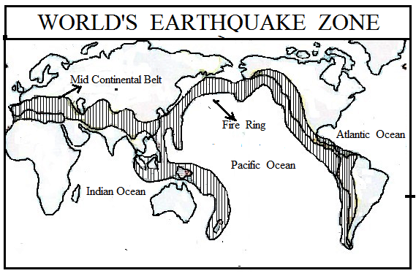

Earthquake Zones in India :-
In India, the earthquake zones are mainly concentrated in the Himalayan region and its foothills. Many earthquake takes place in Ganga valley. Initially it was considered that the Deccan trap of India was free from sudden movements of the earthquake like volcanoes and earthquakes vibrations but at the present time, due to the some local causes, the probability of earthquake is more on Deccan trap. The earthquake in Koyna dam region in 1968 in Maharashtra is the example of earthquakes on Deccan trap of India.

Unit No-3
VOLCANOES/VOLCANISM
The terms volcanoes, mechanisms of volcanoes and vulucanicity are more or less synonym but these have different meaning in geology& geography.
Definitions:-
1) A Volcano is a sudden and abrupt explosion through which molten rocks, boiling magma, stream gases & hot water etc are ejecting out on the earth surface through the weaker parts of the earth’s crust.
2) When all types of material are ejecting out on the earth surface through vent or passage from beneath the earth surface due to sudden movement of internal forces, are known as volcano.
3) A volcano is a vent or opening, usually circular or nearly circular in from through which heated materials consisting of gases, water, liquid lava & fragmented rocks are ejected from the highly heated interior to the surface of the earth.
4) A volcano is the funnel shaped hole in the earth’s crust through which molten material , gases, steam came out. The bottom of this hole leads to the interior of the earth from where gases, lava or steam find their way to the surface. The material comes out from the volcano deposited around the hole & results in conical hill.
Vulcanism /Vulcanicity-
- The term vulcanicity covers all those processes in which molten rock material or magma rises into the crust or is poured out on its surface, there to solidify as a crystalline or semi crystalline rock.
- Vulcanism includes all phenomena connected with the movement of heated material from the interior to or towards the surface of the earth.
GEOGRAPHICAL TERMS RELATED WITH VOLCANOES
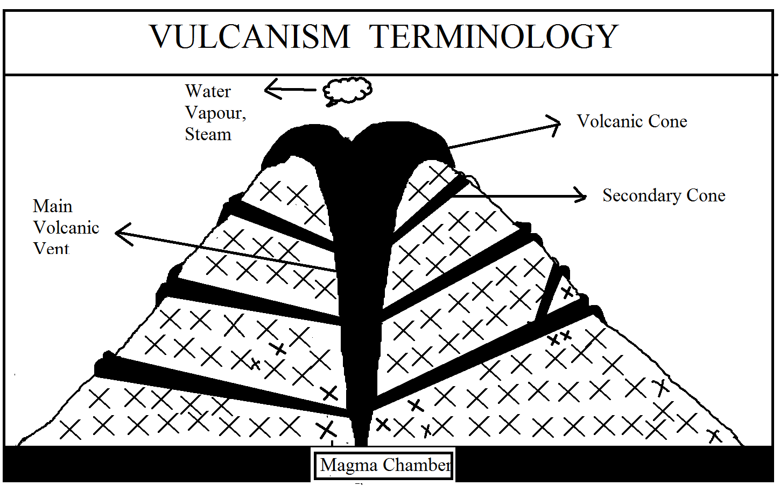
- Volcanic Activity
The explosion of volcanoes is known as volcanic activity or volcanism.
- Volcanic Vent
The hot rock material and and gases come out of a sort of pipe in the crust which is known as vent/Neck
- Volcanic Crater
A volcano makes a funnel shaped circular hole on the surface of the earth in volcanism processes which is known as crater/ volcanic crater.
- Volcanic cone-
The lava coming out of the crater accumulates around it and forms cone which is known as volcanic cone.
MATERIALS EJECTED FROM A VOLCANO
All the there types of material i.e. solid, liquid & gases are ejected by a volcano.
i) SOLIDS-
When volcanic material flows out of the vent of a volcano, it carries with it broken pieces blasted from the old rocks lying in its route. The size & dimensions of the solids varies from small particles to large masses weighing several tones. If the diameter of a piece is more than 32mm, it is known as volcanic bomb or volcanic blocks. At certain places, volcanic bomb having a weight of upto 60 tones. The pieces with diameter 4 to 32 mm are known as cinders and still small pieces are called as ash particles.
ii) LIQUIDS-
The hot siliceous material in liquid form, is known as lava whenever it reaches an the earth surface and it is called as magma whenever it had been cooled and solidified beneath the earth surface. It contains various types of minerals. It has two types i.e. acidic lava/magma and basic lava/magma. The acidic magma is more viscous & low fluidity with high proportion of silica while the basic lava/magma is non viscous & high fluidity with low proportion of silica.
iii) GASES,VAPOUR &STEAMS.-
Steams and gases of different types are ejecting out at the time of volcanic eruption. Carbon-di-oxide, hydrogen, Sulpher-di-oxide, Carbon-mono-oxide etc are important volcanic gases.
CAUSES OF VOLCANOES/VOLCAIC ERRUPTION.
Formation of volcanoes are takes place due to the ejection of hot solid, liquid and gaseous material from beneath the earth surface. The main causes of its as -
1)Percolation of water-
Water percolates down from the bottom of water bodies like seas & oceans in larger proportion to underground. Temperature in the interior of the earth is high as if increases at the rate of 1˚ C for 32 meters depth from the earth surface. When the percolated water gets contact with hot rocks, converts into steam and vapours. These steams & vapour make tries to come out and along the weak zone of the earths crust, wherever the outlets are available. Thus due to the greater force of these steams, some molten begins to eject and form the volcanoes on the earth surface.
2)Earth Movement-
At the time of mountain building movement , the crustal rocks are deformed into form of folding & faulting. In faulting processes, the dislocation & displacement of rocks takes place along the faulting line causes the release of super incumbent pressure of overlying rocks inside the earth crust. The temperature beneath the earth surface is very high with increasing depth but at this temperature, these rocks had not been melted because of their higher melting points due to the high incumbent pressure overlies on them. But whenever the overlying pressure on the rocks have /had been released or decreased by dislocation & displacement of rocks, then underlying rocks are melted due to lowering melting point, which is rather low as surrounding interior melting point, which is rather low as surrounding interior temperature, and magma is fomed. thus these magma ejects out through the weak zone of earth crust to form the volcanoes.
3) Plate Tectonic movement-
Plate tectonic is new concept in geology which explains well the cause of genesis of volcanic eruption. It is believed that the whole earth is divided into 6 major plates and 20 minor plates. The plates are made up of either oceanic or continentals and these are easily floating on a hot liquid low viscous material zone, known as asthenosphere.
These plates may move either away from one another, or may collide to each other and slide past one another, and different distinct boundaries/ margins are formed.
Along the boundary of divergence , basaltic typed magma flows out and spread over as ocean floor spreading & new oceanic curst is formed. Thus quite fissure typed volcanoes have / had been takes place along this margin.
Along the boundary of convergence, an heavy oceanic sima plate have/ had been intruded in the mantle beneath the lighter continental plates and melted there due to the prevailing high temperature and magma is formed. There magma are always busy to overcome on the earth surface with findings of weaker zones of the earth’s crust. Thus convergence& subduction of plates is main cause of volcanic eruption.
- High temperature in the interior of the earth.
The temperature found in the interior of the earth is very high due to the presence & disintegration of radioactive materials like of Uranium, plutonium etc. The bounding rocks may be easily melted down and converts into magma. This magma tries to overcome on the earth surface in the form of volcanoes.

CLASSIFICATION OF VOLCANOES.
- Classification on the basis of the mode of erruption.
ii) Classification on the basis of the periodicity of erruption.
A) ON THE BASIS OF MODE OF ERUPTION /NATURE OF ERUPTION.
Volcanic erruptions occurs mostly in two ways viz,
- Voilent & explosive type of erruption of lavas , valcanic dust volcanic ashes. and fragmented materials through a narrow pipe & small opening under the impact of voilent gases.
- Quiet type or fissure eruption along a long fracture /fissure/fault due to weak gases & huge volume of lavas Thus, on the divided into two types-
i) Central eruption type or explasive eruption types and
ii) fissure erruption type or quiet eruption type.

- CENTRAL ERUPTION TYPE VOLCANOES/EXPLOSIVE ERUPTION
Central eruption type or explosive eruption type of volcanoes occurs through a central pipe and small opening by breaking and off crustal sufaces due to voilent and explosive gases accumulated deep within the earth. The erruption is so rapid and voilent that huge quantity of volcanic material consisting of lavas, volcanic dusts and ashes, fragmented materials after falling down accumulate around the volcanic vent and form valcanic cones of various sorts. Such volcanoes are very destructive and are disastrous natural hazards. It may be divided into 5 subtypes on the basis of difference in the intensity of eruption, variations in the ejected volcanic material and the period of the action of volcanic event as given below-
- Hawaiin types of volcanoes.
Such volcanoes erupt quickly due to less viscous lavas and non violent nature of gases. main ejected material is lava and spreads over a long distances to its low viscosity. The lava continues flow from the main crater or secondary craters. When wind blows, the lava sprads in the form of red threads. The Hawaiian people consider these long glassy threads of red molten lava as ‘pele’s hair pele is the name of goddess of fire. such volcanoes have been named as howain type because of the fact that such eruption are of very common occurrence on howail is land e.g. The eruption of Kilauea volcano of the southen Hawail island in 1959-60 continued for 7 days.
- Strombolian type of volcanoes.
It is named after the stramboli volcano of sicily in the northern part of Mediterranean sea mostly basalt lava is ejected from this volcano some times the explosion is too great. It explodes after every 15 minutes and is known as the Light-house of the Mediterranean. Besides lava, other volcanic materials like pumic, scoria, bombs, etc are also ejected upto greater height in the sky These materials again fall down in the volcanic craters The eruptions are almost rythamatic or nearly continuous in nature but same times they are interrupted by long interval.
- Vulcanian type of volcanes-
These are named after volcano of Lipari is land in the Mediterranean sea. Such volcanoes erupt with great force and intensity. The lavas are so viscous and pasty that these are quickly solidified and hardened between two eruptions and thus They crust over (plus) the volcanic vents. These lava crust obstruct the escape of violent gases during next eruptions consequently, the violent gases break & shatter the lava crust into angular fragments and appear in the sky as ash laden volcanic clouds of dark & often black colour assuming convoluted or curliflower shape.
- Pelean type of volcanors.
These are named after the pelee volcano of Martinique island (west indies) in the Caribbean sea. These are most violent and most explosive type of volcanoes. The ejected lavas are most viscous and pasty. Thus after solidifying it closes the mouth of volcano and seals its crater. But net erupted magma breaks the seals with deavasting explosion due due to great pressure and makes a roring noise. The most disastrous volcain eruption of Mount Pelee on may 8, 1902 destroyed the whole city of Pierre killing all the inhabitants The molten lava, poisonous gas produced a cloud which is known a fiery cloud. Mount Katmai in Alaska also exploded in the same way but it was more fierce than Mount Pakc. This Katmai valley is known as valley of ten thousand smoke.
- Vesuvius volcanoes.
The volcanoes belonging to this type explode after a long time but the explosion is very destructive. The lava ejected by a Visuvian type of volcano contains a large quantity of gas. The errupted material balances itself in the air like a curliflower. This type is named after the famous Vesuvius volcano near Neples
B) FISSURE ERUPTION TYPE OF VOLCANOES-
Such volcanoes occur along a long fracture, fault & fissure & there is slow upwelling of magma from below and the resultant lava spread over the ground surface. The speed of lava movements depends on the nature of magma, volume of magma slope of ground surface and temperature conditions.
In such processes, the flow of ejection is very slow & the ejected material spreads over the wide area like a thin sheet called as volcanic shield. e.g. deccan plateau of India is formed by deposition of magma through fissure eruption.
B) CLASSIFICTION OF THE BASIS OF PERIODICITY OF ERUPTIONS-
Volcanoes are divided into three on the basis of period of eruption and interval period between the two eruptions of volcano e.g. i) active volcanoes ii) domant volcanoes & iii)extinct volcanoes.
- ACTIVE VOLCANOES -
The volcanoes which shows continuous eruption are known as active volcanoes. The molten material, gaseous,& fragments of rocks are coming out on the earth surface through its mouth at the time of eruption. It is estimated that there are about more than 500 volcanoes in the world. Etna & Stromboli of the Midetarranean Sea are the most significant example of this category. Stromboli volcano is known as light house of Mediterranean Sea because of continuous emission of burning and luminous incandescent gases. Most of the active volcanoes are found along the mid oceanic ridges representing divergent plate margins and convergent plate margins. Shasta, Hood, Reniyar in USA, Popocatepetl in Mexico , Lameyon on Philippines island are the also example of it.
- DORMANT VOLCANORS-/ (sleeped volcanoes)
The eruption activities of some volcanoes are caused up (stopped) due to some reason for a longer period, but they may reoccur in future at any time. Such volcanoes are called as dormant volcanoes. They erupted very violently and cause enormous damage to human health &wealth. For example, Vesuvius volcanoes of ltaly is dormant volcanoes. Recently, reoccurrence of volcanic eruption in Philippines is the best example of such volcanoes.
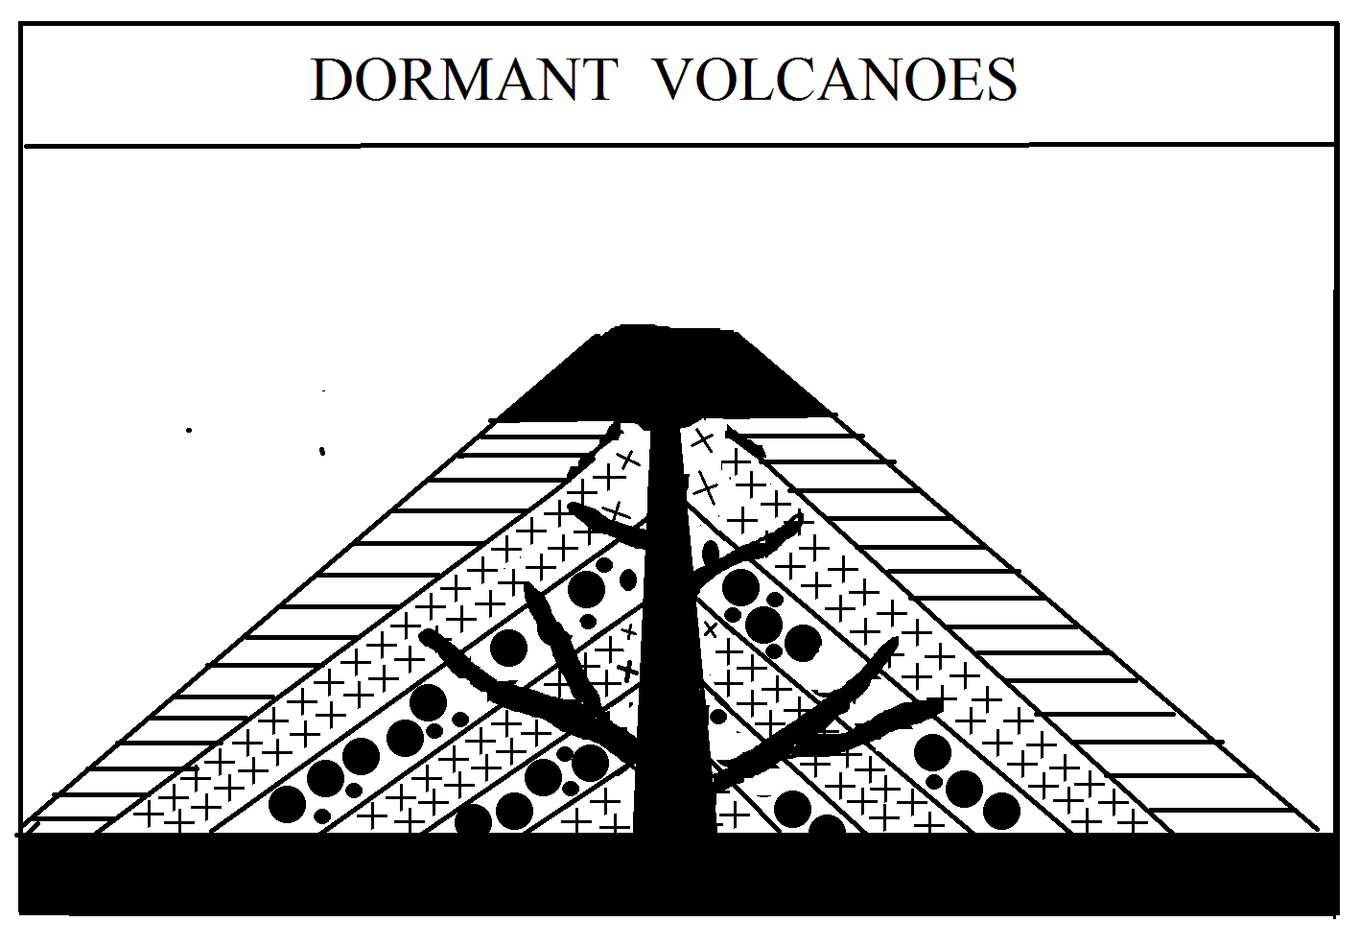
iii) EXTINT VOLCANOES./ (Dead volcanoes)
When the eruption activities of some volcanoes are completely ceased up forever and there is no probability of reoccurrence of them, such volcanoes are called as extinct volcanoes the month of volcanoes is always closed. Sometimes a crater lake is formed at its mouth due to accumulating of water in it.
TOPOGRAPHY FORMED BY VULCANICITY.
Numerous types of landforms are created due to cooling & solidification of magmas below the earth surface and due to accumulation of fragmented materials, dusts & ashes with lavas such as different types of volcanic cones. The cones & craters are not always permanent landforms because they are changed & modified during every successive eruption. explosive types of volcanoes helps in the formation of several types of cones where as fissure flows in the formation of lava plateaus & lava plains due to accumulation of thick layers of basaltic lava over extensive areas. The topographic features produced by the entire process of vulcanicity are grouped into two broad categories. viz i) Extrusive toporgraphy &ii) Intrusive topography.
1) Extrusive volcanic topography-
A) From Explosive type of eruptions-
a) Elevated forms eg. volcanic cones
b) Depressed forms eg. Craters and calderas.
B) From fissure eruption-
a) Lava plateaus.
b) Lava plains
2.Intrusive volcanic Topography-
i) Intrusive lava domes
ii) Batholiths
iii) Laccoliths
iv) Phacoliths
- Lapoliths
- sills
- dykes, stocks.
Elevated forms- VOLCANIC CONES-
- CINDER & ASH CONRS-(PYROCLASTIC CONRS)
Cinder & ash cones are usually of low heights & are formed of volcanic dust & ashes and pyroclastic matter (fragmented materials ). The formation of cinder cones is initiated due to accumulation of finer particles around volcanic vent in the form of they mound which varies in height from a few centimeters to few meters in the beginning. The size to cone gradually increases due to continuous accumulation volcanic materials minus lava the slope of the cinder cones range between 30˚to 45˚. Larger particles are arranged near the finer particles are deposited at the outer margins of the cones. Such cones are not easily eroded & they keep their shape upto hundreds of years.
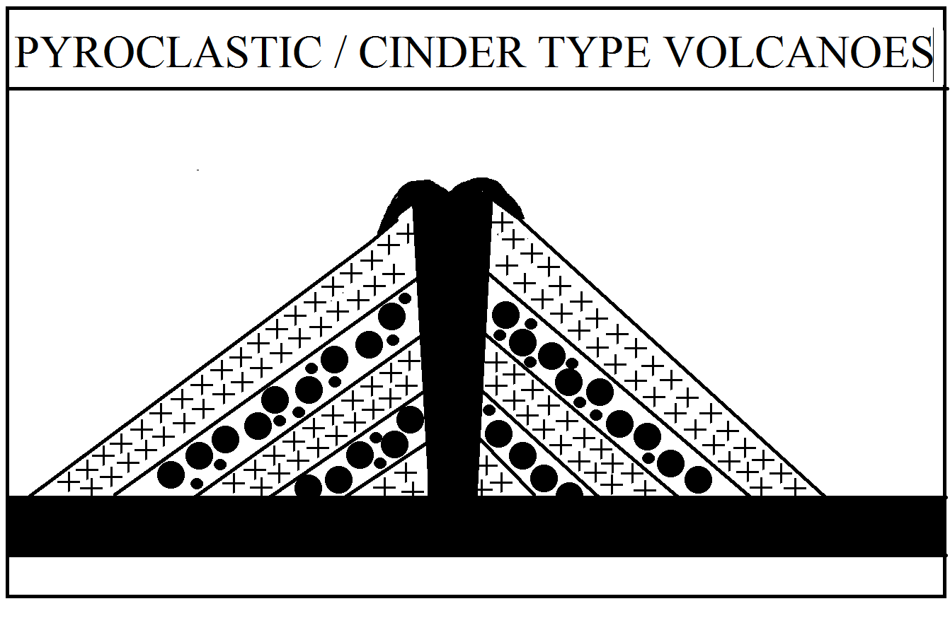
B) DOME-SHAPED CONES/VOLCANOES.
Some times, a very high viscous and lowfluidity magma comes out from the vent of volcanoes and it rises up in small area around the vent Then a volcanic cone is known as dome shaped volcanoes. It is having narrow base &rather more height with steep slope. Based on the domes are divided into three categories.
- Plug dome (formed of lavas due to filling up vents)
- Endogeneous dome (formed silica rich viscous lava)
- Exogenous dome (formed of silica-dificent lava with high degree of fluidity)
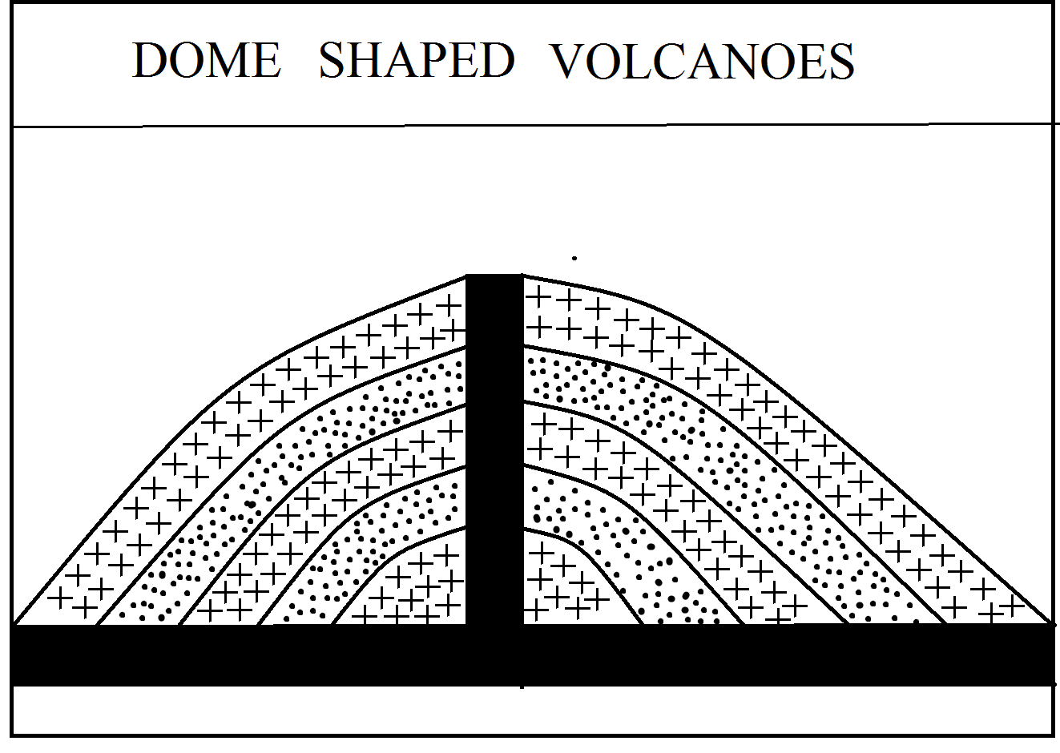
C) COMPOITE CONES. (Strato-cones)
Composite cones are the highest of all volcanic cones. These are formed due to accumulation of different layers of various volcanic materials & hence these are also called as strata cones. In fact, these cones are formed due to deposition of alternate layers of lava & fragmented pyroclastic materials wherein lava acts as cementing materials for the compaction of fragmented materials. The cone becomes comparatively resistant to erosion if it is coated by thick layer of lava. On the other hand, if the outer layer is composed of fragmented materials, the composite cone is subjected to severe erosion.
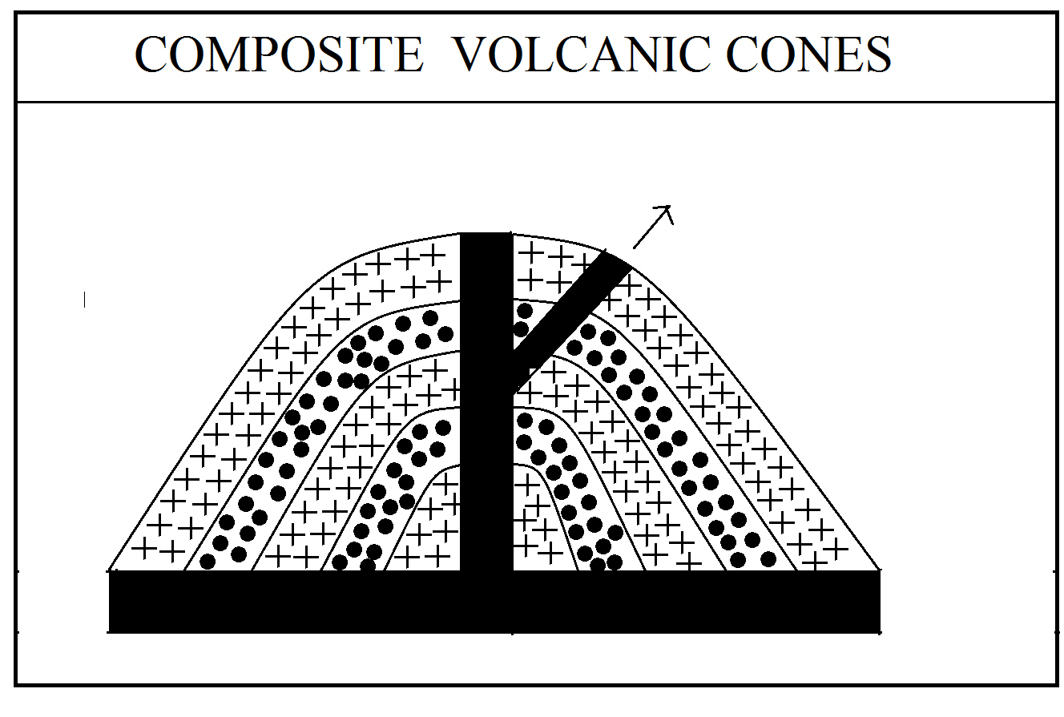
D) PARASITE CONES-
Several branches of pipes come out from the main central pipe of the volcano when the volcanic cone are enormously enlarged. Lavas and other volcanic material come out from there minor pipes & these materials are deposited around newly formed vent located on the outer surface of the main cone & thus smaller cones are formed on major cone these cones are called parasite cones comes from the main pipe.
E) SHIELD OR BASALT LAVA CONES.
Basic lava cones is formed of light & less viscous lava with less quantity of silica. In fact, when the lava coming out of fissure lava flow is deficient in silica and is characterized by high degree of fluidity, it cools & solidifies after spreading over larger area. Thus a long cone with significantly low height are formed such cone are called as shield cones because of their shapes resembling a shield.
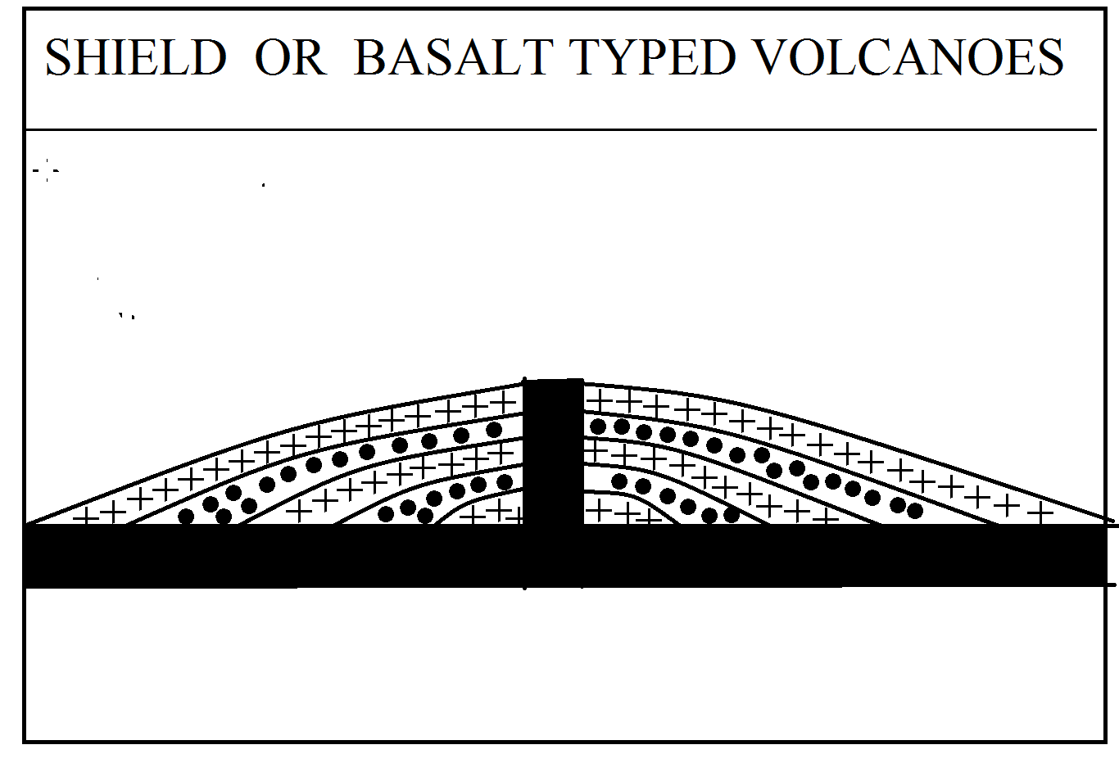
F) ACIDIC LAVA CONES.
Acid lava cones are formed where the lava coming out of volcanic eruption are highly viscous & rich in silica content in fact, mobility & hence they are immediately cooled and solidified after their appearance on the earth’s surface. Thus high cones of steep slopes are formed. Such cone is very often known as strambolian type of cone.
G) LAVA PLUGS.
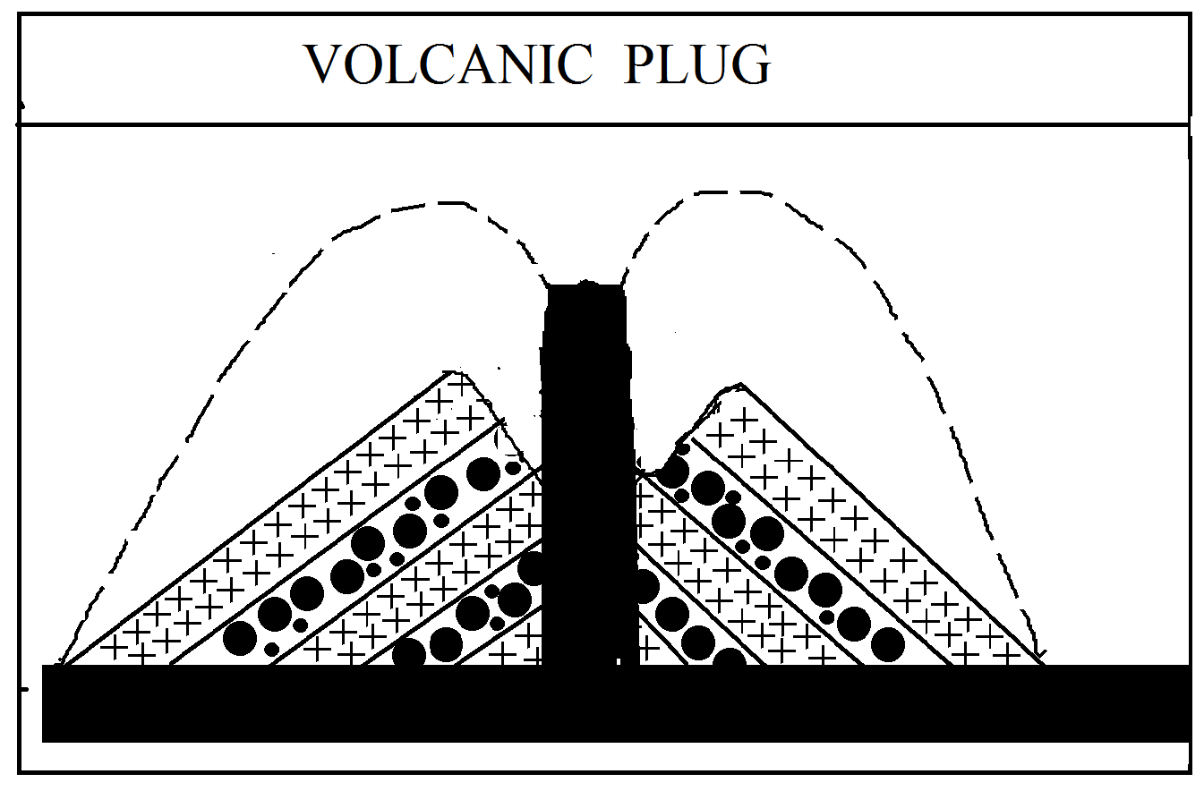
Lava plugs are formed due to plugging of volcanic pipes & vents when volcanoes become extinct / dead. These vertical columns of solidified lavas appear on the earth surface when the volcanic cones are eroded away. The lava filled volcanic pipe is called as volcanic neck. Generally, the volcanic necks are cylindrical shaped & measure. 50to60 meter on height & 300m to 600 m in diameter depressed forms.
DEPREESED LANDFORMS BY VOLACANISM
- CRATERS-
The depression formed at the mouth of a volcanic vent is called a crater which is usually a funnel shaped. The slope of a crater depends upon the volcanic cone in which crater cone slopes at the angle between 25˚to 30˚. The size of a crater increases with increase & expansion of its cone. A crater may be differentiated from a caldera on the basis of size of a crater may be differentiated from a calderas on the basis of size and mode of formation. An average crater measures 300 meter in diameter and 300 meter in depth but there is wide range of variation in craters from the standpoint of their size. eg. craters range from small crater lets having a diameter of a few hundred meters to large craters having a diameter of a few kilometers. The crater of extinct “Aniakchak” volcano of Alaska has a diameter of 9.6km & side walls are 304mto 912 meters high.
- CRATER LAKE-
When a crater is filled with water, it becomes a crater lake.
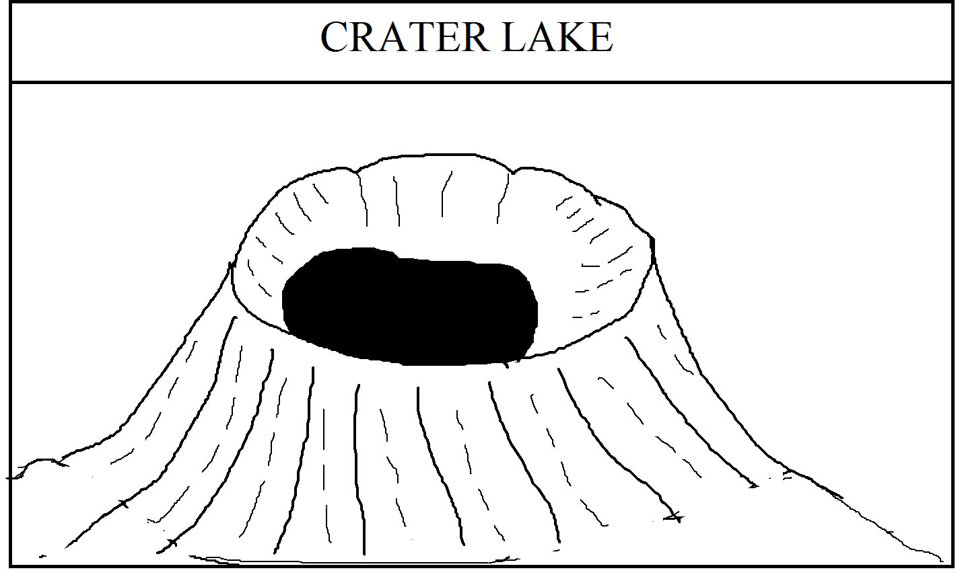
- CRATERLETS/NESTED CRATERS.
When the crater of volcanoes becomes very extensive and if there are few eruptions of very small intensity after long time. several small cones are formed within the extensive older crater & thus several small cones are formed within the extensive older crater & thus several small sized craters are formed at the mouth of each craters/ crater lets are called nested craters or craters within the crater.
- CALDERAS.
Generally, enlarged form of a crater is called caldera. It is an enlarged form of a crater and it is surrounded by steep walls from all sides.
INTRUSIVE TOPOGRAPHY-
When gases and vapour are not much strong during volcanic activity, the ascending magma do not erupt as lavas these are intruded in voids below the crustal surface after cooling and solidification assume several interesting forms like batholiths, lacooliths, phaccoliths, lopoleths sills & dykes. These intrusive volcanic forms are seen only when the overlying country rocks are through prolonged erosion.
i) GEYSERS :- Geyers is a special type of hot springs which spout hot water & vapour from time to time. The word ‘geysir’ has been derived from an lcelandic word was used to indicate the spouting water of a hot spring of ice land known as Great Geyser or Gesir. Geysers are hot springs from which a column of hot water & steam is explosively discharged at intervals, spouting in some cases to heights of hundreds of feet. Geysers are intermittent hot springs that from time to time spout steam and hot water from their craters. There is a small difference in between hot springs & Geysers. In the hot springs, there is a intermittent spouting of water with regular time interval. A geyser spouts water from a small & narrow vent which is connected by a circuitous pipe with a underground acquitters. the temperature of water coming out of a geyser ranges between 75˚C to 90˚C.
These are classified into two categories viz i) Pool type of geyser and ii) Nozzle type of geyser. For example old faithful Geyser of Yellow Stone, National park. USA.
ii) FUMEROLES :-
Fumaroles means such a vent through which three in emission of gases & water vapour. It appears from a distant place that three is emission of enormous volume of smokes from a particular centre. Thus smoke or gas emitting vents are called fumaroles centre. Thus fumaroles are directly linked with volcanic activities. Emission of gases & vapour begins after the emission of gases & vapour is continuous but in majority of the cases emission occurs after intervals. It is believed that gases & vapour are continuous generated due to cooling & contraction of magma after the termination of the eruption of a volcano. These gases & vapour appear on the earth’s surface through a narrow & constricted pipe. It may be pointed out that fumaroles are the last signs of the activeness of a volcanic craters. The temperature of vapour emitted from fumaroles is round 645˚c. the constitution of vapour is 98.4 to 98.99% of total gases emitted from fumaroles. other gases inside carbon -di-oxide, hydrochloric, hydrogen sulphide, nitrogen, some oxygen & ammonia. Numerous fumeroles are found in groups near Katmai volcano of Alaska cusas. Here fumaroles are found in groups in extensive valleys. zone which is called a valley of ten thousand smoke which fumaroles appear from 10000 vents the diameter of which is round 3 meters.

HAZARDOUS EFFECTS OF VOLCANIC ERUPTIONS -
Volcanic eruption cause heavy damage to human lives and property through advancing hot lavas and fallout of volcanic materials, destruction to human structures such as buildings, factories, roads, rails airports. dams & reservoirs.
i)Huge volume of hot & liquid lavas moving at considerably fast speed (= 48 km/hr)bury human structures, kill people & animals, destroy agricultural farms & pastures, block river & lakes , burns &destroy formed etc.
ii) Fallout of immense quantity of volcanic materials including fragmented materials, dust and ashes, smokes etc covers large ground surface & thus destroys crops, vegetations & building disrupts & diverts natural drainage system. Creates health hazards and causes killer acid rains.
iii)The heavy rainfall, associated with volcanic eruptions mixing with falling volcanic dust and gases cause enormous mudflow/Lahar on the steep slopes of volcanic cones which causes sudden death of human beings.
iv) Earthquake caused before & after the radiation eruption generates destructive & disastrous sea waves which create most destructive tsunamis seismic waves causing innumerable deaths of human beings in the affected coastal areas.
v) Volcanic eruption also change the radiation balance on the earth and the atmosphere & thus help in causing climatic changes. Greater concentrations of volcanic dusts & ashes in the sky reduces the amount of insolation reaching the earth’s surface as they scatter & reflect some amount (A in coming shortwave solar radiation.

ADVANTAGES OF VALCANOES / GOOD EFFECTS OF VALCANOES. The good effects of volcanoes are very less in numbers
- These are very useful for knowing the study of internal structure of the earth & lithology the study of intern of structure of the earth & lithology of the earth.
- Many important minerals are uncovered from the interior of the earth due to the out coming lava on the earth surface. These minerals are very useful for various purposes like of industrial development for example, Iron ores in Sweden, Diamonds in Kimberley of Africa, are the good examples. some radio-active materials like U 235-(uranium) & thorium, plutonium are very useful for power generation in nuclear reactor & great explosion in Nuclear bond.
- Much of the hot springs, Geysers are formed due to the volcanic eruption. They supply a hot water from underground. It contains a sulpher which is very useful for curing of skin problems of human beings
- Various landforms can be formed.

GEOGRAPHICAL DISTRIBUTION OF VOLCANOES IN WORLD.
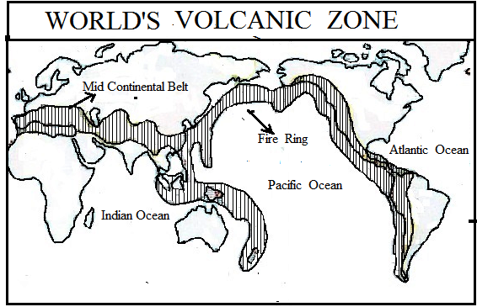
These are three important regions of volcanoes in the world.
- Circum-Pacific Belt.
The circum pacific –belt, also known as the ‘volcanic zones of the convergent oceanic plate margins’ includes the volcanoes of the eastern & western coastal areas of the pacific ocean, of island arcs & festoons off the east coast of Asia & of the volcanic islands scattered over the pacific ocean. This volcanic belt is called as the “Fire Girdle of the Pacific’ or the fire ring of the pacific. This belts beings from Erebus mountain of Antarctica & runs northward through Andres & Rockies mountain of South & North Americas to reach Alaska from where the belt turns towards eastern Asiatic coast to include the volcanoes of island arcs & festoon eg. Sakhalin, Japan, Kamchatka, Philippines. This belt ultimately merge with the mid continental belt in the East Indies. Most of the high volcanic cones & volcanic mountains are found in this belt. Most of the volcanic are found in chins eg the volcanoes of Aleutian island, Hawaii island, Japan etc.
There volcanic eruption are primarily caused due to collision of American & pacific plates & due to subduction of pacific plates below Asiatic plates.
B) Mid- continental-Belt. This belt is also known as the volcanic zones of convergent continentals plate margins. This belt includes of Alpine mountain chains & the Mediterranean sea & the volcanoes of fault zone of eastern Africa. Here the volcanic eruptions are caused due to convergent & collision of Eurasian plates, African & India plates The famous volcanoes of the Mediterranean sea such as Stromboli, Vesuvius, Etna, & the volcanoes of Aegean sea are included in this belt.
This region starts froms Alps fold mountain in Europe. and reaches upto inlands of SE Asia through Afghanistan, Baluchistan, India, Indo Burma Border.
C)Mid Atlantic-Belt.
This belts includes the volcanoes mainly along the mid Atlantic ridge which represents the splitting zone of plates. Mainly a fissure eruption typed volcanoes occur along the constructive or divergent plate margins. The most active volcanoes area is Iceland which is located on the mid Atlantic ridge.

Questions
- What is mean by a earth movement ? State its causes with good examples.
- Classify the Earth movement and explain it with suitable diagrams and good examples.
- Explain the processes of folding and state its various types in detail.
- Explain the processes of faulting and state its various types in detail.
- What is a earthquake ? State its causes.
- State the adverse effects of earthquakes with examples
- Describe the world distribution of earthquake zones on globe.
- What is a volcano? State its causes.
- Classify volcanoes on different basis.
- Describe the intrusive type topography by volcanism processes.
- State the adverse and good effects of volcanoes on the earth surface.
- Describe the world distribution of volcanic zones on globe
Short Notes
- Sudden and fast earth movement
- Slow and secular earth movement .
- Horizontal forces
- Vertical forces
- Block mountain / Horst
- Rift valley
- Symmetrical folds
- Asymmetrical folds
- Monoclinal folds
- Isoclinal folds
- Nappes
- Faulting
- Normal fault
- Reverse fault
- Lateral fault
- Terminology of Earthquake processes.
- Types of earthquakes on the basis of depth
- Terminology in Volcanism processes.
- Classification of Volcanoes on the basis of its periodicity
- Composite Cones
- Crater Lake

